***Review Article***

***Sterculia villosa* Roxb. ex Sm.:A Versatile Tree Species Warranting Conservation Focus**

**Abstract:**

*Sterculia villosa*, commonly known as the Elephant Rope Tree or Hairy Sterculia, is a versatile and valuable tree species with cultural, ecological, and economic significance. Phytochemical analyses reveal the diverse compounds present in *S. villosa*, particularly flavonoids, terpenoids, and alkaloids, showcasing its potential therapeutic applications. Medicinal uses, including its role in traditional Indian medicine, further underscore its significance in human well-being. Beyond its ecological and medicinal contributions, *S. villosa* serves as a valuable resource in culinary practices, with edible roots and seeds utilized in various preparations. The tree's economic contributions are multifaceted, ranging from wood utilization to fiber production and gum extraction. Despite its current Least Concern category, conservation efforts are critical for *Sterculia villosa* due to prevailing regional threats like deforestation and climate change. With only a few trees remaining in central India, it is now imperative to preserve this valuable species through dedicated propagation and cultivation initiatives. The plant's phenology, cultivation details, and propagation methods are also examined, providing insights for sustainable management. The paper advocates for responsible conservation measures to ensure the sustained existence of this valuable species, recognizing its multifaceted contributions to biodiversity and human well-being.

**Keywords:** Elephant Rope Tree, Hairy Sterculia, Phytochemistry, Pharmacological Properties, Cultivation, Conservation, SDGs

**Introduction:**

*Sterculia villosa*, commonly known as the Elephant Rope Tree or Hairy Sterculia, is a botanical marvel with significant implications for biodiversity, cultural heritage, and economic sustenance. Belonging to the Malvaceae family (earlier Sterculiaceae), this deciduous tree with large lobed leaves and yellow flowers is indigenous to subtropical and tropical regions (Ghani, 2003). Traditionally utilized as a diuretic and aphrodisiac in Indian traditional medicine, it also finds application in treating inflammation (Kumar et al., 2004; Namsa et al., 2009). This multipurpose plant aligns with global sustainability goals such as No Poverty, Zero Hunger, Good Health and Well-being, Quality Education, and Gender Equality, as it integrates seamlessly into local communities, offering diverse benefits. This comprehensive review explores the taxonomy, botanical characteristics, distribution, conservation status, and cultivation practices of *S. villosa*. Emphasizing its ecological importance, the paper details the tree's morphology, vernacular diversity, and cultural relevance. Despite being categorized as Least Concern by IUCN, the looming regional threat specifically in central India necessitates conscientious conservation efforts. The integration of sustainable cultivation practices aligns with the objectives of achieving Zero Hunger and fostering economic well-being within communities. This review delves into phenology, cultivation nuances, and propagation methods, advocating for sustainable management. A detailed analysis of phytochemical composition highlights flavonoids, terpenoids, and alkaloids, showcasing the therapeutic potential grounded in traditional Indian medicine. Beyond medicinal use, the review recognizes the culinary utility of *S. villosa*, contributing to the promotion of Quality Education by preserving traditional knowledge and practices. Economically, the tree's versatility is evident in wood utilization, fiber production, and gum extraction, impacting local economies and contributing to the overarching goal of No Poverty. *Sterculia villosa* stands as a botanical wonder with far-reaching influences on ecological equilibrium, cultural practices, and economic landscapes. The paper advocates for responsible conservation to ensure its sustained existence, emphasizing its pivotal role in biodiversity preservation and human well-being. The findings underscore the need for continued research, presenting a compelling case for harnessing the full spectrum of the plant's medicinal potential to address health challenges and promote Good Health and Well-being.

**Material and methods**

An exhaustive literature review was conducted, encompassing a comprehensive exploration of diverse resources, including prominent databases such as PubMed, Google Scholar, Web of Science, and Springer Nature. This thorough investigation involved employing various combinations of keywords to ensure inclusivity. Additionally, valuable insights were extracted from sources beyond traditional databases, such as pertinent websites and relevant thesis works. The overarching objective of this methodological approach was to comprehensively gather information pertaining to the utility, botany, conservation, and cultivation aspects of the *Sterculia villosa*.

**Results and discussion:**

**Phytochemistry:**

*Sterculia villosa* exhibits diverse pharmacological properties, including anti-inflammatory, antimicrobial, antioxidant, and analgesic effects. Below are the specifics of the identified phytochemicals (Table 1) and the pharmacological properties (Table 2):

**Table 1: Phytochemicals identified in *Sterculia villosa***

|  |  |
| --- | --- |
| **Phytochemicals identified** | **References** |
| Flavonoids, terpenoids, coumarins, alkaloids, phenolic acids, and steroids | Muqarrabun *et al*., 2015; Harborne, 1989 |
| Tannins supports astringent and antimicrobial potential | Muqarrabun *et al*., 2015 |
| Luteolin 3'-methyl ether, chrysoeriol 7-O-β-D-glucoside, luteolin 4'-methyl ether (diosmetin) | Hossain *et al*., 2012; Alfaro *et al*., 2009 |
| Fifty-two compounds identified in bark extract | Lyzu *et al*., 2022 |

**Table 2: Pharmacological Properties in *Sterculia villosa***

|  |  |
| --- | --- |
| **Pharmacological Properties** | **References** |
| Anthelmintic Properties | Haque *et al*., 2012; Paul *et al*., 2014 |
| Antithrombotic Activity | Tania *et al*., 2013 |
| Antiprotozoal Activity | Nwodo *et al*., 2015 |
| Antioxidant and Anti-inflammatory properties, Astringent and Antimicrobial | Muqarrabun *et al*., 2015 |
| Anti-inflammatory, antimicrobial, antioxidant, analgesic effects | Hossain *et al*., 2013 |
| Antileishmanial potential | Das *et al*., 2017; Hossain *et al*., 2016; Nwodo *et al*., 2015 |
| Antioxidant activity | Lyzu *et al*. (2022) |

**Medicinal Uses:**

The medicinal uses of *Sterculia villosa* emphasize its significant role in traditional Indian medicine, reflecting its therapeutic potential and contribution to overall well-being within local communities. The plant's traditional uses (Table 3) are well-established, with *S. villosa* serving as a diuretic, cooling agent, and aphrodisiac herb in Indian traditional medicine.

**Table 3: Medicinal Uses of *Sterculia villosa***

|  |  |
| --- | --- |
| **Medicinal Uses** | **References** |
| Gastrointestinal Disorders | Hossain *et al*., 2013 |
| Wound Healing, Membrane Stabilization | Tania *et al*., 2013 |
| Treatment of Inflammation | Kumar, 2004; Namsa, 2009 |
| Antidiabetic Properties | Hossain *et al*., 2013 |
| Cooling and Aphrodisiac Properties | Kumar *et al*., 2004 |
| Diuretic Agent | Kumar *et al*., 2004 |
| Skin Diseases | Hossain *et al*., 2013; Kunwar *et al*., 2010 |
| Rheumatism | Kumar *et al*., 2004 |
| Urinary Problems | Kumar *et al*., 2004 |
| Rheumatism, urinary problems, and seminal weakness | Hossain MM *et al*., 2013 |

**Other uses:**

*Sterculia villosa* stands out as a versatile and valuable resource, playing a vital role in culinary, ecological, and economic aspects. Its impact extends from traditional uses to various industrial applications, highlighting its cultural and ecological importance. Responsible conservation efforts are essential to ensure the sustained existence of this botanical wonder for future generations.

1. **Culinary Uses:**

**Edible Resource:** *Sterculia villosa* serves as a valuable dietary resource in local communities, enhancing culinary diversity and nutritional well-being.

**Root Powder Preparation:** The powdered root, mixed with rice flour, is used to create a bread-like doughnut known for its soft texture and pleasant taste (https://tropical.theferns.info/viewtropical.php?id=Sterculia+villosa).

**Nutrient-Rich Seeds:** Roasted or cooked seeds are consumed, similar to pulses, contributing to dietary sustenance and food security (Facciola, 1998).

**Gum Substitute:** The gum from the bark is used as a substitute for gum tragacanth in confectionery, highlighting its role in food production (Facciola, 1998).

**Traditional Drink Ingredient:** The plant is a popular ingredient in locally made drinks during hot summers, promoting a feeling of freshness, relaxation, and sound sleep (Manandhar, 2002).

1. **Ecological Contributions:**

**Nectar Source:** The flowers of *Sterculia villosa* provide nectar for pollinators like bees and butterflies, supporting local biodiversity.

**Wildlife Food Source:** Fruits with edible pulp contribute to wildlife food sources, enhancing overall regional biodiversity.

1. **Economic Contributions:**

**Wood Utilization:** The soft wood is used in tea boxes, toys, guitars, matchboxes, and commercial plywood, contributing to various industries (Ghosh & Baruah, 1997).

**Fiber Production:** Coarse fiber from inner bark is used in ropes, bags, and cordage, fulfilling industrial needs.

**Gum Production:** The plant produces gum karaya, used in lozenges for sore throats, emphasizing its medicinal and commercial significance (Verma & Kharakwal, 1977).

**Paper Pulp Potential:** *Sterculia villosa* is suitable for paper production, with its fibrous material exhibiting a remarkable pulp yield and wood fiber properties. The fibrous material contributes significantly to the pulp and paper industry, supporting sustainable paper resources (Ghosh & Baruah, 1997; Barua & Rabha, 1992).

1. **Cultural and Ecological Significance:**

**Botanical Wonder:** *Sterculia villosa* symbolizes the intricate connection between nature and human culture, emphasizing responsible land management and conservation efforts for its sustained existence.

**Versatile Resource:** From traditional medicine to diverse industrial applications, *Sterculia villosa* proves its versatility and value, impacting various sectors.

**Economic and Cultural Relevance:** Beyond economic significance, the plant holds cultural and ecological relevance, underlining its importance in various contexts.

**Taxonomy**:

The genus *Sterculia* belongs to the subfamily Sterculioideae of family Malvaceae (Wilkie *et al*., 2006). It was previously placed in the now obsolete Sterculiaceae, which comprised approximately 200 species distributed mainly in tropical and subtropical regions. Some of the *Sterculia* species are classified under different genera based on distinct morphological features.

**Taxonomic Classification:**

Kingdom: Plantae

Phylum: Streptophyta

Class: Equisetopsida

Order: Malvales

Family: Malvaceae Genus: *Sterculia* L.

Species: *Sterculia villosa* Roxb. ex Sm.

**Synonyms:**

*Clompanus armata* (Mast.) Kuntze

*Clompanus villosa* (Roxb. ex Sm.) Kuntze

*Sterculia armata* Mast.

*Sterculia lantsangensis* Hu

*Sterculia ornata* Wall. ex Kurz

**Vernacular names:**

*Sterculia villosa*, commonly known as the Elephant-rope tree, hairy sterculia, or woolly ordure tree, boasts a rich diversity of vernacular names across various regions (Table 4), showcases the extensive regional diversity in nomenclature for this versatile and widely recognized tree species (Sankara Rao, 2019).

**Table 4: Vernacular name of *Sterculia villosa* across different languages**

|  |  |
| --- | --- |
| **Vernacular Name** | **Language** |
| Udhal | Hindi |
| Bilidali | Kannada |
| Muruthan, Vakkai, Anai-nar | Tamil |
| Kummari puliki | Telugu |
| Kodalo | Oria |
| Kudal, Kuthada, Sardol | Marathi |
| Oudal | Assamese |
| Ubak | Garo |
| Sardol | Gujarati |
| Dieng star | Khasi |
| Sardol | Konkani |
| Vakka | Malayalam |
| Hei-rit | Manipuri |
| Khau-pui | Mizo |
| Khava, Odani | Nepali |
| Massu | Punjabi |
| Anai-nar, Vakku-nar | Tamil |
| Kummarapoliki, Kavili, Narapoliki, Vakkunara Akkanarumaram | Telugu |

**Botanical Description:**

Medium-sized monoecious deciduous tree, typically grows to a height of 10-20 meters with a girth of about 1.4-1.6 meters. Described by its thick, gnarled trunk and a distinctive, irregular crown providing ample shade, the tree's often spreading and wide canopy contributes to its regal appearance. In dry deciduous jungles, it can reach significant heights, displaying rapid growth (Kanjilal et al., 1934; Barua et al., 1992).

**Bark:** The mature tree of *Sterculia villosa* is recognized by its grey bark, which is about 2.5 to 2.65 centimeters thick. The bark texture and thickness contribute to the tree's resilience and protection against various environmental factors.

**Wood:** The wood of *Sterculia villosa* is notably soft and lightweight. It exhibits a range of colors, from pale yellowish or greyish white to light greyish or brown. This lightweight wood makes it a versatile resource for various uses.

**Leaves:** large, simple, and palmately lobed leaves (as depicted in Figure 2) are covered with sparsely stellate-hairs above, tomentose below,. Petiole of about 25–40 cm and a lamina composed of 5-7 lobes, approximately 20–40 cm in both length and width, (Ghani, 2003; Kumar et al., 2004).

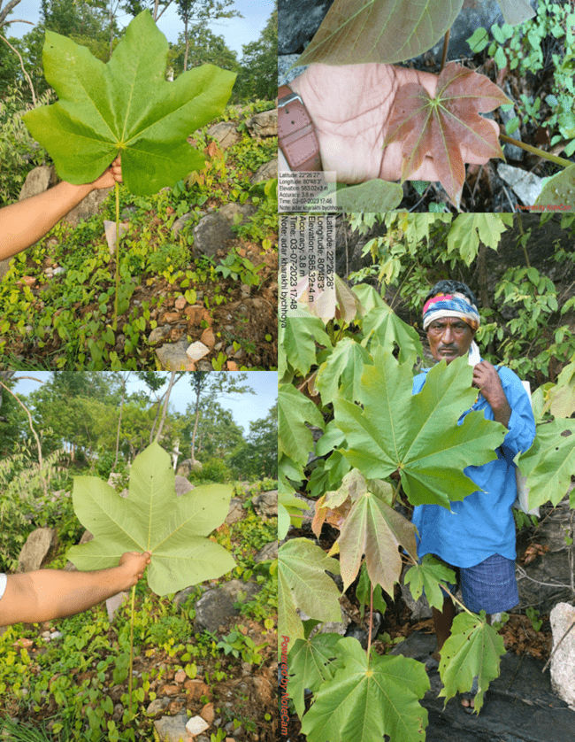

**Figure-2: Leaf morphology of *Sterculia villosa***

**Flowers**

Flowers unisexual, pinkish yellow, 1–2 cm wide, much branched rusty pubescent, terminal, drooping panicles, male and female flowers intermixed.

Pedicel 4 to 8 mm long, deciduous.

Calyx and Corolla: Calyx campanulate, pinkish inside, 5-lobed, hairy, lobes spreading; tube 3 mm ♂: staminal column 2-3 mm long, curved; anthers 10. ♀: Ovaries 5, 2-3 mm long, gynandrophore hairy, globose with sterile anthers at base; styles 2 mm long, recurved; stigmas 5-lobed.

Follicles: 3-5, 2.5–4 cm long, oblong, spreading, rusty villous, red inside; seeds 3-5 in each follicle, 7-10 mm long, oblong, smooth, black (Britto, 2019).

**Seed Morphology:**

The seeds of *Sterculia villosa*, with specific characteristics and structural components, play a crucial role in the tree's reproductive success and ecological significance (Ghani, 2003). The detailed description of seed morphology includes:

Shape and Size: Predominantly oblong, the seeds exhibit an elongated and slightly oval shape, of moderate size, contributing to the overall seed-bearing capacity of the tree. The approximate seed number per kilogram is 5400-6000 (Ghani, 2003).

Surface Texture: The seeds have a smooth surface, lacking prominent ridges or indentations, enhancing efficiency in seed dispersal and germination (Ghani, 2003).

Color: Typically dark black, the seeds provide a visual contrast, aiding in their identification within the fruit or in the surrounding environment (Ghani, 2003).

Endospermic Content: The seeds are endospermic, containing a nutrient-rich tissue surrounding the embryo. This endosperm serves as a vital source of nourishment for the developing plant during germination and initial growth stages (Ghani, 2003).

The distinctive seed morphology of *Sterculia villosa*, characterized by its oblong shape, smooth surface texture, dark black color, and endospermic seeds, contributes significantly to the tree's reproductive cycle, and facilitates the dissemination and establishment of new seedlings within its native habitat (Ghani, 2003).

**Phenology of *Sterculia villosa*:**

Flowering: The flowering phase of *Sterculia villosa* occurs from January to March.

Fruiting: Fruiting phase from March to April,.

Fruit/Seed Collection Time: The ideal time for collecting the fruits or seeds of *Sterculia villosa* typically falls between May and June, allowing for the collection and propagation of viable seeds for various purposes.

Pollination Method: The tree primarily relies anemophily pollinationmethod, utilizing the natural movement of air currents to facilitate the transfer of pollen between flowers.Mode of Dispersal: The dispersal of seeds is mainly facilitated by wind, enabling the seeds to be carried over distances and dispersed within the surrounding ecosystem, contributing to the tree's reproductive success and population distribution.

**Habitat:**

A plant of lowland, subtropical to tropical areas, where it is found at elevations from sea level to 1,050 metres. It grows best in areas where annual daytime temperatures are within the range 30 – 42°C, though it can tolerate 7 – 47°C. It can be killed by temperatures of -2°c. It prefers a mean annual rainfall within the range 1,300 – 1,900 mm, but tolerates 750 – 4,000 mm, usually growing in areas with a distinct dry season. Requires a sunny position, though seedlings are shade tolerant. Grows best in a light, well-drained soil and also tolerate poor, rocky soils. Established plants are very drought tolerant. Prefers a pH in the range 6.5 – 7.5, but tolerates 6–8. The trees can be tapped for their gum about 5 times during their lifetime. (Tropical Plants Database, 2022).

**Distribution:**

*Sterculia villosa,* native to diverse regions in Indian subcontinent, including India, Sri Lanka, Myanmar, Thailand, Malaysia, China, and Indo-china regions, thrives in tropical and subtropical forests, often near riverbanks and areas with well-drained soil (Ghani, 2003; Manandhar, 2002). Commonly found in dry deciduous jungles, it prefers cool, moist valleys (as depicted in Figure 3), and is observed along forest edges or in cleared patches in the wild, particularly in regions like Bhutan, India, Nepal, Pakistan, and East Asia (Manandhar, 2002).

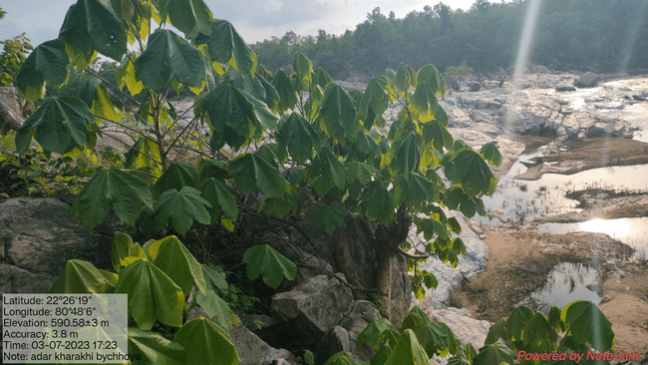

**Figure-3: Natural Habitat within the hilly region of a river basin area in Madhya Pradesh.**

In India, the species is widely distributed across various states, such as West Bengal, Assam, Odisha, and the North Eastern states, ascending to altitudes of up to 1000 meters (Ghani, 2003). The plant's adaptability is evident in its prevalence in diverse ecosystems, including *Terminalia tomentosa* forests and alluvial savanna forests, showcasing a preference for light sandy or gravelly soils and an annual rainfall ranging between 750 – 4000 mm (Ghani, 2003). Its presence extends to South Asian countries like Bangladesh, Bhutan, and Myanmar, as well as East Asian countries such as Nepal, Thailand, and Cambodia, reflecting its widespread distribution and adaptability to various ecological conditions (Ghani, 2003). In China, *Sterculia villosa* is distributed in the southern regions, emphasizing its adaptability to diverse climatic and ecological conditions within the country (Ghani, 2003). The tree's widespread distribution across these regions underscores its role in contributing to local biodiversity and ecological balance as depicted in Figure 4 (Ghani, 2003; Manandhar, 2002, GBIF 2023).

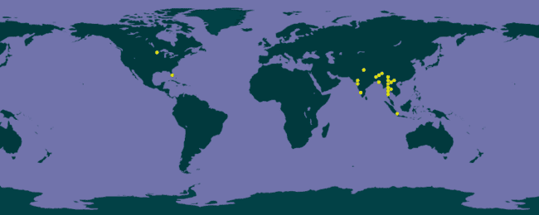

**Figure-4: Occurrences of *Sterculia villosa*** (Source: GBIF.org (31 December 2023) GBIF Occurrence Download <https://doi.org/10.15468/dl.gmbyet>)

**Conservation Status**

*Sterculia villosa,* classified as a species of Least Concern according to the IUCN Red List ver 3.1 (Year Published: 2022), exhibits extensive geographical spread and a substantial population with no substantial current threats or foreseeable risks (IUCN, 2022). Despite this favorable classification, conservation efforts are deemed critical, especially in the face of regional threats such as deforestation and climate change. The urgency for preservation is highlighted by the dwindling number of trees in central India, emphasizing the need for dedicated propagation and cultivation initiatives. Ongoing deforestation and habitat degradation necessitate monitoring of populations and habitats, underlining the importance of conservation measures to ensure the continued presence of *Sterculia villosa*. These efforts are vital not only for the survival of this unique tree but also for its significant contributions to local ecosystems and cultures.

**Propagation & cultivation**

The plant can be raised from seeds and also from stem cuttings. The aril surrounding the seed should also be removed - this is easiest when it has been softened through soaking in water. The seeds germinate optimally at temperatures between 20 – 30°C. They can be sown in a nursery seedbed or in containers. A germination rate of about 95%, occurring within about 2 weeks can be expected if the seed has been properly treated.

The application of seed pre-treatment methods involving 50-100 PPM GA3, 100 PPM Thiourea, and hot water treatment for 24 hours demonstrated superior results in promoting germination in *Sterculia villosa* when compared to the control group. The maximum germination (94.33) percentage of *Sterculia villosa* was obtained from the seeds treated with thiourea 100 ppm which was statistically at par with thiourea 50 ppm treated seeds (93.66) followed by cold water (91.66) and hot water (91.16) treatments. The particular concentration of thiourea probably helps to inhibit the activity of inhibitor chemicals present in seeds and resulting higher germination percentage. The superior effect of boiling water may be due to its combined effect in softening the seed coat and leaching out of the chemical inhibitors (Willan, 1985). All treatments showed a positive impact on the shoot length of *Sterculia villosa* seedlings. The maximum shoot length was recorded with GA3 100 ppm treated seeds (35.56 cm) which was statistically at par with GA3 50 ppm treated seeds (34.22 cm). The increased shoot length in auxin treated seeds can be attributed to its peculiarity to increase shoot growth by cell enlargement (Noggle and Fritz, 1986).

In another germination study of *Sterculia villosa* seeds revealed that the maximum germination rate (80%) was achieved in a propagator house, surpassing the control group with a 76% germination rate (Hasnat et al., 2019).

Over the period from May 2014 to September 2019, the investigation cantered on exploring the germination, growth, and development of the uncommon tree species *Sterculia villosa*. The mature seeds displayed an 80% germination rate within a span of 21 days. The transplantation of twelve-month-old saplings yielded swift growth, culminating in a six-year-old specimen reaching a height of 249 cm. The study underscores the significance of conservation initiatives in promoting biodiversity (Rai et al., 2020).

**Future Perspectives:**

Future research on *Sterculia villosa* should encompass a comprehensive exploration of its pharmacological, morphological, conservation, and cultivation aspects. Pharmacological studies should aim to unveil its medicinal potential, exploring applications in traditional medicine or pharmaceutical development. Morphological analyses, including molecular investigations, are crucial for a nuanced understanding of the plant's structure and genetic diversity. Conservation efforts should focus on robust strategies, considering ecological significance, reintroduction programs, and sustainable harvesting. Cultivation techniques need optimization, with an emphasis on agroforestry models and sustainable practices. Assessing economic viability, community engagement, and climate resilience are pivotal components, ensuring a balanced approach that integrates ecological preservation, traditional medicine, and sustainable development. Interdisciplinary collaboration among pharmacologists, botanists, ecologists, and social scientists is essential for a holistic understanding and effective management of *Sterculia villosa*. These future perspectives aim to contribute significantly to biodiversity conservation, traditional medicine, and sustainable development, fostering a harmonious relationship between the plant species and the communities it influences.

**Conclusion:**

In conclusion, *Sterculia villosa* stands out as a plant of great significance, not only for its ecological role but also for its potential pharmacological applications. The studies discussed shed light on the plant's distinctive morphological features, distribution, and its role in supporting local ecosystems. While currently classified as a species of Least Concern, conservation efforts are deemed crucial, given regional threats such as deforestation and climate change. The comprehensive seed and fruit morphology descriptions provide valuable insights into the reproductive cycle and ecological interactions of *Sterculia villosa*. Additionally, the findings related to seed germination and seedling development present practical implications for propagation and cultivation. As evidenced by successful germination and growth trials, future research could delve into optimizing cultivation practices for enhanced yields and sustainability. Overall, the knowledge compiled here offers a foundation for informed conservation strategies and sustainable utilization of *Sterculia villosa*, ensuring its continued contribution to ecosystems and potentially benefiting pharmaceutical and agroforestry endeavors.

**References:**

Al Muqarrabun, L. M., & Ahmat, N. (2015). Medicinal uses, phytochemistry, and pharmacology of family Sterculiaceae: A review. European Journal of Medicinal Chemistry, 92, 514-530.

Alfaro, A., Pérez, A., García, J. C., López, F., Zamudio, M. A. M., & Rodríguez, A. (2009). Ethanol and soda pulping of tagasaste wood: Neural fuzzy modeling. Cellulose Chemistry and Technology, 43(7-8), 295-306.

Barua, P. P., & Rabha, L. C. (1992). Chemical pulp and paper from *Sterculia villosa* Roxb. Indian Forester, 118(3), 213-217.

Das, A., Jawed, J. J., Das, M. C., Sandhu, P., De, U. C., Dinda, B., Akhter, Y., & Bhattacharjee, S. (2017). Antileishmanial and immunomodulatory activities of lupeol, a triterpene compound isolated from *Sterculia villosa*. International Journal of Antimicrobial Agents, 50(4), 512-522. doi: 10.1016/j.ijantimicag.2017.04.022

Facciola, S. (1998). Cornucopia II. California: Kampong Publications. ISBN 0-9628087-2-5.

GBIF.org (31 December 2023) GBIF Occurrence Download https://doi.org/10.15468/dl.gmbyet)

Ghani, A. (2003). Medicinal Plants of Bangladesh with Chemical Constituents and Uses (p. 183). Dhaka, Bangladesh: Asiatic Society of Bangladesh.

Ghosh, S. R., & Baruah, P. P. (1997). *Sterculia villosa* Roxb — A potential source of wood-fibre for pulp and paper making. Bioresource Technology, 62(1-2), 43-46. doi:10.1016/S0960-8524(97)00047-3

Harborne, J. B. (1989). Flavonoids. In J. W. Rowe (Ed.), Natural products of woody plants (pp. 533-570). Heidelberg: Springer Berlin Heidelberg.

Hasnat, G. N. T., Hossain, M. A., & Hossain, M. K. (2019). Pre-Sowing Treatments Accelerate Germination Percent for Restoration of Fourteen Threatened Tree Species in Bangladesh. Journal of Tropical Forestry and Environment, 9(2), 36-45. https://doi.org/10.31357/jtfe.v9i2.4466

Hossain, M. K., Prodhan, M. A., Even, A. S. M. I. H., Morshed, H., & Hossain, M. M. (2012). Anti-inflammatory and antidiabetic activity of ethanolic extracts of *Sterculia villosa* barks on Albino Wistar rats. Journal of Applied Pharmaceutical Science, 2(8), 96-100.

IUCN SSC Global Tree Specialist Group, Botanic Gardens Conservation International (BGCI), Lakhey, P., & Pathak, J. (2022). *Sterculia villosa*. The IUCN Red List of Threatened Species 2022: e.T150220667A152201452. https://dx.doi.org/10.2305/IUCN.UK.2022-1.RLTS.T150220667A152201452.en

K N Tania, et al. (2013). Journal of Biomedical and Pharmaceutical Research, 2(1), 09-14.

Kumar, R., Suman, N., & Dash, S. (2004). Traditional uses of plants by tribals of Amarakantak region, Madhya Pradesh. Indian Journal of Traditional Knowledge, 03(4), 383–390.

Lyzu, C., Mitra, S., Perveen, K., Khan, Z., Tareq, A. M., Bukhari, N. A., Husain, F. M., Lipy, E. P., Islam, D., Hakim, M., Emran, T. B., & Dashti, M. G. (2022). Phytochemical Profiling, Antioxidant Activity, and In Silico Analyses of *Sterculia villosa* and Vernonia patula. Hindawi Evidence-Based Complementary and Alternative Medicine, 2022, 3190496. https://doi.org/10.1155/2022/3190496

Namsa, N. D., Tag, H., Mandal, M., Kalita, P., & Das, A. K. (2009). An ethnobotanical study of traditional anti-inflammatory plants used by the Lohit community of Arunachal Pradesh, India. Journal of Ethnopharmacology, 125(2), 234–245.

Nwodo, N. J., Ibezim, A., Ntie-Kang, F., Adikwu, M. U., & Mbah, C. J. (2015). Anti-trypanosomal activity of Nigerian plants and their constituents. Molecules, 20, 7750–7771.

Rai, Y., Kumar, P., Rajput, S., & Paliwal, P. (2020). Growth and Development of Rare Tree Species *Sterculia villosa* Linn. in Districts, Meerut and Bulandshahr, U.P., India. Asian Journal of Research in Agriculture and Forestry, 6(4), 1-8. https://doi.org/10.9734/AJRAF/2020/v6i430109

Sankara Rao, K (2019). Flora of Peninsular India. Retrieved from http://peninsula.ces.iisc.ac.in/plants.php?name=Sterculia+villosa

Tropical Plants Database. (2022). *Sterculia villosa* Roxb. Retrieved from tropical.theferns.info/viewtropical.php?id=Sterculia+villosa

Verma, V. P. S., & Kharakwal, G. N. (1977). Experimental tapping of *Sterculia villosa* Roxb. for gum karaya. Indian Forester, 103(4), 269-272.

Wilkie, P., Clark, A., Pennington, R. T., Cheek, M., Bayer, C., & Wilcock, C. C. (2006). Phylogenetic relationships within the subfamily sterculioideae (Malvaceae/Sterculiaceae-Sterculieae) using the chloroplast gene ndhF. Systematic Botany, 31(1), 160-170.