**Stochastic Optimal Bequest and Consumption Strategy for**

**Retirees: A Monte Carlo based Dynamic Programming**

**Approach**

ABSTRACT

|  |
| --- |
| Determining optimal consumption and bequest policies is complex but essential aspect of retirement planning. It can balance the immediate need for consumption with the desire to leave a legacy, managing risks and economic activities more sustainably and efficiently. One of the key challenges for such optimal retirement planning is the stochasticity in the retiree’s income, which can include uncertain pension payments, fluctuating investment returns, or unexpected windfalls or losses. This paper proposes a robust Monte Carlo-based-dynamic programming technique to approximate the deterministic equivalent of the intractable stochastic utility bequest-consumption problem. The utility function is modelled using constant relative risk aversion (CRRA), and a weighting function modulates the bequest utility. This stochastic approach allows for a more realistic representation of the uncertainties faced by retirees. The dynamic programming approach involves recursive value functions that consider the maximum expected utility from the current period to the end of the planning horizon, given the state variables of wealth and income. This paper contributes to retirement planning by offering a sophisticated tool for optimizing consumption and bequest strategies in uncertain future income and survival probabilities. |

**Keywords**: Monte-Carlo Simulation; Bequest Planning; Optimal Consumption; Survival Probability; Stochastic Income; Dynamic Programming Model

1. INTRODUCTION

The concept of bequest has a long history, dating back thousands of years, playing significant roles in societal structures and the intergenerational transfer of wealth. In ancient Egypt, it was common to bequeath wealth to family members and even servants (Alonso-Carrera and Bouche, 2024). Similarly, in ancient Greece, bequests were an integral part of inheritance law, with affluent individuals frequently bequeathing their estates, lands, and possessions to their successors through meticulously crafted wills or legal instruments (Anderson et al., 2024). In the modern era, bequests constitute a key aspect of estate planning, where individuals work with legal practitioners and financial advisors to ensure their assets are distributed according to their wishes after they pass away (Arandjelovic et al.´, 2023a). Despite disagreements about the exact value of this intergenerational transfer, its undeniable impact on aggregate capital accumulation must be addressed.

Recent years have witnessed a resurgence of interest in the concept of bequest, notably catalyzed by Yaari’s model (Yaari, 1964), which explains the annuity puzzle through the lens of bequest motives (Dagpunar, 2021). According to this puzzle, individuals accumulate savings during their active years and then draw upon these reserves at retirement to maintain a steady standard of living. However, empirical studies reveal a departure from this theoretical framework, with individuals persisting in their savings habits even post-retirement (Han et al., 2020). Yaari attributes this behaviour to the desire to bequeath an inheritance to future generations, thereby perpetuating the cycle of saving (He et al., 2024). Building upon Yaari’s foundational work, subsequent studies have sought to explain the annuity puzzle from a bequest perspective (Bernheim, 1991; Laitner, 2002; Anderson et al., 2024; Yang and Gan, 2020; Van Rymenant, 2023; Lee and Tan, 2023). Conversely, scholars such as Brown Brown (1999) and others have refuted this claim, arguing that the bequest motive holds negligible sway over an individual’s decision to purchase annuities.

In bequest modelling, Yaari introduced a weighting function denoting the relative utility assigned to a bequest left at age *𝑡*. This function signifies an individual’s evaluation of the potential wealth bequeathed to heirs at any given moment. Yaari’s model postulates a hump-shaped curve, suggesting that individuals place more excellent utility on bequests when their familial responsibilities are at their zenith. It diminishes this utility as children reach independence and familial dependency wanes. In essence, Yaari posits that the utility of a bequest is age-dependent.

While scholars like Fisher (2010) align with this age-dependent utility framework, others such as Kraft et al. (2022) propose a non-age-dependent weighted function, directly linking it to the bequest-consumption ratio in the final phase. Diverging from these approaches, both studies Brown (1999); Kraft et al. (2022) assume a constant utility of bequest over the life cycle, while Hurd and Smith (2002) for goes the application of the weighting function entirely. Most of these models adopt simplified forms to mitigate computational complexities, while others dismiss it as inconsequential.

Yet, in bequest modelling, it is imperative to consider the subjective satisfaction an individual derives from a bequest, a facet that varies significantly among individuals. While we concur with Yaari’s assertion that age influences the level of bequest, we posit the existence of additional factors that significantly impact one’s bequest preferences. For instance, an individual’s religious and traditional beliefs can affect the utility they derive from bequest. Ignoring these nuanced factors in determining optimal consumption or annuity levels could yield skewed outcomes.

Retirement planning is a critical aspect of financial management, aiming to balance the need for immediate consumption with the desire to leave a legacy. This process involves strategic decision-making to ensure financial security and sustainability over an uncertain lifespan. One of the central challenges in retirement planning is the inherent stochasticity in a retiree’s income (Alonso-Carrera and Bouche, 2024). Uncertain pension payments, fluctuating investment returns, and unexpected financial windfalls or losses add complexity to this already intricate task. The optimal determination of consumption and bequest policies has been extensively studied in economics and finance.

Early models, such as the life-cycle hypothesis by Bernheim (1991), laid the foundation for understanding consumption and saving behaviours over a lifetime. These models, however, often assumed deterministic income streams and did not fully capture the uncertainties faced by retirees. Recent advancements have introduced stochastic elements to these models. For instance, Yaari (1964) incorporated uncertain lifespans, while more recent works have considered stochastic income processes. Studies such as those by Neumann and Scheuer (2024), Chen et al. (2024), Gaziolu and Bastıyalı-Hayfavi (2010), and He and Liang (2017) highlight the importance of considering income volatility in financial planning but often do not provide comprehensive solutions for the combined consumption and bequest problem under uncertain income.

The optimal problem requires effective approaches such as Dynamic Programming (DP). DP has been a popular method for solving such optimization problems. Merton (1969) pioneered the application of dynamic programming to portfolio selection and consumption under uncertainty. Recently, many studies have employed DP for retirement planning. For instance, Das et al. (2023) developed a strategy to explore the risks associated with lifestyle, longevity, and legacy in retirement portfolio decumulation, focusing on using annuities. Their study accounts for the stochastic nature of solvency regulations and aims to maximize the probability of meeting the bequest goal while maintaining financial stability (Xu et al., 2024). Other studies, such as those by Pagnoncelli et al. (2024) and Arandjelovic et al.´ (2023b), examine the interplay between life cycle insurance, bequest motives, and annuity loads, highlighting the impact of annuity loads on the optimal decision-making process.

These models often require simplifying assumptions to remain tractable (Arandjelovic et al., 2023c). As demonstrated by Abubakar et al. (2023), Monte Carlo simulations offer a way to address the complexity of stochastic processes. Given the increasing complexity of financial markets and the rising uncertainties in retirement incomes, there is a pressing need for more robust and realistic models (Alonso-Carrera and Bouche, 2024). Traditional deterministic approaches fail to capture the true nature of retirement income variability. A more nuanced approach incorporating stochastic elements and leveraging advanced computational techniques is essential for effective retirement planning. This paper is motivated by the need to provide retirees with a sophisticated tool to optimize their consumption and bequest strategies amidst uncertain future incomes and survival probabilities.

Despite significant progress in the field, issues such as stochastic modeling still need much attention (Arandjelovic et al., 2023c). Thus, this paper addresses some of these gaps by proposing a robust Monte Carlo-based dynamic programming technique to approximate the deterministic equivalent of the intractable stochastic utility bequest-consumption problem. Key contributions include:

1. Stochastic Income Modeling Via Monte Carlo Simulation: Many existing models either oversimplify income processes or do not adequately integrate stochastic elements (Arandjelovic et al., 2023c). Therefore, the application of the robust Monte Carlo simulations could handle the stochastic nature of retirement income, providing a more realistic and practical solution for retirees.
2. Integration of Consumption and Bequest: Most studies focus on either consumption or bequest optimization separately, without a unified framework that addresses both simultaneously under uncertainty (Alonso-Carrera et l., 2024). The proposed method in this paper involves recursive value functions that consider the maximum expected utility from the current period to the end of the planning horizon, given the state variables of wealth and income. This approach effectively integrates consumption and bequest decisions into a unified framework.

Based on these key contributions, the paper seeks to answer the following research questions?

1. How can Monte Carlo simulations address the limitations of traditional models by effectively representing the stochastic nature of retirement income?
2. What advantages do stochastic elements offer when integrated into dynamic programming models for improving the accuracy of consumption and bequest decisions under uncertain income?
3. How does a unified framework that optimizes both consumption and bequest strategies using advanced techniques improve retirement planning in the face of complex financial markets?

This paper significantly advances the field of retirement planning by offering a detailed and practical approach to managing the complexities of uncertain income. By integrating stochastic elements with dynamic programming and Monte Carlo simulations, the proposed method provides a robust framework for retirees to make informed and optimal financial decisions, balancing their consumption needs and bequest desires in the face of economic uncertainties. This method is not just a theoretical advancement, but a practical tool that can empower retirees to navigate the complexities of retirement planning with confidence.

This paper is organized into four sections. The introduction discusses the importance of optimal consumption and bequest policies in retirement planning, highlighting the challenges posed by income stochasticity. It also provides an overview of existing methods, their limitations, and the research gap concerning stochastic income and survival probabilities. The methodology outlines Constant Relative Risk Aversion (CRRA) for the utility function, the Monte Carlo-based technique for simulating income uncertainties, and the dynamic programming framework for recursive value functions, including algorithm implementation. The analysis and results section highlights the validation of real-world scenarios and impact analysis of the proposed approach, followed by a discussion of the results. The conclusion summarizes key findings and suggests future research directions.

2. methodology

We adopt the Yaari (1964) approach in this modelling strategy. Consider an individual who retires at time  with a maximum life expectancy of  years. Upon retirement, the individual receives a lump sum pension (), which must be managed for the remainder of their life. The individual faces two primary risks: depleting their income before death or not fully utilizing it. To mitigate the risk of running out of money, the individual invests part of the income in a life annuity (), ensuring a regular and fixed income () until death (Details are given in Equation (7). The remaining funds () are invested in risky assets, such as equities, which offer higher returns (). Thus, the total income (wealth) at time  is given as:

 (I)

At retirement, an individual who intends to leave a legacy for their family while seeking to experience optimal consumption policies until death faces the need to balance consumption and bequest policies. With these considerations and the assumption that no pre-determined income exists, this study seeks to determine the optimal consumption levels and bequests for such individuals. This involves predicting the total returns described as net present value (NPV) by the robust Monte Carlo method. Based on the estimated income and discounting future utilities, a dynamic programming (DP) approach is employed to determine the optimal bequest and consumption policies, incorporating the utility derived from bequests for such retirees.

The Expected Utility-Based Present Value Model that needs to be optimized can be stated as follows Yaari (1964):

 (II)

where  represents consumption at time , and  denotes the utility derived from consumption.  indicates bequests given at the time of death with  being the utility function for bequests.  is a discount factor, which is applied uniformly to both consumption and bequests in this work.

Assuming constant relative risk aversion utility and incorporating the utility of bequests, the model can be rewritten as follows:

 (III)

Where  is a weighting function representing the relative weight of the utility of bequests, which, according to Hurd et al. (2002), can be interpreted as the relative importance an individual at age  assigns to the utility of bequests compared to the expected utility derived from the flow of consumption at the same age. It should be noted that this term is slightly different from , which refers to the welfare function defined over bequests. We model the bequest function slightly differently to adjust for individual preferences and life circumstances. An individual's utility for bequests could be influenced by factors such as religious belief, age, number of children, family ties, etc. If we incorporate these factors into bequests, we then have (Dynan et al., 2002):

 (IV)

Where:  is a scaling parameter,  is a positive parameter controlling the shape of the bequest function,  are coefficients for the factors  influencing the utility of bequest,  is the error term.

The problem constraints are described as the following: As the individual invests the lump sum in annuity and stock, the constraints can be stated as follows:

1. **Budget Constraint:** It ensures that the present value of all expenditures, including consumption and bequests, does not exceed the value of all resources, including initial and future incomes:

 (V)

Given that , constraint (V) becomes:

 (VI)

1. **Life Annuity Definition:** A life annuity provides payments for the lifetime of the annuitant. The model incorporates actuarial present value, which accounts for the probability of survival at each payment period. For simplicity, the present value of a life annuity can be approximated by (Friedler, 1986):

 (VII)

where  and  are interest and mortality rates.

1. **Non-Negativity Constraints:**



* 1. **Modeling of the Stochastic Investment Returns () by Monte Carlo Simulation**

Monte Carlo simulation is an effective and practical technique that enhances classical net present value (NPV) analysis. It provides an intuitive way to visualize risk and project potential investment outcomes. By simulating a wide range of possible scenarios, Monte Carlo methods estimate the net present values while accounting for the uncertainties in cash flows. Studies by Shaffie et al., (2016) and Abubakar et al., (2023) emphasized that Monte Carlo simulation does not require extensive computational resources and can generate realistic and easily understandable results for decision-makers. The simplicity of Monte Carlo simulations encourages decision-makers to adopt this method for reliable capital investment valuation. The study shows that Monte Carlo simulations can estimate net present values while incorporating cash flow uncertainty. The model’s effectiveness and ease of use make it valuable for improving investment analysis and aiding in more informed decision-making. As a result, the Monte Carlo simulation is employed in this paper to evaluate the NPV of capital investment by a retiree (). This approach considers the variability () in cash flow projections, incorporating uncertainty into the financial analysis. The NPV, which is defined as , is given by (Shaffie et al., 2016):

  (VIII)

Where:  is the discount factor at time t,  is the initial cash inflow and  is the initial investment cost. Readers are referred to the appendix for the detailed derivation.

Combining Monte Carlo simulation with numerical optimization is an effective approach for solving the optimal bequest-consumption problem, since the income from the risky investment is uncertain. The challenge lies in directly optimizing the random objectives and the problem constraints, which can be computationally difficult even if the underlying problem has favorable properties such as continuity, differentiability, or convexity (Abubakar et al., 2023). To tackle this complexity, there is the need to generate a reasonable number of scenarios that could capture the uncertainty to make the problem tractable. Thus, enabling numerical optimization schemes converge in a polynomial time. This deterministic equivalent of the stochastic consumption-bequest problem could now be solved efficiently by numerical optimization such as the dynamic programming approach and the solution approach in this paper is summarized by the following key steps:

1. **Simulation of Scenarios**:

Monte Carlo simulations generate multiple scenarios of income or returns, based on their probability distributions, to model the inherent uncertainty in investment or income sources.

1. **Evaluation of Strategies**: For each generated scenario, various consumption-savings strategies are assessed to determine their impact on the utility function, which reflects the individual's preferences over consumption and bequest.
2. **Optimization**: Numerical optimization techniques are applied to adjust strategies, aiming to maximize the expected utility across all scenarios. This involves iterating between the simulation and optimization processes, continuously refining strategies based on the results.

By integrating Monte Carlo simulation with numerical optimization, the complexities and uncertainties of the optimal bequest-consumption problem are effectively managed. This combination enables the development of a strategy that maximizes expected utility, offering a realistic and practical solution under uncertain conditions. The detailed algorithm and the mathematical formulations for this modeling strategy presented in the appendix.

* 1. **Dynamic Programming Formulation for Optimal Consumption and Bequest Problem**

To formulate a stochastic Dynamic Programming (DP) model for the optimal Consumption and bequest problem with random income , we follow Richard Bellman's principle of optimality. The goal is to maximize the expected utility of consumption  and bequest  over time, considering the stochastic nature of income. Let's define the value function  as the maximum expected utility from time  to , given wealth  at time . The Bellman equation for this problem can be written as:

**Table 1**: The descriptions of parameters

|  |  |
| --- | --- |
| Parameter | Description |
| : | Maximum life expectancy in years |
| : | Lump sum pension received at retirement |
| : | Amount invested in a life annuity |
| : | Fixed Income from the life annuity at time |
| : | Remaining funds after investing in the annuity |
| : | Returns from risky assets (e.g., equities) at time |
| : | Total income (wealth) at time |
| : | Bequest at time |
| : | Bequest planned for the next period |
| : | Utility derived from consumption at time |
| : | Utility function for bequests |
| : | Discount factor of utility |
| : | Survival probability at time |
| : | Probability of death at time , |
| : | Coefficient of relative risk aversion |
| : | Weighting function representing the relative weight of the utility of bequests |
| : | Scaling parameter for the bequest function |
| : | Parameter controlling the shape of the bequest function |
| : | Coefficients for the factors  influencing the utility of bequests |
| : | Factors influencing the utility of bequests |
| : | Error term in the bequest function |
| :  **:**  **:**  **:** | Interest rate at time  Discount factor for the investment at time  Initial investment cost  Cash inflows at time  Growth rate of cash inflows |

 (IX)

where  is the total wealth at time , and the wealth update equation is given by:

 (X)

Constraints:

1. Non-negativity constraints:



1. Budget constraint at each time step:



Recursive Bellman Equation: The recursive Bellman equation can be written as:

 (XI)

Boundary Condition: At the terminal period , the value function is:

 (XII)

Considering the stochastic nature of income, this approach will yield the optimal Consumption and bequest strategies that maximize the expected utility over the planning horizon.

**3.1 Simulations: Modeling of Uncertainties Via the Monte Carlo Simulation**

In this section, the MCs are applied to handle the randomness effect in the income. Historical data is fitted to suitable probability distributions to account for the variability in income. This approach allows calculating expected values through Monte Carlo simulations derived from these distributions. The study utilized the cumulative distribution functions (CDFs) of five standard probability distributions, Lognormal, Gamma, and Gaussian-to model this variability. The Weibull distribution outperformed the others through a comparative analysis using RMSE, and its output was subsequently used in the Monte Carlo simulations. The results displayed by Figure (1) is the Monte Carlo simulation graph depicting the convergence of simulated mean to actual mean over 10,000 simulations.

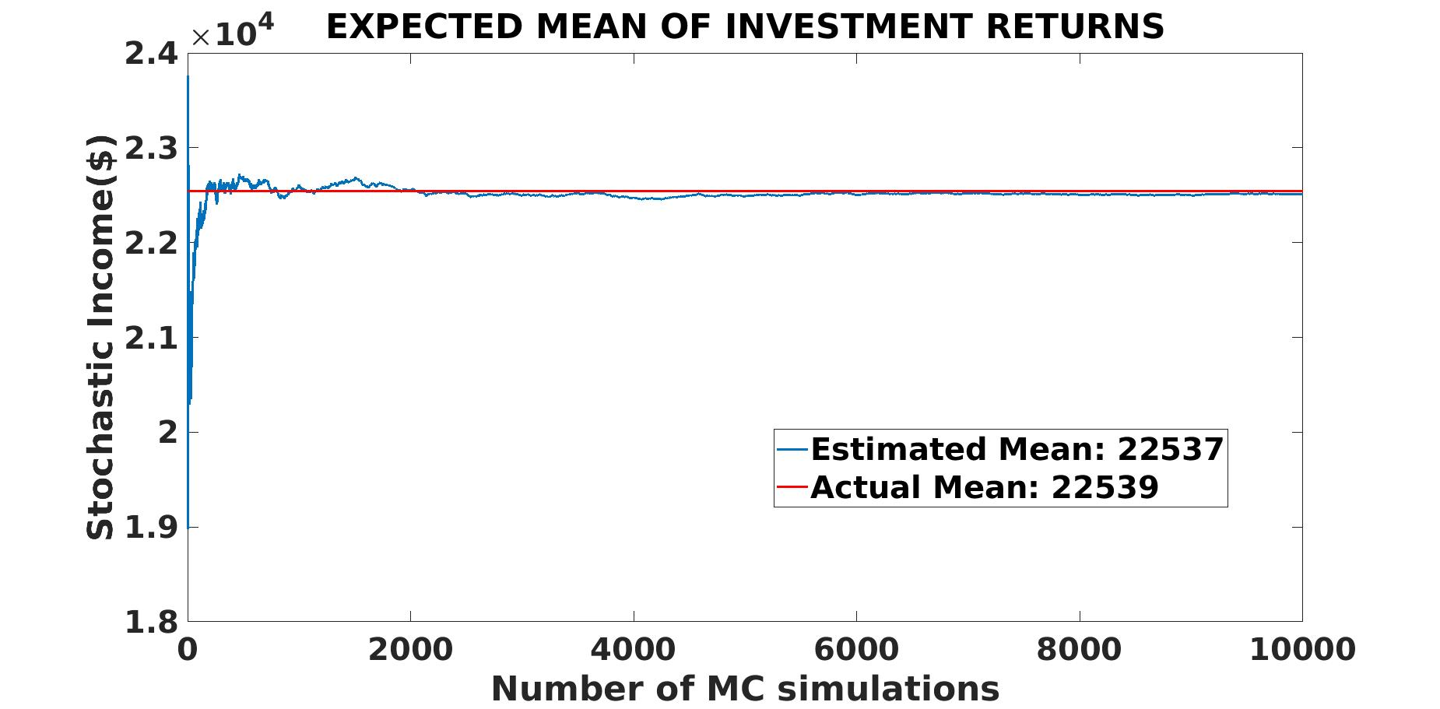

**Figure 1:** Monte Carlo Estimation of the Stochastic Income

**3.2. Implementation of the Dynamic Programming**

The 45-year optimal bequest and consumption policies for a retiree are summarized by Table (2). The amounts shown actually reflect average yearly values in 2023 dollars. These amounts represent consumption, bequests, and income for a retiree within a household, not for a broader population or economic unit. Moreover, the values vary based on the retiree's lump sum, with larger sums resulting in higher amounts.

Now, detailed statistical analysis is carried out on optimal Consumption, bequest, and Income as it is essential for identifying trends, evaluating policies, forecasting future values, understanding economic and social impacts, and making data-driven decisions. This comprehensive analysis ultimately contributes to better financial planning, policy formulation, and economic stability.

3. **Simulations, Analysis and Discussions of Results**

**3.3. Statistical Analysis**

**Table (3)** presents the summary statistics for the optimal consumption policy, optimal bequest policy, and income from ages 60 to 105. The statistics reveal a diverse range of consumption, bequest, and income values among the individuals in the study. These distributions indicate varying financial strategies, priorities, and economic conditions over the 45-year period. Understanding these patterns can help tailor financial advice and policies to better support individuals in managing their consumption, savings, and bequest decisions throughout their later years. From the table, the lowest optimal consumption level is $6,839. This value represents the minimal level of consumption predicted by the model, potentially reflecting a period of highly conservative spending. On the other hand, the highest optimal consumption is $25,729, indicating some outliers or exceptionally high consumption values, which might occur during significant expenditures such as healthcare, travel, or major purchases. The first quartile indicates that 25% of the optimal consumption values are below $10,344, reflecting a lower consumption range where individuals may prioritize bequests over spending.

**Table 2**: Time Series Data for Optimal Consumption, Optimal Bequest, and Income

|  |  |  |  |  |  |  |  |  |  |  |  |
| --- | --- | --- | --- | --- | --- | --- | --- | --- | --- | --- | --- |
| **Year** | **Cons.**  **($/100)** | **Beq.**  **($/100)** | **Income**  **($/100)** | **Year** | **Cons.**  **($/100)** | **Beq.**  **($/100)** | **Income**  **($/100)** | **Year** | **Cons.**  **($/100)** | **Beq.**  **($/100)** | **Income**  **($/100)** |
| 1 | 257.29 | 14.53 | 271.82 | 16 | 80.52 | 64.06 | 144.58 | 31 | 141.51 | 118.28 | 259.79 |
| 2 | 254.48 | 10.52 | 265 | 17 | 150.26 | 139.38 | 289.64 | 32 | 142.71 | 146.41 | 289.11 |
| 3 | 223.28 | 55.99 | 279.27 | 18 | 148.8 | 134.53 | 283.33 | 33 | 114.53 | 93.39 | 207.92 |
| 4 | 157.24 | 107.6 | 264.84 | 19 | 111.25 | 91.98 | 203.23 | 34 | 98.28 | 95.99 | 194.27 |
| 5 | 133.59 | 110.47 | 244.06 | 20 | 160.89 | 135.68 | 296.56 | 35 | 133.07 | 103.54 | 236.61 |
| 6 | 131.61 | 110.42 | 242.03 | 21 | 159.58 | 131.51 | 291.09 | 36 | 118.75 | 89.22 | 207.97 |
| 7 | 74.22 | 52.66 | 126.88 | 22 | 103.44 | 88.18 | 191.61 | 37 | 106.2 | 76.09 | 182.29 |
| 8 | 87.19 | 96.04 | 183.23 | 23 | 72.55 | 60.94 | 133.49 | 38 | 126.41 | 105.89 | 232.29 |
| 9 | 73.7 | 50.47 | 124.17 | 24 | 122.81 | 111.41 | 234.22 | 39 | 109.01 | 85.36 | 194.38 |
| 10 | 96.77 | 79.01 | 175.78 | 25 | 138.65 | 131.67 | 270.31 | 40 | 171.09 | 115.47 | 286.56 |
| 11 | 130.99 | 102.92 | 233.91 | 26 | 135.42 | 101.09 | 236.51 | 41 | 122.81 | 91.09 | 213.91 |
| 12 | 109.01 | 110.1 | 219.11 | 27 | 126.46 | 93.7 | 220.16 | 42 | 104.06 | 74.43 | 178.49 |
| 13 | 68.39 | 60.47 | 128.85 | 28 | 127.86 | 127.34 | 255.21 | 43 | 82.03 | 53.28 | 135.31 |
| 14 | 140.16 | 126.04 | 266.2 | 29 | 96.82 | 94.32 | 191.15 | 44 | 221.82 | 120.83 | 342.66 |
| 15 | 74.01 | 77.6 | 151.61 | 30 | 124.53 | 114.11 | 238.65 | 45 | 222.24 | 102.5 | 324.74 |

The median optimal consumption is $12,641, suggesting that half of the consumption values are below this point, providing a central tendency around which most consumption values are clustered. The third quartile shows that about 75% of the optimal consumption values are below $14,271, indicating that higher consumption levels are less common but still significant. The average (mean) optimal consumption is $13,081, slightly higher than the median, indicating a right-skewed distribution where higher consumption values pull the mean above the median. This skewness may be due to occasional high-spending periods, influenced by larger-than-usual expenses or income changes.

For the optimal bequest policy, the minimum value is $1,052, showing that some individuals leave minimal bequests, possibly due to lower overall income or higher consumption needs. The first quartile value of $7,760, the median of $9,604, and the third quartile value of $11,411 illustrate that most individuals aim to leave a significant portion of their income as bequests. The maximum bequest of $14,641 indicates that some individuals prioritize leaving larger bequests, possibly reflecting personal values or familial responsibilities.

Regarding income, the minimum recorded value is $12,417, while the maximum is $34,266. The first quartile income is $19,115, the median is $23,391, and the third quartile is $26,620. These statistics suggest a broad range of income levels, with a central tendency around the median of $23,391. The mean income of $22,540, slightly lower than the median, indicates a left-skewed distribution, where lower income values pull the average down. This skewness could be due to periods of lower earnings or financial challenges faced by some individuals. Optimal consumption has a variance of $2,110,762, suggesting significant variability in how individuals allocate their consumption. This variability can arise from different personal financial strategies, unexpected expenditures, and income levels. High variance in consumption indicates that individuals face varying economic circumstances or have different preferences and priorities, leading to significant differences in spending behaviour over the studied period.

Also, the optimal bequest variance of $942,864 suggests moderate variability in the amounts individuals choose to leave as bequests. While some prioritize larger bequests, others might allocate less due to higher consumption needs or lower overall wealth. This moderate variance indicates consistency in bequest values, with noticeable differences based on individual financial planning, cultural factors, and familial responsibilities. It reflects the diverse financial goals and priorities regarding leaving a legacy. Lastly, income variance of $3,070,965 indicates substantial variability in income levels. This high variance suggests wide dispersion around the mean, with some individuals having much higher or lower income levels than others. High-income variance could be due to different career paths, employment statuses, investments, pensions, or other income sources. It reflects economic diversity, with some individuals having stable and high incomes while others experience fluctuations or lower income levels.

**Table 3**: Summary Statistics of Optimal Consumption,

Optimal Bequest, and Income

|  |  |  |  |
| --- | --- | --- | --- |
| **Statistic** | **Optimal Consumption** | **Optimal Bequest** | **Income** |
| **Min** | 6839 | 1052 | 1242 |
| **1st Qu.** | 10344 | 7760 | 1911 |
| **Median** | 12641 | 9604 | 2339 |
| **Mean** | 13081 | 9459 | 2254 |
| **3rd Qu.** | 14271 | 11411 | 2662 |
| **Max** | 25729 | 14641 | 3427 |

The Figure (2) analyzes bequest consumption against one’s income over 45 years. It could be observed that income fluctuations with a general increasing trend indicate economic growth or improved financial strategies despite variability. Also, consumption starts high and then stabilizes around a mean with short-term variations, reflecting consistent efforts to balance expenditures with available resources. Bequest values initially increase, then fluctuate significantly, suggesting stable long-term planning but subject to short-term changes due to adaptive financial strategies. Thus, the graph underscores the dynamic relationship between income, consumption, and bequest, highlighting the importance of understanding these patterns for effective financial planning and resource management.

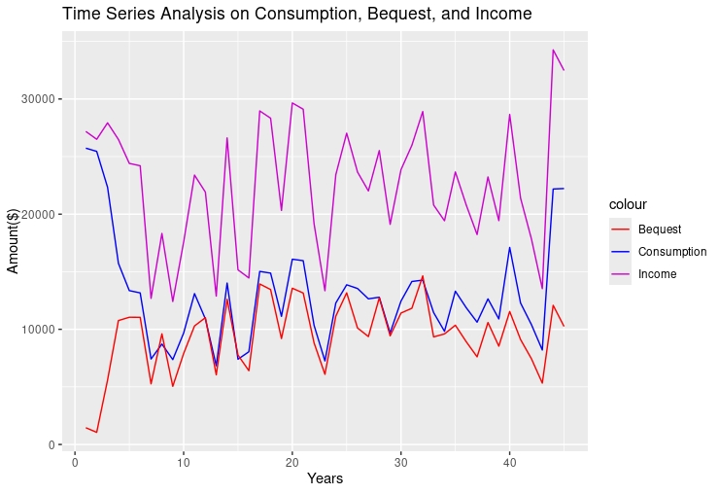

**Figure 2:** Time Series Analysis of the Income, Bequest and the Consumption

Optimal bequest and consumption policies are crucial in informing the survival analysis results depicted in the Kaplan-Meier curve for retirees shown by Figure (3). By strategically balancing immediate financial needs with long term sustainability, these policies help maintain higher initial financial stability and ensure resources last longer.

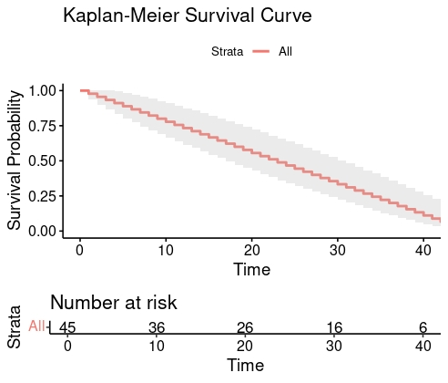

**Figure 3:** Survival Analysis for the Retiree over the 45-year Period

Conservative consumption patterns, diversified investments, and continuous reassessment of financial strategies mitigate risks and adapt to changing conditions, thereby contributing to a gradual decline in survival probability rather than a steep drop. This approach underscores the importance of careful financial planning to sustain retirees’ financial health over time.

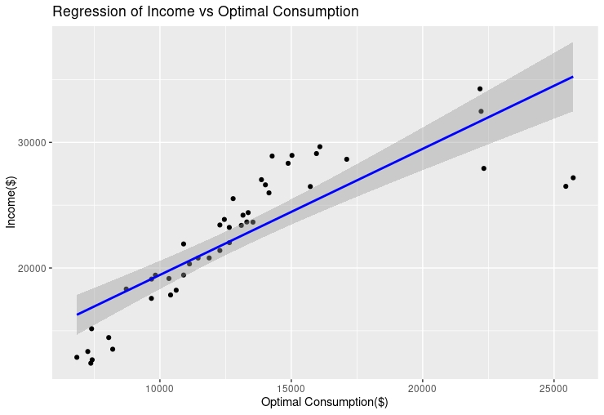

**Figure 4:** Regression of Income on Consumption

The linear regression model has a perfect fit with an R-squared value of 1, indicating that the model explains 100% of the variability in income. The coefficients for optimal Consumption and optimal bequest are 1.000, with minimal standard errors, suggesting that each unit increase in either predictor results in an equivalent unit increase in income. The residuals are nearly zero, further confirming the excellent fit of the model. The t-values for both predictors are extraordinarily high, and their p-values are less than , indicating that they are highly significant. The F-statistic is also extremely high, reinforcing the model’s significance. This shows a strong linear dependency between income, optimal Consumption, and optimal bequest. These are depicted by Figures (4) and (5).

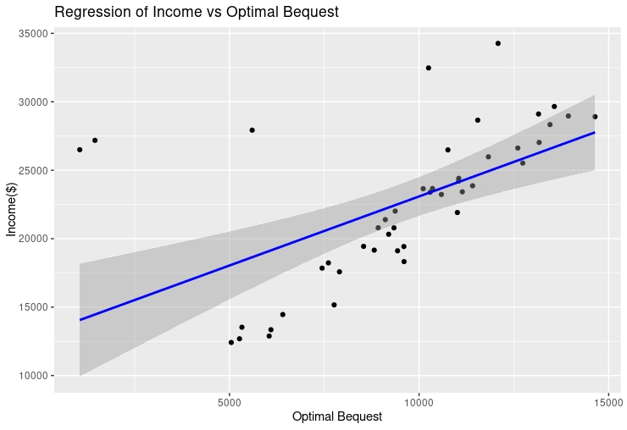

**Figure 5:** Regression of Income on Bequest

4. Conclusion

In this paper, a robust Monte Carlo-based Dynamic Programming approach was developed to optimize consumption and bequest policies for retirees over 45 years, addressing the stochastic nature of retirement income. The simulations effectively modeled income variability from risky investments, demonstrating the benefits of incorporating stochastic elements into retirement planning. The dynamic programming approach accurately identified the optimal consumption and bequest strategies, with statistical analyses revealing significant variability in income, consumption, and bequest levels. This underscores the importance of a unified framework that integrates both consumption and bequest optimization, enabling more accurate and personalized financial strategies in the face of uncertain income conditions. The study's findings also highlighted the strong dependency of optimal consumption and bequest decisions on income levels, emphasizing the need for personalized financial strategies. Additionally, the Kaplan-Meier survival analysis underscored the critical role of strategic financial planning, including conservative consumption, diversified investments, and continuous reassessment, in maintaining economic stability for retirees. This paper reinforces the importance of advanced computational techniques in enhancing the effectiveness of retirement planning amidst increasing financial market complexities. However, the model presented in this study has notable limitations. First, it excludes factors such as long-term care costs, which are significant in regions with high healthcare expenses. Incorporating these costs would improve the model’s applicability and accuracy, especially for retirees facing substantial healthcare expenses. Second, while the model provides a robust theoretical framework for optimal behavior, real-world behaviors may diverge from these predictions. Empirical studies by Hurd et al. (2013) and Jones et al. (2016) have highlighted discrepancies between theoretical expectations and actual retirement behaviors, driven by factors such as unexpected health shocks, economic changes, and variations in bequest motives and consumption preferences. This suggests that future research could benefit from incorporating these real-world complexities to refine the model and enhance its practical relevance.

Competing interests

We the authors declare that we have no sort of competing interest related to the work presented in this article. We confirm that we have disclose all relevant information in accordance with the guidelines set by the journal. We assure that the findings presented in this work are unbiased and solely reflect our professional and academic perspective.

References

Abubakar, A., Borkor, R.N., Amoako-Yirenkyi, P., 2023. Stochastic optimal selection and analysis of allowable photovoltaic penetration level for grid-connected systems using a hybrid nsgaii-mopso and monte carlo method. International Journal of Photoenergy 2023, 5015315.

Alonso-Carrera, J., Bouche, S., 2024. Intergenerational transmission of preferences and the operativeness of bequest motive. Journal of Money, Credit and Banking 56, 899–932.

Anderson, J., Heckman, S., Furlong, J., 2024. Altruistic bequests: Giving motive and receipt expectation using the 2019 survey of consumer finances. Financial Services Review: The Journal of Individual Financial Management 32, 29–46.

Arandjelovic, A., Kingston, G., Shevchenko, P.V., 2023a. Life cycle insurance, bequest motives and annuity loads. Journal of Economic Dynamics´ and Control 157, 104759.

Arandjelovic, A., Kingston, G., Shevchenko, P.V., 2023b. Life cycle insurance, bequest motives and annuity loads. Journal of Economic Dynamics´ and Control 157, 104759.

Arandjelovic, A., Kingston, G., Shevchenko, P.V., 2023c. Life cycle insurance, bequest motives and annuity loads. Journal of Economic Dynamics´ and Control 157, 104759.

Bernheim, B.D., 1991. How strong are bequest motives? evidence based on estimates of the demand for life insurance and annuities. Journal of political Economy 99, 899–927.

Brown, J.R., 1999. Retirement income, bequests, and insurance: implications of mortality risk in a stochastic life cycle model. Ph.D. thesis. Massachusetts Institute of Technology.

Chen, S., Luo, D., Yao, H., 2024. Optimal investor life cycle decisions with time-inconsistent preferences. Journal of Banking & Finance 161, 107115.

Dagpunar, J., 2021. Closed-form solutions for an explicit modern ideal tontine with bequest motive. Insurance: Mathematics and Economics 100, 261–273.

Das, S.R., Ostrov, D., Radhakrishnan, A., Srivastav, D., 2023. Lifestyle, longevity, and legacy risks with annuities in retirement portfolio decumulation. The Journal of Wealth Management.

Dynan, K.E., Skinner, J., Zeldes, S.P., 2002. The importance of bequests and life-cycle saving in capital accumulation: A new answer. American Economic Review 92, 274–278.

Fisher, P.J., 2010. Income uncertainty and household saving in the United States. Family and Consumer Sciences Research Journal 39, 57–74.

Friedler, L.M., 1986. Actuarial mathematics. by newton l. bowers, jr., hans u. gerber, james c. hickman, donald a. jones, cecil j. nesbitt. The American Mathematical Monthly 93, 489–491.

Gaziolu, S¸., Bastıyalı-Hayfavi, A., 2010. Stochastic optimization applied to self-financing portfolio: does bequest matter? Applied Economics 42, 3831–3838.

Han, W., Wang, P., Dong, H., 2020. Influence of egoistic and altruistic bequest motives on the willingness to participate in reverse mortgages in china. Asian Economic Journal 34, 430–463.

He, L., Liang, Z., 2017. Optimal pension decision under heterogeneous health statuses and bequest motives. Journal of Industrial & Management Optimization 13, 1641.

He, Z., Zhang, Q., Pan, Y., 2024. Bequest motives in the housing wealth effect: A new perspective from china. Cities 146, 104771.

Hurd, M.D., Smith, J.P., 2002. Expected bequests and their distribution.

Kraft, H., Munk, C., Weiss, F., 2022. Bequest motives in consumption-portfolio decisions with recursive utility. Journal of Banking & Finance 138, 106428.

Laitner, J., 2002. Wealth inequality and altruistic bequests. American Economic Review 92, 270–273.

Lee, S., Tan, K.T., 2023. Bequest motives and the social security notch. Review of Economic Dynamics 51, 888–914.

Lockwood, L.M., 2018. Incidental bequests and the choice to self-insure late-life risks. American Economic Review 108, 2513–2550.

Merton, R.C., 1969. Lifetime portfolio selection under uncertainty: The continuous-time case. The review of Economics and Statistics , 247–257.

Neumann, B.A., Scheuer, N., 2024. The impact of bequest taxation on wealth inequality: Theory and evidence. Technical Report. Research Papers in Economics.

Pagnoncelli, B.K., Homem-de Mello, T., Lagos, G., Castañeda, P., García, J., 2024. Solving constrained consumption-investment problems by decomposition algorithms. European Journal of Operational Research .

Shaffie, S.S., Jaaman, S.H., 2016. Monte carlo on net present value for capital investment in malaysia. Procedia-Social and Behavioral Sciences 219, 688–693.

Van Rymenant, P., 2023. Bequests and the estate tax. a review of theory and (new) evidence. A Review of Theory and (New) Evidence .

Xu, L., Fan, K., Wang, M., Yao, D., 2024. Optimal investment and reinsurance to reach a bequest goal with random time solvency regulation. International Journal of Control, 1–13.

Yaari, M.E., 1964. On the consumer’s lifetime allocation process. International Economic Review 5, 304–317.

Yang, X., Gan, L., 2020. Bequest motive, household portfolio choice, and wealth inequality in urban china. China Economic Review 60, 101399.

APPENDIX

A.1: Derivation of the monthly income from the risky investment:

 (XIII)

where:  is the initial investment capital from the lump sum,  Cash inflows at time  and  is the Discount rate. Rewritten, the Equation (8) becomes:

 (XIV)

where  represent the varying monthly cash inflows for different years. Assume that the cash inflows grow at a random rate each month. Then, the monthly cash inflows can be expressed as:

January:  (initial cash inflow)

February: 

March: 



December: 

**Thus:**



**A.2: The Monte Carlo Simulation**

This is typically done by approximating the high-dimensional integrals involved in the problem through sampling  scenarios, where each scenario is characterized by realizations  and associated probabilities . This approximation boils down the integral into a sum, making the problem more tractable. Therefore, in this study we generate  samples  for each  from the distribution of the random income  and the expected utility is approximated by the sample average: (XV)

The resulting deterministic problem is:

 (XVI)

Subject to:

 (XVII)

|  |
| --- |
| **Algorithm 1**: Optimal Bequest-Consumption Strategy Using Dynamic Programming and Monte Carlo Simulation |
| **Require**: Initial wealth , number of time periods , number of scenarios , utility function , discount factor , risk aversion parameter  Ensure: Optimal consumption strategy  and optimal bequest   1. **Initialization:**   Set initial wealth  time periods , and number of scenarios  Define the utility functions  and  Initialize the terminal value function     1. **Scenario Generation:** 2. f**or** each scenario  do 3. Generate a sequence of random returns  for income  using a probability distribution 4. **end for** 5. **Backward Induction:** 6. **for** time  down to 1 **do** 7. **for** each scenario  **do** 8. Compute the wealth update 9. Evaluate the value function  using the Bellman equation:      1. Store the optimal consumption  and bequest  for each scenario 2. **end for** 3. **end for** 4. **Output:** 5. Return the optimal consumption strategy  and bequest  over the time periods. |