Journal Name: | Journal of Advances in Microbiology
Manuscript Number: | Ms_JAMB_140408
Title of the Manuscript: | Effect of salinity on hyphal growth and antimicrobial metabolite production in two halophilic fungi
Type of the Article

PART 1: Comments

 | Reviewer’s comment  Artificial Intelligence (AI) generated or assisted review comments are strictly prohibited during peer review. | Author’s Feedback (It is mandatory that authors should write his/her feedback here)
Please write a few sentences regarding the importance of this manuscript for the scientific community. A minimum of 3-4 sentences may be required for this part. | The growth, antimicrobial activity, and chemical profile of two halophilic fungal strains, Fusarium oxysporum RAS2 and Aspergillus niger RAS3 have been studied. For the chemical profiling of the metabolites, IR spectra have been carried out of the raw extracts. (The general target of the research is interesting and worthwhile)
Is the title of the article suitable?  (If not please suggest an alternative title) | As discussed below, the antimicrobial metabolite production is not adequately discussed. This part needs to be re-done or deleted from the title.
Is the abstract of the article comprehensive? Do you suggest the addition (or deletion) of some points in this section? Please write your suggestions here. | The abstract is comprehensive. “FTIR analysis revealed the presence of functional groups including alcohols, phenols, ketones, and amines, which are known to contribute to antimicrobial activity” – the experiments should be redone or this sentence should be deleted from the abstract as should be the term “chemical profile”..
Is the manuscript scientifically, correct? Please write here. | As the screening of secondary metabolites, which is an important part of the manuscript, is not done correctly. Infrared spectra of mixtures will not help here. It is advised to carry out GC/MS spectrometric analysis. In fact, the two IR spectra depict water/moisture in A and ethyl acetate in B. So, all sections to do with the discussion of secondary metabolites need to be re-done or deleted. This includes the deletion of Tables 6 and 7 and Figure 2.  This is the spectrum for water/moisture (for comparison)  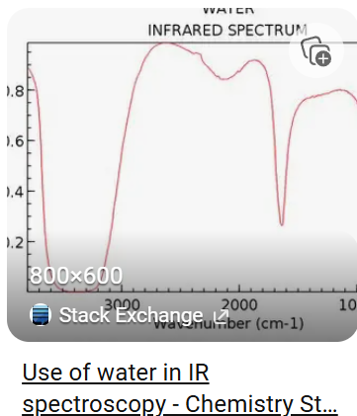  and ethyl acetate in B.  This is to compare with spectrum B. Ethyl acetate was used as a solvent for the extracts.  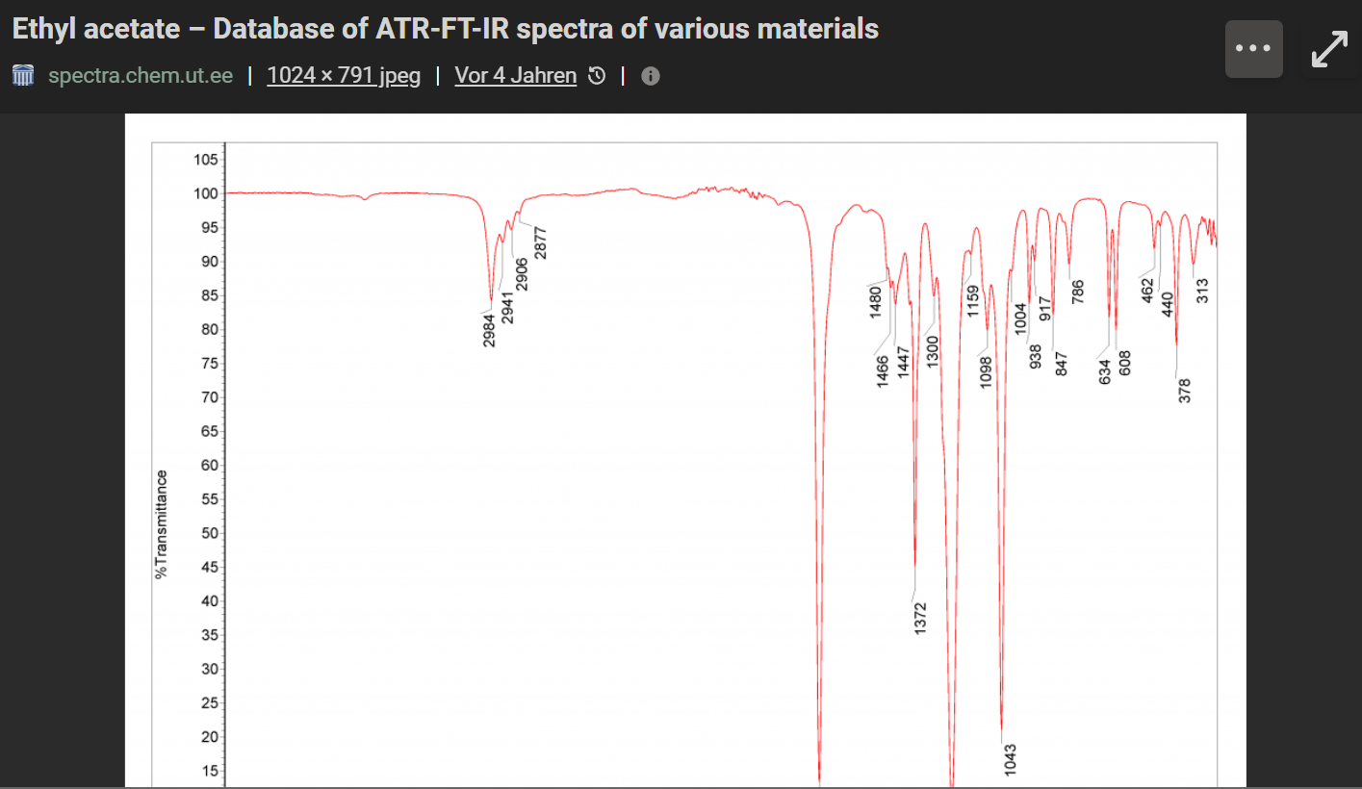
Are the references sufficient and recent? If you have suggestions of additional references, please mention them in the review form. | There are quite a few references for the size of the article. Some of the references can be deleted.
Is the language/English quality of the article suitable for scholarly communications? | The English can be readily understood.
Optional/General comments | It is strongly suggested that the extracts are subjected to GC/MS analysis (instead of using IR spectroscopy).

PART 2:

 | Reviewer’s comment | Author’s comment (if agreed with reviewer, correct the manuscript and highlight that part in the manuscript. It is mandatory that authors should write his/her feedback here)
Are there ethical issues in this manuscript? | (If yes, Kindly please write down the ethical issues here in details)

Reviewer details:

Thies Thiemann, Germany

