**Disease and pest management in mushroom farming: A comprehensive review**

**ABSTRACT**

Mushroom cultivation, particularly for edible species like button, oyster, and shiitake mushrooms, is an increasingly popular agricultural practice globally, valued for its high nutritional content and economic significance. The productivity of mushrooms is seriously threatened by pests and diseases, which can result in large financial losses. Pests related to fungi, bacteria, viruses, and insects, such as Trichoderma, Pseudomonas, and sciarid flies, can negatively impact the growth of mushrooms by harming the mycelium and fruiting bodies. In order to effectively manage these pests, a variety of techniques have been employed, including chemical treatments, biological agents, and mechanical controls. A more sustainable and eco-friendly alternative is provided by the integrated pest management (IPM) strategy, which blends cultural, biological, physical, and chemical tactics. With an emphasis on button and oyster mushrooms, this paper compiles the most recent research on managing pests and diseases in mushroom growing. It highlights how crucial IPM is to attaining sustainable pest management, lowering reliance on chemicals, and increasing mushroom production. The assessment also looks at new methods and potential lines of inquiry for bettering disease and pest control in mushroom farming.

**Keywords-** Mushroom cultivation, Integrated Pest Management (IPM), Pest control Sustainable agriculture, Fungal pathogens.

**INTRODUCTION**

Now a day, growing mushrooms as an edible fungus is becoming more and more popular worldwide. Like agriculture and horticulture crops, mushrooms are seen as significant crops that can be consumed either fresh or processed, especially in cans more than dozen types of edible mushrooms are cultivated worldwide. Growing mushrooms has a connection to converting agricultural and agro industrial waste into food with significant nutritional value and economic significance. Significant period is posed by pest infestations of various kinds. A number of insect pests that frequently result in large crop losses are more likely to affect mushrooms. Several pest infestation poses serious risks to the mushroom crop while it is being grown. A fast expending sector of the world economy is mushroom farming, mainly the production of edible species like Oyster mushroom, Button mushroom, and Shiitake. The mushrooms demand because of their nutritional value which includes a high protein content, vitamins, and minerals as well as their use in both culinary and therapeutic contexts (Sharma & Kumar, 2020). Numerous pests and disease have a substantial impact on the productivity and profitability of mushroom farms, even with the growing market. These challenges might result in significant financial losses in addition to lowering productivity particularly in regions where mushroom farming is the main agricultural activity (Khan et al., 2021). Pests and diseases that affects mushrooms growth are diverse (Alam et al., 2019). And it can be categorized into fungal, bacterial, viral, and insect-related threats. The most frequent culprits that impede the healthy growth of mushrooms by causing mycelial growth inhibition and fruiting body illnesses are fungi, including *Trichoderma spp.*, *Verticillium spp.*, and *Fusarium spp.*, (Pérez et al., 2022). Discoloration or Soft rot in the mushroom tissue are common symptoms of bacterial infections caused by *Pseudomonas spp.* and other bacteria often manifest as (Yadav et al., 2018). Furthermore, insect pests like sciarid flies (*Sciara spp.*) and mushroom mites (*Tyrophagus putrescentiae*) are notorious for destroying mushroom crops by feeding on the fruiting bodies and mycelium, creating an environment that allows infections to proliferate (Bukhari et al., 2020). Mushroom farmers rely on various management techniques and strategies to mitigate the impact of these pests and diseases which include biological control agents such as beneficial fungus and predatory mites, traditional chemical treatments, biological control agents (e.g., predatory mites, beneficial fungi), and integrated pest management (IPM) strategies that combine cultural practices, environmental and biological controls (Anderson et al., 2017). In mushroom cultivation, the use of chemical pesticides is often limited, because chemicals can adversely affect the growth of the mushrooms and the health of workers (Chattopadhyay et al., 2020). Recent advancement of environment friendly and effective pest management techniques, including the utilization of microbial biocontrol agents, have drawn attention as potential solutions to these challenges (Hamid et al., 2021; Kaundal et al., 2024). Controlling a number of pest therefore crucial for the farms maximum mushroom harvest. It is important to note that using the Integrated Pest Management (IPM) strategy to manage pest in mushrooms increases their effectiveness and efficiency. In IPM, biological pest control method is an important method for the ecological pest management approach in mushroom cultivation because of its no or very less side effects. In biological method of pest control, pests related to the mushrooms are managed by using the natural anti- pest properties of wasps, nematodes and bacteria. Infestation of pathogen and pests at various stages of mushroom farming- some important susceptibility stages emerge during the mushroom’s growth, making it more vulnerable to attack by various pests and diseases. The aim of present study is to consolidate current knowledge on pest and disease management in mushroom farming with special reference to button mushroom and oyster mushroom, with an emphasis on integrated approaches that support sustainability. In the following sections, we will also discuss key pests and diseases affecting mushroom crops, management strategies, and highlight innovative solutions being explored in the field.

**Pests and Disease of Button Mushrooms**-

|  |  |  |  |  |  |
| --- | --- | --- | --- | --- | --- |
| **S. No.** | **Disease Name** | **Causative Agent** | **Symptoms** | **Prevention and Control Measure** | **References** |
| **1-** | **Fungal Disease-**  Dry bubble | Lecanicillium fungicola or Verticillium fungicola | Muddy brown, sunken spot on mushroom cap & greyish, white mouldy growth seen on cap. Typical onion shaped mushrooms are produced, if infection occurs in the early stage. | **Mechanical control**- Proper pasteurization of casing material and compost.  **Chemical control-** Dithane Z-78, Sporagon, Topsin M may be sprayed. | Kumar et. al, (2014), Singh et. al., (2024) |
| **2-** | **Fungal Disease- Cobweb** | Cladobotryum dendroides, Dactylium dendroides. | The disease’s initial symptoms are tiny, round patches of grey mycelium on the casing surface. As it progress, a fluffy white mycelium covers the mushroom and appears like cotton balls. Later, turns brown, start to rot, and die off. | Sterilizing the casing mixture. Routine cleaning, removing dead, cut stems & regulating humidity & temperature. Apply 1gm Benomyl in 0.5-1 litre of water/m2. | (Sharma, 1994), (Munshi et. al., 2010), |
| **3-** | **Fungal Disease-**  Wet bubble | Mycogoneperniciosa | Mycelial development on fruiting bodies. Covers the entire cap with it. Eventually, Sporophores turned into a soft whitish and odorous mass. The formation of a deformed mass of mushroom tissue known as “sclerodamoid mass” which starts off white fluffy & before turning brown & eventually decomposing. | Sterilized casing soil should be used in conjunction with strict hygiene guidelines. Spray benomyl (0.5 gm2) right after casing. Applying a 0.8% formalin spray to the casing surface effectively prevent wet bubble illness. | (Munshi et. al., 2010), (Gupta et. al., 2018) |
| **4-** | **Fungal Disease**  Green mould | Tricoderma viride, T. hamatum, T. harzianum, T.koningii, Penicillium cyclopium, Aspergillus spp, | On casing surface or in compost pure white growth of mycelium appears. Later on mycelium may turns into green colour due to the heavy sporulation of causative agent. | High humidity in the mushroom houses & incorrectly pasteurized compost are conductive to fungus growth, so humidity level should be kept stable. Using formalin not more than 2%. **Chemical control**- Zinebdust, or calcium hypochlorite (15%) treatment. | (Gupta et. al., 2018) |
| **5-** | **False Truffle disease** | Pseudobalsamia microspore, Diehlimyces microspore | Fruiting body appears round, wrinkled, cream coloured. The mushroom on top of casing soil and in the bed are tiny. When fully grown, these bodies release spores and turn reddish brown. | Steer clear of temperature above (270C) during the spawn- run & after casing. Take out the impacted truffles. On afflicted areas, apply 2% formaldehyde solution. | (Munshi et. al., 2010) |
| **6-** | **Bacterial Blotch** | Pseudomonas talaasii | Initially lesions are tiny, and covered a large portion of the pileus before gradually decomposing and developing an unpleasant odor. | Bacteria cannot spread to the developing sporophores if the humidity is lowered to 80% & fans are turned on right away after watering to dry the caps. Apply bleaching powder 100 ppm to the beds. | (Gupta et. al., 2018) |
| 7- | **Pest Diseases-** flies | Megaselia halterata (Sciarid flies) and Megaselia tamilnodolensis (Phorid flies), Cecid flies | Lay eggs on mushrooms, larva emerging from damaged crop & consume mycelium, infiltrate fruiting bodies, & render them unfit for human consumption. | Use a nylon or wire net to screen the doors, windows and ventilators to prevent adult flies from entering. Apply fly repellent or a fly trap. | Gupta et.al., (2018), |
| **8-** | Nematodes disease | Ditylenchus mycelophagus | Nematodes infestation is more severe in button mushroom. | Maintain hygienic condition in mushroom room | Gupta et.al., (2018), Singh et. al., (2024) |

**Table 1**- Disease, symptoms and pests of button mushrooms with their causative agents and management practices

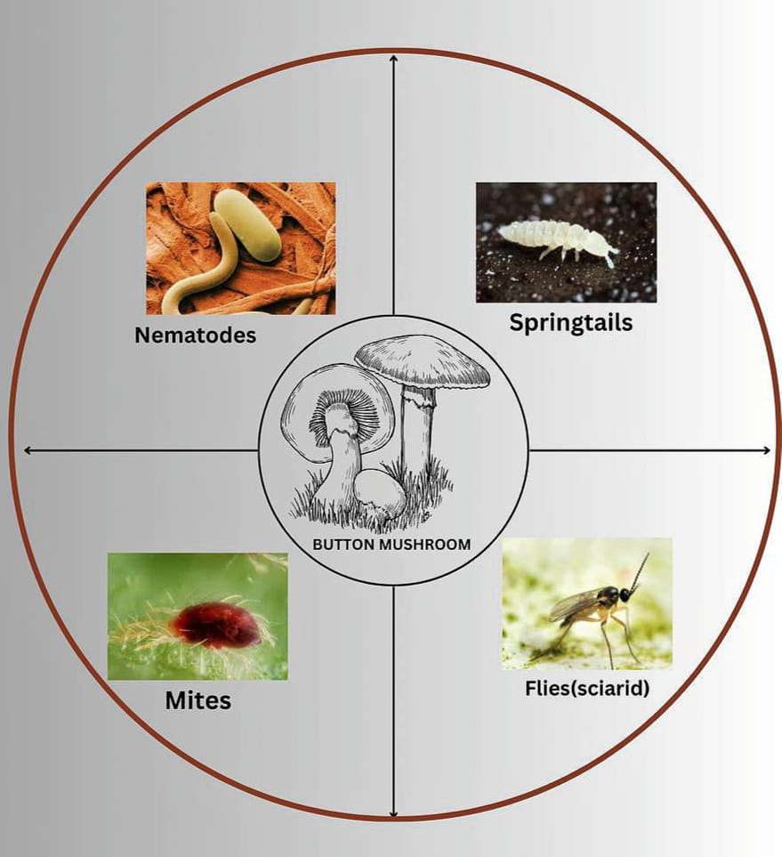

**Fig.1- Pest affecting button mushrooms**

**Pests and Disease Affecting Oyster Mushrooms-**

According to Moreira et.al, (2010), Oyster mushroom crop are vulnerable to a number of illnesses brought on by microorganisms, rival moulds, and insect pests. Up to 100% of the yield may be lost due to bug, fly, and midge infestations that injure the fruiting bodies and mycelia of the mushrooms (Kumar and Sharma, 2005). One of the significant families of insect pests are Coleopteran beetles, whose adults consume the succulent tissues of stripe, gills, and pileus as well as mushroom mycelia. In different regions of India, some other beetles spp. recorded, like Kerala’s Stahylinus sp., Chandigarh’s Cyllodeswhiteii and Himachal Pradesh’s two additional Histeridae and Languiriidae beetles (Kumar and Sharma, 2005). Disease and Pests that affects oyster mushrooms are as follows-

|  |  |  |  |  |  |
| --- | --- | --- | --- | --- | --- |
| **S. No.** | **Disease Name** | **Causative Agent** | **Symptoms** | **Prevention and Control Measure** | **References** |
| **1-** | Dry bubble | Lecanicillium fungicola or Verticillium fungicola | Muddy brown, sunken spot on mushroom cap & greyish, white mouldy growth seen on cap. Typical onion shaped mushrooms are produced, if infection occurs in the early stage. | **Mechanical control**- includes controlling insect vectors like flies, mites and nematodes, as well as properly pasteurizing casing material & compost.  **Chemical control-** Dithane Z-78, Sporagon, Topsin M may be sprayed. | Kumar et. al, (2014), Singh et. al., (2024) |
| 2 | Soft mildew | Cladobotryum dendroides | A fine grey-white mycelium on the casing soil causes little white patches that infect the closest mushroom. The stipe, pileus and gills are covered in a floccose white mycelium, which ultimately causes the entire fruit body to decompose. Mycelium becomes pigmented as the infection progresses finally taking on a delicate pink covering. | Mushroom house needs to have adequate ventilation & be kept free of excessive dampness.  **Chemical control-** Apply Bavistin + TMTD, then TBZ and Benlate. 0.2% Di-ethane [Z-78](mailto:Z-78@0.2%25). Before beginning a new crop, clean the mushroom house with formalin solution. | Aminuzzaman et.al., (2022) |
| 3- | Inky Cap | Coprinus lagopus and Coprinus comatus | Appearance of long thin hat. Black inky liquids dissolve off the thin slender stalk. Ink cap show up outside the manure piles and in the compost during spawn run or freshly cased beds. | The only recommended control measure is to remove Coprinus from the cube. Compost trays need to have ammonia removed. After 2hours of Re- pasteurization at 600C, the spawn trays were Re-spawned and re-cased. | Aminuzzaman et.al., (2022), Singh et. al., (2024) |
| 4. | Sepedonium yellow mould | Sepedonium chrysoporium | The first sign of yellow moulds sickness are yellow brown corky mycelium on the compost and casing interphase, which has a strong metallic odor akin to carbide. | The only way to stop this mould is to keep hygienic condition and ensure that the air is properly filtered. | Aminuzzaman et.al., (2022), Singh et. al., (2024) |
| 5- | Pink mould | Cephalothecum roseum | On the casing soil, it first manifests white growth at an earlier level of contamination before turning turns pink. | To maintain hygienic condition | Francisco and Maria, (2017), Aminuzzaman et.al., (2022) |
| 6- | Green mould | Tricoderma viride, T. hamatum, T. harzianum, T.koningii, Penicillium cyclopium, Aspergillus spp, | On casing surface or in compost pure white growth of mycelium appears. Later on mycelium may turns into green colour due to the heavy sporulation of causative agent. | High humidity and incorrectly pasteurized compost are conductive to fungus growth, so humidity level should be kept stable. Using formalin not more than 2%.  **Chemical control**- Apply Zinebdust, or calcium hypochlorite, Mancozeb or Bavistin TBZ | Gupta et.al., (2018), |
| 7- | Soft rot | Pantoea sp. | The pileus and stipes of the mushroom develop a tiny, water soaked lesion with dark, pus like patches. In 7-14 days, the lesion gradually enlarges, thickens, and turns discoloured. Later on, infected area develops soft rot, turns mushy, and smells bed. | Sterilization, proper hygiene & care throughout production period. Chlorine treatment lowers infection without compromising production. Use of Calcium hypochlorite solutions with 175ppm active chlorine lowers the illness. | (Kim et. al, 2015) |

Table 2**-** Disease, symptoms and pests of oyster mushrooms with their causative agents and management practices

|  |  |  |  |  |
| --- | --- | --- | --- | --- |
| **S. No.** | **Pests** | **Symptoms** | **Prevention and Control Measure** | **References** |
| **1-** | **Fungi** | Fungus directly harm shiitake & provide unfavourable/ inhospitable conditions to shiitake such as drying the log. | Inoculate the logs. Make sure the logs are shaded and there is enough ventilation and drainage. Logs should be kept off the ground & away from any potential source of contamination. Remove logs from the site that have a significant fungal infection. | Greg (2019) |
| **2-** | **Termites** | Although they typically pose no threat, they only ruin logs. | Use pallets or another method to keep logs off the ground. | Greg (2019) |
| **3-** | **Beetles** | Certain beetle species may inflict harm, by introducing other fungus or excavating beneath the bark during their larval stage. The shiitake will dry out and die if the bark falls of the log. | To prevent beetles from depositing their eggs on the logs, cover them with a net. | Greg (2019) |
| **4-** | **Soldier Beetles** | These little insects are visible in the mushrooms bottom gills, instead of damaging mushroom, they consume microscopic mites that are invisible to the human eye. | While the caps are still round harvest the mushrooms as soon as possible. A hair dryer can be used to remove the insects from the mushroom after they have been harvested. | Greg (2019) |
| **5-** | **Snail and Slugs** | In moist weather, snails and slugs pose a major threat. | Harvest the mushrooms as soon as possible. Remove any area that snail, slugs might use for food shelter, & reproduction, such as decaying wood, abandoned objects like boxes & flats & dead plant matter. Use lettuce or cabbage leaves to decoy and capture snails, then remove quickly. Slug & snail can be repelled with wood ash and lime. | Greg (2019) |
| **6-** | **Mammals (rabbit, mice, squirrels, deer)** | There have been reports of both domestic & wild animals consuming shiitake. | A range of methods, such as repellents or barriers like wire screens or fences, may work well. Gather mushrooms as soon as possible. | Greg (2019) |

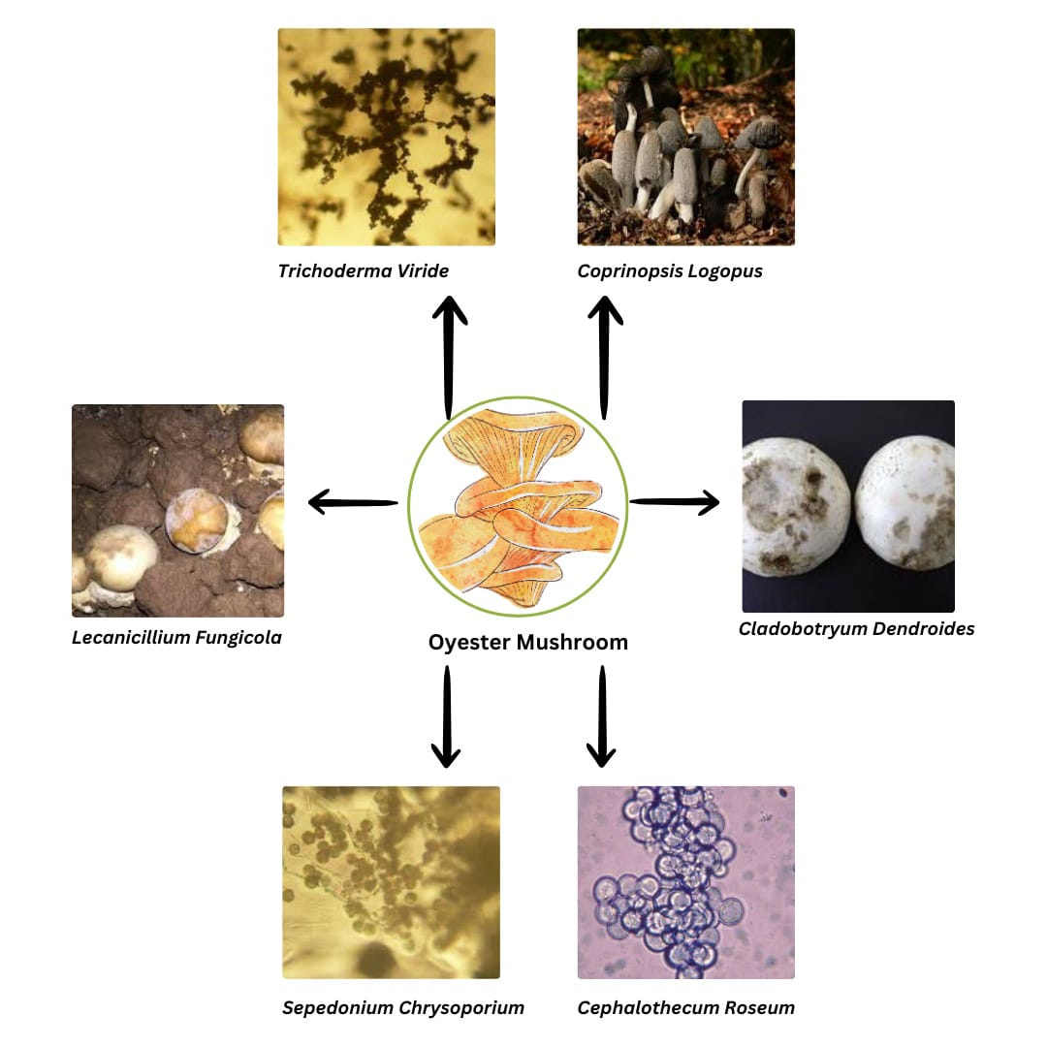

**Fig.2- Pest affecting oyster mushrooms**

**Pests and Disease Affecting Shiitake Mushrooms**

The cultivation of shiitake mushrooms is frequently linked to certain pests. Thankfully, there aren’t many pests that pose a significant threat. Other fungi that impact the wood and shiitake mycelia may be the main source of the shiitake problem. Pests typically don’t have much time to cause significant damage to real mushroom because the fruiting bodies on the log grow quickly and should be removed before the mushroom caps flatten out. According to Bak and Kwon (2005), the following are some pests.

**Table 3** Disease, symptoms and pests of shiitake mushrooms with their causative agents and management practices.

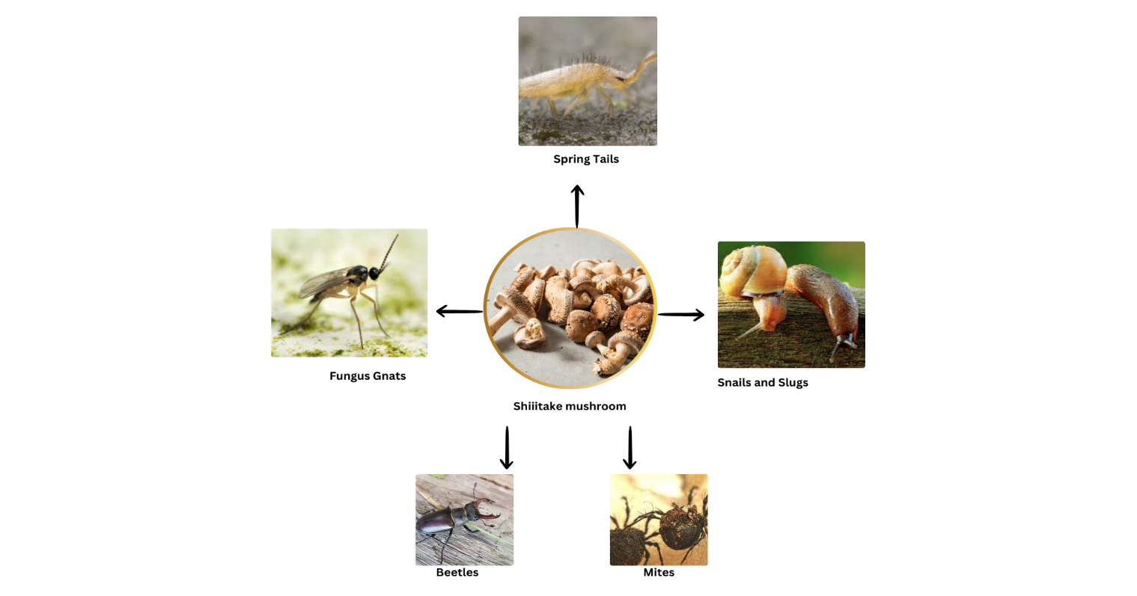

**Fig.3- Pest affecting shiitake mushrooms**

**IPM in Mushroom Farming**-

IPM is an environment friendly approach that includes physical, cultural, chemical and biological processes to control different pests based on ecological principles and knowledge. It is important to note that using Integrated Pest Management (IPM) strategy to manage pest in mushrooms increasing their effectiveness and efficiency. Sanitation, exclusion, monitoring and pest control are four primary components of IPM (Shamshad, 2010). IPM helps to regulate the environment in which pest live and develop. Preventing pest attacks on mushrooms and making it more successful, well liked, popular and efficient pest control method. Additionally, it promotes the growers of mushrooms to use fewer artificial pesticides. Because of these advantages, the IPM technique is the most effective and sensible strategy for long term, sustainable pest management (Coles, 2002). Thus, reducing the negative consequences of mushroom flies and other pests require an effective IPM plan (Rinker 2017).

**MANAGEMENT METHODS-**

**Physical Methods**-

**Hygiene and Sanitation**- The main strategy for controlling pest in mushroom farming is hygiene. It serves as the cornerstone upon which all other control strategies rely for success. Any hygiene program’s goals are to remove diseases and pests from the production cycle, getting rid of pathogens and pests. And eliminating any disease and pest that remain in a crop as it nears the end of its life. The goal of sanitation is to eradicate or destroy pests. A good hygiene technique is to routinely remove stumps from the room where the crop is being grown. Sanitary procedures are intended to eliminate serious crop hazards in addition to mushroom pests.

**Screening of Ventilators and Doors**- Mushroom flies can readily pass through regular wire screens and enters the mushroom house to breed on the compost and spawned mushroom beds. Using nylon net with a mesh size of 35 or greater to screen doorways and ventilators can effectively prevent flies from entering the crop.

**Lamp traps**- To manage adult flies, each cropping room has a fluorescent strip lamp attached to coated polythene sheets. Insects are drawn to yellow light at lower temperatures and to white light at 15℃.

**Poison Baiting**- In cropping rooms, poison baiting with baygon diluted with water and a small amount of sugar is an efficient way to keep flies away.

**Cookout** –The most extensively contaminated part of a farm is where the oldest crops are scheduled to be terminated. The most crucial phase in any effective management program is the elimination of pests that are accumulated within these crops. All stages of pest and pathogen are successfully killed at a temperature of 71℃ maintained for 2-3 hours.

**Disposal of Spent Compost**- Insects, mites and nematodes are present in the spent compost and casing material. It becomes a perfect substrate for pest reproduction when the spent compost and casing material are disposed in dump, shaded areas. To prevent the fly breeding, place this material in the compost pit and cover it with a layer of manure that is at least 10 cm deep.

**Getting Rid of Leftover Compost**- Insects, mites and nematodes are found in the casing material and discarded compost. It becomes the perfect substrate for pest reproduction when the spent compost and casing material are disposed of in damp, shaded areas. To prevents the fly breeding, this material should be placed in the compost pit and covered it with 10 cm deep manure layer.

**Chemical Techniques**-

In cropping rooms where mushroom flies are detected, ULV should spray 30 ml of Nuvan 76 EC at 22.5g.a.i./100m3 (<http://agridaksh.iasri.res.in>). After the spraying, shut the door and ventilators for two hours. Steer clear of spraying mushroom beds directly. Keep track of the 48-hour gap between mushroom spraying and harvesting. Permethrin dust can be applied to kill flies without leaving any residue. Seven days after casing, beds can also be sprayed with malathion. Pyrethrum, administered as smoke or aerosol effectively controls larvae and adults. Adults are successfully checked by spraying cypermethrin and fenvalerate on the floors, on the walls, and corridors.

**Cultural Method**-

It is one of the most important methods of IPM, which covers any crop production adjustment that lowers the pest population below the Economic Threshold Level ETL. According to Schlellhorn et, al., (2000), the cultural method of pest control involves intentionally altering agricultural production methods to reduce the number of pests and shield crops from significant financial loss or harm.

**Future Opportunities**-

One of the principal constraints in mushroom production is damage from various pests, including arachnids, insects, and nematodes. Because bugs are subjected to a strong selection of pesticides, several pest species have evolved resistance to various pesticides in recent decades. There will always be a demand for innovative and efficient synthetic chemicals because pesticides are the main weapon used to combat various mushroom pests. However, given the high production cost and pressure from environmental groups, that might not be easily accessible. Therefore, using ecologically oriented methods to control pests related to mushrooms will be more necessary. In order to keep the pest population below the economic thresholds, ecological pest control techniques are suitable, sustainable, ecologically sound and economical.

In the future, applying information and communication technology and implementing all aspects of IPM in mushroom production businesses may have a major impact on protecting mushrooms from a variety of biotic and abiotic challenges. In order to meet the problems of the future, it will be essential to concentrate on research facilities and the education of scientists, farmers, and extension agents. Thus, these actions could potentially increase mushroom output while also helping to control pests in an environmentally responsible way. As a result, it could greatly boost mushroom yield and quality in the days ahead.

**CONCLUSION**

In conclusion, mushroom cultivation is currently the most well- liked business. Like agriculture and horticulture, farmers from all over the world are actively cultivating various mushroom species. However, severe insect infestation is one of the major risks during mushroom growing which can cause massive damage to the mushroom and significant financial loss. Growing mushroom is a significant source of nutrients and can help reduce food production. Numerous pathogens, including bacteria, viruses and fungi can be exposed during mushroom cultivation, leading to a major reduction in yield. Its life and growth are dependent on several variables. Because unsanitary conditions in mushroom farming provide an excellent home for a number of diseases, a clean environment is crucial for mushroom cultivation. IPM serves as an ecological tool for effective and efficient pest management, combining restorative and preventive methods to maintain crops pest free with the least amount of harm to the ecosystem. It is best to employ fewer chemicals to control pests because overuse of chemicals harms the natural ecosystem over the long run and has bad effects on both humans and beneficial living things. To improve disease diagnosis and implement efficient management strategies, research is required.

**REFERENCES**

Alam, M. M., Bhat, K. A., & Chishti, S. M. (2019). Fungal pathogens of mushrooms and their management. *Mycological Research*, 15(2), 121-130.

Aminuzzaman, F. M. Smirti Shahi, Sudip Thapa and Kallol Das (2022). Mushroom diseases and their Management. A review in Recent advances in Mushroom Cultivation Technology and its application Vol-2 ISBN: 978-93-92804-20-5.

Anderson, R., Williams, G., & Green, J. (2017). Integrated pest management in mushroom production. *Journal of Agricultural Science*, 34(4), 45-56.

Bak,W.C. and Kwon, H. (2005). Biology and control of pests and diseases in shiitake log cultivation. Mushroom Growers Handbook 152-161.

Bukhari, M., Tariq, M. I., & Mehmood, M. S. (2020). Insect pests of mushrooms: Their control strategies and economic impact. *Insect Science*, 27(3), 567-576.

Chattopadhyay, P., Roy, A., & Mishra, B. (2020). Chemical and biological control of pests in mushroom cultivation. *International Journal of Pest Management*, 35(1), 65-73.

Coles, P.S. (2002). Pennsylvania mushroom integrated pest management hand book, pp 91. The Pennsylvania State University, College of Agricultural Sciences. Penn State Extension Press, USA.

Francisco J G and Maria, J N (2017). Mushroom Disease and Control. Edible and Medicinal Mushrooms: Technology and Applications, First Edition Cuenca, Spain: Centro de investigation, experimentation y Servicios del Champinon (CIES).

Greg Frey (2019). Pest Affecting Shiitake Mushrooms. August 26, 2019 by Forest Farming.

Gupta S, Summuna B, Singh R. Gupta M., Gupta A. (2018). Mushroom disease: A potential threat to mushroom cultivation. Transformation of Indian Agriculture through innovative technologies. Astral International Pvt. Ltd, 5:57-70.

Hamid, Z., Rauf, M., & Rehman, S. (2021). Biocontrol agents for sustainable pest management in mushroom cultivation. *Biocontrol Science and Technology*, 31(9), 1189-1203.

Khan, S., Aslam, M., & Zahid, A. (2021). Pathogens and pest management in Agaricus bisporus production: Current status and future prospects. *Journal of Mushroom Research*, 19(2), 234-243.

Kim, M. K.,Lee, S.H., Lee, Y.H., Kim, H., Lee,J., et al., (2015). Characterization and chemical control of soft rot disease caused by Pantoea sp. strain PPE7 in Pleurotus spp. mushroom crops Revista Argentina de microbiologia, 50(2),216-226.

Kumar Adesh, Rijal Robin & Maity Priyanka (2021). Pests of mushroom and their ecological management strategies: a review biological forum- an international journal 13(1):375-387(2021)

Kumar N. Mishra A. B., Bharadwaj M. C. (2014). Effects of verticillium fungicola inoculation in casing soil and conidial spray on white button mushroom Agaricus bisporus. African Journal of Agriculture research. 9: 1141-1143. <https://doi.org/10.5897/AJAR2013.7554>

Kumar S. and S.R. Sharma (2005). Insect, Mite and nematode pests of mushrooms and their management. National Research Centre for Mushroom, ICAR, Solan, H.P., India. Pp43-48.

Moreira G.F., C.C. Moreira, V. Andalo, A.J. Moino, E.T. Martos, E.S. Dias and P.L. Lopes (2010)- Occurrence and characterization of injuries caused by Mycotretusapicalis Lacordaire, 1842 (Coleoptera: Erotylidae) on cultivation of Pleurotus sajor-caju. World J. Microbiol Biotechnol 26:573-575. Doi:10.1007/s 11274-009-0205-1.

Munshi N. A. Dar, G.H. Ghani,M.Y., Kauser,S., and Mughal,N. (2010). Button Mushroom Cultivation. Communication and Publication Centre SKUAST-K.1:1-28.

Pérez, L., Rodríguez, J., & González, E. (2022). Fungal diseases affecting mushrooms: Biology and management strategies. *Fungal Biology Reviews*, 36(4), 122-137.

Rinker, D.L. (2017). Insect, mite, and nematode pests of commercial mushroom production. Edible

Schlellhorn N. A., Harmon J.P. and Andow, D. A. (2000). Using cultural practices to enhance insect pest control by natural enemies, p. 147-170. In Insect Pest Management Techniques for environmental protection, CRC Press, USA.

Shamshad, A. (2010). The Development of integrated pest management for the control of mushroom Sciarid flies, Lycoriella ingenua (Dufour) and Bradysiaocellaris (Comstock) in cultivated mushrooms pest management science, 66(10):1063-1074. DOI:10. 1002/ps.1987.

Sharma, S., & Kumar, A. (2020). Advances in mushroom cultivation: Techniques and challenges. *Horticultural Science*, 47(3), 255-264.

Sharma, S.R. (1994): Viruses in Mushrooms. In Mushroom Biotechnology (Nair M.C. Gokulapalan C., Das Leds). Pp 658-685. Indus Publishing company, New Delhi.

Singh Nalini, Singh Praveen and Brar (2024). Disease and pests in Mushroom crop and their management. International Journal of Current Microbiology and Applied Sciences. ISSN: 2319-7706 Volume 13 Number 7 (2024).

Yadav, A., Verma, R., & Singh, R. (2018). Bacterial pathogens in mushroom cultivation and their management. *Journal of Plant Protection Research*, 58(4), 345-352.

Kaundal, M., Ojha, S., Singh, V., & Bharti, B. (2024). Natural farming potential to mitigate climate change for sustainable agriculture: A comprehensive review. International *Journal of Advanced Biochemistry Research* 8(7), 714-717.