Genome-wide identification and characterization of zinc transporter (ZnT) gene family in Amaranthus hypochondriacus: Insights into molecular mechanisms of zinc homeostasis and biofortification potential

Abstract
Amaranthus hypochondriacus, a nutritionally superior C4 pseudocereal, naturally accumulates high zinc concentrations in its tissues, making it a promising candidate for biofortification programs addressing global micronutrient malnutrition. However, the molecular mechanisms underlying this zinc accumulation capacity remain largely unexplored. This study presents the first comprehensive genome-wide characterization of the zinc transporter (ZnT) gene family in A. hypochondriacus through systematic in silico analysis. Using Hidden Markov Model-based screening of the complete proteome, we identified nine ZnT genes (AhZnT1-AhZnT9) exhibiting remarkable structural diversity with genomic sizes ranging from 2.5-12.7 kb and coding sequences containing 1-12 exons. All proteins contained the characteristic Cation Diffusion Facilitator domain, with 55.6% additionally possessing ZT dimer domains, suggesting evolved regulatory mechanisms. Phylogenetic analysis revealed three major evolutionary clades, indicating ancient duplication events and functional diversification, while chromosomal mapping showed dispersed distribution across seven scaffolds, suggesting evolution through segmental rather than tandem duplications.
Tissue-specific expression analysis across seven tissue types revealed distinct functional specializations, with AhZnT5 showing highest expression in reproductive tissues (45.8 TPM in flowers) and AhZnT9 in embryonic tissues (44.9 TPM), indicating critical roles in zinc mobilization during reproduction and seed development. Several genes displayed highly restricted expression profiles, such as AhZnT4 with preferential expression in seed and cotyledon tissues, suggesting specialized developmental functions. This comprehensive characterization provides crucial molecular insights into zinc homeostasis mechanisms in amaranth and identifies key candidate genes for biofortification strategies. The identified ZnT genes, particularly those with high tissue-specific expression like AhZnT5 and AhZnT9, represent promising targets for genetic engineering approaches including transgenic expression, gene editing via CRISPR/Cas systems, and marker-assisted breeding programs. These genes can potentially be transferred to major staple crops such as rice, wheat, and maize to enhance their zinc content, establishing a foundation for developing zinc-enriched crop varieties to combat global micronutrient deficiencies and enhance agricultural sustainability.
Keywords: Amaranthus hypochondriacus, Micronutrients, Zinc Transporter, Cation Diffusion Facilitator, Genomics

1. Introduction
Amaranthus hypochondriacus, a pseudocereal crop of Mesoamerican origin, is rapidly gaining global attention as a powerhouse of nutrition and resilience [1]. As a plant utilizing the high-efficiency C4 photosynthetic pathway, amaranth demonstrates exceptional productivity and remarkable tolerance to a range of abiotic stresses, including drought, salinity, and high temperatures [2]. These agronomic strengths are matched by a superior nutritional profile. Its grain contains high-quality protein with a balanced amino acid composition, notably rich in lysine, an essential amino acid often deficient in staple cereals like maize, rice, and wheat [3]. The crop has also numerous therapeutic properties – antioxidant, anti-inflammatory, and also anticancerous [4,5]. This unique combination of stress tolerance and nutritional value positions amaranth as a key crop for diversifying food systems and enhancing agricultural sustainability in a changing climate [6].
The promise of resilient crops like amaranth is set against the backdrop of a pressing global health crisis: micronutrient malnutrition, or "hidden hunger." This pervasive issue affects over two billion people worldwide, impairing immune function, cognitive development, and overall human health [7]. Deficiencies in essential minerals such as iron and zinc are particularly widespread, stemming from a reliance on staple crops that are often poor sources of these vital nutrients. Addressing this challenge requires multifaceted strategies, including the development and promotion of crops that are naturally rich in bioavailable minerals. Biofortification, the process of increasing the nutritional value of food crops has emerged as a sustainable and cost-effective approach, with a focus on leveraging a plant’s innate genetic potential to accumulate higher levels of key nutrients in its edible parts [8].
Among the essential micronutrients, zinc (Zn) is fundamentally important, serving as a critical structural or catalytic cofactor for thousands of proteins across all domains of life [9]. In humans, it is vital for immune response and growth, while in plants, it underpins everything from photosynthesis and carbohydrate metabolism to reproductive development and stress defense. To survive and thrive, plants must maintain a delicate balance of zinc, a process known as zinc homeostasis. This is managed by a sophisticated network of metal transporters, chief among them the ZRT/IRT-like Protein (ZIP) family, which primarily handles zinc uptake into the cytoplasm, and the Cation Diffusion Facilitator (CDF) family, also known as Zinc Transporters (ZnT) [10]. The ZnT family plays a crucial role in cellular protection by mediating zinc efflux from the cytoplasm either into organelles like the vacuole for storage or out of the cell for long-distance transport, including the critical process of loading zinc into developing seeds [11].
A remarkable feature of A. hypochondriacus is its inherent capacity to accumulate high concentrations of minerals in its tissues, particularly zinc [12]. This natural biofortification suggests that amaranth possesses an exceptionally efficient genetic system for zinc uptake, translocation, and storage. However, despite this well-documented trait, the specific genes and molecular mechanisms that govern this robust zinc homeostasis network in amaranth remain almost entirely unknown. This knowledge gap represents a significant barrier to understanding and harnessing the full potential of amaranth for nutritional improvement. Elucidating the key genetic players involved in zinc transport is the essential first step toward targeted breeding and biotechnological strategies.
To address this gap, we conducted the first comprehensive genome-wide analysis of the ZnT gene family in Amaranthus hypochondriacus, leveraging its recently assembled high-quality reference genome. Through a systematic in silico approach, we aimed to identify all putative AhZnT genes and characterize their fundamental properties [13]. Our investigation encompassed a detailed analysis of their gene structures, conserved protein domains, and phylogenetic relationships to map their structural and evolutionary diversity. Furthermore, we determined their chromosomal distribution to uncover evidence of gene duplication events and profiled their tissue-specific expression patterns to infer their potential physiological roles. This study provides a foundational blueprint of the ZnT family in amaranth, identifying key candidate genes that likely contribute to its superior zinc content and paving the way for future functional genomics research and targeted crop biofortification.
2. Materials and Methods
2.1 Plant Material and Genome Sequence Data
The complete genome sequence of Amaranthus hypochondriacus version 2 was obtained from Phytozome v13 database [14]. This genome assembly contains 29,471 predicted protein-coding sequences and represents an improved chromosome-scale assembly developed through single-molecule sequencing and Hi-C-based proximity-guided assembly [15]. The proteome served as the primary dataset for bioinformatics analyses. Genome annotation files including GFF3 format and chromosomal coordinates were downloaded for structural and positional analyses of ZnT family members.
2.2 Identification and Retrieval of ZnT Transporter Sequences
ZnT gene family members were identified using Hidden Markov Model (HMM) profile-based searches with HMMER v3.3.2 [16]. The Pfam domain profile PF01545 representing the Cation Diffusion Facilitator (CDF) family was retrieved from InterPro [17] and used to screen the complete A. hypochondriacus proteome using hmmscan with an E-value threshold of 1×10⁻⁵. A total of 9 ZnT family members were identified and designated as AhZnT01 through AhZnT09 based on their locus identifiers.
2.3 Domain Architecture
Comprehensive domain architecture analysis was performed for all identified ZnT family members using the NCBI Conserved Domain Database (CDD) Batch CD-Search tool [18]. Each protein sequence was submitted to identify conserved functional domains, superfamilies, and architectural features. The resulting domain compositions were systematically catalogued, and graphical representations of domain architectures were generated using TBtools v1.098769 [19] to facilitate comparative analysis across family members.
2.4 Gene Structure and Chromosomal Localization
Gene structure analysis was performed using the Gene Structure Display Server (GSDS 2.0) [21]. The coding sequences (CDS) and corresponding genomic DNA sequences for each ZnT gene were uploaded in FASTA format. The GSDS algorithm automatically aligned CDS with genomic sequences to determine exon-intron boundaries, intron phases, and overall gene architecture. Graphical representations were generated showing exon positions, intron lengths, and UTR regions to provide insights into evolutionary relationships and functional organization.
Chromosomal localization of ZnT genes was determined using genomic coordinates from the A. hypochondriacus genome annotation files. Each gene's position was mapped to its respective chromosome based on coordinates in the GFF3 annotation file. Physical positions were recorded and the distribution pattern was analyzed to identify gene clusters or dispersed arrangements. Chromosomal distribution maps were created to visualize spatial organization across the genome and provide insights into gene duplication events and evolutionary processes.
2.5 Phylogenetic Analysis
Multiple sequence alignment of AhZnT proteins was performed using ClustalW algorithm in MEGA X software [22]. All nine ZnT protein sequences were aligned using default parameters including gap opening penalty of 10, gap extension penalty of 0.2, and Gonnet protein weight matrix. The alignment quality was manually inspected and refined to ensure proper alignment of conserved regions and functional domains.
Phylogenetic relationships among AhZnT family members were inferred using the Maximum Likelihood (ML) method in MEGA X [22]. The best-fit substitution model was determined using model selection, and the tree was constructed with standard ML parameters through heuristic searches. Statistical support was assessed through bootstrap resampling with 100 replicates, with bootstrap values ≥70% considered strong support. The bootstrap consensus tree was generated to identify well-supported clades and assess evolutionary relationships among ZnT family members.
2.6 Gene Expression Analysis
Transcriptomic data for Amaranthus hypochondriacus were obtained from the NCBI Sequence Read Archive (SRA) database under BioProject PRJNA263128 [23], focusing on the Plainsman variety for consistency with the reference genome. The dataset encompassed multiple tissue types including root, stem, leaf, cotyledon, embryo, flower, and seed tissues, providing comprehensive coverage of major plant organs and developmental stages. Raw RNA-seq reads were downloaded in FASTQ format and subjected to quality assessment using FastQC [24].
Quantitative gene expression analysis was performed using Salmon v1.4.0 [25] for transcript quantification. Reference transcriptome indices were built using A. hypochondriacus transcriptome sequences, and RNA-seq reads from each tissue were mapped and quantified. Expression levels were quantified as Transcripts Per Million (TPM) values, enabling direct comparison across genes and samples.
Differential expression analysis was conducted using DESeq2 R package [26] to identify tissue-specific expression patterns among ZnT family members. Raw count data were imported into DESeq2 with appropriate experimental design matrices accounting for tissue effects. Differentially expressed genes were identified with adjusted p-values (padj < 0.05). Expression data visualization was performed using ggplot2 package [27] to generate heatmaps and expression profiles showing tissue-specific patterns.

Results and Discussion

3.1.1 Genome-wide Identification and Characterization of ZnT Transporters
Our comprehensive HMM-based genome-wide screening of the Amaranthus hypochondriacus proteome using the PF01545.hmm profile successfully identified nine putative ZnT (Zinc Transporter) genes belonging to the Cation Diffusion Facilitator (CDF) family. All identified sequences met the stringent E-value threshold of 1×10⁻⁵, confirming their statistical significance and authentic membership in the ZnT family. The genes were systematically renamed from their original locus identifiers (AH001412-RA, AH006882-RA, AH010891-RA, AH016853-RA, AH019735-RA, AH020319-RA, AH022184-RA, AH022259-RA, and AH023492-RA) to a standardized nomenclature system as AhZnT1 through AhZnT9, where "Ah" represents the species (Amaranthus hypochondriacus), "ZnT" denotes the zinc transporter family, and the numerical suffix (1-9) indicates the sequential order based on alphabetical arrangement of their original locus identifiers (Table 1). This systematic approach ensures that the nomenclature remains stable and independent of future functional characterization or expression analysis results, providing a comprehensive representation of the complete ZnT family complement in A. hypochondriacus.

Table 1: Gene Naming and protein details of the identified ZnT transporters
Gene_Name | Locus_ID | Protein_Length | E_value
AhZnT01 | AH001412-RA | 831 | 3.20E-45
AhZnT02 | AH022184-RA | 356 | 6.20E-36
AhZnT03 | AH022259-RA | 452 | 1.50E-30
AhZnT04 | AH023492-RA | 397 | 4.20E-26
AhZnT05 | AH010891-RA | 418 | 4.20E-25
AhZnT06 | AH020319-RA | 225 | 1.20E-15
AhZnT07 | AH016853-RA | 206 | 6.70E-14
AhZnT08 | AH019735-RA | 155 | 1.30E-10
AhZnT09 | AH006882-RA | 280 | 1.70E-10

3.1.2 Genomic Size Variation and Structural Diversity
The identified ZnT genes exhibited remarkable variation in genomic organization and size, ranging from 2,493 bp (AhZnT1) to 12,747 bp (AhZnT8), representing a more than five-fold difference in gene length (Table 2). This substantial size variation indicates significant structural diversity within the ZnT family and suggests different evolutionary pressures and functional requirements among family members. The size distribution shows that most genes fall within the moderate range of 2,000-7,000 bp, with AhZnT7 (8,344 bp) and particularly AhZnT8 (12,747 bp) representing notably larger family members. The considerable size variation among AhZnT genes is consistent with the diverse roles of ZnT transporters in cellular zinc homeostasis and suggests that larger genes may contain additional regulatory elements, alternative splicing sites, or extended non-coding regions that contribute to functional specialization. The presence of both compact genes (such as AhZnT1 and AhZnT4) and extensively long genes (such as AhZnT7 and AhZnT8) indicates that the ZnT family has evolved different strategies for gene organization and regulation. The number of ZnT genes identified in A. hypochondriacus (n=9) falls within the typical range observed in plant genomes, where ZnT family sizes generally vary from 8-15 members. This moderate expansion compared to model organisms like Arabidopsis thaliana (12 members) [28,29] and Oryza sativa (10 members) [30] suggests that amaranth has maintained a balanced complement of zinc transporters sufficient for its physiological needs without extensive gene duplication events. The presence of nine functional ZnT genes indicates that A. hypochondriacus possesses a robust zinc homeostasis system, which may contribute to its known tolerance to mineral stress conditions and nutritional quality as a pseudocereal crop.

Table 2: Genomic characteristics of the identified ZnT members
Gene Name | Gene Identifier | Chromosome | Start | End | Strand Orientation | Size
AhZnt1 | AH001412 | Scaffold_1 | 25526580 | 25529073 | forward | 2493
AhZnt2 | AH006882 | Scaffold_4 | 4585547 | 4590442 | forward | 4895
AhZnt3 | AH010891 | Scaffold_6 | 20817201 | 20822742 | reverse | 5541
AhZnt4 | AH016853 | Scaffold_11 | 6346952 | 6349699 | forward | 2747
AhZnt5 | AH019735 | Scaffold_13 | 11408572 | 11413279 | reverse | 4707
AhZnt6 | AH020319 | Scaffold_13 | 18058935 | 18065042 | reverse | 6107
AhZnt7 | AH022184 | Scaffold_15 | 4646042 | 4654386 | forward | 8344
AhZnt8 | AH022259 | Scaffold_15 | 5414621 | 5427368 | forward | 12747
AhZnt9 | AH023492 | Scaffold_16 | 11597339 | 11603830 | forward | 6491

3.2 Domain Architecture and Functional Classification
Domain analysis revealed that all identified AhZnT proteins contain the characteristic Cation Diffusion Facilitator (CDF) domain (pfam01545), confirming their classification as authentic zinc efflux transporters [31]. The domain architecture analysis showed interesting patterns of domain organization, with seven genes (AhZnT1, AhZnT3, AhZnT7, AhZnT8, and AhZnT9) containing both the core Cation efflux domain and the ZT dimer domain (pfam16916), while AhZnT5 and AhZnT6 possessed only the Cation efflux superfamily domain. This architectural diversity suggests functional specialization within the ZnT family, where proteins with ZT dimer domains may form homodimers or heterodimers to enhance transport efficiency or specificity [32,33]. The pictorial demonstration of the domains present in the AhZnT proteins is given in Figure 1.
The presence of the ZT dimer domain in the majority of AhZnT proteins (55.6%) indicates that dimerization is likely a crucial mechanism for ZnT function in amaranth. This domain typically facilitates protein-protein interactions that are essential for proper membrane insertion, stability, and transport activity [34,35]. The positional analysis of these domains shows that the ZT dimer domain consistently appears C-terminal to the Cation efflux domain, suggesting a conserved structural organization that may be critical for proper protein folding and function [36].
Notably, AhZnT4 showed a unique domain arrangement where the ZT dimer domain precedes the Cation efflux superfamily domain, indicating potential functional divergence or specialized subcellular localization. This reversed domain organization might confer distinct regulatory properties or substrate specificity, highlighting the evolutionary plasticity of the ZnT family in adapting to specific cellular requirements [31].
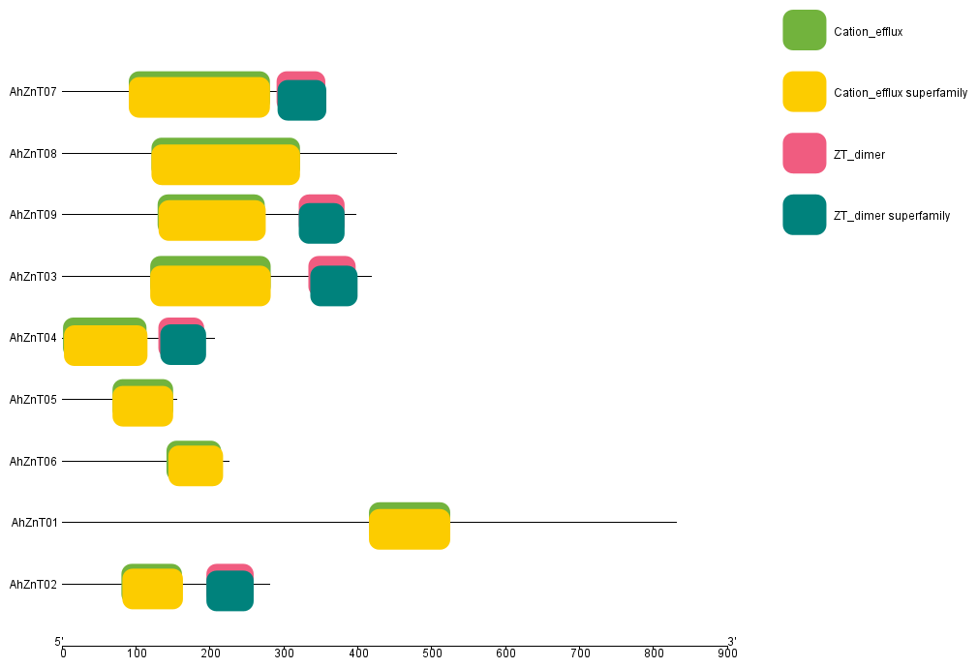

Figure 1: Domain analysis of AhZnT members.

3.3 Gene Structure and Genomic Organization
The exon-intron structure analysis revealed remarkable diversity in the genomic architecture of AhZnT genes, with coding sequence (CDS) exon numbers ranging from 1 to 12 across the family members. AhZnT1 displays the simplest organization with a single continuous CDS region spanning 2.5 kb without any introns, representing an intronless gene structure. In contrast, AhZnT8 exhibits the most complex architecture with 12 CDS exons interspersed with 11 introns across its 12.7 kb genomic length, making it the most structurally elaborate family member.
The remaining genes show intermediate complexity: AhZnT2 contains 6 CDS exons, AhZnT3 has 7 CDS exons, AhZnT4 possesses 5 CDS exons, AhZnT5 contains 2 CDS exons, AhZnT6 has 4 CDS exons, AhZnT7 exhibits 10 CDS exons, and AhZnT9 contains 6 CDS exons. Notably, several genes also contain extensive upstream and downstream untranslated regions (UTRs), with AhZnT3, AhZnT4, AhZnT5, AhZnT6, AhZnT8, and AhZnT9 showing prominent 5' and/or 3' UTR regions that may harbor important regulatory elements (Figure 2).
The structural complexity correlates strongly with gene size, where the intronless AhZnT1 (2.5 kb) represents the most compact organization, while multi-exon genes like AhZnT7 (10 exons, 8.3 kb) and AhZnT8 (12 exons, 12.7 kb) accommodate extensive intronic sequences. The presence of numerous large introns in complex genes, particularly the substantial intronic regions in AhZnT7 and AhZnT8, suggests sophisticated regulatory mechanisms through intronic regulatory elements [37,38] This genomic complexity, ranging from intronless structures to elaborate multi-exon architectures with extensive UTRs, indicates that the ZnT family has evolved diverse strategies for gene regulation and may contribute to fine-tuned control of zinc homeostasis across different tissues and developmental stages in A. hypochondriacus [39].
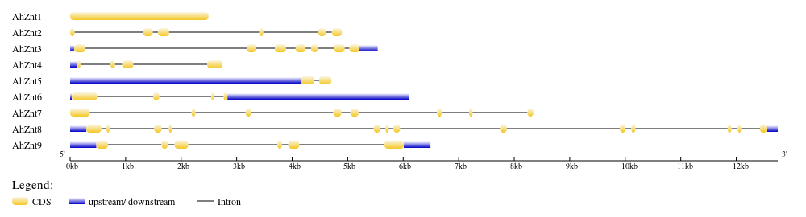
Figure 2: Gene structure and exon – intron organization of AhZnT members.

3.4 Chromosomal Distribution and Genomic Clustering
The chromosomal mapping analysis revealed that AhZnT genes are distributed across seven different scaffolds (1, 4, 6, 11, 13, 15, and 16), indicating a relatively dispersed genomic organization rather than tandem clustering (Figure 3). However, some notable clustering patterns were observed, particularly on Scaffold_13, which harbors two ZnT genes (AhZnT5 and AhZnT6) located approximately 6.6 Mb apart, and Scaffold_15, which contains AhZnT7 and AhZnT8 in relatively close proximity (approximately 0.8 Mb apart).
The clustering of AhZnT7 and AhZnT8 on Scaffold_15 suggests a potential tandem duplication event during evolution, which is supported by their similar domain architectures and the presence of both Cation efflux and ZT dimer domains. This clustering pattern may facilitate coordinated expression or allow for subfunctionalization following duplication [40]. The physical proximity of these genes may also indicate shared regulatory elements or chromatin domains that coordinate their expression in response to zinc availability or stress conditions.
The dispersed distribution of most AhZnT genes across multiple scaffolds suggests that the family has evolved through a combination of segmental duplications and chromosomal rearrangements rather than primarily through tandem duplications [41,42]. This distribution pattern may provide evolutionary advantages by reducing the risk of simultaneous loss of multiple family members through chromosomal deletions and allowing for independent regulation of different subfamily members [43,44].

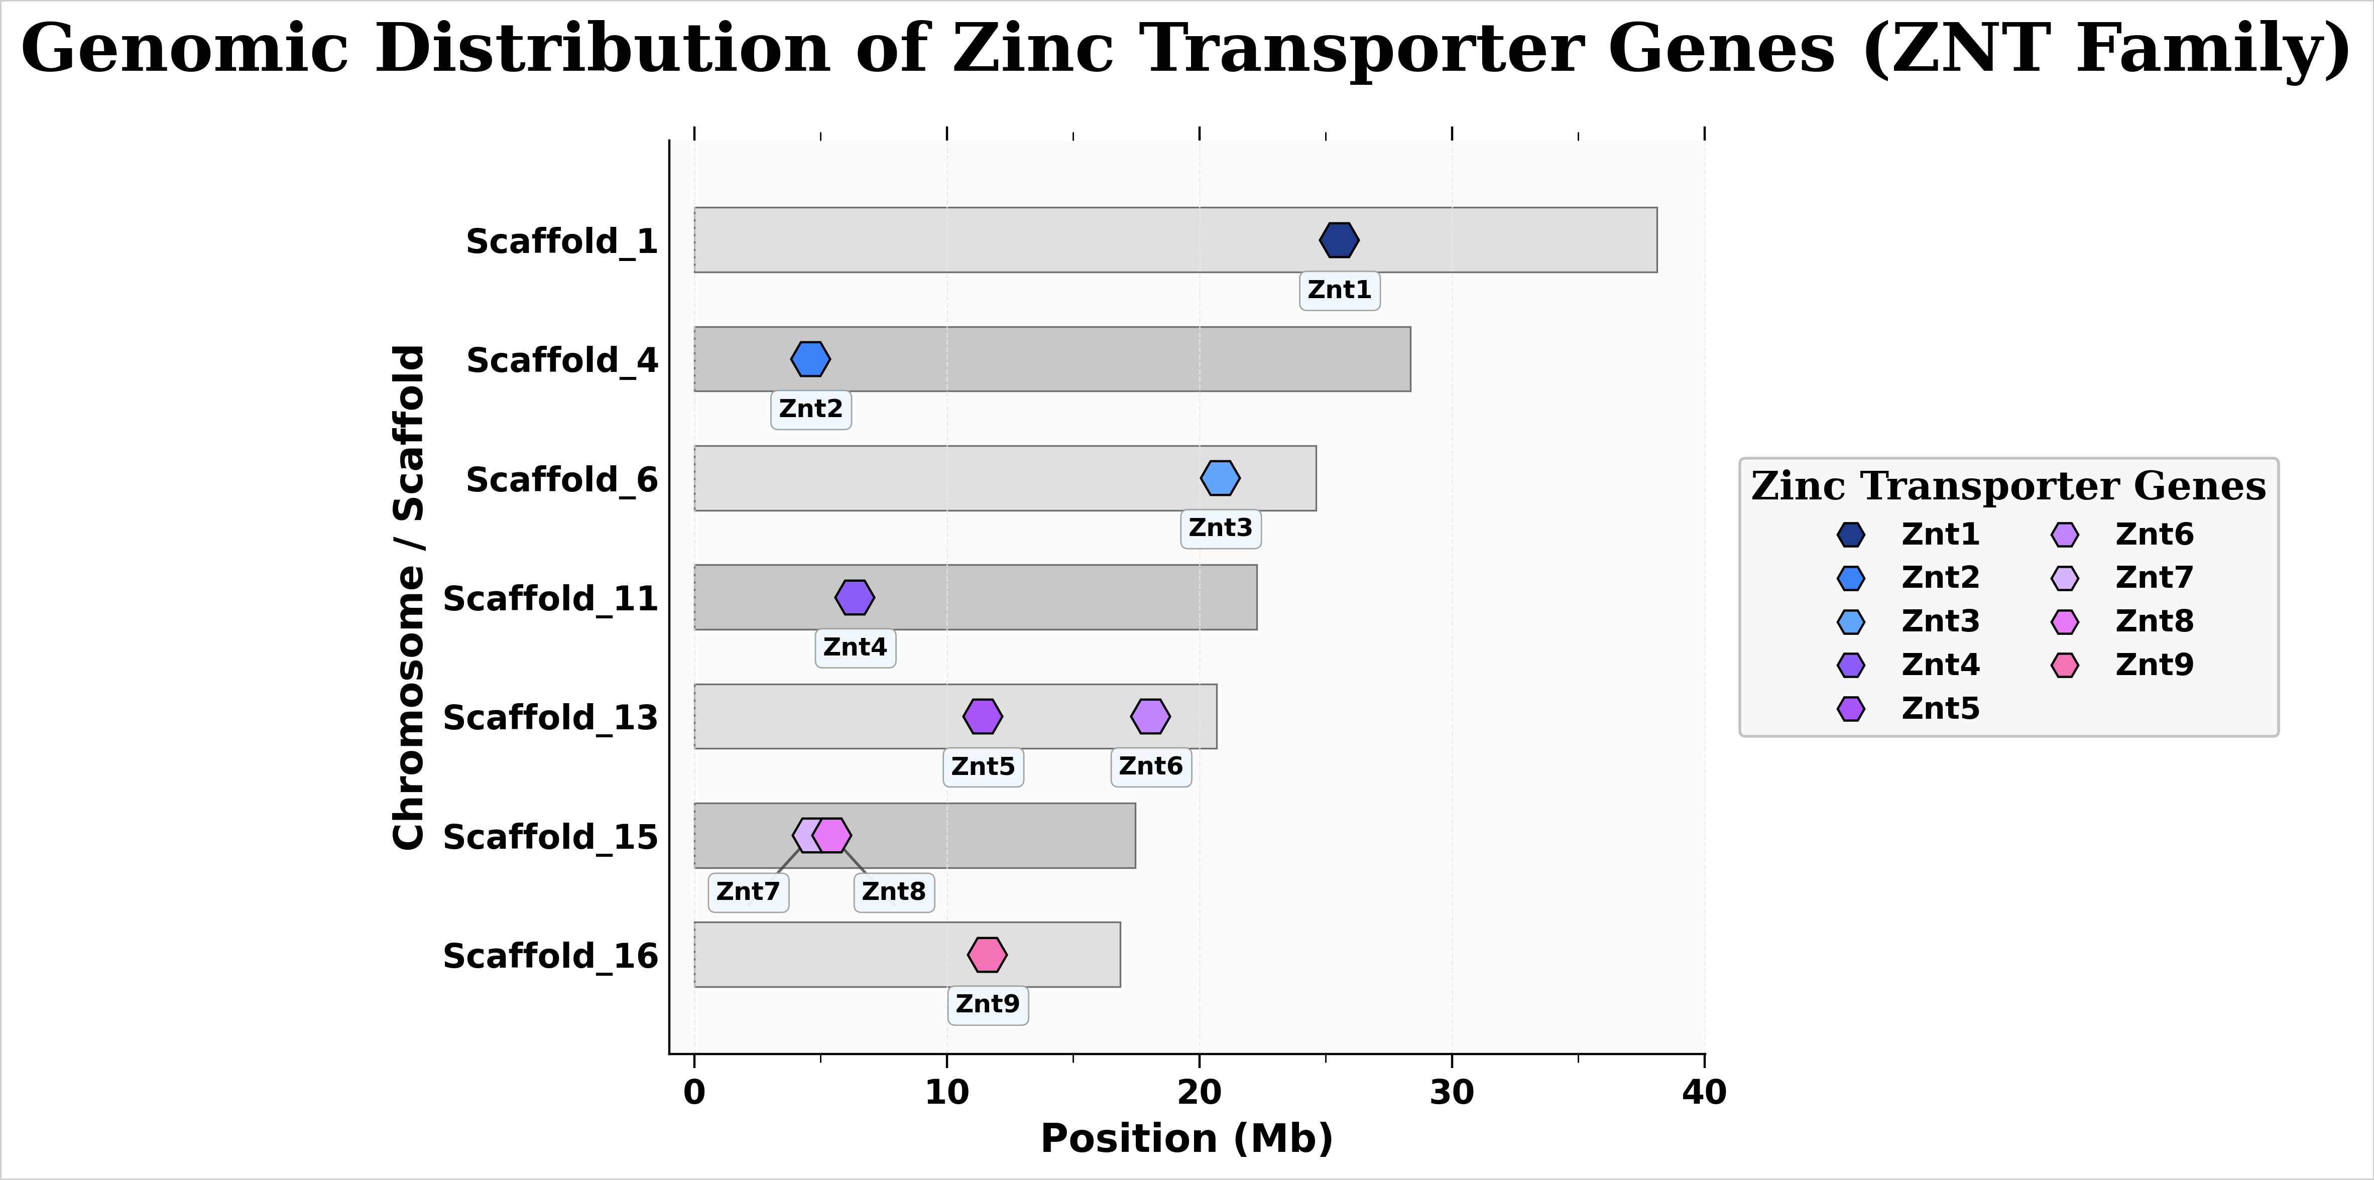

Figure 3: Genomic distribution of the identified AhZnT members

3.5 Phylogenetic Relationships and Evolutionary Analysis
The phylogenetic analysis based on protein sequences revealed clear evolutionary relationships among the nine AhZnT family members, with the maximum likelihood tree supported by bootstrap values ranging from 0.48 to 0.97. The phylogenetic tree demonstrates the presence of three major clades, suggesting ancient duplication events that gave rise to distinct ZnT subfamilies with potentially different functional characteristics (Figure 4).
The first clade includes AhZnT08 and AhZnT06, which form a sister group with moderate bootstrap support (0.68), indicating shared ancestry and potential functional similarity [45]. This clade appears to be the most divergent from the other ZnT family members, suggesting early evolutionary separation. The second clade encompasses AhZnT05, AhZnT07, and AhZnT01 with bootstrap support of 0.51. Within this clade, AhZnT07 and AhZnT01 show closer evolutionary relationship, while AhZnT05 is more distantly related. Interestingly, despite their chromosomal proximity, AhZnT07 and AhZnT08 do not cluster together in the phylogenetic tree, suggesting that their physical linkage may be due to chromosomal rearrangements rather than recent tandem duplication. The third major clade contains AhZnT09, AhZnT04, AhZnT03, and AhZnT02 with strong bootstrap support (0.97) separating this group from the rest. Within this clade, AhZnT03 and AhZnT02 form a highly supported sister pair (bootstrap value 0.97), indicating recent common ancestry and likely similar functional properties. AhZnT09 and AhZnT04 show closer relationship to each other (bootstrap support 0.8) than to the AhZnT03/AhZnT02 pair, suggesting sequential duplication events within this lineage.
The phylogenetic relationships provide insights into the evolutionary history of the ZnT family and can guide functional predictions based on sequence similarity [46,47]. The relatively short branch lengths observed throughout the tree indicate that the ZnT family has been subject to purifying selection, suggesting that most amino acid positions are functionally constrained [48,49]. This conservation pattern is consistent with the essential role of ZnT transporters in maintaining cellular zinc homeostasis and indicates that major structural features required for transport function have been preserved throughout evolution.

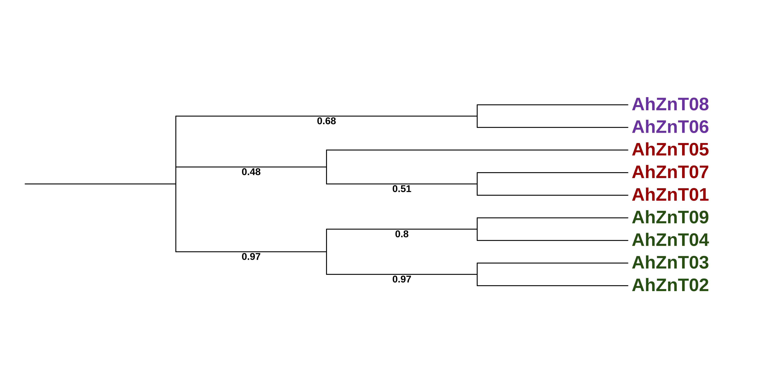
Figure 4: Phylogenetic analysis of the identified AhZnT proteins

3.6 Tissue-Specific Expression Patterns and Functional Implications
The comprehensive expression analysis across seven tissue types (embryo, stem, flower, leaf, root, cotyledon, and seed) revealed distinct expression patterns that provide insights into the functional specialization of individual ZnT family members. The expression heatmap demonstrates that AhZnT genes exhibit remarkable tissue-specific expression patterns, with some genes showing broad expression across multiple tissues while others display highly restricted expression profiles. The heat map portraying the tissue specific expression patterns of each of the AhZnT members are given in Figure 5.
AhZnT5 emerged as the most highly expressed family member, showing particularly strong expression in flower tissue (45.8 TPM) and leaf tissue (39.5 TPM), suggesting a crucial role in reproductive development and photosynthetic tissues. The high expression in flowers indicates that AhZnT5 may be involved in zinc mobilization during pollen development, fertilization, or seed formation, which are processes requiring significant zinc cofactor availability [10,50]. The substantial expression in leaves suggests involvement in photosynthetic processes or zinc recycling during leaf senescence [51]. AhZnT5 also showed considerable expression in root tissue (25.1 TPM) and stem tissue (19.8 TPM), indicating its importance in vegetative tissues as well.
AhZnT9 showed the highest expression in embryo tissue (44.9 TPM), indicating a critical role in early seed development and zinc accumulation for germination. This pattern suggests that AhZnT9 may be responsible for loading zinc into developing seeds, which is essential for proper embryonic development and seedling establishment [11,52]. The elevated expression in embryonic tissue aligns with the known importance of zinc in DNA synthesis, protein synthesis, and cellular division during early plant development [9]. The gene also exhibited notable expression in flower tissue (31.2 TPM), seed tissue (21.2 TPM), and root tissue (20.9 TPM), suggesting broader involvement in reproductive and storage tissues.
AhZnT8 displayed its highest expression in leaf tissue (28.0 TPM), with moderate levels in stem (12.4 TPM) and embryo (11.8 TPM), and lower expression in flower (9.9 TPM). This expression pattern suggests that AhZnT8 may play an important role in zinc homeostasis within photosynthetic tissues and may be involved in zinc transport between different cellular compartments in leaves [53]. The preferential leaf expression indicates a specialized function in vegetative zinc management.
Several genes showed more restricted expression patterns, which may indicate specialized functions. AhZnT4 exhibited its highest expression in seed tissue (18.3 TPM) and cotyledon tissue (16.9 TPM), with very low expression across other tissues, suggesting a highly specialized role in zinc mobilization during seed maturation and early seedling development [54]. AhZnT2 showed moderate expression primarily in flower (13.3 TPM) and leaf (11.4 TPM) tissues, with minimal expression elsewhere, indicating a more specialized role in specific developmental processes.
AhZnT3 displayed relatively uniform, low-to-moderate expression across most tissues, with slightly higher expression in flower tissue (10.6 TPM), suggesting a potential housekeeping function. AhZnT7 showed consistent low expression across all tissues, with the highest level in flower tissue (8.8 TPM). AhZnT6 and AhZnT1 exhibited the lowest overall expression levels across all tissues, with maximum values of 8.3 TPM and 6.6 TPM respectively, suggesting either condition-specific roles or functional redundancy with other family members.
The expression patterns reveal clear functional specialization, with genes like AhZnT5 and AhZnT9 showing high tissue-specific expression in metabolically active or developmentally important tissues, while others like AhZnT4 display highly restricted expression profiles that suggest specialized developmental functions. The diverse expression patterns indicate that gene duplication events have been followed by functional divergence, allowing the ZnT family to support various aspects of zinc homeostasis throughout amaranth development [55].
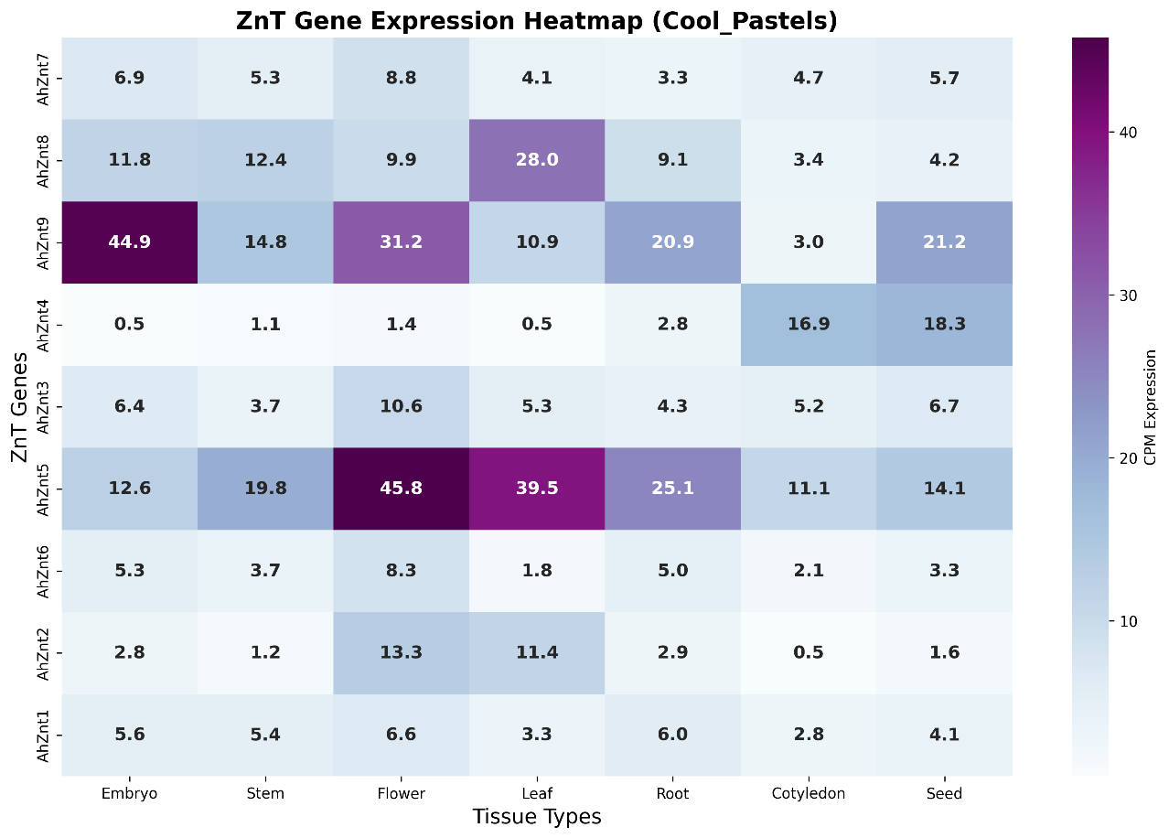
Figure 5: Tissue wise transcriptional expression analysis of the identified AhZnT genes

4. Conclusion
This study presents the first comprehensive genome-wide analysis of zinc transporter (ZnT) genes in Amaranthus hypochondriacus, identifying nine family members with diverse structural and functional characteristics. The ZnT family in amaranth exhibits moderate size compared to model plants, with family members displaying remarkable variation in genomic structure (2.5-12.7 kb), domain architecture, and tissue-specific expression patterns. Our phylogenetic analysis revealed three major clades reflecting ancient duplication events and functional diversification. The universal conservation of the CDF domain confirms the essential zinc transport function, while the variable presence of additional domains, particularly the ZT dimer domain in 55.6% of AhZnTs, suggests evolved regulatory mechanisms for specific physiological conditions. Tissue-specific expression analysis identified key functional specializations, with AhZnT5 showing highest expression in reproductive tissues (flower: 45.8 TPM) and AhZnT9 in embryonic tissue (44.9 TPM), indicating critical roles in zinc mobilization during reproduction and seed development. The dispersed chromosomal distribution of AhZnT genes across seven scaffolds suggests evolution through segmental duplications rather than tandem events, potentially providing evolutionary advantages through reduced risk of simultaneous gene loss. These findings establish a foundation for understanding zinc homeostasis in amaranth and provide molecular targets for biofortification strategies. The identification of tissue-specific transporters, particularly those highly expressed in edible tissues, offers promising candidates for genetic improvement programs aimed at enhancing the nutritional quality of this important pseudocereal. Future functional validation studies and investigation of regulatory mechanisms will be crucial for developing zinc-enriched amaranth varieties to address global micronutrient deficiencies. In conclusion, this comprehensive characterization of the A. hypochondriacus ZnT family not only deciphers the genetic basis of zinc transport in a vital pseudocereal but also provides a valuable genomic toolkit for future efforts to improve its nutritional value and stress resilience for sustainable agriculture.

References:
- Joshi, D. C., Sood, S., Hosahatti, R., Kant, L., Pattanayak, A., Kumar, A., et al. (2018). From zero to hero: the past, present and future of grain amaranth breeding. Theoretical and Applied Genetics, 131(9), 1807-1823.
- Sage, R. F. (2017). A portrait of the C4 photosynthetic family on the 50th anniversary of its discovery: species number, evolutionary lineages, and Hall of Fame. Journal of Experimental Botany, 68(2), e11-28.
- Aswal, K. S., Prabhakaran, S., Chauhan, R., Joshi, D., Sharma, R., Pandey, D., et al. (2025). Genome-wide identification, in-silico analysis and expression profiling of regulatory genes involved in essential amino acid biosynthesis during different stages of germination in grain amaranth (Amaranthus hypochondriacus). Genetic Resources and Crop Evolution, 1-22.
- Chauhan, R., Prabhakaran, S., Singh Aswal, K., & Pandey, D. (2023). Molecular docking studies for evaluation of Amaranth grain squalene for treatment of melanoma skin cancer in human beings. Letters in Organic Chemistry, 20(9), 829-836.
- Pandey, D., Bharti, M., Rana, A., Prabhakaran, S., & Chauhan, R. (2024). Molecular Docking of Phytomolecules of Grain Amaranth (Amaranthus hypochondriacus) with AKR1C3Protein Involved in Prostate Cancer in Human Beings. Letters in Organic Chemistry, 21(8), 677-686.
- Stetter, M. G., Joshi, D. C., & Singh, A. (2025). Assessing and mining grain amaranth diversity for sustainable cropping systems. Theoretical and Applied Genetics, 138(7), 171.
- Black, R. E., Victora, C. G., Walker, S. P., Bhutta, Z. A., Christian, P., De Onis, M., et al. (2013). Maternal and child undernutrition and overweight in low-income and middle-income countries. The Lancet, 382(9890), 427-451.
- Bouis, H. E., & Saltzman, A. (2017). Improving nutrition through biofortification: a review of evidence from HarvestPlus, 2003 through 2016. Global Food Security, 12, 49-58.
- Broadley, M. R., White, P. J., Hammond, J. P., Zelko, I., & Lux, A. (2007). Zinc in plants. New Phytologist, 173(4), 677-702.
- Sinclair, S. A., & Krämer, U. (2012). The zinc homeostasis network of land plants. Biochimica et Biophysica Acta - Molecular Cell Research, 1823(9), 1553-1567.
- Olsen, L. I., & Palmgren, M. G. (2014). Many rivers to cross: the journey of zinc from soil to seed. Frontiers in Plant Science, 5, 30.
- Shukla, S., Bhargava, A., Chatterjee, A., Srivastava, J., Singh, N., & Singh, S. P. (2006). Mineral profile and variability in vegetable amaranth (Amaranthus tricolor). Plant Foods for Human Nutrition, 61(1), 21-26.
- Chauhan, R., Prabhakaran, S., Taj, G., Guru, S. K., & Pandey, D. (2024). Structural and functional characterization of an amino acid transporter in Amaranthus hypochondriacus using bioinformatics tools. Journal of Advances in Biology & Biotechnology, 27(8), 280-288.
- Goodstein, D. M., Shu, S., Howson, R., Neupane, R., Hayes, R. D., Fazo, J., et al. (2012). Phytozome: a comparative platform for green plant genomics. Nucleic Acids Research, 40(D1), D1178-D1186.
- Lightfoot, D. J., Jarvis, D. E., Ramaraj, T., Lee, R., Jellen, E. N., & Maughan, P. J. (2017). Single-molecule sequencing and Hi-C-based proximity-guided assembly of amaranth (Amaranthus hypochondriacus) chromosomes provide insights into genome evolution. BMC Biology, 15(1), 74.
- Eddy, S. R. (2011). Accelerated profile HMM searches. PLoS Computational Biology, 7(10), e1002195.
- Paulsen IT, Saier, Jr MH (1997). A novel family of ubiquitous heavy metal ion transport proteins. The Journal of membrane biology,156(2):99-103.
- Lu, S., Wang, J., Chitsaz, F., Derbyshire, M. K., Geer, R. C., Gonzales, N. R., et al. (2020). CDD/SPARCLE: the conserved domain database in 2020. Nucleic Acids Research, 48(D1), D265-D268.
- Chen, C., Chen, H., Zhang, Y., Thomas, H. R., Frank, M. H., He, Y., et al. (2020). TBtools: an integrative toolkit developed for interactive analyses of big biological data. Molecular Plant, 13(8), 1194-1202.
- Krogh, A., Larsson, B., Von Heijne, G., & Sonnhammer, E. L. (2001). Predicting transmembrane protein topology with a hidden Markov model: application to complete genomes. Journal of Molecular Biology, 305(3), 567-580.
- Hu, B., Jin, J., Guo, A. Y., Zhang, H., Luo, J., & Gao, G. (2015). GSDS 2.0: an upgraded gene feature visualization server. Bioinformatics, 31(8), 1296-1297.
- Kumar, S., Stecher, G., Li, M., Knyaz, C., & Tamura, K. (2018). MEGA X: molecular evolutionary genetics analysis across computing platforms. Molecular Biology and Evolution, 35(6), 1547-1549.
- Sunil, M., Hariharan, A. K., Nayak, S., Gupta, S., Nambisan, S. R., Gupta, R. P., et al. (2014). The draft genome and transcriptome of Amaranthus hypochondriacus: A C4 dicot producing high-lysine edible pseudo-cereal. DNA Research, 21(6), 585-602.
- Andrews, S. (2010). FastQC: a quality control tool for high throughput sequence data. Available online at: http://www.bioinformatics.babraham.ac.uk/projects/fastqc
- Patro, R., Duggal, G., Love, M. I., Irizarry, R. A., & Kingsford, C. (2017). Salmon provides fast and bias-aware quantification of transcript expression. Nature Methods, 14(4), 417-419.
- Love, M. I., Huber, W., & Anders, S. (2014). Moderated estimation of fold change and dispersion for RNA-seq data with DESeq2. Genome Biology, 15(12), 550.
- Wickham, H. (2016). ggplot2: elegant graphics for data analysis. Springer.
- Montanini, B., Blaudez, D., Jeandroz, S., Sanders, D., & Chalot, M. (2007). Phylogenetic and functional analysis of the Cation Diffusion Facilitator (CDF) family: improved signature and prediction of substrate specificity. BMC Genomics, 8, 107.
- Gustin, J. L., Zanis, M. J., & Salt, D. E. (2011). Structure and evolution of the plant cation diffusion facilitator family of ion transporters. BMC Evolutionary Biology, 11, 76.
- Ram, H., Kaur, A., Gandass, N., Singh, S., Deshmukh, R., et al. (2019). Molecular characterization and expression dynamics of MTP genes under various spatio-temporal stages and metal stress conditions in rice. PLoS One, 14(5), e0217360.
- Kolaj-Robin, O., Russell, D., Hayes, K. A., Pembroke, J. T., & Soulimane, T. (2015). Cation Diffusion Facilitator family: Structure and function. FEBS Letters, 589(12), 1283-1295.
- Lu, M., & Fu, D. (2007). Structure of the zinc transporter YiiP. Science, 317, 1746-1748.
- Bin, B. H., Fukada, T., Hosaka, T., Yamasaki, S., Ohashi, W., Hojyo, S., et al. (2011). Biochemical characterization of human ZIP13 protein: a homo-dimerized zinc transporter involved in the spondylocheiro dysplastic Ehlers-Danlos syndrome. Journal of Biological Chemistry, 286, 40255-40265.
- Wei, Y., & Fu, D. (2006). Binding and transport of metal ions at the dimer interface of the Escherichia coli metal transporter YiiP. Journal of Biological Chemistry, 281, 23492-23502.
- Cotrim, C. A., Jarrott, R. J., Martin, J. L., & Drew, D. (2019). A structural overview of the zinc transporters in the cation diffusion facilitator family. Acta Crystallographica Section D: Structural Biology, 75(4), 357-367.
- Lu, M., Chai, J., & Fu, D. (2009). Structural basis for autoregulation of the zinc transporter YiiP. Nature Structural & Molecular Biology, 16, 1063-1067.
- Jo, B. S., & Choi, S. S. (2015). Introns: the functional benefits of introns in genomes. Genomics & Informatics, 13(4), 112-118.
- Rose, A. B. (2019). Introns as gene regulators: a brick on the accelerator. Frontiers in Genetics, 9, 672.
- Coulombe-Huntington, J., & Majewski, J. (2007). Characterization of intron loss events in mammals. Genome Research, 17, 23-32.
- Cannon, S. B., Mitra, A., Baumgarten, A., Young, N. D., & May, G. (2004). The roles of segmental and tandem gene duplication in the evolution of large gene families in Arabidopsis thaliana. BMC Plant Biology, 4, 10.
- Qiao, X., Li, Q., Yin, H., Qi, K., Li, L., Wang, R., et al. (2019). Gene duplication and evolution in recurring polyploidization-diploidization cycles in plants. Genome Biology, 20, 38.
- Zhang, Y., Xia, R., Kuang, H., & Meyers, B. C. (2019). The diversification of plant NBS-LRR defense genes directs the evolution of microRNAs that target them. Molecular Biology and Evolution, 33, 2692-2705.
- Freeling, M. (2009). Bias in plant gene content following different sorts of duplication: tandem, whole-genome, segmental, or by transposition. Annual Review of Plant Biology, 60, 433-453.
- Wang, Y., Wang, X., & Paterson, A. H. (2012). Genome and gene duplications and gene expression divergence: a view from plants. Annals of the New York Academy of Sciences, 1256, 1-14.
- Felsenstein, J. (1985). Confidence limits on phylogenies: an approach using the bootstrap. Evolution, 39, 783-791.
- Eisen, M. B. (2002). Phylogenomics: improving functional predictions for uncharacterized genes by evolutionary analysis. Genome Research, 8, 163-167.
- Barker, D., & Pagel, M. (2005). Predicting functional gene links from phylogenetic-statistical analyses of whole genomes. PLoS Computational Biology, 1(1), e3.
- Kuo, C. H., & Ochman, H. (2009). Inferring clocks when lacking rocks: the variable rates of molecular evolution in bacteria. Biology Direct, 4, 35.
- Wyder, S., Kriventseva, E. V., Schröder, R., Kadowaki, T., & Zdobnov, E. M. (2007). Quantification of ortholog losses in insects and vertebrates. Genome Biology, 8, R242.
- Pandey, N., Gupta, B., & Pathak, G. C. (2011). Zinc is critically required for pollen function and fertilisation in lentil. Journal of Trace Elements in Medicine and Biology, 25, 89-95.
- Waters, B. M., & Sankaran, R. P. (2011). Moving micronutrients from the soil to the seeds: genes and physiological processes from a biofortification perspective. Plant Science, 180, 562-574.
- Bashir, K., Rasheed, S., Kobayashi, T., Seki, M., & Nishizawa, N. K. (2016). Regulating subcellular metal homeostasis: the key to crop improvement. Frontiers in Plant Science, 7, 1192.
- Ricachenevsky, F. K., Menguer, P. K., Sperotto, R. A., & Fett, J. P. (2015). Got to hide your Zn away: molecular control of Zn accumulation and biotechnological applications. Plant Science, 236, 1-17.
- Waters, B. M., & Grusak, M. A. (2008). Quantitative trait locus mapping for seed mineral concentrations in two Arabidopsis thaliana recombinant inbred populations. New Phytologist, 179, 1033-1047.
- Eroglu, S., Meier, B., von Wirén, N., & Peiter, E. (2017). The vacuolar manganese transporter MTP8 determines tolerance to iron deficiency-induced chlorosis in Arabidopsis. Plant Physiology, 170, 1030-1045.

