Characterization of Linseed (Linum usitatissimum L.) Germplasms at Morphological, Biochemical & Molecular Level
ABSTRACT
The study focused on the characterization of 18 linseed (Linum usitatissimum L.) germplasms to evaluate genetic diversity through morphological, biochemical, and molecular markers. Germplasm characterization is essential for identifying valuable traits and facilitating the development of effective breeding programs. Significant variation was observed among the 18 genotypes for agro-morphological traits. Similarity coefficients ranged from 0.00 (indicating complete dissimilarity) to 0.78, with GP-381 – R-4237, GP-208 – R-4253, and others being the most dissimilar. Days to first flowering ranged between 38.5 days (R-4218) and 41.5 days (GP-405), with an average of 39.41 days. GP-208 showed the earliest 50% flowering (51.5 days), while GP-345 was the latest (56.5 days). Capsule production varied from 14 (R-4237) to 23 (GP-208), with a mean of 16.75 per plant. Plant height ranged between 48.16 cm (GP-381) and 72.12 cm (R-4266), with a mean height of 56.71 cm. The number of seeds per capsule ranged from 4.5 (R-4218) to 12 (GP-208), with a mean of 7.22. The 1000 seed weight ranged between 4.72 g (R-4253) and 6.97 g (R-4237, R-4275). Primary branches varied from 3.5 (GP-345) to 11 (R-4244, GP-209), averaging 6.4. Among the 18 lines, 15 had purple flowers, while GP-433 was off-white, GP-411 had white, and GP-345 had dark purple flowers. Yield ranged from 74.7 g (GP-405) to 143.75 g (GP-208), with an average of 97.09 g per plant. SDS-PAGE revealed 13 protein bands, with 8 being polymorphic and 5 monomorphic. Cluster analysis using UPGMA grouped the genotypes into two major clusters at 50% homology, indicating moderate genetic variation. ISSR markers revealed high diversity in genotypes GP-352, GP-208, and GP-473. Primers UBC-815, UBC-819, and UBC-825 showed high polymorphism and PIC values (0.41 to 0.48). SSR analysis confirmed that GP-473 and GP-208 were the most diverse. Primers LU-3, LU-6, LU-8, and LU-9 had the highest PIC values and 100% polymorphism.
Keywords: Linseed; agro morphological; germplasms; protein; SDS-PAGE; PIC.

1. INTRODUCTION
Linseed (Linum usitatissimum L., 2n = 30), belonging to the family Linaceae and order Malpighiales, is one of the earliest cultivated crops, with a history spanning over 6,000-7,000 years. The genus name Linum originates from the word "lin" or "thread," and usitatissimum means "most useful" in Latin. Linseed is widely recognized for its dual purpose-used as an oilseed (flaxseed) and as a fiber crop (fiber flax) (Vaisey-Genser and Morris, 2003). Its genome size is approximately 368–373 Mb (Ragupathy et al., 2011). Flax is considered one of the top five oilseed crops globally and the third-largest source of natural fiber. It thrives in tropical and temperate climates, particularly in silt loam, clay loam, and alluvial soils with pH 6–7 (Rai, 2012). Ideal growing regions include black soils in peninsular India and the Indo-Gangetic plains. Despite its importance, linseed is still underutilized and is cultivated in only 34 countries, with major producers including India, USA, Canada, Argentina, China, Ethiopia, and Australia (Wakjira et al., 2004; Green et al., 2008). Linseed is highly valued for its nutritional composition, especially its rich content of omega-3 and omega-6 fatty acids. Key omega-3 fatty acids like α-linolenic acid (ALA), docosahexaenoic acid (DHA), and eicosapentaenoic acid (EPA) are known for their role in reducing cardiovascular disease (Hurteau, 2004). Linseed contains about 16% ALA and 57% linoleic acid (LA), making it a rich source of essential polyunsaturated fatty acids (PUFAs) (Ganorkar and Jain, 2013).
To improve linseed cultivars, characterization of germplasm and assessment of genetic variability are essential. Though traditional breeding techniques like selection, hybridization, and introduction have been employed, modern tools such as molecular and biochemical markers are now increasingly used. Among molecular tools, the ISSR (Inter Simple Sequence Repeat) technique stands out for its simplicity, high reproducibility, and independence from prior genomic information (Wolfe and Liston, 1998). ISSR-PCR primers are effective in identifying polymorphisms across multiple loci (Zietkiewicz et al.1994). Additionally, SSR (Simple Sequence Repeat) markers, or microsatellites, offer high polymorphism, heritability, and co-dominant nature, making them ideal for marker-assisted selection (MAS) and diversity studies. These approaches have significantly contributed to the development of improved linseed cultivars (Sandip et al., 2012).

2. MATERIALS AND METHODS
The current study, titled "Characterization of Linseed (Linum usitatissimum L.) Germplasm at Morphological, Biochemical & Molecular Level" was conducted during 2024-2025 at the Department of Plant Biotechnology, College of Agricultural Biotechnology, Latur [Vasantrao Naik Marathwada Agricultural University, Parbhani (M.S.)]
2.1 MATERIALS
The linseed germplasm used in this study was obtained through an MTA from the collection maintained at Indira Gandhi Agricultural University, Raipur (C.G.). A total of 18 germplasm lines were utilized for morphological, biochemical, and molecular analyses in this investigation.
Table No. 1. List of Linseed Germplasms Used in Present Investigation
Sr. No. | Germplasms | Sr. No. | Germplasms
1. | R- 4218 | 10. | GP- 333
2. | R- 4237 | 11. | GP- 345
3. | R- 4244 | 12. | GP- 352
4. | R- 4253 | 13. | GP- 381
5. | R- 4266 | 14. | GP- 405
6. | R- 4275 | 15. | GP- 411
7. | GP-208 | 16. | GP- 418
8. | GP-209 | 17. | GP- 455
9. | GP-312 | 18. | GP- 473

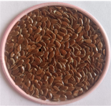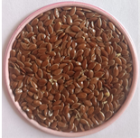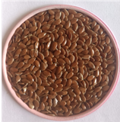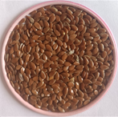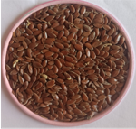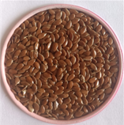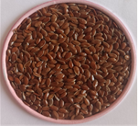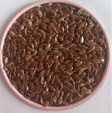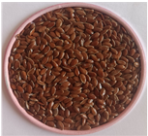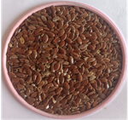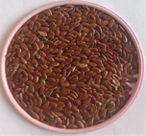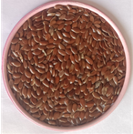
R-4218 R-4237 R-4244 R-4253
R-4266 R-4275 GP-208 GP-209
GP-312 GP-333 GP-345 GP-352
GP-381 GP-405 GP-411 GP-418
GP-455 GP-473

Plate No. 1 Germplasms used in the present study

2.2 METHODS 2.2.1 MORPHOLOGICAL CHARACTERIZATION
The experiment was conducted at the college of agricultural biotechnology, Latur in a randomized block design with three replications for morphological characterization. Observations were made on five plants chosen at random in every entry derived from every replication. Days to first flower, Days to 50% flowering, Colour of flower, Plant height at maturity (cm), Number of primary branches per plant, Number of capsules per plant, Number of seeds per capsule, 1000 seed weight (g), Yield per plant (g). (Akbar et al., 2003). Statistical analyses were performed on the morphological character results, using measures such as the arithmetic mean, coefficient of range, standard error, etc.
2.2.2 BIOCHEMICAL ANALYSIS
2.2.2.1 ISOLATION OF TOTAL PROTEIN
Using linseed flour from mature, dehulled grains, (Sardar et al. 2012) calculated the total seed protein content of linseed grain. After preparing a mixture of 3 mg of flour and 100μl of extraction buffer (which included 0.1% bromophenol blue, 2.3% SDS, 5% β-mercaptoethanol, 10% glycerol, and 0.055 M Tris-HCl at pH 6.8), the mixture was heated for 10 minutes. After adding the freshly made protein extraction solution to each tube, a cyclo-mixer was used to thoroughly mix the mixture. The tubes were then incubated for one to two hours at -20°C. The samples were centrifuged at 10,000 rpm for five minutes at 4°C after incubation. After mixing with dye, the supernatant was collected and heated in a water bath at 95°C for 5 minutes, yielding denatured proteins that were subsequently used for SDS-protein profiling. SDS-PAGE in a discontinuous buffer system was used to analyze the extracted samples' proteins, with a 5% stacking gel and a 15% acrylamide resolving gel. After loading a 10μl sample of extracted proteins and a protein marker, the gel was electrophoresed in Tris-glycine buffer at 30mA for 3 hours. The resulting protein banding patterns were considered the genotype's "fingerprint".

2.2.3 MOLECULAR ANALYSIS
Genomic DNA was extracted from the leaves of 18 linseed genotypes following the Cetyltrimethyl Ammonium Bromide (CTAB) method with some modifications as described by Doyle and Doyle (1987).
2.2.3.1 ISSR AND SSR ANALYSIS
The analysis involved the use of five SSR and six ISSR primers. 25µL of reaction volume containing the following chemicals was used for PCR amplifications: 0.1µmol/L of primer, 1x PCR buffer, 3U Taq polymerase, 25–30ng of genomic template DNA, 2.0 mmol/L MgCl2, and 100 µmol/L of each dNTP. To enhance the findings, some modifications were made to the original program, including alterations to the annealing temperature and the number of amplification cycles. The amplification procedure involved pre-denature at 94 °C for 5 minutes, 45 cycles of 94 °C for 1 minute, 36 °C (for ISSR analysis) or 58-60 °C (for SSR analysis) for 1 minute, and 72 °C for 1 minute, with a final extension at 72 °C for 10 minutes. The amplification results were observed using ethidium bromide-stained 1.8% (for ISSR analysis) or 2.5% (for SSR analysis) agarose gel electrophoresis. Using the 100 bp and 1000 bp DNA marker ladders, the length of each fragment (bp) in the amplified product was calculated. (Kale et al. 2012; Rajwade et al. 2010), (Soto-Cerda et al., 2011; Chandravati et al., 2018; Saroha et al., 2022).
3. RESULTS AND DISCUSSION
3.1 MORPHOLOGICAL CHARACTERIZATION
The phenotypic data has been obtained on 18 genotypes. Agro-morphological characterization was tried. The character days to first flower ranged from 38.5 days for R-4218 to 41.5 days for GP-405, with an average of 39.41 days. R-4218 flowers the earliest (38.5 days), while GP-455 had the first flower (41.5 days). The character days to 50% flowering varied from 51.5 days (GP-208) to 56.5 days (GP-345), with a mean of 54.17 days. GP-208 had the earliest 50% flowering time of any genotype (51.5 days). Among all germplasm, GP-345 showed late 50% flowering (56.5 days). (Akbar et al., 2003). The number of capsules each plant varied between 14 (R-4237) and 23 (GP-208), with an average of 16.75 capsules per plant. The shortest plant among all genotypes was GP-381 (48.16 cm), while the tallest was R-4266 (72.12 cm). The average number of seeds per capsule was 7.22, with a range of 4.5 (R-4218) to 12 (GP-208). R-4218 contained the fewest seeds (4.5 seeds per capsule), whereas GP-208 contained the most seeds (12 seeds per capsule). Across all linseed genotypes, the 1000 seed weight varied from 4.72 gm (R-4253) to 6.97 gm (R-4237) and (R-4275). R-4237 and R-4275 had the highest 1000 seed weight (6.97 gm), while R-4253 had the lowest (4.72 gm). (Green and Marshall, 1981). The genotypes of linseed varied greatly in the number of primary branches per plant, with a mean of 6.4 and a range of 3.5 (GP-345) to 11 (R-4244) and (GP-209). While GP-345 had the fewest primary branches (3.5), R-4244 and GP-208 (11) had the most. The mean linseed germplasm yield was 97.09, with a range of 74.7gm (GP-405) to 143.75gm (GP-208) per plant. Plant yields were best for GP-208 (143.75gm) and lowest for GP-405 (74.7gm). Only one of the eighteen lines (GP-433) has an off-white flower, one (GP-411) has a white flower, and one (GP-345) has a dark purple flower. The last fifteen lines were colored purple. (Akbar et al., 2003; Tadesse et al., 2010).
3.1.1 SIMILARITY MATRIX BASED ON MORPHOLOGICAL CHARACTERS
Jaccard's estimates of similarity matrix were evaluated for a collection of eighteen linseed germplasms based on the morphological character score. These 18 promising linseed germplasms had an average similarity of 0.22, ranging from 0.00 to 0.78. For 18 linseed accessions, the morphological analysis showed a similarity matrix ranging from 0.00 (GP-381 - R-4237), (GP-208 - R-4253), (GP-455 - R-4275), (GP-333 - GP-208), (GP-381 - GP-208), (GP-473 - GP-208), (GP-405 - GP-352) to 0.78 (GP-312 - R-4244). Therefore, the genotypes that were most similar to one another were GP-312 and R-4237, whereas the genotypes that were the most distinct were GP-381 - R-4237, GP-208 - R-4253, GP-455 - R-4275, GP-333 - GP-208, GP-381 - GP-208, GP-473 - GP-208, and GP-405 - GP-352 (Beer et al., 1993). (Fig. No. 1)

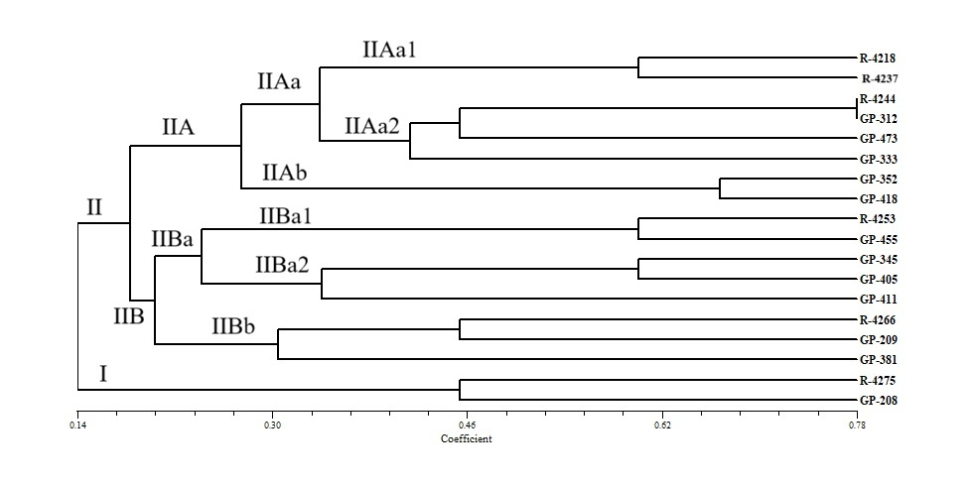
Fig. No. 1. Morphological Characterization based on Phenotypic Observations

Fig. No. 1. Morphological Characterization based on Phenotypic Observations

Fig. No. 2. Dendrogram Generated by UPGMA analysis based on Morphological Characters

3.2 BIOCHEMICAL CHARACTERIZATION
Thirteen distinct protein bands that could be scored were identified in each linseed germplasm. Protein bands were verified using a stacking gel (5 ml) and observed during protein assembly using 0.05% Bromophenol Blue (Fig. No. 3). Five bands were monomorphic, and eight bands were polymorphic among these thirteen bands. The two primary clusters identified by UPGMA cluster analysis are I and II. GP-411 is the only genotype found in the out-grouped main cluster I. Two minor clusters, IIA and IIB, which sprang from main cluster II, were similar to each other, according to a 50% cut-off on the scale. It was shown that the minor clusters IIAa and IIAb were similar with a 72% cut-off on the scale. The genotypes in minor cluster IIAa that are 100% comparable to those of R-4244 and R-4253 are R-4218, R-4237, R-4275, GP-208, GP-209, GP-381, and GP-352. The genotypes of GP-333, GP-345, GP-418, and GP-455 are 87% identical. Between GP-312 and GP-405, there exist distinctions and out groupings. In a related study, (Saradar et al.2012) found that the genetic diversity of total seed protein profiles was low. (Gulla et.al., 2021) found a high level of variation among linseed genotypes. (Fig No. 3).
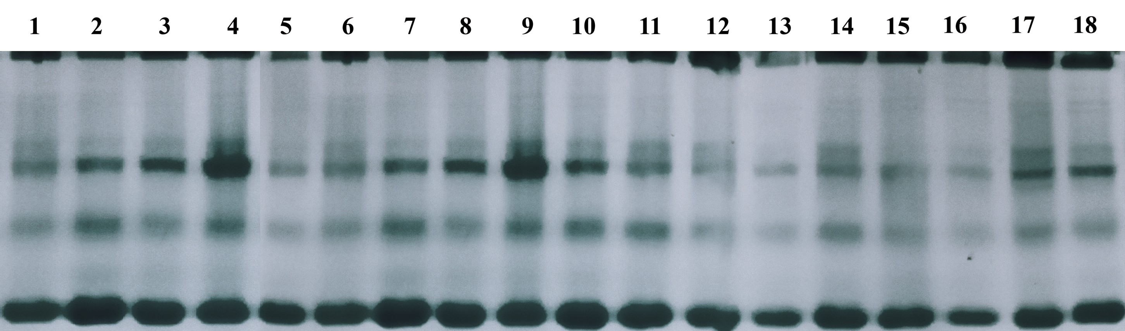

Fig. No. 4. Cluster analysis via UPGMA

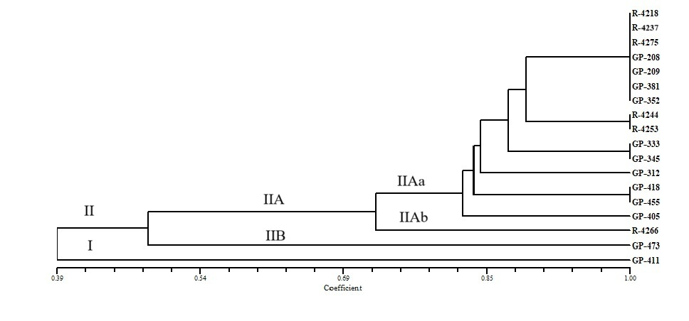
Fig. No. 3. Gel Electrophoresis Based on Total Seed Protein

3.3 MOLECULAR CHARACTERIZATION
3.3.1 CHARACTERIZATION BY USING ISSR PRIMERS
Using a set of ten ISSR primers, 18 genomic DNA was amplified by PCR. Six of the ten ISSR primers employed in this investigation were effective at amplifying genomic DNA. In this study, six ISSR primers produced a total of 24 amplicons. 21 amplicons were found to be polymorphic, with an average polymorphism of 87.5%. On average, each primer produced four amplicons. The size of the amplification product varied from 400bp to 6000bp. The primers UBC-807, UBC-819, and UBC-825 produced the most amplicons (5), whereas UBC-810 and UBC-850 produced four and three amplicons, respectively, and UBC-815 produced the fewest amplicons (2). Primer UBC-850 has the lowest polymorphism rate (66.66%). The polymorphic information content (PIC) of each primer ranged between 0.29 and 0.48, with an average of 0.40. The most informative ISSR primers were UBC-815, UBC-819, and UBC-825, which had 100% polymorphism and PIC values of 0.41, 0.47, and 0.48, respectively. The primers UBC-807 exhibit 80% polymorphisms with a PIC value of 0.36. Primer UBC-810 demonstrates that 75% of polymorphisms have a PIC value of 0.37. While ISSR primer, the least informative primer, UBC-850, had a PIC value of 0.29, while the most informative marker, UBC-825, had a PIC value of 0.48. (Adhikari et al., 2015). (Fig. No. 5) The ISSR data show that the similarity matrix between 18 linseed accessions varied from 0.94 (GP-411 - R-4244) to 0.26 (GP-352 - GP-208) and (GP-473 - GP-208). As a result, the most like germplasm was GP-411 and R-4244 (0.97), while the most dissimilar genotypes were GP-352 - GP-208 and GP-473 - GP-208, which had the lowest similarity score (0.26). (Pali et al. 2015).
The genetic history of the native lines is extremely varied, according to the cluster analysis based on ISSR markers across multiple linkage groups. Separate groups of 18 linseed germplasm were found to be represented by two distinct and sizable clusters (I and II). Two subclusters, IA and IB, comprise the main cluster I. GP-208, the most diverse genotype, is the only genotype found in Subcluster IA. There are two genotypes in sub-cluster IB: GP-333 and GP-381. It was found that subclusters IA and IB were similar at the 57% scale cut-off. Two smaller clusters, IIA and IIB, were created by further subdividing the big cluster II. Two minor clusters, IIA and IIB, that were produced in main cluster II were found to be similar to each other at about the 65% cut-off on the scale. Eleven linseed genotypes were found in each of the two sub-clusters, IIAa and IIAb, that were formed from the minor cluster IIA. Two sub-clusters, IIAb1 and IIAb2, were identified from the minor cluster IIAb. R-4244 and GP-411 are the two genotypes that comprise Subcluster IIAb1. The six genotypes that make up sub cluster IIAb2 are 100% similar and are R-4253, R-4266, GP-345, GP-209, GP-418, and GP-455. IIBa and IIBb are the two minor clusters that make up IIB. R-4275 and GP-352, the two genotypes that comprise the minor cluster IIBa, are 100% identical. The two genotypes that make up the minor cluster IIBb, GP-312 and GP-473, are 100% identical. Pali and Mehta (2016) (Fig. No. 6)

ISSR profiling of 18 linseed lines obtained with primer UBC-819

ISSR profiling of 18 linseed lines obtained with primer UBC-807

ISSR profiling of 18 linseed lines obtained with primer UBC-815

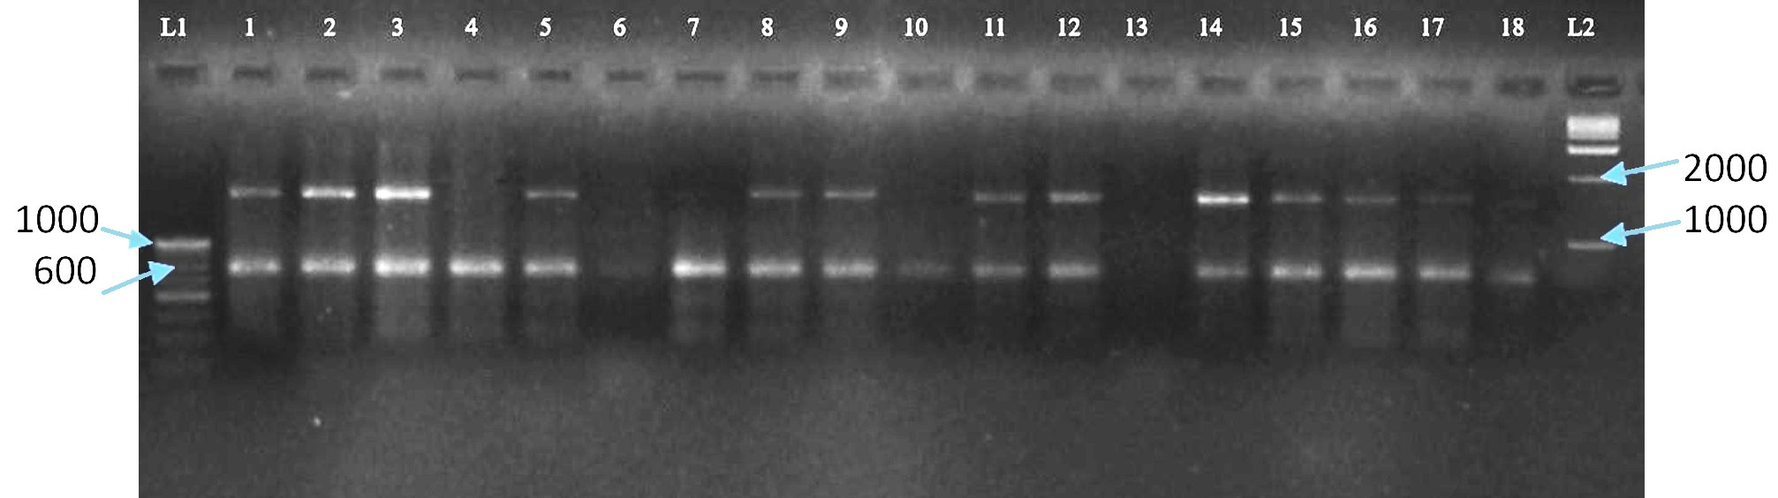
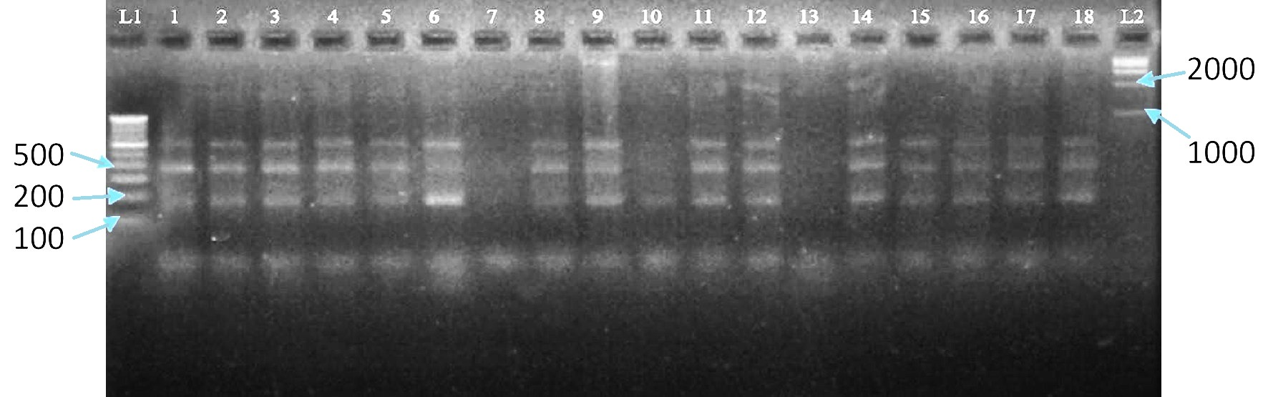

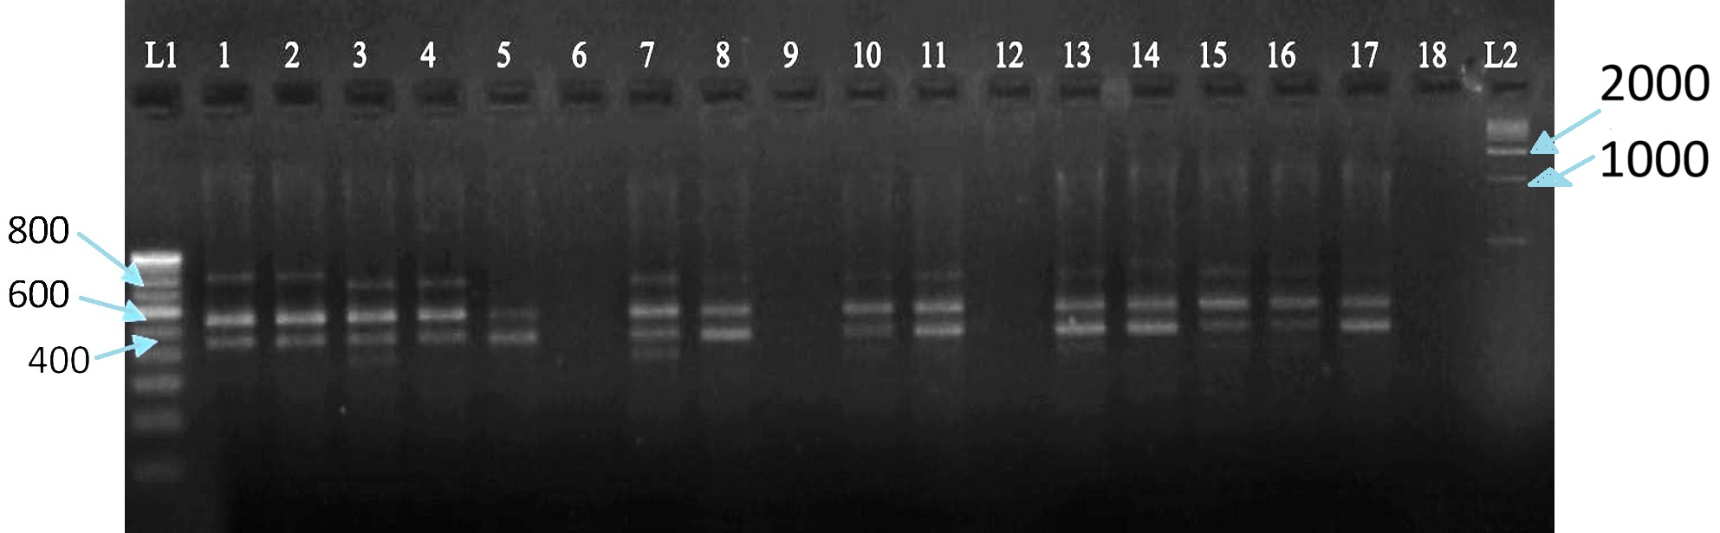

Fig. No. 5. Characterization of Linseed Germplasm using ISSR primers

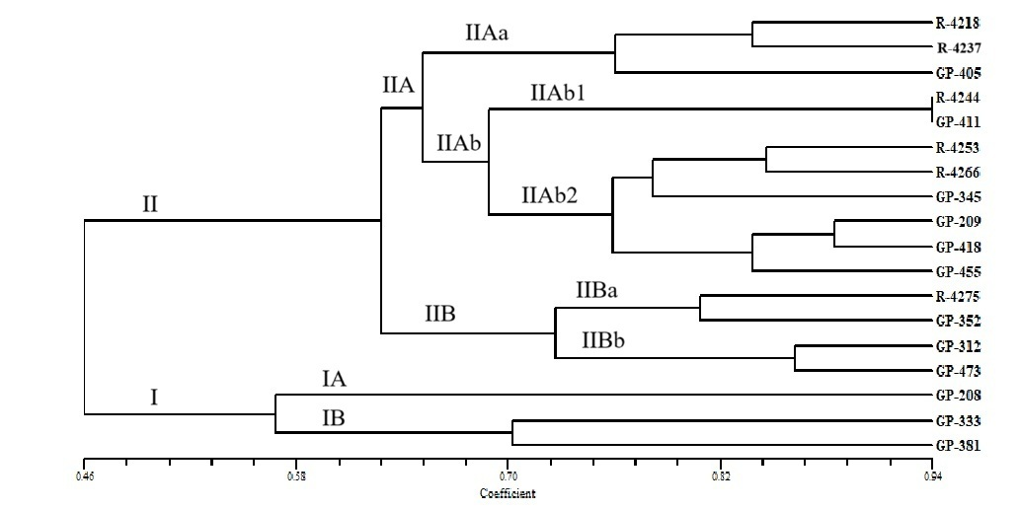

Fig. No. 6. Cluster analysis via UPGMA

3.3.2 CHARACTERIZATION BY USING SSR PRIMERS
In the present study, thirteen amplicons were obtained using five SSR primers. The average polymorphism of 12 amplicons was found to be 90%. The average yield of each primer was 2.6 amplicons. With a range of 0.19 to 0.47, the average polymorphic information content (PIC) value for every primer was 0.32. With 100% polymorphism and a PIC value of 0.47, SSR primer LU-6 was the most informative marker. The PIC value of 0.19 for SSR primer LU-8 indicated that it was the least informative primer. (Cloutier et al. 2012). The SSR analysis revealed that the similarity matrix between the 18 linseed accessions varied from 0.09 (GP-473, GP-208) to 1.0 (R-4266, R-4253, R-4275, GP-312, GP-209, GP-455, GP-405). Thus, the most divergent genotypes found (GP-473, GP-208) and the most similar genotypes (R-4266, R-4253, R-4275, GP-312, GP-209, GP-455, GP-405) were discovered. (Kumari S, et al. 2020) (Figure No. 7)
UPGMA-based cluster analysis was utilized to create a dendrogram from the genetic similarity matrix, revealing two significant clusters (I and II). The giant cluster I was subdivided into the two lesser clusters, IA and IB. Cluster IB is the primary cluster that contains the only germplasm, GP-418. The genotype that was found to be the most distinct was GP-418. The major cluster IA was found to have two subsidiary clusters, IAa and IAb, that were equivalent to each other at a cut-off of roughly 65% on the scale. There are eight genotypes that show 80% similarity with each other: GP-209, GP-312, GP-352 & GP-333, GP-405, GP-455, GP-473, and GP-411. GP-411 was found to be out-grouped within the cluster IAa2. IAa1 and IAa2 were the two subclusters that were created from the minor cluster IAa. The minor cluster IAb contains two genotypes, GP-345 and GP-381, that are 100% identical to each other. Another noteworthy cluster, Cluster II, was further separated into IIA and IIB. There is only one germplasm, GP-208, in Subcluster IIB. GP-208 was shown to be the most distinct genotype. Subcluster IIA contains six genotypes, designated R-4218, R-4237, R-4253, R-4266, R-4275, and R-4244. Clusters IIA and IIB were found to be similar on the scale at roughly 80% cut-off. The genotypes of GP-345, GP-381, GP-405, GP-455, and GP-405 are all 100% identical. GP-418 and GP-208 were the most dissimilar genotypes, whereas GP-411, GP-433, and R-4244 were found to be out-grouped. The genotypes GP-209 and GP-352 and R-4218 and R-4275 are 100% similarity. (Soto-Cerda et al., 2012). (Figure No. 8)
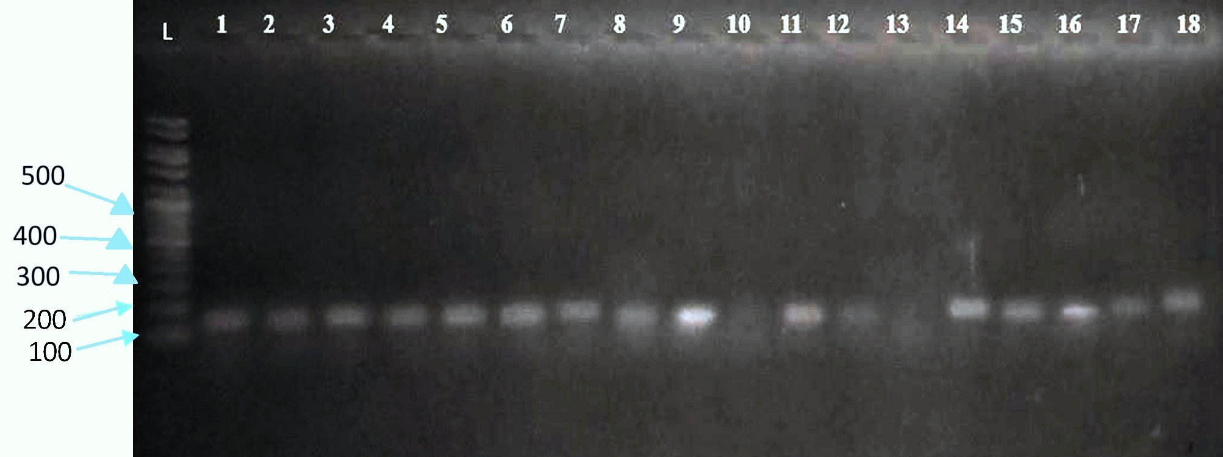

SSR profiling with primer LU-3

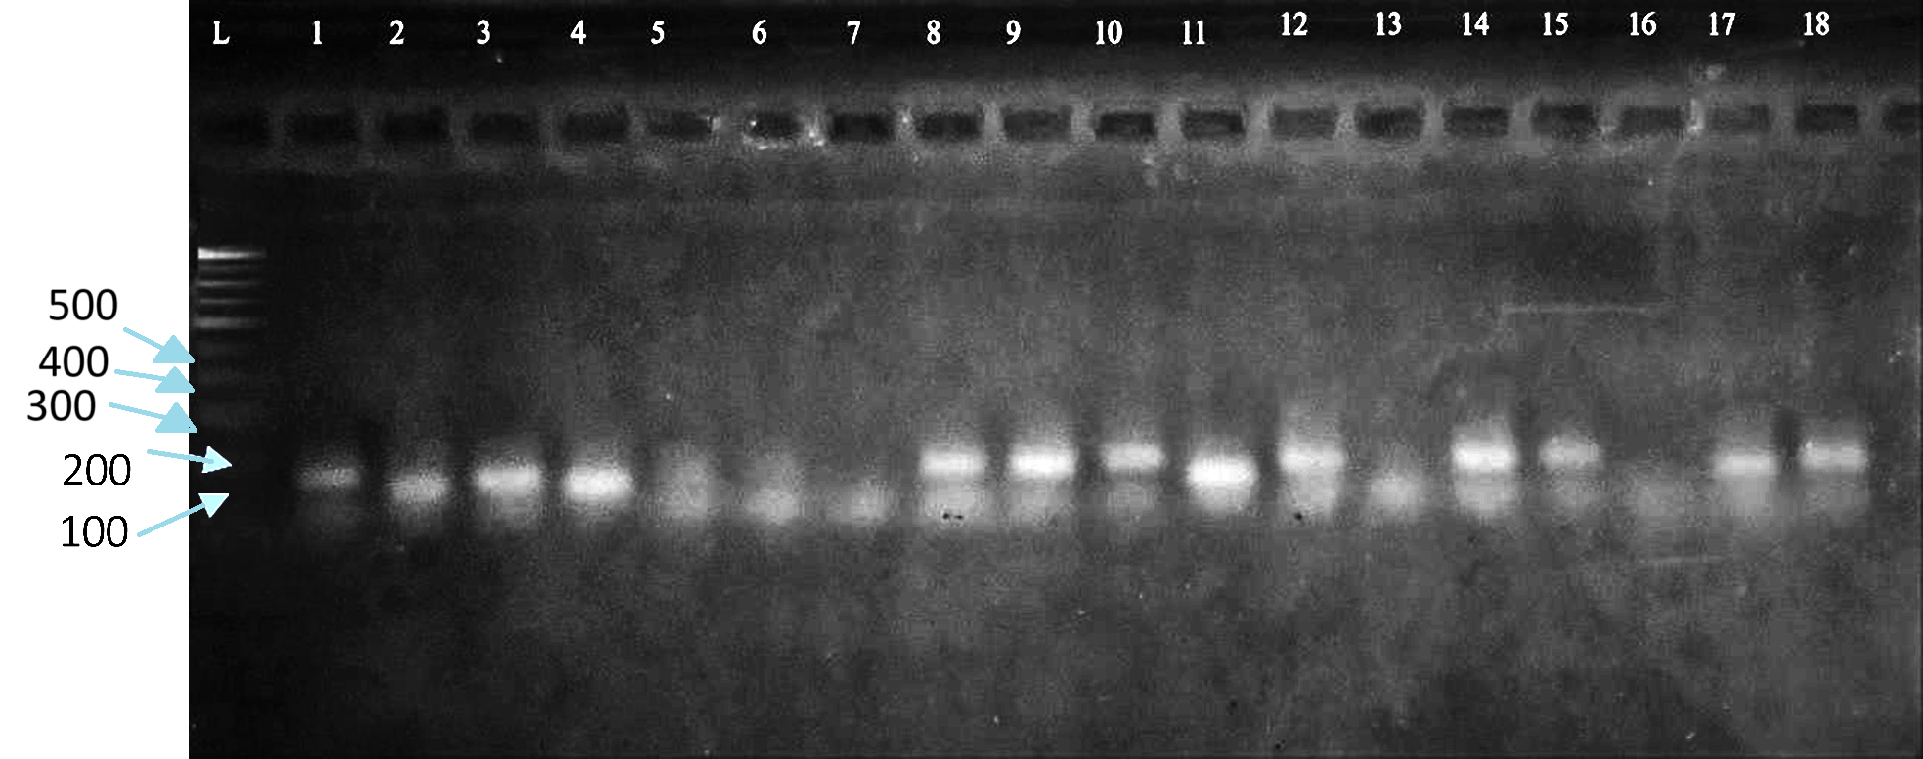

SSR profiling with primer LU-6

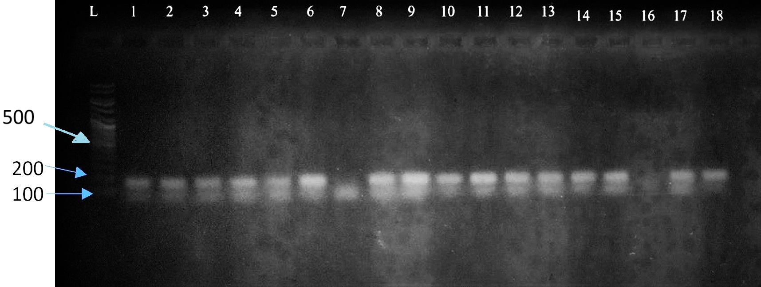

SSR profiling with primer LU-9

Fig. No. 7. Characterization of Linseed Germplasm using SSR primers

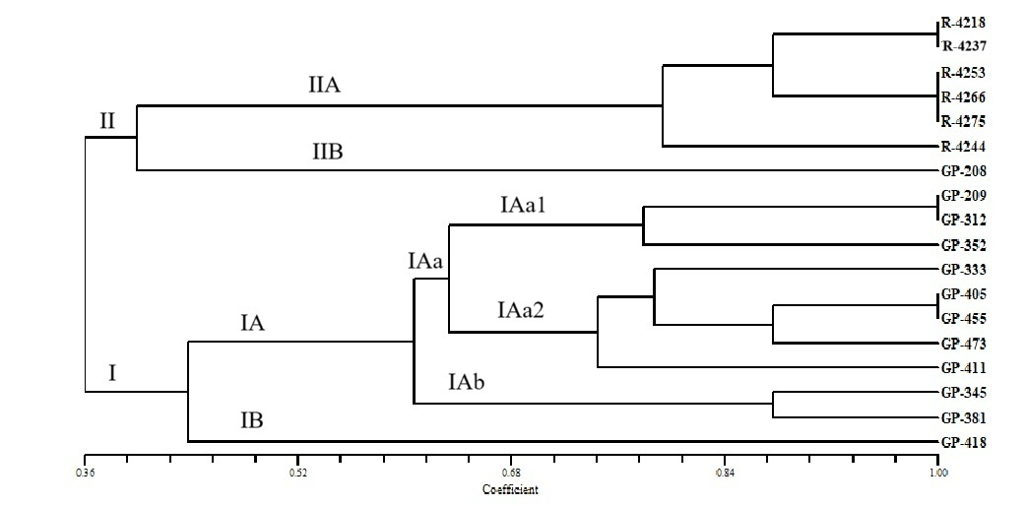

Fig. No. 8. Cluster analysis via UPGMA

4. CONCLUSION
The comprehensive characterization of 18 linseed genotypes through agro-morphological, biochemical, and molecular markers revealed substantial genetic variability, indicating rich diversity among the genotypes evaluated. Phenotypically, GP-208 stood out as the most promising genotype, exhibiting the earliest 50% flowering (51.5 days), highest number of capsules per plant (23), highest seed count per capsule (12), most primary branches (11), and maximum yield per plant (143.75 g). In contrast, GP-405 recorded the lowest yield (74.7 g), and R-4218 showed the least seed count per capsule (4.5). The tallest plant was R-4266 (72.12 cm), while GP-381 was the shortest (48.16 cm). The highest 1000-seed weight was recorded in R-4237 and R-4275 (6.97 g), whereas R-4253 showed the lowest (4.72 g). Biochemically, 13 scorable protein bands were observed using SDS-PAGE, out of which eight were polymorphic and five monomorphic, suggesting moderate protein diversity. UPGMA clustering based on protein profiles grouped the genotypes into two major clusters, with GP-411 forming a distinct out-group. Molecular marker analysis using ISSR and SSR techniques further validated the genetic diversity. Six ISSR primers amplified 24 polymorphic bands, with 87.5% mean polymorphism. UBC-815, UBC-819, and UBC-825 showed 100% polymorphism with the highest PIC values (up to 0.48), making them the most informative primers. Genetic similarity ranged from 0.26 to 0.94, identifying GP-208 and GP-352/GP-473 as the most genetically distant pairs, while GP-411 and R-4244 were the most similar (0.97). SSR marker analysis using five primers yielded 13 bands, with 92% average polymorphism. The most informative SSR marker was LU-6 (PIC 0.47, 100% polymorphism), while LU-8 was the least (PIC 0.19). Similarity indices ranged from 0.09 (GP-208 vs. GP-473) to 1.0, confirming GP-208 and GP-473 as highly diverse. Cluster analysis based on SSR data grouped genotypes into two main clusters, further subdivided into multiple sub-clusters. GP-208 and GP-418 emerged as the most genetically distinct genotypes, while several others showed complete genetic similarity (100%).

REFERENCES
Adhikari, S., Saha, S., Bandyopadhyay, T. K., & Ghosh, P. (2015). Efficiency of ISSR marker for characterization of Cymbopogon germplasms and their suitability in molecular barcoding. Plant systematics and evolution, 301, 439-450.
Akbar, M., Mahmood, T., Anwar, M., Ali, M., Shafiq, M., & Salim, J. (2003). Linseed improvement through genetic variability, correlation and path coefficient analysis. Int. J. Agric. Biol, 5(3), 303-305.
Beer, S. C., Goffreda, J., Phillips, T. D., Murphy, J. P., & Sorrells, M. E. (1993). Assessment of Genetic Variation in Avena sterilis using Morphologicall Traits, Isozymes, and RFLPs. Crop Science, 33(6), 1386-1393.
Chandrawati, D., Singh, N., Kumar, R., Kumar, S., Ranade, S. A., & Kumar Yadav, H. (2018). Agro-Morphological Traits and Microsatellite Marker s Based Genetic Diversity in Indian Genotypes of Linseed (Linum usitatissimum L.).
Cloutier, S., Miranda, E., Ward, K., Radovanovic, N., Reimer, E., Walichnowski, A., s & Ragupathy,R. (2012). Simple sequence repeats marker development from bacterial artificial chromosome end sequences and expressed sequence tags of flax (Linum usitatissimum L.). Theoretical and applied genetics, 125, 685-694.
Doyle J.J. & J.V. Doyle. (1987). A rapid DNA isolation procedure for small amounts of leaf tissue. Phytochem. Bull., 19: 810–815.
Ganorkar, P.M. and Jain, R.K. 2013. Flaxseed – a nutritional punch. International Food Research Journal, 20(2): 519-525.
Green, A. G., & Marshall, D. R. (1981). Variation for oil quantity and quality in linseed (Linum usitatissimum). Australian Journal of Agricultural Research, 32(4), 599- 607.
Green, A. G.; Chen, Y.; Singh, S.P. and Dribnenki, J.C. (2008). Flax in compendium of transgenic crop plants. Edited by Kole C, Hall,T. C.; Oxford: Blac/...--well Publishing Limited. 199-226.
Gulla, B., Jadhav, V., & Dudhare, M. S. (2021). Assessment of genetic diversity and physiochemical analysis of linseed (Linum usitatissimum L.) genotypes. TPI, 10(2), 328-331.
Hurteau, M.C. 2004. Unique new food products contain good omega fats. J. Food Sci. Edu., 3: 52-53.
Kale, S. M., Pardeshi, V. C., Kadoo, N. Y., Ghorpade, P. B., Jana, M. M., & Gupta,V. S. (2012). Development of simple genomic sequence repeat markers for linseed using next-generation sequencing technology. Molecular breeding, 30(1), 597-606.
Kumari, S., Prasad, B.D. & Nirala, R.B.P. (2020). Assessment of molecular diversity among linseed (Linum usitatissimum L.) genotypes using SSR markers. The Indian Society of Oilseeds Research. 142.
Pali, V., & Mehta, N. (2016). Genetic diversity assessment of flax (Linum usitatissimum L.) germplasm using molecular and morphological markers. Electronic Journal of Plant Breeding, 7(4), 986-995.
Pali, V., Mehta, N., Verulkar, S. B., Xalxo, M. S., & Saxena, R. R. (2015). Molecular diversity in flax (Linum usitatissimum L.) as revealed by DNA based markers. Int J Plant Res, 28, 157-165.
Ragupathy, R., Rathinavelu, R., & Cloutier, S. (2011). Physical mapping and BAC-end sequence analysis provide initial insights into the flax (Linum usitatissimum L.) genome. BMC genomics, 12, 1-17.
Rai, M. (2012). oil seed. Handbook of agriculture, pp 1186-1194.
Rajwade, A.V., Arora, R.S., Kadoo, N.Y., Harsulkar, A.M., Ghorpade, P.B. & Gupta, Reddy, M.P.; Sarla, N. & Siddiq, E.A. (2002). Inter simple sequence repeats (ISSR) polymorphism and its application in plant breeding. Euphytica. 128, 9–17.
Sandip, M.K., Varsha, C.P., Narendra, Y.K., Prakash, B.G., Murari, M.J. & Vidya, S.G. (2012). Development of simple genomic sequence repeat markers for linseed using next generation sequencing technology. Mol. Breed. 30, 597– 606. doi: 10.1007/s11032-011-9648-9
Sardar AK, Shinwari ZK, Rabbani A. (2012) Study of total seed protein pattern of rice (Oryza sativa L.) breeding lines of Pakistan through sds-page. Pak. J Bot 2012;45(3):871- 876.
Saroha, A., Pal, D., Kaur, V., Kumar, S., Bartwal, A., Aravind, J., ... & Wankhede, D. P. (2022). Agro-morphological variability and genetic diversity in linseed (Linum usitatissimum L.) germplasm accessions with emphasis on flowering and maturity time. Genetic Resources and Crop Evolution, 69(1), 315-333.
Soto-Cerda, B. J., Maureira-Butler, I., Muñoz, G., Rupayan, A., & Cloutier, S. (2012). SSR-based population structure, molecular diversity and linkage disequilibrium analysis of a collection of flax (Linum usitatissimum L.) varying for mucilage seed-coat content. Molecular breeding, 30, 875-888
Soto-Cerda, B. J., Saavedra, H. U., Navarro, C. N., & Ortega, P. M. (2011). Characterization of novel genic SSR markers in Linum usitatissimum (L.) and their transferability across eleven Linum species. Electronic Journal of Biotechnology, 14(2), 4-4.
Tadesse, T., Parven, A., Singh, H., & Weyessa, B. (2010). Estimates of variability and heritability in linseed germplasm. International Journal of Sustainable Crop Production, 5(3), 8-16.
Vaisey-Genser M, Morris D.H. (2003) Introduction: History of the cultivation and uses of flaxseed. In AD Muir, ND Westcott, eds, Flax: The genus Linum. Taylor & Francis, London, pp 1-21.
Wakjira, A.; Maryke, T. and Arno, H. (2004). Variability in oil content and fatty acid composition of Ethiopian and introduced cultivars of linseed. Journal of Science Food and Agriculture. 84: 1-8
Wolfe, A.D. & Liston, A. (1998). Contributions of PCR-based methods to plant systematics and evolutionary biology. In: "Molecular systematics of plants", 67 (Eds.): Soltis, D.E., P.S. & Doyle J.J., 2nd Edition. Kluwer Academic Publishers, Boston. PP. 43-86.
Zietkiewicz, E., Rafalski A. & Labuda, D. (1994). Genome fingerprinting by simple sequence repeat (SSR) anchored polymerase chain reaction amplification. Genomics. 20: 176–183.

