Original Research Article

**COMPARATIVE ANALYSIS OF INDICATORS TO TIME OF FLOWERING IN MUNGBEAN (*Vigna radiata* L.)**

ABSTRACT

|  |
| --- |
| Mungbean (*Vigna radiata* L. Wilczek) is a short-duration pulse crop of economic and nutritional importance in Asia, with India being the leading global producer. Despite its potential, productivity remains low due to environmental stress at flowering during rainy season. In the present study, 270 genotypes were evaluated to assess the reliability of days to 50% flowering (DFF) and growing degree days (GDD) as selection traits across two contrasting seasons (Summer 2024 and post-rainy 2024–25). GDD showed higher genetic variability (GCV: 9.38%, PCV: 15.37%) than DFF (GCV: 5.73%, PCV: 9.87%). Heritability and genetic advance were also slightly higher in GDD. A weak but significant correlation (r = 0.135*, p < 0.001) suggests GDD captures temperature responses distinct from calendar days. Significant genotype × season interactions were observed for both traits. Overall, GDD appears to be a more robust and physiologically meaningful trait for assessing flowering time, revealing its use in breeding for climate-resilient mungbean cultivars. |

*Keywords: Days to 50% flowering, Growing degree days, Mungbean, Screening*1. INTRODUCTION

In India, mungbean is cultivated in both rainy and post rainy seasons, with total production estimated at 1607 thousand tonnes of which, 1500 thousand tonnes in rainy and 107 thousand tonnes in post-rainy season (Indiastat, 2025). Despite its higher sown area during rainy season, productivity is significantly low (440 kg/ha) compared to post-rainy (795 kg/ha). This productivity gap is attributed partly to flowering coinciding with erratic rainfall and high wind during rainy season, leading to heavy flower drop and reduced pod set.

Among the various agronomic traits considered in mungbean improvement, days to 50% flowering (DFF) is often overlooked due to its inconsistent or negative association with yield in previous and the ongoing studies (Manivelan et al., 2019). DFF is typically recorded through visual observation as the number of calendar days from sowing to flowering, making it highly susceptible to environmental variability, particularly temperature and photoperiod.

Nevertheless, flowering time is a critical adaptive trait in mungbean, with direct implications for yield potential, resource-use efficiency, and stress avoidance. Early flowering genotypes may escape terminal stresses such as drought and heat, while late-flowering ones may benefit from longer vegetative growth in favourable environments (Shavrukov et al., 2017). Thus, identifying and selecting an optimal flowering window is quite essential for enhancing yield stability across diverse agro ecological zones.Limitations of DFF can be addressed through growing degree days (GDD) that offers a more robust and physiologically meaningful measure of flowering time. GDD reflects the cumulative thermal time required for a crop to reach developmental stages, calculated using daily temperature data (Gill et al., 2011). By integrating actual temperature exposure, GDD provides a standardized metric that minimizes confounding effects of seasonal variability and allows for more accurate comparison across environments.

The present study was aimed to compare DFF and GDD in a diverse mungbean panel evaluated across two contrasting seasons. The primary objective was to assess the reliability and consistency of GDD as a selection criterion for flowering time, and its potential application in improving the precision of mungbean breeding.

2. material and methods

The present study was conducted at the research farm of the International Crops Research Institute for the Semi-Arid Tropics (ICRISAT), Patancheru, India. A total of 270 mungbean (*Vigna radiata* L. Wilczek) accessions from the minicore collection sourced from World Vegetable Centre, Patancheru, were evaluated. The experiment was laid out in an alpha lattice design with two replications during the Summer 2024 season and three replications during the post-rainy season, 2024–25. Each entry was sown in a plot of 2 meters length with a spacing of 30 x 15 cm. The observation for days to 50% flowering (DFF) was recorded when 50% of the plants in a plot flowered.

Growing Degree Days (GDD) was calculated to assess the thermal time requirement for flowering using the formula:

$$Growing degree days \left(0∁ day\right)= \frac{T_{max }+ T_{min}}{2}- T_{b}$$

Where,

Tmax – Daily maximum temperature (0C)

Tmin- Daily minimum temperature (0C)

Tb – Base temperature (0C)

GDD values were obtained through the simple arithmetic accumulation of daily mean temperatures exceeding the base temperature.

**Statistical Analysis**

Phenotypic and genotypic coefficients of variation (PCV and GCV) were computed following the method proposed by Burton and De Vane (1953). Broad-sense heritability (H²) was estimated as the ratio of genotypic variance to phenotypic variance and expressed as a percentage, as described by Lush (1949) and Hanson et al. (1956). Genetic advance (GA) as a percentage of the mean was categorized as low (<10%), moderate (10–20%), and high (>20%) following the criteria of Johnson et al. (1955). Phenotypic and genotypic correlation coefficients were estimated as per the method of Singh and Chaudhary (1977). All statistical analyses were performed using appropriate packages in R software version 4.5.1.

3. results and discussion

**Descriptive statistics and seasonal variations in flowering time**

The mean days to 50% flowering (DFF) and growing degree days (GDD) across genotypes were 39.23 days and 16.54 units, respectively. The boxplot of days to 50% flowering (DFF) across seasons indicated that flowering occurred slightly earlier during post-rainy season 2024–25, as reflected by a lower median DFF compared to summer 2024 (Fig 1a). However, the range and inter quartile spread were broader in the summer season, suggesting greater phenotypic variability. Additionally, multiple outliers were observed particularly in summer, indicating the presence of genotypes with unusually delayed flowering, potentially due to higher temperatures or stress conditions.

The boxplot of growing degree days (GDD) further implied that genotypes required a higher thermal accumulation to reach flowering during summer 2024 than post-rainy season, 2024–25. The median GDD was clearly shifted upward for summer, consistent with elevated ambient temperatures and extended photoperiods. A few extreme outliers, including negative values, may point to possible errors in temperature data recording or issues with baseline temperature calibration (Fig 1b).

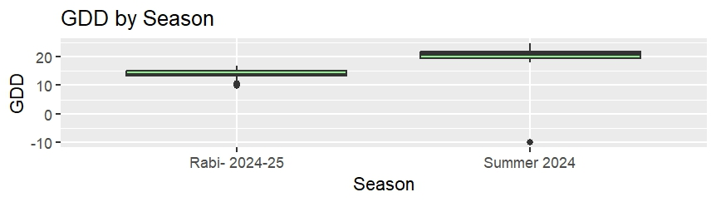Box plot visualization highlighted that DFF reflects moderate seasonal shifts while, GDD more precisely captures the thermal sensitivity of flowering. This supported the use of GDD as a physiologically robust trait for evaluating flowering time, especially under variable climatic conditions. Thus, in temperature sensitive crops like mungbean, GDD offers a more reliable estimate than calendar days for comparing performance of genotypes across environments.

Figure 1: Boxplots showing (A) Days to 50% Flowering (DFF) and (B) Growing Degree Days (GDD) across two contrasting growing seasons—Rabi 2024–25 and Summer 2024

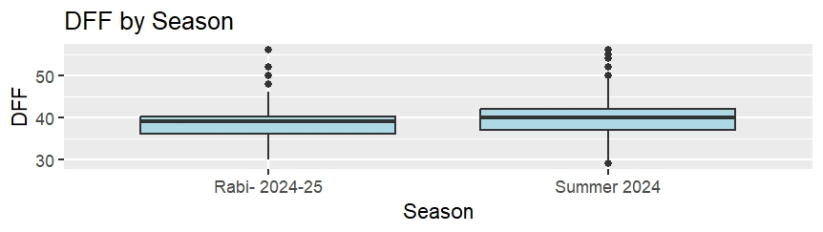**Assessment of genetic parameters for DFF and GDD**

The genotypic coefficient of variation (GCV) was higher for GDD (9.38%) than for DFF (5.73%), indicating greater genetic variability in GDD compared to flowering time. Similarly, the phenotypic coefficient of variation (PCV) was also higher in GDD (15.37%) than in DFF (9.87%), suggesting that GDD captures more environmental influence in addition to genetic variation.

**Assessment of genetic parameters of DFF and GDD**

Broad-sense heritability (H²) was moderate for both traits but slightly higher in GDD (37.28%) compared to DFF (33.65%). The genetic advance as a percentage of the mean (GA%) followed the same trend, being notably higher for GDD (11.80%) than for DFF (6.84%), indicating greater potential for selection gain through GDD.

Heritability estimates were moderate for DFF (33.6%) and GDD (37.2%) but, GDD exhibited substantially higher genotypic and phenotypic coefficients of variation (GCV and PCV), as well as a greater expected genetic advance. Even though, phenotypic variance (Vp) was same for DFF and GDD, the higher GCV and GA in GDD suggested its capturing ability of genetic differences better despite at similar error levels. These findings were in agreement with that of Jyoti (2016), Prasad and Prasad (2013) and Narsimhulu *et al.* (2013) who also reported moderate heritability for DFF. This revealed that while, both traits were moderately heritable, GDD provides a more sensitive and reliable indicator of genetic differences in flowering behavior across genotypes. Therefore, GDD may serve as a more effective selection criterion for flowering time improvement in mungbean under variable environmental conditions (Table 1). The coefficient of variation (CV) was notably higher for GDD (23.72%) than for DFF (8.96%), reflecting greater relative dispersion in thermal time requirements among genotypes. The higher CV and SD for GDD support its utility in capturing finer-scale differences in flowering behavior under varying environmental conditions.

Table 1**: Descriptive statistics and genetic parameters for DFF and GDD**

|  |  |  |
| --- | --- | --- |
| **Parameter** | **DFF** | **GDD** |
| **Mean** | 39.23 days | 16.54 units |
| **GCV (%)** | 5.73 | 9.38 |
| **PCV (%)** | 9.87 | 15.37 |
| **H² (%)** | 33.65 | 37.28 |
| **GA (%)** | 6.84 | 11.80 |
| **Vg** | 5.04 | 5.04 |
| **Vp** | 14.99 | 14.99 |
| **SD** | 3.51 | 3.92 |
| **CV (%)** | 8.96 | 23.72 |

**Analysis of Variance**

The results of the ANOVA (Table 2) revealed significant effects of season and genotype on both days to 50% flowering (DFF) and growing degree days (GDD), indicating that both environmental and genetic factors influenced these traits.

For DFF, the effect of season was highly significant (F = 36.91, *p* = 1.75 × 10⁻⁹), reflecting substantial variation in flowering time between summer and post-rainy seasons. The genotypic effect was also highly significant (F = 1.97, *p* = 1.51 × 10⁻¹⁴), indicating meaningful genetic variability among the 270 accessions. Similarly, GDD also showed a very strong seasonal effect (F = 3544.52, *p*< 2 × 10⁻¹⁶) and a significant genotypic effect (F = 1.24, *p* = 0.00991) but, a lesser magnitude than DFF. This confirmed that thermal accumulation differs substantially across seasons and that genetic differences in GDD do exist, albeit modestly.

**Table 2. ANOVA for Days to 50% Flowering (DFF) and Growing Degree Days (GDD)**

|  |  |  |  |  |  |
| --- | --- | --- | --- | --- | --- |
| **Trait** | **Source** | **Sum of Squares** | **Mean Square** | **F Value** | **Pr(>F)** |
| DFF | Season | 367.03 | 367.03 | 36.91 | 1.75 × 10⁻⁹ |
|  | Genotype | 5575.65 | 19.63 | 1.97 | 1.51 × 10⁻¹⁴ |
|  | Residuals | 10003.33 | 9.94 |  |  |
| GDD | Season | 14354.19 | 14354.19 | 3544.52 | < 2 × 10⁻¹⁶ |
|  | Genotype | 1426.79 | 5.02 | 1.24 | 0.00991 |
|  | Residuals | 4069.94 | 4.05 |  |  |

**Two-Way ANOVA and Interaction Effects**

The two-way ANOVA with genotype × season interaction (Table 2) provided deeper insight into the trait behavior across environments. For DFF, all sources of variation i.e., season, genotype, and their interaction were highly significant (p < 0.001). The significant G × E interaction (F = 1.77, *p* = 3.65 × 10⁻⁹) suggested that genotype performance for flowering time was not consistent across seasons, underlining the importance of evaluating genotypes in multiple environments (Table 3) and these results align with Khan *et al*. (2004).

For GDD, the season effect remained extremely significant (F = 3904.36, *p* ≈ 0), while both genotype (F = 1.37, *p* = 0.00057) and genotype × season interaction (F = 1.40, *p* = 0.00033) were also statistically significant. Although the magnitude of these F-values was smaller compared to DFF, the interaction still revealed differential thermal response among genotypes across seasons.

Table 3**. Two-Way ANOVA with Genotype × Season Interaction**

|  |  |  |  |  |  |
| --- | --- | --- | --- | --- | --- |
| **Trait** | **Source** | **Sum of Squares** | **Mean Square** | **F Value** | **Pr(>F)** |
| DFF | Season | 367.03 | 367.03 | 43.99 | 6.28 × 10⁻¹¹ |
| Genotype | 5575.65 | 19.63 | 2.35 | 2.33 × 10⁻²⁰ |
| Season × Genotype | 3713.33 | 14.74 | 1.77 | 3.65 × 10⁻⁹ |
| Residuals | 6290.00 | 8.34 |  |  |
| GDD | Season | 14354.19 | 14354.19 | 3904.36 | 3.63 × 10⁻³⁰⁰ |
| Genotype | 1426.79 | 5.02 | 1.37 | 0.00057 |
| Season × Genotype | 1301.57 | 5.16 | 1.40 | 0.00033 |
| Residuals | 2768.37 | 3.68 |  |  |

The significant genotypic variance and moderate heritability for both DFF and GDD indicated that genetic improvement through selection is possible. Notably, the stronger environmental and interaction effects observed in GDD suggested that temperature-driven flowering responses were more variable and season-dependent compared to calendar-based flowering time. However, the higher GCV, PCV, and genetic advance in GDD also implied that selection based on GDD could be more efficient in identifying genotypes with stable and early flowering under variable climates.

On the overall, the significant genotype × season interactions for both traits highlighted the importance of multi-environment trials. GDD, in particular, offers a more climate-resilient measure of flowering time and could be a valuable trait for selection in breeding programs targeting stable adaptation under diverse seasonal conditions.

**Correlation between Days to 50% Flowering (DFF) and Growing Degree Days (GDD)**

The relationship between DFF and GDD was presented in Table 4. The Pearson correlation coefficient was r = 0.135, indicating a weak but statistically significant positive correlation between the two traits (p = 1.16 × 10⁻⁶). The 95% confidence interval for the correlation ranged from 0.081 to 0.188, based on a large sample size (n = 1289), suggesting robustness of the estimate despite the low magnitude of association.

**Table 4: Correlation between GDD and DFF**

|  |  |
| --- | --- |
| **Parameter** | **Value** |
| **Pearson correlation (r)** | 0.135 |
| **p-value** | 1.16 × 10⁻⁶ |
| **95% Confidence Interval** | 0.081 – 0.188 |
| **Sample size (df + 2)** | 1289 |

The scatterplot showed a wide dispersion of GDD values across the DFF range, with some genotypes accumulating higher or lower thermal time despite having similar flowering durations. This reflected the inconsistent thermal response across genotypes, likely due to differences in growth rate, canopy structure, or microclimatic variation. The low correlation indicated DFF and GDD, though related, captured distinct aspects of flowering behaviour DFF being a calendar-based trait, while GDD accounts for temperature-driven developmental progress (Figure 2).

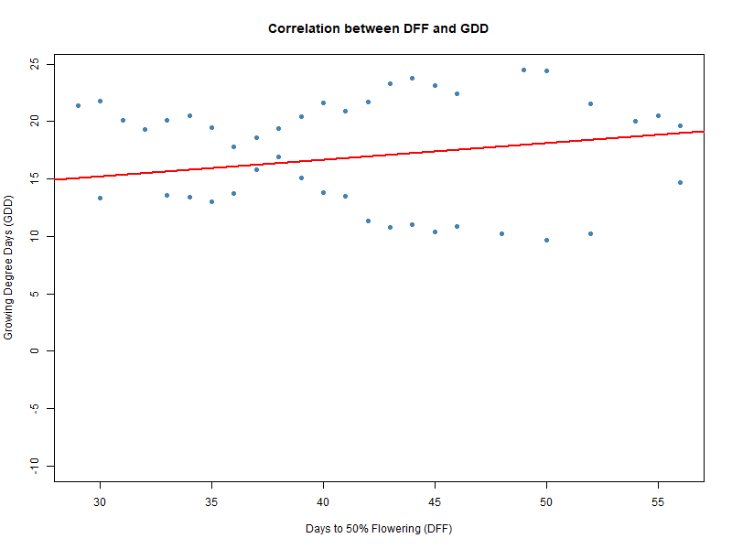

Figure 2: Scatter plot between DFF and GDD

From a breeding perspective, this weak correlation suggested that selection based on DFF alone may not fully reflect genotypic efficiency in thermal time utilization, especially under variable climates. Therefore, GDD can serve as a complementary trait in identifying heat-resilient or early-flowering genotypes under fluctuating environmental conditions.

4. Conclusion

The present study highlighted the importance of integrating temperature-based measures like growing degree days (GDD) in phonological assessment of mungbean. While days to 50% flowering (DFF) remains a conventional trait and it was influenced heavily by seasonal and environmental fluctuations. In contrast, GDD captures cumulative thermal time and offers a more stable and genetically informative estimate of flowering behavior. GDD can serve as a valuable selection criterion for identifying early, stable, and climate-resilient flowering genotypes in mungbean breeding. Its integration alongside traditional calendar-based traits can enhance the accuracy and efficiency of crop improvement under variable and unpredictable agroclimatic scenarios.

a

**REFERENCES**

Burton, G.W. and De Vane, D.E., 1953. Estimating heritability in tall fescue (Festuca arundinacea) from replicated clonal material.

Gill, K.K., Singh, G., Bains, G.S. and Ritu, 2011. Prediction of Mungbean Phenology of Various Genotypes Under Varying Dates of Sowing Using Different Thermal Indices. *Challenges and Opportunities in Agrometeorology*, pp.491-497.

Hanson, C.H., Robinson, H.F. and Comstock, R.E., 1956. Biometrical studies of yield in segregating populations of Korean lespedeza 1. *Agronomy journal*, *48*(6), pp.268-272.

Indiastat, https://www.indiastat.com/

Jha, U.C., Shafi, S., Tallury, S., Nayyar, H., Udgata, A.R., Ciampitti, I.A., Siddique, K.H. and Prasad, P.V., 2025. Dynamic changes in seed nutritional components of mung bean [(Vigna radiata (L.) R. Wilczek)] under heat stress. *Scientific Reports*, *15*(1), p.12586.

Johnson, H.W., Robinson, H.F. and Comstock, R.E., 1955. Estimates of genetic and environmental variability in soybeans.

Jyoti, 2016, Study of mungbean yellow mosaic virus (MYMV) resistance in mungbean [*Vigna radiata* (L.) Wilczek] and urdbean [*Vigna mungo* (L.) Hepper] employing NBS-LRR and in-silico based markers. *M.Sc. (Agri.) Thesis*, University of Agricultural Sciences, Dharwad, Karnataka, India.

Khan M D, Khalil I H, Khan M A and Kramullah I, 2004, Genetic divergence and association for yield and related traits in mashbean. *Sarhad Journal of Agriculture*, 20: 555-561.

Khan, M.D., Khalil, I.H., Khan, M.A. and Ikramullah, I., 2004. Genetic divergence and association for yield and related traits in mash bean.

Lush, J.L., 1949. Heritability of quantitative characters in farm animals.

Manivelan K, Karthikeyan M, Blessy V, Priyanka A R, Palaniyappan S and Thangavel P, 2019, Studies on correlation and path analysis for yield and yield related traits in greengram [*Vigna radiata* (L.) Wilczek]. *Pharma Innovation Journal*, 8(9): 165-167.

Mishra, A., Singh, C.M., Sharma, V., Kumar, H., Shukla, G. and Kumar, M., 2025. Genetic variability, association and principal component analysis for agronomical traits in mungbean (Vigna radiata L. Wilczek). *Journal of Environmental Biology*, *46*(3), pp.373-381.

Narasimhulu, R., Naidu, N.V., Shanthi, P., Rajarajeswari, V. and Reddy, K.H., 2013. Genetic variability and association studies for yield attributes in mungbean (*Vigna radiata* (L.) Wilczek). *Indian Journal of Plant Sciences*, 2(3), pp.82–86.

Prasad, B.V. and Prasad, G.S., 2013. Genetic Variability, Trait Association and Path Analysis of Yield and Yield Components in Vigna radiata L. *International journal of Bio-resource and Stress Management*, *4*(2), pp.251-254.

Shavrukov, Y., Kurishbayev, A., Jatayev, S., Shvidchenko, V., Zotova, L., Koekemoer, F., De Groot, S., Soole, K. and Langridge, P., 2017. Early flowering as a drought escape mechanism in plants: how can it aid wheat production?. *Frontiers in plant science*, *8*, p.1950.

Singh, R.K. and Chaudhary, B.D., 1981. Biometrical methods in quantitative genetic analysis.