Journal Name: | Journal of Advances in Biology & Biotechnology
Manuscript Number: | Ms_JABB_140188
Title of the Manuscript: | Sun Basking Behaviour and Ecological Significance of Banbakri Antelope (Boselaphus tragocamelus, Pallas 1766), India
Type of the Article

PART 1: Comments

 | Reviewer’s comment  Artificial Intelligence (AI) generated or assisted review comments are strictly prohibited during peer review. | Author’s Feedback (It is mandatory that authors should write his/her feedback here)
Please write a few sentences regarding the importance of this manuscript for the scientific community. A minimum of 3-4 sentences may be required for this part.

Is the title of the article suitable?
(If not please suggest an alternative title)

Is the abstract of the article comprehensive? Do you suggest the addition (or deletion) of some points in this section? Please write your suggestions here.

Is the manuscript scientifically, correct? Please write here.
Are the references sufficient and recent? If you have suggestions of additional references, please mention them in the review form.

Is the language/English quality of the article suitable for scholarly communications?

Optional/General comments | Overall, the manuscript presents what appears to be the first documented study of sun basking behavior in the Banbakri antelope (Boselaphus tragocamelus) under free-ranging conditions in Bihar, India. This focus on a relatively understudied species and behavior contributes original observational data to the fields of animal behavior and wildlife ecology. However, there are some weaknesses that need to be addressed to improve it. Therefore, I suggest Major Revisions.  General Observations  - The manuscript requires language editing to enhance clarity, eliminate redundancies, and improve grammar and readability.  - Some sentences are overly long and complex and should be simplified for clarity.  - Address inconsistent use of commas, periods, and ampersands.  - Ensure consistent formatting of figure labels (e.g., “Fig. 2” vs. “Figure 2”) and caption style throughout the manuscript. Use only one format and follow the journal guidelines.  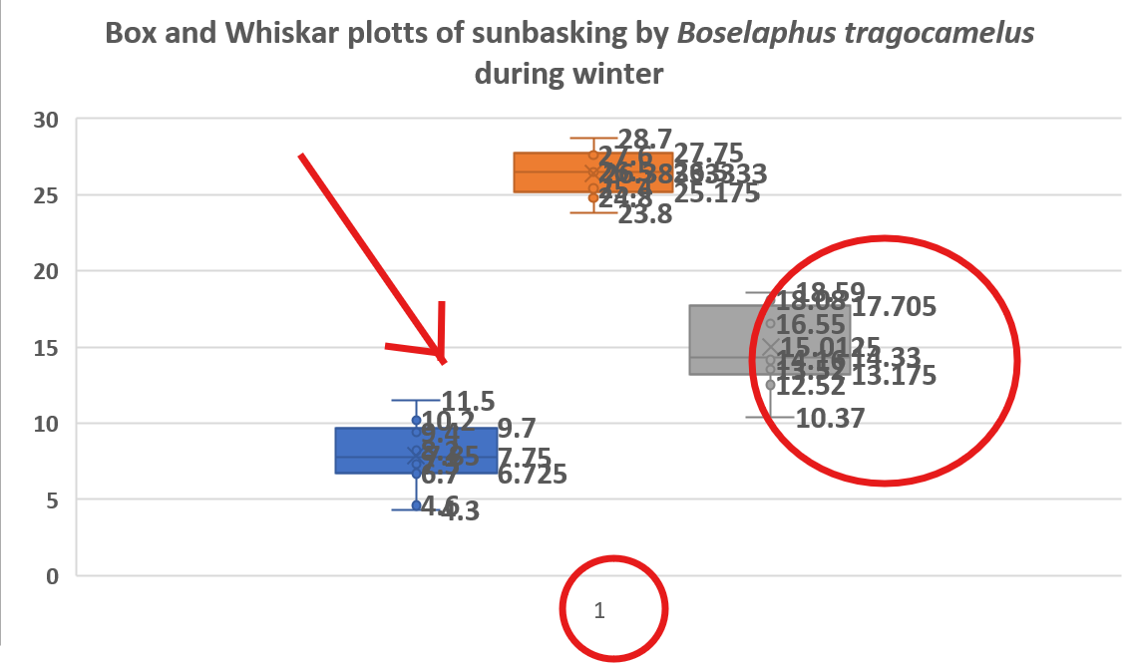  - Delete the number and insert the right name of X and Y axis, same for Fig. 3  - Maintain consistency in the species' common name (“Banbakri” vs. “Nilgai”) throughout the manuscript. The manuscript inconsistently uses “Banbakri” and “Nilgai” without clarifying that they refer to the same species, which may confuse readers.  - Figures should be embedded near their first mention and have descriptive captions.  - Graphs must have clearly labeled axes including units, legends if multiple groups or variables are shown, and error bars where applicable.  - A figure comparing basking time across seasons would provide clearer visual evidence of seasonal differences.  - Graphs showing temperature and basking frequency over time would strengthen the link between environmental conditions and behavior.  Specific comments  Abstract  - The abstract does not specify how many herds or individuals were observed, nor the duration or time frame of the study. In addition, the number of breakdown by age/sex, or other notable patterns (e.g., time of day, group vs. solitary basking) are not included.  - A brief mention of whether observed differences in basking time are statistically significant is missing.  - A concise statement on how these findings could impact conservation or management is absent. There is no clear statement on the broader implications or applications of the findings.  - Lines 5-25: In my opinion, the species is commonly known as the “Nilgai,” although it is occasionally referred to as the “Banbakri antelope.” This inconsistency may confuse readers who are unfamiliar with the term.  - Lines 8–11: Consider shortening repetitive phrases.  - Lines 9–10: The abstract states, “no prior reports document this behavior in Boselaphus tragocamelus.” This strong claim necessitates a comprehensive literature review; without it, there is a risk of overgeneralization.  - Lines 14–18: The terms "average maximum sun basking time" and "minimum in summer" need clarification for non-specialist readers.  - Lines 14–15: The phrase "average maximum sun basking time recorded in winter was 15.01 ± 2.46 minutes, while the minimum in summer was 10.06 ± 1.86 minutes" is unclear. Specify whether "minimum" refers to the lowest observed value or the average minimum, and how this compares to the "average maximum" in winter.  - Line 23: The claim of "first evidence" is unsubstantiated without a clear demonstration of an exhaustive review.  Keywords  - The keywords are appropriate, but "adaptation" is broad; consider use  - Keywords: Banbakri Antelope, thermoregulation, behaviour, ecological significance , sun basking  Introduction  - I believe the introduction lacks a clear research question and does not explicitly state research questions guiding the study.  - In my perspective, the rationale for choosing the specific study area is not clearly justified in terms of its ecological relevance, and the introduction lacks a concise explanation of why basking behavior is important for survival and fitness in this species.  - It is essential to clearly identify what is unknown about basking behavior in this species and why this study is important. Additionally, providing more detailed information on thermoregulatory strategies in large ungulates, specifically antelopes, would enhance the introduction.  - I feel there is little discussion of how basking in Banbakri antelope compares to similar behaviors in other large mammals or antelopes. Adding some information in this context would be beneficial.  - While the lack of prior studies is mentioned, I think a more systematic review of related species would better justify the claim "no prior studies or reports are available on the sunbathing behavior of the Banbakri antelope" may be an overstatement without such a review.  - In my opinion, the introduction is somewhat repetitive regarding the ecological role and distribution of the species; the listing of all the states and habitats is overly detailed and distracts from the main focus.  - Lines 38, 45: To my mind, the species name is spelled “Banbakri” but is commonly known as “Nilgai.” This inconsistency may confuse readers.  - Lines 43–46: I believe the introduction describes the Banbakri antelope as both "free-roaming" and subject to "controlled culling," which may confuse readers about its conservation status.  - Lines 46–51: The shift from Schedule III to V is important, and I think it would benefit from a brief explanation of the implications for conservation, as the legal status of the species is discussed but could be clearer.  - Lines 52–64: the discussion on basking behavior in other taxa is informative but somewhat lengthy; the statement "sun-basking behavior is performed by many vertebrate species, including humans, birds, reptiles, and insects" is too broad and not all-inclusive.  - Lines 73–75: It also highlights the species’ interactions with humans in agricultural landscapes, its role in local wildlife ecology, and its broader ecological and cultural significance.  Materials and Methods  - I believe it is important to specify the number of individuals and total observation hours/days for transparency.  - It is essential to provide clear operational definitions of “basking” and other behaviors to avoid ambiguity.  - I think describing how temperature, humidity, wind speed, and other climatic factors were recorded will enhance the study's credibility.  - Detailing the statistical tests used to analyze basking time and behavior will provide a clearer understanding of the results.  - Including information on observer training and efforts to ensure consistency is crucial for the reliability of the observations.  - An ethical statement regarding permits and wildlife observation practices should be included to demonstrate compliance with ethical standards.  - Improving clarity and specificity in the Materials and Methods section is vital for reproducibility.  - I suggest avoiding irrelevant details and redundancies to maintain focus.  - It is important to ensure all figures are present and correctly referenced for accuracy.  - Adding supporting references for geographical and ecological claims will strengthen the study's foundation.  - I believe it would be beneficial to strengthen the justification for the study by addressing knowledge gaps and comparing it with related research.  - Line 81–83: While the geographic coordinates are precise, I recommend placing the map figure closer to this description for better flow. Consider adding the reference here: "84°20' to 84°40' East longitude (Figure 1)" and deleting "(as shown on Google Maps)."  - I suggest removing "(as shown on Google Maps)" from line 83 for clarity.  - Lines 86–87: Clarifying the source and period of temperature and rainfall data is necessary for thoroughness.  - I believe extensive climatic data in lines 86–104 could be summarized more succinctly or presented in a table for clarity.  - In line 93, while the area is well described, ensuring all figures are properly included and referenced is critical.  - Lines 94–97: Excessive detail about local geography is not directly relevant to basking behavior; condensing or removing this information will help maintain focus.  - I feel the methodology in lines 106–116 lacks sufficient detail on sample size, observation frequency, and behavioral categorization criteria. Specifying how many days and individuals were observed is important.  - In lines 107–110, referencing standard ethological observation protocols and providing details on observer reliability will enhance the methodology's credibility.  - Lines 111–113, mentioning the use of a motorcycle and walking for fieldwork may be unnecessary unless it directly relates to data collection bias; I suggest removing or clarifying its relevance.  - Line 114, discussing this limitation is important for understanding the generalizability of the findings.  - I recommend specifying statistical tests used beyond mean and standard deviation in line 116 to provide a more comprehensive analysis.  Results and Discussion  - Ensure that speculative statements are supported by data. The behavior of short basking periods as a strategy to minimize predation is mentioned but lacks direct evidence.  - Discuss methodological limitations and generalizability of results. There is no discussion of potential biases, observer effects, or environmental confounders affecting basking behavior.  - Quantify and systematically analyze statements. For instance, the number of basking events, individuals observed, and breakdown by age/sex class are not provided.  - Provide quantitative physiological data, such as body temperature or parasite load, to support functional claims. Statistical analysis correlating basking events with temperature, humidity, or other environmental variables would strengthen the findings.  - Include statistical analyses, such as significance testing results, confidence intervals, and effect sizes for differences in basking time. Current statistical analyses are minimal and lack mention of sample size and variance.  - Present clear, well-labeled figures and tables illustrating key findings. Lines 141, 166, 184: Figures are referenced, but actual images or graphs are missing from the text provided.  - Provide direct comparisons with similar ungulates or sympatric species to enhance the relevance of findings. Comparative analysis with basking behaviors in other ungulates or antelope species is lacking.  - Address predation risk evidence. Data or observations supporting the hypothesis that short basking reduces predation are absent.  - Lines 123–125, 149–155: Remove or condense irrelevant information and redundancies. For example, references to group basking and alert postures are repetitive.  - Lines 134–138: Detailed descriptions of color morphs and herd structure are not directly relevant to the main research question.  - Line 146: Provide a stronger comparative analysis to support claims. The claim that "our study provides the first direct evidence" is repeated without adequate comparative analysis.  - Lines 146–147: The phrase "may use basking to facilitate rewarming from torpor" is speculative and lacks physiological support.  - Lines 172–173: Additionally, statements about sunbathing behavior in calves and juveniles are not quantified.  - Lines 197–224: Discuss environmental correlations. Detailed analysis of how weather variables affect basking behavior is missing. The discussion on environmental influence on basking time is good but could be clearer with shorter sentences.  - Line 206: Clarify ambiguous phrases. The phrase “Inevitable animals” is unclear and likely a typo; it could be replaced with “Certain animals” or “Notable animals.”  - Lines 217–218: Avoid distracting references. The mention of golden jackals basking in a zoo may not be directly relevant to wild Banbakri behavior and could distract readers.  - Lines 199–200: consider breaking down lengthy and complex sentences for clarity, particularly in the discussion of environmental influences on basking time.  Conclusion  - Provide concrete suggestions for conservation, management, or community engagement based on the study’s findings.  - Summarize key findings concisely and focus on the main takeaways  References  This section must be revised, it does not respect the journal format

PART 2:

 | Reviewer’s comment | Author’s comment (if agreed with reviewer, correct the manuscript and highlight that part in the manuscript. It is mandatory that authors should write his/her feedback here)
Are there ethical issues in this manuscript? | (If yes, Kindly please write down the ethical issues here in details)

Reviewer details:

Ngaba Mbezele Junior YannickM, Southwest University, PR China.

