# Evaluating efficacy of Integrated Treatments on the Disease Intensity of *Alternaria alternata* in Stevia (*Stevia rebaudiana*)

ABSTRACT

|  |
| --- |
| **Aim:** A field experiment was conducted at Central Research Field, SHUATS, Prayagraj to evaluate the effect of organic manures (FYM@ 4.5 Kg/m2, neem cake @ 40g/m2), bioagent (*Pseudomonas fluorescens* @ 2g/m2) and biomix at two intervals against *Alternaria* leaf spot (*Alternaria alternata)* of stevia (*Stevia rebaudiana*) during *rabi* season 2022-23.  **Study design:** Randomized Block Design in factorial concept with three replications and eight treatments was used to carry out present investigation  **Place and Duration of Study:** Department of Plant Pathology and Central Research Field, SHUATS, Prayagraj were the site in which the experiment was conducted and the objectives were carried out  **Methodology:** The disease intensity was assessed by using 0 to 5 rating scale for measuring disease intensity. Proper Statistical tools and package were used according to the experiment requirement.  **Results:** The minimum per cent disease intensity was recorded in FYM + neem cake + *Pseudomonas fluorescens* + Biomix (18.56%), followed by neem cake + *Pseudomonas fluorescens* + Biomix (21.85%).  **Conclusion:** The minimum disease intensity (%) at 45 DAT (10.98 %) and at 90 DAT (18.56 %) was recorded in treatment T7 - FYM + Neem cake + *Pseudomonas fluorescens* + Biomix. |

*Keywords: Alternaria leaf spot, Organic manures, Bioagent, Biomix, Alternaria alternata, Stevia*

1. INTRODUCTION

A significant part of our eating habits is sugar. The primary source of sugar has historically been cane sugar with a trace amount of beet sugar. The excessive consumption of dangerous sugars found in food, drinks, and a variety of other goods poses a serious threat to human health. From a medical perspective, using more sugar-enriched (sucrose-enriched) items encourages the development of chronic diseases like diabetes and obesity. Therefore, consumer’s interest in goods that use artificial sweeteners rather than sucrose has increased in an effort to limit their intake of sugar through food. The majority of artificial sweeteners are made from artificial components or are solely obtained through chemical synthesis in a lab, both of which are detrimental to human health. Therefore, more and more sweeteners extracted from natural materials are used **(Dushyant *et al*., 2014).**

Native to the Amambay region in northeastern Paraguay, *Stevia rebaudiana* is a bushy shrub with branches that belongs to the *Asteraceae* family. Numerous nations expressed interest in producing stevia and started conducting research. Stevia is grown on 32,000 hectares of land worldwide, with China accounting for 75% of this total and leading the world in both cultivation and supply. India's farmers have been encouraged to grow stevia on a huge scale by the increased demand for natural sweeteners. Many Indian states, including Rajasthan, Punjab, Uttar Pradesh, West Bengal, Madhya Pradesh, Karnataka, Chhattisgarh, Odisha, Maharashtra, and Tamil Nadu, have successfully grown stevia*.* **(Das *et al*.,2010; Singh and Verma, 2015; Pal *et al*., 2015; Maiti *et al.,* 2007).** The plant Stevia rebaudiana produces stevioside, a natural sweetener that is up to 300 times sweeter than sucrose and non-glycemic. Dry stevia leaves are 10–15 times sweeter than sucrose with a glycemic index of zero, meaning they have no calories and have been shown to have no harmful effects on human health. (**Gantait *et al.,* 2015**; **Savita *et al*., 2004)** . The following 11 food items have recently been approved by the FSSAI to use steviol glycoside as a zero-calorie sweetener: ready-to-eat cereals, carbonated water, soft drink concentrate, yoghurt, fruit nectars, non-carbonated water-based beverages, edible ice, jams, jellies, and marmalades, and chewing gum.

According to a survey conducted over the past five years, *Alternaria alternata-*caused Alternaria leaf spot disease is highly prevalent in medicinal plants grown in different West Bengali areas in India. At first, the symptoms manifested as tiny, round, light brown patches. Later, some stayed round with concentric rings or zones, while others turned irregular and dark brown to grey. Large necrotic patches were formed on badly infected leaves by the aggregation of several spots. (**Sen *et al*., 2012).**

The raw materials derived from therapeutic herbs should be free of any harmful or chemical residues, according to the Ayurvedic, Unani, and Siddha schools of Indian medicine. The increased use of agrochemicals in modern agriculture has led to their residues in pharmaceutical preparations. The careless application of chemical pesticides and fertilizers also raises the possibility of environmental contamination and health risks. In order to obtain increased vegetative growth, high yield, and quality improvement, it is imperative that medicinal plants be grown using a sustainable, environmentally friendly, and safe organic farming method in conjunction with bioagents. Therefore, the current investigation was carried out taking into account the aforementioned facts.

2. material and methods

During the *Rabi* season of 2022, the study was carried out in the experimental field of the Department of Plant Pathology at SHUATS, Prayagraj. The land is sandy loam type, uniform, cultivable, and has good drainage. Located at 25.08 ºN latitude and 81.25 ºE longitude, Prayagraj is 98 meters above mean sea level. The current study used a Randomized Block Design in factorial concept with eight treatments and three replications.

According to a survey conducted over the past five years, *Alternaria alternata*-caused leaf spot disease is highly prevalent in medicinal plants. In FYM, biomass yield and a variety of other yield metrics, such as dry leaf yield and the number of leaves per plant, are growing nicely. Farmyard manure (FYM) has the following nutrient composition: N = 0.55%, P2O5 = 0.28%, and K2O = 0.52%. By adding humus and slowly releasing nutrients to the soil, FYM improves soil fertility. It helps retain nutrients and water. **(Abbasi *et al.,* 2005; Rakesh *et al.,* 2013).** The best soil conditioner is neem cake. When applied in combination rather than separately, organic manures were significantly more effective for stevia. The application of biological control agents as a substitute, environmentally beneficial method *Pseudomonas* are thought to be significant rhizosphere organisms. *Pseudomonas fluorescens* is more metabolically and functionally varied, aids in maintaining the health of the soil, and shields crops from diseases. **Biomix** is an all-purpose organic fertilizer made by vermicomposting fish amino acids, bokashi, humic acid, seaweed extract, and a wide spectrum of beneficial microorganisms. It is the only plant food that contains every nutrient required for healthy crop growth. Biomix not only provides a complete balance of macro- and micronutrients but also enhances soil health by enriching it with organic matter and microbial life. It stimulates robust root development, improves soil structure, and boosts plant immunity against pests, diseases, and environmental stress. The natural compounds present help buffer soil pH and create an ideal environment for plant growth. Fast-acting yet long-lasting, Biomix supports sustainable agriculture by being entirely biodegradable, eco-friendly, and free from harmful chemicals. Its rich, earthy composition nourishes the soil and the plant, making it a powerful, all-in-one solution for farmers and gardeners seeking high yields and long-term soil vitality. In contrast to conventional fertilizers, this product delivers nutrients into the soil gradually so that plants may readily access them. Biofungicides, biopesticides, and growth-promoting bioagents were added to create a new biomix. It contains *Trichoderma viride*, *Trichoderma harzianum*, *Aspergillus niger*, *Pseudomonas fluorescens*, *Pseudomonas striata*, *Beauveria bassiana*, *Metarhizium anisopliae*, *Gluconacetobactor*, *Paecilomyces lilacinus*, *Bacillus subtillis*, *Verticillium lecanii*, *Azospirillum brasilince* **(Garde, 2012)**.

Corning glassware and borosil were utilized in all laboratory studies. After being wrapped in sterile paper, the pipettes and petri plates were sanitized for two hours at 160 degrees Celsius in a hot air oven (**Chaudhary et al., 2011).** The usual recipe was followed in the preparation of the culture media. Potato Dextrose Agar (PDA) medium was employed to isolate and cultivate the pathogen. The following is the makeup of PDA: 200g of peeled potatoes, 20g of dextrose, 20g of agar, 1000ml of distilled water, and a pH between 6.0 and 6.5.The pathogen was isolated from the diseased leaf exhibiting typical disease symptoms. The pathogen was isolated using the conventional tissue isolation technique. After 60 seconds of surface sterilization with a 1:1000 mercuric chloride (HgCl2) solution, the diseased components were separated and cleaned in sterile distilled water to get rid of any remaining mercury residues. They were then placed in sterile petri dishes with potato dextrose agar (PDA). The growth of pure colonies was monitored on a regular basis while the petri plates were incubated at room temperature (27 ± 1°C) (Gupta et al., 2010). After growing from the pieces, the pure colonies were placed on PDA slants and cultured for five to seven days at 27 ± 1°C. Characters were then studied using such slants. A tiny amount of the culture will be removed with a sterile needle and put onto a sterile glass slide.

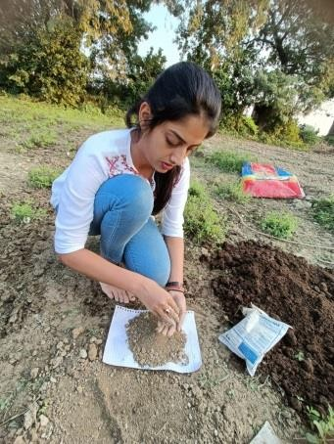 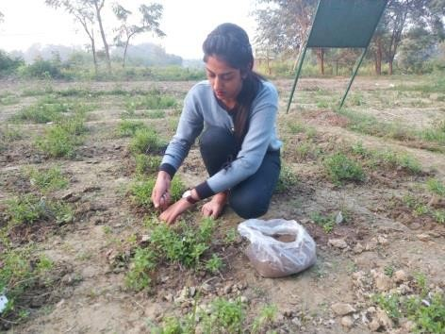

**Fig. 1 Application of biomix Fig. 2 Application of treatments**

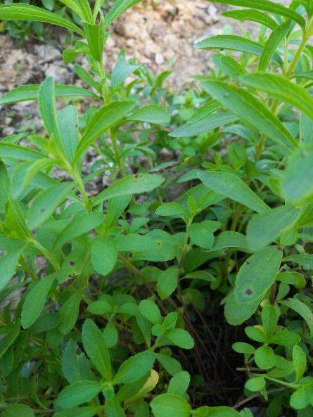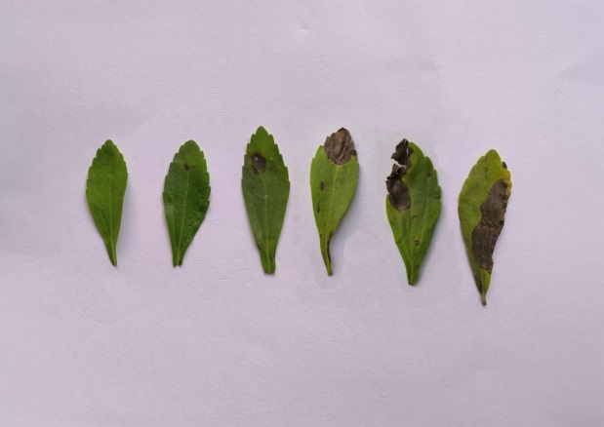

**Fig. 3 Typical symptoms of *Alternaria* leaf spot of stevia**

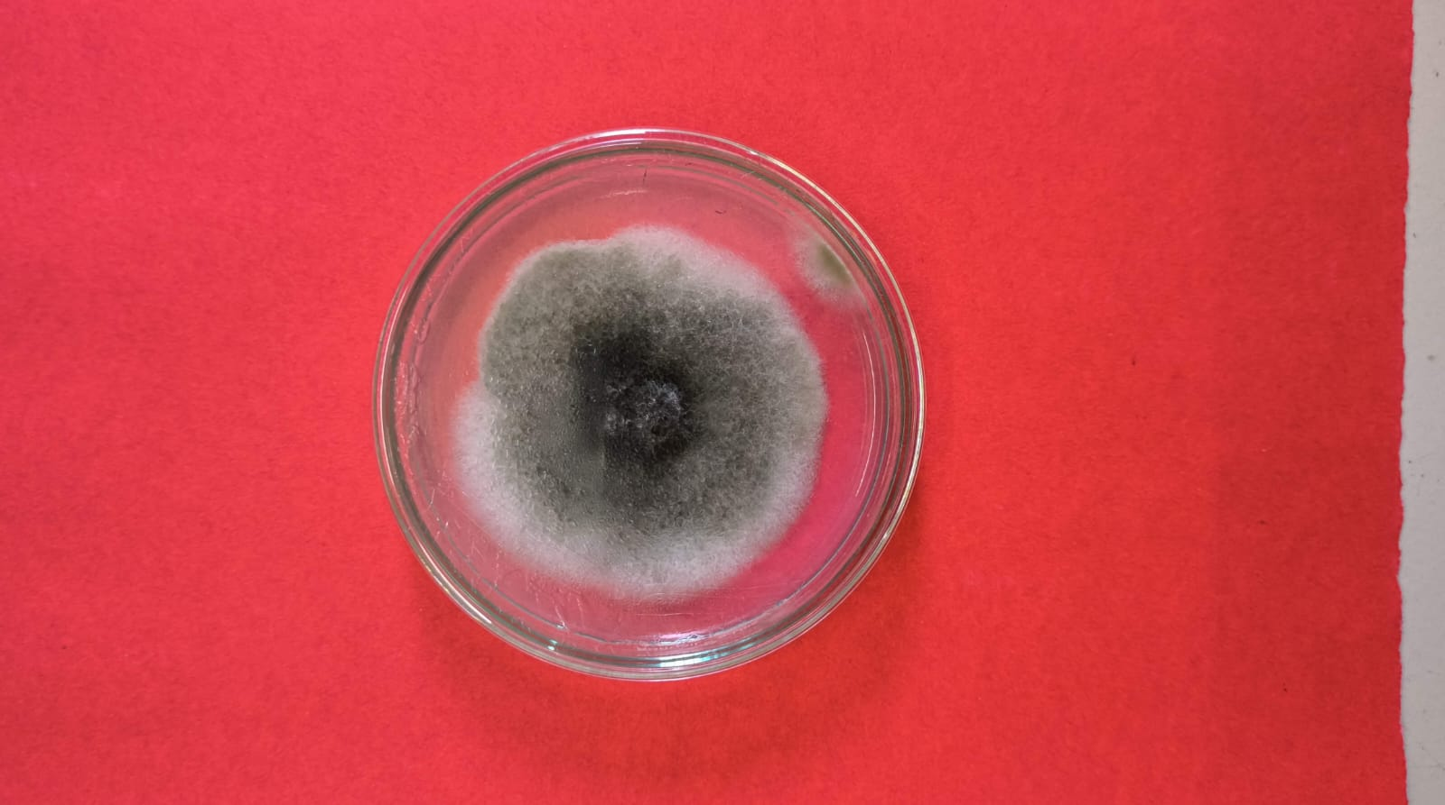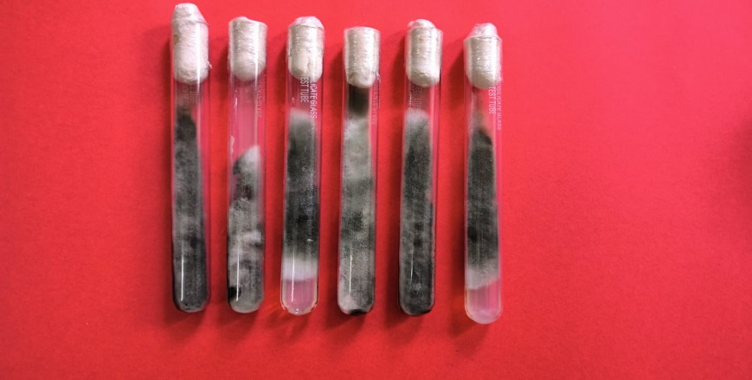

**Fig.4 Pure culture of *Alternaria alternata***

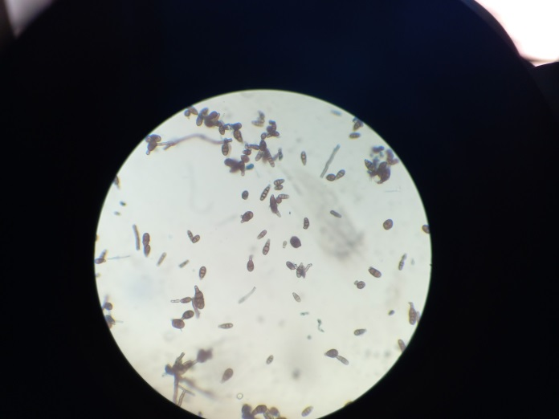

**Fig. 5 Microscopic view of conidia of *Alternaria alternata***

**2.1 Morphological characteristics of *Alternaria alternata*:**

*A. alternata* conidiophores were light brown, simple, and varied in length from 17.10 to 61.56 μm. They were often 2- to 3-septate, although infrequently they were 4-5-septate. Conidia were discovered to be light to dark brown in color, uniform in size with 1-6 transverse and 0-2 longitudinal septa, and primarily oval in shape with a simple beak. They were roughly 10.26-77.52 x 4.56-14.82 μm. The organism was determined to be *Alternaria alternata* based on its morphological characteristics **(Kumar *et al.,* 2025).**

**1.2 Details of the treatments :**

In this study, FYM (farmyard manure), *Pseudomonas fluorescens*, and neem cake were applied both individually and in various combinations to evaluate their effects on crop performance. The first application of treatment was incorporated into the soil at 30 days after planting (DAP), allowing sufficient time for initial microbial colonization and organic matter breakdown. This was followed by the application of **Biomix** at 45 DAP. The second round of the initial treatments (FYM, *Pseudomonas*, and neem cake) was carried out at 60 DAP, helping to maintain soil fertility and microbial activity during the mid-growth stages. This was followed by a second **Biomix application at 75 DAP**.

|  |  |  |  |
| --- | --- | --- | --- |
| Serial Number | Treatment No. | Treatment Name | Doses (Per meter square) |
| 1 | T0 | Control |  |
| 2 | T1 | FYM + Biomix | 4.5kg /m2 + 40g/m2 |
| 3 | T2 | Neem Cake + Biomix | 40g/m2+ 40g/m2 |
| 4 | T3 | *Pseudomonas fluorescens* + Biomix | 2g/m2+ 40g/m2 |
| 5 | T4 | FYM + Neem cake + Biomix | 4.5kg/m2 + 40g/m2+40g/m2 |
| 6 | T5 | FYM + *Pseudomonas fluorescens* + Biomix | 4.5kg/m2 + 2g/m2 + 40g/m2 |
| 7 | T6 | Neem Cake + *Pseudomonas fluorescens* + Biomix | 40g/m2 + 2g/m2 + 40g/m2 |
| 8 | T7 | FYM + Neem Cake + *Pseudomonas fluorescens* + Biomix | 4.5kg/m2 + 40g/m2  + 2g/m2+ 40g/m2 |

**Table 1 : Details of Treatment and their respective Dose**

**Disease intensity:**

The disease intensity was assessed by using 0 to 5 rating scale **(Hilal *et al.,* 2013)** for measuring disease intensity.

**Disease rating scale**

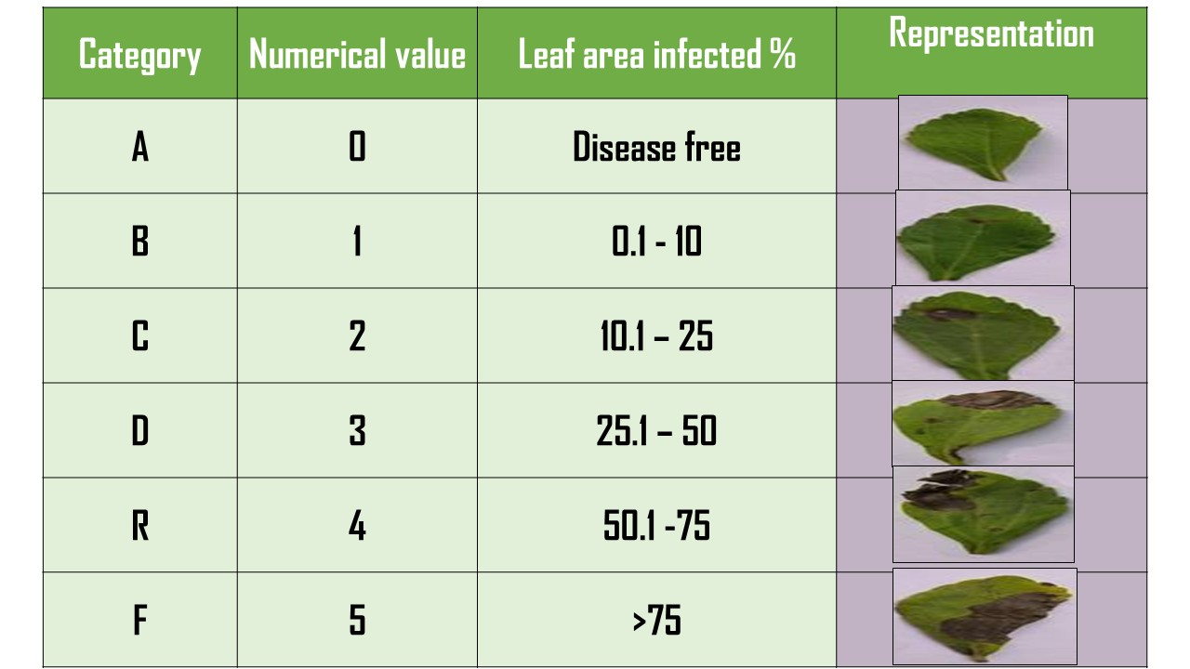

**Figure 6 : Demonstrating Disease Intensity Scale and the Pictorial Representation**

$$Disease Intensity \left(\%\right)\frac{Sum of all disease ratings}{Total number of ratings X Maximum Disease Grade }X 100$$

**Figure7 : Typical symptoms of *Alternaria* leaf spot of stevia**

**Symptoms according to Disease Intensity Scale**

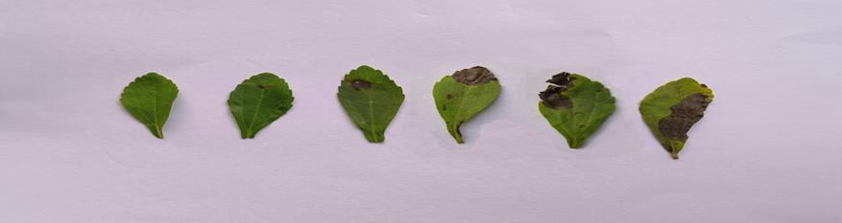

**0**

**1**

**2**

**3**

**4**

**5**

3. results

**3.1 Disease Intensity at 45 Days After Planting (DAP)**  
At 45 DAP, a significant reduction in the intensity of *Alternaria* leaf spot in stevia was observed across all treatment combinations when compared to the untreated control (T0), which recorded a disease intensity of 22.48%. The most effective treatment was T7 (FYM + Neem Cake + *Pseudomonas fluorescens* + Biomix), which achieved the lowest disease intensity at 10.98%. This was followed by T6 (Neem Cake + *Pseudomonas fluorescens* + Biomix) with 12.96%, and T4 (FYM + Neem Cake + Biomix) with 14.46%. Other treatments, including T5 (15.50%), T3 (17.57%), T2 (18.38%), and T1 (19.24%) also showed considerable disease suppression. Statistical analysis revealed all treatments were significantly more effective than the control, based on a critical difference (CD) value of 1.32. It was discovered that the treatments (T1, T2), (T2, T3), and (T4, T5) were not significantly different from one another.

**3.2 Disease Intensity at 90 Days After Planting (DAP)**  
A similar trend was observed at 90 DAP, where T7 (FYM + Neem Cake + *Pseudomonas fluorescens* + Biomix) continued to provide the highest level of disease suppression, recording only 18.56% disease intensity compared to 34.50% in the untreated control (T0). This was followed by T6 (21.85%), T4 (22.97%), T5 (26.04%), T3 (28.53%), T2 (29.34%), and T1 (30.13%). All treatments showed statistically significant reductions in disease intensity relative to the control based on a CD value of 0.83. It was discovered that there was no significant difference between the treatments (T1, T2) and (T2, T3).

**4. Discussion**

The results obtained in this study, evaluated using the disease rating scale of Hilal et al. (2013), clearly demonstrate the effectiveness of integrated organic and biological inputs in managing *Alternaria alternata* in stevia. The combination treatment T7 proved consistently superior, indicating a synergistic interaction among FYM, neem cake, *Pseudomonas fluorescens*, and Biomix. The significant disease reduction is likely attributable to multiple factors, including the antimicrobial action of azadirachtin in neem cake, which inhibits mycelial growth and conidial germination (Khajista, 2013; Ruchi & Kanika, 2021). Furthermore, the inclusion of *Pseudomonas fluorescens*, a known biocontrol agent, enhances disease suppression through induced systemic resistance and microbial antagonism.

The role of **Biomix** in disease management appears particularly noteworthy. As a biologically active formulation containing humic acid, seaweed extract, fish amino acids, bokashi, and beneficial microbes, Biomix not only improves nutrient uptake but also strengthens plant immunity and promotes beneficial soil microbial activity. Its integration into all treatments likely contributed to the observed reduction in disease severity. The findings align with previous reports (Raut et al., 2020), where integrated use of neem-based products and microbial consortia such as *Pseudomonas fluorescens* significantly lowered disease incidence. Thus, the application of Biomix, especially in combination with FYM, neem cake, and biocontrol agents, offers a promising eco-friendly strategy for managing *Alternaria* leaf spot in stevia cultivation.

|  |  |  |  |  |  |
| --- | --- | --- | --- | --- | --- |
| **S.NO** | | **Treatment details** | | **45 DAT** | **90 DAT** |
| **T0** | | Control (Untreated) | | 22.48 | 34.50 |
| **T1** | | FYM + Biomix | | 19.24 | 30.13 |
| **T2** | Neem Cake + Biomix | | 18.38 | | 29.34 |
| **T3** | *Pseudomonas fluorescens* + Biomix | | 17.57 | | 28.53 |
| **T4** | FYM + Neem cake + Biomix | | 14.46 | | 22.97 |
| **T5** | FYM + *Pseudomonas fluorescens* + Biomix | | 15.50 | | 26.04 |
| **T6** | Neem Cake + *Pseudomonas fluorescens* + Biomix | | 12.96 | | 21.86 |
| **T7** | FYM + Neem Cake + *Pseudomonas fluorescens*  + Biomix | | 10.98 | | 18.56 |
| **SE.(d)±** | | | **0.61** | | **0.39** |
| **CD(0.05)** | | | **1.32** | | **0.83** |

Table 2: Effect of organic manures, individually and in combination with a bioagent, on the Disease intensity (%) of *Alternaria alternata* in stevia at 45 and 90 days after planting (DAP)

Figure 8 : Disease Intensity at 45 and 90 DAT

4. Conclusion

According to the current study, *Pseudomonas fluorescens*, organic manures, Neem cake, and biomix all exhibit potent antifungal action against *Alternaria alternata.* According to the findings, T7—FYM + Neem cake + *Pseudomonas fluorescens* + Biomix—had the highest plant height (61.88 cm), the most suckers (66.03), the fresh and dry leaf yields (66.91 gram), and the lowest disease intensity (18.56%) among the treatments. Together with biomix in the field, organic manures applied to the plant's rhizosphere area decreased illness and encouraged plant growth, making them advantageous and environmentally benign. However, the current study's research period was only six months. Therefore, additional trials are required to support the current result.

References

1. Dushyant, S., Kumar, S., Maurya, A. K., & Meena, K. R. (2014). Efficacy of organic manures on growth, yield and biomolecules of stevia (Stevia rebaudiana Bertoni). *J. Crop Weed*, *10*(1), 107-110.
2. Pal, P. K., Kumar, R., Guleria, V., Mahajan, M., Prasad, R., Pathania, V., ... & Ahuja, P. S. (2015). Crop-ecology and nutritional variability influence growth and secondary metabolites of Stevia rebaudiana Bertoni. *BMC Plant Biology*, *15*, 1-16.
3. Das, A., Biswas, M. and Mandal, N. (2010). An economic analysis of stevia ( *Stevia rebaudiana* Bert.) cultivation through stem cutting and tissue culture propagule in India. *Trends in Agricultural Economics.* 3(4):56-59.
4. Maiti, C.K., Sen, S., Acharya, R. and Acharya, K. (2007). First report of *Alternaria alternata* causing leaf spot on *Stevia rebaudiana*. *Plant Pathology*. 56(4): 723.
5. Singh, A. and Verma, P.P.S. (2015). Survival and growth performance of stevia cutting under different growing media. *Journal of Medicinal Plants Studies*. 3(2): 111-113.
6. Gantait, S., Das, A. and Mandal, N. (2015). Stevia: a comprehensive review on ethnopharmacological properties and *in vitro* regeneration. *Sugar Tech*. 17(1): 95–106.
7. Savita, S.M., Sheela, K., Sunanda, S., Shankar, A.G. and Ramakrishna, P. (2004). *Stevia rebaudiana*–A functional component for food industry. *Journal of Human Ecology*. 15(4): 261-264.
8. Chaudhary, V., Prasanna R., Nain, L., Dubey, S. C., Gupta, V., Singh R., Jaggi S. and Bhatnagar, A. (2012). Bioefficacy of novel cyanobacteria-amended formulations in suppressing damping off disease in tomato seedlings. *World Journal of Microbiology and Biotechnology.*27(2):44-45.
9. Garde, A.P., Shinde, S.J. and Kale, A.S.(2022). Effect of inorganic fertilizers (NPK) with organic sources (biomix and humic acid) on bulbs and roots of onion (*Allium cepa* L.). *Pharma Innovation.*11(1):833-839.
10. Sen, S., Biswas, G., Basu, S. K. and Acharya, K. (2012). Management of leaf spot disease of *Stevia rebaudian*a Bertoni with antagonistic bacteria. *Australian Journal of Crop Science*. 6(2): 350-356.
11. Kumar, P., Rani, P., & Tripathy, P. P. (2025). Indirect mode solar drying of stevia (Stevia rebaudiana) leaves: experimental and numerical investigation of fluid flow pattern, moisture, and temperature distribution profile. *Biomass Conversion and Biorefinery*, *15*(5), 7523-7542.
12. Hilal, A.B., Khurshid, A.R.A., Rayees, A., Ahanger, N. A., Qazi, N.A.D. and Ganie, S.A. (2013) Status and symptomatology of Alternaria leaf blight (*Alternaria alternata*) of Gerbera (*Gerbera jamisonii*) in Kashmir valley. *African Journal of Agricultural Research*. 8(9):819-823.
13. Khajista (2016) Antifungal activity of *Azadirachta indica* against *Alternaria Solani*. *Journal of Life Sciences and Technologies.* 1(1):89-83.
14. Raut, V., Kanitkar, S., Hegade, G., Kulkarni, M. and Kadam, M. (2020). Bio-efficacy of ‘SUDO-TM’ (*Pseudomonas fluorescens*) as a biocontrol agent against early blight (*Alternaria solani*) disease of tomato*. International Journal for Research in Applied Sciences and Biotechnology*.7(10): 31-33.
15. Ruchi and Kanika (2021) *In-vitro* assay of antifungal activity of various elicitors and binders against *Alternaria alternata*. *Plant Archives,* 21(1): 933-938.