Host-specific genotype patterns of Orf virus as revealed from Genetic analysis of GM-CSF/IL-2 inhibition factor (GIF) gene

ABSTRACT
Contagious Ecthyma (CE), commonly referred to as Orf or scabby mouth, is a viral disease that mostly affects sheep and goats, caused by the Orf virus. In addition to sheep and goats, it also affects domestic and wild ruminants, as well as humans, highlighting its zoonotic importance. This study aims to characterize ORFV strain circulating in Tamil Nadu.
In the present study, the partial GM-CSF/IL-2 inhibition factor (GIF) gene of ORFV was amplified from nine ORFV-positive clinical material/isolates recovered from nine different outbreaks over five years (2012 to 2016) from Tamil Nadu State, India. Further GIF gene-specific PCR-RFLP analysis was carried out with Hae III and sequence analysis was carried out to identify the strain variation among ORFV strain. In PCR, all the nine-samples yielded 408 bp GIF-gene specific PCR amplicons. RFLP analysis identified three distinct genotyping patterns (I, II and III) among ORFV strains infecting sheep and goats. All sheep-associated ORFV strains belonged to a single genotype, while two additional genotypes were detected among the goat-associated strains. Moreover, the nucleic acid and deduced amino acid sequence analyses revealed the presence of distinct genotyping patterns among the ORFV affecting sheep. On phylogenetic analysis, the GIF gene phylogenetic tree revealed the distinct clustering of sheep and goat ORFV. The presence of host-specific molecular signatures and the heterogeneity among ORFV strains among species circulating in the field necessitates thorough investigation of the prevalent genotypes and/or molecular patterns biased towards the particular preferred host, the importance of cross-immunity across the heterologous host, and the use of universal or host-specific vaccine strains for effective disease prevention.
Keywords: Contagious ecthyma, Orf virus, GIF gene, Phylogeny, Genotyping, Prophylactic measures
1. INTRODUCTION
Orf virus (ORFV), classified under the genus Parapoxvirus within the subfamily Chordopoxvirinae of the Poxviridae family, is the etiological agent of contagious ecthyma (CE), primarily affecting domestic ruminants such as sheep and goats, as well as various wild ruminant species and, less frequently, other mammals (Guo et al., 2004; Yao et al., 2020; Pang et al., 2024). The disease is even reported in human beings, indicating its zoonotic importance (Hubner et al., 1974; Robinson and Peterson, 1983; Crumbie., 1998; Paiba et al., 1999; Lederman et al., 2007; Ara et al., 2008; Qiu and Yanes., 2021). The ORF virus is an epitheliotropic virus that produces erythematous, vesicular, pustular, scab, and crust-like proliferative lesions in the skin around the mouth as well as in oral mucosa in sheep and goats (Tedla et al., 2018; Bala et al., 2019; Ma et al., 2022).
The ORFV is a double-stranded enveloped DNA virus whose genome size is approximately 135 kb, containing 63% G + C and 132 open reading frames (ORFs) (Sahu et al., 2022; Zhou et al., 2022). The genome of ORFV consists of a central conserved core region and a variable terminal region on both ends. Structural components, replication, and nucleotide synthesis are regulated by genes in the central region, whereas genes in the variable region determine host range and pathogenicity (Mangga et al., 2022). It replicates in the host cell cytoplasm. During replication, the viral genes are expressed in a bi-phasic manner, i.e., early gene transcription and translation followed by late (both intermediate and late) gene transcription and translation.
The highly conserved B2L, VIR, and F1L genes are the most targeted genes for molecular characterization of ORFV. Recent studies suggested that analyzing genes in the non-core region, such as GIF, ORF125, and vIL-10, provides more information for distinguishing the ORFV strains (Shimizu et al., 2020; Li et al., 2023).
The granulocyte-macrophage colony-stimulating factor/Interleukin-2 inhibition factor (GIF) gene is an intermediate-late viral gene that augments the viral replication by interfering with the host immune mechanism (Deane et al., 2000). It interferes with the host’s granulocyte-macrophage colony-stimulating factor (GM-CSF), which is responsible for myelopoiesis of neutrophils, monocytes, and eosinophils as well as differentiation of antigen-presenting dendritic cells, leading to an environment that impedes adaptive immune response. The virus-encoded GIF gene also interferes with interleukin-2 (IL-2) responsible for T-cell and NK cell activation and proliferation (Karki et al., 2022). Hence, this immunomodulatory gene is one of the vital genetic components of the virus contributing to its survival. Thus, any change in its genetic makeup may alter the decisive implication in its phenotype, which may ultimately alter its persistence in the host and pathogenicity. Hence, characterization based on this gene is highly essential to know the nature of circulating ORFV strains and the varied phenotypes they produce. Moreover, the studies about the genetic diversity of ORFV based on the GIF gene are scanty in the literature. Hence, the present study aims to genotype the ORFV strains prevalent under Indian field conditions.
2. MATERIALS AND METHODS
The disease outbreaks
A total of nine ORFV suspected samples available at the Central University Laboratory repository were taken for the study. All of these clinical materials, viz., skin scrapings/scab materials suspected for CE, were collected from nine different outbreaks (three outbreaks in sheep flock and six outbreaks in tribe of goats) over five years from 2012 to 2016 from various regions of Tamil Nadu, India. The samples were OrfV/KPM/TN/Sheep/12, OrfV/Ooty/TN/Sheep/16 and OrfV/VPM/TN/Sheep/16 from outbreaks that happened in sheep flock from Kanchipuram (2012), Nilgiris (2016) and Vilupuram (2016) districts respectively; similarly, OrfV/MLMR/TN/Goat/12, OrfV/SLM/TN/Goat/13, OrfV/MEC/TN/Goat/13, OrfV/MLMR/KPM/TN/Goat/15 and OrfV/NKL/TN/Goat/15, OrfV/VPM/TN/Goat/15 from outbreaks in goats from Melmaruvathur (2012), Thiruvallur (2013), Mecheri town of Salem district (2013), Kancheepuram (2015), Namakkal (2015) and Vilupuram (2015) respectively. All the outbreaks were reported from the unvaccinated animals. Clinically, the affected sheep and goats were showing the clinical signs and symptoms of anorexia, fever, papular proliferative lesions/ ulcerated scabs around the nostrils and mouth (Fig 1). All the positive clinical materials/ isolates were handled with appropriate biosafety precautionary measures.
Virus isolation
Scab material was homogenized to a 10% suspension in phosphate-buffered saline (PBS, pH 7.2) and centrifuged at 3000 rpm for 5 minutes. The supernatant was subsequently treated with antibiotics-antimycotic solution (HiMedia, India) and filtered through a 0.45 µm syringe filter. Vero cells were infected with the filtrate, incubated at 37°C, and observed daily for the appearance of cytopathic effects (CPE).
Polymerase chain reaction (PCR)
The template DNA was prepared from suspected samples/cell culture suspension using the QIAamp DNA mini kit (Qiagen) according to the manufacturer’s instructions. The primers specific for the Orf virus GIF gene, which amplify a 408 bp region, were as follows: Forward: 5´-GCTCTAGGAAAGATGGCGTG -3´ and Reverse: 5´-GTACTCCTGGCTGAAGAGCG -3´ (Klein and Tryland, 2005). PCR was carried out in a Thermal Cycler Pro-S (Eppendorf, Germany). The GIF gene was amplified using 12.5µl of Red Dye 2x master mix (Ampliqon, Denmark) containing 1.5 mM MgCl₂, 10 pmol/µl each of forward and reverse primers (Final concentration: 0.4 pmol/µl) and suspected template DNA. The PCR amplification conditions followed in this study were 94°C for 5 minutes; followed by 35 cycles of 94°C for 30 seconds, 54°C for 30 seconds, 72°C for 30 seconds; 72 °C for 7 minutes. The amplified PCR products were separated in a 1.5% agarose gel stained with ethidium bromide (0.5µg/ml) using 1X TAE buffer at a constant voltage of 100 volts and visualized in a gel documentation system (Gel doc XR+ imager, BioRad, USA ).
Restriction fragment length polymorphism (RFLP) analysis
The amplified PCR products were digested with the Hae III restriction endonuclease (RE) enzyme (10,000 units/ml; New England Biolabs Inc., USA). A volume of 15μl of purified PCR products was digested with 1μl of Hae III RE enzyme and 2μl of 10X Cut SmartTM Buffer (1X final concentration; New England Biolabs Inc., USA) at 37°C for 2h. The digested mixture was then incubated at 80 °C for 20 minutes to inactivate the restriction enzyme. The restriction enzyme-digested DNA fragments were separated on 2% agarose gel containing ethidium bromide and visualized in a gel documentation system (Gel doc XR+ imager, BioRad, USA). The different restriction digestion patterns were analyzed to categorize the ORFV into distinct groups.
DNA Sequencing
The samples representing each group of ORFV having distinct RFLP fingerprints were sequenced by outsourcing in a 96-capillary ABI 3730xl DNA analyzer (Applied Biosystems, USA) through Sanger’s Dideoxy sequencing technology. The results were aligned and analyzed through BioEdit Sequence Alignment Editor Version 7.2.5 (Hall., 1999). Further, the aligned sequences were submitted to NCBI GenBank.
Phylogenetic Analysis
The phylogenetic tree was constructed using MEGA 11™ platform using Neighbour -Joining method, Kimura-2 parameter with 1000 bootstrap replicates (Kimura, 1980; Kumar et al., 2018). Totally 36 reference sequences from NCBI GenBank were included in the analysis (Table 1).
3. RESULTS AND DISCUSSION
The ORFV, which belongs to the genus Parapoxvirus, usually produces localized infections in large as well as small ruminants, humans, and a few other mammals. The ORFV replicates in the host's epidermal keratinocytes and employs various immune evasion strategies to survive within the infected host cell, including the secretion of various immunomodulatory proteins. GM-CSF as well as IL-2, are among such proteins deployed by the host cells as an antiviral immune aid (Haig., 2006; Li et al., 2023).
In virus isolation, the CPE started at 3 days post-inoculation and was completed by 7 days post-inoculation. The characteristic CPE observed, like rounding, ballooning, vacuolation, and eventually detachment of the cell sheet, was observed after 3 blind passages (Fig 2). Out of nine ORFV-positive samples, only three could be successfully isolated. The CPE observed in Vero cells were consistent with the earlier findings (Mann et al., 2014; Coradduzza et al., 2021).
The B2L, VIR, and F1L genes are the most targeted genes for molecular characterization of ORFV. However, these genes are highly conserved, and recent studies have suggested that GIF, ORF125, and vIL-10 genes are more informative markers for distinguishing ORFV strains (Shehata et al., 2022). Hence, the GIF gene was focused in this study for the molecular analysis of ORFV. In the GIF gene-based PCR, all nine samples were amplified and yielded 408 bp specific amplicon (Fig 3).
RFLP fingerprinting of the purified PCR amplicons showed three distinct profiles (group I, II, and III). Group I showed three bands with a size of 103 bp, 144 bp, and 161 bp. All ORFV samples from sheep (OrfV/KPM/TN/Sheep/12, OrfV/Ooty/TN/Sheep/16, and OrfV/VPM/TN/Sheep/16) belonged to group I. The ORFV from goats had been characterized into two groups, viz., group II and group III. The restriction digestion pattern in group 2 showed 4 bands of size 103 bp, 81 bp, 63 bp, and 161 bp. Four ORFV samples belonged to group II (OrfV/MLMR/TN/Goat/12, OrfV/MLMR/KPM/TN/Goat/15 and OrfV/NKL/TN/Goat/15, OrfV/VPM/TN/Goat/15). In group III, restriction digestion yielded 3 bands of 103 bp, 81 bp, and 224 bp in size. Two samples (OrfV/SLM/TN/Goat/13, OrfV/MEC/TN/Goat/13) belonged to group III (Fig 4). The PCR-RFLP of GIF gene amplicons is highly useful for discriminating ORFV strains. Earlier studies have used genomic DNA fingerprints for the differentiation (Klein and Tryland,2005) but this study highlights the use of GIF gene-based RFLP with Hae III enzyme for the differentiation of ORFV strain.
Further, the PCR products were sequenced, and both the nucleotide and the deduced amino acid sequences were analyzed. The nucleotide sequence analysis revealed that the restriction sites of Hae III in the GIF gene sequence were well correlated with the RFLP fingerprints. Sequence analysis also revealed differences in the nucleotide sequences between sheep and goat strains at the following nucleotide positions: 31(T to C); 156 (T to C), 162 (T to C), 167 (A to G); 281 (G to A) (Fig 5). Significant variation between the ORFV of goat and sheep strains was evident in the amino acid sequence analysis of the GIF gene. At amino acid position 56, all goat strains had Serine (S), whereas all the sheep strains had asparagine (N). At aa position 94, the asparagine (N) in sheep was replaced with serine (S) in goat strains (Fig 6). The study sequence OrfV/MLMR/KPM/TN/Goat/15 showed 100-95.45% nucleotide similarity with other ORFV strains, while the other sequences OrfV/SLM/TN/Goat/13, OrfV/KPM/TN/Sheep/12, OrfV/Ooty/TN/Sheep/16, and OrfV/VPM/TN/Sheep/16 had 99.49 to 94.7% nucleotide similarity with other ORFV strains.
Phylogram constructed based on partial GIF gene sequences revealed two distinct clusters among the ORFV strains. The goat strains were clustered in cluster I. Cluster II consisted of sheep strains as well as ORFV strains from reindeer and humans. The goat strains were found to be closely related to other Indian and Chinese goat strains of ORFV (Fig 7). The goat strains showed high similarity to other Indian ORFV strains, whereas the GIF gene sequences from sheep strains of Indian origin were limited for comparison with other Indian sheep strains. The strain differentiation by RFLP and by phylogenetic analysis were well correlated. The GIF gene-based genotype patterns as revealed in the study indicate the possible preferential host bias. Interestingly, very similar host-specific molecular signatures are present in certain other poxviruses like sheep pox virus (SPPV) and goat pox virus (GTPV), those affecting sheep and goats e.g., the presence of nucleic acid residues at the 77th, 275th, 403rd, 552nd, 867th and 964th positions of the p32 gene of Capripoxvirus as the host-specific molecular signature residues that differentiate SPPV and GTPV (Roy et al., 2018; Jaisree et al., 2024).
The Phylogenetic analysis based on the B2L gene did not differentiate between sheep and goat strains, as all ORFV strains were clustered together (Mann et al., 2014; Nagarajan et al. 2019). Recent studies based on whole genome sequencing have classified the ORFV strains into two categories as SA00 cluster and the IA82 cluster (Li et al., 2023). The SA00 cluster consists of an Asian strain, and the IA82 cluster originates from a more complex source. Even though our analysis is based on partial gene sequencing, it is in consistent with the findings reported by Li et al. (2023), where the goat strains in cluster I belong to the SA00 cluster, while the sheep strains belong to the IA82 cluster. However, those earlier studies did not report the host-specific differences. In differentiating ORFV strain, the GIF gene appears to be a more effective tool than B2L, F1L, and VIR genes.
The nature of the prevailing ORFV pathogens in sheep and goats, based on the antigenic similarity/dissimilarity, and the use of appropriate vaccine strains are always debatable and requires more scrutiny. At present, the commercial vaccines for the disease CE are available only in a few ORFV-prevalent countries across the world. Moreover, the protective efficacy of certain commercial vaccines in other ruminants such as reindeer, has been reported as uncertain (Tryland et al., 2013; da Costa et al., 2019). Hence, the potential of using single vaccine strain for CE across the diverse host species, and understanding cross-protection between the diverse field as well as vaccine strains, remains an area that requires further investigation. Moreover, the possibility of the re-infection of the virus in animals requires a thorough understanding of appropriate vaccine strains with respect to antiviral immune response of the host cell (Fleming et al., 2015). Further, concerns have also been raised regarding the amino acid substitutions in attenuated vaccine strains (Zhang et al., 2014).
In the present study, GIF gene-based RFLP fingerprints revealed a unique pattern for Indian ORFV affecting sheep only and indicates the circulation of unique sheep-associated ORFV strains in India. However, this finding could be further substantiated through high-throughput sequencing strategies and the inclusion of a greater number of ORFVs from diversified geographical locations.
4. CONCLUSION
In this study, the GIF gene analysis of ORFV revealed that the sheep-associated strains differ from the goat-associated strains. The findings also suggest the potential for developing RFLP probes for gene mapping and identifying unique hybridization patterns specific to certain genotypes. Further, the study shows the diversity among the prevailing ORFV genotypes circulating in the field conditions and warrants judicious selection of appropriate vaccine strains. For effective prevention of Orf, the study recommends evaluating host-specific vaccines, unified vaccine strains, or multi-epitope vaccines, rather than relying on a single vaccine strain for both sheep and goats.

DISCLAIMER (ARTIFICIAL INTELLIGENCE)
Author(s) hereby declare that NO generative AI technologies such as Large Language Models (ChatGPT, COPILOT, etc.) and text-to-image generators have been used during the writing or editing of this manuscript.
REFERENCES
- Ara, M., Zaballos, P., Sanchez, M., Querol, I., Zubiri, M.L., Simal, E. and Hörndler, C. (2008). Giant and recurrent orf virus infection in a renal transplant recipient treated with imiquimod. Journal of the American Academy of Dermatology. 58(1): 39-40.
- Bala, J.A., Balakrishnan, K.N., Abdullah, A.A., Adamu, L., Noorzahari, M.S.B., May, L.K., Mangga, H.K., Ghazali, M.T., Mohamed, R.B., Haron, A.W. and Noordin, M.M. (2019). An association of Orf virus infection among sheep and goats with herd health programme in Terengganu state, eastern region of the peninsular Malaysia. BMC Veterinary Research. 15(1): 250.
- Coradduzza, E., Sanna, D., Rocchigiani, A.M., Pintus, D., Scarpa, F., Scivoli, R., Bechere, R., Dettori, M.A., Montesu, M.A., Marras, V. and Lobrano, R. (2021). Molecular insights into the genetic variability of ORF Virus in a Mediterranean region (Sardinia, Italy). Life. 11(5): 416. doi:10.3390/life11050416.
- Crumbie, A. (1998). The orf virus: a disease of the farming community. Community Nurse. 4(1): 44-45.
- da Costa, R.A., Cargnelutti, J.F., Schild, C.O., Flores, E.F., Riet-Correa, F. and Giannitti, F. (2019). Outbreak of contagious ecthyma caused by Orf virus (Parapoxvirus ovis) in a vaccinated sheep flock in Uruguay. Brazilian Journal of Microbiology. 50(3): 565-569.
- Deane, D., McInnes, C.J., Percival, A., Wood, A., Thomson, J., Lear, A., Gilray, J., Fleming, S., Mercer, A. and Haig, D. (2000) Orf virus encodes a novel secreted protein inhibitor of granulocyte-macrophage colony-stimulating factor and interleukin-2. Journal of Virology. 74(3): 1313-1320. doi:10.1128/jvi.74.3.1313-1320.2000.
- Fleming, S.B., Wise, L.M., Mercer, A.A. (2015). Molecular genetic analysis of orf virus: a poxvirus that has adapted to skin. Viruses. 7(3):1505-1539. doi:10.3390/v7031505.
- Guo, J., Rasmussen, J., Wünschmann, A. and de La Concha-Bermejillo, A. (2004) Genetic characterization of orf viruses isolated from various ruminant species of a zoo. Veterinary Microbiology. 99: 81-92.
- Haig, D.M. (2006). Orf virus infection and host immunity. Current opinion in infectious diseases. 19(2): 127-131. doi:10.1097/01.qco.0000216622.75326.ef.
- Hall, T.A. (1999). BioEdit: a user-friendly biological sequence alignment editor and analysis program for Windows 95/98/NT. Nucleic acids symposium series. 41: 95-98.
- Hubner, G., Loewe, K.R. and Dittmar, F.K. (1974). Human infection by the virus of contagious pustular dermatitis of sheep. Deutsche Medizinische Wochenschrift . 99(45): 2392-2394.
- Jaisree, S., Venkadabady, N. and Roy, P. (2024). Molecular characterization of the goatpox virus from an outbreak in Villupuram district, Tamil Nadu, India. International Journal of Veterinary Sciences and Animal Husbandry. 9(4): 485-489. doi:10.22271/veterinary.2024.v9.i4h.1586.
- Karki, M., Venkatesan, G., Kumar, A. and Pandey, A.B. (2022). Genetic analysis of two viroceptor genes of orf virus. Archives of Virology. 167(7):1577–1582. doi:10.1007/s00705-022-05447-1.
- Kimura, M. (1980). A simple method for estimating evolutionary rates of base substitutions through comparative studies of nucleotide sequences. Journal of molecular evolution. 16(2): 111-120.
- Klein, J. and Tryland, C.M. (2005) Characterisation of parapoxviruses isolated from Norwegian semi-domesticated reindeer (Rangifer tarandus tarandus). Virology Journal. 2(79):1-6. doi:10.1186/1743-422X-2-79.
- Kumar, S., Stecher, G., Li, M., Knyaz, C., Tamura, K. (2018). MEGA X: molecular evolutionary genetics analysis across computing platforms. Molecular biology and evolution. 35(6): 1547-1549.
- Lederman, E.R., Austin, C., Trevino, I., Reynolds, M.G., Swanson, H., Cherry, B., Ragsdale, J., Dunn, J., Meidl, S., Zhao, H. and Li, Y. (2007). ORF virus infection in children: clinical characteristics, transmission, diagnostic methods, and future therapeutics. The Pediatric infectious disease journal. 26(8): 740-744.
- Li, S., Jing, T., Zhu, F., Chen, Y., Yao, X., Tang, X., Zuo, C., Liu, M., Xie, Y., Jiang, Y. and Wang, Y. (2023). Genetic analysis of Orf virus (ORFV) strains isolated from goats in China: insights into epidemiological characteristics and evolutionary patterns. Virus Research. 334: 199160. doi:10.1016/j.virusres.2023.199160.
- Ma, W., Pang, M., Lei, X., Wang, Z., Feng, H., Li, S. and Chen, D. (2022). Orf virus detection in the saliva and milk of dairy goats. Frontiers in Microbiology. 13: 837808. doi:10.3389/fmicb.2022.837808.
- Maan, S., Kumar, A., Batra, K., Singh, M., Nanda, T., Ghosh, A. and Maan, N.S. (2014). Isolation and molecular characterization of contagious pustular dermatitis virus from Rajasthan, India. Virus Disease. 25(3): 376-380. doi:10.1007/s13337-014-0205-0.
- Mangga, H.K., Bala, J.A., Balakrishnan, K.N., Bukar, A.M., Lawan, Z., Gambo, A., Jesse, F.F.A., Noordin, M.M. and Mohd-Azmi, M.L. (2022). Genome-wide analysis and molecular characterization of Orf Virus Strain UPM/HSN-20 isolated from goat in Malaysia. Frontiers in Microbiology. 13: 877149. doi:10.3389/fmicb.2022.877149.
- Nagarajan, G., Pourouchottamane, R., Reddy, G.M., Yogisharadhya, R., Sumana, K., Rajapandi, S., Murali, G., Thirumaran, S.M.K., Mallick, P.K. and Rajendiran, A.S. (2019). Molecular characterization of Orf virus isolates from Kodai hills, Tamil Nadu, India. Veterinary World. 12(7):1022-1027. doi:10.14202/vetworld.2019.1022-1027.
- Paiba, G.A., Thomas, D.R., Morgan, K.L., Bennett, M., Salmon, R.L., Chalmers, R., Kench, S.M., Coleman, T.J., Meadows, D., Morgan‐Capner, P. and Softley, P. (1999). Orf (contagious pustular dermatitis) in farmworkers: prevalence and risk factors in three areas of England. Veterinary record. 145(1): 7-11.
- Pang, F., Long, Q. and Liang, S. (2024). Designing a multi-epitope subunit vaccine against Orf virus using molecular docking and molecular dynamics. Virulence. 15:2398171. doi:10.1080/21505594.2024.2398171.
- Qiu, C.S. and Yanes, A.F. (2021) Orf. New England Journal of Medicine. 384(16): 1552. doi:10.1056/NEJMicm2029641.
- Robinson, A.J. and Petersen, G.V. (1983). Orf virus infection of workers in the meat industry. The New Zealand Medical Journal. 96(694): 81-85.
- Roy, P., Jaisree, S., Balakrishnan, S., Senthilkumar, K., Mahaprabhu, R., Mishra, A., Maity, B., Ghosh, T.K. and Karmakar, A.P. (2018). Molecular epidemiology of goat pox viruses. Transboundary and Emerging Diseases. 65(1): 32-36. doi:10.1111/tbed.12763.
- Sahu, B.P., Majee, P., Singh, R.R., Sahoo, N. and Nayak, D. (2022). Recombination drives the emergence of orf virus diversity: evidence from the first complete genome sequence of an Indian orf virus isolate and comparative genomic analysis. Archives of Virology. 167(7): 1571-1576. doi:10.1007/s00705-022-05443-5.
- Shehata, A.A., Elsheikh, H.A. and Abd-Elfatah, E.B. (2022) Molecular detection and characterization of Orf virus from goats in Egypt. Open Veterinary Journal. 12(2): 273-280. doi:10.5455/OVJ.2022.v12.i2.16.
- Shimizu, K., Takaiwa, A., Takeshima, S.N., Okada, A. and Inoshima, Y. (2020). Genetic variability of 3′-proximal region of genomes of orf viruses isolated from sheep and wild Japanese serows (Capricornis crispus) in Japan. Frontiers in Veterinary Science. 7: 188. doi:10.3389/fvets.2020.00188.
- Tedla, M., Berhan, N., Molla, W., Temesgen, W. and Alemu, S. (2018). Molecular identification and investigations of contagious ecthyma (Orf virus) in small ruminants, north West Ethiopia. BMC Veterinary Research. 14:13. doi:10.1186/s12917-018-1339-x.
- Tryland, M., Klein, J., Berger, T., Josefsen, T.D., das Neves, C.G., Oksanen, A. and Åsbakk, K. (2013) Experimental parapoxvirus infection (contagious ecthyma) in semi-domesticated reindeer (Rangifer tarandus tarandus). Veterinary Microbiology. 162(2-4): 499-506. doi:10.1016/j.vetmic.2012.10.039.
- Yao, X., Pang, M., Wang, T., Chen, X., Tang, X., Chang, J., Chen, D. and Ma, W. (2020) Genomic features and evolution of the parapoxvirus during the past two decades. Pathogens. 9(11): 888. doi:10.3390/pathogens9110888.
- Zhang, K., Liu, Y., Kong, H., Shang, Y. and Liu, X. (2014). Comparison and phylogenetic analysis based on the B2L gene of orf virus from goats and sheep in China during 2009-2011. Archives of Virology. 159(7): 1475-1479. doi:10.1007/s00705-013-1946-6.
- Zhou, Y., Guan, J., Lv, L., Cui, H., Xu, M., Wang, S., Yu, Z., Zhen, R., He, S., Fang, Z. and Zhong, J. (2022). Complete genomic sequences and comparative analysis of two Orf virus isolates from Guizhou Province and Jilin Province, China. Virus Genes. 58(3): 403-413. doi:10.1007/s11262-022-01918-4.
Table 1. Reference sequences from NCBI used for phylogenetic analysis
Accession No | Strain | Host | Country
MG712417.1 | SY17 | Sheep | China
KY053526.1 | OV-HN3/12 | sheep | China
KF234407.1 | NA1/11 | Sheep | China
MN454854.1 | TVL | Sheep | USA
KF837136.1 | B029 | Human | Germany
JF773690.1 | F07.3748S | Sheep | USA
AY386263.1 | OV-IA82 | Sheep | USA
KM057394.1 | 2012-137 caribou | Reindeer | USA
JF773686.1 | F07.808R | Reindeer | Finland
MF489147.1 | AH1704 | Goat | China
JF773684.1 | F94.848R | Reindeer | Finland
HM133903.1 | D1701 | Sheep | Germany
MF414632.1 | Jalandhar/SP41 | Goat | India
MF414630.1 | Mukteswar/59/05 | Goat | India
DQ922634.1 | MUK59/05/P51 | Goat | India
AY386264.1 | OV-SA00 | Goat | USA
MG674916.2 | NA17 | Goat | China
MF414637.1 | Ludhiana/50/06 | Goat | India
MF414631.1 | Bangalore/89/05 | Goat | India
MF489143.1 | AH1604 | Goat | China
MF489141.1 | AH1505 | Goat | China
MF414633.1 | Shahjahanpur | Goat | India
KF666567.1 | Xinjiang1 | Goat | China
KP010354.1 | GO | Goat | China
KP010353.1 | YX | Goat | China
KF666566.1 | Xinjiang2 | Goat | China
MF770655.1 | AH-GY13 | Goat | China
MF414636.1 | Assam/LK/2014 | Goat | India
MF172958.1 | AH-GY13 | Goat | China
MF414635.1 | Gujarat/SP26/2006 | Goat | India
KF726847.1 | Shihezi3 | Goat | China
MF414638.1 | ORFV/Alwar | Goat | India
DQ184476.1 | NZ2 | Sheep | Newzealand
AF192803.1 | NZ2 | Sheep | Newzealand
GQ329670.1 | Pseudocowpox virus  strain VR634 | Cow | Newzealand
EU999744.1 | Pseudocowpox virus  strain VR634 | Cow | Newzealand

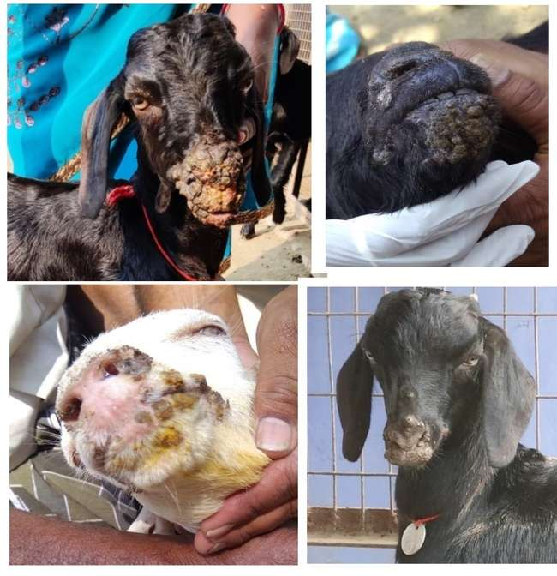

Fig 1: Papular proliferative lesions/ ulcerated scab in sheep and goats infected with ORFV

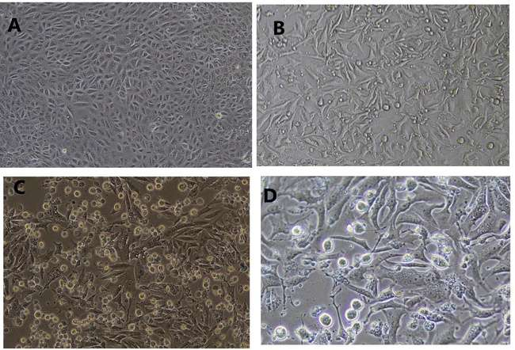
Fig 2: ORFV infected Vero cells showing cytopathic effects
- Normal Vero cells
- ORFV infected Vero cells 3dpi showing rounding
- ORFV infected Vero cells 5dpi showing rounding, vacuolation and ballooning
- ORFV infected Vero cells 7dpi showing detachment of cell sheet and vacuolation

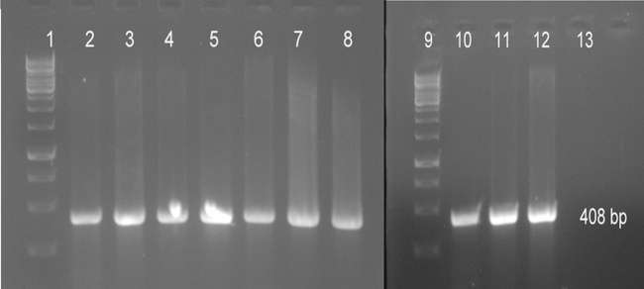
Fig 3: Agarose gel electrophoresis of GIF-gene PCR amplicons showing specific product size of 408 bp (Lane 1, 9: 1 kb DNA ladder (GeneDirex, USA); Lane 2 to 8 and 10 to11: ORFV positive samples; Lane 12: Positive control; Lane 13: Negative control)
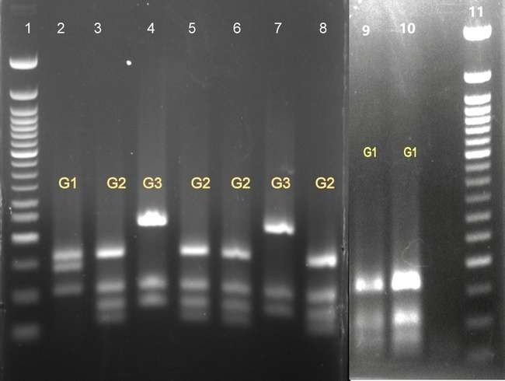
Fig 4: PCR RFLP analysis of partial GIF products grouped the ORFV into 3 groups Lane 1, 11: 50 bp DNA ladder; Lane 2: OrfV/KPM/TN/Sheep/12;
Lane 3: OrfV/MLMR/TN/Goat/12; Lane 4: OrfV/SLM/TN/Goat/13;
Lane 5: OrfV/MLMR/KPM/TN/Goat/15 Lane 6: OrfV/NKL/TN/Goat/15,
Lane 7: OrfV/MEC/TN/Goat/13; Lane 8: OrfV/VPM/TN/Goat/15;
Lane 9: OrfV/Ooty/TN/Sheep/16; Lane 10: OrfV/VPM/TN/Sheep/16

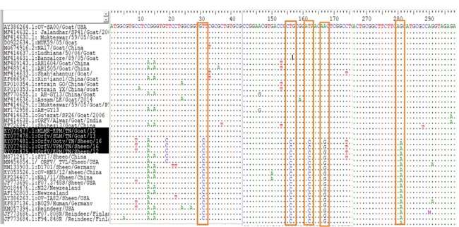
Fig 5: Multiple sequence alignment of nucleotides revealed specific signature residues for sheep and goat at position 31st, 156th, 162nd, 167th and 281st positions.
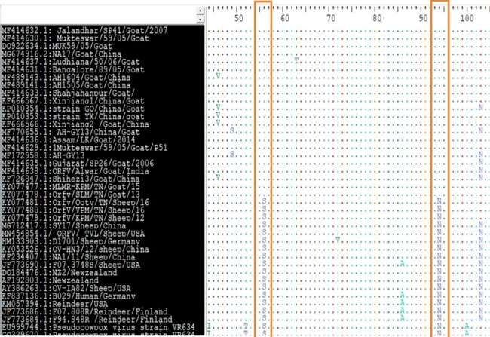
Fig 6: Amino acid sequence alignment of partial GIF gene sequences revealed amino acid changes at position 56 (N to S) and 94 (S to N) between goat and sheep strains.

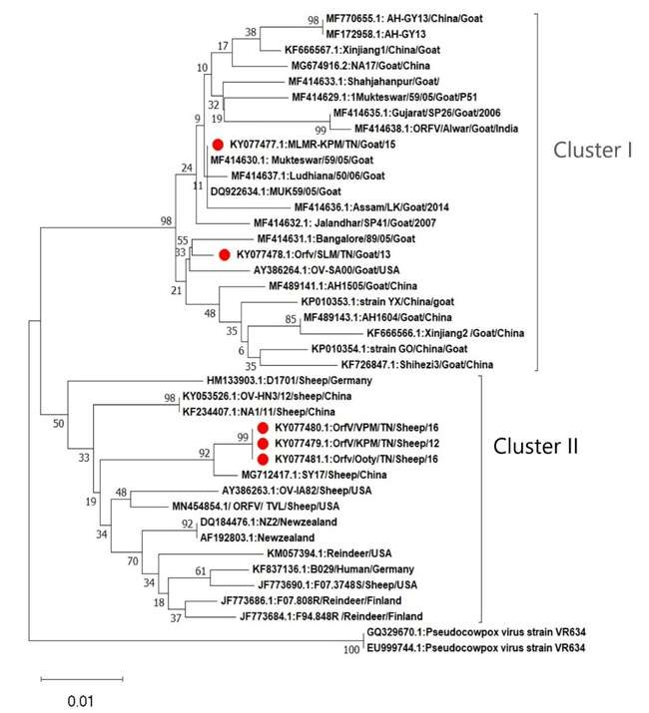

Fig 7: Phylogram constructed based on partial GIF gene sequences by Neighbour-Joining method, Kimura-2 parameter with 1000 boot strap replicates grouped the study sequences in two clusters. Cluster I consisted of ORFV strains from goat and cluster II consisted of ORFV strains from sheep, reindeer and human.

