Optimization of in-vitro protocols for seed germination and seedling development in Paphiopedilum gratrixianum

Abstract
Paphiopedilum gratrixianum (Masters) Rolfe is a relatively rare orchid species belonging to family Orchidaceae. Because of several factors including limited geographical range of growth, habitat destruction and mass exploitation, the orchid species’ natural growth rate is declining and under Critically Endangered (IUCN 3.1). So as to conserve this orchid species, the current study provides a protocol for in-vitro mass propagation using MS (Murashige & Skoog) basal media enhanced with the use of several PGRs (Plant Growth Regulators) for seed germination, growth and rooting at different doses, either single or in combination. Fastest seed germination (46.84 days) was favored by combination of MS+1.0 mg/l GA₃+1.0 mg/l BAP. It also produced tallest plantlet (4.94 cm), longest (5.82 cm) and broadest leaves (0.557 cm) per plantlet at 90 days after seed germination. For PLB formation, the combination of MS+1.0 mg/l GA₃+0.5 mg/l BAP was best suited (15.64 DAG) and treatment with MS+1.5 mg/l KIN for shoot proliferation (4.01) and highest number of leaves (6.61) per plantlets. Root initiation was fastest (7 DAI) in MS+1.5 mg/l IBA, while the number of roots per plantlet were highest (4.56) in the treatment containing MS+ 1.5 mg/l NAA. The same treatment also showed the largest root diameter (1.15 mm). Maximum root length (3.72 cm) was observed in MS+1.0 mg/l IBA. Amongst all the hardening media studied, the well rooted plantlets were best survived in media composed of vermiculite and charcoal in 1:1 ratio with a survival rate of 93.89%.
Keywords: Paphiopedilum gratrixianum, in-vitro, immature seed pods, KIN (Kinetin), BAP (6-Benzylaminopurine), GA₃ (Gibberellic acid), NAA (Naphthalene acetic acid), IBA (Indole -3- Butyric acid) and IAA (Indole-3-acetic acid)
Introduction
Paphiopedilum gratrixianum (Masters) Rolfe is a species of orchid native to Southeast Asia, particularly found in regions of Vietnam, Laos, and southern China. It's a terrestrial orchid, meaning it grows on the ground rather than on trees like many other orchids. This species belongs to the slipper orchid family (Orchidaceae), and under sub-family Cypripedioideae, recognized for its unique pouch-shaped lip, which resembles a slipper. It grows at elevations between 800-1200 meters. The plant produces one or two flowers per inflorescence, with the bloom typically lasting for a long period.
Owing to factors such as limited geographical range of ecological niche, habitat destruction and over collection, the orchid is relatively rare and has been listed as vulnerable or endangered in many regions where it naturally occurs and under Critically Endangered (IUCN 3.1). And hence, conservation efforts are crucial to safeguarding this species from extinction. Keeping the above reasons in view, the current study has been conducted to help with the establishment of in vitro protocol for mass propagation and further conservation of this rare orchid.
Materials and Methods
The present study was carried out at the research laboratory of Manipur International University, Imphal, Manipur (India) for two successive years (2022-2024). The seeds of the Orchid species Paphiopedilum gratrixianum were collected from State Orchidarium, Khonghampat. Immature pods of orchid, Paphiopedilum gratrixianum were collected for use as explants.
Sterilization
Initially, the green un-dehisced matured seed pods were carefully washed using running tap water together with 2-3 drops of Tween-20, this was done for half an hour. Then, the pods were treated with Carbendazim 50 W.P. 1g/l of water for another half an hour followed by 9% of Streptomycin sulphate with 1% of tetracycline hydrochloride i.e., Plantomycin @ 1g/l for yet another half an hour. The seed pods were then washed repeatedly with sterilized double distilled water. This was carried out in the laminar air flow cabinet. Surface sterilization was then carried out stepwise with ethyl alcohol (70%) for a minute followed by HgCl₂ (0.1%) solution for another 3 minutes and then rinsed finally 6-7 times completely with sterile distilled water. After complete sterilization, the capsules were cut horizontally using sterile surgical blades. Inoculation of around 200mg of seeds were done per culture vessel.
Preparation of Culture Medium and Incubation
Murashige & Skoog (MS) medium was taken in full strength, and the experiments were carried out. Various parameters related to in vitro seed germination, shoot proliferation, further growth and development are to be determined. While preparing the culture medium, few cultures were kept hormone free while others were supplemented with PGRs – kin, GA_{3,} BAP for shoot proliferation and NAA, IBA and IAA for root development. These PGRs were taken either solely or in combination with different proportions in different preparations. Using 30g/L of sucrose, the medium was strengthened. 8g/L of agar was also has added to solidify the medium. The prepared mediums were adjusted to pH of 5.2-5.8 with the help of 1N NaOH. The agar added were then dissolved by boiling the mixture. The culture jars were filled up to 100ml each with the prepared mixture and autoclaved for 20 min at 121⁰ C at a pressure of 1.05 Kg/cm².
The cultures were maintained in a light cycle of 12-16 hours of light per day around 350-500 lux using white, fluorescent tube lights and a temperature of 25°C.
Seeds Inoculation
In the laminar air flow hood (to prevent contamination), the followings were carried out – surface sterilized immature green pods were transferred on disinfected petri dish containing disinfected blotting paper. The blotting paper absorbs the excess moisture from the pods. The pods were cut with disinfected surgical blade horizontally and immature seeds were scraped out with the help of disinfected spatula. These seeds were then scattered over the medium’s surface in the culture jars. These were sub-cultured once for every 8 weeks using freshly prepared medium. For each treatment, the experiments were replicated 3 times. Then records of the various parameters to be studied were taken every week.
Data Analysis
Using 12 culture jars, the experiment was carried on for each treatment and every parameter studied which included seed germination, growth, development, acclimatization, etc., replicating 3 times for all the treatments. Data obtained from the two-year work were laid out and ran in ANOVA and all required statistical calculations were carried out.

Table 1. Effect of PGRs on seed germination and vegetative growth of Paphiopedilum gratrixianum in-vitro
Treatment | Days to seed germination (days) | Days to PLB formation after germination (days) | Plant Height (cm) 90 days after germination | No. of shoot/plant at 90 days after germination
T₁- MS₀ | 105.49 | 34.08 | 0.75 | 1.31
T₂ –MS+ 0.5 mg/l Kin | 80.89 | 25.30 | 1.35 | 2.54
T₃ –MS+ 1.0 mg/l Kin | 69.95 | 21.89 | 2.56 | 3.43
T₄ –MS+ 1.5 mg/l Kin | 68.20 | 20.36 | 2.91 | 4.01
T₅ –MS+ 0.5 mg/l BAP | 69.97 | 24.38 | 1.91 | 2.07
T₆ –MS+ 1.0 mg/l BAP | 58.12 | 18.23 | 2.92 | 2.53
T₇ –MS+ 1.5 mg/l BAP | 64.03 | 16.36 | 3.39 | 3.14
T₈ – MS+ 1.0 mg/l GA₃ + 0.5 mg/l Kin | 59.01 | 17.90 | 3.03 | 3.28
T₉ –MS+ 1.0 mg/l GA3 + 1.0 mg/l Kin | 57.22 | 16.64 | 3.90 | 3.64
T₁₀ –MS+ 1.0 mg/l GA3 + 0.5 mg/l BAP | 49.60 | 15.68 | 3.95 | 2.67
T₁₁–MS+ 1.0 mg/l GA₃ + 1.0 mg/l BAP | 46.84 | 34.08 | 4.94 | 3.30
S.E(m)± | 1.2563 | 0.5868 | 0.1177 | 0.1433
C.D. (5%) | 3.6847 | 1.7211 | 0.3451 | 0.4202

Table 2. Effect of PGRs on leaf parameters of Paphiopedilum gratrixianum in-vitro
Treatment | No. of leaves/shoot 90 DAG | Length of leaves (cm) | Leaf breadth (cm)
T₁- MS₀ | 2.62 | 0.87 | 0.067
T₂ –MS+ 0.5 mg/l Kin | 5.22 | 1.31 | 0.220
T₃ –MS+ 1.0 mg/l Kin | 5.78 | 1.51 | 0.332
T₄ –MS+ 1.5 mg/l Kin | 6.61 | 1.97 | 0.450
T₅ –MS+ 0.5 mg/l BAP | 4.16 | 1.41 | 0.283
T₆ –MS+ 1.0 mg/l BAP | 5.19 | 2.54 | 0.398
T₇ –MS+ 1.5 mg/l BAP | 5.80 | 3.20 | 0.494
T₈ – MS+ 1.0 mg/l GA₃ + 0.5 mg/l Kin | 5.72 | 3.01 | 0.360
T₉ –MS+ 1.0 mg/l GA3 + 1.0 mg/l Kin | 6.06 | 3.54 | 0.484
T₁₀ –MS+ 1.0 mg/l GA3 + 0.5 mg/l BAP | 5.01 | 5.00 | 0.372
T₁₁–MS+ 1.0 mg/l GA₃ + 1.0 mg/l BAP | 6.01 | 5.82 | 0.557
S.E(m)± | 0.2423 | 0.0793 | 0.0116
C.D. (5%) | 0.7105 | 0.2327 | 0.0337

Table 3. Effect of PGRs on rooting and root parameters of Paphiopedilum gratrixianum in-vitro
Treatment | Days to root initiation (days) | No. of roots/plantlet (90 DAG) | Length of roots (cm) | Diameter of root (mm)
T₁- MS₀ | 28.74 | 1.09 | 0.60 | 0.49
T₂ –MS+ 0.5 mg/l NAA | 13.28 | 2.57 | 3.11 | 0.88
T₃ –MS+ 1.0 mg/l NAA | 11.70 | 4.04 | 3.41 | 1.08
T₄ –MS+ 1.5 mg/l NAA | 10.06 | 4.56 | 2.24 | 1.15
T₅ –MS+ 0.5 mg/l IBA | 10.49 | 3.11 | 2.84 | 0.90
T₆ –MS+ 1.0 mg/l IBA | 8.94 | 3.69 | 3.72 | 1.13
T₇ –MS+ 1.5 mg/l IBA | 7.00 | 3.88 | 3.39 | 1.16
T₈ – MS+ 0.5 mg/l IAA | 14.62 | 2.15 | 2.81 | 0.66
T₉ –MS+ 1.0 mg/l IAA | 12.16 | 2.95 | 3.28 | 1.05
T₁₀ –MS+ 1.5 mg/l IAA | 12.95 | 3.43 | 3.16 | 1.07
S.E(m)± | 0.7667 | 0.1244 | 0.1238 | 0.0357
C.D. (5%) | 2.2617 | 0.3670 | 0.3654 | 0.1436

Table 4. Effect of different media on survival rate of in-vitro regenerated seedlings ex-vitro
Hardening Media | Survival (%)
H₁ - Cocopeat | 70.69
H₂ - Vermiculite | 90.39
H₃ - Charcoal | 78.06
H₄ - Cocopeat + vermiculite (1:1) | 82.86
H₅ - Cocopeat + Charcoal (1:1) | 84.60
H₆ - Vermiculite + Charcoal (1:1) | 93.89
S.E(m)± | 0.7833
C.D. (5%) | 3.1886

Results
The experiment showed different results for each treatment. Growth rate was variable, some media and the added PGRs were very suitable and showed positive effect while some media combination was least favoured. Treatment with MS along with added PGRs in combination of 1.0mg/l GA₃ and 1.0mg/l BAP showed the fastest seed germination taking 46.84 days while it took longest span of 105.49 days to germinate when only MS media was used for the treatment. PLB formation post germination was also slowest when no PGR was added to MS media (34.08 days). Supplementing the MS basal medium with 1.0mg/l GA₃ + 0.5mg/l BAP took the fastest of 15.68 days for the PLB formation.
At 90 days after germination, different parameters were measured which showed different results in different treatment conditions. Tallest plantlet height of 4.94cm was obtained among the treatment in MS basal media enhanced with 1.0mg/l GA₃ +1.0mg/l BAP, shoot proliferation and number of leaves were highest in MS +1.5mg/l KIN with 4.01 shoots/plantlets and 6.61 leaves/shoots. They all were least in non-hormone added MS basal medium – just 0.75cm for plant height, 1.31 shoots per plantlet and 2.62 leaves per shoot. The length and breadth of leaves were also measured least in hormone free MS basal medium with 0.87cm for length and 0.067cm for breadth. Both parameters showed the best result in treatment of MS medium added with 1.0mg/l GA₃ +1.0mg/l BAP with length of 5.82cm and breadth 0.557cm.
For root growth and further development, the cultures were transferred to treatments which were prepared using PGRs – NAA, IBA and IAA. For root initiation it took only 7 days in MS + 1.5mg/l IBA treatment while it took as long as 28.74 days in treatment with only MS medium. Further 4.56 roots/ plantlet (highest) was obtained in MS + 1.5mg/l NAA and least of only 1.09 roots/plantlet in just MS media treatment. Root length measured up to 3.72cm in MS + 1.0mg/l IBA and diameter up to 1.15mm in MS + 1.5mg/l NAA. Both were least in treatment of just MS media with only 0.60 cm for root length and diameter of only 0.49mm.
After the seedlings were well rooted in vitro, they were removed from the culture jars and washed repeatedly in running tap water. This removes the bits of semisolid agar medium adhered to the roots. The seedlings were then treated for 30 min using fungicide Carbendazim 50 W.P. at the rate of 1g/l and again with a bactericide Plantomycin for another 30 min at the same rate. Plastic containers were prepared using different well sterilized growing mediums which consist of vermiculite, cocopeat and charcoal. The well rooted seedlings were then transferred to these containers with different hardening media. For the Paphiopedilum gratrixianum species, hardening media prepared using Vermiculite & Charcoal in the ratio 1:1 showed the highest survival rate with as much as 93.89%. Using only Vermiculite was also a good option with a survival rate of 90.39%. These seedlings were then kept maintained inside the growing chamber at a temperature of about 25⁰ C. Relative humidity and density of light were maintained at a relatively higher percentage of 80% and 4000 lux respectively.
Discussion
The addition of PGRs enhances tissue culture of orchids by influencing key physiological and development processes critical for growth, differentiation and regeneration. The faster seed germination observed with the combination of 1.0 mg/L GA₃ (Gibberellic Acid) and 1.0 mg/L BAP (6-Benzylaminopurine) in Murashige and Skoog (MS) medium compared to MS alone can be attributed to the synergistic effects of plant growth regulators (PGRs) on seed dormancy breaking and germination promotion. Studies suggest that GA₃ and Cytokinin act together to break dormancy and improve germination rates, especially in species with slow germination. MS medium without PGRs lacks dormancy-breaking stimulants. The seeds might require endogenous GA₃ synthesis, which takes time, resulting in a longer germination period (105.49 days) [3,10,18]. The faster Protocorm-Like Body (PLB) formation with the addition of 1.0 mg/L GA₃ + 0.5 mg/L BAP compared to MS medium alone can be attributed to the influence of these PGRs on cellular differentiation, morphogenesis, and metabolic activation. The cytokinin-to-auxin ratio is critical for PLB induction, and BAP promotes shoot initiation, which is vital in early PLB formation [1,21,22]. The synergistic effect of GA₃ and BAP enhances both cell elongation (GA₃) and cell division (BAP), leading to taller plantlets [9,15,18]. Kinetin (KIN) is a strong cytokinin that induces axillary bud activation, enhancing shoot proliferation. Higher cytokinin levels enhance meristematic activity, leading to more shoot formation [1,16,22]. Kinetin promotes chloroplast development and leaf expansion, leading to an increased number of functional leaves [7,11]. Only endogenous auxin and cytokinin influence growth, leading to slow cell division and elongation and thus poor growth in MS medium without PGRs [4,14]. The significant improvement in leaf length (5.82 cm) and breadth (0.557 cm) with 1.0 mg/L GA₃ + 1.0 mg/L BAP compared to hormone-free MS medium (0.87 cm length and 0.067 cm breadth) is attributed to the roles of gibberellins and cytokinins in leaf expansion, cell division, and elongation. GA₃ is known to reduce leaf thickness while promoting elongation, leading to longer and broader leaves in many plant species [2,17]. BAP, promotes cell division in leaf primordia, resulting in increased leaf area [11,7]. This combination increases metabolic activity and nutrient flow, allowing larger leaf development compared to hormone-free MS medium [9,20].
The significant reduction in root initiation time (7 days) in MS + 1.5 mg/L Indole-3-Butyric Acid (IBA) compared to 28.74 days in hormone-free MS medium can be explained by the role of auxins in root induction and development. IBA is a potent auxin that stimulates root primordia differentiation from the basal region of plantlets [5,6]. Without IBA, root meristem activation and pericycle cell division occur at a slower rate, extending the rooting period to nearly a month [8,12]. The highest number of roots per plantlet (4.56) in MS + 1.5 mg/L Naphthalene Acetic Acid (NAA) compared to only 1.09 roots per plantlet in hormone-free MS medium can be explained by NAA’s role in root induction, elongation, and lateral root proliferation. NAA promotes higher endogenous auxin accumulation in root primordia, accelerating root differentiation and development. NAA is particularly strong in stimulating lateral root growth, leading to more roots per plantlet [5,6]. Endogenous auxins are insufficient for robust root proliferation [8,12]. The observed differences in root length (3.72 cm in MS + 1.0 mg/L IBA) and root diameter (1.15 mm in MS + 1.5 mg/L NAA) compared to the least values in hormone-free MS medium (0.60 cm length, 0.49 mm diameter) can be explained by the distinct roles of Indole-3-Butyric Acid (IBA) and Naphthalene Acetic Acid (NAA) in root development. IBA promotes elongation and apical dominance [5,6]. NAA promotes lateral root formation, leading to shorter but thicker roots with more secondary root branches [8,13].
Conclusion
From the above results it can be concluded that the current study is efficient for mass propagation of the P. gratrixianum orchid species (Fig.1.) and an easy-to-follow in vitro protocol for using immature seeds as the explant (Fig.2). Using only the MS basal medium could also help in germination but better results were obtained when PGRs such as KIN, GA_{3,} BAP were employed in the treatments. Roots developed better when PGRs – NAA, IAA and IBA were used in the treatments and PLB formation in culture (Fig. 3) and. Scaling of growing plantlets (Fig.4) were observed. When the in vitro plantlets were hardened ex vitro (Fig. 5), using the combination of charcoal and vermiculite had the highest survival rate. Following these protocols can help in the mass propagation of this rare species of orchid and help in their conservation.
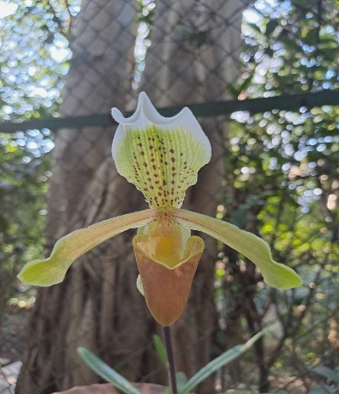 | 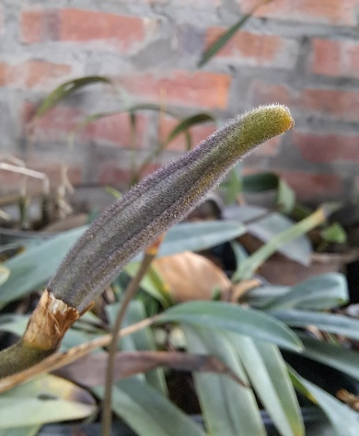 | 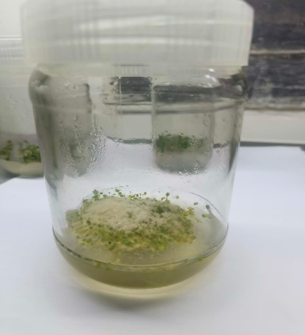
Fig. 1. P. gratrixianum flower | Fig. 2. Seed pod | Fig. 3. Seed germination
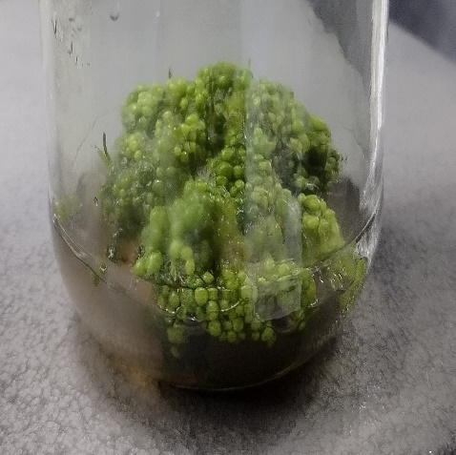 | 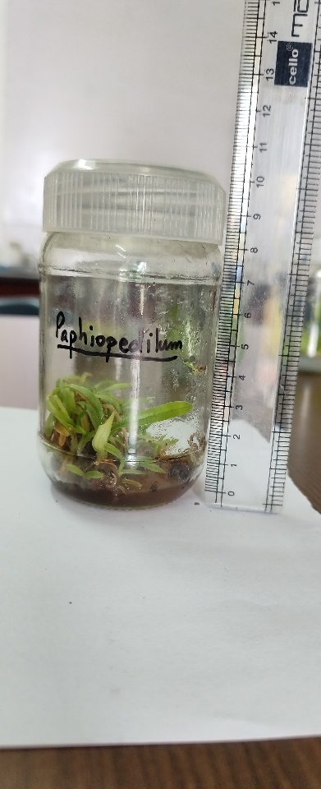 | 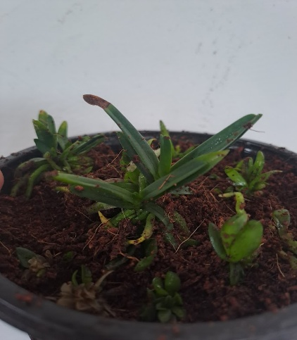
Fig. 4. PLB formation in culture | Fig. 5. Plantlets multiplication | Fig. 6. Hardening of plantlet

Figures legends.
References:
1. Arditti J, Ernst R. 1993. Micropropagation of Orchids. John Wiley & Sons, Inc. New York, 696.
2. Baroja-Fernández E, Muñoz FJ, Saikusa T, Rodríguez-López M, Akazawa T, Pozueta-Romero J. 2002. Gibberellin stimulates the synthesis of starch in photosynthetic cells by activating ADP-glucose pyrophosphorylase. Plant Physiology, 128(2), 664-673.
3. Bewley JD. Black M. 1994. Seeds: Physiology of Development and Germination. Springer 3rd Edition, Plenum Press, New York, 445 p.
4. Bhojwani SS, Razdan MK. 1996. Plant Tissue Culture: Theory and Practice. A revised Edition (Study in Plant Science Vol. 5) - Elsevier, 767 p.
5. Blakesley D, Weston GD, Hall JF. 1991. The role of endogenous auxin in root initiation. IBA vs. IAA. Journal of Plant Growth Regulation, 10(2), 115-123.
6. De Klerk GJ, Van Der Krieken W, De Jong JC. 1999. The formation of adventitious roots: New concepts, new possibilities. In Vitro Cellular and Developmental Biology-Plant, 35(3), 189-199.
7. Gaspar T, Kevers C, Faivre-Rampant O, Crèvecoeur M, Penel C, Greppin H, Dommes J. 2003. Changing concepts in plant hormone action. In Vitro Cellular and Developmental Biology-Plant, 39(2), 85-106.
8. Gaspar T, Kevers C, Penel C, Greppin H, Dommes J. 1996. Plant hormones and in vitro rooting. Plant Growth Regulation, 20(3), 383-388.
9. George EF, Hall MA, De Klerk GJ. 2008. Plant Propagation by Tissue Culture the Background. 3rd edn., Springer, Dordrecht, Vol. 1.
10. Kaur R, Sharma M, Walia S. 2021. Effect of Gibberellic Acid on Germination and Seedling Growth of Medicinal Plants. Journal of Plant Growth Regulation, 40(2), 405-417.
11. Mok DWS, Mok MC. 2001. Cytokinins: Chemistry, activity, and function. Critical Reviews in Plant Sciences, 20(5), 393-426.
12. Nanda KK, Jain VK. 1971. Role of auxins in root initiation. Physiologia Plantarum, 25(1), 44-49.
13. Pacurar DI, Perrone I, Bellini C. 2014. Auxin is a central player in the hormone cross-talks that control adventitious rooting. Physiologia Plantarum, 151(1), 83-96.
14. Pierik RLM. 1990. In Vitro Culture of Higher Plants. Springer Science and Business Media B.V., Dordrecht.
15. Resmi L, Nair AS. 2007. Plant regeneration through somatic embryogenesis in Musa spp. nt Cell, Tissue and Organ Culture, 90(3), 181-189.
16. Rout GR, Jain SM. 2004. Micropropagation of ornamental plants: A review. Biotechnology Advances, 22(6), 801-837.
17. Salisbur FB and Ross CW. 1992. Plant Physiology, Hormones and Plant Regulators: Auxins and Gibberellins. 4th Edition, Wadsworth Publishing, Belmont, 357-381.
18. Taiz L, Zeiger E, Møller IM, Murphy A. 2015. Plant Physiology and Development. 6th Edition, Sinauer Associates, Sunderland, CT.
19. Thokchom R, Maitra S, Sharma S. 2017. In vitro Mass Propagation of Endangered Terrestrial Orchid - Phaius tankervilliae (L’Her.) Blume through Green Seed Pod Culture. Int. J. Curr. Microbiol. App. Sci., 6(5): 722-728.
20. Werner T, Holst K, Pörs Y, Guivarc’h A¸ Mustroph A, Chriqui D, Grimm B, Schmülling T. 2008. Cytokinin deficiency causes distinct changes of sink and source parameters in tobacco shoots and roots. Journal of Experimental Botany, 59(10), 2659-2672.
21. Yang X, Lee YI. 2022. The role of cytokinins in PLB induction and shoot organogenesis in orchids. Plant Cell Reports, 41(4), 565-578.
22. Zeng S, Wu K, Teixeira da Silva JA, Zhang J, Chen Z, Xia N, Duan J. 2012. Propagation of Dendrobium officinale through protocorm-like bodies: The effects of plant growth regulators and organic additives. Science Horticulturae, 139, 80-86.

