**Nutritional and Ethno-medicinal Insights into Freshwater Snail, *Brotia costula*: Consumer Perceptions and Functional Food Potential in Manipur, India**

**ABSTRACT**

This study investigates the nutritional, ethno-medicinal, and socioeconomic relevance of Brotia costula, a freshwater snail species widely consumed in Manipur, India. A community-based survey involving 300 respondents across six districts assessed traditional knowledge, consumption patterns, and perceptions of value addition. This study revealed that 72.67% of consumers were aware of the snail’s traditional medicinal uses mainly for wound healing, skin infections, and bone-related ailments while only 12.67% recognized its potential for value-added applications such as calcium supplements. B. costula are known to have high protein, polyunsaturated fatty acids, and bioactive compounds of medicinal importance however, these snails remains underutilized in both food systems and healthcare sectors. This study highlights the tremendous potential for sustainable utilization through capacity-building initiatives and integration into the One Health framework. This study also contributes to bridging the gap between traditional knowledge and scientific validation, thereby promoting B. costula as a functional food resource with both cultural and economic potential.

**KEYWORDS:** Ethno-medicine, functional foods, Brotia costula, nutritional value, traditional knowledge, value addition

**INTRODUCTION**

Food demands continue to rise sharply as the global population faces an unprecedented escalation outpacing the food supply. To balance this issue, developing the aquaculture sectors is imperative, as they are the primary source of nutrition and livelihood. Simultaneously, the global burden of various chronic and infectious diseases has been increasing, some of which require long-term medication. However, the high cost of synthetic drugs or modern pharmaceuticals makes them inaccessible for most people, especially in rural areas. World Health Organization (WHO) reports, in 2021, shows that around 828 million people were affected by chronic hunger and were unable to fulfil their nutritional energy requirements (WHO, 2022). To address this issue, exploration of culturally rooted, nutrient-rich and easily accessible food sources that offer potent medicinal benefits is essential.

Molluscs are a diverse aquatic organism and are one of the underutilised food systems that represent a valuable source of nutrition which are rich in protein, essential amino acids, while also having low fat content and containing bioactive compounds with potential health-promoting effects (Moniruzzaman et al., 2021; Ngangbam et al., 2024a,b; Nongmaithem et al., 2017; Radis-Baptista, 2022). Freshwater molluscs, including snails, are considered an important food source for humans and are traditionally consumed both as food and medicine by indigenous communities of Northeast India (Baghele et al., 2023; Ngangbam et al., 2024; Nongmaithem et al., 2024). It is believed that consumption of these edible freshwater snails can cure several ailments such as gastritis, arthritis, hypertension and post-operative care, and is still in practice today (Jadhav et al., 2020).

*Brotia costula* (Manipuri name- Lai Tharoi), a freshwater gastropod of the family Pachychilidae, is consumed in the Northeastern Indian states including Manipur. This species thrives in clean, slow-moving streams and rivers, often in areas rich in aquatic vegetation and organic matter. *B. costula* like other freshwater snails contains high amount of proteins, carbohydrates and polyunsaturated fatty acids (PUFA) and also possesses potent antioxidative and antibacterial properties (Ghosh et al., 2017; Khalua et al., 2014; Rout et al., 2022). Given the nutritional, ecological and ethno-medicinal properties, *B. costula* remains an underutilized freshwater gastropod within the traditional food systems of Northeast India.

Despite its consumption and cultural relevance, comprehensive scientific documentation on its medicinal properties and value addition perceptions remains scarce. There is a lack of systematic studies that document its medicinal attributes, socioeconomic relevance, and scope for value addition in both food and agriculture sectors. Recognizing this gap, the present study was aimed to engage directly with local communities to assess their knowledge, perception, and practices surrounding the use of *B. costula*. This community-based approach not only supports the preservation of indigenous knowledge systems, but also helps in promoting the sustainable utilization and conservation of native molluscan species.

**MATERIALS AND METHODS**

A survey was conducted over a two month duration from June to July 2024, to get consumers’ perceptions, ethno-medicinal knowledge and utilization patterns of *B. costula*, (Fig. 1) which is a commonly consumed snail species in Manipur. The survey targeted 300 snail consumers from six districts of Manipur, 75 consumers each from Imphal-West and Imphal-East, 50 consumers each from Thoubal and Kakching, 35 consumers from Bishnupur and 15 consumers from Ukhrul (Table 1; Fig. 2), who were interviewed through a specifically randomized selection that was selected based on the ecological suitability and cultural prevalence of *B. costula*. Individuals were approached directly and prior verbal consent was obtained from each individual, those who declined to participate were not engaged further.

To provide clarity and avoid species confusion, the participants were provided with the scientific name, high resolution images of the targeted species, *B. costula* (Fig. 1)and a structured questionnaire, and each individual was administered through verbal interviews in the local language to ensure accurate understanding and accessibility. The questionnaire was divided into multiple sections to capture a detailed understanding that encompasses several parameters, including traditional medicinal knowledge and value-added products of freshwater snails. Both qualitative and quantitative analysis was conducted. Descriptive statistics like response rates, binary (yes/no) outcomes, etc., were used to analyse the quantitative responses. Qualitative inputs like open-ended feedback, suggestions from participants, and cultural anecdotes were organised thematically. This mixed framework provides a better understanding of the role *B. costula* in heritage and health traditions in the targeted regions.

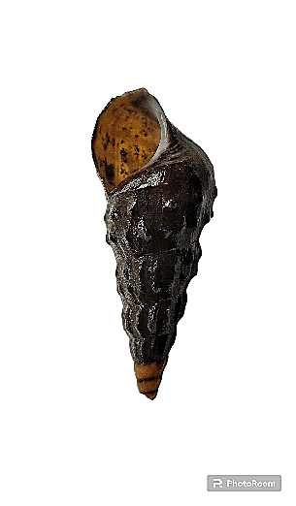

8.1 cm

3.2 cm

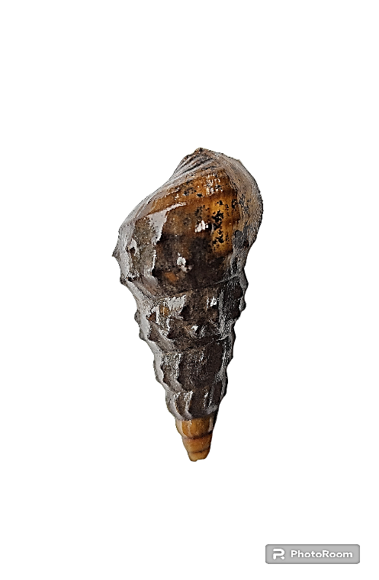

8.1 cm

3.2 cm

Fig. 1. *Brotia costula*, a freshwater gastropod locally known as Lai Tharoi in Manipur

**Table 1.** List of districts and the number of respondents used in the survey

|  |  |  |
| --- | --- | --- |
| **State** | **District** | **No. of consumers** |
| Manipur | Imphal West | 75 |
| Manipur | Imphal East | 75 |
| Manipur | Thoubal | 50 |
| Manipur | Kakching | 50 |
| Manipur | Bishnupur | 35 |
| Manipur | Ukhrul | 15 |
|  | **Total** | **300** |

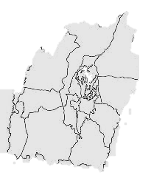

Imphal-West

Imphal-East



Bishnupur

Thoubal

Kakching

Ukhrul

Fig. 2. Geographical distribution of surveyed districts in Manipur.

**RESULTS**

A survey was conducted across six districts of Manipur, consisting of 300 consumers, focusing on the consumer’s perception, ethno-medicinal knowledge and utilization patterns of *B. costula*. Of the total 300 consumers, 25% each were from Imphal West and Imphal East, 16.67% each from Thoubal and Kakching, 11.67% from Bishnupur and 5% from Ukhrul. In terms of gender distribution, 60% were females and 40% males (Fig. 3). This distribution reflects a targeted effort to capture opinions from areas known for snail consumption. In terms of age distribution, the largest segment of respondents fell within the age range of 18 to 30 years, comprising 50% of the total. Following closely behind, respondents aged between 30 and 50 years accounted for 30%, while those over 50 years constituted 20%.

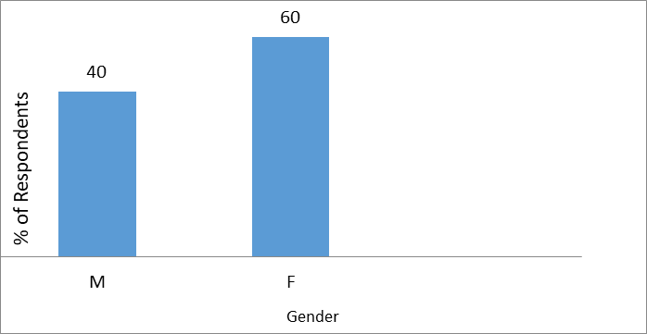

Fig.3. Gender distributions

Evaluation of the ethno-medicinal practices indicated a substantial level of awareness among the consumers. 72.67% (218 individuals) of the surveyed population were familiar with the ethno-medicinal practices, while the remaining 27.33% (82 individuals) were unaware of the medicinal properties of *B. costula* (Fig. 4). The traditional medicinal use of snails was passed down through generations, exhibiting cultural and regional variability. The most commonly reported traditional practice by 218 individuals who previously knew traditional uses of snail, was the use of snail extracts in the treatment of skin infections and wound healing, while 24 individuals (12.84%) out of the 218 individuals reported that boiled snail broth was also applied externally in the case of inflammation and musculoskeletal diseases, especially bone fractures and joint-related problems, which might be due to their high calcium content (Fig. 5). This high proportion of medicinal awareness among the individuals reflects the significant role of snails in traditional medicinal practices.

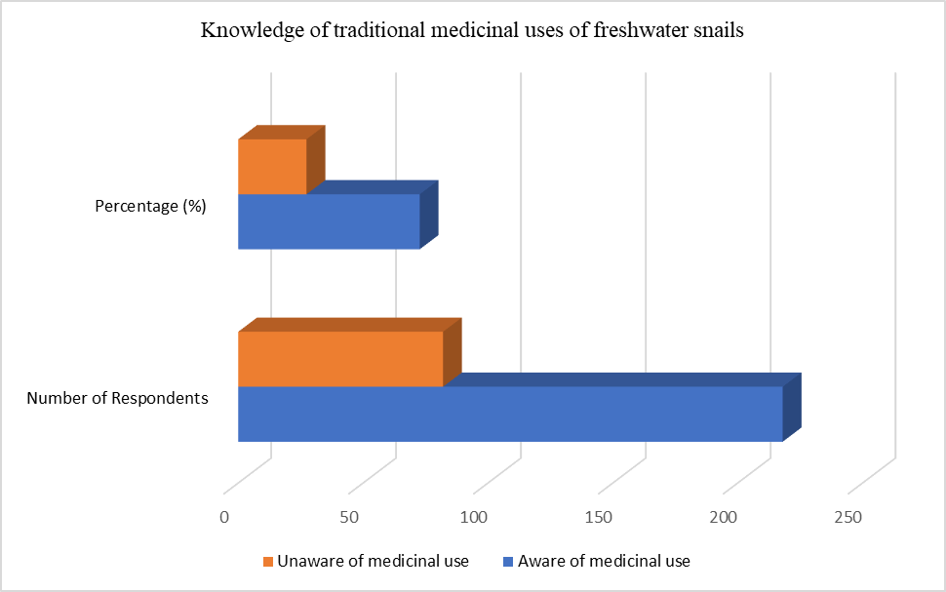

**27.33%**

**72.67%**

**218**

**82**

Fig. 4.Knowledge of ethno-medicinal practices of freshwater snails among the consumers

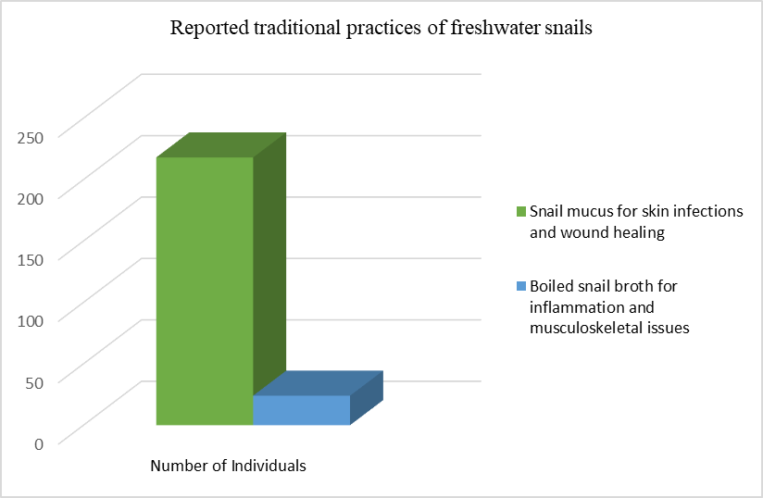

**218**

**24**

**12.84%**

Fig. 5.Traditional medicinal uses of *B. costula* among knowledgeable consumers

In contrast to the widely retained traditional knowledge, the use of snails as a value-added product is limited to only 12.67% (38 individuals) of the 300 surveyed population, including the utilization of crushed snail shells as organic calcium supplements for kitchen garden and liming purposes, the remaining population (87.33%) does not acquire this knowledge, despite being consumers of snails (Fig. 6). Upon being informed about the benefits of snails in scientific and economic prospects, majority of the individuals expressed curiosity to receive training, especially value addition of snails as a food.

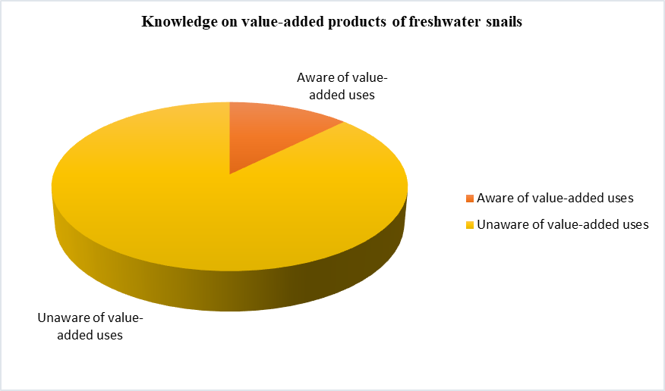

**12.67%**

**87.33%**

Fig. 6.Knowledge distribution of consumers on value-added products of *B. costula*

This study revealed the diverse consumer perspectives, including interest in enhancing snail meat consumption as snail meat is a healthy food due to its high protein content, vitamins and minerals, traditional medicinal uses of snails, and perceptions of health benefits associated with snail consumption. This survey highlights the importance of understanding consumer perceptions and provide insights to potentially enhance the cultural, economic, and health aspects of snail consumption in Manipur. The findings provide a foundation for future initiatives in promoting and developing the snail fisheries sector in the region.

**DISCUSSION**

This study underscores the important role of B. costula as a culturally relevant and nutritionally rich freshwater snail species in Manipur, India. The findings reveal a high level of ethno-medicinal knowledge among the local consumers, with over 72.67% of respondents highlighting the traditional use of B. costula in treating ailments such as skin infections, musculoskeletal inflammation, and wound healing. These practices are in alignment with previous studies on molluscan bioactivities, including antioxidant, antimicrobial, and anti-inflammatory properties (Baghele et al., 2021; Ngangbam et al., 2015; Ngangbam et al., 2019; Ngangbam et al., 2024a; Nongamithem et al., 2017). The use of snail extracts in traditional medicine shows the strong cultural transmission of knowledge and highlights the potential of B. costula as a functional food and natural therapeutic agent.

Despite this strong traditional foundation, this survey also reveals a significant gap in consumer awareness regarding the value addition and commercialization potential of B. costula. Only 12.67% of respondents reported knowledge of using snail by-products, such as shell-derived calcium for agricultural purposes. This highlights that there is an urgent need for community-level training and extension programs to promote the economic potential of snails, not only as food but also in nutraceutical areas (Ngangbam et al., 2024a; Nongmaithem et. al., 2024; Baghele et al., 2023). The majority of the respondents expressed interest in capacity-building opportunities, indicating a readiness for engagement in sustainable snail-based microenterprises.

The demographic data revealed that young adults and women were the most actively involved groups, thereby suggesting a potential demographic for targeted livelihood interventions. This aligns with the broader goals of food security, gender inclusion, and sustainable aquaculture development, especially in biodiversity-rich and economically vulnerable regions like Northeast India (Nongmaithem et al., 2024).

This study also support the integration of B. costula into local food systems under the One Health framework, connecting human nutrition, traditional medicine, and environmental sustainability. In light of increasing food insecurity and reliance on imported or synthetic healthcare products, promoting native snail such as B. costula could offer a low-cost, locally available solution for improving dietary health and socioeconomic resilience (Ngngbam et al., 2024b; Nongmaithem et al., 2018; Prabhakar and Roy, 2009).

Overall, this study will contribute in filling the knowledge gap between the ethno-biological and functional potential of B. costula and lays the foundation for future research, policy development, and sustainable commercialization of freshwater snails in Manipur.

**CONCLUSION**

This study highlights the nutritional, ethno-medicinal, and cultural significance of *Brotia costula* in Manipur, its widespread traditional use and potential as a functional food. While a strong foundation of indigenous knowledge exists, especially regarding its medicinal benefits, awareness of value addition and commercialization remains limited. By engaging local communities and farmers, this study emphasizes the need for targeted awareness programs, training, and policy support to promote the sustainable utilization of this underutilized snails. The maximum inclusion of *B. costula* in local food systems could be promoted thereby contributing meaningfully to public health, livelihoods, and regional food security in Northeast India, particularly Manipur.

**REFERENCES**

Baghele, M., Mishra, S., Meyer-Rochow, V. B., Jung, C. and Ghosh, S. (2021). Utilization of snails as food and therapeutic agents by Baiga tribals of Baihar tehsil of Balaghat District, Madhya Pradesh, India. *Inter. J. Ind. Entomol.* 43(2).

Baghele, M., Mishra, S., Meyer-Rochow, V. B., Jung, C.and Ghosh, S. (2023). A review of the nutritional potential of edible snails: A sustainable underutilized food resource. *Indian J. Nat. Prod. Resour.* 13 (4): 419-433.

Ghosh, S., Jung, C. and Meyer-Rochow, V. B. (2017). Snail as mini-livestock: Nutritional potential of farmed *Pomacea canaliculata* (Ampullariidae). *Agric. Nat. Resour.* 51(6): 504-511.

Jadhav, A., Das, N. K., Sil, M. and Aravind, N.A. (2023). Snails on the plate: Edible freshwater molluscs of Northeast India*. Indian J. Tradit. Knowl.* 22(2): 409-419.

Jadhav, A., Das, N.K. and Aravind, N.A. (2020). Edible freshwater molluscs from Northeast India. *Tentacle.* 28(3):3-4.

Khalua, R. K., Tripathy, S., Paul, B. and Bairy, D. (2014). Seasonal variation of carbohydrate, protein and lipid of common freshwater edible gastropod (*Bellamya bengalensis*) of Medinipur district, West Bengal. *Res. J. Biol.* 2: 49-52.

Moniruzzaman, M., Sku, S., Chowdhury, P., Tanu, M. B., Yeasmine, S., Hossen, M. N. and Mahmud, Y. (2021). Nutritional evaluation of some economically important marine and freshwater mollusc species of Bangladesh. *Heliyon* 7: https://doi.org/ 10.1016/j.heliyon.2021.e07088.

Ngangbam, A.K., Baten, A., Waters, D.L., Whalan, S. and Benkendorff, K. (2015). Characterization of bacterial communities associated with the Tyrian purple producing gland in a marine gastropod. *PLoS One,* 10(10): p.e0140725.

Ngangbam, A.K., Mouatt, P., Smith, J., Waters, D.L. and Benkendorff, K. (2019). Bromoperoxidase producing *Bacillus* spp. isolated from the hypobranchial glands of a muricid mollusc are capable of tyrian purple precursor biogenesis. *Mar. Drugs*. 17(5): p.264.

Ngangbam, A.K., Nongmaithem, B. D., Singh, L.L., Khundrakpam, L., Chanu, L.P. and Precious, I (2024). Assessment of the Consumer’s Knowledge on Underutilized Freshwater Gastropod from North-East India – A High Value Food. *Annals of Biology*, 40 (2): 327-334.

Ngangbam, A. K., Nongmaithem, B. D., Dai, V. T., Lenin, L., Khundrakpam, L., Pinky, L., & Sharma, H. S. (2024). Advancing the discovery of bioactive compounds, its extraction and identification from the underexplored mollusc, *Cipangopaludina lecythis* (WH Benson, 1836). *Fisheries and Aquatic Sciences*, *27*(9), 539-551.

Nongmaithem, B. D., Mouatt, P., Eichinger, Y., Savins, D. and Benkendorff, K. (2018). Effect of cooking on nutrient composition and anticancer indoles of the marine whelk *Dicathais orbita-*Can it be another high-value seafood product? *Food Chem.* 266: 38-46.

Nongmaithem, B. D., Mouatt, P., Smith, J., Rudd, D., Russell, M., Sullivan, C.and Benkendorff, K. (2017). Volatile and bioactive compounds in opercula from Muricidae molluscs supports their use in ceremonial incense and traditional medicines. *Sci.Rep.* 7(1): 17404.

Nongmaithem, B. D., Chungkham, S.Ngangbam, A.K. and Sharma, N. (2024) Freshwater mollusc of northeast India and need for developing a sustainable farming practises for potential inclusion as a component of blue revolution. *Eco. Env. & Cons.* 30 (2): 454-461. http://doi.org/10.53550/EEC.2024.v30i02.004

Prabhakar, A.K.and Roy, S.P.(2009). Ethno-medicinal uses of some shell fishes by people of Kosi river basin of North-Bihar, India. *Stud. Ethno-Med.* 3(1): 1-4.

Radis-Baptista, G. (2022). Nutraceuticals from Molluscs. In Marine-Based Bioactive Compounds. pp. 109-140. CRC Press.

Rout, B., Mehta, N.K., Tripathi, H.H., Sharma, S., Majumdar, R.K. and Priyadarshini, B. 2022. Preliminary investigations on antimicrobial, antioxidant and nutritional properties of freshwater snail *Brotia costula* (Rafinesque, 1833). Indian J. Fish., 69(2): 100-110.

World Health Organization. (2022). UN Report: Global hunger numbers rose to as many as 828 million in 2021. World Health Organization (WHO): Geneva, Switzerland. <https://www.who.int/news/item/06-072022-un-report—global-hunger-numbers-roseto-as-many-as-828-million-in-2021> (accessed 19 May 2025).