***Review Article***

**Recent advancement in plant biotechnology to mitigate concurrent and emerging challenges in crop improvements**

**ABSTRACT**

Adverse climate change and exploding population is a threat to the sustenance of the mankind on the planet. Recent and conventional system of agriculture finds insufficient to feed the burgeoning population.Traditional plant breeding needs integration of smart tools and techniques for speedy crop improvements to be in tandem with the fast growing population rate. The integration of plant biotechnology and agriculture has solved the purpose to a great extent and holds much potential to address the challenges for the sustenance of the life. The use of recent and advanced tools and techniques of biotechnology is an alternative way to ameliorate the environment and agricultural system in the light of concurrent challenges. Therefore, researchers are exploring new advances in plant biotechnology to serve the agriculture in more promising way. In this review, article we have tried to incorporate the recent advancement in plant biotechnology and its intervention in agriculture for the improvement of crops with changing technology & future perspective.

Keywords: please make sure to mention keywords without fail before publication

**1. INTRODUCTION**

It is expected that the population of the world may reach nine and half billion by 2030, with disproportionately higher surge in both developing and underdeveloped nations. Migration of rural population into urban areas for so called a better standard of living has put the limited resources under extreme pressure and population density. This not only brings the national economy under risk and but exacerbates the challenges associated with sustainable agriculture. Modern agriculture is facing plethora of challenges such as climate change, soil management, crop maintenance and rising global soil biodiversity. In this context, the available area for cultivation is shrinking rapidly. This poses a question of nutrition and food security to serve burgeoning population all over the world. This has also given birth to another problem, the issue of malnutrition. The upcoming decades may face many differences, disturbances and disparities unlike past decades. These issues have to be addressed and worked one after the other with immediate effect for smooth maintenance of life (Suchith Kumar, 2024).Recent advent in Plant Biotechnology can serve the agriculture to the great extent to mitigate mentioned concurrent & emerging challenges.

**2. CONVENTIONAL AND MUTATION BREEDING**

Mutation breeding is one of the ways of crop improvement utilizing physical, chemical, biological and other ways to bring and induce mutations in plant genetic structure leading with the development of crop varieties with desired traits. It has developedmany superior plant varieties and has been widely used to bring desirable traits in the crop of interest (Ma et al., 2021). Physical stimulations such as X-rays, α- and β-particles, fast neutrons, and UV light lead to chromosome changes to induce mutation. In the same way, chemical treatments such as ethyl methane sulfonate, typically cause point mutations (Shamshad et al., 2023). Particularly in the horticultural crops, mutation is an important breeding tool for creating variability and selection. Mutation breeding provides serves as an approach for the improvement of traits like dwarf plant, earliness, tolerance and resistance to various diseases and pests within short period of time(Dattatray et al., 2025). Mutant identification or selection at the genotypic level, with the integration of new technologies, has advanced and surpassed the conventional the mutations breeding utilized in fruit crops. Recently, the *In vitro* culture in association with induced mutation has speeded up the breeding program for more genetic variations or for multiplication. It has also led to the development of commercial varieties for the sake of nutritional security (Karishma et al., 2025).

**3. INTERVENTION OF PLANTY BIOTECHNOLOGY IN TREDITIONAL AGRICULTURE PRACTICE**

Conventional agriculture rendered indiscriminate use of chemical fertilizer, herbicides and pesticides without taking concern of pollution, particularly soil and water. Plant Biotechnology help to minimize the use of fertilizer and pesticide and tends to rehabilitate soil, air, and water quality, the important component of world ecosystem (Zafar et al., 2024) Hence plant Biotechnology is very crucial and decisive in direction of sustainable agriculture.

The Tissue culture technology is playing pivotal role to generate millions of copy of any lite varieties within limited space and time. This technology also helps germplasm for long-term, particularly of vegatatively propagated crops.This is essential to enrich and maintain the biodiversity of the crops (Kumar et al., 2018).Tissue culture technologies have multifaceted applications in the development and conservation of germplasm. It helps to utilize the genetic variability in crops though *in vitro* pollination and embryo rescue for distant hybridization. In addition, haploids, doubled haploids and polyploids can also be developed through tissue culture technology. Moreover, tissue culture technology has potential for in vitro mutagenesis, somaclonal variation, in vitro selection, protoplast fusion for producing somatic hybrids, and regeneration of gene manipulated explants for genetically modified are the and doing well in agriculture (Pathirana et al., 2024).

The recent advancements in plant biotechnological research have elucidated the underlying molecular path of various metabolic processesto develop various high-yielding and stress-tolerant crop varieties too. This has resulted in good return of yield alongwith precision agriculture. Genemanipulation, marker-assisted selection and molecular breeding, plant transformation and genomics are recent techniques of Plant biotechnologies involved in developing novel variety and nearly isogenic variety. Genetic mapping is helpful in the screening for essential traits which was difficult to be done using traditional breeding. Marker assisted selection has been proved as a facilitative tool of biotechnology, through which we are able to shorten the period required in the development of the variety (Kumar et al., 2024).

Molecular markers helps in the characterization of germplasm and finding out duplicates and gaps in collections, while high-resolution genetic analysis is useful in physical mapping and positional gene cloning of desirable trait (Hamdon et al., 2022). It has become an integral part in some breeding programs when used for the early rejection of undesirable perennial crops such as, early rejection of male vines in hybrid populations and screening in kiwifruit through marker-assisted selection (Numanet al., 2021; Tigist et al., 2023). The development of saturated linkage maps in different crops and pyramiding genes through multiple gene introgressions has only become possibleby high resolution genetic analysis (Purdy et al., 2023; Adly et al., 2023). Development of Genetically modified crops is unavoidable choice. That is why, despite the protest of genetically modified crops and strict regulation, transgenic varieties of maize, soybean, rapeseed, cotton, tomato, potato, papaya, etc. are being cultivated over 190 million hectares in more than 25 countries. It is benefitting 17 million farmers in addition to environmental benefits despite of social controversy (Dreiseitl et al., 2021).Thus Agricultural biotechnology has multifaceted potential to sort-out major challenges in sustainable way such as growing enough food within limited space without loss of usable lands and with limited resources despite of water scarcity under different environmental stress such as drought, salinity, high temperature and by minimal use of chemical fertilizer and pesticides (Das et al., 2023).

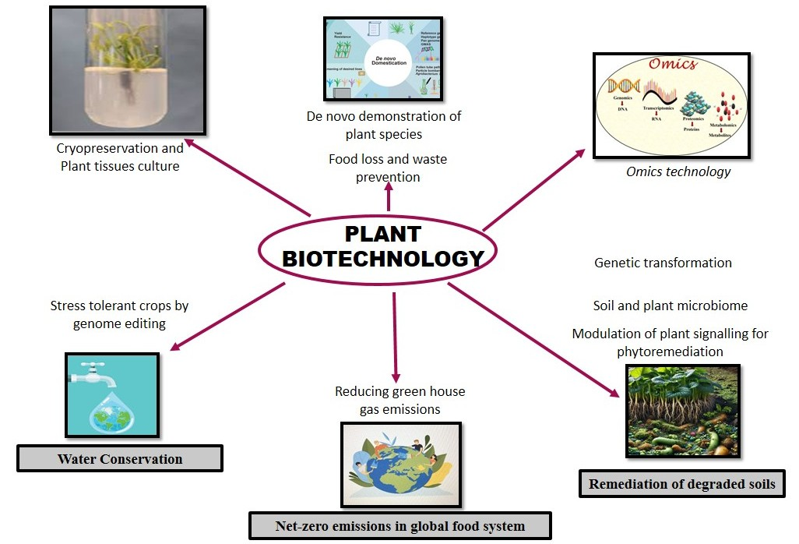

**Fig. 1. Rising horizon of plant biotechnology and its advancement to deal with crop improvements and allied factors.**

Fortified foods through the involvement of plant biotechnology are the future scope advancements. It may enable to avail consumers with nutritionally enriched foods with good shelf life. Production of new medicines such as plant-based vaccines and antibodies through genetically engineered crops and new sustainable plant-made pharmaceutical industry are emerging promise of plant biotechnology.

**4. THE MAJOR BREAKTHROUGH OF PLANT BIOTECHNOLOGY**

Biotechnology has some splendid contribution in agriculture. It had led the development of few resistant crops variety against devastating diseases.

**Table 1. Important GM crops with area of cultivation in different countries are mentioned below (Aziz et al., 2022)**

|  |  |  |  |  |
| --- | --- | --- | --- | --- |
| **S. N.** | **Country** | **Continent** | **Common GM Crops** | **Area (Mha)** |
| 1 | Costa Rica | North America | Soybean and cotton | < 0.1 |
| 2 | Ethiopia | Africa | Cotton | < 0.1 |
| 3 | Eswatini | Africa | Cotton | < 0.1 |
| 4 | Nigeria | Africa | Cowpea | < 0.1 |
| 5 | Bangladesh | Asia | Eggplant | < 0.1 |
| 6 | Indonesia | Asia | Cotton | < 0.1 |
| 7 | Portugal | Europe | Maize | < 0.1 |
| 8 | Malawi | Africa | Cotton, cowpea, and banana | < 0.1 |
| 9 | Chile | South America | Rapeseed, soybean, and maize | < 0.1 |
| 10 | Honduras | North America | Maize | < 0.1 |
| 11 | Vietnam | Asia | Maize | 0.1 |
| 12 | Colombia | South America | Cotton and maize | 0.1 |
| 13 | Spain | Europe | Maize | 0.1 |
| 14 | Mexico | North America | Soybean and cotton | 0.2 |
| 15 | Sudan | Africa | Cotton | 0.2 |
| 16 | Myanmar | Asia | Cotton | 0.3 |
| 17 | Australia | Australia | Rapeseed and cotton | 0.8 |
| 18 | Philippines | Asia | Maize | 0.6 |
| 19 | Uruguay | South America | Maize and soybean | 1.3 |
| 20 | Bolivia | South America | Soybean | 1.3 |
| 21 | South Africa | Africa | Cotton, soybean, and maize | 2.7 |
| 22 | Pakistan | Asia | Cotton | 2.8 |
| 23 | China | Asia | Tomato, sweet pepper cotton, papaya, and poplar | 2.9 |
| 24 | Paraguay | South America | Maize, soybean, and cotton | 3.8 |
| 25 | India | Asia | Cotton | 11.6 |
| 26 | Canada | North America | Soybean, sugar beet, rapeseed, and maize | 12.5 |
| 27 | Argentina | South America | Cotton, soybean, and maize | 24 |
| 28 | Brazil | South America | Soybean, cotton, and maize | 52.8 |
| 29 | United States | North America | Cotton, papaya, alfalfa, sugar beet, rapeseed, soybean, maize, and squash | 71.5 |

The development of genetically engineered rainbow papayas resistant to the papaya ring spot virus revived and brought sea change in Hawaiian papaya industry(Gonsalves, 2006). Similar kind of effort in research is being made for virus threatened potatoes, squash, and tomatoes etc. This Biotech based crops has enormous potential to enhance socio economic status of farmers by higher income resulting from enhanced nutrient use efficiency and yield, improved nutritional profile, developed resistance to biotic and abiotic stress etc in those crops. According to one report, genetically modified technology was adopted in 76 countries and regions globally in the year 2023. 206.3 million hectares of Genetically Modified crops were cultivated in 27 countries and regions. It exhibited 3.05% growth over the previous year (Agbio Investor, 2024). The planting area of GM crops is expanding day by day. It has expanded 121 times since 1996, and it accounts for 13.38% of the total 1,542 million hectares, the global farm land area with a total exceed of 3.4 billion hectares.

**5. AGRICULTURE NEEDS BALANCED APPROACH**

There is worldwide conflict over the adoption and acceptance of transgenic crop developed by biotechnological approaches. But as of now, plant biotechnology tools seem to be the only option for the agricultural scientist for the development of any crop as per changing climatic conditions and exploding population. Therefore, balance approach of biotechnology and agriculture need to be adopted in the interest of growing population abiding strict regulatory framework and environmental concern. The impact analysis of genetically modified crop is also being done, but no major untoward effect of genetically modified crops has came to the notice yet (Raman et al., 2017). Ongoing research in biotechnology is expected to bring forth many more types of crops with various traits and utility in agriculture. The recent surge in biotechnology has enabled the development of molecular tools to identify crucial traits such as increased yield, pest resistance, drought resistance, and herbicide resistance, which can be subsequently modified in crops for the desired traits. That farmers used to employ selective breeding to bring desirable changes in plants for centuries.

Biotechnology can improve the soil quality through phyto-remediation. It can help conserve natural resources, enhance nutrient use efficiency, reduce nutrient runoff and increase organic carbon sequestration in soil. Good soil quality can produce dense crops thriving in harsh environments. But minimal inputs of fuel, labor, fertilizer, and water must be complemented and encouraged by conventional agriculture practices (Das et al., 2023).Production of bio fertilizer mediated by biotechnological approaches is one of sweetest example of good integration in biotechnology and conventional agriculture. By genetic modification, the nutritional profile of crops can be improved, and herbicide, pest, and disease-resistant varieties can be produced in more precise and quicker way than conventional way (Mmbando et al., 2025).

**6. CHALLENGES AND FUTURE DIRECTIONS OF AGRICULTUTAL BIOTECHNOLOGY IN OVERCOMING ABIOTIC AND BIOTIC STRESS**

Although plant systems have been endowed with many natural resistance mechanisms against the stress, but due to sudden climatic changes, sensitive plants fail to cope up with natural stresses. Despite of the much advancement in the Plant Biotechnology &Molecular Breeding and their utilization in the development of biotic and abiotic resistant plant, challenges are many. Traditional breeding strategies are lagging behind to modify or manipulate genetic architecture to face either biotic or abiotic stress (Tohidfar and Khosravi, 2015). The major obstacle in the path of stress resistance in agriculture is that the crop has to face complex responses. But the plants respond to multiple stresses differently than facing individual stresses. Therefore, complex stresses are controlled by network of various signaling pathways system that crosstalk, interact and restrict each other. Here, dilemma is that, the genetic manipulation in this complex signaling pathway can either reduce or enhance resistance to biotic pests or pathogens, and vice versa. Another major challenges in this direction is that there are plenty of environmental factors in both biotic and a biotic stress.Biotic factors include virus, bacteria, fungi, insect & pests, and direct animal and human intervention. Similarly, the list of abiotic stress include, climatic changes, air and soil pollution, magnetic fields, temperatures, drought, submergence, heavy metals toxicity and saline condition. Tackling of all these stresses require multi-dimensional and diligent approach including conventional and smart breeding programs in integration with genetic engineering and genome editing (Shelake et al., 2024).

**7. FUTURE DIRECTION TO BIOTIC AND ABIOTIC DTRESS IN PLANT**

Therole of Genetic engineering in the crop improvement of many crops such as maize, rice, cotton, and canola and others has already been validated. The identification of candidate genes against the both kind of stress and further theirover expression or introgression in the sensitive plant species is the most common approach and way now a day. One complexity associated with stress tolerance is that positive effect in one plant genotype might not be positive for other plant and specific external abiotic or biotic stress, might exacerbate a stress condition to the crop depending upon the plants genetic structure and acquired response as stated above. Both abiotic as well as biotic stresses are posing heavier drastic effect onthe yield of crop. However, recent research in crop physiology and plant breeding has explored various molecular mechanisms to combat both biotic and abiotic stresses (Ramegowda et al., 2024).

Antioxidant enzymes activities such as ascorbate peroxidase, glutathione peroxides, glutathione reductase, signal transduction cascades and protein transporters for mineral such as sodium transport plays crucial role against stress condition, particularly abiotic stress (Hasanuzzaman, 2020). The role of these components and signaling mechanisms, QTLs linked with metabolic fates, and environment gene interaction have all been well studied and being investigated further for high throughput efficiency. The researcher have also identified key stress related transcription factor and they have observed the positive effect also after introgression of that gene under controlled condition(Villalobos-López et al., 2022). Advancements in OMICS technology have significantly expanded the understanding and role of transcription factor (TF) binding sites in plants and their roles in concerned biological processes. This progress has facilitated the validation of Transcription Factor related mutations and its alleles. It can offer new opportunities for breeders to achieve rapid genetic advantage against abiotic and biotic stresses. The crop improvements mediated by Transcription Factors are key targets and approaches. Because, this approach is irrespective of crop type, mode of inheritance, number of operative genes and their interactions. TFs– bZIP, bHLH, NAC, ATAF, AP2/ERF, MYB, and WRKY are some of the families of transcription factor which have been extensively studied for abiotic and biotic stress resilience in crops(Roopali et al., 2025).

Diversified populations, economic Single Nucleotide Polymorphism profiling, QTL/ Association mapping, molecular breeding, DNA methylation and overexpression /knockdown, as well as CRISPR/Cas mediated genome editing are the emerging techniques of plant biotechnology. These technologies can be utilized as a promising approach for the crop improvement in terms of both biotic and abiotic stresses (Shabbir et al., 2022). Molecular breeding approaches in association with conventional breeding and adapting collaborative advances in functional, comparative, and structural genomics can be significant to enhance the degree of tolerance in stress tolerant varieties (Ahmar et al., 2020).Now a day, comparative genomics has been emerged as a new technology. This study can help to develop waysand strategy to develop tolerant varieties with high resilience with coexistence of abiotic stresses(Manghwar, Hakim, and WajidZaman. 2024).

**7.1. Marker Assisted Breeding**

Marker-Assisted Breeding has made significant strides in horticulture, enabling the development of improved varieties of fruits, vegetables, and ornamental plants. Plant Breeders can accelerate the selection process, enhance trait precision, and address challenges such as low yield, biotic and environmental stress toleranceby leveraging genetic markers linked to desirable traits (Tejaswini et al, 2024; Koshariya et al., 2024).Although examples are many exhibiting the practical application of MAS in the yieldenhancement (Yin et al., 2003). It is well known and established concept that, an integrated approach involving traditional approach of of agricultural improvement in combination with crop modelling and QTL mapping holds much potential to select a suitable cultivar for a desirable environment (Hasan et al., 2021).

**7.2. Cutting edge Technologies in Plant Biotechnology**

Genome editing is a major breakthrough in the field of gene manipulation to bring desirable changes in plant genome more rapidly and more perfectly than any other available method. Conventional methods of crop improvement take years to introduce a new trait into any crop, while genome editing has the potential to curtail the time frame of decade into few years. It is a precise tool for breeders to do bring very specific changes in the frame shift of the DNA. This technology createschanges in plant by targeting at a location of interest within in a gene of the chromosome. CRISPR (Clustered regularly interspaced short palindromic repeats) is a one of the genome editing tool among others which was discovered by E. Charpentier and J. Doudna, Nobel Prize winner in Chemistry in the year 2020 forCRISPR/Cas9 molecular mechanism (Li et al., 2023). TALENs (Transcription Activator-Like Effector Nucleases), is another genome editing tool which led to the development of the first genome-edited Soybean for commercially cultivation in USA. This was being sold as a food product with high oleic and low linolenic oil content (Xuet al., 2020). These genome editing tools and techniques can handle the menace of changing climatic conditions by developing crops of resilient nature. Researchers have developed cacao plants, the main ingredient of chocolate with high immunity. Similarly, this technology has helped to develop tomato with shortened stems, which grows faster and requires less acreage. This unique makes the plants suitable for kitchen and roof top gardening (Tiwari et al., 2023).

**7.3. CRISPR-CRISPER associated nucleases (CRISPR/Cas)**

CRISPR/Cas editing tool makes use of RNA-guided nucleases liable for immune system in bacteria. CRISPR/Cas9 system is the most widely CRISPR/Cas editing tool. Here, Cas9 is nuclease which targets the DNA mediated by the guide RNA. This guide RNA is complementary to the target sequence. Cas9 induces a Double Stranded DNA break at the site when this guide RNA binds to the target site on DNA (Asmamaw et al., 2021). The beauty of the guide RNA is that, it can be easily engineered to identifya specific DNA sequence of the interest. This makes CRISPR-Cas9 a prolific and choice tool for the editing of genome. Application of CRISPR/Cas9 genome editing tools in the improvement of crop have opened up new dimension for the improvement of yield, nutrition quality, disease resistance, climate resilience and other desirable agronomic traits (Ansori et al., 2023). One interesting thing about this genome editing technology that, it not only improves the crops by gene manipulation but also explorenew paradigm in plant science research by elucidating gene function and role in genomics (Bortesi and Fischer, 2015).

**7.4. Synthetic Biology**

As it is evident from is name, synthetic biology meant for design and synthesis of new biology for technological advancement and ultimately to the humankind. Prior work and understanding of working of cells and biological systems, new advancement in mathematical modeling, simulation modeling and high through put deoxyribonucleic acid sequencing and artificial synthesis of DNA are the basis of synthetic biology (Lewis et al., 2014). It is result of use of multidisciplinary research in different discipline such as system biology, engineering, chemistry, physics, computer science, social science and their collaboration to form global interaction and exchange of ideas and results(Garner, 2021).

**7.5. Synthetic Biology in agriculture**

Synthetic biology devises approach, afterwell combination of different discipline such as metabolic engineering, minimal genomes, regulatory circuits, and orthogonal bio-systems (Karatas and Ayaz, 2025). Concurrent research in this emerging area of research is essential for formulation of novel ideas and development of new products and research tools.

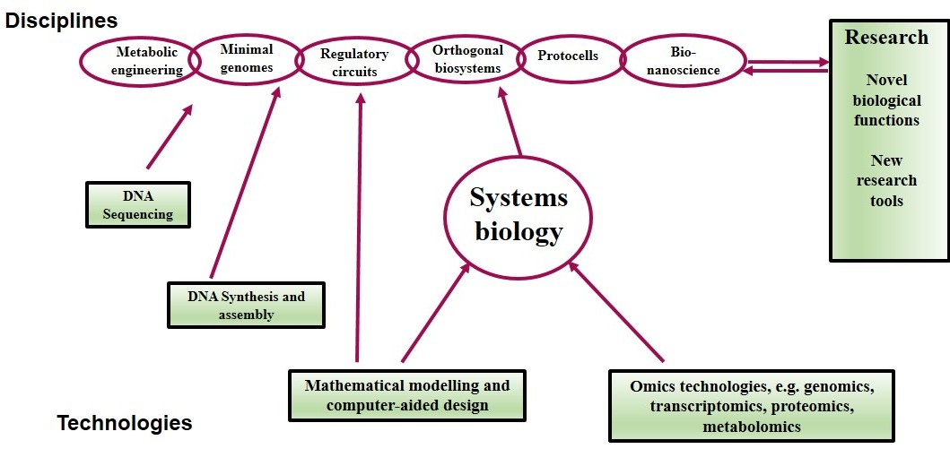

**Fig. 2. Pictorial representation of principle of synthetic biology (Garner et al., 2021).**

Cutting edge research in systems biologyis the major contributory of the development of synthetic biology. Exploration of these technologies requires sufficient advances. Mathematical modeling and the omics based technologies such as transcriptomics, proteomics, and metabolomics, have progressed parallel with systems biology (Veenstra, 2021). It takes into account the holistic approach to understand the functioning of cells and organism. Synthetic Biology approach looks in entire networks of interactions or systems rather than focusing on single metabolic flux and pathway (Kezhen et al., 2025) Future agricultural development needs to address the food crisis caused by the global food shortage and the environmental demand for green and sustainable technology. The rising horizon of [synthetic biology](https://www.sciencedirect.com/topics/agricultural-and-biological-sciences/synthetic-biology) has brought new opportunities for modern [agriculture](https://www.sciencedirect.com/topics/agricultural-and-biological-sciences/agricultural-science). Synthetic biology has potential to transform crops metabolic pathways and [genetic](https://www.sciencedirect.com/topics/biochemistry-genetics-and-molecular-biology/genetics) information and it also involves the application of microorganism in agriculture (Goold et al., 2018). Therefore, synthetic biology may be instrumental incrop breeding and crop improvement ensuring the safety of the agricultural production environment. The application and future development of synthetic biology in agriculture from the aspects of [plant breeding](https://www.sciencedirect.com/topics/agricultural-and-biological-sciences/plant-breeding), [photosynthetic system](https://www.sciencedirect.com/topics/biochemistry-genetics-and-molecular-biology/photosystem), [nitrogen fixation](https://www.sciencedirect.com/topics/biochemistry-genetics-and-molecular-biology/nitrogen-assimilation), and microorganisms have been illustrated in the fig. 2(Wang et al., 2022).

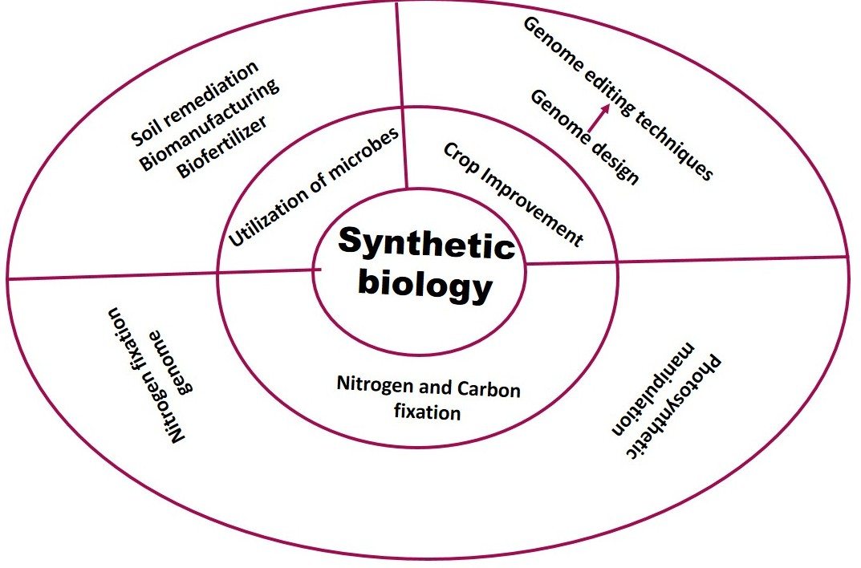

**Fig. 3.Emerging potential and scope of synthetic biology in agriculture and allied discipline**

**8. THE ROLE OF BIOTECHNOLOGY IN CLIMATE RESILIENCE**

The long term anthropogenic activities without caring environmental consequence in the early days have resulted in erratic weather condition and geographical phenomenon such as global warming. This has posed problem and threat for the flora and fauna of different ecosystem and agricultural system of the globe. Indiscriminate anthropogenic activities have brought the natural resource at the point of shortage. Moreover, Biotechnology can help in the reduction of reduce methane emissions(The key component of green house gases) by the improvement of strain of bacteria consuming emitted methane from landfillsand other sources (Shruthy Zara, 2023).Climate change, that has caused profound impact on agricultural produce and productivity by fluctuation in temperatures and rainfall, food chain pattern of pest in the ecosystem. Here, Biotechnology seems the only way of crop improvement resilient to climate change and adverse climatic condition like drought, salinity, submergence, water deficit, heat waves, flood etc (ILS, 2024). But biotechnology is suffering from the dilemma pertaining to the impact of safety and environmental issues between proponents and opponents. Investigation in this regard is on the way and it has revealedthat GMOs is as safe as conventional crops and is eco-friendly and compatible. However the perception of people is changing gradually by awareness regarding benefits of genetically modified crops and misleading information (Hwang et al., 2021).

**9. CHANGING TECHNOLOGIES AND FUTURE PROSPECTIVE**

Crop required a number of technologies either sin single or in combination for its improvement.Marker assisted breeding was the choice approach till 1990s, thereafter, transgenic and cisgenic technologies made valuable contributions in the direction of crop productivity (Klümper and Qaim, 2014). Of late, various genome editing technologies have been established that can manipulate the nuclear DNA to bring desirable change (Manghwar et al., 2019). These editing technologies allow precise editing of genomes either through the introduction of knockout or missense mutations at targeted locus or even the introduction of epigenetic changes. This is a fast-growing area of research, and the introduction of these technologies holds promise for the improvement of crop of interest. Permission of regulatory processes is essential for the intervention of novel technologies required for the improvement of agronomic trait in crop.These vary from nation to nation, but they must have well-established frameworks, based on certain principles (Turnbull et al., 2021). Few countries focus on trait-based approaches, while others use the precautionary principle. However, Most of the developing countries are suffering from having any regulatory framework and it hampers its access to novel plant varieties. This is making big difference between developed and developing in terms of crop improvement (He and Krainer, 2021). The convergence or further divergence of regulatory frameworks is crucial and decisive in the direction of development of biotechnologically altered plants.The success of improvement of major, agronomic traits lie in the intervention of different technologies such as plant breeding, transgenesis, cisgenesis, and genome editing either in alone or in combination. Many of these technologies have been very instrumental in the crop improvement over the past century and others are becoming increasingly important and hold promise for the crop improvement in instant future.

**REFERENES**

Adly, W.M.R.M., Niedbała, G., EL-Denary, M.E., Mohamed, M.A., Piekutowska, M., Wojciechowski, T., Abd El-Salam, E.-S.T.,Fouad, A.S. (2023).Somaclonal variation for genetic improvement of starch accumulation in potato (*Solanumtuberosum*) tubers. *Plants,12*, 232.

Ahmar, S., Gill, R. A., Jung, K. H., Faheem, A., Qasim, M. U., Mubeen, M., & Zhou, W. (2020). Conventional and Molecular Techniques from Simple Breeding to Speed Breeding in Crop Plants: Recent Advances and Future Outlook. *International journal of molecular sciences*, 21(7), 2590. <https://doi.org/10.3390/ijms21072590>.

Ansori, A. N., Antonius, Y., Susilo, R. J., Hayaza, S., Kharisma, V. D., Parikesit, A. A., Zainul, R., Jakhmola, V., Saklani, T., Rebezov, M., Ullah, M. E., Maksimiuk, N., Derkho, M., &Burkov, P. (2023). Application of CRISPR-Cas9 genome editing technology in various fields: A review. *Narra J*, *3*(2), e184. [*https://doi.org/10.52225/narra.v3i2.184*](https://doi.org/10.52225/narra.v3i2.184)*.*

Asmamaw, M., and Zawdie, B. (2021). Mechanism and Applications of CRISPR/Cas-9-Mediated Genome Editing. *Biologics: Targets & Therapy*, *15*, 353–361. [*https://doi.org/10.2147/BTT.S326422*](https://doi.org/10.2147/BTT.S326422)*.*

Aziz1 MA, FaicalBrini, HatemRouached and Khaled Masmoudi (2022). Genetically engineered crops for sustainably enhanced food production systemsFront. Plant Sci., 08 November 2022, Sec. *Plant Biotechnology*, 13| <https://doi.org/10.3389/fpls.2022.1027828>.

Bortesi, L. and Fischer, R. (2015). The CRISPR/Cas9 system for plant genome editing and beyond. *Biotechnology Advances*, 33, 41–52.

Das S, Ray MK, Panday D, Mishra PK (2023) Role of biotechnology in creating sustainable agriculture. *PLOS Sustain Transform,* 2(7): e0000069. <https://doi.org/10.1371/journal.pstr.0000069>.

Dattatray, Vrushali&Bijaya, Jaya & Das, Jaya Bijaya& Scholar, & Kumar, Pradeep &Chougale, Vrushali&Patil, S &Ranganna, Gurrala&Kalyani, Suman&Gangwar, Vishal & Singh andLakhwinder. (2025). Mutation breeding in the ERA of genomics: New frontiers in horticultural research. *International Journal of Advanced Biochemistry Research*. 9. 288-294.

Dennis Gonsalves (2006). Transgenic Papaya: Development, Release, Impact and Challenges, *Advances in Virus Research, Academic Press*, 67, 317-354,https://doi.org/10.1016/S0065-3527(06)67009-7.

Dreiseitl, A.; Nesvadba, Z. (2021). Powdery mildew resistance genes in single-plant progenies derived from accessions of a winter barley core collection. *Plants,* 10,[***https://doi.org/10.3390/plants10101988***](https://doi.org/10.3390/plants10101988)*.*

Garner, K. L. (2021). Principles of synthetic biology. *In Essays in Biochemistry*, 65 (5), 791–811). Portland Press Ltd. <https://doi.org/10.1042/ebc20200059>.

Global GM crop area review. (2024-2-18). [https://gm.agbioinvestor.com](https://gm.agbioinvestor.com/).

Goold, H. D., Wright, P. and Hailstones, D. (2018). Emerging Opportunities for Synthetic Biology in Agriculture. *Genes*, 9(7), 341. <https://doi.org/10.3390/genes9070341>.

Hamdan, M.F.; Karlson, C.K.S.; Teoh, E.Y.; Lau, S.-E.; Tan, B.C. (2022). Genome Editing for Sustainable Crop Improvement and Mitigation of Biotic and Abiotic Stresses. *Plants*, *11*, 2625.

Hasan, N., Choudhary, S., Naaz, N. et al. (2021). Recent advancements in molecular marker-assisted selection and applications in plant breeding programmes. *J Genet. Eng. Biotechnol*.,19, 128. <https://doi.org/10.1186/s43141-021-00231-1>.

Hasanuzzaman, M., Bhuyan, M. H. M. B., Zulfiqar, F., Raza, A., Mohsin, S. M., Mahmud, J. A., Fujita, M., and Fotopoulos, V. (2020). Reactive Oxygen Species and Antioxidant Defense in Plants under Abiotic Stress: Revisiting the Crucial Role of a Universal Defense Regulator. *Antioxidants* (*Basel, Switzerland*), 9(8), 681. <https://doi.org/10.3390/antiox9080681>.

He, S., and Krainer, K. M. C. (2021). The inequity of biotechnological impact. *Mol. Plant*, 14, 1–2. doi: 10.1016/j.molp.2020.12.011.

Hwang, H., & Nam, S. J. (2021). The influence of consumers' knowledge on their responses to genetically modified foods. *GM crops & food*, 12(1), 146–157. <https://doi.org/10.1080/21645698.2020.1840911>.

Institute of Life Sciences, (2024). Role of Biotechnology to combat Climate Change, <https://www.ils.res.in/title-role-of-biotechnology-to-combat-climate-change>.

Karataş, P., Ayaz, F. (2025). Synthetic biology and application areas. *Discov.Biotechnol*., 2, 3. <https://doi.org/10.1007/s44340-025-00010-5>.

Kezhen Qin, Fang Liu, Caibin Zhang, Rui Deng, Alisdair R. Fernie, Youjun Zhang (2025). Systems and synthetic biology for plant natural product pathway elucidation, Cell Reports, 44 (6), 115715. https://doi.org/10.1016/j.celrep.2025.115715.

Klümper, W., and Qaim, M. (2014). A meta-analysis of the impacts of genetically modified crops. *PLoS ONE* 9:e111629. doi: 10.1371/journal.pone.0111629.

Koshariya, A. K., Satkar, K., &Rawte, S. (2024). Novel Biotechnological Strategies to Boost Disease Resistance and Enhance Quality Parameters in Horticultural Plants.*Plant Cell Biotechnology and Molecular Biology*, 25(7-8), 79-100.

Kumar, R., Das, S. P., Choudhury, B. U., Kumar, A., Prakash, N. R., Verma, R., Chakraborti, M., Devi, A. G., Bhattacharjee, B., Das, R., Das, B., Devi, H. L., Das, B., Rawat, S., & Mishra, V. K. (2024). Advances in genomic tools for plant breeding: harnessing DNA molecular markers, genomic selection, and genome editing. *Biological research*, 57(1), 80. <https://doi.org/10.1186/s40659-024-00562-6>.

Lanteng Wang, XinZang andJiahai Zhou (2022). Synthetic biology: A powerful booster for future agriculture, *Advanced Agrochem.*, 1 (1), 7-11,https://doi.org/10.1016/j.aac.2022.08.005.

Lewis Daniel D., Villarreal Fernando, D., Wu Fan, Tan Cheemeng (2014). Synthetic biology outside the cell: linking computational tools to cell-free systems, Front. Bioeng. Biotechnol., Sec. Synthetic Biology, 2.<https://doi.org/10.3389/fbioe.2014.00066>.

Li, T., Yang, Y., Qi, H. *et al.* (2023). CRISPR/Cas9 therapeutics: progress and prospects. *Sig Transduct Target Ther*.,8, 36. <https://doi.org/10.1038/s41392-023-01309-7>.

Ma, L., Kong, F., Sun, K., Wang, T., &Guo, T. (2021). From Classical Radiation to Modern Radiation: Past, Present, and Future of Radiation Mutation Breeding. *Frontiers in public health*, 9, 768071. <https://doi.org/10.3389/fpubh.2021.768071>.

Manghwar, H., Lindsey, K., Zhang, X., and Jin, S. (2019). CRISPR/Cas System: recent advances and future prospects for genome editing. *Trends Plant Sci*., 24, 1102–1125. doi: 10.1016/j.tplants.2019.09.006.

Hakim, M. and Zaman, W.(2024). Plant Biotic and Abiotic Stresses" Life 14, no. 3: 372. <https://doi.org/10.3390/life14030372>.

MasoudTohidfar and SolmazKhosravi (2015). Transgenic crops with an improved resistance to biotic stresses. A review. *Biotechnol. Agron. Soc. Environ*., 19(1), 62-70.

Mmbando, G.S. (2025). Exploring the capacity of modern biotechnology to enhance climate smart crop production in Africa. *DiscovAgric*., 3, 48.<https://doi.org/10.1007/s44279-025-00198-4>.

Numan, M., Khan, A.L., Asaf, S., Salehin, M., Beyene, G., Tadele, Z.,Ligaba-Osena, A. (2021.) From Traditional Breeding to Genome Editing for Boosting Productivity of the Ancient Grain Tef [Eragrostistef (Zucc.) Trotter]. *Plants,* *10*, 628.

Pathirana, R.;Carimi, F. Plant Biotechnology: An Indispensable Tool for Crop Improvement. *Plants,* 2024, 13, 1133. <https://doi.org/10.3390/plants13081133>.

Purdy, S.J., Fuentes, D.,Ramamoorthy, P., Nunn, C., Kaiser, B.N., Merchant, A. (2023). The metabolic profile of young, watered chickpea plants can be used as a biomarker to predict seed number under terminal drought. *Plants*, *12*, 2172.

Raman R. (2017). The impact of Genetically Modified (GM) crops in modern agriculture: A review. *GM crops and food*, *8*(4), 195–208. <https://doi.org/10.1080/21645698.2017.1413522>.

Ramegowda, V., Senthil, A. and Senthil-Kumar, M. (2024). Stress combinations and their interactions in crop plants. *Plant Physiol. Rep.*, 29, 1–5. <https://doi.org/10.1007/s40502-024-00785-5>.

Ravi Kesari, Tribhuwan Kumar, SareetaNahakpam, Sweta Sinha and Sudhir Kumar Genome Editing for Plant Disease Resistance in the Proceedings-cum-Technical Report for the workshop on SPlHIMS, Published by: Department of Plant Pathology, Bihar Agricultural University, Sabour Bhagalpur – 813210 ISBN: 978-81-963064-9-6.

RoopaliBhoite, Onyemaobi, O. Halder, T.,Shankar, M. and Sharma, D.(2025). Transcription factors – Insights into abiotic and biotic stress resilience and crop improvement,*Current Plant Biology*, 41. 100434, <https://doi.org/10.1016/j.cpb.2025.100434>.

Sadia Zafar, Maria Bilal, Muhammad Fraz Ali, AtharMahmood, JureeratKijsomporn, Ling Shing Wong, Harshini M, Vikas Kumar, Saqer S. Alotaibi, (2024). Nano-biofertilizer an eco-friendly and sustainable approach for the improvement of crops under abiotic stresses, *Environmental and Sustainability Indicators*, 24,100470, <https://doi.org/10.1016/j.indic.2024.100470>.

Sebastian Karishma, Bindu B. and Arya M.S. (2025). Recent Advances and Achievements in Mutation Breeding of Fruit Crops: A Review. Agricultural Reviews. 46(2): 220-228. doi: 10.18805/ag.R-2616.

Shabbir, R., Singhal, R.K., Mishra, U.N., Chauhan, J., Javed, T.,Hussain, S., Kumar, S., Anuragi, H., Lal, D. and Chen, P. (2022). Combined Abiotic Stresses: Challenges and Potential for Crop Improvement. *Agronomy*, 12, 2795. <https://doi.org/10.3390/agronomy12112795>.

Shamshad, A., Rashid, M., Jankuloski, L., Ashraf, K., Sultan, K., Alamri, S., Siddiqui, M. H., Munir, T., and Zaman, Q. U. (2023). Effect of ethyl methanesulfonate mediated mutation for enhancing morpho-physio-biochemical and yield contributing traits of fragrant rice. *PeerJ.*, *11*, e15821. <https://doi.org/10.7717/peerj.15821>.

Shelake, R. M., Wagh, S. G., Patil, A. M.,Červený, J., Waghunde, R. R., and Kim and J. Y. (2024). Heat Stress and Plant-Biotic Interactions: Advances and Perspectives. *Plants (Basel, Switzerland)*, 13(15), 2022. <https://doi.org/10.3390/plants13152022>.

Shruthy Zara, (2023). Generalbiotechnology, challenges, climate change, environment, impact, potential, resource scarcity, <https://kahedu.edu.in/>Suchithkumar C, Sreekanth Reddy; PrashanthiDivyavani; SaiDivya; MuthaSravya; Manju Mani; GeethaManoharan (2024) Modern challenges in agriculture AIP Conf. Proc. 2971, 040051 (2024) <https://doi.org/10.1063/5.0195744>.

Tejaswini R, Ranjithkumar, G.,Varsha, H.D., Kale, T.K., Kumar, A. Keerthana, S., Karthikeyan, M. and Shankar M. (2024). Advancing Horticulture: The Role of Marker-Assisted Breeding in Crop Improvement”. *Journal of Advances in Biology & Biotechnology*, 27 (11):1017-33. <https://doi.org/10.9734/jabb/2024/v27i111686>.

Tigist, S.G., Sibiya, J., Amelework, A. andKeneni, G. (2023). Agromorphological and physiological performance of Ethiopian common bean (*Phaseolus vulgaris* L.) Genotypes under Different Agroecological Conditions. *Plants*, *12*, 2342, <https://doi.org/10.3390/plants12122342>.

Tiwari, J. K., Singh, A. K. and Behera, T. K. (2023). CRISPR/Cas genome editing in tomato improvement: Advances and applications. *Frontiers in plant science*, *14*, 1121209. <https://doi.org/10.3389/fpls.2023.1121209>.

Kumar, T., Singh, R.K., Kesari, R and Pal, A.K. (2018).MICROPROPAGATION AND GENETIC TRANSFORMATION OF BANANA (*Musa paradisiaca* L. cv. Chinia), *The Bioscan*, 13(2): 495-499 2018.

Turnbull, C., Lillemo, M., and Hvoslef-Eide, T. A. K. (2021). Global regulation of genetically modified crops amid the gene edited crop boom – A review. *Front. Plant Sci*., 12:630396. doi: 10.3389/fpls.2021.630396.

Veenstra, T. (2021). Omics in Systems Biology: Current Progress and Future Outlook. PROTEOMICS. 21. 2000235. 10.1002/pmic.202000235.

Villalobos-López, M.A., Arroyo-Becerra, A., Quintero-Jiménez, A., Iturriaga, G. (2022). Biotechnological Advances to Improve Abiotic Stress Tolerance in Crops. *Int J Mol Sci.,* 10, 23(19):12053. doi: 10.3390/ijms231912053.

XuHu, Zhang Lixiao, Kang, Z. andYidong, R. (2020). Progresses, Challenges, and Prospects of Genome Editing in Soybean (Glycine max). *Front. Plant Sci*., 22 October 2020 Sec. *Plant Biotechnology, 11 - 2020 |* <https://doi.org/10.3389/fpls.2020.571138>.

Yin X, Stam P, Kropff MJ, Schapendonk AHCM (2003) Crop modeling, QTL mapping, and their complementary role in plant breeding. Agron J 95(1):90–98. <https://doi.org/10.2134/agronj2003.0090>.