**Original Research Article**

**EVALUATION OF F2 POPULATION OF GENOTYPES IN BITTER GOURD (*Momordica charantia* L.)**

**Abstract**: An investigation entitled “Evaluation of F2 population of genotypes in bitter gourd (Momordica charantia L.)” was conducted during Kharif season 2023-24 at the Horticulture Research Scheme (Vegetable), Department of Horticulture, College of Agriculture, Parbhani, using a Randomized Block Design (RBD) with twenty treatments and two replications. Growth parameters like vine length and number of branches were recorded at the final harvest stage, with the maximum vine length observed in IC-085618 x Arka Harit (5.95 m) and the highest number of branches per vine in IC-085618 x Phule Green Gold (21.68). IC-085617 x CO-1 recorded the lowest node for first male flower appearance (12.36), while IC-085618 x Phule Green Gold showed the earliest male flower opening (37.47 days). Phule Hirkani had the lowest node for first female flower appearance (16.78), and IC-085618 x Konkan Tara showed the earliest female flower opening (46.44 days), 50% flowering (55.56 days), and first fruit harvest (58.11 days). IC-085618 x Phule Green Gold excelled with the highest number of female flowers per vine (69.99), fruits per vine (40.23), fruit yield per vine (3.92 kg), yield per hectare (24.86 q/ha), fruit length (19.43 cm), fruit weight (86.59 g), and longest duration to final harvest (137.18 days). IC-085617 x CO-1 had the highest fruit diameter (4.39 cm), and IC-505639 x CO-1 recorded the maximum flesh thickness (7.29 mm). Regarding quality, IC-085618 x Arka Harit was superior, showing the highest ascorbic acid content (113.43 mg/100g) and lowest incidence of Powdery mildew (10.57%) and Yellow mosaic virus (7.25%). Based on the results, IC-085618 x Phule Green Gold was identified as the most promising genotype for yield and fruit quality traits, while IC-085618 x Arka Harit was notable for superior nutritional quality and disease resistance.

**Keywords**: (Bitter gourd, F2 Population, Genotypes, Fruit yield)

# Introduction

Bitter gourd (*Momordica charantia* L.) is an important commercial cucurbitaceous vegetable belonging to the family Cucurbitaceae, with a diploid chromosome number, 2n=22. It is variously known as balsam pear, bitter melon, bitter cucumber and African cucumber (Heiser, 1979). It is commonly called as *Karela* in hindi and *Hagalakayi* in kannada. Momordica is a large genus with many species of annual and perennial climbers of which *Momordica charantia* L. is widely cultivated. The other species grown for their edible fruits are *M. dioica* (kakrol) , *M.* *cochinchinensis* (sweet gourd ), *M. tuberosa* and *M. balsamina L* (Balsam apple). Bitter gourd is highly cross pollinated due to monoecy.

The origin of bitter gourd is obscure. The centre of domestication likely lays in eastern Asia, possibly eastern India or southern China (Miniraj *et al*., 1993). However, there have been no archaeological reports of bitter gourd remains in China. Wild or small-fruited cultivated forms are mentioned in Ayurvedic texts written in Indian Sanskrit from 2000-200 BC by members of the Indo Aryan culture (Docker and Walters, 1999), indicating early cultivation of bitter gourd in India. It is believed to be native of Tropical Asia particularly East India and South China i.e., Indo Burma centre of origin. Bitter gourd is widely distributed in China, Malaysia, India, Tropical Africa and North and South America.

Bitter gourd fruits are good source of carbohydrates, proteins, vitamins and minerals and have the highest nutritive value among cucurbits (Desai and Musmade, 1998). The fruit has relatively high nutritional value, in respect of iron and ascorbic acid contents. The vitamin C content of Chinese bitter gourd varies significantly (440 – 780 mg / kg). Considerable variation in nutrients has been observed in bitter gourd (Kale *et al*., 1991). It has export potentiality because of its excellent keeping quality and grows round the year due to photo insensitivity nature. The green fruits are superior with regard to nutritive value and can very well be compared with any other vegetable. The fruits contain 2.1 g of protein, 2.0 mg of iron, 23.0 mg of calcium, 96.0 mg of vitamin C, 38 mg of phosphorus and 210 I.U. of vitamin A in 100 g of edible portion (Gopalan *et al*., 1993).

Bitter gourd *(Momordica charantia* L.), is monoecious and highly cross-pollinated due to its significant heterozygosity (Singh *et al*., 2013). It is utilized as a vegetable and is known to possess medicinal properties (Behera *et al*., 2008). The genus derives its name from the Latin word "mordicus," meaning bitten, due to the resemblance of the seed's jagged edges to bite marks . Bitter gourd has been a staple in the traditional medicine systems of India, China, Africa, and Latin America for centuries. Its immature tender fruits are prepared in various ways such as boiling, currying, stuffing, or frying before consumption. Additionally, they are pickled, canned, or dehydrated for preservation.

Numerous medicinal properties have been attributed to nearly all parts of the bitter gourd plant. Extracts from bitter gourd possess a wide range of beneficial properties including antioxidant, antimicrobial, antiviral, anti hepatotoxic (protecting the liver), ulcerogenic (treating ulcers), purgative (promoting bowel movements), stomachic (aiding digestion), carminative (relieving flatulence), antihelminthic (expelling intestinal worms), anti-inflammatory, febrifuge (reducing fever), vulnerary (promoting wound healing), stimulant, and thermogenic (increasing metabolism) effects. Furthermore, bitter gourd extracts have shown the ability to lower blood sugar levels, which is of particular interest in the management of diabetes. These medicinal activities are believed to be attributed to a variety of biologically active plant chemicals present in bitter gourd, including triterpenes, pisteins, and steroids, as noted by (Grover and Yadav, 2004).

Although due attention has not been given to a need-based crop improvement program, bitter gourd cultivation has recently gained popularity due to increasing consumer awareness of its anti diabetic properties and nutritional value. Vegetable breeder’s efforts have resulted in marked improvements in yield, with numerous new varieties and hybrids developed. However, there is still much work to be done in bitter gourd improvement, particularly in identifying resistant sources for pests and diseases. Thus, improvement efforts should prioritize the selection of genotypes for improved yield, quality, and resistance to biotic stresses.

Major constraints in productivity of bitter gourd are lack of early and high yielding hybrids, low genetic potential of improved varieties, poor quality seeds, poor crop management, biotic and abiotic stress. Conventional hand pollination in bitter gourd hybrids may be constrained due to its requirement of a lot of labor and time.

The present study is planned to evaluate the performance of different bitter gourd genotypes for their growth and yield characters with the following objectives.

1. To study the performance of F2 population of genotypes for growth and yield characters.

2. To find the high yielding potential F2 genotypes in bitter gourd.

# Materials and methods

The present study entitled “Evaluation of F2 population of genotypes in bitter gourd (*Momordica charantia* L*.*)” was undertaken at Horticulture Research Scheme (vegetable), Vasantrao Naik Marathwada Krishi Vidyapeeth, Parbhani (M.S.). during *Kharif* season 2023-2024. Parbhani is situated at an elevation of 413 meters above mean sea level at latitude of 19.27 North and longitude of 76.48° East. The experiment was laid out in Randomized Block Design (RBD) with twenty treatments and two replication namely [IC-085616 x Phule Green Gold, IC-085616 x Phule Hirkani, IC-085616 x CO-1, IC-085617 x Arka Harit, IC-085617 x CO-1, IC-085618 x Konkan Tara, IC-085618 x CO-1, IC-085618 x Phule Hirkani, IC-085618 x Phule Green Gold, IC-505629 x Phule Hirkani, IC-505629 x Konkan Tara, IC-505639 x Phule Green Gold, IC-505639 x Konkan Tara, IC-505639 x CO-1, IC-085617 x Phule Green Gold, IC-505639 x Arka Harit, IC-085618 x Arka Harit, Phule Green Gold (check), Phule Hirkani (check) and Pusa Aushadhi (check)], were selected for evaluation. The seeds were directly sown in the main field with a spacing of 1.5m x 1.0m in plot size of 4m x 4.5m. Full dose of P2O5 and K2O (50 kg) and half dose of N (50 kg) were applied as basal dose before sowing, remaining dose of N (50 kg) was applied as top dressing after one month of sowing. Gap filling was carried out after 8 days of sowing and plant population of each treatment plot was maintained. Irrigation was given uniformly and regularly with drip irrigation method when required in order to conserve the soil moisture. Hand weeding was undertaken at 15 days interval where 4-5 weeding are completed and experimental plot were kept weed free. The crop was protected from insect, pest, and disease by spraying Imidachloprid (1ml/l) and drenching with fungicide like Copper Oxychloride when required.

Data on the vine length, number of branches per vine, node at which first male flower appears, number of days to first male flower opening, node at which first female flower appears, number of days to first female flower opening, days to 50 per cent flowering, number of female flowers per vine, days to first fruit harvest, days to final harvest, fruit length, fruit diameter, flesh thickness, average fruit weight, number of fruits per vine, fruit yield per vine, fruit yield per hectare, ascorbic acid, powdery mildew incidence, yellow mosaic virus incidence were collected and subjected to analysis of variance to test significant difference among the genotypes.

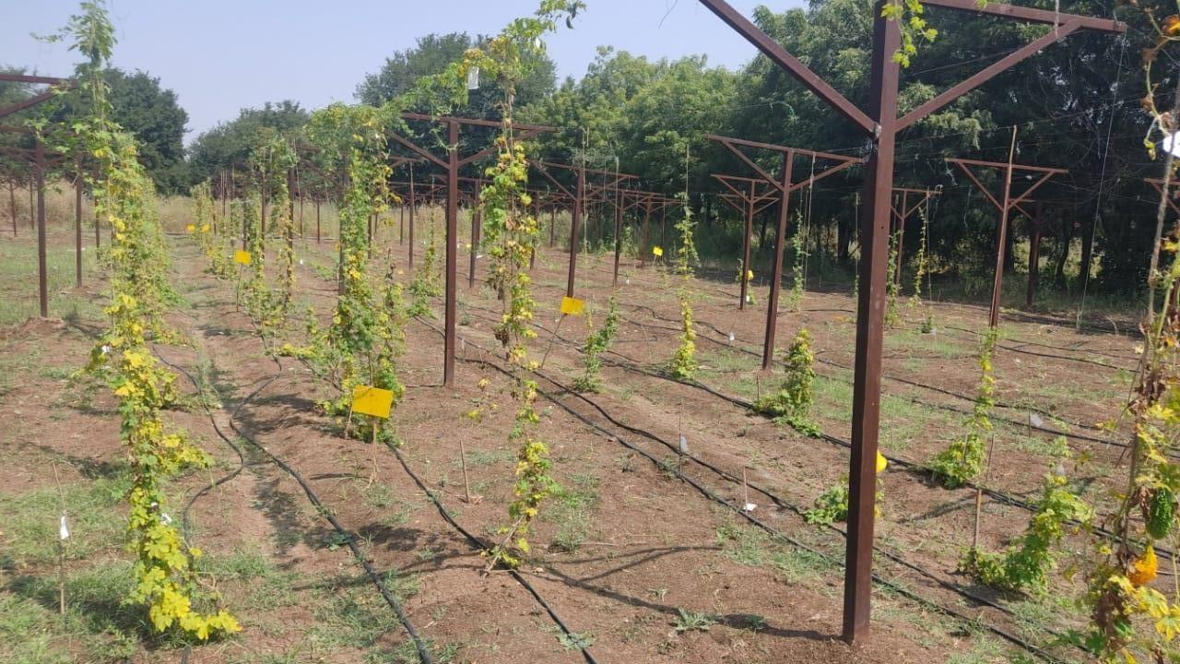

Plate 1. General View of Experimental Plot

# Results and discussion

# *Growth parameters*

# *Vine length (cm)*

At the final stage of harvest, the progenies of bitter gourd under study showed significant differences in vine length (Table 1). Among the progenies evaluated, vine length varied from 3.31 m to 5.95 m at the final harvest. The maximum vine length was recorded by IC-085618 x Arka Harit (5.95 m) and on par with IC-085616 x CO-1 (5.54 m), IC-085617 x Arka Harit (5.50 m), IC-085618 x CO-1 (5.50 m), The minimum vine length was observed in IC-505639 x Phule Green Gold (3.31 m). The variation in vine length might be due to the inherent properties, vigour of the crop, specific genetic makeup of different genotypes, hormonal factors, environmental factors, soil condition. These factors highly influences the growth of plant. Previous studies have also noted variations in bitter gourd vine length. It has been reported earlier in bitter gourd by Yadav *et al*. (2008) and Singh *et al.* (2016) and Priyadharshini *et al*. (2018) in *Momordica charantia var. muricata* L.

***3.1.2* Number of branches per vine**

The progenies of bitter gourd showed significant differences in respect to number of branches per vine at the final harvest. At the final harvest, maximum number of branches per vine was recorded in IC-085618 x Phule Green Gold (21.68) and on par with IC-085618 x Konkan Tara (21.64), IC-085618 x CO-1 (20.67), IC-505629 x Phule Hirkani (20.13), IC-085618 x Arka Harit (19.24). The minimum number of branches per vine was recorded in IC-085617 x Phule Green Gold (14.05). The number of branches differed among progenies, which could be attributed to the vine's genetic characteristics as well as factors like vine length, inter nodal spacing, environmental conditions, and the source-sink relationship. Additionally, hormonal regulation influences both the quantity and length of branches. Similar results were reported by Singh *et al.* (2016) in bitter gourd, Samadia (2002) in bottle gourd, Madhavi *et al.* (2021) in ridge gourd and Annigeri *et al.* (2023) in sponge gourd.

***3.2. Flower attributes***

The flower parameters *viz,* Node at which first male flower appears, number of days to first male flower opening, node at which first female flower appears, number of days to first female flower opening, days to 50% flowering, number of female flowers per vine, were narrated below.

***3.2.1* Node at first male flower appears**

The progenies IC-085617 x CO-1 (12.36) recorded lowest node at which first male flower appears which was on par with Phule Hirkani (check) (12.48), IC-505629 x Phule Hirkani (14.77), IC-085618 x Phule Green Gold (15.17) and IC-085618 x CO-1 (15.27). Whereas IC-085618 x Phule Hirkani (19.77) recorded the highest node at which first male flower appear. The node where the first male flower emerges is a crucial factor in determining the crop’s earliness or lateness. The variation in the node at which first male flower emergence on a vine, might be due to the vigour of the crop, specific genetic makeup of different genotypes, inter nodal length, number of internodes and vigour of the crop, inherent properties. Similar results have been reported by Thangamani (2008), Thangamani *et al*. (2011), Thangamani and Pugalendhi (2013), Singh *et al*. (2016) in bitter gourd, Saranyadevi *et al*. (2017) and Priyadharshini *et al*. (2018).in *Momordica charantia var. muricata* L.

***3.2.2* Number of days to first male flower**

Among the progenies IC-085618 x Phule Green Gold (37.47 days) had recorded minimum number of days to first male flower opening and on par with IC-085618 x Konkan Tara (38.29 days), IC-085618 x Arka Harit (43.84 days), IC-085618 x CO-1 (43.86 days). Maximum number of days to first male flower opening was recorded by Pusa Aushadhi (check) (53.94 days). The variation in number of days to first male flower opening might be due to vigour of the crop, specific genetic makeup of different progenies, inherent properties, hormonal activities, environmental factors (light intensity and temperature) and fertility status of soil. These findings are in line with the findings reported by Sahni *et al.* (1987) in ridge gourd, Sundaram (2009), Jadhav *et al*., (2009), Thangamani *et al*. (2011), Thangamani and Pugalendhi (2013) and Singh *et al*. (2016) in bitter gourd, Saranyadevi *et al*. (2017) and Priyadharshini *et al*. (2018) in *Momordica charantia* var *muricata* L.

**3.2.3 Node at first female flower appeared**.

The lowest values for node at which first female flower appeared was observed in Phule Hirkani (check) (16.78) which was on par with IC-505629 x Phule Hirkani (17.10), IC-085616 x CO-1 (17.95), IC-505639 x CO-1 (18.32), IC-085618 x CO-1 (18.66), IC-085618 x Arka Harit (18.75), Pusa Aushadhi (19.77). The highest value for node at which first female flower was observed in IC-085618 x Konkan Tara (26.56). The node where the first female flower emerges is an

**Table 1. Mean values of vine length, number of branches per vine, node at first male flower appears and number of days to first male flower in bitter gourd progenies**

|  |  |  |  |  |
| --- | --- | --- | --- | --- |
| **Treatments** | **Vine length (m)** | **Number of branches per vine** | **Node at first male flower appears** | **Number of days to first male flower** |
| T1 -IC-085616 x Phule Green Gold | 4.41 | 14.75 | 15.84 | 47.57 |
| T2 -IC-085616 x Phule Hirkani | 4.43 | 18.38 | 17.28 | 46.96 |
| T3 -IC-085616 x CO-1 | 5.54 | 18.64 | 15.63 | 48.06 |
| T4 - IC-085617 x Arka Harit | 5.50 | 14.23 | 16.31 | 47.03 |
| T5 -IC-085617 x CO-1 | 5.20 | 15.88 | 12.36 | 45.64 |
| T6 - IC-085618 x Konkan Tara | 5.13 | 21.64 | 18.08 | 38.29 |
| T7 - IC-085618 x CO-1 | 5.50 | 20.67 | 15.27 | 43.86 |
| T8 -IC-085618 x Phule Hirkani | 4.34 | 18.55 | 19.77 | 46.62 |
| T9 -IC-085618 x Phule Green Gold | 4.24 | 21.68 | 15.17 | 37.47 |
| T10 - IC-505629 x Phule Hirkani | 4.31 | 20.13 | 14.77 | 45.48 |
| T11 - IC-505629 x Konkan Tara | 4.26 | 17.28 | 16.38 | 46.79 |
| T12 - IC-505639 x Phule Green Gold | 3.31 | 18.41 | 17.14 | 48.23 |
| T13 - IC-505639 x Konkan Tara | 3.63 | 17.86 | 16.14 | 48.88 |
| T14 - IC-505639 x CO-1 | 4.24 | 16.08 | 17.53 | 45.64 |
| T15 - IC-085617 x Phule green gold | 4.12 | 14.05 | 15.77 | 46.42 |
| T16  - IC-505639 x Arka Harit | 4.33 | 15.10 | 15.69 | 45.24 |
| T17 - IC-085618 x Arka Harit | 5.95 | 19.24 | 15.84 | 43.84 |
| T18 - Phule Green Gold (check) | 4.88 | 14.37 | 17.76 | 45.55 |
| T19 - Phule Hirkani (check) | 4.53 | 14.78 | 12.48 | 45.17 |
| T20 - Pusa Aushadhi (check) | 4.43 | 14.96 | 17.13 | 53.94 |
| **GM** | 4.61 | 17.33 | 16.11 | 45.83 |
| **S. Em** + | 0.23 | 0.88 | 0.98 | 2.18 |
| **CD @ 5%** | 0.68 | 2.61 | 2.92 | 6.47 |

important character, which determines the earliness or lateness of the crop. The early appearance of female flower and late appearance of female flower helps in the occurance of early/late flush of the crop which is advantageous for market to fetch the higher price. The variation in node at which first female flower appeared might have been due to specific strain characters, vigour of crop and first appearance of male flower, environmental and soil condition. These results are similar with, Thangamani *et al*. (2011), Thangamani and Pugalendhi (2013), Thangamani (2008) and Singh *et al*. (2016) in bitter gourd. Saranyadevi *et al*. (2017) and Priyadharshini *et al*. (2018) in *Momordica charantia var. muricata* L.

**3.2.4 Number of days to first female flower**

Days to opening of first female flower is directly associated with the days to first fruit harvest. The maturity of a variety is determined by number of days taken for its first female flower opening. The progenies IC-085618 x Konkan Tara (46.44 days) taken minimum number of days to first female flower opening and on par with IC-085616 x Phule Green Gold (49.74 days), IC-505629 x Phule Hirkani (52.62 days), IC-085618 x Phule Green Gold (53.60 days), IC-505639 x CO-1 (54.20 days), whereas maximum number of days to first female flower opening was taken in IC-505639 x Konkan Tara (64.40 days). The variation in node at which first female flower appeared might have been due to vigour of crop, first appearance of male flower, genetic features of plants, hormonal activities, environmental factors (light intensity and temperature) and fertility status of soil. The early appearance of female flower and late appearance of female flower helps in the occurance of early/late harvest of the crop which is advantageous for market to fetch the higher price. The results are in line with the findings of Sahni *et al*. (1987) in ridge gourd, Sundaram (2009), Jadhav *et al.* (2009), Thangamani *et al*. (2011), Thangamani and Pugalendhi (2013) and Singh *et al*. (2016) in bitter gourd Saranyadevi *et al*. (2017) and Priyadharshini *et al*. (2018) in *Momordica charantia var. muricata* L.

**3.2.5 Days to 50 per cent flowering**

The minimum days to 50 per cent flowering was recorded in progeny IC-085618 x Konkan Tara (55.56 days) and which was at par with IC-505629 x Phule Hirkani (59.75 days), Phule Hirkani (60.13 days), IC-085617 x CO-1 (61.19 days), IC-505639 x CO-1 (64.81 days). Whereas the progeny IC-085616 x CO-1 (79.65 days) recoded maximum days to 50 per cent flowering. Early

**Table 2. Mean values of node at first female flower appears, number of days to first female flower, days to 50 % flowering and number female flowers per vine in bitter gourd progenies under study**

|  |  |  |  |  |
| --- | --- | --- | --- | --- |
| **Treatments** | **Node at which first female flower appears** | **Number of days to first female flower opening** | **Days to 50 % flowering** | **Number of female flowers per vine** |
| T1 -IC-085616 x Phule Green Gold | 23.34 | 49.74 | 70.46 | 57.46 |
| T2 -IC-085616 x Phule Hirkani | 22.23 | 59.27 | 71.75 | 62.23 |
| T3 -IC-085616 x CO-1 | 17.95 | 62.15 | 79.65 | 59.37 |
| T4 - IC-085617 x Arka Harit | 24.28 | 61.02 | 72.40 | 58.46 |
| T5 -IC-085617 x CO-1 | 21.05 | 56.43 | 61.19 | 58.31 |
| T6 - IC-085618 x Konkan Tara | 26.56 | 46.44 | 55.56 | 59.17 |
| T7 - IC-085618 x CO-1 | 18.66 | 54.90 | 69.41 | 67.48 |
| T8 -IC-085618 x Phule Hirkani | 24.68 | 55.07 | 69.23 | 63.52 |
| T9 -IC-085618 x Phule Green Gold | 22.64 | 53.60 | 69.09 | 69.99 |
| T10 - IC-505629 x Phule Hirkani | 17.10 | 52.62 | 59.75 | 57.36 |
| T11 - IC-505629 x Konkan Tara | 22.15 | 56.78 | 67.82 | 55.21 |
| T12 - IC-505639 x Phule Green Gold | 24.61 | 58.41 | 67.01 | 57.23 |
| T13 - IC-505639 x Konkan Tara | 20.31 | 64.40 | 70.25 | 54.58 |
| T14 - IC-505639 x CO-1 | 18.32 | 54.20 | 64.81 | 53.41 |
| T15 - IC-085617 x Phule Green Gold | 23.42 | 58.00 | 68.84 | 61.27 |
| T16  - IC-505639 x Arka Harit | 20.90 | 56.13 | 66.75 | 61.39 |
| T17 - IC-085618 x Arka Harit | 18.75 | 58.21 | 71.16 | 57.63 |
| T18 - Phule green gold (check) | 21.08 | 56.66 | 65.78 | 43.18 |
| T19 - Phule Hirkani (check) | 16.78 | 57.69 | 60.13 | 41.85 |
| T20 - Pusa aushadhi (check) | 19.77 | 60.08 | 69.65 | 43.96 |
| **GM** | 21.22 | 56.58 | 67.53 | 57.15 |
| **S. Em** + | 1.06 | 2.80 | 3.16 | 2.80 |
| **CD @ 5%** | 3.13 | 8.31 | 9.37 | 8.29 |

appearance of male and female flowers on the vine is an indication of crop earliness. Similar findings have been reported by Koppad *et al*. (2015), Hegade *et al*. (2009), Tyagi *et al*. (2010) and in ridge gourd.

**3.2.6 Number of female flowers per vine**

Among the genotypes tested, number of female flowers per vine varied from 69.99 to 41.85. The highest number of female flowers per vine was observed in IC-085618 x Phule Green Gold (69.99) and was on par with IC-085618 x CO-1 (67.48), IC-085618 x Phule Hirkani (63.52), IC-085616 x Phule Hirkani (62.23). whereas Phule Hirkani (check) (41.85) found lowest number of female flowers per vine. The variation in number of female flowers per vine might have been due to vigour of the crop, environmental factor, genetic makeup, Harmonal factor. In the present investigation genotypes with good number of female flower resulted good yield. These results are in accordance with Kumari *et al* (2018) in cucumber, Nalawade *et al*. (2011), Singh and Singh (2015) in bitter gourd and Gaonkar *et al*. (2023) in bottle gourd.

**3.3 Fruit characters**

**3.3.1 Days to first fruit harvest**

Among the genotypes, IC-085618 x Konkan Tara (58.11 days) recorded lowest number of days to first fruit harvest which was on par with IC-085616 x Phule Green Gold (59.97 days), IC-505629 x Phule Hirkani (63.62 days), IC-085618 x Phule Green Gold (64.09 days), IC-505639 x CO-1 (68.01 days). The highest number of days to first fruit harvest was observed in IC-505639 x Konkan Tara (78.03 days). Early harvesting allows the crop to enter the market sooner to fetch the higher price which is the major advantage. The variation in days to first fruit harvest might be due to vigour of crop, first appearance of female flower and first appearance of male flower, varietal genetic factor, environmental factor and hormonal factor. The progenies which flowers early with respect to female flower was noted for early fruit harvest, where as the genotype which flowers late will be noted for delayed fruit harvest. Similar findings were observed by, Singh *et al*. (2016) in bitter gourd, Pandey and Singh (2007) in sponge gourd, Kumar *et al.* (1999) and Sirohi *et al*. (1988), Harika *et al*. (2012) in bottle gourd.

**3.3.2 Days to final harvest**

The maximum number of days to final harvest was noticed in IC-085618 x Phule Green Gold (137.18) and which was on par with IC-085618 x CO-1 (134.91), IC-085618 x Konkan Tara (131.95), IC-085618 x Arka Harit (127.95), IC-085618 x Phule Hirkani (123.42), IC-505629 x Phule Hirkani (121.32), IC-085616 x Phule Hirkani (120.88). Whereas IC-505639 x CO-1 (105.58) recorded minimum number of days to final harvest. The results may be due to higher production and assimilation of photosynthates and also might be due to higher number of flower production which may have prolonged the harvesting days. These results may also due to genetic character of the genotype. These results are similar with results of Koppad *et al*. (2015).

**3.3.3 Fruit length (cm)**

Among the genotypes tested, fruit length varied from 19.43 cm to 12.28 cm. The maximum fruit length was recorded in IC-085618 x Phule Green Gold (19.43 cm) which was on par with IC-085618 x CO-1 (18.58 cm), IC-085617 x CO-1 (17.59 cm), IC-085616 x Phule Green Gold (17.38 cm) and minimum fruit length was recorded in IC-505639 x Arka Harit (12.28 cm). The fruit length directly influences the fruit weight which leads to higher fruit yield/plant and fruit yield ha-1. The variation in fruit length is due to genetic behavior of crops and variable in different climatic conditions. The fruit yield is highly influenced by the length of fruit crop. The average fruit length which was observed maximum was due to maximum ovary length. Research findings are in line with Singh *et al*. (2016) in bitter gourd, Ahamed *et al*. (2004) in cucumber, Choudhary *et al*. (2014) in ridge gourd and Priyadharshini *et al.* (2018) in *Momordica charantia var. muricata* L.

**3.3.4 Fruit diameter (cm)**

Among the progenies tested, fruit diameter varied from 4.39 cm to 3.28 cm. Highest fruit diameter was noticed in IC-085617 x CO-1 (4.39 cm) which is on par with IC-085618 x Konkan Tara (4.06 cm), Pusa Aushadhi (4.02 cm), IC-085618 x Phule Hirkani (3.95 cm), IC-505639 x CO-1 (3.95 cm) and IC-505639 x Konkan Tara (3.86 cm). Lowest fruit diameter were recorded in IC-085616 x CO-1 (3.28 cm). The fruit diameter directly affect the fruit weight which leads to higher fruit yield/plant and fruit yield ha-1. The variation in diameter is due to genetic behavior of crops and variable in different climatic conditions. The fruit yield is highly influenced by the diameter of fruit crop. Research findings are in line with Singh *et al*. (2016), Thakur *et al.*(2018)

**Table 3. Mean values of days to first fruit harvest, days to final harvest, fruit length and fruit diameter in bitter gourd progenies**

|  |  |  |  |  |
| --- | --- | --- | --- | --- |
| **Treatments** | **Days to first fruit harvest** | **Days to final harvest** | **Fruit length (cm)** | **Fruit diameter (cm)** |
| T1 -IC-085616 x Phule Green Gold | 59.97 | 115.29 | 17.38 | 3.35 |
| T2 -IC-085616 x Phule Hirkani | 74.16 | 120.88 | 14.79 | 3.64 |
| T3 -IC-085616 x CO-1 | 75.28 | 118.54 | 15.72 | 3.28 |
| T4 - IC-085617 x Arka Harit | 74.75 | 113.02 | 13.73 | 3.82 |
| T5 -IC-085617 x CO-1 | 69.66 | 119.61 | 17.59 | 4.39 |
| T6 - IC-085618 x Konkan Tara | 58.11 | 131.95 | 14.78 | 4.06 |
| T7 - IC-085618 x CO-1 | 68.50 | 134.91 | 18.58 | 3.61 |
| T8 -IC-085618 x Phule Hirkani | 68.85 | 123.42 | 13.57 | 3.95 |
| T9 -IC-085618 x Phule Green Gold | 64.09 | 137.18 | 19.43 | 3.70 |
| T10 - IC-505629 x Phule Hirkani | 63.62 | 121.32 | 13.29 | 3.66 |
| T11 - IC-505629 x Konkan Tara | 70.30 | 119.38 | 16.45 | 3.52 |
| T12 - IC-505639 x Phule Green Gold | 74.12 | 116.60 | 15.39 | 3.61 |
| T13 - IC-505639 x Konkan Tara | 78.03 | 109.38 | 16.60 | 3.86 |
| T14 - IC-505639 x CO-1 | 68.01 | 105.58 | 16.13 | 3.95 |
| T15 - IC-085617 x Phule Green Gold | 72.70 | 117.14 | 16.65 | 3.63 |
| T16  - IC-505639 x Arka Harit | 69.38 | 109.91 | 12.28 | 3.75 |
| T17 - IC-085618 x Arka Harit | 73.68 | 127.95 | 14.96 | 3.58 |
| T18 - Phule Green Gold (check) | 69.87 | 118.92 | 13.11 | 3.37 |
| T19 - Phule Hirkani (check) | 71.81 | 108.46 | 13.38 | 3.30 |
| T20 - Pusa Aushadhi (check) | 74.44 | 111.67 | 13.64 | 4.02 |
| **GM** | 69.96 | 119.05 | 15.37 | 3.70 |
| **S. Em** + | 3.49 | 5.89 | 0.79 | 0.19 |
| **CD @ 5%** | 10.33 | 17.46 | 2.34 | 0.56 |

in bitter gourd, Singh *et al*. (2019) in bitter gourd and Ahamed *et al*. (2004) in cucumber.

**3.3.5 Flesh thickness (mm)**

The highest flesh thickness was recorded in progeny IC-505639 x CO-1 (7.29 mm) and which is on par with IC-505639 x Arka Harit (6.93 mm), IC-505629 x Konkan Tara (6.89 mm), IC-085618 x Phule Hirkani (6.77 mm), IC-085618 x Konkan Tara (6.67 mm), IC-085618 x Phule Green Gold (6.47 mm). whereas Lowest flesh thickness was recorded in Pusa Aushadhi (check) (4.72 mm). Fruit flesh thickness is an important fruit quality trait which determines the market preference and an essential determinant of yield in bitter gourd. The thicker the fruit flesh, the higher the edible portion of the fruit. The variation in flesh thickness is might be due to genetic nature of crop. Similar results have been reported by Mohan (2005), Singh *et al*. (2016), Alhariri *et al*. (2018) and Reshmika *et al*. (2019) in bitter gourd.

**3.4 Yield parameters**

**3.4.1 Average fruit weight (g)**

Among the progenies tested, fruit weight varied from 86.59 g to 45.38 g. Highest fruit weight were noticed in IC-085618 x Phule Green Gold (86.59 g) which is on par with IC-085618 x CO-1 (85.39 g), IC-085617 x Phule Green Gold (82.37 g), IC-085618 x Phule Hirkani (80.20 g), IC-505639 x Phule Green Gold (77.84 g), IC-085616 x Phule Green Gold (76.69 g). Lowest fruit weight was noticed in Phule Hirkani (45.38 g). Fruit weight is directly affected by fruit length and diameter, resulting in increased fruit yield per plant. The variations in yield and yield attributes among the progenies could be explained on the fact that genotypes differ in their morphological and physiological characteristics and thereby translocation of carbohydrates from source to sink. The variation in fruit weight is due to genetic behavior of crops and variable in different climatic condtions. The results are in line with the findings of Rani (2014), Singh *et al.* (2016) and Thakur *et al*. (2018) in bitter gourd.

**3.4.2 Number of fruits per vine**

Number of fruits per vine is one of the yield contributing trait, the maximum number of fruits per vine were noticed in IC-085618 x Phule Green Gold (40.23) which was on par with IC-085618 x CO-1 (39.67). Minimum number of fruits per vine were noticed in Phule Hirkani (21.67). The number of fruits/vine is one of the major factors for deciding the yield of the crop.

**Table 4. Mean values of flesh thickness, average fruit weight and Ascorbic acid in bitter gourd progenies**

|  |  |  |  |
| --- | --- | --- | --- |
| **Treatments** | **Flesh thickness (mm)** | **Average fruit weight (g)** | **Ascorbic acid (mg/100 g)** |
| T1 -IC-085616 x Phule Green Gold | 5.33 | 76.69 | 98.91 |
| T2 -IC-085616 x Phule Hirkani | 5.71 | 76.13 | 99.37 |
| T3 -IC-085616 x CO-1 | 5.17 | 72.44 | 102.22 |
| T4 - IC-085617 x Arka Harit | 6.02 | 52.63 | 110.60 |
| T5 -IC-085617 x CO-1 | 5.83 | 75.88 | 101.87 |
| T6 - IC-085618 x Konkan Tara | 6.67 | 75.17 | 109.32 |
| T7 - IC-085618 x CO-1 | 6.24 | 85.39 | 106.43 |
| T8 -IC-085618 x Phule Hirkani | 6.77 | 80.20 | 100.62 |
| T9 -IC-085618 x Phule Green Gold | 6.47 | 86.59 | 100.53 |
| T10 - IC-505629 x Phule Hirkani | 5.27 | 71.60 | 94.38 |
| T11 - IC-505629 x Konkan Tara | 6.89 | 62.25 | 96.12 |
| T12 - IC-505639 x Phule Green Gold | 5.54 | 77.84 | 101.97 |
| T13 - IC-505639 x Konkan Tara | 6.03 | 74.69 | 99.7 |
| T14 - IC-505639 x CO-1 | 7.29 | 71.25 | 98.05 |
| T15 - IC-085617 x Phule Green Gold | 5.87 | 82.37 | 99.60 |
| T16  - IC-505639 x Arka Harit | 6.93 | 61.28 | 107.18 |
| T17 - IC-085618 x Arka Harit | 4.95 | 66.76 | 113.43 |
| T18 - Phule Green Gold (check) | 6.15 | 46.63 | 95.05 |
| T19 - Phule Hirkani (check) | 6.33 | 45.38 | 97.12 |
| T20 - Pusa Aushadhi (check) | 4.72 | 51.68 | 93.48 |
| **GM** | 5.99 | 69.64 | 101.30 |
| **S. Em** + | 0.3 | 3.39 | 3.73 |
| **CD @ 5%** | 0.91 | 10.04 | 11.05 |

The variation in number of fruits per vine might have been due to intermodal length, number of inter node sex ratio, fruit set percentage, genetic nature and their response to varying environmental conditions. Similar findings were also observed by Thangamani *et al.* (2011) as well as Thangamani and Pugalendhi (2013), Singh *et al.* (2016) and Srivastava and Srivastava (1976) in bitter gourd.

**3.4.3 Fruit yield per vine (kg)**

Yield per plant is the ultimate and the most important trait. Among the progenies tested, fruit yield per vine varied from 3.92 kg to 2.06 kg. The maximum fruit yield per vine was observed in IC-085618 x Phule Green Gold (3.92 kg) and on par with IC-085618 x CO-1 (3.87 kg), IC-085617 x Phule Green Gold (3.64 kg), IC-085616 x CO-1 (3.53 kg), IC-085618 x Phule Hirkani (3.44 kg). Minimum fruit yield per vine were observed in Phule Hirkani (2.06 kg). The fruit yield of bitter gourd is economically important and depends on the variety and crop management practices. The significant variation in yield per vine might be due to fruit set percentage, fruit length, number of fruits per vine, fruit weight and fruit width. Similar findings were observed by Thangamani *et al.* (2011), Thangamani and Pugalendhi (2013).

**3.4.4 Fruit yield per hectare (q / ha)**

Among the progenies tested, fruit yield per hectare varied from 24.86 q/ha to 13.67 q/ha, IC-085618 x Phule Green Gold (24.86 q/ha) recorded highest fruit yield per hectare which was on par with IC-085618 x CO-1 (24.66 q/ha), IC-085617 x Phule Green Gold (22.43 q/ha), IC-085618 x Phule Hirkani (21.36 q/ha). Whereas Phule Green Gold (13.67 q/ha) recorded lowest fruit yield per hectare. The length and diameter of the fruit have a direct impact on fruit weight, resulting in increased fruit yield ha-1. The variation in fruit yield per hectare might be due to sex ratio, fruit set percentage, fruit length, fruit diameter, crop vigour, genetic nature of strains, environmental and soil condition. Differences in fruit yield ha-1 was due to the number of fruit/plant, fruit yield/vine, fruit size and fruit weight. These findings are in close conformity with findings of Srivastava and Srivastava (1976), Singh *et al*. (2016) and Thakur *et al*. (2018) in bitter gourd.

**Table 5. Mean values of number of fruits per vine, fruit yield per vine and per ha in bitter**

**gourd progenies**

|  |  |  |  |
| --- | --- | --- | --- |
| **Treatments** | **Number of fruits per vine** | **Fruit yield per vine (kg)** | **Fruit yield (q / ha)** |
| T1 -IC-085616 x Phule Green Gold | 30.68 | 2.85 | 18.17 |
| T2 -IC-085616 x Phule Hirkani | 33.43 | 3.20 | 20.23 |
| T3 -IC-085616 x CO-1 | 32.37 | 3.53 | 18.48 |
| T4 - IC-085617 x Arka Harit | 32.56 | 2.40 | 14.37 |
| T5 -IC-085617 x CO-1 | 33.73 | 3.24 | 19.74 |
| T6 - IC-085618 x Konkan Tara | 32.85 | 3.15 | 19.26 |
| T7 - IC-085618 x CO-1 | 39.67 | 3.87 | 24.66 |
| T8 -IC-085618 x Phule Hirkani | 34.42 | 3.44 | 21.36 |
| T9 -IC-085618 x Phule Green Gold | 40.23 | 3.92 | 24.86 |
| T10 - IC-505629 x Phule Hirkani | 31.45 | 2.85 | 17.42 |
| T11 - IC-505629 x Konkan Tara | 29.24 | 2.43 | 14.76 |
| T12 - IC-505639 x Phule Green Gold | 30.83 | 3.10 | 19.34 |
| T13 - IC-505639 x Konkan Tara | 27.48 | 2.57 | 15.61 |
| T14 - IC-505639 x CO-1 | 29.78 | 2.67 | 16.48 |
| T15 - IC-085617 x Phule Green Gold | 35.27 | 3.64 | 22.43 |
| T16  - IC-505639 x Arka Harit | 33.72 | 2.57 | 16.52 |
| T17 - IC-085618 x Arka Harit | 32.43 | 2.76 | 17.21 |
| T18 - Phule Green Gold (check) | 22.87 | 2.26 | 13.67 |
| T19 - Phule Hirkani (check) | 21.82 | 2.06 | 13.84 |
| T20 - Pusa Aushadhi (check) | 21.67 | 2.38 | 14.56 |
| **GM** | 31.32 | 2.94 | 18.14 |
| **S. Em** + | 1.52 | 0.16 | 1.21 |
| **CD @ 5%** | 4.51 | 0.49 | 3.60 |

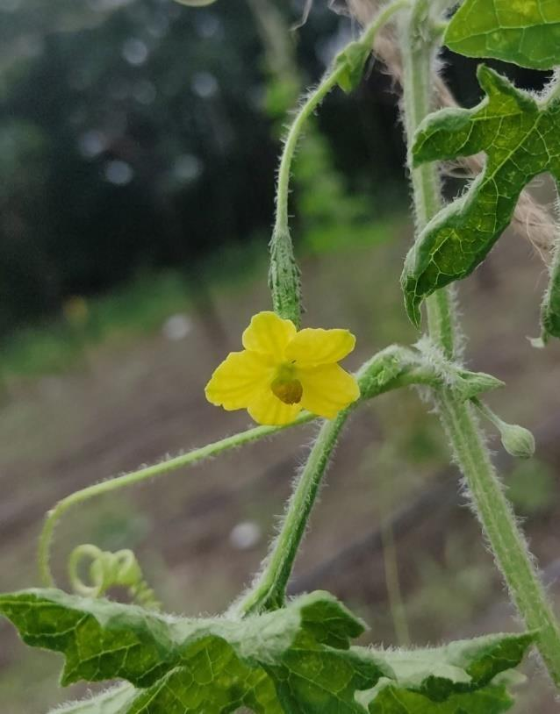 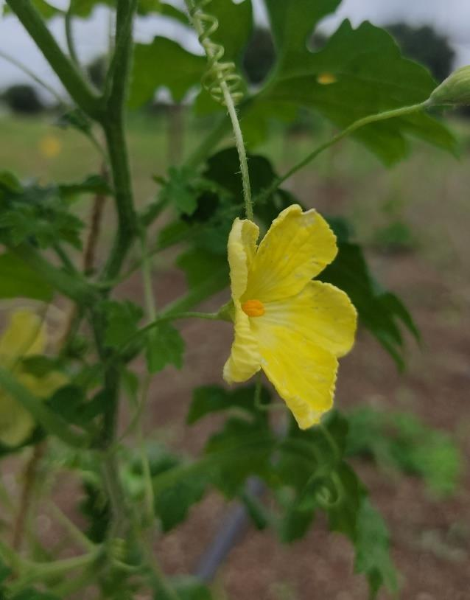

Female flower Male flower

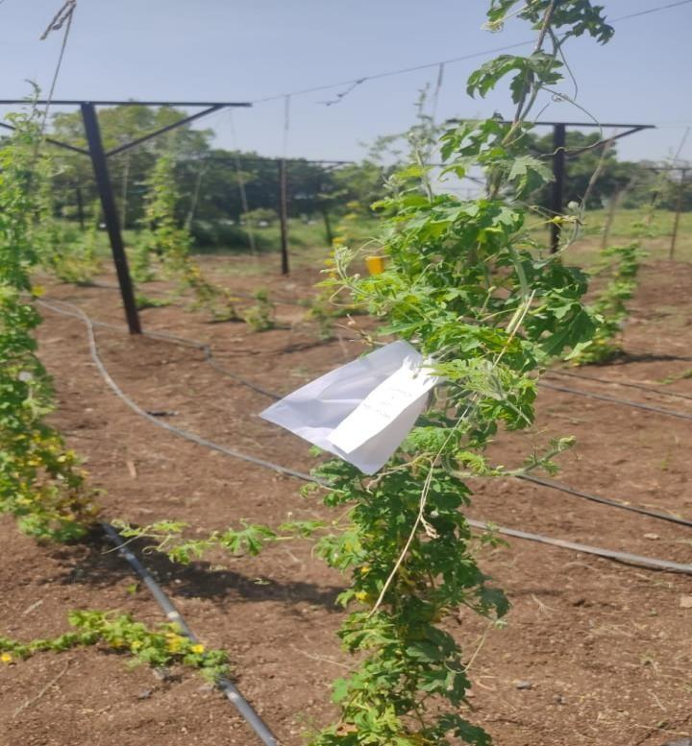

Bagged selfed female flower

Plate 2. General view of female and male flowers in bitter gourd with selfed plant.

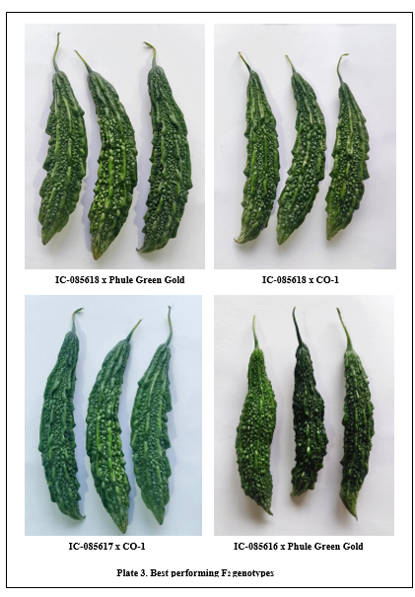

**3.5 Biochemical parameter**

**3.5.1 Ascorbic acid (mg/100g)**

Ascorbic acid is a nutritionally important character, among the genotypes maximum ascorbic acid content were noticed in IC-085618 x Arka Harit (113.43 mg/100g) and was on par with IC-085617 x Arka Harit (110.60 mg/100g), IC-085618 x Konkan Tara (109.32 mg/100g), IC-505639 x Arka Harit (107.18 mg/100g), IC-085618 x CO-1 (106.43 mg/100g). Minimum ascorbic acid was noticed in Pusa Aushadhi (93.48 mg/100g). The variation in ascorbic acid in different strains might be due to the strong influence by genotype differences, inheritance of parents and little influence due to environmental and soil condition. The findings of this study suggest that bitter gourd fruits from various genotypes are rich in ascorbic acid content. These findings are in close conformity with findings of Gopalan *et al*. (1993), Singh *et al.* (2016) and Singh *et al*. (2017) in bitter gourd.

**3.6 Disease incidence**

**3.6.1 Powdery mildew incidence (%)**

Data recorded on incidence of Powdery mildew ranged from 10.57 % to 24.77 % Among the genotypes IC-085618 x Arka Harit (10.57 %) observed lowest powdery mildew incidence which is on par with IC-085617 x Arka Harit (12.74 %), IC-085616 x Phule Green Gold (13.54 %), IC-085618 x Phule Green Gold (14.28 %), IC-085618 x Phule Hirkani (14.84 %) where as highest powdery mildew incidence were noticed in IC-505639 x Phule Green Gold (24.77 %). Powdery mildew, a fungal disease, thrives in warm and dry conditions, making bitter gourd crops more susceptible. High temperatures and low relative humidity favor the growth and spread of powdery mildew in bitter gourd. Rainfall and sunshine hours also impact the diseease’s development, with excessive rainfall increasing the risk of infection. Similar results were reported by Yadav *et al*. (2008) in bitter gourd.

**3.6.2 Yellow mosaic virus (%)**

Minimum yellow mosaic virus incidence were noticed in IC-085618 x Arka harit (7.25%) and was on par with IC-085617 x Arka Harit (9.55%), IC-085618 x Phule Green Gold (10.78 %) whereas maximum yellow mosaic virus were noticed in Phule Hirkani (21.82 %). The yellow mosaic disease of bitter gourd is caused by virus complex where three viruses ZYMV, CMV and ToLCNDC were found to be associated. The plants showed blistering and mosaic symptoms. The virus associated with bitter gourd yellow mosaic disease is transmitted by whitefly. The results are in line with the findings of Asna *et al*. (2018) in bitter gourd.

**Conclusion**

After analysis of all the findings, it can be concluded that genotype IC-085618 x Phule Green Gold showed maximum number of branches per vine and minimum number of days to first male flower opening. Similarly, it was found superior among all the progenies for yield and yield related characters like number of female flowers per vine, number of fruits per vine, fruits yield per vine, fruit yield per hectare and number of days to final harvest and also found prime in quality characters like fruit length and fruit weight. However, the genotype IC-085618 x Arka Harit recorded maximum ascorbic acid content and minimum incidence of Powdery mildew and Yellow mosaic virus diseases.

1. **Further Research**

Research can focus on evaluating the performance of F3 genotypes in bitter gourd. Cultivating genotypes across different seasons and agro-climatic zones to assess stability and adaptability. Studies on pest and disease resistance, nutrient management, and post-harvest handling can further enhance cultivation practices. Additionally, exploring hybrid development and molecular characterization could improve breeding efficiency.

# Reference

Ahmed, M., A. Hamid and A. Zarqa (2004). Growth and yield performance of six cucumber (*Cucumis sativus L*.) cultivars under agro climatic conditions of Rawalakot, Azad Jammu and Kashmir. *Int. J. Agri. & Bio*., 2: 396-399.

Alhariri, A., Behera, T. K., Munshi, A. D., Bharadwaj C and Jat, G. S. 2018. Exploiting gynoecious line for earliness and yield traits in bitter gourd (*Momordica charantia L*.). *Int. J. Curr. Microbiol. App.Sci*., 7(11): 922-928.

Annigeri, S. V., Shashidhar, T. R., Patil, R. V., Shripad Kulkarni. and Patil, B. R. (2023). Performance of sponge gourd [*Luffa cylindrical (Roem.) L*.] genotypes for growth, yield and Quality traits. *Pharma Innov. J* 12, 461-68, 2023.

Asna, A. C., jiji joseph, Sainamole kurian, P and Joseph john, K. (2018). Identification of bitter gourd genotypes with field tolerance to viral diseases. *Journal of Tropical agriculture* 56(1): 9-16, 2018.

Choudhary, B. R., Kumar, S, and Sharma, S. K. (2014). Evaluation and correlation for growth, yield and quality traits of ridge gourd (*Luffa acutangula*) under arid conditions. *Indian Journal of Agricultural Sciences.* 84(4), 498-502.

Gopalan, C., Rama Sastri, B. V and Balasubramanian, S. C. (1993). Nutritive value of Indian foods, 2nd ed. Hyderabad : National Institute of Nutrition, ICMR.

Hegade, V. C., Pradeepkumar, T. and George, T. E., 2009, Variability and genetic diversity studies in ridge gourd (Luffa acutangula (Roxb) L.) Proceedings of the 21st Kerala Science Congress, Kerala State Council for Science Technology and Environment, 28-31 January 2009, Kollam, pp 37-39.

Jadhav, K.A., Garad, B.V., Dhumal, S.S., Kshirsagar, Patil, B.T. and Shinde, K.G. 2009. Heterosis in Bitter gourd (*Momordica charantia L*). Agric. Sci. Digest, 29(1): 7-11.

Koppad, S. B., Chavan, M. L., Hallur, R. H., Rathod, V . and Shantappa, T. (2015). Variability And character association studies in ridge gourd (*Luffa acutangula Roxb*.) with reference to yield attributes. *Journal of global biosciences.* Volume 4, Number 5. 2332-2342.

Kumar, S., Singh, S. P. and Jaiswal, R. C., 1999, Heterosis over mid and top parent under the Line X Tester fashion in bottle gourd [*Lagenaria siceraria (Molina) Standl.*]. *Veg. Sci*., 26(1): 30-32.

Kumari, A., Singh, A. S., Moharana, D. P., Kumar, A. and Kumar, N., 2018, Character relationship and path coefficient analysis for yield and yield components in diverse genotypes of cucumber (*Cucumis sativus L.*). *The Pharma. Inno. J.*, 7 (5): 33-38.

Madhavi, N., Naram Naidu, L., Reddy, R.V. S. K., Uma jyothi, K,. Ratna Babu, D. and Uma Krishna, K. (2021). Evaluation of ridge gourd hybrids for growth and yield. *The pharma innovation journal* 10(5), 1385-1388.

Mohan, L. 2005. Heterosis and combining ability studies in bitter gourd (*Momordica charantia L*.). M.Sc. (Ag) thesis, University of agricultural sciences, Dharwad, 104p.

Nalawade, N. P., Chavan, S. D., Barkule, S. R., Bhosale, A. M. and Shinde, S. J. (2011). Varietal performance of bitter gourd (*Momordica charantia L*.) in respect of flowering and fruiting parameters under Parbhani district of Maharashtra, India. *International Journal of Agricultural Sciences.* Vol. 7 : 144-146.

Pandey, R. and Singh, D. K., 2007, Seasonal effect on fruit yield and study of genetic variability on indigenous germplasm lines of sponge gourd (*Luffa cylindrica Roem*.). *Ann. Agric. Res. New Series*, 28(2): 184-191.

Priyadharshini, S., Kumanan, K., Krishnamoorthy, V and Sabir Ahamed, A. (2018). Performance of bitter gourd genotypes (Momordica charantia var. muricata L.) for higher yield and quality traits under sodic soil condition cultivar mithi pagal*. Electronic journal of plant breeding.* 9 (3), 1107-1114.

Rani, E. A. and Jansirani, P. 2014. Per se performance of ridge gourd (*Luffa acutangula (Roxb.) L*.) germplasm for growth and flower characters. Trends in Biosciences.7 (5):347-350.

Reshmika, P. K., Pradeepkumar, T., Krishnan, S. and Sureshkumar, P. (2019). Evaluation of bitter gourd Hybrids. *Electronic Journal of Plant Breeding,* 10 (4): 1617-1623.

Sahni, G. P., Singh, R. K and Saha, B. C (1987). Genotypic and phenotypic variability in ridge gourd (*Luffa acutangula Roxb*.). *Indian J. Agril. Sci*., 57 : 666-688.

Samadia, D. K. (2002). Performance of bottle gourd genotypes under hot arid environment. *Indian J. Hort*., 59 (2) : 167-170.

Saranyadevi,G, Lakshmanan,V. and Rohini, N. (2017). Performance evaluation and correlation analysis in mithipagal genotypes (Momordica charantia var. muricata). Electronic Journal of Plant Breeding, 8(2): 652-659.

Singh, H. K. and Singh, D. R., 2015, Association and path co-efficient analysis among yield and its components in bitter gourd (Momordica charantia L.), *Asian J*. *Hort*.,10(2): 212-215.

Singh, V., Rana, D. K and Shah, K.N. 2017. Genetic variability, heritability and genetic advance in some strains of bitter gourd (*Momordica charantia L.*) Under subtropical conditions of Garhwal Himalaya. *Plant Archives*. 17(1): 564-568.

Singh. V., Shah, K. N. and Rana, D. K. (2016). Performance of different bitter gourd (Momordica charantia L.) strain for growth, yield and quality traits under garhwal hills. *Plant Archives* Vol. 16No. 2, 815-820.

Singh. V., Shah, K. N. and Rana, D. K. (2016). Performance of different bitter gourd (Momordica charantia L.) strain for growth, yield and quality traits under garhwal hills. *Plant Archives* Vol. 16No. 2, 815-820.

Sirohi, P. S., Sivakami, N. and Choudhury, B., 1988, Genetic studies in bottle gourd. *Ann. Agric. Res*., 9(1): 1-5.

Srivastava, V. K. and Srivastava, L.S. (1976). Genetic parameters Correlation coefficients and path coefficient amalysis in bitter gourd (*Momordia charantia L*.). *Indian J. Hort*., 33(1):66-70.

Sumit Singh., Prasad, V. M., Amit Sharma and Rajat Kumar Singh. 2019. Varietal evaluation in bitter Gaurd (*Momordica charantia L*.) for better growth flowering and higher yield. *Journal of Pharmacognosy and Phytochemistry*. 8(4): 3400-3402.

Sundaram, V. 2009. Evaluation of bitter gourd (Momordica charantia L.) hybrids under salinity. Agric. Sci. Digest, 29 (1): 63-65.

Thangamani, C and Pugalendhi, L. 2013. Development of heterotic hybrids in bitter gourd (*Momordica charantia L*.) for earliness, High yield and quality traits. *Asian journal of Horticulture,* Vol. 8, No. 1, 195-201 ref. 11.

Thangamani, C., Pugalendhi, L., Sumathi, T., Kavitha, C. and Rajashree V. (2011). Estimation of combining ability and heterosis for yield and quality characters in bitter gourd (*Momordica charantia L.*). *Electronic journal of plant breeding* 2 (1), 62-66.

Thangamani. (2008). Studies on development of F1 hybrids in bitter gourd (*Momordica charantia* L.) for high yield and quality. M.Sc., (Hort.) Thesis, HC and RI, TNAU.

Tyagi Nidhi. and Singh, V. B. (2017). Performance of bitter gourd (Momordica charantia L.) genotypes for earliness and yield under Faizabad condition. *Trends in Biosciences* 10 (26), 5510-5512.

Vandana Thakur., Sushil Kumar., Rajni Tiwari and Chormule, S. R. 2018. Yield and yield contributing traits of bitter gourd (*Momordica charantia L.)* genotypes. *Journal of Pharmacognosy and Phytochemistry* ,7(3): 844-846.

Vibha Vithal Gaonkar., Dr. Vijay Bahadur., Samir E Topno and Anita Kerketta. (2023). Performance of Bottle gourd (Lagenaria siceraria L.) genotypes for growth, yield and quality under Prayagraj agro-climatic condition. *The Pharma Innovation Journal* ; 12(5): 3339-3343

Yadav, M., Singh, D. B and Chaudhary, R. (2008). Genetic analysis and powdery mildew resistance in bitter gourd (*Momordica charantia L.*) *International symposium on underutilized plants for food security, Nutrition, Income and Sustainable Development*. 806, 331-338.

Yadav, M., Singh, D. B and Chaudhary, R. (2008). Genetic analysis and powdery mildew resistance in bitter gourd (*Momordica charantia L.*) *International symposium on underutilized plants for food security, Nutrition, Income and Sustainable Development*. 806, 331-338.