Laboratory and Molecular detection of Bordetella bronchiseptica from clinical respiratory tract infections of canines in Mizoram: First Report

ABSTRACT

This research work records the detection of B. bronchiseptica in presented canine cases at the Veterinary Clinical Complex. Oro-nasal swabs were collected from 113 from respiratory tract infection suspected canine cases. Detection was done by culture, isolation, identification, biochemical test and confirmatory diagnosis by PCR. Samples from 12 canines were positive for the genus specific amplicon of B. bronchiseptica. The organism was grown in MacConkey agar and isolated using specific medium Smith-Baskerville. The isolated organisms were positive for citrate, urease, catalase, and oxidase test and negative for sucrose and glucose fermentation test.

Key words: Bordetella bronchiseptica, Canine, Clinical, PCR, respiratory tract infection

INTRODUCTION

Bordetella bronchiseptica is one of the major pathogens affecting canine respiratory tract, which is transmitted through aerosol, secretions, contaminated faces or urine as well as through infected fomites. The agent affects all age groups and breeds of dogs and known to have zoonotic potential (Rose et al., 2025). Although there is no significant clinical manifestation in immunocompromised humans after exposing to B. bronchiseptica, it is considered rare zoonosis of immunocompromised individuals (Afonso, 2019). The respiratory tract of dogs, pigs, cats, rabbits, mice, rats, guinea pigs, lambs, horses, and bears are various mammalian hosts, colonized by the Gram-negative bacterium B. bronchiseptica (Ito and Uemura, 2016). Respiratory diseases of canines are considered as an important, circulating disease caused by different types of viruses and bacteria. A common clinical problem in dogs is respiratory system disease especially in dogs that are housed at high densities such as pens and boarding houses, shelters, research centres or veterinary clinics. Despite immunization, Canine Infectious Respiratory Disease Complex (CIRD-C), historically known as "kennel cough" remains one of the most prevalent infectious diseases in dogs globally, primarily affecting young and kennel dogs (Fastrès et al., 2020). It is often diagnosed as 'Infectious Tracheobronchitis' (ITB) when the infectious nature of the disease is evident. In most cases, animals are often infected with multiple viral and bacterial pathogens (Day et al., 2020). Clinically healthy dogs can harbour B. bronchiseptica asymptomatically, serving as reservoirs that spread the infection to vulnerable hosts (Nemzek et al., 2015). Its unique function in CIRD-C epidemiology and transmission is highlighted by its high transmissibility and asymptomatic carriage (Reagan and Sykes, 2019).

B. bronchiseptica was recognised in 1910 as a respiratory pathogen in mammals and Ferry first isolated it (Ferry, 1910). B. bronchiseptica are small (0.2-0.5µm in diameter and 0.5-2.0µm in length) gram negative, motile, aerobic coccobacilli belonging to class of Beta Proteobacteria, order Burkholderiales and the family Alcaligenaceae (Sykes, 2022; Rose et al., 2025). It is also known that B. bronchiseptica, a commensal organism can be found in respiratory tracts of both wild and domestic mammals. The upper respiratory tract of a variety of animal species, including birds and mammals, is commensal with B. bronchiseptica. Although it is most significant and best described in dogs and pigs, it also plays a significant role in veterinary medicine as a primary and secondary pathogen of the upper respiratory tract in a number of species (Kadlec and Schwarz, 2018). It mostly causes chronic respiratory infections and can survive in the environment outside a mammalian host. B. bronchiseptica can thrive in water and has the potential to spread from dogs to cats and it can also survive within a healthy host for a long period because of its capacity to elude the immune response (Canonne et al., 2016). Host and environmental factors influence the development of the disease and its severity (Day et al., 2020).

With timely intervention and treatment, the disease is often resolved though it may be asymptomatic or mild to severe respiratory symptoms. According to observations, the incubation period for B. bronchiseptica can last anywhere from two to fourteen days after infection, and in certain situations, shedding can continue for more than six months. It produces a number of toxins, including cytotoxins that cause ciliostasis, to increase its capacity to infect and colonize the respiratory tract (Afonso, 2019; Chamorro et al., 2023). Although this infectious condition frequently resolves on its own, a variety of respiratory symptoms have been reported, ranging from minor sickness to severe pneumonia and mortality, contingent on factors such the presence of concurrent bacterial or viral pathogens and immunological and immunization status (Canonne et al., 2016). Typical clinical signs include coughing with or without dyspnoea, ocular or nasal discharge and weight loss (Sariga et al., 2022). The disease pathogenicity increases with the concomitant infection with other pathogenic respiratory agents. Infected dogs begin coughing after an incubation period of, typically, two days to two weeks. In the beginning, the cough is dry and paroxysmal, but eventually develops into a productive cough with nasal discharge, conjunctivitis and fever. Due to their immature immune systems, young pups tend to acquire the most serious consequences. Aged animals, those with weakened immune systems are more vulnerable. The lesions of B. bronchiseptica infection can be tracheobronchitis, suppurative bronchiolitis and suppurative or mucopurulent rhinitis (Lopez and Martinson, 2017).

Many traditional bacteriological, immunological, and molecular techniques have been employed recently to identify Bordetella infection in animals (Tabatabaei and Rohani, 2022). For a B. bronchiseptica infection to be definitively diagnosed, positive cultures of nasal swabs, pharyngeal swabs, and tracheal lavage fluid are necessary (Tabatabaei and Rohani, 2022). B. bronchiseptica can be isolated using a variety of culture mediums, including MacConkey agar, Bordet-Gengou agar, and Smith-Baskerville media (Ashmi et al., 2022). A review on bacterial infectious diseases of dogs. Acta Scientific Veterinary Sciences (ISSN: 2582-3183), 4(7).). Nucleic acid amplification assays, such as PCR and, more recently, real-time PCR, address some of the limitations of culture and serological approaches for diagnosing Bordetella infections. The majority of PCR tests are focused on detecting insertion sequences (IS) occurring in many copies per genome, which increases their sensitivity.

MATERIALS AND METHODS

Dogs of either sex which were brought for treatment to the Veterinary Clinical Complex, College of Veterinary Sciences and Animal Husbandry, Aizawl, Mizoram of the college were screened. The suspected dogs were selected based on the presence of respiratory tract symptoms associated with B. bronchiseptica. The confirmation was done based on culture, isolation, identification, biochemical tests, haemato-biochemical parameters, and PCR. Nasal and oro-pharyngeal swabs were collected and further proceeded for culture, isolation and biochemical test (Ruch‐Gallie et al., 2016).

CULTURE EXAMINATION

The collected nasal and oropharyngeal swab samples were incubated at 37⁰C in Nutrient broth for 24 hrs. Culture, isolation and identification of B. bronchiseptica was carried out (Munn et al., 2025). First identification of B. bronchiseptica subclinical mastitis in a lactating dairy cow in New Zealand. New Zealand Veterinary Journal, 1-6.). Formation of blue colour minute colony on Smith Baskerville and on MacConkey agar, pale pink small non lactose fermenting colonies were indicated for B. bronchiseptica.

Biochemical test: Biochemically, they are positive for citrate utilisation and production of urease, catalase, oxidase and negative for glucose and sucrose (Mohamed et al., 2024).

Molecular diagnosis of Bordetella bronchiseptica using Polymerase Chain Reaction (PCR)
PCR was done as per the standard method (Sariga et al., 2022) using published primer 237BBFla 4 (F) and 237BBFla 2 (R) (Sánchez, 2023).

RESULTS
A total of 618 dogs of either sex which were brought for treatment to the Veterinary Clinical Complex of the college were screened for canine respiratory tract ailments with B. bronchiseptica. Out of 618 cases, 113 cases were of respiratory system infections and out of which 12 dogs were confirmed as positive for B. bronchiseptica by laboratory and molecular techniques.

CULTURE, ISOLATION AND IDENTIFICATION

Samples were obtained from nasal and oropharyngeal swabs and cultured in Luria Bertani broth. Then streaked in Smith Baskerville and Mac Conkey agar and pure culture colonies were isolated.

PCR ASSAY RESULT

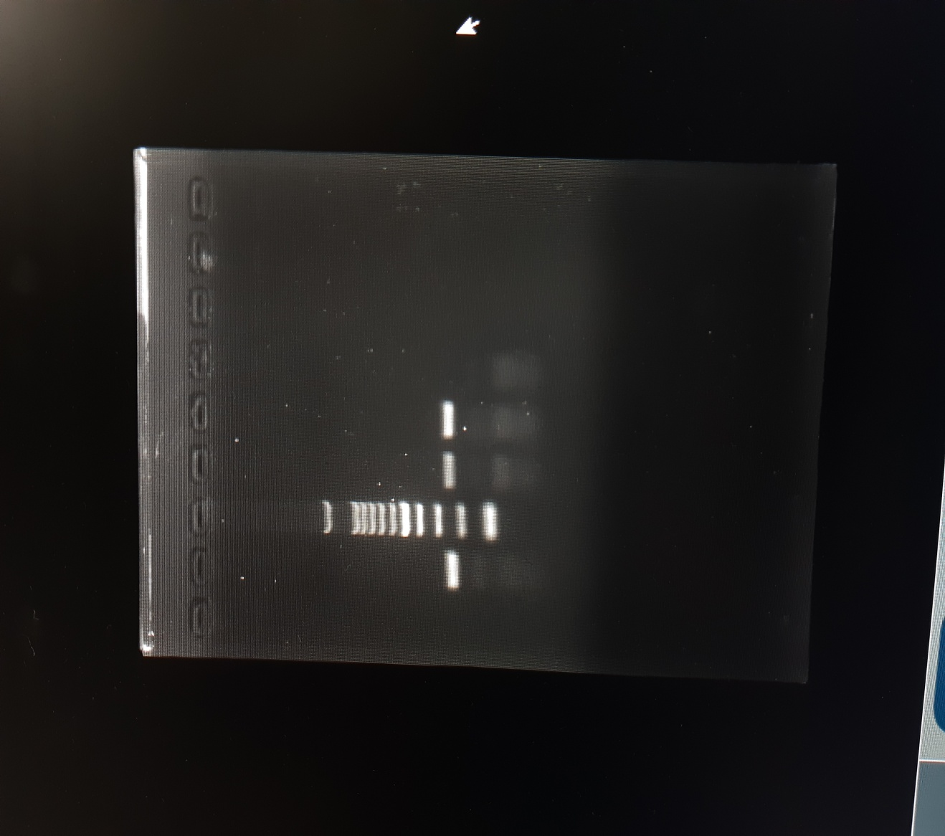

L1 L1

L2
L3
L4
M

237bp

L1: Positive sample
L2: Positive control
L3: Positive sample
L4: Negative control
M: 100 bp DNA ladder

Fig.1. Agar gel showing 237bp amplicon size: Fla gene of B. bronchiseptica

DISCUSSION

Among the 113 animal samples screened for B. bronchiseptica, a total of 12 samples were found positive. In a similar work checking B. bronchiseptica and viruses in canines with respiratory system diseases, using PCR showed prevalence of 45.6% for B. bronchiseptica and 78.7% in diseased dogs (Chamorro et al., 2023). They also used nasal and pharyngeal samples of animals for screening.

CULTURE, ISOLATION AND IDENTIFICATION

In this work, the samples collected from nasal and oropharyngeal swabs were cultured in Luria Bertani broth. B. bronchiseptica colonies on Smith-Baskerville media showed small blue colonies. The isolated B. bronchiseptica from pigs gave rise to small blue colonies giving the medium blue colour indicating alkaline pH (Milanov et al., 2018). The colony specifications were described by other workers also (Fastrès et al., 2020). Colonies of isolate of B. bronchiseptica on MacConkey agar showed pale small colonies which is non lactose fermenting. Gram staining showed gram negative coccobacilli under light microscopy. These observations were in agreement with previous work (Sánchez, 2023).

BIOCHEMICAL TEST
In the present, B. bronchiseptica were positive for citrate utilisation, urease, catalase and oxidase production and negative for glucose and sucrose fermentation test. The result was consistent with others (Mohamed et al., 2024).

MOLECULAR DIAGNOSIS OF B. bronchiseptica BY POLYMERASE CHAIN REACTION

In the present study, the culture from nasal and oropharyngeal samples which were screened with species specific primer for confirmatory diagnosis (Sariga et al., 2022). The amplicon size was 237 bp for fla gene. The result was in agreement with others, where samples taken from nasal and pharyngeal sample of dogs for screening animals with respiratory disease found fla gene (Afonso, 2019).

CONCLUSION

B. bronchiseptica is one of the pathogens associated with upper respiratory disease among dogs. During the study period, a total of 618 animals came for treatment at VCC and among that 113 animals were diagnosed with respiratory tract infections with clinical signs. Samples from 12 animals were recorded as positive for B. bronchiseptica by culture, identification and confirmed by PCR (11.5%). The cases can be diagnosed with clinical symptoms; laboratory examination of the samples and PCR will be the gold standard.

ANIMAL ETHICS & INSTITUTIONAL BIO-SAFETY COMMITTEE

The research work is having necessary approval for conducting the research.

REFERENCES
- Afonso, M. M. R. M. G. (2019). A re-evaluation of known and potential pathogens in canine and feline infectious respiratory disease. PhD Thesis, The University of Liverpool (United Kingdom).
https://livrepository.liverpool.ac.uk/id/eprint/3059917
- Ashmi, M., Sanjana, A. K., & Nikunjkumar, P. (2022). A review on bacterial infectious diseases of dogs. Acta Scientific Veterinary Sciences, 4(7).
- Canonne, A. M., Billen, F., Tual, C., Ramery, E., Roels, E., Peters, I., & Clercx, C. (2016). Quantitative PCR and cytology of bronchoalveolar lavage fluid in dogs with Bordetella bronchiseptica infection. Journal of Veterinary Internal Medicine, 30(4), 1204-1209.
- Chamorro, B.M., De Luca, K., Swaminathan, G., Longet, S., Mundt, E., & Paul, S. (2023). Bordetella bronchiseptica and Bordetella pertussis: similarities and differences in infection, immuno- modulation, and vaccine considerations. Clinical Microbiology Reviews, 36(3), e00164-22.
- Day, M. J., Carey, S., Clercx, C., Kohn, B., MarsilIo, F., Thiry, E., Freyburger, L., Schulz, B., & Walker, D. J. (2020). Aetiology of canine infectious respiratory disease complex and prevalence of its pathogens in Europe. Journal of Comparative Pathology, 176, 86-108.
- Fastrès, A., Canonne, M. A., Taminiau, B., Billen, F., Garigliany, M. M., Daube, G., & Clercx, C. (2020). Analysis of the lung microbiota in dogs with Bordetella bronchiseptica infection and correlation with culture and quantitative polymerase chain reaction. Veterinary Research, 51, 1- 12.
- Ferry, N.S. (1910). A preliminary report of the bacterial findings in canine distemper. American Veterinary Review, 37: 499-504.
- Ito, Y., & Uemura, K. (2016). Successful treatment of Bordetella bronchiseptica pneumonia by minocycline in anti-neutrophil cytoplasmic antibodies-associated vasculitis patient. Journal of Infection and Chemotherapy, 22(12), 808-810.
- Kadlec, K., & Schwarz, S. (2018). Antimicrobial resistance in Bordetella bronchiseptica. Microbiology Spectrum, 6(4), 10-1128.
- Lopez, A., & Martinson, S. A. (2017). Respiratory system, mediastinum, and pleurae. Pathologic Basis of Veterinary Disease, 471. doi: 10.1016/B978-0-323-35775-3.00009-6
- Milanov, D., Đilas, M., Velhner, M., & Aleksić, N. (2018). Laboratory diagnosis of Bordetella bronchiseptica tracheobronchitis in dog. Archives of Veterinary Medicine, 11(2):33-41.
- Mohamed, N., San Juan, M. R., & Navarathna, D. H. (2024). Multifocal pneumonia caused by Bordetella bronchiseptica: Insights from a human case study. IDCases, 37, e02030.
- Munn, R. R., MacPherson, Y., Karkaba, A., & McDougall, S. (2025). First identification of Bordetella bronchiseptica subclinical mastitis in a lactating dairy cow in New Zealand. New Zealand Veterinary Journal, 1-6.
- Nemzek, J. A., Lester, P. A., Wolfe, A. M., Dysko, R. C., & Myers Jr, D. D. (2015). Biology and diseases of dogs. In Laboratory animal medicine (pp. 511-554). Academic Press.
- Reagan, K. L., & Sykes, J. E. (2019). Canine infectious respiratory disease. The Veterinary Clinics of North America. Small Animal Practice, 50(2), 405.
- Rose, K. T., Rajesh, J. B., Marwein, S. C., Kar, P., Behera, S. K., Bayan, H., ... & Prasad, H. (2025). Significance of Bordetella bronchiseptica in Respiratory Tract Infections of Canines. International Journal of Bio-Resource & Stress Management, 16(1).
- Ruch‐Gallie, R., Moroff, S., & Lappin, M. R. (2016). Adenovirus 2, Bordetella bronchiseptica, and Parainfluenza Molecular Diagnostic Assay Results in Puppies After vaccination with Modified Live Vaccines. Journal of Veterinary Internal Medicine, 30(1), 164-166.
- Sánchez, F.L. (2023). Detección molecular de Bordetella bronchiseptica en Canis familiaris, urbanización Andrés Araujo Morán, Tumbes-2022. Thesis submitted to National University of Tumbes, Peru
- Sariga, K., Bipin, K. C., Deepa, P. M., Rateesh, R. L., & Dinesh, P. T. (2022). Molecular identification and occurrence of bordetellosis among dogs in northern Kerala. Journal of Veterinary and Animal Sciences, 253 (4): 541-544.
- Sykes, J. E. (2022). Greene's Infectious Diseases of the Dog and Cat-E-Book. 5th Edn, Elsevier Health Sciences.
- Tabatabaei, M., & Rohani, H. R. (2022). Identification of Bordetella bronchiseptica in the throat and nose of dogs and cats by PCR. Molecular Biology Research Communications, 11(3), 127.

