Original Research Article
Isolation and Identification of Bordetella bronchiseptica from Clinical
Respiratory tract Infections of Canines in Mizoram: First Report
ABSTRACT
Bordetella bronchiseptica is one of the major bacterial causes of Canine Infectious Respiratory Disease Complex (CIRD-C) with zoonotic potential. The agent can affect dogs of all ages and breeds in the kennel. Aerosol mode of transmission plays an important role in the transmission. This research work records the detection of B. bronchiseptica in presented canine cases at the Veterinary Clinical Complex. Oro-nasal and pharyngeal swabs were collected from 113 from canine cases suspected for respiratory tract infection. Detection was done by culture, isolation, identification, biochemical test and confirmatory diagnosis by Polymerase Chain Reaction. Luria Bertani broth was used for the initial work and Smith-Baskerville media were used for culturing B. bronchiseptica. The organism was grown in MacConkey agar and isolated using specific medium Smith-Baskerville. Isolate on MacConkey agar showed non lactose fermenting small pale colonies. The isolated organisms were positive for citrate, urease, catalase, and oxidase test and negative for sucrose and glucose fermentation test. The confirmation was done using PCR with published primers targeting fla gene. Samples from 12 canines were positive for the genus specific amplicon size (237 bp) of B. bronchiseptica. As the presence of the agent is confirmed in many research works, immunization of the pups can be considered.
Key words: Bordetella bronchiseptica, Canine, Clinical, PCR, respiratory tract infection
INTRODUCTION
Bordetella bronchiseptica is one of the major pathogens affecting canine respiratory tract, which is transmitted through aerosol, secretions, contaminated faces or urine as well as through infected fomites. The agent affects all age groups and breeds of dogs and is known to have zoonotic potential (Rose et al., 2025). Although there is no significant clinical manifestation in immunocompromised humans after exposure to B. bronchiseptica, it is considered rare zoonosis of immunocompromised individuals (Afonso, 2019). The respiratory tract of dogs, pigs, cats, rabbits, mice, rats, guinea pigs, lambs, horses, and bears are various mammalian hosts, colonized by the Gram-negative bacterium B. bronchiseptica (Ito and Uemura, 2016). Respiratory diseases of canines are considered as an important, circulating disease caused by different types of viruses and bacteria. A common clinical problem in dogs is respiratory system disease especially in dogs that are housed at high densities such as pens and boarding houses, shelters, research centres or veterinary clinics. Despite immunization, Canine Infectious Respiratory Disease Complex (CIRD-C), historically known as "kennel cough" remains one of the most prevalent infectious diseases in dogs globally, primarily affecting young and kennel dogs (Fastrès et al., 2020). It is often diagnosed as 'Infectious Tracheobronchitis' (ITB) when the infectious nature of the disease is evident. In most cases, animals are often infected with multiple viral and bacterial pathogens (Day et al., 2020). Clinically healthy dogs can harbour B. bronchiseptica asymptomatically, serving as reservoirs that spread the infection to vulnerable hosts (Nemzek et al., 2015). Its unique function in CIRD-C epidemiology and transmission is highlighted by its high transmissibility and asymptomatic carriage (Reagan and Sykes, 2019).
B. bronchiseptica was recognised in 1910 as a respiratory pathogen in mammals and Ferry first isolated it (Ferry, 1910). B. bronchiseptica are small (0.2-0.5µm in diameter and 0.5-2.0µm in length) gram negative, motile, aerobic coccobacilli belonging to class of Beta Proteobacteria, order Burkholderiales and the family Alcaligenaceae (Sykes, 2022; Rose et al., 2025). It is also known that B. bronchiseptica, a commensal organism, can be found in respiratory tracts of both wild and domestic mammals. The upper respiratory tract of a variety of animal species, including birds and mammals, is commensal with B. bronchiseptica. Although it is most significant and best described in dogs and pigs, it also plays a significant role in veterinary medicine as a primary and secondary pathogen of the upper respiratory tract in a number of species (Kadlec and Schwarz, 2018). It mostly causes chronic respiratory infections and can survive in the environment outside a mammalian host. B. bronchiseptica can thrive in water and has the potential to spread from dogs to cats and it can also survive within a healthy host for a long period because of its capacity to elude the immune response (Canonne et al., 2016). Host and environmental factors influence the development of the disease and its severity (Day et al., 2020). Considering its importance many research works were done and a vaccine also developed to curtail its occurrence among the canine population (Wille et al., 2020). Adding to its seriousness, in one of the works in China all the isolates of B. bronchiseptica were showing multi drug resistance (MDR)and this was a wakeup call for the scientific community (Shang et al., 2024). Apart from the studies in canines, studies in the swine population in China also revealed the presence of resistant B. bronchiseptica (Yi et al., 2024). With timely intervention and treatment, the disease is often resolved though it may be asymptomatic or mild to severe respiratory symptoms. B. bronchiseptica spreads through aerosolized droplets during sneezing or coughing. It can affect all breeds and dogs of all ages. Transmission will be more in high-density kennels and shelters (Jang et al., 2025). According to observations, the incubation period for B. bronchiseptica can last anywhere from two to fourteen days after infection, and in certain situations, shedding can continue for more than six months. It produces a number of toxins, including cytotoxins that cause ciliostasis, to increase its capacity to infect and colonize the respiratory tract (Afonso, 2019; Chamorro et al., 2023). Although this infectious condition frequently resolves on its own, a variety of respiratory symptoms have been reported, ranging from minor sickness to severe pneumonia and mortality, contingent on factors such the presence of concurrent bacterial or viral pathogens and immunological and immunization status (Canonne et al., 2016). Typical clinical signs include coughing with or without dyspnoea, ocular or nasal discharge and weight loss (Sariga et al., 2022). The disease pathogenicity increases with the concomitant infection with other pathogenic respiratory agents. Infected dogs begin coughing after an incubation period of, typically, two days to two weeks. In the beginning, the cough is dry and paroxysmal, but eventually develops into a productive cough with nasal discharge, conjunctivitis and fever. Due to their immature immune systems, young pups tend to acquire the most serious consequences. Aged animals, those with weakened immune systems are more vulnerable. The lesions of B. bronchiseptica infection can be tracheobronchitis, suppurative bronchiolitis and suppurative or mucopurulent rhinitis (Lopez and Martinson, 2017).
Many traditional bacteriological, immunological, and molecular techniques have been employed recently to identify Bordetella infection in animals (Tabatabaei and Rohani, 2022). For a B. bronchiseptica infection to be definitively diagnosed, positive cultures of nasal swabs, pharyngeal swabs, and tracheal lavage fluid are necessary (Tabatabaei and Rohani, 2022). B. bronchiseptica can be isolated using a variety of culture mediums, including MacConkey agar, Bordet-Gengou agar, and Smith-Baskerville media (Ashmi et al., 2022). Nucleic acid amplification assays, such as PCR and, more recently, real-time PCR, address some of the limitations of culture and serological approaches for diagnosing Bordetella infections. The majority of PCR tests are focused on detecting insertion sequences (IS) occurring in many copies per genome, which increases their sensitivity. Aim of the present study was to isolate B. bronchiseptica from clinical respiratory tract diseases in dogs using culture examination, biochemical tests and molecular diagnosis using PCR.
MATERIALS AND METHODS
Dogs of either sex which were brought for treatment to the Veterinary Clinical Complex (VCC), College of Veterinary Sciences and Animal Husbandry, Aizawl, Mizoram during the period of 2023-2024 were screened. The suspected dogs were selected based on the presence of respiratory tract symptoms associated with B. bronchiseptica. The confirmation was done based on culture, isolation, identification, biochemical tests, haemato-biochemical parameters, and PCR. Nasal and oro-pharyngeal swabs were collected and further processed for culture; isolation and biochemical test (Ruch‐Gallie et al., 2016).
CULTURE EXAMINATION
The collected nasal and oropharyngeal swab samples were incubated at 37⁰C in Nutrient broth for 24 hrs. Culture, isolation and identification of B. bronchiseptica were carried out (Munn et al., 2025). Formations of blue colour minute colony on Smith Baskerville media and pale pink small non lactose fermenting colonies on MacConkey agar were indicated for B. bronchiseptica.
Biochemical test: Biochemically, they are positive for citrate utilisation and production of urease, catalase, oxidase and negative for glucose and sucrose (Mohamed et al., 2024).
Molecular diagnosis of Bordetella bronchiseptica using Polymerase Chain Reaction (PCR)
PCR was done as per the standard method (Sariga et al., 2022) using published primer 237BBFla 4 (F) and 237BBFla 2 (R) (Sánchez, 2023; Tabatabaei and Rohani, 2022).
RESULTS
A total of 618 dogs of either sex which were brought for treatment to the Veterinary Clinical Complex of the college were screened for canine respiratory tract ailments with B. bronchiseptica. Out of 618 cases, 113 cases were of respiratory system infections and out of which 12 dogs were confirmed as positive for B. bronchiseptica by laboratory and molecular techniques (Table 1).

Table 1. Isolation of B. bronchiseptica from clinical rtespiratory tract infections of canines
Number of Dogs screened | Number of dogs with respiratory signs | Number of dogs confirmed with B. bronchiseptica infection | Samples showing B. bronchiseptica presence in culture examination | Samples showing B. bronchiseptica presence in Biochemical tests | Samples showing B. bronchiseptica in PCR
618 | 113 | 12 | 12 | 12 | 12

CULTURE, ISOLATION AND IDENTIFICATION
Samples were obtained from nasal and oropharyngeal swabs and cultured in Luria Bertani broth. Then streaked in Smith Baskerville and Mac Conkey agar and pure culture colonies were isolated.
PCR ASSAY RESULT
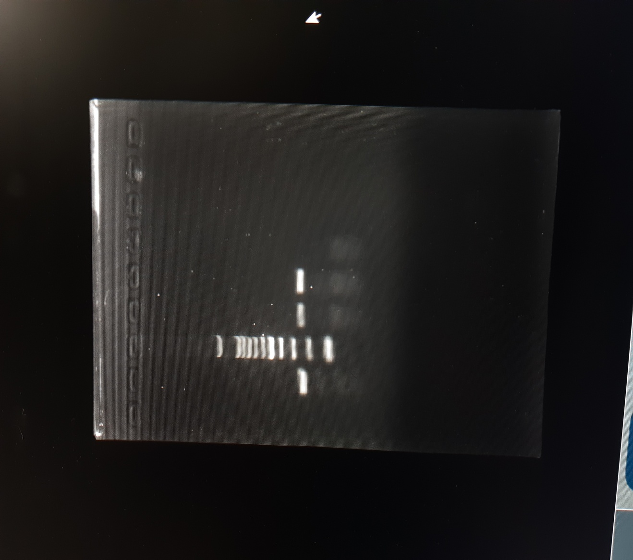

L1 L1

L2
L3
L4
M

237bp

L1: Positive sample
L2: Positive control
L3: Positive sample
L4: Negative control
M: 100 bp DNA ladder

Fig.1. Agar gel showing 237bp amplicon size: fla gene of B. bronchiseptica
DISCUSSION
B. bronchiseptica is one of the bacterial causes among the major pathogens causing CIRD-C. Among the 113 animal samples screened for B. bronchiseptica, a total of 12 samples were found positive. In a similar work checking B. bronchiseptica and viruses in canines with respiratory system diseases, using PCR showed prevalence of 45.6% for B. bronchiseptica and 78.7% in diseased dogs (Chamorro et al., 2023). They also used nasal and pharyngeal samples of animals for screening. Similarly in another study by Viitanen et al., (2015) revealed the association of B. bronchiseptica in bacterial pneumonia in canines. In another study in the United States, Dong et al. (2023) isolated B. bronchiseptica from clinical respiratory diseases in dogs.
CULTURE, ISOLATION AND IDENTIFICATION
In this work, the samples collected from nasal and oropharyngeal swabs were cultured in Luria Bertani broth. B. bronchiseptica colonies on Smith-Baskerville media showed small blue colonies. The isolated B. bronchiseptica from pigs gave rise to small blue colonies giving the medium blue colour indicating alkaline pH (Milanov et al., 2018). The colony specifications were described by other workers also (Fastrès et al., 2020). Colonies of isolate of B. bronchiseptica on MacConkey agar showed pale small colonies which are non-lactose fermenting. Gram staining showed gram negative coccobacilli under light microscopy. These observations were in agreement with previous work (Sánchez, 2023). Chamorro et al. (2023) opined that the microbiological culture is a longer technique but is highly specific, and the resultant colonies can be subtyped. Tabatabaei and Rohani (2022) recorded that usually the diagnosis of B. bronchiseptica is based on culture and isolation of bacteria and is very specific. Muhammad et al. (2019) used selective culture methods for the quantitative growth studies involving B. Bronchiseptica.
BIOCHEMICAL TEST
In the present study, B. bronchiseptica were positive for citrate utilisation, urease, catalase and oxidase production and negative for glucose and sucrose fermentation test. The result was consistent with others (Mohamed et al., 2024). Zhang et al. (2021) used biochemical tests for the identification of B. bronchiseptica in their studies along with other tests.
MOLECULAR DIAGNOSIS OF B. bronchiseptica BY POLYMERASE CHAIN REACTION
In the present study, the culture from nasal and oropharyngeal samples which were screened with species specific primer for confirmatory diagnosis (Sariga et al., 2022). The amplicon size was 237 bp for fla gene. The result was in agreement with others, where they used nasal and pharyngeal samples of dogs for screening animals with respiratory disease and found fla genes (Afonso, 2019). Canonne et al. (2016) opined that even though bacterial culture can be used for the detection of B bronchiseptica, recently PCR analysis is used for the diagnosis. Authors like Taha-Abdelaziz et al (2016) were using PCR as one of the detection methods for B. bronchiseptica in their study. Jinnerot et al. (2015) suggested that fast and accurate diagnosis helps in management of B. bronchiseptica infection and they were developing PCR for the same.
CONCLUSION
B. bronchiseptica is one of the major bacterial pathogens associated with upper respiratory disease among dogs. Apparently healthy animals also can harbor the agent in the respiratory system. The agent also has zoonotic potential. During the study period, a total of 618 animals were registered for treatment at VCC and among that 113 animals were diagnosed with respiratory tract infections with clinical signs. Nasal and oropharyngeal swab samples from 12 animals were recorded as positive for B. bronchiseptica by culture, identification and confirmed by PCR. Luria Bertani broth and Smith-Baskerville media were used for culturing B. bronchiseptica. Isolate on MacConkey agar showed non lactose fermenting small pale colonies. Further confirmation was done with biochemical tests like citrate utilisation, urease, catalase, oxidase production and glucose and sucrose fermentation test. Confirmation with PCR was carried out using published primers for fla gene following standard protocol. PCR is considered as the gold standard for diagnosis of B. bronchiseptica. Regular vaccination of pups against B. bronchiseptica should be considered for curbing the menace of this zoonotic agent.
ANIMAL ETHICS & INSTITUTIONAL BIO-SAFETY COMMITTEE
The research work is having necessary approval for conducting the research.
Disclaimer (Artificial intelligence)
Author(s) hereby declare that NO generative AI technologies such as Large Language Models (ChatGPT, manuscript.
REFERENCES
- Afonso, M. M. R. M. G. (2019). A re-evaluation of known and potential pathogens in canine and feline infectious respiratory disease. PhD Thesis, The University of Liverpool (United Kingdom).
https://livrepository.liverpool.ac.uk/id/eprint/3059917
- Ashmi, M., Sanjana, A. K., & Nikunjkumar, P. (2022). A review on bacterial infectious diseases of dogs. Acta Scientific Veterinary Sciences, 4(7).
- Canonne, A. M., Billen, F., Tual, C., Ramery, E., Roels, E., Peters, I., & Clercx, C. (2016). Quantitative PCR and cytology of bronchoalveolar lavage fluid in dogs with Bordetella bronchiseptica infection. Journal of Veterinary Internal Medicine, 30(4), 1204-1209.
- Chamorro, B.M., De Luca, K., Swaminathan, G., Longet, S., Mundt, E., & Paul, S. (2023). Bordetella bronchiseptica and Bordetella pertussis: similarities and differences in infection, immuno- modulation, and vaccine considerations. Clinical Microbiology Reviews, 36(3), e00164-22.
- Day, M. J., Carey, S., Clercx, C., Kohn, B., MarsilIo, F., Thiry, E., Freyburger, L., Schulz, B., & Walker, D. J. (2020). Aetiology of canine infectious respiratory disease complex and prevalence of its pathogens in Europe. Journal of Comparative Pathology, 176, 86-108.
- Dong, J., Tsui, W. N. T., Leng, X., Fu, J., Lohman, M., Anderson, J., & Bai, J. (2023). Validation of a real-time PCR panel for detection and quantification of nine pathogens commonly associated with canine infectious respiratory disease. MethodsX, 11, 102476.
- Fastrès, A., Canonne, M. A., Taminiau, B., Billen, F., Garigliany, M. M., Daube, G., & Clercx, C. (2020). Analysis of the lung microbiota in dogs with Bordetella bronchiseptica infection and correlation with culture and quantitative polymerase chain reaction. Veterinary Research, 51, 1- 12.
- Ferry, N.S. (1910). A preliminary report of the bacterial findings in canine distemper. American Veterinary Review, 37: 499-504.
- Ito, Y., & Uemura, K. (2016). Successful treatment of Bordetella bronchiseptica pneumonia by minocycline in anti-neutrophil cytoplasmic antibodies-associated vasculitis patient. Journal of Infection and Chemotherapy, 22(12), 808-810.
- Jang, J. Y., Lee, D., Oh, S. Y., & Yoo, H. S. (2025). Co-infections with Bordetella bronchiseptica in canine: A systematic review and meta-analysis. Veterinary Immunology and Immunopathology, 280, 110886.
- Jinnerot, T., Malm, K., Eriksson, E., & Wensman, J. J. (2015). Development of a TaqMan real-time PCR assay for detection of Bordetella bronchiseptica. Vet. Sci. Res. Rev, 1, 14-20.
- Kadlec, K., & Schwarz, S. (2018). Antimicrobial resistance in Bordetella bronchiseptica. Microbiology Spectrum, 6(4), 10-1128.
- Lopez, A., & Martinson, S. A. (2017). Respiratory system, mediastinum, and pleurae. Pathologic Basis of Veterinary Disease, 471. doi: 10.1016/B978-0-323-35775-3.00009-6
- Milanov, D., Đilas, M., Velhner, M., & Aleksić, N. (2018). Laboratory diagnosis of Bordetella bronchiseptica tracheobronchitis in dog. Archives of Veterinary Medicine, 11(2):33-41.
- Mohamed, N., San Juan, M. R., & Navarathna, D. H. (2024). Multifocal pneumonia caused by Bordetella bronchiseptica: Insights from a human case study. IDCases, 37, e02030.
- Muhammad, A., Kassmannhuber, J., Rauscher, M., Falcon, A. A., Wheeler, D. W., Zhang, A. A., & Lubitz, W. (2019). Subcutaneous immunization of dogs with Bordetella bronchiseptica bacterial ghost vaccine. Frontiers in Immunology, 10, 1377.
- Munn, R. R., MacPherson, Y., Karkaba, A., & McDougall, S. (2025). First identification of Bordetella bronchiseptica subclinical mastitis in a lactating dairy cow in New Zealand. New Zealand Veterinary Journal, 1-6.
- Nemzek, J. A., Lester, P. A., Wolfe, A. M., Dysko, R. C., & Myers Jr, D. D. (2015). Biology and diseases of dogs. In Laboratory Animal Medicine (pp. 511-554). Academic Press.
- Reagan, K. L., & Sykes, J. E. (2019). Canine infectious respiratory disease. The Veterinary Clinics of North America. Small Animal Practice, 50(2), 405.
- Rose, K. T., Rajesh, J. B., Marwein, S. C., Kar, P., Behera, S. K., Bayan, H., & Prasad, H. (2025). Significance of Bordetella bronchiseptica in Respiratory Tract Infections of Canines. International Journal of Bio-Resource & Stress Management, 16(1).
- Ruch‐Gallie, R., Moroff, S., & Lappin, M. R. (2016). Adenovirus 2, Bordetella bronchiseptica, and Parainfluenza Molecular Diagnostic Assay Results in Puppies After vaccination with Modified Live Vaccines. Journal of Veterinary Internal Medicine, 30(1), 164-166.
- Sánchez, F.L. (2023). Detección molecular de Bordetella bronchiseptica en Canis familiaris, urbanización Andrés Araujo Morán, Tumbes-2022. Thesis submitted to National University of Tumbes, Peru
- Sariga, K., Bipin, K. C., Deepa, P. M., Rateesh, R. L., & Dinesh, P. T. (2022). Molecular identification and occurrence of bordetellosis among dogs in northern Kerala. Journal of Veterinary and Animal Sciences, 253 (4): 541-544.
24. Shang, Q., Gao, W., Zhang, X., Zhao, J., Wu, Y., Li, H., & Zhao, L. (2024). Investigation of the epidemiology, pathogenicity and immunogenicity of Bordetella bronchiseptica isolated from cats and dogs in China from 2021 to 2023. Animal Diseases, 4(1), 16.
25. Sykes, J. E. (2022). Greene's Infectious Diseases of the Dog and Cat-E-Book. 5th Edn, Elsevier Health Sciences.
26. Tabatabaei, M., & Rohani, H. R. (2022). Identification of Bordetella bronchiseptica in the throat and nose of dogs and cats by PCR. Molecular Biology Research Communications, 11(3), 127.
27. Taha-Abdelaziz, K., Bassel, L. L., Harness, M. L., Clark, M. E., Register, K. B., & Caswell, J. L. (2016). Cilia-associated bacteria in fatal Bordetella bronchiseptica pneumonia of dogs and cats. Journal of Veterinary Diagnostic Investigation, 28(4), 369-376.
28. Viitanen, S. J., Lappalainen, A., & Rajamäki, M. M. (2015). Co‐infections with respiratory viruses in dogs with bacterial pneumonia. Journal of Veterinary Internal Medicine, 29(2), 544-551.
29. Yi, L., Fan, H., Yuan, S., Li, R., Wang, H., Quan, Y., & Wang, Y. (2024). Antimicrobial Resistance and Biofilm Formation of Bordetella bronchiseptica in Central China, with Evidence of a Rare Heteroresistance Strain to Gentamicin. Animals, 14(9), 1301.
30. Wille, M., Wensman, J. J., Larsson, S., van Damme, R., Theelke, A. K., Hayer, J., & Malmberg, M. (2020). Evolutionary genetics of canine respiratory coronavirus and recent introduction into Swedish dogs. Infection, Genetics and Evolution, 82, 104290.
31. Zhang, Y., Yang, H., Guo, L., Zhao, M., Wang, F., Song, W., & Wu, B. (2021). Isolation, antimicrobial resistance phenotypes, and virulence genes of Bordetella bronchiseptica from pigs in China, 2018–2020. Frontiers in Veterinary Science, 8, 672716.

