***Original Research Article***

**Bio-efficacy of entomopathogenic nematode, *Heterorhabditis bacteriophora* infecting termite (*Odontotermis obesus*** **Rambur) under field condition.**

**Abstract**

Field efficacy of entomopathogenic nematodes (EPNs), *Heterorhabditis* *bacteriophora* were evaluated to ensure the feasibility of native isolate of entomopathogenic nematode to be used in the bio-control of termite (*Odontotermes obesus*) infestation. EPNs were applied as a soil drenching method at two different doses up to three times of application on termite mound. Results revealed that *H.bacteriophora* were able to infect *O.obesus* and cause mortality within the mound. The Per cent mortality *O. obesus* were highest (58.30%) in the treatment with *H.bacteriophora* at 5.0×109 IJs/mound, three time application at one month interval. *H.bacteriophora* successfully penetrated and reproduced well in workers and soldiers of *O.obesus* in all the treatments. Persistence of *H.bacteriophora* after one month of last application was better as shown by the mortality of *Galleria mellonella* larvae (5.2-43.8%).

*Key words:* Termite(*Odontotermes obesus*), entomopathogenic nematodes (EPNs), *Heterorhabditis* *bacteriophora,* infestation, bioefficacy, soil drenching.

**Introduction**

Termites are a group of social insects belong to the order Isoptera which are widely distributed throughout the world (Eggleton, 2000). Out of around 2900 species, 300 species are of economic importance as pests in agriculture, forestry, and urban situations (Krishna and Grimaldi, 2003). Termite colonies contain three principal castes: workers (pseudergates), soldiers, and reproductives (king, queen, alates or swarmers) (Potter, 2011). A termite mound is the most familiar form of termite nest. The major mound-building species in India are *Odontotermes obesus*, *O. redemanni*, *O. wallonensis,* and *Microtermes obesi* (Chhillar et al. 2006). *Odontotermes* *obesus* Rambur (Blattodea: Termitidae) build both subterranean and epigeal nests. Due to feeding habits, the worker caste causes the widespread destruction resulting into major economic losses in tropical and subtropical areas by destroying agricultural crops, live trees, and wooden structures in houses (Sindhu *et al*., 2011). Economic losses due to termite in India have been estimated around 35.12 million US$ (Joshi et al. 2005); Severe losses in different regions of India have been recorded on highly susceptible crops such as wheat and sugarcane in North India; maize, groundnuts, and sunflower in South India; cotton in Western India; and tea in Northeast India (Das, 1965; Roonwal, 1979; Choudhury,1999; Rajagopal, 2002 ;Roy et al.2020).

Most termite management practices are focused on total elimination of termite population rather than sustaining their population. Common methods for controlling these termites are the application of termiticides (Su and Scheffrahn, 1990; Woodrow et al.2006). Queen removal, breaking up termite galleries, crop rotation, and application of wood ash or burning with straw, application of plant insecticides are some of the management practices. Due to increasing concerns about the side effects of chemical insecticides, there has been great interest in finding other methods, especially biological control (Grace, 2003; Grace et al.,2009). Biocontrol agents like predators, parasitoids and pathogens have been tested to suppress termite populations (Sindhu *et al*., 2011). However, reproductive and nymphs of subterranean termites are concentrated in nests near or below ground level, out of reach of some of the bio-control agents (use of predators, parasitoids and pathogens). Entomopathogenic nematodes (EPNs), *Steinernema* spp. and *Heterorhabditis* spp. can be applied as a bio-control agent against termite colonies (Fujii, 1975; Poinar 1979; Georgis & Poinar , 1982; Georgis et al.,1982; Epsky and Capinera 1988; Wang et al., 2002; Yu et al., 2006; Hiranwrongwera et al.2007; Ibrahim et al.2008; El-Bassiouny & Randa, 2011; Al-Zaidawi et al.2020; Javed et al.2021; Aslam et al.2023; Gutema et al.2025). These EPNs have been recognized as potential bio-control agent against most of the soil dwelling pests (Poinar, 1975; Gaugler and Kaya, 1990; Burnell and Stock, 2000). The infective juveniles (IJs) of EPNs are soil dwelling and obligate parasites of insects (Kaya and Gaugler, 1993). Once IJs locate a possible host in the soil environment, they penetrate the host hemolymph through natural openings such as mouth, anus, and spiracle or directly through the integument (Lewis *et al*., 2006). Having penetrated the host, the nematodes release the bacteria (*Xenorhabdus* spp. in *Steinernema* spp. *Photorhabdus* spp. in *Heterorhabditis* spp.) into the host hemolymph that cause septicemia and death of the insect. The nematode feeds on the proliferating bacteria and two or three cycles of reproduction occur in the host prior to emergence of infective stages (Adams *et al*., 2006). Apart from being environmentally safe, the use of EPN in pest control in general, and in termite control in particular, is rapid, sustainable, cost effective, and easy to apply. Moreover, IJs can find host actively or passively and are compatible with many pesticides (Smart, 1995). Termites live and forage in habitats that are moist, cool, and without direct sunlight. These environmental conditions are ideal for the survival and movement of entomopathogenic nematodes, and, therefore, provide the basis for the interest in their role in control of termites (Chouvenc *et al*., 2011). During *in vitro* screening of *H.bacteriophora* at 100 IJs against *O.obesus* reported more than 50% mortality after 48h of application (Devi *et al*., 2018). Certain species of nematodes although effective in laboratory control is often quite variable under field conditions (Wu et al.1991;Wang et al., 2002). However, soil moisture and soil type appear to limit the nematode’s ability to move in the soil and locate termites (Poinar & Georgis, 1989; Michael, 2005). Only a limited number of field studies have been conducted using EPNs as control agents for termites (Murugan &  Vasugi, 2011; Mohan et al.,2016; Rathour et al.2017; Wagutu et al.2017). Therefore, the field study was conducted to determine the efficacy of native EPN species, *Heterorhabditis bacteriophora* under biologically relevant concentrations against termite , *O.obesus* .

**Materials and Method**

**Source of Entomopathogenic nematodes**

EPN, *H. bacteriophora* previously recovered from the District Majuli were used in this study (Devi *et al*.,2016).The EPNs were reared *in vivo* on the last instar larvae of *Galleria mellonella* (Lepidoptera: Pyralidae) under laboratory conditions. The larvae of *G.mellonella* were obtained from the Department of Entomology, AAU, Jorhat. The last larval stage of this insect was used to maintain and propagate the nematodes throughout the entire period of time in this study. *G.mellonella* were multiplied in glass jars at 28± 2oC, 60% RH, with an artificial diet described by Metwally et al.,(2012). The harvested IJs were kept at 10-12°C for experiments for less than a week before they were applied in the experiment. Before use, they were allowed to warm up to room temperature (25 ±1°C) for 2 h (Woodring and Kaya,1998). Also, their viability for motion was confirmed using dissected microscope.

**Field trial**

The field trials were conducted to evaluate the efficacy of *H.bacteriophora* during 2022-2023 in various agricultural fields covering horticultural as well as field crops located under the District Jorhat. Jorhat district covers an area of 285100 hectares in Assam, lies between 26.20" and 27 10.30" north latitude and 93.39" and 94 36.30" east longitudes, at an altitude of 86.8 m above mean sea level. The district falls under subtropical climatic condition with warm humid summer and cool dry winter with mean annual rainfall of 2029 mm. The average maximum temperature is 42°C and minimum temperature is 8°C. On an average, the relative humidity is more than 80% throughout the year. The agricultural fields were naturally infected with the termite pest (*Odontotermis obesus* Rambur).No natural colonization of the termite nests by EPN was detected after baiting (*G. mellonella*) soil samples from the nests. Experiments were performed on *O.obesus* with mounds or a central nest structure. In preliminary assays, it was observed that *O.obesus* colonies were able to reconstruct an aboveground nest within one month after its demolition. So, the aboveground nests were first pull downed before the application of treatment regardless of the nest size. *H. bacteriophora* were used in the field trials carried out in the rainy season. Treatment (EPN) was applied over the demolished surface. Six treatments were compared: T1:2.5×109IJs/mound (One time application), T2:2.5×109 IJs/mound (Two times , one month interval) , T3:2.5×109 IJs/mound (Three times, one month interval) , T4:5.0×109 IJs/mound (One time application) , T5:5.0×109 IJs/mound (Two times ,one month interval) , T6:5.0×109 IJs/mound (Three times, one month interval) and (T7) untreated control. The nematodes were applied with different doses using a manual sprayer as a soil drench. Sterilized water alone was added to the untreated control. The trial was conducted in a randomized complete block design with three replications. Soil drenching was done with the required dose of EPNs after employing cold weather practices as described in the Field management manual of Tea Research Association.

Three parameters *viz*. Mortality of different life stages of termites, Progeny production of nematode inside their host, nematode persistence in the nests were recorded.

**Mortality of different life stages of termites**

Seven days after application of last treatment, the top nests made by *O.obesus* were broken to collect the dead insects. Samples of 250 g each were collected from four corners as well as from the middle of the nest. Samples were collected in plastic containers, mixed properly, and transferred to the laboratory. From the mixer, 250g of samples were taken for observation. Dead individuals of worker and soldiers were separated and counted. Dead insects were dissected for presence of nematodes.

**Progeny production of nematode inside their host**

To assess progeny production, the dead insects were rinsed and transferred to White traps in 2.2-cm diam. plates lined with a filter paper, individually and incubated at room temperature (25±1°C) for 10 days. The total number of emerging IJs from each insect was determined.

**Nematode persistence**

Nematode persistencein the nest area was assessed by randomly taking soil samples composed of 3 cores (0-15 cm depth) from each treated nest 30 days after last treatment (application). The three soil core samples were individually baited with 10 last instar *G. mellonella* larvae and kept at room temperature (25±1°C) for one week. Then, dead larvae (%) were recorded daily from the fifth day to the seventh. Cadavers were dissected to confirm EPN infection.

**Statistical analysis**

Prior to analysis, all data were corrected for the mortality rate of the control group using Abbott’s formula (Abbott, 1925; Fleming and Retnakam, 1985). To stabilize the variance of means, mortality percentages were arcsine transformed and subjected to one way ANOVA (OPSTAT) to test for significant differences among treatment means (Sheoran *et al*.,1998). The 5% level of probability was used in all statistical tests.

**Results and Discussion**

From the results (Table1. Fig.1), it was observed that *H.bacteriophora* caused a significant mortality of *O.obesus*. Insect mortality was found to be increased with increasing doses and frequency of application. There was a significant difference with other treatments in mean mortality (58.3%) of *O.obesus* when application was done three times at higher dose (5.0×109 IJs/mound). Significant difference was observed in the treatments for the mortality of workers (9.1-32.6%) as well as soldiers (7.1-24.4%) of *O.obesus*. High virulence and ability to search and locate host in cryptic habitats of the EPN isolate is one important characteristic required for the successful biological control of a pest. The native isolate *H.bacteriophora* is having all the characteristics against termite.   
Wilson-Rich *et al*., (2007) showed that *S.carpocapsae* cause dose dependent mortality of the dampwood termite (*Zootermopsis angusticollis*). The live wood tea termite, *Glyptotermes dilatatus* was successfully controlled within 2-3 months in tea plantations on Sri Lanka with *Heterorhabditis* sp. with a dose of 4000 and 8000 ml nematode suspension in doses of 40 and 30 ml per tea bush, respectively (Danthanarayana and Vitarana,1987). Lenz *et al*., (2000) eliminated *Neotermes* sp. colonies through the use of nematodes and fungal pathogens from coconut palms, citrus and mahogany trees. The efficacy of *Neoaplectana carpocapsae* against foraging workers of *Reticulitermes tibialis* was studied in pasture land. A study testing the efficacy of *S. carpocapsae* (Weiser) against foraging workers of *Reticulitermes tibialis* in pasture land Epsky and Capinera (1988). The application rate of nematodes was 1x107 per m2 directly beneath baited traps to the soil and it was concluded that the entire colony of termites should be treated rather than feeding sites .Weeks and Baker (2004) and Yu et al.(2008) evaluated the differences in survivability, detectability and ability of *S. carpocapsae* and *H. bacteriophora*, to kill a subterranean termite *Heterotermes aureus*. *S. riobrave* (TP) caused greater mortality in *R. flavipes* and *C. formosanus* compared to the other nematode strains (Yu et al.2010). Specifically, the *S. riobrave* (TP) caused 75% and 91% mortality in *R. flavipes* and *C. formosanus*, respectively, under laboratory condition. An attempt to control *Coptotermes formosanus*, with nematodes has already demonstrated the effectiveness of *S. feltiae* nematodes against large field colonies (Wu et al.1991). Manzoor (2012) reported synergism between imidacloprid and nematodes species *S. carpocapsae* and *H. bacteriophora* that caused more than 50 % mortality of workers and nymphs of *R. flavipes* within all three colonies tested. Amarasinghe and Hominick (1993) reported that higher doses of *S. carpocapsae* and *S. feltiae* showed promising control of live-wood termite *Postelectrotermes militaris* in tea plantations. Studies indicate that colonies of *Neotermes* attacking in the South Pacific Islands can be eliminated using *Heterorhabditis* sp. from palms and other trees (Dolinski and Lacey, 2007).

Perusal of data from the Table 2 and Fig 2 ,it was observed that, *H.bacteriophora* reproduced well in workers and soldiers of *O.obesus.* The level of progeny production did not varied significantly between doses. However, it was found to be higher progeny production of *H.bacteriophora* (1280 - 1590) at higher dose (5.0×109 IJs/mound) with three time application. The larger size of either worker or soldiers of *O.obesus* enabled the higher number of IJ /insect whereas the small soldiers and workers of *O.obesus* produced the fewest number of IJ /insect. This is in agreement with findings of Blinova and Ivanova (1987) and Flanders *et al.* (1996), who demonstrated that IJ yield is proportional to host size. *H.bacteriophora* penetrated and successfully established in soldiers as well as workers. Progeny production or multiplication is an essential character for EPN populations to increase their chance for getting established in the insect environment (Phan *et al.*, 2005; Griffin ,2012) .In samples collected at 30 days after last application of EPNs, mortality of *G.mellonella* larvae (5.2-43.8%) was observed due to the presence of *H.bacteriophora* in soil samples (Table 2). Koppenhofer *et al*., (1997) and Susurluk and Ehlers, (2008) stated that the number of infected larvae found by sampling was related to the number of nematodes that were present in the soil after application of nematodes. Entomopathogenic nematodes also differ in their abilities to survive different environmental conditions (Baimey et al. 2015). Successful nematode establishment in the larvae implies a potential for recycling of EPNs in the host environment, thereby increasing the control potential (Bedding & Stanfield,1981 ;Mankowski et al.2005).

There is no discussion of the persistence of nematodes in the study environment. Please remedy this.

**Conclusion**

Based on the outcome of the field study,it is stated that the native isolate of EPN, *H. bacteriophora* is virulent to *O.obesus* and possess the characteristics needed to create an epizootic within the mound i.e., to self-replicate, disperse and reach secondary cycling within the termites (Zadji et al.,2013; Zadji et al.,2014). Termite workers and soldiers might come across EPNs in soil when foraging, or when de-winged reproductive burrow into soil to establish initial colonies (Razia et al.2017;Labaude and Griffin, 2018).Three time application of *H. bacteriophora* at one month interval could able to cause mortality up-to 58.3% with successful persistence may support the hypothesis that biological control for termites only works with inundative methods where most of the nest is accessible for treatments and sequential instead of simultaneous application of EPN is effective (Mauldin & Beal ,1989; Zhu, 2002;Georgis *et al*., 2006 ).

**DISCLAIMER (ARTIFICIAL INTELLIGENCE)**

Author hereby declare that NO generative AI technologies such as Large Language Models (ChatGPT, COPILOT, etc) and text-to-image generators have been used during writing or editing of this manuscript.

**REFERENCES**

Abbott, W.S. 1925. A method of computing the effectiveness of an insecticide. Journal of Economic Entomology.  18(2): 265-267. <https://doi.org/10.1093/jee/18.2.265a>

Adams, B.J., Fodor, A., Koppenhofer, H.S., Stackenbrandt, E., Stock, S.P. & Klein, M.G. 2006. Biodiversity and systematics of nematode-bacterium entomopathogens. *Biological Control*. 37(1): 32-49. DOI:[10.1016/j.biocontrol.2005.11.008](http://dx.doi.org/10.1016/j.biocontrol.2005.11.008)

Al-Zaidawi, J.B., Karimi, J.,& Mahdikhani Moghadam, E. 2020. Entomopathogenic nematodes as potential biological control agents of Subterranean termite, *Microcerotermes diversus* (Blattodea: Termitidae) in Iraq. Environmental Entomology.  49(2):412-421. <https://doi.org/10.1093/ee/nvaa014>

Amarasinghe LD. & Hominick WM.1993. Efficacy of entomopathogenic nematodes to control up-country live-wood termite. Sri Lanka Journal of Tea Science. 62(1):16-24.<https://dl-tri.nsf.gov.lk/handle/1/1283>

Aslam, A., Chi, D.F., Abbasi, A. & Arshad M. 2023. Biocontrol potential of Entomopathogenic nematodes against *Odontotermis obesus* (Blattodea: Termitidae) under laboratory and field conditions. *Forests*.14(3),580.https://doi.org/10.3390/f14030580.

Baimey, H., Zadji L., Afouda L., Moens M., & Decraemer W. 2015. Influence of pesticides, soil temperature and moisture on entomopathogenic nematodes from southern Benin and control of underground termite nest populations. Nematology. 17(9): 1057-1069. <https://doi.org/10.1163/15685411-00002923>

Bedding, RA. & Stanfield. M. 1981. Nematodes for insect control *Mastotermes*, Annual Report. CSIRO Division of Entomology, Canberra, Australia. pp. 79-80.

Blinova, S.L. & Ivanova, E.S. 1987. Culturing the nematode bacterial complex of *Neoaplectana carpocapsae* in insects. In: Helminths of Insects. M.D. Sonin (Ed.).American Publishing Co., New Delhi, pp.22-26.

Burnell, A.M. & Stock, P.S. 2000. *Heterorhabditis*, *Steinernema* and their bacterial symbionts-Lethal pathogens of insects. *Nematology.* 2: 31-42.[10.1163/156854100508872](https://doi.org/10.1163/156854100508872).

Chhillar BS, Saini RK, Roshan Lal (2006) Emerging trends in economic entomology. Chaudhary Charan Singh Haryana Agricultural University Press, Center of Advance Studies,Department of Entomology, Hissar, pp. 191-192.

Choudhury, P.1999. Studies on the pests of *Camellia sinensis* L (O) Kuntze and their control in the tea agro-ecosystem in Barak Valley, Assam. Ph.D. thesis, Gauhati University, India.

Chouvenc, T., Su, Nan-Yao., Grace, JK. 2011. Fifty years of attempted biological control of termites -Analysis of a failure. *Biol Control* 59: 69-82.

Danthanarayana, W.& Vitarana, SL. 1987. Control of the live-wood tea termite *Glyptotermes dilatus* using *Heterorhabditis* sp. (*Nemat.*). *Agric Ecosyst Environ,* 19: 333-342.

Das, G. M. 1965. Pests of tea in North East India and their control. Memo No. 27, Tocklai Experimental Station, Tea Research Association, pp. 169- 173.

Devi, G., Bhattacharyya, B., Mishra, H and Nath, DJ. 2018. Rearing of two entomopathogenic nematodes, *Heterorhabditis bacteriophora* Poinar and *Steinernema* sp. in termite (*Odontotermes obesus* Ramb.) *Appl. Biol. Res.,* 20(1): 77-81.

Devi, G., Mishra, H., Bhattacharyya, B. and Nath, D.J. 2016. Occurrence of entomopathogenic nematode (Rhabditida: Heterorhabditidae, Steinernematidae) in white grub infested areas of Majuli, Assam, India. *J.Biopestic*. 9(2):148-156.

Dolinski C, & Lacey LA.2007. Microbial control of arthropod pests of tropical tree fruits. Neotrop Entomol. 36:161-179.

Eggleton P.2000. Global patterns of termite diversity. In: Abe T, Bignell DE, Higashi M (eds).Termites: evolution, sociality, symbioses, ecology. Kluwer, Dordrecht, pp. 25-51.

El-Bassiouny, AR., & Randa M.A. 2011. Susceptibility of Egyptian subterranean termite to some entomopathogenic nematodes. Egypt J Agric Res. 89: 121-135.

Epsky, ND. & Capinera, JL. 1988. Efficacy of the entomogenous nematode *Steinernema feltiae* against a subterranean termite, *Reticulitermes tibialis* (Isoptera, Rhinotermitidae). Journal of Economic Entomology. 81(5): 1313-1317. DOI: 10.1093/jee/81.5.1313

Flanders, K.L., Miller, J.M.and Shields, EJ.1996. In vitro production of *Heterorhabditis bacteriophora* Oswego’ (Rhabditida: Heterorhabditidae), a potential biological control agent for soil inhabiting insects in temperate regions. J.Econ.Entomol.89: 373-380.

Fleming, R. & Retnakam, A. 1985. Evaluating single treatment data using Abbott’s formula with reference to insecticides. J.Econ.Entomol. 78: 1179-1181. https: //doi. Org /10. 1093 /jee/78.6.1179.

Fujii, JK. 1975. Effects of an entomopathogenous nematode *Neoaplectana carpocapsae* Weiser, on the Formosan subterranean termite, *Coptotermes* *formosanus* Shiraki, with ecological and biological studies on *C. formosanus*. Ph D thesis. University of Hawaii, Honolulu. U. S. A.

Gaugler, R. & Kaya, HK. 1990. Entomopathogenic nematodes in Biological Control.CRC Press.365 pp.

Georgis, R. and Poinar G.O., 1982. Susceptibility of damp-wood termites and soil and wood-dwelling termites to the entomogenous nematode *Neoaplectana carpocapsae.* IRCS Med Sci. 10: 563.

Georgis, R., Koppenhofer, A.M., Lacey, L.A., Belair, G., Duncan, L.W., Grewal, P.S., Samish, M., Tan, L., Torr, P., van Tol, R.W.H.M. 2006. Successes and failures in the use of parasitic nematodes for pest control. Biol. Control. 38:103-123.

Georgis, R., Poinar, GO., Wilson, AP. 1982. Susceptibility of dampwood termites and soil and wood-dwelling termites to the entomogenous nematodes *Neoaplectana carpocaisae*. *IRCS Medical Science .*10, 563.

Grace, J.K. 2003. Approaches to biological control of termites. *Sociobiology*, 41(1):115-121.

Grace,J.K., Woodrow, R.J. and Oshiro, R.J. 2009. Expansive gallery systems of one piece termites (Isoptera: Kalotermitidae). *Sociobiology*. 54:37-44.

Griffin, C.T. 2012. Perspectives on the behavior of entomopathogenic nematodes from dispersal to reproduction: Traits contributing to nematode fitness and biocontrol efficacy. *J. Nematol*. 44(2):177-184.

Gutema BA, Achlehum DM, Edosa TT, Feyisa B, Yimer F, Dinka TD.2025. Evaluation of entomopathogenic nematode isolates against subterranean termites under laboratory and field. F1000 Research. 12:1601. https://doi.org/10.12688/f1000research.138237.3

Hiranwrongwera,C., Adisettakul,P., Tansirichaiya,S., Piyabun,O., Somsuk,V.2007. Efficacy of a nematode (*Steinernema carpocapsae*) and its symbiotic bacterium (*Xenorhabdus nematophila*) at eliminating the termite *Coptotermes curvignathus* that infests para rubber(*Hevea brasiliiensis*).The 5th International Symposium on Biocontrol and Biotechnology, November 1-3, 2007. Khon Kaen University, Nong Khai Campus, Nong Khai, Thailand. p.90.

Ibrahim, SAM., Abd El-Latif, NA. 2008.   A laboratory study to control subterranean termites, Psammotermes hybostoma (Desn.) (Isoptera: Rhinotermitidae) using entomopathogenic nematodes. *Egypt J Biol Pest Co*.18 (1): 99-103.

Javed, S., Ali, A. and Khanum,T.A. 2021. Biocontrol potential of the entomopathogenic nematodes (Rhabditida: Steinernematidae and Heterorhabditidae) against the termite species, *Microtermes* *obesi* (Holmgren) (Blattodea: Termitidae). Egypt. J. Biol. Pest Control.31:99.https://doi.org/10.1186/s41938-021-00448-9.

Joshi PK, Singh NP, Singh NN, Gerpacio RV, Pingali PL.2005. Maize in India: production systems, constraints, and research priorities. DF CIMMYT, Mexico, p 22.

Kaya, H.K. and Gaugler, R. 1993. Entomopathogenic Nematodes. *Annu. Rev. Entomol*. 38:181-206.

Koppenhofer, A.M., Baur, M.E., Stock, S.P., Choo, H.Y., Chinnarsri, B.and Kaya, H.K.1997. Survival of entomopathogenic nematodes within host cadavers in dry soil. *Appl.Soil Ecol*.6: 231-240.

Krishna K,& Grimaldi DA. 2003. The first cretaceous Rhinotermitidae (Isoptera): a new species, genus, and subfamily in Burmese Amber. Nat Hist. 3390:10

Labaude, S. & Griffin, C.T. 2018. Transmission success of entomopathogenic nematodes used in pest control. *Insects*. 9(2):72 doi: 10.3390 /insects9020072.

Lenz, M., Kamath, M.K., Lal, S. and Senivasa, E. 2000. Status of the tree-damaging *Neotermes* sp., in Fiji’s American mahogany plantation and preliminary evaluation of the use of entomopathogens for their control. *Project Report. ACIAR small project No.FST/96/205.*P.111.

Lewis, E.E., Campbell, J., Griffin, C., Kaya, H.K. and Peters, A. 2006. Behavioral ecology of entomopathogenic nematodes. *Biol.Control*. 38(1):66-79.

Mankowski, M., Kaya, H.K., Grace, J.K. and Sipes, B.S. 2005. Differential susceptibility of subterranean termite castes to entomopathogenic nematodes. *Biocontrol Sci.Technol*.15: 367-377. [10.1080/09583150400016951](https://doi.org/10.1080/09583150400016951)

Manzoor, F. 2012.  Synergism of Imidacloprid and entomopathogenic nematodes for the control of eastern subterranean termite, Reticulitermes flavipes (Isoptera: Rhinotermitidae). *Pak J Zool.* 44: 1397-1403.

Mauldin, J. K. & Beal R. H. 1989. Entomogenous nematodes for control of subterranean termites, *Reticulitermes* spp. (Isoptera: Rhinotermitidae). J. Econ. Entomol. 82: 1638-1642.

Metwally, H.M.S., Hafez,G.A., Hussein, M.A., Hussein, M.A., Salem H.A.and Saleh,M.M.E. 2012. Low cost artificial diet for rearing the greater wax moth, *Galleria mellonella* L.(Lepidoptera: Pyralidae) as host for entomopathogenic nematodes. *Egypt. J. Biol. Pest Control*.22(1):15-17.

Michael L.2005.Biological control in termite management: The potential of nematode and fungal pathogen. Proceedings of the 5th International Conference on Urban Pests. July 11-12, Singapore, pp.48–50.

Mohan,S., Upadhyay A., Gupta,R. 2016.[Control of primary reproductives of *Microtermes* spp. in soil treated with *Galleria* cadavers infected with *Heterorhabditis indica*](https://www.researchgate.net/publication/311518277_Control_of_primary_reproductives_of_Microtermes_spp_in_soil_treated_with_Galleria_cadavers_infected_with_Heterorhabditis_indica). *Nematology.* 18(9):1113-1118.

Murugan K. ,&  Vasugi C. 2011. Combined effect of *Azadirachta indica* and the entomopathogenic nematode *Steinernema glaseri* against subterranean termite, *Reticulitermes flavipes*. J. Entomol. Acarol. Res. 43: 253, [10.1016/j.biocontrol.2010.08.00](https://doi.org/10.1016/j.biocontrol.2010.08.00)

Phan, K.L., Tirry, L.and Moens, M. 2005. Pathogenic potential of six isolates of entomopathogenic nematodes (Rhabditida: Steinernematidae) from Vietnam. *Biocontrol*. 50: 477-491.

Poinar, GO. Jr. 1979. Nematodes for biological control of insects. CRC, Boca Raton, FL.

Poinar, GO. Jr., Georgis, R. 1989. Biological control of social insects with nematodes. *In* A. R. Leslie and R. L. Metcalf (eds.), Integrated pest management for turfgrass and ornamentals. U.S. Environmental Protection Agency, Washinton D. C.

Poinar, GO.Jr. 1975. Entomogenous nematodes. Leiden, The Netherlands, Brill.

Potter, MF. 2011. Termites. In: Handbook of Pest Control: the behavior, life history, and control of household pests, 10th ed. Mallis, A., Hedges, S.A. & Moreland D.(Eds). Cleveland: GIE Media Inc.

Rajagopal D. 2002. Economically important termite species in India. Sociobiology. 40:33–46

Rathour, KS, Ganguly S, Anupama, Das TK, Singh P, Kumar A , Somvanshi VS. 2014. Biological Management of Subterranean termites (*Odontotermes obesus*)infesting wheat and pearl millet crops by entomopathogenic nematodes. *Indian J Nematol.* 44(1):97-100.

Razia, M.; Baïmey, H.; Zadji, L.; Afouda, L.; Fanou, A.; Kotchofa, R.; Decraemer, W. 2017.Searching for better methodologies for successful control of termites using entomopathogenic nematodes. In: Nematology-Concepts, Diagnosis and Control; Intech: London, UK,; p. 53.

Roonwal ML.1979. Termite life and termite control in tropical south Asia. Scientifi c Publishers,Jodhpur, p 25.

Roy, S., Barooah, A.K., Ahmed, K.Z., Baruah, R.D., Prasad, A.K.and Mukhopadhyay, A. 2020. Impact of climate change on tea pest status in northeast India and effective plans for mitigation. *Acta Ecol. Sin*.. 40(6):432-442.

Sheoran,O.P., Tonk, D.S.,Kaushik,L.S., Hasija,R.C. and Pannu, R.S. 1998.Statistical software package for Agricultural research workers. Recent Advances in information theory, Statistics & Computer Applications by D.S.Hooda & R.C. Hasija, Department of Mathematics Statistics, CCS HAU, Hisar .

Sindhu, S.S., Rakshiya, Y.S., and Verma M.K.2011. Biological control of termites by antagonistic soil microorganisms. Bioaugmentation, Biostimulation and Biocontrol, Soil Biology ,Vol 108, A. Singh, N Parmar, R Kuhad. (eds.), Springer, Berlin, Heidelberg. pp.261-309. DOI 10.1007/978-3-642-19769-7_12

Smart, G.C. 1995. Entomopathogenic nematodes for thebiological control of insects. J. Nematol. 27: 529–534.

Su NY.& Scheffrahn RH (1990) Economically important termites in the United States and their control. Sociobiology. 17:77–94

Susurluk, I.A. & Ehlers, R.U. 2008. Comparison of some characterizations of recovered from soil and newly fermented entomopathogenic nematode, *Heterorhabditis bacteriophora*. *J. Biol. Environ. Sci*. 2(6):65-71.

Wagutu GK., Kang’ethe LN.,Waturu CN. 2017. Efficacy of entomopathogenic nematode (*Steinernema karii*) in control of termites (*Coptorermes formosanus*) *J. Agric. Sci.* *Technol.* 18: 55-64.

Wang C, Powell JE, Nguyen,K 2002.Laboratory Evaluations of Four Entomopathogenic Nematodes for Control of Subterranean Termites (Isoptera: Rhinotermitidae), Environmental Entomology.31(2):381-387, <https://doi.org/10.1603/0046-225X-31.2.381>

Weeks, B. & Baker, P. 2004. Subterranean Termite (Isoptera: Rhinotermitidae) mortality due to Entomopathogenic Nematodes (Nematoda: Steinernematidae, Heterorhabditidae) Turfgrass and Ornamental Research Report, index at: http: //cals. arizona. Edu / pubs/ crops/ az1359/.

Wilson-Rich N.,  Stuart R.J.,  Rosengaus R.B. 2007. Susceptibility and behavioral responses of the dampwood termite *Zootermopsis angusticollis* to the entomopathogenic nematode *Steinernema carpocapsae.* J. Invertebr. Pathol.. 95 :. 17-25. [10.1016/j.jip.2006.11.004](https://doi.org/10.1016/j.jip.2006.11.004)

Woodring JL. & Kaya HK.,1998. Steinernematidae and a Heterorhabditidae nematodes: A handbook of Biology and techniques. Nematode Subcommittee on the Southern Regional Project S135-Entomopathogens for use in Pest Management Systems, Arkansas: Southern Cooperative, (Series Bulletin No.331)

Woodrow, R.J., Grace, J.K. and Oshiro, R.J. 2006. Comparison of localized injections of spinosad and selected insecticides for the control of *Cryptotermes brevis* (Isoptera: Kalotermitidae) in naturally infested structurally mesocosms. *J. Econ. Entomol*. 99: 1354-1362.

Wu, HJ., Wang, ZN., Ou, CF., Tsai, RS., Chow, YS. 1991. Susceptibility of two formosan termites to the entomogenous nematode, *Steinernema feltiae* Filipjev. *Bull Inst Zool Acad Sin.* 30:31-39.

Yu H, Gouge DH, Baker P. 2006. Parasitism of subterranean termites (Isoptera: Rhinotermitidae:Termitidae) by entomopathogenic nematodes (Rhabditida: Steinernematidae; Heterorhabditidae).J. Econ. Entomol. 99: 1112–1119.

Yu H, Gouge DH, Shapiro-Ilan DI. 2010. A novel strain of *Steinernema riobrave* (Rhabditida: Steinernematidae) possesses superior virulence to subterranean termites (Isoptera: Rhinotermitidae). J. Nematol.42: 91-95.

Yu, H., Gouge, DH., Stock, SP., Baker, PB. 2008. Development of Entomopathogenic Nematodes (Rhabditida: Steinernematidae; Heterorhabditidae) in the Desert Subterranean Termite *Heterotermes aureus* (Isoptera: Rhinotermitidae). *J Nematol*. 40: 311-317.

Zadji, L., Baimey, H., Afouda, L., Moens, M. ,Decraemer, W. 2014. Characterization of biocontrol traits of heterorhabditid entomopathogenic nematode isolates from South Benin targeting the termite pest *Macrotermes bellicosus*. *BioControl .*59 (3):333-344.

Zadji, L., Baimey, H., Afouda, L., Moens, M., Decraemer, W. 2013. Effectiveness of different *Heterorhabditis* isolates from Southern Benin for biocontrol of the subterranean termite, *Macrotermes bellicosus* (Isoptera: Macrotermitinae), in laboratory trials. *Nematology.* 16 (1), 109-120.

Zhu, JH.2002. Study on application of entomopathogenic nematodes to control *Odontotermes formosanus* Shiraki on Eucalyptus. *Journal of Fujian College of Forestry.* 22(4): 366-370.

Table 1. Mortality (%) of workers and soldiers of *Odontotermes obesus* at different doses of application of *Heterorhabditis bacteriophora*

|  |  |  |  |
| --- | --- | --- | --- |
| **Treatments** | **Observations (Av. of 3 replications)** | | |
| Mortality (%) of caste of termites | | |
| Worker | Soldier | Total |
| T1:2.5×109 IJs/mound  ( One time application) | 9.1  (17.52)e | 7.1  (15.47)e | 16.6  (24.04)e |
| T2:2.5×109 IJs/mound  ( Two times , one month interval) | 11.2  (19.55)de | 9.1  (17.58)de | 20.8  (27.12)de |
| T3:2.5×109 IJs/mound  ( Three times ,one month interval) | 14.2  (22.17)cd | 10.2  (18.56)cd | 24.9  (29.95)d |
| T4:5.0×109 IJs/mound  ( One time application) | 18.3  (25.28)c | 13.2  (21.34)c | 32.2  (34.6)c |
| T5:5.0×109 IJs/mound  ( Two times ,one month interval) | 24.4  (29.64)b | 17.3  (24.52)b | 42.7  (40.78)b |
| T6:5.0×109 IJs/mound  ( Three times ,one month interval) | 32.6  (34.82)a | 24.4  (29.6)a | 58.3  (49.81)a |
| T7: Control | 2.0  (8.13)f | 2.0  (8.13)f | 4.0  (11.53)f |
| CD(0.05) | (3.40) | (2.86) | (4.17) |

Table 2. Progeny production and persistence of *Heterorhabditis bacteriophora* on termite, *Odontotermes obesus* .

|  |  |  |  |
| --- | --- | --- | --- |
| Treatments | Observations (Av. of 3 replications) | | |
| Progeny production of nematode inside their host (mean± SE) | | Persistence of the nematodes in the nests  Insect  (*Galleria mellonella* ) mortality(%) |
| Worker | Soldier |
| T1:2.5×109 IJs/mound  ( One time application) | 1260-1500  (1416±2.65) | 1240-1500  (1418±2.75) | 5.2  (13.25)c |
| T2:2.5×109 IJs/mound  ( Two times , one month interval) | 1230-1520  (1416±3.56) | 1250-1530  (1430±4.90) | 8.7  (16.64)c |
| T3:2.5×109 IJs/mound  ( Three times ,one month interval) | 1240-1540  (1420±2.75) | 1280-1550  (1430±5.85) | 19.2  (25.89)b |
| T4:5.0×109 IJs/mound  ( One time application) | 1242-1550  (1425±3.28) | 1260-1540  (1440±3.90) | 22.8  (28.37)b |
| T5:5.0×109 IJs/mound  ( Two times ,one month interval) | 1240-1582  (1464±3.33) | 1290-1560  (1460±3.65) | 33.3  (35.20)a |
| T6:5.0×109 IJs/mound  ( Three times ,one month interval) | 1282-1590  (1478±3.65) | 1280-1580  (1470±4.75) | 43.8  (41.44)a |
| T7: Control |  |  | 2.0  (6.40)d |
| CD(0.05) |  |  | (6.55) |

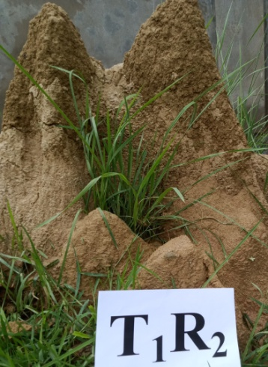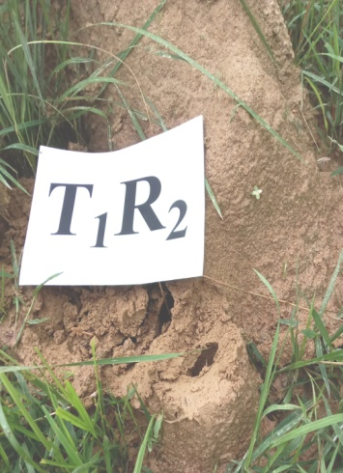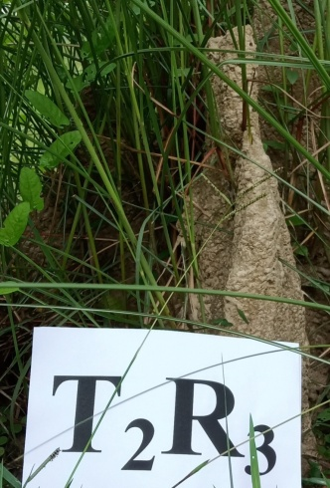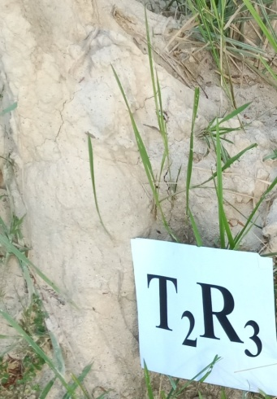

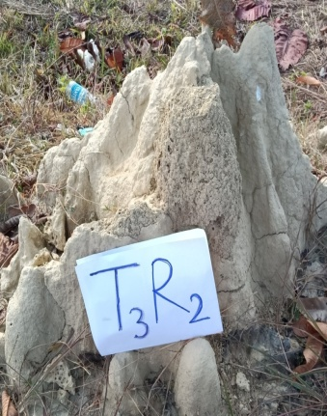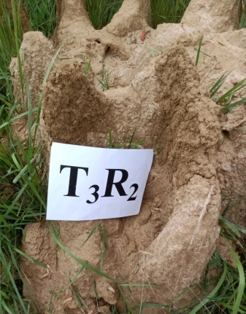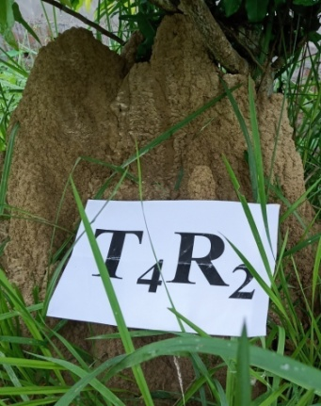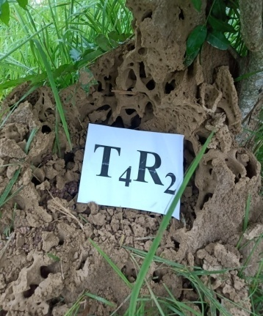

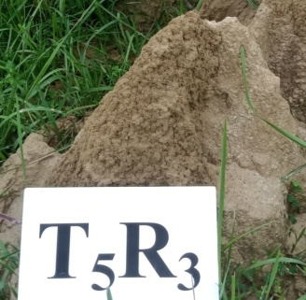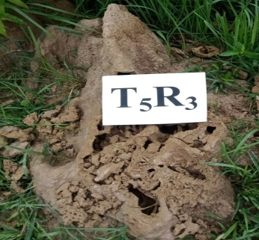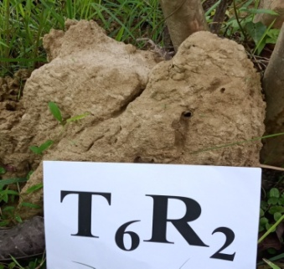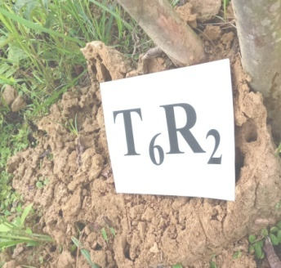



Fig.1. Termite mound (*Odontotermis obesus*), before and after application of *H.bacteriophora*

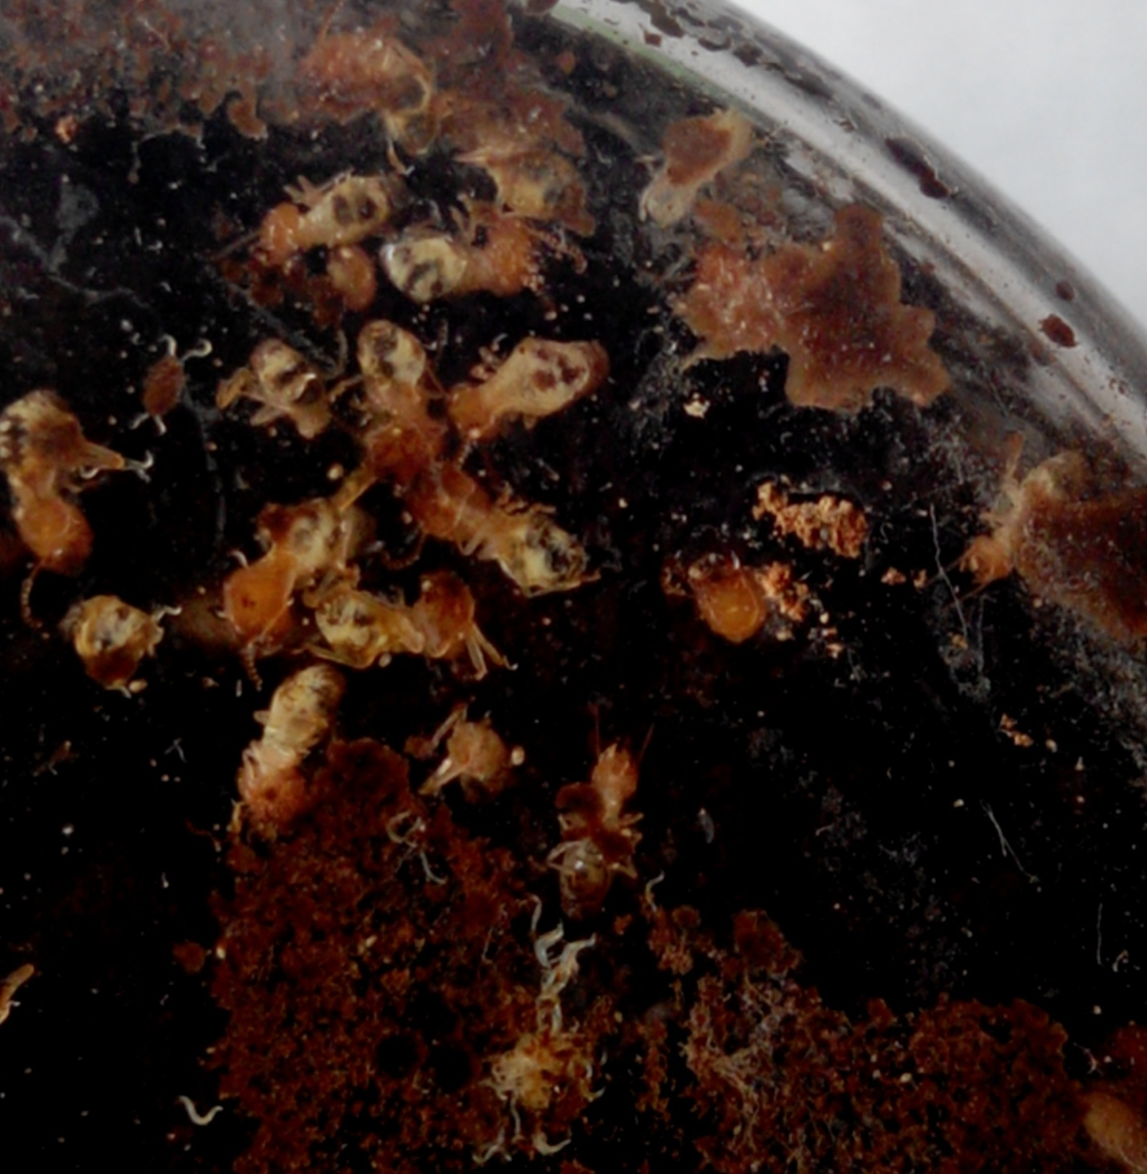

Fig.2. *Odontotermes obesus* infected by *Heterorhabditis bacteriophora*