Air Layering in Semecarpus anacardium L. f.: A Novel Approach to the Propagation and Conservation of an Important Wild Edible Fruiting Species

Abstract
Semecarpus anacardium L. f. (Bhilawa), a significant wild edible fruiting species with prominent medicinal value, is renowned for its bioactive compounds, including flavonoids, phenolics, and tannins, which contribute to its therapeutic applications in both traditional and modern medicine. Despite its immense potential for combating malnutrition and supporting sustainable development goals, the species faces a decline in natural populations, primarily due to poor seed viability and challenging propagation traits. This study explores the use of air layering as an innovative vegetative propagation method for S. anacardium, aimed at addressing these challenges. We evaluated the effectiveness of four distinct air layering media—soil, cocopeat, sphagnum moss, and soilrite—both individually and in combination with the bio-regulator indole-3-butyric acid (IBA) at 1000 ppm. Our results reveal that the combination of soil and IBA at 1000 ppm yielded the highest callus formation (72.66%), rooting percentage (80%), and root development (27.34 roots per layer). Additionally, this treatment resulted in the highest survival rates, with 13.43% survival in nursery conditions under partial shade and 7.30% in open-field conditions. These findings emphasize the significance of selecting optimal air layering media and bio-regulators to improve rooting efficiency and plant survival. This study lays the groundwork for developing effective propagation protocols for S. anacardium, supporting its conservation and sustainable utilization for future generations.
Keywords:Semecarpus anacardium, air layering, IBA, rooting efficiency, survival rate
Introduction
SemecarpusanacardiumL.f. (Bhilawa) is a deciduous tree with significant medicinal and pharmacological importance, particularly in Ayurveda. It is rich in bioactive compounds such as flavonoids, phenolic compounds, and tannins, contributing to its therapeutic potential. However, the natural populations of Semecarpus anacardium are rapidly declining due to habitat loss, overharvesting, and other environmental pressures. This has created an urgent need for effective propagation and conservation strategies to ensure its survival and continued medicinal use.
The propagation of Semecarpus anacardium is challenging, primarily due to its poor seed viability and difficult rooting characteristics. The seeds exhibit limited and brief viability, requiring immediate sowing after collection for successful propagation [1]. Traditional seed propagation is further complicated by factors such as hard seed coats that cause dormancy, genetic variation leading to inconsistent plant quality, and difficulties in obtaining microbe-free seedlings in vitro due to phenolic leaching [2]. These limitations underscore the need for alternative vegetative propagation techniques.Vegetative propagation methods, such as cuttings, grafting, and layering, offer the advantage of producing true-to-type plants with uniform growth, essential for large-scale multiplication of superior clones. However, Semecarpus anacardium presents specific challenges, including root hardness, low rooting potential, and susceptibility to transplant shock, making stem cuttings an unreliable method for propagation.
Air layering, a vegetative propagation technique, involves inducing root formation on a stem while it remains attached to the parent plant, mitigating issues related to poor rooting potential and transplant shock. This method is particularly effective for difficult-to-root species and has been used across various tree species [3][4]. It is an excellent way to replicate plants without disturbing the parent plant, allowing the original tree to continue flowering or bearing fruit. It produces mature plants in a shorter time compared to seed propagation or cuttings. It is often used for tropical fruit trees and shrubs, as it ensures the new plant is identical to the parent plant, in terms of fruit quality and other traits. Air-layered plants typically develop a balanced root system and grow rapidly once transplanted, which makes this method ideal for vegetative propagation of woody plants (, 2007). The method requires careful attention to season, as proper light, moisture, and temperature conditions enhance root formation [5].In India, air layering has not been widely tested on forest tree species, but it has been used in situations where rooting from cuttings is slow [6]. Previous studies have demonstrated successful air layering in several forestry species. [7] achieved successful clonal propagation in Boswellia serrata and Dalbergia sissoo, with rooting percentages of 52% and 68%, respectively, using a soilrite and black polythene covering technique. Similarly, [8] achieved 50–60% success in ring air-layering for several endangered endemic species in the Western Ghats. [9] found successful rooting in Parkiatimoriana, a medicinal species, using IBA and specific media treatments.Several other studies have reported success with air layering for a variety of tree species, including Ficuskrishnae, Bombax ceiba, Gmelina arborea, and Acacia nilotica[10][11][12]. The use of polythene covers, rooting hormones like IBA, and proper moisture levels have been key factors for successful rooting in these studies.
Given the difficulties associated with traditional propagation methods for Semecarpus anacardium, this study aims to explore, for the first time, the influence of different growing media and bio-regulators on the rooting efficiency of air layering. The goal is to optimize vegetative propagation protocols for this valuable medicinal species, offering a promising alternative to seed propagation and contributing to its conservation and sustainable use.
Materials and Methodology
Experimental Site:The study was conducted at the Mandla Forest Division of Madhya Pradesh and the Silviculture, Forest Management, and Agroforestry nursery at the ICFRE-Tropical Forest Research Institute, Jabalpur, during the 2022-24. The region's subtropical climate, characterized by distinct seasonal variations, provided optimal conditions for the study.
Plant selection:Semecarpus anacardium L. f. plants were sourced from natural populations in central India. The selected plants were mature, healthy, and free from disease or pest infestation, with an approximate age of 8-10 years. This age range was deemed optimal for vegetative propagation through air layering.
Experimental setup:Air layering was performed during the monsoon season (July-August) to leverage the high humidity, which enhances rooting success. Branches with a diameter of 1-2 cm were chosen. A 2-3 cm wide ring of bark was removed from each branch to expose the cambium layer, facilitating root formation.
- Growing Media: Various growing media were tested to evaluate their effects on rooting behavior. The media included:
- Soil: Loamy soil collected from the natural habitat of Semecarpus anacardium.
- Cocopeat: Commercial cocopeat with high water retention capacity.
- Soilrite: A mix of vermiculite and perlite, known for its excellent aeration and drainage.
- Sphagnum Moss: Selected for its superior moisture-retentive properties.
- Combinations: Mixtures of soil with cocopeat, Soilrite, and sphagnum moss were also evaluated.
Additionally, Indole-3-butyric acid (IBA) was applied at a concentration of 1000 ppm to assess its effect on rooting efficiency.
Experimental Design:The experiment utilized a randomized block design (RBD) to account for variability among trees. A total of 54 air layers (6branches per treatment) were applied to each of 15 medium-aged trees, resulting in 810 air layers overall. Each tree was treated as a block, with treatments randomly assigned to air layers within each tree to ensure uniform application and control for tree-related variability. The air layers were wrapped in transparent polythene bags filled with the respective growing media and secured with twine (Figure I). To maintain adequate moisture levels for rooting, the polythene bags were regularly watered as needed throughout the experiment.
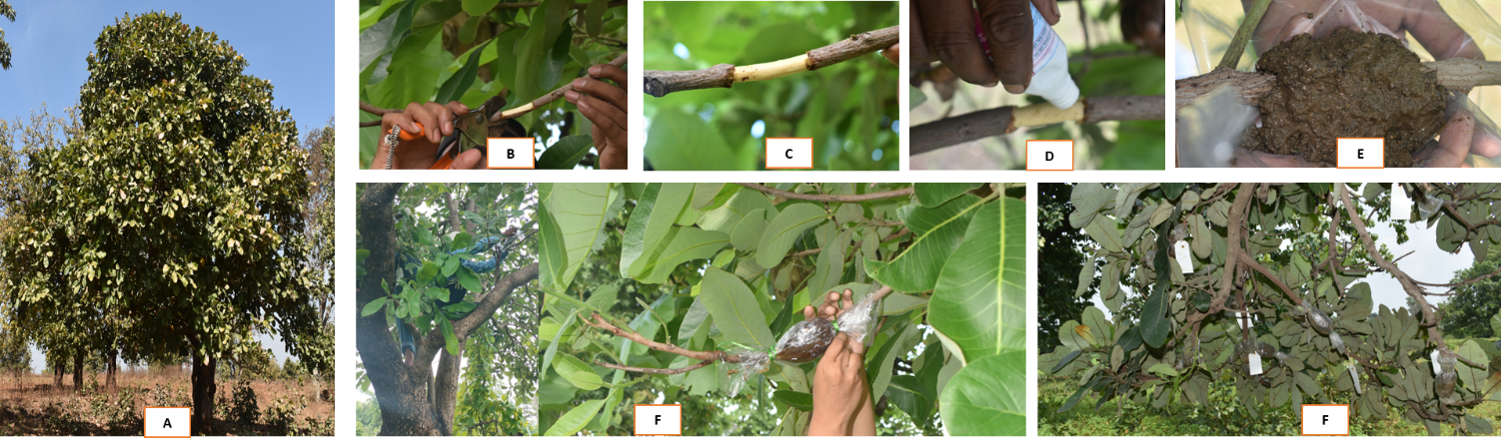
Figure I: Air layering technique in Semecarpus anacardium (A) Semecarpus anacardium in natural habitat; (B-F) Steps in air layering
Data Collection:Rooting parameters were assessed 60 days after layering. The following metrics were recorded:
- Percent Callused Layers: The proportion of layers that developed calluses at the ringed bark site.
- Rooting Percentage: The percentage of layers that successfully formed roots.
- Number of Roots per Layer: The average number of roots per successful layer.
- Root Length: The average length of roots in each successful layer.
- Survivability: Survival rates were recorded under nursery conditions (partial shade) and after transplanting to open field conditions.
Rooting and Post-Layering Care:Rooted air layers were monitored regularly. They were detached 60 says after layering when fibrous roots were clearly visible. After removal, rooted layers were planted in large polythene bags in the nursery and at the field plantation site, with segregation by treatment. Both nursery and field sites were regularly watered based on moisture levels. Survival, growth, and development were assessed 180 days after planting, with periodic recordings of survival data.
Statistical Analysis:Data were analysed using Analysis of Variance (ANOVA) to determine significant differences between treatments at the 5% level. The Least Significant Difference (LSD) test was employed for mean comparisons to identify the most effective growing medium for rooting in Semecarpus anacardium.
Results
The experiment evaluated different treatment types on various parameters including percent callused layer, rooting percent, number of roots per layer, root length, nursery polythene bags under partial shade survivability, and open field survivability. The following observations were made:
Percent Callused Layer
The Figure II highlight the influence of different growing media and the growth regulator IBA (1000 PPM) on the percent callused layer, with significant variation observed across treatments. Soil combined with IBA (1000 PPM) produced the highest callus formation (72.66%), indicating its superior effectiveness, followed by soil alone (68.36%). Treatments with Cocopit and its combination with IBA showed much lower callus formation (32.81% and 31.71%, respectively), suggesting limited suitability for callus development. Similarly, Soilrite and its combination with IBA yielded poor results (23.99% and 25.55%, respectively). Sphagnum moss performed moderately well (34.66%), but the addition of IBA slightly reduced its effectiveness (29.23%). The statistical measures confirmed the reliability of the results, with a low coefficient of variation (9.76%) indicating consistency and an F-test value of <0.001 confirming that the treatment differences were highly significant.

Figure II: Influence of different growing media and the growth regulator IBA (1000 PPM) on the percent callused layer
Rooting Percent
The Figure III and IVhighlight the effect of different growing media and the growth regulator IBA (1000 PPM) on the rooting percentage. Soil combined with IBA (1000 PPM) showed the highest rooting percentage (33.93%), followed by soil alone (29.32%), indicating the superior effectiveness of soil, particularly when supplemented with IBA, for rooting. Cocopit and Cocopit+IBA exhibited much lower rooting percentages of 11.86% and 10.51%, respectively, suggesting their limited suitability for promoting rooting. Soil+Cocopit+IBA (9.68%) and Soilrite (9.43%) had the lowest rooting percentages among all treatments, while Soilrite+IBA showed moderate improvement (13.15%). Sphagnum moss achieved 11.2%, and its combination with IBA resulted in slightly better rooting at 12.3%. The F-test value of <0.001 indicates that the differences among treatments are statistically significant.
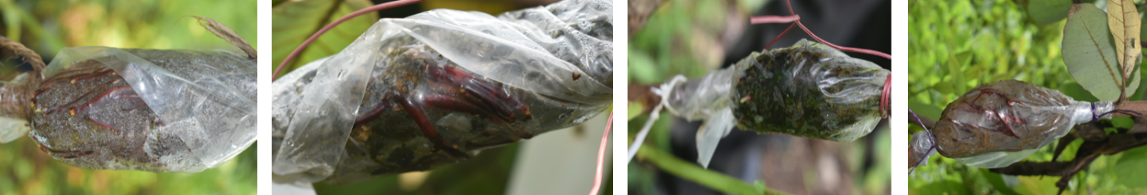

Figure III: Rooted air layered branches of Semecarpus anacardium

Figure IV: Influence of different growing media and the growth regulator IBA (1000 PPM) on the Rooting Percent

Number of Roots per Layer
The Figure V and VI highlight the effect of different growing media and the growth regulator IBA (1000 PPM) on the number of roots per layer. Soil combined with IBA (1000 PPM) produced the highest number of roots per layer (27.343), followed by soil alone (21.987), demonstrating the effectiveness of soil, especially when enhanced with IBA, for root production. Cocopit+IBA (21.6%) and Cocopit (18.693) also showed relatively good results, while Soil+Cocopit+IBA yielded 20.403 roots per layer.On the other hand, Soilrite and its combination with IBA resulted in significantly fewer roots (4.787 and 5.29, respectively), indicating their limited suitability for this purpose. Sphagnum moss alone produced 13.61 roots per layer, which slightly increased to 14.913 when combined with IBA. The F-test value (<0.001) indicates statistically significant differences among the treatments.

Figure V: Influence of different growing media and the growth regulator IBA (1000 PPM) on the Number of Roots per Layer
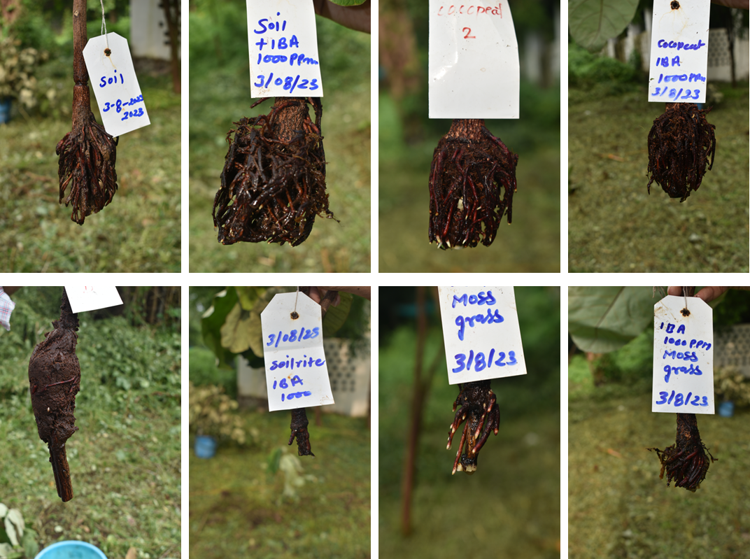
Figure VI: Rooted air layered branches of Semecarpus anacardium ready for plantation
Root Length:Figure VII highlights the impact of different growing media and IBA (1000 PPM) on root length. Soil combined with IBA showed the highest root length (7.53 cm), followed by Soil alone (6.65 cm), indicating its effectiveness for root elongation. Moderate root lengths were observed with Cocopeat + IBA, Soil + Cocopeat + IBA, and Sphagnum Moss + IBA, while the shortest root lengths occurred in Soilrite and Soilrite + IBA, demonstrating their limited suitability. The F-test (<0.001) confirmed significant differences among treatments, with IBA significantly enhancing rooting percentages, root length, and the number of roots per layer. Soil-based media consistently outperformed alternatives like Cocopeat and Soilrite, likely due to superior nutrient availability and moisture properties.

Figure VII: Influence of different growing media and the growth regulator IBA (1000 PPM) on the Root Length
Survival Percentage in Nursery Polythene Bags Under Partial Shade Survivability
Figure VIII and IX highlights the survival percentage of rooted layers transplanted into nursery polythene bags under partial shade, using different growing media and the growth regulator IBA (1000 PPM). Among the treatments, Soil combined with IBA (1000 PPM) showed the highest survivability (13.43%), followed by Soil alone (11.233%), indicating the superior suitability of soil, especially with IBA, for enhancing survival under nursery conditions. Moderate survivability was observed in treatments such as Soil+Cocopit+IBA (9.88%), Cocopit+IBA (8.447%), and Spagnummoss+IBA (8.58%), reflecting the beneficial impact of IBA across various media. In contrast, Soilrite and Soilrite+IBA had the lowest survivability rates, at 5.697% and 5.927%, respectively, suggesting Soilrite's limited suitability under partial shade. With a critical difference (C.D.) of 0.471, a low coefficient of variation (C.V.) of 3.108%, and an F-test value of <0.001, the results demonstrate significant differences among treatments and consistency across replicates.

Figure VIII: Influence of growing media and growth regulators on Survival Percentage in Nursery Polythene Bags Under Partial Shade
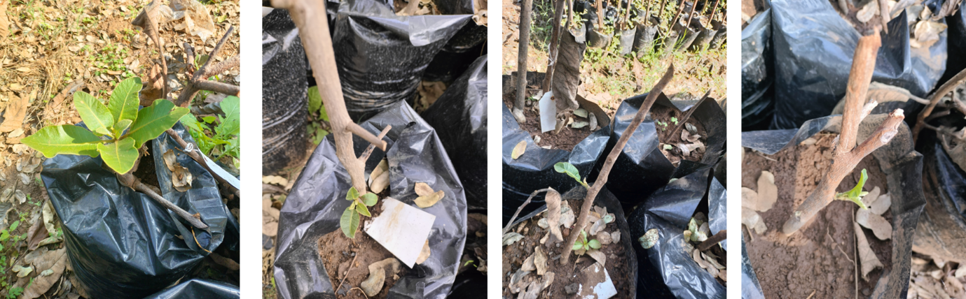
Figure IX: New leaves sprouting in the rooted twigs in polythene begs

Open Field Survivability
Figure X, XI and XII highlights the survival percentage of rooted layers transplanted in an open field, considering various growing media and the growth regulator IBA (1000 PPM). Among the treatments, Soil with IBA (1000 PPM) recorded the highest survival percentage (7.297%), followed by Soil alone (6.723%), indicating that soil-based media are the most effective for promoting plant survivability in open-field conditions. Treatments like Spagnummoss+IBA (5.737%) and Soil+Cocopit+IBA (5.37%) also showed moderate survival rates, suggesting a beneficial effect of combining IBA with specific media. Conversely, Cocopit (3.16%), Soilrite (3.533%), and their combinations with IBA exhibited lower survival percentages, indicating limited suitability for open-field conditions.

Figure X: Influence of growing media and growth regulators on Survival Percentage in Open Field
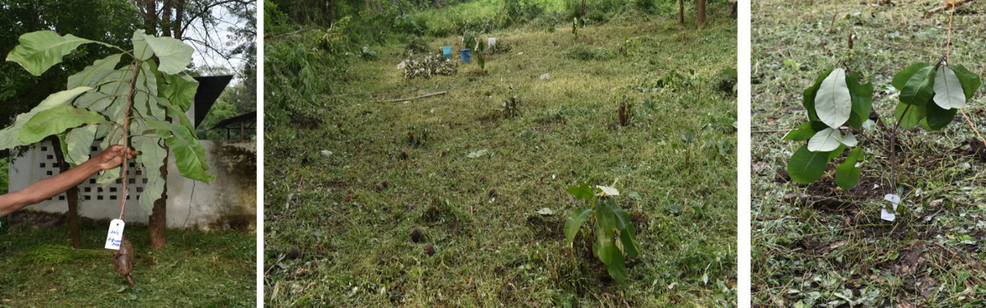
Figure XI: Field plantation of rooted branches of Semecarpus anacardium

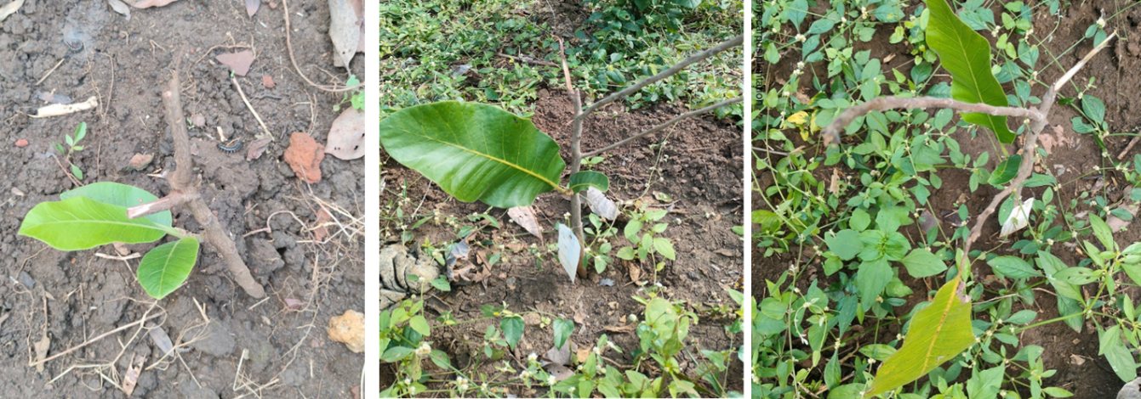
Figure XII: New leaves sprouting in the rooted twigs in open field
Discussion
The experiment provides valuable insights into the effectiveness of different growing media and the application of IBA on the propagation and survival of Semecarpus anacardium through air layering. Soil, particularly when combined with IBA, outperforms other media in parameters such as callus formation, rooting percentage, root length, and survivability under both nursery and open field conditions.
The highest percentage of callus formation was observed in soil supplemented with IBA, highlighting the critical role of both the medium and the growth regulator in promoting callus development. Soil offers superior nutrient availability and moisture retention essential for cellular growth and differentiation, while IBA further enhances these processes. This supports findings by [13]. that growth regulators like IBA significantly induce callus formation in many plant species. Conversely, media like Cocopit and Soilrite are less effective, likely due to their inferior nutrient profiles or water-holding capacity, as noted by [14].
The superior rooting percentage in soil combined with IBA aligns with previous research demonstrating IBA's role in enhancing rooting across various species [15]. Soil provides optimal conditions for root development, including essential nutrients, organic matter, and moisture retention. The low rooting percentages in Cocopit and Soilrite further underscore the importance of nutrient-rich and moisture-retentive media. These observations are consistent with [16], who highlighted the necessity of an appropriate combination of media and growth regulators for optimal rooting success.
Significant increases in root length were also observed in soil with IBA, making this combination the most effective for promoting root initiation and elongation, crucial for transplantation and field establishment. Robust root systems developed in this treatment facilitated better nutrient and water absorption, leading to higher survivability under both controlled and open field conditions. These findings reinforce the role of proper media and growth regulators in achieving successful plant establishment, as also supported by [17].
Seasonality is another critical factor influencing the success of air layering. [18], found the rainy season (July) most favorable for rooting in Spondiaspinnata, with IBA at 500 ppm proving highly effective. High humidity and optimal temperatures during this periodcontribute to improved rooting success. [19], [20], similarly observed enhanced rooting under high-humidity conditions, linked to the water retention capacity of sphagnum moss and the favorable temperatures of 25–32 °C.
Several studies confirm the effectiveness of IBA in stimulating root initiation across species. [21], observed improved rooting in Terminalia chebula, while demonstrated similar results in Carissa carandas and Dalbergia sissoo. Rooting responses in Bauhinia variegata further underscore the synergistic effects of auxins like IBA and seasonal factors [22].It has also been successfully applied in various forest species, including Ficuskrishnae and Ficusauriculata[11], Gmelina arborea[12],Prosopis cineraria[23], Acacia nilotica[17], and Guadua angustifolia[24]. These studies collectively highlight the widespread applicability of IBA and the importance of seasonal timing in improving rooting success across diverse species.
Conclusion
In conclusion, this study highlights the critical role of growing media and growth regulators like IBA in the propagation of Semecarpus anacardium. Soil, particularly when supplemented with IBA (1000 PPM), proved to be the most effective for promoting callus formation, rooting, and survival. These findings offer practical insights for optimizing propagation techniques in Semecarpus anacardium and other species with similar challenges. Future research could explore further refinements in media composition or the use of alternative growth regulators to enhance propagation outcomes, contributing to the sustainable management and conservation of medicinal plants like Semecarpus anacardium.

References
- Anonymous (1999) Wealth of India. Vol. IX. CSIR Publication, pp 271–275
- Yang QH, Ye WH, Yin XJ (2007) Dormancy and germination of Areca triandra seeds. Sci Hortic 113, 107–111
- Parthiban KT, Sudhagar RJ, Kanna SU, Vennila S, Sekar I, Baranidharan K (2016) Forestry: A subjective guide for IFS aspirants. Scientific Publishers-Competition Tutor
- Evans E, Blazich FA (1999) Plant propagation by leaf, cane, and root cuttings: Instructions for the home gardener. North Carolina Cooperative Extension Service
- Bose TK, Mitra SK, Sadhu MK (1986) Guava. In: Propagation of tropical and sub-tropical horticultural crops. Naya Prokash, pp 291–301
- Hartmann HT, Kester DE (1975) Plant propagation principles and practices. 3rd edn. Prentice Hall
- Singh S, Kumar P, Mandal AK, Ansari SA (2004) Air-layering of trees with differential adventitious rooting response. Indian Forester 130(3). https://doi.org/10.36808/if/2004/v130i3/2005
- Jose P, Mohanan NN, Hussain A (2009) Clonal propagation through air layering in four endemic trees of Western Ghats. J Non-Timber For Prod 16, 321–324. https://doi.org/10.54207/bsmps2000-2009-VO5Z0W
- Borpuzari PP, Singh MK, Dutta A (2020) Air layering of Parkiaroxburghii G. Don Syn. P. timoriana (DC.) Merr.: A high-value tree species of northeast India. Pharma Innov J 9(8), 192–194
- Puri S, Nagpal R (1988) Effects of auxins on air layers of some agroforestry species. Indian J For 11(1), 28–32
- Tomar A, Singh VRR (2011) Effect of air layering time (season) with the aid of indole butyric acid in Ficuskrishnae and Ficusauriculata. Indian Forester 137(12), 1363–1365
- Arya RS, Haque MS (1982) Grafting and budding in Gmelina arborea. Indian Forester 108(7), 497–500
- Hartmann HT, Kester DE (1965) Plant propagation principles and practices. Prentice Hall
- Sharma SB, Ray PK, Singh BK (1990) Note on rooting and survival of litchi layers. Indian J Hortic 47(2), 174–176
- Dimri DC, Nautial MC (2000) Effect of IBA on rooting and survival of air layering in lemon cv. Pant Lemon and Kagzi Lime under low hill valley area of Uttaranchal. Prog Hortic 32(2), 186–189
- Mandal B, Sengupta BN, Brahamchari VS (1988) Effect of PGR on rooting of cutting in litchi. Bihar Acad Agric Sci 35(36), 19–23
- Sharma SK, Verma SK, Bhojvad PP (2004) Cloning of Acacia nilotica for multiplication and establishment of clonal seed orchard. In: Multipurpose trees in the tropics: Management and improvement strategies. AFRI, pp 691–700
- Tomar A (2016) Impact of seasonal changes on air layering and rooting hormone in Spondiaspinnata (J. Koenig ex L. f.) Kurz. Trop Plant Res 3(1), 131–135
- Chauhan PS, Dua IS (1982) Improvement of forest biomass. Pragati Press
- Srivastava SC, Kumar P, Misra YD (1994) Air layering in Galwang (Albizia lucidaBenth.): A Lac host plant. Indian Forester 120, 524–528
- Misra KK, Jaiswal HR (1994) Effects of growth regulators on rooting and survival of air layers of Karaunda (Carissa carandas L.). Ann Agric Res 11(2), 208–210
- Nagpal R, Singh K (1986) Propagation of some social forestry species by air layering. In: Khosla PK, Kohli RK (eds) Social forestry for rural development. Pragati Press, pp 222–227
- Solanki KR, Kackar NL, Jindal SK (1984) Propagation in Prosopis cineraria (L.) Macbride by air layering. Curr Sci 53(21), 1166–1167
- Verma PK, Das N, Kaushik PK, Kumar V, Yadav A (2013) Vegetative propagation through air layering of Guadua angustifoliaKunth—A commercially important bamboo. Indian Forester 139(12), 1088–1091

