**AI-Driven Crop Breeding-Revolutionizing Agriculture with Smart Technologies: A review**

**Abstract**

The integration of artificial intelligence (AI) into crop breeding is transforming agricultural innovation by leveraging big data, machine learning (ML), and deep learning (DL) techniques. Advances in genomics, phenomics, and environmental sensing have enabled the development of high-dimensional datasets, fostering more precise and efficient breeding strategies. AI-driven approaches, including ML models like random forests and convolutional neural networks, enhance phenotypic predictions and yield forecasting. Deep learning further accelerates genotype-to-phenotype mapping by extracting key traits from large-scale datasets. Additionally, AI-powered genomic selection and gene editing tools, such as CRISPR-Cas9, are revolutionizing targeted breeding. Automation, including UAVs and high-throughput phenotyping platforms, streamlines data collection and analysis, reducing costs and improving accuracy. Despite these advancements, challenges such as data standardization, computational demands, and ethical concerns remain. Overcoming these hurdles will be critical in harnessing AI’s full potential for sustainable agriculture and global food security.

**Keywords** Artificial Intelligence, Crop Breeding, Machine Learning, Deep Learning, Genomic Selection, Phenomics, High-Throughput Phenotyping, Gene Editing

**Introduction**

At the beginning of the 21th century, new opportunities for innovation in creation technology were made possible by the convergence of genomics, molecular biology, image, Remote sensing (RS) computer, Big biological data (BBD) and Artificial intelligence. The rapid development of agricultural phenomenon, which overcame manual phenotyping disadvantages and created high-performance phenotypic data sets, covering a variety of the microscopic sizes tissues and dimensions to plants and entire roofs-is a remarkable discussion during this period. Precision creation now has crucial assistance, thanks to advances in environmental detection technology, which have made it possible for researchers to collect and combine accurate and real -time environmental data in a variety of habitat conditions. The multi -dimension and high dimension data sets recently replaced conventional one -dimensional creation data (Wallace et al., 2018). These comprehensive data sets, as opposed to unique omic databases, combine various levels of biological data, resulting in a more complete and reliable database that accelerates culture genetic research and the improvement of characteristics.

Due in large part to the recent rapid breakthroughs in genomics and phenomics technology, centuries of breeding have resulted in the accumulation of vast amounts of data. These advancements have ushered in a new era of omics research in the domains of agriculture and plant sciences, marked by important discoveries and data-driven approaches (Zhao C et.al,2019). Due in large part to the recent rapid breakthroughs in genomics and phenomics technology, centuries of breeding have resulted in the accumulation of vast amounts of data. These advancements have ushered in a new era of omics research in the domains of agriculture and plant sciences, marked by important discoveries and data-driven approaches. Furthermore, because of their high dimensionality, strong variability, and severe noise, large crop genomic and multiomics datasets frequently pose difficulties. Traditional data analysis techniques are complicated by these features, which make it challenging to effectively and precisely evaluate complex, multifaceted, and heterogeneous data. Professor Edwards Buckler, a member of the US National Academy of Sciences and a corn genetics breeder at Cornell University, presented the idea of "Breeding 4.0"-intelligent design breeding-in 2018 in response to these difficulties (Wallace et al., 2018). This cutting-edge breeding strategy aims to facilitate the effective and customized production of new crop varieties by fusing biotechnology with big data and artificial intelligence (AI) technologies. Breeding practices have seen a dramatic change from traditional "scientific" approaches to more "intelligent" ones (Wang and Cai, 2019; Jing et al., 2021).

Understanding the basic relationships between genotypes and phenotypes is the main goal of crop genetic breeding research in order to produce superior varieties that meet a range of human needs (Wallace et al., 2018). Crop breeding practices have seen a dramatic change as a result of recent technological developments, shifting from conventional phenotype-based approaches to intelligent design breeding that makes use of cutting-edge genomic technology and big data analytics. Domestication breeding, genetic breeding, molecular breeding, and the new field of big data intelligent design breeding are the four main phases of crop breeding development (Zhang Y et al., 2021). An important turning point in the development of human agricultural techniques was the beginning of domestication breeding some 10,000 years ago. To selectively domesticate and produce wild plant species that satisfied human needs, early farmers mostly relied on visual evaluations of phenotypes (Zhang Y et al., 2024). Despite laying the foundation for modern agriculture, this approach was characterized by a dearth of rigorous theoretical frameworks and was frequently predicated on chance, uncertainty, and experience.

The introduction of Mendelian genetics and Darwinian evolutionary theory in the late 19th and early 20th centuries caused a change in crop breeding from an experience-based method to one that was directed by science. The genetic breeding phase was started by this shift, which greatly increased breeding efficiency. In order to create recordable and traceable breeding data, breeding methods started to methodically integrate statistical analysis, field trial procedures, and genetic principles (Fisher et al., 1919; Wright et al., 1921). But there wasn't much data collected during this time, and it wasn't quantified or standardized. Biotechnology breakthroughs in the late 20th century led to new ideas and methods in molecular breeding. The genome assembly of several crops, including rice, corn, and wheat, was made possible by the extensive use of high-throughput sequencing and gene chip technologies as well as the quick advancement of bioinformatics. This produced large datasets and made it easier to build thorough genomic databases, opening up new avenues for study in areas such as precise functional gene identification, genetic analysis of important crop traits, and a better comprehension of the mechanisms underlying genetic evolution (Risch and Merikangas, 1996).

**AI Technologies in Crop Breeding**

**Machine learning**

As we tackle the problems brought on by emerging illnesses and climate change, AI-driven methods provide a powerful set of tools to assist ensure global food security and promote agricultural sustainability. Climate change is a major threat to agricultural systems, therefore understanding how crops tolerate cold temperatures is crucial. In order to investigate how gene expression patterns alter in response to temperature variations. Konecny et al. (2023) introduced a machine learning technique based on Self Organizing Maps (SOM). Their research showed that SOM might be a helpful tool for interpreting complex transcriptome data and offered significant new insights into the molecular mechanisms behind grapevines' ability to withstand cold. Plant breeding has been transformed by genomic selection, which allows breeders to determine a plant's genetic value based on its genomic information. However, assessing long-term genetic value accurately remains challenging. An intriguing viewpoint on the challenges and opportunities in plant breeding is offered by the concept of oracle selection. Vanavermaete et al.(2023) examined how oracle selection could enhance breeding operations and emphasized its potential to encourage innovation in genomic selection techniques. Even though oracle selection may not be immediately useful in real-world scenarios, it fosters innovation and critical thinking when developing breeding plans.

Phenomics has become a key technique in plant breeding for overcoming the disconnect between genetics and phenotype. Singh et al .(2023) addressed the challenge of accurately predicting biomass using models constructed from RGB photos, stressing the importance of consistent performance over numerous experiments. Their findings pave the way for the use of high-throughput, non-invasive phenotyping methods to identify more genes linked to biomass production and break yield plateaus. Using drone-collected high-throughput phenotyping data, demonstrated the efficacy of machine learning models in predicting peanut yields and enhancing breeding efficiency (Pugh et al.,2024). Their innovative approach to estimating subsurface yields by utilizing aboveground features helps overcome the drawbacks of conventional phenotyping. ML methods, such as (RFs) and XG-Boost, have exhibited exceptional accuracy in predicting agricultural yields and finding desirable plant features.

In their discussion of advancements in vegetation indices and unmanned aerial remote sensing for winter wheat production forecasting, emphasized the necessity of effective feature selection to improve model performance (Li et al.,2023). Their work provided useful information for future yield prediction and feature selection research by showcasing the advantages of the Cubist model and the effectiveness of the PCRFRFE technique. In order to solve the yield prediction challenge combined machine learning with soil and environmental factors to estimate wheat yields (Mousavi et al.,2024). By accurately mapping actual wheat yields using random forests and artificial neural networks (ANNs) that included soil parameters, topography factors, and vegetation indices, their study illustrated how machine learning may enhance agricultural production.

|  |  |  |
| --- | --- | --- |
| Ml Applications | Details | References |
| Impact of Climate Change on Crops | Understanding crop tolerance to cold is crucial for food security. Machine learning with Self-Organizing Maps (SOM) provided insights into grapevine cold tolerance from transcriptome data. | Konecny et al., 2023 |
| Genomic Selection and Oracle Selection | Oracle selection fosters innovation in genomic selection techniques and aids in long-term genetic value assessment, despite limited real-world application. | Vanavermaete et al., 2023 |
| High-Throughput Phenomics for Biomass Prediction | Non-invasive phenotyping models from RGB photos improved biomass prediction, enabling identification of genes linked to yield potential. | Singh et al., 2023 |
| Drone-Based Phenotyping for Peanut Yield Prediction | Machine learning using drone-collected phenotyping data accurately predicted peanut yields and enhanced breeding efficiency. | Pugh et al., 2024 |
| ML Models for Agricultural Yield Prediction | ML models like Random Forest (RF) and XG-Boost showed high accuracy in yield prediction and identifying desirable traits. | Pugh et al., 2024 |
| Winter Wheat Production Forecasting | Feature selection techniques, such as PCRFRFE, improved model performance for winter wheat yield prediction using vegetation indices and remote sensing. | Li et al., 2023 |
| Wheat Yield Prediction via ML and Soil Data | Combining ML models (RF, ANN) with soil and environmental data enhanced wheat yield predictions. | Mousavi et al., 2024 |

Table 1 :-MI-Driven Methods in Agriculture: Advances and Applications

**Deep Learning**

By analyzing large amounts of data, deep learning resolves complex issues. Images continue for the primary data format used in crop breeding for phenotypeic selection (Araus and Cairns et al., 2014). The application of (DL) to image processing for plant phenotyping is expanding rapidly, especially with the effectiveness of notable CNN in phenotypeic large data analysis (Chang et al., 2016). It features powerful modeling and convenience retrieval the capabilities., which provide a new strategy to resolve obstacles. In analysis of data. Six steps are usually included in deep learning-based crop breeding workflows: Data Collection: Collect genetic and agricultural information for target crops, such as environmental variables, genetic markers, and phenotypic features (Cross et al., 2010).Data Preroposing: Use methods for data growth, convenience extraction, data normalization, and handling the missing data to clean and prepaors collected data . Model Building: Using data types and reproductive goals as a guide, choose the best nervous network topology to create an intensive teaching model that is suitable for special reproductive functions.Model Training: Using preprosensed data, training deep learning models by fine-tuning model parameters to reduce discrepancies between expected and observation values. Back propagation and gradient decents are two general training methods that are used to update model weight (Zhou et al., 2018). Selecting and optimizing genetic parameters: Use DLmodels that are designed to predict and assess crop genetic symptoms and agricultural facilities. Adapt the genetic factors and choose individuals that are suitable for breeding according to forecasts. (6) Iterative Reforms: To develop dl models and reproductive process, repeat recurrence, training, evaluation and selection processes (Nee et al., 2019). This creates an efficient breeding strategy that allows parents to contact the desired symptoms. Construction on major genes that have been found, integrates cutting the edge of information technologies like dl-informed fertility, next generation bioteomics and bd and AI. Deep learning-based breeding is based on the discovery of key genes through genetics and transgenic techniques. Through the plant phenotypeic analysis and high throwput phenotyping platforms, new techniques like large data sets, AI and Multiomics speed up the breeding process. They evaluate plants, identify special genes and accelerate breeding (PAN and Y., 2015; Banerjee et al., 2020). Identification of important genes and regulatory components, evaluating regulatory mechanisms and biological alterations, and guiding plant breeding is all made easier by integration of multi-ommix data, including transchcriptomics , protomics, phenomics, metabolomics, and genomics (Yang et Al.,2021). Even more complicated is the fact that the entire genome analysis and the telomere-to-telomere (T2T) full genome analysis identify genetic variability and representative markers to improve genetic reforms and functional genomics (Deng et al, 2022). Let's work In addition, breeding successes have been smooth by gene editing approach (Li et al., 2018).The targeted reproduction is made possible by wise reproductive techniques operated by large data and AI, such as (GEP) population-environmental interactions and genomics (Yin et al., 2008). With only a few rows of the code, these scores can be applied efficiently, thanks to the deep learning structure that provide automatic differences. . They will support the effective selection and production of better, pathological novel varieties by helping genotypes, phenotypes and large, multidimensional large data of the environment. It should be noted that intensive genetic studies are required using the associated environment and phenotypeic data (Parmley et al., 2019; Xu et al., 2021).

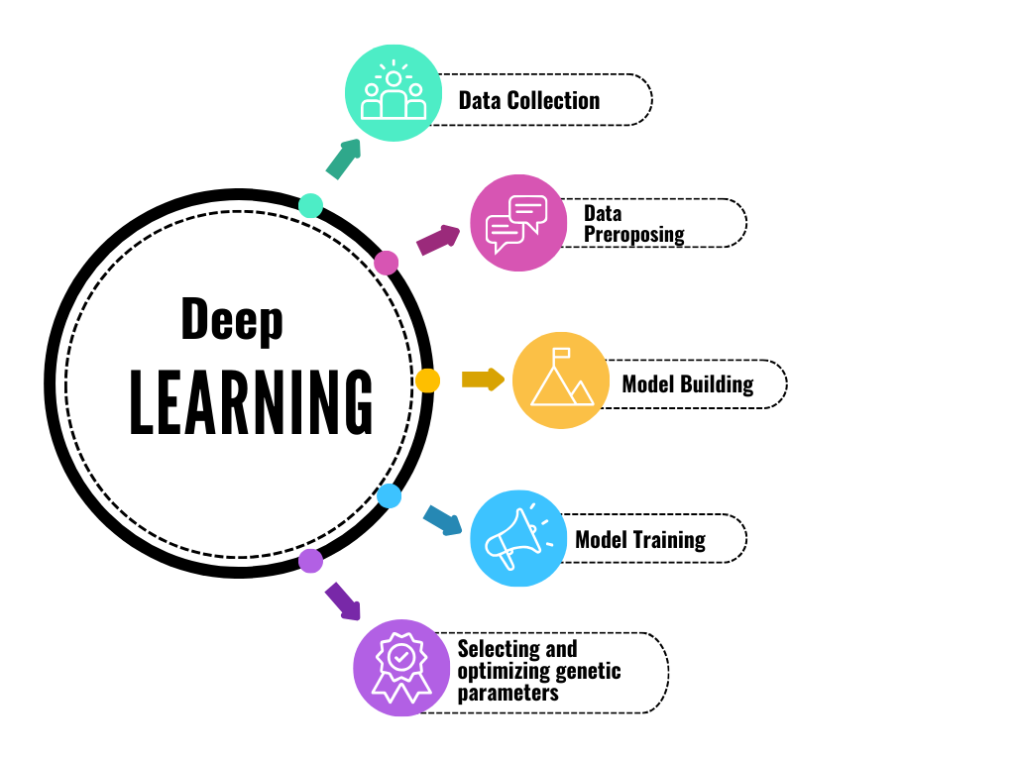

. Figure 1:- Deep learning based crop breeding. Source( )

**Analyzing Phenotypic with AI Models**

Getting thorough and precise phenotypic data from the training population is the foundation of effective phenotypic prediction. The reliability of the phenotypic data can be estimated through repeated field experiments conducted in various settings; phenotypic data with low heritability or repeatability shouldn't be used for training. Large-scale phenotypic data of different plant properties may be collected via phenomic platforms, and feature identification from these vast volumes of data is made possible by AI models (such machine learning) (Farooq et al., 2024). To forecast the breeding values of a test population, GS combines these genotypic and phenotypic data from a population under training (Jannink et al., 2010). Other BBD categories, such as transcriptome, metabolic, and environmental data , can also be utilized to predict trait performance (Dan et al.,2019; Gemmer et al., 2020;). Furthermore, models based on a single type of BBD perform worse than those that incorporate numerous BBD (Azodi et al., 2020).

Phenotypic prediction has had recent attempts at BBD integration using both traditional models and AI-aided models (Alemu et al., 2024). Given that other statistical models usually struggle with the complexity of the genotype-to-phenotype (G2P) relationships, many AI models such as SVM, RF, MLP, CNNs, and other deep learning , genomic breeding machine J, DNNGP, Soy DNGP, and Deep CCR (a DL model using CNNs in combination with bidirectional long short term memory) have been suggested (Wang et al.,2023; Ma et al.,2024) .More exploration is needed on the superiority of AI models to other conventional prediction models (Montesinos‐López et al., 2021).Improving the traits of crops requires one to do it at the same time, as they may correlate or share the same genetics. ML and DL models that focus on multiple traits outperformed those designed for only one trait in predicting yield amounts and protein content of wheat through RF algorithm or through MLP neural networks (Sandhu et al., 2021a). The prediction of traits (polygenic) with omics level precision was further simplified by utilizing Multi trait ML approach Targeted-Omics Phenotyping (TOP) which facilitates the integrated trait selection aimed at identifying the closest candidate varieties to the ideal type (Yang et al., 2022). Moreover, the implementation of the TrG2P model allows pre-trained models to be fetched from the AI cloud by employing the CNN algorithm on the initial dataset of genotype non yield trait phenotype images, tuning the convolutional layers to improve the prediction performance when transferring to the yield prediction task (Li et al., 2024c). All in all, newly developed AI models which have coupled multi trait dependencies have broken the bounds of predictive performance of more traditional modelling techniques. The absence of a specific type of qualitative data - genomic data bundled with organized phenotypic information that meets the ideal categorization. A complete set of genes, which includes the associated G2P data, has now made it possible to build intelligent breeding systems powered by AI for faster genome-designed breeding (Chen et al., 2023). For instance, CropGS-Hub offers services with six modeling options and houses a compilation of more than 224 billion genotypic and 434000 phenotypic data sets from over 30,000 people in 14 representative communities of the seven main crop kinds.

|  |  |  |
| --- | --- | --- |
| Phenotypic Prediction | Details | References |
| Phenomic Platforms for Data Collection | Large-scale data collection is possible through phenomic platforms and AI models. | Farooq et al., 2024 |
| Genomic Selection (GS) for Breeding Values | Integrates genotypic and phenotypic data for predicting breeding values. | Lorenz et al., 2010 |
| Additional Big Biological Data (BBD) | Transcriptome, metabolic, and environmental data enhance trait prediction. | Chen et al., 2019; Jiang et al., 2020 |
| Effectiveness of Multi-BBD Models | Multi-BBD models outperform single BBD models. | Prado et al., 2020 |
| AI Models Used in Phenotypic Prediction | SVM, RF, MLP, CNNs, DNNGP, Soy DNGP, Deep CCR, TrG2P, etc. | Abid et al., 2023; Zhang et al., 2024 |
| Multi-Trait Prediction with ML/DL Models | ML/DL models outperform single-trait models in predicting yield and protein content. | Sandhu et al., 2021a |
| TOP (Targeted-Omics Phenotyping) for Multi-Trait Selection | Integrates multi-trait selection for ideal variety identification. | Yang et al., 2022 |
| TrG2P Model (AI Cloud-Based Prediction) | Uses CNN-based pre-trained AI models for improved yield prediction. | Li et al., 2024c |
| Intelligent Breeding Systems Powered by AI | Enabled by genomic data with structured phenotypic information. | Chen et al., 2023 |
| CropGS-Hub Database Overview | Stores 224 billion genotypic and 434,000 phenotypic datasets from 30,000 individuals across seven major crop types. | Chen et al., 2023 |

Table 2:- Summary of AI Models and Phenotypic Prediction in Crop Breeding

**Analyzing genotype data with AI**

Many researches have demonstrated possible uses of artificial intelligence (AI) in analysis of biochemical data to improve our knowledge of biology of stress on plants. For example, Artificial intelligence has been successfully applied to determine genomic areas with high mutation rates by predicting genomic crossings in both maternal and parents' maize plants (Demiri et al., 2021). To identify and define genomic regions and to differentiate between functional genes and pseudozens, researchers also used AI approach to check DNA Methilation pattern in stress-walked maize (Sartor et al., 2019). Similarly, (Uygun S et al., 2019) used the Artificial Intelligence ​​algorithm to study the expression pattern of vital genes, which allowed them to identify CIS-control elements and gene promoters in Maize and *Arabidopsis Thaliana* (Varla et al., 2018). Additionally, by optimizing biomass production by means of various types of algae and plant species blooms, the important work of AI in bio -organism management and later improved the generation of biofuels (Meena M et al.,2021).

Long reading sequencing has become the most commonly used technique in crop breeding because technology quickly advances progress. Compared to short-read sequencing, this technique has the benefit of gathering additional haplotype and structural variation data; however, it introduces more mistakes and makes different identity more difficult. Deep Learning (DL)-Long-reading techniques are long-reading sequencing (Ahsan et al., 2021; Zheng et al., 2022) both short-read sequencing and (poplin et al. Al., 2018). To use intricate details in lengthy reeds and to lessen the impacts of mistakes, these methods use a variety of techniques, such as image-based representation, local restoration, complete alignment and haplotype -ware modeling. It leads to better performance than current techniques and makes it easier to find new variants in parts of genomes that are challenging for map (Shafin et al., 2021). The fact devices are mostly focused on somatic cells in humans, a major disadvantage, because it means that various calling techniques need to be carefully modified before being used in agricultural plants. It is clear that increased variant naming accuracy will improve marker-assisted breeding and genomic selection (GS) accuracy, strengthening breeders for better crop reform decision making. It is still very difficult to identify small insertion/deletion (Indel) variant and single-nucleotide polymorphism (SNP), which is using the second and third generation sequencing technology. This problem is being addressed by Artificial Nervous Network (ANNS). (Luo et al. ,2019). Using information from Illumina, Pacbio, and Oxford Nanopor sequencing systems, he assessed the clarventte with emphasis on identifying the general version locations from the 1000 genome project dataset, which had a minor allele frequency of at least 5%.

**Gene editing throught AI**

The exact modification of DNA sequences found in live cells is made possible by genome editing (GED) technology (Ma et al., 2015). This has transformed our ability to study gene function and develop novel therapeutic strategies. ZFNs , TALENs, and CRISPR/Cas9 are the three most sophisticated Genomic editing technology ( Siva et al., 2021). Because of its adaptability, efficiency, and user-friendliness, CRISPR/Cas9 is the most widely utilized GED technology (Zhu et al.,2022; Arora et al., 2017). The field of gene or cell treatment is always changing, and Considerable progress has been achieved recently in the creation of CRISPR-based various clinical trials. There are several ways that GED technologies can be applied to cure human illnesses (Li et al., 2020). It can be used, for instance, to treat mutations that cause disease, including those in tumor suppressor genes or cardiovascular conditions such as hypertrophic cardiomyopathy and long QT syndrome. It can also be used to address genetic disorders like these, remove faulty genes, and introduce new genes into cells. Cystic fibrosis and sickle cell anemia. Additionally, it has the ability to target genes linked to neurodegenerative illnesses including Huntington's and Alzheimer's. Finally, it can produce cells that are immune to viral illnesses like Hepatitis B and HIV (BED) (Gaudelli et al., 2017), (PED) (Anzalone et al., 2019), and (epi-GED) (Goell et al , 2021) are now included in the CRISPR-based GED approaches. Each of these approaches has unique advantages and disadvantages and may be useful in particular situations. This highlights the significance of AI in the process of creating decisions that are suitable and specially designed to handle various scenarios in the GED process.

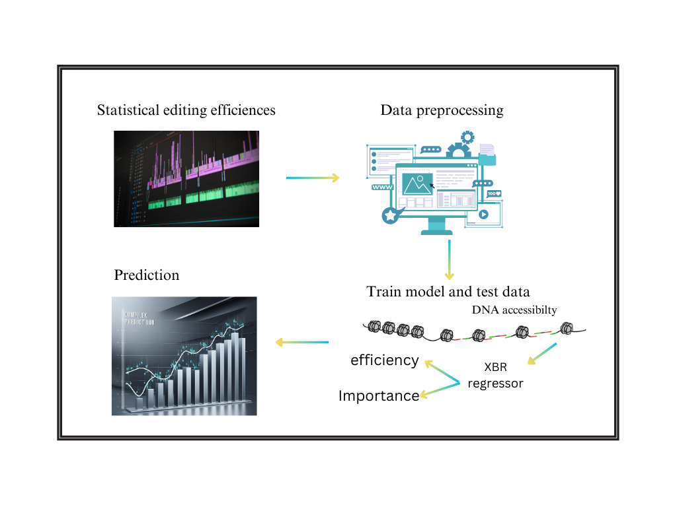

Figure 2 :- Gene editing through Machine Learning. Source: ( )

Artificial Intelligence in Genome editing is essential and has the potential to completely transform the agriculture field. Technologies for CRISPR-based editing, such as CRISPR/Cas9, provide accurate and focused altering an organism's genetic code, a significant biotechnological advance (Tyagi et al., 2020). But the combination of AI and CRISPR enhances the GED pipeline as a whole by offering fresh perspectives, new tools, and chances to work with and comprehend the genetic code. AI is now required for medical information analysis because to recent developments in multi-omics technologies that can generate huge information several sources, including genes, RNA, proteins, and DNA changes (Hamet and Tremblay, 2017). Large and complicated genetic data sets have been analyzed and understood using DL and ML algorithms (Quazi et al.,2022). By finding more suitable features for AI models, these studies may help improve their capacity to forecast editing consequences like off-target editing. For instance, CRISPR-based GED can help build immune cells that can target cancer subtypes or disrupt oncogenes, while AI algorithms can Using genetic information to determine cancer subtypes (Katti et al., 2022). An ML system named SPROUT was created ( Leenay et al., 2019) and has a good degree of accuracy in predicting the repair outcomes of Genome editing in primary T cells. SPROUT was trained on a large dataset of CRISPR-Cas9 editing events that altered the outcome, it can be used to design CRISPR experiments that maximize the desired outcomes. Researchers employing CRISPR-Cas9 to create novel treatments for cancer and other illnesses will find it to be a useful tool. The technology of CRISPR is developing rapidly. Figure 1 illustrates that there are other options for GED besides Cas9. For this reason, different Cas protein variations are being studied. Examples include CRISPR-Cas3 (Morisaka et al., 2019), CRISPR-Cas12 (Xiao et al., 2021; Senthilnathan et al., 2023), and CRISPR-Cas13 (Kavuri et al., 2022). Consequently, the use of AI techniques ought to grow in significance.

***AI's function in digital agriculture and automation:-***

Genetic enhancements in plant breeding and genetic research are substantially accelerated by automation in collecting data and processing. Large volumes of data, including genotypic and phenotypic data, are gathered more quickly and precisely by automated methods. This quick data collection speeds up the cycle of reproduction and quickens the incorporation of preferable features into new plant varieties by enabling researchers to make better-informed selections and decisions in breeding programs (Sheikh et al., 2024). By enabling dynamic decision-making, data analysis improves genetic. Only the plants that perform the best are chosen thanks to the accurate measurement of phenotypic features made possible by AI-driven sensor and image analysis technology. Through analytical and automated learning models, AI can also evaluate historical data, model breeding techniques, and optimize breeding designs. Massive breeding projects can be automated thanks to capacity, which produces reliable genetic information or expedites the spread of improved varieties across various climates and geographical areas (Harfouche et al., 2019). The breeding of plants is undergoing an innovation thanks to the use of Robots and imaging satellites, which promotes early variety selection, increases genetic diversity evaluations, and permits high-throughput phenotyping. This greatly improves the selection of the top-performing types during the early phases of breeding when paired with AI (Jasim et al., 2023; Redhu et al., 2022).

Breeders can evaluate genetic variety and react to environmental stressors by using advanced UAVs to gather high-resolution data from agricultural areas. These statistics aid in the selection of more stress-tolerant plants, resulting in resilient crop varieties. UAVs minimize human error, increase the accuracy of criteria for selection, and reducing costs and labor to make the most of time and resources. Breeding cycles are accelerated via rapid data collecting, allowing for several cycles in shorter amounts of time [Sarić et al., 2022]. Modern breeding programs are being revolutionized by high-throughput phenotyping (HTP), which uses drones and (UAVs) to gather extensive information on plant health, stress levels, and nutritional content. Early in the breeding process, it employs thermal imaging to identify plant stress and phenotyping [Telikani et al., 2024]. Additionally, UAV data can be used to monitor pests and diseases, evaluate environmental stress, detect nutrient deficits, help choose resistant cultivars, and enhance nutrient use efficiency [Costa et al., 2022]. In addition to helping with soil and terrain mapping, climate impact research, and the selection of climate-resilient crops, satellite imagery offers broad spatial coverage for agricultural evaluation across a variety of landscapes [Sankaran et al., 2020]. It can also be used in conjunction with airplanes and Drones to integrate data at several sizes, giving a thorough picture of plant performance at both the plot and regional levels (Guan et al., 2017).

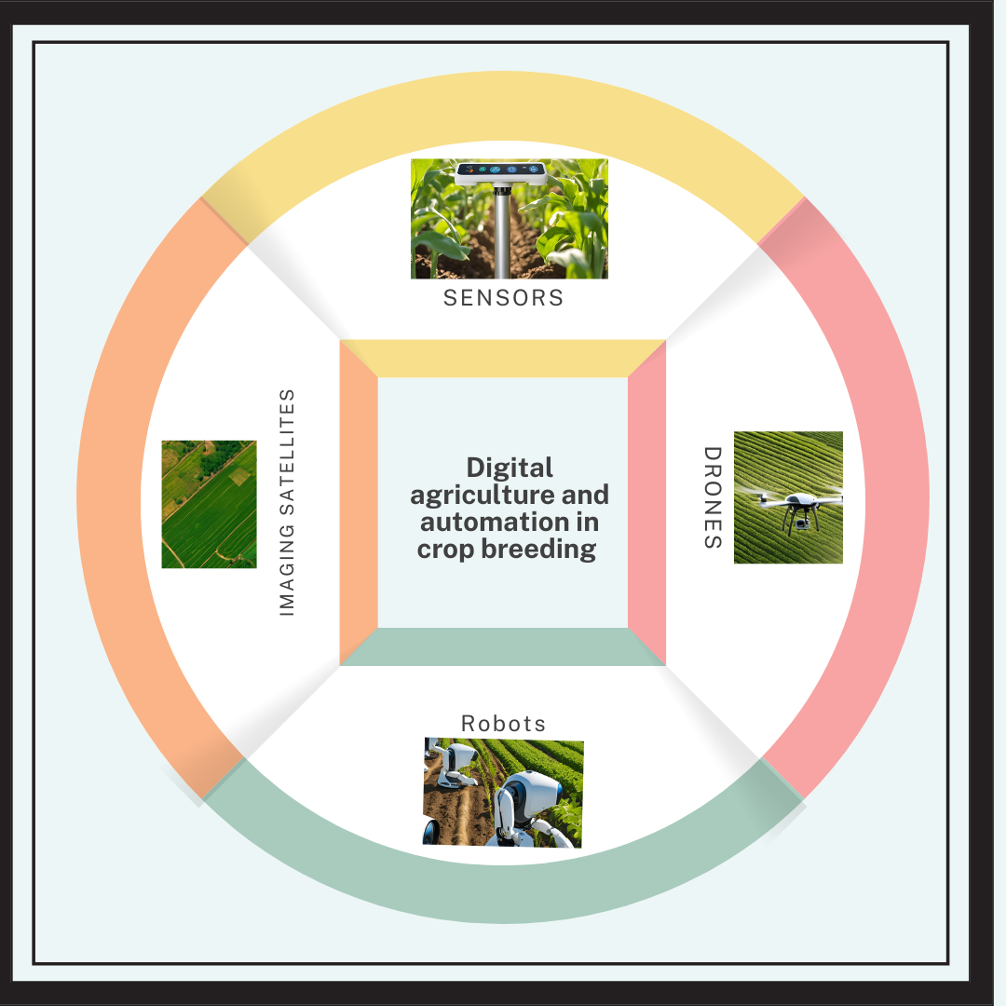

Figure 3:- Digital agriculture and automation in crop breeding. Source: ( )

**Benefits of AI in crop breeding:-**

Artificial intelligence (AI) uses computers and technology to mimic the human mind's capacity for problem-solving and judgment (Jarrahi, 2018). The field of computer science known as Machine intelligence, or AI, is the field that focuses on developing and managing technology that can learn to make judgments and do tasks on its own without assistance from humans (Dwivedi et al., 2021). Any software or hardware component that supports machine learning, computer vision, natural language processing, and comprehension is referred to as artificial intelligence (AI)(Reference). It is a general term that encompasses several different technologies (Li et al., 2021). Today's AI is based on the same basic computing processes that power traditional software and classic complementary metal-oxide-semiconductor hardware. In today's digital world, artificial intelligence (AI) is the computer science technology that is developing the fastest. It produces intelligent machines that mimic human intelligence (Harfouche et al., 2019). Examples of machine-learning algorithms include (DNN), (ANN), random forests (RF), and support vector machines (SVM). Other examples include sophisticated high-tech devices like the IoT ( Baduge et al., 2022). AI is a fascinating technological system that opens up the new possibilities for digital breeding and offers countless agricultural applications (Montesinos-López et al., 2018). It is anticipated that future generations of artificial intelligence will inspire new types of brain-inspired circuits and architectures that can make data-driven decisions more quickly and accurately as compare to humans (Xu et al., 2021). Additionally, the terms AI, BBD, ML, and data analytics are commonly used in contemporary academic and business works pertaining to data (Duan et al., 2019).

The phrases (AI), (ML), and big data are crucial for characterizing contemporary computer operations (Cravero et al.,2021). Big data entails the use of extensive, varied datasets with intricate structures that are beyond the scope of conventional approaches (Supriya et al., 2020). Artificial Intelligence (AI) teaches computers to do jobs that humans cannot, particularly when it comes to time and labor, which are important when making decisions in a variety of situations (Berente et al., 2021). While ML refines or uncovers new relationships in the datasets, such as how sea surface temperature affects weather predictions over land, big data gathers meteorological or Earth System-related measurements and high-resolution (ESM) outputs for environmental and weather applications (Huntingford et al., 2019). Based on trends identified by ML, AI then automatically issues warnings for extreme weather events (Raschka et al., 2020). Since AI speeds up the detection and processing of data, it helps breeders by ensuring ongoing farm monitoring, freeing them up to concentrate on higher-value duties (Talaviya et al ., 2020). Through high-throughput genomics and phenomics, AI has speed up the creation of new plant species (Esposito et al.,2020), and machine learning is being used more and more in MAS, GED, and GS (Reinoso-Peláez et al., 2022). To assist farmers in maximizing expenses and production, corporations such as Monsanto and John Deere have made significant investments in artificial intelligence (AI) and data technology (Faulkner et al ., 2014). In Romania, businesses such as Nippon Electric Company (NEC) and Dacom are also using big data technologies and environmental sensors for precision farming trials (El Bilali et al ., 2018). However, architecture, algorithms, and analytics intended to derive value from agricultural datasets have difficulties due to their complexity (Priya et al ., 2020). Planning, learning, and decision-making in agriculture are being improved by research on AI techniques, such as machine learning and deep learning (Shaw et al ., 2019). Plant breeders are creating systems to comprehend plant behavior under different climates (Jeong et al.,2016). AI has the ability to revolutionize global food security and agriculture by introducing of potent supercomputers like Summit, which can house 27,000 GPUs (Streich et al., 2020).

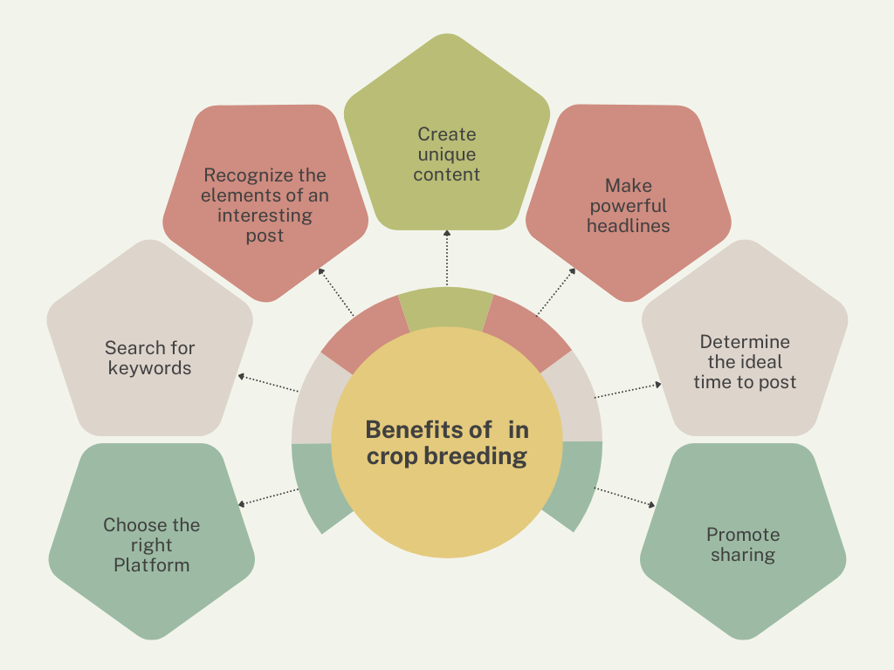

Figure 4 :- Benefits of AI in crop breeding. Source: ( )

**Future and challenges faced due to AI:-**

The use of AI in plant breeding has generated a lot of debate in recent years over its revolutionary potential in agriculture, especially in the field of plant genomics. In order to improve breeding success, researchers and breeders must match computer-generated insights with farmers' demands as they work to capitalize on the digital revolution. By encouraging creative, human-centered methods and the use of robotics, the advent of AI technologies has already resulted in higher profitability and economic growth in a number of industries, including agriculture. However, the existing dearth of extensive plant datasets makes it difficult to successfully train AI applications. AI is anticipated to address challenging genetic problems in plant science in the near future, including aiding comparative genomics and controlling several species in intercropping systems. Farmers and breeders can obtain vital phenomics and genomics data by utilizing cloud-based AI apps via portable devices and drones. However, the intricacy and expense of conventional breeding procedures limit their reliance on these technologies. However, plant scientists are finding answers that move the emphasis from algorithmic efficiency to creating sustainable farming models, which might spark a new agricultural revolution that is good for the environment and people. AI has the potential to completely transform "omics" methods and breeding management by facilitating the quick screening of a wide range of genotypes and phenotypes using cutting-edge methods like speed-breeding management and model-based envirotyping. This would ultimately reduce breeding cycles and increase genetic gains.

To guarantee its efficient and fair application, a number of ethical and technological issues pertaining to the use of artificial intelligence (AI) in agricultural research must be resolved. Although data availability and quality are technically critical to AI performance, agricultural data frequently suffers from fragmentation, heterogeneity, and incompleteness, making data gathering and processing more difficult. AI model training is hampered by problems like sensor quality, data standardization, and interoperability, and developing algorithms that can handle multi-source heterogeneous data is made extremely difficult by the complexity and unpredictability of agricultural situations. Furthermore, because AI models may perform well on particular datasets but suffer in real-world applications due to environmental changes, their generalization ability is essential. Agricultural research frequently lacks the significant computer resources needed to train deep learning models, and small and medium-sized farmers and research organizations may find the high prices of AI technology unaffordable. Since sensitive data regarding farmers' output and financial circumstances needs to be safeguarded, the ethical application of AI in agriculture presents questions with data security and privacy. Furthermore, because AI has the potential to worsen agricultural output disparities, attention must be paid to equity so that producers of all sizes and geographical locations can take advantage of new technologies. Because reliance on precision agriculture may have detrimental effects on ecosystems, the environmental impact of AI technology also needs to be carefully evaluated. Furthermore, adopting AI could result in the loss of agricultural workers, especially in developing nations, underscoring the necessity of legislative actions to assist impacted farmers. In conclusion, developing strong laws and regulations that support equitable, just, and sustainable technology applications is necessary to overcome these ethical and technical obstacles, as is working together to develop technological innovation and infrastructure. The use of AI in agricultural research is set to grow in popularity and influence with continued developments and real-world experience, promoting sustainable growth and agricultural modernization.

**Conclusion:-**

The integration of artificial intelligence (AI) in crop breeding marks a paradigm shift in agricultural research, enabling precision breeding through advanced computational techniques. Machine learning (ML) and deep learning (DL) models facilitate efficient genotype-to-phenotype mapping, improving trait selection and yield prediction. AI-powered genomic selection and CRISPR-based gene editing accelerate the development of high-performing crop varieties. Additionally, automation through UAVs and high-throughput phenotyping enhances data collection and analysis, reducing labor and costs. Despite these advancements, challenges such as data heterogeneity, computational demands, and ethical concerns remain. Standardizing data formats, improving model generalization, and ensuring equitable access to AI-driven technologies are crucial for widespread adoption. The synergy between AI, big data, and multi-omics approaches will continue to redefine breeding strategies, fostering climate-resilient and high-yield crop varieties. Future research should focus on optimizing AI models, integrating diverse biological datasets, and addressing sustainability challenges. By overcoming these barriers, AI-driven crop breeding can significantly contribute to global food security and agricultural sustainability.

References :-

1. Wallace JG, Rodgers-Melnick E, Buckler ES. On the road to breeding 4.0: unraveling the good, the bad, and the boring of crop quantitative genomics. Annu Rev Genet 2018;52:421–44
2. Risch N, Merikangas K. The future of genetic studies of complex human diseases. Science. 1996 Sep 13;273(5281):1516-7.
3. Fisher RA. XV.—The correlation between relatives on the supposition of Mendelian inheritance. Earth and Environmental Science Transactions of the Royal Society of Edinburgh. 1919 Jan;52(2):399-433.
4. Wright S. Systems of mating. II. The effects of inbreeding on the genetic composition of a population. Genetics. 1921 Mar;6(2):124.
5. Zhang Y, Liao S, Wang J, Guo X, Yang X, Zhao C. Information technology and intelligent equipment facilitating smart breeding. J Jilin Agric Univ 2021;43(2):119–29. Chinese
6. Zhang Y, Huang G, Zhao Y, Lu X, Wang Y, Wang C, Guo X, Zhao C. Revolutionizing Crop Breeding: Next-Generation Artificial Intelligence and Big Data-Driven Intelligent Design. Engineering. 2024 Dec 19.
7. Zhao C. Big data of plant phenomics and its research progress. J Agric Big Data 2019;1(2):5– 14
8. Zhao C, Zhang Y, Du J, Guo X, Wen W, Gu S, et al. Crop phenomics: current status and perspectives. Front Plant Sci 2019;10:714
9. Wang X, Cai Z. Era of maize breeding 4.0. J Maize Sci 2019;27(1):1–9
10. Jing H, Tian Z, Chong K, Li J. Progress and perspective of molecular design breeding. Sci Sin Vitae 2021;51(10):1356–65
11. Konecny T, Nikoghosyan M, Binder H. Machine learning extracts marks of thiamine’s role in cold acclimation in the transcriptome of Vitis vinifera. Frontiers in Plant Science. 2023 Dec 6;14:1303542.
12. Vanavermaete D, Maenhout S, Fostier J, De Baets B. Oracle selection provides insight into how far off practice is from Utopia in plant breeding. Frontiers in Plant Science. 2023 Jul 21;14:1218665.
13. Singh B, Kumar S, Elangovan A, Vasht D, Arya S, Duc NT, Swami P, Pawar GS, Raju D, Krishna H, Sathee L. Phenomics based prediction of plant biomass and leaf area in wheat using machine learning approaches. Frontiers in Plant Science. 2023 Jun 28;14:1214801.
14. Pugh NA, Young A, Ojha M, Emendack Y, Sanchez J, Xin Z, Puppala N. Yield prediction in a peanut breeding program using remote sensing data and machine learning algorithms. Frontiers in Plant Science. 2024 Feb 20;15:1339864.
15. Li Z, Zhou X, Cheng Q, Zhai W, Mao B, Li Y, Chen Z. An integrated feature selection approach to high water stress yield prediction. Frontiers in Plant Science. 2023 Dec 4;14:1289692.
16. Mousavi SR, Jahandideh Mahjenabadi VA, Khoshru B, Rezaei M. Spatial prediction of winter wheat yield gap: agro-climatic model and machine learning approaches. Frontiers in Plant Science. 2024 Jan 8;14:1309171.
17. Araus, J. L., and Cairns, J. E. (2014). Field high-throughput phenotyping: the new crop breeding frontier. Trends Plant Sci. 19, 52–61
18. Chang, L., Deng, X.-M., Zhou, M.-Q., Wu, Z.-K., Yuan, Y., Yang, S., et al. (2016). Convolutional neural networks in image understanding. Acta Automatica Sin. 42, 1300–1312.
19. Cross, J., de Los Campos, G., Perez, P., Gianola, D., Burgueno, J., Araus, J. L., et al. (2010). Prediction of genetic values of quantitative traits in plant breeding using pedigree and molecular markers. Genetics 186, 713–724.
20. Zhou, X. (2018). Understanding the convolutional neural networks with gradient descent and backpropagation. J. Phys.: Conf. Ser. (IOP Publishing) 1004, 012028.
21. Nee, P., Huang, N., Zhang, Z., Wang, D.-P., Liang, F., Miao, Y., et al. (2019). Deepsignal: detecting dna methylation state from nanopore sequencing reads using deep-learning. Bioinformatics 35, 4586–4595.
22. Pan, Y. (2015). Analysis of concepts and categories of plant phenome and phenomics. Acta Agronom. Sin. 41, 175–186.
23. Banerjee, B. P., Joshi, S., Thoday-Kennedy, E., Pasam, R. K., Tibbits, J., Hayden, M., et al. (2020). Highthroughput phenotyping using digital and hyperspectral imaging derived biomarkers for genotypic nitrogen response. J. Exp. Bot. 71, 4604–4615.
24. Yang, Y., Saand, M. A., Huang, L., Abdelaal, W. B., Zhang, J., Wu, Y., et al. (2021). Applications of multi-omics technologies for crop improvement. Front. Plant Sci. 12, 563953
25. Deng, Y., Liu, S., Zhang, Y., Tan, J., Li, X., Chu, X., et al. (2022). A telomere-to telomere gap-free reference genome of watermelon and its mutation library provide important resources for gene discovery and breeding. Mol. Plant 15, 1268–1284.
26. Li, T., Yang, X., Yu, Y., Si, X., Zhai, X., Zhang, H., et al. (2018). Domestication of wild tomato is accelerated by genome editing. Nat. Biotechnol. 36, 1160–1163
27. Yin, J., Huo, L., Guo, L., and Hu, J. (2008). “Short-term load forecasting based on improved gene expression programming,” in 2008 7th World Congress on Intelligent Control and Automation.
28. Parmley, K. A., Higgins, R. H., Ganapathysubramanian, B., Sarkar, S., and Singh, A. K. (2019). Machine learning approach for prescriptive plant breeding. Sci. Rep. 9, 17132.
29. Xu, W., Gao, Y., Wang, Y., and Guan, J. (2021). Protein–protein interaction prediction based on ordinal regression and recurrent convolutional neural networks. BMC Bioinf. 22, 1–20
30. Farooq, M.A., Gao, S., Hassan, M.A., Huang, Z., Rasheed, A., Hearne, S., Prasanna, B., Li, X., and Li, H. (2024). Artificial intelligence in plant breeding. Trends Genet. 40: 891–908.
31. Jannink, J.L., Lorenz, A.J., and Iwata, H. (2010). Genomic selection in plant breeding: From theory to practice. Brief Funct. Genomics 9: 166–177.
32. Dan, Z., Chen, Y., Zhao, W., Wang, Q., and Huang, W. (2019). Metabolome‐based prediction of yield heterosis contributes to the breeding of elite rice. Life Sci. Alliance
33. Azodi, C.B., Pardo, J., VanBuren, R., de los Campos, G., and Shiu, S.H. (2020). Transcriptome‐based prediction of complex traits in maize. Plant Cell 32: 139–151.
34. Gemmer, M.R., Richter, C., Jiang, Y., Schmutzer, T., Raorane, M.L., Junker, B., Pillen, K., and Maurer, A. (2020). Can metabolic prediction be an alternative to genomic prediction in barley? PLoS One 15: e0234052
35. Li, Y., Wang, S., Umarov, R., Xie, B.Q., Fan, M., Li, L.H., and Gao, X. (2018). DEEPre: Sequence‐based enzyme EC number prediction by deep learning. Bioinformatics 34: 760–769.
36. Sandhu, K.S., Mihalyov, P.D., Lewien, M.J., Pumphrey, M.O., and Carter, A.H. (2021b). Combining genomic and phenomic information for predicting grain protein content and grain yield in spring wheat. Front. Plant Sci. 12: 613300.
37. Alemu, A., Åstrand, J., Montesinos‐López, O.A., Sánchez, J.I.Y., Fernández‐González, J., Tadesse, W., Vetukuri, R.R., Carlsson, A.S., Ceplitis, A., Crossa, J., et al. (2024). Genomic selection in plant breeding: Key factors shaping two decades of progress. Mol. Plant 17: 552–578.
38. Wang, K.L., Abid, M.A., Rasheed, A., Crossa, J., Hearne, S., and Li, H.H. (2023). DNNGP, a deep neural network‐based method for genomic prediction using multi‐omics data in plants. Mol. Plant 16: 279–293.
39. Ma, X.D., Wang, H., Wu, S.Y., Han, B., Cui, D., Liu, J., Zhang, Q., Xia, X.Z., Song, P., Tang, C.F., et al. (2024). DeepCCR: Large‐scale genomics‐based deep learning method for improving rice breeding. Plant Biotechnol.
40. Montesinos‐López, O.A., Montesinos‐López, A., Pérez‐Rodríguez, P., Barrón‐López, J.A., Martini, J.W.R., Fajardo‐Flores, S.B., Gaytan‐ Lugo, L.S., Santana‐Mancilla, P.C., and Crossa, J. (2021). A review of deep learning applications for genomic selection. BMC Genomics 22: 19.
41. Sandhu, K., Patil, S.S., Pumphrey, M., and Carter, A. (2021). Multitrait machine‐ and deep‐learning models for genomic selection using spectral information in a wheat breeding program. Plant Genome 14: e20119.
42. Yang, W.Y., Guo, T.T., Luo, J.Y., Zhang, R.Y., Zhao, J.R., Warburton, M.L., Xiao, Y.J., and Yan, J.B. (2022). Target‐oriented prioritization: targeted selection strategy by integrating organismal and molecular traits through predictive analytics in breeding. Genome Biol. 23: 80.
43. Li, J., Zhang, D., Yang, F., Zhang, Q., Pan, S., Zhao, X., Zhang, Q., Han, Y., Yang, J., and Wang, K. (2024). TrG2P: A transfer learning‐based tool integrating multi‐trait data for accurate prediction of crop yield. Plant Commun. 15: 100975.
44. Chen, J.X., Tan, C., Zhu, M., Zhang, C.Y., Wang, Z.H., Ni, X.M., Liu, Y.L., Wei, T., Wei, X.F., Fang, X.D., et al. (2023). CropGS‐Hub: A comprehensive database of genotype and phenotype resources for genomic prediction in major crops. Nucleic Acids Res. 52: D1519–D1529.
45. Wei, X., Qiu, J., Yong, K.C., Fan, J.J., Zhang, Q., Hua, H., Liu, J., Wang, Q., Olsen, K.M., Han, B., et al. (2021). A quantitative genomics map of rice provides genetic insights and guides breeding. Nat. Genet. 53: 243–253
46. Demiri M, Gozde H, Taplamacioglu MC. Comparative dissolved gas analysis with machine learning and traditional methods. In2021 3rd International Congress on Human-Computer Interaction, Optimization and Robotic Applications (HORA) 2021 Jun 11 (pp. 1-6). IEEE.
47. Sartor RC, Noshay J, Springer NM, Briggs SP. Identification of the expressome by machine learning on omics data. Proceedings of the National Academy of Sciences. 2019 Sep 3;116(36):18119-25.
48. Uygun S, Azodi CB, Shiu SH. Cis-regulatory code for predicting plant cell-type transcriptional response to high salinity. Plant physiology. 2019 Dec 1;181(4):1739-51.
49. Varla K, Marshall-Colón A, Cirrone J, Brooks MD, Pasquino AV, Léran S, Mittal S, Rock TM, Edwards MB, Kim GJ, Ruffel S. Temporal transcriptional logic of dynamic regulatory networks underlying nitrogen signaling and use in plants. Proceedings of the National Academy of Sciences. 2018 Jun 19;115(25):6494-9.
50. Meena M, Shubham S, Paritosh K, Pareek N, Vivekanand V. Production of biofuels from biomass: Predicting the energy employing artificial intelligence modelling. Bioresource Technology. 2021 Nov 1;340:125642.
51. Poplin R, Chang PC, Alexander D, Schwartz S, Colthurst T, Ku A, Newburger D, Dijamco J, Nguyen N, Afshar PT, Gross SS. A universal SNP and small-indel variant caller using deep neural networks. Nature biotechnology. 2018 Nov;36(10):983-7.
52. Ahsan MU, Liu Q, Fang L, Wang K. NanoCaller for accurate detection of SNPs and indels in difficult-to-map regions from long-read sequencing by haplotype-aware deep neural networks. Genome biology. 2021 Dec;22:1-33.
53. Zheng Z, Li S, Su J, Leung AW, Lam TW, Luo R. Symphonizing pileup and full-alignment for deep learning-based long-read variant calling. Nature Computational Science. 2022 Dec;2(12):797-803.
54. Shafin K, Pesout T, Chang PC, Nattestad M, Kolesnikov A, Goel S, Baid G, Eizenga JM, Miga KH, Carnevali P, Jain M. Haplotype-aware variant calling enables high accuracy in nanopore long-reads using deep neural networks. BioRxiv. 2021 Mar 5:2021-03.
55. Luo , Sedlazeck FJ, Lam TW, Schatz MC. A multi-task convolutional deep neural network for variant calling in single molecule sequencing. Nature communications. 2019 Mar 1;10(1):998.
56. Ma, D., and Liu, F. (2015). Genome editing and its applications in model organisms. Genomics, proteomics Bioinforma. 13 (6), 336–344. doi:10.1016/j.gpb.2015.12.001
57. Siva, N., Gupta, S., Gupta, A., Shukla, J. N., Malik, B., and Shukla, N. (2021). Genomeediting approaches and applications: a brief review on CRISPR technology and its role in cancer. 3 Biotech. 11, 1–25. doi:10.1007/s13205-021-02680-4
58. Zhu, Y. (2022). Advances in CRISPR/Cas9. BioMed Res. Int. 2022, 9978571. doi:10. 1155/2022/9978571
59. Arora, L., and Narula, A. (2017). Gene editing and crop improvement using CRISPRCas9 system. Front. plant Sci. 8, 1932. doi:10.3389/fpls.2017.01932
60. Li, H., Yang, Y., Hong, W., Huang, M., Wu, M., and Zhao, X. (2020). Applications of genome editing technology in the targeted therapy of human diseases: mechanisms, advances and prospects. Signal Transduct. Target. Ther. 5 (1), 1. doi:10.1038/s41392- 019-0089-y
61. Gaudelli, N. M., Komor, A. C., Rees, H. A., Packer, M. S., Badran, A. H., Bryson, D. I., et al. (2017). Programmable base editing of A• T to G• C in genomic DNA without DNA cleavage. Nature 551 (7681), 464–471. doi:10.1038/nature24644
62. Anzalone, A. V., Randolph, P. B., Davis, J. R., Sousa, A. A., Koblan, L. W., Levy, J. M., et al. (2019). Search-and-replace genome editing without double-strand breaks or donor DNA. Nature 576 (7785), 149–157. doi:10.1038/s41586-019-1711-4
63. Goell, J. H., and Hilton, I. B. (2021). CRISPR/Cas-based epigenome editing: advances, applications, and clinical utility. Trends Biotechnol. 39 (7), 678–691. doi:10.1016/j. tibtech.2020.10.012
64. Tyagi, S., Kumar, R., Das, A., Won, S. Y., and Shukla, P. (2020). CRISPR-Cas9 system: a genome-editing tool with endless possibilities. J. Biotechnol. 319, 36–53. doi:10.1016/j. jbiotec.2020.05.008
65. Hamet, P., and Tremblay, J. (2017). Artificial intelligence in medicine. Metabolism 69, S36–S40. doi:10.1016/j.metabol.2017.01.011
66. Quazi, S. (2022). Artificial intelligence and machine learning in precision and genomic medicine. Med. Oncol. 39 (8), 120. doi:10.1007/s12032-022-01711-1
67. Katti, A., Diaz, B. J., Caragine, C. M., Sanjana, N. E., and Dow, L. E. (2022). CRISPR in cancer biology and therapy. Nat. Rev. Cancer 22 (5), 259–279. doi:10.1038/s41568-022- 00441-w
68. Leenay, R. T., Aghazadeh, A., Hiatt, J., Tse, D., Roth, T. L., Apathy, R., et al. (2019). Large dataset enables prediction of repair after CRISPR–Cas9 editing in primary T cells. Nat. Biotechnol. 37 (9), 1034–1037. doi:10.1038/s41587-019-0203-2
69. Morisaka, H., Yoshimi, K., Okuzaki, Y., Gee, P., Kunihiro, Y., Sonpho, E., et al. (2019). CRISPR-Cas3 induces broad and unidirectional genome editing in human cells. Nat. Commun. 10 (1), 5302. doi:10.1038/s41467-019-13226-x
70. Xiao, R., Wang, S., Han, R., Li, Z., Gabel, C., Mukherjee, I. A., et al. (2021). Structural basis of target DNA recognition by CRISPR-Cas12k for RNA-guided DNA transposition. Mol. Cell 81 (21), 4457–4466.e5. doi:10.1016/j.molcel.2021. 07.043
71. Senthilnathan, R., Ilangovan, I., Kunale, M., Easwaran, N., Ramamoorthy, S., Veeramuthu, A., et al. (2023). An update on CRISPR-Cas12 as a versatile tool in genome editing. Mol. Biol. Rep. 50 (3), 2865–2881. doi:10.1007/s11033-023-08239-1
72. Kavuri, N. R., Ramasamy, M., Qi, Y., and Mandadi, K. (2022). Applications of CRISPR/Cas13-based RNA editing in plants. Cells 11 (17), 2665. doi:10.3390/ cells11172665
73. Sheikh, M.; Iqra, F.; Ambreen, H.; Pravin, K.A.; Ikra, M.; Chung, Y.S. Integrating Artificial Intelligence and High-Throughput Phenotyping for Crop Improvement. *J. Integr. Agric.* **2024**, *23*, 1787–1802.
74. Harfouche, A.L.; Jacobson, D.A.; Kainer, D.; Romero, J.C.; Harfouche, A.H.; Scarascia Mugnozza, G.; Moshelion, M.; Tuskan, G.A.; Keurentjes, J.J.B.; Altman, A. Accelerating Climate Resilient Plant Breeding by Applying Next-Generation Artificial Intelligence. *Trends Biotechnol.* **2019**, *37*, 1217–1235.
75. Jasim, A.N.; Fourati, L.C.; Albahri, O.S. Evaluation of Unmanned Aerial Vehicles for Precision Agriculture Based on Integrated Fuzzy Decision-Making Approach. *IEEE Access* **2023**, *11*, 75037–75062
76. Redhu, N.S.; Thakur, Z.; Yashveer, S.; Mor, P. Chapter 37—Artificial Intelligence: A Way Forward for Agricultural Sciences. In *Bioinformatics in Agriculture*; Sharma, P., Yadav, D., Gaur, R.K., Eds.; Academic Press: Cambridge, MA, USA, 2022; pp. 641–668. ISBN 978-0-323-89778-5.
77. Sarić, R.; Nguyen, V.D.; Burge, T.; Berkowitz, O.; Trtílek, M.; Whelan, J.; Lewsey, M.G.; Čustović, E. Applications of Hyperspectral Imaging in Plant Phenotyping. *Trends Plant Sci.* **2022**, *27*, 301–315.
78. Telikani, A.; Sarkar, A.; Du, B.; Shen, J. Machine Learning for UAV-Aided ITS: A Review with Comparative Study. In *IEEE Transactions on Intelligent Transportation Systems*; IEEE: Piscataway, NJ, USA, 2024; pp. 1–19
79. Costa, L. Determining Leaf Nutrient Concentrations in Citrus Trees Using UAV Imagery and Machine Learning. *Precis. Agric.* **2022**, *23*, 854–875.
80. Zhang, C.; Marzougui, A.; Sankaran, S. High-Resolution Satellite Imagery Applications in Crop Phenotyping: An Overview. *Comput. Electron. Agric.* **2020**, *175*, 105584.
81. Guan, K.; Wu, J.; Kimball, J.S.; Anderson, M.C.; Frolking, S.; Li, B.; Hain, C.R.; Lobell, D.B. The Shared and Unique Values of Optical, Fluorescence, Thermal and Microwave Satellite Data for Estimating Large-Scale Crop Yields. *Remote Sens. Environ.* **2017**, *199*, 333–349.
82. Jarrahi, M.H. Artificial intelligence and the future of work: Human-AI symbiosis in organizational decision making. Bus. Horiz. 2018, 61, 577–586.
83. Dwivedi, Y.K.; Hughes, L.; Ismagilova, E.; Aarts, G.; Coombs, C.; Crick, T.; Duan, Y.; Dwivedi, R.; Edwards, J.; Eirug, A. Artificial Intelligence (AI): Multidisciplinary perspectives on emerging challenges, opportunities, and agenda for research, practice and policy. Int. J. Inf. Manag. 2021, 57, 101994.
84. Li, Y.; Zhou, X.; Li, G. Bridging natural language and graphical user Interfaces. In Artificial Intelligence for Human Computer Interaction: A Modern Approach; Springer: Berlin/Heidelberg, Germany, 2021; pp. 463–493.
85. Harfouche, A.L.; Jacobson, D.A.; Kainer, D.; Romero, J.C.; Harfouche, A.H.; Mugnozza, G.S.; Moshelion, M.; Tuskan, G.A.; Keurentjes, J.J.B.; Altman, A. Accelerating climate resilient plant breeding by applying next-generation artificial intelligence. Trends Biotechnol. 2019, 37, 1217–1235.
86. Baduge, S.K.; Thilakarathna, S.; Perera, J.S.; Arashpour, M.; Sharafi, P.; Teodosio, B.; Shringi, A.; Mendis, P.J.A.i.C. Artificial intelligence and smart vision for building and construction 4.0: Machine and deep learning methods and applications. Autom. Constr. 2022, 141, 104440.
87. Montesinos-López, O.A.; Montesinos-López, A.; Crossa, J.; Gianola, D.; Hernández-Suárez, C.M.; Martín-Vallejo, J. Multi-trait, multi-environment deep learning modeling for genomic-enabled prediction of plant traits. G3 Genes Genomes Genet. 2018, 8, 3829–3840.
88. Xu, Y.; Liu, X.; Cao, X.; Huang, C.; Liu, E.; Qian, S.; Liu, X.; Wu, Y.; Dong, F.; Qiu, C.-W. Artificial intelligence: A powerful paradigm for scientific research. Innovation 2021, 2, 100179. [CrossRef] 19. Duan, Y.; Edwards, J.S.; Dwivedi, Y.K. Artificial intelligence for decision making in the era of Big Data–evolution, challenges and research agenda. Int. J. Inf. Manag. 2019, 48, 63–71.
89. Duan, Y.; Edwards, J.S.; Dwivedi, Y.K. Artificial intelligence for decision making in the era of Big Data–evolution, challenges and research agenda. Int. J. Inf. Manag. 2019, 48, 63–71.
90. Cravero, A.; Sepúlveda, S. Use and adaptations of machine learning in big data—Applications in real cases in agriculture. Electronics 2021, 10, 552
91. Supriya, M.; Deepa, A. Machine learning approach on healthcare big data: A review. Big Data Inf. Anal. 2020, 5, 58–75.
92. Berente, N.; Gu, B.; Recker, J.; Santhanam, R. Managing artificial intelligence. MIS Q. 2021, 45, 1433–1450.
93. Huntingford, C.; Jeffers, E.S.; Bonsall, M.B.; Christensen, H.M.; Lees, T.; Yang, H. Machine learning and artificial intelligence to aid climate change research and preparedness. Environ. Res. Lett. 2019, 14, 124007.
94. Raschka, S.; Patterson, J.; Nolet, C. Machine learning in python: Main developments and technology trends in data science, machine learning, and artificial intelligence. Information 2020, 11, 193.
95. Talaviya, T.; Shah, D.; Patel, N.; Yagnik, H.; Shah, M. Implementation of artificial intelligence in agriculture for optimisation of irrigation and application of pesticides and herbicides. Artif. Intell. Agric. 2020, 4, 58–73.
96. Esposito, S.; Carputo, D.; Cardi, T.; Tripodi, P. Applications and trends of machine learning in genomics and phenomics for next-generation breeding. Plants 2020, 9, 34.
97. Reinoso-Peláez, E.L.; Gianola, D.; González-Recio, O. Genome-enabled prediction methods based on machine learning. In Genomic Prediction of Complex Traits; Methods in Molecular Biology; Ahmadi, N., Bartholomé, J., Eds.; Humana: New York, NY, USA, 2022; Volume 2467.
98. Faulkner, A.; Cebul, K.; McHenry, G. Agriculture Gets Smart: The Rise of Data and Robotics; Cleantech Agriculture Report; Cleantech Group: San Francisco, CA, USA, 2014.
99. El Bilali, H.; Allahyari, M.S. Transition towards sustainability in agriculture and food systems: Role of information and communication technologies. Inf. Process. Agric. 2018, 5, 456–464. Int. J. Mol. Sci. 2022, 23, 11156 11 of 13
100. Priya, R.; Ramesh, D.J.S.C.I. ML based sustainable precision agriculture: A future generation perspective. Sustain. Comput. Inform. 2020, 28, 100439.
101. Shaw, J.; Rudzicz, F.; Jamieson, T.; Goldfarb, A. Artificial intelligence and the implementation challenge. J. Med. Internet Res. 2019, 21, e13659.
102. Jeong, J.H.; Resop, J.P.; Mueller, N.D.; Fleisher, D.H.; Yun, K.; Butler, E.E.; Timlin, D.J.; Shim, K.M.; Gerber, J.S.; Reddy, V.R.; et al. Random Forests for Global and Regional Crop Yield Predictions. PLoS ONE 2016, 11, e0156571.
103. Streich, J.; Romero, J.; Gazolla, J.G.F.M.; Kainer, D.; Cliff, A.; Prates, E.T.; Brown, J.B.; Khoury, S.; Tuskan, G.A.; Garvin, M. Can exascale computing and explainable artificial intelligence applied to plant biology deliver on the United Nations sustainable development goals? Curr. Opin. Biotechnol. 2020, 61, 217–225.