**Path coefficient analysis of turmeric (*Curcuma longa* L.) for yield and yield traits under Aonla and Guava cropping system**

**ABSTRACT**

Thirty two turmeric genotypes collected from different resources were evaluated for yield and yield attributes at Department of Horticulture, Naini, Agricultural Institute, Sam Higginbottom University of Agriculture, Technology and Sciences, Prayagraj during two consecutive years 2019-20 and 2020-2021. The data recorded on different characters were subjected to work out path coefficient analysis to investigate the association, direct and indirect contribution of various characters on rhizome yield (q ha-1). The genotypic and phenotypic path coefficient analysis indicated that the traits like plant height, number of tillers per stem, number of leaves per plant, leaf area (cm), number of secondary rhizomes, weight of fingers (g), weight of mother rhizome, curcumin and oleoresin exhibited high and positive direct effects on rhizome yield per ha (q-1) at both level of genotypic and phenotypic under Aonla cropping system in 2019-2020. Whereas the revealed that the maximum direct effect on rhizome yield per ha (q-1) was expressed by plant height, leaf area (cm), number of fingers , weight of fingers (g) and curcumin at both genotypic and phenotypic level of turmeric under Aonla cropping system in 2020-21. Revealed that the maximum direct effect on rhizome yield per ha (q-1) was expressed by plant height, number of tillers per stem, number of leaves per plant, number of fingers , weight of fingers (g), weight of mother rhizome, oleoresin at both level of genotypic and phenotypic of turmeric under guava cropping system in 2019-20. Whereas revealed that the maximum direct effect on rhizome yield per ha (q-1) was expressed by plant height, number of leaves per plant, weight of fingers (g) and oleoresin. at both genotypic and phenotypic of turmeric under guava cropping system in 2020-21. In pooled analysis for two seasons (2019-20 & 2020-21) under each (aonla and guava) cropping system revealed that weight of fingers per plant (0.356 & 0.331) exhibited highest positive direct effect on rhizome yield per ha followed by plant height (0.248 & 0.351), leaf area (0.240 & 0.015) and number of fingers (0.078 & 0.233) at phenotypic level respectively.

**Key words :-** Turmeric, genotypic & phenotypic path coefficient and rhizome yield per ha (q-1)

**INTRODUCTION**

Globally, India is prime producer as well as consumer of turmeric. **(Parthasarthy *et al*., 2006).** The worldwide production of turmeric is about 11 lakh tones per annum. India dominates by contributing 78 % followed by China and Myanmar, Nigeria and Bangladesh together contributing 6%. But Indian turmeric is supposed to be the best inthe global market as it contains high curcumin content (3.14% by weight). Turmeric exports of India reached $236 million (around Rs 1,632 crore) in 2018 (Trade Promotion Council of India). Turmeric exports of India reached $236 million (around Rs 1,632 crore) in 2018 (Trade Promotion Council of India). The cultivated area under turmeric in India is 238,000 ha-1 and the production 1133,000MT **(N.H.B, 2017-18).** Due to underground portion of plant, known as rhizome, turmeric has high nutritional value and extract of the same can be used as natural coloring agent for various foods, cosmetic and dyes. One of the most important ingredients found in turmeric is Curcuminoids. This active principle of turmeric has many medicinal features and has been used in curing many circulatory problems, dermatological disorders and liver diseases as reported by (**Singh and Singh 2019).** This system is highly profitable for the farmers having small holdings which cannot afford the investment required to make their holdings more productive. Under certain circumstances available solution in the agrihorticulture system which combines fruit trees with agricultural crops (**Singh and Singh 2019).** The choice of crops for intercropping mainly depends on farmer’s need. There is more cooperation in nature than competition. Cooperation is epitomized by mutually beneficial relationships that occur between species within genera. When two or more crops are growing together, each should occupy adequate space to contribute and maximize cooperation and reduce competition between them. This is exercised by the four following factors namely: spatial arrangement, plant density, maturity dates of the crops grown, plant architecture. Spices are highly amenable for intercropping owing to their ecological niche. Zingiberaceae crops like cardamom, ginger, turmeric and galangal are also ideal crops under tall growing trees that permits partial light. In this paper we have summarized the results of experiments on intercropping of turmeric in fruit and plantation crops conducted in different parts of India (**Nilanjana and Sarkar 2021).** The tree canopy of aonla with sparse foliage allows filtered light and permits intercropping even after the trees are fully grown. Intercropping not only generates an extra income, but also helps check soil erosion through ground coverage and improves the soil physico-chemical condition1. Traditionally, intercropping in the interspaces of fruit orchards is practised due to economic considerations, but only a few experimental results are available for aonla-based hortipastoral and horticultural systems as reported by (**Kumar *et al.,* 2009) and (Awasthi *et al.,* 2009).**

**MATERIALS AND METHODS**

The experiment was conducted at Horticultural Experimental Field, Department of Horticulture, Naini Agricultural Institute, Sam Higginbottom University of Agriculture, Technology and Sciences, Prayagraj. during two consecutive years 2019-20 and 2020-2021. The experiment was laid out in Randomized Block Design with three replications and thirtytwo genotypes, thus making a total 96 plots under each cropping system. There were 10 plantin each plot. The genotypes were allocated randomly to a unit plot in each replication. For seed purpose finger rhizomes were used and sown in raised bed plots of size 8 m2 (4m×2m) with the spacing of 30 × 20 cm. The observations were recorded on five selected plants of a genotypes in each replication. Average of the data from the sampled plants of each treatment was used for statistical analysis. The data was recorded on following characters viz., plant height (cm), number of tillers per stem, number of leaves per plant, leaf area (cm2), number of fingers per plant, number of secondary rhizome per plant, weight of fingers per plant (g), weigh of mother rhizome per plant (g), rhizome yield/ ha (q)**,**  dry matter (%), curcumin (%) and oleoresin (%).The analysis of variance for Randomized Block Design was carried out using the procedure as suggested by **Panse and Sukhatme (1984).** Path coefficients were obtained according to the procedure as suggested by **Wright (1921)** and as elaborated by **Dewey and Lu (1959).** The path coefficient analysis was done to find out their direct and indirect effects. Residual factor was also included in the casual system representing all other factors, which might effect yield.

The following equations are formed and solved for estimating direct and indirect effects. riy = ri1 Pi1y + ………………..+Pij…………………+rij pi (y) + rin (y)

**RESULTS AND DISCUSSION**

Path coefficient analysis revealed that the genotypic and phenotypic path coefficients were in general higher than the corresponding phenotypic path coefficients. It was an evidence of considerable effect of environment on these traits of turmeric under Aonla and guava cropping system in 2019-2020 and 2020-21. Path coefficient analysis devised by **Dewey and Lu (1959),** however, provides a realistic basis for allocation of appropriate weightage to various attributes while designing a pragmatic programme for the improvement of yield. The results revealed that both direct and indirect effect play major role in choice of economic trait for selection criteria based on path analysis. The similar results were reported in turmeric **(Verma et al., 2014).**

**Genotypic and Phenotypic path coefficient of turmeric under Aonla cropping system in 2019-2020 & 2020-21**

Perusal of Table- 1 & 2 revealed that highest positive direct effect on Rhizome yield per ha (q-1) was expressed by Plant height (0.3972 & 0.3967), number of tillers per stem (0.1786 & 0.1757), number of leaves per plant (0.0472 & 0.0423), leaf area (cm) (0.1243 & 0.1188), number of secondary rhizomes (0.2096 & 0.2236), weight of fingers (g) (0.3654 & 0.3592), Weight of mother rhizome (0.1044 & 0.1021), curcumin (0.1022 & 0.1055) and oleoresin (0.1001 & 0.1104). The character like Number of fingers (-0.2036 & -0.2085) and Dry matter (%) (-0.0589 & -0.0510) showed direct negative effect on Rhizome yield per ha (q-1) at both genotypic and phenotypic level of turmeric under Aonla cropping system in 2019-2020. Whereas the revealed that maximum direct effect on Rhizome yield per ha (q-1) was expressed by Plant height (0.0414 & 0.0409), leaf area (cm) (0.3075& 0.3078), Number of fingers (0.5002& 0.4970), weight of fingers (g) (0.2709& 0.2713) and Curcumin (0.1539& 0.1529). The character like number of tillers per stem (-0.1402 & -0.1404), number of leaves per plant (-0.0994 & -0.0987), number of secodary rhizomes (-0.1659 & -0.1633), Weight of mother rhizome (-0.1356 & -0.1344), Dry matter (%) (-0.2085 & -0.2086) and oleoresin (-0.0763 & -0.0761) showed direct negative effect on Rhizome yield per ha (q-1) at both genotypic and phenotypic level of turmeric under Aonla cropping system in 2020-21. Earlier workers **(Verma *et al.* 2014, Mishra *et al.* 2015, Aarthi *et al.* 2018 and Maurya *et al.* 2018)** have also reported similar effects of component traits on yield. Oleoresin had positive indirect effect through curcumin on yield. Path analysis is important to study the association and effects of yield contributing traits on the trait of yield and importance of traits in further breeding programme **(Paw et al., 2020) and Vithya *et al.,* (2021).**

**Genotypic and Phenotypic path coefficient under Guava cropping system in 2019-20 & 2020-21.**

Perusal of Table- 3 and 4 revealed that maximum direct effect on Rhizome yield per ha (q-1) was expressed by plant height (0.3212 & 0.3295), number of tillers per stem (0.0061 & 0.0091), number of leaves per plant (0.1822 & 0.1819), Number of fingers (0.5206 & 0.5113), weight of fingers (g) (0.2490 & 0.2487), Weight of mother rhizome (0.2337 & 0.2210), oleoresin (0.0223 & 0.0261). The character like leaf area (cm) (-0.0050 & -0.0076), number of secondary rhizomes (-0.3437 & -0.3328), Dry matter (%) (-0.1418 & -0.1477), curcumin (-0.0599 & -0.0576) showed direct negative effect on Rhizome yield per ha (q-1) at both genotypic and phenotypic of turmeric under Guava cropping system in 2019-20. Whereas revealed that maximum direct effect on Rhizome yield per ha (q-1) was expressed by Plant height (0.4501 & 0.4504), number of leaves per plant (0.3753 & 0.3748), weight of fingers (g) (0.4337 & 0.4334) and oleoresin (0.1428 & 0.1421). The character like number of tillers per stem (-0.0581 & -0.0586), leaf area (cm) (-0.1523& -0.1515), Number of fingers (-0.0233& -0.0232), number of secondary rhizomes (-0.2198& -0.2199), Weight of mother rhizome (-0.0543& -0.0538), Dry matter (%) (-0.0561& -0.0563) and curcumin (-0.1892& -0.1888) showed direct negative effect on Rhizome yield per ha (q-1) at both genotypic and phenotypic of turmeric under Guava cropping system in 2020-21. The residual value obtained in the path study indicated that, the yield attributes were covered related to rhizome yield and hence selection criteria based on this study would be reliable. Path analysis studies of **Shanmugasundaram (1998), Abraham and Latha (2003), Velmurugan and Chezhiyan (2003) and Tomar *et al.,* (2005) in turmeric are in confirmation with the present** view. Path analysis is important to study the association and effects of yield contributing traits on the trait of yield and importance of traits in further breeding programme **(Paw *et al.,* 2020) and Vithya *et al.,* (2021).**

**Genotypic and Phenotypic path coefficient analysis for different characters of turmeric under Aonla (Pooled of two years) and guava (Pooled of two years) cropping system.**

Path coefficient is simply a standardized partial regression coefficient and as such measures the direct influence of one variable upon another, which permits the separation of correlation coefficient into components of direct and indirect effects. In pooled analysis for two seasons (2019-20 & 2020-21) under each (aonla and guava) cropping system revealed that weight of fingers per plant (0.356 & 0.331) exhibited highest positive direct effect on rhizome yield per ha followed by plant height (0.248 & 0.351), leaf area (0.240 & 0.015) and number of fingers (0.078 & 0.233) at phenotypic level under aonla and guava cropping system, respectively. However, dry matter (-0.149 & -0.083) exhibited negative direct effect on rhizome yield at phenotypic level under aonla and guava cropping system, respectively presented in table 5 and 6. The present findings are supported by **Panja *et al.* (2002), Pandey *et al.* (2003), Tomar *et al.* (2005). Verma *et al*. (2014), Mishra *et al.* (2015) and Gupta *et al.* (2016).** These findings showed that selection should be made on the basis of plant height, number of tillers per stem, number of leaves per plant, leaf area (cm), number of secodary rhizomes, weight of fingers (g), weight of mother rhizome, Curcumin and oleoresin, having the highest positive direct effect taking other traits into consideration, while making improvement in yield of turmeric. Earlier workers like **Singh and Tiwari (1995), Hazra *et al.,* (2002), Chattopadhyay *et al.,* (2004), Yadav *et al.,* (2006) and Sharon *et al.,* (2011)** have also reported similar effects of component traits on yield. Path analysis is important to study the association and effects of yield contributing traits on the trait of yield and importance of traits in further breeding programme **(Paw *et al.,* 2020) and Vithya *et al.,* (2021).**

**CONCLUSION**

High positive direct effects on fresh rhizome yield per plant was recorded by weight of mother and primary rhizomes, length of secondary and mother rhizome, number of tillers and plant height. weight of fingers per plant (0.356 & 0.331), plant height (0.248 & 0.351), leaf area (0.240 & 0.015) and number of fingers (0.078 & 0.233) at genotypic and phenotypic levels under aonla and guava (Pooled of two years) cropping system, respectively.

**REFERENCES**

**Aarthi S, Suresh J & Prasath D (2018).** Variability and association analysis of curcumin content with yield components in turmeric (*Curcuma longa* L.). *Electron. J. Plant Breed.* 9 (1): 295–303.

**Abraham Z, Latha M. (2003).** Correlation and path analysis in ginger (*Zingiber officinale* Rosc.). *J. Spices Aromatic Crops.* 2003; 12(2):187-189.

**Awasthi, O. P., Singh, I. S. and More, T. A. (2009)** Performance of intercrops during establishment phase of aonla (*Emblica officinalis*) orchard. Indian J. Agric. Sci., 2009, 79(8), 587–591.

**Chattopadhyay N, Hore JK and Bandyopadhyay A. (2004).** A Studies on character association and genetic variability in turmeric. *Horticultural Journal* 17: 259- 66.

**Kumar, S., Kumar, S. and Chaubey, B. K. (2009).** Aonla based hortipastoral system for soil nutrient buildings and profitability. *Ann. Arid Zone,* 2009, 48, 153–157.

**Maurya R, Pandey V P, Yadav S, Singh A & Yadav S (2018).** Genetic variability studies in turmeric (*Curcuma longa* L.). *Int. J. Chem. Stud.* 6(4): 1960–1962.

**Mishra R, Gupta A K, Lal R K, Jhang T & Banerjee N (2015).** Genetic variability, analysis of genetic parameters, character association and contribution for agronomical traits in turmeric (*Curcuma longa* L.). *Ind. Crops Prod.* 76: 204–208.NHB.gov.in › statistics › Publication

**Nilanjana Datta and Tapas Sarkar (2021).** Prospects of turmeric as intercrop in fruit and plantation crops: A comparative study. *International Journal of Botany* Studies. 6:(6) 466-468.

**Parthasarthy, V. A., Johny, A. K., Jayarajan, K., and Utpala, P. (2006).** Site suitability for turmeric production in India, GIS interpretation green page: *Research Article*. 6(2):142-147.

**Paw, M., Munda, S., Borah, A., Pandey, S. K., & Lal, M. (2020).** Estimation of variability, genetic divergence, correlation studies of Curcuma caesia Roxb. *Journal of Applied Research on Medicinal and Aromatic Plants,* 17, 100251.

**Sharon A, Shoba N, Rajamani K and Manonmani S. (2011).** Correlation studies in turmeric (*Curcuma longa* L.). *Research on Crops* 12: 195-97.

**Singh DP and Tiwari RS. (1995).** Path analysis in turmeric (*Curcuma longa* L.). *Recent Horticulture* 2: 113-16.

**Singh Jatinder and Singh Rupinder (2019).** Turmeric Cultivation in Guava based Agrihorticulture System-A Practice of Agroforestry. *Think India Journal. 22 (34).*

**Subramanian S. (1986).** Studies on growth and development of turmeric (*Curcuma longa* L.). M. Sc., (Ag.) Thesis submitted to Tamil Nadu Agricultural University, Coimbatore, 1986.

**Tomar NS, Nair SK, Gupta CR (2005).** Character association and path analysis for yield components in turmeric (*Curcuma longa* L.). J. Spices Aromatic Crops. 2005; 14(1):75-77.

**Velmurugan M, Chezhiyan N. (2003).** Correlation studies in turmeric. In: National Seminar on New Perspective in Spices, Medicinal and Aromatic plants, 27-29 November 2003, held at ICAR Research complex on Goa, 2003.

**Verma R K, Pandey V P, Solankey S S & Verma R B (2014).** Genetic variability, character association and diversity analysis in turmeric. Indian J. Hort. 71(3): 367–372.

**Verma, R.K., Pandey, V.P., Solankey, S.S. and Verma, R.B. (2014).** Genetic variability, character association and diversity analysis in turmeric. Indian Journal of Horticulture. 71(3): 367-372.

**Vithya, K., Venkatesan, K.; Selvi, B.S.; Manonmani, S. and Kokiladevi, E. (2021).** Genetic Variability and Character Association Studies in Turmeric (Curcuma longa L.) Cultures. Biological Forum – An International Journal, 13(4): 373-380.

**Yadav RK, Yadav DS, Rai N, Asati BS and Singh AK. 2006.** Correlation and path coefficient analysis in turmeric (Curcuma longa L.). Indian Journal of Horticulture 63: 103-06.

**Table 1: Genotypic and phenotypic path coefficient analysis for different characters of turmeric under Aonla cropping system in 2019-2020**

|  |  |  |  |  |  |  |  |  |  |  |  |  |  |
| --- | --- | --- | --- | --- | --- | --- | --- | --- | --- | --- | --- | --- | --- |
|  | | **Plant height (cm)** | **number of tillers per stem** | **number of leaves per plant** | **leaf area (cm)** | **Number of fingers** | **number of secodary rhizomes** | **weight of fingers (g)** | **Weight of mother rhizome** | **Dry matter (%)** | **Curcumin** | **oleoresin** | **Rhizome yield per ha (q)** |
| **Plant height (cm)** | **G** | **0.3972** | 0.0441 | 0.1366 | 0.1807 | 0.0044 | 0.1093 | 0.0643 | 0.0131 | 0.0254 | -0.0253 | -0.0398 | 0.588** |
| **P** | **0.3967** | 0.0440 | 0.1363 | 0.1804 | 0.0044 | 0.1087 | 0.0640 | 0.0130 | 0.0249 | -0.0252 | -0.0395 | 0.584** |
| **number of tillers per stem** | **G** | 0.0198 | **0.1786** | -0.0161 | 0.0362 | 0.0659 | 0.0822 | 0.0709 | -0.0403 | 0.0021 | -0.0318 | -0.0007 | 0.367** |
| **P** | 0.0195 | **0.1757** | -0.0158 | 0.0356 | 0.0646 | 0.0806 | 0.0696 | -0.0396 | 0.0021 | -0.0311 | -0.0007 | 0.365** |
| **number of leaves per plant** | **G** | 0.0162 | -0.0043 | **0.0472** | 0.0102 | 0.0177 | 0.0157 | 0.0003 | 0.0075 | 0.0110 | 0.0122 | -0.0017 | 0.216* |
| **P** | 0.0145 | -0.0038 | **0.0423** | 0.0092 | 0.0157 | 0.0140 | 0.0003 | 0.0068 | 0.0099 | 0.0108 | -0.0016 | 0.214* |
| **leaf area (cm)** | **G** | 0.0566 | 0.0252 | 0.0269 | **0.1243** | 0.0047 | 0.0488 | 0.0363 | 0.0290 | 0.0002 | -0.0043 | 0.0154 | 0.566** |
| **P** | 0.0540 | 0.0241 | 0.0257 | **0.1188** | 0.0043 | 0.0463 | 0.0345 | 0.0276 | 0.0001 | -0.0043 | 0.0143 | 0.561** |
| **Number of fingers** | **G** | -0.0022 | -0.0751 | -0.0765 | -0.0076 | **-0.2036** | -0.1394 | -0.0884 | 0.0024 | -0.0561 | -0.0246 | -0.0022 | 0.1873 |
| **P** | -0.0023 | -0.0767 | -0.0777 | -0.0076 | **-0.2085** | -0.1428 | -0.0906 | 0.0023 | -0.0574 | -0.0260 | -0.0038 | 0.1898 |
| **number of secondary rhizomes** | **G** | 0.0577 | 0.0964 | 0.0698 | 0.0822 | 0.1435 | **0.2096** | 0.1358 | -0.0127 | 0.0438 | -0.0109 | -0.0221 | 0.528** |
| **P** | 0.0613 | 0.1025 | 0.0741 | 0.0871 | 0.1531 | **0.2236** | 0.1449 | -0.0132 | 0.0475 | -0.0105 | -0.0216 | 0.531** |
| **Weight of fingers (g)** | **G** | 0.0591 | 0.1451 | 0.0022 | 0.1065 | 0.1587 | 0.2367 | **0.3654** | -0.1039 | 0.1065 | -0.1077 | 0.0027 | 0.508** |
| **P** | 0.0580 | 0.1424 | 0.0022 | 0.1043 | 0.1560 | 0.2327 | **0.3592** | -0.1017 | 0.1051 | -0.1049 | 0.0038 | 0.508** |
| **Weight of mother rhizome** | **G** | 0.0035 | -0.0236 | 0.0166 | 0.0243 | -0.0012 | -0.0063 | -0.0297 | **0.1044** | 0.0072 | 0.0270 | 0.0332 | 0.0537 |
| **P** | 0.0033 | -0.0230 | 0.0163 | 0.0237 | -0.0011 | -0.0060 | -0.0289 | **0.1021** | 0.0073 | 0.0264 | 0.0324 | 0.0560 |
| **Dry matter (%)** | **G** | -0.0038 | -0.0007 | -0.0138 | -0.0001 | -0.0162 | -0.0123 | -0.0172 | -0.0040 | **-0.0589** | 0.0145 | 0.0072 | 0.0437 |
| **P** | -0.0032 | -0.0006 | -0.0119 | 0.0000 | -0.0140 | -0.0108 | -0.0149 | -0.0037 | **-0.0510** | 0.0123 | 0.0057 | 0.0508 |
| **Curcumin** | **G** | -0.0065 | -0.0182 | 0.0265 | -0.0035 | 0.0124 | -0.0053 | -0.0301 | 0.0264 | -0.0252 | **0.1022** | 0.0364 | -0.0130 |
| **P** | -0.0067 | -0.0187 | 0.0270 | -0.0038 | 0.0132 | -0.0050 | -0.0308 | 0.0273 | -0.0254 | **0.1055** | 0.0382 | -0.0072 |
| **Oleoresin** | **G** | -0.0100 | -0.0004 | -0.0035 | 0.0124 | 0.0011 | -0.0106 | 0.0007 | 0.0318 | -0.0122 | 0.0356 | **0.1001** | 0.1284 |
| **P** | -0.0110 | -0.0004 | -0.0041 | 0.0133 | 0.0020 | -0.0106 | 0.0012 | 0.0351 | -0.0123 | 0.0399 | **0.1104** | 0.1377 |
| **Rhizome yiel** | **G** | 0.588** | 0.367** | 0.216* | 0.566** | 0.1873 | 0.528** | 0.508** | 0.0537 | 0.0437 | -0.0130 | 0.1284 | **1.0000** |
| **P** | 0.584** | 0.365** | 0.214* | 0.561** | 0.1898 | 0.531** | 0.508** | 0.0560 | 0.0508 | -0.0072 | 0.1377 | **1.0000** |
| **Partial R2** | **G** | 0.2334 | 0.0656 | 0.0102 | 0.0703 | -0.0381 | 0.1107 | 0.1857 | 0.0056 | -0.0026 | -0.0013 | 0.0128 |  |
| **P** | 0.2317 | 0.0642 | 0.0091 | 0.0666 | -0.0396 | 0.1186 | 0.1826 | 0.0057 | -0.0026 | -0.0008 | 0.0152 |  |

**G= Genotypic, P= Phenotypic and R2= Residual effect**

**Table 2: Genotypic and phenotypic path coefficient analysis for different characters of turmeric under Aonla cropping system in 2020-21**

|  |  |  |  |  |  |  |  |  |  |  |  |  |  |
| --- | --- | --- | --- | --- | --- | --- | --- | --- | --- | --- | --- | --- | --- |
|  | | **Plant height (cm)** | **number of tillers per stem** | **number of leaves per plant** | **leaf area (cm)** | **Number of fingers** | **number of secodary rhizomes** | **weight of fingers (g)** | **Weight of mother rhizome** | **Dry matter (%)** | **Curcumin** | **oleoresin** | **Rhizome yield per ha (q)** |
| **Plant height (cm)** | **G** | **0.0414** | -0.0019 | 0.0020 | 0.0288 | 0.0153 | 0.0168 | 0.0222 | 0.0026 | 0.0045 | -0.0025 | 0.0006 | 0.479** |
| **P** | **0.0409** | -0.0019 | 0.0020 | 0.0285 | 0.0151 | 0.0165 | 0.0220 | 0.0025 | 0.0044 | -0.0024 | 0.0006 | 0.479** |
| **number of tillers per stem** | **G** | 0.0065 | **-0.1402** | -0.0390 | 0.0196 | -0.0167 | -0.0366 | 0.0061 | 0.0476 | -0.0181 | 0.0315 | 0.0048 | -0.221* |
| **P** | 0.0065 | **-0.1404** | -0.0390 | 0.0196 | -0.0166 | -0.0364 | 0.0061 | 0.0476 | -0.0180 | 0.0313 | 0.0048 | -0.221* |
| **number of leaves per plant** | **G** | -0.0049 | -0.0276 | **-0.0994** | -0.0009 | -0.0241 | -0.0035 | -0.0036 | 0.0045 | -0.0480 | 0.0174 | 0.0051 | -0.1259 |
| **P** | -0.0049 | -0.0274 | **-0.0987** | -0.0009 | -0.0238 | -0.0034 | -0.0036 | 0.0044 | -0.0475 | 0.0172 | 0.0050 | -0.1258 |
| **leaf area (cm)** | **G** | 0.2141 | -0.0430 | 0.0029 | **0.3075** | 0.1435 | 0.1019 | 0.1659 | 0.0751 | 0.0485 | -0.0446 | 0.0527 | 0.578** |
| **P** | 0.2143 | -0.0431 | 0.0029 | **0.3078** | 0.1432 | 0.1017 | 0.1657 | 0.0751 | 0.0484 | -0.0445 | 0.0524 | 0.578** |
| **Number of fingers** | **G** | 0.1851 | 0.0594 | 0.1212 | 0.2334 | **0.5002** | 0.3654 | 0.3323 | 0.1080 | 0.1100 | -0.0901 | -0.0405 | 0.581** |
| **P** | 0.1835 | 0.0587 | 0.1201 | 0.2313 | **0.4970** | 0.3627 | 0.3302 | 0.1069 | 0.1093 | -0.0895 | -0.0402 | 0.580** |
| **number of secondary rhizomes** | **G** | -0.0671 | -0.0433 | -0.0058 | -0.0550 | -0.1212 | **-0.1659** | -0.0742 | 0.0014 | -0.0010 | -0.0180 | 0.0102 | 0.421** |
| **P** | -0.0658 | -0.0423 | -0.0057 | -0.0539 | -0.1191 | **-0.1633** | -0.0729 | 0.0013 | -0.0010 | -0.0177 | 0.0100 | 0.420** |
| **Weight of fingers (g)** | **G** | 0.1455 | -0.0118 | 0.0098 | 0.1461 | 0.1800 | 0.1212 | **0.2709** | 0.0160 | 0.0510 | -0.0989 | -0.0032 | 0.617** |
| **P** | 0.1455 | -0.0118 | 0.0098 | 0.1461 | 0.1802 | 0.1212 | **0.2713** | 0.0160 | 0.0510 | -0.0989 | -0.0032 | 0.617** |
| **Weight of mother rhizome** | **G** | -0.0084 | 0.0460 | 0.0061 | -0.0331 | -0.0293 | 0.0011 | -0.0080 | **-0.1356** | -0.0149 | -0.0267 | -0.0262 | 0.1122 |
| **P** | -0.0083 | 0.0456 | 0.0060 | -0.0328 | -0.0289 | 0.0011 | -0.0079 | **-0.1344** | -0.0147 | -0.0264 | -0.0258 | 0.1121 |
| **Dry matter (%)** | **G** | -0.0226 | -0.0269 | -0.1007 | -0.0329 | -0.0458 | -0.0013 | -0.0392 | -0.0229 | **-0.2085** | 0.0567 | 0.0564 | -0.0977 |
| **P** | -0.0226 | -0.0267 | -0.1004 | -0.0328 | -0.0459 | -0.0013 | -0.0392 | -0.0228 | **-0.2086** | 0.0567 | 0.0563 | -0.0976 |
| **Curcumin** | **G** | -0.0092 | -0.0345 | -0.0270 | -0.0223 | -0.0277 | 0.0167 | -0.0562 | 0.0303 | -0.0418 | **0.1539** | 0.0551 | -0.0486 |
| **P** | -0.0091 | -0.0341 | -0.0267 | -0.0221 | -0.0275 | 0.0165 | -0.0557 | 0.0301 | -0.0415 | **0.1529** | 0.0546 | -0.0485 |
| **Oleoresin** | **G** | -0.0012 | 0.0026 | 0.0039 | -0.0131 | 0.0062 | 0.0047 | 0.0009 | -0.0148 | 0.0206 | -0.0273 | **-0.0763** | 0.0388 |
| **P** | -0.0012 | 0.0026 | 0.0039 | -0.0130 | 0.0061 | 0.0047 | 0.0009 | -0.0146 | 0.0205 | -0.0272 | **-0.0761** | 0.0386 |
| **Partial R2** | **G** | 0.0198 | 0.0310 | 0.0125 | 0.1778 | 0.2904 | -0.0698 | 0.1672 | -0.0152 | 0.0204 | -0.0075 | -0.0030 |  |
| **P** | 0.0196 | 0.0310 | 0.0124 | 0.1779 | 0.2882 | -0.0686 | 0.1674 | -0.0151 | 0.0204 | -0.0074 | -0.0029 |  |

**G= Genotypic, P= Phenotypic and R2= Residual effect**

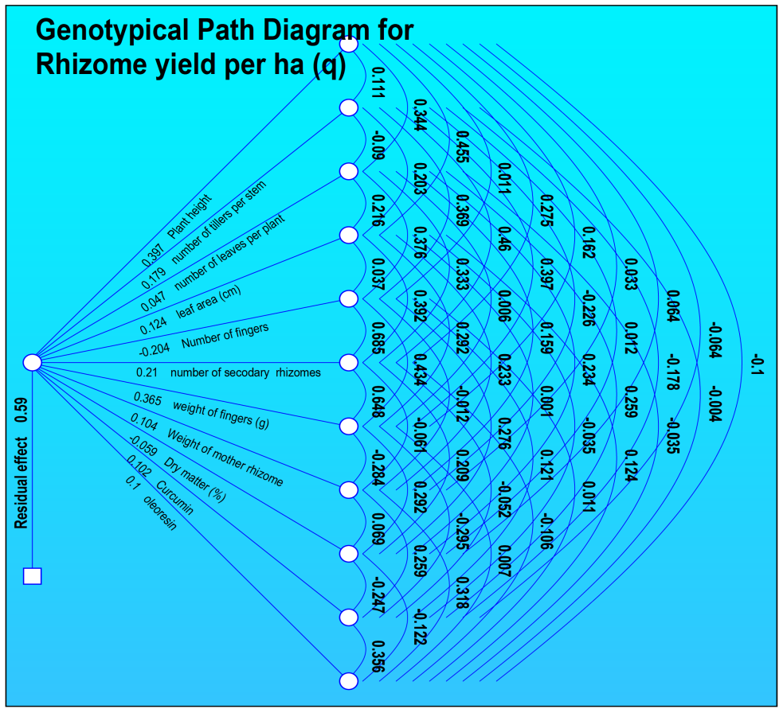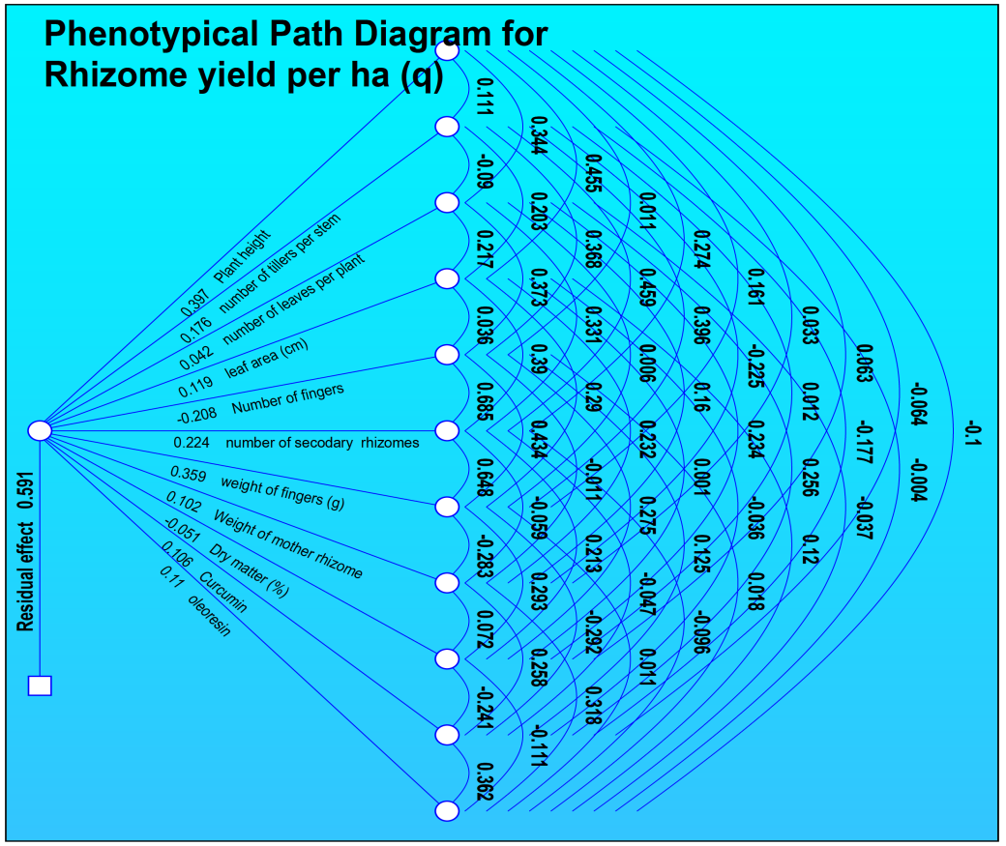

**Fig. 1: Genotypic and phenotypic path coefficient analysis for different characters of turmeric under Aonla cropping system in 2019-2020**

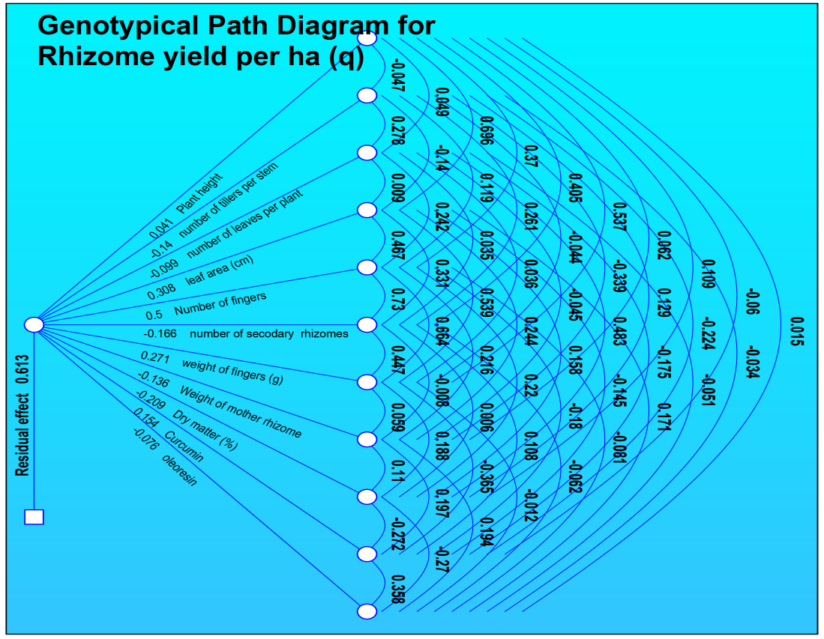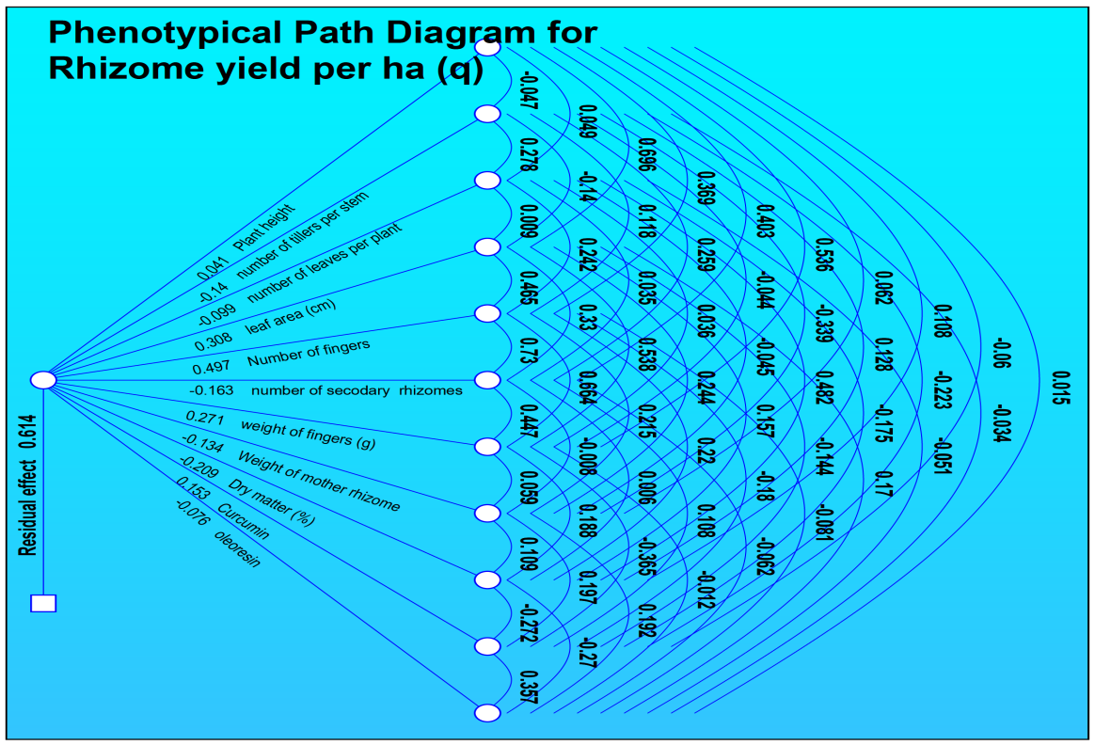

**Fig.2 Genotypic and phenotypic path coefficient analysis for different characters of turmeric under Aonla cropping system in 2020-21**

**0**

**Table 3: Genotypic and phenotypic path coefficient analysis for different characters of turmeric under Guava cropping system in 2019-20.**

|  |  |  |  |  |  |  |  |  |  |  |  |  |  |
| --- | --- | --- | --- | --- | --- | --- | --- | --- | --- | --- | --- | --- | --- |
|  | | **Plant height (cm)** | **number of tillers per stem** | **number of leaves per plant** | **leaf area (cm)** | **Number of fingers** | **number of secodary rhizomes** | **weight of fingers (g)** | **Weight of mother rhizome** | **Dry matter (%)** | **Curcumin** | **oleoresin** | **Rhizome yield per ha (q)** |
| **Plant height (cm)** | **G** | **0.3212** | 0.1387 | 0.1688 | 0.1663 | 0.0786 | 0.1247 | 0.1894 | 0.1506 | 0.0329 | -0.0192 | 0.0047 | 0.657** |
| **P** | **0.3295** | 0.1423 | 0.1732 | 0.1706 | 0.0806 | 0.1280 | 0.1944 | 0.1495 | 0.0338 | -0.0197 | 0.0048 | 0.657** |
| **number of tillers per stem** | **G** | 0.0026 | **0.0061** | 0.0020 | 0.0007 | 0.0018 | 0.0018 | 0.0022 | 0.0020 | 0.0008 | 0.0003 | 0.0006 | 0.406** |
| **P** | 0.0039 | **0.0091** | 0.0030 | 0.0010 | 0.0027 | 0.0027 | 0.0033 | 0.0029 | 0.0013 | 0.0004 | 0.0009 | 0.406** |
| **number of leaves per plant** | **G** | 0.0957 | 0.0596 | **0.1822** | 0.0820 | 0.0459 | 0.0761 | 0.0852 | 0.0575 | 0.0002 | -0.0044 | -0.0020 | 0.530** |
| **P** | 0.0956 | 0.0595 | **0.1819** | 0.0818 | 0.0459 | 0.0760 | 0.0851 | 0.0558 | 0.0002 | -0.0044 | -0.0020 | 0.530** |
| **leaf area (cm)** | **G** | -0.0026 | -0.0006 | -0.0023 | **-0.0050** | -0.0019 | -0.0021 | -0.0016 | -0.0009 | -0.0003 | 0.0002 | -0.0006 | 0.410** |
| **P** | -0.0039 | -0.0009 | -0.0034 | **-0.0076** | -0.0028 | -0.0032 | -0.0025 | -0.0013 | -0.0005 | 0.0002 | -0.0010 | 0.410** |
| **Number of fingers** | **G** | 0.1274 | 0.1562 | 0.1313 | 0.1924 | **0.5206** | 0.4375 | 0.2323 | 0.0218 | 0.0767 | -0.0158 | -0.0384 | 0.457** |
| **P** | 0.1251 | 0.1534 | 0.1289 | 0.1890 | **0.5113** | 0.4297 | 0.2282 | 0.0214 | 0.0750 | -0.0155 | -0.0377 | 0.457** |
| **number of secondary rhizomes** | **G** | -0.1335 | -0.1008 | -0.1435 | -0.1454 | -0.2888 | **-0.3437** | -0.2433 | -0.0678 | -0.0750 | 0.0306 | 0.0831 | 0.486** |
| **P** | -0.1292 | -0.0976 | -0.1390 | -0.1408 | -0.2796 | **-0.3328** | -0.2356 | -0.0643 | -0.0725 | 0.0296 | 0.0803 | 0.486** |
| **Weight of fingers (g)** | **G** | 0.1469 | 0.0901 | 0.1164 | 0.0818 | 0.1111 | 0.1763 | **0.2490** | 0.0814 | 0.0378 | -0.0404 | -0.0439 | 0.574** |
| **P** | 0.1467 | 0.0900 | 0.1163 | 0.0817 | 0.1110 | 0.1761 | **0.2487** | 0.0788 | 0.0377 | -0.0404 | -0.0438 | 0.574** |
| **Weight of mother rhizome** | **G** | 0.1096 | 0.0767 | 0.0737 | 0.0415 | 0.0098 | 0.0461 | 0.0764 | **0.2337** | -0.0222 | 0.0420 | 0.0465 | 0.486** |
| **P** | 0.1003 | 0.0705 | 0.0679 | 0.0384 | 0.0093 | 0.0427 | 0.0700 | **0.2210** | -0.0160 | 0.0378 | 0.0422 | 0.470** |
| **Dry matter (%)** | **G** | -0.0145 | -0.0195 | -0.0001 | -0.0092 | -0.0209 | -0.0309 | -0.0215 | 0.0135 | **-0.1418** | 0.0382 | 0.0375 | -0.0807 |
| **P** | -0.0151 | -0.0204 | -0.0002 | -0.0096 | -0.0217 | -0.0322 | -0.0224 | 0.0107 | **-0.1477** | 0.0397 | 0.0389 | -0.0802 |
| **Curcumin** | **G** | 0.0036 | -0.0029 | 0.0014 | 0.0018 | 0.0018 | 0.0053 | 0.0097 | -0.0108 | 0.0161 | **-0.0599** | -0.0214 | -0.0205 |
| **P** | 0.0034 | -0.0028 | 0.0014 | 0.0017 | 0.0017 | 0.0051 | 0.0093 | -0.0098 | 0.0155 | **-0.0576** | -0.0206 | -0.0205 |
| **Oleoresin** | **G** | 0.0003 | 0.0021 | -0.0002 | 0.0028 | -0.0016 | -0.0054 | -0.0039 | 0.0044 | -0.0059 | 0.0080 | **0.0223** | 0.0884 |
| **P** | 0.0004 | 0.0025 | -0.0003 | 0.0033 | -0.0019 | -0.0063 | -0.0046 | 0.0050 | -0.0069 | 0.0093 | **0.0261** | 0.0882 |
| **Partial R2** | **G** | 0.2109 | 0.0025 | 0.0965 | -0.0021 | 0.2377 | -0.1669 | 0.1429 | 0.1135 | 0.0114 | 0.0012 | 0.0020 |  |
| **P** | 0.2164 | 0.0037 | 0.0963 | -0.0031 | 0.2334 | -0.1616 | 0.1427 | 0.1038 | 0.0119 | 0.0012 | 0.0023 |  |

**G= Genotypic, P= Phenotypic and R2= Residual effect**

**Table 4: Genotypic and Phenotypic path coefficient analysis for different characters of turmeric under Guava cropping system in 2020-21.**

|  |  |  |  |  |  |  |  |  |  |  |  |  |  |
| --- | --- | --- | --- | --- | --- | --- | --- | --- | --- | --- | --- | --- | --- |
|  | | **Plant height (cm)** | **number of tillers per stem** | **number of leaves per plant** | **leaf area (cm)** | **Number of fingers** | **number of secodary rhizomes** | **weight of fingers (g)** | **Weight of mother rhizome** | **Dry matter (%)** | **Curcumin** | **oleoresin** | **Rhizome yield per ha (q)** |
| **Plant height (cm)** | **G** | **0.4501** | 0.3527 | 0.2984 | 0.3107 | 0.2272 | 0.2039 | 0.2330 | 0.1827 | 0.0489 | -0.0270 | 0.0068 | 0.647** |
| **P** | **0.4504** | 0.3529 | 0.2985 | 0.3109 | 0.2273 | 0.2040 | 0.2331 | 0.1828 | 0.0489 | -0.0270 | 0.0067 | 0.647** |
| **number of tillers per stem** | **G** | -0.0455 | **-0.0581** | -0.0352 | -0.0393 | -0.0353 | -0.0373 | -0.0291 | -0.0227 | 0.0060 | 0.0003 | 0.0029 | 0.459** |
| **P** | -0.0459 | **-0.0586** | -0.0355 | -0.0396 | -0.0356 | -0.0376 | -0.0294 | -0.0229 | 0.0061 | 0.0003 | 0.0030 | 0.459** |
| **number of leaves per plant** | **G** | 0.2488 | 0.2271 | **0.3753** | 0.2381 | 0.1587 | 0.1342 | 0.1508 | 0.1722 | 0.0006 | 0.0528 | 0.0092 | 0.580** |
| **P** | 0.2484 | 0.2268 | **0.3748** | 0.2378 | 0.1585 | 0.1340 | 0.1506 | 0.1719 | 0.0006 | 0.0527 | 0.0091 | 0.580** |
| **leaf area (cm)** | **G** | -0.1051 | -0.1029 | -0.0966 | **-0.1523** | -0.0531 | -0.0504 | -0.0644 | -0.0210 | -0.0095 | 0.0354 | -0.0077 | 0.500** |
| **P** | -0.1046 | -0.1024 | -0.0961 | **-0.1515** | -0.0528 | -0.0501 | -0.0640 | -0.0209 | -0.0095 | 0.0352 | -0.0077 | 0.500** |
| **Number of fingers** | **G** | -0.0118 | -0.0142 | -0.0098 | -0.0081 | **-0.0233** | -0.0158 | -0.0123 | -0.0090 | -0.0004 | 0.0028 | 0.0032 | 0.336** |
| **P** | -0.0117 | -0.0141 | -0.0098 | -0.0081 | **-0.0232** | -0.0158 | -0.0123 | -0.0090 | -0.0004 | 0.0028 | 0.0032 | 0.336** |
| **number of secondary rhizomes** | **G** | -0.0996 | -0.1411 | -0.0786 | -0.0727 | -0.1490 | **-0.2198** | -0.1252 | -0.0960 | -0.0026 | -0.0207 | 0.0151 | 0.210* |
| **P** | -0.0996 | -0.1412 | -0.0786 | -0.0727 | -0.1491 | **-0.2199** | -0.1252 | -0.0960 | -0.0026 | -0.0207 | 0.0151 | 0.210* |
| **Weight of fingers (g)** | **G** | 0.2245 | 0.2174 | 0.1743 | 0.1833 | 0.2293 | 0.2470 | **0.4337** | 0.1725 | 0.0614 | -0.0486 | -0.0826 | 0.551** |
| **P** | 0.2243 | 0.2172 | 0.1741 | 0.1832 | 0.2291 | 0.2468 | **0.4334** | 0.1724 | 0.0614 | -0.0486 | -0.0825 | 0.551** |
| **Weight of mother rhizome** | **G** | -0.0220 | -0.0212 | -0.0249 | -0.0075 | -0.0209 | -0.0237 | -0.0216 | **-0.0543** | -0.0050 | -0.0048 | -0.0123 | 0.335** |
| **P** | -0.0218 | -0.0210 | -0.0247 | -0.0074 | -0.0207 | -0.0235 | -0.0214 | **-0.0538** | -0.0050 | -0.0047 | -0.0121 | 0.335** |
| **Dry matter (%)** | **G** | -0.0061 | 0.0058 | -0.0001 | -0.0035 | -0.0010 | -0.0007 | -0.0079 | -0.0052 | **-0.0561** | 0.0152 | 0.0152 | 0.0561 |
| **P** | -0.0061 | 0.0058 | -0.0001 | -0.0035 | -0.0010 | -0.0007 | -0.0080 | -0.0052 | **-0.0563** | 0.0153 | 0.0152 | 0.0561 |
| **Curcumin** | **G** | 0.0113 | 0.0009 | -0.0266 | 0.0439 | 0.0231 | -0.0178 | 0.0212 | -0.0166 | 0.0514 | **-0.1892** | -0.0678 | -0.1327 |
| **P** | 0.0113 | 0.0008 | -0.0265 | 0.0438 | 0.0231 | -0.0178 | 0.0212 | -0.0165 | 0.0513 | **-0.1888** | -0.0674 | -0.1327 |
| **Oleoresin** | **G** | 0.0021 | -0.0072 | 0.0035 | 0.0073 | -0.0195 | -0.0098 | -0.0272 | 0.0323 | -0.0387 | 0.0512 | **0.1428** | 0.0247 |
| **P** | 0.0021 | -0.0072 | 0.0035 | 0.0072 | -0.0194 | -0.0097 | -0.0270 | 0.0321 | -0.0384 | 0.0508 | **0.1421** | 0.0247 |
| **Partial R2** | **G** | 0.2911 | -0.0267 | 0.2175 | -0.0761 | -0.0078 | -0.0461 | 0.2390 | -0.0182 | -0.0031 | 0.0251 | 0.0035 |  |
| **P** | 0.2913 | -0.0269 | 0.2172 | -0.0758 | -0.0078 | -0.0461 | 0.2388 | -0.0180 | -0.0032 | 0.0250 | 0.0035 |  |

**G= Genotypic, P= Phenotypic and R2= Residual effect**

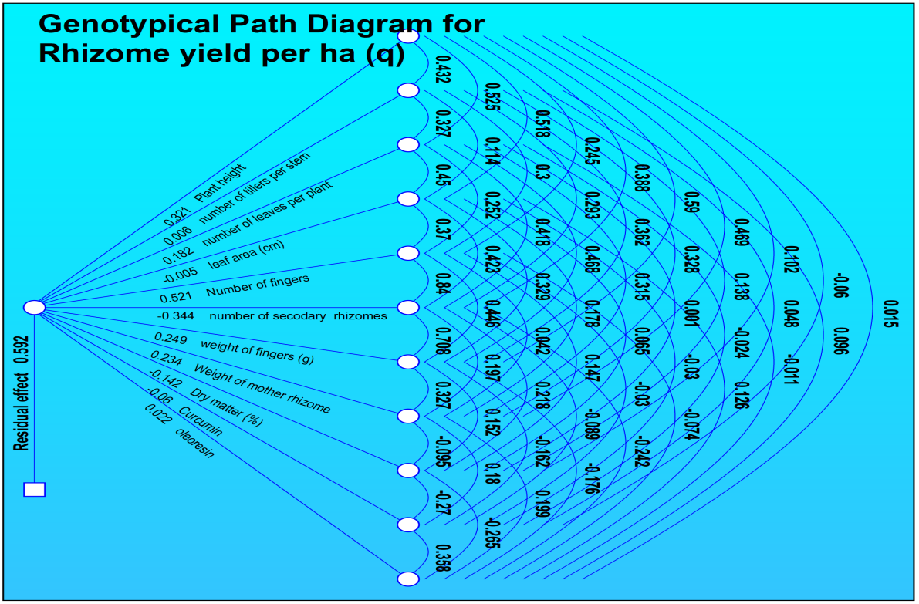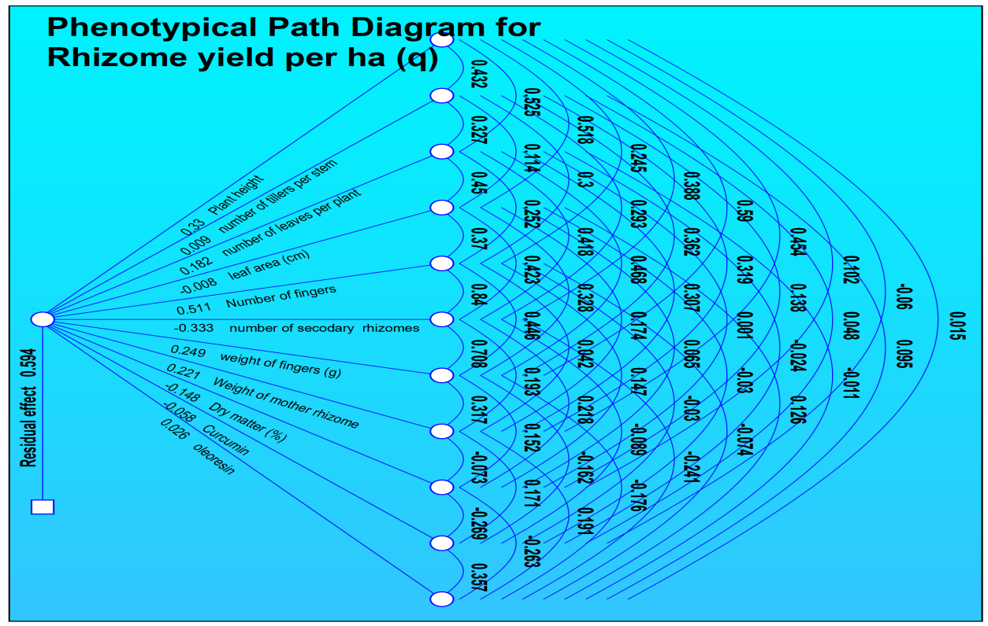

**Fig. 3 Genotypic and phenotypic path coefficient analysis for different characters of turmeric under Guava cropping system in 2019-20.**

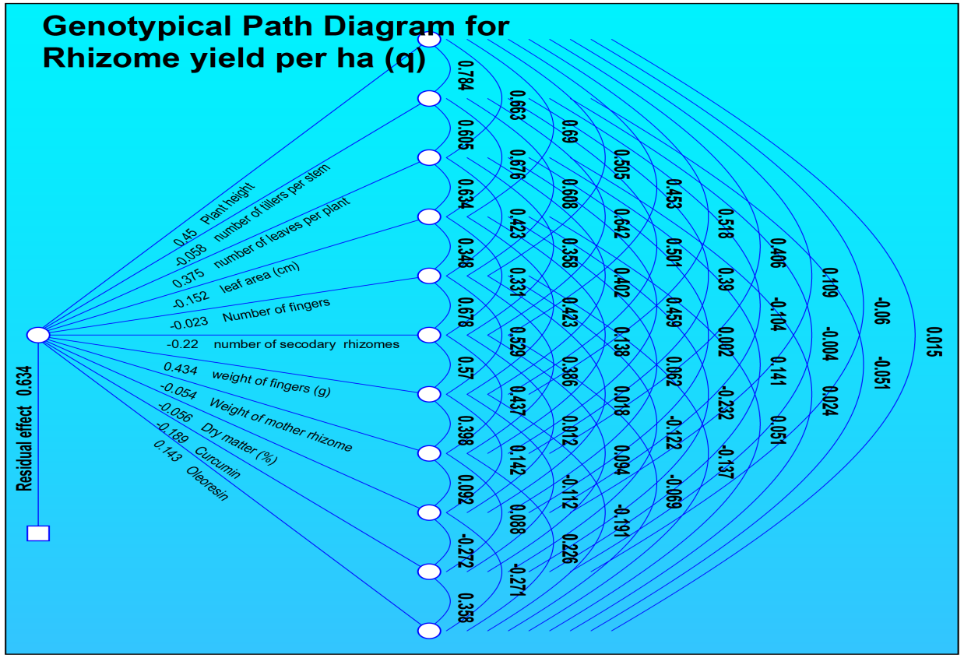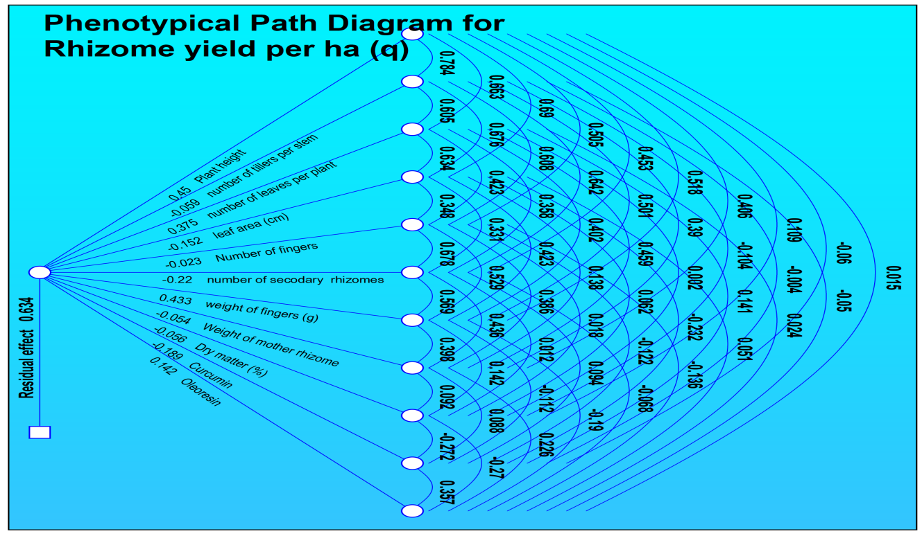

**Fig. 4 Genotypic and Phenotypic path coefficient analysis for different characters of turmeric under Guava cropping system in 2020-21.**

**Table 5: Genotypic path coefficient analysis for different characters of turmeric under Aonla (Pooled of two years) and guava (Pooled of two years) cropping system.**

|  |  |  |  |  |  |  |  |  |  |  |  |  |  |
| --- | --- | --- | --- | --- | --- | --- | --- | --- | --- | --- | --- | --- | --- |
| Traits |  | **Plant height** | **Number of tillers per stem** | **Number of leaves per plant** | **leaf area (cm)** | **Number of fingers** | **Number of secondary rhizomes** | **Weight of fingers (g)** | **Weight of mother rhizome** | **Dry matter (%)** | **Curcumin** | **oleoresin** | **Rhizome yield per ha (q)** |
| **Plant height (cm)** | **Under Aonla** | **0.305** | -0.004 | -0.057 | 0.252 | 0.107 | -0.046 | 0.107 | -0.008 | -0.011 | -0.008 | -0.001 | 0.637 |
| **Under Guava** | **0.457** | -0.020 | 0.213 | -0.108 | -0.068 | 0.068 | 0.282 | -0.047 | -0.011 | 0.009 | 0.003 | 0.778** |
| **number of tillers per stem** | **Under Aonla** | 0.011 | **-0.112** | -0.008 | 0.014 | 0.155 | -0.049 | 0.062 | 0.048 | -0.008 | -0.027 | 0.000 | 0.085 |
| **Under Guava** | 0.355 | **-0.026** | 0.182 | -0.100 | -0.098 | 0.095 | 0.253 | -0.044 | -0.003 | -0.004 | 0.006 | 0.617** |
| **number of leaves per plant** | **Under Aonla** | 0.076 | -0.004 | **-0.229** | 0.058 | 0.195 | -0.041 | 0.056 | -0.011 | -0.053 | 0.008 | -0.002 | 0.053 |
| **Under Guava** | 0.290 | -0.014 | **0.336** | -0.095 | -0.063 | 0.066 | 0.207 | -0.043 | 0.000 | -0.009 | 0.002 | 0.675** |
| **leaf area (cm)** | **Under Aonla** | 0.196 | -0.004 | -0.034 | **0.392** | 0.113 | -0.051 | 0.116 | -0.043 | -0.010 | -0.013 | 0.003 | 0.665 |
| **Under Guava** | 0.321 | -0.017 | 0.208 | **-0.154** | -0.064 | 0.073 | 0.251 | -0.029 | -0.008 | 0.023 | 0.022 | 0.626** |
| **Number of fingers** | **Under Aonla** | 0.072 | -0.039 | -0.099 | 0.099 | **0.450** | -0.112 | 0.146 | -0.011 | -0.034 | -0.005 | -0.002 | 0.464 |
| **Under Guava** | 0.193 | -0.016 | 0.132 | -0.061 | **-0.161** | 0.136 | 0.320 | -0.026 | -0.009 | 0.013 | -0.026 | 0.495** |
| **number of secondary rhizomes** | **Under Aonla** | 0.108 | -0.043 | -0.074 | 0.156 | 0.393 | **-0.128** | 0.153 | 0.006 | -0.013 | 0.004 | -0.002 | 0.560 |
| **Under Guava** | 0.210 | -0.017 | 0.149 | -0.076 | -0.148 | **0.147** | 0.345 | -0.038 | -0.013 | -0.001 | -0.037 | 0.522** |
| **Weight of fingers (g)** | **Under Aonla** | 0.130 | -0.028 | -0.051 | 0.181 | 0.262 | -0.078 | **0.250** | 0.024 | -0.032 | -0.051 | -0.001 | 0.607 |
| **Under Guava** | 0.286 | -0.015 | 0.154 | -0.086 | -0.114 | 0.113 | **0.451** | -0.043 | -0.018 | 0.023 | -0.046 | 0.707** |
| **Weight of mother rhizome** | **Under Aonla** | 0.016 | 0.036 | -0.016 | 0.112 | 0.033 | 0.005 | -0.041 | **-0.150** | -0.012 | 0.032 | 0.006 | 0.022 |
| **Under Guava** | 0.222 | -0.012 | 0.149 | -0.046 | -0.043 | 0.058 | 0.199 | **-0.097** | 0.000 | -0.022 | 0.052 | 0.461** |
| **Dry matter (%)** | **Under Aonla** | 0.026 | -0.008 | -0.098 | 0.031 | 0.126 | -0.013 | 0.065 | -0.014 | **-0.123** | -0.034 | -0.005 | -0.046 |
| **Under Guava** | 0.048 | -0.001 | 0.001 | -0.012 | -0.014 | 0.018 | 0.075 | 0.000 | **-0.108** | 0.040 | -0.059 | -0.011 |
| **Curcumin** | **Under Aonla** | -0.019 | 0.023 | -0.014 | -0.040 | -0.018 | -0.004 | -0.098 | -0.037 | 0.032 | **0.129** | 0.008 | -0.038 |
| **Under Guava** | -0.027 | -0.001 | 0.021 | 0.024 | 0.014 | 0.001 | -0.070 | -0.014 | 0.029 | **-0.148** | 0.078 | -0.092 |
| **Oleoresin** | **Under Aonla** | -0.014 | 0.002 | 0.018 | 0.056 | -0.045 | 0.015 | -0.015 | -0.042 | 0.027 | 0.047 | **0.022** | 0.069 |
| **Under Guava** | 0.007 | -0.001 | 0.003 | -0.016 | 0.019 | -0.025 | -0.094 | -0.023 | 0.029 | -0.053 | **0.219** | 0.067 |

**G= Genotypic, P= Phenotypic and R2= Residual effect**

**Table 6: Phenotypic path coefficient analysis for different characters of turmeric under Aonla (Pooled of two years) and guava (Pooled of two years) cropping system.**

|  |  |  |  |  |  |  |  |  |  |  |  |  |  |
| --- | --- | --- | --- | --- | --- | --- | --- | --- | --- | --- | --- | --- | --- |
| Traits |  | Plant height | number of tillers per stem | number of leaves per plant | leaf area (cm) | Number of fingers | number of secondary rhizomes | weight of fingers (g) | Weight of mother rhizome | Dry matter (%) | Curcumin | oleoresin | Rhizome yield per ha (q) |
| Plant height | **Under Aonla** | **0.248** | -0.001 | -0.007 | 0.137 | 0.015 | 0.028 | 0.126 | 0.002 | -0.013 | -0.005 | -0.001 | 0.531** |
| **Under Guava** | **0.351** | -0.026 | 0.123 | 0.009 | 0.088 | -0.112 | 0.183 | 0.039 | -0.009 | 0.004 | 0.001 | 0.652** |
| number of tillers per stem | **Under Aonla** | 0.009 | **-0.017** | -0.003 | 0.009 | 0.019 | 0.030 | 0.060 | -0.010 | -0.010 | -0.015 | 0.000 | 0.072 |
| **Under Guava** | 0.215 | **-0.042** | 0.097 | 0.006 | 0.107 | -0.126 | 0.144 | 0.032 | -0.001 | -0.001 | 0.002 | 0.433** |
| number of leaves per plant | **Under Aonla** | 0.051 | -0.001 | **-0.032** | 0.028 | 0.024 | 0.016 | 0.008 | 0.002 | -0.053 | 0.003 | -0.001 | 0.045 |
| **Under Guava** | 0.209 | -0.020 | **0.206** | 0.008 | 0.079 | -0.103 | 0.144 | 0.035 | 0.000 | -0.004 | 0.000 | 0.556** |
| leaf area (cm) | **Under Aonla** | 0.142 | -0.001 | -0.004 | **0.240** | 0.020 | 0.030 | 0.150 | 0.009 | -0.012 | -0.007 | 0.002 | 0.569** |
| **Under Guava** | 0.213 | -0.017 | 0.112 | **0.015** | 0.084 | -0.100 | 0.125 | 0.014 | -0.005 | 0.009 | 0.007 | 0.456** |
| Number of fingers | **Under Aonla** | 0.047 | -0.004 | -0.010 | 0.061 | **0.078** | 0.059 | 0.199 | 0.004 | -0.037 | -0.002 | 0.000 | 0.395** |
| **Under Guava** | 0.133 | -0.019 | 0.070 | 0.005 | **0.233** | -0.201 | 0.162 | 0.020 | -0.007 | 0.005 | -0.008 | 0.394** |
| number of secondary rhizomes | **Under Aonla** | 0.083 | -0.006 | -0.006 | 0.086 | 0.055 | **0.084** | 0.192 | -0.001 | -0.016 | 0.002 | -0.001 | 0.473** |
| **Under Guava** | 0.148 | -0.020 | 0.080 | 0.006 | 0.176 | **-0.266** | 0.211 | 0.029 | -0.009 | 0.000 | -0.012 | 0.342** |
| weight of fingers (g) | **Under Aonla** | 0.088 | -0.003 | -0.001 | 0.101 | 0.043 | 0.045 | **0.356** | -0.003 | -0.035 | -0.024 | 0.000 | 0.567** |
| **Under Guava** | 0.194 | -0.018 | 0.089 | 0.006 | 0.114 | -0.169 | **0.331** | 0.033 | -0.012 | 0.009 | -0.014 | 0.562** |
| Weight of mother rhizome | **Under Aonla** | 0.012 | 0.005 | -0.002 | 0.057 | 0.008 | -0.003 | -0.034 | **0.036** | -0.014 | 0.017 | 0.003 | 0.086 |
| **Under Guava** | 0.150 | -0.015 | 0.079 | 0.002 | 0.051 | -0.085 | 0.119 | **0.091** | -0.001 | -0.008 | 0.016 | 0.400** |
| Dry matter (%) | **Under Aonla** | 0.021 | -0.001 | -0.011 | 0.019 | 0.019 | 0.009 | 0.084 | 0.003 | **-0.149** | -0.019 | -0.002 | -0.027 |
| **Under Guava** | 0.037 | -0.001 | 0.000 | 0.001 | 0.019 | -0.029 | 0.049 | 0.001 | **-0.083** | 0.017 | -0.020 | -0.010 |
| Curcumin | **Under Aonla** | -0.015 | 0.003 | -0.001 | -0.022 | -0.003 | 0.003 | -0.118 | 0.008 | 0.038 | **0.074** | 0.004 | -0.029 |
| **Under Guava** | -0.021 | -0.001 | 0.013 | -0.002 | -0.018 | -0.002 | -0.045 | 0.012 | 0.023 | **-0.063** | 0.027 | -0.079 |
| oleoresin | **Under Aonla** | -0.012 | 0.000 | 0.001 | 0.034 | -0.002 | -0.007 | 0.000 | 0.009 | 0.028 | 0.026 | **0.012** | 0.090 |
| **Under Guava** | 0.005 | -0.001 | 0.001 | 0.001 | -0.024 | 0.041 | -0.061 | 0.019 | 0.022 | -0.023 | **0.075** | 0.057 |

**G= Genotypic, P= Phenotypic and R2= Residual effect**

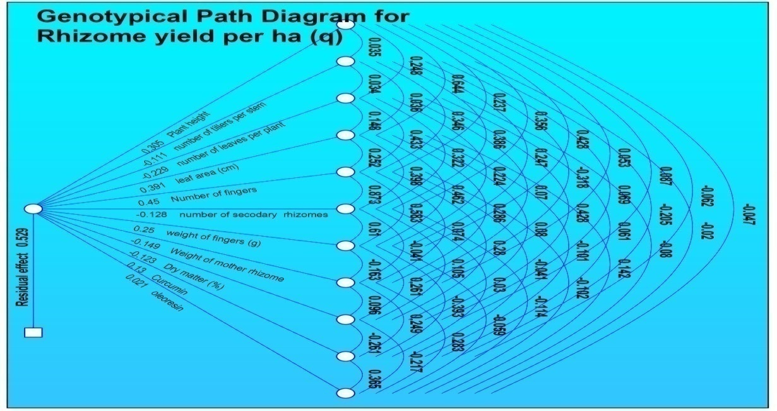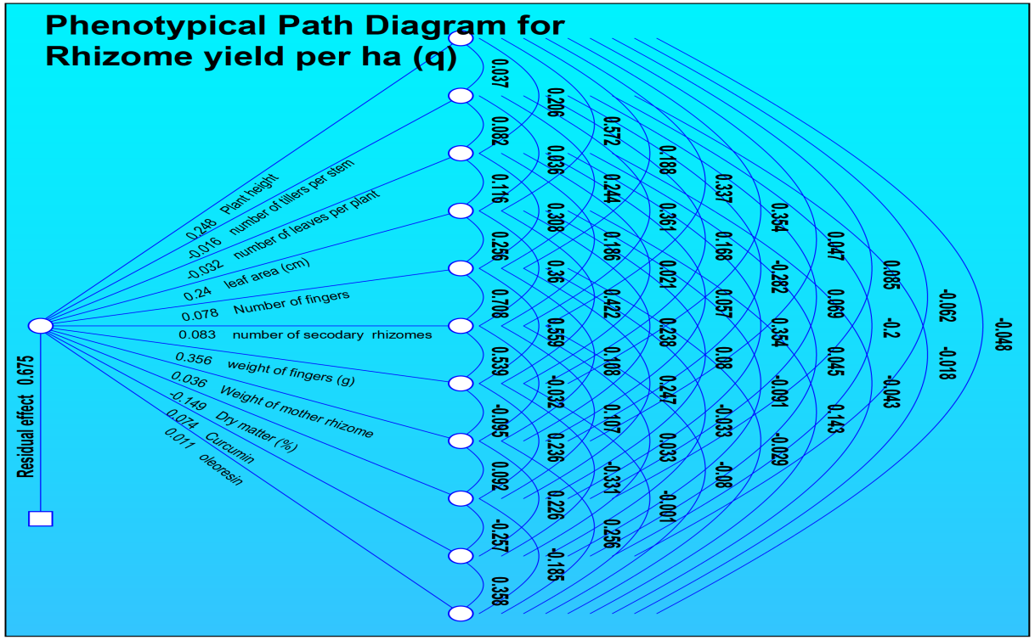

**Fig. 5 Genotypic and Phenotypic path coefficient analysis for different characters of turmeric under Aonla cropping system (Pooled of two years)**

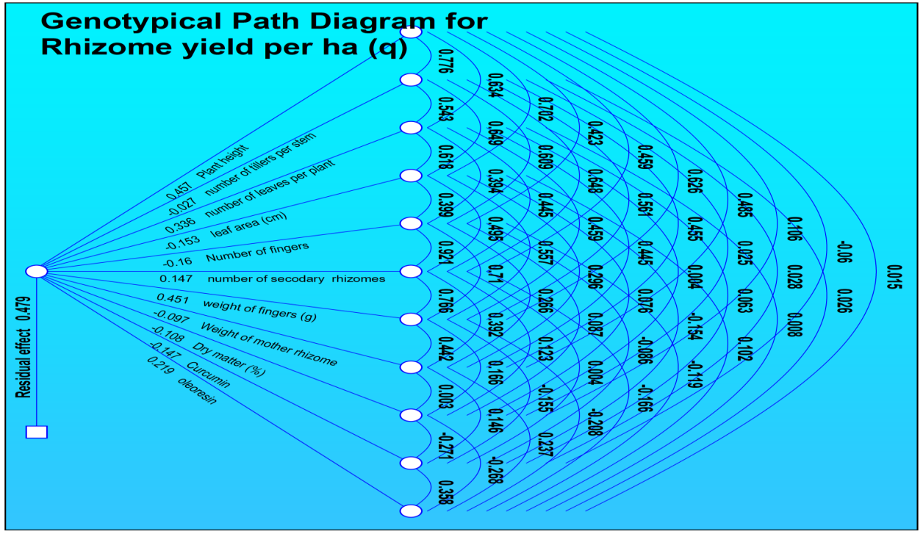 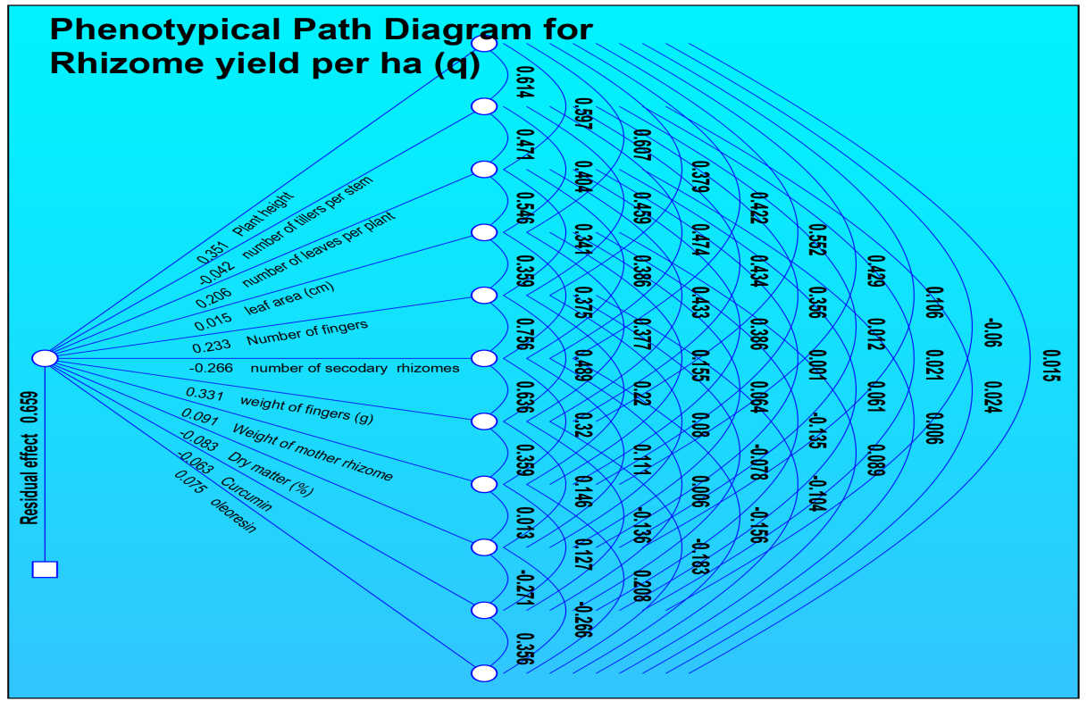

**Fig. 6 Genotypic and Phenotypic path coefficient analysis for different characters of turmeric under guava cropping system (Pooled of two years).**