Short Research Article

**Effect of combination of insecticides against maize stem borer,**

***Chilo partellus* (Swinhoe)**

**ABSTRACT**

A field experiment was carried out during the *Kharif* season of 2024 at the Central Research Farm (CRF), SHUATS, Uttar Pradesh, India, to evaluate the effectiveness of various insecticidal treatments against *Chilo partellus* infestation in maize. The study was designed using a Randomized Block Design (RBD) comprising eight treatments with three replications each: T1 (Neem Oil 1 % + Imidacloprid 17.8% SL), T2 (Chlorantraniliprole 18.5 %SC + Azadirachtin 1500 ppm), T3 (Carbofuran 3G + Imidacloprid 17.8% SL), T4 (Imidacloprid 17.8% SL @ 4g a.i./kg of seed), T5 (Carbofuran 3G), T6 (Karanj Oil 3% + Imidacloprid 17.8% SL), T7 (Spinetoram

11.7% SC + Azadirachtin 1500 ppm), and an untreated control. Observations on larval population after the first and second sprays indicated that all treatments significantly reduced *C. partellus* infestation compared to the control. Among them, T7 (Spinetoram 11.7% SC + Azadirachtin 1500 ppm ) was the most effective, recording the lowest larval population (2.22 and 1.36), followed by T2 (Chlorantraniliprole

18.5% SC + Azadirachtin 1500 ppm), T6 (Karanj Oil 3%+ Imidacloprid 17.8% SL), and T1 (Neem Oil 1% + Imidacloprid 17.8% SL). The least effective treatment was T5 (Carbofuran 3G), with the highest larval counts (3.53 and 2.46) after both sprays. These findings highlight the superior efficacy of Spinetoram 11.7% SC + Azadirachtin

1500 ppm in managing *Chilo partellus* under field conditions.

**Key words***:*, *Chillo partellus,* , Maize

**INTRODUCTION**

Maize (*Zea mays* L.), often referred to as the "queen of cereals," is a highly adaptable and versatile cash crop capable of thriving under a wide range of agro-climatic conditions. It also boasts the highest yield potential among cereals. In India, maize is cultivated across approximately 9.43 million hectares, producing around 22.23 million tonnes annually, with an average productivity of 2.5 tonnes per hectare **(Anno, 2014).**

However, one of the major biotic constraints to maize production is the damage caused by stem borers. Among the pest complex, *C. partellus* (Swinhoe), *Sesamia inferens* (Walker), and *Atherigona soccata* (Rondani) are the most significant across different growing seasons in India (Kumar et al., 2005). Yield losses attributed to *C. partellus* and *S. inferens* range from 26.7% to

80.4% and 25.7% to 78.9%, respectively, across various agro-climatic zones **(Chatterji et al.,**

**1969).**

Stem borers initially damage maize by feeding on leaf tissue, then continue to cause harm by tunneling into stems and sometimes the cobs **(Jalali and Singh, 2002).** For effective control, timely application of insecticides—particularly at the early whorl stage—is critical, since these pests are internal feeders and late-stage interventions are less effective **((Songa *et al*., 2001)).**

Emphasis should be placed on using environmentally safer insecticides with novel modes of action, which are essential for managing insecticide resistance. While chemical control remains a key strategy due to its fast-acting results **(Kulkarni et al., 2015),** excessive dependence on synthetic pesticides poses environmental and health risks. Therefore, it's important to identify more efficient and safer insecticide options that are also compatible with natural enemy conservation. Approaches such as whorl application of granules, dust-based biopesticides, and foliar sprays using novel insecticides have shown promising results in managing stem borers(Reference???). In this context, the current study was undertaken to evaluate and reassess the field performance of botanicals, biorationals, and insecticides against maize stem borers by measuring reductions in percent leaf damage and dead heart incidence. The ultimate goal is to develop optimized insecticide application schedules that serve as effective chemical components within an Integrated Pest Management (IPM) framework and support resistance management strategies.

**Material and Methods**

A field experiment was conducted during the *Kharif* season of 2024 at the Central Research Farm, Department of Entomology, SHUATS, Prayagraj to evaluate the impact of combined insecticides on the control of maize stem borer, *C. partellus* (Swinhoe). The experiment was laid out in a Randomized Block Design (RBD) with three replications and included eight treatments, including an untreated control. Each treatment was applied to plots measuring 3 × 2 m², with a plant and row spacing of 60 cm × 20 cm. The treatments tested were: T1 – Neem Oil

+ Imidacloprid 17.8% SL, T2 – Chlortantraniliprole 18.5 % SC + Azadirachtin 1500 ppm, T3 – Carbofuran 3G + Imidacloprid 17.8% SL, T4 – Imidacloprid 17.8% SL, T5 – Carbofuran 3G, T6 – Karanj Oil 3% + Imidacloprid 17.8% SL, T7 – Spinetoram 11.7% SC + Azadirachtin 1500 ppm, and T8 – Untreated Control. A total of 24 plots were sown with the local maize hybrid VNR 4226, and all recommended agronomic practices such as fertilizer application, thinning, interculture, and weeding were followed uniformly across all treatments. The larval population was recorded from five randomly selected plants in each plot, and the average population across the three replications was calculated for each treatment. Observations of *Chilo partellus* infestation were made one day before spraying and on the 3rd, 7th, and 14th days after insecticide application. Marketable yield of each plot of different treatment is collected and weighted separately and then calculated treatment cost, common cost of cultivation per hectare. Total gross return was calculated by multiplication of total yield and current market price. Net return is calculated by subtracting total cost from total income. The collected data were transformed and subjected to statistical analysis using OPSTAT software.

**Results and Discussion**

The findings (Table-1) following the first and second spray insecticide applications indicated that all treatments were significantly more effective than the untreated control. The mean larval population of *C. partellus* recorded on the 3rd, 7th, and 14th days after the first and second spray showed that all chemical treatments performed significantly better in reducing pest incidence compared to the control. Among all treatments, Spinetoram 11.7 % SC + Azadirachtin

1500 ppm (2.22 and 1.36) recorded lowest larval population of *C. partellus* after both sprays followed by Chlorantraniliprole 18.5% SC + Azadirachtin 1500 ppm (2.42 and 1 . 6 3 ) , Karanj oil 3% + Imidacloprid 17.8% SL (2.66 and 1.80 ), Neem Oil 1% + Imidacloprid 17.8% SL (2.86 a n d 1.96 ), Carbofuron 3G + Imidacloprid 17.8% SL (3.10 and 2.13 ), Imidacloprid

17.8% SL (3.40 and 2.26), Carbofuron 3G (3.53 and 2.46) was the least effective among all treatments respectively.

The highest yield was recorded in Spinetoram 11.7% SC + Azadirachtin 1500 ppm (43.56 q/ha), followed by Chlorantraniliprole 18.5% SC + Azadirachtin 1500 ppm (41.508 q/ha), Karanj oil (3%) + Imidacloprid 17.8% SL (39.10 q/ha), Neem oil (1%) + Imidacloprid 17.8 % SL (36.74 q/ha), Carbofuran 3G + Imidacloprid 17.8% SL 4g a.i./kg of seed (32.98 q/ha), Imidacloprid 17.8% SL 4g a.i./kg of seed (29.84 q/ha), Carbofuran 3G (28 q/ha), Control (20.5q/ha).

Among all this treatment combination best and most economic treatment is Spinetoram 11.7% SC + Azadirachtin 1500 ppm with cost benefit ratio 1:2.61 followed by Chlorantraniliprole 18.5% SC + Azadirachtin 1500 ppm (1:2.41) followed by Karanj oil (3%) + Imidacloprid 17.8% SL (1:2.19) followed by Neem Oil (1%) +Imidacloprid 17.8%SL (1:2.01) followed by Carbofuran 3G + Imidacloprid 17.8 % SL @ 4 g a.i./kg of seed (1:1.82) followed by Imidacloprid 17.8 % SL @ 4g a.i./kg of seed (1:1.69) followed by Carbofuran 3G (1:1.65) followed by untreated control (1:1.29).

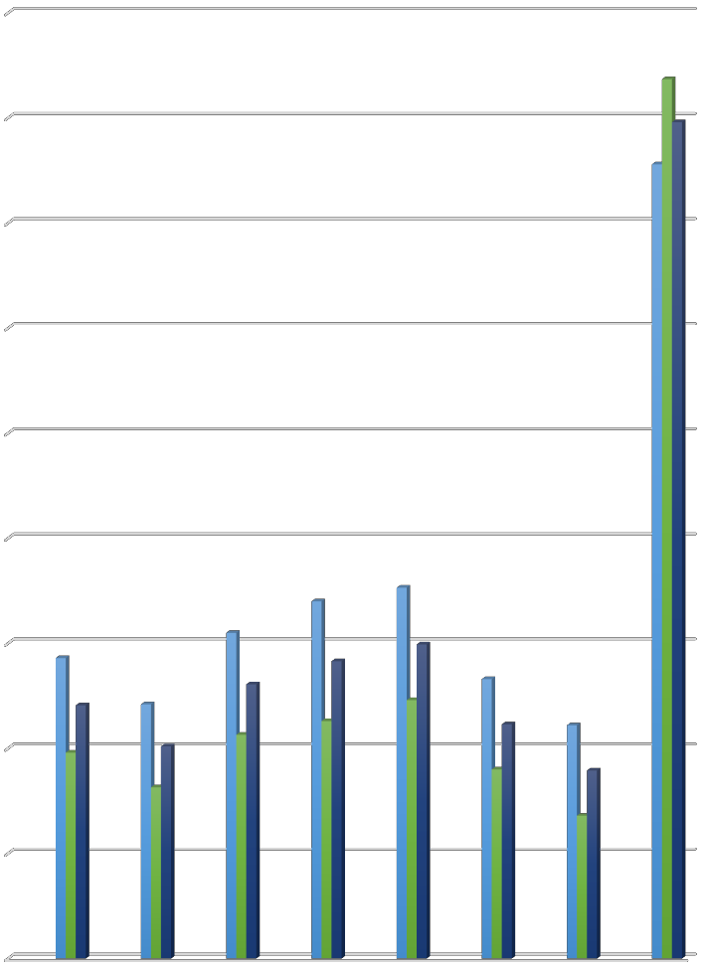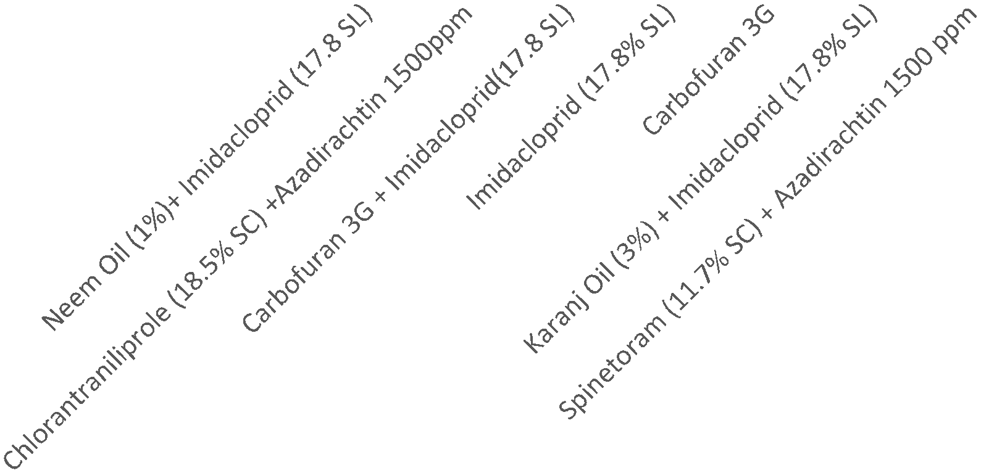

9

8

7

6

5

**Larval Population**

4

3

2

1 1st spray

2nd Spray

0 Mean

**Treatments**

**Comparative efficacy of combination of different insecticides against larval population of maize stem borer (*Chilo partellus*, Swinehoe)**

**Table 1. Comparative study of combination of insecticides against maize stem borer, *Chilo partellus, Swinhoe.***

**S.No. Treatments Dosage Larval Population of *chilo partellus/ 5 plants* Yield C: B**

**First spray Second spray Overall**

**q/ha Ratio**

|  |  |  |  |  |  |  |  |  |  |  |  |  |  |  |
| --- | --- | --- | --- | --- | --- | --- | --- | --- | --- | --- | --- | --- | --- | --- |
|  | | | **1DBS** | **3DAS** | **7DAS** | **14DAS** | **Mean** | **3DAS** | **7DAS** | **14DAS** | **Mean** | **mean** |  | |
| T1 | Neem Oil (1%)  + Imidacloprid | 10 ml/lit +  2 ml/lit | 5.00 | 3.26 | 2.40 | 3.00 | 2.86 | 2.73 | 1.53 | 1.73 | 1.96 | 2.41 | 36.74 | 1:2.01 |
|  | 17.8 % SL |  |  |  |  |  |  |  |  |  |  |  |  |  |
| T2 | Chlorantra- niliprole 18.5% SC + Azadirachtin  1500 ppm | 0.2 ml/lit  +2.5 ml/lit | 5.40 | 3.00 | 1.93 | 2.66 | 2.42 | 2.16 | 1.26 | 1.53 | 1.63 | 2.02 | 41.508 | 1:2.41 |
| T3 | Carbofuran 3G  + Imidacloprid  17.8% SL | 10 kg/ha +  4g a.i./kg of  seed | 4.87 | 3.53 | 2.66 | 3.26 | 3.10 | 2.96 | 1.66 | 1.93 | 2.13 | 2.61 | 32.98 | 1:1.82 |
| T4 | Imidacloprid  (17.8% SL) | 4ml/kg of seed | 4.40 | 3.80 | 2.80 | 3.60 | 3.40 | 3.06 | 1.60 | 2.06 | 2.26 | 2.83 | 29.84 | 1:1.69 |
| T5 | Carbofuran 3G | 10 kg/ha | 4.00 | 3.93 | 2.93 | 3.66 | 3.53 | 3.26 | 1.86 | 2.40 | 2.46 | 2.99 | 28.00 | 1:1.65 |
| T6 | Karanj oil (3%)  +Imidacloprid  (17.8% SL) | 30 ml/lit +  0.25ml/lit | 5.00 | 3.13 | 2.20 | 2.73 | 2.66 | 2.46 | 1.40 | 1.60 | 1.80 | 2.23 | 39.10 | 1:2.19 |
| T7 | Spinetoram  11.7% SC + Azadirachtin  1500 ppm | 0.25 ml/lit +  2.5 ml/lit | 5.73 | 2.73 | 1.86 | 2.20 | 2.22 | 2.13 | 0.93 | 1.06 | 1.36 | 1.79 | 43.56 | 1:2.61 |
| T8 | Control |  | 6.20 | 6.93 | 7.13 | 8.46 | 7.56 | 7.93 | 8.33 | 8.86 | 8.37 | 7.96 | 20.50 | 1:1.29 |
| F-Test | | NS | | S | S | S | S | S | S | S | S | S |  |  |
| S.Ed.(±) | | 0.685 | | 6.939 | 5.31 | 6.75 | 3.54 | 6.75 | 5.31 | 6.753 | 3.54 | - |  |  |
| CD (0.05) | | 1.469 | | 0.766 | 0.93 | 0.81 | 0.51 | 0.81 | 0.40 | 0.65 | 0.53 | - |  |  |

*DBS- Day before Spraying, DAS- Day after Spraying, NS- Non significant, S- Significant*

**CONCLUSION**

The study revealed that all insecticidal combination of insecticides with biopesticides shows better synergistic effect on insecticides and. Especially, In case of Spinetoram 11.7% SC + Azadirachtin 1500 ppm quick knockdown effect was seen. Chlorantraniliprole 18.5% SC + Azadirachtin 1500 ppm treatments were slightly less effective than Spinetoram 11.7% SC + Azadirachtin 1500 ppm , in the treatment Karanj oil (3%)+ Imidacloprid 17.85% SL , Karanj oil (3%) seen to be enhancing the effect of 0.25 ml/L Imidacloprid greatly, treatment Neem Oil (1%) + Imidacloprid 17.8% SL shows substantial efficacy but in case of treatments Carbofuran 3G + Imidacloprid 17.8% SL, seen that seed treatment 4g/kg of Imidacloprid 17.8% SL enhances the efficacy of Carbofuran

3G than Carbofuran 3G and Imidacloprid 17.8% SL 4g/kg alone. Among the treatments, the combination of Spinetoram 11.7% SC + Azadirachtin 1500 ppm proved to be the most effective, recording the lowest larval population after both sprays (2.22 and 1.36 larvae per 5 plants). This was followed by Chlorantraniliprole 18.5% SC + Azadirachtin 1500 ppm, Karanj Oil (3%) + Imidacloprid 17.8% SL, and Neem Oil (%)+ Imidacloprid 17.8% SL 2 ml/lit, which also showed substantial efficacy, with Carbofuran 3G 10kg/ha being the least effective among all. Overall, the results suggest that integrated combinations of insecticides, especially those incorporating biopesticides, can provide effective management of maize stem borer and may be recommended as part of an integrated pest management strategy.

**References**

**Ahad, I., Bhagat, R. M., & Ahmad, H. (2012).** Efficacy of insecticides and some biopesticides against maize stem borer, Chilo partellus Swinhoe. *Indian Journal of Entomology*, *74*(2), 99-102.

**Anonymous. (2014).** *Agriculture statistics at a glance*. Government of India.

**Aher S.D., Ilyas. M., Dake .R.B., and Timke. S.H (2022).** Bio efficacy of different insecticides against sorghum stem borer (*Spodoptera frugiperda*). *Journal of Applied Entomologist,* 2022;

2(4):45-47

**Bhandari, G. S., Bhandari, P., & Sah, L. (2024).** Efficacy of Insecticides against Fall Armyworm, Spodoptera frugiperda (JE Smith) in Maize Field in Chitwan, Nepal. *Journal of Nepal Agricultural Research Council*, *10*, 50-60.

**Bajracharya A S R, Bhat B and Sharma P (2020).** Field efficacy of selected insecticides against fall armyworm, Spodoptera frugiperda (J.E. Smith) in maize. J. Pl. Protec. Soc. 6, 127

133.

**Bharadwaj G S, Mutkule D S, Thakre B A and Jadhav A S (2020).** Bioefficacy of different insecticides against fall armyworm, Spodoptera frugiperda (J.E. Smith) on maize. J. Pharmacogn. Phytochem. 9(5), 603-607.

**Chandrakar, G., Bhardwaj, J. R., Khan, H. H., & Sahu, R. (2017).** Assessment of the efficacy of neem based insecticides for the management of yellow stem borer, Scirpophaga incertulas Walk in paddy field. *Journal of Pharmacognosy and Phytochemistry*, *6*(5), 1446-1449.

**Chatterji, S. M., Young, W. R., Sharma, G. C., Sayi, I. V., Chahal, B. S., Khare, B. P., Rathore, Y. S., Panwar, V. P. S. and Siddiqui, K. H. (1969).** Estimation of loss in yield of maize due to insect pests with special reference to borers. *Indian Journal of Entomology*, 31:

109-15.

**DEY, A. (2023).** Bio-ecology and Management of Fall Armyworm, Spodoptera frugiperda S. on

Kharif Maize (Doctoral dissertation, RPCAU, Pusa).

**Garhwal, A., & Yadav, U. (2024)** Comparative Study of Synthetic Insecticides with

Biopesticides against Spotted Stem Borer, Chilo partellus (Swinhoe) on Maize (Zea mays L.).

**Hussain, S., Ahmad, B., Iqbal, T., Mehmood, N., Khan, A., & Khan, Z. (2016).** In vivo

efficacy of two synthetic insecticides and two bio-extracts against maize stem borer (Chilo partellus). *Journal of entomology and zoology studies*, *4*(6), 550-552

**JAWALKAR, A. (2023).** Studies on compatibility and bioefficacy of recommended pesticides in maize crop against fall armyworm under invitro conditions.

**Kulkarni, S., Mallapur, C. P., & Balikai, R. A. (2015).** Bio-efficacy of insecticides against fall armyworms. *Journal of Experimental Zoology*, *18*(1), 233–236.

**Konar, D., & Banerjee, P. K. (2013).** Population dynamics of stem borer, *Spodoptera frugiperda* and efficacy of some insecticides against it on maize. *Journal of Agricultural Research*, *3*(7), 23–28.

**Krishna, D. V., & Kumar, A. (2018).** Comparative efficacy of certain chemicals against Fall army worm (*Spodoptera frugiperda*) in Allahabad Region. *International Journal of Scientific & Engineering Research*, *9*(8), 2229–5518.

**Kurly, S., & Kumar, B. (2020).** Eco-friendly management of maize stem borer with botanical and chemical insecticides. *The Pharma Innovation Journal*, *10*(2), 135-137**.**

**Mian, F. M., Khan, I., Ullah, N., Gondal, A. H., Ajmal, M. S., Qureshi, M. S., ... & Jabbar, A. (2022).** Efficacy of insecticides against fall armyworm, Spodoptera frugiperda (Lepidoptera, Noctuidae) in Maize. *Journal of Bioresource Management*, *9*(2), 14.

**Naik, N. R., Sekhar, D., & Reddy, D. V. (2020).** Occurrence and management of the fall armyworm, Spodoptera frugiperda: a new insect pest on maize at Regional Agricultural Research Station, Chintapalle, Visakhapatnam, Andhra Pradesh, India. *Journal of Experimental Zoology India*, *23*(1).

**RAJASEKHAR, N.** EVALUATION OF PHEROMONE BLENDS AND BIORATIONAL INSECTICIDES FOR THE MANAGEMENT OF Spodoptera frugiperda (JE Smith)(Lepidoptera.

**Neupane, S., Bhandari, G., Sharma, S. D., Yadav, S., & Subedi, S. (2016).** Management of stem borer (Chilo partellus Swinhoe) in maize using conventional pesticides in Chitwan, Nepal. *Journal of Maize Research and Development*, *2*(1), 13-19.

**PAVANA, J. (2021).** *TOXICITY AND EFFICACY OF BOTANICALS AGAINST FALL ARMYWORM, Spodoptera frugiperda (JE Smith) ON MAIZE* (Doctoral dissertation, Keladi

Shivappa Nayaka University of Agricultural & Horticultural Sciences, Shivamogga).

**Sampat, M. P. K. (2024).** ECO-FRIENDLY MANAGEMENT OF FALL ARMYWORM*, Spodoptera frugiperda (JE SMITH) IN MAIZE* (Doctoral dissertation, MAHATMA PHULE KRISHI VIDYAPEETH).

**Sidar, Y. K., Nirmal, A., Gajbhiye, R. K., Bisen, M. S., & Bhargav, P. (2017).** Insect pest succession on hybrid maize and management of pink stem borer, Sesamia inferens Walker. *Journal of pharmacognosy and phytochemistry*, *6*, 143-150.

**Singh, A., & Yadav, U. (2023).** Evaluate the Efficacy of Different Biopesticides with Imidacloprid against Maize Spotted Stem Borer (Chilo partellus swinhoe) on maize under field conditions. Int. J. Plant Soil Sci, 35(18), 1001-1006**.**

**Songa, J. M., Zohu, G. and Overholt, W. A. (2001).** Relationship of stem borer damage and plant physical condition to maize yield in a semi-arid zone of Eastern Kenya. *Insect Science Appliances*, 21(3): 243-249.

**Yadav, U.** Efficacy of different insecticides against fall armyworm Spodoptera frugiperda (JE Smith) on maize (Zea mays L.).