**Review Article**

**Endospore-Producing Endophytes: Structural Adaptations, Functional Roles, and Their Significance in Plant Growth and Stress Management**

ABSTRACT

Endospore-forming endophytic bacteria, particularly members of the genus *Bacillus*, are gaining increasing recognition for their multifaceted roles in sustainable agriculture. These microorganisms are capable of colonizing internal plant tissues and forming highly resistant endospores that ensure their survival under harsh environmental conditions. This review highlights the structural and functional aspects of bacterial endospores, including their formation, layers, and resistance mechanisms. Furthermore, it explores the significance of endophytic *Bacillus* spp. as plant growth-promoting agents through nutrient solubilization, phytohormone production, and disease suppression. The ability of these bacteria to alleviate biotic stresses through antimicrobial metabolites and systemic resistance, as well as their contribution to abiotic stress tolerance *via* antioxidant enzyme activation and ion homeostasis, is discussed in detail. The unique combination of persistence, adaptability, and beneficial plant interactions makes endospore-forming *Bacillus* spp. highly valuable for modern agricultural applications, especially under changing climatic conditions.

*Keywords: Bacillus, endospore, endophytes, plant growth-promoting bacteria (PGPB), abiotic stress, biocontrol, ISR, nutrient solubilization, drought tolerance, salinity stress*

1. INTRODUCTION

Endospore-forming endophytic bacteria are a unique group of microbes that reside within the internal tissues of plants and possess the ability to produce highly resistant spores. Genera like *Bacillus* and *Paenibacillus* are well-known representatives that establish stable, beneficial relationships with their host plants, often enhancing plant growth and resilience. The formation of endospores allows these bacteria to withstand unfavourable environmental conditions while remaining viable within plant tissues, thereby ensuring their continued presence and contribution to plant health.

Research by Fira *et al*. (2018) and Ambawade and Pathade (2015) has emphasized the important role of endospore-forming endophytic bacteria in promoting plant growth, improving nutrient uptake, and enhancing tolerance to environmental stress. Additionally, their potential in suppressing a range of crop diseases has been demonstrated (Nandana and Anith, 2024; Sivapriya *et al*., 2024). Due to their resilience and multifunctional benefits, these bacteria are considered valuable agents for advancing sustainable agriculture and developing biotechnological solutions in plant-microbe interactions, particularly under the challenges posed by climate change.

2. ENDOSPORE

2.1 Endospore structure

Endospores are highly resistant, dormant structures formed by certain bacteria to survive unfavourable environmental conditions. To observe endospores under the microscope, the Schaeffer-Fulton staining method is commonly used, which stains the endospore green with malachite green and the vegetative cell pink with safranin (Fig.1).

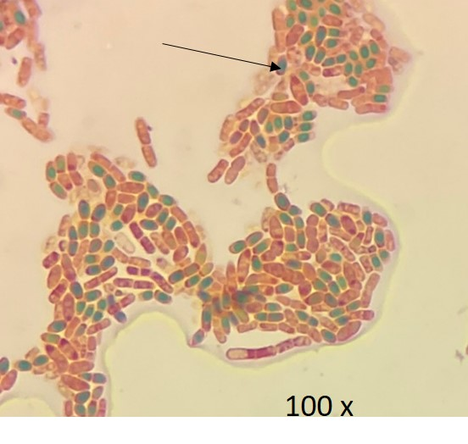

Fig. 1. Endospore-producing endophytic bacteria isolated from ginger visualized under 100× magnification using the Schaeffer–Fulton staining method. The green-stained structures (indicated by arrows) represent endospores stained with malachite green, while the surrounding vegetative cells appear pink due to safranin counterstaining.

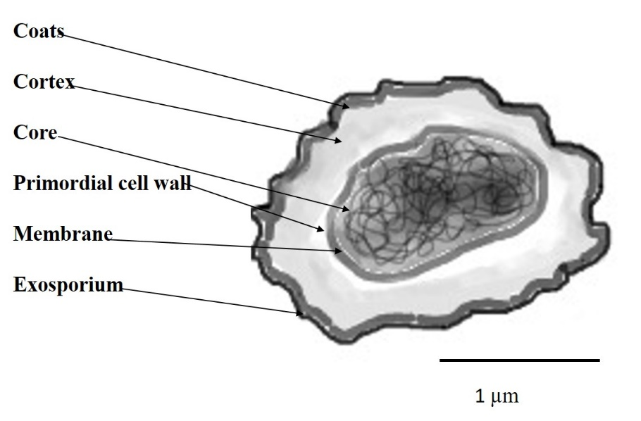

Fig. 2. Digitally illustrated representation of an endospore. The image highlights the endospore structure.

The structural organization of spores remains largely conserved across all endospore-forming bacteria. Spore formation is a tightly regulated and intricate process involving multiple stages of assembly. A digital illustration of a *Bacillus subtilis* spore (Fig. 2) illustrates the complex architecture, particularly the spore coat, which consists of several distinct layers. This protective coat is made up of up to 25 different polypeptides, many of which are extensively cross-linked, contributing to the spore's resilience. The spore coat contributes to resistance against chemical and enzymatic challenges by functioning primarily as a selective permeability barrier (Driks, 1999). Located beneath the spore coat is a dense peptidoglycan layer, which may contribute up to 10% of the spore’s total dry weight. This layer is composed of two distinct regions: a thin inner layer known as the primordial cell wall, and a thicker outer region called the cortex. The primordial cell wall constitutes only about 2–5% of the total peptidoglycan content in the spore. It helps maintain cellular integrity following germination and acts as a scaffold for peptidoglycan synthesis during the outgrowth phase (Atrih *et al*., 1996).

The cortex exhibits a distinct structural organization and features that are widely conserved among various spore-forming bacteria (Fig. 3). Notable characteristics include the presence of α-lactam modifications at approximately every alternate muramic acid residue and a low degree of cross-linking, with only about 2.9% of muramic acid residues being cross-linked in *B. subtilis* spores (Atrih & Foster, 2001). The low level of peptidoglycan cross-linking in spores is thought to be crucial for maintaining the specific architecture of this structural polymer. It is proposed that this reduced cross-linking represents a functional balance—providing sufficient wall stability to support core dehydration, while also allowing the necessary flexibility and degradability required for spore outgrowth. This structural property also facilitates cortex hydrolysis during germination, aiding in the transition of the spore from dormancy to active growth (Meador-Parton & Popham, 2000).

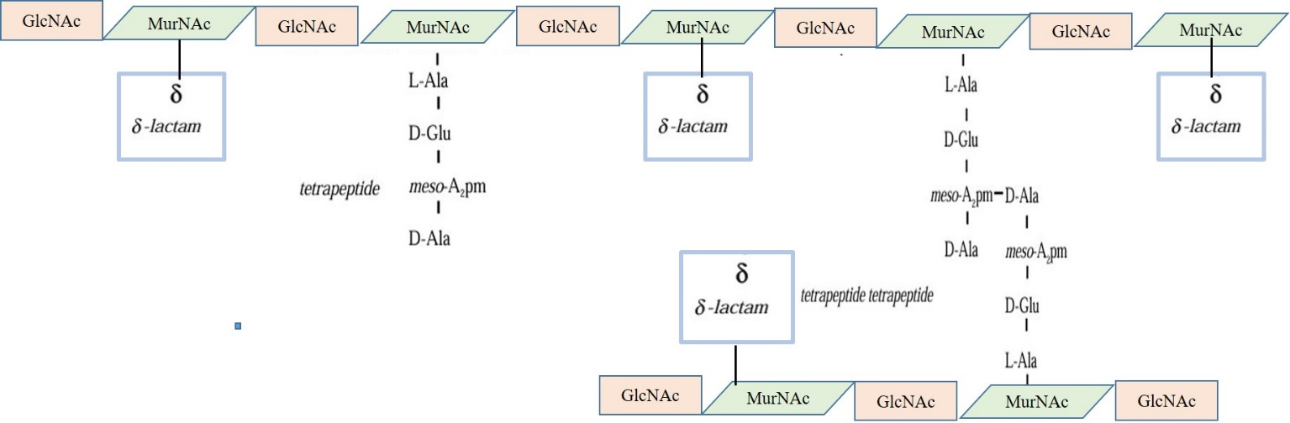

Fig. 3. The distinct structural organization in cortex. Notable characteristics include the presence of α-lactam modifications at approximately every alternate muramic acid residue and a low degree of cross-linking.

The spore core, or cytoplasm, houses all essential metabolic components of the cell, including the genomic DNA. In its dormant state, the core remains highly dehydrated, a condition that contributes significantly to the spore’s heat resistance (Gerhardt & Marquis, 1989). Upon germination and rehydration, the enzymes within the core regain activity. The core is also rich in minerals such as Ca²⁺, Mn²⁺, and Mg²⁺, which are primarily chelated with di Anexolinic acid, a spore-specific molecule. Additionally, the core contains a high concentration of small acid-soluble proteins (SASPs) that bind to DNA, playing a critical role in protecting it from UV damage (Setlow, 1994).

The inner membrane of dormant spores exhibits a highly compressed, polycrystalline structure and is significantly more viscous compared to the membrane of vegetative cells, to which it transitions during germination (Elmes *et al*., 1983). Modifications in the inner membrane have been found to influence germination behaviour, as the interaction of specific germinates with this membrane leads to changes in its fluidity (Skomurski *et al*., 1983).

2.2 Endospore formation

Endospore formation in bacteria, particularly in *Bacillus* and *Clostridium* species, is a highly coordinated developmental process that is triggered by environmental stress, such as nutrient limitation. The process is initiated by the activation of the master regulator Spo0A, a response regulator that becomes phosphorylated through a complex phosphorelay system involving multiple kinases (Hoch, 1993). Once phosphorylated, Spo0A~P activates the expression of genes required for sporulation and represses genes involved in vegetative growth.

Sporulation begins with asymmetric cell division, generating a smaller forespore and a larger mother cell. The forespore is then engulfed by the mother cell membrane, forming a double-membraned structure. Protective layers such as the cortex, composed of loosely cross-linked peptidoglycan, and the multi-layered spore coat are sequentially synthesized. Meanwhile, the spore core dehydrates and accumulates dipicolinic acid and calcium ions, contributing to heat resistance and dormancy. Finally, the mother cell undergoes programmed lysis, releasing the mature endospore into the environment. The spore remains metabolically inactive yet highly resilient, capable of germinating into a vegetative cell when conditions become favourable.

2.3 Spore resistance mechanisms

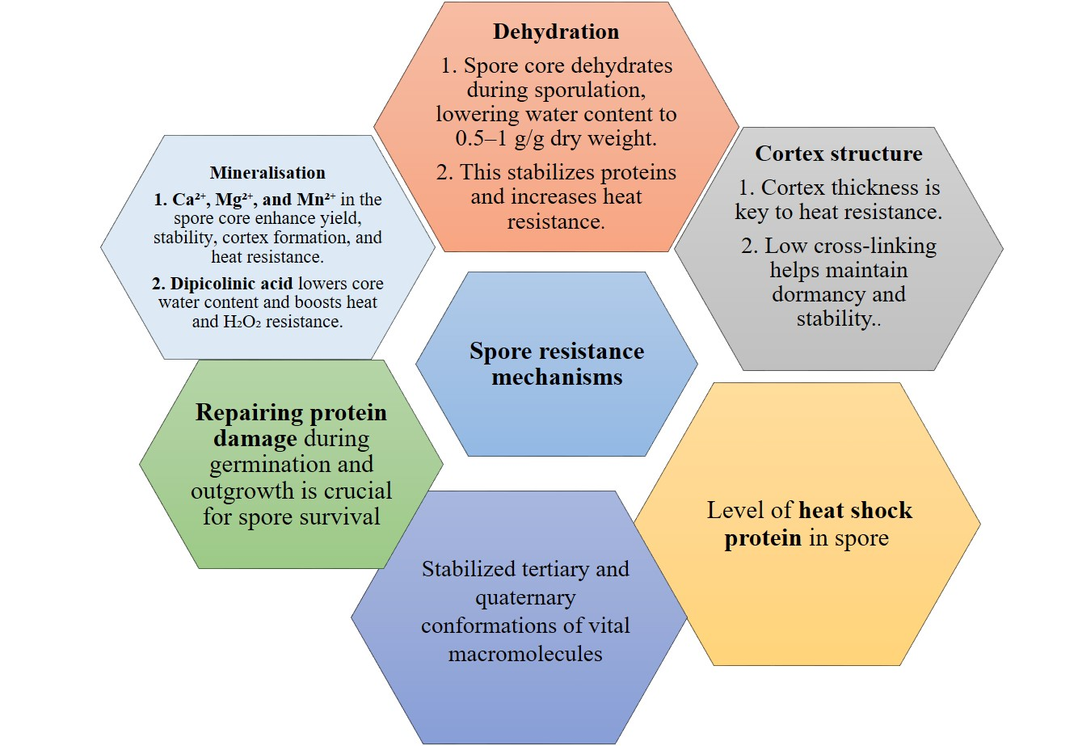

#### Fig. 4. Spore resistance mechanisms for surviving extreme environmental conditions

Bacterial spores have evolved as a robust survival strategy, enabling them to endure extreme environmental conditions (Fig. 4). Compared to their vegetative forms, spores exhibit significantly enhanced resistance. The molecular basis of their heat resistance is complex and involves multiple factors. Proteins and enzymes are believed to be the primary targets during heat-induced spore killing (Belliveau *et al*., 1992). Interestingly, enzymes extracted from spores lose activity at much lower temperatures than the same enzymes within intact spores, highlighting the protective nature of the spore structure. However, the specific enzymes and proteins that serve as the key targets for thermal inactivation remain unclear.

3. ENDOSPORE-FORMING ENDOPHYTES AS PLANT GROWTH PROMOTERS

Species of the genus *Bacillus*, commonly found in soil, are frequent endophytes known for their significant contributions to plant growth and development. These bacteria influence plant physiology by producing phytohormones or growth regulators that, even in low concentrations, can stimulate, suppress, or alter plant growth. *Bacillus* spp. enhance plant health through multiple strategies, including the suppression of phytopathogens. For example, *Bacillus subtilis* SWR01 demonstrates traits such as swarming motility and chemotaxis, which are vital for efficient root colonization (Gao *et al.,* 2018). Moreover, the ability to form biofilms often induced by seed and root exudates—further supports their successful establishment in the rhizosphere and endosphere (Zhang *et al*., 2016).

One of the key roles of *Bacillus* species in plant-microbe interactions is their ability to solubilize nutrients and enhance nutrient uptake. These bacteria can convert complex nutrient forms into simpler, bioavailable forms for plant absorption. Studies have revealed that both *Bacillus* and *Paenibacillus* species carry the nifH gene, which is associated with nitrogen fixation (Ding *et al*., 2005). *Bacillus* spp. also contribute to phosphorus availability by producing organic acids such as gluconic, acetic, succinic, and propionic acids (Saied *et al*., 2018). Certain strains, including *B. amyloliquefaciens* NBRI-SN13, have demonstrated efficient tricalcium phosphate solubilization (Nautiyal *et al*., 2013). In addition, species like *B. megaterium* and *B. cereus* have been shown to solubilize phosphorus from organic sources such as poultry and fish bones (Saeid *et al*., 2018). *Bacillus* species can dissolve potassium from insoluble minerals through the production of organic acids, which enhance mineral solubilization by providing protons or complexing calcium ions (Teotia *et al.,* 2016).

*Bacillus* species are also known for producing phytohormones such as auxins, gibberellins, and cytokinins, which play a vital role in promoting plant growth and increasing crop yield (Miljakovic *et al*., 2020). Some strains synthesize ACC deaminase, an enzyme that lowers ethylene levels in plants, thereby enhancing growth under stress conditions (Xie *et al*., 2021). The production of growth regulators like gibberellic acid (GA₃) and indole-3-acetic acid (IAA) by *Bacillus* spp. improves nutrient uptake and stimulates plant development (Shafi *et al*., 2017). These phytohormones contribute to better nutrient absorption and strengthen plant defence against both biotic and abiotic stresses. Endophytic strains such as *Bacillus subtilis*, *B. methylotrophicus*, and *B. cereus* are capable of producing ammonia, solubilizing essential nutrients, and fixing atmospheric nitrogen (Hassan *et al.,* 2017). Species like *B. amyloliquefaciens* and *B. velezensis* are well-known for their gibberellin production, which promotes plant growth by enhancing seed germination and related developmental processes (Shahzad *et al*., 2020). In addition, the synthesis of cytokines by these bacteria contributes to root system development by stimulating lateral root elongation and increasing root hair formation (Asari *et al*., 2017).

Siderophore production by *Bacillus* species plays a key role in enhancing iron availability to plants. These compounds chelate ferric iron (Fe³⁺) and convert it into the more plant-accessible ferrous form (Fe²⁺) (Wilson *et al*., 2016). Notably, species such as *B. anthracis*, *B. thuringiensis*, and *B. subtilis* have been reported to produce siderophores (Ramadoss *et al*., 2013; Goswami *et al.,* 2014).

Overall, *Bacillus* species play a crucial role in promoting plant growth and development through multiple direct and indirect mechanisms. Their capacity to form resilient endospores contributes to long-term stability and ease of formulation, making them ideal candidates for commercial bioinoculants aimed at enhancing crop productivity and resistance to pathogens.

4. ENDOPHYTIC *BACILLUS* AND BIOTIC STRESS MITIGATION

4.1. Mechanisms

Pathogenic microbes pose a major threat to plant health, often leading to significant crop losses. Endophytic bacteria, particularly *Bacillus* species, help combat these threats by secreting bioactive compounds into the rhizosphere, indirectly supporting plant growth. These bacteria suppress a wide range of bacterial, fungal, and viral pathogens through the production of siderophores, antibiotics, hydrogen cyanide, pyoluteorin, pyrrolnitrin, and cell wall–degrading enzymes such as chitinases, cellulases, and proteases (Olanrewaju *et al*., 2017).

*Bacillus* species synthesize both ribosomally produced antibiotics (bacteriocins) and non-ribosomally produced compounds such as lipopeptides and polyketides, enabling broad-spectrum disease suppression (Miljakovic *et al*., 2020). Bacteriocins like amylolysin, amysin, and subtilin have been identified in various *Bacillus* strains and are key contributors to their antimicrobial effects (Abriouel *et al.,* 2011). For instance, *Bacillus subtilis* BSn5 demonstrates strong activity against *Erwinia carotovora* subsp. *carotovora* and produces antifungal agents like iturin A, which effectively inhibit fungal pathogens (Cho *et al*., 2003).

*Bacillus amyloliquefaciens* RWL-1 has been shown to enhance disease resistance in tomato plants against *Fusarium oxysporum* f. sp. *lycopersici* by stimulating amino acid biosynthesis and strengthening plant defence responses (Shahzad *et al*., 2017). Various *Bacillus* species produce cyclic lipopeptides such as iturin, bacillomycin, fungicin, and surfactin, which disrupt pathogen cell membranes (Fira *et al.,* 2018). In addition, these bacteria secrete lytic enzymes including chitinases, glucanases, cellulases, lipases, and proteases that degrade the cell walls of fungal and bacterial pathogens (Tran *et al.,* 2022). *Bacillus* spp. also trigger induced systemic resistance (ISR), leading to a broad-spectrum defence response in plants (Li & Zou, 2017). Species such as *B. amyloliquefaciens*, *B. subtilis*, *B. pasteurii*, *B. cereus*, *B. pumilus*, *B. mycoides*, and *B. sphaericus* have demonstrated ISR-mediated protection against a wide range of plant pathogens, including leaf-spotting bacteria and fungi, systemic viruses, root-knot nematodes, crown-rot, stem blight, blue mold, and late blight diseases (Caulier *et al.,* 2019).

4.2. Biocontrol of foliar diseases

Various studies have reported the effectiveness of *Bacillus subtilis* and related endospore-forming bacteria in controlling foliar diseases. *In vitro* evaluations have shown that *Bacillus* species can suppress the growth of leaf spot pathogens by inducing structural changes in fungal hyphae, such as granulation, coiling, and cytoplasmic damage (Analia & Cecilia, 2007). In field experiments, *B. subtilis* treatments led to a 75% reduction in bean rust severity, performing comparably or even better than the commonly used fungicide mancozeb (Baker *et al*., 1985). Research on Cercospora leaf spot in sugar beet indicated that using bacterial isolates from the phyllosphere, applied at concentrations of 1 × 10⁶ CFU/mL or higher, significantly lowered disease levels when sprayed three days before pathogen inoculation. Although this approach was less effective than chemical fungicides, treated plants consistently showed reduced disease incidence compared to untreated controls (Collins & Jacobsen, 2003).

Commercial formulations of *B. subtilis*, such as FZB24® and Phytovit®, have also shown strong potential against major foliar diseases of tomato, including early and late blight, powdery mildew, and leaf mold. Culture filtrates from *B. subtilis* notably decreased the biomass of *Phytophthora infestans* in tomato leaves by 83% and led to more than 70% reduction in disease severity (Sultan, 2012). A plant growth-promoting strain, *B. subtilis* UD1022, was found to enhance resistance in *Arabidopsis thaliana* by blocking stomatal entry of *Pseudomonas syringae* through induced stomatal closure (Kumar et al., 2012). This effect was also observed in crops like romaine lettuce and spinach, where the strain helped limit pathogen entry (Markland et al., 2013). Collectively, these findings emphasize the role of endospore-forming bacteria, particularly *B. subtilis*, as promising biocontrol agents capable of reducing foliar disease severity and enhancing plant defence mechanisms across a range of crops.

4.3. Biocontrol of root diseases

Several studies have demonstrated the potential of *Bacillus subtilis* strains in managing soilborne plant pathogens. Backman *et al.* (1997) reported that 60–75% of cotton seeds in the US were treated with *B. subtilis* GB03 (Kodiak®), and while its performance was inconsistent, it showed a 22% reduction in *Fusarium* root rot in beans and an 81% increase in chickpea stand. Chen *et al.* (2013) identified six out of 60 *B. subtilis* isolates that exhibited over 50% control efficacy against *Ralstonia solanacearum* in tomato. These strains also formed strong biofilms and carried genes linked to biofilm and matrix production. Similarly, *B. subtilis* EU07 showed 75% disease reduction in tomatoes infected by *Fusarium oxysporum* f.sp*. radicis-lycopersici*, outperforming QST 713, which had only 52% reduction (Baysal *et al*., 2008). The EU07 strain contained a unique YrvN protein associated with protease activity, which could serve as a marker for selecting potent biocontrol strains.

In canola, *B. subtilis* QST 713 (Serenade®) successfully suppressed *Plasmodiophora brassicae* infection when applied twice, with enhanced resistance observed through increased expression of defence-related genes (Lahlali *et al*., 2013). Asaka and Shoda (1996) demonstrated that *B. subtilis* RB14 effectively controlled damping-off in tomato caused by *Rhizoctonia solani*, primarily due to the production of iturin A. Brewer and Larkin (2005) noted that while none of the 28 tested biocontrol agents completely managed stem canker and black scurf in potato, *B. subtilis* GB03 and some fungal strains reduced canker severity by 40–49%. Additionally, combining *B. subtilis* with *Trichoderma virens* provided better disease suppression than individual applications.

4.4. Biocontrol of Post-harvest diseases

Research across various crops has highlighted the efficacy of *Bacillus subtilis* strains in managing postharvest diseases. Liu *et al.* (2011) evaluated several *B. subtilis* strains and sodium bicarbonate, both individually and in combination, for controlling ring rot in pears caused by *Botryosphaeria berengeriana*. All treatments significantly suppressed pathogen growth both *in vitro* and on fruit, with the combined treatment showing enhanced effectiveness in both preventive and curative applications. Similarly, Korsten et al. (1997) demonstrated that *B. subtilis* (B246), along with *B. cereus* (B247 and B249) and *B. licheniformis* (B248), exhibited strong antagonism against a range of avocado postharvest pathogens such as *Colletotrichum gloeosporioides*, *Phomopsis perseae*, *Drechslera setariae*, *Pestalotiopsis versicolor*, and *Fusarium solani*, primarily through antibiotic production.

In a recent study in stored ginger seeds, the lowest disease index for rhizome rot (27.33%) was observed in the treatment with a consortium of *Bacillus* isolates, which was comparable to the chemical control with 2% copper oxychloride (Nandana and Anith, 2024). In another recent study, the rhizobacterial strain *B. subtilis* UD1022 was shown to inhibit the growth of *Listeria monocytogenes*, a human pathogen, particularly during its logarithmic growth phase. When applied as a dip treatment to cantaloupes, the strain significantly reduced *Listeria* levels on the rind after 8 hours of incubation at 37 °C, indicating its potential use in food safety applications beyond plant disease control (Swain *et al.,* 2008). These findings collectively support the versatility of *Bacillus* spp. as biocontrol agents across both agricultural and food safety domains.

*Bacillus* species are widely recognized as effective biocontrol agents against a broad spectrum of plant pathogens, including bacterial, fungal, viral and nematode diseases (Table 1). These beneficial microbes exert their antagonistic effects through multiple mechanisms such as the production of antibiotics, lytic enzymes, and siderophores, as well as by inducing systemic resistance in host plants. For bacterial diseases, strains like *B. amyloliquefaciens* and *B. subtilis* have demonstrated control over pathogens such as *Streptomyces scabies*, *Clavibacter michiganensis*, and *Xanthomonas axonopodis*. In fungal disease management, *Bacillus* spp. effectively suppress biotrophic, hemibiotrophic, and necrotrophic fungi, including *Fusarium oxysporum*, *Botrytis cinerea*, and *Plasmopara viticola*, by disrupting their growth and infection cycles. Additionally, *Bacillus* strains have shown promise in managing plant viral infections such as Tomato yellow leaf curl virus (TYLCV) and Cucumber mosaic virus (CMV) by priming plant immune responses and limiting viral spread. Their ability to colonize plant surfaces and rhizospheres, along with their environmental safety and ease of formulation, makes *Bacillus* an ideal candidate for sustainable disease management in agriculture.

### **Table1: Endospore producing endophytes used as biocontrol agents against various pathogen groups**

|  |  |  |  |  |  |  |
| --- | --- | --- | --- | --- | --- | --- |
| **Pathogen group** | **Pathogen species** | **Disease** | **Biocontrol Bacillus species** | **Crop(s)** | **Experimental set-up** | **Reference** |
| **Bacteria** | Streptomyces scabies | Common scab | B. amyloliquefaciens | Potato | In vitro, Pot assays, Field | Lin *et al*., 2018 |
| Clavibacter michiganensis subsp. michiganensis | Bacterial canker | B. amyloliquefaciens | Tomato | In vitro, Pot assays | Gautam *et al*., 2019 |
| Rhizobium radiobacter | Crown gall | B. subtilis/B. amyloliquefaciens | Tomato | In vitro, In vivo | Frikha-Gargouri *et al*., 2017 |
| Erwinia amylovora | Fire blight | B. amyloliquefaciens | Pear/Apple | In vitro, Field | Ait Bahadou *et al*., 2018 |
| Pseudomonas syringae | Leaf spot | B. amyloliquefaciens/B. pumilus | Sugar beet | In vitro, In vivo | Nikolić *et al*., 2019 |
| Xanthomonas axonopodis pv. vesicatoria | Bacterial leaf spot | B. amyloliquefaciens | Tomato/Pepper | In vitro, In vivo | Medoet *et al*., 2020 |
| **Fungi** | Cladosporium fulvum | Tomato leaf mold | B. subtilis | Tomato | In vitro, Pot assays | Wang *et al*., 2018 |
| Blumeria graminis | Powdery mildew | B. velezensis | Winter wheat/Spring barley/Oats/Triticale | Field, Greenhouse | Matzen *et al*., 2019 |
| Plasmopara halstedii | Downy mildew | Bacillus spp. | Sunflower | Field, Greenhouse | Nandeeshkumar *et al*., 2008 |
| Plasmopara viticola | Downy mildew | B. subtilis/B. pumilus | Grapevine | In vitro, Field | Zhang *et al*., 2017 |
| Mycosphaerella graminicola (Zymoseptoria tritici) | Leaf blotch | B. megaterium | Winter wheat | In vitro, In vivo | Kildea *et al*., 2008 |
| Pyricularia oryzae | Rice blast | Bacillus spp. | Rice | In vitro, Greenhouse | Rais *et al*., 2016 |
| Bipolaris sorokiniana | Wheat spot blotch | B. subtilis | Wheat | In vitro, In vivo | Villa-Rodríguez *et al*., 2019 |
| Colletotrichum acutatum | Anthracnose | B. amyloliquefaciens | Loquats | In vitro, In vivo | Wang *et al*., 2020 |
| Botrytis cinerea | Gray mold | B. velezensis | Pepper | In vitro, Greenhouse | Jiang *et al*., 2018 |
| Fusarium oxysporum | Wilt | B. velezensis | Tomato | Greenhouse, Field | Elanchezhiyan *et al*., 2018 |
| Rhizoctonia solani | Damping-off | B. subtilis/B. amyloliquefaciens | Tomato | In vitro, Greenhouse, Field | Solanki *et al*., 2015 |
| Sclerotinia sclerotiorum | White mold | B. velezensis | Tomato | In vivo, Greenhouse | Farzand *et al*., 2019 |
| Pythium aphanidermatum | Damping-off | B. amyloliquefaciens | Tomato | In vivo, Greenhouse | Zouari *et al*., 2016 |
| Phytophthora infestans | Late blight | B. subtilis | Potato | In vitro, Pilot field | Caulier *et al*., 2018 |
| **Virus** | Tomato yellow leaf curl virus (TYLCV) | - | B. velezensis/B. amyloliquefaciens | Tomato | In vitro, Pot assays | Guo *et al*., 2019 |
| Cucumber mosaic virus (CMV) | - | B. amyloliquefaciens | Pepper/Nicotiana benthamiana | In vivo, Field | Lee and Ryu, 2016 |
| **Nematodes** | *Meloidogyne incognita* | - | B. subtilis | Sugarcane | Field | Morgado *et al.,* 2015 |
| *M. javanica* | *-* | B. subtilis | Egg plant | Field | Abbasi *et al*., 2014 |

5. ABIOTIC STRESS MITIGATION

*Bacillus* species are widely acknowledged for their ability to mitigate abiotic stresses such as drought, salinity, and heavy metal toxicity, all of which can severely affect crop performance. They employ multiple mechanisms to reduce the negative effects of these stresses.

5.1. Stress due to salinity and heavy metal toxicity

Marulanda *et al.* (2009) reported that *Bacillus* colonization enhances root function, particularly by improving water absorption and maintaining ion balance under drought and saline conditions. *Bacillus* spp. play a significant role in regulating ion homeostasis in plants under salinity stress by influencing the expression of the high-affinity potassium transporter 1 (HKT1), which is essential for maintaining the sodium-potassium balance (Viera-Pires *et al.,* 2013). Under saline conditions, where sodium levels in the soil are elevated, *Bacillus*-produced exopolysaccharides help reduce sodium uptake by forming a protective barrier at the root surface. This action supports ion regulation in the plant, enhancing stress tolerance and promoting growth (Radhakrishnan *et al.,* 2017).

The role of *Bacillus subtilis* in alleviating salinity stress has been highlighted by Abeer *et al* (2015), who reported that the bacterium enhances lipid synthesis, thereby helping to maintain membrane integrity and reduce oxidative damage caused by lipid peroxidation. Oxidative stress, commonly triggered by salinity and heavy metals such as cadmium, copper, zinc, chromium, and nickel, leads to cellular damage in plants. *Bacillus* spp. mitigates this stress by boosting the plant’s antioxidant defence system, including the activation of catalase and peroxidase enzymes that neutralize reactive oxygen species (ROS). In addition, they enhance protease activity, which may assist in detoxifying metal-binding proteins or degrading damaged proteins under metal stress (Pandey *et al*., 2013).

5.2. Drought and oxidative stress

Several studies have demonstrated the effectiveness of endophytic *Bacillus* strains in enhancing plant tolerance to drought and oxidative stress. Kuramshina and Khairullin (2023) reported that biopriming wheat, pea, and maize seeds with *Bacillus subtilis* strains enhanced resistance to drought and oxidative stress by activating the plant antioxidant defence system. Similarly, *B. licheniformis* K11, known to produce ACC deaminase, was shown to improve drought tolerance in pepper plants (Lim and Kim, 2013). Eke *et al.* (2019) isolated endophytic *Bacillus* from cactus and used it for tomato seed biopriming, which led to changes in stomatal behaviour, photosystem activity, oxidative response, and internal leaf temperature through the action of enzymes such as guaiacol peroxidase and catalase. In another study, *Bacillus subtilis* was found to enhance drought tolerance in wheat seedlings by reducing lipid peroxidation and proline content, while also preventing electrolyte leakage from plant tissues under stress conditions (Lastochkina *et al*., 2020).

5.3. Stress due to submergence and flooding

Endospore-producing endophytes, particularly those belonging to the phylum Firmicutes such as *Bacillus* and *Paenibacillus*, play a pivotal role in mitigating flooding and submergence stress in plants. Their ability to form resilient endospores allows them to survive and remain functionally active under oxygen-deprived, waterlogged conditions. Under flooding stress, rice culms exhibit a marked decline in aerobic bacterial groups like Gammaproteobacteria, while members of Firmicutes, especially *Bacillus* species, become more dominant due to their adaptability (Cui *et al.,* 2019). In addition, the application of endospore-forming bacteria such as *Bacillus*, *Paenibacillus*, *Microbacterium*, and *Methylophaga* has been shown to alleviate flooding stress in rice by significantly reducing ethylene levels, a stress hormone that accumulates under submergence (Bal & Adhya, 2021). Flooding also causes a shift in the soil microbial community, favouring the proliferation of bacterial taxa capable of anaerobic respiration, including those within Firmicutes and Desulfobacterota, while reducing the abundance of Actinobacteria and Proteobacteria. Moreover, genera such as *Geobacter* and *Clostridium*, known for their strict anaerobic metabolism and prevalence in waterlogged soils, increase in diversity and abundance, further emphasizing the importance of anaerobic and endospore-forming microbes in stress adaptation (Cui *et al.,* 2019). These findings highlight the essential role of endospore-producing endophytes in enhancing plant resilience to flooding through both microbial community restructuring and physiological regulation.

While significant progress has been made in understanding the plant growth-promoting and protective roles of *Bacillus* spp., several avenues remain open for future exploration. More detailed genomic and metabolomic studies are needed to unravel the molecular basis of their interactions with different plant species. Field-level evaluations under diverse agroclimatic conditions will be crucial to validate their consistency and efficacy. Furthermore, the development of stable, cost-effective, and crop-specific bioformulations using indigenous *Bacillus* strains could revolutionize eco-friendly farming. Integrating these microbes into precision agriculture and smart delivery systems (e.g., seed coating, soil capsules) may enhance their practical utility. Overall, leveraging the full potential of endophytic *Bacillus* spp. requires interdisciplinary research bridging microbiology, plant physiology, and biotechnology to meet the global demand for sustainable crop production.

6. CONCLUSION

Endospore-forming *Bacillus* species represent a versatile and resilient group of endophytic bacteria with tremendous potential in sustainable agriculture. Their multifaceted role in promoting plant growth is evident through mechanisms such as nutrient solubilization, nitrogen fixation, phytohormone production, and improvement of root architecture. Moreover, *Bacillus* spp. offer robust biocontrol capabilities by producing a wide array of antimicrobial compounds, including bacteriocins, lipopeptides, and cell-wall degrading enzymes, while also inducing systemic resistance in plants. Importantly, their ability to withstand extreme environmental conditions through endospore formation makes them ideal candidates for bioformulation and field application. Additionally, their role in enhancing plant tolerance to abiotic stresses such as drought, salinity, and heavy metal toxicity further underscores their agricultural value, particularly in the context of changing climate and declining soil health

**DISCLAIMER (ARTIFICIAL INTELLIGENCE):**

The authors declare that generative AI tools (e.g., ChatGPT) were used solely for grammar correction and sentence restructuring. No conceptual or content-level edits were made.

COMPETING INTERESTS DISCLAIMER:

Authors have declared that they have no known competing financial interests OR non-financial interests OR personal relationships that could have appeared to influence the work reported in this paper.

# REFERENCES

Abbasi, M. W., Ahmed, N., Zaki, M. J., Shuakat, S. S., & Khan, D. (2014). Potential of *Bacillus* species against *Meloidogyne javanica* parasitizing eggplant (*Solanum melongena L.*) and induced biochemical changes. *Plant and soil*, *375*(1), 159-173.

Abeer, H., Abdallah, E.F., Alqarawi, A.A., Al-Huqail, A.A., Alshalawi, S.R.M., Wirth, S. & Dilfuza, E. (2015). Impact of plant growth promoting *Bacillus subtilis* on growth & physiological parameters of *Bassia indica* (Indian bassia) grown udder salt stress. *Pak. J. Bot.* 47(5),1735-1741.

Abriouel, H., Franz, C.M., Ben Omar, N. & Gálvez, A. (2011). Diversity & applications of *Bacillus* bacteriocins. FEMS *Microbiol. Rev*. 35(1), 201-32.

Ait Bahadou, S., Ouijja, A., Karfach, A., Tahiri, A. & Lahlali, R. (2018). New potential bacterial antagonists for the biocontrol of fire blight disease (*Erwinia amylovora*) in Morocco. *Microb. Pathog*. 117, 7–15.

Ambawade, M.S. & Pathade, G.R. (2015). Production of gibberellic acid by *Bacillus siamensis* BE 76 isolated from banana plant (*Musa* spp.). *Int. J. Sci. Res.* 4(7), 394-398.

Analia, E.P. & Cecilia, M. (2007). Status and progress of biological control of wheat (*Triticum aestivum* l.) foliar diseases in Argentina. *Fitosanidad.* 11, (2).

Asaka, O. & Shoda, M. (1996). Biocontrol of *Rhizoctonia solani* damping-off of tomato with *Bacillus subtilis* B14. *Appl. Environ. Microbiol*., 62, 408–4085.

Asari, S., Tarkowská, D., Rolčík, J., Novák, O., Palmero, D.V., Bejai, S. & Meijer, J. (2017). Analysis of plant growth-promoting properties of *Bacillus amyloliquefaciens* UCMB5113 using *Arabidopsis thaliana* as host plant. *Planta.* 245(1), 15-30.

Atrih, A. & Foster, S. J. (2001). Analysis of the role of bacterial endospore cortex structure in resistance properties & demonstration of its conservation amongst species. *J. Appl. Bacteriol*. 91, 1–9.

Atrih, A., Zollner, P., Allmaier, G. & Foster, S. J. (1996). Structural analysis of *Bacillus subtilis* 168 endospore peptidoglycan & its role during differentiation*. J. Bacteriol*. 178, 6173–6183.

Backman, P. A., Wilson, M. & Murphy, J. F. (1997). Bacteria for biological control of plant dis eases. In Rechcigl & Rechcigl (Eds.), Environmentally safe approaches to crop disease control (pp. 95–109). Boca Raton: CRC Press.

Baker, C. J., Stavely, J. R. & Mock, N. (1985). Biocontrol of bean rust by *Bacillus subtilis* under field conditions. *Plant Dis*. 69, 770–772.

Bal, H. B., & Adhya, T. K. (2021). Alleviation of submergence stress in rice seedlings by plant growth-promoting rhizobacteria with ACC deaminase activity. *Front. Sustain. Food Syst.* 5, 606158.

Baysal, O., Caliskan, M. & Yesilova, O. (2008). An inhibitory effect of a new *Bacillus subtilis* strain (EU07) against *Fusarium oxysporum* f. sp. *radicis-lycopersici*. *Physiol. Mol. Plant Pathol*. 73, 25–32.

Belliveau, B. H., Beaman, T. C., Pankratz, S. & Gerhardt, P. (1992). Heat killing of bacterial spores analysed by differential scanning calorimetry. *J Bacteriol*, 174, 4463–4474.

Brewer, M. T. & Larkin, R. P. (2005). Efficacy of several potential biocontrol organisms against *Rhizoctonia solani* on potato. *Crop Protection*. 11, 939–950.

Caulier, S., Nannan, C., Gillis, A., Licciardi, F., Bragard, C. & Mahillon, J. (2019). Overview of the antimicrobial compounds produced by members of the *Bacillus subtilis* group*. Front Microbiol*. 10, 302.

Chen, Y., Yan, F., Chai, Y., Liu, H., Kolter, R., Losick, R., & Guo, J. H. (2013). Biocontrol of tomato wilt disease by *Bacillus subtilis* isolates from natural environments depends on con served genes mediating biofilm formation*. Environ Microbiol.* 15, 848–864.

Cho, S.J., Lim, W.J., Hong, S.Y., Park, S.R. & Yun, H.D. (2003). Endophytic colonization of balloon flower by antifungal strain *Bacillus* sp. CY22. *Biosci. Biotechnol. Biochem*. 67(10), 2132-2138.

Collins, D. P. & Jacobsen, B. J. (2003). Optimizing a *Bacillus subtilis* isolate for biological control of sugar beet Cercospora leaf spot. *Biol. Control*. 26, 153–161.

Cui, H. L., Duan, G. L., Zhang, H., Cheng, W., & Zhu, Y. G. (2019). Microbiota in non-flooded and flooded rice culms. *FEMS Microbiol Ecol*. *95*(4), fiz036.

Ding, Y., Wang, J., Liu, Y. & Chen, S. (2005). Isolation & identification of nitrogen‐ fixing bacilli from plant rhizospheres in Beijing region*. J. Appl. Microbiol*. 99(5), 1271-1281.

Driks, A. (1999). *Bacillus subtilis* spore coat*. Microbiol. Mol. Biol. Rev*. 63, 1–20.

Eke, P., Kumar, A., Sahu, K.P., Wakam, L.N., Sheoran, N., Ashajyothi, M., Patel, A. & Fekam, F.B. (2019). Endophytic bacteria of desert cactus (*Euphorbia trigonas* Mill) confer drought tolerance & induce growth promotion in tomato (*Solanum lycopersicum* L.). *Microbiol. res*. 228, 126302.

Elanchezhiyan, K., Keerthana, U., Nagendran, K., Prabhukarthikeyan, S. R., Prabakar, K., Raguchander, T. & Karthikeyan, G. (2018). Multifaceted benefits of *Bacillus* *amyloliquefaciens* strain FBZ24 in the management of wilt disease in tomato caused by *Fusarium* *oxysporum* f. sp. *Lycopersici. Physiol. Mol. Plant Pathol*. 103, 92–101.

Elmes, M. L., Wilkins, P. O. & Fitz-James, P. C. (1983). An electron spin resonance investigation of *Bacillus megaterium* KM spores inner & cell membranes. *Can. J. Microbiol*. 29, 815–818.

Farzand, A., Moosa, A., Zubair, M., Khan, A. R., Massawe, V. C., Tahir, H. A. S., Sheikh, T. M. M., Ayaz, M. & Gao, X. (2019). Suppression of *Sclerotinia sclerotiorum* by the induction of systemic resistance and regulation of antioxidant pathways in tomato using fengycin produced by *Bacillus amyloliquefaciens* FZB42. *Biomolecules* 9(10), 1–17.

Fira, D., Dimkić, I., Berić, T., Lozo, J. & Stanković, S. (2018). Biological control of plant pathogens by *Bacillus* spp. *J. biotechnol*. 285, 44-55.

Frikha-Gargouri, O., Ben Abdallah, D., Bhar, I. & Tounsi, S. (2017). Antibiosis and bmyB gene presence as prevalent traits for the selection of efficient *Bacillus* biocontrol agents against crown gall disease. *Front. Plant Sci*. 8(1363), 1363.

Gao, H., Li, P., Xu, X., Zeng, Q. & Guan, W. (2018). Research on volatile organic compounds from *Bacillus subtilis* CF-3: biocontrol effects on fruit fungal pathogens & dynamic changes during fermentation. *Front. microbiol*. 9, 456.

Gautam, S., Chauhan, A., Sharma, R., Sehgal, R. & Shirkot, C. K. (2019). Potential of *Bacillus* *amyloliquefaciens* for biocontrol of bacterial canker of tomato incited by *Clavibacte*r *michiganensis* ssp. *Michiganensis*. *Microb. Pathog.* 130, 196–203.

Gerhardt, P. & Marquis, R. E. (1989). Spore thermoresistance mechanisms. In I. Smith, R. Slepecky, & P. Setlow (Eds.), Regulation of procaryotic development (pp. 43–63). Washington, DC: American Society for Microbiology.

Goswami, D., Dh&hukia, P., Patel, P. & Thakker, J. N. (2014). Screening of PGPR fromsaline desert of Kutch: Growth promotion in Arachis hypogea by *Bacillus licheniformis* A2. *Microbiol. Res.* 169(1), 66–75.

Guo, Q., Li, Y., Lou, Y., Shi, M., Jiang, Y., Zhou, J., Sun, Y., Xue, Q. & Lai, H. (2019). *Bacillus* *amyloliquefaciens* Ba13 induces plant systemic resistance and improves rhizosphere microecology against tomato yellow leaf curl virus disease. *Appl. Soil Ecol*. 137, 154-166.

Hassan, M.M., Marzan, L.W., Hosna, A. & Hakim, A. (2017). Optimization of some fermentation conditions for the production of extracellular amylases by using *Chryseobacterium* & *Bacillus* isolates from organic kitchen wastes*. J. Genet. Eng. Biotechnol*. 15, 59–68.

Hoch, J.A. (1993). Regulation of the phosphorelay & the initiation of sporulation in *Bacillus subtilis. Ann. Rev. microbiol*. 47, 441-65.

Jiang, C.-H., Liao, M.-J., Wang, H.-K., Zheng, M.-Z., Xu, J.-J. & Guo, J.-H. (2018). *Bacillus* *velezensis*, a potential and efficient biocontrol agent in control of pepper gray mold caused by *Botrytis* *cinerea*. *Biol. Control* 126, 147–157.

Kildea, S., Ransbotyn, V., Khan, M. R., Fagan, B., Leonard, G., Mullins, E. & Doohan, F. M. (2008). *Bacillus megaterium* shows potential for the biocontrol of *Septoria tritici* blotch of wheat. *Biol. Control.* 47(1), 37–45.

Korsten, L., DeVilliers, E. E., Wehner, F. C. & Kotze, J. M. (1997). Field sprays of *Bacillus* *subtilis* and fungicides for control of preharvest fruit diseases of avocado in South Africa*. Plant Dis*. 5, 455–459.

Kumar, A. S., Lakshmanan, V., Caplan, J. L., Powell, D., Czymmek, K. J., Levia, D. F. & Bais, H. P. (2012). Rhizobacteria *Bacillus subtilis* restricts foliar pathogen entry through stomata. *The Plant* *J*. 72, 694–706.

Kuramshina, Z.M. & Khairullin, R.M. (2023). Endophytic Strains of *Bacillus subtilis* Promote Drought Resistance of Plants. *Russ. J. Plant Physiol*. 70(3), 45.

Lahlali, R., Peng, G., Gossen, B. D., McGregor, L., Yu, F. Q., Hynes, R. K., Hwang, S. F., McDonald, M. R. & Boyetchko, S. M. (2013). Evidence that the biofungicide serenade (*Bacillus subtilis*) suppresses clubroot on canola *via* antibiosis and induced host resistance. *Phytopathol*. 103, 245–254.

Lastochkina, O., Garshina, D., Ivanov, S., Yuldashev, R., Khafizova, R., Allagulova, C., Fedorova K., Avalbaev, A., Maslennikova, D. & Bosacchi, M. (2020). Seed priming with endophytic *Bacillus subtilis* modulates physiological responses of two different *Triticum aestivum* L. cultivars under drought stress*. Plants.* 9(12), 1810.

Lee, G. H. & Ryu, C. M. (2016). Spraying of leaf-colonizing *Bacillus* *amyloliquefaciens* protects pepper from Cucumber mosaic virus. *Plant Dis*. 100(10), 2099–2105.

Li, L. & Zou, Y. (2017). Induction of disease resistance by salicylic acid & calcium ion against *Botrytis cinerea* in tomato (*Lycopersicon esculentum*). *Emir. J. Food Agric.* 29(1), 78-82.

Lim, J.H. & Kim, S.D. (2013). Induction of Drought Stress Resistance by Multi-Functional PGPR *Bacillus licheniformis* K11 in Pepper*. J. Plant Pathol*. 29(2), 201-8.

Lin, C., Tsai, C. H., Chen, P. Y., Wu, C. Y., Chang, Y. L., Yang, Y. L. & Chen, Y. L. (2018). Biological control of potato common scab by *Bacillus amyloliquefaciens* Ba01. *PLoS ONE* 13(4), e0196520.

Liu, Y. Z., Chen, Z. Y., Liu, Y. F., Wang, X. Y., Luo, C. P., Nie, Y. F. & Wang, K. R. (2011). Enhancing bioefficacy of *Bacillus subtilis* with sodium bicarbonate for the control of ring rot in pear during storage. *Biol Control*.57, 110–117.

Markland, S. M., Bais, H. P. & Kniel, K. E. (2013). Utilization of plant growth promoting rhizobacteria to inhibit growth of foodborne pathogens on plants*. International Association for Food Protection Annual Meeting.* Charlotte, NC, 3–120.

Marul&a, Adriana, Barea, José-Miguel, Azcón. & Rosario. (2009). Stimulation of Plant Growth & Drought Tolerance by Native Microorganisms (AM Fungi & Bacteria) from Dry Environments: Mechanisms Related to Bacterial Effectiveness. *J. Plant Growth Regul.* 28, 115-124.

Matzen, N., Heick, T. M. & Jørgensen, L. N. (2019). Control of powdery mildew (*Blumeria graminis* spp.) in cereals by Serenade®ASO (*Bacillus amyloliquefaciens* (former *subtilis*) strain QST 713). *Biol. Control* 139, 1–8.

Meador-Parton, J. & Popham, D. L. (2000). Structural analysis of *Bacillus subtilis* spore peptidoglycan during sporulation. *J Bacteriol*, 182, 4491–4499.

Medeot, D. B., Fernandez, M., Morales, G. M. & Jofré, E. (2020). Fengycins from *Bacillus amyloliquefaciens* MEP218 exhibit antibacterial activity by producing alterations on the cell surface of the pathogens *Xanthomonas axonopodis* pv. *vesicatoria* and *Pseudomonas aeruginosa* PA01. *Front. Microbiol.* 10(3107), 1–12.

Miljaković, D., Marinković, J. & Balešević-Tubić, S. (2020). The significance of *Bacillus* spp. in disease suppression & growth promotion of field & vegetable crops. *Microorganisms*.8(7), 1037.

Morgado, T. D. T., Guerra, J. T., de Araujo, F. F., & Mazzuchelli, R. D. C. L. (2015). Effectiveness and persistence of biological control of nematodes in sugarcane. *Afr. J. Agrl. Res.*10(49), 4490-4495.

Nandana, M. S. & Anith K N (2024). Biological management of rhizome rot in ginger (*Zingiber officinale*) plants & stored ginger seeds. *Plant Sci. Today*. 11(3), 124-136.

Nandeeshkumar, P., Ramachandrakini, K., Prakash, H. S., Niranjana, S. R. & Shekar Shetty, H. (2008). Induction of resistance against downy mildew on sunflower by rhizobacteria. *J. Plant Interact*. 3(4), 255–262.

Nautiyal, C.S., Srivastava, S., Chauhan, P.S., Seem, K., Mishra, A. & Sopory, S.K. (2013). Plant growth-promoting bacteria *Bacillus amyloliquefaciens* NBRISN13 modulates gene expression profile of leaf & rhizosphere community in rice during salt stress. *Plant Physiol*. *Biochem*.66, 1-9.

Nikolić, I., Berić, T., Dimkić, I., Popović, T., Lozo, J., Fira, D. & Stanković, S. (2019). Biological control of *Pseudomonas syringae* pv. *aptataon* sugar beet with *Bacillus pumilus* SS-10.7 and *Bacillus amyloliquefaciens* (SS-12.6 and SS-38.4) strains. *J. Appl. Microbiol*. 126(1), 165–176.

Olanrewaju, O.S., Glick, B.R. & Babalola, O.O. (2017). Mechanisms of action of plant growth promoting bacteria. *World J. Microbiol. Biotechnol*. 33, 1-16.

Pandey, Sanjeev, Ghosh, Pallab, Ghosh, Sisir, De, Tarun, Maiti. & Tushar. (2013). Role of heavy metal resistant *Ochrobactrum* sp. & *Bacillus* spp. strains in bioremediation of a rice cultivar & their PGPR like activities*. J. Microbiol*. KJM. 51: 11-7.

Radhakrishnan, R., Hashem, A. & Abd Allah, E.F. (2017). *Bacillus*: A Biological Tool for Crop Improvement through Bio-Molecular Changes in Adverse Environments. *Front Physiol.* 6(8), 667.

Rais, A., Shakeel, M., Hafeez, F. Y. & Hassan, M. N. (2016). Plant growth promoting rhizobacteria suppress blast disease caused by *Pyricularia oryzae* and increase grain yield of rice. *Biocontrol.* 61(6), 769–780.

Ramadoss, D., Lakkineni, V.K., Bose, P., Ali, S. & Annapurna, K. (2013). Mitigation of salt stress in wheat seedlings by halotolerant bacteria isolated from saline habitats. *Springer plus*. 2(1), 6.

Saeid, A., Prochownik, E. & Dobrowolska-Iwanek, J. (2018). Phosphorus solubilisation by *Bacillus* species. *Molecules*. 23(11), 2897.

Setlow, P. (1994). Mechanism which contribute to the long-term survival of spores of Bacillus species. J. Appl. Bacteriol. 76, 49–60.

Shafi, J., Tian, H. & Ji, M. (2017). *Bacillus* species as versatile weapons for plant pathogens: a review. *Biotechnol. Biotechnol*. *Equip*. 31(3), 446-459.

Shahzad, R., Shehzad, A., Bilal, S. & Lee, I.J. (2020). *Bacillus amyloliquefaciens* RWL-1 as a new potential strain for augmenting biochemical & nutritional composition of fermented soybean. *Molecules*. 25(10), 2346.

Shivapriya, S. L. & Anith, K. N. (2024). Isolation, characterization & screening of endospore forming endophytic bacteria from cowpea [*Vigna unguiculata* L.) for plant growth promotion & abiotic stress mitigation. *Int. J. Plant & Soil Sci.* 36(2), 214-227.

Skomurski, J. F., Racine, F. M. & Vary, J. C. (1983). Steady-state fluorescence anisotropy changes of 1,6 Diphenyl-1,3,5,-Hexatriene in membranes from *Bacillus megaterium* spores. *Biochimica et Biophysica Acta,* 731, 428–438.

Solanki, M. K., Singh, R. K., Srivastava, S., Kumar, S., Kashyap, P. L. & Srivastava, A. K. (2015). Characterization of antagonistic-potential of two *Bacillus* strains and their biocontrol activity against *Rhizoctonia solani* in tomato. *J. Basic Microbiol*. 55(1), 82–90.

Teotia, P., Kumar, V., Kumar, M., Shrivastava, N. & Varma, A. (2016). Rhizosphere Microbes: Potassium Solubilization & Crop Productivity – Present & Future Aspects. In: Meena, V., Maurya, B., Verma, J., Meena, R. (Eds), Potassium Solubilizing Microorganisms for Sustainable Agriculture (pp. 315-325). New Delhi: Springer.

Tran, C., Cock, I.E., Chen, X. & Feng, Y. (2022). Antimicrobial *Bacillus*: metabolites & their mode of action. *Antibiotics*. 11(1), 88.

Vieira-Pires, R., Szollosi, A. & Morais-Cabral, J. (2013). The structure of the KtrAB potassium transporter. *Nature*. 496, 323–328.

Villa-Rodríguez, E., Parra-Cota, F., Castro-Longoria, E., López-Cervantes, J. & de los Santos-Villalobos, S. (2019). *Bacillus* *subtilis* TE3: a promising biological control agent against *Bipolaris* *sorokiniana*, the causal agent of spot blotch in wheat (*Triticum* *turgidum* L. subsp. *durum*). *Biol. Control.* 132, 135–143.

Wang, H., Shi, Y., Wang, D., Yao, Z., Wang, Y., Liu, J., Zhang, S. & Wang, A. (2018). A biocontrol strain of *Bacillus subtilis* WXCDD105 used to control tomato *Botrytis cinerea* and *Cladosporium fulvum* Cooke and promote the growth of seedlings. *Int. J. Mol. Sci*. 19(5), 1–17.

Wang, X., Yuan, Z., Shi, Y., Cai, F., Zhao, J., Wang, J. & Wang, Y. (2020). *Bacillus* *amyloliquefaciens* HG01 induces resistance in loquats against anthracnose rot caused by *Colletotrichum* *acutatum*. *Postharvest Biol. Technol.* 160,1-7.

Wilson, B. R., Bogdan, A. R., Miyazawa, M., Hashimoto, K. & Tsuji, Y. (2016). Siderophores in iron metabolism: from mechanism to therapy potential. *Trends Mol. Med.* 22, 1077–1090.

Xie, Z., Li, M., Wang, D., Wang, F., Shen, H., Sun, G., Feng, C., Wang, X., Chen, D. & Sun, X. (2021). Biocontrol efficacy of *Bacillus siamensis* LZ88 against brown spot disease of tobacco caused by *Alternaria alternata*. *Biol. Control*. 154, 104-508.

Zhang, D., Yu, S., Yang, Y., Zhang, J., Zhao, D., Pan, Y., Fan, S., Yang, Z. & Zhu, J. (2020). Antifungal effects of volatiles produced by *Bacillus subtilis* against *Alternaria solani* in potato. *Front. Microbiol*. 11(1196), 1196.

Zhang, S., Li, Z., Yan, Y., Zhang, C., Li, J. & Zhao, B. (2016). *Bacillus urumqiensis* sp. nov., a moderately haloalkaliphilic bacterium isolated from a saltlake. *Int. J. Syst. Evol. Microbiol.* 66(6), 2305-2312.

Zouari, I., Jlaiel, L., Tounsi, S. & Trigui, M. (2016). Biocontrol activity of the endophytic *Bacillus* *amyloliquefaciens* strain CEIZ-11 against *Pythium* *aphanidermatum* and purification of its bioactive compounds. *Biol. Control* 100, 54–62.