**Original Research Article**

**Assessment of Survival rate in *Hydrangea macrophylla* cuttings under varying levels of Indole-3-butyric Acid, Cutting types and Media**

**ABSTRACT**

A propagation study was undertaken to standardize type of stem cuttings, IBA concentrations and different media for propagation of *Hydrangea macrophylla* L. Hydrangea is considered as “Queen of flowering shrubs” and it performs best at higher altitudes. In the present study, softwood, semi hardwood and hardwood cuttings were collected during the month of September 2016. They were treated with IBA 500 ppm and 250 ppm for a period of 30 minutes and a control was maintained. The treated cuttings were maintained in protrays containing four different propagating media, namely sand, perlite, vermiculite and soil rite. The trays were kept under 75% agro shade net. Different biometric observations were recorded at 30, 45, 60 and 75 days after planting under first stage of investigation. At 75 days the cuttings were uprooted to study the root and other growth parameters. The percentage of survival was highest under semi hardwood cuttings × control × sand or perlite (60.7%) followed by softwood cuttings × control × sand or perlite (53.4%). IBA 500 ppm produced highest number of roots (45.0) and root length was also highest (1.57cm) under this treatment. With the present standardization of propagation, large scale cultivation of hydrangea can be possible in the place where plenty of sunshine is available in the morning hours.

*Keywords: Hydrangea macrophylla, IBA, Cuttings, Rootings, Media, Propagation*

**INTRODUCTION**

Shrubs, next to trees, play a vital role in enhancing the beauty and utility of gardens. While trees are permanent and structural elements in landscaping, shrubs—both evergreen and deciduous—offer flexibility in design and are often used in hedges, borders, and topiary work. Among flowering shrubs, Hydrangea macrophylla, known as the "Queen of flowering shrubs," is widely valued for its large, ball-shaped inflorescences and its ornamental potential across climates. Though hydrangeas are native to temperate regions, they are also well-distributed in subtropical zones, thriving especially at mid to high altitudes (Bhattacharjee *et al*., 1986).

In high-altitude zones, hydrangea plants grow vigorously with larger vegetative and floral parts, while at mid-elevations, they are frequently cultivated in containers. Their cultural requirement includes well-drained soil, partial sunlight (especially morning sun), and frequent irrigation. Nutritional interventions such as foliar applications of iron sulphate have been known to influence flower colour from pink to blue due to pH alterations (Reily and Carroll, 2002). These characteristics make hydrangeas attractive for home gardening as well as commercial floriculture, especially in regions like Kalimpong, Darjeeling, Himachal Pradesh, Shillong, and the Kashmir valley.

Hydrangeas also hold commercial significance as cut flowers. Countries like New Zealand export hydrangea cut blooms extensively, with major importers including Japan, the USA, and the Netherlands. The flowers, which typically bloom during the monsoon, remain ornamental for 2–3 months and are commonly used in floral arrangements and trade. However, efficient cultivation of *Hydrangea macrophylla* in tropical climates like Bhubaneswar remains largely unreported and underutilized.

Vegetative propagation is the most widely practiced method for hydrangea multiplication. The success of this method depends on factors such as the type of stem cutting, rooting media, and use of growth regulators such as Indole-3-butyric Acid (IBA). Root initiation in hydrangea is complex, often bypassing callus formation and directly emerging from bark tissues, a trait observed in many other species such as sweet potato (Jacobs *et al*., 1990). However, survival and rooting potential are known to be influenced by temperature, humidity, and physiological condition of the mother plant. High ambient temperatures, such as those found in Bhubaneswar, may deplete carbohydrate reserves in cuttings, potentially reducing rooting and survival (Candido *et al*., 2012). Jena *et al*., 2025 studied that for better survival percentage of *Cordyline terminalis*, Cold drier months under Bhubaneswar conditions were preferrable.

Previous studies have reported improved rooting responses with IBA in low concentrations (Widiastoety *et al*., 1988), while higher concentrations can reduce survival. Media composition is also crucial—well-aerated, moist, and porous substrates like sand and perlite have shown promising results (Chong *et al*., 1996). Sand has also been highlighted as a cost-effective medium with effective drainage and aeration (Luz *et al*., 2007). Sahoo *et al*., 2025 suggested that IBA 750 ppm + Aspirin 40mg/l of distilled water proved to be the best treatment for rooting in Chrysanthemum cuttings. In another research, Jena *et al*., 2025 studied that Triacontanol lead to production of flower stalk in Cordyline suggesting that phytohormones have potential to regulate bio-chemical and physiological process of ornamental floriculture. Similar findings was suggested that use of growth hormones significantly improved survival rate in ornamental crops preferably Cordyline by Jena et al. (2025)

Given these considerations, the present study was conducted to standardize the propagation techniques for *Hydrangea macrophylla* under Bhubaneswar conditions, with specific focus on evaluating the effects of different stem cutting types, IBA concentrations, and propagation media on cutting survival. This work addresses the need for region-specific propagation protocols, particularly in tropical climates where high temperatures and humidity levels can accelerate carbohydrate depletion in cuttings, negatively impacting rooting and survival.

It was hypothesized that semi-hardwood cuttings rooted in porous media such as sand or perlite—without exogenous IBA application—may result in better survival outcomes under the agro-climatic conditions of Bhubaneswar.

**2. METHODOLOGY**

**2.1 COLLECTION OF CUTTINGS FOR PLANTING**

Mother plants were maintained in department of Floriculture and Landscaping prior to experiment. Uniform and healthy mother plants were selected for obtaining cuttings. Mother plants having lengthy branches and producing few adventitious roots were discarded. Long branches were collected for obtaining cuttings. Cuttings were collected during morning hours after proper irrigation. Then collected branches were prepared by removing the large leaves, and each long branch was separated in three groups. The terminal portion having light green colour were, use for softwood cuttings. The middle portion having a tinge of greenish and brownish colour were use for collection of semi hardwood cuttings. The basal portion having brown bark were used for collection of hardwood cuttings. In each group 180 cuttings were collected after careful selection. Cuttings were selected for uniform stem maturity and girth. Total 540 stem cuttings were collected. The collected cuttings were kept in a bucket containing clean water to reduce transpiration from cuttings. Fig.1.

**2.2 Preparation of growth regulator (IBA) solution**

To prepare a stock solution of 1000ppm of Indole Butyric Acid (IBA), 0.5 g of IBA with 100% purity was weighed accurately by an electrical balance and dissolved in 2 ml of 50% ethyl alcohol. Then the volume was made up to 100ml with distilled water to get stock solution of 1000ppm. All glassware was sterilized with 70% ethanol prior to use to ensure aseptic conditions. For this experiment 100ml of 1000ppm IBA stock solution was prepared. From this stock solution 250 ppm and 500pmm of IBA solution were prepared.

**2.3** **Media used for rooting study and media characteristics**

Four types of media were used. They were collected from Deportment of Floriculture and Landscaping, College of Agriculture, OUAT Bhubaneswar. Before filling the media in the trays, they are uniformly mixed to avoid clods and other materials. The protrays were cleaned and dried. Different media were filled in different protrays as per requirement and lightly watered to settle down properly in the protrays. All the protrays were kept under 75% agro shade net. The characteristics of different media has been described as follows in Table-1.

**2.4. Experiment details**

The experiment was conducted to study the standardization of propagation methods in hydrangea. In hydrangea 3 types of stem cuttings (softwood, semi hardwood and hardwood cuttings), treated with 3 levels of IBA concentration (control, 250 & 500 ppm) and planted in 4 types of media (sand, perlite, vermiculite and soil rite).

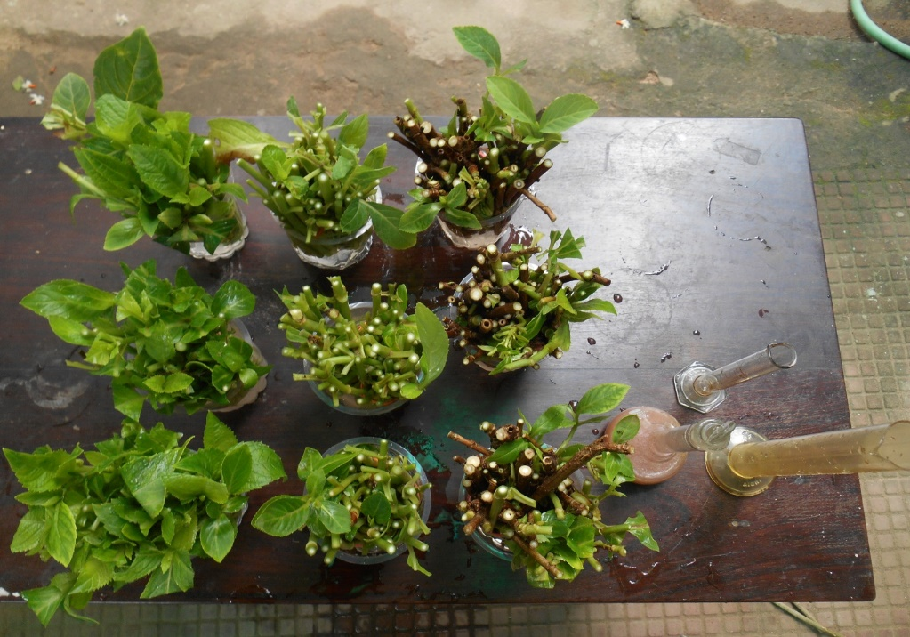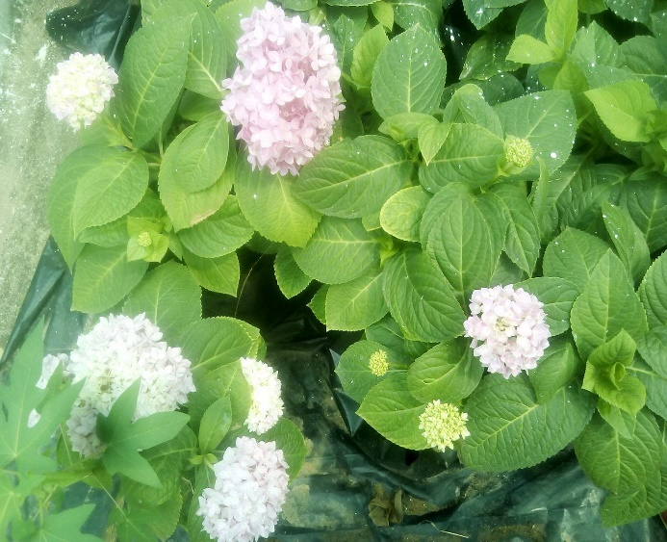

**Fig.1. Mother plants**

**Fig.2. Collection of different cuttings (softwood, semi hardwood and hardwood cuttings)**

* **Experimental design:** Factorial CRBD
* **Number of treatments:** 36
* **Number of replications:** 3
* **Number of cuttings/trays:** 45
* **Number of cuttings/treatments**: 15
* **Number of cuttings/replications**: 5

**Table 1- Characteristics of different mediums**

|  |  |  |  |  |
| --- | --- | --- | --- | --- |
| **CHARECTERISTICS** | **SAND** | **PERLITE** | **VERMICULITE** | **SOILRITE** |
| 1. Formation | The result of weathering of various rocks. | It is a grey-white silicaceous material, is of volcanic origin, mined from lava flows. | It is a micaceous mineral that expands markedly when heated. | It is comprised of both organic and inorganic components. |
| 2. particle size | 0.05-2.0 mm in diameter. | 1.6-3 mm in diameter. | Graded to four sizes: 1. 5-8 mm, 2. 2-3 mm, 3. 1-2 mm & 4. 0.75-1 mm. | 0.002 mm in diameter. |
| 3. pH | Neutral | 6-8 | Neutral | 6.5-7 |
| 4. Buffering capacity | No | No | Good buffering property. | No |
| 5. CEC | No | No | High | High |
| 6. Weight | About 45 kg cubic meter (100 lb cubic foot). | 80-100 kg cubic meter (5-8 lb cubic foot). | 90-150 kg per cubic meter (6-10 lb per cubic foot). | 1-1.3 tons per cubic meter (74-110 lb per cubic foot). |
| 7. Minerals | Depending upon type of rock.  Quartz sand, consisting chiefly of silica complex. | Contains no mineral nutrients. | It contains magnesium and potassium. | Contains Organic minerals. |
| 8. Use | Generally used for propagation purposes. | Useful in increasing aeration and very popular rooting medium for cuttings. | Used for [growing media for hydroponics](https://en.wikipedia.org/w/index.php?title=Growing_media_for_hydroponics&action=edit&redlink=1) and Propagating media. | Propagation medium in commercial horticulture. |
| 9. Water holding capacity | It holds 1-2 times of its weight of water. | It holds 3-4 times of its weight of water. | It holds 2-4 times of its weight of water. | It holds 6-8 times of its weight of water. |

**2.5 Treatment details**

T1 = Softwood cuttings + IBA 500 ppm + sand

T2 = Softwood cuttings + IBA 500 ppm + perlite

T3 = Softwood cuttings +IBA 500 ppm + vermiculite

T4 = Softwood cuttings +IBA 500 ppm + soil rite

T5 = Softwood cuttings +250 ppm IBA+ sand

T6 = Softwood cuttings +250 ppm IBA +perlite

T7 = Softwood cuttings +250 ppm IBA +vermiculite

T8 = Softwood cuttings +250 ppm IBA +soil rite

T9 = Softwood cuttings +control +sand

T10 = Softwood cuttings +control +perlite

T11 = Softwood cuttings +control +vermiculite

T12 = Softwood cuttings +control +soil rite

T13 = Semi hardwood cuttings +IBA 500 ppm + sand

T14 = Semi hardwood cuttings +IBA 500 ppm + perlite

T15 = Semi hardwood cuttings +IBA 500 ppm + vermiculite

T16 = Semi hardwood cuttings +IBA 500 ppm + soil rite

T17 = Semi hardwood cuttings +250 ppm IBA +sand

T18 = Semi hardwood cuttings +250 ppm IBA +perlite

T19 = Semi hardwood cuttings +250 ppm IBA +vermiculite

T20 = Semi hardwood cuttings +250 ppm IBA +soil rite

T21 = Semi hardwood cuttings +control +sand

T22 = Semi hardwood cuttings +control +perlite

T23 = Semi hardwood cuttings +control +vermiculite

T24 = Semi hardwood cuttings +control +soil rite

T25 = Hardwood cuttings +IBA 250 ppm + sand

T26 = Hardwood cuttings +IBA 250 ppm + perlite

T27 = Hardwood cuttings +IBA 250 ppm + vermiculite

T28 = Hardwood cuttings +IBA 250 ppm + soil rite

T29 = Hardwood cuttings +250 ppm IBA +sand

T30 = Hardwood cuttings +250 ppm IBA +perlite

T31 = Hardwood cuttings +250 ppm IBA +vermiculite

T32 = Hardwood cuttings +250 ppm IBA +soil rite

T33 = Hardwood cuttings +control +sand

T34 = Hardwood cuttings +control +perlite

T35 = Hardwood cuttings +control +vermiculite

T36 = Hardwood cuttings +control +soil rite

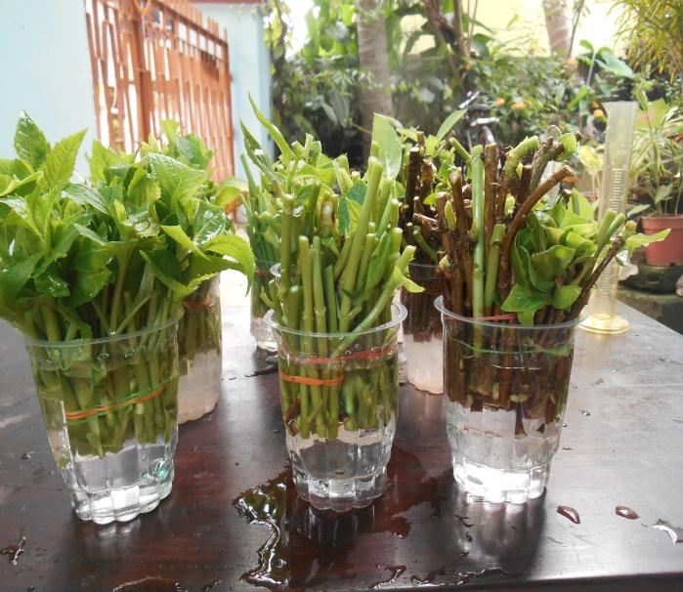

**Fig.3. Treatment of cuttings with different IBA concentrations**

**2.6 IBA treatment of cuttings** Selected cuttings were treated with IBA solution @ 250 ppm, 500 ppm and control. The bottom of the cuttings was soaked for 30 minutes in IBA solution. Care was taken to immerse the cuttings in solution by maintaining polarity so that distal end of the cuttings remained in solution. For controls distilled water was used and then the treated cuttings were removed from the respective solutions after 30 minutes. Fig.3.

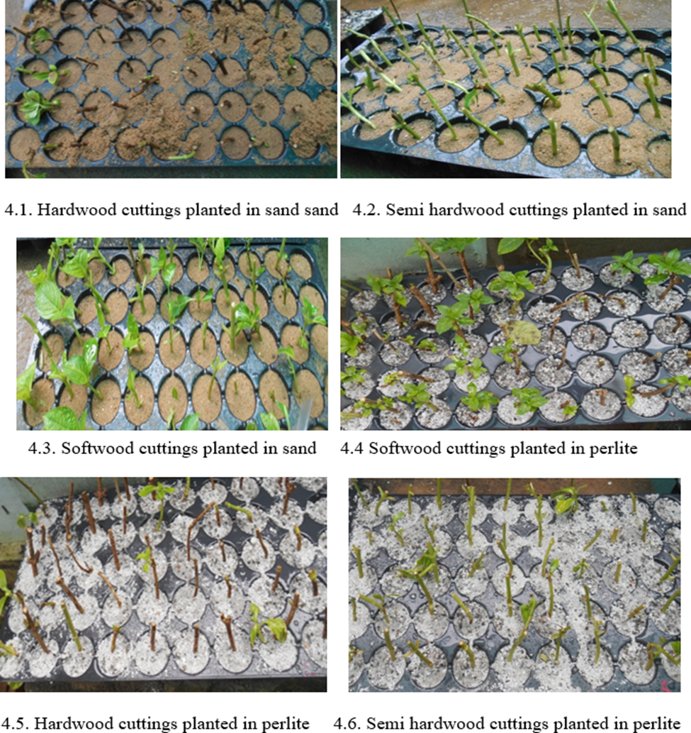

**Fig.4- Planting of cuttings in protrays in different media**

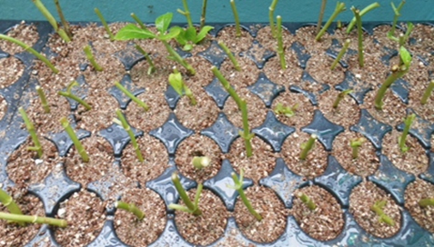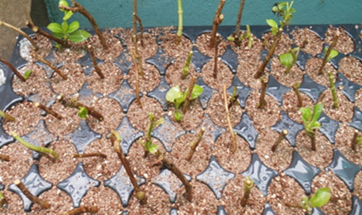

4.7. Hardwood cuttings planted in vermiculite 4.8. Semi hardwood cuttings planted in vermiculite

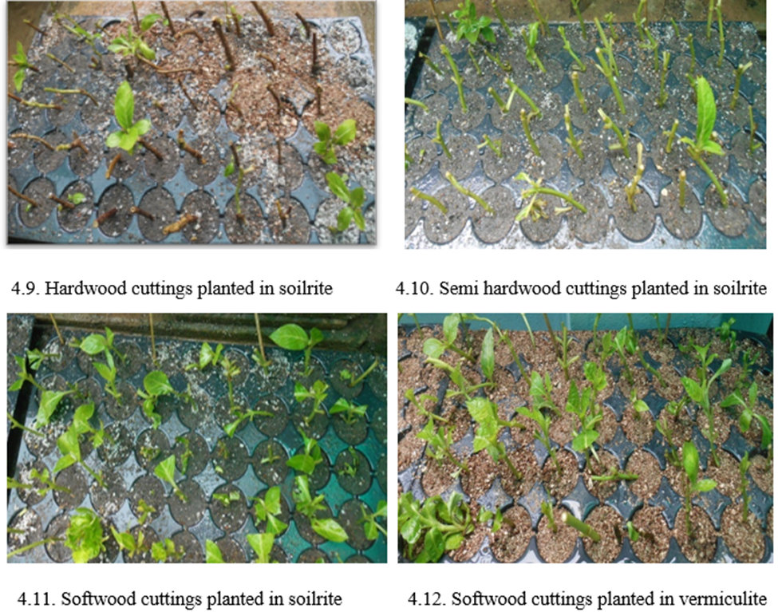

**2.7 Planting of cuttings**

Treated cuttings were planted immediately in portrays containing media after IBA treatment. Planting was done manually. A hole was made at centre of the medium with a stick and the cuttings were planted in the hole. The bottom of the cuttings was covered by media. All cuttings were planted as mentioned above, in the morning hours on 2nd September 2016. Fig.4.

**2.8 After care**

After planting the protrays were properly labelled and kept under agro shade net (75%). Care was taken to see that uniform sunlight fell on the protrays.

**2.9 Watering**

Watering was done by a rose cane in the morning hours. Watering was provided daily depending upon the media moisture condition.

**2.10 Plant protection**

The cuttings were sprayed with 0.1% solution of SAFAYA (carbendazim + mancozeb) at 15 days after planting as a preventive measure against soil borne pathogens. 2nd spraying was done after one month of 1st spraying.

**2.11 Removal of cuttings for observation**

Cuttings were removed with due care from protrays 75 days after planting and final observation on different characters were recorded.

**2.12 Observational Techniques**

**2.12.1**. **Survival per cent of cuttings**

Survival rate of cuttings was recorded at 30, 60 & 75days after planting. The number of cuttings that died were removed on due days.

**2.12.2. Number of leaves produced per cutting**

Number of leaves produced per cuttings at 45 & 60 days after of planting was counted and recorded.

**2.12.3. Length of the new growth per cuttings**

The length of the new growth per sprouted cuttings was measured by a scale expressed in cm at 45 & 60 days after planting and recorded.

**2.12.4. Number of roots produced per cuttings**

After careful uprooting, the total number of the roots produced per cuttings was counted at 75 days after planting and recorded.

**2.12.5. Length of the roots**

The length of the roots per cutting was measured by a scale in cm, at 75 days after of planting and recorded.

**2.13. Statistical Analysis**

Factorial CRBD was employed for studying the effect of types of cutting, growth regulator and media on different growth parameters and rooting study in the first experiment and CRBD was employed for growth and flowering in the second experiment investigation to analyze data.

Mean, standard error, analysis of variance and critical variances were calculated for different characters in the experiment. The percentage value do not follow the normal distribution, therefore they were transformed into their angular values and the transformed values were used for statistical analysis. Significant data for ‘F’ values were found out from ‘F’ table.

Standard error mean = $\sqrt{\frac{EMS}{r}}$

SE (m) ± for type of cuttings = $\sqrt{\frac{EMS}{r ×growth regulator×media}}$

SE (m) ± for growth regulator= $\sqrt{\frac{EMS}{r ×type of cuttings ×media}}$

SE (m) ± for media = $\sqrt{\frac{EMS}{r ×type of cutting ×growth regulator}}$

**3. RESULTS**

**Survival percentage of cuttings of Hydrangea macrophylla at 30, 60 and 75 days**

**3.1. Survival (%) of cuttings at 30 days after planting**

Observations on survival percentage of cuttings were recorded at 30 days after planting and the data so obtained were statistically analyzed and presented in Table-2.

From the Table-2 it was found that the survival percentage of cuttings at 30 DAP showed no significant result for type of cuttings. However, the highest survival at this stage was recorded for hardwood cuttings (56.7%) followed by softwood cuttings (49.4%) and semi hardwood cuttings (47.3%). Growth regulator treatments revealed a significant result for survival at 30 days among the different treatments. Control (73.1%) had the highest percentage of survival at 30 days followed by IBA 250 ppm treatment (48.2%) and IBA 500 ppm (31.5%). Media treatments significantly differed from each other. The highest percentage of success at this stage was observed with sand (62.7%) followed by perlite (59.4%), vermiculite (47.4%) and soilrite (34.8%).

**3.2. Survival (%) of cuttings at 60 days after planting**

Observations on survival percentage of cuttings were recorded at 60 days after planting and the data so obtained were statistically analyzed and presented in Table-3.

From the Table-3 it was found that the data on survival at 60 DAP revealed non-significant result for type of cuttings. However, highest survival was recorded with softwood cuttings (44.5%), semi hardwood cuttings (43.2%) and hardwood cuttings (42.9%). Growth regulator treatments revealed significant result. The highest survival was recorded with control (63.4%) and it was significantly reduced to (41.9%) with IBA 250 ppm and only (26%) in IBA 500 ppm. Significant difference was observed with media for survival per cent at 60 DAP. The highest survival percentage recorded with perlite (55.5%) followed by sand (52.2%). The lowest was recorded under soilrite (26.3%). Sand, vermiculite and soilrite remained at par.

**4.3. Survival (%) of cuttings at 75 days after planting**

Observations on survival percentage of cuttings were recorded at 75 days after planting and the data so obtained were statistically analyzed and presented in Table-4.

From the Table-4 the final survival of cuttings recorded at 75DAP before removal of cuttings to pots revealed no significant difference for types of cuttings. However, the highest percentage was with semi hardwood cuttings (33.6%) followed by softwood cuttings (30.3%) and lowest was recorded with hardwood cuttings (28.7%). Growth regulator treatments revealed a significant difference among the treatments and the highest was recorded with control (41.1%) and lowest was recorded with IBA 500 ppm (22.6%). Data recorded at 75 DAP for survival revealed significant difference for media. The highest survival was with sand (38.6%) followed by perlite (38.5%) and lowest was under soilrite (21.3%).

**Table 2- Effect of types of cutting, growth regulator and media on survival (%) of cuttings at 30 days after planting**

|  |  |  |  |  |  |  |  |
| --- | --- | --- | --- | --- | --- | --- | --- |
| **Type of cuttings** | **IBA Concentration (ppm)** | **Media** | | | | **Mean** | **Grand mean** |
| **Sand** | **Perlite** | **Vermiculite** | **Soilrite** |  |  |
| Softwood cuttings | IBA 500 ppm | 54.00 (47.30) | 60.00 (50.77) | 20.00 (26.56) | 20.00(26.56) | **37.5 (37.79)** |  |
| IBA 250 ppm | 60.7 (51.15) | 75.00 (60.00) | 20.00 (26.56) | 20.00  (26.56) | **43.1 (41.06)** |  |
| IBA 0ppm (control) | 97.7 (81.15) | 97.7 (81.15) | 26.3  (30.78) | 20.00  (26.56) | **67.00 (54.91)** |  |
| **Mean** | **74.8 (59.87)** | **80.7 (63.97)** | **22.00 (27.97)** | **20.00 (26.56)** |  | **49.4 (44.59)** |
| Semi  hardwood cuttings | IBA 500 ppm | 33.00 (35.01) | 20.00 (26.56) | 20.00 (26.56) | 33.00  (35.01) | **26.2 (30.78)** |  |
| IBA 250 ppm | 60.7 (51.15) | 39.4 (38.85) | 39.4  (38.85) | 47.00  (43.08) | **46.6 (42.98)** |  |
| IBA 0ppm (control) | 67.7 (55.37) | 60.7 (51.15) | 97.9  (81.15) | 39.4  (38.85) | **69.7 (56.63)** |  |
| **Mean** | **53.8 (47.17)** | **39.4 (38.85)** | **56.6**  **(48.76)** | **39.5**  **(38.98)** |  | **47.3 (43.44)** |
| Hardwood cuttings | IBA 500 ppm | 20.00 (26.56) | 26.3 (30.78) | 46.00 (42.70) | 33.00  (35.01) | **30.9 (33.76)** |  |
| IBA 250 ppm | 59.6 (50.51) | 60.7 (51.15) | 67.7  (55.37) | 32.3  (34.63) | **55.1 (47.91)** |  |
| IBA 0ppm (control) | 91.6 (73.08) | 80.00 (63.44) | 80.00 (63.44) | 73.9  (59.22) | **81.8 (64.79)** |  |
| **Mean** | **58.8 (50.05)** | **56.0 (48.45)** | **65.2**  **(53.83)** | **46.4**  **(42.95)** |  | **56.7 (48.82** |
| IBA 500 ppm | | 35.0 (36.29) | 34.6 (36.04) | 28.0  (31.94) | 28.4  (32.19) |  | 31.5 (34.11) |
| IBA 250 ppm | | 60.3 (50.94) | 58.7 (50.00) | 41.8  (40.26) | 31.5  (34.16) |  | 48.2 (43.98) |
| IBA 0ppm (control) | | 88.2 (69.86) | 82.5 (65.24) | 72.6  (58.46) | 43.9  (41.54) |  | 73.1 (58.77) |
| **Grand Mean** | | **62.7 (52.36)** | **59.4 (50.42)** | **47.4**  **(43.52)** | **34.8**  **(36.16)** |  |  |

|  |  |  |  |
| --- | --- | --- | --- |
| **Effects** | **‘F’ Test** | **SE(M)±** | **CD at 5%** |
| Types of cuttings | NS | - | - |
| Growth regulator concentration (ppm) | ** | 2.07 | 5.85 |
| Media | ** | 2.39 | 6.76 |

**\* =** significant at 5 % level. **= significant at 1 % level. (Figures in parenthesis indicate the corresponding angular values)

**Table 3- Effect of types of cutting, growth regulator and media on survival (%) of cuttings at 60 days after planting**

|  |  |  |  |  |  |  |  |
| --- | --- | --- | --- | --- | --- | --- | --- |
| **Type of cuttings** | **IBA Concentration (ppm)** | **Media** | | | | **Mean** | **Grand mean** |
| **Sand** | **Perlite** | **Vermiculite** | **Soilrite** |  |  |
| Softwood cuttings | IBA 500 ppm | 47.00  (43.08) | 46.00  (42.70) | 20.00  (26.56) | 20.00  (26.56) | **32.4**  **(34.72)** |  |
| IBA 250 ppm | 54.00  (47.30) | 75.00  (60.00) | 20.00  (26.56) | 20.00  (26.56) | **41.4**  **(40.10)** |  |
| IBA 0ppm (control) | 90.8  (72.29) | 94.9  (76.92) | 20.00  (26.56) | 20.00  (26.56) | **59.7**  **(50.58)** |  |
| **Mean** | **65.9**  **(54.22)** | **74.8**  **(59.87)** | **20.00**  **(26.56)** | **20.00**  **(26.56)** |  | **44.5**  **(41.80)** |
| Semi  hardwood cuttings | IBA 500 ppm | 26.3  (30.78) | 20.00  (26.56) | 20.00 (26.56) | 20.00  (26.56) | **21.5**  **(27.61)** |  |
| IBA 250 ppm | 53.4  (46.92) | 39.4  (38.85) | 32.3 (34.63) | 40.00  (39.23) | **41.2**  **(39.90)** |  |
| IBA 0ppm (control) | 67.7  (55.37) | 67.7  (55.37) | 97.7  (81.15) | 26.3  (30.78) | **68.2**  **(55.66)** |  |
| **Mean** | **48.9**  **(44.35)** | **43.5**  **(40.26)** | **54.3**  **(47.44)** | **28.4**  **(32.19)** |  | **43.2**  **(41.06)** |
| Hardwood cuttings | IBA 500 ppm | 20.00  (26.56) | 20.00  (26.56) | 32.3  (34.63) | 26.3  (30.78) | **24.5**  **(29.63)** |  |
| IBA 250 ppm | 47.00  (43.08) | 47.00  (43.08) | 53.4  (46.92) | 26.3  (30.78) | **43.00**  **(40.96)** |  |
| IBA 0ppm (control) | 60.7  (51.15) | 80.00  (63.44) | 67.1  (54.99) | 40.00  (39.23) | **62.5**  **(52.20)** |  |
| **Mean** | **43.5**  **(40.26)** | **48.9**  **(44.36)** | **50.9**  **(45.51)** | **30.6**  **(33.59)** |  | **42.9**  **(40.93)** |
| IBA 500 ppm | | 30.5  (33.47) | 28.0  (31.94) | 23.8  (29.25) | 22.0  (27.97) |  | 26.0  (30.65) |
| IBA 250 ppm | | 51.3  (45.77) | 54.0  (47.31) | 34.6  (36.04) | 28.4  (32.19) |  | 41.9  (40.32) |
| IBA 0ppm (control) | | 74.4  (59.60) | 82.4  (65.24) | 65.8  (54.23) | 28.4  (32.19) |  | 63.4  (52.81) |
| **Grand Mean** | | **52.2**  **(46.27)** | **55.5**  **(48.16)** | **41.00**  **(39.83)** | **26.3**  **(30.78)** |  |  |

|  |  |  |  |
| --- | --- | --- | --- |
| **Effects** | **‘F’ Test** | **SE(M)±** | **CD at 5%** |
| Types of cuttings | NS | - | - |
| Growth regulator concentration (ppm) | ** | 1.81 | 5.12 |
| Media | ** | 2.09 | 5.92 |

**\* =** significant at 5 % level. **= significant at 1 % level. (Figures in parenthesis indicate the corresponding angular values)

**Table 4- Effect of types of cutting, growth regulator and media on survival (%) of cuttings at 75 days after planting**

|  |  |  |  |  |  |  |  |
| --- | --- | --- | --- | --- | --- | --- | --- |
| **Type of cuttings** | **IBA Concentration (ppm)** | **Media** | | | | **Mean** | **Grand mean** |
| **Sand** | **Perlite** | **Vermiculite** | **Soilrite** |  |  |
| Softwood cuttings | IBA 500 ppm | 33.00  (35.01) | 39.4  (38.85) | 20.00  (26.56) | 20.00  (26.56) | **27.7**  **(31.74)** |  |
| IBA 250 ppm | 32.3  (34.63) | 39.4  (38.85) | 20.00  (26.56) | 20.00  (26.56) | **27.6**  **(31.65)** |  |
| IBA 0ppm (control) | 53.4  (46.92) | 53.4  (46.92) | 20.00  (26.56) | 20.00  (26.56) | **35.8**  **(36.74)** |  |
| **Mean** | **39.4**  **(38.85)** | **44.00**  **(41.54)** | **20.00**  **(26.56)** | **20.00**  **(26.56)** |  | **30.3**  **(33.37)** |
| Semi  hardwood cuttings | IBA 500 ppm | 20.00  (26.56) | 20.00  (26.56) | 20.00  (26.56) | 20.00  (26.56) | **20.00**  **(26.56)** |  |
| IBA 250 ppm | 46.00  (42.70) | 32.3  (34.63) | 26.3  (30.78) | 33.00  (35.01) | **34.2**  **(35.78)** |  |
| IBA 0ppm (control) | 60.7  (51.15) | 60.7  (51.15) | 53.4  (46.92) | 20.00  (26.56) | **48.2**  **(43.94)** |  |
| **Mean** | **41.5**  **(40.13)** | **36.9**  **(37.44)** | **32.5**  **(34.75)** | **24.1**  **(29.37)** |  | **33.6**  **(35.42)** |
| Hardwood cuttings | IBA 500 ppm | 20.00  (26.56) | 20.00  (26.56) | 20.00  (26.56) | 20.00  (26.56) | **20.00**  **(26.56)** |  |
| IBA 250 ppm | 33.00  (35.01) | 32.3  (34.63) | 26.3  (30.78) | 20.00  (26.56) | **29.2**  **(31.74)** |  |
| IBA 0ppm (control) | 54.00  (47.30) | 53.4  (46.92) | 33.00  (35.01) | 20.00  (26.56) | **39.5**  **(38.94)** |  |
| **Mean** | **35.1**  **(36.29)** | **34.6**  **(36.03)** | **26.2**  **(30.78)** | **20.00**  **(26.56)** |  | **28.7**  **(32.40)** |
| IBA 500 ppm | | 24.1  (29.38) | 26.0  (30.66) | 20.0  (26.56) | 20.0  (26.56) |  | 22.6  (28.28) |
| IBA 250 ppm | | 36.9  (37.45) | 34.6  (36.04) | 24.1  (29.38) | 24.1  (29.38) |  | 29.7  (33.03) |
| IBA 0ppm (control) | | 56.0  (48.46) | 55.8  (48.33) | 34.8  (36.16) | 20.0  (26.56) |  | 41.1  (39.87) |
| **Grand Mean** | | **38.6**  **(38.42)** | **38.5**  **(38.33)** | **26.1**  **(30.69)** | **21.3**  **(27.49)** |  |  |

|  |  |  |  |
| --- | --- | --- | --- |
| **Effects** | **‘F’ Test** | **SE(M)±** | **CD at 5%** |
| Types of cuttings | NS | - | - |
| Growth regulator concentration (ppm) | ** | 1.44 | 4.06 |
| Media | ** | 1.66 | 4.69 |

**\* =** significant at 5 % level. **= significant at 1 % level. (Figures in parenthesis indicate the corresponding angular values)

**5. DISCUSSION**

The success of vegetative propagation in *Hydrangea macrophylla* is closely linked to the survivability of stem cuttings, which depends on several factors including cutting type, media composition, and application of plant growth regulators. In this study, survival percentages were assessed at multiple stages (30, 60, and 75 days after planting) to evaluate the influence of these variables under Bhubaneswar's humid tropical conditions. At 30 days after planting, the survival rate was highest under control (0 ppm IBA) treatments, particularly with softwood and semi-hardwood cuttings planted in sand or perlite. This suggests that the natural rooting potential of hydrangea may be sufficient without exogenous auxin application, especially under conditions of high ambient temperature and humidity. The decline in survival rate with increasing IBA concentrations, particularly at 500 ppm, indicates a possible phytotoxic effect, which aligns with findings by Widiastoety et al. (1988) who reported optimal rooting of *Hibiscus rosa-sinensis* at low IBA levels. As the propagation period progressed to 60 and 75 days, overall survival rates declined, likely due to physiological stress on the cuttings in the warm climate. By 75 DAP, the highest survival (33.6%) was recorded in semi-hardwood cuttings treated with no IBA and grown in sand or perlite. This trend highlights the importance of cutting maturity and media aeration in maintaining cutting viability during prolonged rooting periods. The lack of significant differences among cutting types suggests that survival was influenced more by media and growth regulator levels than by cutting woodiness. The superior performance of sand and perlite across time points may be attributed to their high porosity, good drainage, and moderate water-holding capacity. Similar results were reported by Chong et al. (1996), who found perlite to be an ideal medium for propagation due to its aeration and moisture retention properties. In contrast, soilrite and vermiculite, though commonly used in horticulture, were less effective in this study, possibly due to water retention leading to poor aeration and increased susceptibility to microbial activity in the tropical environment. Interestingly, callus formation was not prominently observed, and root initiation appeared to occur directly from the bark tissue, a rooting pattern consistent with anatomical observations in sweet potato and other species (Jacobs *et al*., 1990). This supports the notion that hydrangea roots may originate from pre-differentiated cell zones rather than *de novo* callus, emphasizing the need for immediate post-planting care to maintain cutting turgor and tissue integrity. The low efficacy of IBA treatments, particularly at higher concentrations, contrasts with studies where auxin significantly improved rooting. Reily and Carroll (2002) noted that certain ornamental plants root efficiently without auxin in moist, well-drained media, which corresponds to the high survival seen in the untreated control group here. Additionally, Candido et al. (2012) demonstrated that physiological status at collection time impacts rooting, which may explain why cuttings taken post-flowering in a high-temperature environment showed limited response to hormone application.

Overall, the findings indicate that semi-hardwood cuttings planted in sand or perlite without auxin treatment offer the best survival outcomes for *Hydrangea macrophylla* under Bhubaneswar conditions. This suggests that for tropical propagation, emphasis should be placed on cutting maturity and media optimization rather than hormonal enhancement. These results are particularly relevant for expanding hydrangea cultivation to non-traditional climates, where tailored propagation protocols are essential.

**CONCLUSION**

The present study highlights the significant influence of media type and IBA concentration on the survival of *Hydrangea macrophylla* cuttings under Bhubaneswar's tropical conditions. Among the treatments tested, semi-hardwood cuttings planted in sand or perlite without IBA application consistently recorded the highest survival percentages across all observation periods. In contrast, higher IBA concentrations (especially 500 ppm) negatively impacted survival, likely due to auxin-induced physiological stress under warm, humid conditions.

These findings suggest that exogenous application of IBA is not essential for ensuring high survival in hydrangea cuttings when appropriate cutting type and well-aerated media are used. Sand and perlite, due to their excellent drainage and aeration properties, proved to be the most effective media for maintaining cutting viability.

The study provides a region-specific propagation strategy for successful establishment of *Hydrangea macrophylla* in non-traditional, lowland tropical environments. This can facilitate the commercial expansion of hydrangea cultivation in new agro-climatic zones by promoting cost-effective and efficient propagation methods.

COMPETING INTERESTS DISCLAIMER:

Authors have declared that they have no known competing financial interests OR non-financial interests OR personal relationships that could have appeared to influence the work reported in this paper.

**REFERENCES**

Bhattacharjee, S. K. (1986). *Advances in Ornamental Horticulture* (**Vol. 1**). Pointer Publishers.

Candido, W. S., Silva, E. F. F., & Neves, L. G. (2012). Cutting propagation of Croton zehntneri Pax et Hoffm.: influence of phenological stage, substrate and plant growth regulators. Revista Brasileira de Plantas Medicinais, **14**(1), 42–47. <https://doi.org/10.1590/S1516-05722012000100006>

Chong, C., Paling, R. N., & Lumis, G. P. (1996). Growth and mineral nutrition of container nursery crops in bark- and coir-based media with two fertilizer regimes. *HortScience*, **31**(2), 209–214. https://doi.org/10.21273/HORTSCI.31.2.209

Jacobs, W. P., & colleagues. (1990). The physiology of plant growth and development. Holt, Rinehart and Winston.

Jena, S. S., Tripathy, L., Beura, S., Dash, S. K., Maharana, K., & Jena, P. (2025). In vitro Optimization of Protocol for Micropropagation in Cordyline [Cordyline terminalis (L.) Kunth]. *Journal of Advances in Biology & Biotechnology*, ***28***(6), 880–912. <https://doi.org/10.9734/jabb/2025/v28i62449>

Jena, S. S., Tripathy, L., Maharana, K., & Jena, P. (2025). Bioenzyme-mediated Growth Enhancement in Cordyline (Cordyline terminalis): A Developmental Study. *PLANT CELL BIOTECHNOLOGY AND MOLECULAR BIOLOGY*, *26*(7-8), 116–132. <https://doi.org/10.56557/pcbmb/2025/v26i7-89396>

Jena, S. S., Jena, P., Paul, M., Singh, S. K., David, K. M., & Nagaraju, D. (2025). Advances in micropropagation of Cordyline terminalis: A critical review of In vitro techniques and optimization strategies. *Int. J. Agric. Food Sci*., **7**(6):283-291. DOI: <https://doi.org/10.33545/2664844X.2025.v7.i6d.469>

Luz, J. M. Q., de Carvalho, A. J. C., & Mendonça, V. (2007). Propagation of croton by stem cuttings in different substrates. *Revista Brasileira de Horticultura Ornamental*, **13**(1), 55–59.

Reily, E. H., & Carroll, S. B., Jr. (2002). Introductory Horticulture (6th ed.). Delmar Cengage Learning.

Sahoo, T. T., Maharana, K., Beura, S., & Jena, S. S. (2025). Effect of Indole-3-butyric Acid, Aspirin and Natural Plant Extracts on Rooting of Chrysanthemum (Dendranthema grandiflora L.) cv. Flirt. *Asian Journal of Research in Biochemistry*, ***15***(4), 30–50. <https://doi.org/10.9734/ajrb/2025/v15i4405>

Widiastoety, D., Soemarna, K., & Manuhara, G. J. (1988). Effect of plant growth regulators on rooting of Hibiscus rosa-sinensis cuttings. *Indonesian Journal of Horticulture*, **6**(2), 77–82.