**Review Article**

**GENETIC ENHANCEMENT OF TOMATO (Solanum lycopersicum L.) FOR HEAT AND WATERLOGGING STRESS**

**Abstract**

Tomato (Solanum lycopersicum L.), a globally important crop, suffers significant yield losses under hot and wet environmental conditions. High temperatures cause poor pollen viability, sunscald, flower drop, and reduced fruit set. Excess water leads to oxygen deficiency, root damage, and plant mortality. Both additive and non-additive genetic effects play a role in developing tolerance to these stresses. Hybrids such as BGH-0025 × BGH-0468 and Nagcarlang LA-2661 perform well under high temperatures, showing better fruit set and yield. In waterlogged conditions, grafting onto eggplant rootstocks like Arka Nilkanth and tomato lines L 150 and L 191 enhances survival, recovery and fruit production. Combining conventional breeding with grafting improves resilience in hot-wet climates. Emphasis on traits like fruit quality, stress tolerance and rootstock compatibility can lead to more sustainable tomato production. High-throughput phenotyping and molecular tools can further accelerate the development of climate-resilient cultivars.

**INTRODUCTION**

Vegetables serve as the expansive gateway, inviting eager gardeners into a world brimming with diversity, flavor and nutritional abundance. Tomatoes, often regarded as the gateway plant for budding geneticin and plant breeders, beckon with their vibrant colors and genetic mysteries. Tomato (*Solanum lycopersicum* L., 2n = 2x = 24) is one of the most widely grown vegetable crop in both tropics and sub tropics of the world (Zhang et al., 2022). It belongs to the family *Solanaceae* and ranks second in importance among vegetables. The center of origin of tomato is believed to be tropical America from Peruvian and Mexican regions. Tomato originated in wild form in Ecuador, Peru and Bolivia of South America (center of diversity of wild tomato). In India, it was introduced by English traders of the East India Company in 1822. While exhibiting a tendency towards cleistogamy, wherein self-pollination prevails due to the enclosed nature of the flower; though, minor yet notable incidence of natural cross-pollination can occur, facilitated predominantly by insects.

Tomato is a perennial herbaceous plant, although often grown outdoors as an annual, in a broad range of ecological conditions; i.e., high altitudes of Himalayas to plains of South India. It grows both under field as well as in poly-house cultivation throughout the year. The tomato plants of the most cultivated species *Solanum lycopersicum* L. have both determinate and indeterminate growth habit. The plant typically grows 3 to 10 feet in height and has a weak stem that often sprawls over the ground and vines over other plants. It bears a berry consisting of seeds with a fleshy pericarp developed from the ovary. The cleistogamy flower of the crop leads to high percentage of self-pollination (Ramírez & Kallarackal, 2019). However, natural cross-pollination has been reported up to the extent of 5 per cent and insects play a major role for cross pollination (Salunkhe *et al*., 1987).

Tomato also ranks first in the list of processed vegetables in the world as numbers of products are prepared from tomato *viz*., ketchup, paste, soup, *etc*. Tomato is consumed in diverse ways, including raw, as an ingredient in many dishes of cooked vegetables, sauces, salads and drinks. Tomato cultivation has become increasingly popular since the mid-nineteenth century because of its varied climatic tolerance and high nutritive value.

Nutritional concerns additionally bring the tomato as a beneficial fruit in the human diet. Tomato is an important supply of many micronutrients, bound minerals (specially, potassium). Additionally, it is rich in different organic acids like ascorbic, citric, malic, fumaric and oxalic acids. Tomato also represents one of the most important sources of vitamins and minerals for the human diet, since they are frequently consumed uncooked. Tomatoes are consumed widely throughout the world and their consumption has recently been demonstrated to possess health benefits because of their rich content of phytonutrients. They contain carotenoids (in particular, lycopene), vitamin C, vitamin E, folate and flavonoids. Regular consumption of tomatoes has been correlated with a reduced risk of various types of cancer and heart diseases. Tomato aside from being tasty, promotes healthy nutritional balance as it is a good source of high energy value of 74 kJ, carbohydrate 3.9 g, dietary fibre 1.2 g, β-carotene 449 μg, lycopene 2573 μg, vitamin A 42 μg and vitamin C 14 mg 100 g-1 of fruit. Ascorbic acid of the tomato fruit is also an important antioxidant, and hence plays a protective role against the many diseases that are produced by reactive oxygen, mostly the superoxide (Aoun *et al*., 2013; Waheed et al., 2020).

Tomato is also known as “poor man′s apple” due to the micronutrients existing at low concentration. Because of its round the year availability and high consumption rate, it may provide significantly to the total intake of these compound to all. Therefore, tomato is one of the most important “protective foods” for its special nutritive value. Tomato has several medicinal values; *i.e*., the pulp and juice of the fruit were found as mild aperients, a promoter of gastric secretions and blood purifier. It is also considered as good antiseptic for the intestine. Several epidemiological studies indicated beneficial effects of tomato consumption in the prevention of some major chronic diseases such as cancer and cardiovascular diseases. The fruit is rich in lycopene, which may have beneficial health effects and considered as the “world′s most powerful natural antioxidant”.

Worldwide, China is the major tomato growing country followed by India, Turkey, Egypt, Iran, USA, Mexico, Italy, Brazil and Spain. Odisha, Madhya Pradesh, Karnataka, West Bengal, Andhra Pradesh, Telangana, Chhattisgarh, Bihar, Gujarat and Maharashtra were the main tomato growing states in the country. Total area of India under tomato cultivation was 8.65 lakh hectares with production of 210.56 lakh tonnes and the average productivity was 24.34 tonnes/ha during 2021 [Agricultural statistics at a glance (2022)].

The production data shows that tomato production have moderated by 0.35% from 206.9 lakh tonnes in 2021-22 to 206.2 lakh tonnes in 2022-23. It has fallen by -2.3% during 2021-22 after remaining stagnant during 2020-21 and increasing by 11.5% in the year 2019-20 (Figure 1). The fall in production in 2022-23 is driven by the fall in production in major states like Gujarat (-23.9%), Tamil Nadu (-26.10%) and Chhattisgarh (-19.7%). Gujarat had deficient rainfall in the previous season and Tamil Nadu and Chhattisgarh have been witnessing fall in a year followed by increase in production in next-year.

**Table 1. Area, share and production of tomato.**

|  |  |  |  |
| --- | --- | --- | --- |
| **State** | **Share (%)** | **Area**  **(Thousand ha)** | **Production**  **(Kg/ha)** |
| M.P. | 14.63 | 113.77 | 3249.82 |
| A.P. | 10.92 | 54.16 | 2337.66 |
| Karnataka | 10.23 | 68.34 | 2198.04 |
| Odisha | 7.06 | 107.16 | 1609.09 |
| Gujarat | 6.87 | 49.71 | 1444.38 |
| WB | 6.33 | 60.20 | 1292.68 |
| Tamil Nadu | 6.18 | 41.53 | 1249.74 |
| Maharashtra | 6.00 | 57.00 | 1111.42 |
| Bihar | 5.40 | 62.81 | 1166.87 |

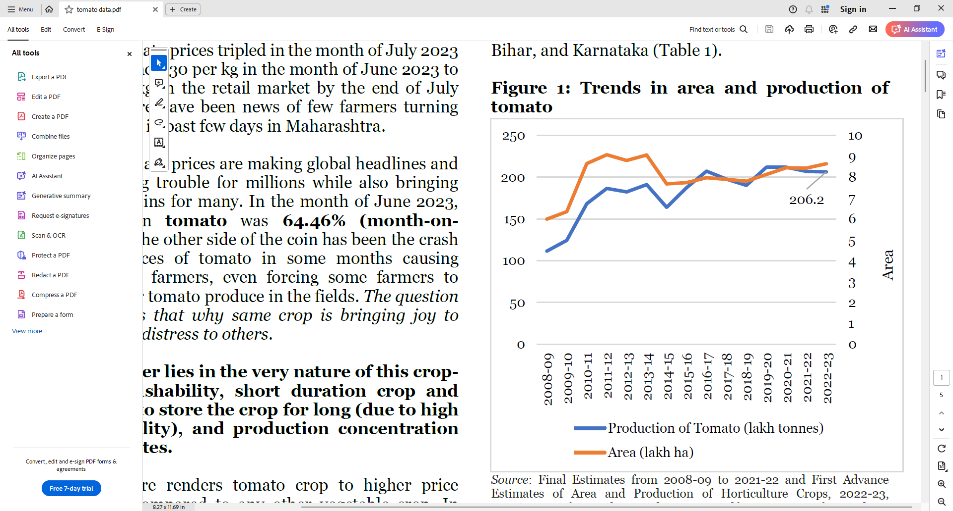

**Fig. 1. Area and production of tomatoes**

**Trends in market arrival and retail price**

The price line (blue line, Figure 2) is a water image of tomato arrival line with every peak accompanying a low point in market arrival (red line). Figure 2 showcases the same peak in prices in the month of July every year accompanied by fall in arrivals during the same month. Such fluctuation in production within an agricultural year ensures stagnant or minimal change in production year over the year. Currently, the prices of tomato in the retail market is at high of past 3 years. The prices have increased further in the last week of July and the first week of August 2023. Price on 10th August 2023 was 304% higher in the wholesale market and 284% higher in retail market in comparison to prices a year ago. The roots of the tomato crisis go back to last year’s extreme weather in states such as Maharashtra and Karnataka, followed by damage to crops this year too. A hailstorm in March, April and May 2023 destroyed large swathes of tomato crop in Maharashtra, which is a major supplier during the monsoon months. Similarly rains in Karnataka in last fortnight of July 2023 further intensified the crises.

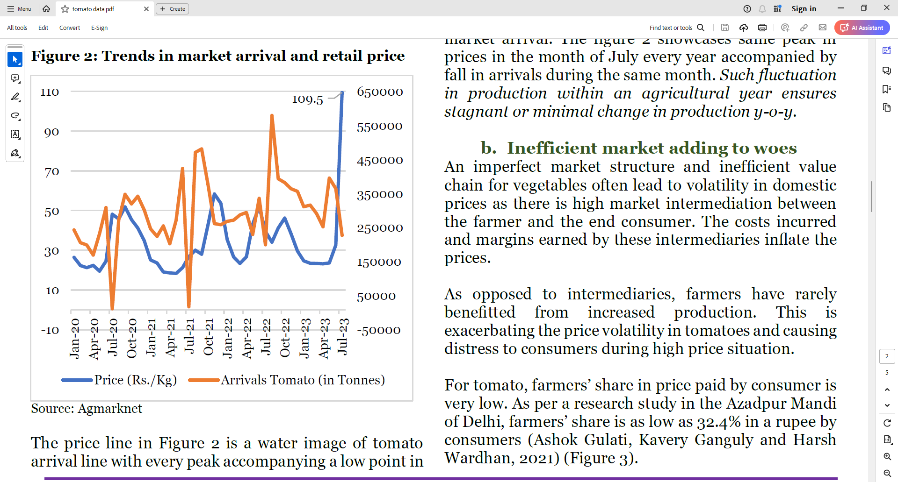

**Fig 2. Plot of the price and arrival time of tomatoes**

**Table 2. Wholesale and retail prices of tomatoes**

|  |  |  |
| --- | --- | --- |
| **Particular** | **Wholesale Price (Rs. / Kg)** | **Retail**  **(Rs. / Kg)** |
| 10-07-23 | 86.31 | 105.42 |
| 30-07-23 | 104.0 | 126.18 |
| 31-07-23 | 108.5 | 130.2 |
| 01-08-23 | 110.7 | 132.57 |
| 09-08-23 | 109.18 | 131.69 |
| 10-08-23 | 106.91 | 131.69 |

The unseasonal rain in May 2023 in major tomato producing states resulted in diminished tomato yields and damaged the crop in these areas. For instance, as per the data released by Ministry of Earth Sciences, rainfall for the month of May 2023 in the Eastern and Western Madhya Pradesh regions was in excess by 377% and 386% respectively, from the normal rainfall for the month. Saurashtra & Kutch, Gujarat Region, Rayalaseema, Coastal Andhra Pradesh, South Interior Karnataka, and North Interior Karnataka also experienced precipitation that was significantly higher than average, at 764%, 233%, 68%, 63%, 36% and 18%, respectively from the normal for the month. In 2022, abrupt rainfall followed by extreme heat led to an explosion in the number of plant viruses transmitted by aphids that feed on tomato plants, especially in both Maharashtra and Karnataka states. For example, farmers in Maharashtra have said that attacks by the cucumber mosaic virus have impacted their tomato crop, while growers in Karnataka and other South Indian states have attributed crop losses to the tomato mosaic virus. Tomato growers have reported a rise in these two viruses' invasion over the past three years, which has resulted in partial to complete crop losses.

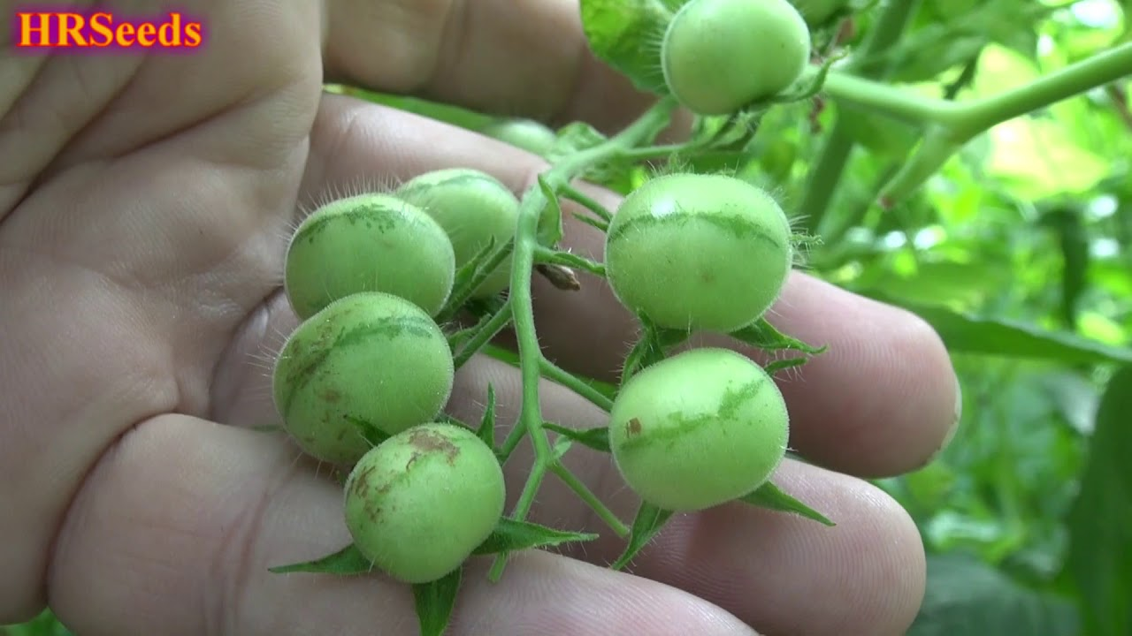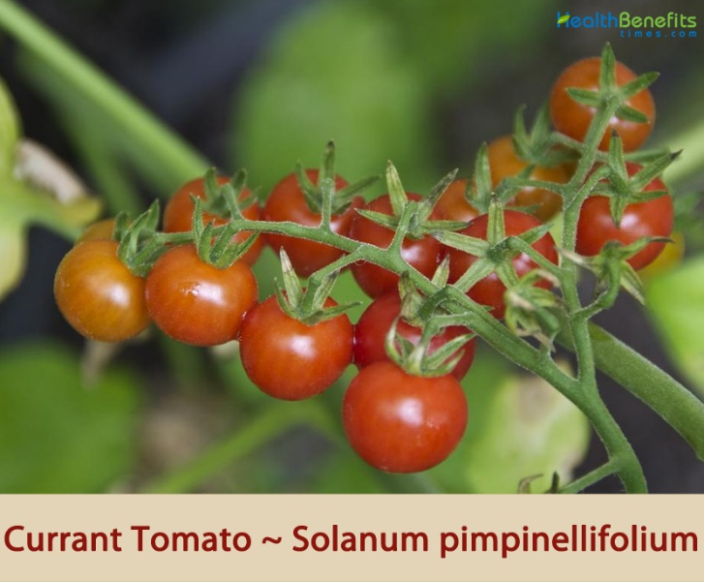 **Currant Tomato- *Solanum pimpinellifolium*** **Green Tomato- *Solanum habrochaites***

**FOR HOT CONDITIONS**

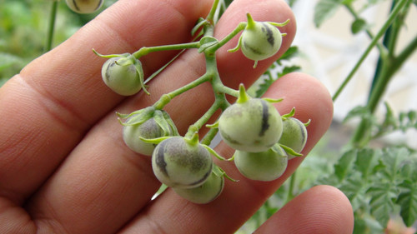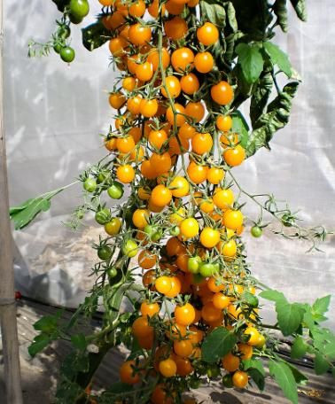**Galapagos Tomato*- Solanum cheesmaniae*  Desert Tomato*- Solanum chilense***

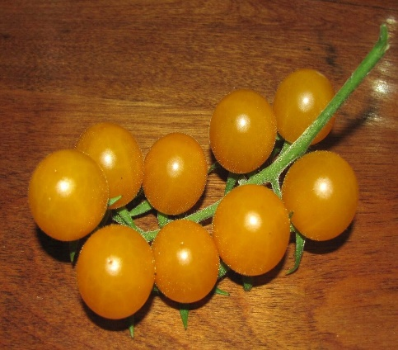

**FOR WET CONDITIONS**

**Fig 3. Wild relatives of the tomato**

Wild relatives of crops offer vital genetic diversity for breeding programs, enhancing traits like resilience to pests, diseases and environmental stresses, ensuring sustainable agriculture and food security in the face of challenge like climate change. In hot conditions, wild tomato relatives offer genes for heat tolerance and drought resistance, enabling the development of tomato varieties adapted to high temperatures and water scarcity. In wet conditions, these relatives provide traits for disease resistance and improved drainage, aiding in the cultivation of tomatoes in humid environments prone to fungal diseases and excess moisture.

**Effect of hot condition**

Hot conditions for tomatoes typically refer to temperatures that exceed the optimal range for tomato growth and development, causing stress to the plants. Optimum temperature for tomato during night is 15-20 °C and in day is 21-30 °C. While tomatoes thrive in warm temperatures, excessive heat can negatively impact various physiological processes, leading to reduced yields and quality (Mitra, 2001). The specific temperature thresholds for heat stress (HS) can vary depending on factors such as tomato variety, stage of growth and duration of exposure, but generally, temperatures above 30 °C (86 °F) can start to induce heat stress in tomatoes (Zainab *et al*., 2016). Generally, temperature rises 10 to 15 °C above ambient can be considered as heat shock or heat stress (Boyer, 1982).

Plant response to HS varies according to developmental stage, species, genotype, and the timing of HS events. HS resistance is genetically diverse. Since their physiological mechanisms are equally diverse, we will first explain the physiological mechanisms and then explain the genetic diversity of HS resistance for breeding (Elsayed *et al*., 2015). Under HS, plants exhibit many physiological responses, such as abscission and senescence of leaves, growth inhibition of the shoots and roots, and fruit damage, resulting in a substantial decrease in plant productivity (Bhatia, 2004). Extreme HS affects performance and crop quality characteristics. The productivity decrease under HS has been attributed to decreased assimilatory capacity associated with reduced photosynthesis caused by altered membrane stability, enhanced maintenance respiration costs, and a reduction in radiation use efficiency. At the beginning of cultivation, reduced germination percentage, reduced plant emergence, abnormal seedlings, poor seedling vigour, and reduced radicle and plumule growth of germinated seedlings are major impacts of HS and have been documented in various cultivated plant species. When tomato plants are cultivated at 42 °C, they sustain severe damage at various stages of development, including seed germination, vegetative and reproductive growth, and fruit setting.

**Effects of heat stress on male parts of the flower**

* Lower pollen production
* Poor pollen viability
* Pollen sterility
* Flower desiccation
* Alteration of anther structure
* Impaired pollen tube growth
* Altered expression of reproductive gene

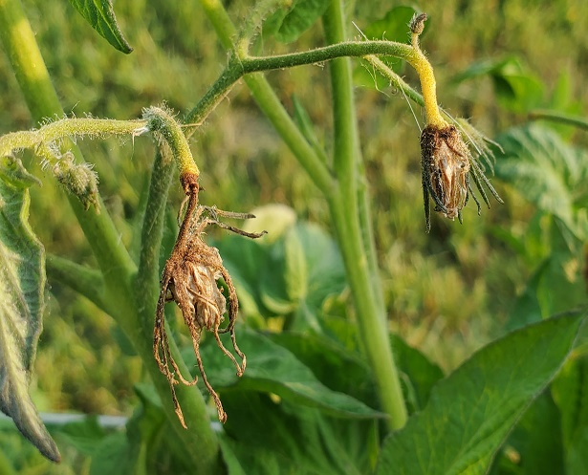**Fig 4. The effect of heat stress on the male parts of the flower**

**Effects of heat stress on the female parts of the flower**

* Stigma desiccation
* Decreased stigma secretions
* Pistil elongation
* Ovary abnormalities
* Poor ovule viability
* Increased abortion of ovule
* Embryo sac degeneration

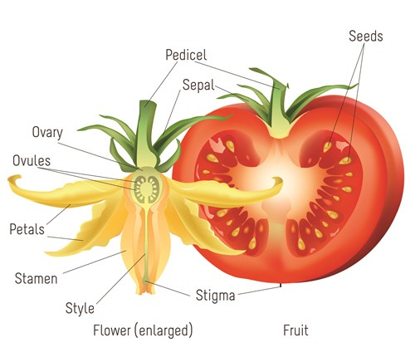

**Fig 5.** **Effects of heat stress on the female parts of the flower**

**Effect of wet conditions**

Wet conditions refer to environmental circumstances where there is a significant presence or accumulation of moisture, typically in the form of water, either in the soil, atmosphere or surrounding surfaces. Waterlogging is a global phenomenon and focal abiotic stress which affects crop growth and yield. It may refer to soil moisture levels that are higher than optimal for crop growth and affect plant health and productivity. Soil is considered waterlogged when the water content is 20% above field capacity and there is a free-standing water on the soil surface (Rivero *et al*., 2019). The primary effect of the waterlogging on tomato plants is hypoxia. Excessive water in the root zone leads to plant injuries due to the blockage of oxygen and other gas exchange between the soil and atmosphere because water fills the pore spaces in the soil. It is estimated that about 13% of the global land area and 16% of the tomato areas in production worldwide are prone to the risk of waterlogging (Bhatt *et al*., 2016). Tomato plants make three basic responses to waterlogging 1. Reduction in signal transductions including carbohydrate assimilation and photosynthate utilization, 2. Activation of fermentative pathways and 3. Morphological changes (formation of aerenchyma and adventitious roots).

**Physiological change in tomato during waterlogging conditions**

* Reduction in ATP production
* Reduced leaf area and early leaf senescence
* Decreased root hydraulic conductance and leaf water potential
* Decreased stomatal conductance and photosynthesis rate
* Changes in plant hormone concentration and interactions
* Accumulation of methane and ethane in root zone
* Increase in soil pH

**A strategy for mitigation of flooding in tomato: Interspecific Grafting**

Tomato is most susceptible to flooding stress. Because there are no flood-tolerant tomato genotypes available, root-stock grafting is considered as an effective and simple technique to combat flooding conditions. Interspecific grafting between tomato and egg-plant can improve flood tolerance in tomatoes due to the deep root system of egg-plant, which helps in accessing water during flooding. Weak stemmed tomato plants can benefit from being grafted on to hard stemmed rootstock of egg-plant. This combination provides structural support and stability to the weaker upper portion and enhance overall resilience of the plants. Grafting is done to manage a soil disease problem such as *Fusarium wilt*, *Fusarium* crown and root rot, southern wilt, corky root rot and root knot nematodes (Chen *et al*., 2015).

**CONCLUSIONS**

* Using conventional breeding and standard set of techniques, it was feasible to identify the appropriate parent or cross for hot-wet environments
* The hybrid BGH-0025 x BGH-0468 showed high adaptation against heat stress under field condition in summer with high total yield
* The Nagcarlang LA-2661 cultivar was found one of the most significant genetic resources and shown good heat tolerance
* The lines L 150 and L 191 were found better rootstock for getting higher yield under flooded conditions than self-grafted as well as non-grafted plant of tomato cultivar FMTT 22
* Among the different egg plants genotypes for root-stocks, Arka Neelkanth variety was efficient and suitable root-stock for prolonged flooding in tomato.

**FUTURE THRUSTS**

* Varieties will be bred to withstand high temperatures and moisture levels, ensuring stable yields even in challenging climates
* Enhancing fruit quality attributes such as taste, color, texture and nutritional content even under stressful hot-wet environmental conditions
* Accelerate breeding process by leveraging advancements in technology, such as high-throughput phenotyping for identifying promising heat tolerant tomato lines
* Breeding for better root-stock to boost grafting success and resilience in hot-wet conditions.

[Author: You need to include some explanation here to introduce Table 3. What is it supposed to show, so the reader is properly oriented to understanding the table.

Also, each of the two columns need a header to explain the contents of the column.

**Table 3. ACHIEVEMENTS**

**Tomato variety Source**

|  |  |
| --- | --- |
| **Phoenix** | AVRDC |
| **HS-102** | HAU |
| **Kashi Tapas** | IIVR |
| **Kashi Adbhut** | IIVR |
| **Pusa-120** | IARI |
| **Pusa Sadabahar** | IARI |
| **Vaishali** | IARI |
| **Homestead** | University of Florida, USA |
| **Sun Gold** | Tokita Seed Company, Japan |

**Note:** AVRDC (Asian Vegetable Research and Development Center), HAU ----

**COMPETING INTERESTS DISCLAIMER:**

Authors have declared that they have no known competing financial interests OR non-financial interests OR personal relationships that could have appeared to influence the work reported in this paper.

**REFERENCES**

Agricultural statistics at a glance (2022) <http://eands.dacnet.nic.in>

Aoun, A. B., Lechiheb, B., Benyahya, L., & Ferchichi, A. (2013). Evaluation of fruit quality traits of traditional varieties of tomato (*Solanum lycopersicum* L.) grown in Tunisia. *Journal of. Food Sci*ence, 7 (10), 350-354.

Bhatia, P., Ashwath, N., Senaratna T. & Midmore, D. (2004). Tissue culture studies of tomato (*Lycopersicon esculentum*) plant cell. *Tissue and organ culture*, 78, 1-21.

Bhatt, R. M., Upreti, K. K., Divya, M. H., Bhatt, S., Pavithra, C. B., & Sadashiva, A. T. (2016). Interspecific grafting to enhance physiological resilience to flooding stress in tomato (*Solanum lycopersicum* L.). *Scientia Horticulturae*, 182, 8-17.

Boyer, J. S. 1982. Plant productivity and environment. *Science*, 218, 443-448.

Chen, Y. & Wang J. (2015). Grafting tomatoes for production in the wet season. *Research Gate*, 7 (12), 10-17.

Elsayed, A. Y. A. M., Elsaid, E. M., & Habiba, R. M. (2015). Selection for heat tolerance in tomato ex situ germplasm. *Journal of Agricultural Chemistry and Biotechnology*, 6 (12), 657-673.

Mitra, J. (2001). Genetics and genetic improvement of drought resistance in crop plants. *Current Science*, 80 (6), 758-763.

Rivero, M., Ruiz, M. & Romero, L. (2019). Role of grafting in horticultural plants under stress conditions. *Journal of Food Agriculture and Environment*, 1 (6): 70–74.

Salunkhe, D. K., Desai, B. B., & Bhat, N. R. (1987). *Vegetables and Flower Seed Production* (1st ed., pp. 118-119.). Agricola Publishing Academy, New Delhi, India.

Zeinab, I. E. S. (2016). Tomato breeding for heat stress conditions. *European Journal of Academic Essays*, 3 (2):87-93

Zhang, S., Griffiths, J. S., Marchand, G., Bernards, M. A., & Wang, A. (2022). Tomato brown rugose fruit virus: An emerging and rapidly spreading plant RNA virus that threatens tomato production worldwide. *Molecular Plant Pathology*, 23(9), 1262-1277.

Waheed, K., Nawaz, H., Hanif, M. A., & Rehman, R. (2020). Tomato. In *Medicinal Plants of South Asia* (pp. 631-644). Elsevier.

Ramírez, F., & Kallarackal, J. (2019). Tree tomato (Solanum betaceum Cav.) reproductive physiology: A review. *Scientia horticulturae*, *248*, 206-215.