Evaluation of Budding Techniques in Sweet Cherry (Prunus avium L): Timing and Success

Abstract
The budding technique is the primary method for sweet cherry plants to be propagated asexually. This research has been carried out at RHR & TS, Mashobra, situated near Shimla city, India, to identify the optimal timing and technique for budding, aiming to achieve the highest success rate in bud compatibility. The present study aimed to identify the most effective timing and techniques for the commercial propagation of sweet cherry plants. The experimentation took place during the periods of 2017-18 and 2018-19. The research comprised four different budding techniques, namely T-budding, chip budding, annular budding, and patch budding, as the primary plot treatments, and five distinct budding dates, specifically the 15th of May, June, July, August and September, as the subplot treatments. The findings indicated that among the four budding techniques, chip budding demonstrated the highest success rate in terms of bud-take success, with a rate of 49.24 %. Among the various budding methods, chip budding exhibited the shortest duration for bud sprouting (77days), the highest percentage of bud sprouting (69.00 %), the greatest scion linear growth (69.76 cm), the highest count of leaves (69), the largest leaf area (25.16 cm²) and the highest proportion of saleable plants (61.58 %). Among the various budding dates examined, plants budded on May 15th exhibited the highest bud-take success rate (65.84 %). Additionally, significant values have been observed for growth parameters such as percent sprouting (69.41 %), linear growth (64.80 cm), and leaf area (22.82 cm²) on May 15th.
Keywords: Cherry, growth, propagation, budding, rootstock
Introduction
Maintaining high plant quality in any woody species is crucial for meeting the productivity goals of newly established plantations. Vegetative propagation in fruit trees is vital for preserving genetic uniformity and ensuring consistency in traits like fruit size, taste, ripening time, and resistance to diseases (Webster, 1995).The surge in demand for horticultural products across the nation can be attributed to factors such as population growth, rising household incomes and increasing awareness about nutritional security (Broeck and Maertens, 2016). There is an immediate need to increase production since there is a lack of land for development. Many fruit species currently yield below the global average, indicating ample scope for improvement (Roberto and Colombo, 2020). The productivity of fruit crops heavily relies on the quality of the planting material.
Unlike seed propagation, which introduces genetic variation, vegetative methods such as grafting and budding enable growers to replicate desired cultivars exactly, preserving their original traits (Bekiret al., 2021). An essential component of this process is the pairing of the rootstock with the scion variety. The rootstock influences tree vigour, root development, resistance to soil-borne diseases, and adaptation to different soil types and climates, whereas, the scion determines the fruit's commercial value (Webster, 1995). The effective union of the rootstock and scion leads to a stronger and more productive plant.
Therefore, it is essential for farmers to utilize planting stock that is both high-yielding and disease-free. The use of efficient bulk propagation methods and the selection of appropriate planting material are critical for the successful cultivation of perennial fruit crops. Errors incurred during orchard establishment are irreversible and lead to a significant reduction in overall productivity (West, 2019). Despite the availability of numerous public and commercial nurseries, sourcing high-quality, disease-free planting material remains a significant challenge due to its limited availability.Tree quality is primarily determined by vigor, branching structure, and branch angle, with cultural practices and climate during the nursery phase significantly impacting early branch development and overall vigor (Musacchi, 2023). The choice of rootstock and scion, coupled through grafting or budding, has a significant impact on these important features and overall tree performance.
Grafting or budding is a technique that involves attaching a scion (a bud or shoot from a preferred variety) to a compatible rootstock, allowing them to fuse and grow together as a single plant. This technique ensures efficient water and nutrient transport once the vascular tissues of the scion and rootstock align and successfully heal (Wang et al., 2017). Vegetative propagation is especially vital in cherry tree cultivation because cherry cultivars are highly heterozygous, causing seed-grown trees to vary widely from their parent plants (Habibi et al., 2022). As a result, clonal propagation via grafting or budding is employed to ensure uniformity and preserve desired traits.
Introducing new varieties of sweet cherry (Prunus avium L.) by vegetative propagation offers multiple advantages. These advancements enhance the efficiency and competitiveness of cherry production. Researchers in previous studies assessed several budding methods, such as chip budding, shield budding, annular budding, and patch budding (Iqbal & Singh, 2020). Of these methods, chip budding carried out in the latter half of May demonstrated the highest bud-take success rate up to 73.87 per cent, along with the most favourable growth characteristics (Verma et al., 2025). A significant advantage of chip budding is its adaptability, as it may be done even when the bark is not sliding, automatically extending the season (Thakur et al., 2025).
Although these methods offer advantages, each grafting and budding technique presents its own set of challenges.For instance, tongue grafting, which has been once commonly used for cherries, has become less popular because it is incompatible with newly transplanted rootstocks and demands precise timing between rootstock establishment and the grafting process.Budding techniques such as shield and chip budding are now favoured due to their simplicity and greater success rates(Vahdati et al., 2022).However, every method has its advantages and disadvantages,chip budding, for example, produces strong vascular connections and high bud-take rates but demands skilled labour and meticulous handling.While shield budding may have a slightly lower bud-take success, it encourages strong radial growth of the scion(Thakur et al., 2025).Annular and patch budding showed comparatively lower success rates, likely due to poorer cambial alignment and more necrotic tissue development(Mostakhdemi et al., 2022).
Enhancement of technological infrastructure and the adoption of alternative propagation methods require the utilisation of high-quality planting material to ensure optimal outcomes(Zheng et. al. 2016).A substantial proportion of available planting material exhibits deficiencies in genetic merit, health status, productivity, and overall quality(Karanjalker&Begane, 2016). Therefore, it is imperative to identify and select superior individual trees within each variety to serve as primary sources for subsequent propagation.Vegetative propagation involves the reproduction of plants without the involvement of sexual reproduction or genetic modification, enabling the generation of genetically identical offspring.Successful grafting depends on the precise alignment and intimate contact between the vascular cambium tissues of both the rootstock and scion. This contact facilitates the establishment of a robust vascular connection, which is critical for the integration and functionality of the grafted plant tissues (Rasool et. al. 2020).
Optimal budding conditions are achieved when the bark on both the rootstock and scion can be readily separated, indicating active cambial activity that facilitates successful graft union(Vahdati, 2021). Cherry trees (Prunus avium L.), belonging to the Rosaceae family, are capable of withstanding 1000–1500 chilling hours during winter and thrive in temperature conditions typically found at elevations ranging from 1600 to 2700 meters above sea level(Kumar et. al. 2020). Cherries are highly valued in temperate regions due to their high economic returns, with the selection of propagation techniques largely influenced by seasonal conditions and optimal timing (Yazdani et. al. 2016). During the budding process, a portion of the cortex containing a single bud-referred to as the scion has been affixed to the rootstock; upon successful union and growth, this bud develops into the crown of the plant(Rasool et. al. 2020).
A major challenge in the cultivation of sweet cherry trees involves regulating tree vigor and overcoming physiological incompatibility issues between specific rootstock and cultivar combinations(Baryla et. al. 2013).The success of bud grafting is significantly affected by the physiological and structural condition of the rootstocks(Baryla and Kaplan, 2012; Baryla et. al. 2013). The timing of budding is an important aspect in determining graft compatibility, and it is regulated by the climatic and environmental parameters of the propagation site(Baryla and Kaplan, 2012). The optimal timing for budding in sweet cherry (Prunus avium L.) has been generally recognised as late August to early September, while mid-August has been considered more suitable for species such as plum (Prunus domestica), apricot (Prunus armeniaca), and peach (Prunus persica) (Ahmad et. al. 2012).The choice of budding and grafting techniques significantly influences bud-take success rates and overall plant survival outcomes (Zenginbal et. al. 2007; Rayya et. al. 2009; Ali et. al. 2012). Exclusive dependence on tongue grafting for propagation is no longer warranted, as alternative methods have proven effective. Moreover, tongue grafting is impractical when using recently transplanted rootstocks due to the narrow temporal window between rootstock establishment and grafting.
Budding has been recognised as a more rapid propagation technique compared to grafting, as scion plants generate a greater number of buds. This reduces the need for a large population of rootstock plants to produce an equivalent number of juvenile trees(Iqbal & Singh, 2020).The optimal budding period, spanning from June to September, coincides with active sap flow and cambial growth. Utilising this timeframe for budding enables the maturation of planting stock one year earlier, thereby allowing for easier completion of the propagation process within the same year(Larraburuand Busilacchi, 2023). A distinctive advantage of chip budding is its feasibility without requiring the rootstock’s bark to be slipping. Performing chip budding during the summer enhances the speed of vascular connection formation and minimises the risk of cold injury(Fiorino and Mattii, 2024).Annular budding has demonstrated efficacy in the propagation of apricot and walnut trees. The adoption of standardised propagation techniques in cherry cultivation facilitates the efficient mass production of superior cultivars by nurserymen.
Considering these factors, our experiment identified the optimal method and timing for cherry propagation. The aim of this research is to address several crucial concerns related to the commercial propagation of sweet cherry plants. This study aimed to identify the most effective propagation technique and optimal timing for cherry cultivation, critical factors influencing both the productivity and profitability of cherry orchards. The present study attempts to resolve ambiguities and inefficiencies in current propagation procedures that might impede achieving the best yield and quality results. Through systematic experimentation and analysis, the research seeks to provide practical solutions to improve production efficiency, bolster yield and ultimately contribute to the sustainable advancement of the sweet cherry industry.

Materials and methods
Location of the trials and material used
The present study has been conducted during the 2017–2018 and 2018–2019 growing seasons at the Regional Horticultural Research and Training Station (RHR&TS), Mashobra.The station where the study has been conducted is affiliated with Dr. Yashwant Singh Parmar University of Horticulture and Forestry (Dr. YSP UHF), Nauni, Solan, Himachal Pradesh, India.The experimental site, situated in Shimla, has been characterized by a temperate climatic zone and receives an average annual rainfall of approximately 1515 mm.The plant material comprised of the Durone Nero-2 cultivar of sweet cherry (Prunus avium), grafted onto Colt rootstocks (can be seen in Fig. 1).Scion material has been collected from healthy, actively growing shoots of one-year-old mother plants.Shoots have been systematically collected during each budding period with attention to uniformity and were subsequently stored under cool and moist conditions to preserve their viability prior to use. Grafting has been performed at heights ranging from 10 to 20 cm above the ground level(refer to Fig. 1).

Treatments considered and experiment design
To investigate the optimal conditions for successful grafting and growth, a field experiment has been conducted using budded sweet cherry plants established on raised soil beds as shown in Fig. 2. A split-split plot experimental design has been employed to assess the effects of budding method and budding date. These factors have been evaluated in relation to graft success and subsequent growth performance of the Durone Nero-2 sweet cherry cultivar grafted onto Colt rootstocks. Four different budding techniques-chip budding, annular budding, patch budding, and shield budding (refer to Fig. 1(a-d)) have been evaluated as the main plot treatment factor in the study. The assessment has been conducted across five distinct budding dates i.e. 15th ofMay,June, July,August, and September which have been designated as subplot treatments to evaluate the influence of seasonal timing.Each treatment combination has been replicated three times with five plants assessed in each replication, providing a robust experimental design for thorough statistical analysis. The experimental design incorporated a randomised distribution of treatments throughout the field to reduce potential environmental bias. To ensure consistent growth conditions and minimise any confounding effects, all treatment plots have been subjected to uniform horticultural practices, including irrigation, fertilization, weed control, and pest management throughout the study period.A summary of all experimental treatments applied in the study has been presented in Table 1.

Data collection
Data have been systematically recorded to assess the influence of budding methodand budding date, on the growth and performance attributes of sweet cherry grafts. Figure 3 presents a pictorial representation of saleable sweet cherry plants and their grafts providing a visual complement to the quantitative data on marketable plant proportions. This figure illustrates the growth outcomes influenced by different budding methods, and dates, as evaluated in the study. The evaluated parameters comprised days to sprouting, bud take success rate, shoot length, average number of leaves per plant, leaf area, and the proportion of marketable plants. Days to sprouting have been determined by monitoring individual buds at two-day intervals from the date of budding until full sprouting has been observed. The number of days required for sprouting of individual buds has been recorded and subsequently averaged for each treatment combination. Bud takes success (%) was assessed following complete sprouting, and has been calculated using the appropriate formula:
$$Bud takes success \left(\%\right)=\left(\frac{Number of Green Buds}{Total Number of Buds Inserted}\right)×100 (1)$$
This percentage represents the proportion of buds that successfully established growth under each treatment condition.
Linear shoot growth has been determined by measuring the distance from the bud union to the apex of the newly developed shoot using a measuring tape. Measurements have been averaged on a per-plant basis and expressed in centimeters. The average leaf count per plant has been determined by enumerating all leaves on individual plants and calculating the mean value across all replicates. Leaf area has been determined by measuring ten fully expanded, randomly selected leaves from each replication using a digital Leaf Area Meter (LI-COR Model 3100). The average leaf area has been calculated and expressed in square centimeters (cm²). The commercial potential of the grafted plants has been assessed by calculating the percentage of marketable plants. Plants have been classified as marketable if they attained a minimum height of 75 cm and exhibited a stem diameter ranging from 1.5 to 2.0 cm at the collar region. The proportion of plants exhibiting these characteristics has been measured for each treatment to evaluate overall plant quality and uniformity.

Data analysis
The collected data have been analysed statistically following the procedures described by Gomez and Gomez (1984). Analysis of variance (ANOVA) has been conducted to evaluate the statistical significance of the effects of various treatments. Statistical significance among treatment means has been determined at the 5% probability level (p < 0.05).Least Significant Difference (LSD) values have been computed, where applicable, to facilitate the comparison of treatment means.

Results and Discussion
Time taken for initiation of sprouting
Chip budding, as indicated in Fig. 4, exhibited the shortest mean duration for the onset of bud sprouting, recorded at 77 days. In contrast, other budding techniques demonstrated significantly longer durations. For instance, the patch budding method showcased the lengthiest period, with bud sprouting commencing at 90 days. The shortest time for bud sprouting initiation has been observed when budding occurred on July 15th, with an average length of 30 days. The greatest length observed for budding occurred on September 15th, with an average time of 183 days for the buds to start sprouting.
A substantial correlation between the dates and techniques has been noted, showing significant differences in the duration of bud sprouting. Chip budding method demonstrated the shortest duration, with a minimum of 24 days, particularly evident when executed on July 15th. Conversely, patch budding exhibited the longest duration, reaching a maximum of 191 days, notably when performed on September 15th. The process of chip budding led to the most rapid commencement of bud sprouting, likely because it improved the alignment between the cambial layers, which facilitated the early development of callus and the start of following growth. The combination of temperature, soil conditions and air moisture expedited the formation of graft unions by promoting the flow of cell sap between the scion and rootstock, thus accelerating the healing process at the bud union and facilitating communication between the two, ultimately resulting in rapid sprouting. Plants with inadequate cell sap flow may experience sap desiccation and eventual cell necrosis. The earliest initiation of sprouting occurred during July, potentially attributed to increased rainfall during this period, as water is essential for cell enlargement and vital for the formation of callus bridges (Howard et. al. 1974). The findings of Dimri et al. (2005) have been consistent with the present study, as they reported that apple budding done on July 30th resulted in the lowest sprouting time of 14 days. However, these observations contradict the results of Dwivedi and Stobdan (2009), who noted the shortest time for bud sprouting using the chip method when budding occurred on May 30th in apple trees.

Percent bud sprouting (%)
Chip budding demonstrated the highest rate of bud sprouting (69%) among the four methods, followed by shield budding with a sprouting rate of 60 percent (can be seen in Fig. 5). Plants budded using the patch method exhibited the lowest sprouting rate (51%), indicating its significantly lower effectiveness compared to other techniques, closely followed by the annular technique (53%). In terms of timing, budding performed on May 15th recorded the highest percentage (69%) of plants that had sprouted. The September period had the lowest bud sprouting percentage (51%), which exhibited statistical similarity to the findings reported on August 15th.However, it has been discovered that this percentage significantly trailed behind all other propagation dates. The analysis of the interaction effect indicated that the initiation of chip budding on May 15th yielded the maximum sprouting rate, reaching 82 percent. In contrast, the patch budding conducted on September 15th had the lowest sprouting rate, measuring at 42 percent. The observed augmentation in bud emergence during chip budding in the present study might perhaps be related to a substantial proliferation of callus production across the budding location. The results presented in the current research are consistent with the findings published (Howard et. al. 1974), wherein a 100 percent sprouting rate was achieved using the chip method in apple. Zenginbal et. al. (2007) documented the highest occurrence of bud sprouting in kiwifruit using the chip budding method throughout the period spanning from May 1st to May 15th.

Bud-take success (%)
Various methods, timing of budding and their interaction significantly influenced bud-take, as demonstrated in the data presented in Fig. 6. The chip budding technique achieved a bud-take success rate of 49 percent, while the T-budding method yielded 48 percent. Annular budding, on the other hand, exhibited the lowest success rate for bud-take at 42 percent. When examining results across different budding dates, May 15th demonstrated the highest success rate for bud-take at 65 percent. Conversely, the lowest success rate of bud-take (19%) has been observed among plants budded on September 15th. When considering interaction effects, it has been shown that chip budding on May 15th had the best success rate for bud-take (70%). In contrast, annular budding on September 15th had the lowest bud-take success rate (16%), similar to patch budding. The current study revealed that chip budding resulted in the best percentage of success for bud-take. This may be attributed to the reduced presence of dead tissue during the grafting process, resulting in improved connection between the rootstock and scion, as well as improved integration of vascular vessels.
The findings presented in this study are consistent with those reported by Rayya et al. (2009), wherein the chip budding method resulted in the highest success rate (89%) in the Neplus Ultra almond cultivar. The findings are consistent with the observations documented by Yordanov and Tabakov (2009), who noted that among the different techniques utilized for persimmon proliferation, the chip budding method achieved the highest success rate at 98 percent. The effectiveness of chip budding can be credited to the significant development of callus surrounding the bud union, as observed by Vatankhah et. al. (2015). The increase in achieved bud-take rates seen in the months of May and June may be attributed to the existence of cell sap in both the rootstock and scion, which plays a crucial role in promoting their fusion. The restricted effectiveness observed in the bud-take process for plants budded in September may be attributed to the inherent tendency of budded plants to enter a dormant state.
Linear growth of the scion
The plants with chip budding had the greatest linear development, measuring 69.7 cm, as seen in Fig. 7. In contrast, it has been observed that patch budded plants had the least favourable linear development, measuring 58.7 cm. Among the many dates of budding, the budding done on September 12th exhibited the maximum linear growth, measuring 79.4 cm. On the other hand, the lowest linear growth, measuring 43.5 cm, has been detected on July 15th, which has been notably lower compared to previous budding periods. In terms of interactions, the chip technique exhibited the highest linear growth (86.7 cm) when conducted on September 15th, surpassing all other dates and approaches by a significant margin. The patch method of budding on July 15th produced the least amount of linear growth (39.7 cm), which has been much less than that of any other date or budding technique. The present research suggests that the improved linear growth seen in chip-budded plants might be ascribed to many factors, including a stronger union establishment, normal development of xylem and phloem vessels at the bud union site and healthier cambial contact. This promotes active vegetative development by making it easier to control the intake of water and nutrients from the soil. The September-budded plants achieved maximum growth due to their longer duration for growth, spanning the entire season from March to August, with sprouting occurring in the subsequent spring season.
Similar results have been found in the study by Rayya et. al. (2009), where they also observed the highest significant linear growth (86.2 cm) using the chip budding method in the Ne plus Ultra cultivar of almond. Howard et. al. 1974 reported comparable findings, observing the highest linear growth (66 cm) using the chip budding method across various apple cultivars. Similarly, Dimri et. al. (2005) noted the maximum length of the scion (97 cm) with the chip budding method in the Red Fuji cultivar of apple. Plant development is accelerated in chip budding because to the rapid and robust union formation, which improves nutrient and water absorption. Insufficient growth seen in patch budded plants may be attributed to gaps present in the longitudinal incisions of the bark and at the corners, as suggested by Das et. al. (2018). The presence of these gaps may have contributed to a decreased percentage of success in the patch budding method.

Number of leaves
Chip budding yielded the highest number of leaves (69), much surpassing the yield of other budding procedures, while patch budding resulted in the lowest number of leaves (58) (can be seen in Fig. 8). The plants that underwent budding on September 15th exhibited the greatest leaf count (79), whilst those that underwent budding on July 15th had the lowest leaf count (43), which has been notably lower compared to all other time periods. The correlation between dates and techniques has a substantial influence on the quantity of leaves. The highest leaf count (86) has been observed with the chip method conducted on September 15th, while the lowest (39) has been achieved with the patch method carried out on July 15th.The higher leaf count in chip budding may be attributed to its resulting maximum linear growth and the maximum number of internodes. This correlation suggests that the number of leaves is linked to the number of internodes, which is in turn associated with the height or linear growth of plants. The parameters exhibited higher values while using the dormant propagation approach, namely; chip budding, which may be attributed to its ability to rapidly form unions and extend the development time. Optimal timing and methods may lead to increased stems and buds, potentially explaining the higher leaf count. This facilitates the uptake of nutrients from the soil and their transportation to where they are required within the plant.
The results are consistent with the findings of Vatankhah et. al. (2015), who observed the largest number of leaves (61) while using the chip budding technique in sour cherry. The better and more quicker water absorption and nutrient uptake of the chip budding process may be ascribed to this phenomenon. The month of September probably had the maximum number of leaves because of excellent weather conditions and increased plant food stores, leading to a greater output of leaves. In a similar vein, Dimri et. al. (2005) documented the highest leaf count (62) achieved by the chip budding technique in the Red Fuji apple cultivar when grown on seedling apple rootstocks. In almond trees, Rayya et. al. (2009) found that the chip budding method produced the most meaningful number of leaves per plant (122).
Leaf area
Based on the data shown in Fig. 9, it can be seen that the chip budding technique demonstrated the highest leaf area, measuring 25.1 cm², whereas annular budding yielded the lowest leaf area, measuring 21.8 cm². The plants that bloomed on September 15th had the largest leaf area, measuring 27.7 cm². In contrast, the plants that bloomed on July 15th had the smallest leaf area, measuring 17.9 cm². These leaf areas have been substantially less compared to any other conceivable dates. The chip budding technique, which has been carried out on September 15th, yielded the highest leaf area of 28.8 cm², whilst the lowest leaf area of 16.7 cm² has been attained on July 15th using patch budding. In this study, plants that budded in September exhibited the highest leaf area, likely due to nutrient availability and enhanced linear growth. The rapid growth and advancement observed in chip-budded plants, in contrast to other budded plants, can be attributed to their prompt sprouting, early leaf emergence, and swift vegetative growth. The results are consistent with the study conducted by Kumar and Ananda (2002) in the realm of apple cultivation. The research revealed that the maximum leaf area has been seen during the occurrence of chip budding in the month of August. Furthermore, a clear association has been seen between the extent of leaf area and the maximum number of leaves.
Percent saleable plants
The proportion of saleable plants was greatest (61%) with chip budding and lowest (56%) with patch budding, as shown in Fig. 10. The maximum proportion of saleable plants (73%) has been seen when budding occurred on September 15th, while the lowest percentage (39%) has been observed when budding took place on July 15th. The relationship between the process and time of budding had a significant impact on the proportion of plants that have been suitable for sale. However, the highest percentage of saleable plants (76%) has been achieved using the chip method on September 15th, which exhibited a statistically significant similarity to the shield budding technique conducted on the same day. The patch budding technique exhibited the lowest proportion of saleable plants (36%) on July 15th, which aligns with the corresponding data for annular budding on the same day.Chip-budded plants exhibited the highest success rate in bud-take and linear development in the present study, potentially explaining their superior saleability. Dimri et. al. (2005) found that apple chip budding resulted in the highest percentage of saleable plants (91%). Dwivedi and Singh (2001) reported that chip budding resulted in the highest percentage of saleable plants (77%). Similarly, Chandel et. al. (2006) achieved the highest percentage of saleable walnut plants using chip budding. Budding on September 12th yielded the most saleable plants, possibly because the buds sprouted in the following spring, allowing them to mature over the entire season.

Conclusion
The empirical evidence presented in this study indicates that the month of May was identified as an optimal period for budding cherry plants. The findings indicated that among the four budding techniques, chip budding demonstrated the highest success rate in terms of bud-take success, with a rate of 49 percent. Among the various budding methods, chip budding exhibited the shortest duration for bud sprouting (77days), the highest percentage of bud sprouting (69%), the greatest scion linear growth (69.7 cm), the highest count of leaves (69), the largest leaf area (25.1 cm²) and the highest proportion of saleable plants (61%). Among the various budding dates examined, plants budded on May 15th exhibited the highest bud-take success rate (65%). Additionally, significant values have been observed for growth parameters such as percent sprouting (69%), linear growth (64.8 cm), and leaf area (22.8 cm²) on May 15th. Chip budding performed between May 15th and May 30th can be recommended for commercial sweet cherry propagation due to its demonstrated superiority in numerous economically significant characteristics, including sprouting success, leaf area, and the proportion of commercially viable plants. Hence, it is advisable for farmers and commercial nurseries to conduct budding operations during the month of May for sweet cherry propagation under the conditions of Himachal Pradesh.

Data availability
The datasets generated and/or analyzed during the current study are available from the corresponding author on reasonable request.
Declarations
Ethical approval
This study did not involve human or animal subjects and no ethical approval is required.
Conflict of Interest
The authors have no relevant financial or non-financial interests to disclose.
References
Ahmad I, Cheng Z, Liu T, Nan W, Ejaz M, Khan MA, Wasila H (2012) Effect of different time of budding on the bud take success of peach-on-peach Rootstock. Adv. Environ. Biol, 6(5), 1848-1852.
Ali JJM, Noori IM, Hama SF (2012) Utilization of wild pears rootstocks as a natural resource for loquat production under rainfed condition in sulaimani governorate. Tikrit University Journal for Humanities, 19, 1-12.
Bekir EAK, Hatipoglu, IH, Dikmetas, B (2021) Propagation of fruit trees. Recent Headways in Pomology (Edited by: M. Pakyurek) Chapter, 3, 55-92.
Chandel JS, Gautam DR, Sharma NC (2006) Chip budding: an excellent method of propagation of walnut (Juglans regia L.). Acta Hortic. 705, 335-39. Doi. 10.17660/ActaHortic.2005.705.45
Chandel JS, Negi KS, Jindal KK (1998) Studies on vegetative propagation in kiwi (Actinidia deliciosa Chev.). Indian J Hortic. 55, 52-54.
Das B, Kishor A, Ahmed N (2018) Budding and grafting time and height as determining factors for bud take and successive plant growth in some temperate fruits. Indian J Hortic. 75, 326-331. https://doi.org/10.5958/0974-0112.2018.00055.5
Dimri DC, Petwal A, Kamboj P (2005) Determination of optimum time for chip budding in apple cv. Red Fuji. Acta Horti. 696, 173-76. https://doi.org/10.17660/ActaHortic.2005.696.29
Dwivedi SK, Singh B (2001) Studies on vegetative propagation of apricot through grafting in Ladakh. Indian J Hortic. 57, 39-41.
Dwivedi SK, Stobdan T. 2009. Standardization of optimum time of chip budding in apple under cold arid condition of Ladakh. Prog. Hort. 41, 210-12.
Fiorino P, Mattii GB (2024) Optimizing chip budding techniques for fruit tree propagation: Timing and environmental considerations. Hortic. Res. 11, uhad289. Doi:10.1093/hr/uhad289
Gomez KA, Gomez AA (1984) Statistical Procedures for Agricultural Research, 2nd ed.; John Wiley & Sons: Singapore, 680.
Habibi F, Liu T, Folta K, Sarkhosh A (2022) Physiological, biochemical, and molecular aspects of grafting in fruit trees. Horti. Res. 9, uhac032. Doi.10.1093/hr/uhac032
Howard BH, Skene DS, Coles JS (1974) The effects of different grafting methods upon the development of one-year-old nursery apple trees. J. Hortic. Sci. 49, 287-295. https://doi.org/10.1080/00221589.1974.11514581
Iqbal M, Singh KK. (2020) Propagation of temperate fruit crops. Innovative agriculture and botany. 119-135.
Karanjalker G, Begane N (2016) Breeding Perennial Fruit Crops for Quality Improvement. Erwerbs-Obstbau. 58, 119–126. https://doi.org/10.1007/s10341-015-0264-4
Kumar A, Sharma V, Thakur M (2020) In vitro rooting and hardening of clonal cherry rootstock Gisela 5 (Prunus cerasus× Prunus canescens). Indian J. Agric. Sci. 90, 1032-1035. https://doi.org/10.56093/ijas.v90i5.104389
Kumar R, Ananda SA (2002) Effects of grafting method and height on the growth of grafted plants and production of feathers in spur-type apple cultivars at nursery stage. J. Appl. Hort. 4, 54-55.
Larraburu EE, Busilacchi HA (2023) Advances in propagation techniques for woody fruit species: A review of budding and grafting optimization. Sci. Hortic. 311, 111824. Doi: 10.1016/j.scienta.2022.111824
Mostakhdemi A, Sadeghi-Majd R, Zadeh Bagheri Najafabad, M, Vahdati K (2022) Evaluation of Patch Budding Success in Persian Walnut Affected by Different Treatments after Budding. Int. J. Fruit Sci. 22(1), 495–503. https://doi.org/10.1080/15538362.2022.2060894
Musacchi S (2023) Optimization of fruit tree propagation techniques and agronomical performances in the nursery. In I International Symposium on Plant Propagation, Nursery Organization and Management for the Production of Certified Fruit Trees 1413, 165-184. Doi.10.17660/ActaHortic.2024.1413.21
Rasool A, Mansoor S, BhatKM, HassanGI, BabaTR, Alyemeni MN, et al. (2020) Mechanisms underlying graft union formation and rootstock scion interaction in horticultural plants. Front. Plant Sci. 11, 590847. https://doi.org/10.3389/fpls.2020.590847
Rayya A, Kasim MS, Shaheen MA, Yehia TA, Ali E (2009) Morphological and anatomical evaluation of different budding and grafting methods and times of Ne plus ultra-almond cultivar. J. Appl. Sci. Res. 5, 253-62.
Roberto SR,Colombo RC (2020) Innovation in Propagation of Fruit, Vegetable and Ornamental Plants. Hortic. 6, 23. https://doi.org/10.3390/horticulturae6020023
ThakurS, Sharma NC, Kumar P, Verma P, Singh U, Verma P (2025) Optimisation of budding timing and methods for production of quality apricot nursery plants. J. Hortic. Sci. Biotechnol. 1–18. https://doi.org/10.1080/14620316.2025.2484676
Vahdati K, Sadeghi-Majd R,Sestras AF, Licea-Moreno RJ,Peixe A,Sestras RE (2022) Clonal Propagation of Walnuts (Juglans spp.): A Review on Evolution from Traditional Techniques to Application of Biotechnology. Plants. 11, 3040. https://doi.org/10.3390/plants11223040
Vahdati K,Sarikhani S, Arab MM, Leslie CA, DandekarAM,Aletà N, et al. (2021) Advances in Rootstock Breeding of Nut Trees: Objectives and Strategies. Plants. 10, 2234. https://doi.org/10.3390/plants10112234
Van den Broeck G, Maertens M (2016) Horticultural exports and food security in developing countries. Glob. Food Sec. 10, 11-20. https://doi.org/10.1016/j.gfs.2016.07.007
Vatankhah M, Jafarpour M, Shams M (2015) Effect of time, method of budding and type of scion on bud take of sour cherry scions onto Mahaleb rootstocks. Int. J. Agron. Agri. Res. 6, 233-39.
Verma P, Sharma NC, Sharma DP, Chand K, Thakur H., Shyam A (2025) Chip Budding (Fall Budding) in Apple (Malus × Domestica Borkh.) for the Production of Feathered Plants. Applied Fruit Sci. 67, 25. https://doi.org/10.1007/s10341-024-01257-8
Wang J, Jiang L, Wu R (2017) Plant grafting: how genetic exchange promotes vascular reconnection. New Phytol. 214, 56-65. https://doi.org/10.1111/nph.14383
Webster AD (1995) Rootstock and interstock effects on deciduous fruit tree vigour, precocity, and yield productivity. N. Z. J. Crop Hortic. Sci. 23, 373–382. https://doi.org/10.1080/01140671.1995.9513913
West J (2019) Multi-criteria evolutionary algorithm optimization for horticulture crop management. Agric. Syst. 173, 469-481. https://doi.org/10.1016/j.agsy.2019.03.016
Yazdani Z, Jafarpour M, Shams M (2016) Effect of scion source, budding method and graft union height on sweet cherry budding compatibility on mahaleb rootstock. Trends in Hort. Res. 6, 1-4. Doi.10.3923/thr.2016.1.4
Yordanov AI, Tabakov SG (2009) Comparison of different methods of propagation of persimmon trees. Acta Hort. 833, 187-192. Doi.10.17660/ActaHortic.2009.833.30
Zenginbal, H, Ozcan M, Haznedar A, Demir T (2007) Comparisons of methods and time of budding in kiwifruit (Actinidia deliciosachev.). Int. J. Nat. Eng. Sci. 1, 23-28.
Zheng X, Yue C, Gallardo K, McCracken V, Luby J, McFerson J (2016) What attributes are consumers looking for in sweet cherries? Evidence from choice experiments. Agric. Econ. Res. Rev. 45, 124-142. Doi.10.1017/age.2016.13

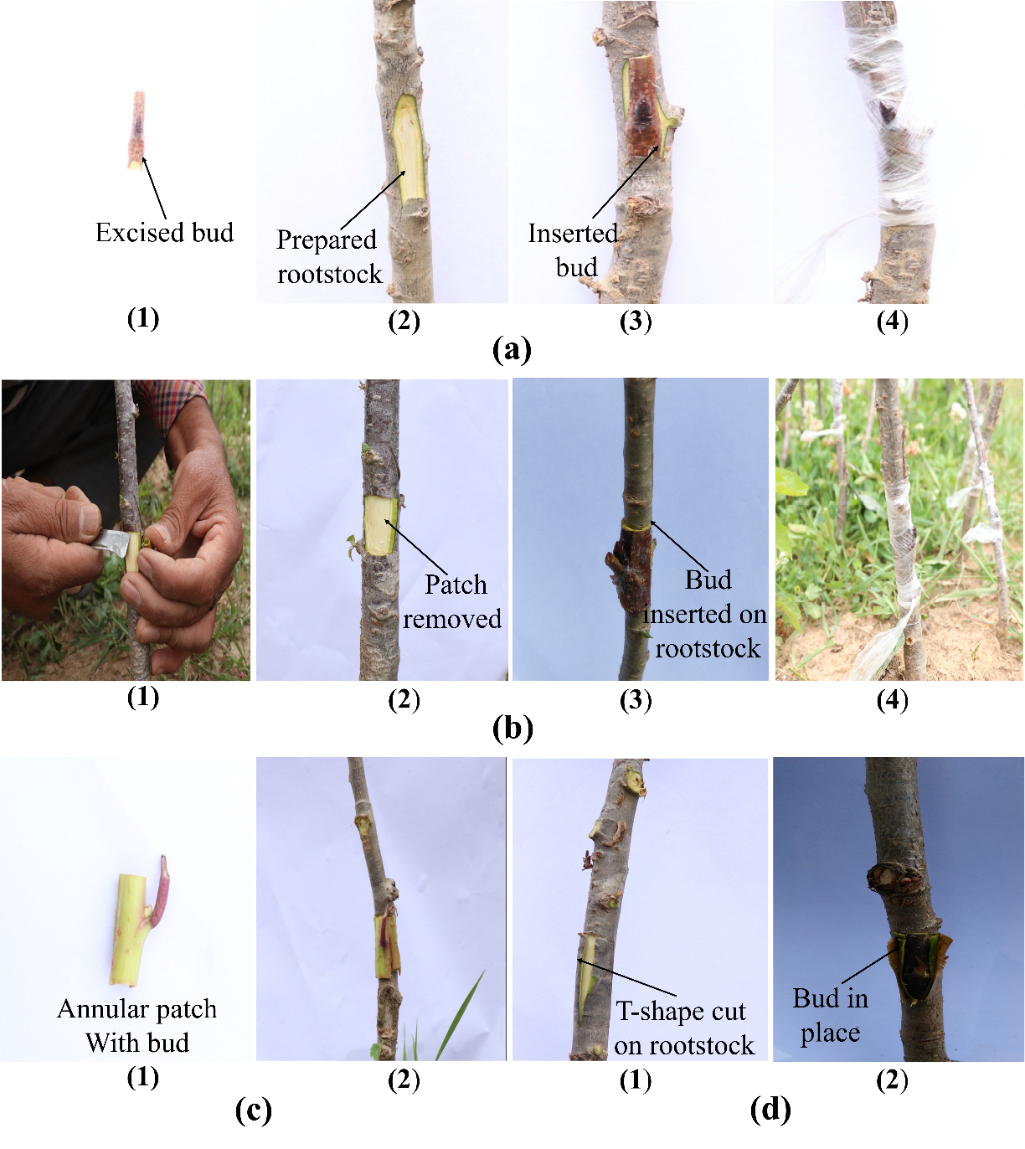
Fig.1. Pictorial representation of steps for (a) chip budding method, (b) patch budding method, (c) annular budding method and (d) shield budding method

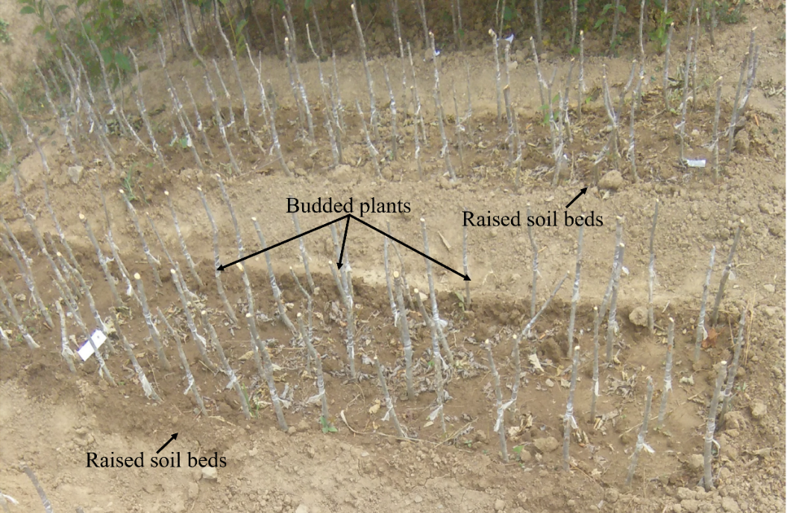
Fig.2. Budded plants established on raised soil beds under different field conditions.

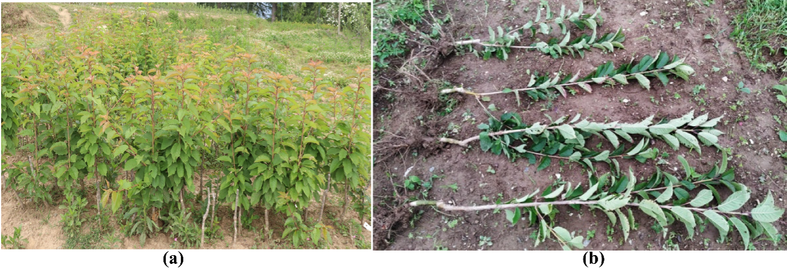
Fig. 3. Pictorial representation of saleable plantsand their grafts

Fig. 4. Effect of budding method and timing on time taken for initiation of sprouting

Fig. 5. Effect of budding method and timing onbud sprouting.

Fig. 6. Effect of budding method and timing onbud-take success.

Fig. 7. Effect of budding method and timing on thelinear growth of scion.

Fig. 8. Effect of budding method and timing on number of leaves.

Fig. 9.Effect of budding method and timing on the leaf area.

Fig. 10. Effect of budding method and timing on the proportion of saleable plants.

Table 1Summary of experimental treatments
Factor | Levels
Budding methods | Chip budding, annular budding, patch budding, and shield budding
Budding dates | 15 May, 15 June, 15 July, 15 August, and 15 September
Replications | 03 replication per treatment combination
Plant per replication | 5 plants
Experimental design | split-split plot design

