Seed bio-priming with Trichoderma harzianum isolates and its rhizosphere colonization in wheat

ABSTRACT

Aims: In this study, the different isolates of Trichoderma harzianum have abilities like antifungal, insecticidal, soil- remediation, plant growth promoting and rhizosphere colonizing properties which assist its biocontrol action were investigated in vitro.
Study design: CRD (Completely Randomized Design).
Place and Duration of Study: An experiment was conducted at Plant Pathology Section, College of Agriculture, Nagpur during 2023-2024.
Methology: A seven days sporulated culture of Trichoderma harzianum isolates (ATH, BTH, CTH, DAG, Thdept) and wheat seeds were collected from Plant Pathology Section, College of Agriculture, Nagpur. For best isolate was identified by using biopriming technique on wheat seeds and the root colonization was also observed.
Results: Among all the isolates, the best treatment having highest germination per cent, root and shoot length and SVI is T₅ (Thdept) i.e. 72.50%, 23.60 cm, 15.97 cm, 2854.50 respectively followed by T₂ (BTH). These results showed that two isolates of Trichoderma harzianum could be used as effective biocontrol for promoting the growth of wheat crop in vitro.
Conclusion: The growth and yield will increase by adding Trichoderma spp. in soil and make it most resistant against different fungus. So by identifying the best isolate or combination of isolates will improve the health and quality of the product.

Keywords: Trichoderma harzianum, Triticum aestivum, bio-priming, rhizosphere colonization.

- INTRODUCTION
Trichoderma, a biological fungus widely used for plant pest control, mainly exists in the soil, air, plant surface, and other ecological environments and can effectively control a variety of plant diseases⁵. Trichoderma spp. has been known to invade other fungi for more than six decades. They're also well-known among scientists as powerful biological control agents^{14,16}. Biological control agents through seed treatment gets introduced into the soil environment which also provides an opportunity for the biocontrol agents to first colonize the roots. Seed treatments do not guarantee protection against root diseases^{9,10,13}, if these biocontrol agents are poor root surface colonizers¹² or incapable of being transported by the root through the soil profile¹¹.

2. MATERIALS AND METHODS

The study was carried out on “Seed bio-priming of with Trichoderma harzianum isolates and its rhizosphere colonization in wheat” during year 2023-24 at Plant Pathology Section, College of Agriculture, Nagpur. Five isolates were obtained from department which were procured from different sources and these isolates were utilized in studying the effect on crop physiological characteristics.

2.1 Biopriming of seed

Wheat seeds were soaked in water for overnight. Mix the formulation of biocontrol agent (Trichoderma harzianum isolates with the pre-soak seeds at the rate of 10-15 g/kg of seeds). Mix well and incubate the seeds under room temperature and high humidity. Sterilized soil in petri plate was taken and kept bioprimed seeds on soil and sprayed autoclaved water. Incubate the seeds under room temperature. Observations were taken using stereobinocular microscope.

2.2 Root imprinting

The roots were washed with tap water for 5 min to remove adhering soil particles. They were surface sterilized by dipping in 75% ethanol for 2 min and then rinsing three times with sterile water, then placed in a 5% Sodium hypochlorite solution and shaking was performed for 5 min, followed by rinsing with 3 times in sterilized distilled water. After careful drying, the surface sterilized roots were cut into 1 cm sections and transferred to the Trichoderma specific medium (TSM) with four per thousand penicillin streptomycin (100X) to isolate the endophytic fungi. Roots were placed in petri plates, and the plates were maintained at 28⁰C for incubation.

CHART 1. Media used in present study and its composition
TSM (Trichoderma Specific Media)
MgSO₄.7H2O | 0.2g
KH₂PO₄ | 1.5g
KCl | 0.14g
NH₄NO₃ | 1g
Glucose | 3g
Agar | 20g
Rose Bengal | 0.15g
Distilled water | 1 litre

3. RESULTS AND DISCUSSIONS
The seeds of wheat were treated with Trichoderma harzianum isolates simultaneously with untreated seeds. The outcomes are shown under

3.1 Bio-priming of wheat with isolates of Trichoderma harzianum
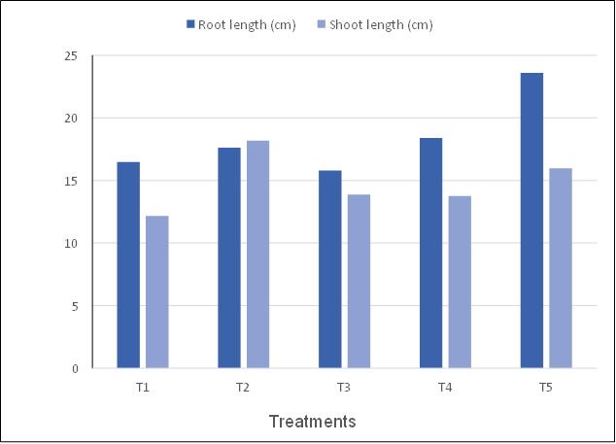
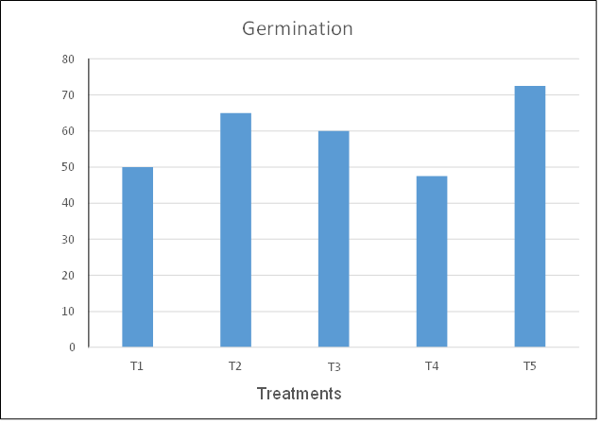
The data revealed in Table.1 and depricted in figure.1,2,3,4 represent that it was observed that Trichoderma harzianum isolates enhance the root, shoot elongation. Highest root enlongation was shown by T₅ (23.6 cm) followed by T₄ (18.4 cm), T₂ (17.62 cm), T₁ (16.47 cm), T₃ (15.8 cm). Similarly, highest shoot elongation was shown by T₂ (18.17 cm), T₅ (15.97 cm), T₃ (13.87 cm), T₄ (13.75 cm), T₁ (12.17 cm) whereas highest germination and also vigour index showed by T₅ (72.5% and 2854.5) followed by T₂ (65% and 2387.25), T₃ (60% and 1526.25), T₄ (47.5% and 1609.5). Among all isolates of Trichoderma T₁ (50% and 1425) showed least germination and seedling vigour index. The result below agrees with¹⁵ alleviation of the adverse effects of salinity stress in wheat (Triticum aestivum L.) by seed biopriming with salinity tolerant isolates of Trichoderma harzianum. Plants obtained from bioprimed seeds showed higher shoot and root length. These results are in agreement with those of other workers^{8,1}, who reported that Trichoderma strains produce plant growth hormones like cytokinin-like molecules, e.g. zeatin and gibberellin GA3 or GA3-related. It had been concluded by their experimentation that seed bioprimed with T. harzianum isolate Th- 14 increased the ability of germination by (1.87%), root length (1.61 cm) and shoot length (1.45 cm) as compared with the control.
Figure 1. Germination Percentage of wheat seeds by Trichoderma harzianum isolates bio-priming
Figure 2. Root-shoot length of wheat seedling by bio-priming of Trichoderma harzianum isolates

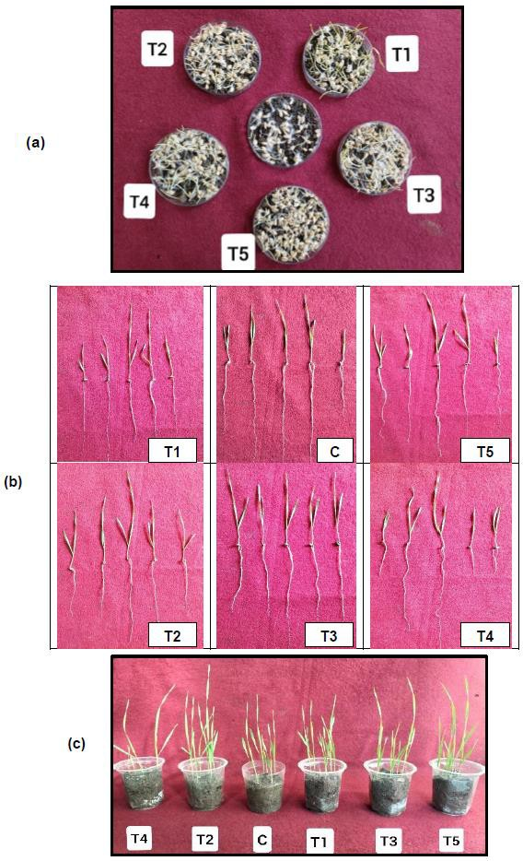
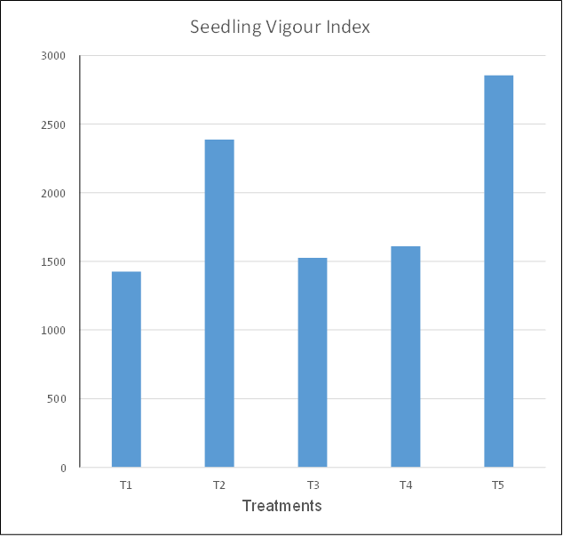

Figure 3. Seedling Vigour Index of wheat seedling by bio-priming of Trichoderma harzianum isolates
Figure 4. (a) represents germination of wheat bioprimed by different isolates of T. harzianum, (b) represents root- shoot length of wheat, (c) represents pots of wheat bioprimed by different isolates of T. harzianum

Table.1: Effect of Trichoderma harzianum isolates on seedling vigour by biopriming of wheat seeds

Treatment No. | Germination of seed out of 10 seeds | Germination (%) | Root Length (cm) | Shoot length (cm) | SVI
T₁ | 5.0 | 50 | 16.47 | 12.17 | 1425
T₂ | 6.5 | 65 | 17.62 | 18.17 | 2387.25
T₃ | 6.0 | 60 | 15.80 | 13.87 | 1526.25
T₄ | 4.75 | 47.50 | 18.40 | 13.75 | 1609.50
T₅ | 7.25 | 72.50 | 23.60 | 15.97 | 2854.50
T₆ - Control | 4.5 | 45 | 16.47 | 12.17 | 1425
F test | Sig | - | Sig | Sig | Sig
SE (±m) | 0.49 | - | 2.56 | 1.81 | 326.84
CD (P = 0.05) | 1.46 | - | 7.62 | 5.38 | 971.10

3.2 Colonization of Trichoderma harzianum isolates in soil

Colonization permits the bioprotectant to take possession of the substrate before either competitive microflora or plant- pathogenic fungi. Solid matrix priming (SMP) is a seed-treatment process⁶ in this process, seeds are first coated with the bioprotectant in a slurry procedure and immediately transferred to an organic matrix (coal or a lignaceous shale). At the physiological level, the positive effects of priming are due to specific metabolic changes induced in the seed when water up-take starts². As a consequence of rehydration, main cellular processes are triggered. Pre-germinative metabolism, i.e., transition from the quiescent state of dry seeds to the active proliferating state of germinating seeds/seedlings¹⁷.We speculate that similar processes at physiological level of the introduced fungal spores (Trichoderma harzianum isolates) might also get initiated with the rehydration of quiescent state of dry seeds. Germination is transformation of a relatively inactive spore to the highly active vegetative thallus. This process is characterized by the absorption of water and by increases in respiration, changes in enzymic activity⁴ and biosynthesis of many cell components. Morphological changes also occur during the germination process; the spore generally swells and forms a germ-tube and eventually a mature thallus. That as a result of pre-germinative metabolism the fungal spores (introduced on the surface of the wheat seeds), germinates and develops into a web of mycelium and seed surface colonization initiates. Table 2 and Figure 5 determines the colonization in roots due to Trichoderma isolates they are imprinted. The data revealed in Figure 6 represents that germination and colonization of T. harzianum isolates on the soil just near the bio-primed seeds. The roots are cutted into small bits of 1 cm size and placed on TSM (Trichoderma Selective Media) and observations were taken after 3-4 days. The above description is similar with³ as sampled roots of the plant derived by the seed treatment with Trichoderma virens BARC G2 mutant from several spots. All the sampled were surface sterilized and were placed in TSM media. Growth of T. virens BARC G2 mutant was observed originating from the surface sterilized roots. It was observed significant differences in the root growth (root volume/ root length, secondary roots etc) in rice and wheat plants derived after seed treatment with Trichoderma virens BARC G2 mutant.

Table 2. Mycelial growth of Trichoderma harzianum isolates on TSM by root imprinting
Trichoderma harzianum isolates | Appearance
T₁ | Dark greenish sporulation with white mycelium web outside which covers 7.2 cm diameter.
T₂ | Pale greenish sporulation was observed which cover 4.73 cm of diameter.
T₃ | White web like mycelial network and no sporulation was observed that cover 4.36 cm diameter.
T₄ | No mycelial web and sporulation were observed.
T₅ | Dark greenish sporulation in the form of layers was observed which covers 4.15 cm diameter.

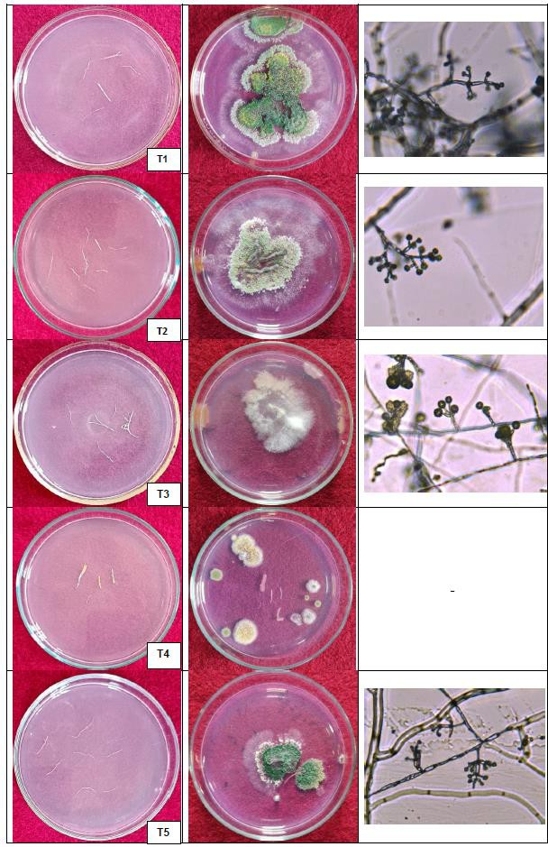
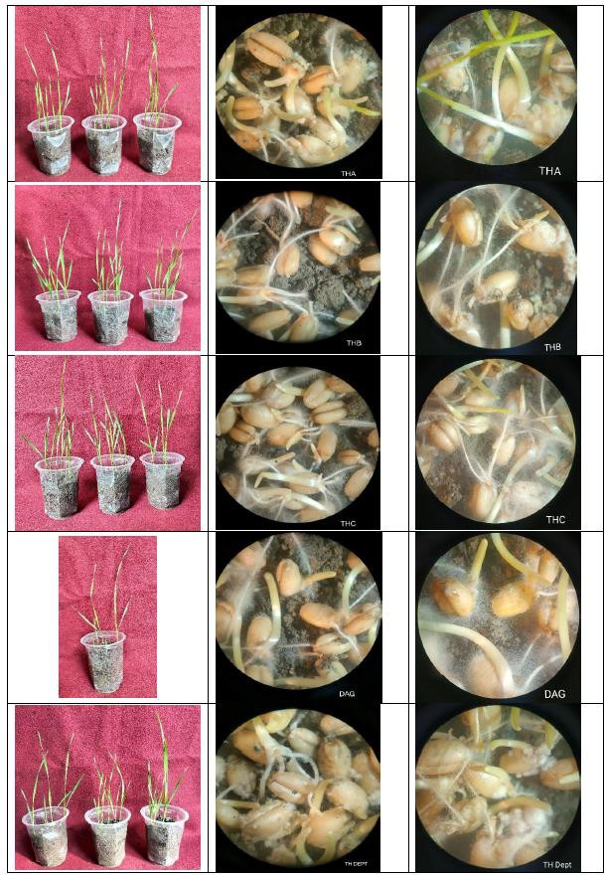

Figure 6. Germination and Colonization of T. harzianum isolates on the soil just near the bio-primed seeds

Figure 5. Imprinting of wheat roots bioprimed by different isolates of T. harzianum and philiades observed in compound microscope (100X magnification)

4. CONCLUSION
The present study evident that few isolates of T. harzianum was significantly effective over the other isolates. Among all the treatments, Seed biopriming in wheat crop, the best treatment having highest SVI is Thdept (T₅) followed by T₂ (BTH). When the roots of wheat were placed on TSM, the morphological parameters were shown by all the isolates i.e. mycelial growth rate, colony appearance, shape of conidia and conidiophore and branching pattern of phialides.

References

- Benitez, T., A. M. Rincon, M. C. Limon and A. C. Codon (2004). Biocontrol mechanism of Trichoderma strains. International Microbiol, 7: 249- 260.
- Dell’Aquila A. and Bewley J. D (1989). Protein synthesis in the axes of polyethylene glycol treated pea seeds and during subsequent germination. J. Exp. Bot., 40: 1001-1007.
- Dole, A (2023). Developing Trichoderma-Plant-Pathogen interaction screening strategies in natural habitat to select potential bioagent. IGKV, Raipur.
- Gottlieb, D. and Caltrider P. G (1963). Synthesis of enzymes during the germination of fungus spores. Nature, 197(4870): 916-917.
- Haouhach S, Karkachi N, Oguiba B, Sidaoui A, Chamorro I, Kihal M, et al. (2020). Three new reports of Trichoderma in Algeria: T. atrobrunneum (South), T. longibrachiatum (South), and T. afroharzianum (Northwest). Microorganisms, 8:1455.
- Harman, G. E. and Taylor A. G. (1988). Improved seedling performance by integration of biological control agents at favorable pH levels with solid matrix priming. Phytopathology, 78(5): 520-525.
- Hornby, D. (1990). Root diseases. The rhizosphere., 233-258.
- Howell, C. R. (2003). Mechanisms employed by Trichoderma species in the biological control of plant diseases: the history and evolution of current concepts. Plant disease, 87(1): 4-10.
- Kraft, J.M. and Papavizas, G.C. (1983). Use of host resistance, Trichoderma, and fungicides to control soilborne diseases and increase seed yields of peas.
- Liu, S. and E. K. Vaughan. (1965). Control of Pythium infection in table beet seedlings by antagonistic microorganisms. Pythopathology, 55: 986-989.
- Madsen, E. L., & Alexander, M. (1982). Transport of Rhizobium and Pseudomonas through soil. Soil Science Society of America Journal, 46(3), 557-560.
- Mendez-Castro, F.A. and Alexander, M. (1983). Method for establishing a bacterial inoculum on corn roots. Applied and Environmental Microbiology., 45(1): 248-254.
- Merriman, P. and Russell K. (1990). Screening strategies for biological control. Biological control of soil-borne plant pathogens, 427-435.
- Naseby D.C., Pascual J.A., Lynch J.M. (2000). Effect of biocontrol strains of Trichoderma on plant growth, Pythium ultimum populations, soil microbial communities and soil enzyme activities. J Appl. Microbiol.88(1):161-169.
- Rawat, Laxmi, Y. Singh, N. Shukla and J. Kumar. (2011). Alleviation of the adverse effects of salinity stress in wheat (Triticum aestivum L.) by seed biopriming with salinity tolerant isolates of Trichoderma harzianum. An International Journal on Plant-Soil Relationships, 343: 10.
- Sharma P, Sharma M, Raja M, Shanmugam V. (2014). Status of Trichoderma research in India: A review. Indian Phytopathol. 67(1):1-19.
- Wei, Z., Huang J., Tan S., Mei X., Shen Q. and Xu Y. (2013). The congeneric strain Ralstonia pickettii QL-A6 of Ralstonia solanacearum as an effective biocontrol agent for bacterial wilt of tomato. Biological Control, 65(2): 278-285.

