Original Research Article

Biological control of tomato (Lycopersicon esculentum Mill.) Fusarium wilt caused by Fusarium oxysporum f.sp. lycopersici (Sacc.) Snyder and Hansen

ABSTRACT

Tomatoes are susceptible to a variety of diseases which can affect the quality of produce and reduce their export potential. One of the most destructive and economically damaging diseases is Fusarium wilt by Fusarium oxysporum f. sp. Lycopersici (FoL). In this series of experiments, randomized complete design was used and repeated three times. In this study, the efficacy of Trichoderma isolates, Pseudomonas fluorescens and Bacillus subtilis to manage fusarium wilt disease under in-vitro and in-vivo condition were investigated. The dominant pathogen which causes fusarium wilt of tomato was isolated and identified as FOL. Under in-vitro condition, result revealed that Trichoderma harzianum was found to inhibit effectively the radial mycelial growth of the pathogen (68.89%). Different chemicals were also tested in the laboratory against FOL under in-vitro condition. The treatment of Carbendazim 12% + Mancozeb 63% and Carboxin 37.5% + Thiram 37.5% are the most effective control with 100% growth inhibition. Meanwhile under pot condition, the application of Trichoderma harzianum exhibited the lowest disease incidence (4.75%) also tomato plants treated with Trichoderma harzianum isolates showed a significant stimulatory effect on plant height (109.75 cm), root weight (10 g) and the fresh weight (91.75 g) of tomato plants in comparison to untreated control (101.75 cm, 7.25 g and 78 g). Therefore, the antagonist Trichoderma harzianum was chosen to be the most promising biocontrol agent for FOL. Based on the base of present study, the biocontrol agent of plant diseases might be exploited for sustainable disease management program to save environment.

Keywords:
Antagonistic effect, Fusarium wilt, Dual culture, Food-poisoned technique, biocontrol Agent

INTRODUCTION
Tomato (Solanum lycopersicum), is a member of the Solanaceae family and it is a highly-valued horticultural crop worldwide due to the adaptability to grow in widely

range of the soil and the climate. The major tomato growing countries are China (30.7%), India (11.5%), USA (8.1%), Turkey (7.0%) and Egypt (5.3%). India ranks second in the area as well as in tomato production after China (Maurya et al., 2019). In India, the area and production of tomato in 2023-24 (2nd Advance Estimates) was 872.9 thousand hectares and 212.38 thousand metric tonnes, respectively followed by productivity 24.3 metric tonnes/ ha (Indiastat, 2023-24). Most of tomato production in India are from Odissa, Madhya Pradesh, Karnataka, west Bengal, Maharasthra, Gujarat, Chhattisgarh, Bihar, Andhra Pradesh and Telangana districts (Indiastat, 2023-24). In district of Andra Pradesh, it is cultivated in an area of 54.18 thousand hectares around the year in various climatic situations with an average production of 2438 metric tonnes/ ha and productivity of 45 metric tonnes per ha (Indiastat, 2023-24).
However, tomato production is significantly affected by several diseases. Among these, fusarium wilt disease caused by Fusarium oxysporum f. sp. lycopersici (FOL) is one of the most devastating diseases in tomato plants. FOL exerts considerable pressure on crop yield leading to production losses ranging from 30-40 % percents. In some cases, if conditions are favourable, the fungal growth may escalate up to 80% (Nirmaladevi, 2016). Tomato yield is significantly reduced by F. oxysporum lycopersici when it invades the roots of tomato and colonizes xylem vessels causing wilt, yellowing of leaves, small fruit productions and eventually death. Numerous strategies have been proposed for controlling this fungal pathogen. Fungicides are the most important management practice which is used to control the plant diseases. Often the use of chemical fungicides may not provide the desired effects and will lead to many ecological problems as well as the development of resistant strains of pathogens (Ahmed, 2011). Plus, the use of chemical fungicides can be harmful to other living organisms besides reduction of soil microorganisms (Hasan, 2010). Therefore, the use of biological control agents have become an attractive, promising, and eco-friendly alternative.
Numerous studies have demonstrated reduced incidence of diseases in different crops after supplementing the soils with fungal or bacterial antagonists (Ahmed, 2011). Successful control of Fusarium wilt in many crops through the application of Trichoderma spp. has been reported (Ramezani,2009). Furthermore, Pseudomonas spp. and Bacillus spp. are among plant growth-promoting rhizobacteria which have been shown to trigger systemic resistance in plants, known as induced systemic resistance (ISR) (Van Loon & Bakker, 2006). ISR improves the plant’s defence mechanisms, is not specific and can protect plants against a broad spectrum of pathogens (Zamioudis et al., 2014). Therefore, the objective of the present study was to assess the ability of different biocontrol agents in suppressing the populations of FOL in tomato under in vitro and in vivo conditions for the management of Fusarium wilt disease.

MATERIAL AND METHODS

Experimental site
The location falls within Lattitude 16° 23’ and Longitude 80° 56’ with altitude average 22m mean above sea level in the coastal zone of Andra Pradesh.

Isolation and purification of pathogens
Pathogens were isolated from the infected vascular tissues of stems and roots of tomatoes, which were collected from Venjandla village during 2024 summer season. Tissues were sterilized with 70% ethyl alcohol, for 5-10 min, and subsequently were washed with three passages of sterile distilled water. Then, they were placed on potato dextrose agar (PDA) medium and incubated in the laboratory conditions at 25 ± 2 ºC, for seven days. The fungi were purified by transferring the hyphal tip into PDA media and maintained as stock cultures for further studies.

Identification and Characterization of pathogens
The observation on colour, septation, size of conidia and other morphological characters of conidia were measured under microscope. The cultural characters like growth of pathogen and colour of mycelial colony were observed.

Pathogenicity test of disease
Tomato seedlings were raised in the pots containing sterilized sandy loamy soil. Three weeks old seedlings (21 days) were used for this study. The pathogen suspension was prepared by scraping the spores from the surface of the pure culture containing petri plates and mixed into 10 ml of sterile distilled water. After that, concentration was adjusted to 1×10⁶ conidia/ml by using hemocytometer. The soil in treatment pots was inoculated with 5 mL of spore suspension of FOL containing 1×10⁶ conidia/ml. The inoculated pots were covered with plastic bags for 48 hours after inoculation to maintain high relative humidity and create conditions suitable for infection. Meanwhile, for control, the pots were inoculated with 5 mL of sterile distilled water.

Procuring, maintaining and mass culturing of biocontrol agents
Pure culture of T. harzianum, T. asperellum, T. konigii, T. virens, T. pseudokonigii, T. reseii, Pseudomonas fluorescens and Bacillus subtilis were procured from the Division of Plant Pathology, College of Horticulture from Dr. Y.S.R Horticultural University, Anantharajupeta. They were maintained on PDA media and sub-cultured and mass multiplied by similar procedures similar to those used for the pathogen fungus.
In-vitro Assessment of Bioagents against FoL pathogen
The antagonistic capability of the fungal isolates of Trichoderma spp., Bacillus subtilis and Pseudomonas fluorescens were tested in-vitro against FOL by a dual culture technique. Isolates of Trichoderma sp., Bacillus subtilis and Pseudomonas fluorescens were grown on suitable nutrient medium for 6 days and used as an inoculum. Disks from each isolate of Trichoderma spp. (5 mm in diameter) were inoculated on PDA medium on one side and the opposite side was plated by FOL inoculum (5 mm in diameter). Meanwhile, the isolate of Bacillus sp. was streak on each side of the media and FOL inoculum was placed in the center. Three replicates were used for each treatment. Inoculated plate with FOL only was used as a control treatment. After a five days incubation period at 28 °C±1, the linear growth of the tested pathogen was recorded. The percentage of growth inhibition was calculated using the following formula:

% Reduction of growth = (pathogen growth in control - pathogen growth in treatment/growth in control) x 100

In-vitro assessment of fungicides against FoL Pathogen
Using the in-vitro poisoned food technique according to Mannai et al., (2018), the in-vitro inhibitory actions of six commercial fungicides, namely Azoxystrobin 18.2% + Difenoconazole 11.4% , Fluxapyroxad 167 g/L + Pyraclostrobin 333 g/L,
Carbendazim 12% + Mancozeb 63%, Tebuconazole 50% + Trifloxystrobin 25%,
Carboxin 37.5% + Thiram 37.5% , Fenamidone 10% + Mancozeb 50% at three different concentrations (Below recommendation dose, recommendation dose and above recommendation dose) were evaluated. Chemical fungicides were mixed into PDA media, autoclaved and poured in sterilized petri plate under laminar flow condition. Subsequently, a bit of pathogen isolate was cut off and placed in the center of media. All plates were incubated at 25 °C for 7 days. After incubation, the diameter of radial mycelial growth of the fungal pathogen was measured (mm) in each treated plate using a calibrated ruler and compared to the control.
% Reduction of growth = (pathogen growth in control - pathogen growth in treatment/growth in control) x 100

Effect of Bio control agents against Fusarium wilt under in-vivo (Pot culture conditions)
The selected antagonists (T. harzianum, Bacillus subtilis and Pseudomonas fluorescens were tested for their ability to reduce the incidence and increase yield parameters of tomato under pot culture conditions. Potting mixture was prepared and autoclaved one hour for two consecutive days then filled in pots. Tomato seeds were sown in the autoclaved potting mixture. After 25 days, the seedlings were transplanted in pots at the rate of one seedling per pot. Then, inoculums of the pathogen and antagonists were incorporated into the pots. The percent of disease incidence was recorded at the time of harvest. Each treatment was conducted triplicate in completely randomized design (CRD).
Percent disease incidence (%) = No. of infected plants /total no of plant assessed x 100

Statistical analysis
All data collected were analysed as per standard statical procedure. The data obtained for different characters were statistical analysed to find out the significance of difference among the treatments. The means value of all characters was evaluated and analysis of Variance was performed by F’ value test. The results have been depicted graphically whenever necessary.

RESULTS AND DISCUSSION

Isolation and characterisation of pathogen
The isolated pathogen was identified based on the mycelia colony and morphology of conidia. The mycelia of FOL are slightly white to pink when observed from PDA plate and often with pink colour on the lower side. Micro conidia formed singly oval to reniform shape and with single septa or without any septation. The size of micro

conidia ranged from 8-16 x 2-4 μm. The macro conidia were sickled in shape with a blunt end and usually 3-6 septate. The size of the macroconidia ranges from 33-55 x 4.5-6 μm. The chlamydospores of Fusarium pathogen appeared as spherical shape, smooth to rough walled, intercalary, single or in pairs in the mycelium. For cultural morphology, Fusarium culture has cottony mycelium and the colour of culture range from red to orange lrig.
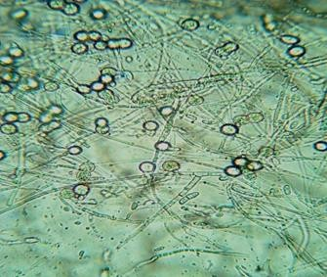
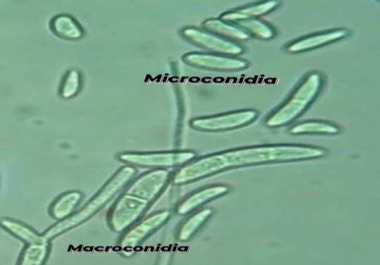
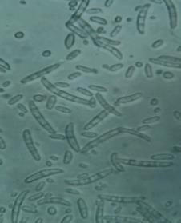

Figure 1: (a) Chlamydospore of Fusarium oxysporum lycopersici (b) Micro conidia and Macro conidia of FoL (c) Macro conidia in abundant
Pathogenicity of Isolates of Fusarium oxysporum on Tomato plants
Two weeks after sowing, the inoculated seedlings showed typical symptoms of Fusarium wilt including yellowing, vascular necrosis and wilting. Upon observation, none of the inoculated plants survived for 14 days after inoculation. Meanwhile, the control plants remained healthy without showing any symptom.
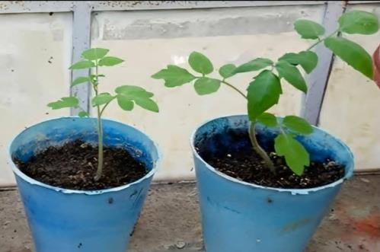
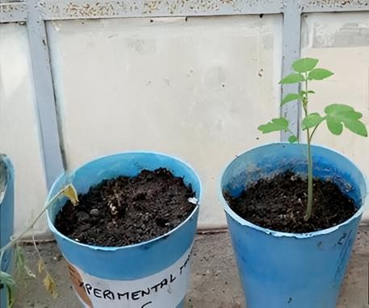
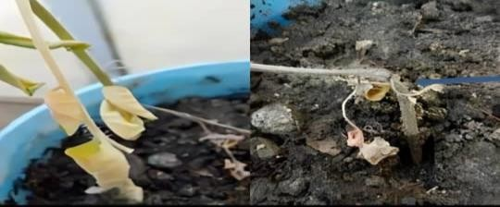

Figure 2: (a) Inoculated and control plants before inoculation of pathogen (b) Inoculated and control plants before inoculation of pathogen (c) Condition of inoculated seedling 2 weeks after inoculation of pathogen

Effects of Biological control agents on inhibition of mycelia growth of FOL in in vitro
All tested antagonistic strains inhibited mycelial growth of F. oxysporum L in dual culture. Significant differences were observed among the antagonistic strains. Growth inhibition was reduced by T. harzianum was the maximum by 68.89%, followed by T. reesei at 66.67% and T. asperellum, T. konigii and T. virens at 61.11%, and T. pseudokonigii at 57.78% respectively. Pseudomonas fluorescens inhibited growth by (55.56%) and Bacillus subtilis inhibited minimum mycelial growth at 44.44%.

Table 1: Growth Inhibition of FoL by Biological control agents in in vitro condition

Growth and inhibition of mycelium
No | Bio agents | Inhibition zone (mm) | Percent inhibition
1 | Trichoderma asperellum | 35 | 61.11
2 | Trichoderma harzianum | 28 | 68.89
3 | Trichoderma reesei | 30 | 66.67
4 | Bacillus subtilis | 50 | 44.44
5 | Trichoderma konigii | 35 | 61.11
6 | Pseudomonas fluorescens | 40 | 55.56
7 | Trichoderma virens | 35 | 61.11
8 | Trichoderma pseudokonigii | 38 | 57.78
9 | Control | 90 | -

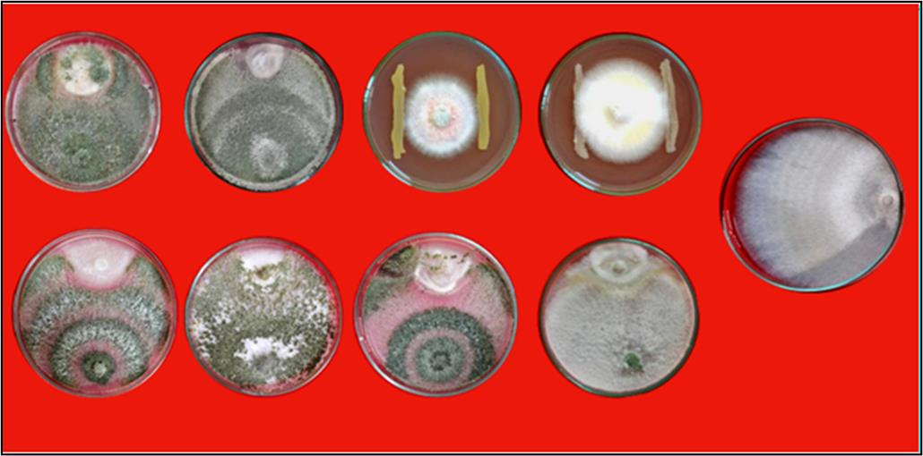
Figure 3: T1- T. asperellum T2- T. harzianum T3- Pseudomonas fluorescens T4- Bacillus subtilis
T5- T. reesei T6- T. pseudokoningii T7- T. virens T8- T. koningi T9- Control

Percent inhibition (%)

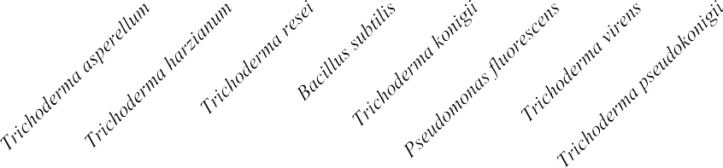
Figure 4: Percent inhibition of mycelia growth (%) against different Biocontrol agents in in vitro
80
70
60
50
40
30
20
10
0

Biocontrol Agents
condition

The findings are in conformity with the work of Kamala and Devi (2012) who found similar results in-vitro, in which the inhibition of the pathogen was maximum with T. harzianum followed by T. asperellum and very less effect of P. fluorescens and B. subtillis were found in inhibition of the pathogen.

In other to survive and compete the Trichoderma produces a wide variety of toxicants and antibiotic metabolites that are active against a large numbers of pathogen, such as, Trichodermin, Trichodermol, Harzianum-A, Harzianolide, T39, -Butenolide, Terpenes and Polypeptides and extracellular hydrolytic enzymes which were involved in the inhibition, competition and mycoparasitism of Fusarium sp. ( Eziashi et al., 2006)

Effects of Commercial fungicide on inhibition of mycelia growth of FOL in in vitro
In-vitro evaluation of six commercial fungicides was carried out at 3 different concentrations (below-recommendation, recommendation and above recommendation). Among the six tested fungicides, maximum inhibition was observed in Carbendazim 12% + Mancozeb 63% and Carboxin 37.5% + Thiram 37.5% at all three different concentrations which yielded 100% inhibition of FoL
mycelia growth of the pathogen respectively. The least inhibition was observed in Fenamidone 10% + Mancozeb 50% with only 20% inhibition at below recommendation concentration (0.1%), 27.78% inhibition at recommended concentration (0.15%) and 43.33% inhibition at an above-recommended concentration (0.2%).

Table 2: Percentage Inhibition of FoL by Chemical fungicide in in vitro condition

Treatment Concentration % Mean radial
growth(mm)
growth
inhibition (%)

Azoxystrobin 18.2% + Difenoconazole 11.4% | 0.05  0.075 | 23  15 | 74.44  83.33
 | 0.1 | 10 | 88.89
Carbendazim 12% + Mancozeb 63% | 0.1 | 0 | 100
 | 0.15 | 0 | 100
 | 0.2 | 0 | 100
Fluxapyroxad 167 g/L+ Pyraclostrobin 333 | 0.05 | 78 | 13.33
g/L
 | 0.075 | 53 | 41.11
 | 0.01 | 45 | 50
Tebuconazole 50% + Trifloxystrobin 25% | 0.025 | 25 | 72.22
 | 0.05 | 23 | 74.44
 | 0.075 | 20 | 77.78
Carboxin 37.5% + Thiram 37.5% | 0.15 | 0 | 100
 | 0.2 | 0 | 100
 | 0.25 | 0 | 100
Fenamidone 10% + Mancozeb 50% | 0.1 | 72 | 20
 | 0.15 | 65 | 27.78
 | 0.2 | 51 | 43.33
Distilled water- Control | - | 90 | -

T1
 | 0.1 % | 0.15 % | 0.2 %
T2
 | 0.05 % | 0.075 % | 0.1 %
T3
 | 0.1 % | 0.15 % | 0.2 %
T4
 | 0.025 % | 0.05 % | 0.075 %
T5 | 0.05 % | 0.075 % | 0.1 %
T6
 | 0.15 % | 0.2 % | 0.25 %

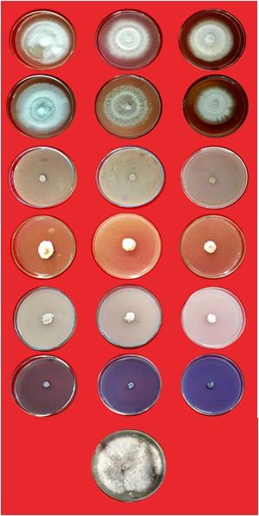
Figure 5: In vitro evaluation of fungicides against Fusarium oxysporum
Control
T1- Fenamidone + Mancozeb T2- Fluxapyroxad + Pyraclostrobin T3- Carbendazim + Mancozeb T4- Tebuconazole + Trifloxystrobin T5- Azoxystrobin + Difenconazle T6- carboxin + Thiram

Per cent inhibition

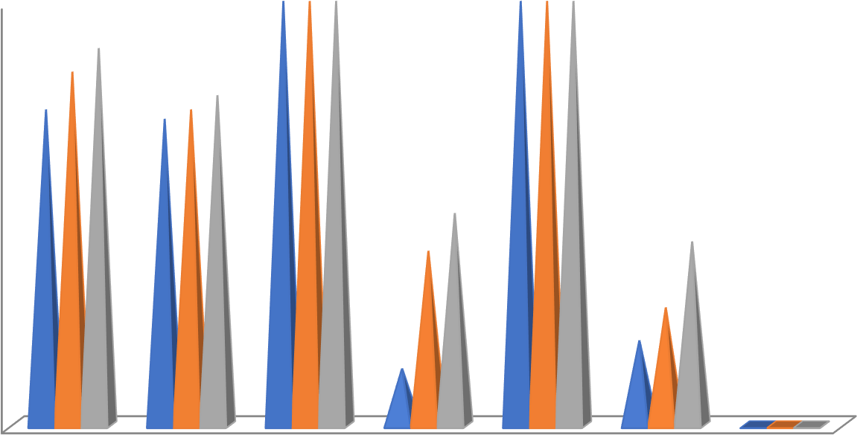
Figure 6: In vitro evaluation of fungicides against Fusarium oxysporum
10% +
Mancozeb 50% WG
WS
333 G/L
25% WG
11.4 % SC
Pyraclostrobin Thiram 37.5%
Difenoconazole Trifloxystrobin
37.5% +
167 G/L +
12% +
Mancozeb 63% WP
18.2 % + 50% +
Control
Azoxystrobin Tebuconazole Carbendazim Fluxapyroxad Carboxin Fenamidone
0
20
40
60
80
100
The results are also in conformity with the findings of several others workers in case of FoL (Liu et al., 2021) who found that this benzimidazoles group fungicide significantly reduce sporulation in FoL. The fungitoxic effect of carbendazim 12% + Mancozeb 63% is provided by interfering with a number of cellular processes such as mitosis, meiosis, intracellular transport of molecular transports of molecules and the maintenance of cell shape leading to the eventual cell death in benzimidazole treated fungi (Liu et al., 2021).

In-vivo management of Fol by using bioagents (Pot experiment)

Tomato plants inoculated with FOL in control pot showing stunted growth and eventually wilting to death. However, in pot treated with Biocontrol agent isolates and fungicide as soil application significantly reduced the wilt severity caused by FOL. The minimum disease incidence was observed in the treatment with Trichoderma harzianum (3.5%) followed by Pseudomonas fluorescens (4.75%) and Bacillus subtilis (4.75 %) over control. Next in chemical efficacy, carbendazim + mancozeb suppressed the wilt severity by 20 % over inoculated control. In this study, the height, fresh weight and root weight were also increased when treated with T. harzianum, P. fluorescens and B. subtilis bioagents. The maximum yield was observed T. harzianum treated seedlings with 109.75 cm in plant height, 91.75g for fresh weight and 10g in root weight. Trichoderma spp. is the best-known biocontrol agent of a wide range of pathogenic fungi and have proven their potential to suppress the diseases in various crops including tomato. Trichoderma affects Phyto-pathogens via various mechanisms, such as enzymatic hydrolysis, direct-parasitism, nutrient competition,

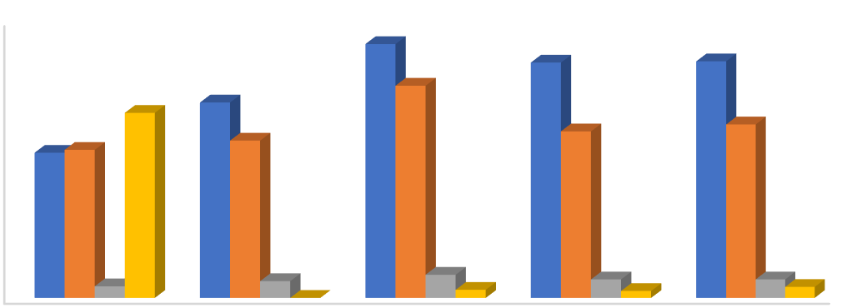
antibiosis and induced resistance as recorded. Similar results were reported by Deepak kumar & Dubey (2001).
120
100
80
60
40
20
0
inoculated control
Fungicide
Tricoderma Bacillus subtillis Psuedomonas harzianum fluorscens
Plant height
Plant fresh weight
Roots weight
Disease incidence(%)

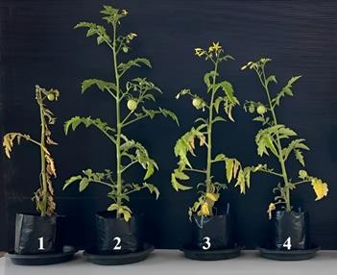
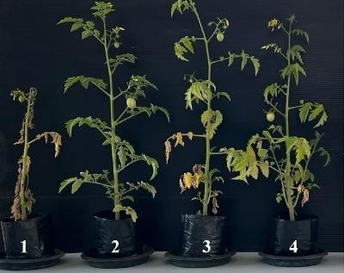
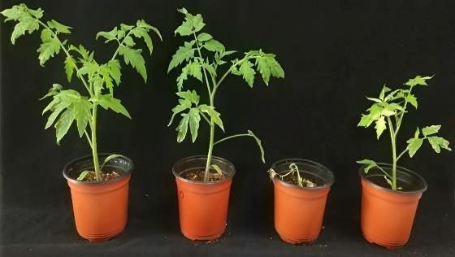
Figure 7: Pot experiment for Pseudomonas fluorescens (a) Pot experiment for Trichoderma harzianum (b) Pot experiment for Bacillus subtilis

Figure 8: Effect of BCAs treatments on plant growth in in vivo condition
Plant growth

Trichoderma sp. can capture water and nutrients, occupy space, and consume oxygen, through rapid growth and reproduction, to weaken pathogen in the same habitat. It can grow significantly faster than plant-pathogenic fungi, making it effective for suppressing their growth. (Mohiddin et al., 2021). Risoli et al. (2022) found that the growth rate of T. harzianum was 2.0 to 4.2 times faster than that of B. cinerea. In addition, Trichoderma also swiftly gather at crop roots, proliferates, and forms a protective layer around them with its hyphae within 24 hours of entering the soil. This action act as a shield to safeguards the roots from pathogen invasion and to kill nearby pathogens. Furthermore, finding by Dugassa et al (2021) also found that Trichoderma mycelium competes with Fusarium graminearum through mycoparasitism mechanisms such as clinging, twining, and inter-penetration, leading to deformity and eventual disappearance of F. graminearum mycelium.

In addition, Trichoderma sp. also produce plant growth stimulators, such as Indoleacetic acid (IAA) and Parthenolide, to promote the development and growth of plant roots. Additionally, Trichoderma sp. secretes Phytase enzymes and Ferritin proteins, which facilitate the uptake of phosphorus (P) and iron (Fe) by plants. This process aids in decomposing soil organic matter, thereby enhancing the soil nutrient availability. Furthermore, it improves crop photosynthetic efficiency and enhances agronomic traits such as plant height and stem diameter as well as other agronomic traits eventually increases agricultural production (Lombardi et al., 2020).

Conclusion & Future Prospects
At present, chemical control is the main method used for plant disease control and is achieved by spraying pesticides and fungicides. Although the effect of chemical control is good and helpful in increasing agricultural production, the unscientific use of chemical pesticides has caused serious environmental pollution to the environment and enhanced pathogens’ resistance to and chemical pesticides. Several experiments have proven that Trichoderma has good biological control effects and can reduce the use of chemical pesticides. However, there are still few biocontrol agents against Trichoderma on the market, and more effective and suitable strains need to be found to join the biocontrol team (Cabral-Miramontes et al., 2022).

REFERENCES

Ahmed, M. (2011). Management of Fusarium wilt of tomato by soil amendment with
Trichoderma koningii and a white sterile fungus. Indian J. Res, 5(1), 35-38.
Aswani, R., Thomas, R., & Radhakrishnan, E. K. (2022). Induction of plant defense response by endophytic microorganisms. In Biocontrol Mechanisms of Endophytic Microorganisms (pp. 89-115). Academic Press.
Cabral-Miramontes, Juan Pablo, Vianey Olmedo-Monfil, María Lara-Banda, Efrén Ricardo Zúñiga-Romo, and Elva Teresa Aréchiga-Carvajal. "Promotion of plant growth in arid zones by selected Trichoderma spp. strains with adaptation plasticity to alkaline pH." Biology 11, no. 8 (2022): 1206.
Dugassa, A., Alemu, T., & Woldehawariat, Y. (2021). In-vitro compatibility assay of indigenous Trichoderma and Pseudomonas species and their antagonistic activities against black root rot disease (Fusarium solani) of faba bean (Vicia faba L.). BMC microbiology, 21, 1-11.
El-Hasan, A., Walker, F., Klaiber, I., Schöne, J., Pfannstiel, J., & Voegele, R. T. (2022). New approaches to manage Asian soybean rust (Phakopsora pachyrhizi) using Trichoderma spp. or their antifungal secondary metabolites. Metabolites, 12(6), 507.
Eziashi, E. I., Uma, N. U., Adekunle, A. A., & Airede, C. E. (2006). Effect of metabolites produced by Trichoderma species against Ceratocystis paradoxa in culture medium. African Journal of Biotechnology, 5(9).
Oruc, H. H. (2010). Fungicides and their effects on animals. Fungicides, Carisse, O. (Ed.) In-Tech Publishers, 349-362

Kamala, T. H., & Devi, S. I. (2012). Biocontrol properties of indigenous Trichoderma isolates from North-east India against Fusarium oxysporum and Rhizoctonia solani. African Journal of Biotechnology, 11(34), 8491-8499.
Kumar, D., & Dubey, S. C. (2001). Management of collar rot of pea by the integration of biological and chemical methods. Indian phytopathology, 54(1), 62-66.
Li, F. J., Komura, R., Nakashima, C., Shimizu, M., Kageyama, K., & Suga, H. (2022). Molecular diagnosis of thiophanate-methyl-resistant strains of Fusarium fujikuroi in Japan. Plant Disease, 106(2), 634-640.
Liu, Z., Chen, Y., Han, J., Chen, D., Yang, G., Lan, T., ... & Zhang, K. (2021). Determination, dissipation dynamics, terminal residues and dietary risk assessment of thiophanate‐methyl and its metabolite carbendazim in cowpeas collected from different locations in China under field conditions. Journal of the Science of Food and Agriculture, 101(13), 5498-5507.
Lombardi, N., Caira, S., Troise, A. D., Scaloni, A., Vitaglione, P., Vinale, F., ... & Woo, S. L. (2020). Trichoderma applications on strawberry plants modulate the physiological processes positively affecting fruit production and quality. Frontiers in Microbiology, 11, 1364.

Maurya, S., Dubey, S., Kumari, R., & Verma, R. (2019). Management tactics for fusarium wilt of tomato caused by Fusarium oxysporum f. sp. lycopersici (Sacc.): A review. Management, 4(5),1-7.
Maruyama, C. R., Bilesky-José, N., de Lima, R., & Fraceto, L. F. (2020). Encapsulation of Trichoderma harzianum preserves enzymatic activity and enhances the potential for biological control. Frontiers in bioengineering and biotechnology, 8, 225.
Mohiddin, F. A., Padder, S. A., Bhat, A. H., Ahanger, M. A., Shikari, A. B., Wani, S. H., ... & Abdel Latef, A. A. H. (2021). Phylogeny and optimization of Trichoderma harzianum for chitinase production: evaluation of their antifungal behaviour against the prominent soil borne phyto-pathogens of temperate India. Microorganisms, 9(9), 1962.
Manganiello, G., Sacco, A., Ercolano, M. R., Vinale, F., Lanzuise, S., Pascale, A., ... & Woo, S. L. (2018). Modulation of tomato response to Rhizoctonia solani by Trichoderma harzianum and its secondary metabolite harzianic acid. Frontiers in microbiology, 9, 1966.
Nirmaladevi, D., Venkataramana, M., Srivastava, R. K., Uppalapati, S. R., Gupta, V. K., Yli-Mattila, T., ... & Chandra, N. S. (2016). Molecular phylogeny, pathogenicity and toxigenicity of Fusarium oxysporum f. sp. lycopersici. Scientific reports, 6(1), 21367.
Nawrocka, J., Małolepsza, U., Szymczak, K., & Szczech, M. (2018). Involvement of metabolic components, volatile compounds, PR proteins, and mechanical strengthening in multilayer protection of cucumber plants against Rhizoctonia solani activated by Trichoderma atroviride TRS25. Protoplasma, 255, 359- 373.
Risoli, S., Cotrozzi, L., Sarrocco, S., Nuzzaci, M., Pellegrini, E., & Vitti, A. (2022). Trichoderma-induced resistance to Botrytis cinerea in Solanum species: A Meta-Analysis. Plants, 11(2), 180.
Ramezani, H. (2008). Efficacy of some fungal and bacterial bioagents against Fusarium oxysporum f. sp. ciceri on chickpea. Journal of Novel Researches on Plant Protection, 1(1), 108-113.
Shaw, S., Le Cocq, K., Paszkiewicz, K., Moore, K., Winsbury, R., de Torres Zabala, M., ... & Grant, M. R. (2016). Transcriptional reprogramming underpins enhanced plant growth promotion by the biocontrol fungus Trichoderma hamatum GD12 during antagonistic interactions with Sclerotinia sclerotiorum in soil. Molecular plant pathology, 17(9), 1425-1441.
Saravanakumar, K., Li, Y., Yu, C., Wang, Q. Q., Wang, M., Sun, J., ... & Chen, J. (2017). Effect of Trichoderma harzianum on maize rhizosphere microbiome and biocontrol of Fusarium Stalk rot. Scientific reports, 7(1), 1771.
Tamizi, A. A., Mat-Amin, N., Weaver, J. A., Olumakaiye, R. T., Akbar, M. A., Jin, S.,
... & Alberti, F. (2022). Genome sequencing and analysis of Trichoderma

(Hypocreaceae) isolates exhibiting antagonistic activity against the papaya dieback pathogen, Erwinia mallotivora. Journal of Fungi, 8(3), 246.
Tian, Y., Tan, Y., Yan, Z., Liao, Y., Chen, J., De Boevre, M., ... & Wu, A. (2018). Antagonistic and detoxification potentials of Trichoderma isolates for control of zearalenone (ZEN) producing Fusarium graminearum. Frontiers in Microbiology, 8, 2710.

Van Loon, L. C., & Bakker, P. A. H. M. (2006). Root-associated bacteria inducing systemic resistance. Plant-associated bacteria. Springer, Dordrecht, 269-316.

Zamioudis, C., Hanson, J., & Pieterse, C. M. (2014). β‐Glucosidase BGLU 42 is a MYB 72‐dependent key regulator of rhizobacteria‐induced systemic resistance and modulates iron deficiency responses in A rabidopsis roots. New Phytologist, 204(2), 368-379.

