Distribution and diversity of major NWFP species in Sal & Teak dominated forests of Central India

Abstract: Mandla district of Madhya Pradesh is a transitional zone between Tropical dry deciduous forest to Tropic moist deciduous forest. For the quadrats, systematic random sampling and square quadrats of size 10m*10m were used in two territorial forest divisions and one wildlife-protected area. Softwares such as Qgis, MS excel, and PAST was used for the study. Tectona grandis (Teak) and Shorea robusta (Sal) are the major tree species in the district which have different associated species depending on the climatic and edaphic factors. These forest types support a large number of Non-wood forest produce (NWFP) species which support the livelihood of local communities. Species like Madhuca sp., Diospyros melanoxylon, Buchanania lanzan, Boswellia serrata, Embelia basal, etc. are the major NWFP species found here. The Shannon-Weinner diversity (H’) index and Simpsons (1-D) diversity index for Teak and Sal forests showed high diversity in both types of forests. In this study, we found that Shorea sp. one of the major NWFP show the highest density among all. Madhuca sp. is one of the key NWFPs in both types of forests but majorly present nearby the agricultural lands surrounding the villages. Diospyros melanoxylon shows a very high frequency in teak forest rather than in Sal forest. The IVI for both Maduca sp. & Diospyros melanoxylon is higher in teak forest than Sal forest showing major socio-ecological role in both forest types as important supporting livelihood.

Keywords: - Tropical dry deciduous forest, Tropical moist deciduous forest, Tree Diversity, Associated species, Diversity index, Shannon –Weiner diversity indices, Simpson(1-D) diversity index, IVI, Non-wood forest produce
Introduction
Non-Wood Forest Products (NWFPs), often referred to as Minor Forest Products (MFPs), encompass a wide range of plants, fungi, and animal-based products harvested from forests for various uses excluding timber. These resources are vital for meeting essential household needs, providing food, medicinal items, fibers, and cultural products, thereby playing a crucial role in both commercial and sustainable livelihoods, particularly in developing regions (Matta, A.F., 2019; FAO, 2018). The Food and Agriculture Organization (FAO) defines NWFPs as biological goods derived from forests, wooded lands, and trees outside forests, excluding wood, and highlights their significance in food security and subsistence (FAO, 2018).
The importance of NWFPs was emphasized during the United Nations Conference on Environment and Development (UNCED) in Rio de Janeiro in 1992, where they were recognized as essential for environmentally sound and sustainable development (Singhal, 2000). In India, the economic and cultural significance of NWFPs is profound, with approximately 3,000 such products integrated into the economy. In some regions, NWFPs contribute to about 50% of the total earnings from forest-related trade (ICFRE, 2000). However, the increasing economic importance of NWFPs has led to intensified harvesting, raising concerns about the sustainability of these resources.
Madhya Pradesh was the first Indian state to nationalize key NWFPs in 1964, including tendu leaves (Diospyros melanoxylon), sal seeds (Shorea robusta), harra (Terminalia chebula), and gum, under the Madhya Pradesh Vanopaj Adhiniyam, 1969, as a measure to regulate and control the exploitation of these valuable forest products (Prasad, 1999; Singhal, 2000). With 30.72% of its geographical area covered by forests, Madhya Pradesh is home to diverse forest types, including tropical dry deciduous, moist deciduous, subtropical semi-evergreen, and tropical moist evergreen forests (FSI, 2021; Krishnen P, 2013). These forests are predominantly classified into teak, sal, and miscellaneous forest formations, each supporting a unique set of plant species and playing a critical role in maintaining biodiversity.
Teak and Sal forests, which are particularly rich in biodiversity, are vital to the ecological health of the region (MFP Federation Scheme report, 2011). Sal forests, in particular, are noted for their species richness and their role in climax-level succession, which is influenced by favorable climatic conditions (Kumar & Saikia, 2018). Studies conducted in other regions, such as the tropical moist deciduous sal forests of Assam, have also highlighted the high species diversity within these ecosystems (Dutta & Devi, 2013). Additionally, sal-dominant forests contribute significantly to the natural regeneration of rare species, aiding in the conservation of associated forest vegetation (Pandey & Shukla, 2003). Given the ecological and economic importance of these forest types, it becomes crucial to understand the presence and variability of Non-Wood Forest Products (NWFPs) that form the basis of forest-dependent livelihoods and sustainable resource management strategies. This understanding can aid in targeted conservation, value chain development, and livelihood enhancement programs. Keeping this in consideration an attempt has been made with the objective to assess the distribution and diversity of major NWFP species in Sal & Teak dominated forests of Central India.
Material and methods
Study area
Central Indian highlands are climatically defined by two major forest types i.e. 1. Tropical dry deciduous forest and 2. Tropical moist deciduous forest. Madhya Pradesh shows the clear distinction between these two forest types. At the northern and western parts of the state which is fairly dry with less precipitation Teak (Tectona grandis) is the dominating tree species while the Southern and eastern parts are dominated by Sal (Shorea robusta). Mandla is one the tribal dominated district of Madhya Pradesh residing between 22⁰30’ N−23⁰15’ N and 79⁰45’ E −80⁰30’ (Srinivas et. al., 2019) with forest cover of 48.79% (FSI,2021) of its total geographical area consisting of both major forest types of Central India (Working Plan East Mandla FD; Working Plan West Mandla FD;). The district with approximately half of its area under forest cover with both Teak and Sal dominated areas makes it important for the study.
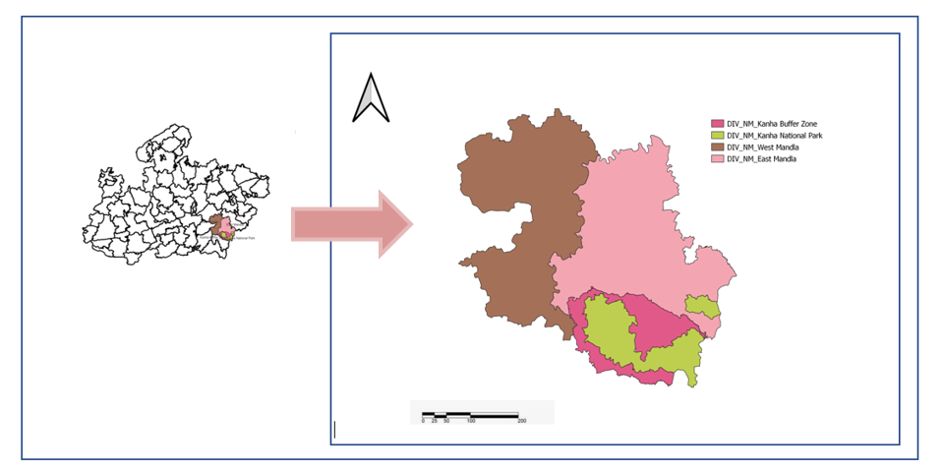
Phen WLS (KTR

Fig.1:- Forest Divisional Map of Mandla district, Madhya Pradesh, India

Sample Distribution
The samples were taken from the two territorial divisions and one protected area i.e. 1. East Mandla forest division (EMFD), 2. West Mandla forest division (WMFD) and 3. Kanha Tiger Reserve (KTR). This district has 17 forest ranges consisting of 74 forest villages and many revenue villages. A total of 237 sampling plots have been laid in the district, separated in two major groups i.e. Teak (160 sampling plots) and Sal (77 sampling plots) dominated forest. Data has been collected through quadrat method. Square quadrat of 10m*10m was used. The targeted areas were designated forests for the forest villages. Systematic random sampling method was used and quadrats have been laid in every 500meter.
Parameters taken
For the analysis of the data PAST software was used. Comparative analysis has been done for the two forest types & key NWFPs. Distribution and Diversity indices such as Shannon-Weinner index of diversity, Simpson’s index of dominance were calculated. To understand the relative importance of species, Importance Value Index (IVI) has been calculated using frequency, density and abundance values.

Result
During this study, it has been seen that 93 species belonging to 35 families are widely present in the Mandla district. A total of 23151 individuals including tree, shrub and seedling were counted for all the species. Samples were taken in teak(160) & sal(77) dominated forests and the total no. of plants excluding the seedlings are 7070 and 4699 found respectively. In the Tropical dry deciduous teak dominated forest 71 species were found whereas 66 species were found in Tropical moist deciduous sal dominated forest. In Sal forest both Tendu & Mahua is rarely found whereas sal alone dominated the forest with the relative density of 46.47. On the other hand in teak dominated forest Tendu and Mahua plants are comparatively more in number.
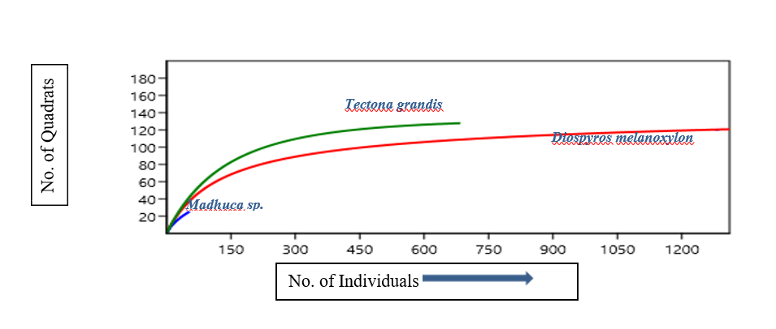

Fig.2: Species area curve of major NWFPs in Teak dominated forest

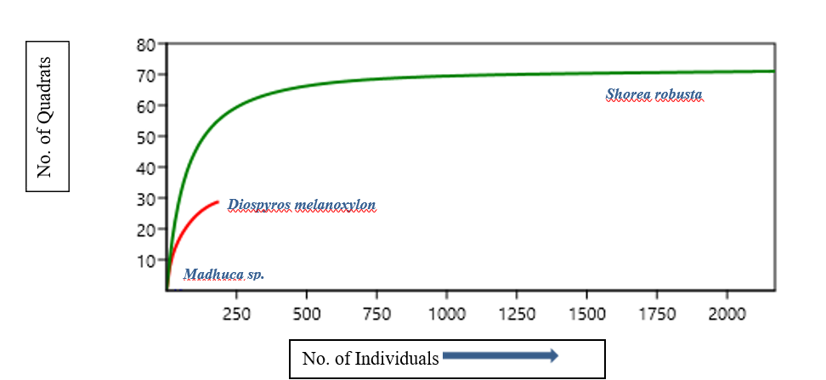

Fig.3: Species area curve of major NWFPs Sal dominated forest

Fig:3. Species area curve of major NWFPs in Sal dominated forest

Figure 2 and 3 illustrate the relationship between the number of individuals and the number of quadrats for different NWFP species in teak and sal-dominated forests. The curves for each species indicate how the species richness accumulates with increasing sampling effort. In both forest types, Tectona grandis and Shorea robusta show a higher number of quadrats compared to Diospyros melanoxylon and Madhuca sp., suggesting these species are more dominant or widely distributed within their respective forest types.
Distribution: In figure 4 and 5 compares three diversity indices between Moist Deciduous Sal Forest (MDSF) and Dry Deciduous Teak Forest (DDTF). The indices measured are Simpson's Diversity Index (Simpson_1-D), Shannon Diversity Index (Shannon_H), and Evenness (Evenness_e^H/S). The bars represent the indices for the two forest types, with blue for MDSF and yellow for DDTF.
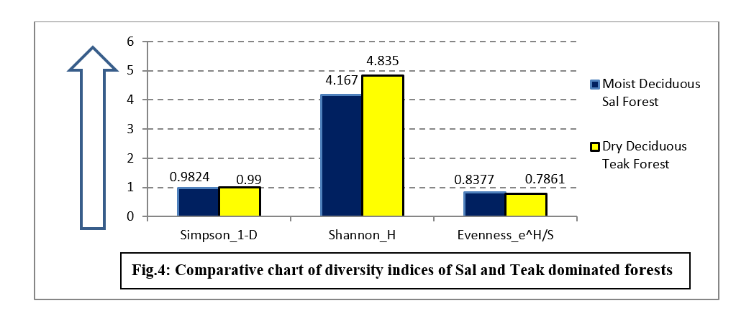
- Simpson's Diversity Index (Simpson_1-D): This index shows a slightly higher diversity in the DDTF(0.99) compared to the MDSF(0.9824), indicating a more even distribution of species in the teak forest.
- Shannon Diversity Index (Shannon_H): The Shannon index is higher in the DDTF(4.835), suggesting greater species richness and diversity in the teak forest compared to the sal(4.167) forest.
- Evenness (Evenness_e^H/S): The evenness index is slightly higher in the MDSF(0.8377) than DDTF(0.7861) indicating a more uniform distribution of individuals among the species present in the sal forest.
The comparative chart effectively highlights the differences in biodiversity between the two forest types, with the DDTF showing higher overall diversity but slightly lower evenness compared to the MDSF. These findings are crucial for understanding the ecological dynamics and management practices required for these forest ecosystems.

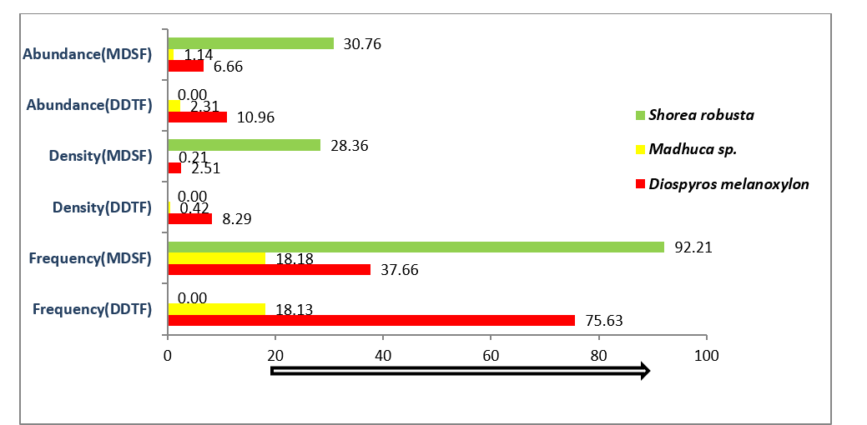
Fig.5: Comparative chart of Frequency, Density and Abundance of major NWFPs in Sal & Teak forest of Central India

Mandla district being the transitional zone from Tropical dry deciduous to Tropical moist deciduous forest, Mavai range of EMFD is the place where shift from Tectona grandis to Shorea robusta can be seen. Shorea robusta is a Key NWFP of the district which shows a frequency of 92.21 as it is found only in fewer places of the district. While Madhuca sp. being one of the most important NTFP shows only 18.18 and 18.13 frequency in Sal & Teak forest respectively. Diospyros melanoxylon shows a very high frequency (75.63) in teak forest than in Sal forest (37.66). This comparative chart highlights the significant differences in the distribution and ecological importance of these NWFP species between the two forest types. Shorea robusta is highly dominant in the MDSF but absent in the DDTF. In contrast, Diospyros melanoxylon shows higher frequency and density in the teak forest. Madhuca sp. is moderately present in both forests with relatively consistent values across all parameters.

Importance value index indicates the relative importance of a species in the community in a particular area. The aggregation of relative frequency, relative density, and relative abundance are used here. This figure illustrates the importance value (IV) index of three major NWFP species in two types of forests: Dry Deciduous Teak Forest (DDTF) and Moist Deciduous Sal Forest (MDSF). The y-axis represents the IV index, while the x-axis lists the species. Diospyros melanoxylon shows a higher (28.41) IVI in the teak forest, indicating its greater ecological significance in this forest type compared to the sal forest (11.10). The IVI for Madhuca sp. is relatively low in both forest types, with a slightly higher value (3.26) in the teak forest than sal forest (2.82), suggesting it has a minor but comparable ecological role in both forest ecosystems. Shorea robusta is highly dominant in the MDSF forest, as indicated by its high (69.84) IV index, whereas it is absent in the DDTF. This highlights its critical ecological importance and prevalence in the ecosystem.
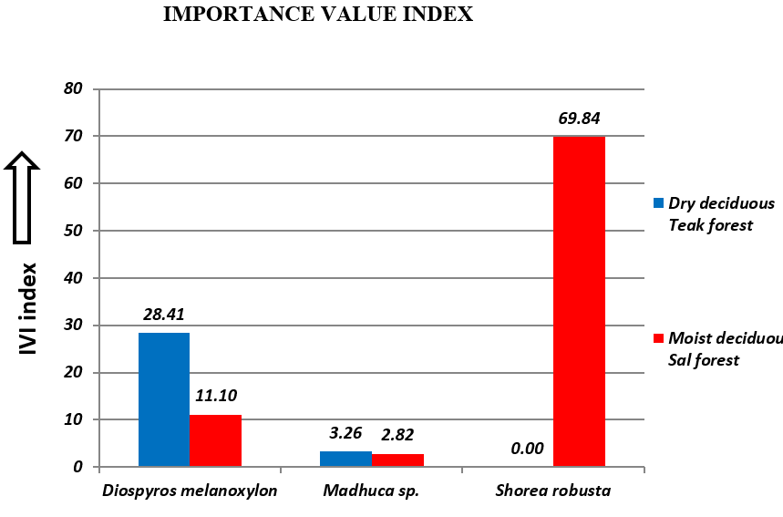
Fig.6: Comparative Importance value index of major NWFPs in Sal and Teak forest

The table below shows the species in both the forest types present very high in numbers. In Moist deciduous forest the maximum plants found is Shorea robusta (2184), while the number of other species ranges from 378 to 100. However, in Dry deciduous forests the plants a more homogenously distributed. The numbers range from 1756 to 115 starting with Anogeissus latifolia. Tectona gradis comes at third (696) in the list.

Table 1. Tree species found highest in Sal forest
Scientific Name | Usage | Parts used | NW usage
Shorea robusta | T/NT | Timber/ Seed | Seed oil in food and cosmetic industries
Mallotus philippensis | NT | Fruit | Dye
Diospyros melanoxylon | T/NT | Timber/Leaf/Fruit | Leaf as Indian cigarette wrap/Fruit as food
Embelia basal | NT | Fruit | Medicines
Catunaregam spinose | NT | Bark/Fruit/Leaf | Medicine/Food
Phoenix sylvestris | NT | Leaves/Fruits | Handicraft/Food
Terminalia elliptica | T | Timber | -
Syzgium cumini | T/NT | Timber/ Fruit | Food
Terminalia chebula | T/NT | Timber/ Fruit | Medicines
Table 2. Tree species found highest in Teak forest
Scientific Name | Usage | Parts used | NW usage
Anogeissus latifolia | T | Timber | Resin in confectionaries and medicinal purposes
Diospyros melanoxylon | T/NT | Timber/Leaf/Fruit | Leaf as Indian cigarette wrap/Fruit as food
Tectona grandis | T | Timber | -
Terminalia elliptica | T | Timber | -
Langerstroemia parviflora | NT | Timber | -
Carissa opaca | NT | Fruit | Food/Medicines
Miliusa tomentosa | NT | Fruit/Leaf | Leaf oil in medicines
Cassia fistula | NT | Bark/Fruit/Leaf/Flower | Medicine/Food
Butea monosperma | NT | Flower | Dye/Medicine
Flacourtia indica | NT | Fruit/Root | Medicine
Casearia graveolens | NT | Fruit/Leaf | Traditional fishing/ Medicine
Catunaregam spinose | T | Bark/Fruit/Leaf | Medicine/Food
Diospyros montana | T | Timber | -

Discussion
The study conducted in the forests of Mandla district, Madhya Pradesh, offers significant insights into the distribution and diversity of Non-Wood Forest Products (NWFPs) within two distinct forest types, the Tropical Dry Deciduous Teak Forest (DDTF) and the Tropical Moist Deciduous Sal Forest (MDSF). The findings reveal that while both forest types harbor a rich diversity of species, the composition and distribution patterns of these species vary considerably between the two forest types. Madhuca sp. being one of key NWFP species present in Central India shows a very low value for all the diversity indices in both the forest types. Most of Mahua trees are near the villages or surrounding the agricultural lands while these sampling plots are taken into the forest only. Also it has been seen that the species compositions differ in both the forest types and Diospyros melanoxylon is majorly found in the dry teak forest. The study underscores the ecological significance of various NWFP species in these forests. For example, Shorea robusta in the Sal forests and Diospyros melanoxylon in the Teak forests demonstrate a high Importance Value Index (IVI), reflecting their crucial roles in the respective ecosystems. Additionally, species like Madhuca sp., despite its lower frequency in the forest interiors, play a vital role in the livelihoods of local communities due to its economic value.

Conclusion
The study shows that in the tropical moist deciduous forest of central India Sal is the most dominant species found in all aspects while in tropical dry deciduous although it is defined by the presence of teak, the mostly found species is Anogeissus latifolia and Diospyros melanoxylon. Both the forest types are highly diverse but species in teak forest is more evenly distributed. In both the forest types the species compositions differ in respect to NWFP species. The research highlights that both Teak and Sal forests in Mandla district are rich in biodiversity, with each forest type having its unique species composition and distribution patterns. The Teak forests exhibit higher overall diversity and species richness, while the Sal forests show more evenness in species distribution. The study also points out the varying ecological and economic importance of different NWFP species in these forests, emphasizing the need for tailored forest management strategies to conserve and sustainably utilize these resources.

Attribution and Representation
All opinions and mistakes are the author(s)’ own and cannot be attributed to the institutions they represent. The publisher is also not responsible either for such opinions and mistakes in the text or graphs or images.

COMPETING INTERESTS DISCLAIMER:
Authors have declared that they have no known competing financial interests OR non-financial interests OR personal relationships that could have appeared to influence the work reported in this paper.
References:
- Dutta, G., & Devi, A. (2013). Plant diversity and community structure in tropical moist deciduous sal (Shorea robusta Gaertn.) forest of Assam, Northeast India. Journal of ISSN, 2319, 8745.
- FAO. (2018). Management of non-wood forest products. Food and Agriculture Organization of the United Nations. Retrieved from https://www.fao.org/sustainable-forest-management/toolbox/modules/management-of-non-wood-forest-products/basic-knowledge/en/
- FSI (Forest Survey of India). (2011). State of forest report 2011. Forest Survey of India.
- FSI (Forest Survey of India). (2021). State of forest report 2021. Forest Survey of India.
- Indian Council of Forestry Research and Education (ICFRE). (2000). Draft national forestry research plan. ICFRE.
- Krishnen, P. (2013). Jungle trees of Central India. Penguin Books.
- Kumar, R., & Saikia, P. (2021). Population structure and regeneration status of Shorea robusta and associated trees in sal forests of Ranchi, Eastern India. Tropical Ecology, 62(1), 34–51.
- Matta, A. F. (2019). Collection of non-timber forest products and dynamics of forest dependence. International Journal of Social Science and Economic Research, 4(3), 2455–8834.
- National Planning Commission. (2011). Report of the Sub‐Group‐II on NTFP and their sustainable management in the 12th Five‐Year Plan. Government of India.
- Pandey, S. K., & Shukla, R. P. (2003). Plant diversity in managed sal (Shorea robusta Gaertn.) forests of Gorakhpur, India: Species composition, regeneration and conservation. Biodiversity and Conservation, 12, 2295–2319. https://doi.org/10.1023/A:1024558617085
- Prasad, R. (1999). Joint forest management in India and the impact of state control over non-wood forest products. Unasylva, 198, 58–62.
- Singhal, R. (2000). Towards sustainable harvesting of non-wood forest products in India: The role of gender. In Seminar proceedings - Harvesting of Non-Wood Forest Products (Turkey, 2–8 October 2000).
- Srinivas, K. N. S. S. S., Kishore, P. P., & Rao, D. S. (2019). The geological site characterization of the Mandla region, Eastern Deccan Volcanic Province, Central India. Journal of Earth System Science, 128, Article 79. https://doi.org/10.1007/s12040-019-1096-7

