**Comparative Analysis of Stationary and Non-stationary Rainfall Intensity-Duration-Frequency Models for Abakaliki in Nigeria.**

**Abstract**

Several regions in the world are currently experiencing changes in their climatic conditions. However, these changes are not reflected in how the Intensity-Duration-Frequencycurvemodelling is done, as “stationarity” is still assumed.Stationarity assumes that the statistical parameters do not change over time. This study aims to present a comparative analysis of stationary and non-stationary Intensity-Duration-Frequency models for Abakaliki, Nigeria. Thirty-one years of rainfall data (1992-2022) for Abakliki obtained from the Nigerian Meteorological Agency (NIMET) were used to calibrate both the stationary and non-stationary IDF curves. The analysis employs the Generalised Extreme Value distribution with different parameterisations to calibrate both stationary and non-stationary models across precipitation durations ranging from 5 minutes to 24 hours. Results demonstrate that non-stationary models consistently outperform stationary approaches, especially at shorter durations and return periods. Percentage differences between rainfall intensity predictions range from -2.54% to +26.08%, with the most substantial underestimation by stationary models occurring for short-duration events. The 10-minute duration, 2-year return period event shows a 26.08% underestimation when using stationary assumptions, highlighting critical implications for urban drainage design. These findings indicate that continued reliance on stationary assumptions poses significant risks to infrastructure adequacy in Abakaliki under changing climatic conditions.

**Keywords**: Rainfall IDF curves, non-stationary modelling, stationary models, climate change, extreme value analysis, infrastructure design

**1. Introduction**

There is mounting evidence of changes in the climatic conditions in the Niger Delta region and South-Eastern part of Nigeria (Masi et al., 2022; Ekwueme et al., 2024; Olali et al., 2025). Masi et al. (2022) stated that there isan increasing in the rainfall precipitation in Uyo city, which is in the Niger Delta region. Ekwueme et al. (2024) reported that the rainfall precipitation in Umuahia ison the rise over the years,and Mann-Kendall test revealed a statistically increasing trend. Olali et al. (2025) reported that there was a significant increase in the temperature recorded in Bayelsa over the years. Olali et al. (2025) reported that the average temperature in Warri is expected to increase by 2.5 °C in the next 100 years. The increase in the atmospheric temperature results in a corresponding increase in the water holding capacity, which invariably increases the rainfall precipitation over the years. Martinkova and Kysely (2020) stated that a 1 degree increase in the temperature will result in a 7% increase in the water holding capacity of the atmosphere. Judging by this, a 2.5 °C increase in the temperature will result to approximately a 20% increase in the water holding capacity in the next 100 years in Warri. This trend of increasing temperature in the Niger Delta region and Southern Eastern part of Nigeria has been seen in recent years, which is a cause for concern as rainfall precipitation also increases.

Most hydraulic designs make use of the Intensity-Duration-Frequency curve for estimation of rainfall intensity for a particular duration and return period. However, the development of IDF assumes that the precipitation statistical parameters remain constant over time, which is known as “stationarity”. But this assumption is not generally true, as it has been confirmed that the rainfall precipitation changes over time. Therefore, the statistical parameter of the extreme rainfall event is expected to change over time. Despite this mounting evidence, most IDF models currently existing in Nigeria assume stationarity when the modelswere developed (Nwaogazie & Sam, 2020). The accuracy of IDF relationships directly influences both the safety and economic efficiency of engineering designs, making the question of stationarity versus non-stationarity critically important for infrastructure planning. The non-stationarity assumptionstates that the statistical parameter of the rainfall extreme event is expected to change over time(Milly et al., 2008). Research has confirmed that estimation of storm design intensities from the IDF model developed adopting “stationarity” resultsin underestimation of the rainfall intensities (Cheng &AghaKouchak, 2014; Ekwueme et al., 2025). The underestimation of the rainfall intensity could be as much as 60%, which will substantially increase flood risk and infrastructure failure (Cheng and AghaKouchak, 2014).The development of non-stationary approaches in extreme value analysis represents a paradigm shift from traditional methods, requiring modification of classical statistical frameworks to accommodate temporal evolution in precipitation characteristics.

Ekwueme et al. (2025) had previously established evidence for non-stationary behaviour in rainfall patterns for Abakaliki, with significant increasing trends identified through Mann-Kendall analysis and change points detected in 2010 and 2012. Also, non-stationary IDF models were developed for Abakaliki. Building upon this foundation, the present study aims to conduct a detailed comparative analysis of rainfall intensity obtained using stationary and non-stationary modelling approaches to quantify the practical implications of model choice for engineering applications in this region experiencing clear climate change impacts.

**2. Materials and Methods**

**2.1 Study Area**

Abakaliki serves as the capital city of Ebonyi State in southeastern Nigeria as presented in Figure 1. Abakaliki is located on geographical coordinates of latitude 6.3426oN and longitude 8.1263 oE. Abakaliki is located 54m above the Mean Sea level and within the humid tropical climate zone. The region experiences two distinct seasons, namely wet and dry seasons. The dry season is predominantly hot, muddy, and partially cloudy, and the wet season is usually warm. The average temperature of the region rarely falls below 15oC and rises above 34oC. The majority of rainfall occurs during the period from April through October. location for examining the practical implications of transitioning from stationary to non-stationary modelling approaches.

**2.2 Data Collection**

The rainfall dataset used for the study covered a thirty-one-year’s duration starting from1992 to 2022. The rainfall data were sourced from the Nigerian Meteorological Agency (NIMET), which is the national body responsible for collection of climatic data in Nigeria. Pre-processingof the rainfall data were done by ensuring the data were void of missing rainfall records. After which,the Annual maximum series data were obtained for each year. The Annual Maximum Series (AMS) is the maximum rainfall that occurred in a particular year. Given that 24hours of rainfall data were collected, the rainfall precipitationvalues were downscaled to obtain smaller rainfall precipitation values. The Indian Meteorological Department formula was used in obtaining the rainfall precipitation for shorter durations using Equation 1 (Sam et al., 2021). The shorter duration records obtained included 5, 10, 20, 30, 60, 120, 360, and 720 minutes.

$R_{t}$ = $R_{24}{\left(\frac{t}{24}\right)}^{1/3}$ 1

Where $R_{t}$ = Downscaled rainfall precipitation, $R_{24}$ = daily rainfall precipitation (mm), t = time.

**Figure 1**: Map of the study Area

**2.3 Data Analysis**

The comparative analysis employs the Generalised Extreme Value distribution as the fundamental statistical framework for both stationary and non-stationary model development. Ekwueme et al. (2025) developed a non-stationary model for Abakaliki, and the developed model for Abakalikiwas used for the comparative Analysis. Three non-stationary models were developed that covariate with time as presented in Table 1. The first non-stationary model had the location parameters covariate with time. The second non-stationary model had the scale parameter covariate with time, and the third had the location and scale parameter covariate with time. AIC and BIC goodness of fit were utilised in selecting the model that best fit the rainfall data. The non-stationary model with the lowest AIC and BIC was the model that best fit the rainfall data. The comparison was done based on the percentage difference between the non-stationary and stationary models. Equation 2 was used in calculating the percentage difference between the stationary and non-stationary.

$Percentage Difference = \frac{[\left(Non-stationary intensity - Stationary Intensity\right)}{Stationary Intensity}x 100$ 2

**Table 1:** Types of Selected GEV Linear Parameter Models

|  |  |  |
| --- | --- | --- |
| **Model Type** | **Parameter Combination** | **Remark** |
| GEVt – 0 | $$μ\left(t\right)= μ$$ $$σ\left(t\right)= σ$$ $$ξ\left(t\right)= ξ$$ | Stationary parameter model |
| GEVt – I | $$μ\left(t\right)= μ_{0}+μ_{1}t$$ $$σ\left(t\right)= σ$$ $$ξ\left(t\right)= ξ$$ | Non-stationary parameter model |
| GEVt – II | $$μ\left(t\right)= μ$$ $$σ\left(t\right)=σ_{0}+σ_{1}t$$ $$ξ\left(t\right)= ξ$$ | Non-stationary parameter model |
| GEVt – III | $$μ\left(t\right)= μ_{0}+μ_{1}t$$ $$σ\left(t\right)=σ_{0}+σ_{1}t$$ $$ξ\left(t\right)= ξ$$ | Non-stationary parameter model |

*Source: Silva and Simonovic (2020)*

**3. Results**

The non-stationary and stationary model for Abakaliki is presented in Table 2 and the computed rainfall intensity for the stationary and non-stationary models is presented in Figure 2. For shorter duration, GEVt – II was the best fit for the rainfall data while for longer duration GEVt – III was deem the best non-stationary model. The quantitative comparison between the stationary and non-stationary modelsfor the rainfall intensity predictions generally showed that the non-stationary models revealed higher rainfall intensity for shorter durations and return periods. However, for longer return periods (> 25 years) and durations exceeding 30 minutes, the stationary model tends to produce slightly higher rainfall intensity. The 5-minute duration revealed that the non-stationary model constantly produced higher rainfall intensity for all return periods. The percentage difference between the non-stationary and stationary models ranged from 0.66 to 6.55% as presented in Figure 3. The largest percentage difference in the rainfall intensity was observed for the 5-minute rainfall that occurred at the 2-year return period. For 10 10-minutedurations, the percentage difference recorded was higher than what was obtainable in a 5-minute duration. The percentage difference of the rainfall intensities between the non-stationary and stationary models ranged from -1.38 to 26.01%. The highest percentage difference was recorded at the 2-year return period. For 10 10-minute durations, the percentage difference in the rainfall intensity ranged from -2.0 to 11.05%. The maximum percentage difference was recorded in the 2-year return period. For 30 30-minute duration, the non-stationary model consistently produced higher rainfall intensity at all return periods. The percentage difference in the rainfall intensity between the non-stationary and stationary model ranged from 0.52 to 8.75%. This pattern of shorter durations and return periods has substantial percentage differences in their rainfall intensities,suggesting the need to utilise non-stationary modelling for rainfall modelling. Most hydraulic structures for cities are designed based on rainfall intensity for shorter durations and return periods.

**Table 2:** Evaluation of the performance of GEV parameters used for non-stationary and stationary models for Abakaliki

|  |  |  |  |  |  |  |
| --- | --- | --- | --- | --- | --- | --- |
| **Time (mins)** | **Models** | **Location Parameter** | **Scale** | **Shape Parameter** | **BIC** | **AIC** |
| 5 | GEVt– 0 | 8.441 | 4.818 | 0.185 | 212.25 | 207.953 |
| GEVt– I | -67.764 + 0.038t | 4.703 | 0.209 | 213.682 | 207.946 |
| GEVt– II | 8.443 | 5.158–0.0002t | 0.185 | 215.689 | 209.953 |
| GEVt- III | -145.167 + 0.076t | -3.348 + 0.004t | 0.310 | 215.269 | 208.099 |
| 10 | GEVt– 0 | 10.636 | 6.071 | 0.185 | 226.588 | 222.286 |
| GEVt– I | -24.522 + 0.018t | 5.846 | 0.193 | 229.292 | 223.555 |
| GEVt– II | 10.638 | 6.50- 0.0002t | 0.185 | 230.022 | 224.286 |
| GEVt- III | -390.026 + 0.199t | -13.12 + 0.009t | 0.177 | 226.067 | 218.897 |
| 20 | GEVt– 0 | 13.399 | 7.649 | 0.185 | 240.908 | 236.606 |
| GEVt– I | -136.164 + 0.075t | 7.457 | 0.167 | 241.987 | 236.251 |
| GEVt– II | 13.402 | 8.190– 0.0007t | 0.219 | 244.343 | 238.607 |
| GEVt- III | -118.461 + 0.066t | -0.115 + 0.004t | 0.203 | 245.640 | *238.470* |
| 30 | GEVt– 0 | 15.339 | 8.756 | 0.185 | 249.291 | 244.989 |
| GEVt– I | 6.277 + 0.005t | 8.948 | 0.1841 | 252.609 | 246.873 |
| GEVt– II | 15.342 | 9.376– 0.0003t | 0.1847 | 252.726 | 246.990 |
| GEVt- III | -82.163 + 0.049t | 3.017 + 0.003t | 0.1624 | 254.861 | *247.691* |
| 60 | GEVt– 0 | 19.323 | 11.031 | 0.185 | 263.601 | 259.308 |
| GEVt– I | 9.759 + 0.005t | 10.961 | 0.188 | 266.934 | 261.198 |
| GEVt– II | 19.329 | 11.813– 0.003t | 0.228 | 267.044 | 261.30 |
| GEVt- III | -86.316 + 0.0528t | 4.843 + 0.0029t | 0.187 | 269.27 | *262.103* |
| 120 | GEVt– 0 | 24.361 | 13.906 | 0.1842 | 277.938 | 273.636 |
| GEVt– I | 17.533 + 0.004t | 14.119 | 0.1791 | 281.315 | 275.580 |
| GEVt– II | 24.355 | 14.89– 0.0005t | 0.1848 | 281.372 | 275.636 |
| GEVt- III | -180.216 + 0.102t | 1.492 + 0.0060t | 0.2055 | 282.945 | *275.775* |
| 360 | GEVt– 0 | 35.141 | 20.066 | 0.1842 | 300.646 | 296.344 |
| GEVt– I | 35.417– 0.00011t | 20.081 | 0.1836 | 304.081 | 298.345 |
| GEVt– II | 35.119 | 21.47– 0.0007t | 0.1849 | 304.080 | 298.344 |
| GEVt- III | -0.1703 + 0.017t | 19.0 + 0.0004t | 0.1954 | 307.297 | *300.127* |
| 720 | GEVt– 0 | 44.245 | 25.257 | 0.185 | 314.70 | 310.668 |
| GEVt– I | 44.635– 0.0002t | 25.296 | 0.183 | 318.406 | 312.670 |
| GEVt– II | 44.252 | 27.05– 0.0009t | 0.2336 | 318.405 | 312.669 |
| GEVt- III | -24.449 + 0.0343t | 22.28 + 0.0011t | 0.2072 | 321.499 | *314.329* |
| 1440 | GEVt– 0 | 55.75 | 31.816 | 0.1845 | 329.29 | 324.992 |
| GEVt– I | 56.244– 0.0002t | 31.872 | 0.3669 | 332.73 | 326.994 |
| GEVt– II | 55.759 | 34.08– 0.0011t | 0.2321 | 332.728 | 326.993 |
| GEVt- III | 12.572 + 0.0215t | 31.23 + 0.0003t | 0.1949 | 335.987 | *328.818* |

For the Intermediate duration, ranging from 60 to 360 minutes, the percentage difference between the non-stationary and stationary tends tobe less noticeable for the shorter duration. However, the stationary model tends to predict slightly higher rainfall intensity, especially between 10 to 50 years return period. For a 60-minute duration, the stationary model had up to a 2.39% difference from the non-stationary model, which was recorded at 10-year return period.Similarly, for a 360-minute duration, the stationary model generally predicted slightly higher rainfall intensity than the non-stationary model. The largest percentage difference in the rainfall intensity was recorded at 10-year return period.

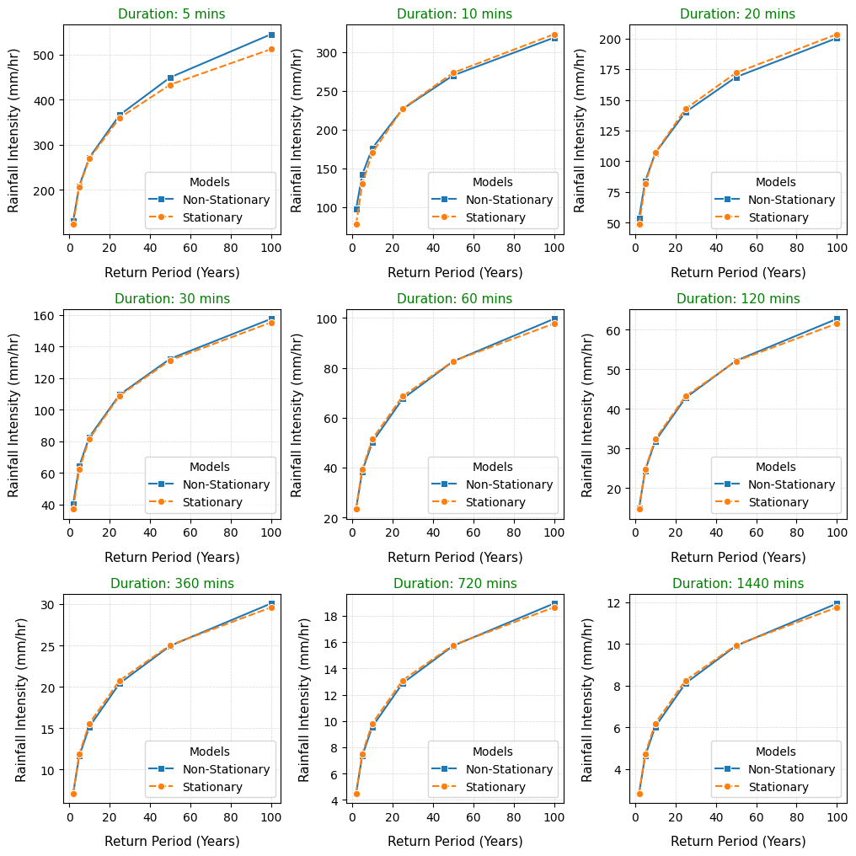

**Figure 2**: Rainfall Intensity for stationary and non-stationary models for various durations and return periods.

For longer rainfalldurations ranging from 720 to 1440 minutes, the percentage difference between the non-stationary and stationary models was small. For 720 minutes, the percentage difference for the rainfall intensity ranged from 0.59 to -2.54%. Similar percentage difference was also observed for 1440-minute duration, as the percentage difference ranged from 0.59 to -2.54%. Average percentage changes across all return period for a particular duration revealed that 2 years return period had the largest percentage difference of rainfall intensity between the non-stationary and stationary models. A 6.34% difference was recorded for 2-year return period, 0.80% for 5-year, -0.70% for 10-year, -0.82% for 25-year, 0.04% for 50-year, and 1.51% for 100-year return periods. These values highlight the predominant underestimation of frequent events by stationary models,especially for shorter return periods.

**Figure 3**: Percentage difference in rainfall intensity between non-stationary and stationary model

**4. Discussion**

The result from the study provides evidence that changing climatic condition in any location affect the rainfall intensity. The use of a stationary model for development of IDF curves in changing climaticconditions can result in significant underestimation of the rainfall intensity. Stationary rainfall models for Abakalikiseriously underestimated the rainfall intensity, particularly for shorter durations and return periods. It was revealed that obtaining the rainfall intensity for 10 10-minute duration for a 2-year design period using IDF model developed using the stationarity assumption could underestimate the rainfall intensity by up to 27%. However, the underestimation could be higher in regions with severe changing climatic conditions. ChengandAghaKouchak(2014) reported that the underestimation could be as high as 60%. Sam and Nwaogazie (2024) reported that the stationary model underpredicted the rainfall intensity in Uyo as much as 24%. Ekwueme et al. (2025) reported that the stationary model underpredicted the rainfall intensity as much as 16%. Significant underprediction of the rainfall intensity by the stationary model occurs for shorter durations and return periods. Underprediction of rainfall intensity at this duration and return period can result inan error that threatens drainage infrastructure design for urban areas.The use of rainfall intensity obtained from stationary IDF model will potentially put the city to risk of flooding as the hydraulic structure will most likely be undersized.

**5. Conclusion**

This comparative analysis demonstrates that non-stationary IDF models provide superior performance compared to traditional stationary approaches for Abakaliki, with the GEV_t-II model consistently outperforming the stationary model, especially for shorter durations and return periods. The magnitude of percentage differences between non-stationary and stationary models ranged from -2.54% to +26.08%. Underprediction of the rainfall intensity as high as 26% can result in error when used for hydraulic structure design. A 26% underestimation might exceed any factor of safety used when the hydraulic structure is designed with rainfall intensity obtained from a stationary model, which will substantially increase the risk of flooding. The 26.08% underestimation for 10-minute, 2-year return period events poses immediate concerns for urban drainage adequacy. These findings provide compelling evidence for updating design standards and practices to incorporate non-stationary modelling approaches in regions experiencing significant climate change impacts, such as Abakaliki.

**References**

Cheng, L., &AghaKouchak, A. (2014). Nonstationary precipitation intensity-duration-frequency curves for infrastructure design in a changing climate. Scientific Reports, 4, 7093. https://doi.org/10.1038/srep07093

Cheng, L., AghaKouchak, A., Gilleland, E., & Katz, R. W. (2014). Non-stationary extreme value analysis in a changing climate. Climatic Change, 127(2), 353-369. https://doi.org/10.1007/s10584-014-1254-5

Coles, S., Bawa, J., Trenner, L., & Dorazio, P. (2001). An introduction to statistical modeling of extreme values. London: Springer-Verlag.

Ekwueme, C. M., Nwaogazie, I. L., &Ikebude, C. (2024). Establishing Climate Change on Rainfall Trend, Variation and Change Point Pattern in Umuahia, Nigeria. International Journal of Environment and Climate Change, 14(11), 118-126.

Ekwueme, C. M., Nwaogazie, I. L., Ikebude, C. F., Amuchi, G. O., & Irokwe, J. O. (2025). Modeling rainfall intensity-duration-frequency (IDF) and establishing climate change existence in Abakaliki-Nigeria using a non-stationary approach. Hydrology, 13(1), 83-89.

Ekwueme, C. M., Nwaogazie, I. L., Ikebude, C. F., Amuchi, G. O., Irokwe, J. O. (2025). Comparative Analyses of Stationary and Non-Stationary IDF Rainfall Models for Umuahia. Hydrology, 13(2), 102-113. https://doi.org/10.11648/j.hyd.20251302.12

Hathaway, J. M., Bean, E. Z., Bernagros, J. T., Christian, D. P., Davani, H., Ebrahimian, A., Fairbaugh, C. M., Gulliver, J. S., McPhillips, L. E., Palino, G., & Strecker, E. W. (2024). A synthesis of climate change impacts on stormwater management systems: Designing for resiliency and future challenges. Journal of Sustainable Water in the Built Environment, 10(2), 04023014. <https://doi.org/10.1061/JSWBAY.SWENG-533>

Milly, P. C. D., Betancourt, J., Falkenmark, M., Hirsch, R. M., Kundzewicz, Z. W., Lettenmaier, D. P., & Stouffer, R. J. (2008). Stationarity is dead: Whither water management? Science, 319(5863), 573-574. <https://doi.org/10.1126/science.1151915>

Nwaogazie, I. L., & Sam, M. G. (2020). A review study on stationary and non-stationary IDF models used in rainfall data analysis around the world from 1951-2020. Int. J. Environ. Clim. Change, 10(12), 465-482.

Olali, K., Nwaogazie, I. L., &Ikebude, C. F. (2025). Establishing Climate Change on Temperature Trend, Variation and Change Point Pattern in Warri, Nigeria. Hydrology, 13(2), 90-101.

Papalexiou, S. M., &Koutsoyiannis, D. (2013). Battle of extreme value distributions: A global survey on extreme daily rainfall. Water Resources Research, 49(1), 187-201. <https://doi.org/10.1029/2012WR012557>

Sam, M. G., & Nwaogazie, I. L. (2024). Comparative Performance of Non-Stationary Intensity-Duration-Frequency (NS-IDF) Models for Selected Gauge Stations in the Niger Delta. Hydrology, 12(2), 17-31.

Sam, M. G., Nwaogazie, I. L., &Ikebude, C. (2021). Improving Indian meteorological department method for 24-hourly rainfall downscaling to shorter durations for IDF modeling. International Journal of Hydrology, 5(2), 72-82.

Sam, M. G., Nwaogazie, I. L., &Ikebude, C. (2022). Climate change and trend analysis of 24-hourly annual maximum series using Mann-Kendall and Sen slope methods for rainfall IDF modeling. Internat. Jour. Environ. Climate Change, 12(3), 44-60.

Silva, A. T., & Simonovic, S. P. (2020). Nonstationary flood frequency analysis in the upper Thames River basin under climate change. Journal of Hydrologic Engineering, 25(4), 04020006.

Simonovic, S. P., & Peck, A. (2009). Updated rainfall intensity duration frequency curves for the City of London under the changing climate. Canadian Water Resources Journal, 34(3), 203-218. https://doi.org/10.4296/cwrj2011-935

Simonovic, S. P., &Schardong, A. (2013). Web-based tool for the development of Intensity Duration Frequency curves under changing climate. Environmental Modelling & Software, 49, 120-127. https://doi.org/10.1016/j.envsoft.2013.06.010

Willems, P., Arnbjerg-Nielsen, K., Olsson, J., & Nguyen, V. T. V. (2012). Climate change impact assessment on urban rainfall extremes and urban drainage: Methods and shortcomings. Atmospheric Research, 103, 106-118. https://doi.org/10.1016/j.atmosres.2011.04.003