**Seasonal Variability and Stability of Growth and Fruit Yield Performance in Eight Elite Mulberry Genotypes**

**Abstract**

A study was conducted at the Department of Sericulture, UAS, GKVK, Bengaluru during 2023-24 to evaluate the mean performance of elite mulberry genotypes across different seasons. Stability parameters were analyzed to assess the adaptability of these genotypes. A promising and stable genotype was identified based on higher mean performance, unitary regression (b*i*) values and minimal deviation from regression (S²d*i*). Most genotypes displayed low environmental sensitivity and were well-adapted across seasons, allowing for performance prediction across all seasons. For fruit characteristics, ME-0220 consistently outperformed other genotypes in terms of the number of fruits per plant and per branch across winter, summer and rainy seasons. ME-0006 showed superior performance in fruit width, length, weight and yield per plant excelling in nearly all traits. Both ME-0006 and ME-0220 were found to be stable and high-yielding across the three seasons based on the G × E interaction and their consistent performance in fruit yield and its related traits.

Keywords: *Mulberry genotypes; G × E interaction; Stability; fruit parameters; Mean performance*

**1.Introduction**

Mulberry (*Morus* spp.) woody, deciduous and perennial plant primarily cultivated as the only host for rearing the domesticated silkworm, *Bombyx mori* L. (Lepidoptera: Bombycidae), to produce mulberry silk. It has a deep root system, the leaves are alternate, simple, stipulate, entire or lobed, petiolate (Sinha, 2008). The inflorescence, which bears unisexual flowers, resembles a catkin with a drooping or pendulous peduncle. Typically, male catkins are longer than those of females. The stigma is bifid and the ovary is single celled. Wind is the primary pollinating agent in mulberry, facilitating the development of its fruit.

The mulberry plant produces tiny syncarps as its fruits, fleshy and succulent, with an oval shape and a soft texture, consisting of multiple drupes. They usually measure between one to two centimeters in length and exhibit a range of colors from dark purple, red or black to white or pale yellow, depending on the species and level of ripeness. These berries offer a perfect balance of sweetness and tartness, enriched with vital nutrients (Reich, 1992).

The commercially unexploited minor fruits have a useful role to play if they are properly utilized. In India, many fruits with low commercial value often go to waste and mulberry is among those that are largely overlooked. In spite of its easy growing conditions, considerably high nutritive value, attractive colour and delicate flavour with appropriate exploitation, mulberry fruit could diversify diets both domestically and in export markets. There is a pressing need to apply modern science and technology to enhance the production, utilization and processing of mulberry fruit.

Mulberry fruit is enjoyed both fresh and dried. With its sweet and slightly tart flavor. It's frequently used to make pies, dried fruit treats, smoothies, jams and jellies. Where there are lots of mulberry trees, the fruit is often incorporated into local cuisines and savored during its seasonal harvest. The versatility of mulberry fruit, combined with its nutritional benefits and medicinal properties to makes it not only a delightful treat but also a valuable source of health and well-being.

Sarkar *et al*. (1986) and Bari *et al*. (1989) have highlighted the critical importance of understanding the nature and relative magnitude of genotype × environment (G × E) interaction for selecting superior genotypes suited for diverse environmental conditions. However, G × E interaction can introduce significant bias in these estimates, complicating the assessment of a variety's potential to maintain stable performance across varying environments. Therefore, studying G × E interaction and phenotypic stability is vital not only for obtaining unbiased estimates of genetic variation across different traits but also for identifying varieties with low G × E interaction. Varieties with low G × E interaction will demonstrate greater stability, while those with high G × E interaction will be more unstable when cultivated in variable environments.

The productivity of a genotype is the function of its adaptability to a particular environment. Stability of a genotype depends on the ability to retain certain morphological and physiological characters along with its production efficiency steadily allowing others to vary resulting in predictable G × E interactions for yield. The yield stability in mulberry over a wide range of environments is one of the most desirable parameters to be considered for selecting a mulberry for large scale cultivation. Fruit yield of mulberry fluctuates with the season due to sensitivity of the genotypes to growing conditions. Exploitation of G x E interaction may prove useful in identifying stable genotypes for different environmental conditions.

The response of yield attributing characters to the various environmental conditions is particularly important for determination of their stability. Developing a variety, that performs equally well under different environmental conditions is a great challenge to plant breeders.

Hence the present studies were undertaken to mean performance and stability of elite mulberry genotypes in different seasons.

**2.Material and methods**

Studies on stability of elite mulberry genotypes for growth and fruit yield parameters was carried out under rainfed condition in the Department of Sericulture, University of Agricultural Sciences, GKVK, Bengaluru-65. The experimental material for the present study comprised of eight elite mulberry genotypes *viz.*, *Morus indica,* *M. cathayana,* *M. latifolia,* *M. macroura,* *M. alba,* *M. multicaulis,* *M. indica* (S-34)and *M. indica* (M-5) Standard check were used. Each genotype was planted with spacing of 4 x 4 feet. The stability for growth and yield parameters was conducted during three seasons *viz.,* winter, summer and rainy seasons of the 2023-24. The experimental plot was maintained as per the recommended package of practices for rain-fed mulberry (Dandin and Giridar, 2014). The performance of each elite genotype was evaluated by selecting randomly five competitive plants in each replication for growth and fruit yield. The genotypes were evaluated 60th day after pruning for growth and fruit yield parameters during different seasons.

**Stability analysis**

Stability analysis was carried out by following Eberhart and Russell, 1966 linear regression model. The model employed is explained below:

Where,

Yi = µi + βi Ij + δij

Yi j= The mean of the ith genotype at jth environment

µi = The mean of the ith genotype over all environment

βi= The regression co-efficient of the ith genotype

βi= The regression co-efficient of ith genotype of the environmental index which measures the response of the ith genotype to varying environments

Ij= The environment index obtained as deviation of mean of all the genotypes at

jth = environment from the grand mean

δij= Deviation from the regression of the ith genotype at jth environment

**These parameters were estimated as follows:**

µ= Yi/ n

ii) βi=∑JYiJIj/∑ JI2J

iii) S2di = ∑j (δij)/n-2)-S2e/r

Where n= Number of environments

Yi = Total of genotype i over all the environment

Yij = Performance of ith genotypes at the jth environment

iv) Environment index (Ij) = (Y.J/V) - (Y.. /Vn)

Y..=Grand total of all genotypes over all environments

Y. J=Total of all genotypes at jth location

V=Number of genotypes

v) ∑S2ij=Sum of squares due to deviation from the regression line obtained as

∑j Y2ij-(Yi2../n)-(∑iYijIj)2/∑jI2J

vi) S2 e/r = Estimated pooled error or the variance of a genotype mean at the jth environment.

**3.4.2 A joint consideration of three parameters *i.e.,***

The mean performance of genotypes over environment (xi)

The regression co-efficient (βi)and

The deviation from linear regression (S2di), is used to define the stability of genotype, or in other words it an estimate of stability of the genotypes. The estimation of deviation from regression denotes the degree of reliance that should be predicted satisfactorily. When deviations are not significant, the conclusions are drawn by joint consideration of mean yield and regression (Eberhart and Russell, 1966) as below:

Chart 1. **Result of stability analysis**

|  |  |  |  |
| --- | --- | --- | --- |
| **Regression** | **Stability** | **Mean yield** | **Remarks** |
| β =1 | Average | x>µ | Well adapted to all environment |
| β =1 | Average | x < µ | Poorly adapted to all environment |
| β >1 | Below Average | x>µ | Specifically adapted to favorable environments |
| β <1 | Above Average | x<µ | Specifically adapted to unfavorable environments |

Regression values of unity are interpreted as average stability since the average slope over the genotypes on the environmental index will be unity.

# 3. Results and discussion

The fruit yield and growth parameters of different elite mulberry genotypes differed significantly among different seasons. During rainy season, no single genotype was superior in respect of all the traits studied.

**3.1. To determine the mean performance for growth and fruit yield parameters of elite mulberry genotypes to identify stable genotypes in three seasons**.

**3.1.1. Number of days required for fruit formation**

The number of days required for fruit formation in eight mulberry genotypes varied from season to season as indicated by varying environmental indices (-4.540 to 4.963). The environment mean and index was highest at S1 (34.28 and 4.963) and lowest in S3 (24.78 and -4.540) respectively. Considering the overall mean, ME-0067 had least number of days required for fruit formation (24.50) followed by MI-0160 (27.09) and ME-0018 (27.93). whereas it was highest in MI-0516 (33.86) (Table 1).

The number of days required for fruit formation in eight mulberry genotypes *viz.,* ME-0067, MI-0160, ME-0018 and ME-0086 was lower than the grand mean with non-significant regression co-efficient and its value is equal to one indicating average stability hence these genotypes are specifically adapted to all seasons. The mean performance of MI-0516, MI-0014, ME-006 and ME-0220 and higher than the grand mean having non-significant regression co-efficient and equal to one with average stability indicating that these genotypes are poorly adapted to all seasons. Whereas the deviation from regression was non-significant for all mulberry genotypes for number of days required for fruit formation indicating predictable performance across the seasons (Table 1 and Fig. 1).

**3.1.2. Fruit length (cm)**

The fruit length in eight mulberry genotypes varied from season to season as indicated by varying environmental indices (-0.104 to 0.192). The environment mean and index was highest at S3 (2.60 and 0.192) and lowest in S2 (2.32 and -0.088) respectively. The overall mean ME-0006 had highest fruit length (3.14) followed by MI-0516 (3.03) and ME-0067 (2.85). whereas it was lowest in ME-0220 (1.51) (Table 2).

The fruit length in eight mulberry genotypes *viz.,* ME-0006, MI-0516, ME-0067, MI-0014 and MI-0160 was higher than the grand mean with non-significant regression co-efficient and its value was equal to one indicating average stability hence these genotypes are specifically adapted to all seasons. The mean performance of ME-0220, ME-0018 and ME-0086 and lower than the grand mean having non-significant regression co-efficient and is equal to one with average stability that indicating that these genotypes are poorly adapted to all seasons. Whereas the deviation from regression was non-significant for all mulberry genotypes for fruit length indicating predictable performance across the seasons (Table 2 and Fig. 2).

**3.1.3. Fruit width (cm)**

The fruit width in eight mulberry genotypes varied from season to season as indicated by varying environmental indices (-0.097 to 0.131). The environment mean and index was highest at S3 (1.51 and 0.131) and lowest in S2 (1.3 and -0.034) respectively. The overall mean ME-0006 had highest fruit width (2.01) followed by MI-0516 (1.86) and ME-0067 (1.52). whereas it was lowest in ME-0220 (0.96) (Table 3).

The fruit width in eight mulberry genotypes *viz.,* ME-0006, MI-0516 and ME-0067 was higher than the grand mean with non-significant regression co-efficient and its value was equal to one indicating average stability, hence these genotypes are specifically adapted to all seasons. The mean performance of ME-0220, MI-0160, ME-0086 and MI-0014 and lower than the grand mean having non-significant regression co-efficient and is equal to one with average stability indicating that these genotypes are poorly adapted to all seasons. Whereas the deviation from regression was non-significant for all mulberry genotypes for fruit width indicating predictable performance across the seasons (Table 3 and Fig. 3).

**3.1.4. Number of fruits per plant**

The number of fruits per plant in eight mulberry genotypes varied from season to season as indicated by varying environmental indices (-5.363 to 16.507). The environment mean and index was highest at S3 (70.31 and 16.507) and lowest in S2 (48.45 and -5.363) respectively. Considering the overall mean, ME-0220 had highest number of fruits per plant (76.04) followed by ME-0018 (59.02) and MI-0014 (56.09). whereas it was lowest in ME-0086 (38.58) (Table ).

The number of fruits per plant in eight mulberry genotypes *viz.,* ME-0220, ME-0018, MI-0014 and MI-0160 was higher than the grand mean with non-significant regression co-efficient and its value is equal to one indicating average stability hence these genotypes are specifically adapted to all seasons.

The mean performance of ME-0086, ME-0006, MI-0516 and ME-0067 and lower than the grand mean having non-significant regression co-efficient and it equal to one with average stability indicating that these genotypes are poorly adapted to all seasons. Whereas the deviation from regression was non-significant for all mulberry genotypes for number of fruits per plant indicating predictable performance across the seasons (Table 4 and Fig. 4).

Similar findings were obtained by Rahman *et al*. (2015) considering strawberry fruits per plant, Sweet Charlie exhibited highest (3.42) fruits per plant. Festival exhibited acceptable mean (x) and deviation from regression (S2di) was 0, with regression co-efficient (bi) near to unity (0.99) and considered to be highly adaptive at any environment.

**3.1.5. Fruit weight (g)**

The fruit weight in eight mulberry genotypes varied from season to season as indicated by varying environmental indices (-0.144 to 0.246). The environment mean and index was highest at S3 (2.46 and 0.246) and lowest in S2 (2.11 and -0.102) respectively. The overall mean ME-0006 had highest fruit weight (3.01) followed by MI-0516 (2.68) and ME-0067 (2.42). whereas it was lowest in ME-0018 (1.61) (Table 5).

The fruit weight in eight mulberry genotypes *viz.,* ME-0006, MI-0516, MI-0067 and MI-0014 was higher than the grand mean with non-significant regression co-efficient and its value is equal to one indicating average stability hence these genotypes are specifically adapted to all seasons. The mean performance of ME-0018, ME-0220, MI-0160 and ME-0086 and lower than the grand mean having non-significant regression co-efficient and equal to one with average stability indicating that these genotypes are poorly adapted to all seasons. Whereas the deviation was non-significant and there is no deviation across all seasons in all mulberry genotypes for fruit weight indicating predictable performance across the seasons (Table 5 and Fig. 5).

**3.1.6. Number of fruits per branch**

The number of fruits per branch in eight mulberry genotypes varied from season to season as indicated by varying environmental indices (-0.807 to 1.022). The environment mean and index was highest at S3 (6.62 and 1.022) and lowest in S2 (5.39 and -0.215) respectively. Considering the overall mean ME-0220 had the highest number of fruits per branch (7.14) followed by ME-0018 (6.01) and MI-0014 (5.83). whereas it was lowest in ME-0086 (4.56) (Table 6).

The number of fruits per plant in eight mulberry genotypes *viz.,* ME-0220, ME-0018, MI-0014 and MI-0516 was higher than the grand mean with non-significant regression co-efficient and its value is equal to one indicating average stability hence these genotypes are specifically adapted to all seasons. The mean performance of ME-0086, ME-0006, ME-0067 and MI-0160 and lower than the grand mean having non-significant regression coefficient and equal to one with average stability indicating that these genotypes are poorly adapted to all seasons. Whereas the deviation from regression was non-significant for all mulberry genotypes for number of fruits per branch indicating predictable performance across the seasons (Table 6 and Fig. 6).

**3.1.7. Fruit yield per plant (g)**

The fruit yield per plant in eight mulberry genotypes varied from season to season as indicated by varying environmental indices (-32.034 to 50.997). The environment mean and index was highest at S3 (166.77 and 50.997) and lowest in S2 (96.91 and -18.963) respectively. When considering the overall mean ME-0006 had highest fruit yield per plant (148.06) followed by MI-0516 (126.71) and MI-0014 (126.30). whereas it was lowest in ME-0086 (84.50) (Table 7).

The fruit yield per plant in eight mulberry genotypes *viz.,* ME-0006, MI-0516, MI-0014 and ME-0220 was higher than the grand mean with non-significant regression co-efficient and its value is equal to one indicating average stability hence these genotypes are specifically adapted to all seasons. The mean performance of ME-0086, ME-0018, MI-0160 and ME-0067 are lower than the grand mean having non-significant regression co-efficient and equal to one with average stability indicating that these genotypes are poorly adapted to all seasons. Whereas the deviation from regression was non-significant and there is no deviation across all seasons in all mulberry genotypes for fruit yield per plant indicating predictable performance across the seasons (Table 7 and Fig. 7).

Similar findings were obtained by Rahman *et al*. (2015) The strawberry genotype Camarosa exhibited acceptable mean (x), insignificant bi but the S2di was not significantly different from zero indicating less fluctuation of genotype to change in different environments. Considering yield (t/ha), Sweet Charlie produced higher mean (x), the bi value nearer to unity but S2di was high, indicating responsiveness of the genotype to unusual changes in the location. FA 008 had excellent regression co-efficient (bi=1) and deviation from regression was least (-0.33) but minimum mean (x) indicating it to be a poor yielder with less responsiveness to unusual change in the location and considered to be adapted to poor environments.

**Conclusion**

The mean performance of eight yield and yield-contributing traits was analyzed separately for different season. Stability analysis of the elite mulberry genotypes for fruit-related parameters provided valuable insights into their adaptability and performance across varying environmental conditions. In terms of fruit yield, genotype ME-0006 demonstrated superior performance across winter, summer and rainy seasons for traits such as fruit width, length, weight and yield per plant. On the other hand, ME-0220 consistently produced a higher number of fruits per plant and per branch across all seasons. Both ME-0006 and ME-0220 were identified as stable genotypes across the three seasons based on G × E interaction, highlighting their high yield potential and resilience to environmental variations. The study further indicated that ME-0006 was particularly preferred for its growth and fruit yield traits across three different seasons.

**DISCLAIMER (ARTIFICIAL INTELLIGENCE):**

Author(s) hereby declare that NO generative AI technologies such as Large Language Models (ChatGPT, COPILOT, etc) and text-to-image generators have been used during writing or editing of manuscripts.

**COMPETING INTERESTS DISCLAIMER:**

**Authors have declared that they have no known competing financial interests OR non-financial interests OR personal relationships that could have appeared to influence the work reported in this paper.**

**5. References**

BARI, M. A., QAIYYUM, M. A. AND AHMED, S. V. 1989, Correlation studies in mulberry. *Indian j. Seric.* **28**(1): 11-16.

DANDIN, S. B. AND GIRIDHAR, K., 2014, *Handbook of Sericulture Technologies*. CSB Publications, pp. : 427.

EBERHART, S. A. AND RUSSELL, W. A. 1966, Stability parameters for comparing varieties. *Crop Sci.,* **6**: 36-40.

RAHMAN, M. M., MIAN, M. A. K. AND ISLAM, M. A., 2015, G×E Interaction for Growth, Yield and Quality Characters of Strawberry (*Fragaria ananassa* Duch.) under Bangladesh Conditions: Genotype Environment Interaction of Strawberry. *Biol. Sci.-PJSIR*, **58**(1): 11-18.

REICH, L., 1992, Native American fruits. *Organic Gardening*, **39**(2): 54-57.

SARKAR, A., DAS, B. C. AND CHAKRABORTY, S. P. 1986. Yield stability in mulberry. *Indian J. Agril. Sci.,* **56**: 30-36.

SINHA, N. K., SIDHU, J., BARTA, J., WU, J. AND CANO, M.P. EDS., 2008, *Handbook of Fruits and Fruit Processing*. John Wiley & Sons. pp. : 56-60.

**Table 1. Mean performance of eight elite mulberry genotypes for three seasons and their stability parameters for number of days required for fruit formation**

|  |  |  |  |  |  |  |  |  |  |  |
| --- | --- | --- | --- | --- | --- | --- | --- | --- | --- | --- |
| **Genotypes** | **S1** | **Rank** | **S2** | **Rank** | **S3** | **Rank** | **Mean** | **Overall Rank** | **b*i*** | **S²d*i*** |
| **MI-0516** | 38.30 | 8 | 35.20 | 8 | 28.07 | 8 | 33.86 | 8 | 1.05 | 4.58 |
| **ME-0018** | 32.40 | 3 | 27.80 | 3 | 23.60 | 3 | 27.93 | 3 | 0.92 | -0.14 |
| **ME-0067** | 29.90 | 1 | 24.20 | 1 | 19.40 | 1 | 24.50 | 1 | 1.10 | -0.20 |
| **ME-0220** | 36.10 | 5 | 28.87 | 5 | 25.67 | 5 | 30.21 | 5 | 1.11 | 0.91 |
| **ME-0086** | 32.80 | 4 | 28.13 | 4 | 23.87 | 4 | 28.27 | 4 | 0.94 | -0.14 |
| **ME-0006** | 36.90 | 6 | 30.40 | 7 | 26.27 | 6 | 31.19 | 6 | 1.12 | -0.09 |
| **MI-0160** | 30.91 | 2 | 27.02 | 2 | 23.33 | 2 | 27.09 | 2 | 0.79 | -0.13 |
| **MI-0014** | 36.93 | 7 | 29.53 | 6 | 28.00 | 7 | 31.49 | 7 | 0.96 | 3.39 |
| **Mean** | 34.28 | - | 28.89 | - | 24.78 | - | 29.32 | - | - | - |
| **Environmental index** | **4.963** | - | **-0.423** | - | **-4.540** | - | - | - | - | - |
| **C. V.** | 2.607 | - | 3.139 | - | 3.210 | - | - | - | - | - |
| **S.Em±** | 0.730 | - | 0.741 | - | 0.649 | - | - | - | - | - |
| **CD @ P=0.05** | 1.565 | - | 1.588 | - | 1.393 | - | - | - | - | - |
| **CD @ P=0.01** | 2.172 | - | 2.205 | - | 1.933 | - | - | - | - | - |

*Significant @ 0.05 level ** Significant @ 0.01 level, b*i*=regression co-efficient, S²d*i*=Deviation from regression

S1=2023 winter season (Dec-Jan), S2=2024 Summer season (March-April) S3=2024 Rainy season (May-June)

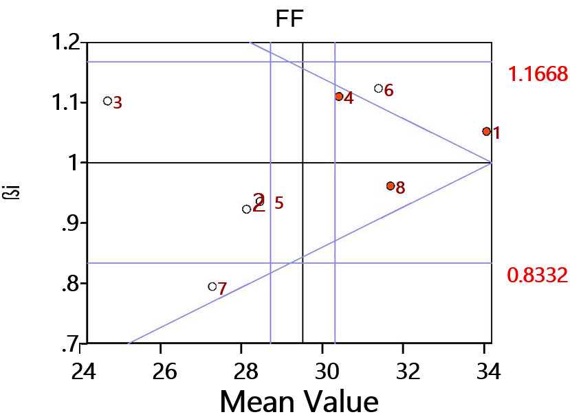

FF: Number of days required for fruit formation

**Fig. 1. Relationship between the regression coefficient (b*i*) and the mean number of days required for fruit formation in three seasons for eight elite mulberry genotypes**

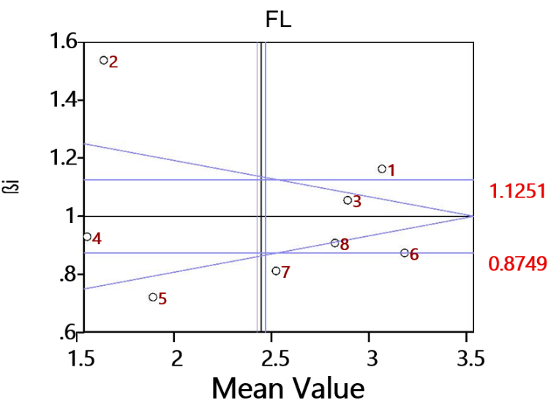

FL: Fruit length (cm)

**Fig. 2. Relationship between the regression coefficient (b*i*) and the mean fruit length in three seasons for eight elite mulberry genotypes**

**Table 2. Mean performance of eight elite mulberry genotypes for three seasons and their stability parameters for fruit length**

|  |  |  |  |  |  |  |  |  |  |  |
| --- | --- | --- | --- | --- | --- | --- | --- | --- | --- | --- |
| **Genotypes** | **S1** | **Rank** | **S2** | **Rank** | **S3** | **Rank** | **Mean** | **Overall Rank** | **b*i*** | **S²d*i*** |
| **MI-0516** | 2.95 | 2 | 2.88 | 2 | 3.25 | 2 | 3.03 | 2 | 1.16 | -0.08 |
| **ME-0018** | 1.46 | 7 | 1.45 | 7 | 1.90 | 7 | 1.60 | 7 | 1.54 | -0.09 |
| **ME-0067** | 2.74 | 3 | 2.76 | 3 | 3.05 | 3 | 2.85 | 3 | 1.06 | -0.09 |
| **ME-0220** | 1.41 | 8 | 1.44 | 8 | 1.69 | 8 | 1.51 | 8 | 0.93 | -0.08 |
| **ME-0086** | 1.75 | 6 | 1.82 | 6 | 1.99 | 6 | 1.85 | 6 | 0.72 | -0.09 |
| **ME-0006** | 3.04 | 1 | 3.08 | 1 | 3.31 | 1 | 3.14 | 1 | 0.87 | -0.09 |
| **MI-0160** | 2.40 | 5 | 2.41 | 5 | 2.64 | 5 | 2.48 | 5 | 0.81 | -0.07 |
| **MI-0014** | 2.68 | 4 | 2.72 | 4 | 2.96 | 4 | 2.79 | 4 | 0.91 | -0.09 |
| **Mean** | 2.30 | - | 2.32 | - | 2.60 | - | 2.41 | - | - | - |
| **Environmental index** | **-0.104** | - | **-0.088** | - | **0.192** | - | - | - | - | - |
| **C. V.** | 15.278 | - | 18.253 | - | 25.976 | - | - | - | - | - |
| **S.Em±** | 0.287 | - | 0.346 | - | 0.551 | - | - | - | - | - |
| **CD @ P=0.05** | 0.616 | - | 0.742 | - | 1.183 | - | - | - | - | - |
| **CD @ P=0.01** | 0.855 | - | 1.029 | - | 1.641 | - | - | - | - | - |

*Significant @ 0.05 level ** Significant @ 0.01 level, b*i*=regression co-efficient, S²d*i*=Deviation from regression

S1=2023 winter season (Dec-Jan), S2=2024 Summer season (March-April) S3=2024 Rainy season (May-June)

**Table 3. Mean performance of eight elite mulberry genotypes for three seasons and their stability parameters for fruit width**

|  |  |  |  |  |  |  |  |  |  |  |
| --- | --- | --- | --- | --- | --- | --- | --- | --- | --- | --- |
| **Genotypes** | **S1** | **Rank** | **S2** | **Rank** | **S3** | **Rank** | **Mean** | **Overall Rank** | **b*i*** | **S²d*i*** |
| **MI-0516** | 1.79 | 2 | 1.86 | 2 | 1.94 | 2 | 1.86 | 2 | 0.63 | -0.07 |
| **ME-0018** | 1.02 | 6 | 1.17 | 5 | 1.39 | 5 | 1.19 | 5 | 1.57 | -0.06 |
| **ME-0067** | 1.44 | 3 | 1.48 | 3 | 1.63 | 3 | 1.52 | 3 | 0.85 | -0.07 |
| **ME-0220** | 0.82 | 8 | 0.89 | 8 | 1.18 | 7 | 0.96 | 7 | 1.61 | -0.07 |
| **ME-0086** | 1.14 | 5 | 1.15 | 6 | 1.29 | 6 | 1.19 | 5 | 0.68 | -0.06 |
| **ME-0006** | 1.94 | 1 | 1.97 | 1 | 2.11 | 1 | 2.01 | 1 | 0.77 | -0.07 |
| **MI-0160** | 0.90 | 7 | 0.93 | 7 | 1.15 | 8 | 0.99 | 6 | 1.13 | -0.07 |
| **MI-0014** | 1.25 | 4 | 1.35 | 4 | 1.44 | 4 | 1.35 | 4 | 0.77 | -0.06 |
| **Mean** | 1.28 | - | 1.35 | - | 1.51 | - | 1.38 | - | - | - |
| **Environmental index** | **-0.097** | - | **-0.034** | - | **0.131** | - | - | - | - | - |
| **C. V.** | 3.062 | - | 47.251 | - | 28.749 | - | - | - | - | - |
| **S.Em±** | 0.032 | - | 0.521 | - | 0.356 | - | - | - | - | - |
| **CD @ P=0.05** | 0.069 | - | - | - | 0.763 | - | - | - | - | - |
| **CD @ P=0.01** | 0.096 | - | - | - | 1.060 | - | - | - | - | - |

*Significant @ 0.05 level ** Significant @ 0.01 level, b*i*=regression co-efficient, S²d*i*=Deviation from regression

S1=2023 winter season (Dec-Jan), S2=2024 Summer season (March-April) S3=2024 Rainy season (May-June)

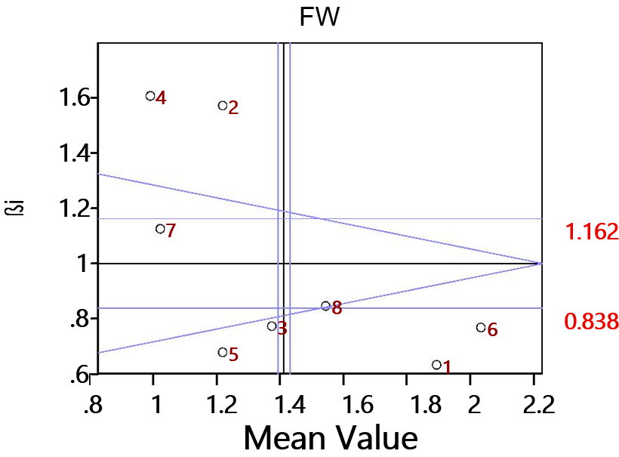

FW: Fruit width (cm)

**Fig. 3. Relationship between the regression coefficient (b*i*) and the mean fruit width in three seasons for eight elite mulberry genotypes**

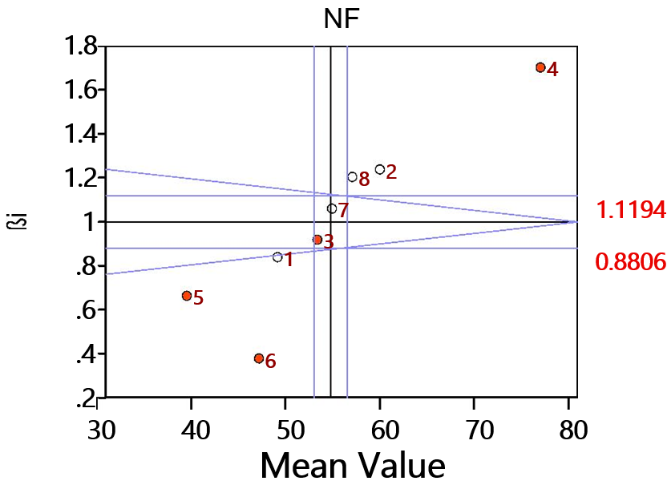

NF: Number of fruits per plant

**Fig. 4. Relationship between the regression coefficient (b*i*) and the mean number of fruits per plant in three seasons for eight elite mulberry genotypes**

**Table 4. Mean performance of eight elite mulberry genotypes for three seasons and their stability parameters for number of fruits per plant**

|  |  |  |  |  |  |  |  |  |  |  |
| --- | --- | --- | --- | --- | --- | --- | --- | --- | --- | --- |
| **Genotypes** | **S1** | **Rank** | **S2** | **Rank** | **S3** | **Rank** | **Mean** | **Overall Rank** | **b*i*** | **S²d*i*** |
| **MI-0516** | 39.02 | 7 | 43.47 | 7 | 62.07 | 6 | 48.19 | 6 | 0.84 | -0.06 |
| **ME-0018** | 45.33 | 2 | 52.27 | 2 | 79.47 | 2 | 59.02 | 2 | 1.24 | -0.72 |
| **ME-0067** | 40.80 | 5 | 49.20 | 3 | 67.20 | 5 | 52.40 | 5 | 0.92 | 4.22 |
| **ME-0220** | 60.33 | 1 | 62.80 | 1 | 105.00 | 1 | 76.04 | 1 | 1.70 | 27.53 |
| **ME-0086** | 29.47 | 8 | 37.20 | 8 | 49.07 | 8 | 38.58 | 8 | 0.66 | 7.16 |
| **ME-0006** | 40.53 | 6 | 46.07 | 6 | 52.07 | 7 | 46.22 | 7 | 0.38 | 5.09 |
| **MI-0160** | 42.73 | 4 | 47.53 | 5 | 71.60 | 4 | 53.95 | 4 | 1.06 | 0.18 |
| **MI-0014** | 43.13 | 3 | 49.07 | 4 | 76.07 | 3 | 56.09 | 3 | 1.20 | -0.21 |
| **Mean** | 42.66 |  | 48.45 |  | 70.31 |  | 53.81 |  |  |  |
| **Environmental index** | **-1.1444** |  | **-5.363** |  | **16.507** | - | - | - | - | - |
| **C. V.** | 1.504 |  | 2.592 |  | 2.997 | - | - | - | - | - |
| **S.Em±** | 0.524 |  | 1.026 |  | 1.721 | - | - | - | - | - |
| **CD @ P=0.05** | 1.124 |  | 2.200 |  | 3.691 | - | - | - | - | - |
| **CD @ P=0.01** | 1.559 |  | 3.053 |  | 5.122 | - | - | - | - | - |

*Significant @ 0.05 level ** Significant @ 0.01 level, b*i*=regression co-efficient, S²d*i*=Deviation from regression

S1=2023 winter season (Dec-Jan), S2=2024 Summer season (March-April) S3=2024 Rainy season (May-June)

**Table 5. Mean performance of eight elite mulberry genotypes for three seasons and their stability parameters for fruit weight**

|  |  |  |  |  |  |  |  |  |  |  |
| --- | --- | --- | --- | --- | --- | --- | --- | --- | --- | --- |
| **Genotypes** | **S1** | **Rank** | **S2** | **Rank** | **S3** | **Rank** | **Mean** | **Overall Rank** | **b*i*** | **S²d*i*** |
| **MI-0516** | 2.53 | 2 | 2.56 | 2 | 2.95 | 2 | 2.68 | 2 | 1.09 | -0.04 |
| **ME-0018** | 1.51 | 7 | 1.52 | 7 | 1.81 | 8 | 1.61 | 8 | 0.80 | -0.05 |
| **ME-0067** | 2.31 | 3 | 2.35 | 3 | 2.60 | 3 | 2.42 | 3 | 0.74 | -0.04 |
| **ME-0220** | 1.47 | 8 | 1.49 | 8 | 2.00 | 7 | 1.65 | 7 | 1.40 | -0.06 |
| **ME-0086** | 1.95 | 6 | 2.03 | 5 | 2.29 | 6 | 2.09 | 5 | 0.82 | -0.06 |
| **ME-0006** | 2.86 | 1 | 2.94 | 1 | 3.23 | 1 | 3.01 | 1 | 0.91 | -0.04 |
| **MI-0160** | 1.89 | 5 | 1.91 | 6 | 2.33 | 5 | 2.04 | 6 | 1.16 | -0.05 |
| **MI-0014** | 2.06 | 4 | 2.12 | 4 | 2.49 | 4 | 2.24 | 4 | 1.08 | -0.04 |
| **Mean** | 2.07 | - | 2.11 | - | 2.46 | - | 2.22 | - | - | - |
| **Environmental index** | **-0.144** | - | **-0.102** | - | **0.246** | - | - | - | - | - |
| **C. V.** | 11.661 | - | 13.084 | - | 20.706 | - | - | - | - | - |
| **S.Em±** | 0.197 | - | 0.226 | - | 0.416 | - | - | - | - | - |
| **CD @ P=0.05** | 0.423 | - | 0.485 | - | 0.893 | - | - | - | - | - |
| **CD @ P=0.01** | 0.588 | - | 0.673 | - | 1.239 | - | - | - | - | - |

*Significant @ 0.05 level ** Significant @ 0.01 level, b*i*=regression co-efficient, S²d*i*=Deviation from regression

S1=2023 winter season (Dec-Jan), S2=2024 Summer season (March-April) S3=2024 Rainy season (May-June)

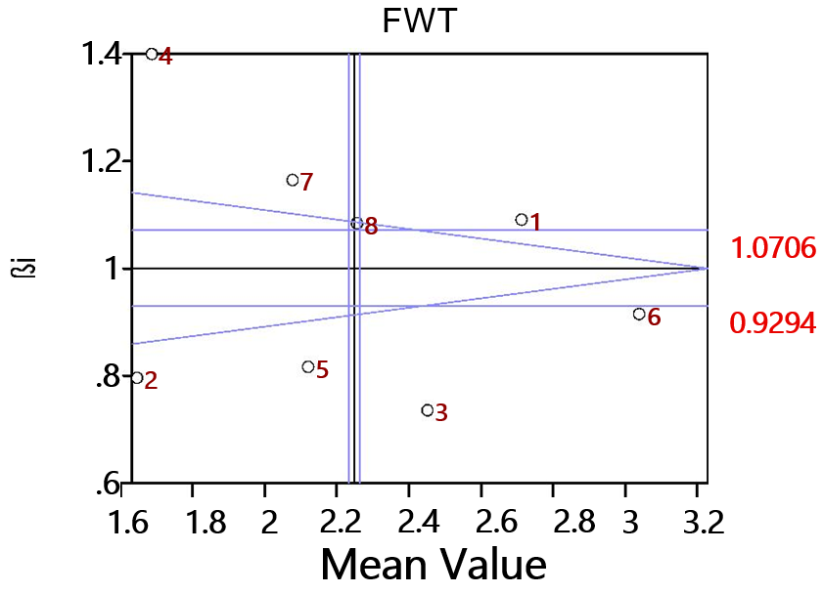

FWT: Fruit weight (g)

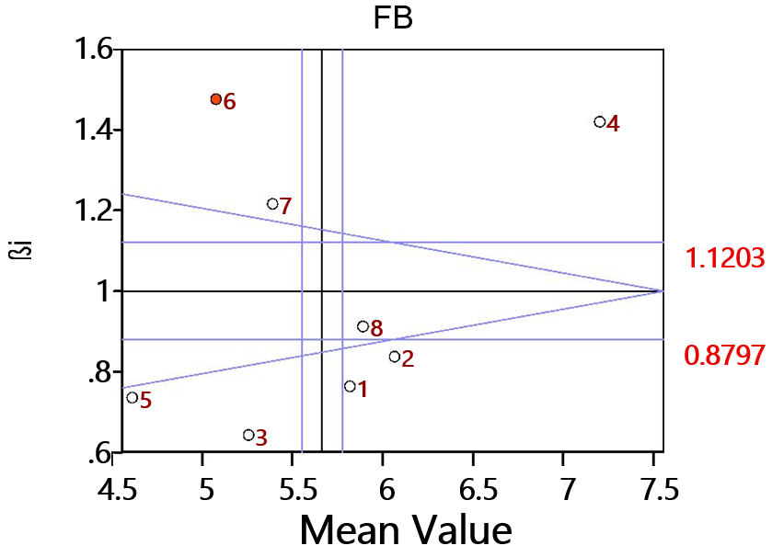**Fig. 5. Relationship between the regression coefficient (b*i*) and the mean fruit weight in three seasons for eight elite mulberry genotypes**

FB: Number of fruits per branch

**Fig. 6. Relationship between the regression coefficient (b*i*) and the mean number of fruits per branch in three seasons for eight elite mulberry genotypes**

**Table 6. Mean performance of eight elite mulberry genotypes for three seasons and their stability parameters for number of fruits per branch**

|  |  |  |  |  |  |  |  |  |  |  |
| --- | --- | --- | --- | --- | --- | --- | --- | --- | --- | --- |
| **Genotypes** | **S1** | **Rank** | **S2** | **Rank** | **S3** | **Rank** | **Mean** | **Overall Rank** | **b*i*** | **S²d*i*** |
| **MI-0516** | 5.12 | 3 | 5.63 | 4 | 6.53 | 5 | 5.76 | 4 | 0.76 | -0.01 |
| **ME-0018** | 5.27 | 2 | 5.92 | 2 | 6.83 | 2 | 6.01 | 2 | 0.84 | 0.01 |
| **ME-0067** | 4.64 | 5 | 5.12 | 5 | 5.84 | 7 | 5.20 | 6 | 0.64 | 0.01 |
| **ME-0220** | 6.01 | 1 | 6.82 | 1 | 8.60 | 1 | 7.14 | 1 | 1.42 | -0.01 |
| **ME-0086** | 3.92 | 8 | 4.46 | 7 | 5.29 | 8 | 4.56 | 8 | 0.74 | 0.00 |
| **ME-0006** | 4.03 | 7 | 4.40 | 8 | 6.51 | 6 | 4.98 | 7 | 1.48 | 0.13 |
| **MI-0160** | 4.39 | 6 | 5.01 | 6 | 6.59 | 4 | 5.33 | 5 | 1.22 | 0.00 |
| **MI-0014** | 5.00 | 4 | 5.78 | 3 | 6.72 | 3 | 5.83 | 3 | 0.91 | 0.02 |
| **Mean** | 4.79 | - | 5.39 | - | 6.62 | - | 5.60 | - | - | - |
| **Environmental index** | **-0.807** | - | **-0.215** | - | **1.022** | - | - | - | - | - |
| **C. V.** | 2.909 | - | 1.984 | - | 3.019 | - | - | - | - | - |
| **S.Em±** | 0.114 | - | 0.087 | - | 0.163 | - | - | - | - | - |
| **CD @ P=0.05** | 0.244 | - | 0.187 | - | 0.350 | - | - | - | - | - |
| **CD @ P=0.01** | 0.339 | - | 0.260 | - | 0.486 | - | - | - | - | - |

*Significant @ 0.05 level ** Significant @ 0.01 level, b*i*=regression co-efficient, S²d*i*=Deviation from regression

S1=2023 winter season (Dec-Jan), S2=2024 Summer season (March-April) S3=2024 Rainy season (May-June)

**Table 7. Mean performance of eight elite mulberry genotypes for three seasons and their stability parameters for fruit yield per plant**

|  |  |  |  |  |  |  |  |  |  |  |
| --- | --- | --- | --- | --- | --- | --- | --- | --- | --- | --- |
| **Genotypes** | **S1** | **Rank** | **S2** | **Rank** | **S3** | **Rank** | **Mean** | **Overall Rank** | **b*i*** | **S²d*i*** |
| **MI-0516** | 91.25 | 2 | 100.80 | 2 | 188.09 | 3 | 126.71 | 2 | 1.19 | 13.64 |
| **ME-0018** | 65.55 | 7 | 86.77 | 7 | 133.41 | 8 | 95.24 | 7 | 0.77 | 58.90 |
| **ME-0067** | 87.46 | 5 | 95.83 | 5 | 169.83 | 5 | 117.71 | 5 | 1.01 | 7.12 |
| **ME-0220** | 88.07 | 4 | 97.04 | 4 | 171.36 | 4 | 118.82 | 4 | 1.02 | 4.80 |
| **ME-0086** | 60.37 | 8 | 66.66 | 8 | 126.46 | 7 | 84.50 | 8 | 0.82 | 4.67 |
| **ME-0006** | 112.27 | 1 | 137.03 | 1 | 194.88 | 1 | 148.06 | 1 | 0.94 | 74.54 |
| **MI-0160** | 75.95 | 6 | 91.25 | 6 | 161.87 | 6 | 109.69 | 6 | 1.03 | -3.28 |
| **MI-0014** | 89.83 | 3 | 99.96 | 3 | 189.12 | 2 | 126.30 | 3 | 1.22 | 12.34 |
| **Mean** | 83.84 | - | 96.91 | - | 166.77 | - | 115.87 | - | - | - |
| **Environmental index** | **-32.034** | - | **-18.963** | - | **50.997** | - | - | - | - | - |
| **C. V.** | 2.870 | - | 2.355 | - | 3.548 | - | - | - | - | - |
| **S.Em±** | 1.965 | - | 1.864 | - | 4.834 | - | - | - | - | - |
| **CD @ P=0.05** | 4.214 | - | 3.997 | - | 10.369 | - | - | - | - | - |
| **CD @ P=0.01** | 5.849 | - | 5.548 | - | 14.391 | - | - | - | - | - |

*Significant @ 0.05 level ** Significant @ 0.01 level, b*i*=regression co-efficient, S²d*i*=Deviation from regression

S1=2023 winter season (Dec-Jan), S2=2024 Summer season (March-April) S3=2024 Rainy season (May-June)

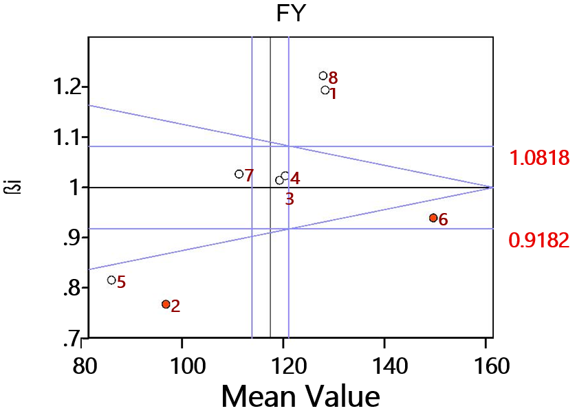

FY: Fruit yield per plant (g)

**Fig. 7. Relationship between the regression coefficient (b*i*) and the mean fruit yield per plant in three seasons for eight elite mulberry genotypes**

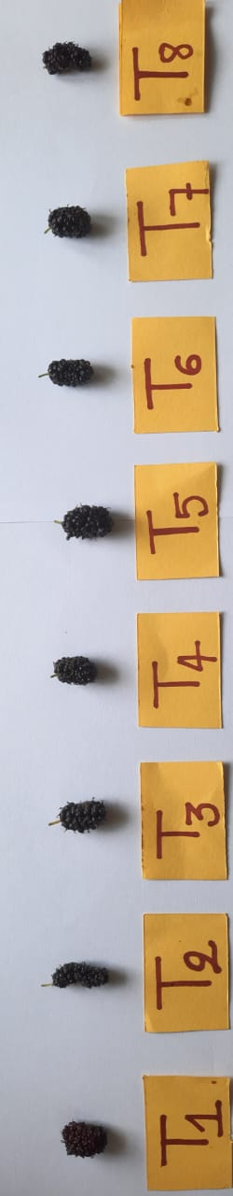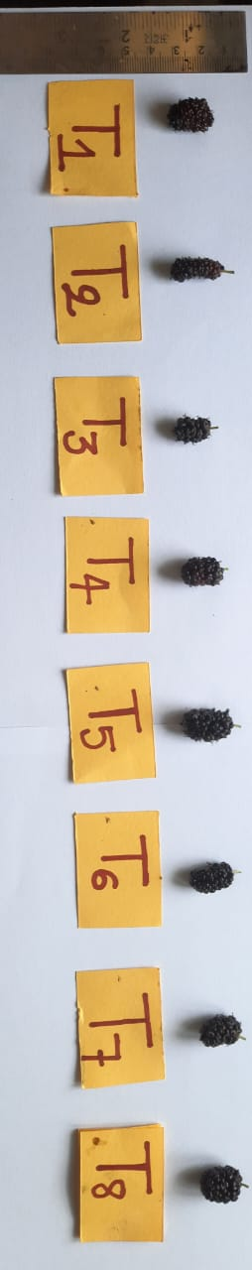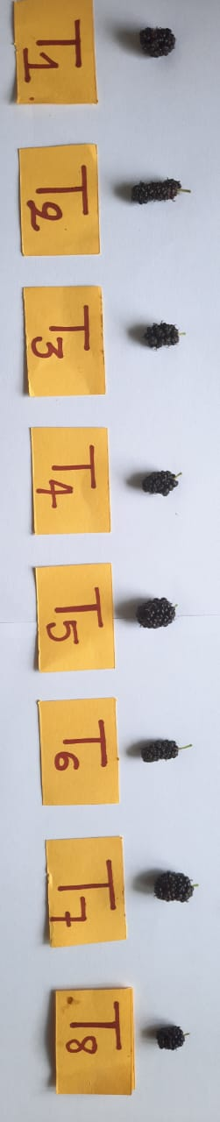

S1

S2

S3

**Plate 1. Effect of different seasons on fruit size of different elite mulberry genotypes (S1, S2 and S3)**

S1=2023 winter season (Dec-Jan), S2=2024 Summer season (March-April) S3=2024 Rainy season (May-June)

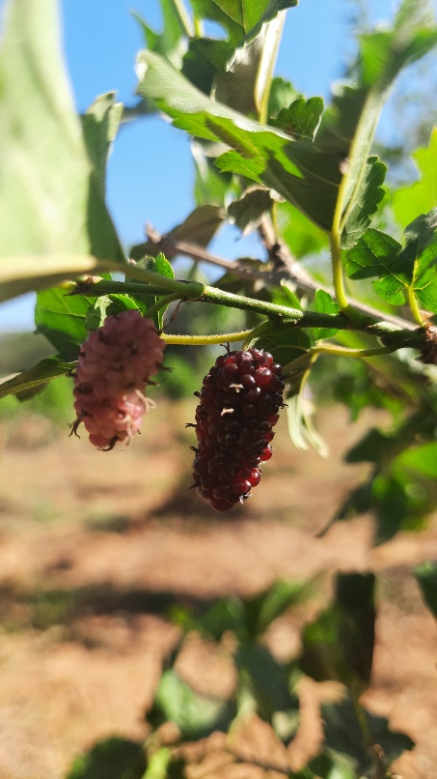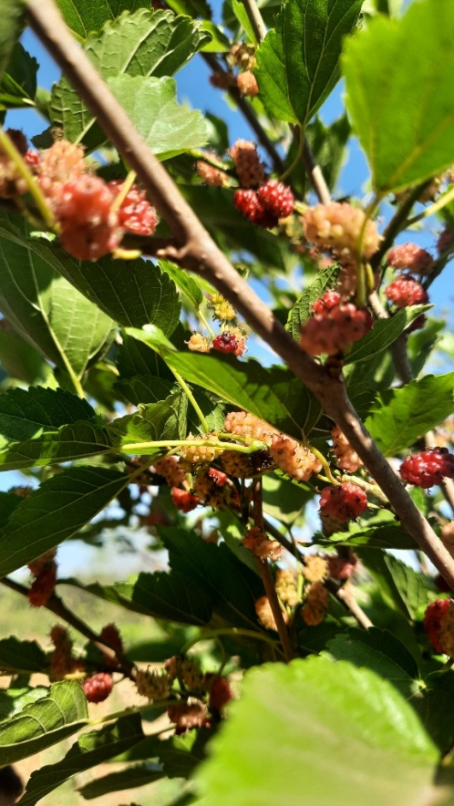

Fig. 9 Fruits of mulberry genotype ME0006

Fig. 8 Fruits of mulberry genotype ME 0220