**Temporal Analysis of Evaporation Trends and their Magnitude in Ambedkar Nagar District**

**Abstract**

This research explores the estimation of pan evaporation in five selected locations—Tanda, Jalalpur, Allapur, Bhete, and Akbarpur—from 1999 to 2022, utilizing meteorological data from NASA Prediction Of Worldwide Energy Resources (POWER). Key environmental variables including as temperature, relative humidity, and wind speed were acquired using the Inverse Distance Weighting (IDW) by leveraging nearby stations in Paraspur, Sarai Meer, Kaptanganj, and Pratapgarh. Dalton's equation was used to calculate Pan evaporation rates using these parameters, resulting in an estimate of evaporation rates across the study sites. Subsequently, the study further investigates long-term trends in the derived evaporation rates and meteorological variables using non-parametric

trend tests, which allow for the assessment of statistically significant changes over time. Additionally, Sen's slope estimator is used to quantify the magnitude of these trends, providing a reliable assessment of the rate of change in evaporation and climatic variables across the research period. Decreasing evaporation trend (1999–2022) was observed in August to December across all five regions: Tanda, Jalalpur, Allapur, Bhete, and Akbarpur, with statistical significance at the 95% confidence level. Akbarpur is the only region showing a significant increasing trend in June, indicating a localized seasonal shift in evaporation patterns.

***Keywords:*** *Evaporation; Mann-Kendall trend test; Humid subtropical climate.*

**Introduction**

Evaporation is an essential global activity that contributes significantly to the hydrological cycle and uses over 25% of incoming solar energy (Trenberth et al., 2009). Nearly 60% of terrestrial precipitation is returned to the atmosphere through plant transpiration (~40%) and direct soil evaporation (~20%) (Oki and Kanae, 2006). Clud formation, precipitation, and the availability of water resources are all influenced by evaporation. Water management, forestry, river flow forecasts, and irrigation all depend on its estimation. Measurement (Young, 1947), energy-mass transfer combinations (Penman, 1948), empirical models (Kohler et al., 1955), mass transfer (Harbeck, 1962), energy budget (Fritschen, 1966), and water budget approaches (Guitjens, 1982) are common techniques for estimating evaporation. Regional variability is revealed by trend analysis of pan evaporation (Epan). There have been reports of decreases in the U.S. and former USSR (Peterson et al., 1995; Golubev et al., 2001), Australia (Roderick and Farquhar, 2004), Japan (Jun et al., 2004), China (Liu et al., 2004), Thailand (Tebakari et al., 2005), and Canada (Burn and Hesch, 2007), despite increases in northeast Brazil (da Silva, 2004) and Israel (Cohen et al., 2002). These patterns are found using a variety of statistical techniques, including Sen's slope, linear regression, and the Mann-Kendall test. It is essential to comprehend these trends in order to manage local water resources (Schmitt, 1995). According to recent studies, climate change is expected to increase worldwide precipitation and evaporation, although it is unclear how different regions will react (Ramarao et al., 2023). The decrease in evapotranspiration could be attributed to aerosol-induced solar darkening, especially across the Indo-Gangetic Plain (Ramarao et al., 2023). Warming may also decrease the amount of precipitation that is recycled across land, increasing dependence on oceanic sources and affecting rain-fed agriculture. The IPCC's CMIP5 (Robock et al., 1993; Stouffer et al., 1989) and other global climate models (GCMs) model future climates based on greenhouse gas scenarios. For instance, high-altitude areas of Nepal are warming more quickly than lowlands, according to Shrestha et al. (1999). Strong correlations between temperature, precipitation, and evapotranspiration were highlighted by Kalma et al. (2008). The Subansiri River basin in India has seen changes in temperature extremes, precipitation patterns, and hydroclimatic behavior, according to climate impact studies conducted by Shivam et al. (2017, 2019, 2021). These studies used downscaled CMIP5 data. Using the Mann-Kendall and Pettitt tests, Jhajharia et al. (2021) evaluated Epan trends in the Godavari basin, detecting sudden and seasonal variations. These regional studies offer crucial information for sustainable water resource management and future climate adaption.

**Study Area and Data Collection**

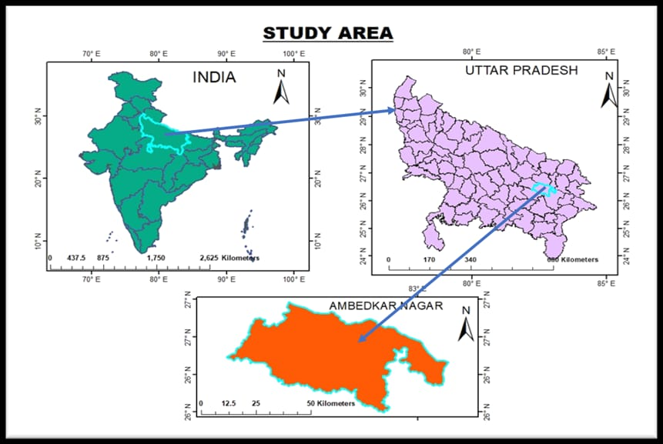Ambedkar Nagar, which was separated from the district of Faizabad in eastern Uttar Pradesh, is 2,350 square kilometers, with 2,255.1 square kilometers of rural land and 94.9 square kilometers of urban land. It is surrounded by Basti, Sant Kabir Nagar, Gorakhpur, Sultanpur, Faizabad, and Azamgarh, and is situated between 82°12' and 83°09' E longitude and 26°09' and 26°40' N latitude (Fig 1). It has nine blocks and a climate typical of eastern Uttar Pradesh, with hot summers (up to 45°C), cold winters (down to 4°C), and 1,135.5 mm of average annual rainfall.

**Fig 1: Map of study area**

Data for this research was obtained from NASA's POWER (Prediction of Worldwide Energy Resources) database, covering the period from 1999 to 2022. The dataset includes key meteorological variables such as relative humidity, minimum temperature, maximum temperature, and wind speed for five tehsils in Ambedkarnagar district: Tanda, Bhete, Allapur, Jalalpur, and Akbarpur. Initially, the data for these five tehsils showed similar patterns. To improve the analysis, additional data from four nearby locations—Paraspur, Sarai Meer, Kaptanganj, and Pratapgarh—was incorporated. For these locations, the data includes key variables such as relative humidity, minimum temperature, and maximum temperature. All data for this study was sourced from NASA's POWER database, covering the same time period from 1999 to 2022.

**Methodology**

The study was carried out in Ambedkarnagar district, Uttar Pradesh, using secondary data from 1999 to 2022. Meteorological indicators such as relative humidity and temperature were collected from five tehsils: Bhete, Tanda, Akbarpur, Jalalpur, and Allapur. Additional data from adjacent locations, such as Paraspur, Sarai Meer, Kaptanganj, and Pratapgarh, aided spatial analyses. Data were obtained from the NASA POWER database. The Inverse Distance Weighting (IDW) approach was used to estimate values, with the assumption that adjacent places have a greater influence than distant ones.

Inverse Distance Weighted (IDW) Equation

$$Z_{p}\text{=}\frac{\sum_{i=1}^{n}{\left(\frac{z_{i}}{d_{i}^{p}}\right)}}{\sum_{i=1}^{n}{\left(\frac{1}{d_{i}^{p}}\right)}}$$

Where:

Zp = estimated value at location p

Zi​ = known value at location i

di​ = distance from location xx to location i

p = power parameter (typically set to 2)

The evaporation rates for the tehsils of Bhete, Allapur, Jalalpur, Akbarpur, and Tanda were calculated using the Dalton’s Equation, utilizing parameters such as relative humidity, maximum temperature, and minimum temperature.

**Evaporation calculation**

In this study, the evaporation rate was estimated using Dalton's equation. Dalton's equation for evaporation is based on the premise that the rate of evaporation is proportional to the difference between the vapor pressure at the water surface and the vapor pressure of the surrounding air. The equation is typically represented as:

E=C⋅(es​−ea​)⋅u

Where:

* E is the rate of evaporation,
* C is a constant that depends on various factors like temperature and pressure,
* es is the vapor pressure at the water surface,
* ea is the vapor pressure of the surrounding air,
* u is the wind speed.

The saturation vapor pressure (es) can be calculated using the Clausius-Clapeyron equation:

es = 6.11 × e^(17.27 × T / (T + 237.3))

Where:

T = Temperature (°C)

The actual vapor pressure (ea) can be calculated from the relative humidity (RH) and saturation vapor pressure:

ea = es × (RH / 100)

The wind function (f) is an empirical term that depends on wind speed. A common formulation is:

f = 0.26 × (1 + 0.54 × u2)

Where:

u2 = Wind speed at 2 meters above ground (m/s)

After calculating evaporation, we conducted trend analysis and Sen’s slope estimation for each tehsil . For the trend analysis applies the Mann-Kendall test in the evaporation parameters data, Mann Kendall is the tool of R-studio software. But that doesn’t find how much magnitude of evaporation has been changed. For analysis of magnitude of evaporation is used Sen’s Slope method. It’s a package of R Studio Software.

**Mann- Kendall Test**

The null hypothesis for this test is that there is no trend, and the alternative hypothesis is that there is a trend in the two-sided test or that there is an upward trend (or downward trend) in the one-sided test. For the time series *x*1, ..,*xn*, the MK Test uses the following statistic:

$$S=\sum_{i=1}^{n-1}{\sum_{j=i+1}^{n}{sign\left(x_{j}-x_{i}\right)}}$$

The variance of *S* is given by

$$var=\frac{1}{18}\left[n\left(n-1\right)\left(2n+5\right)-\sum_{t}{f_{t}\left(f_{t}-1\right)\left(2f_{t}+5\right)}\right]$$

The MK Test uses the following test statistic:

$$z=\left\{\begin{aligned}(S-1)/se, S>0 \\ 0, & S=0 \\ (S+1)/se, S >0 \end{aligned}\right.$$

where se = the square root of var.

**Sens’s Slope Estimator Test**

$$Sen's slope=Median\left\{\frac{x_{j}-x_{i}}{j-i}∶i<j\right\}$$

xj=data values at time j

xi=data values at time k(j>i)

**Results and Discussions**

**Interpolation of Climatic Parameters**

Climatic data for the study area was taken from NASA Power portal which has a coarser resolution, therefore the climatic parameters were calculated for five stations using the interpolation approach. Four distinct locations were used for data collection in our study: Paraspur, Sarai Meer, Pratapgarh, and Kaptanganj. The values for the following additional places were estimated or predicted using this data and the Inverse Distance Weighted (IDW) interpolation method: Bhete, Akbarpur, Tanda, Allapur, and Jalapur. The IDW approach is based on the idea that the influence of known data points diminishes with distance, i.e., the interpolated values are more affected by points that are closer to the observed data locations. This made it possible to provide estimates for the secondary locations based on the starting data points' values and closeness, resulting in a spatially weighted prediction for the whole study region.

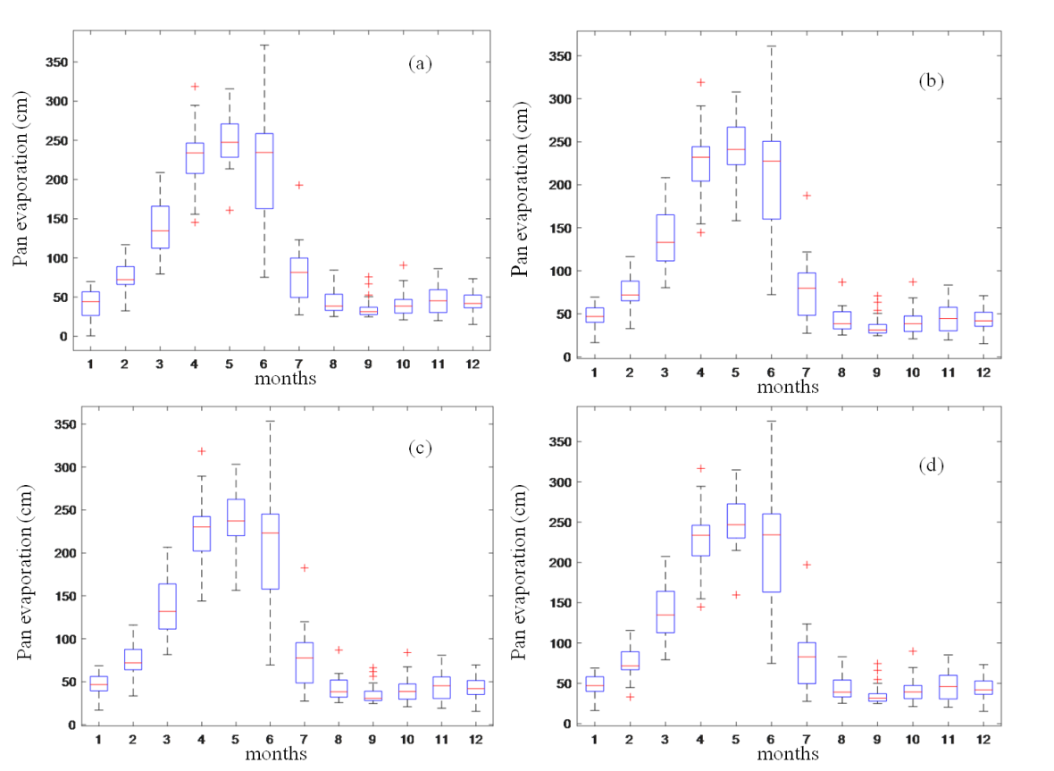**Estimation of Evaporation**

**Fig 2: Box plot of pan evaporation rate (a) Tanda (b) Jalalpur (c) Allapur and (d) Bhete**

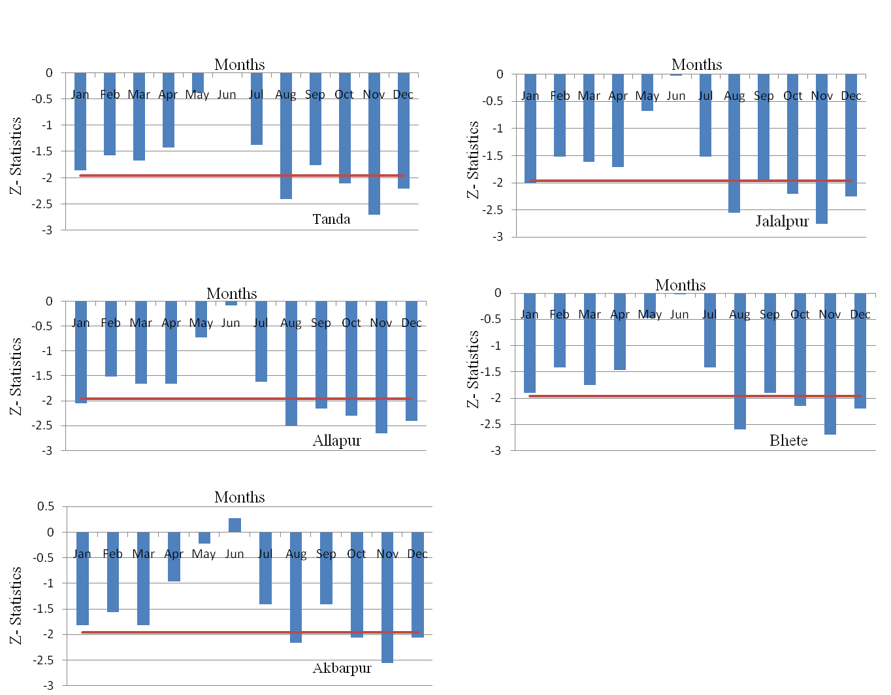Dalton's equation, which takes into account wind speed and the difference between the vapor pressure at the water's surface and the surrounding air, was used to determine the evaporation rates in four Ambedkarnagar stations. While calm and humid circumstances decrease evaporation, higher wind and dry air increase it. June had the highest monthly evaporation rates, while winter had the lowest. Evaporation at Tanda varied from 16.09 cm in January to 371.53 cm in June. In December, Jalalpur recorded 15.30 cm to 361.22 cm in June, Allapur recorded 15.44 cm to 371.51 cm in June, and Bhete recorded 15.10 cm to 375.51 cm in June (Fig 2). These changes are helpful for understanding water loss, helping agricultural planning, managing water resources, and monitoring the environment in the area. They also show the impact of local meteorological elements.

**Trends in Annual and Seasonal Pan Evaporation in Ambedkar Nagar:**

**Fig 3: Trend of Pan evaporation rate (a) Tanda (b) Jalalpur (c) Allapur and (d) Bhete (e) Akbarpur**

This study used Sen's slope estimator and the Mann-Kendall test to analyze trends in annual evaporation data from 1999 to 2022. In numerous months, the analysis found statistically significant patterns in Ambedkarnagar's various tehsils. In August, October, November, and December, evaporation in Tanda dramatically dropped, as seen in Figure 3a. Figure 3b shows that August, September, October, November, and December all showed a declining trend in Jalalpur. Evaporation at Allapur and Bhete also significantly decreased from August to December, as seen in Figures 3c and 3d. Figure 3e shows that evaporation in Akbarpur showed a substantial growing tendency in June, but a significant drop in August, September, October, November, and December.

**Table 1. Estimated Sen’s Slope from 1999 to 2022**

|  |  |  |  |  |  |  |  |  |  |  |  |  |  |
| --- | --- | --- | --- | --- | --- | --- | --- | --- | --- | --- | --- | --- | --- |
| $$SN. No.$$ | $$Name of site$$ | $$Jan$$ | $$Feb$$ | $$Mar$$ | $$Apr$$ | $$May$$ | $$Jun$$ | $$Jul$$ | $$Aug$$ | $$Sep$$ | $$Oct$$ | $$Nov$$ | $$Dec$$ |
| 1 | Tanda | -0.99 | -1.13 | -2.17 | -1.55 | -0.37 | 0.08 | -1.8 | **-0.89** | -0.3 | **-0.81** | **-1.52** | **-1.03** |
| 2 | Jalalpur | -1.03 | -1.14 | -2.12 | -1.68 | -0.73 | -0.19 | -1.73 | **-0.92** | -0.35 | **-0.88** | **-1.46** | **-1.04** |
| 3 | Allapur | -1 | -1.11 | -2.05 | -1.87 | -0.65 | -0.14 | -1.66 | **-0.98** | **-0.41** | **-0.87** | **-1.38** | **-1.01** |
| 4 | Bhete | -0.99 | -1.13 | -2.06 | -1.64 | -0.59 | -0.14 | -1.74 | **-0.89** | -0.31 | **-0.89** | **-1.47** | **-1.03** |
| 5 | Akbarpur | -0.99 | -1.19 | -2.19 | -1.61 | -0.24 | **0.61** | -1.77 | **-0.68** | -0.26 | **-0.75** | **-1.67** | **-1.09** |

**Note:** bold fonts shown significant increasing or decreasing trend.

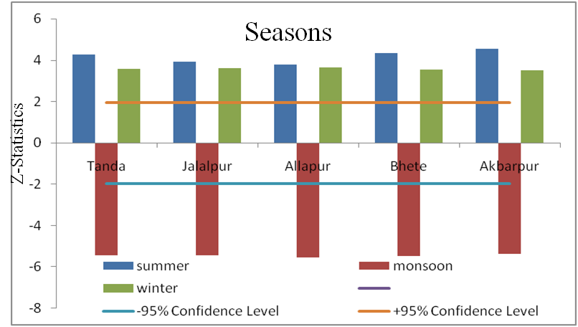Table 1 depicts Sen's Slope, as well as the slope magnitude for each month from January to December throughout a 23-year period. This finding is crucial because when Mann-Kendall trend analysis shows a negative trend, Sen's Slope also shows a negative slope, and vice versa.

**Fig 4: Seasonal Trend Analysis**

Five stations (Tanda, Jalalpur, Allapur, Bhete, and Akbarpur) provided data for the analysis of seasonal pan evaporation trends (Fig 4). At every site, the results demonstrate a notable downward trend throughout the monsoon season, indicating either a decrease in monsoon activity or an increase in humidity. On the other hand, both the summer and winter seasons showed notable growing tendencies, suggesting that temperatures or dry conditions were getting warmer with time. These alterations are indicative of significant seasonal variations in the local climate.

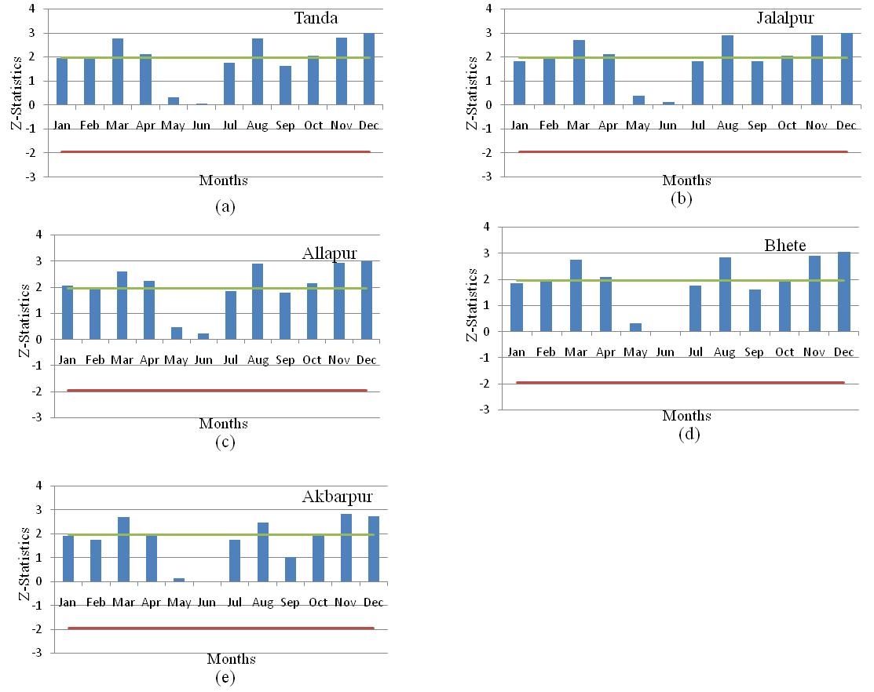 **Influence of meteorological factors on pan evaporation:**

**Fig 5: Trend of Relative Himidity (a) Tanda (b) Jalalpur (c) Allapur (d) Bhete (e) Akbarpur**

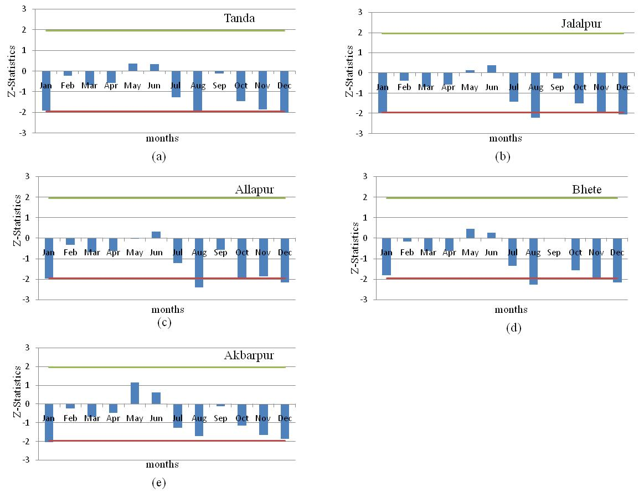A trend analysis of relative humidity and how it affects evaporation at five locations is shown in Figure 5. The findings indicate that in the majority of locations, including Tanda, Jalalpur, Allapur, Bhete, and Akbarpur, the relative humidity significantly increased during the months of March, April, August, October, November, and December. Similarly, as humidity increased in August, October, November, and December, evaporation rates dramatically dropped. For example, evaporation decreased in January and September in Allapur as well. These results demonstrate that evaporation and relative humidity have an inverse relationship: evaporation falls as air moisture rises. Better planning for water resources and the environment is supported by this relationship, which is essential for comprehending local atmospheric behavior.

**Fig 6: Trend of Temperature (a) Tanda (b) Jalalpur (c) Allapur (d) Bhete (e) Akbarpur**

The temperature trends and their impact on evaporation at five locations are depicted in Figure 6. Tanda (January, August, December), Jalalpur (January, August, November, December), Allapur (January, August, October, December), Bhete (August, November, December), and Akbarpur (January, December) were the months with the greatest temperature drops. Additionally, there was a similar drop in evaporation during these months, particularly from August to December. The analysis demonstrates a clear correlation between temperature and evaporation: lower temperatures cause evaporation rates to decrease because there is less energy available for water to turn into vapor. For the purpose of planning and comprehending regional water dynamics, this emphasizes temperature as a critical determinant of evaporation.

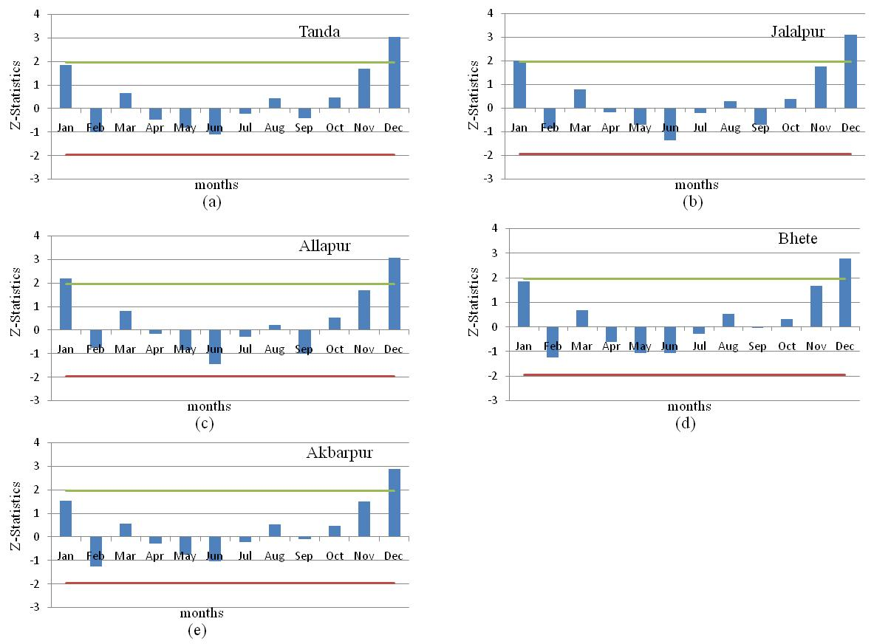**Fig 7: Trend of Wind Speed (a) Tanda (b) Jalalpur (c) Allapur (d) Bhete (e) Akbarpur**

The trend study of annual wind speed and how it affects evaporation at five locations is shown in Figure 7. Wind speed increases significantly in December (and January in Allapur) at all stations: Tanda, Jalalpur, Allapur, Bhete, and Akbarpur. Pan evaporation, however, drastically drops during this time despite the increase in wind speed. This decrease is explained by the combined effects of higher relative humidity and lower temperatures, which offset the effects of more wind. The results highlight the intricate interaction of climatic variables in regulating evaporation rates by showing that although wind speed encourages evaporation, its effects can be countered by other variables like temperature and humidity.

**Conclusion**

The trend analysis of annual and seasonal evaporation from 1999 to 2022 yields numerous important conclusions. Dalton's equation was used to evaluate evaporation data of five tehsils from 1999 to 2022, which included crucial meteorological characteristics such as relative humidity, wind speed, and temperature. Evaporation rates of each tehsil was calculated during a 23-year period using these criteria. The results show that evaporation trends vary throughout time, determined by climatic changes and local weather patterns. Higher temperatures and faster wind speeds, combined with lower relative humidity, often resulted in increased evaporation rates, whereas colder and more humid conditions lowered evaporation. These patterns were constant across all five tehsils, with very small differences due to regional considerations. This analysis provides a thorough understanding of evaporation trends, which is essential for managing water resources in these locations.

**References**

Burn, D.H., Hesch, N.M., 2007. Trends in evaporation for the Canadian Prairies. J. Hydrol. 336, 61–73.

Cohen, S., Ianetz, A., Stanhill, G., 2002. Evaporative climate changes at Bet Dagan, Israel, 1964–1998. Agric. Forest Meteorol. 111 (2), 83–91

da Silva, V.P.R., 2004. On climate variability in northeast of Brazil. J. Arid Environ. 58, 575–596

Golubev, V., Lawrimore, J.H., Groisman, P.Y., Speranskaya, N.A., Zhuravin, S.A., Menne, M.J., Peterson, T.C., Malone, R.W., 2001. Evaporation change over the contiguous United States and the former USSR: a reassessment. Goephys. Res. Lett. 28 (13), 2665–2668

Gupta, S., Goyal, M. K., & Sarma, A. K., 2021. Assessment of hydroclimatological changes in eastern Himalayan River catchment of Northeast India. Journal of Hydrologic Engineering, 26(10), 05021027.

Jhajharia, D., Gupta, S., Mirabbasi, R., Kumar, R., & Patle, G. T., 2021. Pan evaporative changes in transboundary Godavari River basin, India. Theoretical and Applied Climatology, 145, 1503-1520.

Jun, A., Hideyukin, K., Lu, M., 2004. Pan evaporation trends in Japan and its relevance to the variability of the hydrological cycle. Tenki 51 (9), 667–678.

Liu, B., Xu, M., Henderson, M., Gong, W., 2004. A spatial analysis of pan evaporation trends in China, 1955–2000. J. Geophys. Res. 109, D15102, doi:10.1029/2004JD004511.

Oki, T., & Kanae, S., 2006. Global hydrological cycles and world water resources. Science, 313(5790), 1068-1072.

Peterson, T., Golubev, V., Groisman, P., 1995. Evaporation losing its strength. Nature (London) 377, 687–688.

Ramarao, M. V. S., Ayantika, D. C., Krishnan, R., Sanjay, J., Sabin, T. P., Mujumdar, M., & Singh, K. K., 2023. Signatures of aerosol-induced decline in evapotranspiration over the Indo-Gangetic Plain during the recent decades. MAUSAM, 74(2), 297-310.

Roderick, M.L., Farquhar, G.D., 2004. Changes in Australian pan evaporation from 1970 to 2002. Int. J. Climatol. 24, 1077–1090.

Schmitt, R. W., 1995. The ocean component of the global water cycle. Reviews of Geophysics, 33(S2), 1395-1409.

Shivam, G., Goyal, M. K., & Sarma, A. K., 2019. Index-based study of future precipitation changes over subansiri river catchment under changing climate. Journal of Environmental Informatics, 34(1), 1-14.

Shivam, Goyal, M. K., & Sarma, A. K., 2017. Analysis of the change in temperature trends in Subansiri River basin for RCP scenarios using CMIP5 datasets. Theoretical and Applied Climatology, 129, 1175-1187.

Tebakari, T., Yoshitani, J., Suvanpimol, C., 2005. Time-space trend analysis in pan evaporation over Kingdom of Thailand. J. Hydrol. Eng. 10 (3), 205–215

Trenberth, K. E., Fasullo, J. T., & Kiehl, J., 2009. Earth's global energy budget. Bulletin of the american meteorological society, 90(3), 311-324.