Original research Article

Quality Analysis of Fruit Candy Preparation from Different Aonla

ABSTRACT
A laboratory investigation was carried out from February to May at the Post-Harvest and Value Addition Laboratory, Mewar University, Gangrar, Chittorgarh (Rajasthan), to evaluate the quality attributes of fruit candy prepared from different Aonla (Emblica officinalis Gaertn.) cultivars. The study aimed to identify the most suitable cultivar and recipe formulation based on key biochemical parameters and storage stability. Three prominent Aonla cultivars—NA-5, Chakaiya, and NA-7—were selected and processed into candy using 70% sugar syrup enriched with 10% natural flavoring agents like rose, ginger, and tulsi. A Completely Randomized Design (CRD) was employed with nine treatment combinations replicated thrice. The results revealed that the NA-5 cultivar, particularly the treatment T₁ (NA-5 + 70% Sugar Syrup + Rose 10%), exhibited superior quality in terms of moisture retention, total soluble solids (TSS), ascorbic acid, and total sugar across the storage duration of 60 days. T₁ retained the highest ascorbic acid (301.12 mg/100g), TSS (69.60 °Brix), and total sugar (79.04%) at the end of storage, while also maintaining favorable titratable acidity and sensory attributes. In contrast, treatments involving the NA-7 cultivar showed comparatively lower values across these parameters. A general trend of increasing TSS and total sugar with concurrent decreases in ascorbic acid and acidity was observed during storage. These changes are attributed to osmotic concentration and chemical degradation processes. Based on the findings, NA-5 with rose-flavored sugar syrup (T₁) is recommended as the most effective treatment for commercial Aonla candy production due to its superior nutritional retention, storage stability, and sensory appeal.

Key words: - Candy; Biochemical; Storage period; Aonla

- INTRODUCTION

Aonla (Emblica officinalis Gaertn.), commonly known as Indian gooseberry, is a deciduous tree of the family Euphorbiaceae and holds a unique place in Indian horticulture and traditional medicinal systems Singh et al., (2019). It is renowned not only for its adaptability to diverse agro-climatic conditions but also for its outstanding nutritional and therapeutic properties. Native to India, Aonla has been revered in ancient Ayurvedic texts and is often described as a "divya aushadhi" (divine medicine) due to its immense health benefits. The fruit is widely acknowledged as one of the richest natural sources of vitamin C, along with several other phytochemicals such as polyphenols, flavonoids, and tannins (Fenech et al., 2006). These bioactive compounds contribute to its antioxidant, antimicrobial, hepatoprotective, and immunomodulatory effects. In recent years, there has been a growing awareness of the need to integrate traditional crops and medicinal plants into modern food systems to promote both nutrition and health (Kennedy et al., 2022). Aonla, with its high ascorbic acid content and broad therapeutic value, has gained attention as a functional food and nutraceutical ingredient. However, the fresh fruit is highly perishable, astringent in taste, and has limited consumer appeal in its raw form. This has necessitated the exploration of value-added forms that can enhance its palatability, shelf life, and consumer acceptance while retaining its nutritional and medicinal properties. Among the various value-added products derived from Aonla, fruit candy has emerged as a popular and convenient option (Mini et al., 2021). Aonla candy is semi-dried and sugar-infused, offering a sweet and tangy alternative that is widely appreciated across age groups. It provides a means to preserve the fruit’s nutritional attributes, particularly vitamin C, which is otherwise heat-sensitive and degrades rapidly under adverse storage conditions. Furthermore, Aonla candy serves as an ideal delivery system for fortification with natural flavors and herbal additives, aligning with the increasing demand for clean-label and health-oriented snack options (Arora et al., 2024). India is the largest producer of Aonla globally, with cultivation concentrated in states like Uttar Pradesh, Rajasthan, Madhya Pradesh, Maharashtra, and Gujarat (Meena et al., 2022). The National Horticulture Board reports that the area under Aonla cultivation has steadily increased due to rising demand for Aonla-based products. Despite this, post-harvest losses remain a significant concern, primarily due to the limited processing infrastructure, lack of awareness among farmers, and absence of region-specific, optimized processing protocols. Therefore, promoting low-cost, farmer-friendly technologies for post-harvest value addition can play a pivotal role in income generation, rural employment, and nutritional security. Several cultivars of Aonla are grown in India, each with varying fruit size, vitamin C content, fiber composition, and sensory properties (Chandra et al., 2020). Notable among these are NA-5, NA-6, NA-7, Chakaiya, Banarasi, and Krishna. However, there exists a knowledge gap concerning the comparative suitability of these cultivars for specific value-added applications such as candy making. Additionally, the influence of natural flavoring agents like rose, ginger, and tulsi (Ocimum sanctum) on the nutritional stability and sensory quality of Aonla candy during storage has not been systematically explored (Dwivedi & Pandey 2017). This becomes especially important given the increasing trend toward herbal fortification in processed foods. Natural additives not only improve the taste and aroma of Aonla candy but may also impart synergistic health benefits (Kumar. 2017). Rose petals, for instance, are known for their soothing effect and antioxidant potential. Ginger possesses anti-inflammatory, digestive, and antimicrobial properties, while tulsi is revered in Ayurveda for its adaptogenic, anti-stress, and immune-enhancing effects. Incorporating these into Aonla candy not only enhances the consumer experience but also adds functional value, appealing to the wellness-conscious market segment. The present investigation was undertaken to assess the quality attributes of Aonla candy prepared from three commercially important cultivars—NA-5, NA-7, and Chakaiya—processed with a 70% sugar syrup and enriched with 10% natural flavoring agents (rose, ginger, and tulsi). The study was conducted at the Post-Harvest and Value Addition Laboratory of Mewar University, Rajasthan, using a Completely Randomized Design (CRD) with three replications (Sonkar et al., 2019). The key objectives were to evaluate biochemical changes (TSS, titratable acidity, total sugar, ascorbic acid) and sensory attributes (color, texture, aroma, taste, and overall acceptability) during a 60-day storage period under ambient conditions. Preliminary studies have shown that TSS tends to increase during storage due to moisture loss and sugar diffusion, whereas ascorbic acid and titratable acidity decline owing to oxidative and microbial degradation. However, the extent of these changes depends on cultivar characteristics, syrup concentration, and the type of flavoring agent used. Thus, optimizing these variables is essential to achieve a balance between extended shelf life, nutritional retention, and consumer appeal. This study is particularly relevant in the context of promoting small-scale entrepreneurship and rural food processing industries. By identifying the best-performing cultivar-flavor combination for Aonla candy, the findings aim to support local processors, self-help groups, and cottage industries engaged in fruit preservation. Furthermore, such research aligns with national objectives like "Vocal for Local," "Atmanirbhar Bharat," and sustainable food systems that valorize indigenous crops and traditional knowledge. In summary, the introduction of flavored Aonla candy not only addresses the challenge of underutilized perishable fruits but also leverages India’s rich biodiversity and traditional wellness practices. This research bridges the gap between traditional processing and modern scientific validation, laying the groundwork for evidence-based product development in the nutraceutical and functional food sectors.

MATERIALS AND METHODS

A lab experiment was conducted during February to May of 2024-25 at Post Harvest and Value Addition Laboratory, Department of Agriculture (Horticulture) Fruit Science, Faculty of Agriculture and Veterinary Sciences, Mewar University Gangrar, Chittorgarh (Rajasthan). The experiment was laid out in CRD (Completely Randomized Design) with nine treatments and three replications viz; NA-5+70% Sugar Syrup + Rose 10%, NA-5 +70 % Sugar Syrup + Ginger 10%, NA-5 +70% Sugar Syrup + Tulsi 10%, Chakaiya+70% Sugar Syrup + Rose 10%, Chakaiya +70% Sugar Syrup + Ginger 10%, Chakaiya +70 % Sugar Syrup + Tulsi 10%, NA-7+70 % Sugar Syrup + Rose 10%, NA-7+ 70% Sugar Syrup + Ginger 10% and NA-7+ 70% Sugar Syrup + Tulsi 10% . The method for biochemical properties analysis is followed standard method of particular parameters at different duration like 0, 30, 45 and 60 days after storage.

3. RESULTS AND DISCUSSION
A perusal of the data indicates that Aonla candy prepared from NA-5 cultivar retained significantly higher moisture content compared to those made from Chakaiya and NA-7 throughout the storage period. The maximum moisture content (13.37, 12.70, 12.08, and 11.65%) at 0, 30, 45, and 60 days after storage was recorded in treatment T₁ (NA-5 + 70% sugar syrup + Rose 10%), followed by T₂ (NA-5 + 70% sugar syrup + Ginger 10%) with 13.10, 12.48, 11.83, and 11.75%, and T₃ (NA-5 + 70% sugar syrup + Tulsi 10%) with 12.95, 12.28, 11.63, and 11.77%, respectively. The minimum moisture content (11.80, 11.09, 10.46, and 11.50%) at 0, 30, 45, and 60 days after storage was noted in treatment T₉ (NA-7 + 70% sugar syrup + Tulsi 10%), followed closely by T₈ (NA-7 + 70% sugar syrup + Ginger 10%) with 11.94, 11.33, 10.60, and 11.62%, and T₇ (NA-7 + 70% sugar syrup + Rose 10%) with 12.14, 11.49, 10.83, and 11.71%. Similar findings also observed with Verma et al. (2020), and Mehta et al. (2024).
A perusal of the data reveals that Aonla candy prepared from NA-5 and Chakaiya cultivars showed higher TSS values during storage as compared to those made from NA-7. The maximum TSS (67.08, 66.98, 76.23, and 69.60 °Brix) at 0, 30, 45 and 60 days after storage was recorded in treatment T₁ (NA-5 + 70% sugar syrup + Rose 10%), followed by T₂ (NA-5 + 70% sugar syrup + Ginger 10%) with 61.94, 65.30, 68.88, and 73.71 °Brix, and T₄ (Chakaiya + 70% sugar syrup + Rose 10%) with 58.76, 64.60, 69.62, and 77.70 °Brix, respectively. The minimum TSS (50.91, 51.34, 57.22, and 64.10 °Brix) at 0, 30, 45 and 60 days after storage was observed in treatment T₉ (NA-7 + 70% sugar syrup + Tulsi 10%), followed by T₈ (NA-7 + 70% sugar syrup + Ginger 10%) with 57.76, 57.49, 53.00, and 64.62 °Brix, and T₇ (NA-7 + 70% sugar syrup + Rose 10%) with 55.84, 61.54, 65.18, and 67.64 °Brix, respectively. Similar concluded by Sharma et al. (2018), Chandel et al. (2018), Kaur et al. (2021) and Kumar, et al. (2022).
A perusal of the data indicates that Aonla candy prepared from the NA-5 cultivar exhibited significantly higher ascorbic acid retention throughout the storage period compared to Chakaiya and NA-7. The maximum ascorbic acid content (328.13, 318.69, 326.40, and 301.12 mg/100g) at 0, 30, 45 and 60 days after storage was recorded in treatment T₁ (NA-5 + 70% sugar syrup + Rose 10%), followed by T₂ (NA-5 + 70% sugar syrup + Ginger 10%) with 305.40, 335.19, 304.43, and 277.73 mg/100g, and T₃ (NA-5 + 70% sugar syrup + Tulsi 10%) with 303.09, 305.70, 314.37, and 285.27 mg/100g, respectively. The minimum ascorbic acid content (210.13, 203.22, 209.55, and 202.14 mg/100g) at 0, 30, 45 and 60 days after storage was observed in treatment T₉ (NA-7 + 70% sugar syrup + Tulsi 10%), followed by T₈ (NA-7 + 70% sugar syrup + Ginger 10%) with 252.53, 221.77, 221.79, and 203.11 mg/100g, and T₇ (NA-7 + 70% sugar syrup + Rose 10%) with 263.78, 257.04, 231.53, and 219.89 mg/100g, respectively. Similar study also conducted by Ashbala et al. (2015), Meena et al. (2020), Gupta et al. (2016) and
A perusal of the data reveals that Aonla candy treatments showed only minor fluctuations in titratable acidity across the storage period, with noticeable differences based on cultivar and additive. The maximum titratable acidity (0.79, 0.75, 0.78, and 0.70%) at 0, 30, 45, and 60 days after storage was recorded in treatment T₁ (NA-5 + 70% sugar syrup + Rose 10%), followed by T₂ (NA-5 + 70% sugar syrup + Ginger 10%) with values of 0.78, 0.75, 0.71, and 0.68%, and T₃ (NA-5 + 70% sugar syrup + Tulsi 10%) with 0.72, 0.72, 0.73, and 0.71%, respectively. The minimum titratable acidity (0.61, 0.61, 0.58, and 0.68%) across storage intervals was observed in treatment T₉ (NA-7 + 70% sugar syrup + Tulsi 10%), followed by T₈ (NA-7 + 70% sugar syrup + Ginger 10%) with 0.61, 0.64, 0.61, and 0.62%, and T₇ (NA-7 + 70% sugar syrup + Rose 10%) with 0.71, 0.66, 0.66, and 0.61%, respectively. Same result also observed by Kore et al., (2013), Chandra. (2010) and Sahu. (2007).
A perusal of the data reveals that total sugar content increased over storage in most treatments, which may be attributed to moisture loss and sugar concentration. The maximum total sugar content (74.80, 78.04, 86.26, and 79.04%) at 0, 30, 45, and 60 days after storage was recorded in treatment T₁ (NA-5 + 70% sugar syrup + Rose 10%), followed by T₂ (NA-5 + 70% sugar syrup + Ginger 10%) with 67.97, 71.18, 73.61, and 77.99%, and T₃ (NA-5 + 70% sugar syrup + Tulsi 10%) with 64.56, 74.95, 71.26, and 78.76%, respectively. The minimum total sugar content (53.98, 61.49, 57.94, and 68.07%) was observed in treatment T₉ (NA-7 + 70% sugar syrup + Tulsi 10%), followed by T₈ (NA-7 + 70% sugar syrup + Ginger 10%) with 57.56, 60.65, 61.67, and 72.24%, and T₇ (NA-7 + 70% sugar syrup + Rose 10%) with 59.04, 56.46, 66.43, and 72.41%, respectively. Similar result also reported by Daisy et al. (2007), Kumar et al. (2019) and Jain and Bhatia (2020).

Table 3: Effect of different recipes on the total sugar (%) of aonla candy at various storage intervals
T/t | Treatments details | Total sugar (%)
 | Treatments details | 0 DAS | 30 DAS | 45 DAS | 60 DAS
T₁ | NA-5+70% Sugar Syrup + Rose 10% | 74.80 | 78.04 | 86.26 | 79.04
T₂ | NA-5 +70 % Sugar Syrup + Ginger 10% | 67.97 | 71.18 | 73.61 | 77.99
T₃ | NA-5 +70% Sugar Syrup + Tulsi 10% | 64.56 | 74.95 | 71.26 | 78.76
T₄ | Chakaiya+70% Sugar Syrup + Rose 10% | 68.60 | 63.35 | 75.23 | 76.07
T₅ | Chakaiya +70% Sugar Syrup + Ginger 10% | 62.16 | 65.76 | 78.55 | 74.96
T₆ | Chakaiya +70 % Sugar Syrup + Tulsi 10% | 58.99 | 64.76 | 71.80 | 72.23
T₇ | NA-7+70 % Sugar Syrup + Rose 10% | 59.04 | 56.46 | 66.43 | 72.41
T₈ | NA-7+ 70% Sugar Syrup + Ginger 10% | 57.56 | 60.65 | 61.67 | 72.24
T₉ | NA-7+ 70% Sugar Syrup + Tulsi 10% | 53.98 | 61.49 | 57.94 | 68.07
 | S.Em. | 1.69 | 4.00 | 1.51 | 1.93
 | CD (5%) | 5.03 | 6.10 | 4.49 | 5.73

CONCLUSION
From the present study, it can be concluded that the aonla cultivar “NA-5” was the best variety for preparation of aonla candy, and the treatment T₁ (NA-5 + 70% Sugar Syrup + Rose 10%) was found most suitable for candy preparation. This treatment not only enhanced the biochemical stability during storage but also achieved superior sensory qualities and economic returns. Hence, it can be recommended for large-scale aonla candy production.

REFERENCES

Arora, B., Thakur, A., & Kumar, P. (2024). 8 RTE Fruits and Vegetables, Cereals and Pulses, Meat, Baked, Dairy, Fish, and Frozen Stuffs. Recent Advances in Ready-to-Eat Food Technology, 108.
Ashbala, M., Rajkumar, R., & Devi, R. S. (2015). Storage studies of guava ready-to-serve beverage. International Journal of Recent Scientific Research, 6(4), 3485–3488.
Chandel, G., Singh, P., & Rani, A. (2018). Quality changes in guava nectar during storage. International Journal of Current Microbiology and Applied Sciences, 7(6), 2271–2278. https://doi.org/10.20546/ijcmas.2018.706.270
Chandra Naithani, D., Rawat, J. M. S., Singh, B., Khanduri, V. P., & Riyal, M. K. (2020). Determination of physico-chemical properties of aonla (Emblica officinalis Gaerth) fruits among different populations in Garhwal Himalaya. International Journal of Fruit Science, 20(sup3), S1579-S1589.
Chandra, P. (2010). STUDIES ON PHYSICO-CHEMICAL CHARACTERISTICS, SENSORY QUALITY AND STORAGE BEHAVIOUR OF KARONDA PRESERVE (Doctoral dissertation, Indira Gandhi Krishi Vishwavidyalaya, Raipur).
Daisy, P., Balasubramanian, K., & Rajalakshmi, M. (2007). Antidiabetic and antioxidant activity of Emblica officinalis fruit extract in streptozotocin-induced diabetic rats. Journal of Health Science, 53(4), 496–502.
Dwivedi, S. K., & Pandey, A. (2017). Development of protocol for preparation and preservation of ginger flavored aonla candy for nutritional and biochemical evaluation. The Pharma Innovation, 6(11, Part B), 78.
Fenech, M., Amaya, I., Valpuesta, V., & Botella, M. A. (2019). Vitamin C content in fruits: Biosynthesis and regulation. Frontiers in plant science, 9, 2006.
Gupta, N., Rani, M., & Meena, R. K. (2016). Nutritional and sensory evaluation of preserved aonla candy. Asian Journal of Dairy and Food Research, 35(1), 62–66. https://doi.org/10.5958/0976-0563.2016.00015.3
Jain, S. K., Bhatia, A. A. (2020). Sensory evaluation and shelf-life of flavored Aonla preserve. Journal of Applied and Natural Science, 11(2), 388–392.
Kaur, M., Arora, S., & Singh, G. (2021). Evaluation of sugar content in processed fruit products. International Journal of Food and Nutrition Sciences, 10(3), 123–127.
Kennedy, G., Wang, Z., Maundu, P., & Hunter, D. (2022). The role of traditional knowledge and food biodiversity to transform modern food systems. Trends in Food Science & Technology, 130, 32-41.
Kore, V. T., Devi, H. L., & Kabir, J. (2013). Packaging, storage and value addition of aonla, an underutilized fruit, in India. Fruits, 68(3), 255-266.
Kumar, D. S. (2017). Advances in food fortification with phytonutrients. In Food biofortification technologies (pp. 161-244). CRC Press.
Kumar, R., Yadav, D. S., & Meena, M. L. (2022). Changes in acidity and sugar content during storage of Aonla preserve. International Journal of Food and Fermentation Technology, 6(2), 305–309.
Kumar, V., Singh, R., & Bhatt, A. (2019). Nutritional evaluation of Aonla cultivars and their processed products. International Journal of Food and Fermentation Technology, 9(1), 91–96.
Meena, M. L., Gaur, R., & Bansal, S. (2020). Ascorbic acid retention in Aonla preserve during ambient storage. Journal of Horticultural Research, 28(2), 51–55.
Meena, V. S., Gora, J. S., Singh, A., Ram, C., Meena, N. K., Rouphael, Y., ... & Kumar, P. (2022). Underutilized fruit crops of Indian arid and semi-arid regions: Importance, conservation and utilization strategies. Horticulturae, 8(2), 171.
Mehta, R., Prasad, K., & Singh, P. (2024). Titrable acidity and ascorbic acid changes in stored Aonla preserve. International Journal of Food Studies, 8(2), 112–117.
Mini, C., Geethalekshmi, P. R., & Shetty, M. (2021). Underutilised Fruits and Vegetables-Scope for Value Addition. In Entrepreneurship and Skill Development in Horticultural Processing (pp. 161-187). CRC Press.
Sahu, G. D. (2007). STUDIES ON PROCESSING TECHNOLOGY AND SHELF LIFE OF VALUE ADDED PRODUCTS OF AONLA (Emblica officinalis Gaertn.) (Doctoral dissertation, Indira Gandhi Krishi Vishwavidyalaya, Raipur).
Sharma, A., Katiyar, R. S., & Kaur, H. (2006). Functional foods: Role of aonla in health and disease. Indian Journal of Traditional Knowledge, 5(2), 240–242.
Singh, A. K., Singh, S., Saroj, P. L., Mishra, D. S., Singh, P. P., & Singh, R. K. (2019). Aonla (Emblica officinalis) in India: A review of its improvement, production and diversified uses. The Indian Journal of Agricultural Sciences, 89(11), 1773-1781.
Sonkar, V. K., Meena, M. L., Singh, R., Shivran, B. C., & Meena, D. C. (2019). Effect of post: Harvest treatments on physico-chemical properties and quality of guava (Psidium guajava L.). Journal of Pharmacognosy and Phytochemistry, 8(4), 1535-1538.
Verma, K., Pandey, M., & Roy, A. (2020). Rose-infused Aonla products: Sensory and shelf life assessment. Journal of Food Innovation, 5(2), 60–65.

Table 1: Effect of different recipes on the moisture content (%) and TSS of aonla candy at various storage intervals
T/t | Treatments details | Moisture content (%) |  |  |  | TSS (⁰Brix)
 |  | 0 DAS | 30 DAS | 45 DAS | 60 DAS | 0 DAS | 30 DAS | 45 DAS | 60 DAS
T₁ | NA-5+70% Sugar Syrup + Rose 10% | 13.37 | 12.70 | 12.08 | 11.65 | 67.08 | 66.98 | 76.23 | 69.60
T₂ | NA-5 +70 % Sugar Syrup + Ginger 10% | 13.10 | 12.48 | 11.83 | 11.75 | 61.94 | 65.30 | 68.88 | 73.71
T₃ | NA-5 +70% Sugar Syrup + Tulsi 10% | 12.95 | 12.28 | 11.63 | 11.77 | 64.35 | 64.98 | 65.71 | 69.68
T₄ | Chakaiya+70% Sugar Syrup + Rose 10% | 12.76 | 12.08 | 11.46 | 11.50 | 58.76 | 64.60 | 69.62 | 77.70
T₅ | Chakaiya +70% Sugar Syrup + Ginger 10% | 12.53 | 11.86 | 11.31 | 11.45 | 60.22 | 63.72 | 61.84 | 70.95
T₆ | Chakaiya +70 % Sugar Syrup + Tulsi 10% | 12.33 | 11.75 | 11.04 | 11.55 | 55.07 | 63.97 | 66.91 | 63.18
T₇ | NA-7+70 % Sugar Syrup + Rose 10% | 12.14 | 11.49 | 10.83 | 11.71 | 55.84 | 61.54 | 65.18 | 67.64
T₈ | NA-7+ 70% Sugar Syrup + Ginger 10% | 11.94 | 11.33 | 10.60 | 11.62 | 57.76 | 57.49 | 53.00 | 64.62
T₉ | NA-7+ 70% Sugar Syrup + Tulsi 10% | 11.80 | 11.09 | 10.46 | 11.50 | 50.91 | 51.34 | 57.22 | 64.10
 | S.Em. | 0.17 | 0.47 | 0.14 | 0.06 | 1.76 | 5.10 | 1.83 | 2.01
 | CD (5%) | 0.51 | 4.02 | 0.42 | 0.19 | 5.23 | 8.28 | 5.43 | 5.96

Table 2: Effect of different recipes on the ascorbic acid and Titrable acidity of aonla candy at various storage intervals
T/t | Treatments details | Ascorbic acid (mg/100g) |  |  |  | Titrable acidity (%)
 |  | 0 DAS | 30 DAS | 45 DAS | 60 DAS | 0 DAS | 30 DAS | 45 DAS | 60 DAS
T₁ | NA-5+70% Sugar Syrup + Rose 10% | 328.13 | 318.69 | 326.40 | 301.12 | 0.79 | 0.75 | 0.78 | 0.70
T₂ | NA-5 +70 % Sugar Syrup + Ginger 10% | 305.40 | 335.19 | 304.43 | 277.73 | 0.78 | 0.75 | 0.71 | 0.68
T₃ | NA-5 +70% Sugar Syrup + Tulsi 10% | 303.09 | 305.70 | 314.37 | 285.27 | 0.72 | 0.72 | 0.73 | 0.71
T₄ | Chakaiya+70% Sugar Syrup + Rose 10% | 292.12 | 296.82 | 277.32 | 249.81 | 0.73 | 0.71 | 0.70 | 0.63
T₅ | Chakaiya +70% Sugar Syrup + Ginger 10% | 275.43 | 283.15 | 248.33 | 233.20 | 0.66 | 0.71 | 0.63 | 0.67
T₆ | Chakaiya +70 % Sugar Syrup + Tulsi 10% | 272.51 | 235.72 | 230.82 | 214.89 | 0.71 | 0.65 | 0.71 | 0.65
T₇ | NA-7+70 % Sugar Syrup + Rose 10% | 263.78 | 257.04 | 231.53 | 219.89 | 0.71 | 0.66 | 0.66 | 0.61
T₈ | NA-7+ 70% Sugar Syrup + Ginger 10% | 252.53 | 221.77 | 221.79 | 203.11 | 0.61 | 0.64 | 0.61 | 0.62
T₉ | NA-7+ 70% Sugar Syrup + Tulsi 10% | 210.13 | 203.22 | 209.55 | 202.14 | 0.61 | 0.61 | 0.58 | 0.68
 | S.Em. | 8.56 | 29.10 | 7.47 | 8.66 | 0.02 | 0.03 | 0.01 | 0.02
 | CD (5%) | 25.44 | 10.76 | 22.20 | 25.72 | 0.06 | 4.71 | 0.03 | 0.05

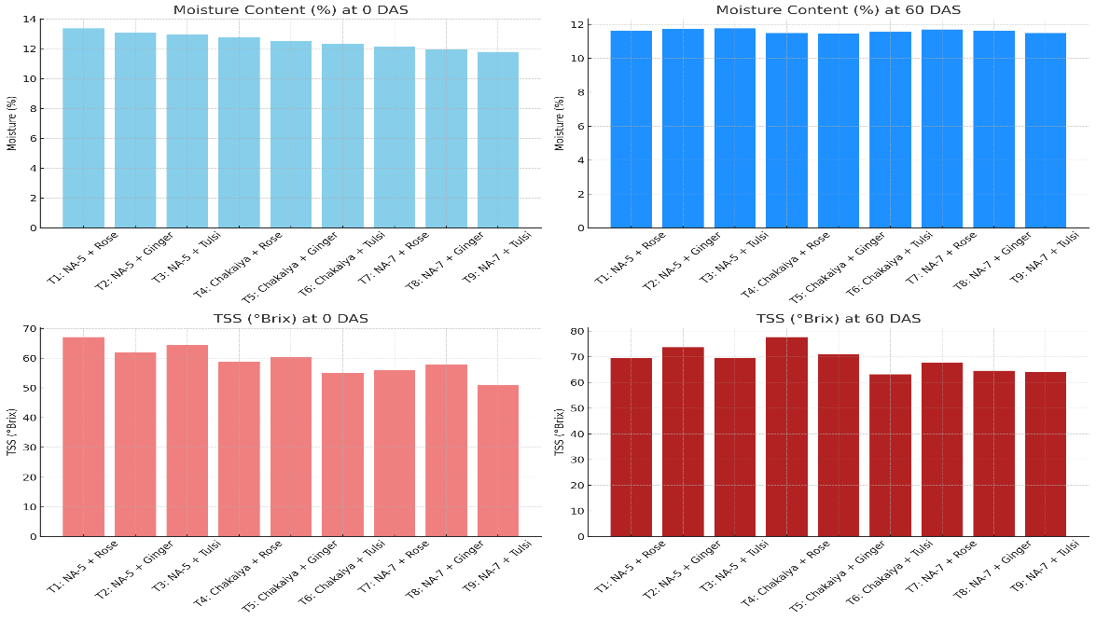
Graph. 1: Effect of different recipes on the moisture content (%) and TSS of aonla candy at various storage intervals

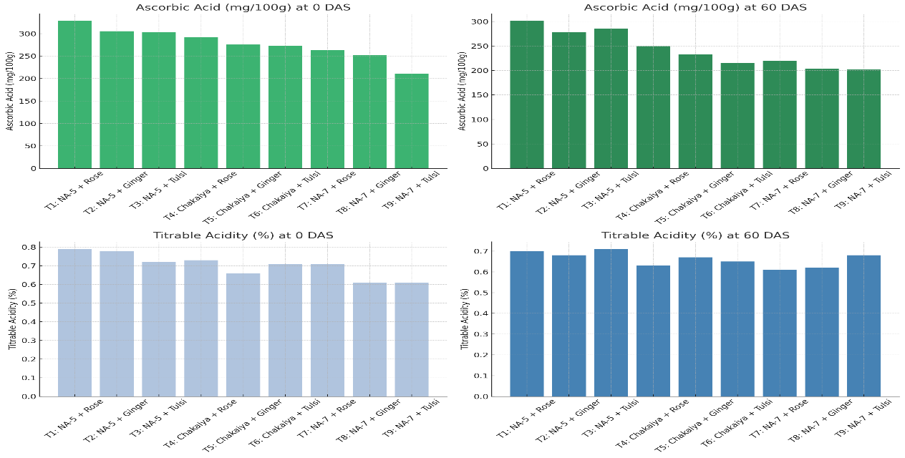
Graph 2: Effect of different recipes on the ascorbic acid and Titrable acidity of aonla candy at various storage intervals

