Original Research Article

**ROLE OF MEOWS (MODIFIED EARLY OBSTETRIC WARNING SCORE) AS A PREDICTOR OF PERIPARTUM MORBIDITY–A PROSPECTIVE STUDY IN A TERTIARY CARE TEACHING INSTITUTE**

ABSTRACT

|  |
| --- |
| **Background:** Maternal morbidity and mortality remain unacceptably high in low-resource settings. Early recognition of clinical deterioration is essential to prevent adverse maternal outcomes. The Modified Early Obstetric Warning Score(MEOWS) is a bedside tool designed to detect physiological abnormalities and escalate care.  **Aims:** To assess the efficacy and predictive accuracy of the Modified Early Obstetric Warning Score( MEOWS) chart in identifying women at high risk for peripartum complications in a tertiary care hospital setting in Uttar Pradesh, India.  **Study design:** institution-based observational study with a prospective design.  **Setting and Duration of Study:** Department of Obstetrics and Gynecology of the Moti Lal Nehru Medical College and Kamala Nehru Memorial Hospital, Prayagraj, Uttar Pradesh and was conducted for 12 months, from May 2023 to May of 2024.  **Methodology;**  A prospective observational study was conducted over a period of 12 months among 200 pregnant women at ≥37 weeks of gestation. Participants were classified into triggered and non-triggered groups based on their obstetrics and medical complication. MEOWS parameters were recorded during labour and at postpartum intervals. The primary outcomes included maternal complications, HDU/ICU transfer, and neonatal outcomes. Statistical analysis was performed using SPSS 22, with significance set at p<0.05.  **Results:** Out of 200 participants, 27% women were in the triggered group. Women of Triggered group had significantly higher rates of HDU/ICU transfers (70.4% vs. 3.4%, p<0.001), postpartum haemorrhage (18.5% vs. 2.7%), and hypertensive crises (16.7% vs. 2.1%). Neonatal complications such as low birth weight (24.1% vs. 4.8%) and NICU admission >24 hours (18.5% vs. 4.1%) were also more frequent. MEOWS demonstrated a sensitivity of 91%, specificity of 78.5%, and overall accuracy of 82%.  **Conclusion:** MEOWS is an effective and practical tool for early detection of maternal and neonatal complications. Its integration into routine obstetric monitoring can improve outcomes, particularly in resource-constrained settings. Broader implementation and training are recommended to enhance maternal healthcare delivery. |

*Keywords: [ MEOWS, maternal morbidity, early warning system, obstetric complications, peripartum care]*

1. INTRODUCTION

Pregnancy, though physiological, carries inherent risks. If left unmanaged, complications can escalate to severe maternal morbidity or death.[1] Early detection of physiological abnormalities has proven effective in preventing such outcomes reference. In this context, early warning systems like the Modified Early Obstetric Warning Score (MEOWS) have emerged as valuable tools, enabling timely interventions by tracking vital signs and escalating care when necessary. [2]

Despite global improvements in maternal health, with a 44% reduction in mortality between 1990 and 2015, maternal deaths remain high, approximately 830 women die daily, predominantly in developing countries. [3] India, despite advancements in maternal care, continues to face significant challenges. With a maternal mortality rate of 97 per 100,000 live births, issues such as inadequate healthcare infrastructure, especially in rural areas, and the rise in non-communicable diseases like hypertension and diabetes exacerbate risks during pregnancy. [4], [5] These systemic gaps highlight the need for reliable, easy-to-use clinical tools like MEOWS.

India’s demographic and epidemiological transitions are reshaping maternal health profiles. Increasing urbanization and lifestyle shifts have led to rising incidences of gestational hypertension, diabetes, and other metabolic disorders that complicate pregnancies reference. Simultaneously, rural populations continue to suffer from poor access to quality maternal care. These dual challenges demand proactive risk identification strategies. MEOWS is designed to address this gap. Its simplicity, adaptability, and predictive utility make it suitable even in resource-limited settings, supporting timely referrals and early interventions by healthcare workers. [6]

Early identification and prompt management of deteriorating maternal conditions is crucial. The MEOWS chart was recommended by the Confidential Enquiry into Maternal and Child Health for this very purpose. It allows bedside assessment of pregnant and postpartum women through color-coded indicators, triggering urgent clinical reviews and interventions as necessary. [7]

MEOWS is a color-coded chart that monitors key physiological parameters such as respiratory rate, oxygen saturation, temperature, heart rate, blood pressure, and others. Scores in the red or amber zones indicate potential complications and prompt clinical action. Its design allows even non-medical personnel to identify at-risk women efficiently. 6

Despite global validation of MEOWS, research in Indian settings remains limited. This study aims to assess the efficacy of MEOWS in identifying high-risk women at a tertiary care hospital in Uttar Pradesh. Specifically, it seeks to evaluate MEOWS’s predictive accuracy, its role in ICU/HDU referrals, and maternal-fetal outcomes between triggered and non-triggered groups.

2. methodology

This study was a prospective, institution-based observational conducted over a 12-month period from May 2023 to May 2024 in the Department of Obstetrics and Gynaecology at Moti Lal Nehru Medical College and Kamala Nehru Memorial Hospital, Prayagraj, Uttar Pradesh. The primary objective was to assess the effectiveness of the Modified Early Obstetric Warning Score (MEOWS) in identifying women at risk of peripartum complications.

The study population consisted of pregnant women with singleton, full-term pregnancies (≥37 weeks of gestation) who were admitted to the hospital for delivery. Women were included if they had vertex presentations and were expected to deliver within 24 hours. Exclusion criteria comprised women with gestational age less than 36 weeks, those who were hemodynamically unstable at presentation, and those unwilling to provide written informed consent.

Patient selection was performed using a consecutive sampling technique. Eligible women were recruited after obtaining ethical clearance from the Institutional Ethics Committee and informed consent from each participant. Upon recruitment, socio-demographic and clinical data were collected using a pre-designed and pretested researcher-administered questionnaire. Clinical history, obstetric status, and relevant laboratory investigations were recorded in the study proforma. Each participant was assessed using the MEOWS chart, which included parameters such as respiratory rate, pulse rate, oxygen saturation, temperature, systolic and diastolic blood pressure, urine output and proteinuria, level of consciousness, pain score, and lochia assessment.

Based on clinical presentation and medical history, participants were categorized into two groups: triggered and non-triggered. The triggered group included women with one or more obstetric or medical complications, such as chronic hypertension, pregnancy-induced hypertension (PIH), preeclampsia, eclampsia, anemia, hypothyroidism, gestational or overt diabetes, antepartum hemorrhage (APH), sepsis, thrombocytopenia, intrahepatic cholestasis of pregnancy (IHCP), and acute kidney injury (AKI). Women without any such complications formed the non-triggered group.

Monitoring using the MEOWS chart was conducted every 4 hours after admission and continued until delivery. For all women, post-delivery MEOWS assessments were performed at 12, 24, and 48 hours. For women who undertook lower-segment cesarean section (LSCS), an additional MEOWS assessment was done at discharge. If a woman’s MEOWS score remained ≥6, she was referred to the High Dependency Unit (HDU) or Intensive Care Unit (ICU) for further management. Patients with declining or improving scores were managed conservatively in the labor ward.

The primary outcome measures included the proportion of women classified as triggered versus non-triggered, the predictive accuracy of the MEOWS score (sensitivity, specificity, positive predictive value, and negative predictive value), and the incidence of maternal complications in the triggered group. Secondary outcomes included fetal and neonatal complications across both groups. The sample size was determined using a previous study by Singh et al., estimating a 30% trigger rate, with a 5% margin of error and a 95% confidence level, leading to a calculated size of 200 participants after accounting for attrition.

Data were entered into Microsoft Excel and analyzed using IBM SPSS version 22. Descriptive statistics were used to summarize data, with categorical variables expressed as frequencies and percentages, and continuous variables as mean ± standard deviation. Chi-square test was used for comparison of categorical variables, and Student’s t-test was used for continuous variables. A p-value < 0.05 was considered statistically significant. Ethical safeguards included anonymizing all data and storing it in password-protected files, with participants fully informed of their rights, including the ability to withdraw from the study at any time.

**TABLE 1: MEOWS SCORE**

|  |  |  |  |  |  |  |  |
| --- | --- | --- | --- | --- | --- | --- | --- |
| Score | 3 | 2 | 1 | 0 | 1 | 2 | 3 |
| SpO2 | <92 | 92-95 |  | >95 |  |  |  |
| Temp | <36oC |  |  | 36.1-37.2oC |  | 37.3-37.7oC | >37.7oC |
| SBP | <90 |  |  | 90-140 | 141-150 | 151-160 | >160 |
| DBP |  |  |  | 60-90 | 91-100 | 101-110 | >110 |
| Pulse | <50 | 50-60 |  | 61-100 | 101-110 | 111-120 | >120 |
| Respiratory rate | <12 |  |  | 12-20 |  | 21-25 | >25 |
| Level of consciousness |  |  |  |  |  |  | A,V, P, or U |
| Pain |  |  |  | Normal |  |  | Abnormal |
| Lochia |  |  |  | Normal |  |  | Abnormal |
| Proteinuria |  |  |  |  |  | + | ++> |

1. results and discussion

3.1 RESULTS

A total of 200 women were enrolled in the study, of which 54 (27%) were categorized into the triggered group based on their MEOWS scores, while the remaining 146 (73%) were classified as non-triggered. The socio-demographic analysis revealed that the majority of participants (48%) were between 25 and 30 years of age, followed by 36% under 25 years and 16% over 30 years. Most of the women (61%) were from rural areas, and the largest proportion (40%) belonged to the lower socioeconomic class. The study population included 56% primigravida and 44% multigravida women, with a mean gestational age at admission of 38.2 weeks (±1.1 SD).

Upon categorization, MEOWS parameters were analyzed. Among all participants, the most common abnormal parameter was elevated or decreased systolic blood pressure, which was observed in 14.5% of women. This was followed by elevated pulse rate in 10.5%, increased respiratory rate in 9%, and reduced oxygen saturation (<92%) in 6% of the women. Other notable findings included proteinuria in 7.5%, abnormal lochia in 4%, and altered consciousness in 3% of participants.

The need for ICU or HDU admission was significantly higher in the triggered group. Among the 54 women in the triggered group, 38 (70.4%) required transfer to HDU/ICU care, whereas only 5 women (3.4%) from the non-triggered group required such escalation. This difference was statistically significant (*P* < 0.001), highlighting the predictive value of the MEOWS chart in identifying women requiring intensive monitoring and intervention.

Maternal complications were more frequent in the triggered group. Postpartum hemorrhage (PPH) was the most commonly observed complication, affecting 18.5% of triggered women compared to only 2.7% in the non-triggered group. Hypertensive crises occurred in 16.7% of the triggered group versus 2.1% in the non-triggered group. Other complications in the triggered group included sepsis (9.3%), eclampsia (5.6%), pulmonary edema (3.7%), and other critical conditions (7.4%). These differences were all statistically significant, demonstrating that women flagged by MEOWS are at substantially greater risk of morbidity.

Fetal and neonatal outcomes also differed significantly between the two groups. Low birth weight (LBW) was reported in 24.1% of neonates born to mothers in the triggered group, while only 4.8% of neonates in the non-triggered group had LBW. Similarly, NICU admissions lasting more than 24 hours were needed for 18.5% of neonates in the triggered group versus 4.1% in the non-triggered group. APGAR scores less than 7 at 5 minutes were noted in 14.8% of the triggered group compared to 2.7% in the non-triggered group. Stillbirths occurred in 3.7% of the triggered group and none in the non-triggered group, further emphasizing the importance of early detection of maternal instability.

Among the 54 triggered patients, 22 (40.7%) had MEOWS scores ≥6, indicating high risk. Of these, 95.5% required HDU/ICU admission and 17.4% needed ventilatory support. Mortality was observed in two patients (9.1%) in this high-score subgroup, while all patients with scores <6 recovered without mortality. In the non-triggered group, only 9 patients (6.2%) had scores ≥6, and 5 of them (55.6%) required HDU/ICU admission, though none experienced mortality.

Interventions in the triggered group included blood transfusion in 33.3%, intravenous antibiotics in 22.2%, antihypertensive adjustments in 20.3%, and ICU monitoring in 7.4%. Hospital stay was significantly longer among triggered patients, averaging 6.4 ± 1.8 days compared to 3.2 ± 1.2 days in the non-triggered group (*P* < 0.001).

Performance analysis of the MEOWS chart showed a sensitivity of 91%, specificity of 78.5%, a positive predictive value (PPV) of 95.9%, and a negative predictive value (NPV) of 61.1%, with an overall accuracy of 82%. ROC curve analyses showed that at a score of 6, the sensitivity and specificity of MEOWS in predicting ICU/HDU admission was 58.3% and 94.4% respectively (AUC 0.780, *P*-value <0.001). At a score of 6, the sensitivity and specificity of MEOWS in predicting death was 100% and 86.5% respectively (AUC 0.952, *P*-value <0.001). At a score of 6, the sensitivity and specificity of MEOWS in predicting ICU/HDU admission was 63.6% and 98.5% respectively (AUC 0.963, *P*-value <0.001).

**3.2 DISCUSSION**

This study evaluated the effectiveness of the Modified Early Obstetric Warning Score (MEOWS) in identifying women at risk of severe obstetric complications and adverse maternal-fetal outcomes. Out of 200 participants, 27% were categorized as triggered, suggesting that a significant proportion of term pregnant women admitted for delivery had underlying or developing complications. These findings align with prior research, such as Singh et al. (2016), which found a similar prevalence of MEOWS triggers among obstetric patients. [8]

One of the central findings was the high incidence of abnormal MEOWS parameters in the triggered group, particularly systolic blood pressure, pulse rate, and respiratory rate. These parameters are early indicators of hemodynamic instability, and their presence supports the role of MEOWS in preemptively flagging clinical deterioration.[9] A significant number of women (%) in the triggered group required admission to HDU or ICU, highlighting the score’s utility in guiding the escalation of care. In comparison, very few in the non-triggered group needed such interventions, reinforcing the tool's specificity. [10]

The MEOWS chart demonstrated excellent sensitivity (91%) and a high positive predictive value (95.9%) in this study, suggesting its reliability in identifying at-risk patients. However, the negative predictive value was relatively lower (61.1%), indicating that while MEOWS effectively identifies risk, it may occasionally miss subtle cases that later progress to complications.This limitation points to the need for MEOWS to be used in conjunction with clinical judgment rather than as a standalone diagnostic tool. [11]

Maternal complications such as postpartum hemorrhage, hypertensive crises, and sepsis were significantly higher in the triggered group. These outcomes are consistent with global patterns of maternal morbidity, where hypertensive disorders and hemorrhage remain the leading causes of severe maternal outcomes. Importantly, fetal outcomes were also adversely affected in the triggered group, including higher rates of low birth weight, NICU admissions, and low APGAR scores. These associations underscore the interconnectedness of maternal and fetal health and validate the use of MEOWS in improving both outcomes.

The study also found that women with MEOWS scores ≥6 were more likely to require intensive care and had higher maternal morbidity and mortality, demonstrating that higher scores can predict not only the presence of complications but also their severity. This observation supports the inclusion of score thresholds in clinical protocols for triaging obstetric patients.

Compared to similar studies in Western healthcare settings, this study reaffirms that MEOWS is effective even in resource-limited environments like tertiary care centers in India. [12], [13] The tool’s simplicity, ease of use, and adaptability to bedside monitoring make it especially valuable in high-volume or rural healthcare settings, where timely recognition and referral can significantly alter outcomes. However, the study had some limitations. It was conducted in a single tertiary care institution, which may not fully represent rural or primary healthcare settings where MEOWS could be most beneficial. Additionally, while MEOWS proved effective in identifying women at risk, its reliance on accurate and consistent monitoring means that training and standardization are essential for optimal use.

Despite these limitations, the findings strongly support the integration of MEOWS into routine obstetric care, especially for high-risk pregnancies and in facilities with limited access to advanced diagnostics. The chart offers a structured approach to early detection and facilitates communication among healthcare providers through a common risk language. By prompting timely interventions, MEOWS can contribute to reducing maternal and neonatal morbidity and mortality.

**Table 2 . Sociodemographic and clinical parameters of the study (n=200)**

|  |  |  |
| --- | --- | --- |
| **Parameters** | **Frequency/ mean** | **Percentage/ SD** |
| **Age group** |  |  |
| <25 | 72 | 36 |
| 25-30 | 96 | 48 |
| >39 | 32 | 16 |
| **Residence** |  |  |
| Rural | 122 | 61 |
| Urban | 78 | 39 |
| **Socioeconomic status** |  |  |
| Lower | 80 | 40 |
| Upper lower | 24 | 12 |
| Lower middle | 20 | 10 |
| Middle | 28 | 14 |
| Upper middle | 40 | 20 |
| Upper | 8 | 4 |
| **Gravida** |  |  |
| Primi | 112 | 56 |
| Multi | 88 | 44 |
| **Gestational age (weeks)** | 38.2 | 1.1 |
| **Study group** |  |  |
| Triggered group | 54 | 27 |
| Non triggered group | 146 | 73 |

**Table 3. MEOWS parameters of the study (n=200)**

|  |  |  |
| --- | --- | --- |
| **Parameters** | **Frequency/ mean** | **Percentage/ SD** |
| Systolic BP > 150 mmHg or <90 mmHg | 29 | 14.5 |
| Pulse >120/min | 21 | 10.5 |
| Respiratory rate >25/min | 18 | 9 |
| SpO₂ < 92% | 12 | 6 |
| Altered consciousness (AVPU) | 6 | 3 |
| Proteinuria | 15 | 7.5 |
| Foul smelling or excessive lochia | 8 | 4 |

**Table 4. Comparison between triggered and non-triggered groups with respect to MEOWS parameters (n=200)**

|  |  |  |  |  |  |
| --- | --- | --- | --- | --- | --- |
| **Parameters** | **Triggered (n=54)** | | **Not triggered (n=146)** | | *P*-value |
| **Frequency/ mean** | **Percentage/ SD** | **Frequency/ mean** | **Percentage/ SD** |
| **HDU/ICU transfer** | 38 | 70.4 | 5 | 3.4 | <0.001* |
| **Maternal Complications** | | | | | |
| PPH | 10 | 18.5 | 4 | 2.7 | <0.001* |
| Hypertensive crisis | 9 | 16.7 | 3 | 2.1 |
| Sepsis | 5 | 9.3 | 1 | 0.7 |
| Eclampsia | 3 | 5.6 | 0 | 0 |
| Pulmonary edema | 2 | 3.7 | 0 | 0 |
| Others | 4 | 7.4 | 1 | 0.7 |
| **Fetal and neonatal complications** | | | | | |
| LBW | 13 | 24.1 | 7 | 4.8 | <0.001* |
| NICU admission required >24 hours | 10 | 18.5 | 6 | 4.1 |
| APGAR score <7 at 5 mins | 8 | 14.8 | 4 | 2.7 |
| Stillbirths | 2 | 3.7 | 0 | 0 |

*\* P < 0.001( Statistically significant)*

**Table 5. Performance of the MEOWS chart for predicting obstetric morbidity by its sensitivity, specificity, and predictive values (n=200)**

|  |  |  |
| --- | --- | --- |
| **Parameters** | **Frequency/ mean** | **Percentage/ SD** |
| Sensitivity | 91 | 80.3%, 91.2% |
| Specificity | 78.5 | 77.9%, 99.2% |
| PPV | 95.9 | 95.1%, 99.6% |
| NPV | 61 .1 | 45.1%, 64.3% |
| Accuracy | 82 | 82.1%, 91.7% |

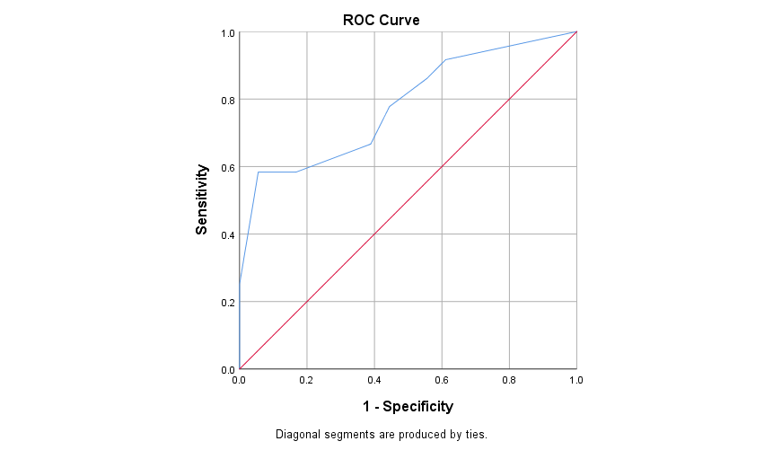**Fig. 1. ROC curve showing MEOWS cut-off for ICU/HDU admission in triggered patients (n=54)**

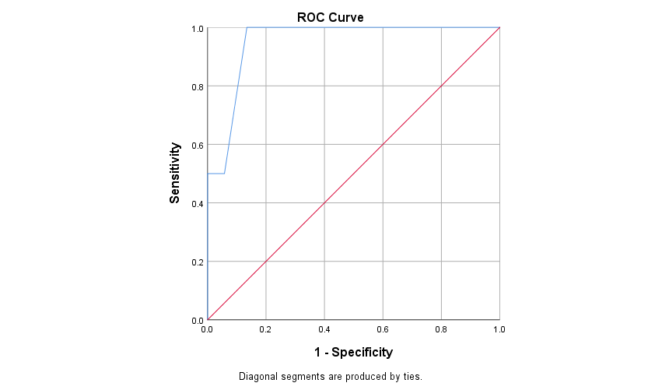

**Figure 2. ROC curve showing MEOWS cut-off for death in triggered patients (n=54)**

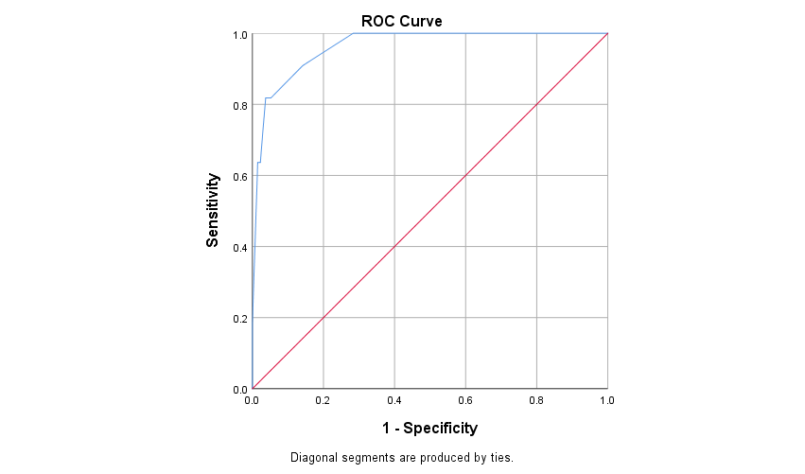

**Figure 3. ROC curve showing MEOWS cut-off for ICU/HDU admission in triggered patients (n=54)**

4. Conclusion

The present study highlights the effectiveness of the Modified Early Obstetric Warning Score (MEOWS) as a reliable bedside tool for identifying pregnant women at risk of developing severe maternal and neonatal complications. MEOWS demonstrated high sensitivity and predictive accuracy in detecting early physiological deviations, enabling timely interventions such as HDU/ICU admissions, thereby preventing escalation to life-threatening conditions. Triggered patients had significantly higher rates of postpartum hemorrhage, hypertensive crises, sepsis, and adverse neonatal outcomes including low birth weight and NICU admissions. The findings reinforce MEOWS as a practical, easy-to-use screening system that can enhance maternal and fetal care, especially in resource-constrained settings.

CONSENT FORM

I have had the study explained to me & have read the contents of this form/had the contents of this form read to me. I have been given the opportunity to ask questions and have them answered to my satisfaction.

I am willing to be enrolled in the study.I have no objection if the results of this research are used for publication in the future.

Name of the subject :

Signature of parent/guardian

Name :

Date :

Relationship with the subject :

**Investigator's statements**

I, the undersigned have explained to the parent/guardian in a language she/he understands the procedures to be followed in the study and risks and benefits.

Signature of the Investigator : Date :

Name of the Investigator

Signature of witness Date :

Name of witness :

Ethical approvAL

ETHICAL CERTIFICATE

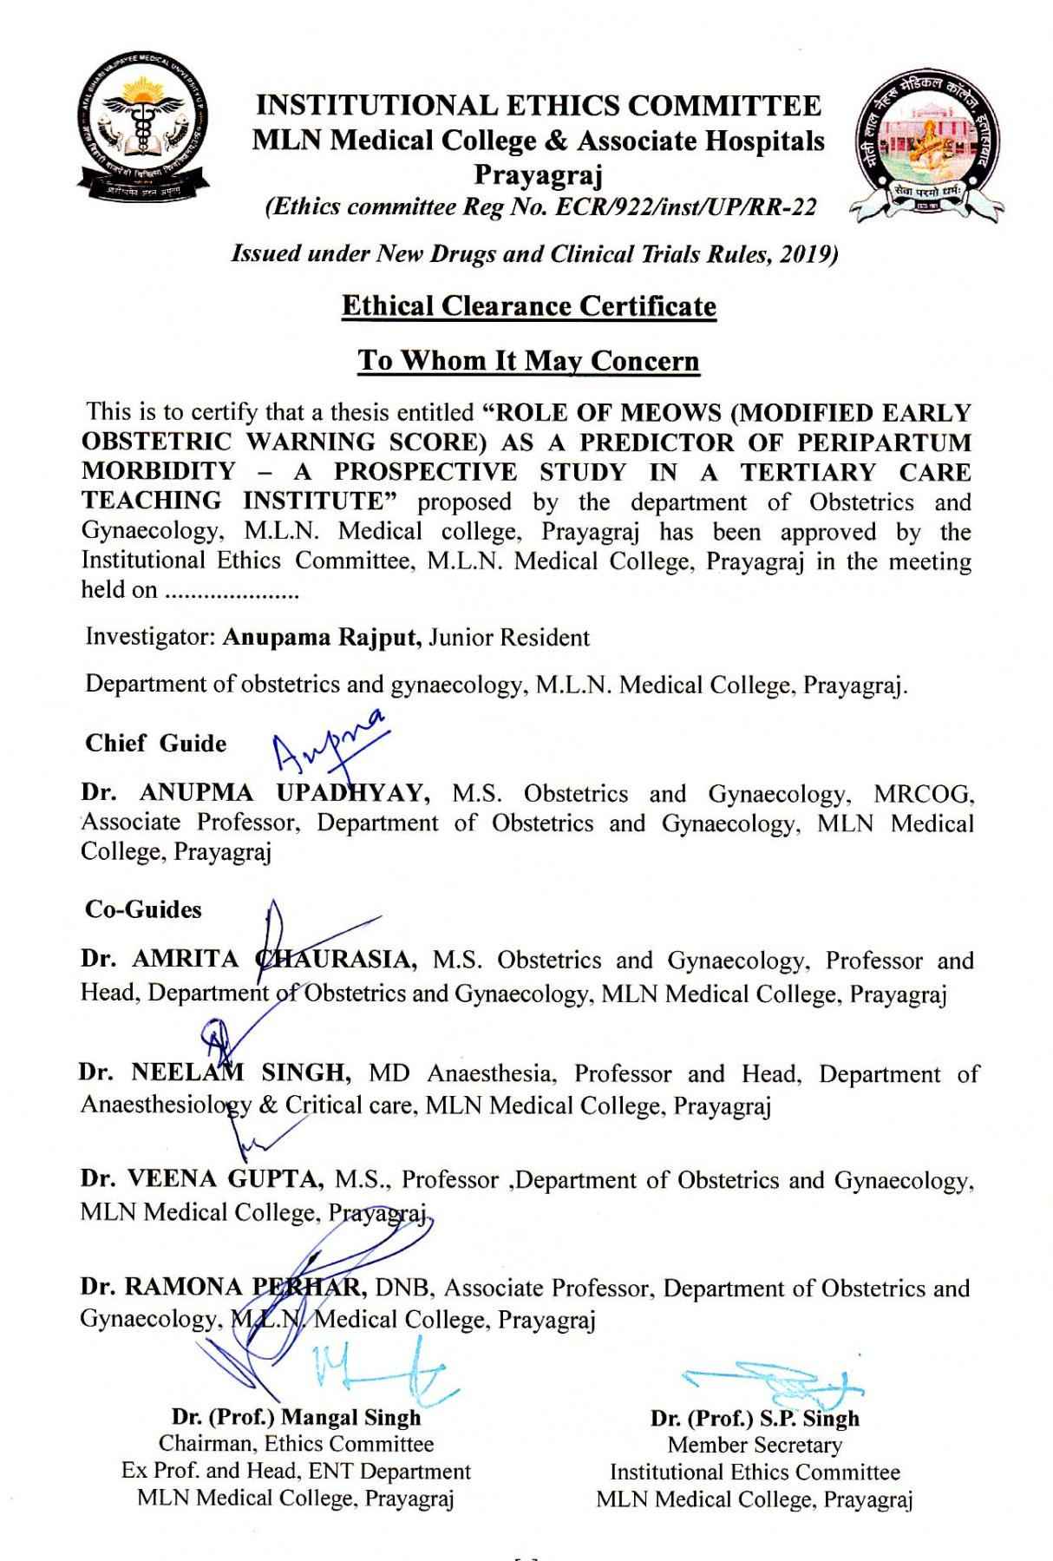References

1. Hirshberg A, Srinivas SK. Epidemiology of maternal morbidity and mortality. Semin Perinatol. 2017;41(6):332–7.
2. Mhyre JM, D'Oria R, Hameed AB, Lappen JR, Holley SL, Hunter SK, et al. The maternal early warning criteria: a proposal from the national partnership for maternal safety. J Obstet Gynecol Neonatal Nurs. 2014;43(6):771–9.
3. Geller SE, Koch AR, Garland CE, MacDonald EJ, Storey F, Lawton B. A global view of severe maternal morbidity: moving beyond maternal mortality. Reprod Health. 2018;15(1):31–43.
4. Meh C, Sharma A, Ram U, Fadel S, Correa N, Snelgrove JW, et al. Trends in maternal mortality in India over two decades in nationally representative surveys. BJOG. 2022;129(4):550–61.
5. Kassebaum NJ, Barber RM, Bhutta ZA, Dandona L, Gething PW, Hay SI, et al. Global, regional, and national levels of maternal mortality, 1990–2015: a systematic analysis for the Global Burden of Disease Study 2015. Lancet. 2016;388(10053):1775–812.
6. Edwards SE, Grobman WA, Lappen JR, Winter C, Fox R, Lenguerrand E, Draycott T. Modified obstetric early warning scoring systems (MOEWS): validating the diagnostic performance for severe sepsis in women with chorioamnionitis. Am J Obstet Gynecol. 2015;212(4):536.e1.
7. Sanneving L, Trygg N, Saxena D, Mavalankar D, Thomsen S. Inequity in India: the case of maternal and reproductive health. Glob Health Action. 2013;6(1):19145.
8. Singh A, Guleria K, Vaid NB, Jain S. Evaluation of maternal early obstetric warning system (MEOWS chart) as a predictor of obstetric morbidity: a prospective observational study. Eur J Obstet Gynecol Reprod Biol. 2016;207:11–7.
9. Singhal S, Acharya N, Madaan S, Mohammad S, Acharya S. Use of the modified early obstetric warning system chart as a predictor of peri-partum obstetric morbidity in a rural teaching institute: A two-year cross-sectional study. J Family Med Prim Care. 2022;11(12):7644.
10. Hedriana HL, Wiesner S, Downs BG, Pelletreau B, Shields LE. Baseline assessment of a hospital-specific early warning trigger system for reducing maternal morbidity. Int J Gynaecol Obstet. 2016;132(3):337–41.
11. Guleria K, Singh A, Jain S. Evaluation of risk factors, triggers, and maternal early warning system to predict obstetric morbidity in low resource country. Chest. 2017;152(4):A581.
12. Moore J, Thomson D, Pimentil I, Fekad B, Graham W. Introduction of a modified obstetric early warning system (MOEWS) at an Ethiopian referral hospital: a feasibility assessment. BMJ Open Qual. 2019;8(1):e000503.
13. Hannola K, Hoppu S, Mennander S, Huhtala H, Laivuori H, Tihtonen K. Obstetric early warning system to predict maternal morbidity of pre-eclampsia, postpartum hemorrhage and infection after birth in high-risk women: a prospective cohort study. Midwifery. 2021;99:103015.

APPENDIX

1. introduction
2. Methodology
   1. table 1 : meows score
3. results and discussion

3.1RESULTS

3.2DISCUSSION

3.1 Table 2 . Sociodemographic and clinical parameters of the study (n=200)

Table 3. MEOWS parameters of the study (n=200)

Table 4. Comparison between triggered and non-triggered groups with respect to MEOWS parameters (n=200)

Table 5. Performance of the MEOWS chart for predicting obstetric morbidity by its sensitivity, specificity, and predictive values (n=200)

Fig. 1. ROC curve showing MEOWS cut-off for ICU/HDU admission in triggered patients (n=54)

Figure 2. ROC curve showing MEOWS cut-off for death in triggered patients (n=54)

1. Conclusion
2. AcknowledgEments
3. Competing interests
4. Authors’ Contributions

8.Consent (where ever applicable)

9.CONSENT FORM

10.Ethical approvAL

11.References

1. Hirshberg A, Srinivas SK. Epidemiology of maternal morbidity and mortality. Semin Perinatol. 2017;41(6):332–7.
2. Mhyre JM, D'Oria R, Hameed AB, Lappen JR, Holley SL, Hunter SK, et al. The maternal early warning criteria: a proposal from the national partnership for maternal safety. J Obstet Gynecol Neonatal Nurs. 2014;43(6):771–9.
3. Geller SE, Koch AR, Garland CE, MacDonald EJ, Storey F, Lawton B. A global view of severe maternal morbidity: moving beyond maternal mortality. Reprod Health. 2018;15(1):31–43.
4. Meh C, Sharma A, Ram U, Fadel S, Correa N, Snelgrove JW, et al. Trends in maternal mortality in India over two decades in nationally representative surveys. BJOG. 2022;129(4):550–61.
5. Kassebaum NJ, Barber RM, Bhutta ZA, Dandona L, Gething PW, Hay SI, et al. Global, regional, and national levels of maternal mortality, 1990–2015: a systematic analysis for the Global Burden of Disease Study 2015. Lancet. 2016;388(10053):1775–812.
6. Edwards SE, Grobman WA, Lappen JR, Winter C, Fox R, Lenguerrand E, Draycott T. Modified obstetric early warning scoring systems (MOEWS): validating the diagnostic performance for severe sepsis in women with chorioamnionitis. Am J Obstet Gynecol. 2015;212(4):536.e1.
7. Sanneving L, Trygg N, Saxena D, Mavalankar D, Thomsen S. Inequity in India: the case of maternal and reproductive health. Glob Health Action. 2013;6(1):19145.
8. Singh A, Guleria K, Vaid NB, Jain S. Evaluation of maternal early obstetric warning system (MEOWS chart) as a predictor of obstetric morbidity: a prospective observational study. Eur J Obstet Gynecol Reprod Biol. 2016;207:11–7.
9. Singhal S, Acharya N, Madaan S, Mohammad S, Acharya S. Use of the modified early obstetric warning system chart as a predictor of peri-partum obstetric morbidity in a rural teaching institute: A two-year cross-sectional study. J Family Med Prim Care. 2022;11(12):7644.
10. Hedriana HL, Wiesner S, Downs BG, Pelletreau B, Shields LE. Baseline assessment of a hospital-specific early warning trigger system for reducing maternal morbidity. Int J Gynaecol Obstet. 2016;132(3):337–41.
11. Guleria K, Singh A, Jain S. Evaluation of risk factors, triggers, and maternal early warning system to predict obstetric morbidity in low resource country. Chest. 2017;152(4):A581.
12. Moore J, Thomson D, Pimentil I, Fekad B, Graham W. Introduction of a modified obstetric early warning system (MOEWS) at an Ethiopian referral hospital: a feasibility assessment. BMJ Open Qual. 2019;8(1):e000503.
13. Hannola K, Hoppu S, Mennander S, Huhtala H, Laivuori H, Tihtonen K. Obstetric early warning system to predict maternal morbidity of pre-eclampsia, postpartum hemorrhage and infection after birth in high-risk women: a prospective cohort study. Midwifery. 2021;99:103015.