**Evaluation of selected silkworm hybrid (FC1XFC2 and FC2XFC1) for rearing performance under sub-temperate conditions of Poonch district of Jammu and Kashmir.**

**ABSTRACT:** Sericulture is a cottage industry par excellence. It is one of the most labor-intensive sectors of the Indian economy combining both agriculture and industry. Silkworm *Bombyx mori* (L.) is one of the most unique holometabolous insects known for production of most versatile silk protein. The growth rate pattern varies significantly from first to last day of the larval period. The current experiment was conducted to evaluate the morphological characters of cocoon which are predominant descriptors for assessment of breeds for distinctiveness, uniformity and stability; but are always influenced by prevailing environment. In present study, the morphological characters were recorded wide phenotypic variation in cocoon colour, cocoon shape, cocoon shell weight, cocoon grains, cocoon shell ratio, pupal percentage and pupal weight. The data showed that there is logarithmical increase in the larval body weight and length until 7th day of the 5th instar. The maximum larval length was observed on 7th day to be 8.5cm in FC1 × FC2 and 7.4 cm in FC2 × FC1. The maximum and minimum values for larval weight for single and 10 larvae ranged from 45.20g to 0.52g and 36.91g to 0.12g in case of silkworm hybrid FC1xFC2 and FC2xFC1 respectively. Similarly, maximum single cocoon weight was recorded as 1.46g for FC1xFC2 and 1.30g for FC2xFC1.

**Keywords:** Silkworm, racial, phenotypic, logarithmical, spinning, cocoon, floss, economic traits, FC1XFC2 and FC2XFC1.

**INTRODUCTION**

**Silk:** The queen of textiles is the natural fiber, spells luxury, elegance, class and comfort, which is secreted by silkworm. India is the second largest producer of silk and also the largest consumer of silk in the world. The silkworm is a monophagous insect which depends on the mulberry for its complete growth and development. Due to this, silkworm requires specific quality of leaves during different phases of its growth and this reflects on the importance of mulberry cultivation practices. Being a potential and economic sector, sericulture plays a major role in rural employment, poverty, alleviation and livelihood generation mainly for marginal farmers. A lot of entrepreneurial opportunities are available in its various activities. Sericulture industry provides employment to approximately 8.25 million persons in rural and semi urban areas of India during the year 2015-2016 (Chanotra et al., 2019)- these authors are not listed in the bibliographical references! India holds the unique position in the global silk market, known to be the only producer of all the known types of commercial silks namely mulberry, tropical tasar, oak tasar, Eri and Muga. Mulberry sericulture is mainly practiced in five states namely Karnataka, Andhra Pradesh, West Bengal, Tamil Nadu and Jammu and Kashmir in the country. North-East has the unique distinction of being the only region producing the golden Muga silk restricted to Assam district only. Overall North-East region contributes 18 per cent of India’s total silk production. Among the four varieties of silk produced in 2019-2020; mulberry accounts for 71.8 per cent (20,434 MT), Tasar 9.9 per cent (2,818 MT), Eri 17.8 per cent (5,054 MT) and Muga 0.6 per cent (166 MT) of the total raw silk production of 28,472 MT (Iqbal et al., 2012)- these authors are not listed in the bibliographical references!

Moreover, silkworm being monophagous insect feeds only on mulberry leaf because of the presence of morin pigment in it. Food consumption and assimilation is influenced by various biotic and abiotic factors. Under different environment, feeding and nutritional conditions and with ingestion of the same quantum of mulberry leaves, the silkworm shows significant difference in its ability to digest, absorb and convert food to body matter. Hence, influence of season, temperature, humidity on food intake, assimilation and conversion efficiency of the Bombyx mori is significant. Consumption and assimilation were reported to be significantly higher among the silkworm reared with optimum temperature and humidity ranges, when compared with silkworm exposed to natural climatic conditions of the respective season. However, during summer the nutritional efficiency parameters were significantly higher among the silkworms. Ingesta and digesta required to produce one gram of cocoon/shell can be observed to vary significantly under varied conditions. This can be attributed to the physiological adaptation of silkworm to different season. Thus, the consumption and assimilation ratio play significant role in quantification of the feed and fixation of the standard feeding requirement by silkworm larvae at various instars. Therefore, in order to evaluate the economic traits of selected hybrids.

**MATERIALS AND METHODS**

The silkworm rearing for the current experiment was conducted at Post Graduate Department of Sericulture, Poonch Campus, University of Jammu during spring season (March-April) in the year 2021. The material and methodology followed for the study has been described under various headings as given below:

**MATERIAL UTILIZED IN THE STUDY:**

1. **Mulberry leaf**
2. **Silkworm hybrids FC1XFC2 and FC2XFC1**

**METHODOLOGY FOLLOWED FOR THE STUDY:**

1. **FEED UTILISATION STUDIES**
2. Feed utilization studies, after resumption from 4th moult, 50 larvae each from 3 replications will be separated and would be reared under standard rearing condition of temperature and relative humidity with control batches.
3. Known quantities of fresh quality mulberry leaf to be supplied to the silkworm for three times (three times feeding schedule @ 10 AM, 2PM and 5PM).
4. Samples of mulberry leaves used for each feeding will be placed in trays for estimation of dry weight determination of Ingesta.
5. Additional larval batches of each treatment will be maintained in parallel direction the dry weight for subsequent determination of daily incremental changes in larval weight.
6. Observations on dry weight of left over leaf, excreta and larval weight will be recorded daily after oven drying at a constant temperature of 80°C.
7. Larvae will mounted on plastic collapsible mountage and cocoon would be harvested after 6th day.
8. Dry weight of the cocoon and shell will be calculated for future validation of results.

From the bioenergetics data, following economic parameters will be recorded.

1. Larval weight.
2. Larval size.
3. Green cocoon weight.
4. Cocoon with floss.
5. Deflossed cocoon.
6. Dry cocoon weight.
7. Shell weight.
8. Pupal weight.
9. Cocoon shell ratio.
10. Cocoon grains.
11. Cocoon compactness.
12. Cocoon size.
13. Pupal percentage
14. **Statistical Analysis**: The raw data generated from the current experiment by Completely Randomized Design (CRD) have been pooled and subjected to Analysis of Variance (ANOVA) on Statistical Package for the Social Sciences (SPSS) software Version; 2021, to determine the significant values for the selected parameters. The formulas for calculation and tabulation of different nutritional parameters include:

**Cocoon shell ratio:** Weight of the cocoon shell/ Weight of cocoon x 100

**RESULTS AND DISCUSSION**

Various larval parameters studied for evaluation of economic traits studies have been under following headings:

1. **Larval Weight:** Rahmathulla et al. (2005) - these authors are not listed in the bibliographical references! reported that the dietary efficiency of silkworm plays a major role in converting mulberry leaf protein into the animal protein i.e., Silk. Weight of the larvae is directly proportional to the amount of food utilized by it during its feeding period. Weight (mg) of the larvae during the present study was measured on a sensitive, digital electronic weighing balance. The various values for larval weight for single larva and 10 larvae of different instars (per day) have been recorded with significant increase with each day (Table, 1-3). The maximum and minimum values for single and 10 larvae ranged from 45.20g to 0.52g and 36.91g to 0.12g in case of silkworm hybrid FC1 × FC2 and FC2 × FC1 respectively on day 7th of 5th instar and day 1st of 3rd instar for both the hybrids. Interestingly, the current results found to be strongly in agreement with that of Craiciu (2011)- this authors is not listed in the bibliographical references!; Cui and Hiratsuka (2019) - these authors are not listed in the bibliographical references!. Similar experiment with respect to feed utilization was earlier reported by Rahmathulla et al. (2002) - these authors are not listed in the bibliographical references!; Rahmathulla et al. (2005) - these authors are not listed in the bibliographical references!, where the maximum larval weight was recorded for the larvae fed with fresh mulberry leaf. The current findings where maximum larval weight was recorded in 5th instar larvae lies in close conformity to the earlier reports of Rahmathulla et al. (2002 and 2005) - these authors are not listed in the bibliographical references!.

**Table 1: Values of larval weight recorded for single and 10 larvae from 3rd instar onwards (per day) in silkworm hybrid FC1 × FC2 and FC2 × FC1.**

|  |  |  |  |
| --- | --- | --- | --- |
| **3rdInstar** | **Days** | **FC1×FC2** | **FC2×FC1** |
| **Weight of Single Larva (g)** | **01** | 0.52±0.02b | 0.12±0.11 b |
| **02** | 0.54±0.04c | 0.15±0.22 bc** |
| **03** | 0.60±0.06c | 0.21±0.43 c |
| **04** | **-** | **-** |
| **Weight of 10 Larvae(g)** | **01** | 3.61±1.16b | 2.74±1.17 b |
| **02** | 3.92±1.11c | 3.02±1.85 bc** |
| **03** | 4.01±1.14c | 3.22±1.64 c |
| **04** | **-** | **-** |

**Table 2: Values of larval weight recorded for single and 10 larvae from 4th instar (per day) in silkworm hybrid FC1 × FC2 and FC2 × FC1.**

|  |  |  |  |
| --- | --- | --- | --- |
| **4th Instar** | **Days** | **FC1 × FC2** | **FC2 × FC1** |
| **Weight of Single Larva(g)** | **01** | 0.62±0.05a | 0.24±0.08 a |
| **02** | 0.78±0.04ab** | 0.31±0.22 ab** |
| **03** | 0.85±0.03ab** | 0.38±0.22 bc** |
| **04** | 0.88±0.07ab** | 0.44±0.21 c |
| **05** | 0.95±0.02a | 0.56±0.11 d |
| **Weight of 10 Larvae(g)** | **01** | 4.21±2.33a | 3.27±2.15 a |
| **02** | 5.2±3.568b | 4.12±2.15 a |
| **03** | 6.42±3.56c | 4.72±2.22 b |
| **04** | 7.07±4.67c | 5.56±1.85 c |
| **05** | 8.12±4.67d | 6.25±4.76 d |

**Table 3: Values of larval weight recorded for single and 10 larvae from 5th instar (per day) in silkworm hybrid FC1 × FC2 and FC2 × FC1.**

|  |  |  |  |
| --- | --- | --- | --- |
| **5th Instar** | **Days** | **FC1×FC2** | **FC2×FC1** |
| **Weight of Single Larva** | **01** | 1.29±0.95a | 0.92±0.66 a |
| **02** | 1.95±0.22ab** | 1.21±0.66 a |
| **03** | 2.01±0.12b | 1.48±0.66 b |
| **04** | 2.65±0.12b | 2.02±0.67 b |
| **05** | 3.07±0.12c | 2.18±0.21 b |
| **06** | 4.21±0.95cd** | 3.45±0.14 c |
| **07** | 4.52±0.11d | 3.69±0.13 c |
| **Weight of 10 Larvae** | **01** | 12.91±0.46a | 9.11±0.66 a |
| **02** | 19.57±0.46a | 12.87±11.9 b |
| **03** | 20.10±0.46b | 14.21±16.55 b |
| **04** | 26.51bc±3.89** | 20.23±18.90 c |
| **05** | 30.71±12.56c | 21.65±14.6 c |
| **06** | 42.11±12.56d | 34.51±18.76 d |
| **07** | 45.20d |  |

**Figure-01:** Graph depicting the maximum and minimum values id larval weight during the different instars and their subsequent day.

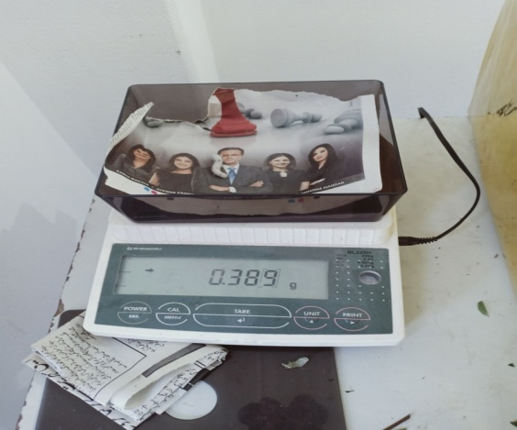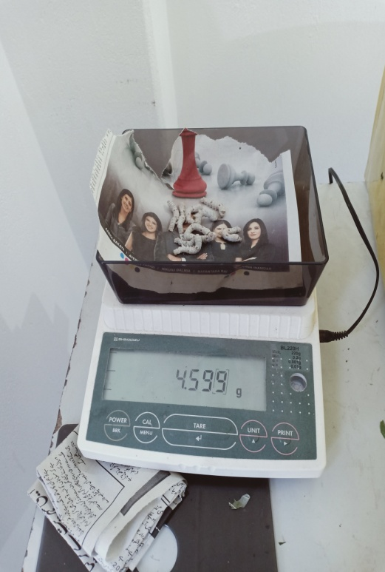

**Plate- 01: Measuring larval weight of single larva and 10 larvae of FC1xFC2 and FC2xFC1 (5th instar)**

1. **Larval Size:** The size of the larvae was measured in centimeter (cm) with the help of dividers and scale when the larva was in fully stretched state taking utmost care, not to disturb them. Similar to larval weight, the larval size was recorded to be significantly variable for different instars and different days.

**Table 4: Values of larval size recorded from 3rd instar (per day) in silkworm hybrid FC1 × FC2 and FC2 × FC1.**

|  |  |  |  |
| --- | --- | --- | --- |
| **3rdInstar** | **Days** | **FC1×FC2** | **FC2×FC1** |
| **Larval length (cm)** | **01** | 2.9±1.11b | 2.4±1.55 b |
| **02** | 3.1±1.16c | 2.6±1.97 bc** |
| **03** | 3.1±1.79c | 2.8±1.2 c |
| **-** | **-** | **-** |
| **Larval width (cm)** | **01** | 0.6±0.9b | 0.4±0.07 b |
| **02** | 0.7±0.77b | 0.6±0.8 c |
| **03** | 0.7±0.77b | 0.6±08 c |
| **-** | **-** | **-** |

# Table 5: Values of larval size recorded from 4th instar (per day) in silkworm hybrid FC1×FC2 and FC2×FC1.

|  |  |  |  |
| --- | --- | --- | --- |
| **4th Instar** | **Days** | **FC1×FC2** | **FC2×FC1** |
| **Larval length (cm)** | **01** | 3.0±2.11a | 2.8±1.4 a |
| **02** | 3.2±2.77a | 2.8±1.4 ab** |
| **03** | 3.3±2.77ab** | 3.1±1.7 b |
| **04** | 3.8±2.77b | 3.9±1.5 c |
| **05** | 4.8±2.87c | 4.2±2.11 c |
| **Larval width (cm)** | **01** | 0.4±0.55a | 0.2±0.08 a |
| **02** | 0.6±0.43ab** | 0.3±0.05 a |
| **03** | 0.8±0.76bc** | 0.3±0.04 a |
| **04** | 0.80.19c | 0.7±0.66 b |
| **05** | 1.20.22d | 1.0±0.45 c |

**Table 6: Values of larval size recorded from 5th instar (per day) in silkworm hybrid FC1 × FC2 and FC2×FC1.**

|  |  |  |  |
| --- | --- | --- | --- |
| **5th Instar** | **Days** | **FC1×FC2** | **FC2×FC1** |
| **Larval length (cm)** | **01** | 4.9±2.22a | 4.6±3.21 a |
| **02** | 5.6±2.22a | 4.8±3.22 a |
| **03** | 6.7±2.34b | 5.8±3.21 b |
| **04** | 6.9±2.13b | 6.4±3.46 c |
| **05** | 7.2±2.12c | 6.8±3.74 c |
| **06** | 7.9±2.98c | 7.3±3.75 d |
| **07** | 8.5±2.74c | 7.4±3.44 d |
| **Larval width(cm)** | **01** | 1.5±1.11a | 1.2 ±1.11 a |
| **02** | 1.9±1.44b | 1.8±1.43 b |
| **03** | 1.9±1.44b | 1.8±1.43 bc |
| **04** | 2.0±1.47bc** | 2.0±1.43 bc |
| **05** | 2.1±1.88bcd*** | 2.0±1.43 bc |
| **06** | 2.4±1.77cd** | 2.1±1.11 bc |
| **07** | 2.5±1.21d | 2.1±1.01 c |

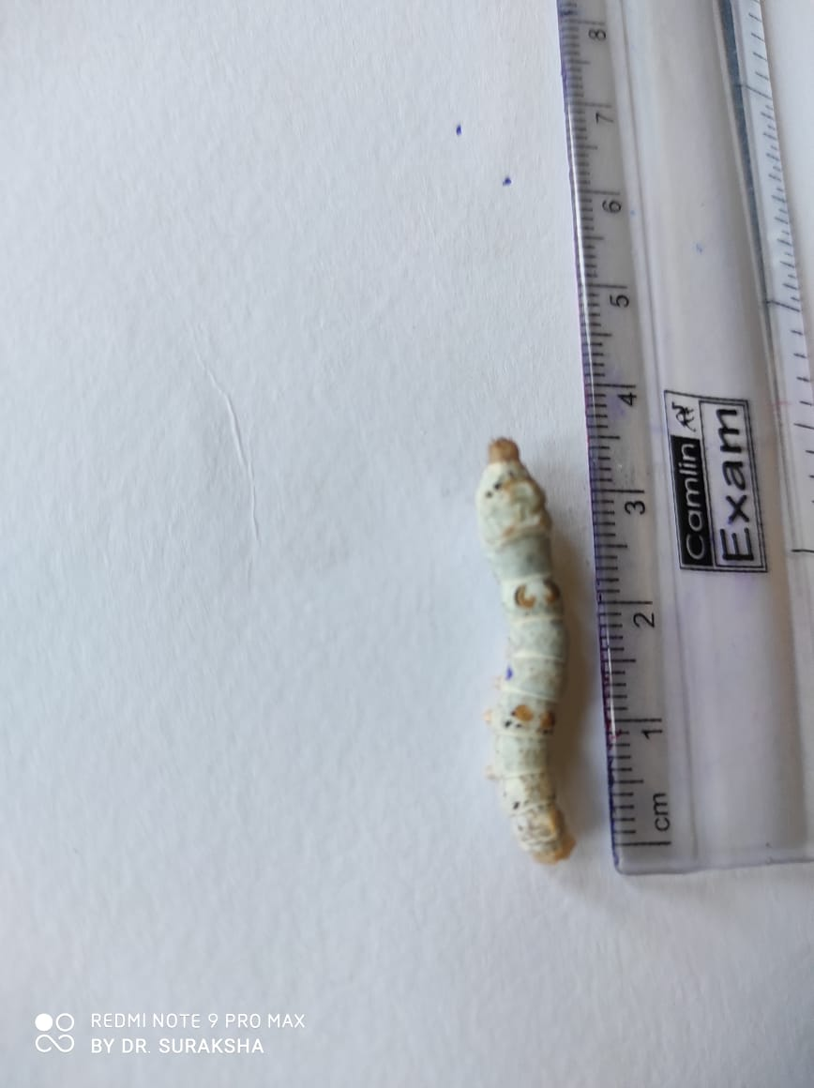 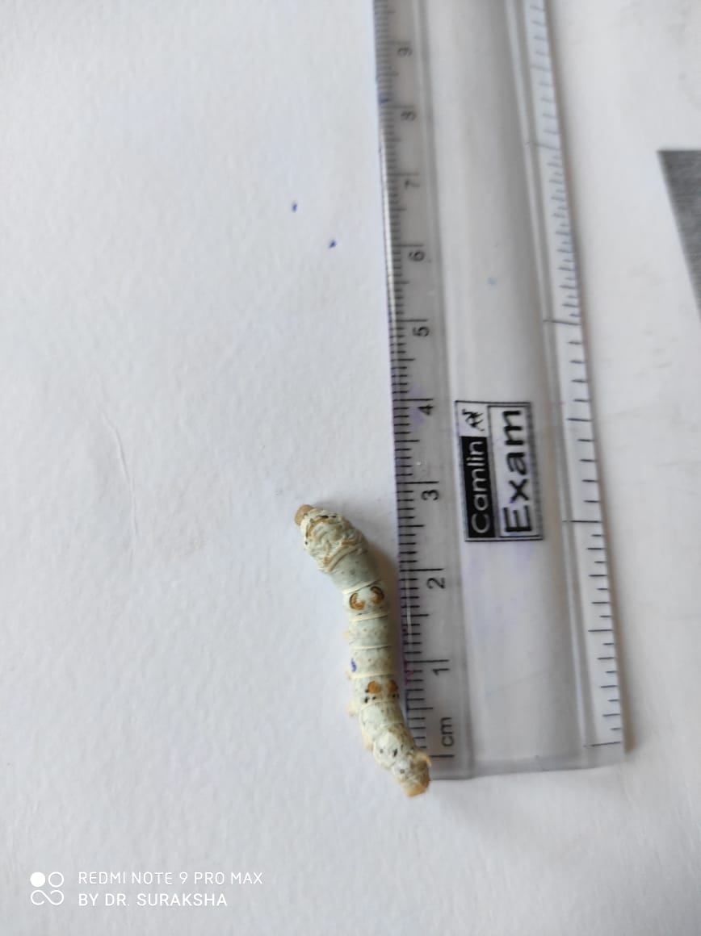

**Plate-2 Plate-3**

**Plate-2&3: Measuring larval length of silkworm (FC1xFC2 and FC2xFC1).**

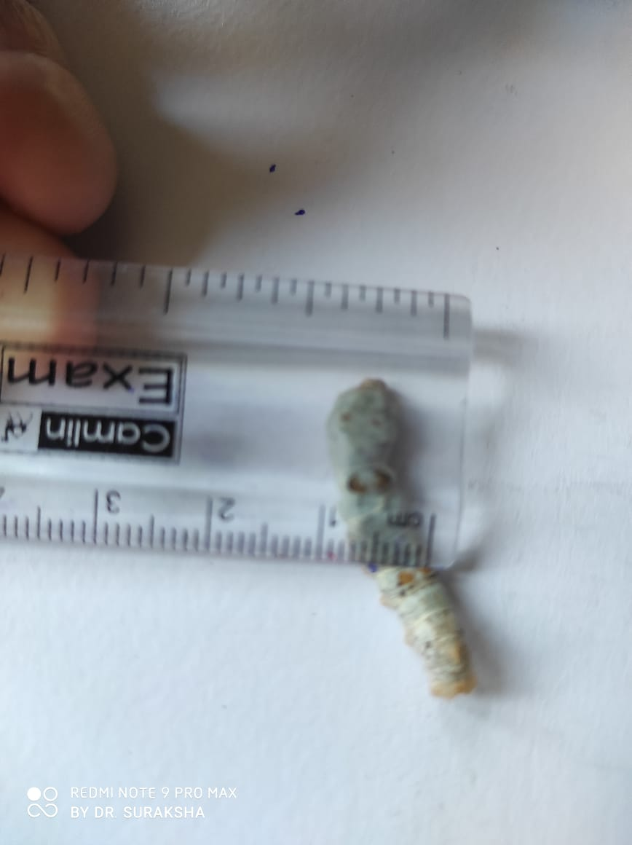

**Plate-4 Plate-.5**

**Plate-4& 5: Measuring larval width of silkworm (FC1xFC2 and FC2xFC1).**

**Some of the important morphological characters of cocoons recorded includes:**

1. **Green cocoon weight**

The cocoon harvested on 6th day of spinning (FC1 x FC2 and FC2 x FC1) were recorded to possess (1.46gm ,1.30 gm) of single and (14.61gm ,13.36 gm) for ten cocoons for green cocoon weight.

1. **Cocoon with floss**

The same cocoons harvested from FC1 x FC2 and FC2 x FC1 was determined to evaluate cocoon weight with floss and recorded to possess (1.38gm, 1.19gm) of single and (15.54gm, 13.32gm) for ten cocoons in case of FC1 x FC2 and FC2 x FC1respectively.

1. **Deflossed cocoon**

The cocoons observed on the 6th day of spinning (FC1 x FC2 and FC2 x FC1) were subjected to deflossing by manual deflossing method with help of woollen stick and the studied hybrids were recorded to possess (1.40gm, 1.08gm) of single cocoon and (14.98 gm, 10.81gm) of 10 cocoons in case of FC1 x FC2 and FC2 x FC1, respectively.

1. **Dry cocoon weight**

Dry weight of single cocoon was observed as (0.55gm, 0.44gm) and (5.94gm, 4.44gm) for 10 cocoons on the 6th day of spinning (FC1 x FC2 and FC2 x FC1).

1. **Shell weight**

Shell weight of the single cocoon and 10 cocoons was recorded as (0.78gm, 046gm) and (7.89gm, 4.63gm) on the 6th day spinning (FC1xFC2 and FC2xFC1), respectively.

1. **Pupal weight**

The cocoon harvested on 6th day of spinning (FC1xFC2 and FC2xFC1) were evaluated for determination of pupal weight and values depicting (1.55gm, 1.27 gm) of pupal weight for single cocoon and (15.92gm, 12.73gm) for ten cocoons, respectively.

1. **Cocoon shell ratio**

The cocoon shell ratio was calculated by the formula

= Weight of the cocoon shell/ Weight of cocoon X 100

And the results showed higher cocoon shell ratio for the hybrid FC1xFC2 as (53.42 per cent, 35.38 per cent) as to that of FC2xFC1 as (54.41 per cent, 36.41 per cent).

1. **Cocoon grains**

The cocoon harvested on 6th day of spinning (FC1x FC2 and FC2xFC1) were observed to possess as deep and coarse grains, depicting the comparatively good quality of cocoons.

1. **Cocoon compactness**

The same cocoons were observed as hard and compact in texture showing the superior quality of the cocoons on the basis of visual examination descriptor.

1. **Cocoon size**

For both the hybrids the cocoons were recorded to possess oval shaped cocoon with slight constriction at the centre as shown in the plate.

1. **Pupal percentage**

Pupal percentage were determined after stifling process and the studied hybrid were recorded to possess high pupal percentage with values as (100 per cent, 100 per cent) and (100 per cent, 90 per cent) for FC1xFC2 and FC2xFC1 respectively.

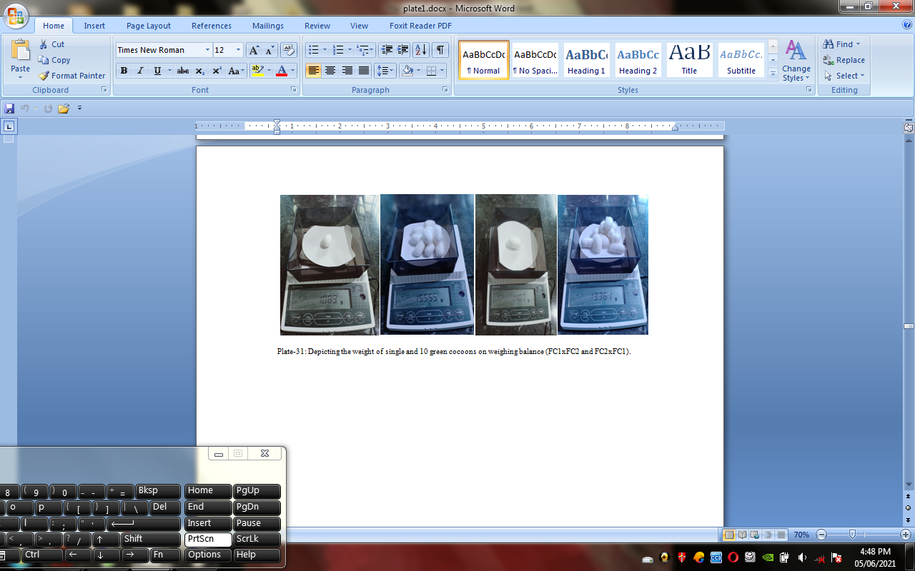

**Plate-06: Weight of single and 10 green cocoons on weighing balance (FC1xFC2 and FC2xFC1).**

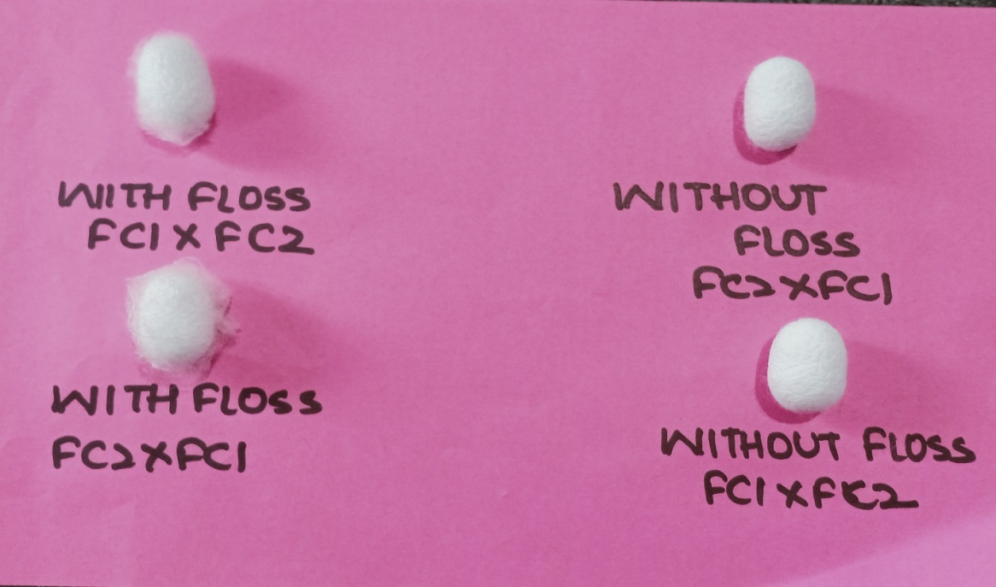

**Plate-07: Cocoon with floss and without floss-FC1xFC2 and FC2xFC1.**

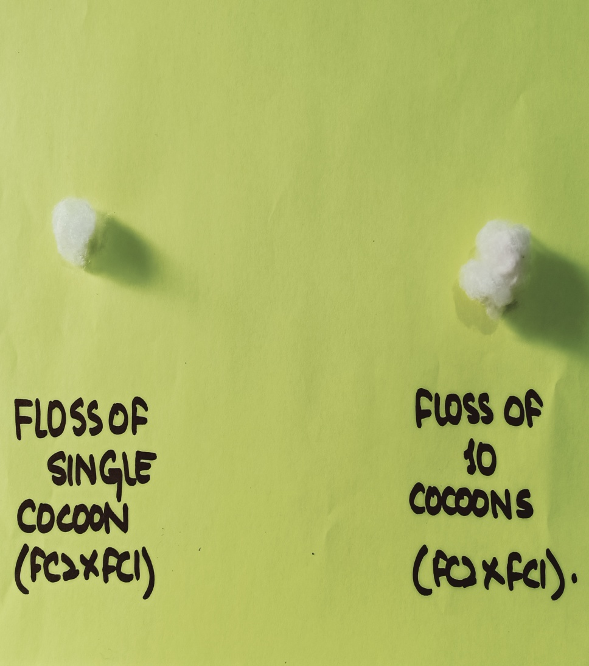

**Plate-08: Depicting the floss of single and 10 cocoons of FC2xFC1.**

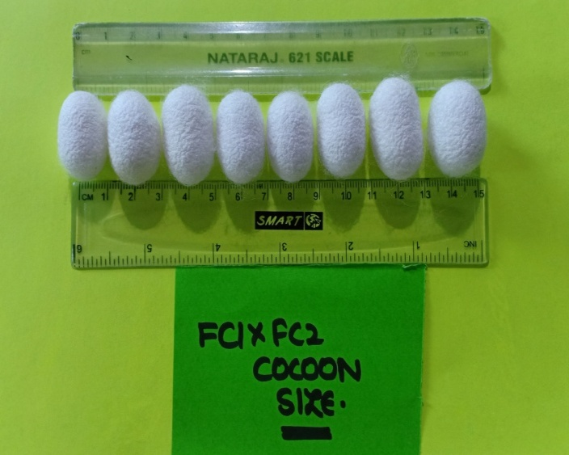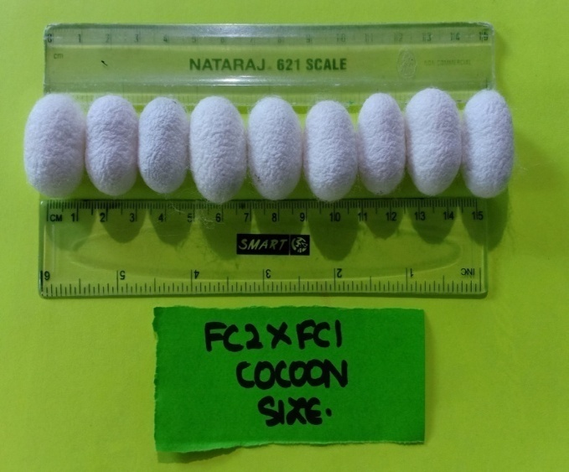

**Plate-09: Measurement of Cocoon Size for Selection of Equal cocoons.**

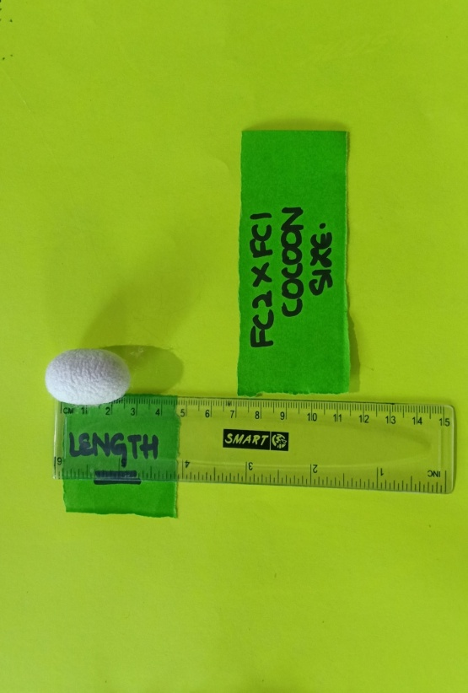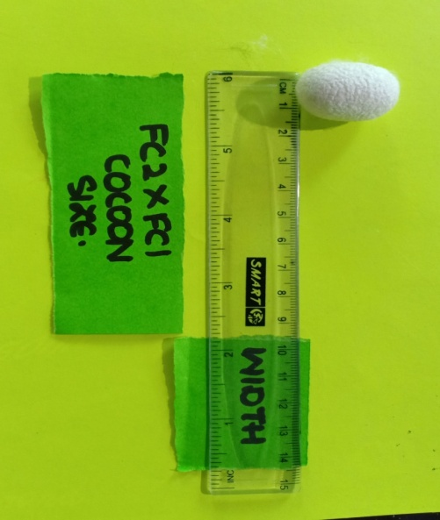

**Plate-10: Measurement of Cocoon size (length and width).**

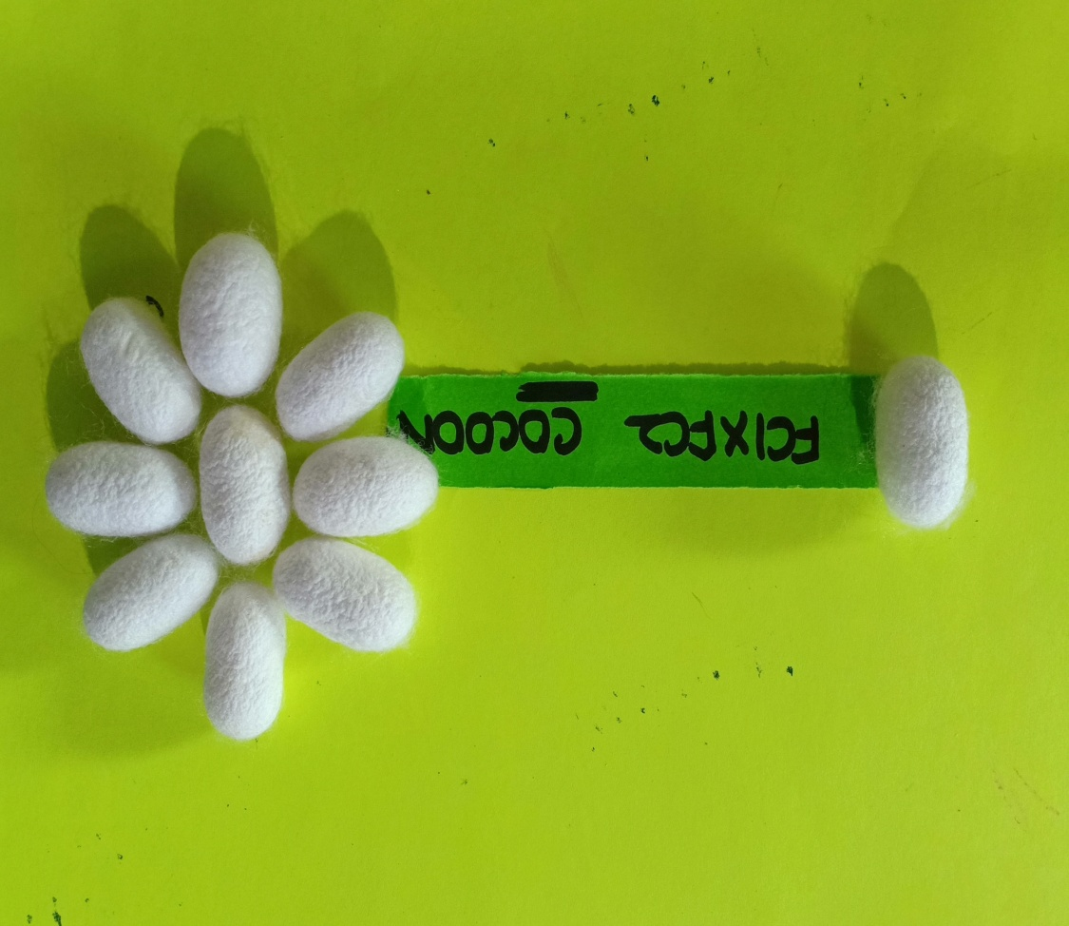

**Plate-11: Cocoons of FC1xFC2.**

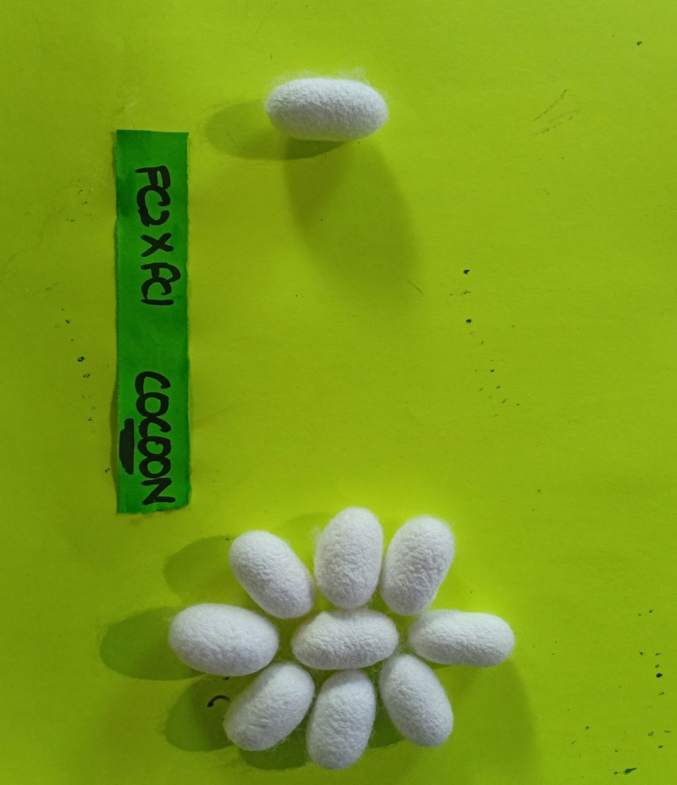

**Plate-12: Cocoons of FC2xFC1.**

**CONCLUSION**

In the present study it was observed that the FC1×FC2 silkworm race was better than other races in aspects of larval, cocoon and post cocoon parameters. This is because FC1×FC2is a bivoltine double hybrid race which exhibit vigor, resulting in higher silk production, better disease resistance, seed crop performance and higher seed recovery and has better crop stability as a result of genetic diversity inherited from both parent races i.e. FC1 and FC2. So, this work would be of great help to farmers in term of crop yield, management and commercial purpose.

**REFERENCES**

Absar, G.K. and Kale, R. D. 2015. Studies on Micronutrient effect on mulberry varieties. *Indian Journal of Sericulture.* 4(**24**): 1317- 1320- these authors are not cited in the text!

Bari, G. J., Horie, Y. and Nakasone, S. 2019. Effect of dietary biotin on fatty acid composition of the silkworm, *Bombyx mori* L. *Journal of Insect Physiology*. 3(**14**): 1381 – 1387. - these authors are not cited in the text!

Chakraborty, A., Sarkar, K., Majumdar, M. and Kumar, V. 2020. Studies on Performance Of Bivoltine Hybrids SK6 X SK7 And Its Reciprocal Crosses During April Crop In West Bengal. *International Journal of Advanced Research in Biological science.* 7(**6**): 134-140. - these authors are not cited in the text!

Das, B.K., Nanavaty, M. And Vijayan, K. 2011. Estimation of leaf yield in mulberry. *Biochemical Journal*.4 (**6**): 7-12. - these authors are not cited in the text!

Gatin, S. G., Horie, Y. and Ito, T. 1965. Nutrition of the silkworm, Bombyx mori. Mineral requirements and the effects of several analogues. *Journal of Insect Physiology.* 2(**11**): 1585-1593. - these authors are not cited in the text!

Kumar, W. G., Hirayama, C., Konno, K. and Shinbo, H. 2020. Utilization of ammonia as a nitrogen source in silkworm, *Bombyx mori L*. *Journal of Insect Physiology*. 42(**10**): 983-988. - these authors are not cited in the text!

Kumari, Nitu. ~~A~~and Roy, S.P. 2011. Some aspects of the identification of nutritionally efficient silkworms (Insecta: Lepidoptera: Bombycoidea), their metabolic rate and sustainable development as energy resources. *Journal of Insect Science.* 6(**3**): 475-481. - these authors are not cited in the text!

Kunhamed, Ramathullavk., Mathur, V.B.and Geetha, R. G. 2013. Growth and dietary efficiency of mulberry silkworm (Bombyx mori) under various nutritional and environmental conditions*. Phillpine Journal of Science*. 133(**1**): 0031-7683. - these authors are not cited in the text!

Kurniasansyah, S. I. and Hamamura, Y. 2020. Food Selection by silkworm larvae. *Indian Journal of Sericulture*. 7(**183**): 1746-1747. - these authors are not cited in the text!

Kurutulmus, D., Gabriel, B.P. and Rapusas, H. R. 2021. The growth and development of *Bombyx mori (L.)* at different leaf maturity and variety of mulberry. *The Philippine Agriculturist*. 3(**60**): 139-146. - these authors are not cited in the text!

Kushwaha, A., Konala N., Abburi, P., Bovilia, V.R. and Mamillapalli, A. 2011. Studies on Bolu Palu silkworm using local varieties mulberry. *Journal of Insect Science.* 4(**13**): 98. - these authors are not cited in the text!

Lakshminarasimhaiah, E. K., Bose, P. C., Mahumder, S. K. and Sengupta, K. 2015.variation for the mulberry varieties attributed to genotypic constitution of the accessions. *Indian Journal of Sericulture*. 4(**28**): 17-31. - these authors are not cited in the text!

Murthy, Y. N. V. 2015. Studies on the effect of different mulberry varieties and seasons on the larval development and cocoon characters of silkworm, *Bombyx mori* (L.). *Indian Journal of Sericulture*. 5(**29**): 44-53. - this author is not cited in the text!

Wyatt, H. 2013. Carbohydrate reserves. *Journal of Entomology.* 6(**22**):01-03*.* - this author is not cited in the text!

Yamashita, G.M. and Majumdar, A. C.2013. Note on the physiological effects on the growth and reproduction of silkworm fed on mulberry leaves. *Journal of Agricultural Science,* 6(**52**): 250-252. - these authors are not cited in the text!

Yokoyama, W. 2016. Morphological parameters posses significant impact on leaf quality and Matric trait. . *Indian Journal of Sericulture.* 5(**44**): 231-233. - this author is not cited in the text!

Yu, S. J. and Fraisse, R. 2021. The correlation between the mulberry leaves taken by the silkworm, the silk protein in the silk gland and the silk filament. *Indian Journal of Sericulture*. 1(**15)**: 595-610. - these authors are not cited in the text!

Yu, Y., Basaiah, J.M.M., Reddy, D.N.R. and Krishnamurthy, R.V. 2018. Consumption and utilization of food by eri silkworm *Samia cynthia ricini*. *Indian Journal of Sericulture*. 1(**15**): 95-98. - these authors are not cited in the text!

Zhou, L. and Chawla. P.S. 2015. Silkworm nutrition. *Indian Journal of Applied Research*. 2(**21**): 1-13. - these authors are not cited in the text!