Floristic Survey of Vascular Plants in Bandis region in Al- Jabal Al- Akhdar, Libya.

.

ABSTRACT

|  |
| --- |
| The floristic composition of the vegetation in the Bandis region was studied., which is within the Al- Jabal Al- Akhdar in Libya. This is the first study to document plant species in that region. The research methodology relied on field surveys through repeated trips to the study area from December 2024 to May 2025. These trips resulted in recording 151 species, 125 genera, 46 families, they are represented by Gymnosperms 3 species Two families, while the remaining 44 families belong to Angiosperms, Dicotyledons 38 families 118 species and Monocotyledons 6 families 30 species and 10 endemic species, where the most dominant families are the Fabaceae family (16%), the Asteraceae family (15%), and the Poaceae family (12%). The most dominant life forms were Therophytes (62%), followed by the Chamaephytes (15%), then Geophytes (13%). |

*Keywords: Bandis, Libya, Floristic, Survey, Al- Jabal Al- Akhdar.*

1. INTRODUCTION

Floristic surveys assess the qualitative composition of plants in a given area and do not give much importance to assessing their quantitative composition. (Taft et al.,1997) but, Floristic surveys are considered the first and necessary step to understand the status of plant biodiversity and its extent and to evaluate it. It is also considered a systematic process to record and document the plant in a specific geographical area, as it is considered the basic foundation because the results of these surveys can be used in many environmental studies. (WCMC, 1992). For more than a century, surveys have become essential in various regions and countries around the world, because such surveys also aid in the conservation of plant resources, the exploration of endemic species, the identification and conservation of endangered plant species, and the assessment, monitoring, and mitigation of the detrimental effects of climate change on plant species. (Ostertag et al., 2014).

Compared to the vast area of Libya, Al- Jabal Al- Akhdar area constitutes only 1%, yet it has a rich biology and unique and diverse flora (Alzerbi & Alaib, 2017). This is due to its topography, which was completely different from most other Libyan regions. These complex topographical factors contribute to the different in climate and thus in soil formations, which reflects the biological diversity of its vegetation in a distinctive way (Noah, 2014). However, due to its difficult terrain, the floral composition of many of its regions has not been completely discovered (Mohammed et al., 2022).

Therefore, conducting adequate botanical surveys in unexplored or partially floristically explored areas and compiling updated species lists is crucial for understanding the composition, structure, and status of plant resources in these areas, protecting them, and conserving biodiversity. There are many areas of the world for which we have little, if any, information. We have not yet completed a baseline survey of their biodiversity. (Funk et al., 2005). Vegetation in mountainous areas is particularly important due to the high biodiversity and relative density of vegetation (Al-Aklabi et al., 2016), and in order to maintain biodiversity in these ecosystems, floral composition studies and vegetation analysis have become increasingly important to provide Data are important for understanding biodiversity and ecosystem functioning in these areas (Heywood, 2004).

Given that the Bandis is one of the regions of Al- Jabal Al- Akhdar area, and is characterized by a rich and diverse vegetation, but basic vegetation information about plants in this region is not available, due to the lack of any previous study on its vegetation. In contrast, most of the prevailing natural and human threats are present, as there is a clear exploited of forests by agricultural activities. Therefore, conducting a vegetation survey throughout this region is very important. To know the current composition and diversity of species and provide valuable baseline data required for the conservation of existing, endemic and endangered species, Thus, we can later evaluate and monitor the effects of human activities on plants and ecosystems analysis in this region. This survey was conducted to create a comprehensive list of all vascular plant species present in the area and to provide basic taxonomic data on these species based on a comprehensive floral inventory for the winter and spring seasons, examination of specimens, their classification and preservation in the herbarium, Therefore, the main objective of this research is to contribute to bridging these gaps.

2. material and methods

**2.1 The study area**

**2.1.1 Location description**

The study area is located on the Mediterranean Coast in the Northeast of Libya about 12Km Southwest of the city of Al-Bayda, between Latitude 32°69´67.60" N and longitude 21°68´88.12" E, it is found on the second terrace of Al-Jabal Al-Akhdar (Figure.1).

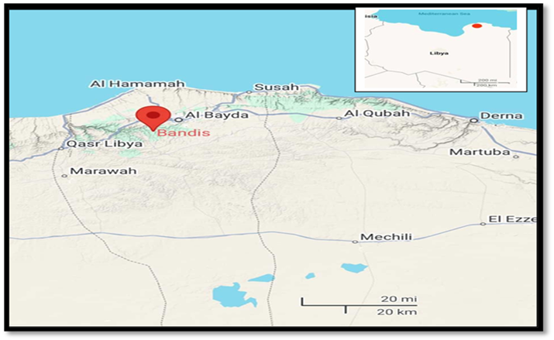

**Fig. 1. Location of the study arae (by Google earth).**

**2.1.2 Climate**

The study of climate is considered one of the basic factors for studying vegetation. Libya’s climate combines between the Mediterranean coast and the Sahara Desert, in terms of temperature and particularly precipitation (FAO,1969 & 1980). Al-Jabal Al-Akhdar area is dominated by the distinctive characteristics of the Mediterranean climate. The precipitation is concentrated in the winter, while the summer is dry and hot (Noah, 2014). Bandis is one of Al-Jabal Al-Akhdar area, enjoying characteristics to the Mediterranean coast climate.

**2.2 Field study**

**2.2.1 Specimen collection and drying stage**

This was done in four steps, the first step involved collecting the sample from the field after photographing it, taking into account that the sample was free of any infection. Also, some data was recorded for each sample, such as the date of collection and its life form, as for the method of collection, for the Specimen of annual plants, the entire plant was collected. As for the Specimen of trees and shrubs, it was represented by taking only a branch, with the necessity of having flowers or fruits on the branch, then the Specimen enters the second step, which is the drying stage, where the plant sample is placed on the newspaper in a way that represents the same shape found in the wild., after placing the plant samples on the drying paper, they are placed in the herbarium press and pressed, and placed in a well-ventilated place. The drying paper is changed until all the fluids inside the tissues of the samples are completely removed. After that, we reach the third step, in which the dried plant samples are glued to the herbarium sheet using white glue, taking care not to cover the herbarium logo with the sample. The sample’s information is written in the table on the lower right side of the herbarium sheet. The last step is to place the plant samples in the refrigerator at a temperature of -20ºC degrees Celsius for the week to kill insects. (Simpson, 2019).

**2.2.2 Plant identification stage**

The plant species were identified in the Sylphium herbarium Department of Botany, Faculty of Science, Omar Al-Mukhtar University, using dissection tools, a dissecting microscope, and the Libyan Flora Encyclopedia (Flora of Libya). (Ali & Jafri, 1976- 1977; Jafri & El-Gadi, 1977–1993; El-Gadi & El-Taife, 1989). Plants were classified into life forms according to (Raunkiaer, 1934). This system of plant classification provides an understanding of the diversity of life forms within the plant kingdom by classifying them according to their adaptation to environmental conditions.

3. results

**3.1 Survey of species in the study area**

The total number of recorded specimens surveyed in the present study was 151 species, belong to 125 genera and 46 families, they are represented by Gymnosperms 3 species 2 families, while the remaining 44 families belong to Angiosperms, Dicotyledons 38 families 118 species and Monocotyledons 6 families 30 species.

**3.2 Floristic composition**

The most dominant family in terms of number of species was the family Fabaceae (16%) with 24 species, such as *Anthyllis tetraphylla* L.*, Astragalus epiglottis* L., *Calicotome villosa* (poir)Link., *Lathyrus aphaca* L. *Trifolium campestre* Schreb. *Vicia hybrida* L., followed by the family Asteraceae (15%) were represented by 22 species, From these species, *Evax contracta* Boiss., *Leontodon tuberosus* L. *Rhagadiolus stellatus* (L.) Gaertner, Fruct. *Sonchus tenerrimus* L. and Poaceae (12%) were represented by 18 species, From these species, *Bromus alopecuros* Poir., *Lolium loliaceum* (Bory & Chaub) Hand.Mazz., *Melica minuta* L., *Trisetaria macrochaeta* (Boiss.) Maire., the family Apiaceae (6%) containing 9 species, such as *Bifora testiculata* (L.) DC., *Lagoecia cuminoides* L*.*, *Torilis nodosa* (L.) Gaertn., *Pimpinella peregrina* L., Lamiaceae (5%) 8 species that were *Micromeria graeca (*L.) Benth ex Reichenb., *Prasium majus* L., *Sideritis montana* L., *Phlomis floccosa* D., the family Brassicaceae (4%) containing 6 species and represented by *Erophila verna* (L.)Besser., *Rapistrum rugosum* (L.) All*.*, *Eruca sativa Mill.,* the Liliaceae family was also represented by the same number of species 6 and thus gave the same proportion of (4%) and including *Asparagus aphyllus* L., *Bellevalia cyrenaica* Maire & Weiller., *Asphodelus microcarpus* Salzm.& Viv*.*, *,* the family Ranunculaceae (3%) containing 4 species and represented by *Nigella damascena* L., *Ranunculus asiaticus* L. There were families of 3 species including Cistaceae, Euphorbiaceae and Polygonaceae, there were families containing 2 species represented by Cupressaceae, Urticaceae, Crassulaceae, Geraniaceae, Primulaceae, Rubiaceae, Scrophulariaceae, Valerianaceae, Iridaceae and Araceae, other families represented by 1 species including Pinaceae, Illecebraceae, Clusiaceae, Fumariaceae, Papaveraceae, Rosaceae, Caesalpiniaceae, Oxalidaceae, Linaceae, Polygalaceae, Anacardiaceae, Rhamnaceae, Malvaceae, Violaceae, Myrtaceae, Ericaceae, Oleaceae, Boraginaceae, Plantaginaceae, Globulariaceae, Caprifoliaceae, Dipsacaceae, Campanulaceae, Alliaceae and Orchidaceae. (Figure. 2) and (Table 1). At the level of genera, the genus *Trifolium* *sp* from the Fabaceae family has the largest number of species, with five species recorded, which are: *Trifolium campestre* Schreb., *T. cherleri* L., *T. stellatum* L., *T. tomentosum* L., *T.purpureum*Lois.

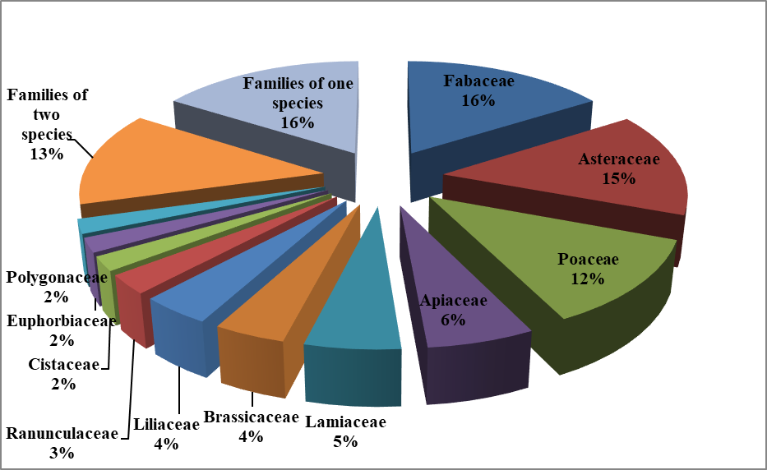

**Fig. 2. Percentage of species recorded in each family**

**3.3 Life** **forms**

(Figure. 3) shows the life forms of 151 recorded species according to Raunkiaer's Life Form Classification, the recorded species belong to five different life forms, Therophytes (62%) includes 94 species, and were represented by the largest number of species, of these were *Bifora testiculata* (L.) DC., *Lagoecia cuminoides* L., *Anthemis stiparum* Pomel., *Carlina lanata* L., *Catananche lutea* L., *Pallenis spinosa* (L.) Cass., *Scabiosa arenaria* Forskal., *Euphorbia falcata* L., and *Geranium molle* L*,.* followed by Chamaephytes has 23 species representing about (15%), among these species were *Globularia alypum* L., *Micromeria graeca (*L.) Benth ex Reichenb., *Satureja thymbra* L., *Stachys tournefortii* Poiret., and *Polygala aschersoniana* Chodat., Geophytes represents about (13%), includes 19 species representing these species were, *Bellevalia cyrenaica* Maire & Weiller., *Gagea reticulate* (Pall.) Schult., *Ornithogalum umbellatum* L., *Ophrys holosericea* (Burm. f.) W., and *Cyclamen rohlfsianum* Aschers., also Phanerophyes (7%) includes 11 species, from these species are *Ceratonia siliqua* L., *Viburnum tinus* L*.*, and *Juniperus phoenlcea* L., and finally come Hemicryptophytes (3%) include 4 species, from these species are *Bellis sylvestris* Cyr.var*. cyrenaica* Beg., and *Melica minuta* L.

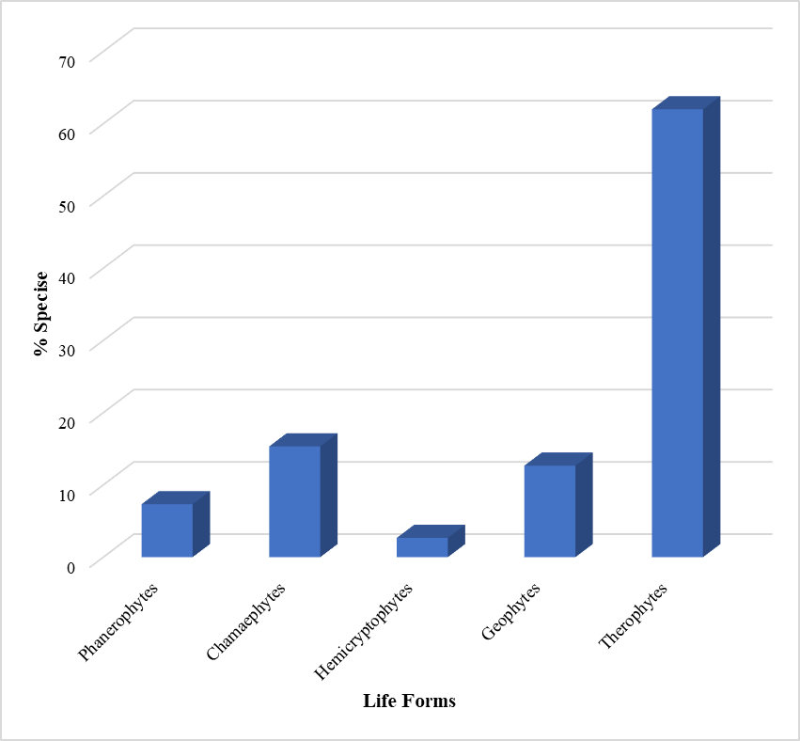

**Fig. 3. Life forms of the recorded species**

**Table 1. List of plant species in the study area**

|  |  |  |  |  |
| --- | --- | --- | --- | --- |
| Local name | Life Forms | Scientific name | Family | No |
| Baattoom | Ph | *Pistacia lentiscus* L. | Anacardiaceae |  |
| Ghazul | G | *Allium roseum* L*.* | Alliaceae |  |
| - | Th | *Bifora testiculata* (L.) DC. | Apiaceae |  |
| - | Th | *Bupleurum lancifolium* Hornem. |  |
| - | Th | *B. trichopodum* Boiss. |  |
| - | Th | *Lagoecia cuminoides* L*.* |  |
| Deryas | Ch | *Thapsia garganica* L. |  |
| - | Th | *Torilis nodosa* (L.) Gaertn. |  |
| Teludi | Ch | *Malabaila suaveolens* (Delile)Coss*.* |  |
| - | Th | *Pimpinella peregrina* L. |  |
| - | Th | *Scandix pecten-veneris* L. |  |
| Weden Essaloqi | G | *Arisarum vulgare* Targ. Tozz. | Araceae |  |
| Wednish, Gedri | G | *Arum cyrenaicum* Hruby. |  |
| - | Th | *Anthemis stiparum* Pomel *.* | Asteraceae |  |
| - | Th | *Atractylis cancellate* L. |  |
| Ain alenaga | H | *Bellis sylvestris* Cyr.var*. cyrenaica* Beg. |  |
| - | Th | *Carduus pycnocephalus* L*.* |  |
| - | Th | *Carlina lanata* L. |  |
| Dhab el kheil | Th | *Catananche lutea* L. |  |
| Akash | Ch | *Centaurea pumilio* L. |  |
| - | Th | *Crepis senecioides* Delile var*. filiformis* (Viv.) Alavi |  |
| - | Th | *Echinops cyrenaicus Durand &Barratte.* |  |
| - | Th | *Evax contracta* Boiss. |  |
| Morrare | Th | *Hedypnois cretica* (L.) Dum. |  |
| Esushbat al Arnab | Th | *Helichrysum stoechas* (L.) Moench. |  |
| Morrare | Th | *Hyoseris scabra* L. |  |
| - | Ch | *Hypochoeris achyrophorus* L. |  |
| - | Ch | *H. glabra* L*.* |  |
| Murrare | G | *Leontodon tuberosus* L. |  |
| - | Th | *Notobasis syriaca* (L.) Cass. |  |
| Libid | Th | *Onopordum arenarium* (Desf.) Pomel |  |
| Shawgreh, Schok-es-sera | Ch | *Pallenis spinosa* (L.) Cass. |  |
| Esushbat al Arnab | Ch | *Phagnalon rupestre* (L.) DC. |  |
| Njm eddib | Th | *Rhagadiolus stellatus* (L.) Gaertner, Fruct. |  |
| Tefaf | Th | *Sonchus tenerrimus* L*.* |  |
| - | Ch | *Echium humile* Desf. | Boraginaceae |  |
| - | Th | *Biscutella didyma* L. | Brassicaceae |  |
| - | Th | *Enarthrocarpus clavatus* Del ex Godr. |  |
|  |
| - | Th | *Erophila verna* (L.) Besser |
| - | Th | *Eruca sativa* Mill. |  |
| Khardal, Barri | Th | *Rapistrum rugosum* (L.) All*.* |  |
| Khardal | Th | *Sinapis alba* L. |  |
| Kharob | Ph | *Ceratonia siliqua* L. | Caesalpiniaceae |  |
| - | Th | *Campanula erinus* L*.* | Campanulaceae |  |
| - | Ph | *Viburnum tinus* L*.* | Caprifoliaceae |  |
| Torrashe abiad | Ch | *Cistus salvifolius* L. | Cistaceae |  |
| Torrase | Ch | *C.parviflorus* Lam. |  |
| - | Th | *Helianthemum salicifolium* (L.) Miller, Gard*.* |  |
| - | Ch | *Hypericum* empetrifolium Willd. | Clusiaceae |  |
| - | Th | *Sedum caespitosum* (Cav.) DC | Crassulaceae |  |
| - | G | *Umbilicus horizontalis*(Guss.) DC. |  |
| Al-sarow | Ph | *Cupressus sempervirens.*  var.*horizontalis* (Mill.) Gordon | Cupressaceae |  |
| *C. sempervirens* L.  var. *Sempervirens* |
| Araar | Ph | *Juniperus phoenlcea* L. |  |
| - | Th | *Scabiosa arenaria* Forskal. | Dipsacaceae |  |
| Lebbena | Th | *Euphorbia falcata* L. | Euphorbiaceae |  |
| - | Th | *E. peplus* L. |  |
| Mregla | Th | *Mercurialis annua* L |  |
| Eshmeri | Ph | *Arbutus pavarii* Pamp. | Ericaceae |  |
| Shacwet Erraie | Th | Anthyllis tetraphylla L. | Fabaceae |  |
| - | Th | *Astragalus epiglottis* L. |  |
| Ganndole | Ph | *Calicotome villosa* (poir)Link. |  |
| - | Th | *Coronilla scorpioides* (L.) Koch, Syn. |  |
| - | Th | *Hippocrepis unisiliquosa* L. |  |
| - | Th | *Lathyrus aphaca* L*.* |  |
| *-* | Th | *L.cicera* L*.* |  |
| - | Th | *Lotus edulis* L*.* |  |
| - | Th | *L. ornithopodioides* L*.* |  |
| Aouinet el hanesh | Th | *Medicago laciniata* (L.) Mill. |  |
| Nefal | Th | *M. minima* (L.) Bart*.* |  |
| Nefal | Th | *M. orbicularis* (L.) Bartal, Cat*.* |  |
| Nefal | Th | *M. polymorpha* L. |  |
| - | Th | *Onobrychis crista-galli* (L)Lam. |  |
| - | Th | *Ononis reclinate* L*.* |  |
| - | Th | *O. viscosa* L. |  |
| Grambosh | Th | *Tetragonolobus purpureas* Moench. |  |
| - | Th | *Trifolium campestre* Schreb. |  |
| - | Th | *T. cherleri* L. |  |
| - | Th | *T. stellatum* L. |  |
| - | Th | *T. tomentosum* L. |  |
| - | Th | *T. purpureum* Lois. |  |
| - | Th | *Vicia hybrida* L. |  |
| Jilban | Th | *V. sativa* L. |  |
| - | Th | *Fumaria capreolata* L. | Fumariaceae |  |
| - | Th | *Erodium keithii* Guitt.et Le Houerou | Geraniaceae |  |
| - | Th | *Geranium molle* L*.* |  |
| Zraiga | Ch | *Globularia alypum* L. | Globulariaceae |  |
| Gafet al abed | Th | *Paronychia arabica* (L.) DC. | Illecebraceae |  |
| - | G | *Iris sisyrinchium* L*.* | Iridaceae |  |
| Al garshod | G | *Romulea cyrenaica* Beguinot. |  |
| - | G | *Marrubium vulgare* L. | Lamiaceae |  |
| - | Ch | *Micromeria graeca* (L.) Benth ex Reichenb. |  |
| - | Ch | *M. nervosa* (Desf.) Benth. |  |
| Ezhera | Ch | *Phlomis floccosa* D*.* |  |
| - | Ch | *Prasium majus* L. |  |
| Zaatar | Ch | *Satureja thymbra* L*.* |  |
| - | Th | *Sideritis montana* L. |  |
| - | Ch | *Stachys tournefortii* Poiret. |  |
| - | G | *Asparagus aphyllus* L. | Liliaceae |  |
| - | G | *Bellevalia cyrenaica* Maire & Weiller |  |
| - | G | *Gagea reticulate* (Pall.) Schult. |  |
| - | G | *Ornithogalum umbellatum* L. |  |
| Ansel | G | *Urginea maritim*a (L.) Baker |  |
| - | G | *Asphodelus microcarpus* Salzm & Viv*.* |  |
| - | Th | *Linum strictum* var *spicatum* Pers. | Linaceae |  |
| Khobbze | Th | *Malva nicaeensis* All. | Malvaceae |  |
| Kaphor | Ph | *Eucalyptus*  *gomphocephala* DC. | Myrtaceae |  |
| Zaitoon | Ph | *Olea europaea* L*.* | Oleaceae |  |
| - | G | *Ophrys holosericea* (Burm. f.) W. Greuter | Orchidaceae |  |
| Hommeida | G | *Oxalis pes-caprae* L. | Oxalidaceae |  |
| Garum, Bugraum | Th | *Papaver rhoeas* L*.* | Papaveraceae |  |
| Senouber | Ph | *Pinus halepensis* Mill. | Pinaceae |  |
| Degghis | Th | *Plantago cyrenaica* Durand &Barratte | Plantaginaceae |  |
| - | Ch | *Polygala aschersoniana* Chodat. | Polygalaceae |  |
| Gurdab | Th | *Polygonum aviculare* L. | Polygonaceae |  |
| Hommadet | Th | *Rumex bucephalophorus* L*.* |  |
| Hommadet | Th | *R. pulcher* L. |  |
| Ain Algatuus | Th | *Anagallis arvensis* L*.* | Primulaceae |  |
| Rakaf | G | *Cyclamen rohlfsianum* Aschers. |  |
| - | Th | *Aegilops geniculata* Roth*.* | Poaceae |  |
| - | Th | *A. ventricosa* Tausch. |  |
| Spulet el agreb | Th | *Avena sterillis* L. |  |
| - | Th | *Briza maxima* L. |  |
| - | Th | *Bromus alopecuros* Poir. |  |
| Bo-shrenta | Th | *B. rubens* L. |  |
| Zewan | Th | *Hordeum murinum* L. |  |
| Bomanjor | Th | *Lolium loliaceum* (Bory & Chaub) Hand.Mazz*.* |  |
| - | Th | *L. multiflorum* Lam. |  |
| - | Th | *Lophochloa cristata* (L.) Hyl. | 1. . |
| - | Th | *L. pubescens* (Lam.) H*.* |  |
| Zewan | Th | *L. pumila* (Desf.) Bor. |  |
|  | H | *Melica minuta* L*.* |  |
| - | H | *Piptatherum miliaceum* (L.) Cosson |  |
| - | Th | *Poa annua* L. |  |
| - | G | *p. bulbosa* L. |  |
| - | Th | *Trachynia distachya* (L.) Link, Hort. |  |
| - | Th | *Trisetaria macrochaeta* (Boiss.) Maire |  |
| Ashbet el Arneb | H | *Parietaria judaica* L. | Urticaceae |  |
| Horeg | Th | *Urtica pilulifera* L. |  |
| - | Th | *Nigella damascena* L. | Ranunculaceae |  |
| - | G | *Ranunculus asiaticus* L. |  |
| Gmeha | Ch | *R. bullatus var. cyrenaicus* (Pamp.) Maire*.* |  |
| - | Th | *R. trilobus* Desf. |  |
| Salof | Ph | *Rhamnus lycioides* L. | Rhamnaceae |  |
| Shapreg | Ch | *Sarcopoterium spinosum* (L.) Spach. | Rosaceae |  |
| - | Th | *Galium aparine* L. | Rubiaceae |  |
| *-* | Th | *Sherardia arvensis* L. |  |
| - | Ch | *Scrophularia canina* L. | Scrophulariaceae |  |
| - | Th | *Misopates orontium* (L.) Rafin. |  |
| - | Th | *Fedia cornucopiae* (L). Gaertner | Valerianaceae |  |
| - | Th | *Valerianella muricata* (Steven) J.W. |  |
| Sidh | Ch | *Viola scorpiuroides* Coss. | Violaceae |  |

*\*(Phanerophytes = Ph, Chamaephytes = Ch, Geophyte s= G, Hemicryptophytes = H, Therophytes = Th).*

**3.4 Endemic species**

The results show the presence of 9 endemic species, which is estimated at 5.96% of the total number of recorded species, and the Asteraceae family obtained the largest number of endemic species, (Table 2).

**Table 2. List of the endemic species**

|  |  |  |
| --- | --- | --- |
| **Scientific name** | **Family** | **No.** |
| *Arum cyrenaicum* Hruby. | Araceae |  |
| *Bellis sylvestris* Cyr.var*. cyrenaica* Beg. | Asteraceae |  |
| *Crepis senecioides* Delile var*. filiformis* (Viv.) Alavi |  |  |
| *Echinops cyrenaicus* Durand & Barratte. |  |  |
| *Erodium keithii* Guitt.et Le Houerou | Geraniaceae |  |
| *Romulea cyrenaica* Beguinot. | Iridaceae |  |
| *Plantago cyrenaica* Durand &Barratte | Plantaginaceae |  |
| *Polygala aschersoniana* Chodat. | Polygalaceae |  |
| *Cyclamen rohlfsianum* Aschers. | Primulaceae |  |

As for the near-endemic species that are found in the borders of North Africa and the Mediterranean region, their number was about 9, which is equivalent to 5.96% of the total number of species, The Asteraceae family also had the largest number of the near-endemic species, (Table 3).

**Table 3 List of the near-endemic species**

|  |  |  |
| --- | --- | --- |
| **Scientific name** | **Family** | **No.** |
| *Atractylis cancellate* L. | Asteraceae |  |
| *Onopordum arenarium* (Desf.) Pomel |  |  |
| *Ceratonia siliqua* L. | Caesalpiniaceae |  |
| *Cupressus sempervirens* L. | Cupressaceae |  |
| *Arbutus pavarii* Pamp. | Ericaceae |  |
| *Globularia alypum* L*.* | Globulariaceae |  |
| *Satureja thymbra* L*.* | Lamiaceae |  |
| *Ranunculus bullatus* var. *cyrenaicus* (Pamp.) Maire. | Ranunculaceae |  |
| *Viola scorpiuroides* Coss. | Violaceae |  |

4

. discussion

The Al-Jabal Al-Akhdar areas has received increasing attention from most researchers in the field of environment in general and plants in particular, due to its location and topography, which has reflected on the quality and diversity of its vegetation. The Al-Jabal Al-Akhdar areas constitutes an important part of species diversity, not only at the level of Libya, but also at the level of the Mediterranean basin, where it has been classified among the most diverse places (Hegazy *et al.*, 2011). Despite the great importance of the Al-Jabal Al-Akhdar areas, it has not been sufficiently studied to identify its vegetation and know its floral composition in detail, due to its difficult terrain (Davis *et al*., 1994).

The Bandis area is one of the Al-Jabal Al-Akhdar areas that has not been mentioned in any previous study to survey its vegetation, despite its diversity vegetation, as it includes a good group of diverse plant species, as about 151 species, 125 genera and 46 families were recorded through repeated field trips to the study area from December 2024 to May 2025. Among the recorded and distinctive species of the vegetation of the area are the *Arbutus pavarii* Pamp., which are considered an endangered species (Kabiel *et al*., 2016) It is considered one of the species that are native to North Africa, specifically Libya and Tunisia (Jafri & El-Gadi, 1977-1993), It has great medical importance, as its fruits contain effective substances that have an impact on treating many diseases. The rest of its parts, such as the leaves and bark, also have economic importance (Alsabri *et al.,* 2013), its flowers are considered a pasture for bees and produce the most famous types of honey (El Hawary *et al.,* 2016). It was also noted that many plants of medicinal importance were recorded, such as: *Ceratonia siliqua* L., *Juniperus phoenlcea* L., *Pistacia lentiscus* L., *Phagnalon rupestre* (L.) DC., and *Globularia alypum* L. (Kotb, 1985).

The results of the floral composition show the dominance of the Fabaceae, Asteraceae and Poaceae families. This study is consistent with many studies in various regions of the Al-Jabal Al-Akhdar areas, such as the study (Saed, 2024) in Shahat, (Dekeel, 2014) in Jarjar oma, Al Mansora and (Alaib *et al.,* 2017) in Al-Agar Valley, these families also control habitats that fall within the Mediterranean climate, which is the prevailing climate in the study area. In addition, the dominance of these families is global (Mahklouf *et al.,* 2020). Also, when referring to the Flora of Libya, we find that these families are the most dominant in Libya (Jafri & El-Gadi, 1977-1993). The Fabaceae family had the largest percentage in terms of the number of species, reaching about (16%) with 24. The dominance of this family is due to its wide-ranging dispersal method (Muhammad *et al.,* 2016), also its large seed size gives it a great competitive ability (Saad, 1984), the Asteraceae family comes after it at a rate of (15%) with 22 species, as most of the species of this family are annual, in addition to the shape of the inflorescence that facilitates the pollination process. All of these characteristics strengthened its dominance and reduced competition between the species of this family (Saad, 1984), The last family in terms of dominance was the Poaceae family (12%) with 18 species. In addition to its short life cycle, as most of its species are annuals, and its production of a large number of seeds, it also has a high capacity for adaptation to various habitats (Hattersley, 1988). As for the genera, the genus *Trifolum sp* within the Fabaceae family has the largest number of species, as 5 species have been recorded. With reference to the terrestrial flora, it is considered the second largest genera after the genus *Astragalus sp*, as 25 species have been recorded in Libya, and 22 species of *Trifoluam sp* (Jafri & El-Gadi, 1977-1993). There are many characteristics that have helped this genus adapt to the expansion of the number of its species, including its high ability to self-pollinate, its long flowering period, and its wide spreading mechanism (Aedo *et al.,* 2013).

The results of the life forms indicate a high dominance of Therophytes at (62%), followed by Chamaephytes at (15%), and Geophytes at (13%). There is a relationship between them and the Mediterranean climate, as Therophytes complete their life cycle in one season and produce seeds, and these seeds remain dormant in the soil until suitable conditions are available. Geophytes and Chamaephytes also keep their buds under or on the surface of the ground, thus protecting themselves from conditions. In this way, they protect themselves from any unfavorable conditions of the Mediterranean climate, known for its hot, dry summers and cold winters (Archibold, 1995; Baker 1974; Shaltout *et al.,* 2010). The number of endemic species in the study area study (9 species) and the near-endemic species (9 species). In both, the Asteraceae family obtained the largest number of endemic species, as this family is considered the largest in terms of endemic species in the Al-Jabal Al-Akhdar areas (El-Darier & Mogaspi, 2009).

4. Conclusion

This research represents the first documentary study of vascular plants in Bandis region in Al- Jabal Al- Akhdar, Libya, providing an important database for understanding the plant diversity in the region. It contributes to the conservation of plant species and the identification of existing plant species, especially endemic species, which helps in developing effective strategies for their protection. This research also contributes to supporting scientific research as it is an important addition to scientific knowledge about plants in Libya, and can be a reference for future researchers. On another level, this research enhances environmental conservation efforts by providing basic information that can be used in developing environmental conservation programs and enhancing environmental awareness, which leads to greater support for environmental conservation initiatives, especially in light of the increasing environmental challenges.

References

Aedo, C., Medina, L., & Fernández‐Albert, M. (2013). Species richness and endemicity in the Spanish vascular flora. Nordic journal of botany, 31(4), 478-488.‏

Alaib, M. A., El-Sherif, I., & Al-Hamedi, R. I. (2017). Floristic and ecological investigation of Al-Agar Valley in Al-Jabal Al-Akhdar area. *Libya. Sci Appl*, 5(1), 57-61.‏

Al-Aklabi, A., Al-Khulaidi, A. W., Hussain, A., & Al-Sagheer, N. (2016). Main vegetation types and plant species diversity along an altitudinal gradient of Al Baha region, Saudi Arabia. *Saudi journal of biological sciences*, *23*(6), 687-697.‏

Ali, S., & Jafri, S. (1976–1977). *Flora of Libya*. Vols. 1–24, Tripoli (Libya): Department of Botany, Faculty of Science, Tripoli University (formerly Al-Fateh University).

Alsabri, S.G., El-Basir, H.M., Rmeli, N.B., Mohamed, S.B., Allafi, A.A., Zetrini, A.A., Salem, A.A., Mohamed, S.S., Gbaj, A., & El-Baseir M.M. (2013). Phytochemical screening, antioxidant, antimicrobial and antiproliferative activities study of Arbutus pavarii plant. J. Chem. Pharm. Res. 5, 32-36.

Archibold, O. W. (1995). *Ecology of world vegetation*. Champman & Hall. London.

Alzerbi, A., & Alaib, M. (2017). Study of vegetation in Sedy Boras region in Al-Jabal Al-Akhdar-Libya. Journal of Environmental Science and Engineering.; 1(1), 67–72.

Baker, H. G. (1974). The evolution of weeds. *Annual review of ecology and systematics*, *5*(1), 1-24.‏

Dakeel, E. (2014). Habitats and plant diversity of Al Mansora and Jarjar oma regions in Al-Jabal Al-Akhdar [*MSc. Thesis*]. University of Omar Al-Mukhtar. Bayda. Libya.

Davis, S. D., & Heywood, V. (1994). Centres of plant diversity: a guide and strategy for their conservation, v. 1. Europe, Africa, South West Asia and the Middle East.‏

El Hawary, S.S., El Shabrawy, A.E.R., Ezzat, S.M., & El Shibani, F.A.A. (2016). Evaluation of the phenolic and f lavonoid contents, antimicrobial and cytotoxic activities of some plants growing in Al Jabal Al-Akhdar in Libya. Int. J. Pharmacogn. Phytochem. Res. 8, 1083-1087.

El-Darier, S. M., & El-Mogaspi, F. M. (2009). Ethnobotany and relative importance of some endemic plant species at Al-Jabal Al-Akhdar area (Libya). *World Journal of Agricultural Sciences*, *5*(3), 353-360.‏

El-Gadi, A., & El-Taife, A. (1989). Flora of Libya: Pteridophytes. Al Faateh University, Faculty of Science, Department of Botany.‏

FAO, Food and Agriculture Organization of the United Nation. (1969). Report to the government of Libya on development on tribal lands settlement project. FAO 1 SF 20, Rome. 2.

FAO. (1980). Soil testing and plant analysis. Bull. No. 38/1, Food and Agriculture Organization of United nations, Rome, Italy.

Funk, V. A., Richardson, K. S., & Ferrier, S. (2005). Survey-gap analysis in expeditionary research: where do we go from here?. *Biological Journal of the Linnean Society*, *85*(4), 549-567.

Hattersley, P. W. (1988). Variations in photosynthetic pathway. In *International Symposium on Grass Systematics and Evolution, Washington, DC (USA), 27-31 Jul 1986*. Smithsonian Institution Press.‏

Hegazy, A. K., Boulos, L., Kabiel, H. F., & Sharashy, O. S. (2011). Vegetation and species altitudinal distribution in Al-Jabal Al-Akhdar landscape, Libya. Pak. J. Bot, 43(4), 1885-1898.‏

Heywood, V. H. (2004). Modern approaches to floristics and their impact on the region of SW Asia. *Turkish Journal of Botany*, *28*(1), 7-16.‏

Jafri, S. M., & El-Gadi, A. A. (Eds) (1977-1993). *Flora of Libya*. Department, Faculty of Sci., Tripoli Univ., Libya.

Kabiel, H.F., Hegazy, A.K., Lovett-Doust, L., Al-Rowaily, S.L., & El-Nasser, A. (2016). Demography of the threatened endemic shrub, Arbutus pavarii, in the Al-Akhdar mountainous landscape of Libya. J. For. Res. 27, 1295 1303.

Kotb, F. T. (1985). Medicinal plants in Libya. Arab Encyclopedia House.‏

Mahklouf, M. H., Shanta, M. B., & El-ahmir, M.S. (2020). Floristic Study of Sedrores Mountains in Gharyan District – Libya. *Journal Of Advanced Zoology*,8(1),1-6.

Mohammed, A. M., Abdalrahman, Y. F., & Abu Bakr, M. S. (2022). Vegetation cover Assessment in Al-Jabal Al-Akhdar Region, Libya Using Selected Spectral Vegetation Indices. *SJST,* 01 (01), 23-34.

Muhammad, Z., Khan, N., Ali, S., Ullah, A., & Khan, S. M. (2016). Density and taxonomic diversity of understory vegetation in relation to site conditions in natural stands of Acacia modesta in Malakand Division, Khyber Pakhtunkhwa, Pakistan. *Science*, *35*(1), 26-34.‏

Noah, S. (2014). Geographical distribution of natural vegetation in Al-Jabal Al -Akhdar area (Libya). *Scientific Journal of the College of Arts, Omar Al-Mukhtar University.* 28, 1483-1500. [In Arabic]

Ostertag, R., Inman-Narahari, F., Cordell, S., Giardina, C. P., & Sack, L. (2014). Forest structure in low-diversity tropical forests: a study of Hawaiian wet and dry forests. *PloS one*, *9*(8), e103268.

Raunkiaer, C. (1934). The life forms of plants and statistical plant geography; being the collected papers of C. Raunkiær. *The life forms of plants and statistical plant geography; being the collected papers of C. Raunkiaer.*‏

Saad, S. E. (1984). *Flowering Plants (Genesis- Evolution- Classification)*. [6th Ed] Dar Al-Fikr Al-Arabi, Cairo. [In Arabic]

Saed, E. (2024). Floristic and Ecological study of (campus Apollo), Cyrene -Libya [*MSc. Thesis*]. University of Omar Al-Mukhtar. Bayda. Libya.

Shaltout, K.H., Sharaf El-Din, A., & Ahmed, D.A. (2010). *Plant Life in the Nile Delta*. Tanta University Press, Tanta. pp.231.

Simpson, M. G. (2019). *Plant systematics*. Elsevier Academic press.‏ (4) 495-525.

Taft, J. B., Wilhelm, G. S., Ladd, D. M., & Masters, L. A. (1997). *Floristic quality assessment for vegetation in Illinois, a method for assessing vegetation integrity* (p. 29). Westville, Illinois: Illinois Native Plant Society.

WCMC (World Conservation Monitoring Centre). 1992. Global Biodiversity: Status of Earth’s Living Resources. Chapman and Hall, London, UK. 585 pp.