Application of Zinc Solubilizing Bacteria (ZSB) as root-dip treatment of Paddy seedling for Zn Management in Paddy growing areas of Namchi District, Sikkim

ABSTRACT
The trials were conducted in the paddy-growing areas of Rabitar and Sumbuk Village in the Namchi District of Sikkim to manage zinc (Zn) through root-dip treatment of paddy seedlings of Var. Sikkim Dhan-1. A mud slurry bed measuring 45 m² was prepared in one corner of the field. Approximately 5 kg of finely ground FYM, along with 3.5 kg/ha or 500 ml of the liquid formulation Zinc Solubilizing Bacteria (ZSB), was thoroughly mixed in the slurry bed. The roots of the paddy seedlings, free from adhering soil, were dipped into the slurry mud and incubated for 2 hours before transplanting in the entire field. Before the transplanting of the seedlings field were prepared following organic packages and practices of paddy. The results show that the average plant height was 112 cm compared to the farmer’s practice of 108 cm. Other parameters, such as the average number of tillers per hill and the average number of panicles per hill, were 14.72 and 13.14, respectively, compared to the farmer’s practice of 11.33 and 10.30, respectively. The average yield was found to be 3.5 tons per hectare, compared to the farmer’s practice yield of 2.52 tons per hectare. The results also indicated that the soil's available zinc before cultivation was 0.84 mg/kg, whereas after harvest, there was a slight increase in the soil's available zinc, measuring 1.26 mg/kg. All other soil parameters also showed slightly higher nutrient availability compared to the farmer’s practice. The B:C ratio was 2.62 for this technology and 1.69 for the farmer’s practice.
Key words: Soil nutrient availability, Yield, Zinc, Zinc solubilizing bacteria.
Introduction:
Rice is one among the staple food crop in Sikkim as inferred from the epithet “Denzong”-meaning “Valley of Rice.” In Sikkim, total area under paddy cultivation is 8.61 t ha with total production of 16.02 t. and productivity of 1860.77 kg ha-1 during 2021-22 (EARAS, 2022). Zinc deficiency has been observed in multiple regions across the globe (Cakmak 2002), it accounts for approximately 30% of the world’s soil. It had also been conveyed that 49% of the Indian soil was Zn deficient (Singh 2009a) and expected to get increased up to 63% by 2025 due to the continuous soil fertility depletion (Singh 2009b). In Sikkim Zn deficiency is one of the major problems for crop production, accounting for about 15.69% (Das et al., 2018). The grain and straw yield of in different rice genotypes significantly increased to the tune of 14 and 16% respectively with the application of zinc (Sudha and Stalin 2015). The increasing levels of zinc supply to rice increased the total zinc content per plant at different growth stages and have beneficial effect on tiller production (Impa et al., 2013; Sarwar et al., 2013).
Zinc Solubilizing Bacteria (ZSB) play a vital role in improving zinc availability for rice, particularly in zinc-deficient soils. When applied as a root-dip treatment, ZSB help facilitate the conversion of insoluble zinc compounds into bioavailable forms, making it easier for rice plants to absorb this essential micronutrient. This process not only enhances zinc uptake but also contributes to improved root morphology by increasing root length and surface area, thereby boosting the plant’s ability to access nutrients. Inoculation with ZSB, such as Pantoea agglomerans and Bacillus aryabhattai, leads to enhanced plant growth, higher biomass production, and increased zinc accumulation in rice. This biological approach is particularly beneficial in submerged rice fields where zinc availability is often limited. By promoting microbial diversity and organic acid production, ZSB also contribute to sustainable soil health, helping maintain long-term fertility and nutrient cycling.
The biochemical actions of microorganisms play the most important roles in converting such unavailable Zn dynamics into the available Zn (Singh and Prasanna, 2020). Hence, there was a requirement for the combined use of Zn fertilizers along with the ZSB as an alternative way of converting the unavailable form of Zn into the available form (Kushwaha et al., 2021). The ability of bacterial isolates to solubilize Zn largely depended on the various conditions, such as the nature of the Zn compounds, temperature, and pH (Bhakti et al., 2021).
Root-dip inoculation with ZSB before transplanting rice seedlings has demonstrated significant improvements in growth parameters, grain yield, and zinc fortification. The effectiveness of this method depends on selecting the appropriate bacterial strains and optimising environmental conditions to support microbial activity.

Materials and Methods:
The field trials were carried out at paddy growing areas of Rabitar and Sumbuk Village under Namchi District, Sikkim for the management of Zinc (Zn) through root-dip treatment of paddy seedling Var. Sikkim Dhan-1. A main field was prepared by applying organic packages of practices of paddy by applying FYM @10t/ha + Vermicompost @ 3 ton/ha along with Neemcake @ 1ton/ha. A mud slurry bed of 45 m² was prepared in the one corner of the main field. Approximately 5 kg of finely grounded FYM along with 3.5 kg/ha or 500 ml of liquid formulation ZSB were mixed thoroughly in the slurry bed. Roots of paddy seedling free from adhere soil were dipped into the slurry mud and incubated for 2 hours before transplanting in the whole field. These parameters were recorded during field experiment such as plant height (cm), number of tillers hill⁻¹, number of panicle hills⁻¹ and yield (q ha⁻¹). Soil parameters, pH (Jackson, 1973), OC (Walkley and Black, 1934), Available N (Subbiah and Asija, 1956), Available P (Bray and Kurtz, 1945), Available K (Hanway and Heidel, 1952) and available zinc (Lindsay and Norvell, 1978) before cultivation was recorded. The Net return and B:C ratio were calculated for both experiments i.e. technology and farmers' practice. Soil chemical properties are presented in table 1.
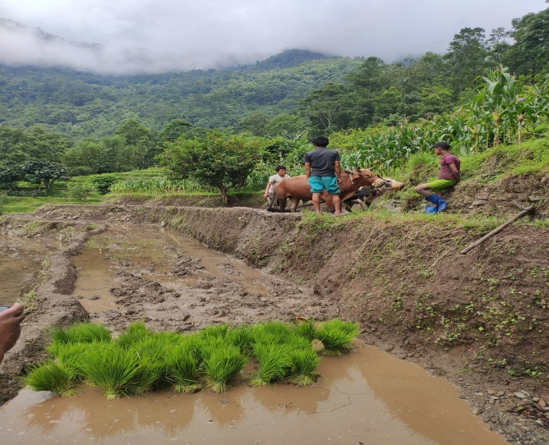 | 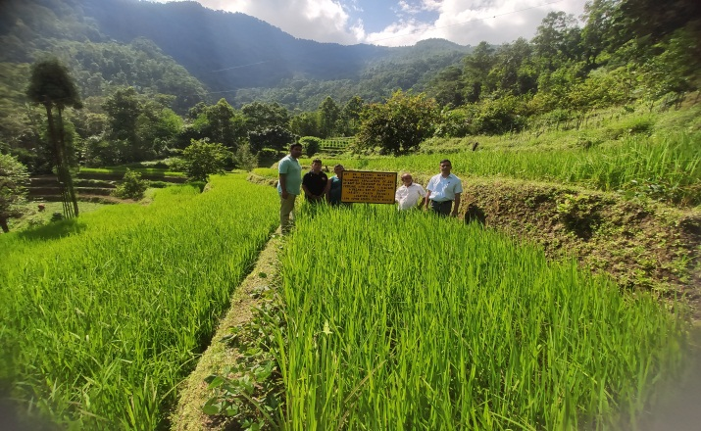
Figure 1: View of experimental area

Table 1: Initial soil chemical properties of experimental soils
Parameters | Technology | Farmer practice
pH | 5.30 | 5.30
Organic Carbon (%) | 0.81 | 0.81
Available N (kg/ha) | 263.70 | 263.70
Available P (kg/ha) | 14.32 | 14.32
Available K (kg/ha) | 213.6 | 213.6
Available Zn (mg/kg) | 0.84 | 0.84
Result and Discussion:
The comparative analysis between technology-based agricultural practices and farmer practices highlights significant improvements in crop performance under technological interventions. Plant growth adoption of advanced agricultural technologies resulted in an increased plant height (112.2 cm) compared to traditional farmer practices (108.4 cm). A higher number of tillers per hill (13.14 and 10.30 Technology and Farmers Practice, respectively) and panicles per hill (14.72 and 11.33 Technology and Farmers Practice, respectively) were observed, indicating improved vegetative growth and tillering ability under technology-based methods.
The grain yield under Technology Practice (TP) was significantly higher than under Farmer Practice (FP). The average grain yield recorded under TP was 35.00 t/ha, whereas FP yielded only 25.22 t/ha (Table 1). This represents an 38.77% increase in grain yield due to the adoption of improved technologies.
The significant increment under TP could be attributed to the adoption of improved application of bioformulation. In contrast, the FP relied on traditional imbalanced fertilizer use, which likely limited crop performance. These results showed that the rice yield stability and sustainability under the organic substitution strategies were superior. In terms of average rice yield, showed the most significant yield increase. Consistent with the findings of this study conducted by Zhang et al. (2020) and Wang et al. (2024) demonstrated that the organic substitution enhanced crop productivity. Similar, study was reported by Tariq et al. (2007) reported the effect of Zn-mobilizing PGPR which significantly reduced the deficiency symptoms of Zn and constantly increased the total biomass, grain yield, and harvest index including Zn concentration in rice.
Table 2: Comparison of plant parameters and yield of rice under farmers' practice and technology.
Parameters | Technology | Farmers Practice
Plant Height (cm) | 112.2 | 108.4
No. of Panicle/hill | 14.72 | 11.33
No. of Tillers/hill | 13.14 | 10.30
Yield (q/ha) | 35.00 | 25.22
The soil pH was found to be slightly higher under technology-driven methods (6.0) compared to farmer practices (5.6), indicating improved buffering capacity and nutrient availability. Organic carbon content also showed an increase (0.97% and 0.84% Technology and Farmers Practice, respectively), suggesting enhanced microbial activity and soil organic matter accumulation.
Available nitrogen remained relatively stable across both practices (287 kg/ha and 281 kg/ha Technology and Farmers Practice, respectively), while phosphorus availability exhibited a significant increase 26.11 kg/ha in Technology and 16.11 kg/ha in Farmers Practice, respectively), reflecting improved phosphorus management strategies such as better fertilization techniques and enhanced solubilization. Potassium levels remained similar (221.2 kg/ha in technology and 219.4 kg/ha in farmers practice, respectively), with technology-based practices maintaining slightly higher values.
Available zinc concentration in soil under demonstration shows higher increment 1.62 mg/kg in technology as compared to 0.94 mg/kg, in farmers practice, respectively). Under technological interventions, underscoring the potential role of zinc solubilizing bacteria or precision nutrient management leads to increase in micronutrient availability. These results align with the findings of Ya-run et al. (2024) due to the application of organic–organic fertilizers increased soil organic carbon content, pH, Available NPK and a higher amount of organic material input resulted in a higher content of soil organic carbon. Ramesh et al. (2014) stated that there is an increase in exchangeable zinc by an increase in the mineralization of organically complexed and bound zinc or solubilizing of zinc from recalcitrant sources such as carbonates of zinc into exchangeable zinc.
Table 3: Comparison of soil properties under farmers' practice and technology.
Parameters | Technology | Farmer practice
pH | 6.0 | 5.6
Organic Carbon (%) | 0.97 | 0.84
Available N (kg/ha) | 287 | 281
Available P₂O₅ (kg/ha) | 26.11 | 16.11
Available K₂O (kg/ha) | 221.2 | 219.4
Available Zn (mg/kg) | 1.62 | 0.94
The net return per hectare was notably higher under technology-driven methods (Rs. 97,500/ha) compared to farmer practices (Rs. 38,240/ha), demonstrating a significant gain in net return due to improved productivity. The benefit-cost ratio showed a clear improvement with technological adoption (2.62) compared to farmer practice (1.69). This indicates that for every rupee spent, technology-based agriculture yielded a higher return on investment, making it a more economically viable approach. These results align with the findings of Sharma et al. (2021)
Table 4: Comparison of economics under Technology and Farmer Practice.
 | Net return (Rs/ha) | B: C ratio (GR/GC)
Technology | Rs. 97,500/- | 2.62
Farmer Practice | Rs.38,240/- | 1.69
Conclusion:
The study highlights the clear advantages of technology-based agricultural practices over farmer practices in terms of crop performance, soil fertility, and economic returns. Technological interventions significantly enhanced plant height, tillers, panicles per hill, and yield. Higher organic carbon, phosphorus availability, and zinc levels indicate better soil health and nutrient retention under advanced management techniques. Net return and B:C ratio emphasize the profitability and efficiency of technology-driven farming.
References:
Bhakat, K., Chakraborty, A. and Islam, E. (2021). Characterization of zinc solubilization potential of arsenic tolerant Burkholderia spp. isolated from rice rhizospheric soil. World J Microbiol Biotechnol, 37:39. https://doi.org/10.1007/s11274-021-03003-8
Bray, R.H. and Kurtz, L.T. (1945) Determination of Total Organic and Available Forms of Phosphorus in Soils. Soil Science, 59, 39-45. http://dx.doi.org/10.1097/00010694-194501000-00006
Cakmak, I. (2002). Plant nutrition research: priorities to meet human needs for food in sustainable ways. Plant Soil, 247:3–24. https:// doi.org/10.1023/A:1021194511492
Das, S.K., Avasthe, R.K., Singh, M. and Yadav, A. (2018). Soil health improvement using biochar application in Sikkim: a success story. Innov Farming, 3(1), 48-50.
Establishment of Agency for Reporting Agricultural Statistics. (2022). Crop cutting and Yield Estimation report. Agriculture Census and Earas Unit Agriculture Department Government of Sikkim.
Hanway, J.J. and Heidel, H. (1952). Soil analysis methods as used in Iowa State College, Soil Testing Laboratory. Iowa Agriculture, 54: 1-31.
Impa, S.M., M.J. Morete, A.M. Ismail, R. Schulin and S.E. Johnson-Beebout (2013). Zn uptake, translocation, and grain Zn loading in rice (Oryza sativa L.) genotypes selected for Zn deficiency tolerance and high grain Zn. J. Exp. Bot., 64: 2739–2751.
Jackson, M. (1973). Soil chemical analysis. Prentice Hall of India Pvt. Ltd., New Delhi
Kushwaha, P., Srivastava, R., Pandiyan, K., Singh, A., Chakdar, H., Kashyap, P.L., Bhardwaj, A.K., Murugan, K., Karthikeyan, N., Bagul, S.Y., Srivastava, A.K. and Saxena, A.K. (2021). Enhancement in plant growth and zinc biofortification of chickpea (Cicer arietinum L.) by Bacillus altitudinis. J Soil Sci Plant Nutr, 21:922–935. https:// doi. org/ 10. 1007/s42729-021-00411-5
Lindsay, W.L. and Norvell, W.A. (1978) Development of a DTPA soil test for zinc, iron, manganese and copper. Soil Sci Soc Am J 42:421–428.
Ramesh, A., Sharma, S., Sharma, M., Yadav, N. and Joshi, O. (2014). Inoculation of zinc solubilizing Bacillus aryabhattai strains for improved growth, mobilization and biofortification of zinc in soybean and wheat cultivated in Vertisols of central India, Appl. Soil Ecol., 73. 87e96.
Sharma, A., Asati, K.P., Yadav, S.S. and Namdeo, K.N. (2021). Impact of organic and inorganic fertilizers on growth, yield and economics of garlic (Allium sativum L.). Annals of Plant and Soil research, 23(4), 477-480.
Singh, D. and Prasanna, R. (2020). Potential of microbes in the biofortification of Zn and Fe in dietary food grains. A Review. Agron Sustain Dev, 40:15. https://doi.org/10.1007/s13593-020-00619-2
Singh, M.V. (2009a). Evaluation of current micronutrient stocks in different Agro Ecological zones of India for sustainable crop production. Fert News, 46:25–42.
Singh, M.V. (2009b). Micronutrient nutritional problems in soils in India and improvement for human and animal health. Indian J Fert., 5(4):11–26.
Subbiah, B.V. and Asija, G.L. (1956). A rapid procedure for the estimation of available nitrogen in soils. Curr Sci, 25:259–260.
Sudha, S. and Stalin, P. (2015). Effect of zinc on yield, quality and grain zinc content of rice genotypes. International Journal of Farm Sciences, 5(3): 17-27.
Tariq, M., Hameed, S., Malik, K.A. and Hafeez, F.Y. (2007). Plant root-associated bacteria for zinc mobilization in rice. Pak J Bot., 39(1):245–253
Walkley, A.J. and Black, C.A. (1934). An estimation of declare methods for determining soil organic matter and a proposed modification of the chromic acid titration methods. J Soil Sci, 37:29–38.
Wang, X., Liu, M., Ciampitti, I.A., Cui, J., Fang, K., Zhao, S., He, P. and Zhou, W. (2024). Benefits and trade-offs of replacing inorganic fertilizer by organic substrate in crop production: a global meta-analysis. Sci. Total Environ. 925, 171781. https://doi.org/ 10.1016/j.scitotenv.2024.171781.
Ya-run, W.A.N.G., Juan, Z.H.A.O., Zhen-xing, Y.A.N.G., Huai-ping, Z.H.O.U., Wen-yan, X.I.E. and Zhi-ping, L.I.U. (2024). Organic carbon composition and carbon sequestration function of cinnamon soil as affected by fertilization modes. Journal of Plant Nutrition and Fertilizers, 30(3), 469-481.
Zhang, X., Fang, Q., Zhang, T., Ma, W., Velthof, G., Hou, Y., Oenema, O. and Zhang, F. (2020). Benefits and trade-offs of replacing synthetic fertilizers by animal manures in crop production in China: a meta-analysis. Global Change Biol. 26, 888–900. https://doi. org/10.1111/gcb.14826.

