**Case report**

**Recurrent Spontaneous Idiopathic Pneumoperitoneum: Avoiding a Second Laparotomy**

**Abstract**

Recurrent spontaneous idiopathic pneumoperitoneum is a rare and perplexing condition that challenges conventional diagnostic and management strategies. This case report details the clinical presentation and management of a 48-year-old Saudi male who experienced two episodes of pneumoperitoneum without an identifiable cause. Initially presenting with upper abdominal pain and confirmed free intraperitoneal air via imaging, the patient underwent extensive laparoscopic and open surgical exploration, which failed to reveal any source of the pneumoperitoneum. Six months later, the patient experienced a recurrence, and a conservative management approach was adopted, resulting in successful recovery without surgical intervention. This report underscores the importance of a meticulous diagnostic approach and highlights the potential for conservative management in select cases of recurrent spontaneous idiopathic pneumoperitoneum, emphasizing the need for individualized patient care and further research into the pathophysiology of this rare condition.

**Background**

Pneumoperitoneum, the presence of free air within the peritoneal cavity, is most commonly associated with gastrointestinal perforation, necessitating immediate surgical intervention due to the risk of peritonitis and sepsis [1]. The introduction of air into the peritoneal cavity typically occurs through a perforation in the gastrointestinal tract, which can result from various etiologies, including peptic ulcer disease, diverticulitis, malignancy, or trauma [1,2]. The resultant free air serves as a key radiologic sign, prompting urgent exploratory surgery to locate and repair the perforation [2].

In rare instances, pneumoperitoneum can occur spontaneously without an identifiable cause, a condition known as spontaneous idiopathic pneumoperitoneum. This form of pneumoperitoneum is not associated with gastrointestinal perforation and therefore poses a unique diagnostic and therapeutic challenge. The incidence of spontaneous idiopathic pneumoperitoneum is exceedingly low, and its pathophysiology remains poorly understood, making it a topic of considerable clinical interest [2-4].

Several theories have been proposed to explain the occurrence of spontaneous idiopathic pneumoperitoneum. One theory suggests the presence of micro-perforations in the gastrointestinal tract that spontaneously seal, allowing air to escape into the peritoneal cavity without significant contamination by intestinal contents [3,4]. These micro-perforations may be so small that they are not detectable during surgical exploration or imaging studies. Another hypothesis involves the translocation of air from the thoracic cavity into the peritoneal cavity through diaphragmatic defects or foramina, particularly in cases of concurrent pneumothorax or other thoracic pathologies [3-6].

Gas-forming bacterial infections within the gastrointestinal tract represent another potential mechanism. Certain bacteria, such as Clostridium species, can produce gas as a metabolic byproduct, which may then accumulate and lead to pneumoperitoneum. However, this explanation is less likely in the absence of clinical signs of infection or inflammation, as seen in our patient [5,7].

Additionally, non-perforating causes such as mechanical ventilation, barotrauma, or recent surgical or endoscopic procedures can lead to pneumoperitoneum. In cases where a recent history of medical intervention is absent, as with our patient, these causes can generally be excluded. In female patients, air may occasionally enter the peritoneal cavity through the genital tract, but this mechanism is not applicable to our male patient [4-6].

Idiopathic cases, where no clear etiology is identified, require a meticulous approach to diagnosis and management. A comprehensive diagnostic workup typically includes detailed patient history, physical examination, laboratory tests, and a variety of imaging studies [2,3]. Initial investigations often involve plain radiographs, which can reveal free air under the diaphragm, a classic sign of pneumoperitoneum. Computed tomography (CT) scans provide more detailed information, allowing for the identification of even small amounts of free air and helping to rule out other intra-abdominal pathologies [2-4].

Current literature is limited, with most reports consisting of isolated case studies or small case series. A better understanding of the underlying mechanisms and risk factors for this condition could inform more effective diagnostic and therapeutic strategies, potentially reducing the need for unnecessary surgeries and improving patient outcomes. This case presentation aims to present and discuss a case of recurrent spontaneous idiopathic pneumoperitoneum and its outcomes.

**Case Presentation**

Our patient is a 48-year-old Saudi male who presented with a two-day history of upper abdominal pain accompanied by nausea but without vomiting. The patient had no significant past medical history and was neither diabetic nor hypertensive. He was not on any regular medications, including steroidal or non-steroidal anti-inflammatory drugs. Additionally, he had no history of endoscopy, surgery, or any gastro-endoscopic procedures within the last six months.

On arrival, the patient was notably apprehensive and tachycardic, with a heart rate of 100 beats per minute. His chest and cardiovascular examinations were unremarkable. Abdominal examination revealed mild tenderness, normal bowel sounds, and no distension. The patient was hemodynamically stable, with blood pressure within normal limits. Blood investigations, including a complete blood count, serum chemistry, and liver function tests, were all normal.

A plain abdominal X-ray revealed a significant amount of free air under the diaphragm, suggestive of pneumoperitoneum, which was subsequently confirmed by a computed tomography (CT) scan showing extensive free intraperitoneal air without any identifiable source of perforation.

Following a detailed discussion with the patient regarding the findings and potential interventions, we decided to proceed with diagnostic laparoscopy. During the laparoscopic examination, the abdomen appeared "virgin," with no signs of previous surgical intervention or visible cause for the pneumoperitoneum. Due to the lack of identifiable cause and to ensure thoroughness, we converted the procedure to a laparotomy.

During the laparotomy, an extensive search was performed. We inserted a nasogastric tube and insufflated a large amount of air into the stomach to identify any leaks from the stomach, lower esophagus, or duodenum, but no source was found. We also insufflated the rectum to check for leaks in the large bowel up to the cecum, again finding no cause. A meticulous examination of the small bowel from the duodenojejunal flexure to the terminal ileum was conducted, but no air leak was identified.

Postoperatively, the patient had an uneventful recovery and was discharged from the hospital three days later in stable condition, still without a definitive diagnosis for the pneumoperitoneum.

One month later, the patient experienced a recurrence of abdominal pain and was diagnosed with pneumoperitoneum at a distant facility. The attending physicians there recommended a laparotomy, but the patient insisted on returning to our hospital. Upon his return, we performed a CT scan with oral, intravenous, and anorectal contrast. The imaging studies once again showed extensive free air within the peritoneal cavity but no definitive source of perforation.

Given the patient's history and the previous negative findings, we opted for conservative management during this second episode. The patient was closely monitored, and supportive care was provided, including analgesics and intravenous fluids. The patient's condition improved without surgical intervention, and he was discharged after three days.

Throughout both episodes, the absence of any identifiable cause for the pneumoperitoneum despite thorough investigation highlights the enigmatic nature of spontaneous idiopathic pneumoperitoneum. This case underscores the challenges in diagnosing and managing such conditions, as well as the potential for successful conservative management in recurrent cases.

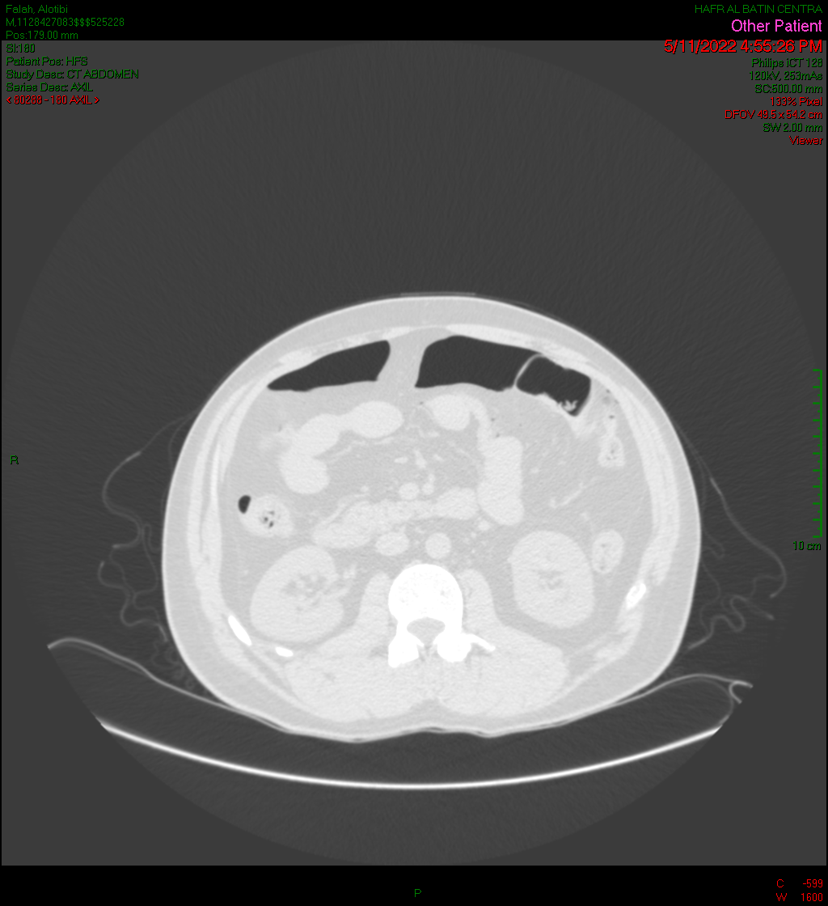

Figure 1: Axial contrast enhanced CT ABDOMEN lung window done at 11 may 2022 revealed pneumoperitoneum presented as extraluminal air seen (thick arrow)

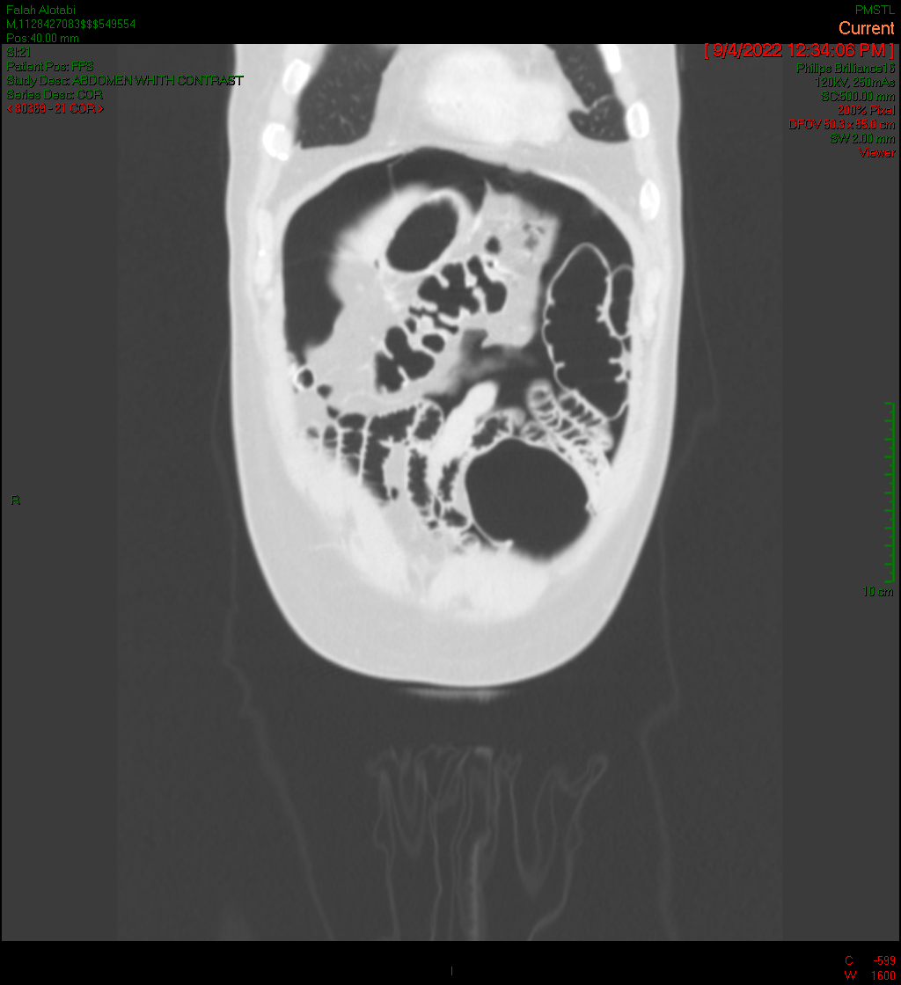

Figure 2: Coronal contrast enhanced CT ABDOMEN lung window done at 11 may 2022 revealed air under diaphragm (thick arrow)

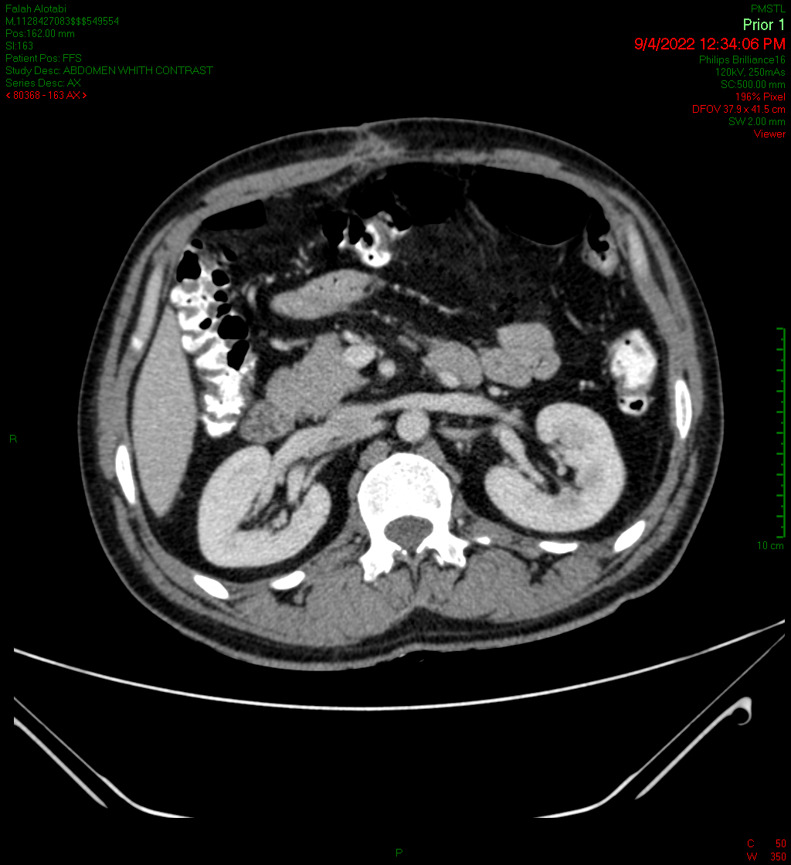

Figure 3: Contrast enhanced CT abdomen post IV, oral and rectal contrast done at 9 April 2022 revealed no extraluminal contrast leak

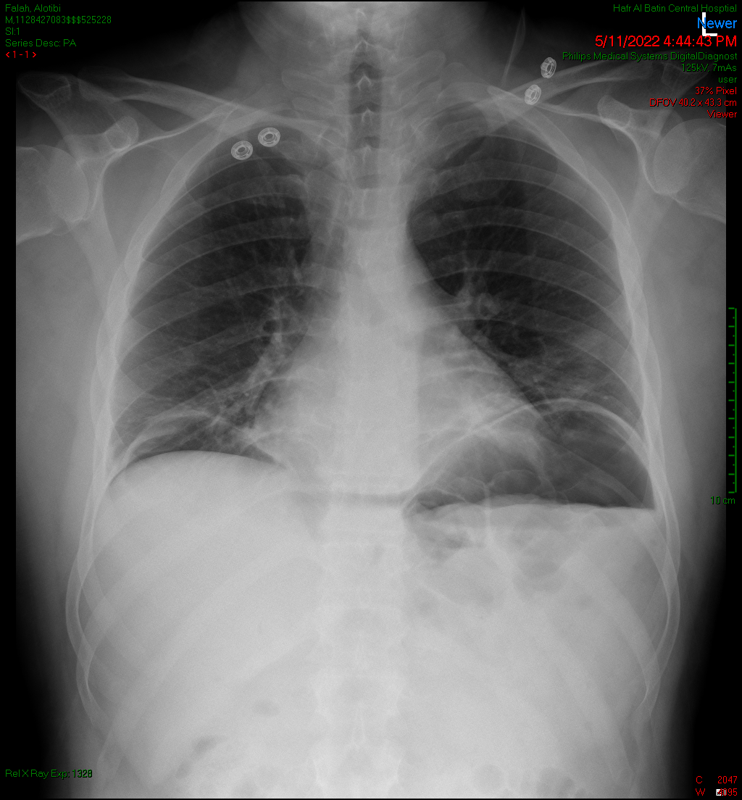

Figure 4: Abdomen CXR done at 1st visit 9 April 2022 showing bilateral air under diaphragm

**Discussion**

Spontaneous idiopathic pneumoperitoneum is an exceedingly rare condition characterized by the presence of free air within the peritoneal cavity without an obvious cause [2-4]. Typically, pneumoperitoneum is a surgical emergency that suggests a perforated abdominal viscus, necessitating prompt surgical intervention to prevent peritonitis and other life-threatening complications. However, in some rare instances, pneumoperitoneum can occur without any perforation or other identifiable source, leading to a diagnostic and therapeutic dilemma [1,3,8]. This case report details the clinical presentation, surgical explorations, and subsequent conservative management of a patient with recurrent idiopathic pneumoperitoneum, providing insight into the complexities of this condition.

Our patient, a 48-year-old Saudi male, presented with non-specific symptoms of upper abdominal pain and nausea but no vomiting. His clinical examination and initial investigations were unremarkable except for the presence of pneumoperitoneum on imaging. The absence of significant past medical history, medication use, or recent procedures added to the diagnostic challenge. Given the extensive nature of our intraoperative examinations during his first admission—spanning from the stomach and lower esophagus to the entire length of the small and large intestines—we were unable to identify any source of air leak or perforation. This thorough examination, including the use of insufflation techniques, aimed to detect even micro-perforations, yet yielded no causative findings.

The pathophysiology of spontaneous idiopathic pneumoperitoneum remains poorly understood. Several theories have been proposed, including the presence of gas-forming bacteria within the gastrointestinal tract, small unrecognized perforations that heal spontaneously, or the migration of air from the thoracic cavity through defects in the diaphragm [9,10]. Another possibility is the introduction of air through the female genital tract, although this is unlikely in our male patient. Additionally, iatrogenic causes such as recent endoscopic procedures were ruled out in this case. The patient's "virgin" abdomen, without any prior surgical scars or history, further complicated the diagnostic picture [4,10].

During the first episode, after extensive laparoscopic and open surgical exploration, the patient's uneventful recovery and subsequent discharge were uneventful, despite no definitive diagnosis being established. This outcome initially suggested that the patient's condition might not have been life-threatening, despite the dramatic imaging findings. However, the recurrence of pneumoperitoneum six months later reignited concerns about an underlying condition that was missed or an atypical presentation of a more sinister pathology [8,11].

When the patient presented with recurrent pneumoperitoneum, the decision to manage conservatively was guided by several factors. Firstly, the absence of signs and symptoms indicative of peritonitis or sepsis suggested that immediate surgical intervention might not be necessary [9,12]. Secondly, the previous negative findings during the extensive exploratory laparotomy indicated that another surgical exploration might not yield additional diagnostic benefits and could instead increase the risk of postoperative complications. Thirdly, the patient's clinical stability and preference played a significant role in this decision-making process [4,5,11].

Conservative management of pneumoperitoneum is not typically advocated due to the potential risks associated with missed perforations. However, in cases of spontaneous idiopathic pneumoperitoneum where extensive workup fails to reveal a cause, a non-operative approach can be considered. This approach includes close clinical monitoring, supportive care, and repeated imaging to ensure that no perforation or other complications develop. In our patient, this strategy proved effective, with the patient recovering well and being discharged without any surgical intervention during the second episode [11,13].

**Clinical Implications**

The clinical course of our patient underscores the importance of individualized patient care. While general guidelines advocate for surgical exploration in cases of pneumoperitoneum, exceptions can be made based on the patient's overall clinical picture and previous diagnostic findings. This case highlights that recurrent spontaneous idiopathic pneumoperitoneum can be managed conservatively in the absence of clinical deterioration or evidence of perforation. The decision to avoid a second laparotomy not only reduced the risk of surgical morbidity but also aligned with the patient's preferences, emphasizing patient-centered care [2,4].

The implications of this case extend to the broader understanding of spontaneous idiopathic pneumoperitoneum. It suggests that in select cases, particularly where there is a history of negative surgical exploration and the patient remains clinically stable, conservative management can be a safe and effective option. This approach requires a high level of vigilance and readiness to intervene surgically if the patient's condition worsens or if new evidence of a perforation emerges [5,7,11].

Moreover, this case highlights the necessity for further research into the etiology and optimal management strategies for spontaneous idiopathic pneumoperitoneum. Currently, the literature on this condition is sparse, with most reports consisting of single-case studies or small case series. A better understanding of the underlying mechanisms and risk factors for this condition could lead to improved diagnostic and therapeutic protocols, reducing the need for unnecessary surgeries and enhancing patient outcomes.

**Conclusion**

In conclusion, recurrent spontaneous idiopathic pneumoperitoneum presents a significant diagnostic and management challenge. This case illustrates the potential for successful conservative management in recurrent cases, emphasizing the need for a careful, individualized approach. The absence of identifiable causes despite thorough surgical exploration suggests that not all cases of pneumoperitoneum necessitate immediate surgical intervention, particularly in the context of recurrent idiopathic presentations. Further studies are needed to elucidate the pathophysiology of this condition and to establish evidence-based guidelines for its management. For now, clinicians should remain vigilant and flexible, balancing the need for thorough investigation with the risks of unnecessary surgical procedures.

COMPETING INTERESTS DISCLAIMER:

Authors have declared that they have no known competing financial interests OR non-financial interests OR personal relationships that could have appeared to influence the work reported in this paper.

**References**

1. Tanner TN, Hall BR, Oran J. Pneumoperitoneum. Surgical Clinics. 2018 Oct 1;98(5):915-32.
2. Fietkau M. Spontaneous Pneumoperitoneum A Review of Diagnostic and Treatment Tactics (Doctoral dissertation, LITHUANIAN UNIVERSITY OF HEALTH SCIENCES).
3. Estridge P, Akoh JA. Recurrent spontaneous pneumoperitoneum: A surgical dilemma. International Journal of Surgery Case Reports. 2017 Jan 1;30:103-5.
4. Peker KD, Çikot M, Bozkurt MA, İlhan B, Kankaya B, Şahbaz NA, Alış H. The Rate of Idiopathic Spontaneous Pneumoperitoneum is 2.36%. Medical Journal of Bakirkoy. 2017 Jun 1;13(2).
5. Sakaguchi T, Kotsuka M, Yamamichi K, Sekimoto M. Management of incidentally detected idiopathic pneumoperitoneum: a case report and literature review. International Journal of Surgery Case Reports. 2021 Oct 1;87:106463.
6. Makki AM. The pattern of causes of pneumoperitoneum-induced peritonitis: results of an empirical study. Journal of Microscopy and Ultrastructure. 2017 Mar 1;5(1):28-31.
7. Abdelmohsen SM, Osman MA. Idiopathic neonatal pneumoperitoneum, a case report. International journal of surgery case reports. 2017 Jan 1;31:250-3.
8. Sidiqi MM, Fletcher D, Billah T. The enigma of asymptomatic idiopathic pneumoperitoneum: a dangerous trap for general surgeons. International Journal of Surgery Case Reports. 2020 Jan 1;76:33-6.
9. Grewal JS, Mayer S, Beaty J, Formaro D. A rare case of spontaneous idiopathic pneumoperitoneum presenting as abdominal pain. Cureus. 2021 May;13(5).
10. İflazoğlu N, Gökçe ON, Kıvrak MM, Kocamer B. Spontaneous idiopathic pneumoperitoneum with acute abdomen. Turkish Journal of Surgery/UlusalCerrahiDergisi. 2015;31(2):110.
11. McLaren O. Spontaneous idiopathic recurrent pneumoperitoneum. Journal of Surgical Case Reports. 2013 Aug 1;2013(8):rjt071.
12. Tanaka R, Kameyama H, Nagahashi M, Kanda T, Ichikawa H, Hanyu T, Ishikawa T, Kobayashi T, Sakata J, Kosugi SI, Wakai T. Conservative treatment of idiopathic spontaneous pneumoperitoneum in a bedridden patient: a case report. Surgical Case Reports. 2015 Dec;1:1-4.
13. Pitiakoudis M, Zezos P, Oikonomou A, Kirmanidis M, Kouklakis G, Simopoulos C. Spontaneous idiopathic pneumoperitoneum presenting as an acute abdomen: a case report. Journal of Medical Case Reports. 2011 Dec;5:1-4.