*Original Research Article*

Antimicrobial Resistance of St*aphylococcus* *aureus* isolated from fomites in emergency units of selected Tertiary Hospitals in Abuja Municipal Area, Nigeria

ABSTRACT

|  |
| --- |
| **Aims:** This study investigated Antimicrobial resistance of *Staphylococcus* *aureus* isolated from fomites in emergency units of selected tertiary hospitals in Abuja Municipal Area, Nigeria.  **Study design:** Cross sectional study.  **Place and Duration of Study:** Department of Microbiology, Nasarawa State University, between December 2024 and April 2025.  **Methodology:** ~~Methodology:~~ A total of 350 environmental samples were collected from various fomites, including door handles, tap handles, nursing stations, sinks, beds, and mattresses across three hospitals: National Hospital Abuja (150 samples), Federal Medical Centre, Jabi, Abuja (50 samples), and National Trauma Centre, Abuja (150 samples). Isolates were identified using standard microbiological techniques.  **Results:** The occurrence of *Staphylococcus aureus* was 50 (14.3%). The nursing station had the highest occurrence (23.7%), while tap handles had the lowest (6.5%). The prevalence of multi-drug resistance (MDR) and extensive drug resistance (XDR) among the isolates was recorded at 70% and 12%, respectively. Antibiotic susceptibility testing showed ofloxacin and ciprofloxacin to have the highest sensitivity, while ampicillin, chloramphenicol, trimethoprim/sulfamethoxazole, clindamycin, erythromycin, and penicillin exhibited the highest resistance. The presence of such resistant strains is alarming, particularly in hospital environments where inadequate hygiene practices—especially in developing countries—may contribute to their spread. This emphasizes the need for antimicrobial resistance (AMR) surveillance to track the evolution of resistant strains in hospital settings. Potential intervention strategies are crucial to combat this rising threat.  **Conclusion:** The high prevalence of *Staphylococcus aureus* and alarming rates of multidrug-resistant strains in hospital fomites highlight urgent needs for improved infection control measures, antimicrobial stewardship, and regular AMR surveillance to mitigate the spread of resistant pathogens in healthcare settings. |

*Keywords: Antimicrobial Resistance (AMR), Staphylococcus aureus, Formites, Antibiotics.*

1. INTRODUCTION

Antibiotic resistance is a major global health challenge, and hospitals serve as key players in combating this growing threat [1]. To mitigate the spread of resistant pathogens, healthcare facilities must adopt stringent infection control strategies, including rigorous hand hygiene practices, sterilization protocols, and robust surveillance systems to monitor resistance trends [2]. Antibiotic resistance stands as one of the most critical challenges to global public health [3, 4, 5]. The overuse and misuse of antibiotics in healthcare have accelerated the rise of multidrug-resistant bacteria, severely complicating ~~infection treatment~~. Among these pathogens, *Staphylococcus aureus* is particularly notorious due to its remarkable adaptability and resistance mechanisms, including methicillin-resistant *S. aureus* (MRSA). This bacterium is a leading cause of both hospital- and community-acquired infections, ranging from mild skin conditions to life-threatening diseases such as pneumonia and septicemia [6].

In hospital environments, fomites—such as door handles, tables, chairs, and bedding—serve as critical reservoirs for pathogen transmission, including *Staphylococcus aureus*. The combination of shared facilities and frequent human contact in these settings facilitates the spread of antibiotic-resistant bacteria, presenting a serious public health risk [7]. Despite this concern, few studies have examined the antimicrobial resistance profiles of *S. aureus* isolated from fomites in Nigerian hospital emergency units. Therefore, this study aims to assess the antimicrobial resistance patterns of *S. aureus* obtained from fomites in emergency units of selected tertiary healthcare facilities within Abuja Municipal Area, Nigeria.

2. material and methods

2.1 Study Location and Sample Collection

This study was conducted in Nasarawa State University Keffi (NSUK), Nigeria. Three hundred and fifty (350) swab samples or sterile swab emulsified in peptone water ~~from emergency units of the selected Hospitals in Abuja, was collected~~ and transported to the Microbiology Laboratory Nasarawa State University Keffi (NSUK) for analysis, as described by [8].

**2.2 Isolation and Identification of Bacterial Isolates**

The collected samples were cultured on Mannitol Salt Agar (MSA) and incubated at 37°C for 24 hours. Following incubation, distinct colonies were sub-cultured onto Nutrient Agar to obtain pure isolates. Bacterial identification was performed using standard biochemical assays, including Gram staining, catalase, oxidase, urease, citrate utilization, coagulase, and hemolysis tests [9, 10, 11, 12]. Additionally, sugar fermentation tests were conducted to differentiate bacterial species based on their metabolic characteristics [13].

The presumptive *S. aureus* isolates, which were Gram-positive cocci in clusters and tested positive for both catalase and coagulase, were confirmed using the KB003 H125TM Kit (HiMedia Ltd, India) according to the manufacturer's protocol. Briefly, three pure colonies of 24-hour Nutrient Agar cultures suspected to be *S. aureus* were transferred into 5 mL of sterile normal saline and adjusted to a turbidity equivalent to 0.5 McFarland standard.

The kit was aseptically opened by removing the sealing foil, and 50 µL of the standardized suspension was inoculated into each well. The wells were then resealed with the foil and incubated at 37°C for 24 hours. Following incubation, 2 drops of Barritt's reagent A were added to well No. 1, followed by 1 drop of Barritt's reagent B. Similarly, 2 drops of NaOH were added to well No. 2. Results were interpreted according to the standard identification index provided with the kit.

**2.3 Antimicrobial Susceptibility Testing**

Antimicrobial susceptibility testing was performed according to Clinical and Laboratory Standards Institute guidelines [14]. Three pure colonies of each isolate were suspended in 5 mL sterile 0.85% (w/v) normal saline, with turbidity adjusted to match the 0.5 McFarland standard. The standard was prepared by adding 0.5 mL of 1.172% (w/v) BaCl₂·2H₂O to 99.5 mL of 1% (w/v) H₂SO₄. Using sterile technique, a cotton swab was immersed in the standardized suspension and streaked uniformly across Mueller-Hinton agar plates. Antibiotic discs were then aseptically placed on the inoculated plates and allowed to pre-diffuse for 1 hour at room temperature. Following incubation at 37°C for 24 hours, inhibition zone diameters were measured in millimeters and interpreted according to CLSI susceptibility breakpoints [14].

3. results and discussion

**3.1 Prevalence of *Staphylococcus aureus***

The prevalence of *Staphylococcus aureus* isolated from fomites in tertiary healthcare facilities in Abuja, Nigeria was analyzed using descriptive statistics (Figures 1-3), with consideration of facility type, fomite category, and disinfectant protocols during sampling. The overall prevalence of *S. aureus* was 14.3% (50/350). Facility-specific analysis revealed the highest prevalence at Federal Medical Centre Jabi (FMCJ; 18.0%, 9/50), followed by National Trauma Centre Abuja (NTCA; 14.7%, 22/150) and National Hospital Abuja (NHA; 12.7%, 19/150).

Fomite-specific distribution showed the highest contamination in nursing stations (NS; 23.3%, 10/43) and sinks (SNK; 20.0%, 9/45), while tap handles (Tp) demonstrated the lowest prevalence (6.5%, 5/77). Disinfectant analysis indicated higher *S. aureus* prevalence in facilities using sodium hypochlorite (Hypo; 18.0%, 9/50) compared to those employing combined hypochlorite and sodium hypochlorite (Jik) solutions (14.7%, 22/150).

Pearson's chi-square test revealed no significant associations between *S. aureus* prevalence and healthcare facilities (χ²=0.902, p=0.637): fomite types (χ²=8.462, p=0.133), disinfectant protocols (χ²=0.902, p=0.637).

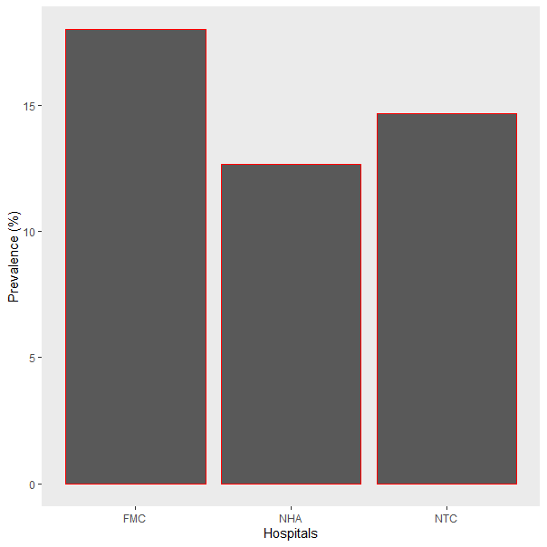

**Figure 1:** Prevalence of *Staphylococcus aureus* isolated from fomites in relation to the Tertiary Health Facilities in Abuja, Nigeria

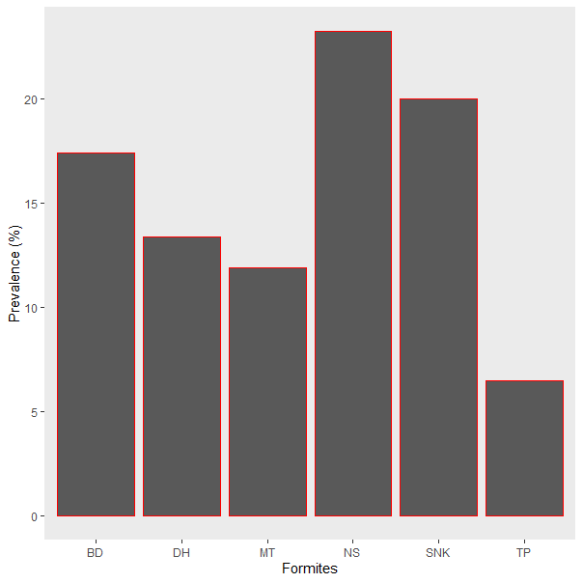

**Figure 2**: Prevalence of *Staphylococcus aureus* isolated in relation to types of fomites in the Tertiary Health Facilities, Abuja, Nigeria

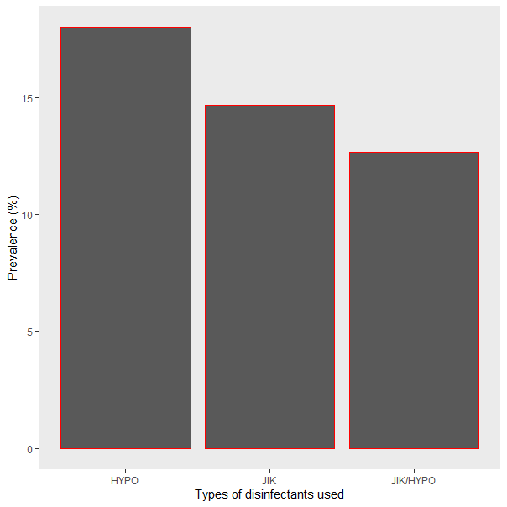

**Figure 3:** Prevalence of *Staphylococcus aureus* isolated from fomites in relation to disinfectant used in the Tertiary Health Facilities, Abuja, Nigeria

**3.2 Antimicrobial Resistance**

Antimicrobial resistance patterns among the isolates from tertiary healthcare facilities in Abuja, Nigeria were analyzed using descriptive statistics (Table 1). The isolates demonstrated resistance to all tested antimicrobials, with resistance rates ranging from 36.0% to 54.0%. The highest resistance rates were observed for ampicillin (54.0%), chloramphenicol (52.0%), and ciprofloxacin (48.0%), while the lowest resistance was recorded for ofloxacin (36.0%).

**3.3 Antimicrobial Resistance Phenotypes**

The *S. aureus* isolates recovered from fomites in Abuja's tertiary healthcare facilities were categorized into distinct antimicrobial resistance phenotypes. As presented in Table.2, the most prevalent resistance pattern was AMP-AZM-FOX-C-SXT-DA-PN-CIP-OFX (20.0%, 8/40), followed by CIP-OFX, AMP, and C (5.0%, 2/40) among the identified phenotypes.

**3.4 Classification of Antimicrobial Resistance**

The antimicrobial-resistant isolates were classified according to established criteria (Magiorakos et al., 2012) into multidrug-resistant (MDR; resistance to ≥3 antimicrobial classes) and extensively drug-resistant (XDR; resistance to all but 1-2 antimicrobial classes) phenotypes. Analysis revealed a predominance of MDR isolates (70.0%, 28/40), while XDR isolates were less common (12.5%, 5/40), as shown in Table 3.

**Table 1: Antimicrobial resistance of *Staphylococcus aureus* isolated from fomites in Tertiary Health facilities, Abuja, Nigeria**

|  |  |  |
| --- | --- | --- |
| **Antimicrobials** | **Disc content (µg)** | **Resistance (%) n=50** |
| Ampicillin | 10 | 27 (54.0) |
| Azithromycin | 15 | 23 (46.0) |
| Cefoxitin | 30 | 23 (46.0) |
| Chloramphenicol | 30 | 26 (52.0) |
| Sulfamethoxazole/Trimethoprim | 25 | 20 (40.0) |
| Clindamycin | 2 | 20 (40.0) |
| Penicillin G | 10 | 22 (44.0) |
| Ciprofloxacin | 5 | 24 (48.0) |
| Ofloxacin | 5 | 18 (36.0) |

**Table.2: Antimicrobial resistance phenotypes of *Staphylococcus aureus* isolated from fomites in Tertiary Health facilities, Abuja, Nigeria**

|  |  |
| --- | --- |
| **Antimicrobial resistance phenotypes** | **Frequency (%), n=40** |
| AMP | 2 (5.0) |
| AZM | 1 (2.5) |
| SXT | 1 (2.5) |
| DA | 1 (2.5) |
| C | 2 (5.0) |
| AZM, C | 1 (2.5) |
| CIP, OFX | 2 (5.0) |
| C, DA, CIP | 1 (2.5) |
| FOX, C, DA | 1 (2.5) |
| C, SXT, CIP | 1 (2.5) |
| AMP, AZM, OFX | 1 (2.5) |
| AMP, PN, CIP | 1 (2.5) |
| AMP, SXT, PN | 1 (2.5) |
| AMP, AZM, FOX, SXT | 1 (2.5) |
| AZM, FOX, C, DA | 1 (2.5) |
| AZM, FOX, DA, CIP | 1 (2.5) |
| AMP, AZM, CIP, OFX | 1 (2.5) |
| AZM, FOX, SXT, PN, CIP | 1 (2.5) |
| AMP, FOX, C, DA, PN | 1 (2.5) |
| AZM, FOX, C, SXT, DA | 1 (2.5) |
| AMP, AZM, C, SXT, DA | 1 (2.5) |
| AZM, FOX, PN, CIP, OFX | 1 (2.5) |
| AMP, FOX, C, PN, OFX | 1 (2.5) |
| AMP, FOX, C, CIP, OFX | 1 (2.5) |
| AMP, FOX, C, DA, PN, CIP | 1 (2.5) |
| AMP, FOX, C, SXT, PN, CIP | 1 (2.5) |
| AMP, AZM, FOX, C, SXT, DA, PN | 1 (2.5) |
| AMP, AZM, FOX, C, SXT, DA, PN, CIP | 1 (2.5) |
| AMP, AZM, C, SXT, DA, PN, CIP, OFX | 1 (2.5) |
| AMP, AZM, FOX, C, SXT, DA, PN, CIP, OFX | 8 (20.0) |

**AMP=Ampicillin; AZM=Azithromycin; FOX=Cefoxitin, C=Chloramphenicol; SXT= Sulfamethoxazole/Trimethoprim; DA=Clindamycin; PN=Penicillin G; CIP=Ciprofloxacin; OFX=Ofloxacin**

**Table 3: Classification of antimicrobial in antimicrobial resistant *Staphylococcus aureus* isolated from fomites in Tertiary Health facilities, Abuja, Nigeria**

|  |  |
| --- | --- |
| **Classes of Antimicrobial resistance** | **Frequency (%), n=40** |
| XDR | 5 (12.5) |
| MDR | 28 (70.0) |

**XDR=Extensive drug resistance; MDR= Multidrug resistance**

The isolation of *S. aureus* from fomites in our study aligns with findings by Sunday et al. (2020) and [16], though our observed prevalence (14.3%) was lower than their reported rates of 15.3% and 21.3% from clinical samples. The presence of this pathogen on hospital fomites, particularly in emergency settings, represents a significant public health concern. *S. aureus* is a well-documented causative agent of severe infections including bacteremia, endocarditis, pneumonia, osteomyelitis, and soft tissue infections [17]. The emergence and spread of antimicrobial-resistant strains complicate clinical management, leading to increased treatment costs, prolonged hospitalization, and elevated morbidity and mortality rates.

Our isolates demonstrated particularly high resistance to ampicillin (54.0%), erythromycin (48.0%), penicillin (52.0%), cefoxitin (46.0%), chloramphenicol (52.0%), and trimethoprim-sulfamethoxazole (50.0%). This resistance profile suggests these antimicrobials may no longer be effective for staphylococcal infections in our study setting, potentially ~~reflecting~~ patterns of inappropriate antibiotic use.

Our findings of high resistance to ampicillin (54.0%), chloramphenicol (52.0%), and ciprofloxacin (48.0%) align with reports by [15] However, the observed resistance rates for ciprofloxacin and cefoxitin in our study contrast with their reported lower resistance levels (19.6% and 17.7%, respectively). Similarly, ciprofloxacin resistance findings in this study differs from [16], who documented 27.8% resistance. Notably, ~~ofloxacin-ciprofloxacin~~ demonstrated strong efficacy against our *S. aureus* isolates, suggesting these antimicrobials may remain viable treatment options for staphylococcal infections in our study setting.

*Staphylococcus aureus*, a prominent opportunistic pathogen, is associated with severe healthcare-associated infections including bacteremia, endocarditis, pneumonia, and osteomyelitis [18]. The global spread of antimicrobial-resistant strains has created significant clinical challenges, complicating treatment protocols and leading to increased healthcare costs, extended hospital stays, and elevated morbidity and mortality rates [17]

The isolation of *Staphylococcus aureus* from fomites in our study centers is consistent with previous findings by [15] and [16], though our observed prevalence (14.3%) was substantially lower than their reported rates (96.4% and 95.3%, respectively) but higher than the 22.0% documented by [19].. The detection of *S. aureus* in these clinical environments carries significant public health implications, as this pathogen is a well-established cause of healthcare-associated infections [17]. Notably, our study revealed higher bacterial prevalence in nursing stations compared to other sampled fomites (sinks, beds, and door handles), contrasting with [15] findings. This distribution pattern may reflect the intensive patient care activities occurring in nursing stations, creating greater opportunities for pathogen transmission between healthcare workers, surfaces, and patients.

Our study revealed concerning resistance patterns among *staphylococcus aureus* isolates, with high resistance rates observed against multiple antimicrobial agents: Ampicillin (54.0%), Erythromycin (48.0%), Penicillin (52.0%), Cefoxitin (46.0%), Chloramphenicol (52.0%), Trimethoprim-sulfamethoxazole (50.0%) and Clindamycin (44.0%). These resistance profiles suggest these antimicrobials may have limited efficacy for treating staphylococcal infections in our study setting, potentially reflecting patterns of inappropriate antibiotic use.

While our findings of high resistance to ampicillin and chloramphenicol align with [15], we observed notably higher resistance to ciprofloxacin (48.0% vs 19.6%) and cefoxitin (46.0% vs 17.7%) compared to their study. Similarly, ~~our~~ ciprofloxacin resistance rates exceeded those reported by [16] (27.8%). Notably, ofloxacin-ciprofloxacin demonstrated strong antimicrobial activity (36.0% resistance), suggesting this combination may represent a more effective treatment option against local *S. aureus* strains.

4. Conclusion

The high prevalence of *Staphylococcus* *aureus* and the emergence of resistant strains are concerning, ~~particularly~~ in hospital settings where suboptimal hygiene practices—common in many developing countries—may facilitate their transmission. These findings underscore the critical need for robust antimicrobial resistance (AMR) surveillance to monitor the evolution and spread of resistant strains in healthcare environments. Implementing targeted intervention strategies is essential to mitigate this growing public health threat.

Consent (where ever applicable)

All authors declare that ‘written informed consent was obtained from the patient (or other approved parties) for publication of this case report and accompanying images. A copy of the written consent is available for review by the Editorial office/Chief Editor/Editorial Board members of this journal.

Ethical approval

Appropriate ethical committee approval was obtained prior to start of the research and is available for review.

Disclaimer (Artificial intelligence)

Author(s) hereby declare that NO generative AI technologies such as Large Language Models (ChatGPT, COPILOT, etc.) and text-to-image generators have been used during the writing or editing of this manuscript

References

1. Salam, M. A., Al-Amin, M. Y., Salam, M. T., Pawar, J. S., Akhter, N., Rabaan, A. A., & Alqumber, M. A. (2023). Antimicrobial resistance: a growing serious threat for global public health. In *Healthcare* (Vol. 11, No. 13, p. 1946). Multidisciplinary Digital Publishing Institute.

2. Habboush, Y., Yarrarapu, S. N. S., & Guzman, N. (2018). Infection control.

3. Collignon PJ, McEwen SA. One health–Its importance in helping to better control antimicrobial resistance. Trop Med Infect Dis. 2019;4(1):22. https://doi.org/10.3390/ tropicalmed4010022 PMid:30700019 PMCid:PMC6473376

4. Segun Dada, Babatunde Odetoyin, Stella Adeyemo, Olarinde Olaniran (2023). High prevalence of multidrug-resistant bacteria in fomites in a tertiary institution in Southwestern Nigeria. Journal of Contemporary Studies in Epidemiology and Public Health. 4(2), ep23006

5.  Antimicrobial Resistance Collaborators. (2022). Global burden of bacterial antimicrobial resistance in 2019: a systematic analysis. The Lancet; 399(10325): P629-655. DOI: <https://doi.org/10.1016/S0140-6736(21)02724-0>

6. Akinrotoye, K. P., Bankole, M. O., Akinduti, P. A., & Lanlokun, O. A. (2019). Antibiotic resistance profiles of *Staphylococcus aureus* isolated from fomites in community schools within abeokuta environs leading to detection of MRSA. *Bioscience Methods*, *10*.

7. Jaradat, Z. W., Ababneh, Q. O., Sha’aban, S. T., Alkofahi, A. A., Assaleh, D., & Al Shara, A. (2020). Methicillin resistant *Staphylococcus aureus* and public fomites: a review. *Pathogens and Global Health*, *114*(8), 426-450.

8. Orike, E. L., Olajugbagbe, T. E., Animasahun, T. O., & Abdulraheem, M. (2024). The Prevalence and Antibiotic-resistant Profile of *Staphylococcus aureus* from Fomites in a Tertiary Institution in Ibadan, Oyo State, Nigeria. *Asian Journal of Research in Infectious Diseases*, *15*(12), 81-88.

9. Ali, M., Diso, S. U., Zage, A. U., Muhammad, A. A., & Garba, M. (2017). Characterization and determination of antimicrobial sensitivity pattern of *Staphylococcus aureus* associated with urinary tract infection. *Journal of Advances in Biology & Biotechnology*, *12*(4), 1-6.

10. Popovici, r., & Baldea, c. (2023). The Catalase Test for *Staphylococcus aureus*. *Analele Universitatii din Oradea, Fascicula Ecotoxicologie, Zootehnie si Tehnologii în Industria Alimentara*, *22*.

11. Rakotovao-Ravahatra, Z. D., Randriatsarafara, F. M., Milasoanjara, R. N., Ranaivosoa, M. K., Rakotovao, A. L., & Rasamindrakotroka, A. (2019). Assessment of the coagulase test in the identification of *Staphylococcus aureus* strains. *Journal of Biotechnology and Biomedicine*, *2*(3), 105-111.

12. Vandecandelaere, I., Van Nieuwerburgh, F., Deforce, D., & Coenye, T. (2017). Metabolic activity, urease production, antibiotic resistance and virulence in dual species biofilms of Staphylococcus epidermidis and *Staphylococcus aureus*. *PLoS One*, *12*(3), e0172700.

13. Shoaib, M., Muzammil, I., Hammad, M., Bhutta, Z. A., & Yaseen, I. (2020). A mini-review on commonly used biochemical tests for identification of bacteria. *International Journal of Research Publications*, *54*(1), 1-7.

14. CLSI. Performance Standards for Antimicrobial Susceptibility Testing. 30th ed. CLSI supplement M100.

Wayne, PA: Clinical and Laboratory Standards Institute; 2020.

15. Nwankwo, I. U., Edward, K. C., & Udensi, C. G. (2022). A case study on antimicrobial resistance of bacterial isolates from high-touched surfaces in hospitals in Madonna Catholic Hospital, Abia State. *Stamford Journal of Microbiology*, *12*(1), 1-7.

16. Angel, O. D., Kadarko, P. S., Muazu, J. S., Bassey, B. E., Helma, A. R., Haruna, N. I., & Boyi, N. Y. (2019). Antimicrobial resistance profile and molecular detection of MecA gene in methicillin resistant Staphylococcus aureus from patients in selected general hospitals in Abuja municipal, Nigeria. *GSC Biological and Pharmaceutical Sciences*, *7*(3), 093-106.

17. Abdullahi, N., & Iregbu, K. C. (2018). Methicillin‑Resistant *Staphylococcus aureus* in a Central Nigeria Tertiary Hospital. *Annals of Tropical Pathology*, *9*(1), 6-10.

18. Turner, N. A., Sharma-Kuinkel, B. K., Maskarinec, S. A., Eichenberger, E. M., Shah, P. P., Carugati, M., & Fowler Jr, V. G. (2019). Methicillin-resistant *Staphylococcus aureus*: an overview of basic and clinical research. *Nature Reviews Microbiology*, *17*(4), 203-218.

19. Yousefi M, Pourmand MR, Fallah F, Hashemi A, Mashhadi R, Nazari-Alam A. Characterization of *Staphylococcus aureus* Biofilm Formation in Urinary Tract Infection. Iran J Public Health. 2016 Apr;45(4):485-93. PMID: 27252918; PMCID: PMC4888176.