***Original Research Article***

**OPTIMIZATION OF MYCELIAL GROWTH FOR MYCELIAL MAT FORMATION FROM POLYPORALES FUNGI**

.

ABSTRACT

|  |
| --- |
| Fungal mycelium-based composites are an eco-friendly and sustainable alternative to petroleum-based products, as synthetic goods are a great threat to our natural ecosystem due to their non-biodegradability and toxicity. The aim of this study was to collect, characterize, and optimize polyporales fungal growth in order to form mycelial mat, which was a prerequisite for the development of mycelium-based biocomposites. Four fungi, namely *Ganoderma* sp., *Trametes* sp., *Polyporus* sp., and *Hexagonia* sp. were collected and their radial growth was observed on PDA, SDA, MEA, and YMPA media. *Trametes* sp. and *Hexagonia* sp. showed lower growth than *Ganoderma* sp. and *Polyporus* sp. Therefore, the mycelial growth of *Ganoderma* sp. and *Polyporus* sp. were optimized under different conditions such as culture media, pH, temperature, and substrates. The optimal temperature and pH for *Ganoderma* sp. and *Polyporus* sp. were found to be 25℃ to 30℃ and 6.0 to 8.0, respectively. Sawdust was found to be a more suitable substrate for mycelial mat formation than rice straw, rice husk, and sugarcane bagasse. |

*Keywords:* Fungal mycelium, Hyphae, Bio-composites, *Ganoderma* sp., *Trametes* sp., *Polyporus* sp., *Hexagonia* sp.

1. INTRODUCTION

Improper management of waste coming from multiple sectors, including agriculture, domestic, commercial, and construction, has led to pollution of soil, air, and water bodies (Alemu *et al.* 2022). Fungi-based substitutes are an emerging green and sustainable alternative to various synthetic goods that serve to alleviate unbearable environmental stresses (Raman *et al.* 2022). Fungi, in particular, are one of the most abundant and fastest-growing living organisms on the planet. Mycelium is the vegetative part of fungi that consists of a compact network of tubular filaments called hypha. Each of the hyphae is surrounded by a strong cell wall consisting of chitin, beta-glucans, and various structural proteins. Chitin provides mechanical strength and rigidity to the hypha and has structural similarities with cellulose (Li *et al.* 2022). Due to its structural and biochemical properties, it has the potential to develop fungi-based bio-composites for instance medicinal compounds, packaging, cosmetics, construction or eco-friendly raw materials etc. (Islam *et al.* 2017).

Various organic materials such as sawdust, straw, rice husk, coffee husk, sugarcane bagasse, and other byproducts have been used as substrates for mycelium-based composite development. When fungal hyphae colonize on substrates, they form an intricate three-dimensional (3D) filamentous linkage with the cellulose, hemicellulose, and lignin properties of the substrate by absorbing their nutrients to form mycelium bio-composites (Manan *et al.* 2021). These bio-composites are eco-friendly, safe, biocompatible, biodegradable, and recyclable. Therefore, fungal mycelium has gained popularity in applied and fundamental research owing to its versatility, zero waste, low cost, and low energy consumption during production (Alaneme *et al.* 2023).

Fungi belonging to the order Polyporales, such as *Ganoderma, Trametes, Polyporus, Pleurotus, Microporus, Formitella, Formitopsis,* etc. are cosmopolitan with large fruiting bodies, and show quick colonization, and capable of degrading a multitude of organic biomass, and are more preferable for bio-composites development (Raut *et al.* 2021).

The growth rate of fungi, the density of cultured mycelium, and the strength of individual hyphae are essential for the development of bio-composites using fungal mycelial networks. Therefore, the motive of this research is to collect Polyporales fungal strains, their characterization and culture under different optimum conditions to form mycelial mat that are suitable for the development of mycelium based bio-composites.

2. material and methods

Ten fungal fruiting bodies were collected in sterile polybags from Bangladesh Council of Scientific and Industrial Research (BCSIR), Rajshahi Campus during monsoon (August to October, 2024). After collection, fungal specimens were taken to the laboratory and photographed carefully. Morphological characteristics were recorded. Collected fungal specimens were dried at room temperature and kept in sterile polybags.

Each of the fungal specimens was cultured on Potato Dextrose Agar (PDA) media. For this, the medium was autoclaved at 15 psi and 121℃ for 15 minutes and dispensed in a sterile 120 mm Petri plate before cooling. After that, a small piece of the fungal fruiting body was cut from the middle portion of the pileus using a sterile scalpel and placed at the center of the PDA plates. The plates were incubated at 27℃ until mycelial growth appeared. When mycelial growth appeared on the PDA plate, it was cultured again by cutting a small fragment of fungal growth and placing it into a fresh PDA plate for its purification. Pure mycelial growth was transferred to agar slant for stock culture and the culture was maintained at 4℃ and sub-cultured at 15-day intervals. Colony characteristics were recorded and microscopic examination was performed using Lactophenol cotton blue dye (Mahajan 2019). Identification of the fungal samples was done following standard literature.

To get optimal growth parameters for mycelial growth, fungal specimens were cultured in different growth conditions (culture media, pH, incubation temperature, and incubation period). For each case, radial mycelial growth of fungi was determined by measuring the colony radius minus the diameter of the inoculum on four perpendicular axes of a 120-mm Petri plate. Mycelial density was also determined which was classified as very thin, thin, thick, or very thick (Raman *et al.* 2022). Each experiment was carried out in three replicates.

For mycelial mat formation, fungal specimens were cultured on four different substrates (sawdust, rice straw, rice husk, and sugarcane bagasse), which were collected from Katakhali Bazar and Rajshahi Sugar mill. Each of the substrates was prepared using a substrate, rice bran, and water (40:10:50) in laboratory beakers or jars and autoclaved before inoculation. A 7-day-old culture of fungal mycelia growing on a PDA plate was cut into small pieces, placed on the substrate, mixed, and incubated at 27℃ in dark conditions under 80% humidity until the substrate was fully colonized. After 7 days of incubation, PDB was added and mixed properly with the substrate, and incubated again. Mycelial growth was observed regularly (Bae *et al*. 2021, Raman *et al.* 2022).

3. results and discussion

Among the ten collected samples, only four of them (Fig. 1) showed growth in culture media. Macro and micro-morphological features of the collected fungal samples were summarized in Table 1. The external appearance, colony morphology, and microscopic features of the isolated fungi showed a resemblance to *Ganoderma* sp., *Trametes* sp., *Polyporus* sp., and *Hexagonia* sp. (Dickinson and Lucas 1982, Arora 1986, Jorden 2000, Das and Aminuzzaman 2017, Fabros *et al.* 2023, Alam *et al.* 2024).

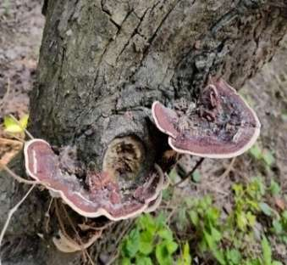

**F2**

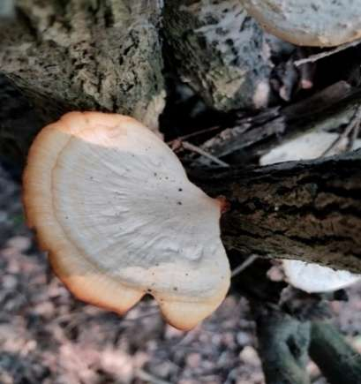

**F3**

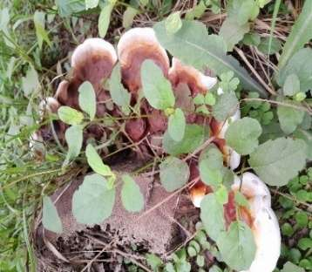

**F1**

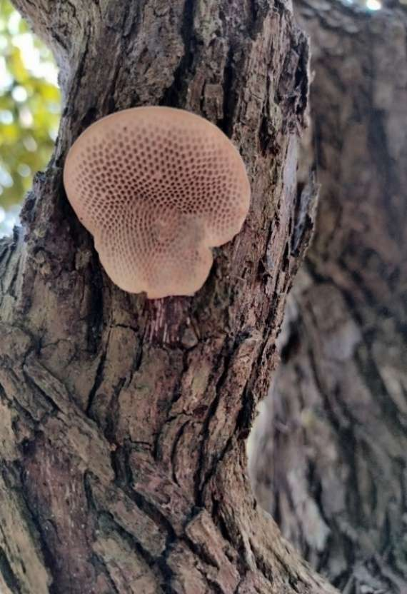

**F4**

Fig 1. Macro-morphology of collected polyporales fungi. (F1) Fruiting body of *Ganoderma* sp., (F2) Fruiting body of *Trametes* sp., (F3) Fruiting body of *Polyporus* sp., and (F4) Fruiting body of *Hexagonia* sp.

Table 1. Characteristics of collected Polyporales fungi and their identification

|  |  |  |  |  |
| --- | --- | --- | --- | --- |
| Sample | External morphology | Colony morphology on PDA | Microscopic structure | Identification |
| F1 | Reddish-brown glossy exterior with white edge, woody texture, and fan like appearance, stipe present | Round, white, compact, cottony texture | Hyphae septate, ellipsoid spore | *Ganoderma sp.* |
| F2 | Dark brown wavy exterior with white edges, sessile, thin bracket like cap | Round, white, velvety texture | Trimitic hyphae, ellipsoid spore | *Trametes sp.* |
| F3 | White or cream wavy cap with brown edges, stipe present, porous on ventral side | Round or filamentous, white, dense, fluffy | Hyphae septate, ellipsoid spore | *Pol yporus sp.* |
| F4 | Pale brown or off white color, honeycomb like hexagonal pores on the ventral side, sessile | Round or filamentous, off white, dense, and compact | Trimitic hyphae, cylindrical spore | *Hexagonia sp.* |

All these 4 samples (*Ganoderma* sp., *Trametes* sp., *Polyporus* sp., and *Hexagonia* sp. were grown on four different culture media (PDA, SDA, MEA, and YMPA) and incubated at 27±2 ℃ in dark conditions for 5 days (Table 2). All of the isolates showed better growth on PDA media rather than SDA, MEA, and YMPA. Among these 4 samples, *Trametes* sp. and *Hexagonia* sp. showed poor radial growth of 35 mm and 37 mm on PDA, whereas *Ganoderma* sp. and *Polyporus* sp. showed radial growth of 58 mm and 57 mm. Therefore, *Ganoderma* sp. and *Polyporus* sp. were selected for their growth optimization in different pH and incubation temperatures using PDA media, and different substrates to get massive mycelial growth or to form mycelial mat.

Table 2. Effects of different culture media on fungal growth

|  |  |  |  |  |  |  |
| --- | --- | --- | --- | --- | --- | --- |
| Strains | Radial Growth (mm in 5 days) | | | | Mycelial density on PDA | Growth rate on PDA (mm/day) |
| PDA | SDA | MEA | YMPA |
| *Ganoderma sp.* | 58 | 42 | 47 | 32 | Thick | 11.60 |
| *Trametes sp.* | 35 | 29 | 28 | 23 | Thin | 7.00 |
| *Polyporus sp.* | 57 | 41 | 43 | 34 | Thick | 11.40 |
| *Hexagonia sp.* | 37 | 28 | 21 | 27 | Thin | 7.40 |

PDA (Potato Dextrose Agar), SDA (Sabouraud Dextrose Agar), MEA (Malt Extract Agar), and YMPA (Yeast Extract-Malt Extract-Peptone Agar)

Temperature is a key factor for fungal growth. To find out the optimum temperature, *Ganoderma* sp. and *Polyporus* sp. were allowed to grow on a PDA medium at seven different temperatures such as 15℃, 20℃, 25℃, 27℃, 30℃, 35℃, and 40℃. Both *Ganoderma* sp. and *Polyporus* sp. were found to grow well in the temperature range 25℃ to 30℃ and the optimum temperature for their maximum growth was 27℃ (Fig. 2). However, the mycelial growth was suppressed at temperatures below 20℃ and above 30℃. According to del Rosario *et al.* (2022), the optimum growth temperature for *G. gibbosum* was 30℃, and for *G. applanatum* and *G. australe* were between 25℃ to 30℃. Nguyen *et al.* (2023) reported the highest mycelial growth between 25℃ to 30℃. In a study of Subedi *et al.* (2021), the highest mycelial growth of *Ganoderma* was observed between 28℃-32℃.

pH has a great impact on cell morphology, cell function, nutrient absorption, and enzyme activity of fungi. A wide range of pH (4, 5, 6, 7, 8, 9, and 10) was observed for the growth of *Ganoderma* sp. and *Polyporus* sp. The pH of the growth media was adjusted using 0.1 M NaOH or 0.1 M HCl. It was found that *Ganoderma* sp. and *Polyporus* sp. were able to grow in all pH values but can grow well at pH ranging from 6.0 to 9.0 (Fig. 2). Similar results were also reported by Jo *et al.* (2009) and Nguyen *et al.* (2023). In a different study, Subedi *et al.* (2021) documented the maximum growth of *Ganoderma* at a pH range of 4.5-5.5. In consequence, optimal pH for mycelial growth varies from genus to genus or different species under the same genus.

Fig. 2. Effect of temperature and pH on radial mycelial growth of *Ganoderma* sp. and *Polyporus* sp.

To obtain an optimum incubation period, culture plates were incubated for 1 to 7 days at 27℃ in dark conditions and growth was observed regularly (Fig. 3). Whole culture plates were covered with fungal growth within 5 days of incubation. Maximum fungal growth appeared at 5-7 days of incubation, after that the growth started to deteriorate due to utilization of nutrients present in media.

Day-0

Day-3

Day-1

Day-5

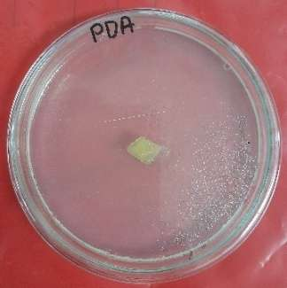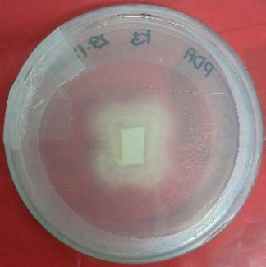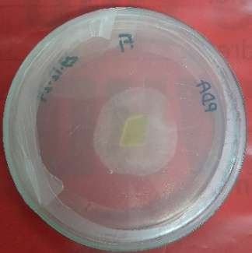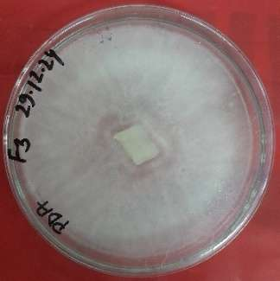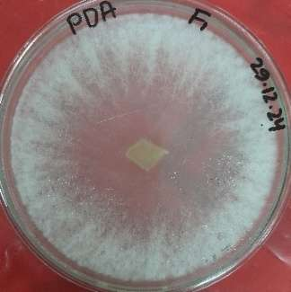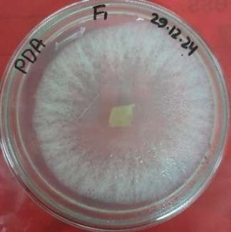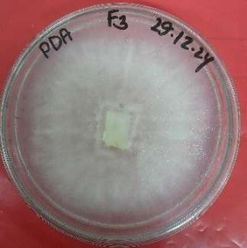

Fig. 3. Growth of *Ganoderma* sp. (row-1) and *Polyporus* sp. (row-2) on PDA media at different growth periods.

Mycelial mat or extensive proliferation of fungal mycelium was the fundamental prerequisite for fungal biocomposite development. For mycelial mat formation, *Ganoderma* sp. and *Polyporus* sp. were grown on 4 different substrates such as sawdust, rice straw, rice husk, and sugarcane bagasse. Both isolates showed colonization on all substrates, but sawdust was found to be a more suitable substrate for mycelial growth than the other three substrates (Fig. 4 and Fig. 5). It was also observed that *Ganoderma* sp. showed quick mycelial colonization on sawdust than *Polyporus* sp. In a different study, Raman *et al.* (2022) used sawdust as a substrate for mycelial mat formation. del Rosario *et al.* (2022) used two substrates (sawdust and rice straw) and found sawdust better for the mycelial growth of *Ganoderma* sp. Bae *et al.* (2021) also found sawdust as a suitable substrate for mat formation.

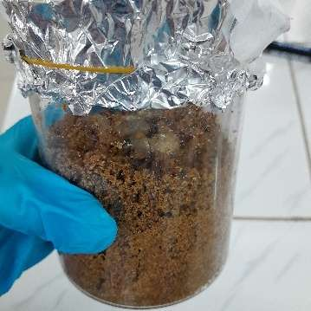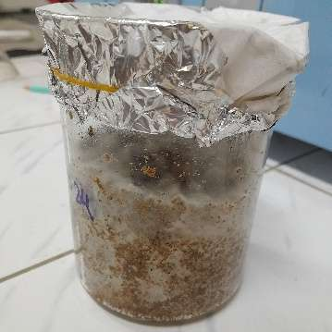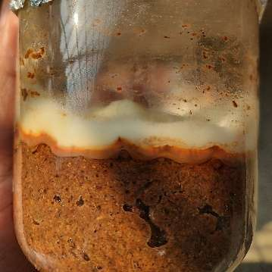

**a**

**b**

**c**

Fig. 4. Growth of *Ganoderma* sp. on sawdust at different growth periods. (a) Inoculation of 7-day-old fungal culture on sawdust, (b) Mycelial growth after 7 days of incubation at 27 ℃ in dark conditions, and (c) Mycelial growth after 15 days of incubation and about 1 cm mycelial mat appeared on the surface of sawdust.

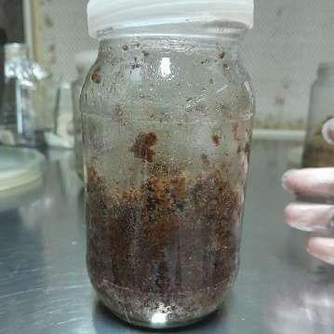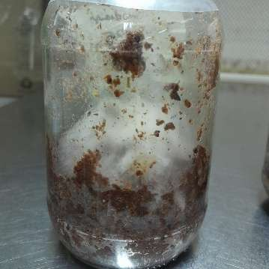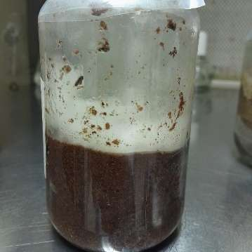

Fig. 5. Growth of *Polyporus* sp. on sawdust at different growth periods. (a) Inoculation of 7-day-old fungal culture on sawdust, (b) Mycelial growth after 7 days of incubation at 27 ℃ in dark conditions, and (c) Mycelial growth after 15 days of incubation and about 0.5 cm mycelial mat appeared on the surface of sawdust.

**a**

**b**

**c**

4. Conclusion

The findings of this study showed that fungal mycelia respond differently when cultured under various conditions. However, further studies on the effect of substrate supplementation need to be investigated to improve the production of mycelial mat.

References

1. Alam, S.A., Shamsi, S., & Ahmed, A., (2024). New records of macrofungi of the mangrove ecosystem of Sundarbans of Bangladesh. Bangladesh J. Plant Taxon., 31(2), 293-299.
2. Alaneme, K.K., Anaele, J.U., Oke, T.M., Kareem, S.A., Adediran, M., Ajibuwa, O.A., & Anabaranze, Y.O. (2023). Mycelium based composites: A review of their bio-fabrication procedures, material properties and potential for green building and construction applications. Alex. Eng. J., 83, 234-250.
3. Alemu, D., Tafesse, M., & Gudetta, D.Y. (2022). Production of mycoblock from the mycelium of the fungus *Pleurotus ostreatus* for use as sustainable construction materials. Adv. Mater. Sci. Eng., 2022(1), 2876643.
4. Arora, D.I. (1986). Mushrooms demystified. Ten Speed Press, Berkeley, UK.
5. Bae, B., Kim, M., Kim, S., & Ro, H.S. (2021). Growth Characteristics of polyporales mushrooms for the mycelial mat formation. Mycobiology, 49(3), 280-284.
6. Das, K., & Aminuzzaman, F.M. (2017). Morphological and ecological characterization of xylotrophic fungi in mangrove forest regions of Bangladesh. J. Adv. Biol. Biotechnol., 11(4), 1-15.
7. del Rosario, M.A., Dulay, R.M., Kalaw, S.P., Damaso, Jr.EJ., Ramos, J.P., Abon, M.A., De Leon, A.M., & Reyes, R.G. (2022). Optimization of mycelial culture conditions and fructification of Ganoderma species in rice straw-based substrates. J. ISSAAS., 28(2), 42-51.
8. Dickinson, C.H., & Lucas, J.A. (1982). VNR color Dictionary of Mushrooms. New York, New York: Van Nostrand Reinhold.
9. Fabros, J.A., Lazo, M.K., Magpantay, J.E., Abon, M.D., Dulay, R.M., Kalaw, S.P., & Reyes, R.G., (2023). The effect of nutritional and physical factors on the growth of *Trametes versicolor* (L.) Lloyd and its mycochemical and cytotoxic properties. Stud. Fungi., 8(1): 1-9.
10. Islam, M.R., Tudryn, G., Bucinell, R., Schadler, L., & Picu, R.C. (2017). Morphology and mechanics of fungal mycelium. Sci. Rep., 7(1), 1-12.
11. Jo, W.S., Cho, Y.J., Cho, D.H., Park, S.D., Yoo, Y.B., & Seok, S.J. (2009). Culture conditions for the mycelial growth of Ganoderma applanatum. Mycobiology., 37(2), 94-102.
12. Jorden, P. (2000). The mushroom guide and identifier. Anness publishing limited Hermes House London.
13. Li, K., Jia, J., Wu, N., & Xu, Q. (2022). Recent advances in the construction of biocomposites based on fungal mycelia. Front. Bioeng. Biotechnol., 10, 1-10.
14. Mahajan, M. (2019). Conventional Methods for Direct Examination of Fungi. Systemic Fungal Infections: Principles, Pathogenesis & Practice., 19-24 p.
15. Manan, S., Ullah, M.W., Ul-Islam, M., Atta, O.M., & Yang, G. (2021). Synthesis and applications of fungal mycelium-based advanced functional materials. J. Bioresour. Bioprod., 6(1), 1-10.
16. Nguyen, L.T., Van Le, V., Nguyen, B.T., Nguyen, H.T., Tran, A.D., & Ngo, N.X. (2023). Optimization of mycelial growth and cultivation of wild *Ganoderma sinense*. Biotechnologia., 104(1), 65-74.
17. Raman, J., Kim, D.S., Kim, H.S., Oh, D.S., & Shin, H.J. (2022). Mycofabrication of mycelium-based leather from brown-rot fungi. J. of Fungi., 8(3), 317.
18. Raut, I., Calin, M., Vuluga, Z., Oancea, F., Paceagiu, J., Radu, N., Doni, M., Alexandrescu, E., Purcar, V., Gurban, A.M., & Petre, I. (2021). Fungal based biopolymer composites for construction materials. Materials., 14(11), 1-20.
19. Subedi, K., Basnet, B.B., Panday, R., Neupane, M., & Tripathi, G.R. (2021). Optimization of growth conditions and biological activities of Nepalese Ganoderma lucidum strain Philippine. Adv. Pharmacol. Pharm. Sci., 2021(1): 1-7.