***In Vitro* Alpha- Amylase and Alpha- Glucosidase Inhibitory Effects of the Methanolic Leaf Extract of *Ficus abutilifolia***

ABSTRACT

|  |
| --- |
| Aim: to investigate α –amylase and α-glucosidase inhibitory effects of the methanolic leaf extract of *Ficus abutilifolia in vitro.*  Study design: The leaf extract was fractionated using Thin Layer Chromatography.  Place and Duration of Study: Department of Biochemistry, Umaru Musa Yar’adua University, Katsina, between July 2024 and November 2024.  Methodology: The fractions of the leaf extract were evaluated for the presence of phytochemicals. The fractions were subjected to α –amylase and α-glucosidase inhibition assays. Different functional groups of bioactive compounds present in the fractions were identified using FT-IR spectroscopy.  Results: Qualitative phytochemical analysis of the extract revealed the presence of alkaloids, saponins, flavonoids, phenols, and cardiac glycosides. Quantification of the phytochemicals showed total alkaloids of (43.556 ± 7.154 mg AE/g), total saponins of (50.857 ± 0.584 mg DE/g), total flavonoids of (36.927± 0.554 mg RE/g) total phenols of (98.419± 9.548), and total cardiac glycosides of (0.540 ± 0.010 %). All the fractions displayed significant inhibitory activities against α –amylase and α-glucosidase. However, Fraction 1 had inhibited α- amylase and α-glucosidase higher than other fractions with IC50 values (36.233 ± 3.223 μg/mL and 121.265 ± 6.348 μg/mL) respectively, though significantly (p< 0.05) lower than acarbose (11.688 ± 3.205 μg/mL and 82.046 ± 3.571 μg/mL). Fraction 3 showed weak inhibitory activity on both enzymes (72.023 ± 5.400 μg/mL and 145.963 ± 4.400 μg/mL). FT-IR analysis of the fractions revealed the presence of different functional groups such as alkanes, alkenes, alkynes, phenols/alcohols, aldehydes, alkyl halides, aliphatic and aromatic amines.  Conclusion: This study demonstrated that the methanolic leaf extract of *Ficus abutilifolia* possesses *in vitro* α –amylase and α-glucosidase inhibitory effects which could be useful in management of postprandial hyperglycemia. . |

*Keywords**: Ficus abutilifolia, α –amylase, α-glucosidase, Inhibitory effects.*

1. INTRODUCTION

Diabetes mellitus (DM) is a metabolic disorder characterised by chronic hyperglycaemia or increased blood glucose levels with disturbances in carbohydrate, fat and protein metabolism resulting from absolute or relative lack of insulin secretion [1]. DM is classified into two main categories: Type 1 diabetes mellitus, caused due to complete absence of insulin production and Type 2 diabetes mellitus, occurred due to the relative deficiency of insulin secretion and tissue resistance to insulin action [2]. Postprandial hyperglycemia (PPHG) plays a vital role in the development of type 2 diabetes and its associated chronic complication [3]. People with diabetes are more vulnerable to COVID - 19 severity than non-diabetic patients [4].

According to International Diabetes Federation reports, the global prevalence of diabetes mellitus (DM) reached 9.5% (463 million adults) in 2019 to 10.5% (536.6 million adults) in 2021, rising to 12.2% (783.2million) in 2045 [5], despite global efforts to control the disease. Out of about 537 million people living with Diabetes world-wide, it is estimated that about 55 million people are living with the disease in Africa [6]. Type 2 diabetes accounts for approximately 90 - 95 % of all diabetic cases globally [7]. Several synthetic antidiabetic medications such as acarbose, miglitol etc., are available. However, these drugs have severe complications with undesirable side effects such as diarrhea, flatulence, bloating and nausea [4].

The use of natural products for health started from thousands of years and still a part of practice in other countries [8]. Naturally occurring bioactive components have the potential to delay, defend, control or even prevent the pathogenesis and progression of diseases as well as possessing health-promoting abilities with medicinal properties [9]. Of these, controlling postprandial hyperglycemia via the inhibition of starch-hydrolysing enzymes, using α-amylase and α-glucosidase inhibitors derived from plant, is an effective therapy for type 2 DM [10]. Inhibition of these enzymes delay and in some cases halt carbohydrate digestion, thus prolonging overall carbohydrate digestion time, causing a reduction in the rate of glucose absorption and consequently reducing postprandial plasma glucose rise in type 2 diabetes mellitus (T2DM) [1].

*Ficus abutilifolia,* family, Moraceaeis a small to medium sized, deciduous to semi-deciduous tree that may grow up to 15 m high and grow mostly in the African continent [11]. Chemically, the plant contains glycosides, saponins, flavonoids, anthraquinones as well as alkaloids and tannins [12]. Traditionally, the plant had been used to treat various diseases in Nigeria such as typhoid fever, dysentery, food poison and sexually transmitted infections [13]. Although several studies have been conducted on the biological and pharmacological potentials of *F. abutilifolia*, there is paucity of information regarding its effect on α-amylase and α-glucosidase *in vitro*. The aim of this study, was to evaluate the *in vitro* α-amylase and α-glucosidase inhibitory effects of the methanolic leaf extract of *F. abutilifolia.*

2. material and methods

## **Chemicals and Reagents**

All chemicals and reagents used in this study were of analytical grade.

**Plant Material**

Fresh leaves of *Ficus abutilifolia* were collected from its natural habitat, in the month of July, 2024 at Ajiwa village of Katsina State, Nigeria. The sample was identified, authenticated and deposited in the Herbarium, Department of Biology, Umaru Musa Yar’adua University, Katsina State, Nigeria, where a Voucher specimen (UMYUH12) was assigned for future reference. Thereafter, the fresh leaves were washed under running tap to remove all foliar contaminants, and air dried under shade at room temperature for four weeks until completely dried. The dried leaves were grounded into fine powder using pestle and mortar, labelled and then stored in an air tight dry container.

**Preparation of Plant Extract**

Fifty grams (50g) of powdered sample was soaked in 250 mL of methanol for five days away from sunlight with frequent agitation. The resulting mixture was filtered using Whatmann filter Paper. The filtrate was evaporated to dryness using a hot air oven at 50oC to obtain waxen extract which was then refrigerated at 4oC to avoid biological degradation until required for further use. The percentage yield of the evaporated dried extract was 7.48%.

**Qualitative Phytochemical Analysis**

Phytochemical composition of the plant extract was determined by the method described by [14], to identify the presence of alkaloids, flavonoids, phenols, saponins, tannins, terpenoids, steroids and cardiac glycosides.

**Quantitative Phytochemical Analysis**

Quantitative determination of the detected secondary metabolites was carried out using the methods of [15, 16, 17, 18 and 19].

## **Thin Layer Chromatography (TLC) Analysis**

Thin Layer Chromatography was undertaken according to the method described by Kidane *et al.* [20] with slight modification. Briefly, Test sample (1 mg/mL of extract in methanol) was drawn with micropipette and applied on a stationary phase (silica-gel coated plate) about 1 cm from the base. The sample was allowed to dry and then dipped carefully into the mobile phase (ratio of 5 mL of ethyl acetate to 5 mL of methanol). After the solvent has reached nearly 3/4th of the plate, the plate was removed from the tank and dried briefly at moderate temperatures 60-120°C. Each band obtained was separately scrapped into a labelled beaker and then washed with methanol to obtain pure fractions. The obtained fractions were evaporated to dryness using a hot air oven and stored until required for the bioassays. The analysis was performed in triplicate. Retention factor (Rf) values of the fractions were calculated using:

Rf = Distance travelled by the sample/ Distance travelled by the solvent

## ***In Vitro* Alpha-amylase Inhibitory Assay**

This assay was carried out using a modified procedure of [21]. A total of 250 μL of each fraction of varied concentration ranging from (31.25 – 1000 µg/mL) was placed in a tube and 250 μL of pancreatic α-amylase solution (0.45 mg/ mL) in 0.02 M sodium phosphate buffer (pH 6.9) was added. The mixture was incubated at 25oC for 10 min, after which 250 μL of starch solution (1%) in 0.02 M sodium phosphate buffer (pH 6.9) was added. This reaction mixture was again incubated at 25°C for 10 min. The reaction was finally quenched by 500 μL of a reagent, 96mM 3,5-dinitrosalicylic acid (DNS), and further incubated in boiling water for 5 min and then cooled at room temperature. The content of each test tube was diluted with 5 mL of distilled water and the absorbance was measured at 540 nm in a spectrophotometer. Absorbance of control was also measured. The assay was carried out in triplicate for each fraction. The results were expressed as percentage inhibition of α-amylase activity using the following formula:

Inhibition (%) = [(A Control –A Sample) /A Control] ×100

where A control is the absorbance of the control and A sample is the absorbance of the sample.

## ***In Vitro* Alpha-glucosidase Inhibitory Assay**

This assay was carried out according to the method described by Kim *et al*. [22] using α-glucosidase from *Saccharomyces cerevisiae*. A total of 50 μL of each fraction of varied concentration ranging from (31.25 – 1000 µg/mL) was placed in a tube and 100 μL of α- glucosidase (1.0 mg/mL) in 100 mM sodium phosphate buffer (pH 6.9) was added. The mixture was incubated at room temperature for 10 min, after which 50 μL of substrate solution, p-nitrophenyl glucopyranoside (pNPG) (3.0 mM) in 0.02 M sodium phosphate buffer (pH 6.9) was added. This reaction mixture was again incubated at 37°C for 20 min. The reaction was finally quenched by 2 mL of 0.1 M Na2CO3. The absorbance of the yellow colored p-nitrophenol, released from pNPG, was measured at 405 nm. Absorbance of control was also measured. The assay was carried out in triplicate for each fraction. The results were expressed as percentage inhibition of α-glucosidase activity using the following formula:

Inhibition (%) = [(A Control –A Sample) /A Control] ×100

where A control is the absorbance of the control and A sample is the absorbance of the sample.

## **Fourier Transform Infrared (FTIR)-Spectroscopic Analysis**

The FT-IR spectroscopic analysis was carried out for each fraction according to the method described by Abdulrahman *et al*. [23] using software and FTIR spectroscope. Scan range of 650-4000 cm⁻¹ and a resolution of 8 cm⁻¹ was used to detect the characteristic peaks of the phytochemical functional groups. The peaks obtained were analysed using a standard IR spectra table.

## **Statistical Analysis**

Statistical analysis was performed using Graph Pad Instat3 Software version, 3.05. One-way analysis of variance (ANOVA) was used to evaluate the statistical differences between different inhibitory concentrations followed by Tukey HSD post hoc test. Probit regression modelling was used to estimate the 50% inhibitory concentration (IC50). The values were considered significant when P<0.05. Experiments were done in triplicate and the mean value was reported as mean ± S.D.

3. results and discussion

**Qualitative Phytochemical Analysis**

Qualitative phytochemical tests for the methaolic leaf extract of *F. abutilifolia* revealed the presence of alkaloids, flavonoids, phenols, saponins and cardiac glycosides. However, tannins, terpenoids and steroids were not detected (Table 1).

Table 1: Qualitative Phytochemical Content of the Methanolic Leaf Extract of *F. abutilifolia.*

|  |  |
| --- | --- |
| Phytochemicals Tested | Inference |
| Alkaloids | + |
| Flavonoids | + |
| Phenols | + |
| Tannins | - |
| Saponins | + |
| Steroids | - |
| Terpenoids | - |
| Cardiac glycosides | + |

Key: (+) detected, (-) not detected

**Quantitative Phytochemical Analysis**

Table 2 revealed that the methanolic leaf extract of *F. abutilifolia* showed a variable amount of flavonoids (36.927± 0.554 mg RE/g), alkaloids (43.556 ± 7.154 mg AE/g), phenols (98.419 ± 9.548 mg GAE/g), saponins (50.857 ± 0.584 mg DE/g) and cardiac glycosides (0.540 ± 0.010 %).

Table 2: Quantitative Phytochemical Composition of the Methanolic Leaf Extract of *F. abutilifolia.*

|  |  |  |  |  |
| --- | --- | --- | --- | --- |
| Total Alkaloids (mg AE/g) | Total Saponins (mg DE/g) | Total Flavonoids (mg RE/g) | Total Phenols (mg GAE/g) | Total Cardiac glycosides (%) |
| 43.556 ± 7.154 | 50.857 ± 0.584 | 36.927± 0.554 | 98.419 ± 9.548 | 0.540 ± 0.010 |

Key: AE: Atropine Equivalent, DE: Diosgenin Equivalent, RE: Rutin Equivalent, GAE: Gallic Acid Equivalent.

Values are presented as mean ± S.D of triplicate determinations (n=3).

**Thin Layer Chromatography**

The methanolic leaf extract of *F. abutilifolia* was fractionated and total of four fractions were obtained. The Rf values of Fraction 1, Fraction 2, Fraction 3, and Fraction 4 were 0.352 ± 0.003, 0.529 ± 0.021, 0.705 ± 0.042 and 0.970 ± 0.054 respectively (Table 3).

Table 3: Fractions of the Methanolic Leaf Extract of *F. abutilifolia*

|  |  |
| --- | --- |
| **Fractions** | **Retention factor (Rf)** |
| Fraction 1 | 0.352±0.003 |
| Fraction 2 | 0.529±0.021 |
| Fraction 3 | 0.705±0.042 |
| Fraction 4 | 0.970±0.054 |

Data are presented as mean ± standard deviation of triplicate readings (n=3).

***In Vitro* α- amylase Inhibitory Activity.**

The inhibitory effects of fractions of the methanolic leaf extract of *F. abutilifolia* on α- amylase are displayed in Figure 1. All fractions showed α-amylase inhibitory action in a concentration dependent manner. The percentage inhibitory activity of acarbose on α- amylase was significantly (P<0.05) higher than all fractions at all concentrations (31.25-1000 μg/mL). Fraction 1 had inhibited α- amylase higher than other fractions at all concentrations except at 125 and 250 μg/mL, where, fraction 4, had the highest inhibitory activity, followed by fraction 2. Fraction 3 had the least percentage inhibition of α-amylase.

The IC50 values of fractions of the methanolic leaf extract of *F. abutilifolia* on α-amylase are presented in Table 4. Fraction 1 displayed significantly (p<0.05) lower IC50 value of (36.233 ± 3.223 μg/mL) against α-amylase when compared with other fractions. Fraction 3 had the highest IC₅₀ value (72.023 ± 5.400 μg/mL) and it was significantly (p<0.05) different from other fractions and acarbose. IC50 values of fraction 1 and fraction 4 (36.233 ± 3.223 and 48.365 ± 0.724) μg/mL did not differ significantly from each other. Acarbose showed the lowest IC50 value (11.688 ± 3.205 μg/mL).

**Figure 1**: Graph of α -amylase Inhibitory Activity of Different Fractions of the Methanolic Leaf Extract of *F. abutilifolia.*

***In Vitro* α- glucosidase Inhibitory Activity.**

The α-glucosidase percentage inhibitory activity showed that at high concentrations (500 μg/ml and 1000 μg/ml), fraction 1 had inhibited α-glucosidase higher than other fractions though significantly (P<0.05) lower than acarbose, followed by fraction 4. Fraction 2 and fraction 3 had the least percentage inhibition activities against α glucosidase (Figure 2).

Fraction 1 displayed significantly (p<0.05) lower IC50 value (121.265 ± 6.348 μg/mL) when compared with other fractions. Fraction 3 had the highest IC50 value (145.963 ± 4.400 μg/mL) and did not differ significantly (p<0.05) from fraction 2 (138.359 ± 3.662 μg/mL). Acarbose showed the lowest IC50 value (82.046 ± 3.571 μg/mL) (Table 4).

Figure 2: Graph of α -glucosidase Inhibitory Activity of Different Fractions of the Methanolic Leaf Extract of *F. abutilifolia.*

Table 4: IC50 of α -amylase and α -Glucosidase Inhibitory Activities of Fractions of the Methanolic Leaf Extract of *F. abutilifolia.*

|  |  |  |
| --- | --- | --- |
|  | **IC50** values (μg/mL) |  |
| Fractions | **α- amylase** | **α- glucosidase** |
| Fraction 1 | 36.233 ± 3.223b | 121.265 ± 6.348c |
| Fraction 2 | 57.189 ± 3.420c | 138.359 ± 3.662d |
| Fraction 3 | 72.023 ± 5.400d | 145.963 ± 4.400d |
| Fraction 4 | 48.365 ± 0.724b | 128.659 ± 5.871b |
| Ascorbic acid | 11.688 ± 3.205a | 82.046 ± 3.571a |

Data are presented as mean ± standard deviations of triplicate readings n=3. Values within the same column bearing different superscripts letters are statistically (p<0.05) different.

## **FTIR- Analysis of Fractions of the Methanolic Leaf Extract of *F. abutilifolia****.*

The FTIR spectrum of fraction 1 confirmed the presence of phenols and alcohols with peak values at 3670.99 cm⁻¹ corresponded to hydroxyl and O-H bonding respectively. The peak values obtained at; 2832.77 cm⁻¹ and 2944.76 cm⁻¹ (C-H stretch) confirmed alkanes, 1655.96 cm⁻¹ (-C=C-H:C-H stretch) showed alkenes, 668.67 cm⁻¹ and 1990.0cm⁻¹ (-C=C-H:C-H bend) generated alkynes. Peak values at 1119.89 cm⁻¹, 1026.18 cm⁻¹ and 2166.10 cm⁻¹ confirmed, alkyl halides (-CH2X), aliphatic amines (C-N stretch) and aldehydes (C-H stretch) respectively (Figure 3).

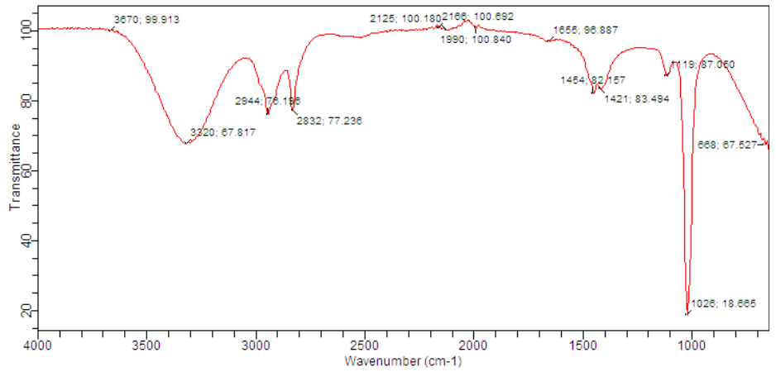

Figure 3: Fourier Transformation Infrared (FTIR) Spectrum of Fraction 1.

Fraction 2 showed characteristics absorption bands at; 2832.77 cm⁻¹, 2944.76 cm⁻¹ (C-H stretch), and 1424.83 cm⁻¹ (C-H bend) for alkanes, 1655.97 cm⁻¹ (-C=C- stretch) for alkenes, 2117.10 cm⁻¹ for alkynes, 1119.87 cm⁻¹ and 1026.18 cm⁻¹ for alkyl halides(-CH2X) and aliphatic amines (C-N stretch) respectively (Figure 4).

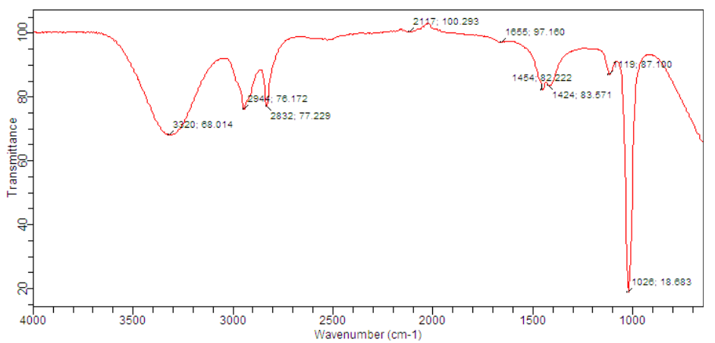

Figure 4: Fourier Transformation Infrared (FTIR) Spectrum of Fraction 2.

For fraction 3, peaks at 2832.77 cm⁻¹ and 2944.77 cm⁻¹ (C-H stretch) revealed alkanes, 1674.98 cm⁻¹ (-C=C- stretch) generated alkenes and 3324 cm⁻¹ confirmed alkynes (terminal). At 1119.87 cm⁻¹ and 1026.19 cm⁻¹, alkyl halides(-CH2X) and aliphatic amines (C-N stretch) were seen respectively (Figure 5).

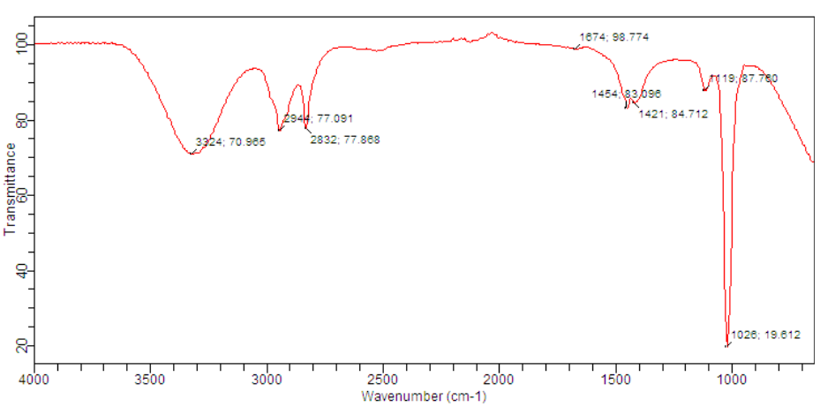

**Figure 5:** Fourier Transformation Infrared (FTIR) Spectrum of Fraction 3.

The peak values of fraction 4 revealed 2944.76 cm⁻¹ (C-H stretch) and 1451.83 cm⁻¹ (C-H bend) for alkanes, 1655.96 cm⁻¹ (-C=C- stretch), 1413.82 cm⁻¹, 959.78 cm⁻¹ (C-H bend) for alkenes, and 2121.10 cm⁻¹ for alkynes. The values at 1119.87 cm⁻¹, 1026.18 cm⁻¹ and 1320.92 cm⁻¹ confirmed alkyl halides (-CH2X), aliphatic amines (C-N stretch) and aromatic amines (C-N stretch) respectively (Figure 6).

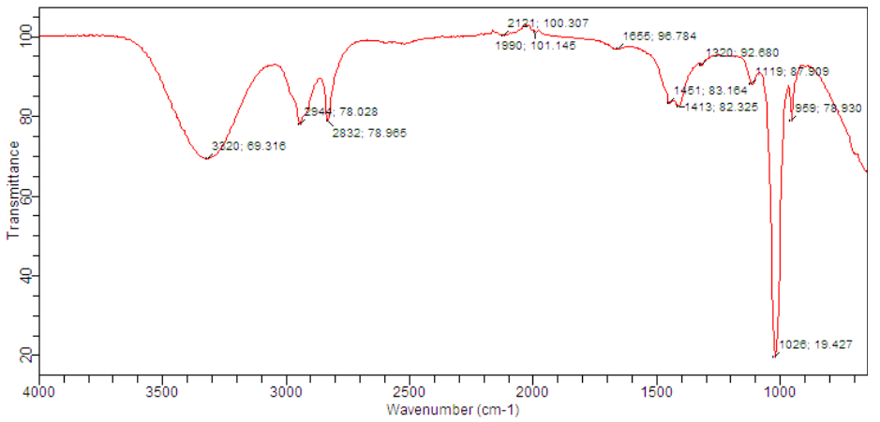

**Figure 6:** Fourier Transformation Infrared (FTIR) Spectrum of Fraction 4.

**DISCUSSION**

Phytochemical analyses are essential methods in phyto-medicine especially since plants of the same species may differ in terms of constituents available [24]. Moreover, medicinal properties of plants lie in their phytochemical composition [25]. In this study, phytochemical screening was conducted to evaluate different bio-active compounds present in the methanolic leaf extract of *F. abutilifolia*, which may be responsible for the medicinal property of the plant [24]. The evaluation of phytoconstituents of the methanolic leaf extract of *F. abutilifolia* revealed the presence of alkaloids, saponins, flavonoids, phenols and cardiac glycosides while tannins, steroids and terpenoids were not detected. Ahmad *et al.* [24] reported the presence of these compounds in aqueous leaf extract of *F. abutilifolia.* The absence of tannins, steroids and terpenoids could be due to the origin of the plant, solvent polarity or the method of extraction as these may influence the composition of the extract on chemical constituents [26]. High phenolic (98.419 mg GAE/g) and low flavonoid (36.927± 0.554 mg RE/g) and contents were seen in this study. The presence of high phenols in the methanolic leaf extract of *F. abutilifolia* was supported by Madeleine *et al*. [27] who reported high phenolic content in the leaf extracts of *F. abutilifolia*. Thus, the effects of *F. abutilifolia* methanolic leafextract may be associated with the high content of phenolics.

The ensign of diabetes mellitus is high blood glucose level which leads to hyperglycemia; therefore, effective control of postprandial hyperglycemia and its associated complications at an early stage of the disease is crucial [26]. In this study, the effects of fractions of the methanolic leaf extract of *F. abutilifolia* on α-amylase and α-glucosidase were investigated *in vitro*. All the fractions investigated in this study demonstrated significant potency in inhibiting activities of α-amylase and α-glucosidase. The findings are in agreement with that of Olaokun *et al*. [28] who reported significant inhibitory activities of ten Ficus species against α-amylase and α-glucosidase. Fraction 1 was found to have stronger inhibitory activity on both enzymes followed by fraction 4, with appreciable activities. Fraction 2 had the least inhibitory activity after fraction 3, which had the highest IC50 values (72.023 ± 5.400 μg/mL and 145.963 ± 4.400 μg/mL) for α-amylase and α-glucosidase respectively. The activities of these fractions against α-amylase and α-glucosidase could be attributed to the presence of the phytochemicals in the fractions. High activity of fraction 1 may be attributed to the presence of phenols. This is supported by other reports that secondary metabolites have high ability to inhibit the activity of α-amylase enzyme compared to primary metabolites [29]. Suryavanshi *et al*. [30] stated that phenolic acids have shown their potential in lowering blood sugar levels by inhibiting α-amylase and α-glucosidase activities. A systematic review of literature revealed that phenols showed potent inhibitory activity toward α-glucosidase [26].

Despite some reports on bioactivities of *F. abutilifolia*, there is paucity of information regarding the effects of fractions of the methanolic leaf extract of *F. abutilifolia* on α- amylase and α-glucosidase *in vitro*. However, the present findings are in accordance with Deepa *et al*. [31] results, where different Ficus species were reported to possess antidiabetic properties. Mopuri *et al*. [32] reported that different extracts of fruits and leaves of *F. carica* showed a potent inhibitory activity against α-amylase and α-glucosidase enzymes. However, the present study showed higher inhibitory activities against α- amylase and α- glucosidase when compared with extracts of fruits and leaves of *F. carica*.

The FT-IR spectroscopic analysis of fractions of the methanolic leaf extract of *F. abutilifolia* revealed the existence of different biologically active functional groups like alkanes, alkenes, alkynes, phenols, alcohols, aldehydes, alkyl halides, aliphatic and aromatic amines. Most of the compounds were identical in all fractions. A notable exception was phenols, alcohols, and aldehydes found in fraction 1, and aromatic amines present in fraction 4, which might play a role in high activities of the fractions. As reported by Mayur *et al*. [33], phenolic compounds have antidiabetic potentials. Moreover, the presence of lone pair of electrons in amine functional group could stabilize free radicals that further help in the prevention of oxidative stress in the cell [30] and thus, manages diabetes. Therefore, the presence of these functional groups in the fractions may be responsible for the antidiabetic properties that the fractions displayed.

4. Conclusion

The present study indicated that the methanolic leaf extract of *F. abutilifolia* is endowed with various pharmacologically active phytoconstituents and showed significant α-amylase and α-glucosidase inhibitory activities. Fraction 1 of the methanolic leaf extract of *F. abutilifolia*, however, displayed higher activity than other fractions. FT-IR analysis results confirmed the existence of various functional groups of different bioactive compounds present in fractions of the methanolic leaf extract of *F. abutilifolia*. The obtained results demonstrated the potentials of the extract in mitigating postprandial hyperglycemia. Further studies are required to isolate and characterise the bioactive compounds responsible for the activities observed in this study. Also, antidiabetic potential of the methanolic leaf extract should be investigated *in vivo.*

References

1. Onah, E., Olufunke, D. M. and Mukaram, A. A. (2020). α - amylase and α -glucosidase antidiabetic potential of ten essential oils from *Calophyllum inophyllum Linn*. *Iberoamerican Journal of Medicine*, *04*: 253–260.
2. Xu, L., Li, Y., Dai, Y. and Peng, J. (2018). Natural products for the treatment of type 2 diabetes mellitus: Pharmacology and mechanisms. *Pharmacological Research*, *130*: 451-465.
3. Momina, S. S. and Rani, V. S. (2020). *In vitro* Studies on α-Amylase and α-Glucosidase Inhibitory Activity of Some Bioactive Extracts. *Journal of Young Pharmacists*, *12*(2): 72–75. <https://doi.org/10.5530/jyp.2020.12s.50>
4. Mehta, M., Puri, R., Angmo, D. and Devi, G. (2023). Phytochemical Screening , *In Vitro* Antidiabetic and Antioxidant Activity of *Rabdosia rugosa* ( Wall . ex Benth .) H . Hara Extract from Kinnaur District , Himachal Pradesh. *Defence Life Science Journal*, *8*(1): 62–70.
5. Sun, H., Saeedi, P., Karuranga, S., Pinkepank, M., Ogurtsova, K., Duncan, B. B., Stein, C., Basit, A., Chan, J. C. N., Mbanya, J. C., Pavkov, M. E., Ramachandaran, A., Wild, S. H., James, S., Herman, W. H., Zhang, P., Bommer, C., Kuo, S., Boyko, E. J. and Magliano, D. J. (2022). IDF diabetes atlas: Global, regional and country-level diabetes prevalence estimates for 2021 and projections for 2045. *Diabetes Research and Clinical Practice,* *183*: 109–119.
6. IDF, Diabetes Atlas. (2021). 10th edition. Retrieved November 30, 2022. Available from: <https://idf.org>.
7. Duangsri, W., Chaiyawatthanananthn, P., Itharat, A., Pipatrattanaseree, W. and Ooraikul, B. (2022). *In Vitro* α-Amylase , α-Glucosidase Inhibition , and Antioxidant Activities of Plant Components in Ya-Hom Teppajid. *Asian Medical Journal and Alternative Medicine*, *20*(22): 1–11.
8. Dahiru, T., Alhaji, A., Aliyu, A. and Shehu, A. (2016). A Review of Population Based Studies on Diabetes Mellitus in Nigeria. *Sub-saharan Afr J Med*., *3*(2): 59-61.
9. Mohammed, B. S., Sanadelaslam, E., Salwa, I. A. E. and Ahmed, S. J. (2024). *HPLC-PDA-MS* Identification of Phenolic Profile and *in Vitro* Antioxidant Activity of *Adansonia digitata L* . Leaves from Sudan. *Mor. J. Chem., 12*(1): 221–232.
10. Kanwugu, O. N., Glukhareva, T. V., Danilova, I. G. and Kovaleva, E. G. (2022). Natural antioxidants in diabetes treatment and management: Prospects of astaxanthin. *Critical Reviews in Food Science and Nutrition, 62*(18): 5005–5028.
11. Danmalam, U. H., Agunu, A., Abdurahman, E. M., Ilyas, N., Magaji, M. G. and Yaro, A. H. (2017). Anticonvulsant studies on a traditional antiepileptic mixture used by the Hausa people of north-western Nigeria. *Research Journal of Pharmacognosy (RJP), 4*(3): 113-116.
12. Ukwubile, C. A. (2013). Comparative Pharmacognostic Study of *Ficus abutilifolia* Miq . ( Moraceae ) Plant Leaf , Stem bark , and Root. *Scientific Journal of Crop Science,* *2*(1): 90–98.
13. Taiwo, F. O., Fidelis, A. A. and Oyedeji, O. (2016). Antibacterial Activity and Phytochemical Profile of Leaf Extracts of *Ficus abutilifolia*. *British Journal of Pharmaceutical Research*, *11*(6): 1–10. <https://doi.org/10.9734/BJPR/2016/25608>
14. Velavan, S. (2015). Phytochemical techniques - a review. *World Journal of Science and Research*, *1*(2): 80–91.
15. Ushie, O. A., Aikhoje, E. F., Aasegh, T. J., Ibrahim, A. I., Bako, B. and Ettah A. O. (2022). Estimation of Total Alkaloids, Saponins Flavonoid, Tannins and Phenols in *Thaumatococcus Danielli* Leaves. *World Journal of Pharmaceutical Research Article and Medical Research*, *8*(4): 242–246.
16. Makkar, H. P., Siddhuraju, P., Becker, K. (2007). Methods in molecular biology: plant secondary metabolites,Totowa: *Human Press*, *42:* 93-100.
17. Jia, Z. S., Tang, M. C. and Wu, J. M. (1999). The Determination Of Flavonoid Contents in Mulberry and Their Scavenging Effects on Superoxide Radicals. *Food Chemistry*, *64*: 555-559.
18. Siddhuraju, P. and Becker, K. (2003). Antioxidant Properties of Various Solvent Extracts of Total Phenolic Constituents From Three Different Agrocimatic Origins Of Drumstick. *Journal of Agriculture and Food Chemistry*, *51*(8): 2144-2155.
19. Muhammad, S. A. and Abubakar, S. M. (2016). Qualitative and Quantitative Determination of Phytochemicals in Aqueous Extract of *Chrysophyllumalbidum* Seed Kernel. *Biosciences Biotechnology Research Asia,* *13*(2): 1201–1206. <https://doi.org/10.13005/bbra/2153>.
20. Kidane, Y., Bokrezion, T., Mebrahtu, J., Mehari, M., Gebreab, Y. B., Fessehaye, N. and Achila, O. O. (2018). *In Vitro* Inhibition of  alpha-Amylase and alpha -Glucosidase by Extracts from *Psiadia punctulata* and *Meriandra bengalensis*. *Evidence-Based Complementary and Alternative Medicine*, *20*(18): 1–9.
21. Mccue, P. and Shetty, K. (2004). Inhibitory effects of *rosmarinic* acid extracts on porcine pancreatic amylase *in vitro*. *Asian Pac J ClinNut.*, *13*: 101-106.
22. Kim, Y. M., Jeong, Y. K., Wang, M. H. and Rhee, H. I. (2005). Inhibitory effect of pine extract on α-glucosidase activity and postprandial hyperglycemia. *Nutrition*, *21*: 756-761.
23. Abdulrahman, B. O., Bala M. and Oluwasesan, B. M. (2021). Evaluation of *in vitro* antioxidant and antidiabetic potential of extracts from *Phaseolus vulgaris L*. seeds (Black turtle beans). *Functional Food Science*, *1*(9): 23-38.
24. Ahmad, U., Salisu, N. and Sani, D. (2023). Phytochemical Evaluation and Acute Oral Toxicity of Aqueous Leaf Extract of *Ficus abutilifolia* (Miq) in Mice. *Arid Zone Journal of Basic and Applied Research,* *2*(4): 12–18.
25. Deepa, V. S., Rajaram, K. and Kumar, P. S. (2013). *In vitro* and *in vivo* antidiabetic effect of *Andrographis lineate*, *Nees* and *Andrographis serphyllifolia* leaf extracts. *African Journal of Pharmacy and Pharmacology*, *7*(29): 2112-2121.
26. Laoufi, H., Benariba, N., Adjdir, S. and Djaziri, R. (2017). *In vitro* α -amylase and α -glucosidase inhibitory activity of *Ononis angustissima* extracts. *Journal of Applied Pharmaceutical Science*, *7*(02): 191–198. <https://doi.org/10.7324/JAPS.2017.70227>
27. Madeleine, D. T., Noël, N. J., Atchadé, A. De T. and Hamidou, A. (2020).
28. Antioxidant Activity and Chemical Constituents from Stem Bark of *Ficus abutilifolia* . Miq ( Moraceae ). *European Journal of Medicinal Plants, 31*(13): 48–59.

1. Olaokun, O. O., Mcgaw, L. J., Eloff, J. N. and Naidoo, V. (2013). Evaluation of the inhibition of carbohydrate hydrolysing enzymes , antioxidant activity and polyphenolic content of extracts of ten African Ficus species ( Moraceae ) used traditionally to treat diabetes. *BMC Complementary and Alternative Medicine*, *13*(14): 1–10.
2. Samudra, A. G., Nugroho, A. E. and Husni, A. (2015). Aktivitas Inhibisi α-amilase ekstrak karagenan dan senyawa polifenol dari Eucheuma denticulatum. *Media Farmasi*, *12*(1): 83–92. <http://dx.doi.org/10.12928/mf.v12i1.3023>.
3. Suryavanshi, A., Kumar, S., Kain, D. and Arya, A. (2022). *In vitro* antidiabetic, antioxidant activities and chemical composition of *Ajuga parviflora* Benth shoot. *Journal of Herbmed Pharmacology*, *11*(1): 131–139. <https://doi.org/10.34172/jhp.2022.15>
4. Deepa, P., Sowndhararajan, K., Kim, S. and Park, S. J. (2019). A role of Ficus species in the management of diabetes mellitus: A review. *Journal of Ethnopharmacology*, *215*: 210– 232. https://doi.org/10.1016/j.jep.2017.12.045.
5. Mopuri, R., Ganjay, M., Meriga, B., Koorbanally, N. A. and Islam, M. S. (2018). The effects of *Ficus carica* on the activity of enzymes related to metabolic syndrome. *J. Food Drug,* *2*(4): 201–210.
6. Mayur, B., Sandesh, S., Shruti, S. and Sung-Yum. S. (2010). Antioxidant and α- glucosidase inhibitory properties of *Carpesium abrotanoides L*. *Journal of Medicinal Plants Research*, *4*: 1547-53.