**Impact of Essential Oils on *Sitophilus oryzae* Infestation and Seed Viability in Wheat**

**Abstract:**

The protection of stored grains from insect pests while maintaining seed viability is a significant challenge in post-harvest management. This study investigates the impact of various essential oils on the rice weevil (*Sitophilus oryzae*) infestation in stored wheat (*Triticum aestivum*) grains and evaluates their influence on seed germination. The study employed the Free Choice Method to assess the repellent and toxic effects of selected essential oils on *S. oryzae*. Wheat grains treated with different essential oils were offered alongside untreated controls, and insect preference and survival rates were monitored to determine efficacy. Additionally, the treated grains were subjected to germination tests to evaluate the effect of essential oil application on seed viability. Results indicated that certain essential oils significantly deterred infestation and reduced adult weevil survival compared to control treatments. However, variations in germination percentages were observed, highlighting the importance of selecting oils that balance pest control with minimal impact on seed quality. This study underscores the potential of plant-based essential oils as eco-friendly alternatives for managing storage pests while preserving seed viability.

**Introduction:**

Wheat isone ofthe most important and widelycultivated staple foodcropsamong the cereals and is contributing about 30% to the food basket of the country. It is agronomically and nutritionally most important cerealessential forthe food security, povertyalleviationand improved lively hoods. The world acreage under wheat crop accounts 223.11 million hectare with production of 737.83 million metric tons with an average productivity of 3.39 tons/h**.** After China, India is leading producer of wheat in the world. In India, wheat comes second in number after rice among cereals and cultivated in an area 30 million hectare with the production of 97.44 metric tons recorded in 2016-17 **(Kumar *et. al.,* 2017, Ghosh et al, 2023).** During storage the grain and seeds are subjected to spoilage and wastage by various means. A large amount of grain is spoiled by insects,*Sitophilus oryzae* is the predominant one causing considerable damage to stored grains. Voracious feeding on whole grain by *Sitophilus oryzae* results in weight loss, fungalgrowthand quality loss. Riceweevil is a serious grain pest which attack on rice, wheat, sorghum, maize, barley, pulses, dried beans and cerealproducts. Larvae and adults are internal feeders affecting quality and quantity of grains. This specieshas a relativelyshort developmentalperiod and highpopulations caneasily be built up. Thus, unlesscontrolmeasuresare taken, heavyinfestations maytake place. Additionally, the kernel damage caused by *S*. *oryzae* larvae enables other species, the external feeders, which are not capable of infesting sound grain, so increase the damage rapidly. The adultweevil female lays 4 eggs per day andup to300 over their life time and may live for four to five months. The total life cycle may take only 26 to 32 days during hot summer months, but requires a much longer period during cooler weather. The eggs hatch in about 3-5 days. The larval period is upto 18-25 days depending upon climatic conditions which feed inside grain kernel. The pupa is naked and the pupalstage is about 6-8 days. The new adult remains in the seed for 3 to 4 days while it hardens and matures. Both, adults and grubs damage the grain on which they feed voraciously so the grain is rendered unfit for human consumption as well as forthe seed purposes. The grubstage is more injurious thanadult, it makes small hole into the grain, enters inside and feeds on the starchy content of the grain leaving only shell intact. Rice weevil remains active throughout the year, however serious damage is caused from July to November. The important factor is moisture for its development. Under the favorable condition, it can multiply in a large number and the respiration hot spots are developed in grains. In case of heavy infestation there is the mass of broken grains. Sometimes black fungus also develops **(Ghosh and Durbey, 2003)**.Ina periodof100 days a single female of most prolific strains rice weevil produces 24 adults and more than 57 percent of grains are attacked by them. The losses of grains due to weevils are estimated to an average of25to 40per cent after 100days ofstorage**(Ladang *etal*., 2008)**. Seedweight loss was reported to be the best indicator of economic loss from damage by rice weevils.

2. Materials and Methods

**2.1 Insectculture:Rearingoftestinsect*S.oryzae*:**

The cultures of *S. oryzae* were obtained from the local markets ofPrayagraj. Plastic containers of 1.5 kg capacitywere used for insect rearing. About 500 gmof grains were kept in each container and about 600 adults of insects were released separately. They wereallowed to lay eggs for 3 to 5 days and removed after 7 days, when the egg laying was over. These containers were kept at room temperature for the adult emergence of *S. oryzae.*

* 1. **Analysis of the Free Choice Method to Determine the Efficacy of Different Essential Oils on Stored Wheat Grains**

The **free choice method** is employed to realistically assess the efficacy of different essential oils in protecting stored wheat grains from rice weevil infestation. Unlike no-choice tests, this method allows adult weevils to move freely and select among multiple grain samples treated with various essential oils. This setup closely mimics natural storage conditions where pests encounter different treated or untreated grains, providing insight into their true preference or avoidance behavior. Consequently, the free choice test offers a more accurate measure of each essential oil’s deterrent or repellent effect on the pests.

In the experiment, 100 grams of wheat grains were evenly placed around the container’s center to ensure equal accessibility to all samples. About 50 pairs of 12-day-old adult rice weevils were released centrally, giving them complete freedom to orient and choose any grain sample. The containers were covered with muslin cloth to prevent escape while allowing air circulation. This procedure was repeated three times to ensure consistent results. Observations were recorded at 30, 60, and 90 days after weevil release to monitor ongoing pest activity and grain damage over time.

The primary measure of efficacy was the weight loss of wheat grains, which directly reflects pest feeding damage. By calculating weight loss in each treatment, researchers could compare how well each essential oil protected the grains. The free choice method’s strength lies in allowing natural pest behavior to guide the results, providing a reliable evaluation of essential oils’ protective potential under conditions that simulate real-world grain storage environments.

* 1. **To determine the germination percentage of treated wheat grains [Evaluation based on germination]**

The effect of various treatments on the germination capacity of wheat seeds was assessed 90 days after treatment application. The germination test was conducted using the paper towel method, a reliable and widely accepted technique for evaluating seed viability. For each treatment, three replicates were maintained to ensure the accuracy and consistency of results. In each replicate, 50 seeds were randomly selected and placed evenly on moist paper towels, which were kept in a controlled environment to maintain adequate moisture for germination. The seeds were monitored over a period of 7 days, after which the number of germinated seeds was recorded. This allowed for the calculation of the germination percentage, providing insight into the impact of the treatments on seed viability and potential crop establishment. Germination Percentage was calculated byusing formula

$$Percentage of Seed Germination =\frac{Number of Germinated Seeds}{Total Number of seeds }X 100$$

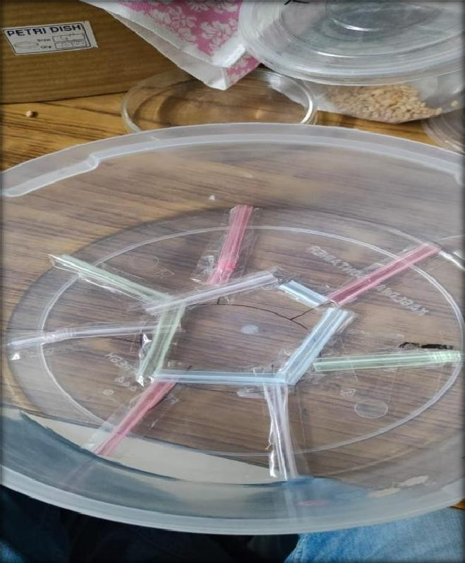

**Figure 1:Setupforfreechoice test**

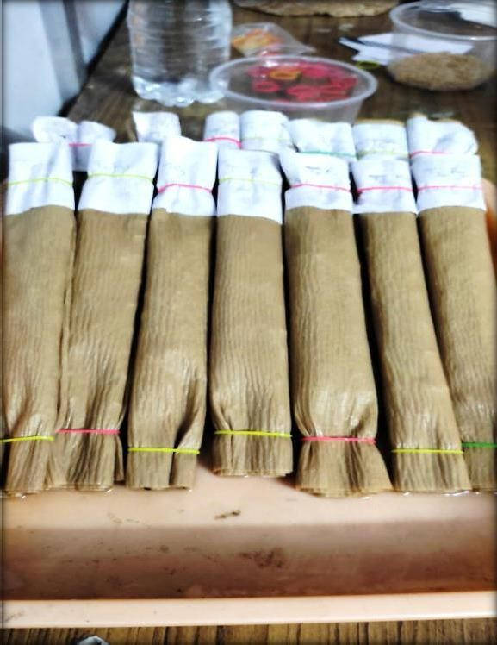

**Figure 2 :An overviewforgerminationtestprocedure**

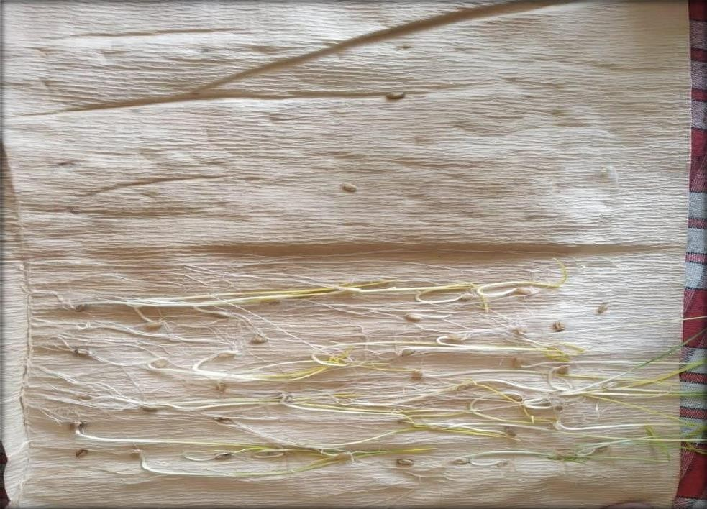

**Figure 3 :Germinationofwheatgrains**

3. Results

* 1. **Efficacyofdifferent essentialoilsonweightlossoftreatedgrainunderfreechoice test**

In the free choice test, the impact of various essential oils on grain weight loss caused by Sitophilus oryzae was evaluated at 30, 60, and 90 days after treatment (DAT). At 30 DAT, neem oil (T1) demonstrated the highest efficacy, resulting in the lowest weight loss of 4.21%, followed by karanj oil (T4) at 7.66%. Among the remaining treatments, clove oil (T2) led to 12.41% weight loss, followed by eucalyptus oil (T5) at 18.60%, lemongrass oil (T6) at 22.28%, and tea tree oil (T7) at 27.13%. Lavender oil (T3) was the least effective among treatments, showing a higher grain loss of 36.05%. In contrast, the untreated control (T0) experienced a significant weight loss of 41.36%, indicating the protective role of essential oils. The trend observed at 30 DAT persisted over time, with neem oil consistently offering superior protection. At 60 DAT, T1 (neem oil) again recorded the lowest weight loss (7.96%), followed by T4 (karanj oil) at 13.36%, and T2 (clove oil) at 17.85%. T3 (lavender oil) continued to show relatively high weight loss (42.40%), only slightly better than the control (T0) at 48.46%. By 90 DAT, the effectiveness of neem oil remained evident with just 9.80% loss, while karanj oil resulted in 15.00% and clove oil in 20.13%. Other treatments ranged between 25.66% and 44.75%, with the untreated control reaching the highest grain loss of 52.15%. These findings clearly establish neem and karanj oils as the most effective botanical protectants in mitigating grain loss caused by S. oryzae over time.

**Figure 4 Efficacy of different essential oils on weight loss of treated grain under free choice test [OVERALL MEAN]**

**Table 1:Efficacyofdifferentessentialoilsonweightlossoftreatedgrainunderfree choice test**

|  |  |  |  |  |  |
| --- | --- | --- | --- | --- | --- |
| **treatments** | **dosage** | **%weightloss** | | | |
| **30DAT** | **60DAT** | **90DAT** | **Overallmean** |
| Neemoil | 5ml/kg | 4.21 | 7.96 | 9.8 | 7.32 |
| Cloveoil | 5ml/kg | 12.41 | 17.85 | 20.13 | 16.79 |
| Lavenderoil | 4ml/kg | 36.05 | 42.4 | 44.75 | 41.06 |
| Karanjoil | 4ml/kg | 7.66 | 13.36 | 15 | 11.99 |
| Eucalyptusoil | 5ml/kg | 18.60 | 24.06 | 25.66 | 22.77 |
| Lemongrass oil | 5ml/kg | 22.28 | 28.13 | 29.8 | 26.73 |
| Teatree oil | 5ml/kg | 27.13 | 31.91 | 34.38 | 31.14 |
| Untreatedcontrol |  | 41.36 | 48.46 | 52.15 | 47.32 |
| S.E.(d) |  | 0.268 | 0.221 | 0.23 | 1.353 |
| C.D |  | 1.393 | 1.15 | 1.197 | 7.028 |
| C.V |  | 3.794 | 2.481 | 2.388 | 15.831 |

**3.2 Effectongerminationpercentageofwheatgrains**

**90DAT** results revealed a significant variation in germination percentage among the different treatments. The highest germination was recorded in T1 (neem oil) with an impressive 93.33%, indicating its strong protective and non-phytotoxic properties. This was followed closely by T4 (karanj oil), which also performed well with 86.66% germination. On the other hand, the lowest germination rate was observed in T3 (lavender oil) at 46.66%, suggesting a possible adverse effect on seed viability. The remaining treatments showed intermediate levels of germination. T2 (clove oil) maintained a respectable 73.33% germination, followed by T5 (eucalyptus oil) at 66.66%, T6 (lemongrass oil) at 63.33%, and T7 (tea tree oil) at 53.33%. Notably, the untreated control (T0) recorded the lowest germination percentage at only 23.33%, highlighting the extent of damage caused by Sitophilus oryzae in the absence of treatment. These findings suggest that neem and karanj oils not only offer effective protection against infestation but also preserve the physiological quality of the grain.

**Table2 :Effectongerminationpercentageofwheatgrains**

|  |  |  |
| --- | --- | --- |
| **Treatments** | **dosage** | **germination%** |
| Neemoil | 5ml/kg | 93.33 |
| Cloveoil | 5ml/kg | 73.33 |
| Lavenderoil | 4ml/kg | 46.66 |
| Karanjoil | 4ml/kg | 86.66 |
| Eucalyptusoil | 5ml/kg | 66.66 |
| Lemongrassoil | 5ml/kg | 63.33 |
| Teatree oil | 5ml/kg | 53.33 |
| Untreatedcontrol |  | 23.33 |
| S.E.(d) |  | 1.92 |
| C.D |  | 9.99 |
| C.V |  | 9.11 |

**4. Discussion**

**4.1 Efficacy of Different Essential Oils on Weight Loss of Treated Grain Under Free Choice Test**

The free choice test is a valuable method used to evaluate the effectiveness of different treatments under conditions that closely mimic real storage scenarios. In this test, insects are allowed to move freely among treated and untreated grain samples, thereby reflecting their natural behavior in choosing a host. This approach helps in assessing not only the direct toxicity of the treatment but also its repellency or deterrent effect. By allowing the insects to express preference, the test provides a holistic understanding of how effectively a treatment protects stored grain over time. It is especially relevant for integrated pest management strategies, where both mortality and reduced damage due to avoidance play crucial roles. In the present study, all essential oil treatments were found to be significantly superior to the untreated control in minimizing grain weight loss by enhancing adult mortality of Sitophilus oryzae. The highest mortality was observed in T1 (neem oil), corroborating the findings of Poudel et al. (2023), and resulting in the least weight loss. T4 (karanj oil) followed as the next most effective treatment, with results comparable to those reported by Gayatree et al. (2022). Clove oil (T2) was the third most effective, supported by Bhattarai et al. (2023), followed by T5 (eucalyptus oil), as noted by Yang et al. (2020). Lemongrass oil (T6) and tea tree oil (T7) showed moderate efficacy, also aligning with studies by Poudel et al. (2023) and Yang et al. (2020), respectively. T3 (lavender oil) demonstrated the least effect in terms of mortality and protection, consistent with Germinara et al. (2017). These results validate the use of free choice testing in identifying potent botanical protectants, with neem and karanj oils emerging as the most promising candidates for effective and sustainable grain storage management.

**4.2 Effect on Germination Percentage of Wheat Grains**

The impact of various essential oils on the germination percentage of wheat grains was found to be significant when compared to the untreated control. All the treatments not only contributed to enhanced adult mortality of Sitophilus oryzae but also preserved seed viability to a notable extent. Among the tested oils, T1 (neem oil) recorded the highest germination percentage, reaffirming its dual role in both pest management and seed preservation. These findings are in agreement with Poudel et al. (2023), who reported similar results on the effectiveness of neem oil in maintaining seed health post-treatment.Following neem oil, T4 (karanj oil) exhibited the next best performance in sustaining germination, consistent with observations made by Gayatree et al. (2022). Clove oil (T2) also showed considerable effectiveness, as supported by Bhattarai et al. (2023). Eucalyptus oil (T5), lemongrass oil (T6), and tea tree oil (T7) demonstrated moderate impacts on germination, aligning with findings from Yang et al. (2020) and Poudel et al. (2023). However, T3 (lavender oil) was the least effective in preserving germination percentage, mirroring the results reported by Germinara et al. (2017). These results highlight the importance of selecting essential oils that not only offer protection against pests but also ensure minimal impact on the physiological quality of stored seeds.

Conclusion

The free choice test effectively evaluated the efficacy of different essential oils in protecting stored wheat grains by allowing *Sitophilus oryzae* adults to choose between treated and untreated samples, simulating natural storage conditions. This method revealed both the toxic and repellent effects of the treatments, providing a comprehensive understanding of their protective potential. All essential oils significantly reduced grain weight loss by increasing adult mortality compared to the untreated control. Neem oil showed the highest efficacy, resulting in the least weight loss, followed by karanj, clove, and eucalyptus oils, each demonstrating moderate to strong protection. Lemongrass and tea tree oils exhibited moderate effects, while lavender oil was the least effective. Additionally, these treatments significantly preserved the germination percentage of wheat grains, indicating that essential oils not only control pest infestation but also maintain seed viability. Neem oil again showed the highest germination rate, highlighting its dual role in pest management and seed health preservation. Karanj and clove oils also maintained good germination, while eucalyptus, lemongrass, and tea tree oils showed moderate effects, with lavender oil having the least impact. These results underscore the importance of selecting essential oils that provide effective pest control while ensuring the physiological quality of stored seeds, with neem and karanj oils emerging as the most promising sustainable options for integrated grain storage management.

Disclaimer (Artificial intelligence)

Option 1:

Author(s) hereby declare that NO generative AI technologies such as Large Language Models (ChatGPT, manuscript.

**COMPETING INTERESTS DISCLAIMER:**

Authors have declared that they have no known competing financial interests OR non-financial interests OR personal relationships that could have appeared to influence the work reported in this paper.

**REFERENCES**

* **Ghosh,S.K.andDurbey,S.L.(2003).**Integratemanagementofstoredgrainpest.InternationalBookDistributingCompany,Lucknow.pp.125-126.
* Kumar, A., Maurya, B. R., Raghuwanshi, R., Meena, V. S., &Tofazzal Islam, M. (2017). Co-inoculation with Enterobacter and Rhizobacteria on yield and nutrient uptake by wheat (Triticum aestivum L.) in the alluvial soil under indo-gangetic plain of India. *Journal of plant growth Regulation*, *36*, 608-617.
* Ladang, Y. D., Ngamo, L. T. S., Ngassoum, M. B., Mapongmestsem, P. M., & Hance, T. (2008). Effect of sorghum cultivars on population growth and grain damages by the rice weevil, Sitophilus oryzae L.(Coleoptera: Curculionidae). *African Journal of Agricultural Research*, *3*(2), 255-258.
* Aryal, S., Poudel, A., Bajracharya, A. S. R., Aryal, L. N., & Kafle, K. (2023). Toxicity evaluation of essential oil of clove (Syzygiumaromaticum) bud against Sitophilus zeamaisMotschulsky (Coleoptera: Curculionidae). *Journal of Nepal Agricultural Research Council*, 22-35.
* Sahoo, G., & Sahoo, B. K. (2022). Assessment of certain plant products toxixity against Sitophilus oryzae in milled rice grains in coastal Odisha. *Environment Conservation Journal*, *23*(3), 326-334.
* Bhattarai, N. (2024). *Efficacy of selected grain protectants on hulled Kernzaо, dehulled Kernzaо, and hard red winter wheat against two economically important stored product insect species* (Doctoral dissertation, Kansas State University).
* Germinara, G. S., Beleggia, R., Fragasso, M., Pistillo, M. O., & De Vita, P. (2019). Kernel volatiles of some pigmented wheats do not elicit a preferential orientation in Sitophilus granarius adults. *Journal of Pest Science*, *92*(2), 653-664.
* Ghosh, A., Yadav, U., Panigrahi, C. K., & Roy, A. (2023). Efficacy of some essential oil for the management of rice weevil (Sitophilus oryzae) on Stored Wheat. *Int J Environ Clim Change*, *13*(10), 4248-4253.