**Indoor air pollution from Solid Fuel Use: Sources and Assessment Methods – A Literature Review**

**Abstract**

This paper examines the causes of the deterioration in indoor air quality and the different methods of studying the emissions of air pollutants associated with the use of solid fuel stoves. Indoor air quality has long received less attention than outdoor air quality, despite the fact that most people spend more time indoors in buildings with higher pollution levels than outdoors. Exposure to air pollutants such as fine particles and carbon monoxide can cause respiratory illness and death. A literature review was carried out to identify the causes of indoor air pollution and the devices and methods most commonly used to characterize emissions of air pollutants. Air pollution databases were searched, and the performance of solid-fuel cooking stoves was studied. Indoor air quality is influenced by a number of pollution sources, including the influence of outdoor air, building characteristics and kitchen equipment. Study methods have been implemented to characterize emissions of indoor air pollutants. Some of these methods are used in field studies, others in controlled laboratory environments.

Key words: Indoor air quality, Indoor air pollutants, Cook stoves.

# Introduction

Air pollution in general, and indoor air pollution in particular, is perceived by many as a consequence of urbanization and industrialization, and therefore a phenomenon that only concerns developed countries where studies have been carried out [1]. Like climate change, this air pollution can affect us all, but its drawbacks differ from one person to another [2]. Air pollution was the second leading risk factor for death in children under 5 in 2021, after malnutrition [2].

A close link has been established between traffic-related air pollution and deaths from lung cancer, the onset of asthma in children and adults, and acute lower respiratory tract infections (ARI) in children. At country level, the highest mortality rates due to ARI were observed in Tchad (159 deaths/100,000 people), while in Burkina Faso there were 108 deaths per 100,000 people [2].

Air pollution in general concerns both outdoor and indoor air. Indoor air pollution differs from outdoor air pollution in terms of source, composition and concentration, so studies on outdoor air pollution cannot be used to infer the effects on indoor air pollution. Indoor air quality depends on outdoor and indoor pollution sources, meteorological factors, housing characteristics and behavioral factors. (Reference)

Most of the health effects of indoor air pollutants are due to emissions of fine particles with aerodynamic diameters less than or equal to 2.5µm (PM2.5) and carbon monoxide (CO). [3]. Indoor air pollutants are classified as one of the major risk factors for global environmental health [4].

The main sources of indoor air pollution in middle- and low-income countries are the incomplete combustion of wood and charcoal in households using open fires and traditional stoves for cooking, and kerosene for lighting [5], [6], [7].

Most of the world's population (99%) lives in areas where PM2.5 pollution levels pose a risk to human health, and 34% of the population lives in areas where pollution levels exceed WHO air quality guidelines [2].

Poor air quality is responsible for the deaths of 8.1 million people worldwide, 38% of which are caused by indoor air pollution [2].

Despite the progress made in recent decades, 47% of the world's population - almost 3.6 billion people - are still exposed to pollution from the domestic use of solid fuels for cooking. In 18 African countries, including Burundi, Mali, South Sudan, Niger and Uganda, over 95% of the population uses solid fuels for cooking. Over the past decade, Nigeria, Ethiopia and the Democratic Republic of Congo have seen an increase of over 20% in exposure to domestic air pollution, largely due to population growth [2].

Two-thirds of the population exposed to air pollutants live in Southeast Asia and Africa [8].

Although Burkina Faso has a policy of subsidizing butane gas for household cooking, a large proportion of the population still relies on solid fuels. In 2022, around 79.3% of households in Burkina Faso used solid fuels as a source of energy for cooking. Of these, 67.7% used wood and 10.8% charcoal [9].

Improved stoves (with high efficiency and relatively low emissions) have been proposed as a potential tool for reducing exposure to indoor air pollution, improving health outcomes and reducing greenhouse gas emissions and deforestation [10].

To better understand the contribution of solid-fuel cookstoves to indoor air pollution, we take a critical look at indoor air pollution resulting from the combustion of solid fuels in households. More specifically, we aim to answer the following questions: (1) What air pollutants can be found in households? (2) What influence do cooking stoves and solid fuels have on indoor air pollution? (3) How can the characteristics of the kitchen influence the level of concentration of pollutants emitted? (4) What equipment and methods are available for studying emissions of indoor air pollutants?

# Indoor air pollution

## Basics of indoor air quality and pollution

According to the EPA (Environmental Protection Agency) definition, indoor air quality is the quality of the air in and around homes and workplaces in particular, which can have an impact on the health and comfort of the occupants of these enclosed environments [11].

Indoor air pollution, on the other hand, refers to the presence of certain pollutants such as particulate matter (PM), volatile organic compounds, inorganic compounds and biological components in enclosed environments which, due to their high concentration levels, can have negative effects on human health [12].

Unlike outdoor air pollution, which is widely known and studied, indoor air pollution has long been ignored by the general public. Yet people spend most of their time in enclosed environments such as homes and workplaces. The main parameters generally considered to assess indoor air quality are pollutant concentrations and climatic conditions (wind speed, temperature, relative humidity) [13].

Studies have shown that indoor air quality in homes and buildings is strongly influenced by three main factors [14], [15] : outdoor air quality, human activities in buildings, and building materials.

The increased concentration of pollutants in outdoor air and the presence of air movement lead to a transfer of pollutants to the interior of buildings. Consequently, the ventilation rate is an important parameter conditioning the relationship between outdoor air pollution and indoor air quality.

Daily human activities such as cooking, smoking, the use of pesticides and cleaning products all contribute to indoor air pollution [16].

## Indoor air pollutants and their sources

The main indoor air pollutants studied are particulate matter and volatile organic compounds (VOCs). Particulate matter is generally classified according to size, but the most commonly reported value corresponds to the concentration of particles with an average diameter of 2.5 µm or less (PM2.5). Carbon dioxide (CO2), carbon monoxide (CO), nitrogen oxides (NOx) and ozone (O3) are among the most widely studied inorganic compounds. VOCs comprise a large group of organic gaseous pollutants with low boiling points and vapour pressures, which are ubiquitous in indoor environments [17]. This group continues to grow as new materials are used in construction and interior design.

### Particulate matter

Particulate matter (PM) is an air pollutant made up of solid and liquid particles suspended in the air. Some particles, such as dust, soot or smoke, are large enough to be visible to the naked eye. [18]. Other small ones can only be seen with an electron microscope. This latter group also includes glass fibers and asbestos (Carazo Fernández *et al*., 2013 ; Leung 2015). The PM most commonly studied are PM2.5, which are inhalable fine particles with diameters of 2.5 micrometers or less, and PM10, which are also inhalable, but with diameters of 10 micrometers or less. Externally-produced PM enters indoor environments through ventilation, while indoor sources include combustion appliances such as furnaces, heaters or cookstoves, as well as tobacco smoke and chimneys. Reactions between ozone and certain VOCs can also be responsible for the production of PM (e.g. terpenes) [19]. When the fuel used is biomass, indoor air particle concentration levels can be above those of polluted cities. Long-term exposure to particulate matter can cause disorders ranging from respiratory and cardiovascular problems such as throat, nose, eye and bronchial irritation and asthma to fibrosis, anthracosis and lung cancer [19], [20].

### Inorganic compounds

Inorganic air pollutants are airborne chemical substances of non-organic origin that have adverse effects on human health. The most widely studied inorganic compounds are CO and NOx.

Carbon monoxide (CO) is a colorless, odorless and toxic gas produced during incomplete combustion. The main indoor sources of CO emissions are tobacco smoke, faulty cooking and heating appliances, chimneys and vehicle gases from adjoining garages, as well as outdoor air exchanges in dense traffic or industrialized areas [19], [20], [21]. CO enters the human body mainly by inhalation. It is able to bind reversibly to hemoglobin, and has a higher affinity than oxygen. The severity of health damage depends on the concentration and duration of exposure, and includes cardiovascular, respiratory and neurological problems. Long-term exposure to high concentrations of CO can lead to death [20], [21].

Nitrogen monoxide (NO) and nitrogen dioxide (NO2) are the most common nitrogen oxides (NOx). NOx are formed during the combustion of nitrogen-containing fuels [22]. Among NOx, the most important in terms of emissions is NO, which is then oxidized to NO2 [23]. The most common sources of NOx indoor air pollution are gas cookstoves and water heaters. Other sources of NOx emissions include environmental tobacco smoke (ETS) and chimneys [19], [20]. Roads and high-intensity industrial zones also contribute to indoor air pollution through infiltration of outdoor air. Inhalation of NO2 can cause a number of respiratory problems. Direct contact with this pollutant can also cause eye irritation [19], [20].

### Volatile organic compounds

Volatile organic compounds (VOCs) are chemical substances composed of carbon and hydrogen. These compounds are also known as solvents, and are characterized by their ease of volatilization at room temperature [24]. VOCs are defined by their molecular structure and functional group. VOCs include aliphatic hydrocarbons (many of which are chlorinated - halocarbons), aromatic hydrocarbons, esters, aldehydes, alcohols, ethers and more [24].

Benzene is a volatile organic compound widely used in industry. Indoor sources of benzene include combustion devices, ETS emissions, building materials such as polymer furniture, paint, solvents, carpeting and wooden furniture [19], [23], [25].

Present in fuels, resins, paints, adhesives, cosmetics and coatings, toluene is one of the major pollutants of indoor air, and the most common member of the BTEX family (benzene, toluene, ethylbenzene and xylene). Indoor sources include infiltration of outdoor air, tobacco smoke, combustion devices and a variety of household products [19], [21], [26], [27].

Ethylbenzene, derived from benzene, is a colorless aromatic liquid at room temperature. Plastics, paints, adhesives and other products in which ethylbenzene is used as a solvent during manufacture are sources of pollution. Combustion processes also generate ethylbenzene emissions [20], [25], [26], [27].

Xylene is an aromatic organic compound that exists in three main isomers: ortho-xylene, meta-xylene and para-xylene. Paints, adhesives, colorants, polymers, cleaning chemicals and pharmaceuticals are all domestic sources of xylenes [20], [21], [25], [26], [27].

Naphthalene is a polycyclic aromatic hydrocarbon in the form of a white crystalline solid, widely used as a raw material in the chemical industry. Indoor sources of naphthalene include tobacco smoke, faulty combustion equipment, herbicides, plastic materials and insecticides (which most often infect clothing), as well as ambient air [21].

Formaldehyde (HCHO) is a colorless, highly reactive gas produced by the incomplete combustion of hydrocarbons. Oxidation of certain VOCs with ozone or radiation can also cause formaldehyde emissions [21], [25].

Trichloroethylene (TCE) is a liquid, colorless, volatile organic chemical synthesized from a chemical process that does not occur naturally [28].

Indoor sources include products where TCE is used as a solvent, such as lubricants, varnishes, paint strippers, adhesives and printer correction fluids. Some bleach-based household products and other cleaning agents may also contain TCE. Contaminated water and soil can contain TCE, indirectly contributing to higher levels of indoor air pollution [26], [27].

Alpha-pinene is one of the liquid terpenes naturally present in plants, and is a common constituent of essential oils. Of all monoterpenes, alpha-pinene is the most frequently emitted, and is also the compound for which particular attention has been paid [29]. This substance is used as a solvent in various paints and sealants, and is found in perfumery products, air fresheners and cleaning products. Wooden materials such as furniture and flooring, particularly those made from pine, can also be sources of pinene emissions [21], [25].

Limonene is a VOC belonging to the terpene family. It exists as two isomers (d- and l-). It is used in a multitude of household products such as detergents, resins, air fresheners, perfumes and shampoos [17], [21], [25] . Because of its citric odor and flavor, this terpene is also present in foods as an additive. Limonene is mainly absorbed by inhalation and ingestion.

# Method for conducting household air pollution surveys

The study of indoor air quality requires the use of several methods to characterize and analyze the various pollutants emitted during the use of cooking stoves and solid fuels.

This study is based on various techniques and methodological approaches for characterizing pollutants emitted into indoor air.

There are two main types of study of indoor air pollution:

* the field study, which consists of measuring air pollutants inside household cooking areas;
* laboratory studies, which involve using different procedures to characterize and measure pollutant emissions at source.

Each of these two methods has its own specificity, making it possible to study the sources of pollution, household habits contributing to this pollution, the characteristics of the pollutants emitted and the potential health risks. The diversity of these approaches also enables us to better define mitigation measures and standards aimed at improving indoor air quality. However, to implement these methods, it is necessary to use a number of devices to quantify the pollutants emitted.

## Measuring devices for indoor air pollutants

Nowadays, there are several devices for measuring emissions of indoor air pollutants. In the literature, the following devices have been used to measure emissions of indoor air pollutants:

* **Partector Pro**

The Partector Pro shown in Figure 1 (naneos GmbH, Windisch, Switzerland) is an improved version of the Partector and Partector 2 [30]. It is a nanoparticle detector.

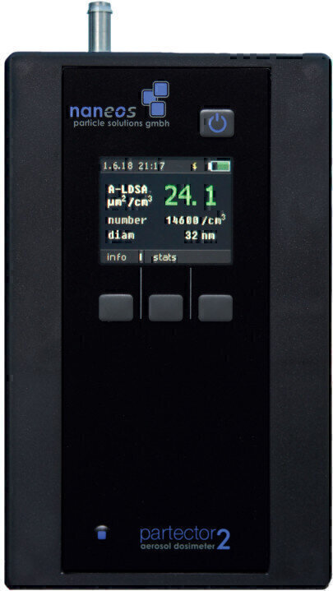

**Figure 1: Partector Pro**

Partector is the only personal real-time monitoring device small enough to be installed and measured directly in a person's breathing zone [31]. All Partector models are small, portable devices that can be operated on battery power. They use unipolar corona scattering generators to treat aerosol particles according to a known, particle-size-dependent charge distribution. The device operates in batch mode, i.e. it switches on and off at short intervals to produce chunks of charged particles. These charged particles enter and exit an induction tube, causing a negative and positive voltage spike, respectively. These peaks are directly proportional to the total charge concentration, which is determined by the peak-to-peak half-value [32]. In the case of particle sizes between approximately 20 and 400 nm [33], the charge concentration and, consequently, the total current generated by charged particles are closely related to the concentration of the particles' pulmonary deposition surface [34], which can be measured with an uncertainty of the order of 30% [35], [36]. Particle deposition surface concentration is therefore the main indicator for measuring Partector models. The main differences between the Partector and other measuring devices are its small size and the principle of charge measurement.

* **DustTrak™ DRX Aerosol Monitor**

The DustTrak™ DRX aerosol meter from Thermo System Inc.(TSI) shown in Figure 2, is a widely used portable instrument for measuring concentrations of particulate matter (PM) [37].

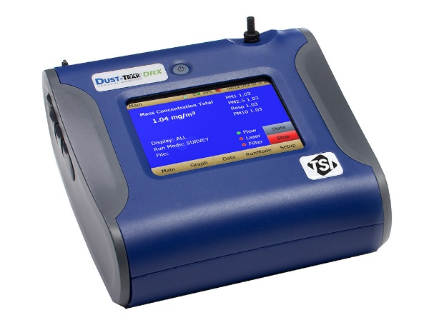

**Figure 2: DustTrak™ DRX Aerosol Monitor**

This device uses a laser photometer to measure the scattering of light by particulate matter. It diffuses light whose intensity is proportional to the concentration of pollutants. Particles are differentiated by size and mass concentration using a proprietary algorithm, enabling complete characterization of pollutants. What all DustTrak models have in common is that they use an optical method to measure pollutants [38].

The first DustTrak model (model 8520) was launched in the early 1990s and has been widely used for particulate matter concentration measurements [39], [40], [41], [42].

Several researchers evaluated the performance of this model's measurement method against standard gravimetric measurement methods and other light-scattering or real-time instruments. The results revealed the model's consistency and excellent signal-to-noise ratio. However, when factory-calibrated, it showed little accuracy compared with the reference method, generally resulting in 2-3 times higher concentrations [41], [43], [44], [45], [46], [47]. This device has been used to measure pollutants in several studies [48], [49], [50] and its performance has already been the subject of several evaluations [37], [51], [52]

* **HOBO CO loggers**

HOBO data loggers, manufactured by Onset Computer Corporation, are typically used to measure and record environmental parameters such as temperature, humidity, light and other parameters in a variety of contexts.

HOBO CO loggers, shown in figure 3, are devices used to monitor and measure carbon monoxide (CO) concentrations in a variety of environments.

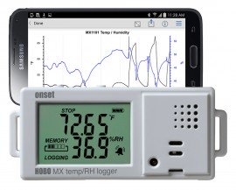

**Figure 3: HOBO CO loggers**

These devices are designed to monitor CO concentration levels and help assess air quality, particularly in indoor environments where exposure to CO can present health risks. This device uses non-dispersive infrared technology to measure CO concentration levels in the air.

HOBO CO loggers are specifically designed to measure and record carbon monoxide (CO) concentration levels in indoor environments. These continuous data loggers measure CO concentration every second, and feature two channels that simultaneously record average concentrations every 30 seconds. Measurement values range from 0.2 to 125 ppm on one channel, with a resolution of 0.5 ppm, and from 0.2 to 500 ppm on the other channel, with a resolution of 2 ppm [53]. This device has been used in several studies [53], [54] to determine CO exposure levels. One of the main advantages of this continuous monitor is that it can be easily calibrated using a standard CO span gas [53].

* **Testo DiSCmini (Diffusion Size Classifier Miniature)**

The testo DiSCmini is a mobile device designed to evaluate the number of nanoparticles, their concentration, the average particle size and the surface area of nanoparticles likely to be deposited in the lungs, with a time resolution of up to 1 second.

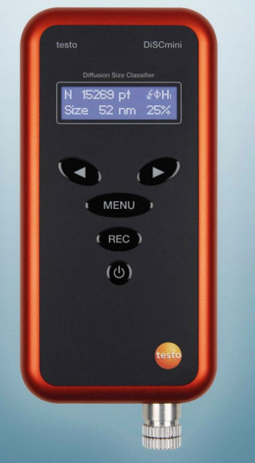

**Figure 4: Testo DiSCmini**

The measurement method is based on the electrical charge of aerosols. The device is small, portable and easy to use, making it ideal for field measurements. The device is equipped with a rechargeable battery that gives it an autonomy of 8 hours. Data is stored on a memory card and transferred to an external computer via a USB cable [55].

The electrical charge of the aerosol is the basis of the testo DiSCmini. The corona effect generates positive air ions which mix into the aerosol. Two-level electrometers then detect the charged particles. The first detector level consists of small wire grids, where the charged particles are generally deposited by diffusion. During this process, the particles release their charge and the current flow is measured. The remaining particles attach themselves to the second stage, the wire stage, and the charge that causes the current to flow is also detected. Calibration of the device relies on the ratio between these two currents to determine the average particle size. Since the charge per particle is related to the particle size, the number of particles/concentration can be determined on the basis of the total current detected (once its size has been identified), combined with the flow rate through the device [55]. Control tests are carried out using antistatic tubes [36], [52], [56]. This instrument has been used in several studies [49], [57] during cooking periods to determine air pollutant concentration levels.

* **Indoor Air Pollution Meter 5000 Series (IAP meter; Aprovecho Research Center, OR, USA)**

The Indoor Air Pollution Meter (IAP Meter) from the Aprovecho research center is a portable instrument designed to measure the concentration level of air pollutants inside an enclosed environment.

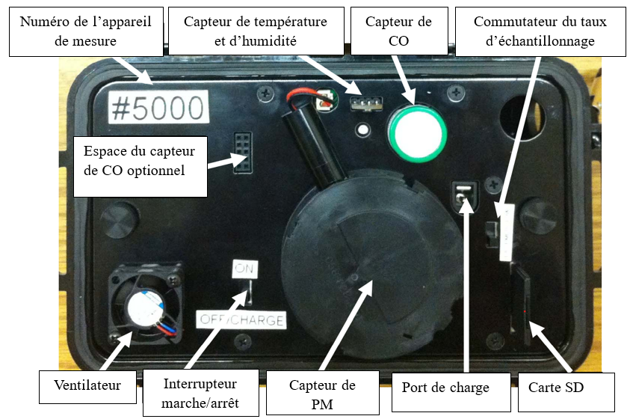

**Figure 5: IAP meter**

The IAP meter, in particular the 5000 series, is designed to measure certain pollutants most commonly found inside kitchens or buildings, particularly those emitted during cooking activities using inefficient or traditional methods. These pollutants often include particulate matter (PM) and carbon monoxide (CO), whose high concentration levels can have harmful effects on health. The CO sensor uses an electrochemical cell, while PM is measured using an optical method [58].

This research-grade device is used for field studies and projects aimed at understanding and mitigating indoor air pollution levels.

This instrument has been used in several studies [49], [59], [60], [61], [62] to quantify the level of indoor air pollution caused by the use of cooking stoves and solid fuels.

# Button Aerosol Sampler

SKC button samplers are curved-surface devices with several evenly spaced orifices.

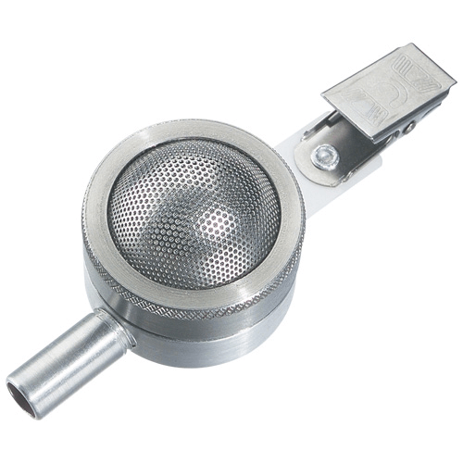

**Figure 6: Button Aerosol Sampler**

This particular design improves inhalable dust collection by minimizing oversampling of very large particles and limiting sensitivity to wind speed and direction. Button samplers comply with ACGIH/ISO sampling criteria for inhalable particle mass. The button sampler can be used in combination with an AirChek 4 L/min series sampling pump for personal or area sampling of inhalable dusts. It can also be combined with specific filters for sampling bioaerosols for viability or non-viability analysis [63].

Traditional samplers for assessing personal exposure to aerosol hazards are generally expensive, noisy and impractical to wear during an 8-hour work shift. They require frequent flow calibration, and are prone to failure in a number of ways [64].

* **Ultrasonic Personal Aerosol Sampler (UPAS)**

The UPAS is a time-integrated filter sampling device that uses an ultrasonic piezoelectric pump (unlike a traditional diaphragm pump).

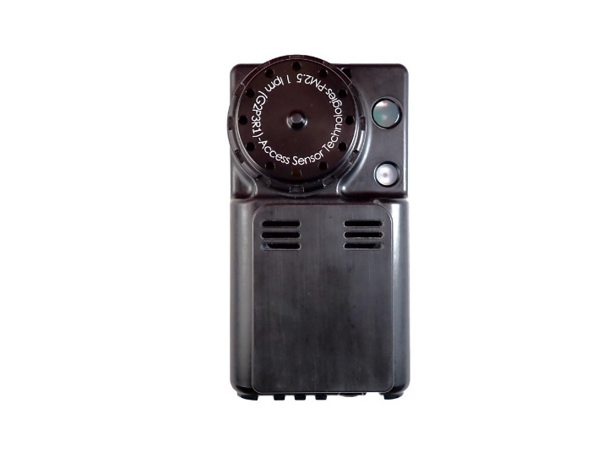

**Figure 7: Ultrasonic Personal Aerosol Sampler**

This system works by converting an electrical charge into a reversible mechanical expansion of a ceramic crystal at high frequency (~25 kHz) [65].

The UPAS is equipped with a miniature piezoelectric pump to draw air through the device, a mass flow controller to control sampling rates, and a cyclone designed to collect an integrated PM2.5 sample on a filter housed inside the device.

The UPAS weighs around 0.2 kg, has the dimensions of a large cell phone (9.7 × 5.1 × 2.5 cm) and a relatively low noise level (< 40 dB at 20 cm) [65].

A miniature chamber beneath the crystal expels air through a diffusion nozzle that acts as a passive dynamic valve, virtually blocking any air return [66], [67], [68].

Piezoelectric pumps are less likely to be damaged by dirty or multiphase flow; furthermore, piezoelectric pumps operate without slip interfaces, with high efficiency and low noise levels. The UPAS prototype was designed using off-the-shelf electronic components, which were integrated into a functional circuit based on an open-source Arduino development system. [65].

Because of its weight, size, battery life, relative silence and performance, the UPAS represents a viable option for exposure assessment in environments where households use solid fuels to meet their daily energy needs and, potentially, in many other environments where PM2.5 exposure is a concern [69].

Despite its innovative nature for measuring fine-particle emissions, the UPAS has limitations that can affect the accuracy of measurement data. Indeed, although the battery has a reasonable operating time (25 to 45 hours), this autonomy may not be sufficient for long-term studies with no means of recharging available. Also, the accuracy of measurement data may be affected by environmental conditions such as humidity [65].

* **Laboratory emissions monitoring system (LEMS)**

The Laboratory Emissions Measurement System (LEMS) is a device used to assess emissions from a variety of sources, in particular cookers.

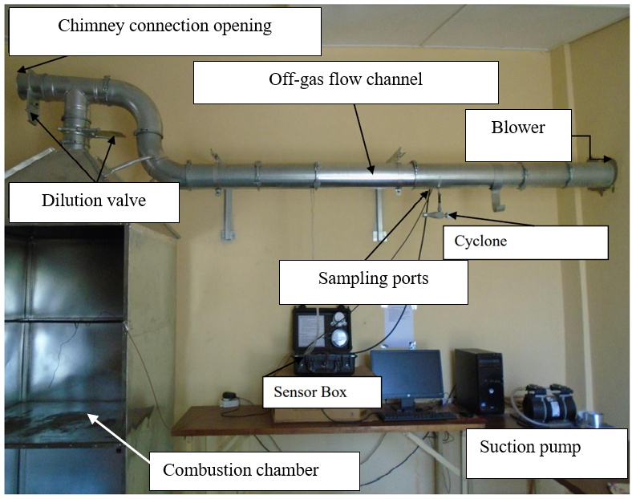

**Figure 8: Laboratory emissions monitoring system**

It is designed to characterize pollutants harmful to health by collecting, measuring and analyzing data [70]. The LEMS is a box containing CO2, CO and PM2.5 sensors, as well as a computer connected to the sensors.

The main features of LEMS are as follows :

* Windows compatible, with features to process data from a boil water test (BWT) or a controlled cooking test (CCT);
* A solid sheet steel hood and variable-speed vacuum cleaner facilitate accurate measurement of household pollutant emissions, such as CO, CO2, PM2.5 and black carbon;
* Real-time measurement of the quantities of pollutants emitted, displayed on the computer screen and recorded using gravimetric filters weighed before and after a test;
* - Complies with International Water Association (IWA) requirements and can measure black carbon using filters [70]

LEMS has been used by researchers studying the performance of cooker hobs around the world for many years. It has played a key role in the characterization of different types of hearths, design modifications and research activities carried out by researchers. It is also used in laboratories to test improved and traditional cookstoves, with the aim of assessing pollutant emissions and combating exposure-related risks.

## Methods for studying air pollutant emissions

### Kitchen Performance Test

The Kitchen Performance Test (KPT) is the main field method for assessing household fuel consumption [71].

#### Definition

This method ranges from household sampling, to characterization of households and cooking stoves, to measurements of concentrations or levels of exposure to indoor air pollutants.

Its aim is to determine the quantity of solid fuel used for cooking with real-life cookstoves by households [72].

The various studies for which this method is used are as follows :

* Evaluate the differences in cooking fuel consumption between households using traditional cooking stoves and households using improved stoves ;
* Evaluate the medium- to long-term fuel consumption habits of households, following interventions on cookstoves (for example, the study can be carried out periodically on a sample of households using new cookstoves to determine whether changes in fuel consumption habits are maintained over the long term) ;
* Test variations in fuel consumption resulting from climate change, fuel availability or local agro-economic cycles (independently of technological changes) ;
* Determine the existence of differences in fuel consumption between households using similar cooking stoves but different fuel types (e.g. firewood versus crop residues or other solid fuels) :
* - Evaluate variations in fuel consumption caused by changes that are not directly related to the nature of the cookstoves used [71].

For these different study cases, the use of devices for measuring air pollutant emissions makes it possible to simultaneously study cookstove performance and indoor air quality.

There are several stages to consider in a study of household performance and air pollution :

* Household characterization: This involves determining parameters such as the characteristics of the kitchen, the wood used and the cooking stoves used by the household ;
* Household sampling and selection

There are three main methods used :

1. The "cross-sectional" method, which involves measuring air pollutant emissions simultaneously in households using improved stoves and traditional stoves, in the same geographical area, after the population has purchased the improved stoves ;
2. The "before and after" method consists of measuring pollutant emissions in a household with traditional stoves in the first instance and improved stoves in the second ;
3. The "Before and after with control group" method involves measuring pollutant emissions in households, first using traditional stoves and then using improved stoves in the same households. In this method, a proportion of households do not receive improved stoves, i.e. still have traditional stoves [73].

For each type of method, it is possible to determine the sample size.

- Protocol implementation

The protocol is implemented over three days in each household [71] and assesses the following parameters :

* through a survey form: household characteristics (household composition and size), kitchen characteristics (construction material, size, number of openings, orientation), energy habits (types of stoves and fuels and number of cooking periods) ;
* the type and quantity of fuel used by the household;
* concentrations of pollutants emitted during cooking.

It should be noted that the deployment of measuring devices depends on their portability and autonomy. [49]. This can lead to variations in measurement periods and in the number of days allocated to a household.

#### Advantages and limitations

KPT is an essential method for assessing cookstove performance and air quality in the home.

It offers the following advantages :

* Real-life application: The KPT is carried out in real domestic environments, enabling cookstove performance to be tested under actual cooking conditions. This method gives a better representation of hearth performance in the context of everyday use than laboratory tests ;
* - Quantitative and qualitative data: KPT combines quantitative measurements of fuel consumption with qualitative surveys of household satisfaction and acceptability. This mixed approach enables us to better understand both the efficiency of the cookstove and its ability to satisfy users' needs and expectations ;
* Influence on fuel consumption: By assessing the amount of fuel consumed before and after the deployment of improved cookstoves, the KPT highlights the impact of these cookstoves on reducing the amount of fuel used by households for cooking activities, which is essential for promoting more economical and less polluting cooking technologies ;
* A comprehensive approach: Household surveys provide a better understanding of social, economic and culinary practices, which is essential for understanding the overall impact of cookstove adoption and use in different communities ;
* Adaptability: The KPT method lends itself to different contexts and household types, making it a flexible tool for various research and intervention projects aimed at improving cooking habits and reducing household dependence on solid fuels ;
* Facilitate the implementation of policies and programs: using the data from these tests, organizations and policy-makers are able to assess the effectiveness of stove interventions and guide future initiatives to enhance household energy efficiency and energy security [71].

Despite its many advantages, the KPT method has limitations that can affect its implementation, reliability and accuracy of results. These limitations include:

* Intrusion into daily household life: The KPT is carried out in households using cooking stoves. This method can cause disruption in the daily activities of the households studied. Implementation therefore influences household behavior, which will change certain habits to adapt to the protocol. As a result, errors may appear in the test results. [71], [74];
* Measurement variability: Significant variations can be observed in measurements of pollutant emissions and fuel consumption. The coefficient of variation (VOC) of the results obtained can reach 40% or more, in contrast to that obtained in the laboratory, which is lower. This is due to the fact that laboratory tests are carried out under more controlled conditions [71], [75] ;
* - The study's sources of error are difficult to control: In a household study, controlling external factors such as cooking habits, the state of disrepair of the cookstove, the humidity and nature of the fuel, and external sources of pollution proves difficult. This can influence the performance of cookers and levels of indoor air pollution [71]. Errors can also be caused by the poor condition of the measuring equipment or even by the person in charge of the study [74];
* The complex implementation of the method: a good understanding of the social and cultural dynamics of the populations concerned by the study and careful planning are necessary for the implementation of the KPT. This is likely to make its implementation complex and costly [71];

In addition to these limitations, other factors can hamper the implementation of the KPT method. In fact, when applying the method in a household, it is possible that the household uses fuel that has not been weighed beforehand. This can happen when the household has used all the fuel weighed before the person in charge of the study arrives. This can lead to errors in the amount of fuel consumed. Also, as the number of meals cooked during the day is an important factor, failure to take precise account of the number of meals leads to errors in calculating the amount of fuel per adult equivalent [74].

In conclusion, although the KPT is a recognized method for assessing the performance of cooker hobs in real-life situations, its limitations must be considered when interpreting the results.

## Water boiling test (WBT)

### Definition

The water boiling test (WBT) is a laboratory study protocol designed to measure the performance of a furnace in heating water in a pot, and the quantity of pollutants emitted during the process. [76]. The test is designed to be easy to implement, reproducible and standardized, making it possible to compare cookstoves of different types manufactured in different locations and for different cooking applications [76]. TEE consists of three phases: the high-power cold-start phase, the high-power hot-start phase and the simmering phase [76].

The genesis of laboratory protocols goes back to 1980, when the Intermediate Technology Development Group (ITDG), now known as Practical Action, first attempted to develop a laboratory test procedure for a furnace [77]. Between 1982 and 1985, VITA volunteers developed the ITDG concept and the Eindhoven Woodburning Stove Group [78] to come up with the very first version of the water boiling test (Water Boiling Test - WBT), used to evaluate the quantity of fuel used under specific conditions to boil water. The first version of the WBT included two phases, a high-power phase and a low-power phase, during which water was rapidly brought to the boil, then left to simmer for 30 minutes. There was no emission test yet. Baldwin's technical report on stoves provided an initial review and discussion of VITA's WBT [79], one of the most widely quoted references by stove designers (it will be called WBT 2.0). In collaboration with researchers from the APROVECHO research center, Dr Kirk Smith and Rob Bailis revised this version of the WBT between 2003 and 2007 [80] resulting in a new version called WBT 3.0 [76]. This version differs from the previous one by adding an additional phase to the protocol, called "hot start", and by standardizing pot sizes and water volumes[81]. The latest version of the boiling water test has been updated to correct errors found in previous versions. It was released in 2014 and is called WBT 4.2.3.

### Advantages and limitations

TEE is a useful tool for assessing household performance, during which the associated measuring equipment measures the quantities of pollutants emitted at source. The main advantages of this method are as follows:

* Precise measurement of thermal efficiency: TEE quantifies the thermal efficiency of stoves, i.e. their ability to convert fuel energy into useful heat for boiling water. This efficiency is essential for comparing different cookstove models and optimizing their design [82].
* A simple, reproducible methodology: TEE is an easy-to-implement method that can be carried out with simple equipment, making it accessible to researchers and field workers alike. The results can thus be widely disseminated and improved stoves adopted more rapidly [76].
* Standardized comparison: TEE facilitates comparison between technologies by providing a standard framework for testing different types of hearths, enabling users to make an informed choice of cooking equipment [76].
* Feedback for innovation: Data collected during boiling tests can be used to improve cookstove design. In this way, the results can be used as a guide to the modifications needed to increase thermal efficiency or reduce pollutant emissions [76].

However, this test has its limitations. It is an approximation of the household cooking process, carried out under controlled conditions by qualified technicians. These limitations include:

* Non-representativeness of actual conditions: TEE is carried out in the laboratory, which is a controlled environment, by operators trained in the implementation of the protocol. This may not reflect actual household cooking conditions. In the laboratory, for example, it is possible to control air inlets and use fuels of the same type. However, in a domestic environment, cooking conditions vary from one household to another, depending on the characteristics of the kitchen, which can influence air inlets, and it is also difficult to have fuels of the same nature for cooking. Also, the level of fuel filling in the cookstove and the handling of the fire during combustion can vary from one operator to another. This can influence cookstove performance and the level of air pollutant emissions. As a result, performances obtained during laboratory tests are likely to differ from those observed on cookstoves used in real domestic conditions.
* Uniformity of the fuel used: In the laboratory, the fuels used for testing are generally of the same type and have the same characteristics. It is also possible to control the moisture content of the fuel, so that it is easy to use. This is not generally the case in the domestic environment. In fact, the moisture content of the fuel and its chemical composition are factors that can influence the level of emissions of indoor air pollutants. [83].
* Handling method not taken into account: TEE does not include the method of handling fuel in the cookstove during firing. This handling, which affects the intensity of the fire and emissions, varies from one operator to another, and can be responsible for increasing or decreasing hearth performance. In fact, managing the size of the fire and refuelling depends on the operator's judgement of the need.

In conclusion, although the Water Boiling Test is a useful tool for assessing the performance of cooker hobs, its limitations need to be carefully considered when analyzing air quality. The results need to be supplemented by field studies and wider analyses to get a complete picture of the impact of cookstoves on air quality.

### Controlled cooking test

### Definition

A controlled laboratory cooking test (CCT) is a method used to evaluate the performance of cooking hobs in a controlled environment. The test involves performing a standard cooking task similar to the actual cooking practices of local populations, while reducing the influence of other factors to allow reproducibility of test conditions. [84]. The main elements of a CCT are as follows:

* materials: The test requires materials such as fuel (e.g. wood or charcoal), sufficient food for all tests and cooking equipment;
* cooking operation: A standard cooking task is developed taking into account the availability of a sufficient quantity of food to carry out the tests;
* Test conditions: the various tests are carried out in a controlled environment, with repeatability enabling differentiation between outbreaks [84] ;
* Participants: the cooking process requires the involvement of local people familiar with both the meal being prepared and the operation of the cookstove to be tested [84].

The TCC protocol has been improved and adapted in different national contexts, such as the Modern Energy Cooking System (MECS) controlled cooking test (CCT) protocol, which is based on the production of reproducible dishes. These dishes are then repeatedly cooked using several types of fuel under controlled conditions. This operation makes it possible to measure and compare the amount of energy required for cooking, as well as the time taken to cook the food [85].

In parallel with the TCC, it is possible to assess the quantities of pollutants emitted and their level of concentration in the cooking zone. Measuring devices positioned close to the cooking area can be used to characterize the pollutants emitted and the levels of household exposure to indoor air pollutants.

### Advantages and limitations of CCT

This method of assessing cookstove performance and air quality offers several advantages:

* By simulating typical cooking activities in the laboratory or in the real world, TCC reflects actual culinary practices. This realism enhances the relevance of results, as it takes into account fuel characteristics and household cooking habits, which are often overlooked in artificial test environments such as laboratories [84];
* The TCC is a standardized method for characterizing and quantifying emissions from various cooking methods under controlled conditions. This reduces variability and enables accurate comparisons to be made between different cookers and fuels, making it possible to collect reliable data on air pollutants such as particulate matter (PM2.5) and carbon monoxide (CO).

Despite the advantages of this method, it has a number of limitations that can affect the accuracy and applicability of the results:

* As this method is carried out in controlled laboratory environments, it may not accurately reflect actual household cooking conditions. Factors such as weather conditions, cooking techniques and household configuration (kitchen size and openness) can have a significant influence on pollutant emissions and concentration levels, but these are often standardized or simplified in the laboratory. This disparity can lead to results that do not fully take into account the complexities of household cooking conditions and practices;
* This method is often based on short cooking tests which do not always take into account the long cooking periods or the diversity of cooking procedures observed in households. This limitation is particularly important in communities where several meals are prepared each day, which can lead to an accumulation of pollutants emitted in the kitchen, which short-duration tests do not allow us to observe.

The controlled cooking test remains an essential tool for establishing the relationship between household cooking practices and the quality of food.

## ISO 19867-1 :2018

### Definition

ISO 19867-1:2018, entitled "Clean stoves and clean cooking solutions - Harmonized laboratory test protocols - Part 1", provides a standard test sequence for comparing the performance of different types of stoves, fuels and cooking practices. It establishes international comparability in the measurement of emissions and efficiency of stoves [86].

The standard was developed by ISO/TC 285. It provides guidelines for emissions and efficiency testing, safety testing and durability testing. The document proposes requirements and guidelines for carrying out tests to provide quantitative and qualitative measurements of cooker performance [86].

The ISO 19867-1:2018 protocol has been used in various studies to determine furnace power, energy efficiency, fuel use and pollutant parameters[87], [88], [89], [90], [91], [92], [93], [94], [95]. The aim of this method was to unify the best methods for studying existing cookstoves and to provide a standard test sequence to enable international comparability in the measurement of emissions and the performance of cooking cookstoves.

### Advantages and limitations of ISO 19867-1:2018

ISO 19867-1:2018 offers several considerable advantages, particularly in the context of cooker hobs and enhanced cooking technologies. The main benefits are as follows :

* Promoting public health: the standard aims to reduce harmful emissions from cooking appliances, thus helping to improve indoor air quality and limit pollution-related health problems, particularly in developing countries where traditional stoves are widespread [86].
* Harmonized standards : ISO 19867-1 provides standardized test protocols to ensure that the performance of cooker hobs can be consistently assessed and compared. [86]. This helps drive innovation and continuous product improvement.
* Accessibility and sustainability: The standard sets clear criteria for performance, safety and sustainability, making cooking technologies more accessible to disadvantaged populations. Indeed, manufacturers can develop affordable equipment that meets local requirements while incorporating modern technologies.

Despite its advantages, ISO 19867-1 has a number of limitations that can compromise its effectiveness:

* Limited applicability: This standard is specifically designed for biomass stoves and may not be suitable for all types of cooking technologies, including those using other energy sources such as gas or electricity [86].
* Laboratory test conditions: test protocols are based on controlled laboratory conditions, which may not accurately reflect the realities of the domestic environment. Consequently, the results obtained may not be indicative of the cookstove's actual performance under normal conditions of use.

ISO 19867-1:2018 plays a major role in promoting safer, more efficient and more sustainable cooking technologies, offering tangible benefits for public health, the environment and the living environment.

# Conclusion

Indoor air pollution is a phenomenon that impacts the lives of people all over the world. These populations spend more than 80% of their time indoors, and despite the risk this entails, there is less data available on the concentration levels of indoor air pollutants compared to outdoor air.

This literature review has given us a better understanding of the causes and sources of indoor air pollution, which are mainly building materials, the influence of outdoor air, cooking stoves and solid fuels. It also enabled us to list the current methods used to study air pollutant emissions. Despite the limitations of some of the studies, the results presented are a major asset in the study and characterization of pollutants emitted during the use of solid fuel cookstoves.

**REFERENCES**

[1] B. H. Chen, “INDOOR AIR POLLUTION IN DEVELOPING COUNTRIES,” 1990.

[2] Health Effects Institute, “State of Global Air 2024. Special Report,” Boston, MA:Health Effects Institute, 2024. Accessed: Jun. 25, 2024. [Online]. Available: https://www.stateofglobalair.org/resources/report/state-global-air-report-2024

[3] R. Pratiti, “Household air pollution related to biomass cook stove emissions and its interaction with improved cookstoves,” *AIMS Public Health*, vol. 8, no. 2, pp. 309–321, 2021, doi: 10.3934/publichealth.2021024.

[4] K. R. Smith and A. Pillarisetti, “Household Air Pollution from Solid Cookfuels and Its Effects on Health,” in *Injury Prevention and Environmental Health*, 3rd ed., C. N. Mock, R. Nugent, O. Kobusingye, and K. R. Smith, Eds., Washington (DC): The International Bank for Reconstruction and Development / The World Bank, 2017. Accessed: Jun. 26, 2024. [Online]. Available: http://www.ncbi.nlm.nih.gov/books/NBK525225/

[5] T. Bond, C. Venkataraman, and O. Masera, “Global atmospheric impacts of residential fuels,” *Energy for Sustainable Development*, vol. 8, no. 3, pp. 20–32, Sep. 2004, doi: 10.1016/S0973-0826(08)60464-0.

[6] J. Zhang and K. R. Smith, “INDOOR AIR POLLUTION FROM HOUSEHOLD FUEL COMBUSTION IN CHINA: A REVIEW,” *Indoor Air*, 2005.

[7] E. Mills, “Identifying and reducing the health and safety impacts of fuel-based lighting,” *Energy for Sustainable Development*, vol. 30, pp. 39–50, Feb. 2016, doi: 10.1016/j.esd.2015.11.002.

[8] R. E. Arku *et al.*, “Elevated blood pressure and household solid fuel use in premenopausal women: Analysis of 12 Demographic and Health Surveys (DHS) from 10 countries,” *Environmental Research*, vol. 160, pp. 499–505, Jan. 2018, doi: 10.1016/j.envres.2017.10.026.

[9] INSD, “Cinquième Recensement Général de la Population et de l’Habitation du Burkina Faso,” Burkina Faso, Aug. 2022. Accessed: Nov. 15, 2023. [Online]. Available: https://www.insd.bf/sites/default/files/2023-08/INSD_Rapport_SYNTHESE%20DES%20RESULTATS%20DEFINITIFS_1.pdf

[10] R. Hanna, E. Duflo, and M. Greenstone, “Up in Smoke: The Influence of Household Behavior on the Long-Run Impact of Improved Cooking Stoves,” *American Economic Journal: Economic Policy*, vol. 8, no. 1, pp. 80–114, Feb. 2016, doi: 10.1257/pol.20140008.

[11] EPA, *Indoor Air Quality (IAQ)*. 2024. [Online]. Available: https://www.epa.gov/indoor-air-quality-iaq

[12] V. V. Tran, D. Park, and Y.-C. Lee, “Indoor Air Pollution, Related Human Diseases, and Recent Trends in the Control and Improvement of Indoor Air Quality,” *IJERPH*, vol. 17, no. 8, p. 2927, Apr. 2020, doi: 10.3390/ijerph17082927.

[13] L. Fang, G. Clausen, and P. O. Fanger, “Impact of Temperature and Humidity on the Perception of Indoor Air Quality,” *Indoor Air*, vol. 8, no. 2, pp. 80–90, Jun. 1998, doi: 10.1111/j.1600-0668.1998.t01-2-00003.x.

[14] M. Marć, M. Śmiełowska, J. Namieśnik, and B. Zabiegała, “Indoor air quality of everyday use spaces dedicated to specific purposes—a review,” *Environ Sci Pollut Res*, vol. 25, no. 3, pp. 2065–2082, Nov. 2017, doi: 10.1007/s11356-017-0839-8.

[15] Z. Peng, W. Deng, and R. Tenorio, “Investigation of Indoor Air Quality and the Identification of Influential Factors at Primary Schools in the North of China,” *Sustainability*, vol. 9, no. 7, p. 1180, Jul. 2017, doi: 10.3390/su9071180.

[16] A. Micallef, J. Caldwell, and J. J. Colls, “The Influence of Human Activity on the Vertical Distribution of Airborne Particle Concentration in Confined Environments: Preliminary Results,” *Indoor Air*, vol. 8, no. 2, pp. 131–136, Jun. 1998, doi: 10.1111/j.1600-0668.1998.t01-1-00008.x.

[17] A. Luengas, A. Barona, C. Hort, G. Gallastegui, V. Platel, and A. Elias, “A review of indoor air treatment technologies,” *Rev Environ Sci Biotechnol*, vol. 14, no. 3, pp. 499–522, Sep. 2015, doi: 10.1007/s11157-015-9363-9.

[18] EPA, “Particulate Matter (PM) Pollution,” USA, Jun. 2024. Accessed: Jul. 04, 2024. [Online]. Available: https://www.epa.gov/pm-pollution/particulate-matter-pm-basics

[19] L. Carazo Fernández, R. Fernández Alvarez, F. J. González-Barcala, and J. A. Rodríguez Portal, “Indoor Air Contaminants and Their Impact on Respiratory Pathologies,” *Archivos de Bronconeumología (English Edition)*, vol. 49, no. 1, pp. 22–27, Jan. 2013, doi: 10.1016/j.arbr.2012.11.004.

[20] D. Y. C. Leung, “Outdoor-indoor air pollution in urban environment: challenges and opportunity,” *Front. Environ. Sci.*, vol. 2, Jan. 2015, doi: 10.3389/fenvs.2014.00069.

[21] D. Kotzias, “Indoor air and human exposure assessment – needs and approaches,” *Experimental and Toxicologic Pathology*, vol. 57, pp. 5–7, Jul. 2005, doi: 10.1016/j.etp.2005.05.002.

[22] EPA, “Nitrogen Oxides (NOx), Why and How They are Controlled,” Nov. 1999, Accessed: Jul. 05, 2024. [Online]. Available: https://www3.epa.gov/ttncatc1/dir1/fnoxdoc.pdf

[23] European Environment Agency, *Air quality in Europe: 2017 report.* LU: Publications Office, 2017. Accessed: Nov. 19, 2023. [Online]. Available: https://data.europa.eu/doi/10.2800/850018

[24] S. S. Anand, B. K. Philip, and H. M. Mehendale, “Volatile Organic Compounds,” in *Encyclopedia of Toxicology*, Elsevier, 2014, pp. 967–970. doi: 10.1016/B978-0-12-386454-3.00358-4.

[25] D. Campagnolo *et al.*, “VOCs and aldehydes source identification in European office buildings - The OFFICAIR study,” *Building and Environment*, vol. 115, pp. 18–24, Apr. 2017, doi: 10.1016/j.buildenv.2017.01.009.

[26] M. Jantunen, E. D. O. Fernandes, P. Carrer, and S. Kephalopoulos, *Promoting actions for healthy indoor air (IAIAQ).* LU: Publications Office, 2011. Accessed: Nov. 19, 2023. [Online]. Available: https://data.europa.eu/doi/10.2772/61352

[27] D. Singh *et al.*, “Statistical modeling of O3, NOx, CO, PM2.5, VOCs and noise levels in commercial complex and associated health risk assessment in an academic institution,” *Science of The Total Environment*, vol. 572, pp. 586–594, Dec. 2016, doi: 10.1016/j.scitotenv.2016.08.086.

[28] National Cancer Institute, “Trichloroethylene (TCE).” Accessed: Jul. 11, 2024. [Online]. Available: https://www.cancer.gov/about-cancer/causes-prevention/risk/substances/trichloroethylene

[29] A. Guenther *et al.*, “A global model of natural volatile organic compound emissions,” *J. Geophys. Res.*, vol. 100, no. D5, pp. 8873–8892, May 1995, doi: 10.1029/94JD02950.

[30] C. Asbach, A. M. Todea, and H. Kaminski, “Evaluation of a Partector Pro for atmospheric particle number size distribution and number concentration measurements at an urban background site,” *Aerosol Research*, vol. 2, no. 1, pp. 1–12, Jan. 2024, doi: 10.5194/ar-2-1-2024.

[31] A. M. Todea *et al.*, “Inter-comparison of personal monitors for nanoparticles exposure at workplaces and in the environment,” *Science of The Total Environment*, vol. 605–606, pp. 929–945, Dec. 2017, doi: 10.1016/j.scitotenv.2017.06.041.

[32] M. Fierz, D. Meier, P. Steigmeier, and H. Burtscher, “Aerosol Measurement by Induced Currents,” *Aerosol Science and Technology*, vol. 48, no. 4, pp. 350–357, Apr. 2014, doi: 10.1080/02786826.2013.875981.

[33] C. Asbach, H. Fissan, B. Stahlmecke, T. A. J. Kuhlbusch, and D. Y. H. Pui, “Conceptual limitations and extensions of lung-deposited Nanoparticle Surface Area Monitor (NSAM),” *J Nanopart Res*, vol. 11, no. 1, pp. 101–109, Jan. 2009, doi: 10.1007/s11051-008-9479-8.

[34] H. Fissan, S. Neumann, A. Trampe, D. Y. H. Pui, and W. G. Shin, “Rationale and principle of an instrument measuring lung deposited nanoparticle surface area,” in *Nanotechnology and Occupational Health*, A. D. Maynard and D. Y. H. Pui, Eds., Dordrecht: Springer Netherlands, 2007, pp. 53–59. doi: 10.1007/978-1-4020-5859-2_6.

[35] A. M. Todea, S. Beckmann, H. Kaminski, and C. Asbach, “Accuracy of electrical aerosol sensors measuring lung deposited surface area concentrations,” *Journal of Aerosol Science*, vol. 89, pp. 96–109, Nov. 2015, doi: 10.1016/j.jaerosci.2015.07.003.

[36] A. M. Todea *et al.*, “Inter-comparison of personal monitors for nanoparticles exposure at workplaces and in the environment,” *Science of The Total Environment*, vol. 605–606, pp. 929–945, Dec. 2017, doi: 10.1016/j.scitotenv.2017.06.041.

[37] I. Rivas *et al.*, “Identification of technical problems affecting performance of DustTrak DRX aerosol monitors,” *Science of The Total Environment*, vol. 584–585, pp. 849–855, Apr. 2017, doi: 10.1016/j.scitotenv.2017.01.129.

[38] TSI Inc, “DustTrak DRX Aerosol Monitor Model 8533/8534/8533EP,” Sep. 2021.

[39] C. He, “Contribution from indoor sources to particle number and mass concentrations in residential houses,” *Atmospheric Environment*, vol. 38, no. 21, pp. 3405–3415, Jul. 2004, doi: 10.1016/j.atmosenv.2004.03.027.

[40] M. MacNeill *et al.*, “Factors influencing variability in the infiltration of PM2.5 mass and its components,” *Atmospheric Environment*, vol. 61, pp. 518–532, Dec. 2012, doi: 10.1016/j.atmosenv.2012.07.005.

[41] H. Moosmüller *et al.*, “Time Resolved Characterization of Diesel Particulate Emissions. 1. Instruments for Particle Mass Measurements,” *Environ. Sci. Technol.*, vol. 35, no. 4, pp. 781–787, Feb. 2001, doi: 10.1021/es0013935.

[42] L. Wang, L. Morawska, E. R. Jayaratne, K. Mengersen, and D. Heuff, “Characteristics of airborne particles and the factors affecting them at bus stations,” *Atmospheric Environment*, vol. 45, no. 3, pp. 611–620, Jan. 2011, doi: 10.1016/j.atmosenv.2010.10.036.

[43] A. Chung *et al.*, “Comparison of Real-Time Instruments Used To Monitor Airborne Particulate Matter,” *Journal of the Air & Waste Management Association*, vol. 51, no. 1, pp. 109–120, Jan. 2001, doi: 10.1080/10473289.2001.10464254.

[44] J. Y. Kim, S. R. Magari, R. F. Herrick, T. J. Smith, D. C. Christiani, and D. C. Christiani, “Comparison of Fine Particle Measurements from a Direct-Reading Instrument and a Gravimetric Sampling Method,” *Journal of Occupational and Environmental Hygiene*, vol. 1, no. 11, pp. 707–715, Nov. 2004, doi: 10.1080/15459620490515833.

[45] S. Kingham, M. Durand, T. Aberkane, J. Harrison, J. Gaines Wilson, and M. Epton, “Winter comparison of TEOM, MiniVol and DustTrak PM10 monitors in a woodsmoke environment,” *Atmospheric Environment*, vol. 40, no. 2, pp. 338–347, Jan. 2006, doi: 10.1016/j.atmosenv.2005.09.042.

[46] J. D. Yanosky, P. L. Williams, and D. L. MacIntosh, “A comparison of two direct-reading aerosol monitors with the federal reference method for PM2.5 in indoor air,” *Atmospheric Environment*, vol. 36, no. 1, pp. 107–113, Jan. 2002, doi: 10.1016/S1352-2310(01)00422-8.

[47] Y. Zhu, T. J. Smith, M. E. Davis, J. I. Levy, R. Herrick, and H. Jiang, “Comparing Gravimetric and Real-Time Sampling of PM 2.5 Concentrations Inside Truck Cabins,” *Journal of Occupational and Environmental Hygiene*, vol. 8, no. 11, pp. 662–672, Nov. 2011, doi: 10.1080/15459624.2011.617234.

[48] Z. Chowdhury *et al.*, “Measurement and modeling of indoor air pollution in rural households with multiple stove interventions in Yunnan, China,” *Atmospheric Environment*, vol. 67, pp. 161–169, Mar. 2013, doi: 10.1016/j.atmosenv.2012.10.041.

[49] C. de la Sota *et al.*, “Indoor air pollution from biomass cookstoves in rural Senegal,” *Energy for Sustainable Development*, vol. 43, pp. 224–234, Apr. 2018, doi: 10.1016/j.esd.2018.02.002.

[50] C. Ochieng, S. Vardoulakis, and C. Tonne, “Household air pollution following replacement of traditional open fire with an improved rocket type cookstove,” *Science of The Total Environment*, vol. 580, pp. 440–447, Feb. 2017, doi: 10.1016/j.scitotenv.2016.10.233.

[51] Z. Chowdhury *et al.*, “An inexpensive light-scattering particle monitor: field validation,” *J. Environ. Monit.*, vol. 9, no. 10, p. 1099, 2007, doi: 10.1039/b709329m.

[52] M. Viana *et al.*, “Field comparison of portable and stationary instruments for outdoor urban air exposure assessments,” *Atmospheric Environment*, vol. 123, pp. 220–228, Dec. 2015, doi: 10.1016/j.atmosenv.2015.10.076.

[53] K. R. Smith *et al.*, “Personal child and mother carbon monoxide exposures and kitchen levels: Methods and results from a randomized trial of woodfired chimney cookstoves in Guatemala (RESPIRE),” *J Expo Sci Environ Epidemiol*, vol. 20, no. 5, pp. 406–416, Jul. 2010, doi: 10.1038/jes.2009.30.

[54] A. Northcross, Z. Chowdhury, J. McCracken, E. Canuz, and K. R. Smith, “Estimating personal PM2.5 exposures using CO measurements in Guatemalan households cooking with wood fuel,” *J. Environ. Monit.*, vol. 12, no. 4, p. 873, 2010, doi: 10.1039/b916068j.

[55] Testo SE & Co. KGaA, “testo DiSCmini Appareil de mesure portatif pour les nanoparticules.” Sep. 2016. Accessed: Nov. 13, 2024. [Online]. Available: https://cleanaireurope.com/wp-content/uploads/2020/06/testo-DiSCmini-Mode-demploi.pdf

[56] C. Asbach *et al.*, “Review of measurement techniques and methods for assessing personal exposure to airborne nanomaterials in workplaces,” *Science of The Total Environment*, vol. 603–604, pp. 793–806, Dec. 2017, doi: 10.1016/j.scitotenv.2017.03.049.

[57] A. Pacitto *et al.*, “Effect of ventilation strategies and air purifiers on the children’s exposure to airborne particles and gaseous pollutants in school gyms,” *Science of The Total Environment*, vol. 712, p. 135673, Apr. 2020, doi: 10.1016/j.scitotenv.2019.135673.

[58] Aprovecho Research Center, “Instructions for Use of the Indoor Air Pollution Meter ( IAP Meter ) 5000 Series.” Jan. 31, 2013. [Online]. Available: http://aprovecho.org/wp-content/uploads/2016/03/iap-meter-5000-series-instruction-manual.pdf

[59] K. Grabow, D. Still, and S. Bentson, “Test Kitchen studies of indoor air pollution from biomass cookstoves,” *Energy for Sustainable Development*, vol. 17, no. 5, pp. 458–462, Oct. 2013, doi: 10.1016/j.esd.2013.05.003.

[60] N. MacCarty, D. Ogle, D. Still, T. Bond, and C. Roden, “A laboratory comparison of the global warming impact of five major types of biomass cooking stoves,” *Energy for Sustainable Development*, vol. 12, no. 2, pp. 56–65, Jun. 2008, doi: 10.1016/S0973-0826(08)60429-9.

[61] F. Mamuye, B. Lemma, and T. Woldeamanuel, “Emissions and fuel use performance of two improved stoves and determinants of their adoption in Dodola, southeastern Ethiopia,” *Sustainable Environment Research*, vol. 28, no. 1, pp. 32–38, Jan. 2018, doi: 10.1016/j.serj.2017.09.003.

[62] C. D. L. Sota, J. Lumbreras, J. Mazorra, A. Narros, L. Fernández, and R. Borge, “Effectiveness of Improved Cookstoves to Reduce Indoor Air Pollution in Developing Countries. The Case of the Cassamance Natural Subregion, Western Africa,” *GEP*, vol. 02, no. 01, pp. 1–5, 2014, doi: 10.4236/gep.2014.21001.

[63] SKC, “Button Aerosol Sampler,” Air Sampling Pumps and Air Sampling Equipment from SKC Inc. Accessed: Aug. 01, 2024. [Online]. Available: https://www.skcinc.com/categories/button-aerosol-sampler-1

[64] D. Breuer, “Analytical Performance Issues: Flow Resistance of Samplers for Personal Monitoring in Work Areas and Requirements for Sampling Pump Performance,” *Journal of Occupational and Environmental Hygiene*, vol. 9, no. 2, pp. D25–D32, Feb. 2012, doi: 10.1080/15459624.2011.640302.

[65] J. Volckens, C. Quinn, D. Leith, J. Mehaffy, C. S. Henry, and D. Miller-Lionberg, “Development and evaluation of an ultrasonic personal aerosol sampler,” *Indoor Air*, vol. 27, no. 2, pp. 409–416, Mar. 2017, doi: 10.1111/ina.12318.

[66] T. Gerlach and H. Wurmus, “Working principle and performance of the dynamic micropump,” *Sensors and Actuators A: Physical*, vol. 50, no. 1–2, pp. 135–140, Aug. 1995, doi: 10.1016/0924-4247(96)80097-5.

[67] E. Stemme and G. Stemme, “A valveless diffuser/nozzle-based fluid pump,” *Sensors and Actuators A: Physical*, vol. 39, no. 2, pp. 159–167, Nov. 1993, doi: 10.1016/0924-4247(93)80213-Z.

[68] A. Ullmann, “The piezoelectric valve-less pump—performance enhancement analysis,” *Sensors and Actuators A: Physical*, vol. 69, no. 1, pp. 97–105, Jun. 1998, doi: 10.1016/S0924-4247(98)00058-2.

[69] A. Pillarisetti *et al.*, “Measuring personal exposure to fine particulate matter (PM2.5) among rural Honduran women: A field evaluation of the Ultrasonic Personal Aerosol Sampler (UPAS),” *Environment International*, vol. 123, pp. 50–53, Feb. 2019, doi: 10.1016/j.envint.2018.11.014.

[70] Aprovecho Research Center, “Instructions for Use of the Laboratory Emissions Monitoring System (LEMS).” Jul. 17, 2013. Accessed: Nov. 24, 2023. [Online]. Available: http://aprovecho.org/portfolio-item/laboratory-emissions-monitoring-system/

[71] R. Bailis, R. Thompson, N. Lam, V. Berrueta, G. Muhwezi, and E. Adams, “Kitchen Performance Test (KPT),” 2018. Accessed: Mar. 28, 2022. [Online]. Available: https://cleancookstoves.org/binary-data/DOCUMENT/file/000/000/604-1.pdf

[72] M. Lillywhite, . “Improved Cookstoves: A Training Manual.” May 1984. Accessed: Nov. 18, 2023. [Online]. Available: https://arcF Chate.org/details/ERIC_ED287741

[73] R. Edwards, A. Hubbard, A. Khalakdina, D. Pennise, and K. R. Smith, “Design considerations for field studies of changes in indoor air pollution due to improved stoves,” *Energy for Sustainable Development*, vol. 11, no. 2, pp. 71–81, Jun. 2007, doi: 10.1016/S0973-0826(08)60401-9.

[74] J. Ventrella, O. Lefebvre, and N. MacCarty, “Techno-economic comparison of the FUEL sensor and Kitchen Performance Test to quantify household fuel consumption with multiple cookstoves and fuels,” *Development Engineering*, vol. 5, p. 100047, 2020, doi: 10.1016/j.deveng.2020.100047.

[75] J. Hafner *et al.*, “A quantitative performance assessment of improved cooking stoves and traditional three-stone-fire stoves using a two-pot test design in Chamwino, Dodoma, Tanzania,” *Environ. Res. Lett.*, vol. 13, no. 2, p. 025002, Feb. 2018, doi: 10.1088/1748-9326/aa9da3.

[76] R. Bailis, D. Ogle, N. MacCarty, K. R. Smith, and R. Edwards, “The Water Boiling Test (WBT),” Jan. 2007, [Online]. Available: https://energypedia.info/images/3/38/Wbt_version_3.0_jan2007.pdf

[77] S. Joseph and Y. Shanahan, “DESIGNING A TEST PROCEDURFEOR DOM?STICk!OODBURNINSGTOVES,” Nov. 1980, doi: https://www.zetatalk4.com/docs/Stoves/Cooking/Designing_A_Test_Procedure_For_Domestic_Woodburning_Stoves_1980.pdf.

[78] K. Prasad, “Some studies on A. riECENTRUM,” 1981, Accessed: Aug. 16, 2024. [Online]. Available: https://research.tue.nl/en/publications/some-studies-on-open-fires-shielded-fires-and-heavy-stoves

[79] S. F. Baldwin, *Biomass stoves: engineering design, development, and dissemination*. Arlington, Va., USA : Princeton, N.J., USA: Volunteers in Technical Assistance ; Center for Energy and Environmental Studies, Princeton University, 1987.

[80] F. Lombardi, F. Riva, G. Bonamini, J. Barbieri, and E. Colombo, “Laboratory protocols for testing of Improved Cooking Stoves (ICSs): A review of state-of-the-art and further developments,” *Biomass and Bioenergy*, vol. 98, pp. 321–335, Mar. 2017, doi: 10.1016/j.biombioe.2017.02.005.

[81] CCA, “The Water Boiling Test Version 4.2.3,” Clean Cooking Alliance, 2014. Accessed: Aug. 16, 2024. [Online]. Available: https://cleancooking.org/research-evidence-learning/standards-testing/protocols/

[82] O. Sanogo, “TESTS DE PERFORMANCES DES FOYERS « ROUMDE »,” Centre National de la Recherche Scientifique et Technologique, Ouagadougou, Sep. 2008. Accessed: Jul. 16, 2022. [Online]. Available: https://energypedia.info/images/5/5e/Tests_des_performance_des_foyersROUMDE_IRSAT.pdf

[83] A. A. M. Martinez, “Étude des émissions polluantes de la combustion de biomasses dans une chaudière à granulés,” Mar. 2022, Accessed: Apr. 17, 2024. [Online]. Available: https://theses.hal.science/tel-03609132/document

[84] R. Bailis, “Controlled Cooking Test (CCT).” Aug. 2004. Accessed: Nov. 27, 2023. [Online]. Available: https://cleancooking.org/binary-data/DOCUMENT/file/000/000/80-1.pdf

[85] J. Leary and J. F. Todd, “MECS Controlled Cooking Test (CCT) Protocol.” May 2023.

[86] ISO 19867-1:2018, “Fourneaux et foyers de cuisson propres — Protocoles d’essai en laboratoire harmonisés —Partie 1: Séquence générale d’essais en laboratoire.” Jun. 2018. Accessed: Jul. 05, 2022. [Online]. Available: https://www.iso.org/fr/standard/66519.html

[87] I. Aier, U. Kakati, Vijay, and P. Kaushal, “Laboratory Testing and Investigation of TEG Cookstoves and Study of its Performance,” *International Energy Journal*, Dec. 2022, Accessed: Nov. 28, 2023. [Online]. Available: https://www.thaiscience.info/Journals/Article/IENJ/10996067.pdf

[88] S. Bentson, D. Evitt, D. Still, D. Lieberman, and N. MacCarty, “Retrofitting stoves with forced jets of primary air improves speed, emissions, and efficiency: Evidence from six types of biomass cookstoves,” *Energy for Sustainable Development*, vol. 71, pp. 104–117, Dec. 2022, doi: 10.1016/j.esd.2022.09.013.

[89] K. R. Bilsback *et al.*, “A Laboratory Assessment of 120 Air Pollutant Emissions from Biomass and Fossil Fuel Cookstoves,” *Environ. Sci. Technol.*, vol. 53, no. 12, pp. 7114–7125, Jun. 2019, doi: 10.1021/acs.est.8b07019.

[90] W. M. Champion *et al.*, “Cookstove Emissions and Performance Evaluation Using a New ISO Protocol and Comparison of Results with Previous Test Protocols,” *Environ. Sci. Technol.*, vol. 55, no. 22, pp. 15333–15342, Nov. 2021, doi: 10.1021/acs.est.1c03390.

[91] M. Deng, P. Zhang, H. Yang, and R. Ma, “Directions to improve the thermal efficiency of household biomass cookstoves: A review,” *Energy and Buildings*, vol. 278, p. 112625, Jan. 2023, doi: 10.1016/j.enbuild.2022.112625.

[92] B. M. Gituku, K. Khisa, N. Bogonko, and C. Mesa, “Energy Efficiency and Emissions of a Natural-Draft Wood Pellets Gasifier Compared to Charcoal Cookstoves in Kenya,” In Review, preprint, Mar. 2021. doi: 10.21203/rs.3.rs-198040/v1.

[93] M. A. Johnson *et al.*, “In-Home Emissions Performance of Cookstoves in Asia and Africa,” *Atmosphere*, vol. 10, no. 5, p. 290, May 2019, doi: 10.3390/atmos10050290.

[94] S. Mawusi *et al.*, “A laboratory assessment of how biomass pellets could reduce indoor air pollution, mitigate climate change and benefit health compared to other solid fuels used in Ghana,” *Energy for Sustainable Development*, vol. 72, pp. 127–138, Feb. 2023, doi: 10.1016/j.esd.2022.12.011.

[95] G. Shen *et al.*, “Fugitive Emissions of CO and PM 2.5 from Indoor Biomass Burning in Chimney Stoves Based on a Newly Developed Carbon Balance Approach,” *Environ. Sci. Technol. Lett.*, vol. 7, no. 3, pp. 128–134, Mar. 2020, doi: 10.1021/acs.estlett.0c00095.