**POTENTIAL TOXIC ELEMENTS (PTEs) ASSESSMENT IN SOIL AND RIVER SEDIMENT WITH IN KWALKWALAWA IRRIGATION FLOODPLAIN OF SOKOTO STATE, NORTH-WESTERN NIGERIA**

**ABSTRACT**

The concentration of potential toxic elements (PTEs) in soil and river sediments within the Kwalkwalawa floodplain area of Sokoto State, Nigeria, was assessed and analysed using the following environmental pollution indices: contamination degree (C*d*), geoaccumulation index (I-geo), enrichment factor (EF) and ecological risk (ER). The PTEs assessed include; Fe, Cu, Cd, Pb, Ni, As and Cr. They were measured using Microwave Plasma Atomic Emission Spectometry (MP-AES). Most parts of the floodplain are actively used for irrigation farming, and the application of agrochemicals can potentially lead to the enrichment of PTEs in soil and river sediments. The computed C*d* for the soil and river sediment is 0.35 and 0.46, respectively. This low values indicatethat the soil and sediments are unpolluted with PTEs, although the concentration of the PTEs in the sediment is significantly higher than that of the soil. It was also observed that the average C*d* of soils (0.42) within the irrigated area of the floodplain is significantly higher than the average C*d* of soil (0.12) in the unirrigated area. The other environmental pollution indices computed, i.e., I-geo, EF and ER, all agree with the no pollution status deduced from the C*d* analysis. Thus, it can be concluded that although the soil is unpolluted at the moment, the irrigation practice is actively enriching soil in most parts of the floodplain area with PTEs, and therefore, regular monitoring is recommended.

**BACKGROUND OF STUDY**

The natural elemental compositions of earth materials are usually within safe limits; the natural sources of PTEs in soils and river sediments are from geological materials (Amadi *et al.,* 2015). However, this ideal environmental balance may be compromised due to the increase of PTEs in the environment from anthropogenic sources (Amadi *et al.*, 2016). Thus, anthropogenic inputs become a source of hazard far superior to that of natural concentrations (Kim *et al.*, 2015). Application of agrochemicals associated with irrigation contributes to PTE contamination from anthropogenic sources (Adamu *et al.*, 2020).

Considering the rising population of the earth, global food security cannot be achieved with dependence on rain-fed agriculture alone, especially arid and semi-arid regions such as Northern Nigeria, where the rainyseason lasts a little over three months. Irrigation farming has thus become a necessity. Shallow floodplain aquifers constitute one of the most important water sources for both irrigation and domestic purposes (Wagh *et al.,* 2016). Shallow floodplain aquifers within the Sokoto basin have high groundwater potentials but, more vulnerable to contamination than deeplyseated confined aquifers (Hamidu *et al*., 2017; Selck *et al*., 2018). Moreover, agricultural activities are a very common practice within these floodplains (Li *et al.,* 2018; Adelena and Olashinde, 2007), with half of the total irrigation farming in Nigeria taking place within floodplain areas (Takeshima *et al.,* 2010).

Soils and river sediments within these floodplains may become contaminated by the accumulation of PTEs, and through irrigation farming, they are the major sinks for PTEs released into the environment, and unlike organic contaminants, which are easily biodegradable by microbial action, most of these PTEs being metals do not undergo microbial or chemical degradation, and their total concentration in soils and sediments persists for a long time after their introduction, although changes in their chemical forms (speciation) and bioavailability are possible (De-vivo, 2008).

These PTEs can enter the food chain through crop assimilation and may become toxic to humans; the toxicity can result in damaged or reduced mental and central nervous function, damaged reproductive systems, lower energy levels, and damage to blood composition, lungs, kidneys, liver, and other vital organs (Amadi et al., 2016). Some of these PTEs have been reported to be carcinogens (Kim et al., 2015). Lead poisoning, for instance, has resulted to the deaths of adults and children, as was the case in some rural villages in Zamfara State in the year 2010 (Umar-Tsafe et al., 2019).

Haliru and Japheth (2019) assessed the effect of the Kwalkwalawa irrigation scheme on the chemical properties of the soil in the area, but their study did not focus on PTEs contamination levels but rather on Organic Carbon content (OC) and Cation Exchange Capacity (CEC). The proposed research seeks to analyse the PTEs contamination levels in the soil of the Kwalkwalawa irrigation scheme, thus providing an insight on pollution levels in the study area.

**STUDY AREA DESCRIPTION AND ITS GEOLOGY**

The study area lies within the floodplain of the Rima River; it is bounded by latitude N 13ᵒ 04' 00", N 13ᵒ 07' 00" and longitude E 05ᵒ 11' 00", E 05ᵒ 15' 00". It covers a total area of about 50 square kilometres. The area is accessible through the major road that connects Sokoto town to the Usmanu Danfodiyo University, Sokoto. Geologically, the area is part of the Nigerian sector of the Iullemmeden Basin, usually referred to as the Sokoto Basin.

The Sokoto Basin is the south-eastern portion of the larger Iullemmeden Basin. The Iullemmeden Basin covers northwestern Nigeria, some parts of the Niger Republic, the Benin Republic, Mali, Algeria and Libya. The Sokoto Basin extends to Zamfara, Sokoto, Kebbi and Katsina States of Nigeria. The sediments of the Iullemmeden Basin were accumulated during four main phases of deposition. Overlying the Pre-Cambrian Basement unconformably, the Illo and Gundumi formations, made up of grits and clays, constitute the Pre-Maastrichtian “Continental Intercalaire” of West Africa. They are overlain unconformably by the Maastrichtian Rima Group, consisting of mudstones and friable sandstones (Taloka and Wurno Formations), separated by the fossiliferous, Shelly Dukamaje Formation. The Dange and Gamba Formations (mainly shales), separated by the calcareous Kalambaina Formation, constitute the Paleocene Sokoto Group. The overlying continental Gwandu Formation forms the post-Paleocene continental erminal. These sediments dip gently and thicken gradually towards the northwest, with a maximum thickness of over 1,200 m near the frontier with the Niger Republic (Obaje, 2009). The study area is specifically covered with rocks from the Kalambaina and Gwandu formations.

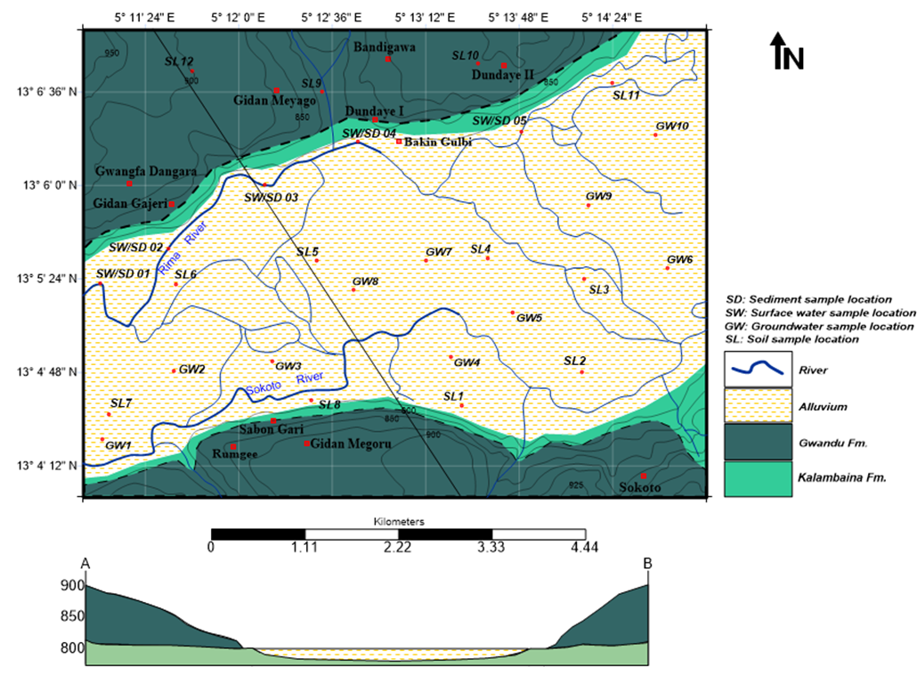

**Figure 1: Geological Map of the study area.**

**MATERIALS AND METHODS**

A comprehensive desk study was carried out on the subject matter; existing literature concerning the geology and hydrogeology of the study area, the nature and sources of heavy metals and the effect of heavy metals on the environment were reviewed. The study area was then divided into twelve (12) grids of about 4 km2 each and a representative soil sample was collected from each grid. An initial six samples of one kilogram (kg) each were collected from a grid and were then thoroughly mixed together and harmonized. One kilogram of the mixed soil samples was bagged into a sterile polythene bag and labelled appropriately as a representative sample of that grid. The same procedure was repeated for the eleven other grids. A sampling depth of 0-20 cm was maintained for all sampling points; a sterile plastic shovel was used to collect samples. The sediments samples were collected at strategic position along the Rima and Sokoto rivers that drain the area. Collected samples were air-dried in the laboratory for 48 hours and disintegrated with a plastic spatula before the commencement of physicochemical analysis at the Central Laboratory of Usmanu Danfodiyo University, Sokoto Physicochemical analysis. PTE’s concentration was measured using the MP-AES. Data analysis

Environmental pollution indices such as Concentration Factor (Cf), Contamination degree (C*d*), Geoaccumulation Index (I-geo), Enrichment Factor (EF), and Ecological Risk (ER) were used to assess the degree of heavy metal pollution in sampled material from the study area.

Contamination Factor (Cf)

The contamination factor (Cf) was used to determine the heavy metal contamination status of the surface water, groundwater, soil, and river sediment in the study area. The Cf value was postulated by Backman *et al.,* (1997) and used to describe the intensity of contamination. The Cf was calculated using the equation:

Cf = C metal / C Background value (1)

Where Cf = Contamination Factor, C metal = metal concentration in sample and C Background value = background value of metal

Contamination Degree (Cd)

Contamination degree is defined as the summation of all contamination factors; it provides information on the intensity of heavy metal contamination caused by the combined effect of all metals present in each sample.

Mathematically Cd = ∑ Cf (2)

Where Cd = Contamination degree and Cf = Contamination factor

**RESULT AND DISCUSSION**

* **PTEs pollution level in soil of the study area**

Twelve soil samples were collected systematically from the study area and tested for seven different heavy metals (Cd, Cr, Cu, As, Fe, Pb, Hg and Ni). Nine of the samples were collected within the irrigated farmlands, while the remaining three were collected outside the irrigated farmlands. The concentrations of Lead, Nickel, and Arsenic were below detection limit in the study area; however, the concentrations of the remaining four heavy metals are presented below:

*Cadmium*

The concentration of cadmium in soils from the study area ranged from 0.01 mg/kg to 0.02 mg/kg, the concentration is below the world average concentration of 0.5mg/kg, which is also taken as the permissible limit for cadmium in soil (FAO, 2011). The concentration of cadmium is generally below the permissible limit in the study area; however, it was observed that the concentration of cadmium in sampling points within the irrigated farmlands is higher than those form outside the irrigated farmlands (S9, S10, S12). This suggests that the application of agrochemicals within the irrigated farmlands might be actively contaminating the soil with cadmium.

*Iron*

The concentration of iron in soils from the study area ranged from 82.94 mg/kg to 226 mg/kg, the concentration is below the world average concentration of 500 mg/kg which is also taken as the permissible limit for ironin soil (FAO, 2011). Even though the concentration of iron is generally below the permissible limit, it was similarly observed that the concentration of iron in sampling points within the irrigated farmlands is higher than those from outside the irrigated farmlands (S9, S10, S12). This suggests that the application of agrochemicals within the irrigated farmlands might be actively contaminating the soil with iron.

*Chromium*

The concentration of chromium in soils from the study area ranged from 0.1 mg/kg to 0.51 mg/kg, the concentration is below the world average concentration of 54 mg/kg which is also taken as the permissible limit for chromium in soil (FAO, 2011). The concentration of Cr in the study area is higher than those from outside the irrigated farmlands (S9, S10, S12). This suggests that the application of agrochemicals within the irrigated farmlands might be actively contaminating the soil with chromium.

*Copper*

The concentration of copper in soils from the study area ranged from 0.28 mg/kg to 1.52 mg/kg, the concentration is below the world average concentration of 25 mg/kg which is also taken as the permissible limit for copper in soil (FAO, 2011). The concentration of copper is generally below the permissible limit in the study area, and unlike for Cd, Fe and Cr, it was observed that the concentration of copper in sampling points within the irrigated farmlands is relatively evenly distributed between irrigated farmlands and non-irrigated farmlands. Thissuggests that the application of agrochemicals related to irrigation farming has not significantly affected the soil within the irrigated farmland area in terms of copper contamination.

* **Contamination Degree (C*d*) PTEs in soils of the study area.**

The computation of C*d* begins with the establishment of the concentration factor (CF) of each element, as illustrated under methodology. The result of the calculated CF for PTEs in the soils of the study area revealed low contamination for all analysed PTEs, as shown in the table below. The average CF ranged from 0.0043 for chromium to 0.28 for Iron.

Table 1: Concentration factors of PTEs in the soils of the study area

|  |  |  |  |  |
| --- | --- | --- | --- | --- |
|  | CF for Cd | CF for Fe | CF for Cu | CF for Cr |
| S1 | 0.04 | 0.205 | 0.0608 | 0.005185 |
| S2 | 0.04 | 0.2109 | 0.0112 | 0.002407 |
| S3 | 0.04 | 0.40436 | 0.0228 | 0.004444 |
| S4 | 0.04 | 0.25712 | 0.014 | 0.002407 |
| S5 | 0.02 | 0.16854 | 0.0116 | 0.001852 |
| S6 | 0.04 | 0.532 | 0.0172 | 0.007037 |
| S7 | 0.04 | 0.43792 | 0.0204 | 0.007037 |
| S8 | 0.04 | 0.33542 | 0.0212 | 0.00463 |
| S9 | 0.04 | 0.18394 | 0.0128 | 0.003704 |
| S10 | 0.02 | 0.16588 | 0.0112 | 0.001852 |
| S11 | 0.04 | 0.36644 | 0.0164 | 0.009444 |
| S12 | 0.02 | 0.1789 | 0.0116 | 0.002593 |
| Average | **0.035** | **0.287202** | **0.019267** | **0.004383** |
| Comment | Unpolluted | Unpolluted | Unpolluted | Unpolluted |

CF less than 1 is considered low, a range of 1 to 3 is considered moderate, 3 to 6 is high, while above 6 is considered very high (Backman et al., 1997). All metals analysed have CF values below 1, which suggest that the soil is unpolluted with such metals; however, it was observed that the CF of Cd, Fe and Cr for sampling sites within the irrigated farmlands is significantly higher than the CF for sampling sites outside the irrigated farmlands (Fig. 2), this suggests that the application of agrochemicals within the irrigated farmlands is actively contaminating the soils with Cd, Cr and Fe, although this contamination is not yet at pollution levels.

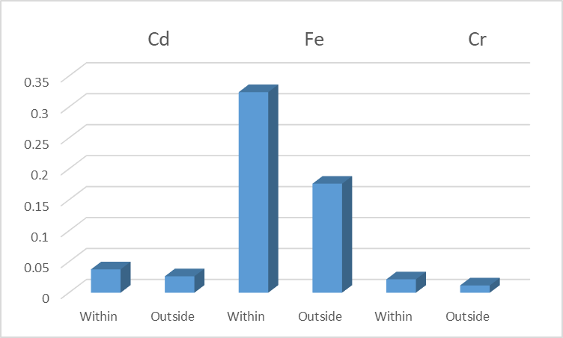

Figure 2: Comparison between concentration factors of Cd, Cr and Fe in the soils within and outside the irrigation area.

The calculated PTEs contamination degree for soils in the study area ranged from 0.198932 for sampling site 10 (S10) to 0.596237 for sampling site 6 (S6). C*d* less than 6 is considered low, a range of 6 to 12 is considered moderate, 12 to 24 is high, while above 24 is considered very high (Backman et al., 1997). The average contamination degree in the study area is 0.35 which is very low and suggests that there is no PTE pollution in the study area however, it was observed that the C*d* for sampling sites within the irrigation farmlands is higher than the C*d* for farmlands outside the irrigated area (Fig. 3). This further suggests that even though the application of agrochemicals has not led to heavy metal pollution, it is actively contaminating the soils with heavy metals.

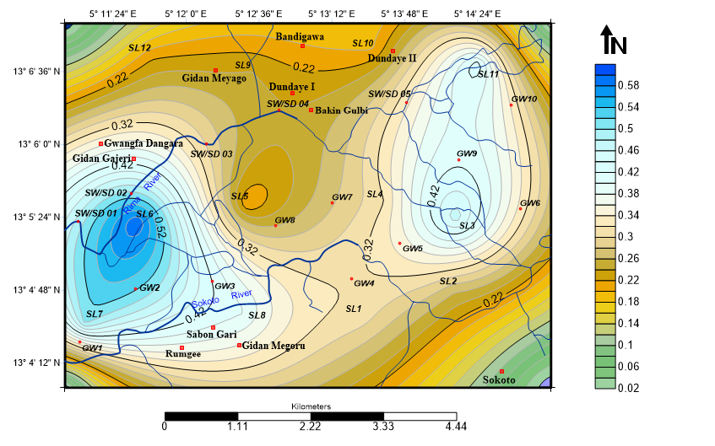

Fig. 3: PTEs contamination degree map

Table 2: Result of other pollution indices

|  |  |  |  |  |  |
| --- | --- | --- | --- | --- | --- |
|  | **Cd** | **Fe** | **Cu** | **Cr** | **Comment** |
| **I-geo** | -3.75787 | -1.65304 | -4.35484 | -5.83555 | Unpolluted |
| **EF** | 0.121866 | NA | 0.067084 | 0.01526 | No enrichment |
| **ER** | 1.0500 | 0.287202 | 0.096333 | 0.008765 | Low Risk |

* **PTEs pollution level of river sediment in the study area**

Five riverbed load sediment samples were collected at strategic positions along the Rima River and analysed for seven heavy metals (Cd, Fe, Cu, Ni, Cr, As and Pb). Three of the analysed heavy metals were below the detection limit (As, Ni and Pb). The results of the remaining four heavy metals analysed are presented below:

*Cadmium*

The concentration of cadmium in the study area ranged from 0.02 ppm to 0.06 ppm with a mean value of 0.042 ppm. The values are below the average concentration of 0.5 ppm which was also taken as the minimum acceptable limit of Cd in sediments. However, it was observed that the concentration of Cd in the river sediment of the study area was higher than the concentration of Cd in the soils. This is an indication that the river sediment environment is more favourable for the accumulation of Cd than the soil environment.

*Iron*

The concentration of iron in the study area ranged from 58.31 ppm to 300.19 ppm with a mean value of 176.36 ppm. The values are below the average concentration of 500 ppm which was also taken as the minimum acceptable limit of Fe in sediments. However, it was also observed that the concentration of Fe in the river sediment of the study area was higher than the concentration of Fe in the soils. This is an indication that the river sediment environment is more favourable for the accumulation of Fe than the soil environment.

*Copper*

The concentration of copper in the river sediment of the study area ranged from 0.24 ppm to 0.54 ppm with a mean value of 0.398 ppm. The values are below the average concentration of 25ppm which was also taken as the minimum acceptable limit of Cu in sediments. However unlike with Cd and Fe, it was observed that the concentration of Cu in the river sediment of the study area was less than the concentration of Cu in the soils. This is an indication that the soil environment is more favourable for the accumulation of Cu than the river sediment environment. This is also consistent with the geogenic origin postulated for the copper in the study area.

*Chromium*

The concentration of chromium in the river sediment of the study area ranged from 0.09 ppm to 0.37 ppm with a mean value of 0.236 ppm. The values are below the average concentration of 54 ppm which was also taken as the minimum acceptable limit of Cr in sediments. It was observed that the concentration of Cr in the river sediment of the study area almost equals the concentration of Cr in the soils. This is an indication that the accumulation of Cr in the soils is happening at almost the same rate as the accumulation of Cr in the river sediment.

* **Contamination Degree (C*d*) PTEs in river sediment of the study area.**

The result of the calculated CF for river sediment in the study area revealed low contamination for all analysed PTEs, as shown in the table below. The average CF ranged from 0.0044 for chromium to 0.3527 for iron.

Table 3: Concentration factor of PTEs in river sediments of the study area

|  |  |  |  |  |
| --- | --- | --- | --- | --- |
|  | CF for Cd | CF for Fe | CF for Cu | CF for Cr |
| RS1 | 0.1200 | 0.4039 | 0.0144 | 0.0054 |
| RS2 | 0.0600 | 0.2931 | 0.0132 | 0.0039 |
| RS3 | 0.1200 | 0.3497 | 0.0208 | 0.0041 |
| RS4 | 0.0400 | 0.1166 | 0.0096 | 0.0017 |
| RS5 | 0.0800 | 0.6004 | 0.0216 | 0.0069 |
| **Mean** | **0.0840** | **0.3527** | **0.0159** | **0.0044** |
| **Comment** | **Unpolluted** | **Unpolluted** | **Unpolluted** | **Unpolluted** |

CF less than 1 is considered low, a range of 1 to 3 is considered moderate, 3 to 6 is high, while above 6 is considered very high (Backman et al., 1997). All metals analysed have CF values below 1 which suggest that the sediments are unpolluted with such elements, however it was observed that the CF of Cd and Fe were significantly higher in the river sediment than in the soil, however the CF of chromium is almost the same in both soil and river sediment while the CF of Cu is higher in soil than in the river sediment (Fig. 4.), this implies that, PTEs contamination of river sediments of the study area with Cd and Fe is happening at a higher rate than in the soil of the study area, the rate of Cu contamination is higher in soil than river sediment while the rate of Cr contamination appears to be the same in both soil and sediments of the study area.

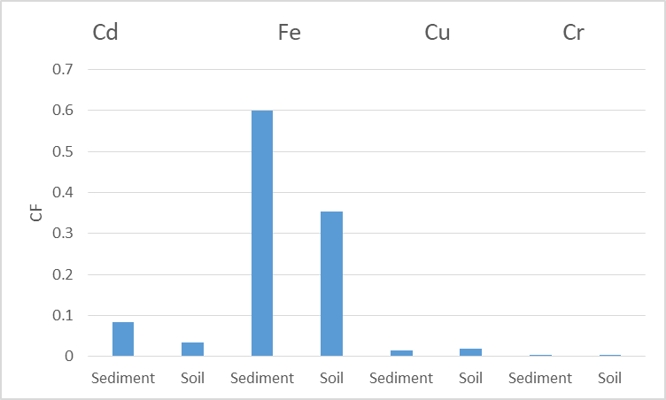

Figure 4: Comparison of concentration factors of PTEs in soil and river sediment of the study area.

The calculated contamination degree of PTEs in sediments ranged from 0.1678 for sampling site 4 (RS4) to 0.7088 for sampling site 5 (RS5). C*d* less than 6 is considered low, a range of 6 to 12 is considered moderate, 12 to 24 is high, while above 24 is considered very high (Bacman et al., 1997). The average contamination degree in the study area is 0.46 which is very low and suggests that there is no PTE pollution in the river sediments of the study area however it was observed that the C*d* for river sediments is higher than the C*d* for soil; this is an indication that generally there is more PTE contamination in the river sediments than in the soil (Figure 5).

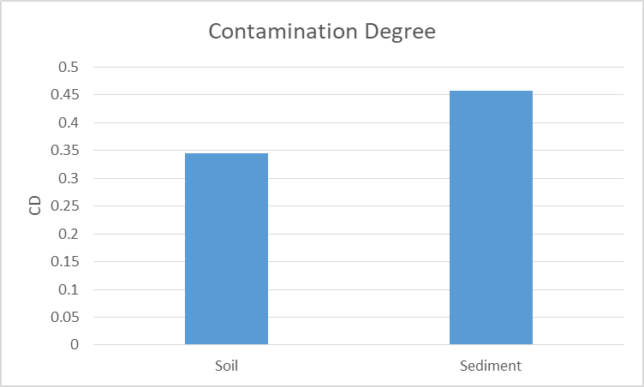

Figure 5: Comparison of contamination degree of PTEs in soil and river sediment of the study area.

Table 4: Result of other PTEs pollution indices

|  |  |  |  |  |  |
| --- | --- | --- | --- | --- | --- |
|  | **Cd** | **Fe** | **Cu** | **Cr** | **Comment** |
| **I-geo** | -2.8824035 | -1.4475004 | -4.5456442 | -5.8383726 | **Unpolluted** |
| **EF** | 0.3968973 | NA | 0.0451329 | 0.0123899 | **No enrichment** |
| **ER** | 2.52 | 0.352736 | 0.0796 | 0.008740741 | **Low Risk** |

**CONCLUSION**

This research aimed to ascertain pollution levels in soil and river sediment in the Kwalkwalawa irrigation floodplain area. Geological mapping was carried out to ascertain the geology of the study area, after which soil samples were collected and analysed for their PTEs concentration (Cd, Cr, Fe, Pb, Ni, Cu, As). Geologically, the area is covered by sedimentary rocks of the Kalambaina and Gwandu formations. The PTEs concentration in soils and sediment is very low, although when the concentration of the elements obtained within the irrigation farming area is compared with those obtained from outside the irrigation farming area, it becomes obvious that the irrigation farming is actively increasing the concentration of these elements in the irrigated farmland area, although the concentrations are not at pollution levels yet.

COMPETING INTERESTS DISCLAIMER:

Authors have declared that they have no known competing financial interests OR non-financial interests OR personal relationships that could have appeared to influence the work reported in this paper.

**REFERENCES**

Adelana M. A., Olasenhinde P. I and Vrbka P. (2006) Quantitative Estimation of groundwater Recharge in part of the Sokoto Basin Nigeria, Journal of Environmental Hydrology, 14(5): 1-16.

Amadi AN, Aminu T, Okunlolai A, Olasehinde PI, Jimoh MO (2015) Lithologic influence on the hydrogeochemical characteristics of groundwater in Zango, North-west Nigeria. Nat Resour Conserv 3(1):11–18

Amadi, A. N., Obaje, N. G. Goki, N. G., Abubakar, K. U.,Shaibu, I. and Nwakife, C. N., (2016). Studies on Water Quality in Suleja, Niger State for Domestic and Irrigational Purposes. Nasara Scientifique: Journal of Natural and Applied Sciences, 5(1), 16 – 29.

Backman, B., D. Bodis, P. Laharmo, S. Rapant, T. Tarvainen, Environmental geology 36(1-2) (1997) 55-64

De-vivo, B., Belkin, H.E, and Lima A. (2008), Environmental Geochemistry. Elsevier Radarweg 29, POBox 211, 1000 AE Amsterdam, Netherlands.

FAO, (2011). Integrated Rural Water Management for Irrigation. Proceedings of the Technical Consultation of Rural Water Management, Rome, Italy

Haliru, M and Japheth, O. (2019). Soil Chemical Properties As Influenced by Irrigation Water Sources in Sokoto, Nigeria. Soil Sci. vol 56.

Hamidu H., Lawal M., Abdulganiyu Y., Kwaya M. Y., Grema H. M., Ibrahim H.A., Kitha M., Yelwa N.A.,(2017). Re-evaluation of Shallow Floodplain Aquifers Groundwater Potentials and Storage of Sokoto Basin, Northwestern Nigeria. American Journal of Water Resources, 5(3), 72 – 84.

Ibrahim, H.A, Abdulkarim, M. Grema H.M. Abdullahi, I.M. Hamidu, H. (2020). Physicochemical assessment of water quality in the Gidan Gulbi Shallow Floodplain Aquifer, Northwestern Nigeria. American Journal of Water Resources, 8(4): 155-163. Doi:10.12691/ajwr-8-4-1.

Kim H.S, Kim Y.J, Seo Y.R, (2015). An Overview of Carcinogenic Heavy Metal: Moleculer Toxicity Mechanism and Prevention. Journal of Cancer Prevention. 20(4): pp 232-240.

Li S, Luo W, Jia Z, Tang S, Chen C (2018). The pros and cons of encouraging shallow groundwater use through controlled drainage in a salt-impacted irrigation area. Water Resour Manag 32(7):2475–2487

Obaje, N.G. 2009 Geology and mineral resources of Nigeria Springer 219

Selck BJ, Carling GT, Kirby SM, Hansen NC, Bickmore BR, Tingey DG, Rey K, Wallace J, Jordan JL (2018) Investigating anthropogenic and geogenic sources of groundwater contamination in a semi-Arid Alluvial Basin, Goshen Valley, UT, USA. Water Air Soil Pollut 229(6186):1–17

Takeshima, H. Adeoti, A. Okoli, S., Salau, S. Rhoe, V. Demand characteristics for small- scale private irrigation technologies: knowledge gap in Nigeria. Abuja IFPRI. (2010): (Working paper, no 0018)

Umar-Tsafe N, T Olayinka A, Ahmed S, S Shehu M, Poggensi G, Habib A, Sabitu K, M Nguku P, Jafiya A, Kachalla M, Binu Gubio A, Inna Muhammad H, Aliyu S, Idris B, Shehu B, Isah A, Ahmad H, Madaro Y, Usman R, Halilu I, Yalwa H, Kolo H, Waziri E, Gidado S, Dalhat M, J Mwangombe B, Olabiyo R, Oloruntuyi G, Zakariyya Yauri A, A Shinkafi B, Sani-Gwarzo N, Iliyasu Z, Indo Mamman A, S Isah H, Akuyam S, Anetor JI and Jean Brown M (2019). The Lead Poisoning Control in Zamfara and Niger States, Nigeria: A 2010-2018 Review. Front. Pharmacol. Conference Abstract: International Conference on Drug Discovery and Translational Medicine 2018 (ICDDTM '18) “Seizing Opportunities and Addressing Challenges of Precision Medicine”. doi: 10.3389/conf.fphar.2019.63.00028

Wagh VM, Panaskar DB, Varade AM, Mukate SV, Gaikwad SK, Pawar RS, Muley AA, Aamalawar ML (2016) Major ion chemistry and quality assessment of the groundwater resources of Nanded tehsil, a part of southeast Deccan Volcanic Province, Maharashtra, India. Environ Earth Sci 75(1481):1–27