**INSIGHTS INTO HYDRODYNAMIC CONTROLS ON SEDIMENT GRAIN SIZE VARIABILITY IN TROPICAL TIDAL FLATS OF CALABAR AND GREAT KWA RIVERS, NIGERIA**

**ABSTRACT**

This study investigates the hydrodynamic influences shaping sediment grain size distributions in tidal flats along the Calabar and Great Kwa Rivers in Southeast Nigeria. Utilizing extensive tidal current velocity measurements and sediment grain size analyses from supratidal, intertidal, and subtidal zones, we reveal distinct patterns of sediment sorting and transport driven by ebb-dominant tidal flows coupled with fluvial inputs. Our results demonstrate that sediment grain size variability is strongly governed by spatial and temporal fluctuations in flow velocity and energy regimes, resulting in characteristic depositional facies that differ significantly between the two river systems. These findings advance the understanding of sedimentological processes in tropical tidal flats and provide a baseline for predicting responses to environmental change in similar systems.

**Keywords:** *Tidal flats, Sediment grain size, Hydrodynamics, Tidal Current velocity,* *Southeast Nigeria*

**INTRODUCTION**

Tidal flats, also known as mudflats, are coastal wetlands formed in intertidal areas where tidal or riverine forces deposit sediments (Gao 2018). These ecosystems are characterized by regular inundation and exposure due to tidal movements, leading to the accumulation of fine-grained sediments such as silt and clay (Gao 2019; Perillo et al. 2024). Globally, tidal flats play a crucial role in coastal dynamics, serving as habitats for diverse biota, acting as buffers against coastal erosion, and contributing to nutrient cycling (Zeng et al. 2021a; Jordan and Fröhle 2022; Zhou et al. 2022).

Hydrodynamics, encompassing tidal currents, wave action, and river discharge, are fundamental in shaping the sedimentary characteristics of tidal flats (Friedrichs 2012). Understanding these hydrodynamic controls is crucial for interpreting sedimentary structures and predicting changes in tidal flat morphology. The energy imparted by these forces determines the transport and deposition of sediments, influencing grain size distribution across different tidal zones (Gao 2019). Furthermore, river discharge introduces additional variability into sediment dynamics. Variations in discharge can alter flow velocities, affecting sediment transport capacity and leading to changes in grain size distribution over time. The combined effects of tidal and riverine forces create a dynamic environment where sediment characteristics are continuously modified.

In tropical regions, tidal flats are particularly significant due to their high biological productivity and sensitivity to environmental changes (Schutte et al. 2019; Mustafa et al. 2024). The interplay between hydrodynamic forces and sediment supply in these areas leads to distinct sedimentary structures and grain size distributions (Gao 2018). However, the complexity of these interactions, influenced by factors such as tidal range, river discharge, and anthropogenic activities, presents challenges in understanding sediment dynamics in tropical tidal flats (Friedrichs 2012).

Recent studies have highlighted the need for comprehensive research on sedimentology in these regions to inform conservation and management strategies (Desjardins et al. 2012; Fagherazzi et al. 2013, 2022; Okon and Seelam 2023; Okon et al. 2023; Perillo et al. 2024), underscoring the importance of understanding sedimentary processes in tropical coastal systems. Similarly, Gao (2019) and Xing et al. (2022) emphasized the role of hydrodynamic conditions in shaping sediment distribution patterns in tidal flats.

Despite these efforts, significant gaps remain in our understanding of how hydrodynamic forces influence sediment grain size variability in tropical tidal flats. This study aims to address these gaps by investigating the sedimentology of tidal flats in the Calabar and Great Kwa Rivers, providing insights into the hydrodynamic controls on sediment distribution in these tropical coastal systems.

In areas with strong tidal currents, such as the Calabar and Great Kwa Rivers, the interplay between ebb and flood tides can lead to the sorting of sediments based on size and density (Lynda E. and Asuquo 2012). Coarse sediments are typically deposited in areas with higher energy conditions, while finer sediments accumulate in low-energy zones. This sorting process results in distinct sedimentary facies within tidal flats, each with unique grain size distributions.

In West Africa, rapid urbanization, industrialization, and agricultural expansion have introduced new challenges to tidal flat ecosystems (Almar et al. 2023; Dada et al. 2024). While extensive research has been conducted on tidal flat sedimentology in temperate regions, studies focusing on tropical tidal systems, particularly in West Africa, remain limited. The unique climatic, hydrological, and anthropogenic factors in these regions necessitate region-specific investigations to understand sediment dynamics accurately.

The Calabar and Great Kwa River basins, increased sedimentation from construction activities, and pollution from industrial waste have altered sedimentary processes and impacted the ecological balance of these areas (Abali and Abua 2021; Abua et al. 2023; Abali and Nkii 2024). These anthropogenic influences, combined with natural hydrodynamic forces, create complex sedimentary environments that require detailed study. These tidal flats represent an understudied yet ecologically and geologically significant part of Nigeria's coastal zone. Despite their importance, comprehensive sedimentological and hydrodynamic investigations have been sparse, limiting effective management and conservation efforts. The comparison of relatively unaffected areas with zones affected by human interventions within these tidal flats offers a valuable contrast for examining the interplay between natural processes and anthropogenic impacts on sediment dynamics.

Furthermore, existing research often lacks comprehensive data on sediment grain size distribution across different tidal zones and the associated hydrodynamic conditions. Lynda E. and Asuquo (2012) provided initial insights into the sedimentology of tidal rivers in southeastern Nigeria, but their study was limited in scope and depth and still left many questions unanswered regarding the specific hydrodynamic controls on sediment distribution.

Rapid urbanization and industrial growth in Calabar and its surrounding areas have intensified sedimentation rates and altered natural sediment transport pathways (Obia et al. 2015). Dredging activities in Marina (Iyata) flat, a key shipping channel, have modified sediment characteristics and potentially influenced faunal distributions (Job Bassey et al. 2015). Moreover, pollution from industrial effluents and agricultural runoff has impacted water quality, affecting physicochemical parameters such as dissolved oxygen and conductivity, which are vital for benthic organisms. These anthropogenic influences, combined with natural seasonal variability, create a complex matrix of environmental factors affecting sedimentology and ecosystem health in the tidal flats. Understanding how these factors interact with hydrodynamics to shape sediment grain size distribution and sedimentary structures is essential for sustainable coastal zone management.

The primary objective of this study is to investigate the hydrodynamic controls on sediment grain size variability in the tidal flats of the Calabar and Great Kwa Rivers, southeastern Nigeria. By examining tidal current velocities, river discharge patterns, and sediment grain size distributions across different tidal zones, the study aims to elucidate the mechanisms governing sediment transport and deposition in these tropical tidal systems. The novelty of this study lies in its comprehensive approach to integrating hydrodynamic data with sedimentological analysis in a tropical West African context. While previous studies have explored aspects of sediment dynamics in these regions, this study provides a holistic examination of the interactions between tidal and riverine forces and their impact on sediment grain size distribution. Additionally, this research offers insights into the effects of anthropogenic activities on sedimentary processes in these coastal areas.

This study aims to bridge these knowledge gaps by providing a detailed analysis of sediment grain size variability and the hydrodynamic factors influencing these patterns in the Calabar and Great Kwa Rivers. By focusing on these West African tidal systems, this research will contribute to a more comprehensive understanding of tropical tidal flat sedimentology and inform effective management strategies for these vital ecosystems. The findings of this study are expected to contribute significantly to the field of coastal sedimentology, offering valuable information for the management and conservation of tidal flat ecosystems in tropical regions. Insights gained from this study can inform broader coastal management policies, not only within Nigeria but also across other tropical tidal systems facing similar challenges globally. By addressing the specific challenges and dynamics of West African tidal systems, the research will fill critical gaps in existing knowledge and provide a foundation for future studies in similar environments.

**Study Area**

The Calabar and Great Kwa Rivers are prominent tidal river systems located in Cross River State, Southeast Nigeria, within the humid tropical rainforest belt of West Africa (Fig. 1). They originate from the Oban Hills and flow through low-lying coastal plains before discharging into the Atlantic Ocean (Lynda E. and Asuquo 2012). The tidal influence extends several kilometers upstream, creating extensive tidal flats characterized by alternating subtidal, intertidal, and supratidal zones.

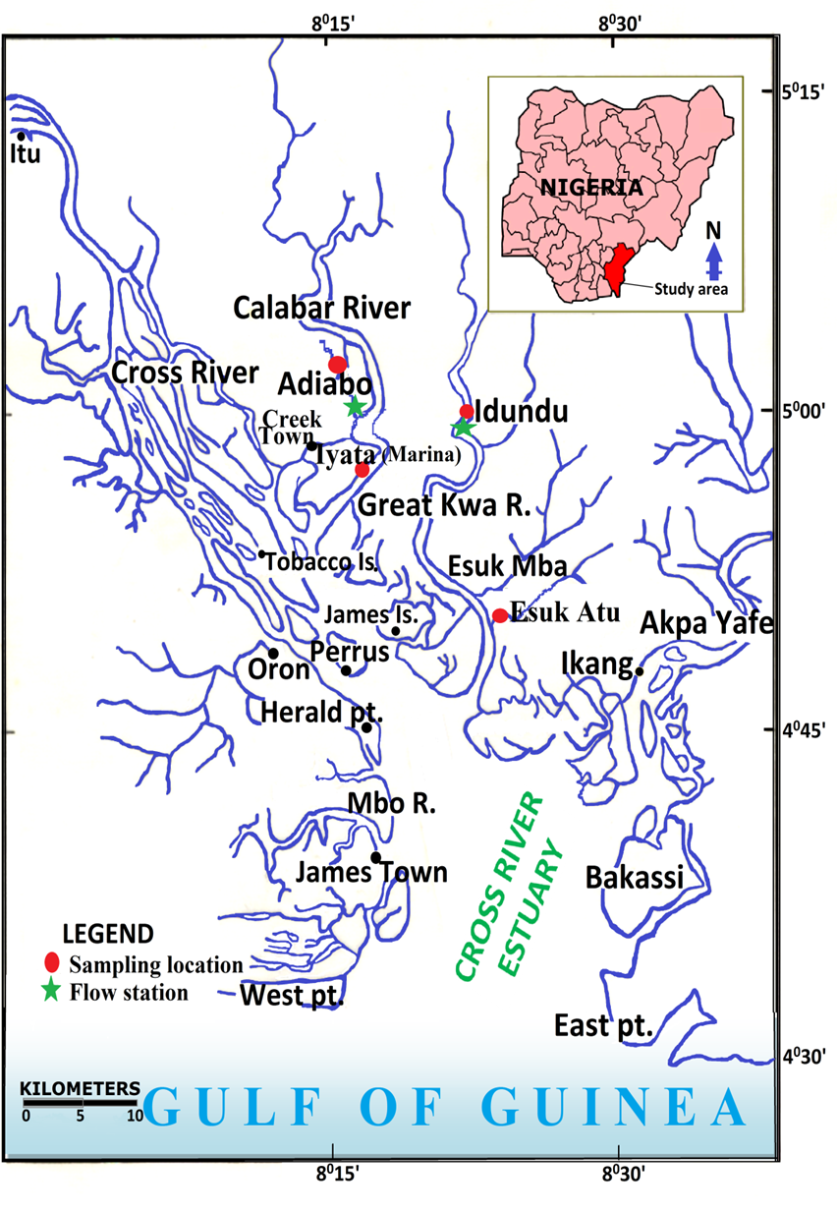

Fig. 1: Study Area Map showing the location of Calabar and Great Kwa Rivers, and sampling sites

These flats are primarily composed of siliciclastic sediments, with textures ranging from coarse sand to fine silt and clay, shaped by the interplay of tidal currents, river discharge, and wave action. The gentle slope of the coastal plains coupled with a moderate tidal range (~1–2 meters) results in wide and ecologically rich tidal flat expanses, especially evident in areas such as the Adiabo, Marina, Atu, and Idundu flats (Lynda E. and Asuquo 2012).

The geology underlying the study area mainly consists of Coastal Plain Sands of Tertiary to Recent age, underlain in some parts by Cretaceous sediments of the Calabar Flank (Okon 2014). These unconsolidated sediments provide a dynamic substrate that responds sensitively to hydrodynamic forces (Emeka et al. 2010). The sediment supply is predominantly fluvial, sourced from weathered materials in the upstream highlands and transported downstream by river flow and tidal currents.

The climate of the region is typified by a humid tropical rainforest regime with a long wet season spanning from April to November and a shorter dry season from December to March. The annual rainfall averages approximately 3,000 mm, with high relative humidity (60–85%) throughout the year. Seasonal variations in precipitation and river discharge significantly influence hydrodynamic conditions and sediment transport processes within the tidal flats (Emeka et al. 2010). Prevailing south-west trade winds generate wind-driven waves that moderately impact the estuarine environments, although these waves are generally subdued due to the sheltered nature of the tidal flats and the narrow river channels. Additionally, the tidal rivers experience bi-directional flows controlled by the semi-diurnal tides, creating ebb- and flood-dominant periods that govern sediment mobilization and deposition (Antia et al. 2012). The tidal flats of the Calabar and Great Kwa Rivers support diverse ecological and socio-economic activities. The region is home to communities engaged in artisanal fishing, aquaculture, small-scale farming, and sand mining. These activities are critical to local livelihoods but also exert pressure on fragile tidal flat environments.

**MATERIALS AND METHODS**

This study employed a multidisciplinary approach that combined field measurements of tidal hydrodynamics, sediment sampling, and laboratory analyses to investigate sediment grain size variability in the tidal flats of the Calabar and Great Kwa Rivers. The integration of these methods allowed for a comprehensive understanding of the physical controls influencing sediment distribution.

**Tidal Flow Measurements and Hydrodynamic Data Collection**

To characterize the hydrodynamic regime governing sediment transport, tidal current velocities and tidal water levels were measured at representative stations within the tidal flats of both rivers. Primary monitoring stations were established at Adiabo in the Calabar River and Idundu in the Great Kwa River.

Tidal current velocities were measured using a Lagrangian flow measurement approach (Lynda and Asuquo 2012; Asuquo et al. 2020), which involves tracking the movement of floating devices or drifters released in the water column to capture flow direction and speed over time. Measurements were conducted at 30-minute intervals during spring tide cycles, the periods of highest tidal range and flow energy, to capture maximum variability.

Tidal water levels were concurrently measured using graduated staffs placed at fixed locations near the flow measurement points. Water level readings were recorded at 30-minute intervals to document tidal height fluctuations and enable correlation with current velocities. These measurements were taken from July 2011 to March 2012, covering both wet and dry seasons to incorporate seasonal hydrodynamic variability.

The tidal flow data were plotted using ordinary graphs to visualize temporal changes in velocity and flow direction, allowing identification of ebb and flood dominance, tidal asymmetry, and any anomalous flow patterns. This hydrodynamic characterization formed the basis for understanding sediment transport mechanisms.

**Sediment Sampling and Grain Size Analysis**

Sediment samples were collected from four georeferenced tidal flats representing different locations along the Calabar and Great Kwa Rivers: Adiabo and Marina flats (Calabar River) and Atu and Idundu flats (Great Kwa River). Sampling sites were carefully selected to represent the supratidal, intertidal, and subtidal zones within each flat, providing vertical and spatial resolution of sediment characteristics.

Sampling was conducted during spring low water slack periods to allow safe and effective access to the flats. At each sampling point, sediment cores were obtained using a push-core sampler with a depth penetration of approximately 0.75 m. Three replicate cores per site were collected to ensure representative sampling and statistical validation.

Collected sediment samples were air-dried in the laboratory and subsequently sieved through a series of mesh screens with size ranges calibrated in phi units (ϕ) to isolate different grain size fractions. The sieving process followed standardized protocols to avoid sample contamination and to ensure accuracy.

Grain size distributions were determined by weighing the percentage of sediment retained on each sieve. These weight percent data were used to construct grain size frequency and cumulative curves, which facilitated the calculation of statistical grain size parameters.

**Grain Size Statistical Parameters and Data Processing**

Grain size data were analyzed using the Folk and Ward (1957) method, a widely accepted statistical approach in sedimentology, to compute key parameters: mean grain size (Mz), sorting (inclusive standard deviation, σ), skewness (SKI), and kurtosis (KG). These parameters provide insight into sediment transport history, depositional environment energy, and sediment source. These parameters were calculated using GRADISTAT version 8.0 (Blott and Pye 2001), which facilitates precise statistical analysis and graphical visualization.

**Data Analysis**

To ensure data reliability, the sediment samples were handled using strict contamination prevention measures. Replicate samples were analyzed to assess variability and confirm the reproducibility of grain size measurements. The instruments used for hydrodynamic measurements were calibrated prior to field deployment and were periodically checked during the study period.

Hydrodynamic data and sediment grain size statistics were integrated to interpret the controls on sediment distribution across tidal flats. Temporal variations in tidal currents and water levels were linked to observed grain size trends to elucidate dynamic sedimentary processes.

This integrative approach enabled a comprehensive understanding of how ebb and flood tides, river discharge, and seasonal factors collectively influence sediment grain size variability in the tidal flats of the Calabar and Great Kwa Rivers.

Bivariate scatter plots were generated to explore the relationships between grain size parameters and interpret sediment dynamics. Key parameter pairs such as sorting versus mean grain size, were plotted for each tidal flat zone. Patterns in these plots helped identify sediment transport mechanisms (ebb or flood dominance), depositional energy regimes, and possible sediment source influences.

**RESULTS**

This section presents the findings from hydrodynamic measurements and sediment grain size analyses across tidal flats in the Calabar and Great Kwa Rivers. The results are structured to highlight tidal current patterns, sediment distribution, grain size statistics, and interrelationships between parameters.

**Tidal Current Velocity Patterns and Tidal Height Variations**

Tidal current velocity data collected from Adiabo (Calabar River) and Idundu (Great Kwa River) revealed dynamic flow regimes that were strongly influenced by tidal cycles and river discharge. Measurements taken during spring tides, the period of the highest tidal range, showed pronounced ebb dominance, especially from July to October 2011 (Fig. 2).

At the Adiabo station, peak ebb velocities reached approximately 0.91 m/s in November 2011, indicating strong seaward flow during low tide. Flood velocities were generally lower, with flow direction reversing between ebb and flood but maintaining a consistent bi-directional pattern throughout the study period (Fig. 2a). This bi-directional flow pattern is characteristic of tidal rivers with alternating current directions, resulting in sediment transport both upstream and downstream.

In contrast, the Idundu station on the Great Kwa River exhibited maximum ebb velocities of approximately 1.00 m/s in January and February 2012 (Fig. 2b). Notably, from July to October 2011, both ebb and flood flows were predominantly oriented southward, suggesting diminished tidal influence during these months, likely caused by increased river discharge overpowering tidal currents. This phenomenon underscores the variable hydrodynamic forces shaping sediment transport within these tidal systems.



\

Fig. 2: Tidal velocity variations (m/s) measured monthly from July 2011 to March 2012 at (a) Adiabo station (Calabar River) and (b) Idundu station (Great Kwa River), showing ebb dominance and seasonal flow variability.

Tidal height measurements confirmed a maximum range of approximately 44 cm at Adiabo in December 2011 and 32 cm at Idundu in October 2011. Peak tidal heights coincided with flood tides and closely corresponded with increased flood flow velocities, reinforcing the linkage between tidal height and current energy that drives sediment redistribution on the flats.

**Grain Size Distribution Across Tidal Zones and Sites**

Sediment samples from the four tidal flats, Adiabo, Marina (Calabar River), Atu, and Idundu (Great Kwa River), demonstrated considerable spatial variability in grain size distributions, reflecting the interplay between hydrodynamics and sediment supply.

|  |
| --- |
|  |

Fig. 3: Mean grain size (φ) distribution across the supratidal, intertidal, and subtidal zones at four tidal flats. Lower φvalues correspond to coarser sediments, illustrating spatial sediment grain size gradients linked to hydrodynamic energy.

**Calabar River**

*Adiabo Flat*Dominated by medium to coarse sands with mean grain sizes ranging from 0.85 to 2.40 φ, the Adiabo flat showed a fining-upward trend from the supratidal to subtidal zones. Sediments were generally poorly sorted, indicating variable energy conditions (Fig. 3). The presence of coarse sand inclusions at depths between 25 and 35 cm within the intertidal zone suggests episodic higher-energy deposition events.

*Marina Flat*

Characterized by very fine silty sediments with mean grain sizes ranging from 1.63 to 4.40 phi, the Marina flat exhibited finer sediments than Adiabo. The subtidal zone contained very coarse silt (4.27 – 4.40 phi), capped by medium to fine sand layers (Fig. 3). Sorting ranged from poor to moderate, reflecting fluctuations in hydrodynamic energy, which may have been influenced by proximity to dredging activities in this navigational channel.

**Great Kwa River**

*Atu Flat*   
Predominantly composed of coarse sands with mean grain sizes ranging from 0.18 to 1.98 phi, the Atu flat sediments were poorly sorted and consistent across all tidal zones. The dominance of coarse sand aligns with higher energy flow conditions, supported by the observed peak current velocities.

*Idundu Flat*

Displaying finer sediments ranging from fine to very fine sands (2.30 – 3.83 phi), the Idundu flat sediments were better sorted relative to Atu flat, indicating more stable depositional conditions. The fining trend seaward reflects decreasing hydrodynamic energy from upstream towards the estuary.

**Statistical Characterization of Sediment Samples**

Key grain size statistical parameters computed for each tidal flat provided quantitative descriptions of sediment texture and depositional processes.

Values reaffirmed field observations, with Adiabo and Atu flats exhibiting coarser sediments, while Marina and Idundu flats were dominated by finer materials (Fig. 4). The mean grain size correlated inversely with distance downstream, consistent with expected fining trends in tidal systems.

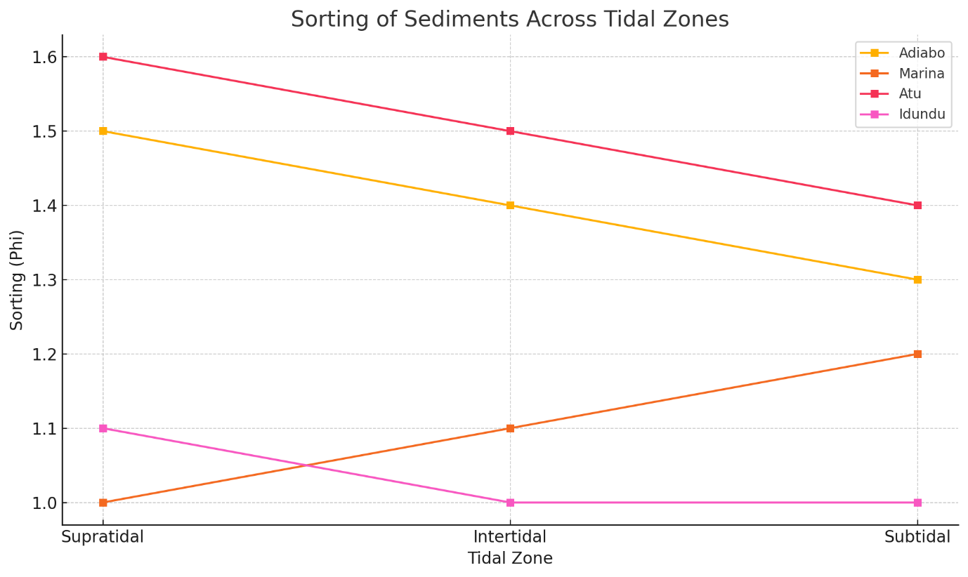Fig. 4: Sediment sorting values (phi) across tidal zones for the four tidal flats, indicating sediment variability and energy conditions.

Poorly sorted sediments were typical in all flats, with Adiabo and Atu flats showing sorting ranges of approximately 1.24–1.61 phi and 0.89–1.73 phi, respectively. The Marina and Idundu flats displayed wider sorting variability, reflecting the influence of episodic sediment inputs and localized hydrodynamic effects.

The Adiabo flat showed a skewness range from slightly negative to positive (-0.29 to 0.22), indicating dominance of coarser grains in some zones and finer grains in others. Marina and Atu flats were mostly positively skewed, suggesting finer sediments were preferentially deposited, while Idundu showed mixed skewness values, highlighting variable sediment sources and transport regimes.

Sediments ranged from platykurtic (flatter distributions) to leptokurtic (peaked distributions), with Marina and Idundu flats exhibiting higher kurtosis values (up to 2.88), indicating episodic concentrations of particular grain sizes, likely due to hydrodynamic sorting during tidal cycles.

These parameters collectively reflect the complex sediment dynamics within the tidal flats and highlight the sensitivity of grain size distributions to localized flow regimes.Scatter plots of grain size parameters (Fig. 5) elucidated relationships that underpin sediment transport processes:

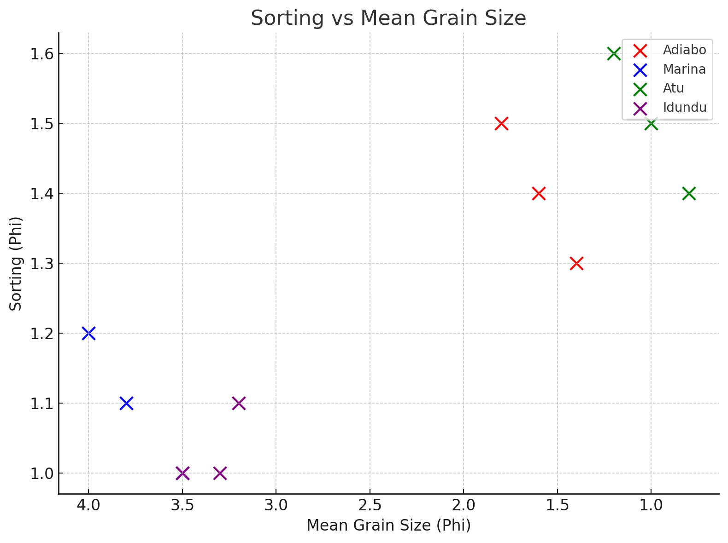

Fig. 5: Bivariate scatter plot illustrating the relationship between sediment sorting and mean grain size for the four tidal flats. An inverse trend highlights differences in sediment transport and depositional energy.

Two distinct clusters were identified. Adiabo and Atu flats showed an increase in mean grain size with deteriorating sorting, indicative of high-energy depositional conditions with variable sediment supply. Conversely, Marina and Idundu flats exhibited decreasing mean grain size with poorer sorting, suggesting low-energy, fine sediment accumulation.

The integration of tidal current data and sediment grain size analyses revealed that sediment distribution within the tidal flats of the Calabar and Great Kwa Rivers is strongly controlled by ebb-dominant tidal flows and river discharge variations. Sediment textures range from coarse sands in upstream flats exposed to higher energy conditions to finer silts and sands downstream in lower energy depositional environments. Statistical grain size parameters and bivariate relationships confirmed these trends and underscored the dynamic nature of tropical tidal flat sedimentology.

**DISCUSSION**

This section interprets the results in the context of existing literature, addressing the hydrodynamic controls on sediment grain size variability in the tropical tidal flats of the Calabar and Great Kwa Rivers. This study emphasizes the importance of understanding how tidal and fluvial dynamics interact to shape sediment distribution, filling knowledge gaps in West African coastal systems and providing novel insights relevant to tropical sedimentology.

**Hydrodynamic Influences on Sediment Grain Size Distribution**

Our findings demonstrate that hydrodynamic forces exert primary control over sediment grain size variability in the studied tidal flats. The measured ebb-dominant tidal currents, with peak velocities reaching up to 1.00 m/s, indicate strong seaward-directed flows that influence sediment transport and sediment sorting. This ebb dominance aligns with patterns observed in other tidal river systems worldwide, where stronger ebb currents facilitate sediment export and create fining gradients downstream (Ahad and Saleh 2010; Cosma et al. 2022; Hanegan et al. 2023).

The interplay between tidal currents and river discharge creates a dynamic energy environment. During periods of high river discharge, as seen from July to October in the Great Kwa River, flood currents weaken or become unidirectional, reducing sediment import and enhancing fluvial sediment export. This phenomenon, known as tidal asymmetry, affects sediment grain size distributions by favoring the deposition of coarser grains in higher energy upstream zones and finer sediments downstream (Prodger 2017; Lepesqueur et al. 2019), as observed in our Adiabo and Idundu flats, respectively. The consistency of these findings underscores the universality of hydrodynamic sediment sorting mechanisms, yet our study fills a critical gap by documenting these processes in a West African context, where such detailed sedimentological and hydrodynamic integration has been scarce.

**Implications of Grain Size Statistics for Depositional Environments**

The statistical parameters derived from sediment grain size analyses offer deeper insights into depositional conditions across the tidal flats. The predominance of poorly sorted sediments across most flats, particularly at Adiabo and Atu, indicates variable and fluctuating energy regimes that are likely influenced by episodic storm events, boat traffic, and seasonal river discharge changes (Nsaif and Abbas 2024). Poor sorting is typical of environments with intermittent high-energy conditions interrupting otherwise low-energy deposition (Li et al. 2023; Maju-Oyovwikowhe and Olowu 2023).

Positive skewness observed in Marina and Atu flats suggests the dominance of finer particles, indicative of sheltered, low-energy environments conducive to fine sediment accumulation. This is supported by sediment texture descriptions of silts and fine sands in these areas, matching studies in similar tropical tidal flats in the Gulf of Thailand, where low-energy tidal basins accumulate fine sediments (Wang et al. 2020; Jiwarungrueangkul et al. 2022).

The variation in kurtosis values between platykurtic to leptokurtic distributions suggests episodic sediment reworking and sorting, reflecting complex interactions between tidal currents and sediment supply. This phenomenon is consistent with recent findings in the tidal flats of the Southern Yellow River (Zeng et al. 2021b), where tidal reworking creates spatial heterogeneity in sediment distribution.

Overall, these grain size characteristics support the interpretation of a depositional continuum, ranging from high-energy, ebb-dominated sand flats upstream to low-energy, mud-rich flats downstream. The gradients and transitions observed provide valuable proxies for reconstructing paleoenvironmental conditions and assessing sedimentary processes in tropical tidal systems.

**Comparison Between Calabar and Great Kwa Rivers: Hydrodynamic and Sedimentary Contrasts**

Despite their geographical proximity, the Calabar and Great Kwa Rivers exhibit notable differences in sediment dynamics, likely driven by their contrasting hydrodynamic regimes and anthropogenic influences.

The Calabar River flats, particularly Adiabo and Marina, showed stronger tidal bi-directionality and a wider range of sediment grain sizes. The presence of dredging operations at Marina likely disrupts natural sedimentation patterns by introducing river bottom sediments and modifying flow energy locally. Such anthropogenic disturbances have been documented in coastal systems globally to cause sediment resuspension and alter depositional facies (Wang 2007; Chen et al. 2024).

Conversely, the Great Kwa River flats, especially Atu and Idundu, displayed more consistent ebb dominance, with sediment textures reflecting predominantly medium to coarse sands at Atu and finer sands at Idundu. This difference may be attributed to the narrower channel morphology of the Great Kwa River, which constrains tidal flow and sediment transport pathways, promoting a more stable depositional environment (Emeka et al. 2023).

These contrasts highlight the sensitivity of tropical tidal flat sedimentology to both natural hydrodynamic factors and human activities. Similar observations in West African estuaries have emphasized the need for site-specific sediment management plans that consider these complexities (Anthony et al. 2002; Laignel et al. 2023; Mbevo Fendoung and Hubert-Ferrari 2025).

**Addressing Research Gaps in West African Tidal Flat Sedimentology**

Prior to this study, West African tidal flats had limited integrated sedimentological and hydrodynamic data, with most research focusing on ecological or broad geomorphological aspects of the flats. This study bridges that gap by providing a holistic assessment linking tidal flow dynamics to sediment grain size distributions, offering a foundational framework for understanding sedimentary processes in this region. The findings corroborate emerging research advocating for the importance of hydrodynamic variability in tropical sedimentary environments (Desjardins et al. 2012; Boota et al. 2015; Gao 2019). Additionally, the study introduces detailed grain size statistical analyses rarely applied in West African coastal sedimentology, setting a new standard for future investigations.

Furthermore, the results highlight the influence of human activities such as dredging and urban runoff, on sediment heterogeneity, emphasizing the need to incorporate anthropogenic impacts into sedimentological models. This integrated perspective aligns with contemporary coastal research paradigms emphasizing coupled natural-human system dynamics (He et al. 2016; Liu et al. 2016; Hassan et al. 2025).

The insights gained extend beyond the regional focus, offering comparative data valuable to tropical tidal flat studies worldwide, including in Southeast Asia, South America, and other parts of Africa. This contributes to a more global understanding of tidal flat sedimentology in diverse climatic and geomorphological settings.

**Implications for Coastal Management**

Understanding hydrodynamic controls on sediment grain size is essential for effective coastal zone management, particularly in regions vulnerable to sea-level rise and human pressures. The identified sediment distribution patterns and hydrodynamic regimes provide critical baseline information for designing interventions aimed at preserving tidal flat integrity, such as regulating dredging activities and managing land-based sediment inputs.

Future research should focus on expanding temporal and spatial coverage, incorporating sediment transport modeling and biogeochemical analyses to unravel sediment dynamics and ecosystem responses fully. Long-term monitoring programs integrating remote sensing with in situ measurements would enhance understanding of sediment fluxes under climate variability.

This study significantly advances the understanding of sediment grain size variability and hydrodynamic controls in tropical tidal flats of the Calabar and Great Kwa Rivers. Addressing regional research gaps and applying a novel integrative methodology provides a valuable scientific foundation for both academic inquiry and coastal management in West Africa and similar tropical environments globally.

**CONCLUSIONS**

This study provides a comprehensive analysis of the hydrodynamic controls on sediment grain size variability within the tidal flats of the Calabar and Great Kwa Rivers in Southeast Nigeria, addressing a significant research gap in tropical West African coastal sedimentology. Integrating tidal flow measurements with detailed sediment grain size statistical analyses has yielded novel insights into the dynamic sedimentary processes shaping these critical coastal environments.

The tidal flats exhibit strong hydrodynamic influence, characterized by ebb-dominant tidal currents with peak velocities up to 1.00 m/s. These forces are primary drivers controlling sediment transport and deposition patterns, consistent with global tidal river systems but uniquely quantified here for a West African context.

Spatial variability in sediment gr in size is marked, with upstream flats such as Adiabo and Atu dominated by medium to coarse sands indicative of higher energy environments, while downstream flats like Marina and Idundu accumulate finer silts and sands in more sheltered, lower energy settings. Grain size statistical parameters confirmed poorly sorted sediments across most flats, reflecting episodic hydrodynamic fluctuations and anthropogenic influences such as dredging. Variations in skewness and kurtosis further illuminate complex depositional mechanisms modulated by tidal asymmetry and river discharge.

This research uniquely combines high-resolution hydrodynamic data with quantitative sedimentological analysis in a tropical West African tidal flat system—a methodological integration rarely achieved in this region. It establishes a foundational understanding of how tidal and fluvial processes interact to shape sediment grain size distributions and sedimentary environments.

By highlighting the influence of anthropogenic activities on sediment characteristics, the study advocates for incorporating human impacts into sediment dynamics models. This holistic perspective enhances both scientific understanding and practical management strategies. These findings underscore the importance of monitoring and managing hydrodynamic alterations and sediment supply in maintaining the ecological and geomorphological integrity of tropical tidal flats. Regulatory attention to dredging, urban runoff, and land-use changes is critical for preserving sedimentary habitats that support biodiversity and coastal resilience.

Future research should expand on temporal scales, incorporate sediment transport modeling, and assess biogeochemical cycles to capture the complexity of these dynamic systems fully. Multidisciplinary approaches integrating remote sensing, ecology, and sedimentology will further advance knowledge and inform adaptive coastal management under global change pressures.

**REFERENCES**

Abali T, Abua M (2021) Rainfall -Sediment Loss On Land use Types in Calabar River Catchment, Cross River State, Nigeria. 4:7–11

Abali T, Nkii L (2024) The Impact of Urban Land Use Changes on the Morphology of the New Calabar River Catchment, Port Harcourt Metropolis, Nigeria. Int J Environ Eng Educ 6:47–56. https://doi.org/10.55151/ijeedu.v6i1.131

Abua MA, Igelle EI, Eneyo VB, et al (2023) Predicting sediment yield on different landuse surfaces in Calabar River Catchment, Nigeria. Heliyon 9:e19071. https://doi.org/10.1016/j.heliyon.2023.e19071

AHAD B, Saleh E (2010) Hydrodynamics and suspended sediment transport at tidal inlets of Salut Mengkabong Lagoon, Sabah, Malaysia. Int J Sediment Res - INT J SEDIMENT RES 25:399–410. https://doi.org/10.1016/S1001-6279(11)60007-3

Almar R, Stieglitz T, Addo KA, et al (2023) Coastal Zone Changes in West Africa: Challenges and Opportunities for Satellite Earth Observations. Surv Geophys 44:249–275. https://doi.org/10.1007/s10712-022-09721-4

Anthony E, Oyédé L, Lang J (2002) Sedimentation in a fluvially infilling, barrier-bound estuary on a wave-dominated, microtidal coast: The Ouémé River estuary, Benin, west Africa. Sedimentology 49:1095–1112. https://doi.org/10.1046/j.1365-3091.2002.00491.x

Antia VI, Emeka NC, Ntekim EEU, Amah EA (2012) Grain Size Distribution and Flow Measurements in Qua-Iboe River Estuary and Calabar Tidal River, SE Nigeria. Eur J Sci Res 67:223–239

Asuquo FE, Okon L, Agi-Odey E, et al (2020) Wind influence on longshore current velocity and sea surface temperatures along a tropical mesotidal coastline, Southeast Nigeria. In: U6CAU Proceedings. pp 110–121

Blott S, Pye K (2001) GRADISTAT: A GRAIN SIZE DISTRIBUTION AND STATISTICS PACKAGE FOR THE ANALYSIS OF UNCONSOLIDATED SEDIMENTS. Earth Surf Process Landforms 26:1237–1248. https://doi.org/10.1002/esp.261

Boota M, Yan C, Soomro S, et al (2015) Appraisal of hydro-ecology, geomorphology, and sediment behavior during low and high floods in the Lower Indus River Estuary

Chen S, Yang H, Li M, et al (2024) Sediment dynamic on the tidal flat sheltered by artificial engineering: A case study on eddies. Estuar Coast Shelf Sci 304:108829. https://doi.org/https://doi.org/10.1016/j.ecss.2024.108829

Cosma M, Lague D, D’Alpaos A, et al (2022) Sedimentology of a hypertidal point bar (Mont-Saint-Michel Bay, north-western France) revealed by combining lidar time-series and sedimentary core data. Sedimentology 69:1179–1208. https://doi.org/https://doi.org/10.1111/sed.12942

Dada OA, Almar R, Morand P (2024) Coastal vulnerability assessment of the West African coast to flooding and erosion. Sci Rep 14:890. https://doi.org/10.1038/s41598-023-48612-5

Desjardins PR, Buatois LA, Mángano MG (2012) Tidal Flats and Subtidal Sand Bodies. Dev Sedimentol 64:529–561. https://doi.org/10.1016/B978-0-444-53813-0.00018-6

Emeka CN, Emeka VI, Akpan E Ben, et al (2023) Dry season physicochemical characteristics of a tropical meso-tidal estuary: Cross River estuary, southeast Nigeria. Glob J Geol Sci 21:183–200

Emeka NC, Antia VI, Ukpong AJ, Amah EA (2010) A study on the Sedimentology of tidal rivers: Calabar and Great Kwa, SE Nigeria. Eur J Sci Res 47:370–386

Fagherazzi S, FitzGerald D, Fulweiler W, et al (2013) Ecogeomorphology of Tidal Flats. Treatise Geomorphol 12:201–220. https://doi.org/10.1016/B978-0-12-374739-6.00403-6

Fagherazzi S, Leonardi N, Carniello L, et al (2022) Modelling Tidal Environments. Treatise Geomorphol 62–82. https://doi.org/10.1016/B978-0-12-818234-5.00097-3

Folk R, Ward W (1957) Brazos River Bar : A Study in the Significance of Grain-Size Parameters. J Sediment Petrol 27:3–26

Friedrichs CT (2012) Tidal Flat Morphodynamics: A Synthesis. Treatise Estuar Coast Sci 3:137–170. https://doi.org/10.1016/B978-0-12-374711-2.00307-7

Gao S (2018) Geomorphology and sedimentology of tidal flats. Coast Wetl An Integr Ecosyst Approach 359–381. https://doi.org/10.1016/B978-0-444-63893-9.00010-1

Gao S (2019) Chapter 10 - Geomorphology and Sedimentology of Tidal Flats. In: Perillo GME, Wolanski E, Cahoon DR, Hopkinson CSBT-CW (Second E (eds). Elsevier, pp 359–381

Hanegan KC, FitzGerald DM, Georgiou IY, Hughes ZJ (2023) Long-term sea level rise modeling of a basin-tidal inlet system reveals sediment sinks. Nat Commun 14:7117. https://doi.org/10.1038/s41467-023-42895-y

Hassan S, Bali BS, Arora P, et al (2025) Apportioning and modeling the anthropogenic fingerprints in a Himalayan freshwater lake over the last ∼ 3.7 ka: Insights into pollution chronology and future policy implications. Environ Chem Ecotoxicol 7:547–564. https://doi.org/https://doi.org/10.1016/j.enceco.2025.02.015

He Y, Wang F, Tian P, et al (2016) Impact Assessment of Human Activities on Runoff and Sediment of Beiluo River in the Yellow River Based on Paired Years of Similar Climate. Polish J Environ Stud 25:. https://doi.org/10.15244/pjoes/60492

Jiwarungrueangkul T, Jirapinyakul A, Sompongchaiyakul P, et al (2022) Response of sediment grain size to sea-level rise during the middle Holocene on the west coast of the Gulf of Thailand. Arab J Geosci 15:. https://doi.org/10.1007/s12517-022-09450-3

Job Bassey E, Edet EO, Iwuagwu EP (2015) Influence of tidal regimes in relation to industrial activities on the hydrodynamics of the Calabar River system in Southern Nigeria

Jordan P, Fröhle P (2022) Bridging the gap between coastal engineering and nature conservation? J Coast Conserv 26:4. https://doi.org/10.1007/s11852-021-00848-x

Laignel B, Vignudelli S, Almar R, et al (2023) Observation of the Coastal Areas, Estuaries and Deltas from Space. Surv Geophys 44:. https://doi.org/10.1007/s10712-022-09757-6

Lepesqueur J, Hostache R, Mart\’\inez-Carreras N, et al (2019) Sediment transport modelling in riverine environments: on the importance of grain-size distribution, sediment density, and suspended sediment concentrations at the upstream boundary. Hydrol Earth Syst Sci 23:3901–3915. https://doi.org/10.5194/hess-23-3901-2019

Li Y, Zhao Y, Xu W, et al (2023) Quantitative provenance study of sediments in the coastal tidal flats of central Jiangsu based on grain-size End-Member analysis. Front Mar Sci Volume 10-2023:

Liu C, Zhong J, Wang J, et al (2016) Fifteen-year study of environmental dredging effect on variation of nitrogen and phosphorus exchange across the sediment-water interface of an urban lake. Environ Pollut 219:. https://doi.org/10.1016/j.envpol.2016.06.040

Lynda E, ASUQUO FE (2012) The impact of flow regime on the sedimentation pattern of Calabar River, Southeast Nigeria. J Oceanogr Mar Sci 3:19–31

Maju-Oyovwikowhe E, Olowu O (2023) GRAIN SIZE ANALYSIS AND DEPOSITIONAL ENVIRONMENTS OF SEDIMENTS IN NIGER DELTA BASIN AT ISIOHOR AND OSASOGIE LOCATIONS, BENIN CITY. 27:169–186

Mbevo Fendoung P, Hubert-Ferrari A (2025) Hydrogeomorphological dynamics and erosion of the soft coasts in tropical Africa, the case study of the Wouri estuary, Cameroon. Discov Geosci 3:48. https://doi.org/10.1007/s44288-025-00154-1

Mustafa G, Hussain S, Liu Y, et al (2024) Microbiology of wetlands and the carbon cycle in coastal wetland mediated by microorganisms. Sci Total Environ 954:175734. https://doi.org/10.1016/J.SCITOTENV.2024.175734

Nsaif F, Abbas S (2024) Analysis of Statistical Parameters of Sediment Grain Size Distribution for Tigris River Downstream Kut Barrage, Iraq. Math Model Eng Probl 11:3489–3498. https://doi.org/10.18280/mmep.111227

Obia A, Itam E, Archibong A (2015) Urban development in the third world and threat to wetlands: The case study of Calabar, Nigeria. Glob J Eng Res 14:33. https://doi.org/10.4314/gjer.v14i1.5

Okon E (2014) Sedimentological and geochemical characterization of Cretaceous strata of Calabar Flank, SE Nigeria. J African Earth Sci 99:427–441. https://doi.org/10.1016/j.jafrearsci.2014.04.035

Okon L-UE, Seelam JK (2023) Seasonal assessment of cross-shore morphodynamic behaviour of wave-dominated beaches using data-driven analysis. Earth Sci Informatics 16:1405–1425

Okon L-UE, Seelam JK, Kumari S, Hemanath L (2023) Sediment dynamics of tropical open coast beaches , central west coast of India : implications of spatio ‑ temporal variability. Geo-Marine Lett 1–17. https://doi.org/10.1007/s00367-023-00746-1

Perillo GME, Gao S, Cuadrado DG (2024) Tidal Flats: Geomorphology and Dynamics. Treatise Estuar Coast Sci (Second Ed 809–842. https://doi.org/10.1016/B978-0-323-90798-9.00034-2

PRODGER S (2017) Spatial and Temporal Variability of Sandy Beach Sediment Grain Size and Sorting

Schutte C, Ahmerkamp S, Wu CS, et al (2019) Biogeochemical Dynamics of Coastal Tidal Flats. pp 407–440

Wang A (2007) Impact of human activities on depositional process of tidal flat in Quanzhou Bay of China. Chinese Geogr Sci 17:265–269. https://doi.org/10.1007/s11769-007-0265-9

Wang C, Chen M, Qi H, et al (2020) Grain-Size Distribution of Surface Sediments in the Chanthaburi Coast, Thailand and Implications for the Sedimentary Dynamic Environment. J Mar Sci Eng 8:242. https://doi.org/10.3390/jmse8040242

Xing F, Wang Y, Jia J (2022) Hydrodynamics and sediment transport patterns on intertidal flats along middle Jiangsu coast. Anthr Coasts 5:. https://doi.org/10.1007/s44218-022-00012-4

Zeng L, Zhan C, Wang K, et al (2021a) Sediment Coarsening in Tidal Flats and Stable Coastline of the Abandoned Southern Yellow River Sub-Delta in Response to Fluvial Sediment Flux Decrease During the Past Decades. Front Mar Sci 8:. https://doi.org/10.3389/fmars.2021.761368

Zeng L, Zhan C, Wang Q, et al (2021b) Sediment Coarsening in Tidal Flats and Stable Coastline of the Abandoned Southern Yellow River Sub-Delta in Response to Fluvial Sediment Flux Decrease During the Past Decades. Front Mar Sci Volume 8-:

Zhou Z, Liang M jiao, Chen L, et al (2022) Processes, feedbacks, and morphodynamic evolution of tidal flat–marsh systems: Progress and challenges. Water Sci Eng 15:89–102. https://doi.org/10.1016/j.wse.2021.07.002