***Short communication***

**New distributional record of *Brugmansia arborea* L. Sweet (Solanaceae) from Nagaland, NE India**

**ABSTRACT**

*Brugmansia arborea* (L.) Sweet, a member of Solanaceae family, is reported for the first time for the North East India from Nagaland. A comprehensive taxonomic account of the species is presented in this paper including morphological description, colour photographs, ecological notes, phenology and the need for conservation.

*Keywords:**Brugmansia arborea*, Solanaceae, Nagaland flora, Taxonomic description.

**1. INTRODUCTION**

*Brugmansia arborea* L. (Solanaceae), often known as "Angel's Trumpet," was first described by Carl Linnaeus in 1753. The genus *Brugmansia* is indigene to the tropical parts of South America, predominantly found along the Andes from Venezuela to northern Chile, and in southeastern Brazil. Belonging to the family Solanaceae, commonly referred to as the nightshade family, *Brugmansia* species are well-known for their richness in alkaloids. Cultivated globally as ornamental container plants, they have also become naturalized in various isolated tropical regions, including parts of North America, Africa, Australia, and Asia (*Exotic Earth Plant*). Notably, extracts derived from its tissues and organs are recognized for their psychoactive properties (Rojas *et al.* 2023). *B. arborea* is characterized as a shrub or small tree, obtaining aheight of 6–12 m (Kim *et al.* 2020), and it thrives across both tropical and temperate zones. *B. arborea* is typically pollinated by moths. Their attraction is drawn by the blooms' white hue and the intensified aroma that emanates in the nights. According to the IUCN 2014 Red List, *B. arborea* is currently classified as extinct in the wild since there are no records of wild *B. arborea* in-situ or cultivated from wild-collected material (Hay 2014). Datura and Brugmansia are frequently misidentified due to their morphological similarities; however, a reliable distinguishing characteristic is the orientation of their flowers: Datura typically exhibits erect, upward-facing blooms, whereas *Brugmansia* is characterized by pendulous, downward-facing flowers (*Exotic Earth Plant*).

*B. arborea* has been used in ethnomedicine to treat acne, menstruation pain, wound healing, joint pain, headaches, and other conditions. Major alkaloids found in phytochemical studies include atropine, scopolamine, and nor-hyoscyamine (Pérez-González *et al*. 2025). Several *Brugmansia* species have anti-inflammatory, antispasmodic, antiasthmatic, antinociceptive, anti-addictive, and antiprotozoal capabilities, indicating their medicinal potential.

**2. MATERIALS AND METHODS**

During a field survey, in a semi-evergreen forest of Akuluto village, Zunheboto district, we encountered a species along the river bank inhabiting along with *Mucunna interrupta*. Based on morphological analysis and thorough literature study, the species was determined to be *Brugmansia arborea.* The identification of the species, San Francisco Botanical Garden. Accession 2008-0567 was consulted. In India, the species is reported to occur in the states of Karnataka, Kerela and Tamil Nadu. Plant with flower were collected and the herbarium specimens were prepared following standard field and herbarium methods (Rao and Jain 1977). The specimens were stored in the Herbarium of Nagaland University, Lumami, Zunheboto, Nagaland (Image 1). A comprehensive botanical description, notes on ecology, distribution and morphological characteristics have been provided (Image 2).

**3. TAXONOMIC TRETAMENT**

***Brugmansia arborea*** L. Sweet Hortus. Suburbanus. Londimensis: 41 (1818), *Datura speciosa* Salisb. in Prodromus. Stirpium. Chapel Allerton: 131 (1796), nom. Superfl, *Brugmansia arbuscula* Bosse in Neue Allg. Deutsche Garten- Blumenzeitung 2: 192 (1846), *Brugmansia cornigera* (Hook.) Lagerh. in Bot. Jahrb. Syst. 20: 663 (1895), *Datura cornigera* Hook. in Bot. Mag. 72: t. 4252 (1846).

*Brugmansia arborea* (L.)Sweetis distinguished by its unusual combination of ovate leaves with a slightly serrated border, gigantic, pendulous, trumpet-shaped white flowers, and tree-like form. Known for their potent nocturnal scent, the single flowers are carried in the leaf axils. The corolla has a slightly recurved limb and is funnel-shaped, usually 20 to 30 cm long. As the bloom grows, the tubular calyx splits on one side. Included are stamens, which are joined close to the corolla tube's base. The species' shorter floral tube, less recurved corolla lobes, and more arborescent (tree-like) growing habit readily set it apart from its near relatives, including Brugmansia suaveolens. In addition, compared to other species in the genus, B. arborea typically flowers at higher elevations and at a younger age.

Large shrub or small tree, 3–9 m tall, woody, branching, evergreen. Leaves Oval and alternating, 9–25 cm long, 4–15 cm width with an acuminate apex, petiole smooth, 2–6 cm long with distinct mid-rib, 5–12 pairs of lateral veins, and an oblique lateral base. Inflorescence solitary, axillary; flowers large, white, fragrant, 11.5 x 12 cm and 12–26 cm long, pendulous, actinomorphic, hermaphroditic; 3–5 flower spikes upto 2.5 cm long; 3 sepals, 8–13 cm long, calyx tubular, 12–22 cm long, persistent; androecium 5 stamens, epipetalous; anthers linear, dehiscing longitudinally, 3.8 cm long; 1 style, long upto 20.5–21.5 cm; Gynoecium bicarpellary, syncarpous, ovary superior, bilocular, stigma bilobed. **Corolla** sympetalous, infundibuliform, large (15–20 cm long), white to cream, fragrant; tube elongate, slightly constricted above base; limb spreading, shallowly 5-lobed, lobes short, broadly triangular, aestivation contorted. **Fruit** berry, indehiscent, ovoid to ellipsoid, smooth or slightly verrucose, 5–10 cm long, green when immature, turning yellowish or brown at maturity; pericarp thick, fleshy; seeds numerous, flattened, embedded in a mucilaginous pulp.discoid to reniform, flattened, 5–8 mm in diameter; testa hard, rough, brown to tan, minutely reticulate; endosperm copious, embryo curved.

**Phenology:** Male and female flowers appeared on the same plant (monoecious) during the February–March flowering season. Soon after, fruit began to form, and between May and July, mature fruits were primarily obtained.

H**abitat:** The field study was carried out on 16th May 2025 in the Reserve Forest of Akuluto village, Zuneheboto district, Nagaland, located between 26.22657 N, 94.48178 Eat an elevation of 787.6 m above sea level (Figure 1). The region receives 2500 mm of rain annually, and its elevation ranges from 800 to 1800 m above MSL. The region is Temperate, humid, and grows at the bank of the river.

**Specimen examined:** Akuluto village, Zuneheboto district, Nagaland (26.22657 N, 94.48178), 16th May, 2025, NU/FRS–239 (Image 1).

**Distribution:** *Brugmansia arborea* is endemic to Ecuador in Northwestern South America with few distribution Andes to Northern Chile, Bolivia, Peru, Bermuda, Colombia, Mexico Central, Romania, Karnataka, Kerela, Tamil Nadu, Nagaland. The present report on the occurrence of *B. arborea* from Zunheboto district, Nagaland is a new species record to the state flora.

**Etymology*:*** Derived from the Latin arbor (tree), this term describes the species' tree-like growth habit. *Brugmansia arborea* differs from many other species in the genus, which are frequently shrubbier in shape, because to this trait. Its arborescent structure, one of its primary distinguishing characteristics, is emphasized by the specific epithet.

**Preliminary Conservation Status:** *Brugmansia arborea* has been assessed as Extinct in the Wild (EW) for *The IUCN Red List of Threatened Species* in 2014. Notwithstanding historical accounts of wild occurrences, there is no verified herbarium evidence of any species of this genus having been collected from authentic wild populations. Moreover, no botanist specializing in this species has ever recorded or observed such plants in their natural environments. Infrequent assertions by non-expert botanists about the existence of 'wild' specimens have repeatedly been shown to be either misidentifications predominantly with Datura or misconceptions regarding semi-naturalized populations. These instances generally pertain to remains of cultivated flora or limited escapes, particularly along waterways, where vegetative proliferation from stem pieces may create a misleading perception of natural populations. Field research in Ecuador and Colombia have verified that all examples pertain to anthropogenic hybrids, which do not form self-sustaining, sexually reproducing populations.

The lack of evidence for fruit dispersal or the occurrence of spontaneous seedlings, despite the presence of numerous fruits containing viable seeds (except B. insignis), suggests the extinction of natural seed dispersers. Based on these data, it seems most suitable to categorize all species under this genus as Extinct in the Wild. This situation is further aggravated by persistent threats in their indigenous South American habitat, where the plants are systematically eradicated from agriculture due to their toxic characteristics. The progressive depletion of indigenous ethnobotanical knowledge exacerbates this vulnerability, as it has traditionally supported their maintenance and may have facilitated their survival throughout millennia. In the absence of immediate conservation efforts, many species are at risk of complete extinction.

**Affinities:** Only *Brugmansia suaveolens* (Humb. & Bonpl. ex Willd.) shares similarities, in its arborescent habit, leaf size and form, and huge, trumpet-shaped, pendulous flowers with reflexed corolla lobes and an elongated floral tube. However, *B. arborea* flowers are more horizontally aligned and erect, as compared to *B. suaveolens* prominently drooping blooms; leaves with a narrower, usually 9–25 cm long (compared to larger leaves up to 30 cm in *B. suaveolens*; and flowers that are usually white and less varied in color (as compared to white to pink or peach, which are frequently highly variable in *B. suaveolens*. Fruit of *B. arborea* is short, ovoid, and smooth, while that of *B. suaveolens* is longer, fusiform. Additionally, Brugmansia arborea blooms more frequently in cooler, high-elevation conditions (usually above 700 m), while *B. suaveolens* prefers lowland, tropical conditions. The corolla (up to 20 cm) and the small basal tube in *B. arborea* are consistent identifying characteristics, despite the similarity in flower size and aroma. Although the two species are occasionally confused in cultivation, their classification as distinct taxa is supported by these consistent physical characteristics.

4. **CONCLUSION**

This study expands the known geographical distribution of *Brugmansia arborea* L. Sweet (Solanaceae) beyond its previously documented areas by reporting it for the first time in Nagaland, Northeast India. The ecological tolerance of the species and the region's underappreciated botanical diversity are highlighted by this new distributional record. The necessity for more thorough floristic surveys and ecological evaluations in the Eastern Himalayan biodiversity hotspot is highlighted by the presence of *B. arborea* in Nagaland. Because of the species' aesthetic and ethnobotanical significance, this study may have ramifications for the conservation of area biodiversity, horticulture interest, and future ecological investigations.

**REFERENCES**

Exotic Earth Plant. BRUGMANSIA NATIONAL COLLECTION HOLDER. Est. 2018 <https://www.exoticearthplants.co.uk/brugmansiaspecies>.

Hay A. 2014. *Brugmansia arborea*. The IUCN Red List of Threatened Species 2014: e.T51247708A58386508.<https://dx.doi.org/10.2305/IUCN.UK.20141.RLTS.T51247708A58386508.en>.

Kim HG, Jang D, Jung YS, Oh HJ, Oh SM, Lee YG, Baek NI. 2020. Anti-inflammatory effect of flavonoids from Brugmansia arborea L. flowers. Journal of Microbiology and Biotechnology 30(2): 163.doi: [10.4014/jmb.1907.07058](https://doi.org/10.4014/jmb.1907.07058).

Pérez-González MZ, del Carmen Juárez-Vázquez M, Sánchez-Ramos M, Moreno-Villalba L, Jiménez-Arellanes MA. 2025. Anti-inflammatory, antioxidant, and acute toxicity of *Brugmansia arborea* extracts from wild plants and shoots obtained by indirect organogenesis. A thermographic assay to anti-inflammatory evaluation. Biomedicine & Pharmacotherapy 186, 117972.

POWO. 2024. (continuously updated). Plants of the World Online. Royal Botanic Gardens, [https://powo.science.kew.org/taxon/urn:lsid:ipni.org:names: 77109574-1](https://powo.science.kew.org/taxon/urn:lsid:ipni.org:names:%2077109574-1).

Rojas S, Madriñan S, Stahl M, Harter K. 2023. Cultural use of tropane alkaloids of Brugmansia species and cultivars in Colombia depends on local plant growth environment rather than genetic diversity. bioRxiv 2023-11 m<https://doi.org/10.1101/2023.11.02.565279>.

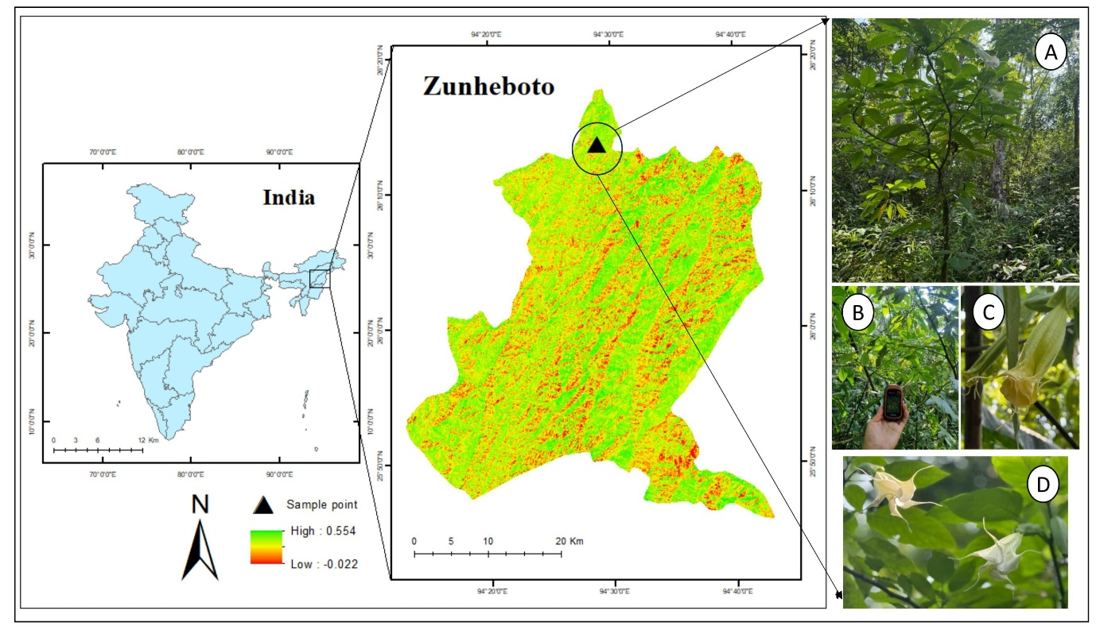

**Fig 1.** Map of Study Area. Photo plate A,B,C,D showing *Brugmansia arborea* from the field site.

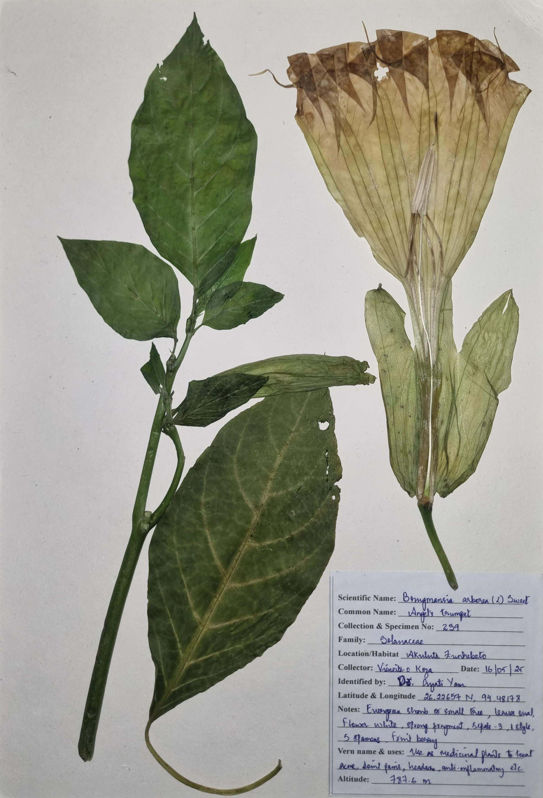

**Image 1.** Herbarium specimen of *Brugmansia arborea* prepared and deposited at Nagaland University, Lumami (NU/FRS-239)

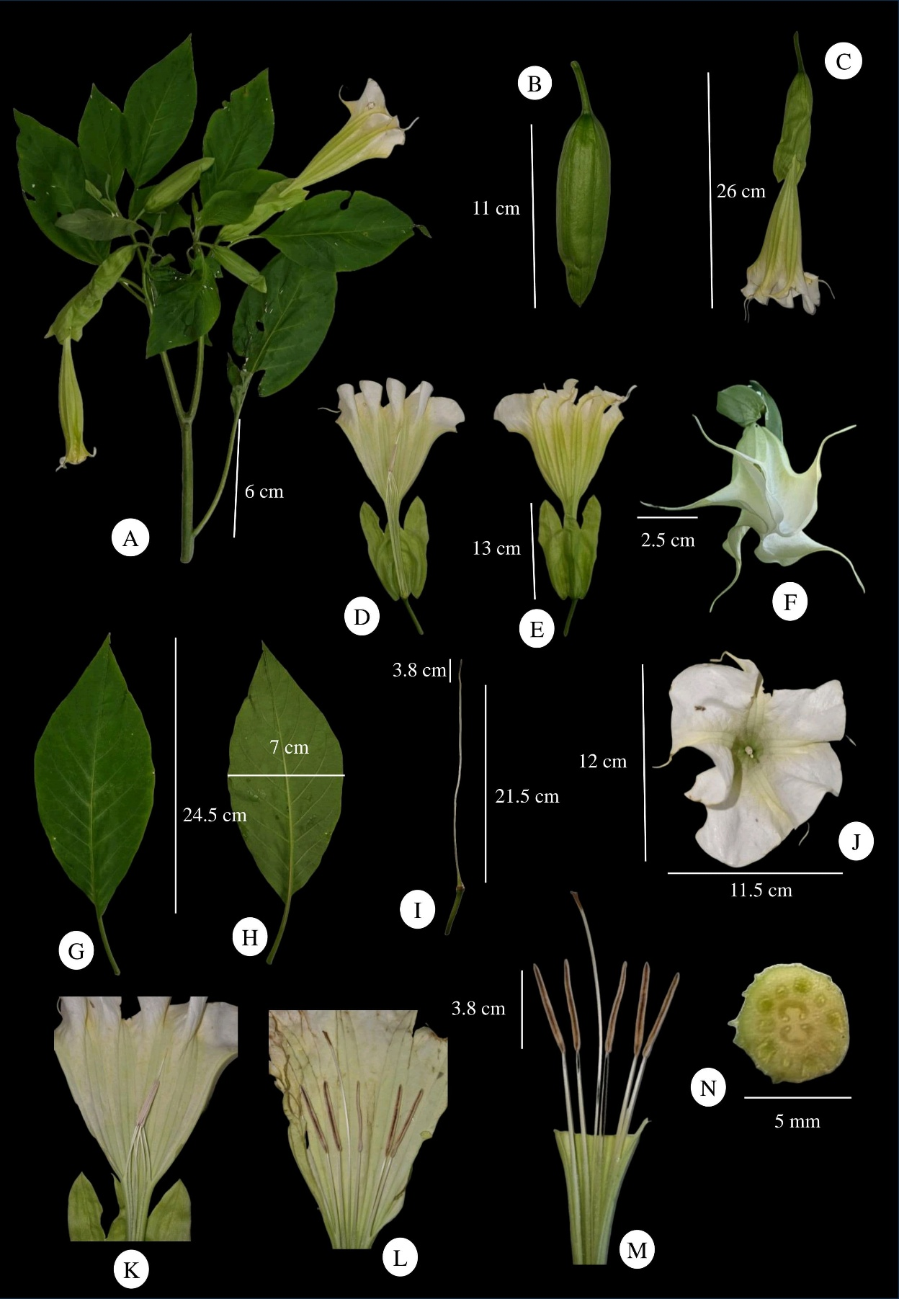

**Image 2.** *Brugmansia arborea*: **A**. Plant. **B–C**.Young flower Buds. **D–E.** Ventral and Dorsal view of Corolla with Calyx.**F.** Enclosed flower with 5 spikes.**G–H.** Leaves. **I.** Calyx with Style and stigma. **J.** Flower top view.**K–L.** Longitudinally dissected corolla with enclosed and open stamens- style. **M.** Stamens. **N.** Cross section of ovary.