**Review Article**

**Rhamnose, A Safe Chemical Compound for The Manufacture of Immunostimulating Pharmaceuticals**

**Abstract**

**Introduction**: Microorganisms such as bacteria, fungi, protozoa and viruses often cause irreparable damage to humanity. This is the case for diseases like black death, flu, AIDS, Ebola, Cholera, Mpox which have caused millions of deaths in the world. Plants and microorganisms contain carbohydrates like rhamnose which help boost the immune system. Some polysaccharide conjugate vaccines were manufactured to treat some pathogenic affections.

**Aim**: The aim of this research is to use the literature to reassure scientists about the role that rhamnose could have in combating pathogenic diseases like immunology disorders.

**Methods**: Electronic database engines such as Google Scholar, ScienceDirect, PubMed, Scopus, Biomed were used to carried out the work.

**Results**: According to the researches, rhamnose (Rha or Rham) is mainly in nature in L form: L-rhamnose. It can be found as disaccharides, heteropolysaccharides and polysaccharides. It can combine with other chemical compounds. This could make the pharmacological activities of rhamnose more interesting and useful to the human organism in the case of immunological dysfunction. Its action repairs the damage caused by pathogens to the body and have used as active product for several studies. Rhamnose has highly an anti-inflammatory and antioxidant properties. Some vaccines have even been manufactured from L-rhamnose.

**Conclusion**: Using rhamnose from any sources especially natural would be very beneficial for the search for effective vaccines, different from those already existing on the market and especially to undesirable effects tolerable for many people. Polysaccharides particularly rhamnose might be use for the manufacture of effective drugs and vaccines to prevent or cure immunodeficiency diseases.

**Keywords:** Rhamnose, Chemical characteristics, Vaccine, Immunostimulant

1. **INTRODUCTION**

The world peace that humanity dreams of is far from being a reality. The war between humans and microscopic organisms is no less. These small organisms such as bacteria, fungi, protozoa and viruses attack vital functions and often cause irreparable damage, leaving humanity with tears and desolation. This is the case for major pandemics and epidemics such as black death, flu, AIDS, Ebola, Cholera, Mpox which have caused millions of deaths. Immunotherapy has become the indispensable approach to effectively solve the majority of diseases of any order including epidemics and pandemics. Many natural or synthesized chemical compounds have been around for a long time in order to serve in the manufacture of drugs, vaccines or serums. Serotherapeutic protocols must be sincerely varied, improved and especially useful for the sake of global world health security.

If vaccines have been manufactured from carbohydrates, it is imperative and encouraging to also continue in the same chemical optics to perfect the efficacy of preventive and curative products (Breton et *al*., 1997; Pasco et *al*., 2002).

Carbohydrates are an organic compound that includes starch, cellulose and sugars like rhamnose, glucose, arabinose, fructose, sucrose, lactose, maltose etc which can be classified into monosaccharides, disaccharides and polysaccharides. Rhamnose which is a monosaccharide is found in plants, animals and microorganisms. It served as active product for many experimental tests. Some potential vaccines have even been manufactured from L-rhamnose.

Using rhamnose from any sources especially natural would be very beneficial for the search for effective vaccines, different from those already existing on the market and especially to undesirable effects tolerable for many people (Maria et al., 2014; Watanabe et al., 2009). Hence, the aim of this manuscript is to use the literature to highlight some useful sources of rhamnose as well as the mechanism of action of polysaccharides, especially rhamnose by analysing the results of relevant articles which fit with the objective of our research.

1. **METHODS**

Electronic search engines such as Google Scholar, ScienceDirect, PubMed, Scopus, Biomed were used. Recent articles on the research topic were read, analysed and, in some cases, compared with each other. This enabled us to bring out the essential points and above all, those which are useful to scientific world.

1. **ORIGIN OF RHAMNOSE**

Table 1 shows some sources of rhamnose.

**Table 1**. **Some main sources of rhamnose**

|  |  |  |  |
| --- | --- | --- | --- |
| **Species** | **Common names** | **Biological Kingdom** | **Authors** |
| *Rhamnus cathartica* | Buckthorn | Plantae | Paniagua-zanbrana et al., 2024 |
| *Toxicodendron radicans* | Poison Ivy or Poison Oak | Plantae | Hu et al., 2024 |
| *Prunus salicina* | Japanese plum or Chinese plum | Plantae | Conan, 2021 |
| *Operculina turpethum or Ipomea turpethum* | Fue vao, St. Thomas lidpod (Morning glory) | Plantae | Monalisa t al., 2024 |
| *Sargassum natans; Sargassum fluitans* | Narrowleaf gulfweed | Chromista | Lambert., 2024 |
| *Brassica oleracea* | Broccoli, | Plantae | Miranda et al., 2024 |
| *Solanum lycopersicum* | Tomato | Plantae | Piccolo et al., 2024  Rawat et al., 2024 |
| *Vicia faba* | Broad bean or horse bean | Plantae | Feng et al., 2024 |
| *Aphanizomenon flos-aquae* | Klamath algae | Cyanobacteria/Bacteria | Pasco et al., 2002 |
| *Ulva spp.* | Ulva | Plantae | Guevara-Torrejón et al., 2025 |
| *Morchella esculenta* | Morel or common morel | Fungi | Ajith et al., 2025 |
| *Panax ginseng* | Asian ginseng; Chinese ginseng or Korean ginseng | Plantae | Song et al., 2025 |
| Larva of *Protaetia brevitarsis seulensis* | White-spotted flower chafer | Animalia | Olawuyi et al., 2025 |
| *Mangifera indica* (seed core) | Mango | Plantae | Abdin et al., 2025 |

1. **CHEMICAL CHARACTERISTICS**

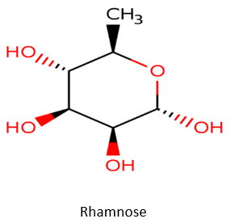Most of natural sugars are usually in the D form but rhamnose (Rha or Rham) is mainly in nature in L form: L-rhamnose (6-deoxy-L-rhamnose). Rhamnose can be called methylpenthose or 6-deoxyhexose. The molecular formula of rhamnose is C6H12O5.

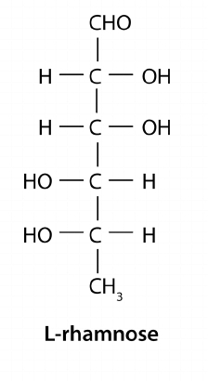

Rhamnose exists in the form of disaccharides, heteropolysaccharides and polysaccharides:

• Disaccharides: rhamnose form with glucose a rutinose (or 6-o-α-l-rhamnose-d-glucose) which is a disaccharide.

• Heteropolysaccharides called rhamnosides when rhamnose is combined with flavonoids such as: myricitrin C21H20O12 (with myricetin), quercitrin C21H20O11 (with quercetin), azalein C22H22O11 (with azaleatin), kaempferitrin C27H30O14 (with kaempferol). It is found naturally in plants as a heteropolysaccharide, for examples: hesperidin C28H34O15, ziziphin C51H80O18.

• Polysaccharides: rhamnose is widely present in plant in the form of gellan gum or hemicellulose.

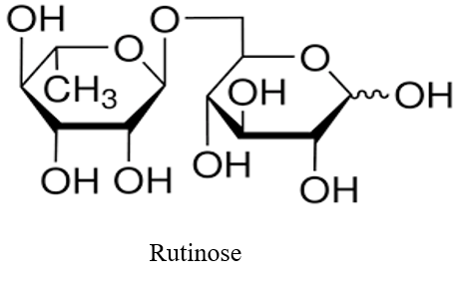

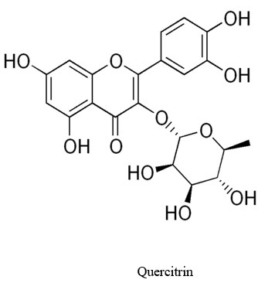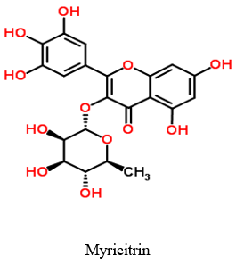

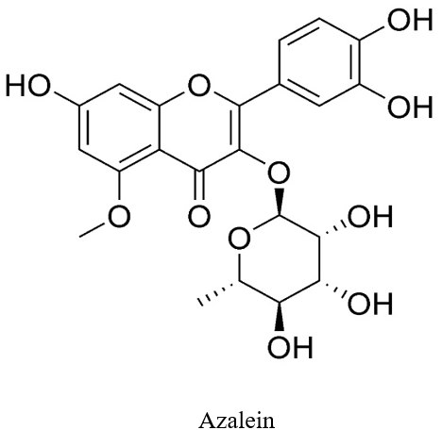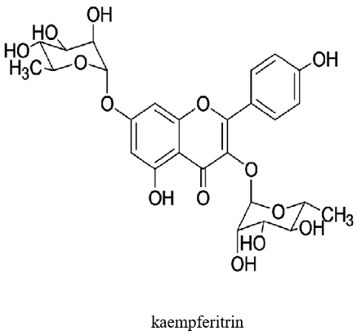

1. **IMMUNOSTIMULANT ACTIVITY OF RHAMNOSE: RESULTS AND DISCUSSION**

Breton et al. and Pasco et al. each got their patent by manufacturing immunostimulant products from polysaccharides derived from microorganisms such as *Klebsiella pneumoniae* and microalgae (Breton et *al*., 1997; Pasco et *al*., 2002).

According to the works directed by Breton, the quantity of polysaccharides contained in the final formulation must vary between 10 and 20% and can be formulated as milks, foams, creams, gelled aqueous solutions or biphasic lotions.

Research carried out by Pasco et al. (2002) showed that polysaccharides derived preferentially from food microalgae and extracted by aqueous alcohol should have a powerful immunostimulant effect. They also point out that the conditions under which the polysaccharides should be extracted are crucial. The volume of ethanol must be at least 50% at temperatures of 60 to 70° C. These conditions are necessary to obtain the expected effective effect as an immunostimulant activity of the polysaccharide-based pharmaceutical product. A preparation containing one or more glycoside components of immunostimulant polysaccharides such as rhamnose, fucose, galactose, glucose, mannose, methylated sugars and N-acetylated amino sugars was extracted from *Aphanizomenon flos-aquae* by Pasco’s team. These extractions from different experimental protocols showed different flow diagrams before ultrafiltration (molecular weight approximately 2 million daltons at a 200-microliter injection dose, 1 milligram per milliliter) and after ultrafiltration (molecular weight approximately 100 daltons at a 100-microliter injection dose, 1 milligram per milliliter). For each preparation, the percentage of recovery differs and EC50 is greater than 1000 nanograms per milliliter **(Figure 1 and Figure 2)** (Pasco et al., 2002).

Polysaccharide conjugate vaccines were developed against species including *Haemophilus influenzae* type B, *Neisseria meningitidis*, *Streptococcus pneumoniae* (Michel-Yves et *al*., 2016).

L-rhamnose and some of its recombinant products have recently been used to manufacture potential vaccines against A *Streptococcus* which is the widely distributed bacterium Gram-positive that serves as the primary cause of acute rheumatic fever episodes (Ajay et *al*., 2024; Ambari et *al*., 2024). Ajay et al., (2024) have developed a validated universal Strep A vaccine candidate that is presented on E. coli outer membrane vesicles (OMVs) by using recombinant rhamnose polysaccharides (RhaPS). Mouse and rabbit models were used for the assessment of OMV-RhaPs for their immunogenicity. The results showed that Strep A carbohydrate (GAC) in *S. pyogenes* and S. *dysgalactiae subsp. equisimilis* were recognized by RhaPS-specific antibodies. RhaPS stimulate also the long-term memory immune cells, due to the increase in IL-17a level from RhaPS-OMV-immunized splenocytes. Recombinant rhamnose polysaccharides could not only induce humoral-mediated immune responses but also, it could cause the trigger antibodies which recognize Strep A bacteria (Ajay et *al*., 2024. Zhang et al., 2025). In other hand, Ambari et al. (2024) hammered that the use of L-rhamnose derived from the poly-rhamnose backbone of group A carbohydrate is a very useful and safe. The L-rhamnose-based vaccines protects against Group A Streptococcus infection by increasing IgG antibody level without provoke cross-reactive antibodies in animal.

Crude exopolysaccharides produced by Chotmanee et al, (2025) from various fungal strains (*Pycnoporus sanguineus, Schizophyllum commune, Ganoderma fornicatum, Earliella scabrosa G. williamsianum, Favolus tenuiculus* and *Lentinus sajor - caju*) have demonstrated antioxidant activity, anti-Salmonella effect and effective immunostimulant activity. These pharmacological properties could be explained on the one hand through the remarkable phagocytic action of macrophages against Salmonella germs, and on the other through the stimulation of normal production of pro-inflammatory cytokines in macrophages, which play a decisive role in the body's defense against pathogenic germs.

Furthermore, Sun et al (2025) isolated the intracellular polysaccharides of *Phaeodactylum tricornutum* to study their antitumor properties on HeLa cervical cancer cells by transcriptomic analysis. Results revealed that *P. tricornutum* purified polysaccharide fractions reduced viability and altered cell morphology. Furthermore, research results showed that polysaccharides inhibited HeLa cell proliferation **(Figure 3 and Figure 4)**. According to the Cell Counting Kit 8 (CCK-8) assay, the extract had a good inhibitory potential. Transcriptomic analysis also showed that several genes were up-regulated against tumors, and would have been involved in various signaling pathways linked to cancer and apoptosis.

*Chaetomium globosum* CGMCC 6882 was used by Wang et al, (2025), to produce from fermented tobacco stem, a mixture of polysaccharides and proteins containing 92.55% ± 3.16% polysaccharides (CGP-TS) and 4.73% ± 1.04% proteins. According to the results of the structural characterization, the polysaccharides (CGP-TS) with a molecular weight of 613.235 kDa contain rhamnose. In vitro pharmacological study carried out by wang's team revealed that polysaccharides (CGP-TS) had immunomodulatory effects by stimulating the activity of IL-1β, IL-6, TNF-α and NO cytokine release, as well as the exacerbation of the phagocytic activity of RAW 264.7 macrophages **(Figure 5 and Figure 6)**. Polysaccharides (CGP-TS) also exhibited concentration-dependent (0.5 mg/mL to 2.5 mg/mL) free radical scavenging activity in DPPH (2,2-diphenyl-1-picrylhydrazyl), ABTS (2,2-azyno-bis-(3-ethylbenzothiazoline-6-sulfonic), hydroxyl and superoxide antioxidant assays. These various antioxidant and anti-inflammatory mechanisms contributed enormously to restoring normal and well-controlled immunostimulant activity (Dermane et al., 2024).

Certain sulfated heteropolysaccharides called ulvans are capable to stimulate the immune response in vitro. Ulvans collected in Algarrobo, Chile, were studied by Guevara-Torrejón et al, (2025) using a human cell model. The study revealed that crude ulvans extracted from *Ulva spp.* were composed of 47.6% total sugars, 8.9% sulfates and 14.3% uronic acids, with an average molecular weight of 40,000 kDa according to spectrophotometric methods. Bands related to rhamnose, the sulfate group and uronic acids were shown by the FTIR (Fourier Transform Infrared) spectrum **(Figure 7)**. The presence of rhamnose is confirmed by GCMS (Gaz Chromatography-Mass Spectrometry) analysis. By using HL60 (Human Leukemia 60) cells differentiated into macrophages and cultured with three concentrations of crude ulvan (25, 50 and 100 μg/mL), results showed that crude ulvan has activated CD86 (cluster of differentiation 86) co-stimulatory molecules and has promoted significant release of nitric oxide and cytokines IL-6, IL-10, IL-4 in comparison with control **(Figure 8)**. Their research showed that cell viability remains above 90% at the lowest concentrations **(Figure 9)**. The 50 µg/mL dose of crude ulvan has a better immunostimulant effect than the reference adjuvant MPLA (Monophosphoryl Lipid A).

In vivo cytotoxic, antioxidant and immunostimulant activities of *Ulva uncialis* from Chile were evaluated in the work of Véliz et al (2025). The results revealed that *U. uncialis* has stimulated cytokine production in RAW 264.7 cells (murine macrophage-like cells derived from a tumor), and that it is a promising source of nutritional and bioactive compounds thanks to the pharmacological effects of its polysaccharides.

*Ulva pertusa* from Korea also has pharmacological properties such as anti-inflammatory and immunostimulant effects, according to research caried out by Kim et al. (2025). In addition to the pharmacological properties revealed by the Guevara-Torrejón et al. (2025) and Véliz et al. (2025) studies in Chile, the study of Kim et al. (2025) on another *Ulva* species (*U. pertusa* from Korea) showed that *U. pertusa* induced the expression of cytokine genes in macrophages. They also pointed out that these immune responses were probably triggered by Tool-like receptor 2 (TLR2) and Tool-like receptor 4 (TLR4), Mitogen-activated Protein Kinase (MAPK) and nuclear factor kappa B (NF-κB) pathways serving as principal signaling mechanisms in signal transduction from the extracellular to the intracellular environment (notably the nucleus); which induces the regulation of cell growth, their proliferation, differentiation, survival, stress response or apoptosis through their influence on genes. In addition, *U. pertusa* has restored normal activity of B, T and NK (natural killers) lymphocytes; and has prevented cyclophosphamide-induced weight loss and lymphoid tissue damage in immunodeficient murine cells. The Guevara-Torrejón team has particularly attributed the immunostimulant properties of *Ulva spp*. to polysaccharides including rhamnose.

These results are in agreement with the work of Ajith et al. (2025) realized on polysaccharides of *M. esculenta*. They specified that the immunostimulatory effect of polysaccharides is caused by phagocytosis and macrophage proliferation without inflammation disorder. Hence, polysaccharides such as rhamnose, mannose, glucose or arabinose have a possibility to stimulate macrophages. The anti-inflammatory effect of polysaccharides extracted from *M. esculenta* was showed by many mechanisms: the blockade of toll like recptor-4, the reduction of proinflammatory cytokines, the NF-κB (nuclear factor kappa) dephosphorylation, the inhibition of cyclooxygenase-2 or the induction of nitric oxide synthase. It’s clear that high molecular weight polysaccharides (4.7 kDa-1391.5 kDa) could have important activities especially immunostimulant effect. These high molecular components can include rhamnose and other polysaccharides such as xylose, galactose, glucose and mannose (Ajith et al., 2025).

L-rhamnose-binding lectins (RBLS) have been isolated from various fish and invertebrates during some research work. These phytochemical compounds interact with different types of bacteria, highlighting their involvement in several inflammatory reactions. Researchers have studied the effect of L-rhamnose-binding lectins from chum salmon or dog salmon (*Oncorhynchus keta*), named CSL, on two cell lines: established fibroblast cell line derived from rainbow trout gonadal tissue (RTG-2) and the rainbow trout (*Oncorhynchus mykiss*) peritoneal macrophage cell line (RTM5). The L-rhamnose-binding lectins CSL have interacted with Gb3 (globotriaosylceramide), have bound to the surface of RTG-2 and RTM5 cells and have induced the production of pro-inflammatory cytokines such as IL-1β1, IL-1β2, TNF-alpha1, TNF-alpha2 and IL-8 in both cell line types. Their work demonstrated that rhamnose would have significantly inhibited CSL-induced opsonization on the rainbow trout (Oncorhynchus mykiss) RTM5 peritoneal macrophage cell line. This proves that LSCs enhanced phagocytosis by binding to Gb3 on the cell surface. Watanabe and his team proved for the first time that L-rhamnose-binding lectins (RBLs) may have played a role in innate immunity in association with Gb3 (globotriaosylceramide). Brief, rhamnose has a beneficial effect on immunity. It helps improve phagocytosis (Watanabe et *al.*, 2009).

In addition, rhamnolipids could stimulate the immune system against microorganisms. The L-rhamnose bending lectins regulate immune function by binding to endogenous and exogenous ligands, ensuring complement activation, pathogen recognition and opsonization (Matteo et *al.*, 2016). Also, rhamnose improves intermolecular interactions, and surface chain mobility, boosting tissue adhesion. Rhamnose demonstrated high human skin adhesion and contributed to increase significantly cohesion compared to acrylic pressure-sensitive adhesive 87-DT-4098. Therefore, L-rhamnose shows in vitro many importance in drug loading and biocompatibility (Song et *al*., 2024).

Pectic polysaccharides extracted from *Panax ginseng* leaves using the high-pressure extraction method (HPEM) have demonstrated immunostimulant activity and also an anticancer effect. Phytochemical analyses showed that the HPEM extract of *Panax ginseng* leaves contained approximately nine different monosaccharides, including rhamnose. The extract induced complement activation and macrophage stimulation, and a high production of cytokines such as IL-6, IL-12 and TNF-α (Tumor necrosis factor), as shown by the work of Watanabe et al. (2009), Guevara-Torrejón et al. (2025) and Véliz et al. (2025), which we have already briefly presented and discussed, as well as that of Yani et al. (2025).

On another note, oral (po) and intravenous (IV) treatment with *Panax ginseng* leaf extract by the HPEM method also significantly showed anticancer activity in mice with Colon 26-M3.1 carcinoma-induced lung cancer. This anticancer effect is due to the increased capacity of Natural Killers (NK) and cytotoxic lymphocytes (CTL) to destroy cancer cells (Figure 6). The extract is also reported to have an effect on the viability of primary cells (peritoneal macrophages and total splenocytes) and cancer lineage cells in vitro (Son et al., 2025). These results suggest agreement with the work of Sun et al. (2025), confirming the use of polysaccharides as a therapeutic agent in cancer treatment.

*Mangifera indica* seed kernel polysaccharides, with a molecular weight of approximately 4,2 × 10 4 Da, have been studied for their immunostimulatory properties and potential benefits for gut flora health. The level of rhamnose contained in the polysaccharide mixture is 12.72%. *Mangifera indica* seed kernel polysaccharides showed a shear thinning effect and stimulated the immune system through nitric oxide production, phagocytosis in RAW 264.7 murine cells and enhanced acid phosphatase activity (Abdin et al., 2025).

In short, rhamnose could be used continuously to manufacture immunostimulant drugs. Microorganisms are in perpetual mutation, so preventive or curative medicines against immune disorders are indispensable. And rhamnose might be one of the appropriate solutions.

1. **CONCLUSION**

Rhamnose derived from plants or microorganisms has been use several times to manufacture immunostimulant pharmaceuticals. Research has shown that polysaccharides including rhamnose are found in many species from virtually all kingdoms of life. The results showed that rhamnose is non-toxic and could appropriately stimulate immunostimulatory pathways via various mechanisms involving humoral and cellular mediators. These rhamnose-mediated pathways would sometimes involve inflammation and oxidation processes. This undoubtedly explains the anti-tumor properties of rhamnose, and hence of polysaccharides, as demonstrated by certain scientific studies. This makes it a potential candidate for the manufacture of vaccines, vaccine adjuvants, antibiotics or anti-cancer products. It’s there for imperative not to lose sight of rhamnose in scientific research for preventive and curative purposes against epidemics and pandemics. However, the development of pathogens’ glycobiology is crucial.

**ETHICAL APPROVAL**

Not applicable.

**DISCLAIMER (ARTIFICIAL INTELLIGENCE)**

Author declares that No generative AI technologies such as large language models (ChatGTP, COPILOT, etc) and text-to-image generators have been used during writing or editing of this manuscript.

**REFERENCES**

Abdin, M., Alnadari, F., El-Masry, H. G., Aly-Aldin, M. M., Naeem, M. A., Younes, M., Ayyash, M. (2025). Structure characterization and rheological properties of novel polysaccharides extracted from mango seed kernel, and their effects on immunomodulation and human gut microbiota. Food Chemistry, 479, 143841.

Ajay Castro, S., Thomson, S., Shaw, H.A., Zorzoli, A., Meyer, B.H., Reglinski, M., Dorfmueller, H.C., 2024. Rhamnose polysaccharide-decorated outer membrane vesicles as a vaccine candidate targeting group A Streptococcus from Streptococcus pyogenes and Streptococcus dysgalactiae subsp. equisimilis. bioRxiv, pp.2024-08.

Ajith, T. A., Das, S., & Janardhanan, K. K. (2025). Morchella esculenta polysaccharides: a functional food with potential immunomodulatory properties. Natural Product Research, 1-12.

Ambari AM, Desandri DR, Dwiputra B, Radi B, Qhabibi FR, Baravia PA, Makes IK. (2024). Unveiling the Group A Streptococcus vaccine-based l-rhamnose from backbone of group a carbohydrate: current insight against acute rheumatic fever to reduce the global burden of rheumatic heart disease. F1000Research. 2024 Feb 22;13:132. https://doi.org/10.1080/14786419.2025.2511160

Breton Lionel, Desolle Pierre, Pineau, Nathalie (1997). Use of a polysaccharide to stimulate immune defenses. European Patent Office. International publishing number: EP 0 81 8 201 A1.

Chotmanee, T., Suwannarach, N., Kumla, J., Phongphisutthinant, R., Chaipoot, S., Wiriyacharee, P., ... & Lumyong, S. (2025). Exopolysaccharide production by seven basidiomycetous fungi and their antioxidant and immunomodulatory activities against Salmonella infection. Frontiers in Cellular and Infection Microbiology, 15, 1610403.

Conan Catherine (2021). Plums and their many benefits. Update on 04-13-2021. [French]. www.passeportsante.net.

Dermane A, Kporvie AKG, Kindji KP, Metowogo K, Eklu-Gadegbeku K. (2024) Immunomodulatory and anti-inflammatory activities of hydro-ethanolic extract of Securidaca longipedunculata Fresen leaves. J Herbmed Pharmacol. 13(2):280-288. doi: 10.34172/jhp.2024.49352.

Feng Z, Morton JD, Maes E, Kumar L, Serventi L. (2024). Exploring faba beans (Vicia faba L.): bioactive compounds, cardiovascular health, and processing insights. Critical Reviews in Food Science and Nutrition. 2024 Jul 31:1-4.

Guevara-Torrejón, V., Chandía Parra, P., Campos-Estrada, C., & Vera Quezada, W. E. (2025). Evaluation of the Immunostimulatory Effect of Ulvan Polysaccharide on Human Macrophages: Use as a Potential Vaccine Adjuvant. Marine Drugs, 23(6), 248.

Hu X, Wang M, Cai F, Liu L, Cheng Z, Zhao J, Zhang Q, Long C. (2024). A comprehensive review of medicinal Toxicodendron (Anacardiaceae): Botany, traditional uses, phytochemistry and pharmacology. Journal of Ethnopharmacology. 318:116829.

Kim, T. E., Son, S. U., & Shin, K. S. (2025). Low-molecular-weight ulvan prepared from the Korean seaweed Ulva pertusa enhances immune responses via signaling pathways, short chain fatty acids, and G-protein coupled receptors. International Journal of Biological Macromolecules, 145143.

Lambert P, Radouani F, Ahmed MS, Salvin P, Roos C, Lebrini M. (2024). Extract from Sargassum fluitans III: A Promising Valuable Resource of Anti-bacterial Metabolites. Advances in Biochemistry and Biotechnology. vol 9(1).

Maria Alhede, Thomas Bjarnsholt, Michael Givskov, Morten Alhede (2014). Pseudomonas aeruginosa biofilms: Mechanisms of Immune Evasion. Editor(s): Sima Sariaslani, Geoffrey M. Gadd. Pseudomonas aeruginosa Biofilms: Mechanisms of immune evasion. Advances in Applied Microbiology,Academic Press. Volume 86. Pages 1-40. ISSN 0065-2164, ISBN 9780128002629. <https://doi.org/10.1016/B978-0-12-800262-9.00001-9>.

Matteo Cammarata, Maria G. Parisi, Gerardo R. Vasta (2016). evolution and immune function of fish lectins. Editor(s): Loriano Ballarin, Matteo Cammarata. Lessons in Immunity. Academic Press,2016. Pages 239-256. ISBN 9780128032527. <https://doi.org/10.1016/B978-0-12-803252-7.00018-7>.

Michel-Yves Mstou, Iain C. Sutcliffe, Nina M. van Sorge (2016). Bacterial glycobiology: rhamnose-contain cell wall polysaccharides in Gram-positive bacteria. Federation of European Microbiological Societies (FEMS) Microbiology Reviews, 2016: 40(4). doi 10.1093/femsre/fuw006.

Miranda LL, Sarandy MM, Altoé LS, Bastos DS, Melo FC, Novaes RD, Esposito DA, Gonçalves RV. (2024). Antioxidant and anti-inflammatory potential of Brassica oleracea accelerates third-degree burn healing in rats. Cosmetics. 2024 Feb 9;11(1):27.

Monalisa K, Behera S, Mohapatra D, Biswal AK, Naik SK. (2024). In vitro plant regeneration from nodal segments and biochemical fidelity analysis of Operculina turpethum, a threatened medicinal plant of Odisha. InIn Vitro Propagation and Secondary Metabolite Production from Medicinal Plants: Current Trends (Part 2). pp. 245-258). Bentham Science Publishers.

Olawuyi, I. F., Heo, E., Jeong, M., Kim, J. H., Park, J. J., Chae, J., Byun, S. (2025). Acidic polysaccharide from the edible insect Protaetia brevitarsis seulensis activates antiviral immunity to suppress norovirus infection. Carbohydrate Polymers, 347, 122587.

Paniagua-Zambrana NY, Bussmann RW, Khojimatov OK. (2024). Rhamnus cathartica L. Rhamnaceae. In ethnobotany of the mountainous regions of Eastern Europe: Carpathians. pp. 1-10. Cham: Springer International Editions.

Pasco David stanley, Ross Samir (2002). Potent immunostimulant from microalgae cross-reference to related applications. Patent cooperation treaty. World Intellectual Property Organisation. International publishing number: WO 02/04000 A1.

Piccolo V, Maisto M, Schiano E, Iannuzzo F, Keivani N, Rigano MM, Santini A, Novellino E, Tenore GC, Summa V. (2024). Phytochemical investigation and antioxidant properties of unripe tomato cultivars (Solanum lycopersicum L.). Food Chemistry. 2024 Apr 16;438:137863.

Rawat A, Upadhyay M, Singh O. (2024). Exploring the pharmacological potential and traditional use of Solanum lycopersicum L. (Tomato): A review. Journal of Pharmacognosy and Phytochemistry. 2024;13(2):768-71.

Son, S. U., Hong, K. R., & Shin, K. S. (2025). Immunostimulating and Anticancer Activities of the Pectic Polysaccharide from Panax ginseng Leaves Treated with High Pressure/Enzyme Process. Current Issues in Molecular Biology, 47(4), 257.

Song H, Cai Y, Nan L, Liu J, Wang J, Wang X, Liu C, Guo J, Fang L (2024). A rhamnose-PEG-modified dendritic polymer for long-term efficient transdermal drug delivery. ACS Applied Materials & Interfaces. 2024 Feb 21;16(8):9799-815.

Sun, H., Liang, Z., Zang, Y., Liu, S., Liu, H., & Li, M. (2025). Transcriptome Analysis Reveals Possible Antitumor Mechanism of Intracellular Polysaccharide From Phaeodactylum tricornutum on Cervical Cancer HeLa Cells. Chemistry & Biodiversity, e202402779.

Véliz, K., Abdala-Díaz, R., Chandía, N., Toledo, P., Álvarez-Torres, D., Figueroa, F., & Tala, F. (2025). Toward the valorization of Ulva biomass from Chile: Analysis of the bioactive polysaccharide and chemical profile of unprocessed and residual biomass of Ulva uncialis. Food Chemistry, 483, 144310

Wang, S., Chang, H., Li, N., Zhu, D., Wang, Z., Qiao, X., & Duan, S. (2025). Structural characterization and immunomodulatory activity of a polysaccharide produced by chaetomium globosum CGMCC 6882. Scientific Reports, 15(1), 19992.

Watanabe Y, Tateno H, Nakamura-Tsuruta S, Kominami J, Hirabayashi J, Nakamura O, Watanabe T, Kamiya H, Naganuma T, Ogawa T, Naudé RJ, Muramoto K. (2009). The function of rhamnose-binding lectin in innate immunity by restricted binding to Gb3. Dev Comp Immunol. 2009 Feb;33(2):187-97. doi: 10.1016/j.dci.2008.08.008. Epub 2008 Sep 20. PMID: 18809432.

Yani, L., Yulong, W., Liming, Y., Kailing, C., Fei, L., Yaping, H., & Netala, V. R. (2025). Phytochemical constituents and pharmacological effects of Dangshen (Codonopsis pilosula), an Important Traditional Chinese Medicinal. Journal of Plant & Research, 12 (2): 2777.

Zhang, M., Wang, W., Li, W., Wang, Z., Bi, K., Li, Y., ... & Du, Q. (2025). Ultrasonic-Assisted Extraction of Polysaccharides from Brassica rapa L. and Its Effects on Gut Microbiota in Humanized Mice. Foods, 14(11), 1994.

**FIGURES**

**Figure 1: Flow chart showing protocol for hot water extraction at 40° c following by ammonium sulfate precipitation to remove phycocyanin material (Pasco et al., 2002).**

**Figure 2: Flow chart showing protocol for hot water extraction at 40° c following by 70% ethanol precipitation to remove phycocyanin material** **(Pasco et al., 2002).**

**Figure 3: Inhibition of proliferation of cervical cancer HeLa cells by four fractions of intracellular polysaccharides from *Phaeodactylum Tricornutum*. * p<0.05 significant difference; *** p<0.01 high significant difference. (Sun et al., 2025)**

**Figure 4: Anticancer effect of intravenous (a) and oral (b) administration of pectic polysaccharides from *Panax ginseng* leaves extract by using the high-pressure extraction method (HPEM). I–III, a–d, A–D indicate statistical significance (p < 0.05). NC represents the negative control (Son et al., 2025).**

**Figure 5: Effect of polysaccharides from fermented tobacco stem on phagocytic activity analysis of CGP-TS on RAW 264.7 macrophages. *p<0.05; **p<0.001 compared to the control group. (Wang et al., 2025).**

**Figure 6: Effect of polysaccharides CGP-TS from fermented tobacco stem on the production of some chemical mediators of immune system by RAW 264.7 macrophages. TNF-α (A), IL-1β (B), IL-6 (C) and NO (D).** **\*p<0.05; **p<0.001 compared to the control group. (Wang et al., 2025).**

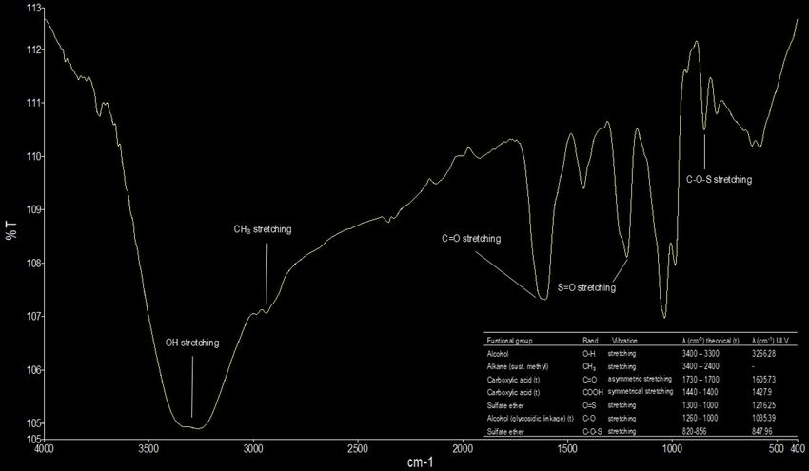

**Figure 7: FTIR (Fourier Transform Infrared) spectrum of crude ulvan from Ulva spp. of Vaparaiso region** **(****Guevara-Torrejón et al., 2025)**

**Figure 8: Assessment of cytokines production in the HL60 cell line differentiated into macrophages, incubated with different concentrations of crude ulvan (21, 25, 50 et 100 μg/mL) rich in polysaccharides and vaccine adjuvants. * p > 0.05; *** p < 0.01; **** p < 0.001; ns indicates not significant. (Guevara-Torrejón et al., 2025)**

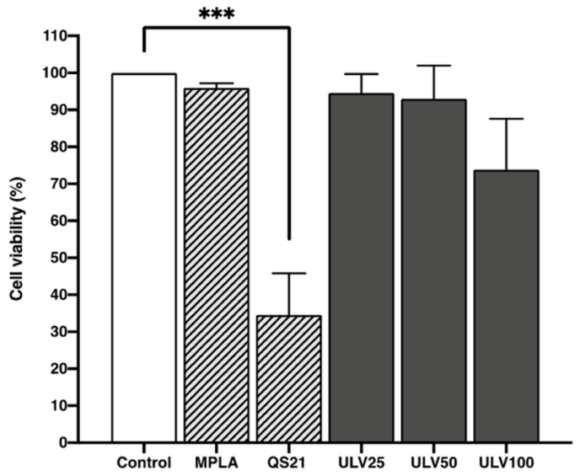

**Figure 9: Cell viability evaluation using the resazurin method in the HL60 cell line differentiated into macrophages with differences concentration of ulvan rich in polysaccharides. *** p < 0.01 significative difference. (Guevara-Torrejón et al., 2025).**

**ANNEX**E: **Photos of species rich in rhamnose**