**Green synthesis, Characterization, Evaluation of Silver Nanoparticle by using *Phyllanthus emblica* leaf extract.**

**ABSTRACT**

Green synthesis of nanoparticles is a more eco-friendly, cost-effective, and sustainable alternative to physical and chemical approaches of synthesis. Using medicinal herbs like Phyllanthus emblica can improve the therapeutic potential of manufactured nanoparticles. While numerous plant extracts have been utilized to synthesize silver nanoparticles (AgNPs), few investigations have focused on Phyllanthus emblica leaf extracts. The primary goal of this study was to produce silver nanoparticles from Phyllanthus emblica leaf extract and assess their structural characteristics and antibacterial activity.Silver Nitrate is used as metal precursor and phyllanthus emblica is used as reducing and stabilizing agent.After a visual color shift from yellow to brown, the formation was verified by UV-visible spectroscopy. It was then further described using FTIR to determine the functional group's involvement and the Agar well diffusion method to assess its antibacterial activity against both Gram-positive and Gram-negative bacterial strains. A far-off Surface Plasmon Resonance peak at about 440 nm was visible in the UV-Vis Spectra, indicating the production of AgNPs. Hydroxyl (O–H), carbonyl or aromatic (C=O or C=C) and metal ligands (Ag–O or Ag–N) functional groups were detected by FTIR analysis, suggesting their role in the production and stabilization of silver nanoparticles.The produced silver nanoparticle demonstrated significant antibacterial action, particularly against bacteria that are Gram-negative. These results demonstrate the potential of silver nanoparticles mediated by Phyllanthus emblica as strong antibacterial agents. The work encourages further investigation of phytochemical-rich plants for biomedical research and supports the use of plant-based green synthesis techniques in nanotechnology.

**KEY WORDS:** Green synthesis, Phyllanthus emblica, Silver Nanoparticles, UV-Vis Spectroscopy, FTIR, Agar well diffusion, Antibacterial activity.

**INTRODUCTION**

Over the last century, nanotechnology has evolved as an important field of research, resulting in numerous significant developments in various scientific domains. It comprises the creation, engineering, and application of materials ranging in size from 1 to 100 nm, also known as nanoparticles. [1] Nanoparticles application has grown significantly in the twenty-first century due to their specified chemical, optical, and mechanical capabilities. Among them, metallic nanoparticles are most promising because they show good antibacterial properties due to their large surface area to volume ratio, which is now the current interest of researchers due to the growing microbial resistance to metal ions, antibiotics, and the development of resistant strains. [2]

Although a variety of nanoparticles, including copper, zinc, titanium, magnesium, gold alginate, and silver, have been investigated, silver nanoparticles have proven to be the most successful. Their potent antibacterial properties against viruses, bacteria, and other eukaryotic microorganisms have drawn a lot of attention to them. [3] The distinctive physical and chemical characteristics of silver nanoparticles (AgNPs), such as their morphology and distribution, size, shape, and high surface area, make them widely used in a variety of industries, including food, medicine, healthcare, and industry. Along with a broad range of applications connected to organic chemistry, they also demonstrate superior performance in optical, electrical, and thermal devices with high electrical and heat conductivity. They are also used in the food sector, medical device coatings, optical sensors, cosmetics, and many medicinal items. It's also important to note their application as antibacterial, anti-inflammatory, and anticancer agents in drug administration, theranostics, and diagnostics. [4]

Nanoparticles have been synthesized using a variety of techniques, which can be broadly divided into three categories: physical, chemical, and biological (green) techniques. However, the use of hazardous chemicals, high energy consumption, and costly equipment are common in physical and chemical procedures, which might pose environmental risks. Green synthesis, on the other hand, is seen as a sustainable and environmentally beneficial method. It entails the creation of nanoparticles employing microbes, proteins, or plant extracts as stabilizing or reducing agents. [5] Because of its ease of use, affordability, and the inclusion of natural phytochemicals that improve the stability and biological activity of nanoparticles, plant-mediated synthesis has drawn a lot of attention.[6]

**1.PLANT INTRODUCTION**

Phyllanthus emblica Linn. (Syn. Emblica officinalis), also referred to as Indian gooseberry or amla, is a significant herbal remedy utilized in ayurveda and unani medicine. It belongs to the Euphorbiaceae family. The herb is used to restore lost strength and vitality as a tonic and as a medication. Phyllanthus emblica is high in nutrients and may be a significant source of minerals, amino acids, and vitamin C. Additionally, the plant includes tannins, phenolic chemicals, phyllembelic acid, phyllembelin, rutin, curcuminoids, andemblicol.**[7]**.Every part of the plant has a medical value, but the fruit in particular is known for its powerful rasayana properties in Ayurveda and its usage in traditional medicine to treat inflammation, diarrhea, and jaundice. Additionally, a number of plant parts have demonstrated chemopreventive, hepatoprotective, hypolipidemic, antibacterial, antioxidant, antidiabetic, and antitulcerogenic qualities. These phytochemicals have made P. emblica leaf and fruit extract useful as stabilizing and reducing agents in the environmentally friendly creation of metal nanoparticles, especially silver nanoparticles.**[8]**

**2.MATERIALS AND METHODS:**

Silver nitrate, Double distilled water, Amoxicillin, Nutrient agar, Nutrient broth, Phyllanthus emblica leaf extract were used. Other instruments used were of laboratory and analytical grade.

**2.1 Preparation of Extract from Selected Medicinal Plant:**

The freshly collected leaves of P. emblica were collected from in and around the area of Shapur. The Botanical Survey of India, Deccan Regional Center,Hyderabad verified the plant material as Phyllanthus emblica L. (Ref. No:BSI/DRC/202425/Tech./Identification/565, dated 05.12.2024subsequently, the leaves were washed under running tap water, dried in shade for 15 days, sliced in to small pieces and grinded to coarse powder. 200ml of double-distilled water (DDW) and 20g of powder were heated for one hour. Whatman filter paper No. 1 was used to filtrate the leaf extract and once it had cooled to room temperature, the filtrate was stored in a refrigerator at 4°C for later use. [9]

**2.2 Green Synthesis of Silver Nanoparticles**

0.1M of aqueous solution of Silver nitrate was prepared and used for the synthesis of Silver Nanoparticles, in the microwave-assisted synthesis of silver nanoparticles, 10ml of plant extract was added to 190ml of aqueous solution of 0.1MAgNO3and reaction mixture was taken in a conical flask. It was irradiated in a domestic microwave oven operating at medium power (800W) for 2-5 minutes. The generation of silver nanoparticles will be visualised by the colour change from yellow to brown**.**[10]Synthesized silver nanoparticles were obtained without any chemical reagent, now the synthesized silver nanoparticles were isolated by centrifugation technique at a speed 10000 rpm for about 20 minutes. For the further settlement of particles, the supernatant material was transferred to a beaker and frequent centrifugation was carried out to purify AgNPs. After being oven-dried, the produced nanoparticle pellet was put away for additional examination.[11]

* 1. **Characterization of Silver Nanoparticles**

1. **UV-Vis Spectroscopy and Visual Identification of PEAENP**

Colour of PEAE and AgNO3 solution was taken as a control and change in the colour of reaction mixture after addition of PEAE to AgNO3 solution is the first indication for the formation of PEAENP. A UV-Vis spectrophotometer at wavelength of 200-800nm was used to characterize the AgNPs using PEAE. The absorption peak from 400 to 450nm indicates the reduction of silver ions[12].The results show the existence of silver ion and a reduction in the analysed substance.

**ii) FTIR Spectroscopy of PEAE and PEAENP**

In order to determine the involvement of functional groups in the formation of PEAENP, FTIR spectroscopy (Thermo Scientific Nicolet IS50) was conducted in the range of 4000-400cm-1 .PEAENP synthesized also include biomolecules that are not encapsulated on nanoparticles; these are eliminated by dissolving them in DDW and centrifuging the mixture for 15 minutes at 5000 rpm.This procedure is repeated for 3 times and final pellet obtained is dried at 60⁰C in hot air oven and used for characterization.

**iii) Antibacterial activity of PEAENP**

Researches has shown that Silver Nanoparticles possess antibacterial activity. The antibacterial potential of PEAENP was assessed against both Gram-positive (i.e., Staphylococcus aureus) and Gram-negative bacteria (i.e., Escherichia coli). Among these Staphylococcus aureus is a pathogenic Gram-positive strain, While Escherichia coli is a commonly used non-pathogenic strain of Gram-negative bacteria. The antibacterial activity of PEAENP was evaluated through Agar well diffusion method to determine zone of inhibition. [13] Both the bacterial cultures were freshly grown overnight at 37⁰C in nutrient broth CFU/ml. Each cultures of bacteria wasspread over the individual nutrient agar plates. Wells of approximately 6mm diameter were bored into agar surfaces using sterile cork borer, an each well was loaded with 25µL of silver nanoparticle solution of various concentrations (25%, 75%, and 100%) The antibiotic Ampicillin was used as positive control and sterile water as Negative control shown in (Figure.4). The cultured plates were then incubated at 37⁰C for 24 hours. After incubation for 24 hours, the zone of inhibition was measured and data was interpreted.[14]

**3.RESULTS**

**3.1 Visible identification and UV-Vis Spectroscopy of PEAENP:**

UV-visible spectroscopy was employed to understand the formation of PEAENP as a result of addition of PEAE to the solution of AgNO3 which leads to a color change from pale yellow to dark brown, as shown in (Figure.1) UV spectra of PEAE, Silver Nitrate, and PEAENP are presented in (Figure 2) and the corresponding peak values are listed in [Table.1].A characteristic pe

ak appeared at 440nm in the PEAENP sample, which was absent in both AgNO3 and PEAE solutions.

**AgNO3**

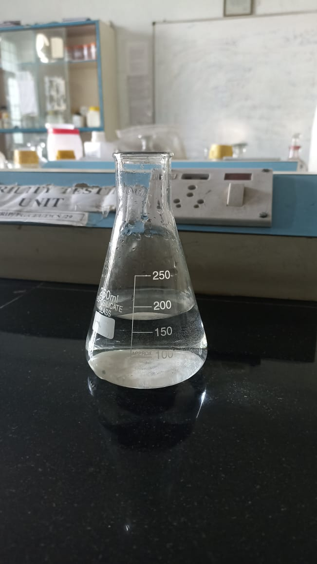 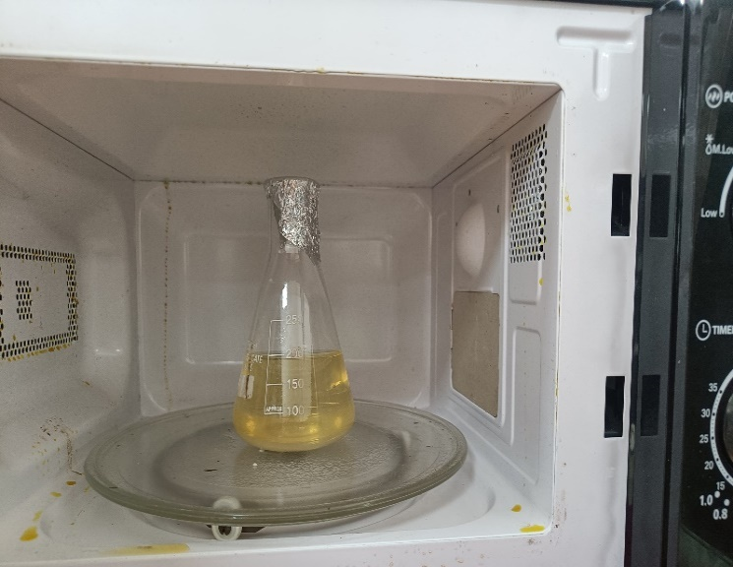

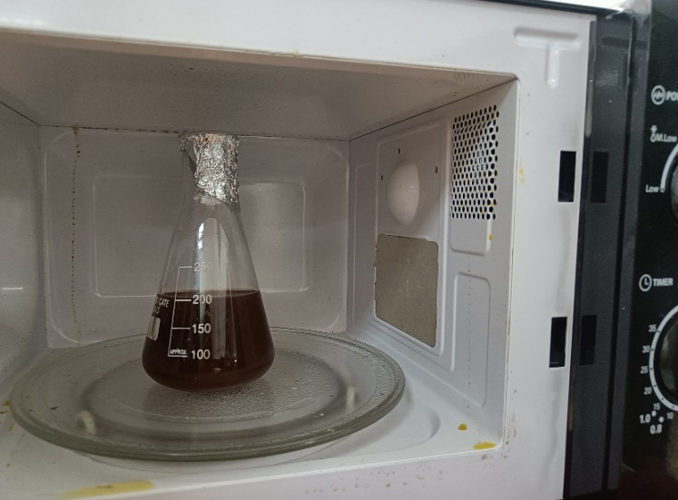

**PEAE**

**PEAENP**

**Figure.1:** PEAE which is pale yellow in colour when added to 1mM AgNO3 solution forms dark brown coloured PEAENP. Change of colour indicates the formation of Nanoparticles.

**Table.1: UV-Vis Absorption peak of AgNO3, PEAE and PEAENP.**

|  |  |  |  |
| --- | --- | --- | --- |
| **Wavelength (nm)** | **AgNO3** | **PEAE** | **PEAENP** |
| 200 | 0.42 | 0.1 | 0.05 |
| 210 | 0.48 | 0.14 | 0.7 |
| 220 | 0.45 | 0.18 | 0.9 |
| 240 | 0.25 | 0.25 | 0.12 |
| 260 | 0.15 | 0.45 | 0.15 |
| 278 | 0.1 | 0.6 | 0.18 |
| 300 | 0.05 | 0.5 | 0.2 |
| 320 | 0.04 | 0.38 | 0.23 |
| 340 | 0.03 | 0.3 | 0.3 |
| 360 | 0.02 | 0.25 | 0.3 |
| 380 | 0.01 | 0.2 | 0.4 |
| 400 | 0.00 | 0.1 | 0.65 |
| 420 | 0.00 | 0.05 | 0.85 |
| 440 | 0.00 | 0.03 | 1.1 |
| 460 | 0.00 | 0.01 | 1.0 |
| 480 | 0.00 | 0.00 | 0.7 |
| 500 | 0.00 | 0.00 | 0.4 |
| 520 | 0.00 | 0.00 | 0.15 |
| 550 | 0.00 | 0.00 | 0.5 |
| 600 | 0.00 | 0.00 | 0.00 |

**Figure.2:** UV Spectra of AgNO3, PEAE and PEAENP

**3.2 FTIR Spectroscopy of PEAE and PEAENP:**

FTIR spectra of both PEAE and PEAENP are shown in (Figure.3), with peak values and corresponding functional groups which are assigned in [Table.2]. A broad peak at 3261.826 cm-1 was observed in the PEAE spectrum, which shifted to 3269.537 cm-1 in the PEAENP spectrum. Another peak was recorded at 1635.931 cm-1in PEAE and shifted to 1636.167cm-1 in PEAENP. The peak at 421.175 cm-1 in PEAE shifted slightly to 418.175 cm-1 in the PEAENP, similarly 406.316 cm-1shifted to 409.418 cm-1, in PEAENP. Additionally a new peak was observed at 456.916 cm-1 in PEAENP spectrum, which is absent in PEAE spectrum.



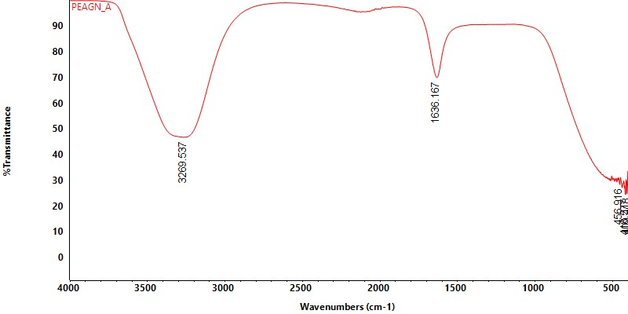

**PEAE**

**PEAENP**

**Figure.3**: FTIR Spectra of PEAE and PEAENP.

**Table.2**: FTIR peak vales and corresponding Functional groups of PEAE and PEAENP**.**

|  |  |  |  |
| --- | --- | --- | --- |
| **S.NO** | **Peak in PEAE (cm-1)** | **Peak in PEAENP (cm-1)** | **Corresponding Functional groups** |
| 1. | 3261.826 | 3269.537 | O-H stretching vibration of Alcohols or Phenols (H- bonding, Phytochemicals) |
| 2. | 1635.931 | 1636.167 | C=O or C=C stretching in Aromatic or Amide groups (Carbon skeleton) |
| 3. | 421.175 | 418.577 | Fingerprinting/ Metal-Ligand interaction. |
| 4. | 406.316 | 409.418 | Fingerprinting region. |
| 5. | - | 456.916 | New peak .Confirms formation of Ag-N or Ag-O bond. |

* 1. **Antibacterial study:**

The antibacterial activity of PEAENP was evaluated against Escherichia. Coli and Staphylococcus aureus using varying concentrations of silver nanoparticles (25%. 75% and 100%). The results shows at 25%, 75% and 100% concentrations, the ZOI observed against E.coli were 8mm, 10mm and 12mm respectively, while for Staphylococcus aureus they were 7mm, 9mm and 11mm. The standard antibiotic (Amoxicillin) showed 16mm and 14mm zones against E.coli and Staphylococcus aureus, respectively. The Blank (sterile water) showed no inhibition. These values are summarized in Table.3, supported by Petri plates images (Figure.5) and the trend visualized in the bar graph (Figure6).

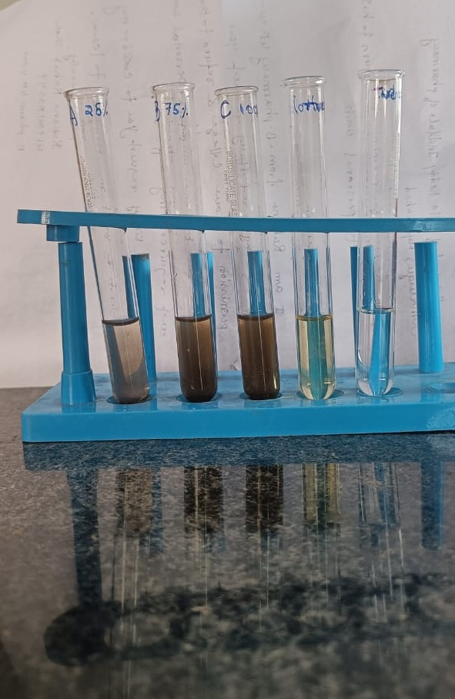

**Figure.4:** Test samples, positive and negative controls.

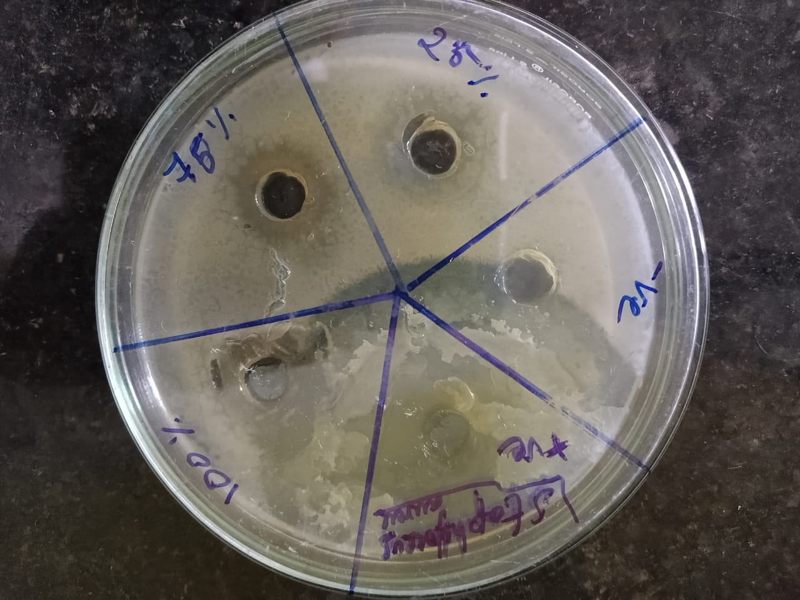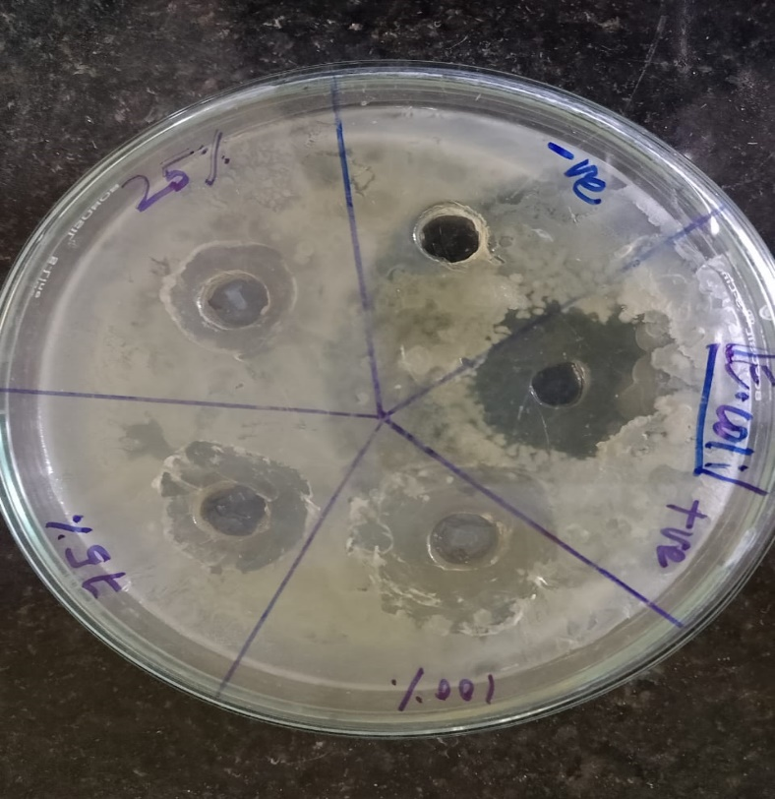

**Figure.5:** Photos of Inhibition zones obtained in the Antibacterial Assay of Phyllanthus emblica by Agar well Petriplates of Gram-positive (Staphylococcus aureus) and Gram-negative (Escherichia. Coli) bacteria**.**

**Table.3:** Screening of Test compounds for Antibacterial activity

|  |  |  |  |
| --- | --- | --- | --- |
| **Compound name** | **Concentration (%)** | **Zone of Inhibition (mm)** | |
| **Escherichia.Coli Gram-ve** | **Staphylococcus aureus Gram+ve** |
| **Silver Nanoparticle**  **AgNPs** | 25 | 8 | 7 |
| 75 | 10 | 9 |
| 100 | 12 | 11 |
| **Blank**  **(Sterile water)** | - | - | - |
| **Standard**  **(Amoxicillin)** | - | 14 | 16 |

**Figure.6:** Bar graph of Antibacterial activity of Silver Nanoparticles**.**

**3.DISCUSSION:**

The current study shows successful synthesis of silver nanoparticles (AgNPs) using Phyllanthus emblica leaf extract which was confirmed by a notable color change from pale yellow to dark brown color. This transformation indicates the reduction of silver ions Ag+ into elemental form Ago Which occurs due to the presence of phytochemicals in the plant extract that act as a both reducing and stabilizing agents. The color shift is due to Surface Plasmon Resonance (SPR) effect, SPR is characteristic of metallic nanoparticles, and in the case of silver, typically appears within the range of 400-450nm.This was further supported by UV-Visible spectroscopy, which showed a strong absorption peak at 440nm for the synthesized AgNPs. This peak is absent in both plant extract and silver nitrate solution. But was found to be present in PEAENP. The position and sharpness of this peak confirms the synthesis of silver nanoparticles and correlates with the green synthesis of various medicinal plants[13]

FTIR spectroscopy was used to identify the involvement of functional groups in the synthesis and stabilization of nanoparticles. A noticeable broad peak in the PEAE was detected at 3261.826 cm-1; this peak has since been moved to 3269.537 cm-1 in the PEAENP spectrum.This shift indicates the presence of polyphenols and other phytochemicals that can reduce Ag+ to Ago. It corresponds to the O-H stretching vibration of alcohols or phenolic compounds. In PEAE, another peak was observed at 1635.931 cm-1, which shifted slightly to 1636.167 cm-1 in PEAENP,which is attributed to C=C or C=O stretching vibrations, which are frequently linked to amide or aromatic groups. These minor shifts suggest their role in nanoparticles stabilisation.

Furthermore, the peaks at 421.175 cm-1 in PEAE and 418.577 cm-1 in PEAENP, and the peak at 406.316 cm-1 shifted to 409.418 cm-1, indicating interaction with silver ions.[5]Importantly, a new peak appeared at 456.916 cm-1 in the PEAENP spectrum, which was not present in PEAE spectrum. This peak is attributed to Ag-O or Ag-N bond formation, confirming successful silver nanoparticles synthesis. The appearance of this new metal-ligand interaction band confirms the role of phytochemicals in both reduction and stabilization, as evidenced by FTIR analysis.

The antibacterial activity of the synthesized AgNPs was evaluated using agar well diffusion method against both Gram-negative (Escherichia. Coli) and Gram-positive (Staphylococcus aureus) bacterial strains. The results revealed a concentration-dependent response, with higher concentrations of AgNPs (100%) showing greater zone of inhibition for both strains. The antibacterial effect of AgNPs can be attributed to several mechanism: disruption of the bacterial cell wall and membrane, generation of reactive oxygen species (ROS), and interaction with cellular components like proteins and DNA, ultimately leading to cell death. Because of their small size and large surface area, AgNPs can easily penetrate bacterial membranes and accumulate inside the cells.

Interestingly, slightly stronger inhibition was observed against E.coli compared to Staphylococcus aureus. This can be explained by difference in bacterial cell wall structures. Gram-negative bacteria like E.coli have thinner peptidoglycan layer and an outer membrane that facilitates easier nanoparticle penetration, whereas Gram-positive bacteria possess thicker cell wall that may act as a barrier. These findings are consistent with previous studies, which also report greater susceptibility of Gram-negative bacteria to AgNPs due to enhanced permeability and cell wall differences [15]

**3.CONCLUSION:**

Silver nanoparticles were produced utilizing the green synthesis method and Phyllanthus emblica leaf extract. According to the study's findings, the synthesis is a safe method of producing nanoparticles. UV-Vis and FTIR spectroscopy techniques were used to analyze the reduced silver nanoparticles. According to the characterization results, the UV-Vis spectra showed a strong absorption peak at 440nm, demonstrating the creation of silver nanoparticles. FTIR research indicated the existence of several functional groups that are responsible for AgNP reduction and stabilization.Additionally, the agar well diffusion method was used to assess the produced silevr nanoparticles' antibacterial activity. The standard (positive control) exhibited more activity against specific bacteria, whereas the results demonstrated notable inhibitory effects against the tested bacterial strains. According to these results, the biosynthesized AgNPs have promising antibacterial qualities and may find use in pharmaceutical and biological applications.

**5.REFERENCES:**

1. Joudeh, N., Linke, D. Nanoparticle classification, physicochemical properties, characterization, and applications: a comprehensive review for biologists. *J Nanobiotechnol* **20**, 262 (2022). <https://doi.org/10.1186/s12951-022-01477-8>
2. Gong P, Li H, He X, Wang K , Tan W, Zhang S, Yang X. Preparation and antibacterial activity pf Fe3O4@ Ag nanoparticles. Nanotechnology, 18(28), 285604 <https://doi.org/10.1088/0957-4484/18/28/285604>
3. Franci, G.M Falanga, A., G aldiero, S., Palomba, L., Rai, M., Morelli G.M & Galdiero,M . (2015). Silver Nanoparticles as Potential Antibacterial Agents. Molecules, (2015), 8856-8874. <https://doi.orrg/10.3390/molecules20058856>
4. Zahoor, M., Nazir, N., Iftikhar, M., Naz, S., Zekker, I., Burlakovs, J., Uddin, F., Kamran, A. W., Kallistova, A., Pimenov, N., & Ali Khan, F. (2021). A Review on Silver Nanoparticles: Classification, Various Methods of Synthesis, and Their Potential Roles in Biomedical Applications and Water Treatment. Water, 13(16), 2216. <https://doi.org/10.3390/w13162216>
5. Iravani, S. (2011) Green Synthesis of Metal Nanoparticles Using Plants. Green Chemistry, 13, 2638-2650.http://dx.doi.org/10.1039/c1gc15386b
6. Ahmed S, Ahmad M, Swami BL, Ikram S. A review on plants extract mediated synthesis of silver nanoparticles for antimicrobial applications: A green expertise. J Adv Res. 2016 Jan;7(1):17-28. doi: 10.1016/j.jare.2015.02.007. Epub 2015 Mar 9. PMID: 26843966; PMCID: PMC4703479.
7. Mirunalini,, S. & Krishnaveni,, M. (2010). Therapeutic potential of Phyllanthus emblica (amla): the ayurvedic wonder. Journal of Basic and Clinical Physiology and Pharmacology, 21(1), 93-105. https://doi.org/10.1515/JBCPP.2010.21.1.93
8. Krishnaveni M, Mirunalini S. Therapeutic potential of Phyllanthus emblica (amla): the ayurvedic wonder. J Basic Clin Physiol Pharmacol. 2010;21(1):93-105. doi: 10.1515/jbcpp.2010.21.1.93. PMID: 20506691.
9. Sharma, S. , Kumar, S. KAL , Pai, K. and Kumar, R. (2024). Synthesis of silver nanoparticles using Phyllanthus emblica leaf extract: Characterization, antioxidant, anti-inflammatory and antileishmanial activity against L. donovani. Nanomedicine Research Journal, 9(1), 9-19. doi: 10.22034/nmrj.2024.01.002
10. Francis, S., Joseph, S., Koshy, E. P., & Mathew, B. (2017). Microwave assisted green synthesis of silver nanoparticles using leaf extract of elephantopus scaber and its environmental and biological applications. Artificial Cells, Nanomedicine, and Biotechnology, 46(4), 795–804. <https://doi.org/10.1080/21691401.2017.1345921>
11. Jadoun, S. Synthesis of Silver Nanoparticles by Phyllanthus emblica Plant Extract and Their Antibacterial Activity. Material Science Research India. <https://doi.org/10.13005/MSRI/170206>
12. Prabhu N, Divya RT, Yamuna GK, Siddiqua AS, Pushpa JD. Synthesis of silver phyto nanoparticles and their antibacterial efficacy. Digest Journal of Nanomaterials and

Biostructures. 2010;5(1):185-89.

1. M. M. Hossain, A. Hamza, S. A. Polash, et al., “Green Synthesis of Silver Nanoparticles Using Phyllanthus emblica Extract: Investigation of Antibacterial Activity and Biocompatibility In Vivo,” RSC Pharmaceutics 1, no. 2 (2024): 245–258, <https://doi.org/10.1039/D3PM00077J>.
2. Muniappan Ayyanar and Pandurangan Subash Babu. Syzygium cumin L Skeels:((2012) A review of its phytochemical constituents and traditional uses. Asian Pacific Journal of Tropical Biomedicine; 240-246.
3. Rai, M.; Yadav, A.; Gade, A. (2009). Silver nanoparticles as a new generation of antimicrobials. Biotechnology Advances. pp 76–83.