Original Research Article

ECHOING THE VOICES OF TEACHERS BEYOND SPECIALIZATION: THE LIVED EXPERIENCES OF NON-TLE TEACHERS IN TEACHING TLE SUBJECTS

ABSTRACT
Out-of-field teaching has been a common problem in many countries. Teaching outside their area of specialization can profoundly affect their instructional effectiveness, as they are essentially novices in that subject. This study explored the lived experiences of non-TLE teachers teaching Technical and Livelihood Education (TLE) subjects. It sought to gain a deeper understanding of the participants' experiences and explore the coping strategies they employ to navigate the challenges they face. This study utilized a phenomenological approach as its research design. The data were gathered from three (3) participants through In-depth Interview (IDI) and Focus Group Discussions (FGD). Results revealed that participants' experiences in the study emerged into two main themes: Teaching Beyond the Comfort Zone and Struggles to Meet Teaching Demands. Meanwhile, regarding coping with the challenges encountered by the non-TLE teachers teaching TLE subjects, two main themes were formulated: Collaborative Growth in the Face of Resource Challenges and Turning Doubt into Growth. The findings indicate that non-TLE teachers encountered significant challenges while teaching TLE subjects outside their area of expertise. These challenges included a lack of specialized knowledge, insufficient resources, and limited access to necessary equipment. This study highlights non-TLE teachers' challenges when teaching outside their expertise, including limited resources, insufficient knowledge, and pressure to adapt to new curriculum demands. To address these challenges, collaboration, professional development, mentorship, and technology integration are crucial to empowering non-TLE teachers and ensuring quality education delivery in TLE subjects.

Keywords: Non-TLE teachers, out-of-field teaching

1. INTRODUCTION
Out-of-field teaching—assigning teachers to subjects outside their specialization—can reduce student engagement, limit content knowledge, and strain resources (Mercado & Morante, 2024). Schools often resort to hiring such teachers due to a shortage of specialists, but this fails to address the underlying issue. The problem is compounded by underqualified hires and a lack of qualified personnel. Unlike students randomly assigned to classes, less qualified teachers face challenges that affect professionalism, student safety, learning outcomes, instructional quality, and their professional identity (Nakar & Du Plessis, 2023; Carothers et al., 2019).
Due to the “structural teacher shortage” issue in many primary schools, which hinders these teachers’ professional development, there have been many instances of out-of-field teaching in China in recent years (Ma, 2024). Furthermore, due to insufficient training and credentials, teachers in Canada encounter difficulties when instructing students in subjects outside of their areas of expertise. This can hinder their ability to teach those subjects effectively (Hobbs & Porsch, 2021).
In Kidwalan, Davao del Sur, non-TLE teachers assigned to TLE subjects struggle due to lack of expertise and insufficient resources (Tingzon & Buyok, 2022). Similarly, in Cebu City, unqualified social studies teachers face challenges in lesson planning and delivery (Pacana et al., 2019). According to the Second Congressional Commission on Education (EDCOM 2), 62% of educators teach subjects outside their college major (Press Release - EDCOM 2, 2024).
Furthermore, in the locality of Tagum City Davao del Norte, non-TLE teachers are teaching TLE subjects despite not possessing all the competencies of a fully qualified TLE teacher. Some acquired TLE competencies through experiences, peer tutorials, self-study, social media and other technology. Despite these initiatives, teachers remain problematic (Tingzon & Buyok, 2022). A mismatch between duties and abilities in the position negatively affects the macroeconomic and microeconomic productivity levels at work (Taripe, 2024).
The researchers perceive a dearth of research on the challenges faced by non-TLE teachers instructing TLE topics in Tagum City Davao del Norte. This research must immediately be done, since employing teachers who are not specialists in their field can impede the delivery of high-quality instruction. This study aims to advance knowledge about the challenges faced by non-TLE teachers and their coping mechanisms.
This study, like others, explores the experiences of non-TLE educators teaching outside their specialization. While past research highlights emotional struggles and calls for systemic reform, this study focuses on practical challenges such as inadequate preparation, curriculum demands, limited resources, and shifting self-efficacy. Unlike broader analyses, it aims to improve teaching effectiveness and job satisfaction within the existing educational framework.

2. OBJECTIVES
This study aims to explore the lived experiences of non-TLE teachers teaching TLE subjects. Specifically, this research sought to answer the following questions: 1. What are the experiences of non-TLE teachers in teaching TLE subjects? 2. What strategies did the school employ to support non-TLE teachers to effectively teach the TLE subject? 3. How do teachers' perceptions of self-efficacy and career interests shift when assigned TLE subjects outside their area of expertise?

3. MATERIALS AND METHODS
Research Design
This study employs a qualitative, phenomenological approach to explore the experiences of non-TLE teachers teaching TLE subjects. Qualitative research focuses on context, perspective, and meaning to interpret complex social phenomena (Lim, 2024). Phenomenology seeks to understand the universal essence of a phenomenon by examining individuals’ lived experiences while setting aside researchers’ biases (H, 2023).
Research Instruments
The primary research instrument used in this study was an interview guide composed of open-ended questions aimed at gathering insights from non-TLE teachers handling TLE subjects in the Division of Tagum City.

Respondents of the Study
The study involved teachers from the Division of Tagum City, Department of Education (DepEd), who hold a baccalaureate degree and have at least two to three years of experience teaching TLE subjects. Both male and female teachers were included as participants.

Data Gathering
Focus Group Discussions (FGDs) with 3–5 participants facilitated in-depth qualitative data through focused conversations (Masriwati et al., 2024; Pérez & Pérez, 2024). Before interviews, approvals were secured, the Interview Guide validated, and informed consent obtained, including permission for audio recording.

Interviews addressed three main research questions with follow-up probes, conducted face-to-face in private settings with confidentiality ensured via data encryption and anonymization. FGDs followed established ground rules for respectful dialogue. Post-interview, researchers applied Braun and Clarke’s (2006) six-phase coding, transcribing, translating, verifying, and organizing data by topic.

4. RESULTS AND DISCUSSION
The researchers transcribed and translated recordings using McMullin’s (2021) method. A focus group discussion (FGD) supported data triangulation. Analysis followed three stages—data reduction, display, and conclusion drawing—with rigorous verification. Transcriptions highlighted participants’ perspectives to ensure reliability and validity. Guided by their mentor, the researchers applied data reduction techniques (Moustakas, 1994; Creswell, 2012) to condense the qualitative data for analysis.

Themes and Sub Themes generated for Research Question No. 1.
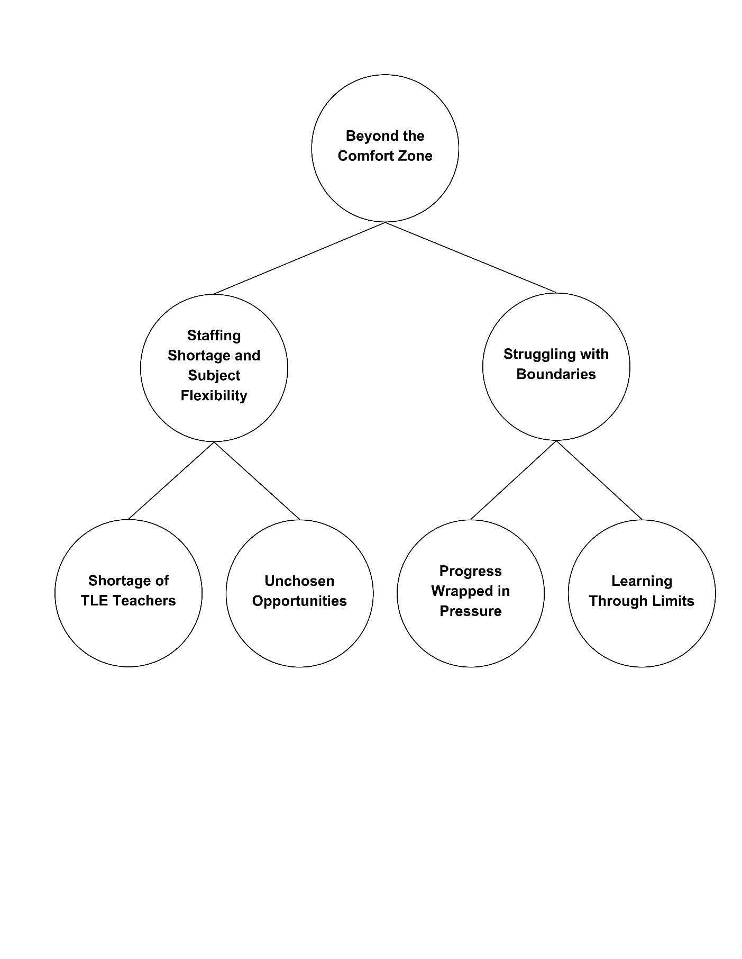

Figure 1 Emergent Themes, Categories, and Codes on the Lived Experiences of Non-TLE Teachers Teaching TLE Subjects.
RQ.1 What are the experiences of non-TLE teachers teaching TLE subjects?
Lived Experiences of Non-TLE Teachers Teaching TLE Subjects.
Figure 1 presents the emergent themes, categories, and codes derived from the lived experiences of non-TLE teachers tasked with teaching TLE subjects. The overarching theme is that these educators often find themselves beyond their Comfort Zone.
Theme 1: Beyond the Comfort Zone
Non-TLE teachers, assigned to unfamiliar roles, are pushed beyond their comfort zones, taking on new challenges and developing unexpected skills. They often struggle with balancing added responsibilities, lack of subject expertise, and fear of failure.
Category 1: Staffing Shortage and Subject Flexibility
The shortage of TLE teachers has led schools to assign non-TLE teachers to cover technical-vocational subjects, despite their limited expertise. This highlights the growing need for teacher flexibility and adaptability. Two codes emerged under this category: Shortage of TLE Teachers and Unchosen Opportunities.
Shortage of TLE Teachers
The ongoing shortage of TLE teachers affects the quality of technical-vocational education, limiting students’ access to hands-on learning and practical skill development. Contributing factors include teacher turnover, changes in curricula and student-teacher ratios, and challenges in recruiting and retaining educators in specialized fields (Sutcher et al., 2019). This was confirmed by the participants (IDI-1, FGD_1, IDI_2, FGD_2)
A lack of qualified TLE teachers significantly impacts the quality of vocational education. Generelao et al. (2021) highlight that teacher quality is essential for student learning, while Antera (2023) notes that fewer specialized instructors limit hands-on training. Castro (2022) adds that such shortages impact school operations, staff morale, and student performance, leaving students less prepared for the workforce.
Unchosen Opportunities
Economic pressures often push teachers to take on TLE roles outside their expertise, with those trained in subjects like English, Science, or Math being reassigned, as stated by the participants (IDI_2, IDI_3). Despite their commitment, a lack of subject-specific training can affect teaching quality and student readiness. Tran (2023) observes that while attitudes vary, teaching unfamiliar subjects remains a challenge.
Teachers assigned outside their specialization often lack the content expertise needed for effective instruction, resulting in less engaging lessons and misaligned assessments. This can hinder student performance. Hobbs & Porsch (2021) emphasize that such challenges affect teachers at all career stages, requiring significant effort to adapt and meet subject demands.

Category 2: Struggling with Boundaries
Non-TLE teachers face the challenge of balancing increased responsibilities with limited subject-specific knowledge and skills. Despite lacking formal training, they feel pressured to deliver quality TLE instruction. Limited access to resources, time, and support further hampers their ability to grow in the role.
Progress Wrapped in Pressure
The challenges of adapting to unfamiliar content and assessments often result in stress, anxiety, and burnout as confirmed by the participants (IDI_1, IDI_2, IDI_3). Von Der Embse et al. (2019) link these pressures, intensified by test-based accountability, to absenteeism, negative school climate, and behavioral problems.
Thrust into new roles, they must quickly learn complex concepts while ensuring instructional quality, leading to stress. Culajara (2023) highlights the importance of embracing change, supported by ongoing training to build confidence and competence.
Learning Through Limits
As Cheruiyot (2024) notes, a lack of confidence and skills in teaching new curricula can result in confusion for both teachers and students, underscoring the need for targeted support and training.
Non-TLE teachers often face challenges with unfamiliar terms and tools, requiring self-study and peer support to adapt. Arendain & Limpot (2022) note that, despite early struggles, they improve over time by developing strategies and using English to convey concepts clearly.
Themes, Sub Themes, and Codes generated for the Research Question No. 1. EXPERIENCES

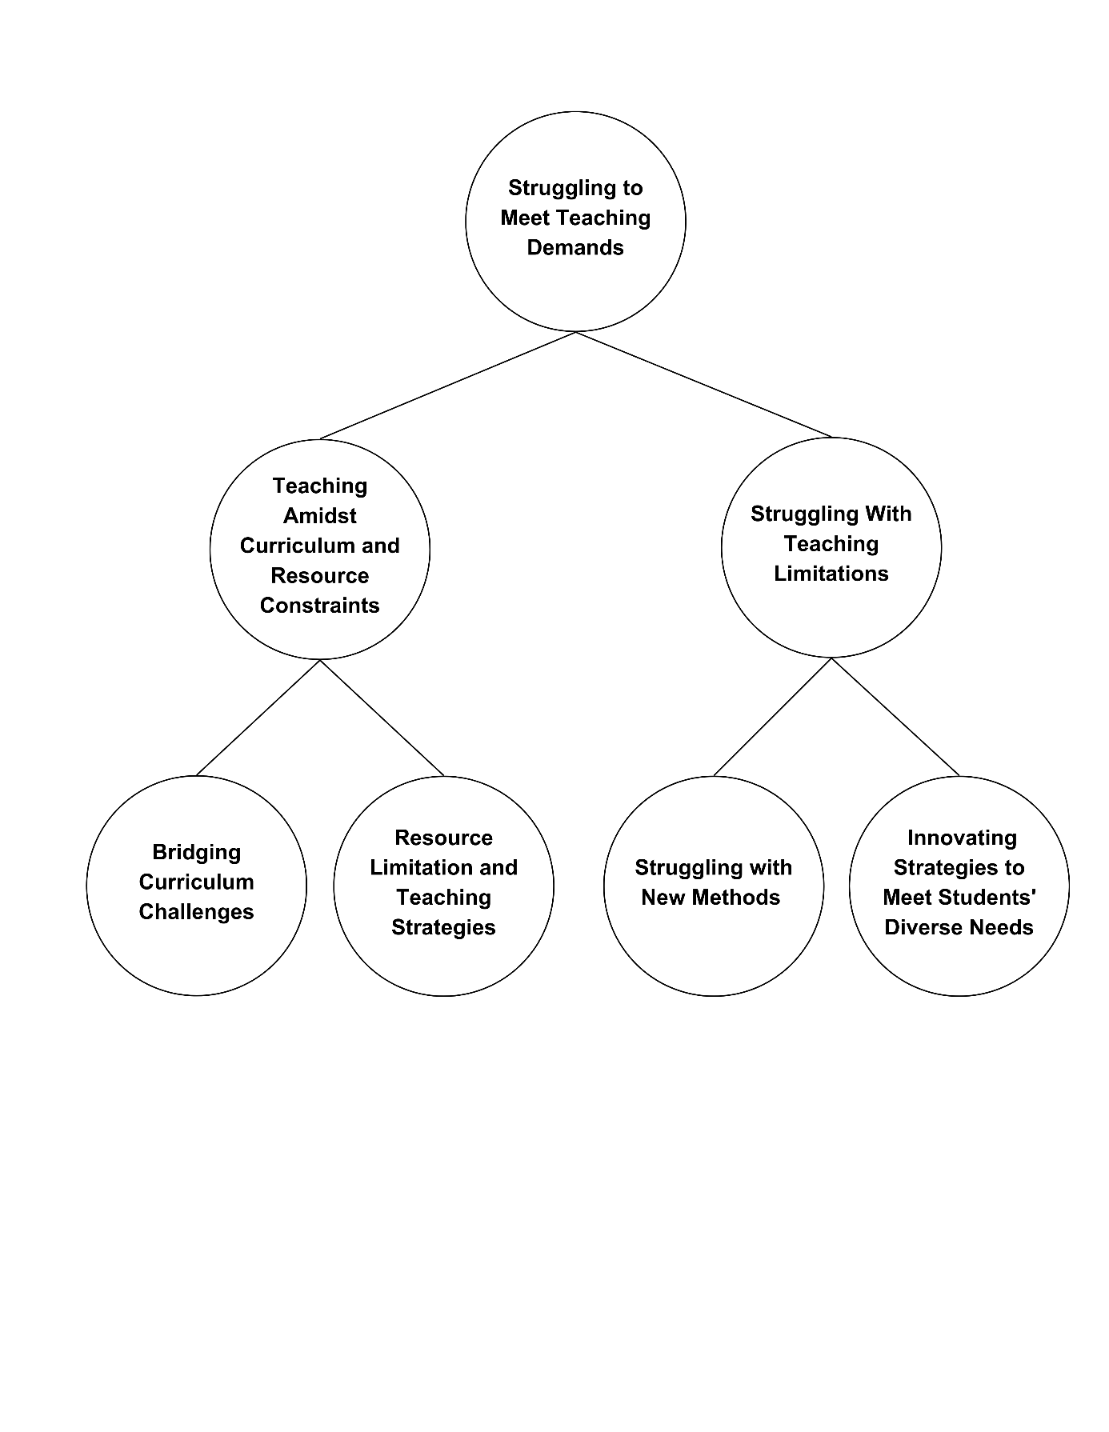

Figure 2 Emergent Themes, Categories, and Codes on the Lived Experiences of Non-TLE Teachers Teaching TLE Subjects.

RQ.1 What are the experiences of non-TLE teachers teaching TLE subjects?
Lived Experiences of Non-TLE Teachers Teaching TLE Subjects.
Two categories emerged: Teaching Amidst Curriculum and Resource Constraints and Struggling with Teaching Limitations. These highlight issues such as inadequate resources, misaligned curricula, and limited training, all of which hinder teachers’ ability to deliver quality instruction and meet subject-specific demands.
Theme 2: Struggling to Meet Teaching Demands
Participants described feeling overwhelmed by the demands of the TLE curriculum and the lack of resources. Frustration stemmed from insufficient training and support, making it difficult to address diverse learners’ needs effectively.
Category 1: Teaching Amidst Curriculum and Resource Constraints
Participants reported major challenges in implementing the TLE curriculum due to a lack of resources, particularly reference materials for technical terms. This made it difficult to explain concepts clearly and assess students’ performance on specialized tasks.

Bridging curriculum challenges
Participants emphasized the difficulty of adapting to the new TLE curriculum, particularly due to limited time for learning and preparation (Pak et al., 2020), as shared by participants (IDI_2 and IDI_3). The lack of adequate references, especially for technical terms, further hindered their ability to explain concepts clearly and effectively to students.
Maffea (2020) emphasizes that inadequate resources create stress and hinder learning, underscoring the need for sufficient materials and targeted professional development.
Frequent curriculum changes pose challenges for teachers, making it hard to adapt strategies and plans. Thi et al. (2023) note that such transitions can affect teaching quality and professional growth.

Limited Resources and Teaching Strategies
Participants (IDI_2, IDI_3) shared limited time and insufficient administrative support affected their ability to create quality resources and assess technical tasks effectively (Jr & Sumeg-ang, 2023). As a result, teachers often used self-made materials from online sources, though these were not always curriculum aligned.
Teachers face difficulties implementing the new curriculum due to a lack of reference materials, especially for technical terms, making concept explanation harder (Ana et al., 2023). They also struggle to grade performance tasks outside their expertise and feel overwhelmed by the workload of creating and contextualizing instructional materials.
Category 2: Struggling with teaching limitations
Non-TLE teachers assigned to TLE faced challenges adapting to hands-on teaching and working beyond their expertise. They adjusted strategies, addressed diverse student needs, and relied on creativity and experience to deliver quality instruction despite limitations.

Struggling with New Methods
Participants (IDI_1 and IDI_2) shared challenges in adapting to TLE’s hands-on approach, often departing from traditional methods. Limited materials and equipment restricted practical lessons, leading teachers to rely on outdated strategies (Tingzon & Buyok, 2022). Teaching outside one’s specialization, such as in TLE, requires educators to adapt their methods to meet curriculum demands. Limited resources often hinder effective instruction (Canoy et al., 2022).

Innovating Strategies to Meet Students' Diverse Needs
Participants felt uncertain and doubtful about teaching outside their expertise, but saw it as a learning opportunity IDI_1 and IDI_3). Despite the steep learning curve, they embraced continuous skill development (Grünwald, 2021).
Many experiences self-doubt, questioning their ability to teach unfamiliar subjects (Tran, 2023; Zaid et al., 2020). Still, this struggle can lead to professional growth as educators develop new strategies and expand their skills.
A shortage of subject specialists often forces teachers into roles they’re unprepared for, increasing stress and affecting learning quality. Limited resources and training make it harder to adopt innovative methods. Supporting diverse learners, especially those with special needs, requires institutional backing, family involvement, and ongoing professional development (Damyanov, 2024).

Themes, Sub-Themes and Codes generated for the Research Question No. 2. COPING MECHANISMS

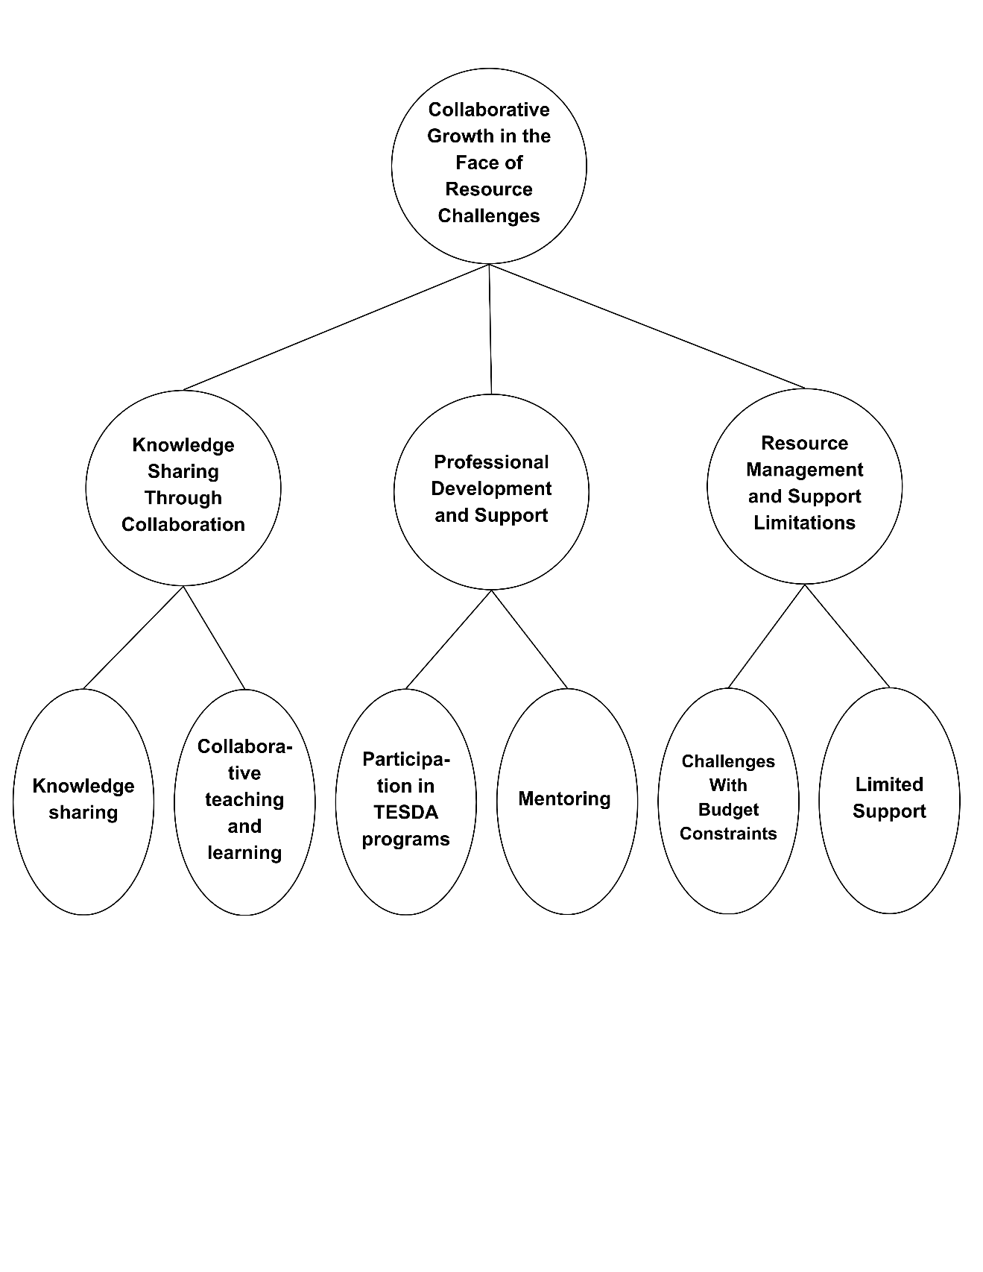

Figure 3 Emergent Themes, Categories, and Codes on the Strategies Employ to Support Non-TLE Teachers in Effectively Teaching TLE Subjects.
RQ. 2 What strategies did the school employ to support non-TLE teachers to effectively teach the TLE subject?
Strategies Employed to Support Non-TLE Teachers in Effectively Teaching TLE Subjects.
Knowledge Sharing Through Collaboration emphasizes the importance of educators collaborating to share their expertise. Professional Development and Support highlights the need for ongoing training and mentoring to prepare non-TLE teachers. Resource Management and Support Limitations stresses innovative strategies to maximize resources and support their specific needs.

Theme 1: Collaborative Growth in the Face of Resource Challenges
Sharing expertise, lesson plans, and innovative techniques allows teachers to pool resources, reduce workload, and foster a supportive learning environment. They also highlighted the value of collaborative professional development, such as workshops and peer observations, to improve teaching skills and knowledge.

Category 1: Knowledge Sharing through Collaboration
Participants highlighted the important role of collaborative platforms such as LAC sessions, FGDs, and SLACs in promoting knowledge sharing. These forums enabled teachers, especially TLE and non-TLE educators, to exchange ideas, strategies, and experiences.
Knowledge Sharing
Participants (IDI_1 and IDI_3) emphasized the importance of peer-to-peer learning and mentorship in acquiring knowledge and developing skills. The involvement of senior high school TVL teachers in providing guidance and sharing expertise was seen as a crucial factor in enhancing the participants' knowledge base.
Collaborative learning includes various group-based strategies like peer tutoring, team-based, and problem-based learning (Yang, 2023). Teacher-centered collaboration supports meaningful discussions on instruction and student learning (Dejong et al., 2022), but without proper facilitation, its impact may be limited.
Programs like SLAC help but face issues like time constraints and lack of support. Enhancing collaboration and professional development requires better planning, resources, and ongoing teacher support (Barksdale et al., 2021).

Collaborative Teaching and Learning (CTL)
Participants (IDI_1 and IDI_2) highlighted the value of collaborative platforms, specifically LAC sessions, FGDs, and SLACs, in facilitating knowledge sharing among teachers. These forums enabled the exchange of ideas, strategies, and experiences, particularly between TLE and non-TLE educators.
Collaborative Teaching and Learning (CTL) plays a key role in professional development, especially for TVL and non-TVL teachers. Platforms like LAC sessions, FGDs, and SLACs promote knowledge sharing and skill enhancement (Culajara, 2023).
Category 2: Professional Development and Support
Participants emphasized mentoring and TESDA programs as vital to professional development. Mentoring by experienced TLE teachers offered valuable guidance, while TESDA programs provided opportunities for skill and knowledge enhancement, supporting overall growth.
Participation in TESDA Programs
These programs offered opportunities for professional growth and development as shared by the participants (IDI_1 and IDI_2). The ability to effectively convert information and knowledge into novel goods and services will characterize prosperous organizational economies (Cataraja & Cataraja, 2022).
Teachers acknowledge TESDA programs’ potential but question their quality, relevance, and applicability. Alignment with teaching roles and workloads is uncertain. Edralin & Pastrana (2023) stress that Philippine TVET curricula must align with the 2022–2028 Development Plan and Industry 4.0 to meet SDG #4. Abdallah & Alkaabi (2023) recommend tailoring TESDA programs to TLE teachers’ needs and providing ongoing support to ensure effective classroom integration and improved instruction.

Mentoring
Participants (IDI_2 and IDI_3) emphasized that mentoring from experienced TLE teachers is vital for professional growth. Out-of-field teaching demands proper training, mentoring, resources, and support networks to address pedagogical, technological, and content challenges, improving teacher effectiveness (Nob & Tañola, 2024).

Mentoring is vital for the professional growth of TLE teachers, as experienced mentors provide guidance and support (Belavina & Klyuchko, 2024). However, time and resource limitations can hinder its effectiveness.
Category 3: Resource Management and Support Limitations
Participants cited limited support and budget constraints as key challenges in technical-vocational education. Though SLAC sessions and mentorship were the main supports, they often failed to meet non-TLE teachers’ varied needs. Budget limits also hindered access to equipment, materials, and professional development, affecting effective TLE program delivery.
Challenges with Budget Constraints
Education funding has been repeatedly reviewed to address misallocation and better support specific needs (Treto-French, 2024). Budget constraints significantly hinder TLE and non-TLE teachers by limiting professional development, essential materials, and the creation of effective learning environments as shared by the participants (IDI_1, IDI_2 and IDI_3).
Out-of-field teaching, often driven by financial constraints, adversely affects student outcomes and education quality. Effective policies requiring teacher certification in their fields are needed (Du Plessis, 2020). Budget constraints highlight the need for efficient resource distribution and creative solutions to improve education without increasing costs (Garbuzova et al., 2024).
Limited Support
Participants identified the limited support activities available to non-TLE teachers, mainly relying on SLAC sessions and mentorship programs (IDI_1, IDI_2, and IDI_3). These were often insufficient to address their specific needs.
Though SLAC sessions and mentoring support professional growth, teachers noted limited help for non-TLE educators. Activities like SLACs and FGDs often don't meet their varied needs. Specialized workshops, coaching, and resources could boost effectiveness. Gamboa (2023) recommends enhancing SLACs through balanced workloads, innovation, and improved monitoring.

Themes, Sub Themes and Codes generated for Research Question No. 3. INSIGHTS
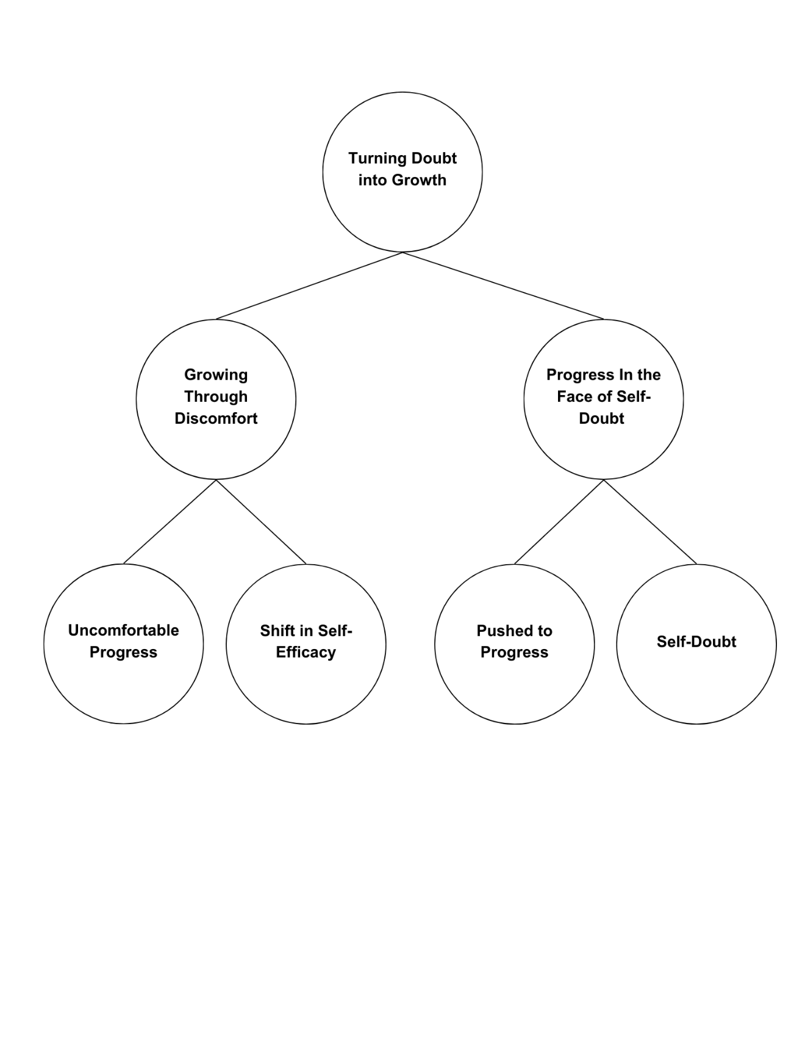

Figure 4 Emergent Themes, Categories, and Codes on the Teachers’ Perceptions of Self-Efficacy and Career Interests Shift When Assigned to Teach TLE Subjects.

RQ. 3 How do teachers' perceptions of self-efficacy and career interests shift when assigned TLE subjects outside their area of expertise?
Teachers’ Perceptions of Self-Efficacy and Career Interests Shift When Assigned to Teach TLE Subjects.
With their newfound confidence, teachers broadened their career interests and found renewed purpose through practical, hands-on activities. This shift underscores how out-of-field assignments can foster unexpected growth and deepen understanding of teaching’s multifaceted nature.

Theme 1: Turning Doubt into Growth
By embracing discomfort and stepping outside their comfort zones, they built confidence and broadened their career perspectives. This highlights the resilience and adaptability of teachers who learned to thrive in unfamiliar roles.

Category 1: Growing Through Discomfort
Participants noted that growth often arises from discomfort, viewing out-of-field teaching as a valuable learning experience. Facing these challenges helped them build new skills, life competencies, and greater self-efficacy, supporting both personal and professional development.
Uncomfortable Progress
Participants (IDI_1, and IDI_2) acknowledged the importance of embracing discomfort as a catalyst for growth. They highlighted that personal and professional development can occur in various situations outside one's comfort zone.
The belief that growth can occur anywhere is idealistic but often unrealistic for educators facing such challenges, leading to frustration and burnout. Out-of-field teachers, in particular, struggle with professional development due to broad subject demands, negative attitudes, and low self-confidence, making it difficult to adapt and succeed (Ma, 2024). Many educators report that traditional PD lacks sufficient preparation time and fails to support the use of evidence-based strategies in the classroom (Wong et al., 2022).
Shift in Self-Efficacy
Participants (IDI_1 and IDI_3) noted that taking on new challenges positively impacted their self-efficacy. According to Arias-Pastor et al. (2024), teachers with strong self-efficacy are more open to new ideas, use innovative methods, plan effectively, and teach with greater enthusiasm.
Teaching outside one’s specialization offers growth but also challenges, including stress, self-doubt, and lower instructional quality without proper support. Regier (2021) notes this can impact teacher confidence, highlighting the need for thoughtful curriculum design.
Category 2: Progress in the Face of Self-Doubt
Despite initial self-doubt, non-TLE teachers persisted in their efforts to teach TLE subjects. As they gained experience and confidence, they developed a stronger sense of professional identity and a deeper understanding of the multifaceted nature of teaching.

Pushed to Progress
Despite initial self-doubt, participants (IDI_1 and IDI_2) were motivated to embrace the challenges of teaching TLE subjects. Almerez et al. (2019) note that TLE teachers demonstrate resilience and dedication, often collaborating and utilizing resources to overcome obstacles. While it broadens their view of the profession, this growth often comes with the challenge of leaving their comfort zone without adequate support, leading to feelings of being overwhelmed and underprepared.

Self-Doubt
While many non-TLE teachers experienced a sense of growth and empowerment, others struggled with feelings of self-doubt and uncertainty (IDU_1, IDI_2 and IDI_3). These doubts can hinder professional development and impact overall job satisfaction.
Teaching outside one’s specialization can cause self-doubt and lower confidence, especially without adequate support. Brushkova et al. (2020) highlight that declining status, mistrust, and diverse student needs increase this uncertainty. Such challenges may prompt teachers to question their career paths.
5. CONCLUSION AND RECOMMENDATION
Conclusion
Based on the findings of the study, the following conclusions were drawn:
- Non-TLE teachers in selected schools around Tagum City, Davao del Norte, experienced both positive and negative aspects of teaching TLE. Key challenges included staffing shortages, limited subject flexibility, and resource constraints.
- These teachers struggled with TLE content and assessment practices due to unfamiliarity, particularly with performance-based tasks and the practical nature of the curriculum.
- Their professional identity and self-efficacy were impacted, as many felt uncertain about their ability to deliver quality instruction despite mentorship and peer support.

- Teachers showed resilience by using online resources, adapting materials, and learning independently. However, limited budgets—especially in smaller schools—restricted access to essential tools and technology.

- Overall, the study highlights the complexity of teaching outside one’s specialization and emphasizes the need for continuous learning, adaptability, and strong institutional support to help non-TLE teachers succeed.
Recommendations
- Schools should implement structured mentorship, team teaching, and regular knowledge-sharing sessions to support non-TLE teachers and foster collaboration.
- Targeted professional development—through workshops, seminars, and online training—should focus on TLE-specific content and pedagogy to build teacher confidence and competence.
- Teachers are encouraged to use resources creatively, integrate digital tools, and engage in reflective practices to enhance resilience and self-efficacy.
- School leaders should recognize non-TLE teachers’ efforts through incentives, public acknowledgment, and improved access to instructional resources. Subject-specific networks can support ongoing collaboration.
- Strategic workforce planning and hiring aligned with teachers' expertise should be prioritized. Budget allocations must ensure equitable access to materials for performance-based subjects like TLE.
- DepEd is encouraged to align teacher assignments with specialization, address staffing shortages through better recruitment and retention, and offer training for non-TLE teachers teaching TLE.
- DepEd may also support professional learning communities and provide updated materials and technologies. Regular assessments of teacher credentials and classroom needs should guide policy decisions.
- Future research should broaden the study beyond Tagum City to include more schools in Davao del Norte and explore the long-term effects of teaching outside one's specialization.
- Investigating the reasons behind subject misassignments can offer insights into recruitment practices and reinforce the need for subject-aligned staffing to uphold education quality.

References
Abdallah, A. K., & Alkaabi, A. M. (2023). Induction Programs' effectiveness in boosting new teachers' instruction and student achievement: A Critical review. International Journal of Learning Teaching and Educational Research, 22(5), 493–517. https://doi.org/10.26803/ijlter.22.5.25
Aithor. (2024). The impact of curriculum change on student outcomes and teacher adaptability in the 21st-century educational landscape. aithor.com. https://aithor.com/essay-examples/the-impact-of-curriculum-change-on-student-outcomes-and-teacher-adaptability-in-the-21st-century-educational-landscape
Almerez, Q. L. G., Adolfo, G. C., Bucod, J. E. G., Egos, M. B., & Tangpos, A. S. (2019). Technical Vocational Education in the context of Globalization: Its pedagogy and Strategies. Asian Journal of Education and Social Studies, 1–10. https://doi.org/10.9734/ajess/2019/v5i330144
Ana, A. N. F., Safrizal, N., & Sunarti, N. (2023). ANALISIS KESULITAN GURU DALAM MENGIMPLEMENTASIKAN KURIKULUM MERDEKA. MUBTADI Jurnal Pendidikan Ibtidaiyah, 4(2), 96–110. https://doi.org/10.19105/mubtadi.v4i2.8043
Antera, S. (2023). Competence importance and acquisition: comparing qualified and non-qualified vocational teachers. Journal of Education and Work, 36(2), 109–124. https://doi.org/10.1080/13639080.2023.2167956
Apau, S. K. (2022). Out-of-Field teaching in Ghanaian Basic Schools: A matrix of basic school teachers' experiences in Ekumfi District. Social Education Research, 188–199. https://doi.org/10.37256/ser.3120221314
Arendain, N. I. E., & Limpot, N. M. Y. (2022). PHENOMENOLOGICAL APPROACH OF OUT-OF-FIELD TEACHING: CHALLENGES AND OPPORTUNITIES. EPRA International Journal of Multidisciplinary Research (IJMR), 165–170. https://doi.org/10.36713/epra9379
Arias-Pastor, M., Van Vaerenbergh, S., González-Bernal, J. J., & González-Santos, J. (2024). Analysis of Teacher Self-Efficacy and Its Impact on Sustainable Well-Being At Work. Behavioral Sciences, 14(7), 563. https://doi.org/10.3390/bs14070563
Bandura, A. (1997). Self-Efficacy: The Exercise of Control. New York, NY: Freeman.
Bandura, A. (1977). Self-efficacy: Toward a unifying theory of behavioral change. Psychological Review, 84(2), 191–215. https://doi.org/10.1037/0033-295x.84.2.191
Bandura, A. (1978). Reflections on self-efficacy. Advances in Behaviour Research and Therapy, 1(4), 237–269. https://doi.org/10.1016/0146-6402(78)90012-7
Barksdale, S., Upadhyay, B., & Vernon, M. (2021). Teacher professional development: mobile and limited technology-enhanced pedagogy. International Journal of Technology in Education and Science, 5(4), 486–511. https://doi.org/10.46328/ijtes.249
Belavina, Y., & Klyuchko, O. (2024). Mentoring as a developmental mechanism of the All-Russian Olympiad for Primary School Teachers "My First Teacher." Primary Education, 12(2), 9–17. https://doi.org/10.12737/1998-0728-2024-12-2-9-17
Buat, M. D. H., & Limpot, M. Y. (2023). Teacher's sense of efficacy and students' motivation: the mediating effect of parental involvement. Asian Journal of Education and Social Studies, 44(2), 31–40. https://doi.org/10.9734/ajess/2023/v44i2959
Buenacosa, M. S. A., & Petalla, M. B. (2022). Embracing the unknown: Adaptability and resiliency of Out-of-Field Secondary teachers teaching English in public schools. Asian Journal of Education and Social Studies, 1–29. https://doi.org/10.9734/ajess/2022/v37i2796
Braun, V., & Clarke, V. (2006). Using thematic analysis in psychology. Qualitative research in psychology, 3(2), 77-101.
Brushkova, L. A., Gavrov, S. N., Zaia, I. Y., Gevorkyan, A. R., & Manuilova, E. A. (2020). The problem of confidence in schoolteachers in the context of new normality. SHS Web of Conferences, 79, 03002. https://doi.org/10.1051/shsconf/20207903002
Canoy, P. F., Gido, N., Montajes, G. J., Canoy, R., & Tuyor, A. (2022). TEACHING SUBJECTS BEYOND EXPERTISE. International Journal of Multidisciplinary Research and Studies, 05(07), 01–10. https://doi.org/10.33826/ijmras/v05i07.4
Carothers, D. E., Aydın, H., &Houdyshell, M. (2019). Teacher shortages and cultural mismatch: district and university collaboration for recruiting. Journal of Social Studies Education Research, 10(3), 3963. http://files.eric.ed.gov/fulltext/EJ1229410.pdf
Castro, A. J. (2022). Managing Competing demands in a Teacher Shortage context: The impact of teacher shortages on principal leadership practices. Educational Administration Quarterly, 59(1), 218–250. https://doi.org/10.1177/0013161x221140849
Cataraja, G., & Cataraja, R. (2022). Evaluation of the performance of the Technical Education and Skills Development Authority (TESDA) training institutions in Region VIII. East Asian Journal of Multidisciplinary Research, 1(6), 947–960. https://doi.org/10.55927/eajmr.v1i6.695
Caulfield, J. (2019). How to do thematic analysis | Step-by-step guide & examples. Retrieved on July 23, 2023 from https://www.scribbr.com/methodology/thematic-analysis/
Cayabas, J. P., Jr, & Sumeg-Ang, D. A. (2023). Challenges and interventions in developing instructional materials: Perspectives of public school teachers in basic education. International Journal of Innovative Research and Scientific Studies, 6(4), 849–855. https://doi.org/10.53894/ijirss.v6i4.2059
Cchiaro. (2023). The importance of professional development in the 21st century. Graduate Programs for Educators. https://www.graduateprogram.org/2019/09/the-importance-of-professional-development-in-the-21st-century/#:~:text=Professional%20development%20in%20the%2021st%20century%20gives%20educators%20the%20tools,growth%2C%20reflective%20practice%20is%20necessary
Cheruiyot, B. (2024). Challenges faced in the implementation of Competency-Based Curriculum (CBC) in junior schools in Kenya. East African Journal of Education Studies, 7(3), 260–266. https://doi.org/10.37284/eajes.7.3.2098
Conradty, C., & Bogner, F. X. (2022). Measuring students' school motivation. Education Sciences, 12(6), 378. https://doi.org/10.3390/educsci12060378
Collie, R. J., & Martin, A. J. (2016). Adaptability: an important capacity for effective teachers. Educational Practice and Theory, 38(1), 27–39. https://doi.org/10.7459/ept/38.1.03
Culajara, C. J. (2023). Improving teachers' professional development through School Learning Action Cell (SLAC). Journal of Research Policy & Practice of Teachers & Teacher Education, 13(1), 76–88. https://doi.org/10.37134/jrpptte.vol13.1.6.2023
Culajara, C. J. (2023). The voices of physical education teachers: its pressure, measure, and treasure in delivering instruction in physical education. Indonesian Journal of Research in Physical Education, Sport, and Health, 1(2), 98–109. https://doi.org/10.17977/um086v1i22023p98-109
Damyanov, P. K. (2024). Effective Pedagogical Strategies and Support Mechanisms for Enhancing the Learning Outcomes of Students with Special Educational Needs: A Systematic Approach. International Journal of Scientific Research and Management (IJSRM), 12(10), 3700–3718. https://doi.org/10.18535/ijsrm/v12i10.el03
Datsenko, О. А. (2023). Self-efficacy of the individual: a psychological discourse. АктуальніПроблемиПсихології В ЗакладахОсвіти, 13, 9–18. https://doi.org/10.31812/psychology.v13i.7660
De Jong, L., Meirink, J., & Admiraal, W. (2022). School-based collaboration as a learning context for teachers: A systematic review. International Journal of Educational Research, 112, 101927. https://doi.org/10.1016/j.ijer.2022.101927
DePED releases implementation guidelines on Rationalizing teachers' workload and overload compensation | Department of Education. (2024, October 2). https://www.deped.gov.ph/2024/10/02/deped-releases-implementation-guidelines-on-rationalizing-teachers-workload-and-overload-compensation/#:~:text=2024%20reiterates%20that%20teachers%20are,two%20additional%20hours%20per%20day
Domich, M. a. A. (2020). Preguntar-se en el oficio de educar: la importancia de la pregunta en formación docente. Revista Educación, 619–631. https://doi.org/10.15517/revedu.v45i1.41144
Du Plessis, A. E. (2019). Professional support beyond initial teacher education. In Teacher education, learning innovation and accountability (Print). https://doi.org/10.1007/978-981-13-9722-6
Du Plessis, A. E. (2020). Connecting the dots: Policy development and the Out-of-Field Teaching Reality in education. In Springer eBooks (pp. 1–45). https://doi.org/10.1007/978-981-15-1948-2_1
Du Plessis, A. E., Hobbs, L., Luft, J. A., & Vale, C. (2019). The Out-of-Field Teacher in Context: The impact of the school context and environment. In Springer eBooks (pp. 217–242). https://doi.org/10.1007/978-981-13-3366-8_9
Edralin, D., & Pastrana, R. (2023). Technical and vocational education and training in the Philippines: In retrospect and its future directions. Bedan Research Journal, 8(1), 138-172.
Gallagher, M. W. (2012). Self-Efficacy. In Elsevier eBooks (pp. 314–320). https://doi.org/10.1016/b978-0-12-375000-6.00312-8
Gale, J., Alemdar, M., Cappelli, C., & Morris, D. (2021). A mixed methods study of Self-Efficacy, the sources of Self-Efficacy, and teaching experience. Frontiers in Education, 6. https://doi.org/10.3389/feduc.2021.750599
Gamboa, M. Q. (2023). Implementation of School Learning Action Cell (SLAC) and its Monitoring & Evaluation Strategies Employed by Teachers and School Heads in the Division of Occidental Mindoro, Philippines. International Journal of Research Publication and Reviews, 4(11), 2157–2161. https://doi.org/10.55248/gengpi.4.1123.113119
Garbuzova, T., Habibullina, L., Sergeev, N., Grigoriev, A., & Svistunova, I. (2024). EFFECTIVE USE OF EDUCATIONAL RESOURCES IN CONDITIONS OF a LIMITED BUDGET: THE EXPERIENCE OF ECONOMIC PLANNING IN EDUCATION. Moscow Economic Journal, 663–673. https://doi.org/10.55186/2413046x_2024_9_5_273
Generelao, I. N., Ducanes, G., Yee, K. M., & David, C. (2021). Teacher education in the Philippines: Are we meeting the demand for quality? Philippine Journal of Public Policy Interdisciplinary Development Perspectives, 2022. https://doi.org/10.54096/iene4805
Gordon, M. (2023). The educational promises and perils of existential Self‐Doubt. Educational Theory, 73(3), 320–336. https://doi.org/10.1111/edth.12586
Grünwald, J. G. (2021). Embracing Doubt: Teaching in a Post-digital age. In Springer eBooks (pp. 257–267). https://doi.org/10.1007/978-3-030-73770-2_15
Guiaselon, B. U., Luyugen-Omar, S., Mohamad, H. A., Sinsuat, D. R. R. S., Samson, C. D., Maidu, N. U., &Maguid, N. P. (2022). Mismatch of teachers' qualifications and subjects taught: Effects on Students' National Achievement Test. Zenodo (CERN European Organization for Nuclear Research). https://doi.org/10.5281/zenodo.7494892
Gupta, H. (2023). An alternative perspective on the teachers' role in curriculum development. eLearning Industry. https://elearningindustry.com/alternative-perspective-on-the-teachers-role-in-curriculum development#:~:text=They%20provide%20valuable%20input%20in,discussions%2C%20and%20assess%20student%20progress
H, L. (2023, August 30). What is Phenomenological Research Design? — Delve. Delve. https://delvetool.com/blog/phenomenology
Hanway, J. (2024). Teachers face many stressors from inside and outside the classroom. We Are Millard South. https://wearemillardsouth.com/5751/features/teachers-face-many-stressors-from-inside-and-outside-the-classroom/#:~:text=They%20face%20an%20array%20of,the%20community%2C%20and%20the%20parents
Hobbs, L., & Porsch, R. (2021). Teaching out-of-field: challenges for teacher education. European Journal of Teacher Education, 44(5), 601–610. https://doi.org/10.1080/02619768.2021.1985280
Hobbs, L., & Quinn, F. (2020). Out-of-field teachers as learners: Influences on teacher perceived capacity and enjoyment over time. European Journal of Teacher Education, 44(5), 627–651. https://doi.org/10.1080/02619768.2020.1806230
Hoy, A. W. (2022). Gaining efficacy with experience: from teacher education to classroom practice: rroe. Rroe. https://doi.org/10.4324/9781138609877-ree19-1
Hung, L. N. Q. (2020). Teachers' motivation and its influence on quality education: A study at a center for foreign languages in Vietnam. Can Tho University Journal of Science, 12(3). https://doi.org/10.22144/ctu.jen.2020.020
Hussain, M. S., & Khan, S. A. (2022). SELF-EFFICACY OF TEACHERS: A REVIEW OF THE LITERATURE. ResearchGate. https://www.researchgate.net/publication/358368223_SELF-EFFICACY_OF_TEACHERS_A_REVIEW_OF_THE_LITERATURE
Institute of Industry and Academic Research Incorporated. (2024, October 17). Community of Practice and Themes of School Learning Action Cell towards Better Teachers' Performances - IIARI. IIARI. https://iiari.org/conference_article/community-of-practice-and-themes-of-school-learning-action-cell-towards-better-teachers-performances/
Jabeen, R., & Khan, A. I. (2022). A study on Teachers' Sense of Self-Efficacy in Defence Authority Educational Institutions, Karachi, Pakistan. International Journal of Experiential Learning & Case Studies, 6(2). https://doi.org/10.22555/ijelcs.v6i2.38
Jomuad, P., Leah, M., Cericos, E., Bacus, J., Vallejo, J., Dionio, B., Bazar, J., Cocolan, J., & Clarin, A. (2021). Teachers' workload in relation to burnout and work performance. International Journal of Educational Policy Research and Review, 8(2). https://doi.org/10.15739/ijeprr.21.007
Lekamge, G. D., & Thilakeratne, J. (2019). An analysis of action research studies conducted by teachers in Sri Lankan schools. OUSL Journal, 14(1), 27. https://doi.org/10.4038/ouslj.v14i1.7459
Lent, R. W. (2013). "Social cognitive career theory," in Career Development and Counseling: Putting Theory and Research to Work, 2nd Edn, eds S. D. Brown, and R. W. Lent (Hoboken, NJ: John Wiley & Sons), 115–144.
Lent, R. W., Miller, M. J., Smith, P. E., Watford, B. A., Lim, R. H., Hui, K., Morrison, M. A., Wilkins, G., & Williams, K. (2013). Social cognitive predictors of adjustment to engineering majors across gender and race/ethnicity. Journal of Vocational Behavior, 83(1), 22–30. https://doi.org/10.1016/j.jvb.2013.02.006
Lewis, H., Briggs, M., Holweck, T., Hunter, J., Erkkilä, R., & Perunka, S. (2019). Mentoring, coaching and collaborative dialogue to support professional learning throughout teachers' career paths; exploring roles, responsibilities, tensions and opportunities. SciSpace - Paper. https://typeset.io/papers/mentoring-coaching-and-collaborative-dialogue-to-support-2rbdno6qbw
Lim, W. M. (2024). What is qualitative research? An overview and guidelines. Australasian Marketing Journal (AMJ). https://doi.org/10.1177/14413582241264619
Ma, L. (2024). Challenges in the Professional Development of Teachers Teaching Out-of-field in Chinese Elementary Schools under the Background of "Structural Teacher Shortage." In Advances in Social Science, Education and Humanities Research/Advances in social science, education and humanities research (pp. 419–427). https://doi.org/10.2991/978-2-38476-253-8_51
MAEd, N. J. L. M. (2022). Out-of-field Teaching: The stories of novice educators in teaching social studies. International Journal of Research Publications, 112(1). https://doi.org/10.47119/ijrp10011211120224116
Maffea, J. (2020). Lack of resources in classrooms. Research Commons at Kutztown University. https://research.library.kutztown.edu/wickedproblems/38/?utm_sour
Masriwati, S., Krismiadi, D., Dina, H., & Amirudin, N. (2024). Pengaruh Focus Group Discussion Terhadap Pengetahuan Dan Sikap Lansia Yang Menderita Hipertensi Tentang Gaya Hidup Dipuskesmas Kemaraya Kota Kendari. Jurnal Anoa Keperawatan Mandala Waluya. https://doi.org/10.54883/jakmw.v3i2.890
McKinley, D. (2024, July 29). The importance of mentoring new teachers. INcompassing Ed. https://www.incompassinged.com/post/the-importance-of-mentoring-new-teachers#:~:text=Why%20New%20Teachers%20Need%20Mentors,in%20choosing%20professional%20development%20opportunities
McMullin, C. (2021). Transcription and Qualitative Methods: Implications for third sector research. VOLUNTAS International Journal of Voluntary and Nonprofit Organizations, 34(1), 140–153. https://doi.org/10.1007/s11266-021-00400-3
Mercado, H. a. R., & Morante, L. M. (2024). Experiences of senior high school mathematics teachers in out-of-field teaching. Salud Ciencia Y Tecnología - Serie De Conferencias, 3, 1125. https://doi.org/10.56294/sctconf20241125
Mola, S., &Kelkay, A. D. (2020). The status of teachers' motivation and process of quality education: The case of primary school teachers, Ethiopia. Global Journal of Guidance & Counseling in Schools, 10(1), 01–11. https://doi.org/10.18844/gjgc.v10i1.4448
Moran, M. (2024b, December 31). What is Trustworthiness in Qualitative Research? Statistics Solutions. https://www.statisticssolutions.com/what-is-trustworthiness-in-qualitative-research/
Nakar, S., & Plessis, D. (2023). Facing the dilemma of the Out-of-Field teaching phenomenon in Vocational Education and Training (VET). Vocations and Learning, 16(3), 551–575. https://doi.org/10.1007/s12186-023-09329-8
Neubauer, B., Witkop, C. T., &Varpio, L. (2019). How phenomenology can help us learn from the experiences of others. Perspectives on Medical Education, 8(2), 90–97. https://doi.org/10.1007/s40037-019-0509-2
Nob, N. J. M. R., & Tañola, N. M. (2024). Ang Magturo ay Di Biro: A HERMENEUTIC PHENOMENOLOGICAL STUDY ON THE LIVED-EXPERIENCES OF MATH EDUCATORS IN OUT-OF-FIELD TEACHING. EPRA International Journal of Research & Development (IJRD), 131–141. https://doi.org/10.36713/epra15810
Nowell, L.S., Norris, J.M., White, D.E., & Moules, N.J. (2017). Thematic analysis: Striving to meet the trustworthiness criteria. International Journal of Qualitative Methods, 16, 1–13. https://doi.org/10.1177/1609406917733847
O'Leary, P., &Tsui, M. (2022). Lived experience: A constant companion for the social work relationship. International Social Work, 65(6), 1075–1077. https://doi.org/10.1177/00208728221138677
ONyumba, T., Wilson, K., Derrick, C. J., & Mukherjee, N. (2018). The use of focus group discussion methodology: Insights from two decades of application in conservation. Methods in Ecology and Evolution, 9(1), 20–32. https://doi.org/10.1111/2041-210x.12860
Ortan, F., Simut, C., & Simut, R. (2021). Self-Efficacy, Job Satisfaction and Teacher Well-Being in the K-12 educational system. International Journal of Environmental Research and Public Health/International Journal of Environmental Research and Public Health, 18(23), 12763. https://doi.org/10.3390/ijerph182312763
Osborne, N., & Grant-Smith, D. (2021). In-Depth interviewing. In Cities research series (pp. 105–125). https://doi.org/10.1007/978-981-16-1677-8_7
Outreach, R. (2023) Out-of-field teaching: New teachers survive under pressure. Research Outreach. https://researchoutreach.org/articles/out-field-teaching-new-teachers-survive-pressure/
Pacana, N. M. S., Ramos, C. D., Catarata, M. N., &Inocian, R. B. (2019). Out-of-Field Social Studies Teaching through Sustainable Culture-Based Pedagogy: A Filipino Perspective. International Journal of Education and Practice (Online), 7(3), 230–241. https://doi.org/10.18488/journal.61.2019.73.230.241
Pacaol, N. (2021). Teacher's Workload Intensification: A Qualitative Case Study of Its Implications on Teaching Quality. International Online Journal of Education and Teaching, 8(1), 43–60. https://eric.ed.gov/?id=EJ1286549
Pak, K., Polikoff, M. S., Desimone, L. M., & García, E. S. (2020). The Adaptive Challenges of Curriculum Implementation: Insights for Educational Leaders Driving Standards-Based Reform. AERA Open, 6(2). https://doi.org/10.1177/2332858420932828
Paolucci, C., Ríordáin, M. N., & O'Dwyer, L. (2021). A Critical Examination of the Impacts and Lessons Learned from a Professional Development Program for Out-of-Field Mathematics Teachers. European Journal of Mathematics and Science Education, volume–2–2021(volume–2–issue–1–june–2021), 47–62. https://doi.org/10.12973/ejmse.2.1.47
Pérez, I. M. M., & Pérez, S. E. M. (2024). Group Discussions as a Methodology in Multicultural Settings. Advances in Library and Information Science (ALIS) Book Series. https://doi.org/10.4018/979-8-3693-3306-8.ch005
Politz, D. (2024, February 6). In-Depth Interviews in qualitative research — Delve. Delve. https://delvetool.com/blog/in-depth-interviews
Lent, R. W. (2013). "Social cognitive career theory," in Career Development and Counseling: Putting Theory and Research to Work, 2nd Edn, eds S. D. Brown, and R. W. Lent (Hoboken, NJ: John Wiley & Sons), 115–144.
Quilapio, M. P., & Callo, E. C. (2022). The effect of In-Service training programs on the professional development of public elementary school teachers. International Journal of Research Publications, 107(1). https://doi.org/10.47119/ijrp1001071820223799
Recede, R. a. A., Asignado, R. A., & Castro, M. A. (2023). Out-of-Field Teaching: Impact on Teachers' Self-Efficacy and motivation. International Journal of Multidisciplinary, 4(2), 519–533. https://doi.org/10.11594/ijmaber..04.02.19
Regier, B. J. (2021). Preservice music teachers' self-efficacy and concerns before and during student teaching. International Journal of Music Education, 39(3), 340–352. https://doi.org/10.1177/0255761421990787
Rutledge, P. B., & Hogg, J. L. C. (2020). In‐Depth Interviews. The International Encyclopedia of Media Psychology, 1–7. https://doi.org/10.1002/9781119011071.iemp0019
Salvador, R., Limon, M., Borromeo, C. M., Parinas, M. A., Manrique, L., Cruz, L. de la, &Dalere, J. M. (2022). Exploring Technical-Vocational Education Teachers' Challenges and Adaptation Strategies in Teaching Courses Outside their Specializations. Journal of Technical Education and Training, 14(2), 34–48. https://penerbit.uthm.edu.my/ojs/index.php/JTET/article/view/11084/5219?fbclid=IwAR3qCXPw00f7uVtlXJcMAILtbPd8rAob4HtQGgvf0DEEWdM06mhQFoUWVHE
Sampan, F. P., & Caballes, D. G. (2023). Sense of Efficacy and Burnout among General and Special Needs Education Teachers. Journal of Humanities and Education Development, 5(3), 102–105. https://doi.org/10.22161/jhed.5.3.13
Schoch, K. (2020). Case study research. Research design and methods: An applied guide for the scholar-practitioner, 245-258.
Simplilearn. (2023, September 1). What is data collection: methods, types, tools. Simplilearn.com. https://www.simplilearn.com/what-is-data-collection-article
‌Sto, J., & Tomas-Fulgado. (2020). Instructional Flexibility in Out of Field Teaching. The URSP Research Journal |, 6(1). http://www.urs.edu.ph/wp-content/uploads/publications/the-ursp-research-journal/current-issue/1-
Sutcher, L., Darling-Hammond, L., & Carver-Thomas, D. (2019). Understanding teacher shortages: An analysis of teacher supply and demand in the United States. Education Policy Analysis Archives, 27, 35. https://doi.org/10.14507/epaa.27.3696
Talili, I., Lomibao, L., Tan. R., Saludares Q.E., Bug.os. M.A., &Besagas. R., (2021). PERFORMANCE OF OUT-OF-FIELD TEACHERS IN BASIC EDUCATION: BASIS FOR PROGRAM INITIATIVES. Sci. Int.(Lahore),33(5),357-363. http://www.sci-int.com
Taripe, A. L. C. (2024). Technology and Livelihood Education (TLE) During In-Person Classes: Experiences of Secondary School Teachers. International Journal of Research in Interdisciplinary Studies, 2(4), 7-12. https://journal.ijris.com/index.php/ijris/article/view/38
‌Tarraya, H. O. (2023, June 24). Teachers' Workload Policy: Its Impact on Philippine Public School Teachers (Public Policy Analysis and Review). ERIC. https://eric.ed.gov/?q=Teachers%e2%80%99+Workload+Policy%3a+Its+Impact+on+Philippine+Public+School+Teachers+(Public+Policy+Analysis+and+Review)&id=ED629465
Taş, M. (2022). An investigation of curriculum adaptation efforts of teachers working in disadvantaged secondary schools. Pegem Journal of Education and Instruction, 12(1). https://doi.org/10.47750/pegegog.12.01.02
Thi, P., Tham, H., Nguyen, H., Toan, N., Nguyen, T., Trang, H., Nguyen, T., Thuc, T., Hien, N., Mai, M., & Nguyen, M. (2023). The Current Situation of Professional Work Pressure of Junior High School Teachers during the Implementation of the 2018 General Education Curriculum. Hong Kong Journal of Social Sciences, 61. https://doi.org/10.55463/hkjss.issn.1021-3619.61.25
Tingzon, L. L., & Buyok, H. J. A. (2022). LIVED EXPERIENCES OF NON-TLE TEACHERS TEACHING TLE SUBJECTS: A PHENOMENOLOGICAL INQUIRY. European Journal of Education Studies, 9(11). https://doi.org/10.46827/ejes.v9i11.4538
Tran, H. L. (2023). TEACHING OUTSIDE AREA OF EXPERTISE: a BARRIER TO OR ENABLER OF TEACHERS' SENSE OF COMPETENCE? VNU Journal of Foreign Studies, 39(6), 86–99. https://doi.org/10.63023/2525-2445/jfs.ulis.5162
Treto-French, M. (2024). SCHOOL DISTRICT BUDGETING: HOW SCHOOL PRINCIPALS' LACK OF BUDGET KNOWLEDGE CAN LEAD TO NEGATIVE IMPACT ON FUNDING. Huskie Commons. https://huskiecommons.lib.niu.edu/allgraduate-disspractice/35?utm_source=huskiecommons.lib.niu.edu%2Fallgraduate-disspractice%2F35&utm_medium=PDF&utm_campaign=PDFCoverPages
Tribble, D., & PowerSchool. (2024, July 15). The three most common types of teacher professional development and how to make them better. PowerSchool. https://www.powerschool.com/blog/the-three-most-common-types-of-teacher-professional-development-and-how-to-make-them-better/#:~:text=What%20is%20Professional%20Development%20for,technology%20tools%20in%20the%20classroom
Tsindos, T. (2023, March 21). Chapter 14: Focus groups. Pressbooks. https://oercollective.caul.edu.au/qualitative-research/chapter/__unknown__-14/
upEducators. (2023). Professional Development for Teachers: A complete guide. upEducators - Helping Teachers, Educators, Tutors, Tuitions and Parents in Online Teaching With Technology. https://www.upeducators.com/blog/professional-development-for-teachers-a-complete-guide/#:~:text=Types%20of%20Professional%20Development,Research
Von Der Embse, N., Ryan, S. V., Gibbs, T., & Mankin, A. (2019). Teacher stress interventions: A systematic review. Psychology in the Schools, 56(, 1328–1343. https://doi.org/10.1002/pits.22279
What do you do if you're a teacher struggling with self-doubt and imposter syndrome? (2024b, July 23). www.linkedin.com https://www.linkedin.com/advice/0/what-do-you-youre-teacher-struggling-self-doubt-imposter rz37f#:~:text=As%20a%20teacher%2C%20you%20may,with%20practical%20strategies%20and%20tips
What is CPD in Education and Why Is It Important? (2021). The CPD Group. https://thecpd.group/articles/view/what-is-cpd-in-education-and-why-is-it-important#:~:text=Participating%20in%20CPD%20activities%20can,satisfaction%20and%20opportunities%20for%20advancement
Wheeley, E., Klieve, H., Park, E., & Du Plessis, A. (2022). Preservice Teachers' perceptions about Out-of-Field Teaching: Implications for students, teachers and schools. Research Online. https://ro.ecu.edu.au/ajte/vol48/iss4/1/
Wong, J. T., Bui, N. N., Fields, D. T., & Hughes, B. S. (2022). A Learning Experience Design Approach to Online Professional Development for Teaching Science through the Arts: Evaluation of Teacher Content Knowledge, Self-Efficacy and STEAM Perceptions. Journal of Science Teacher Education, 34(6), 593–623. https://doi.org/10.1080/1046560x.2022.2112552
Yang, X. (2023). A historical review of collaborative learning and cooperative learning. TechTrends, 67(4), 718–728. https://doi.org/10.1007/s11528-022-00823-9
Yazid, M. H. (2023). Transformasi Pendidikan Guru SD: Analisis Program TEMA PGSD dalam Meningkatkan Kualitas Pengajaran dan Prestasi Siswa. Jurnal Pendidikan Guru Sekolah Dasar, 1(1), 6. https://doi.org/10.47134/pgsd.v1i1.67
Zaid, B., Gunn, C., Fedtke, J., & Ibahrine, M. (2020). Teaching outside your area of expertise: an opportunity for professional development. Journal of Further and Higher Education, 45(5), 629–640. https://doi.org/10.1080/0309877x.2020.1804538
Zhang, X., Admiraal, W., & Saab, N. (2021). Teachers' motivation to participate in continuous professional development: relationship with factors at the personal and school level. Journal of Education for Teaching International Research and Pedagogy, 47(5), 714–731. https://doi.org/10.1080/02607476.2021.1942804

