Short Communication

Tropical Tasar Silkworm Antheraea mylitta Drury: A Propitious Ecological Indicator of Forest Ecosystems

Abstract
Anthropogenic activities have increasingly led to habitat fragmentation and biodiversity loss across ecosystems worldwide, severely impacting species such as Lepidopterans, which act as ecological indicators. Among them, the Tropical Tasar Silkmoth (Antheraea mylitta Drury), a unique species endemic to India, which has been deeply woven into the lives and traditions of Scheduled Tribe and Scheduled Caste communities, has suffered heavy population losses as its natural habitats continue to shrink. This study investigates the distribution and genetic diversity of A. mylitta ecoraces across Odisha, where seven historical ecoraces have dwindled to five, with signs of local extinction in some regions. Through Cytochrome b as a mitochondrial molecular marker, phylogenetic analyses revealed the gene flow patterns consistent with geographical proximity but also uncovered unexpected genetic similarities, suggesting historical population mixing. Habitat degradation, primarily from mining and deforestation, has severely impacted tasar host plant availability, leading to a decline in the tasar silk production and threatening the wild ecorace survival. The findings highlight the critical need for conservation strategies focusing on habitat protection, genetic monitoring, and sustainable management to preserve A. mylitta populations and the forest ecosystems they symbolize.
Keywords: Cytochrome b, Ecoraces, Tasar, Habitat degradation, Mitochondrial marker
Introduction
Numerous human-induced activities have significantly contributed to the fragmentation of natural habitats and the subsequent decline of biodiversity across various ecosystems. These disturbances have disrupted ecological balance, isolated species populations, and hindered the natural interactions necessary for the survival and sustainability of diverse life forms on Earth. Lepidopterans, particularly those that function as ecological indicator species and serve as vital monitors of local biodiversity health, have not been spared from the relentless cycle of environmental degradation. Despite their critical role in maintaining ecosystem balance and signalling ecological changes, these species are also increasingly threatened by habitat loss, climate change, pollution, and other anthropogenic pressures. Environmental degradation not only impacts Lepidopteran species but also affects the human communities closely linked to them. For instance, economically important Lepidopterans like silkmoths, particularly wild varieties such as the Tropical Tasar Silkmoth (Antheraea mylitta Drury), which are intricately connected to the livelihoods of Scheduled Tribe and Scheduled Caste populations in India (Sahu and Debta, 2020).
- Distribution status of the Tropical Tasar silkmoth Antheraea mylitta Drury in India and Odisha:
This particular species, which is endemic to India only, been found to be distributed across the states of West Bengal, Bihar, Odisha, Jharkhand, Chhattisgarh, Madhya Pradesh, Uttar Pradesh, Maharashtra, Rajasthan, Andhra Pradesh, Karnataka, Kerala, Himachal Pradesh, Nagaland, Assam, Meghalaya, Manipur, including two of the Union territories, Jammu and Kashmir and Dadar Nagar Haveli (Singh and Srivastava, 1997; Srivastava and Sinha, 2002). Anthropogenic habitat degradation has directly affected the distribution of the distribution of this species, leading to its fragmentation into 44 distinct population pockets, commonly referred to as “Ecoraces”. These ecoraces have been found to be phenotypically and behaviourally different from each other. In Odisha, seven ecoraces of tasar silkworms have been previously documented; namely, Modal, Nalia, Sukinda, Jata-Daba, Boudh, Adaba, and Umerkote. However, Adaba and Umerkote have not been reported in the past decade, indicating a possible local extinction of these ecoraces from the region. To assess the current geographical distribution of the existing ecoraces in Odisha, we collected and analysed both primary and secondary data regarding their respective ecozones and present-day availability. This information has been consolidated into a comprehensive point map of Odisha, highlighting the key ecozones associated with each major tasar ecorace (refer Fig 1 and Table 1).
Table 1: Ecoraces of Antheraea mylitta Drury found in Odisha and their respective ecozones
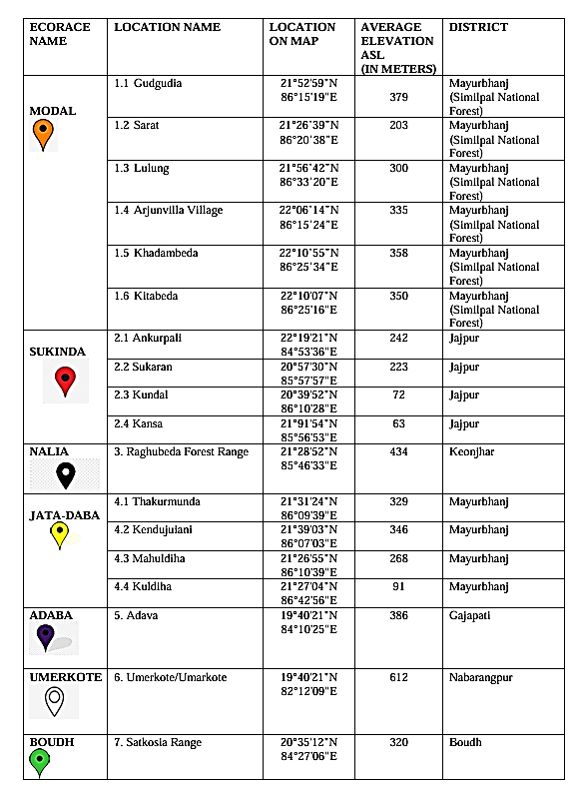
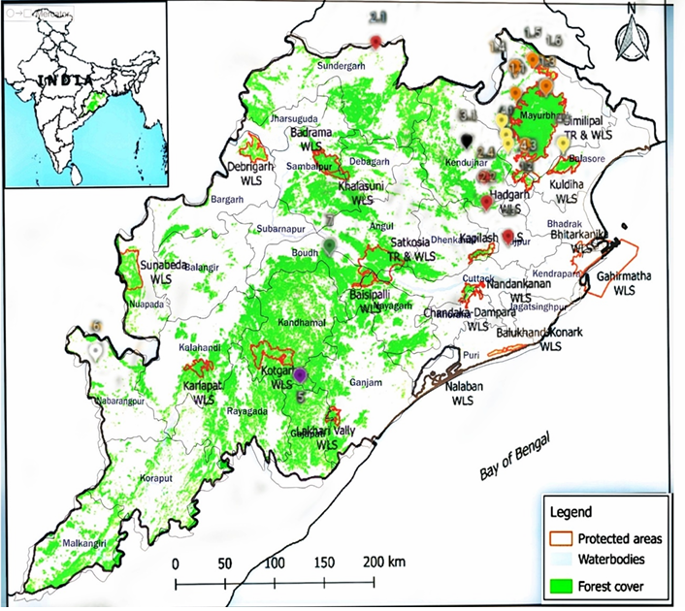
Fig 1: Geographical distribution of the Ecoarces of Tropical Tasar Silkmoth Antheraea mylitta Drury in Odisha (©Ray and Barala, 2024)
- Analysis of Gene Flow among Ecoraces across Distinct Ecozones of Odisha, Using Cytochrome b as a Molecular Marker:
An experiment was conducted by Ray and Barala in 2024, using Cyt b as a mitochondrial molecular marker to estimate the phylogeny among the ecoraces and across other species as well. The intraspecific phylogenetic tree based on the Cyt-b gene showed that the Modal and Nalia ecoraces of Antheraea mylitta Drury exhibit the highest genetic similarity, indicating a strong gene flow between them. Likewise, another cluster in the tree demonstrated that the Jata-Daba and Sukinda ecoraces are genetically closer to each other than to the Boudh ecorace. The intra-generic phylogenetic tree, constructed using the Neighbour-Joining method, further revealed that the A. mylitta ecoraces share an evolutionary relationship with their sister species-Antheraea polyphemus from the USA and Antheraea pernyi, the Chinese Oak Tasar moth, from China (Ray et al. 2024).

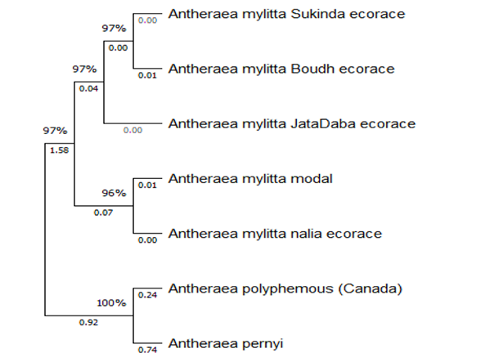
Fig 2: Interspecific Phylogenetic tree using Neighbour Joining Method (Ray et al. 2024)
The genetic patterns largely correspond with geographical proximity—ecoraces from closer ecozones, like Nalia and Modal in the Similipal Biosphere Reserve, exhibit higher gene flow than those from distant regions, such as Boudh from Sunabeda Forest Range. An anomaly was observed between Jata-Daba (native to Similipal) and Sukinda (from Jajpur), which showed unexpectedly high genetic similarity. This may indicate historical mixing of populations or misclassification of one as a distinct ecorace. Interspecific phylogenetic analysis using MEGA 11 showed that Modal and Nalia clustered with Antheraea pernyi (China), Sukinda with A. polyphemus (USA), and Boudh with Saturnia pavonia (Europe). These outgroup species share ecological similarities with A. mylitta, such as tropical or subtropical habitats and polyphagous feeding behavior. Host plant diversity, like Sal, Arjun, Asan, and Oak, might have some influence on the genetic divergence within A. mylitta ecoraces. Similarly, outgroups those have been found in the phylogeny also feed on a wide range of plants, including Oak, Maple, Birch, and Willow, further supporting ecological and genetic parallels between ecoraces of A. mylitta and other out groups. As demonstrated by Safran and Nosil (2012), populations feeding on similar host plants tend to show ecological convergence, possibly explaining the observed phylogenetic clustering in the following.
- Habitat degradation, Tasar silkmoth ecoraces and Biodiversity:
Unlike domesticated silk-producing species like Bombyx mori (Mulberry silk), which can be reared indoors, the tropical tasar silkmoth Antheraea mylitta Drury is entirely wild. It depends on forest ecosystems to complete its life cycle, earning it the name “forest insect”. This species primarily feeds on Sal (Shorea robusta), Arjun (Terminalia arjuna), and Asan (Terminalia tomentosa), which together form the core of its natural habitat. Notably, Sal trees alone constitute about 86.9% of the total tasar flora in India, while Arjun and Asan collectively make up the remaining 13.1% (Lokesh et al., 2016), predominantly within the tropical moist and dry deciduous forests of the Indian Tasar belt.

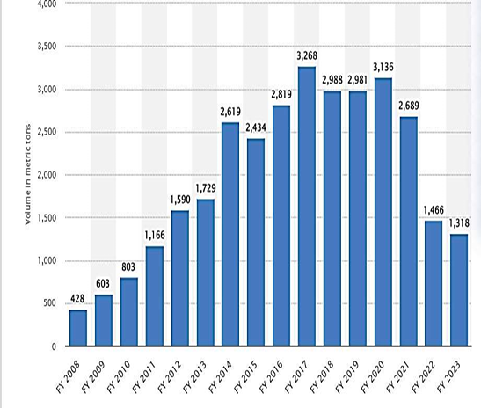  Fig 3: Statistical Data representation on the Tasar Silk Production from 2008-2023 | Table 2: Production of tasar silk Source: Ministry of textiles, Govt. of India  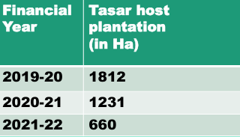
In recent years, there has been a significant decline in both total forest cover and the area under tasar host plant plantations, leading to a corresponding drop in tasar silk production. These wild tasar ecoraces do not only play an important role economically but ecologically as well. The decline in silk production serves as a clear indicator that tasar host plant habitats are increasingly under threat across the country. It has also been observed that the tasar belt regions of India overlap significantly with major mining zones across several states. Activities such as over-mining and infrastructure development have caused substantial anthropogenic disturbances, adversely impacting forest ecosystems. These disruptions are increasingly reflected in the declining populations and diversity of Antheraea mylitta ecoraces.
Among the five wild ecoraces currently viable in Odisha, the Modal ecorace shows the highest productivity, even though it is univoltine. This success can be largely attributed to the relatively undisturbed forest cover within the Similipal Biosphere Reserve. In contrast, ecoraces like Nalia (endemic to Keonjhar) and Sukinda (endemic to Jajpur) are facing significant challenges due to intense mining activities near their natural tasar habitats. As a result, over the past few years, tasar silk production from these bivoltine and trivoltine ecoraces has remained consistently low. Additionally, the phylogenetic analysis using the Neighbor-Joining (N-J) method revealed that the Jata-Daba population is of hybrid origin, thereby challenging and effectively nullifying its recognition as a distinct ecorace (Ray et al. 2024). Similarly, the Boudh ecorace is now found only in the Sunabeda forest range, which raises concerns about its validity as a separate ecorace. The declining population, reduced productivity, and poor-quality cocoon yield are alarming indicators, pointing toward the possible extinction of this ecorace in the future.
Conclusion:
The presence of multiple “ecoraces” of Antheraea mylitta Drury, now fragmented into 44 isolated pocket populations, is a significant cause for concern. These smaller, scattered populations are inherently more susceptible to extinction than a single, large, and well-distributed population. Furthermore, the polyphyletic nature of the species suggests a potential for future speciation, provided that the species survives long enough and anthropogenic disturbances in these regions are mitigated in time. Along with that, since this species is an integrated part of the forest ecosystem, the population’s behaviour is an indication of the native forest ecosystem as well, for which it has gained its name as “Ecological indicator”. Therefore, monitoring key aspects such as population dynamics, productivity, and voltinism of these ecoraces is crucial. It will enable conservationists to develop more effective strategies, not only for the preservation of Antheraea mylitta itself and the population that depends on it, but also for the protection and sustainability of the entire forest ecosystem.
Data Availability: None
Conflict of Interest: There is No Conflict of Interest between the Authors
Ethics Approval: Not Applicable

References:
Lokesh, G., Srivastava, A. K., Kar, P. K., Srivastava, P. P., Sinha, A. K., & Sahay, A. (2016). Seasonal climatic influence on the leaf biochemicals of Sal (Shorea robusta) flora and in situ breeding behaviour of Laria ecorace of tropical tasar silkworm Antheraea mylitta Drury. Journal of Entomology and Zoology Studies, 4(6), 01–07.
Ray, P.P., Barala, B., Dash, P., 2024. Cytochrome b gene as a potential DNA barcoding marker in ecoraces of tropical Tasar silkworm Antheraea mylitta Drury. Gene Reports (35): 101922.
Ray, P.P. and Barala, B., 2024. A Map Indicating the Major Ecozone of the Ecoraces of Tasar Silk producing Tropical Tasar Silkworm Antheraea mylitta Drury in Odisha. [Copyright Registration Number- L/156473/2024]. Copyright certificate issued by the Copyright Office, Government of India.
Safran, R.J., Nosil, P., 2012. Speciation: the origin of new species. Nature Education Knowledge 3 (10), 17.
Sahu, A., Debta, Dr. P.R. (2020). Behavioural Analysis Of Genetic Variants Of Drury In A Natural Population: Similpal Biosphere Reserve A Case Study. International Journal of Creative Research Thoughts (IJCRT). 8: 3998-4008.
Singh, B.M.K., Srivastava, A.K., 1997. Ecoraces of Antheraea mylitta Drury and exploitation strategy through hybridization. CTR&TI, current technology seminar in non-mulberry sericulture. Base Paper. 6, 1–39.
Srivastava, A.K., Sinha, A.K., 2002. Present Status of Tropical Silkworm Germplasm Management. Workshop on Germplasm Management and Utilisation at CSGRC, Hosur, Base Paper, pp. 1–12.

