**Evaluation of Spatio-temporal Variations and Fluctuations of Groundwater Level at Shallow Aquifer(s) of Mymensingh Sadar, North- Central Area of Bangladesh**

**Abstract**

*Mymensingh City is the second-most densely populated and rapidly growing modern city of Bangladesh that depends on groundwater (>90%). Due to explosive population growth, rapid urbanization, industrialization, and agricultural activities in the last few years, there is a progressive increase in groundwater extraction in the study area. However, to assess the groundwater level fluctuations and depletions rates with seasonal variations through time in the groundwater aquifers, long term groundwater level monitoring data over the past 20 years were taken from the Bangladesh Water Development Board designated three monitoring wells i.e., GT6152017, GT6152020, GT6152021 and interpreted with ArcGIS 10.8 and other relevant software. A purposive survey for public opinion was also conducted where 194 respondents from 34 wards were asked about their inconveniences faced during dry months. Results show that at the three monitoring wells, the water level depletion was found to be 0.24 m/y, 0.196 m/y, and 0.139 m/y, and the groundwater level had dropped to 14.32 m, 9.76 m, and 11.22 m, respectively. The average depth to water level during the dry season ranged from 7 to 16 m, according to the results, and during the wet season was between 5 and 12 m. Wet season median groundwater level degradation was 3.23 m, while the dry season mean was 3.33 m. The results of the analysis primarily revealed declining tendencies in the studied area's time series. The present study indicates that the long-term descending pattern will maintain the existing trend patterns in the future, and the government should update the groundwater management plan to ensure that the sustainable water resources in the area are managed.*

***Keywords:*** *Groundwater level, Fluctuations, Monitoring wells, Dry season, Degradation.*

**I. INTRODUCTION**

In Bangladesh, groundwater is the main source of irrigation and drinking water, and about 75% of irrigation water and 90% of drinking water come from the groundwater sources (Shahid et al., 2006; Shariot-Ullah, 2018; Taylor et al., 2013). The tropical monsoonal climate and favorable hydrological and geological features point to a tremendous opportunity for groundwater storage (Zahid & Ahmed, 2013). The monsoon season brings over 80% of the country's rainfall, with the remaining months being largely dry. During dry months, most of the surface water reservoirs (rivers, canals, beels, ponds, etc.) get dried because of limited and erratic rainfall (Rashid et al., 2021). Though a great number of rivers crossed over Bangladesh, the sources of surface water are not sufficient to satisfy the entire requirement of the people (Akhter et al., 2019). However, groundwater is a major source of freshwater storage in the Mymensingh City area, and it is currently witnessing extreme strain on the groundwater resources (Shamsudduha et al., 2011). The area is experiencing a tremendous increase in both population growth and construction activity (Zaman, 2007). There are currently 8,13,141 residents in this 380.72 sq km region (Islam et al., 2012) and the population is growing at a positive rate and the daily water demand is ~4,750,000 liters, or 58 liters per person per day, but that only 57% of the population can get this water from the study area (MCC, 2018). A previous study from 1999- 2019 found that the urban areas had increased by 9.91% and a remarkable increase during 2009-2019, which was 48.85% and consequently, the water bodies decreased by 13.23% (Chowdhury & Islam, 2022; Rakib et al., 2020).

But increasing groundwater exploitation, faster groundwater table declines during the dry season, and base flow to the rivers are depleting the aquifers (Taylor et al., 2013). These days, the deepest groundwater tables are discovered from April to mid-May, and the shallowest groundwater tables are found in November. Seasonal variations in groundwater recharge and storage have the potential to lead to groundwater-related hazards, including but not limited to droughts, floods, and water scarcity (Taylor et al., 2013). As a result, variations in the intra-annual fluctuations of groundwater can have a detrimental effect on society and the environment. Studies from the years 2006 to 2015 suggested that the largest recharge occurred in 2013 and the maximum depletion occurred in 2014. Groundwater recharging did exhibit an inverse and direct relationship with humidity and rainfall, respectively, and over the course of the 10 years of the study, the recharge varied between 2.41 and 14.58% (Akhter et al., 2019). Previous studies also showed that the groundwater level was seasonal and the static water level began to rise in the month of April and kept rising through the months of September and October, and after October, the water level began to drop, and it kept going until April. However, the water level did not fall below 6m in any of the observation wells in Mymensingh (Mojid et al., 1994; Rahman et al., 1975).

The descending trends of groundwater levels indicate that groundwater exploitation exceeds the recharge, indicating unsustainable withdrawal (Zannat et al., 2019). These states demand prudent observations and evaluations of groundwater level depletion. The affinity analysis will facilitate in understanding the variation, changing direction, and trend of the water level. Moreover, groundwater has not received adequate surveillance parallel to surface water reservoirs (Akhter et al., 2019). These conditions demand the proper monitoring and investigations of groundwater level exhaustion. The trend analysis will help in understanding the disparity and aptitude of the groundwater level and the groundwater level projection for future management. The effective management of groundwater resources requires adequate acquaintance with the extent of the storage, the rate of discharge, the rate of recharge to the groundwater body, and the use of economical extraction (Ahmeduzzaman et al., 2012). Although it has been shown that the groundwater level has been dropping over the past few decades, no significant study has been done for the study region that addressed the temporal and spatial fluctuations of groundwater.

As far as we are aware, no noteworthy, in-depth research has been conducted to look into the seasonal GWL depletions in Mymensingh City during the dry and wet seasons. We conducted the study to comprehend the pace of depletion during the dry months and to assess potential long-term effects on the ecosystem and human population resulting from the overexploitation of GW in the study area. A thorough explanation of the temporal GWL depletions associated with climate systems and human activity is given in this work. The novelty of the study is that this is the first research reporting on the recent trends in annual depletion and fluctuations of groundwater levels coupled with mean annual rainfall over the last 20 years (from 2002 to 2021) in the Mymensingh City of Bangladesh.

**II. MATERIAL AND METHODS**

**Study area**

The study area comprises the Mymensingh Municipality and its surrounding areas. The estimated area of the municipality of Mymensingh was 91.315 square kilometers (35.257 square miles). Its coordinates are 24° 15' to 25° 12' north latitude and 90° 04' to 90° 49' east longitude (**Fig. 1)** (Hussain et al., 2016). The region is 18.54 m (60.81 feet) above sea level. On the north, it is bordered by Phulpur; on the south, it is bordered by the Trishal, Bhaluka and Gazipur; on the east, by the Netrokona and Kishoreganj Districts; and on the west, by the Sherpur, Jamalpur, and Tangail Districts. There are small rivers, marshes, canals, and woodland that are also present in the area in addition to the Brahmaputra.

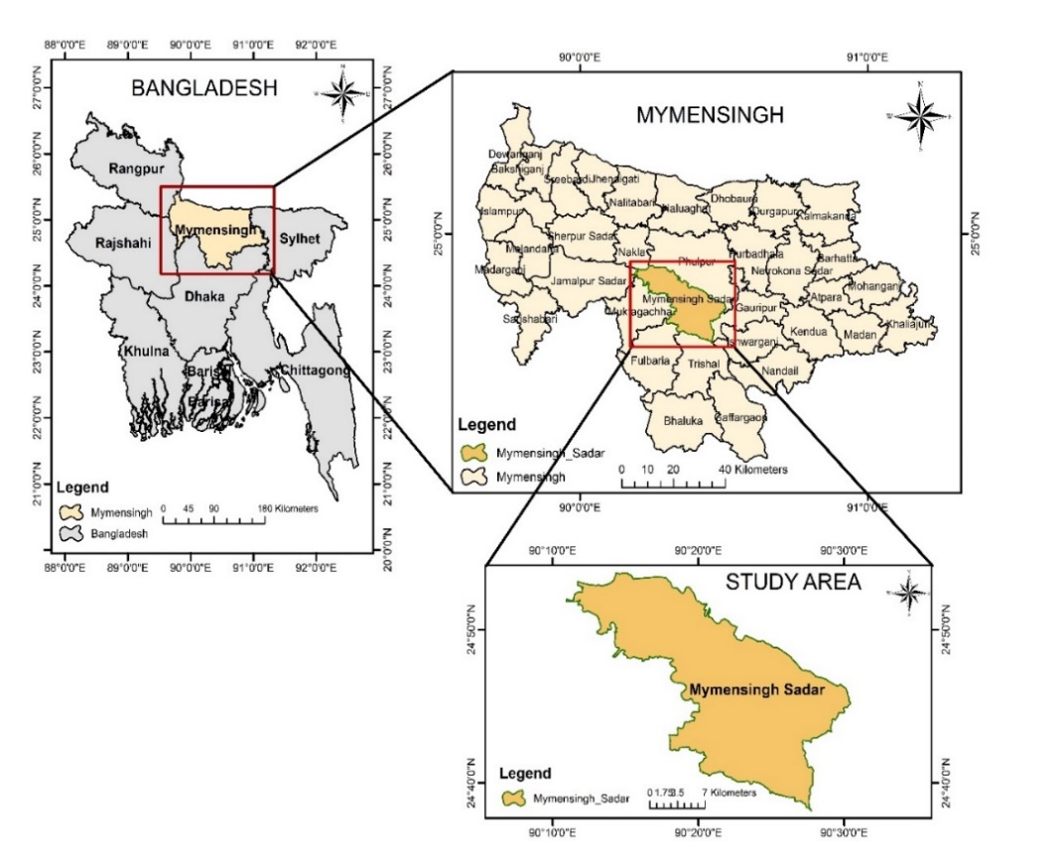

**Fig. 1** Location of the study area.

**Data acquisition and analysis**

The monitoring boreholes are part of the network of the Bangladesh Water Development Board (BWDB), which has been in charge of managing the country's 1250 monitoring wells since the early 1960s. Every Monday, the depth to groundwater levels is measured empirically (Shamsudduha et al., 2020). From 2002 to 2021, the three monitoring wells in the study region received weekly groundwater level data from the Bangladesh Water Development Board (BWDB). BWDB uses a standard horizontal datum called the Public Works Datum (PWD) to determine the groundwater level at each station (Shamsudduha et al., 2009). **Table 1** displays the specifics of the study area's monitoring wells. For each chosen observation well's matching measuring location, BWDB provided weekly data on groundwater levels. These data were then converted into monthly mean levels of groundwater for each well, and monthly data for each monitoring well from 2002 to 2021 were projected.

**Table 1:** Details of the monitoring wells of the study area.

|  |  |  |
| --- | --- | --- |
| **Well ID** | **Old ID** | **Depth (m)** |
| GT6152017 | MY073 | 33.23 |
| GT6152020 | MY024 | 35.98 |
| GT6152021 | MY052 | 38.41 |

In addition to the BWDB recorded data, a field survey was carried out to provide an accurate assessment of the decline in GWL during dry seasons shown in the flow chart of F**ig. 2**. A total of 194 individuals, varying in age, profession, and ward, provided excellent support for the survey. Monthly rainfall, temperature, and relative humidity data, among other relevant hydrometeorological data, were gathered from the National Aeronautics and Space Administration (NASA) Earth Observatory. Following a computation to identify the last fluctuations, these data were plotted in spreadsheets to create the final depiction.

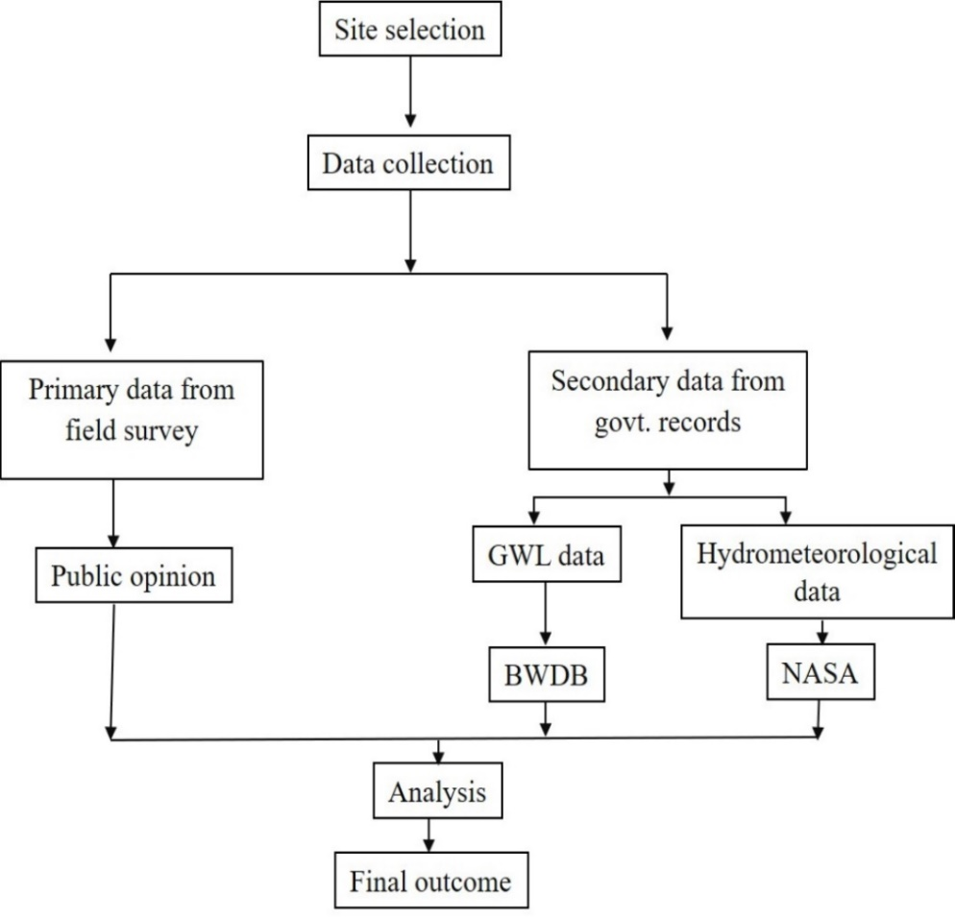

**Fig. 2** Working principles of the study in flow chart.

**Hydrometeorological data analysis of the study area**

In general, an area's groundwater table elevates as a result of increased groundwater storage from sources including surface flow seepage, canal irrigation, seepage from rainfall, replenishing from stream seepage, etc. (Darling et al., 2002). Assessing the patterns of hydrologic variables, including the trend of river water discharge, revealed a notable or trivial pattern in many regions of the world, while in other regions, an upward or downward shift in status could be explained by knowing the trend of groundwater level. Like this, analyzing the long-term patterns of meteorological variables such as temperature and rainfall demonstrated an increasing or declining position or no trend at all in a specific geographic area (Chen & Grasby, 2014; Miller & Oiechota, 2008). Natural groundwater fluctuations are triggered by hydrometeorological factors that are changing spatiotemporally, in addition to topographic and hydrogeologic characteristics that are considered to be temporally constant. Climate change is projected to increase abnormally high temperatures and inconsistent precipitation, which would change the pattern of surface water runoff and recharge to GW (World Bank, 2021).

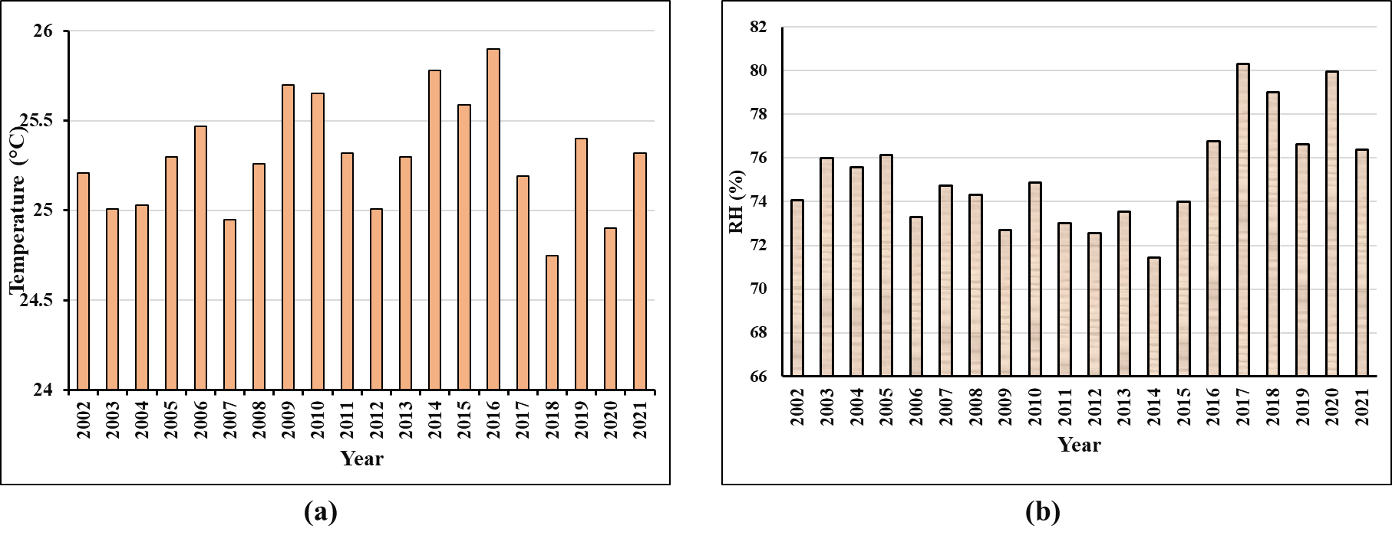**Fig. 3** Annual Temperature (a) and Relative Humidity (b) fluctuations from 2002 to 2021 of the study area.

The annual average temperature of the research region from 2002 to 2021 was displayed in **Fig. 3(a)**. The number clearly showed that, for the most part, the temperature was high enough. There were just three years with temperatures below 25°C: 2007, 2018, and 2020. Every year that followed was warmer than 25°C; a few of them were even warmer than 25.5°C. There was a slight variation visible in the graphs. 2016 recorded a high temperature of 25.9°C. The temperature has been steadily rising during these years. It could be a contributing factor to global warming brought on by a change in the global climate. It is clear from **Fig. 3(b)** that for the most of the years, the RH was within 75%. Following 2016, a new pattern became apparent, indicating the trend of increasing relative humidity. The relationship between humidity and temperature and rainfall is significant. The lowest recorded relative humidity (RH) was 71% in 2014, while the maximum RH was 80% in 2017. Generally speaking, variations in temperature and precipitation impact groundwater recharge, which results in modifications to leachate transport and GWLs (Ali et al., 2012); (Scibek & Allen, 2006); (Eckhardt & Ulbrich, 2003).

**III. RESULTS AND DISCUSSIONS**

**Field survey result**

Seasonal and annual variations in rainfall are the primary source of variations in GWLs. The water level rises during the monsoon and typically declines in the dry months because plants draw water up from the soil surface before it reaches the water table. The depth of the water table can be measured in existing wells to assess the effects of season, climate, or human impacts on groundwater. In cities like Mymensingh, water scarcity in dry months is starting to become a big problem as aquifers are rapidly running out as a result of excessive GW abstraction. A purposive field survey was carried out to gather information about the state of groundwater-related problems that local residents were facing. The survey encompassed all 34 wards within the Mymensingh City Corporation jurisdiction, and its reference population of 194 individuals nearly represented the total population. From **Fig. 4(a)**, in response to questions from representatives, 63% said they used less than 100 liters of water for everyday tasks and 4% said they used more than 100 liters. A question on whether they had any trouble filling water tanks during dry seasons was posed by **Fig. 4(b)** and 75% said they had no problems loading water tanks, while just 25% reported having problems. **Fig. 4(c)** revealed that 21% said they needed more time to load water tanks, 17% installed new pumps that were deeper than the old one. **Fig. 4(d)** shows that 12% of respondents said they had detected unpleasant or metallic smells coming from the water, 46% said they had seen metallic scales on glasses, plastics and utensils. The majority of participants reported scaling, indicating that the water may be hard due to metal carbonates.

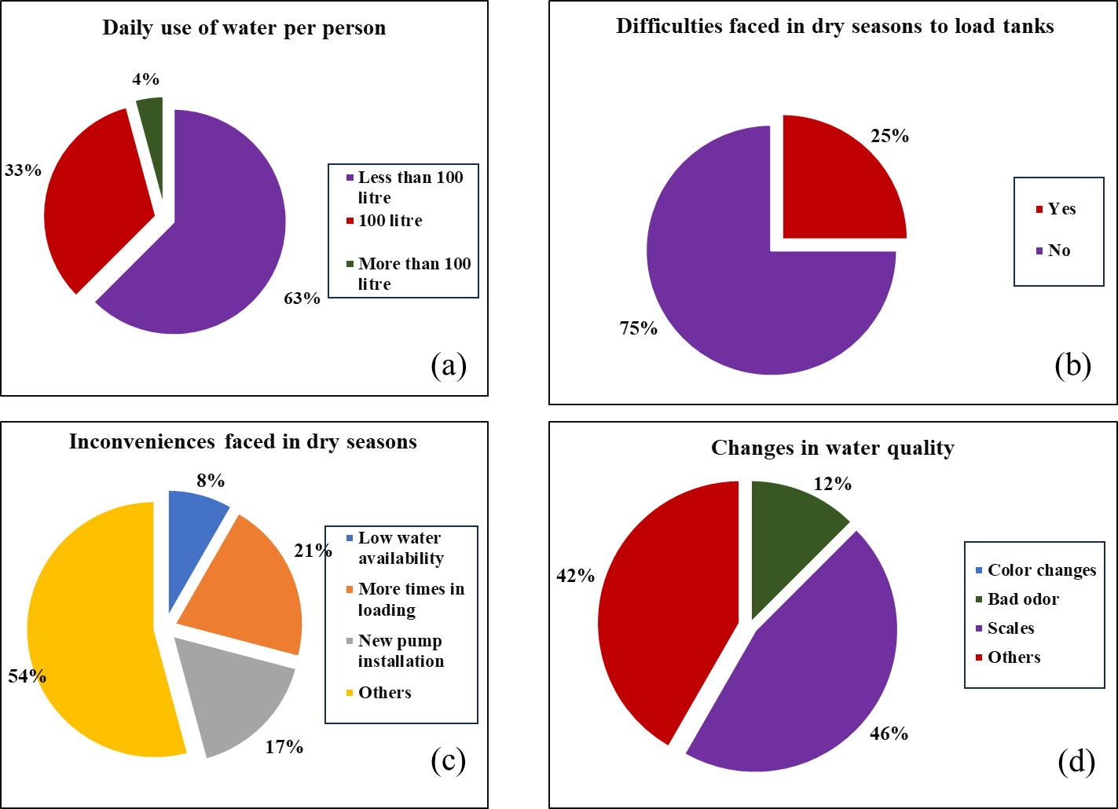

**Fig. 4** Field survey results with percentage.

**Groundwater level fluctuations of the study area**

Fluctuations in groundwater levels are hydraulic reactions to changes in stress, such as water mass loading and unloading above the aquifer surface, as well as changes in the storage of groundwater brought on by aquifer recharge and drainage. According to **Fig. 5**, a station of the BWDB designated GT6152017 in the Mymensingh City Corporation region illustrates a graphic representation of the relationship between groundwater level (m) and yearly rainfall (mm). Both the patterns of rainfall and the water level exhibit significant and distinct modifications. The highest rainfall, 250.14 millimeters, was recorded in 2007; the lowest, 116.7 mm, occurred in 2012. Between 150 and 230 mm of rain fell on average per year between 2002 and 2021. Similar to this, the greatest fall of groundwater level was 2021 which was 14.32 m and lowest fall 8.87 m in 2003. The water level should be according to the dotted linear trendline, however it is not doing so. In light of this, it is obvious that the groundwater table is fluctuating. For station GT6152017, the groundwater level has decreased from 8.87 m to 14.32 m, as demonstrated by the line's tilt. Similarly, in **Fig 6**, although there was adequate rainfall the water level did not recompensate and the years of such were 2015, 2016, 2017, 2020 and 2021 for station GT6152020 marked as red. This may be the consequence of massive urbanization, deforestation, or an array of other factors. One of the greatest rainfall totals ever recorded—230.18 mm—was in 2017, yet the water level was 8.89 m. This suggests that the water table could not be replenished by rainfall. Subsidence, compaction of the soil, and numerous other factors may be accountable for the aforementioned issue. If this keeps up, the water level will eventually tilt the scales in favor of long-term groundwater trends. This serves as a general cautionary lesson.

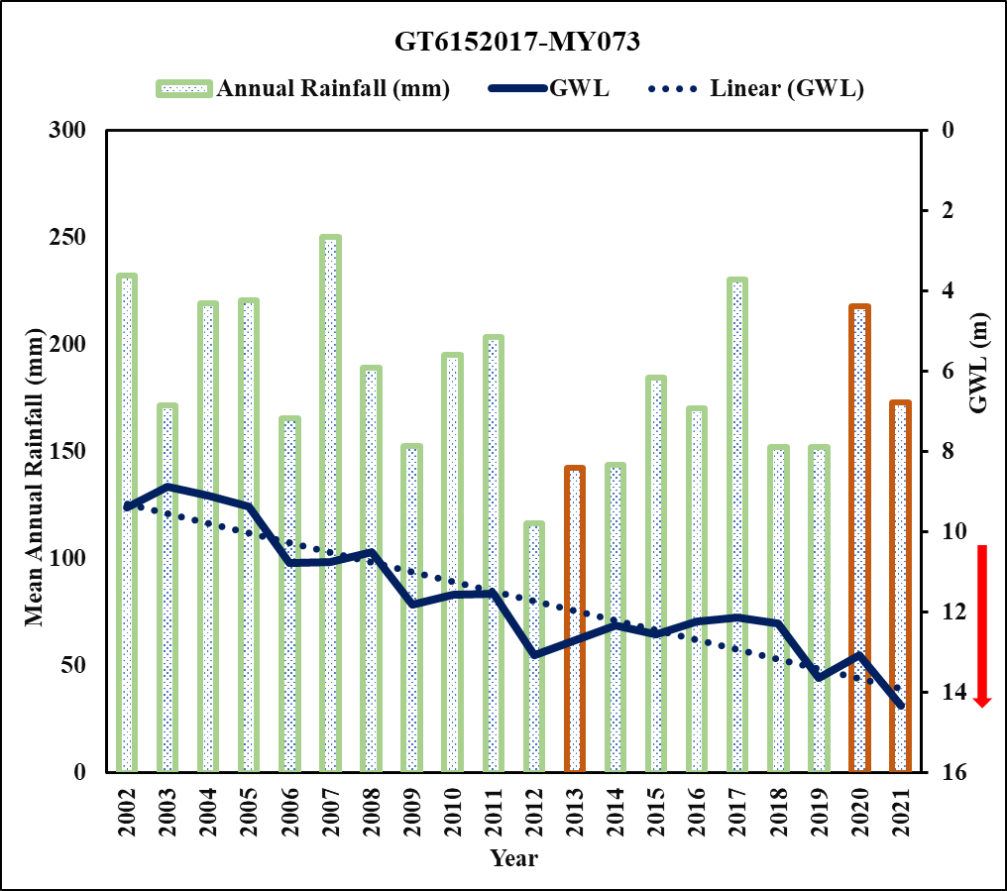

**Fig. 5** Fluctuation trends of GT6152017 monitoring well.

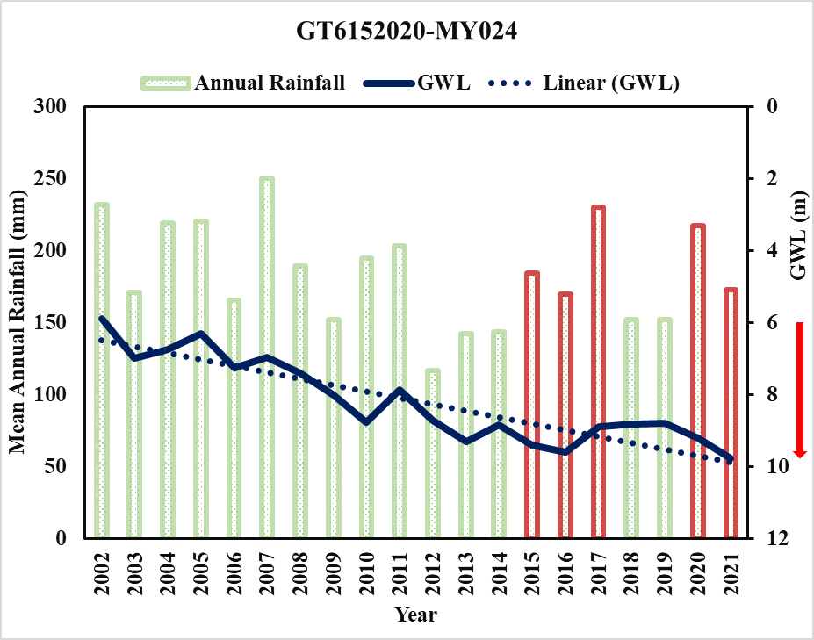**Fig. 6** Fluctuation trends of GT6152020 monitoring well.

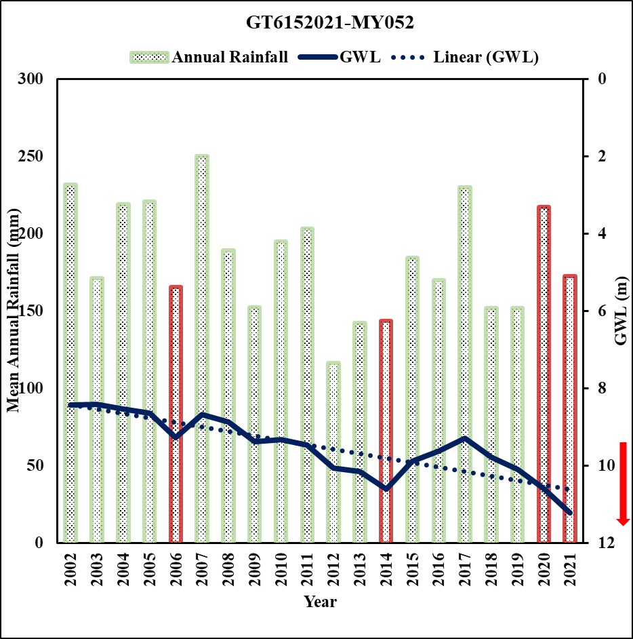A sharp and clear fluctuations in both rainfall trends and the water level is visible in **Fig. 7** which is from 8.41 m to 11.22 m for station GT6152021. The greatest fall of groundwater level was 2021 which was 11.22 m and lowest fall 8.41 m in 2003. Fluctuations in the amount of groundwater are hydraulic reactions to changes in stress, such as water mass loading and unloading above the aquifer surface, as well as changes in groundwater storage caused by aquifer recharge and drainage. The processes occurring over timescales ranging from hours to months are primarily responsible for the aquifer's poroelastic response to changes in terrestrial water loading, which is what causes fluctuations in groundwater levels. The depletion rate per year is shown in **Table 2** which is very alarming for future undoubtedly.

**Fig. 7** Fluctuation trends of GT6152021 monitoring well.

**Table 2** Average rate of depletion of water level of monitoring wells of the study area.

|  |  |  |  |  |
| --- | --- | --- | --- | --- |
| **BWDB well ID** | **Water level (m)** | | **Difference (m)** | **Rate of depletion (m/y)** |
| **2002** | **2021** |
| GT6152017 | 9.38 | 14.32 | 4.94 | 0.247 |
| GT6152020 | 5.87 | 9.76 | 3.92 | 0.196 |
| GT6152021 | 8.43 | 11.22 | 2.79 | 0.139 |

**Groundwater level trends in dry and wet months**

Surface atmospheric events have a significant impact on shallow aquifers (Taniguchi et al., 2009; Taniguchi et al., 2007). The region experiences low frequency and volume of rainfall throughout the dry season, leading to problems with groundwater extraction and depletion of groundwater levels (Chowdhury et al., 2011). When the monsoon or wet season arrives, the quantity and frequency of rainfall progressively rise, peaking in July. Nonetheless, there is a negative correlation between temperature and rainfall (Chowdhury et al., 2011). The average maximum temperature declines as the frequency of rainfall elevates throughout the monsoon. Furthermore, there is an inverse relationship between temperature and relative humidity (RH), stating that as temperature rises, RH falls. As a result, the correlation between RH and rainfall is quite complicated. Increased rainfall is correlated with higher RH (Patrick, 2021). Temperature, RH and rainfall frequency are all correlated with the groundwater level of the study region.

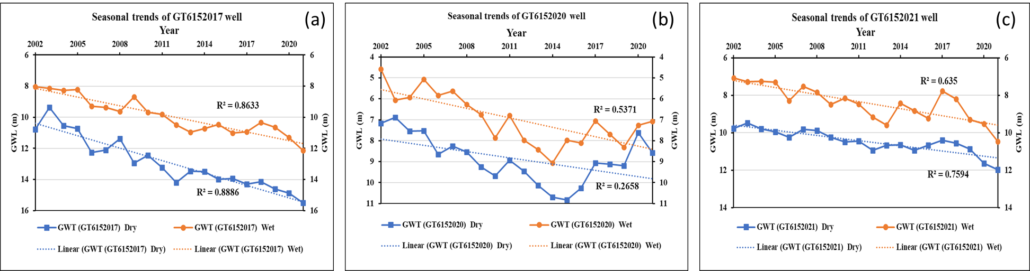**Fig. 8(a)** shows a hydrograph of the GT6152017 monitoring well demonstrating how the water level is dropping in an irregular way. This was quite alarming because there was sufficient annual rainfall to allow for recovery, but it did not occur. For wet and dry months, the R2 (coefficient of determination) is 0.86 and 0.88, respectively. **Fig. 8(b)** demonstrates the dramatic shifts and fluctuations with a great deal of fluctuation in dry seasons. Coefficient of determination for this well is 0.53 and 0.26, respectively for wet and dry seasons. The dry-wet status of the GT6152021 monitoring well is depicted in **fig. 8(c)**. There is a significant rate of variation in GWL in the research area, as indicated by the seasonal trends of the monitoring wells. R2 for wet months is 0.63 and for dry months 0.75 for the monitoring well of GT6152021.

**Fig. 8** Seasonal trends of monitoring wells.

The amount of water that individuals use is significantly influenced by their standard of living. The city's water supply, availability, and quality are so excellent that people want to use it for a multitude of purposes (Sonowal, 2023); (Anonymous, 2022). Since groundwater is underneath the surface, it often appears to be immune to the direct effects of climate change; instead, it is primarily impacted by long-term climatic incidents. Direct effects include those on natural recharge mechanisms (Taylor et al., 2013). Furthermore, the recharge from extreme precipitation events is often what causes microbial pollution of the shallow aquifer, which leads to diarrheal diseases in areas where shallow aquifers are the primary source of water for drinking (Taylor et al., 2009) and the improved recharge degrades the quality of the groundwater by removing naturally occurring contaminants like arsenic from the groundwater system (Shamsudduha et al., 2011; Van Geen et al., 2008). The lateral inflow of water to the groundwater aquifer will be decreased if the current pace of abstraction, prolonged urbanization, and silting of river banks persists, which will exacerbate groundwater (Hoque et al., 2007). Residents in the research area's assessment area may experience severe shortages of drinking water if the higher aquifer were to dry up and social unrest brought on by a shortage of drinking water supplies might seriously endanger the city or have disastrous effects on the economy. Deep wells are drilled in numerous places due to the water shortfall caused by water depletion. Pumps must be put ever-deeper in order to extract water (World Bank, 2021). This will result in higher pumping costs and higher electricity consumption to lift water from deeper depths. The ground surface may eventually undergo land subsidence if groundwater is repeatedly extracted because the water no longer supports the sediment (Plummer et al., 2004). The findings from the study could be utilized in planning and managing the sustainable use and conservation of water resources specifically the groundwater resource in Mymensingh Sadar and diminish water footprints even in developed countries.

**IV. CONCLUSIONS AND RECOMMENDATIONS**

The groundwater level of the study area has been in a continuous descending manner for the past 2 decades. The estimated water level depletion at 3 monitoring wells of the Bangladesh Water Development Board was found 0.24 m/y for GT6152017, 0.196 m/y for GT6152020, and 0.139 m/y for GT6152021. Again, wet season median GWL degradation was 3.23 m, while the dry season mean was 3.33 m. The results of the analysis primarily revealed declining tendencies in the studied area's time series. Because of the high rainfall and flooding during the wet season, the shallow GWT rises almost to the surface. Because of the massive water withdrawals and releases to rivers that deplete the aquifers, water tables drop throughout the dry season. The long-term descending pattern indicates that the variables will sustain their current trend patterns in the future. People should reduce water pumping, find alternative sources of water (rainwater harvesting), whilst the local government ought to amend the master plan for managing the area's sustainable water resources. Attempts should be made to implement long-term adaptation plans and add simulation models of water requirements for the future.

**References**

Ahmeduzzaman, M., Kar, S., & Asad, A. (2012). *A study on groundwater fluctuation at Barind Area, Rajshahi. International Journal of Engineering Research and Applications*. *2*(6), 1465–1470.

Akhter, S., Sharmin, A., Islam, M., & Ullah, M. (2019). Climatic variability on groundwater recharge of Mymensingh district in Bangladesh. *Progressive Agriculture*, *30*(1), 104–112. https://doi.org/10.3329/pa.v30i1.42217

Ali, R., McFarlane, D., Hodgson, G., & Charles, S. (2012). Potential climate change impacts on groundwater resources of south-western Australia. *J Hydro*, *475*, 456–472.

Anonymous. (2022). *Fcators affecting water demand*. https://dreamcivil.com/factors-affecting-water-demand/

Chen, Z., & Grasby, S. (2014). *Reconstructing river discharge trends from climate variables and prediction of future trends*. *J Hydrol*, 267–278.

Chowdhury, Ahmmed, H., & Chowdhury, M. A. I. (2011). *Urban Heat Island: Micro-climatic Evidence in Bangladesh* (Vol. 3). Lap-Lambert Academic Publishing, Germany.

Chowdhury, T. A., & Islam, Md. S. (2022). Assessing and Simulating Impacts of Land Use Land Cover Changes on Land Surface Temperature in Mymensingh City, Bangladesh. *Environment and Natural Resources Journal*, *20*(2), 1–19. https://doi.org/10.32526/ennrj/20/202100110

Darling, W., WG, B., & Hasan, M. (2002). Isotopic evidence for induced river recharge to the Dupi Tila aquifer in the Dhaka urban area, Bangladesh. *TECDOC, IAEA*, 95–207.

Eckhardt, K., & Ulbrich, U. (2003). Potential impacts of climate change on groundwater resources- A global review. *J Hydrol*, *284*(1–4), 244–252.

Hoque, M. A., Hoque, M. M., & Ahmed, K. M. (2007). Declining groundwater level and aquifer dewatering in Dhaka metropolitan area, Bangladesh: Causes and quantification. *Hydrogeol. Jour.*, *15*(8), 1523–1534.

Hussain, Md. M., Bari, S. H., Tarif, M. E., Rahman, Md. T. U., & Hoque, M. A. (2016). Temporal and spatial variation of groundwater level in Mymensingh district, Bangladesh. *International Journal of Hydrology Science and Technology*, *6*(2), 188. https://doi.org/10.1504/IJHST.2016.075587

Islam, S., Islam, M., & Ahmed, A. (2012). *National population census of Bangladesh* (Banglapedia: National Encyclopedia of Bangladesh (Second Ed.)). Asiatic Society of Bangladesh.

MCC. (2018). *Annual field report*. Mymensingh City Corporation

Miller, W., & Oiechota, T. (2008). Regional analysis of trend and step changes observed in hydroclimatic variables around the Colorado River Basin. *J. Hydrometeorol*, 1020–1034.

Mojid, M. A., Talukder, M. S. U., Ahmed, M., & Alam, M. S. (1994). Recharge and Depletion Characteristics of Muktagacha Aquifer, Mymensingh. *Bangladesh Journal of Agricultural Science*, *21*(1), 49–59.

Patrick, G. (2021). *Humidity and Rainfall*. Humidifiercompare. https://humidifiercompare.com/humidity-and-rain-relationship/

Plummer, C. C., McGear, D., & Carlson, D. H. (2004). *Physical geology*.

Rahman, M. A., Hoque, M. R., & Talukder, M. S. U. (1975). *A study on the Ground water recharge and its rate of depletion in Mymensingh district*. A project report, Department of Irrigation and Water Management, Bangladesh Agricultural University

Rakib, A. A., Akter, K. S., Rahman, N., & Arpi, S. (2020). Analyzing the Pattern of Land Use Land Cover Change and its Impact on Land Surface Temperature: A Remote Sensing Approach in Mymensingh, Bangladesh. *1st International Student Research Conference, Dhaka University Research Society (DURS)*. 1st International Student Research Conference, Dhaka, Bangladesh.

Rashid, A., Alamgir, M., Ahmed, M. T., Salam, R., I, A. R., Islam, A., & Towfiqul, M. (2021). *Assessing and Forecasting of Groundwater Level Fluctuation in Joypurhat District, Northwest Bangladesh Using Wavelet Analysis and ARIMA Modeling* [Preprint]. In Review. https://doi.org/10.21203/rs.3.rs-1001988/v1

Scibek, J., & Allen, D. (2006). Modeled impacts of predicted climate change on recharge and groundwater levels. *Water Resour Res*, *42*(11), W11405.

Shahid, S., Chen, X., & Hazarika, M. (2006). Evaluation of groundwater quality for irrigation in Bangladesh using Geographic information system. *Journal of Hydrology and Hydromechanics*, *54*, 3–14.

Shamsudduha, M., Chandler, R. E., Taylor, R. G., & Ahmed, K. M. (2009). Recent trends in groundwater levels in a highly seasonal hydrological system: The Ganges-Brahmaputra-Meghna Delta. *Hydrol. Earth Syst. Sci.*

Shamsudduha, M., Joseph, G., Haque, S. S., Khan, M. R., Zahid, A., & Ahmed, K. M. U. (2020). Multi-hazard Groundwater Risks to Water Supply from Shallow Depths: Challenges to Achieving the Sustainable Development Goals in Bangladesh. *Exposure and Health*, *12*(4), 657–670. https://doi.org/10.1007/s12403-019-00325-9

Shamsudduha, M., Taylor, R. G., Ahmed, K. M., & Zahid, A. (2011). The impact of intensive groundwater abstraction on recharge to a shallow regional aquifer system: Evidence from Bangladesh. *Hydrogeology Journal*, *19*(4), 901–916. https://doi.org/10.1007/s10040-011-0723-4

Shariot-Ullah, M. (2018). Impacts of sugar mill’s wastewater use on physical and hydraulic properties of soil: Evidence from North Bengal Sugar Mill, Natore, Bangladesh. *Sustainable Water Resources Management*, *5*(2), 863–871.

Sonowal, R. (2023). *Factors affecting rate of water demand*. engineeringnotes.com. https://www.engineeringenotes.com/water-engineering-2/water-demand/factors-affecting-the-rate-of-demand-of-water-water-engineering/44396

Taniguchi, M., Shimada, J., Yamano, M., Onodera, S., Kaneko, S., & Yoshikoshi, S. (2009). Anthropogenic effects on the subsurface thermal and groundwater environments in Osaka, Japan and Bangkok, Thailand. *Science of Total Environment*, *407*, 3153–3164.

Taniguchi, M., Uemura, T., & Jagoon, T. (2007). Combined effects of urbanization and global warming on subsurface temperature in four Asian cities. *Vadose Zone Journal*, *6*, 591–596.

Taylor, R. G., Koussis, A., & Tindimugaya, C. (2009). Groundwater and climate in Africa- A review. *Hydrol Sci J*, *54*(4), 655–664.

Taylor, R. G., Scanlon, B., & Treidel, H. (2013). Groundwater and climate change. *Nat. Clim. Change*, *3*(4), 322–329. https://doi.org/10.1038/nclimate1744

Van Geen, A., Zheng, Y., Goodbred, S. J., Horneman, A., Aziz, Z., Cheng, Z., Stute, M., Mailloux, B., Weinman, B., Hoque, M., & Seddique, A. (2008). Flushing history as a hydrogeological control on the regional distribution of arsenic in shallow groundwater of the Bengal Basin. *Environ Sci Technol*, *42*(7), 2283–2288.

World Bank. (2021). *Climate change in Bangladesh: Impact on infectious diseases and mental health*. https://www.worldbank.org/en/news/feature/2021/10/07/climate-change-in-bangladesh-impact-on-infectious-diseases-and-mental-health

Zahid, A., & Ahmed, S. (2013). *Groundwater resources development in Bangladesh: Contribution to irrigation for food security and constraints to sustainability*.

Zaman, R. (2007). *A Study on Ground Water Table Fluctuation in Ishwargonj, Muktagacha and Fulbaria* [Unpublished]. http://rgdoi.net/10.13140/RG.2.2.19040.84488

Zannat, F., Islam, A., & Rahman, M. (2019). Spatiotemporal variability of rainfall linked to ground water level under changing climate in northwestern region, Bangladesh. *European Journal of Geosciences*, *1*(1), 35–56. United Nations Development Programme